FABRICATION OF METAL PANEL DOOR

BY

AHMED MUHAMMED HABEEB

ND/23/MET/FT/0018

SUBMITTED TO THE

DEPARTMENT OF METALLURGICAL ENGINEERING, INSTITUTE OF TECHNOLOGY,
KWARA STATE POLYTECHNIC, ILORIN, NIGERIA.

IN PARTIAL FULFILLMENT OF THE REQUIREMENT FOR THE AWARD OF NATIONAL DIPLOMA {ND} CERTIFICATE IN METALLURGICAL ENGINEERING TECHNOLOGY.

AUGUST, 2025.

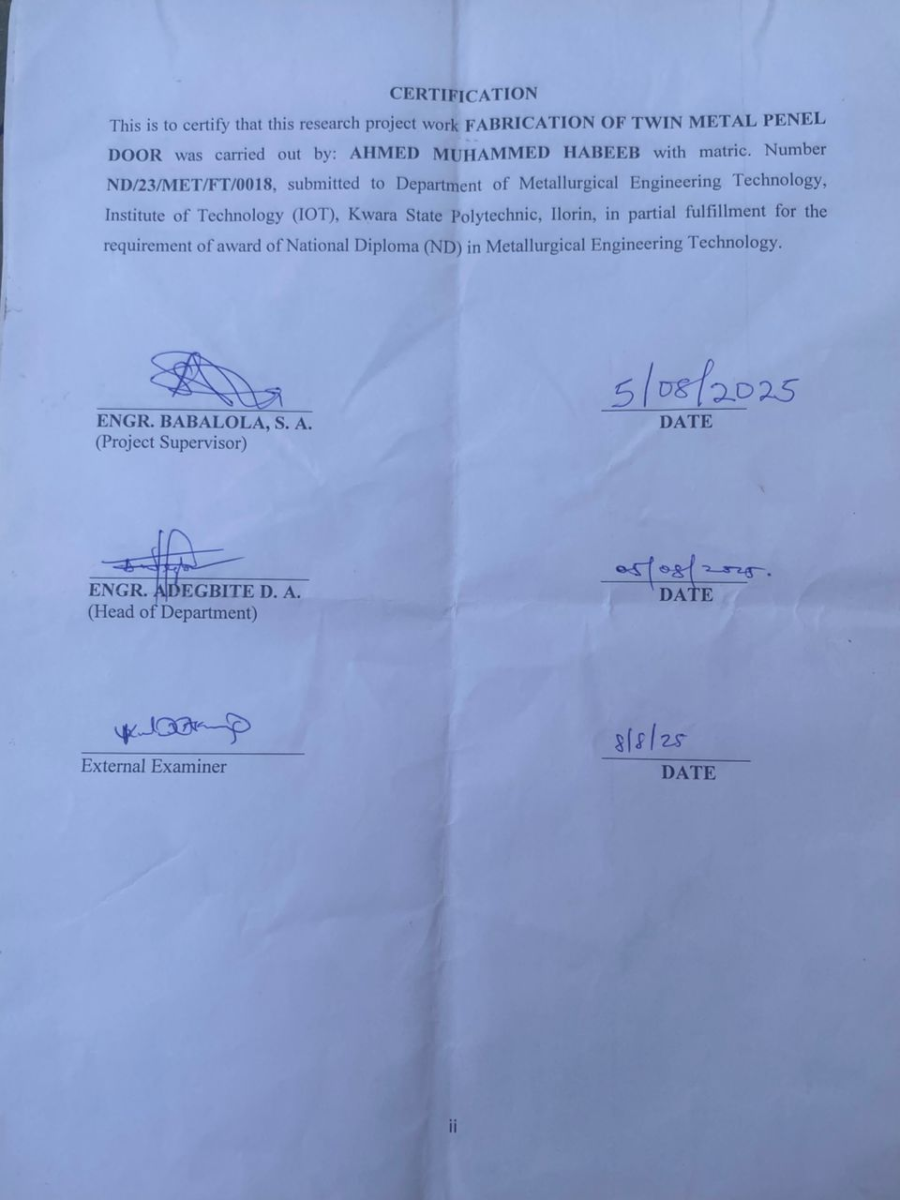
DEDICATION
This project is dedicated to Almighty God, who spared our lives towards the completion of the project.

ACKNOWLEDGMENT
I would like to express my sincere gratitude to all those who contributed to the successful completion of this project.
First and foremost, I extend my heartfelt thanks to my mentor/supervisor, ENGR BABALOLA S.A, for their invaluable guidance, support, and encouragement throughout the project. Their constructive feedback and expertise were crucial in shaping the direction and outcome of this work.
A special thanks goes to my parents, colleagues, and friends who supported me with insightful discussions, motivation, and assistance during various stages of the project.
Finally, I would like to express my deepest appreciation to my family for their unwavering encouragement, patience, and belief in me, which inspired me to persevere and complete this work successfully.

ABSTRACT
Security of life and property cannot be over emphasized. Human beings need privacy in their various homes and offices which necessitate the need for doors among other security service. Ithas been a major challenge for the people to have door of high quality and that are also durable at affordable prices by an average Nigerian. This project was done purposely to fabricate a metal panel door of high quality capable of giving maximum securities to life and properties at affordable price.

TABLE OF CONTENTS
Title page
Approval page
Dedication
Acknowledgement
Abstracts
CHAPTER ONE
Introduction
Definition
Types
Need for metal panel door
Aims and objectives
CHAPTER TWO
2.00 Analysis of alternative method and choice of best alternatives
2.10 Types of door mechanism
2.20 Literature review
CHAPTER THREE
3.0 General description of component and it working principle
3.1 Description of component part.
3.1 Working principle
CHAPTER FOUR
4.0 Design Calculation
CHAPTER FIVE
5.0 Selection of material
5.1 Mechanical properties
5.2 Physical properties
5.3 Corrosion resistance
5.4 Economic properties
5.5 Environmental properties
CHAPTER SIX
6.0 Conclusion and recommendation
6.1 Conclusion
6.2 Recommendation
6.3 Reference
6.4 Appendix i
6.5 Appendix ii
6.6 Appendix iii

CHAPTER ONE
INTRODUCTION
Many years ago, different types of doors were in use, which includes doors made of woods or grasses. These doors were made to meet the purpose of security to both life and properties. It was later discovered that doors made of wood do not last longer. They have short life span and they can easily get burnt.
More so, considering the rate at which armed robbers break into houses in our society, one would regret that wooden doors and grass doors gave them the chance to do so because it could easily be damaged.
Furthermore, door made with wood are very risky to be put at open place. This is because doors made with wood when faced with water frequently, it gets damaged. In addition, termites could make the lifespan of wooden doors short.
Meanwhile, based on the aforementioned reasons and also the urge to improve technologically, so as technologist in training, we have come up with a design to serve as an alternative means of making doors of different patterns of today. The patterns that seems to give doors a long lifespan and serves as a means of security to lives of man and properties.
DEFINITION OF DOOR
Door can be defined as hinges, sliding, or revolving barrier at the entrance to a buildings, vehicles, pieces of furniture etc.(Oxford English Mini-Dictionary 5th Edition).
Door can also be defined as a movable flat or panel surface that open and closes the entrance to a building, Hornby A.S{1995}
TYPES OF DOOR
There are different types of doors depending on their purposes, material of manufacture, durability, personal requirement etc. Some types of doors are listed below:
- Timber/wooden door
- Steel door
- Frame and panel door
- Glass door
- Battened and ledge doors
- Flush door
- Aluminum door
- Glass door e.t.c.
THE NEED FOR METAL PANEL DOOR
The needs for metal panel door in our modern generation are listed as follows:
- It last longer than any other door
- It is of high strength and presentable
- For the purpose of securing both life and property
- It gives no easy access for bugler and thieves.

1.4 AIMS AND OBJECTIVES
1.4.1 AIMS
The aim of this projects is to fabricate the metal panel door that will be of high quality capable of giving maximum security to life and property at affordable price.
1.4.2 OBJECTIVES
The objectives of this project is as follows:
- To design a decent, stronger and well secured door.
- To cut the materials to desired dimensions.
- To assemble the door and fixing the parts.

CHAPTER TWO
LITERATURE REVIEW
In the olden days, door were made either with wood or grasses .The general purpose of door is to secure the life and properties of human being and also serve as a feature of any building without door a building is a skeleton structure.
The earlier record are those represented in the painting of the Egyptian tombs in which they are shown as single or double doors, each in a piece of wood In Egypt, where the climate is intensely dry, there would be no fear of their wrapping, that is, being trusted or bent out of its natural shape, but in other countries it would be necessary to frame them which according to Vitruvius was done with stiles and rails, example is the frame and panel. The space enclosed being filled with panel let into groove made in the stiles and rails Raymond A. (1994) the properties of engineering, material second (2nd) Edition. Edward Arnold London pp280.
As mentioned above traditional door were invariable simple constructions of vertical boarding or timber panel, usually without any form of glazing Alabi S (1999), fabrication of metal panel door, ND project report submitted to department of mechanical engineering, Kwara State polytechnics, Ilorin.
In18th centuries doors surrounds because more flamboyant with classical and gothic styles becoming particular popular.
Mean whiles in the year n1999 and 2012 fabrication of metal panel door was embarked on to suit the aforemention importance. Hornby A S (1995), oxford advance learner’s dictionary fifth edition, Oxford university press, London (pp346). The importance of work is based on the qualities mentioned above and as well as lot of improvement has been made. The design and also the outlook are invariably captivating and beautiful. The most ancient doors were timbers, which were carved and over laid. The doors dwelt upon in “Homes’’ would appear to being cased in silver or brass. Besides olive wood, elm, cedar, Oak e.tc All ancient doors were hung by pivot at the top and bottom of the hanging stile which work in sockets in the Intel and sill, the later being always in some hard stone such as basalt or granite. The tenors of the gates of balata were sheathed with bronze which is now British museum. The door of gates were hung in two leaves each about 4ft by 7ft wide and 27th poses decoration of figure e.t.c, The wood doors would seem to have been about 3 inches thick, but the hanging stile was over 14 inches in diameter (4). The ancient Greek and Roman doors were either single doors, double doors or folding doors in the last case that the leaves were hinged and folded back. inEumachia, there is a single four panel door carve in stone. In Blurb dell collection is base relief of a temple with double doors each leaf with four panel and are framed in bronze. In all these case the hanging still had pivots at the top and bottom. The exact period when the hinge was substituted is not quiet know. But the change apparently brought about another method strengthening and decorating doors, viz with wrought iron bands of infinite varieties of design. As a rule three bands from which the ornamental work springs constitute the hinges which have rings outside the hanging stiles fitting on to vertical tenors run into the Masonry or wooden frame (Raymod .A. 2002) the properties of engineering material fourth Edward Arnold, London pp280
2.0 ANALYISI OF ALTERNATIVE AND CHOICE OF BEST ALTERNATIVE
Based on the improvement and urge, to increase mans comfort, As an Engineer in training learning of the design alternative for making door to meet up with the present demand which gives a long life span and adequate security for life and properties is done. The best alternative choices of doors to metal panel door are listed and discuss below.
- Glass door
- Aluminum door
- Timber/wooden door
- Bat wing door
- Dutch door
GLASS DOOR: Glass is usually provided for door and windows, mostly for paneling. However if the owner so desire, door can made out of glass for specific location.
Normally such doors are mainly provided at the backyard or backside of the house as it is unobstructed view of the backyard. Front doors made of glasses are equally beautiful, but care should be taken to ensure both privacy and durability. The doors made of glasses are mostly heavy and costly compare to its counterpart.
ALUMINIUM DOOR: Aluminum doors as implies is a types of doors that are made out of aluminum. Aluminum is a metal which has been put to large numbers of uses due to being light in weight. Aluminum frame have distinct advantage of resisting difficult environment conditions. The main advantages of aluminum door is that it is not heavy but light in weight, being light in weight they transfer less loads to the foundations. Aluminum frame are not affected by Termite and such door last very longer
DUTCH DOOR OF STABLE DOOR: This types of doors is divide into half horizontally, traditionally the top half can be opened and allow a horse or other animal to fed, while the button half remain closed to keep the animal inside. This style of door has been adapted for home.
- BAT WING DOOR: A bat wing door which is also known as saloon doors are a pair of light weight swing door often found in public bars and especially associated with the American west saloon door also know as café doors often use bi-directional hinges which close the door regardless of which direction it is opened be incorporating springs
- WOODEN DOOR: These types of door are made as a means of entrance and exit, also for security of lives and properties.
Aluminum Dooris the best alternative in the sense that it has great advantages over others.
For instance glass metal panel door cannot be used in an area where many children are living in the course of playing they may throw stone and break it door play football which can then hit the door and break or make it to get damage completely. So if care is not taking they may even make use of the pieces to harm themselves which has no impact on aluminum door.
The choice of best alternative to metal panel door is an Aluminum door.

2.10 TYPES OF DOOR MECHANISM
The main types of door mechanism.
- Hinged doors: most door are hinged along on side to allow the door to pivot away from the door war in one direction but not in the other. The axis of rotation is usually vertical. In some cases, such as hinged garage doors, the axis may be horizontal above the opening.
Door can be hinged so that the axis of rotation is not in the plane of the door to reduce the space required on the side to which the door opens. This requires a mechanism so that the axis of rotation is one side other than that in which the door open’s. This is sometimes the case in trains, such as for sliding door to toilet, which opens inward.
- Sliding door: sliding door is often useful to have doors which slide along tracks often for space or aesthetic consideration
- Dutch door or stable door: the top half of the door operates independently from the button half.
- Swing door: Swing door has special hinges that allow it open either outward or inwards and is usually spring to keep it closed
- Self butting door is called as such because of its special hinges that permit panel leaf to move laterally so that the door itself becomes a giant bolt for better security result. The self bolting door principle can be used for hinge doors as for rotating doors, as well as up and over doors (in the later case, the bolts are then placed at the top and bottom rather than at the sides.
- Rotating Doors. A revolving door normally have several wings and leaves that hang on a centre shaft forming compartment which rotate one way about a vertical axis. Doors using four wings are utmost common, but there are also examples with two, three or six wings. The doors may be motorized or push manually using push bar. People can walk out of and into the building at the same time. Between the point of access and the point of exit, the user walks through air lock. Revolving doors therefore create a good seal from the outside and help to reduce air-conditioning and heating costs climate control from the building. This types of door is often seen as mark of prestige and glamour for a building and it not unusual for neighboring buildings to install their own revolving doors when a rival building get one.

CHAPTER THREE
MATERIALS AND METHODS
3.1 MATERIALS

3.1.1 The Frame
This is the unit that is fasted and locked to the wall and also held to the movable door panel.
It must be cennected to the wall in order to withstand all the load due to oscillatory door panel and the jam-lock.
3.1.2 The Latches
These units are used to lock from inside after closing the door during the night or when outing. They are also fabricated to the metal panel door.
3.1.3 Panel Unit
This is the unit that is fabricated to the frame units. It is the main part of the door and also the movable part of metal panel door after the frame have been fastened and locked to the wall.

3.1.4 Handle
The handle provides easy control of opening and closing of the metal door. It is used to push and pull of the door.

3.2 METHODS
3.1 WORKING PRINCIPLE
Doors are design to close and open with the aid of hinges. This mechanism fails tom function and sometimes noisy when the hinges get corrected. A stopper is fabricated on the frame for the purpose of moving the door inward.
When the correct key is inserted, the gap between the key pin and the drivers pin along with the edge of the plug called the shear line.
A lock from locking device which hooked hole created on the door frame is released and the door open when the correct key is used.

CHAPTER FOUR
RESULTS
4.1 DESIGN CALCULATION FOR METAL DOOR
Parameter of the door frame
$$Breadth (B) =1220mm$$
$$Length (L) =2135mm$$
$$Areaoftheframe= lengthxbreath$$
$$Af = LxB…………… (1) (K . AStroud 2002)$$
$$Af =2.135x1.22m$$
Af =2.6647m2$m^{2}$
Mass of frame
Since D = $\frac{M}{V}$ where thickness of frame = 0.025m
$m_{f}$ = density (p) of mild steel, x volume of frame (v)
$m_{f}$ = $p_{m}xv_{f}………… (11) (RajputM . W 2010)$
$v_{f}$ = area of frame ($A_{f}$) x thickness of frame $T_{f}$ … … … … (111)
(Rajput M .W 2010)
$V_{f}$ = $2.6047M^{2}x 0.025m$
$v_{f}$ = $0.0651175m^{3}$
$m_{f}$ = $p_{m}xv_{f}$
$$m_{f} = 7860kg/m^{3}x 0.0651175m^{3}$$
$m_{f}$ = 511.82355kg
Weight of the Frame
$w_{f}$ = $m_{f}xg…………(iv) (RajputM . V 2010)$
$Since$ ($g$) = $accelerationduetogravity$ ($g$) = $10m/5^{2}$
$$w_{f}= 5118.2355N$$
AREA OF PANEL DOOR
$L_{P}$ = $lengthofpanel$=$\frac{1082}{1000}$ = 1.082
$B_{P}$ =$breadthofpanel$ = 2020 = $\frac{2020}{1000}$ = 2.02
$A$= $lxb(newschoolphysics 5theditionbyOkeke)$
$A$ = $1.082 x 2.02$
$A_{P}$ = $2.1856m^{3}$
MASS OF DOOR
$SinceD$ = $\frac{m}{v}wherethicknessofpanel$= $0.002$
$D$ = $\frac{m}{v}(RajputM . W 2010)$
$M_{P}$ =$densityofchakaplatepcxvolumeofpanel,V_{P}$
$$Volumeofpanel (vp) = areaofpanel\left(ap\right)∩thickness\left(tp\right)………… (vi)$$
$V_{p}$= $A_{p}xT_{P}(RajputM . W 2010)$
$V_{P}$ = $2.1856M^3 X 0.002m$
$V_{P}$=$0.00437128m^{3}$
$Hencem_{p}$, =$P_{C}xV_{p}$ … … … … (vii) (Rajput M. V 2010)
$m_{p}$ = $7800KG/M^{3}X 0.00437128M^{3}$
$m_{p}$= $34. 095984KG$
WEIGHT OF PANEL (WP)
$w_{p}$ = $m_{p}$ x$g$ … … $… (viii) (RajputM. V 2010)$
$$w_{p}= 34. 095984KGX 10MS-^{R}$$
$$w_{p}= 340.95984N$$
MASS OF CROSS BAR (MC)
$Massofcrossbar, mc$ = $p_{c}xv_{c}$ … … …(ix) ($rajputM . W 2010)$
$$v_{c} = L_{C}XB_{c}XH_{C}$$
$V_{c}$ = $0.825MX 0.062MX 0.785M$
$V_{C}$=$0.04015 M^{3}$
Where, mass of cross bar, $M_{C}$= $P_{C}xV_{c}$ … … … $x$ (Rajput M. W 2010)
$M_{C}$= $450KG/M^{3}X 0.04015M^{3}$
$M_{C}$= $18.0675KG$
WEIGHT OF THE CROSS BAR (WC)
$W_{C}$ = $M_{C}Xg$ … … $… (xi) (rajputM . V 2010)$
$W_{C}$ = $18.0675KGX 10MS-^{2}$
$W_{C}$ =$180.675N$
TOTAL WEIGHT OF THE DOOR (W_{C})
$W_{T}$ = $W_{E}$ + $W_{P}$ + $W_{C}$ … … …$(XII) (RAJPUTM. W 2010)$
$W_{T}$ = $5118.2355N + 340.9598N + 180.675N$
$$W_{T}= 5639.8703N$$
TOTAL AREA OF DOOR (A_{T})
$A_{T}$= area of frame ($a_{f}$) + area of panel ($a_{p}$) $- (xiii) (rajputM . W. V 2010)$
$$A_{T}= 2.6047M^{2} +2.1856m^{2}$$
$A_{T}$ = $4.703M^{2}$
CHAPTER FIVE
CONCLUSION AND RECOMMENDATION
5.1 CONCLUSION
The fabrication of metal panel door was embarked upon to solve the problem of short lifespan of door also to update the design of door which serves as an entrance to a building.
All necessary dimensions were consider metallic materials used in producing the door. The assembling of the parts was accurate and the finishing of the door was done to bring the beauty and protective measures of the metallic door that makes it resistance to some vicinity or environmental attack such as water, temperature, termite, humidity, harm than and external forces i.e. push and pull forces which causes deformation of shapes and structure of the door after short period of time.

5.2 RECOMMENDATION
The prosperity Engineering depends upon on the ability to convert the raw materials into useful articles of consumption. The knowledge of the machining in Engineering workshop should be encourage and increase the period of practical works.
However, this work is recommended to all residential buildings and commercial structures where security of the inside is priority.

REFERENCE
Eyiowukawi O. S. (2012) fabrication of metal panel door, ND project report submitted to the department of mechanical engineering, kwara State Polytechnic, Ilorin (unpublished).
Hornby, A.S. (1995).Oxford Advanced learner Dictionary”, 6th edition, Oxford University press London Pp 346
Kayoed A. and omotuaseO.L (2006). Fabrication of metal panel door, ND project report submitted to the department of mechanical engineering, kwara State Polytechnic, Ilorin (unpublished).
OlagokeS.A (2008)” properties of material” 4th Edition S.Amultiventures Ibadan.
Orisabinon .T.J. and Alowosile, S.J. (2008). Fabrication of metal panel door, ND project report submitted to the department of mechanical engineering, kwara State Polytechnic, Ilorin (unpublished).
Raymond A.(1994),” the properties of material” 2nd edition Edward Anold London.

