PETROGRAPHICAL STUDIES OF LEPIDOLITE
(A CASE STUDY OF KAKAFU, KWARA STATE))

BY:

HAMMED YUSUF ADEWALE
ND/23/MPE/FT/0040

BEING A RESEARCH PROJECT SUBMITTED TO THE DEPARTMENT OF MINERALAND PETROLEUMRESOURCES ENGINEERING, INSTITUTE OF TECHNOLOGY, KWARA STATE POLYTECHNIC, ILORIN.

IN PARTIAL FULFILLMENT OF THE REQUIREMENTS FOR THE AWARD OF NATIONAL DIPLOMA (ND) IN MINERAL AND PETROLEUM RESOURCES ENGINEERING

AUGUST, 2025

CERTIFICATION
This is to certify that this project title, PETROGRAPHICAL STUDIES OF LEPIDOLITE (A CASE STUDY OF KAKAFU, KWARA STATE) Submitted by HAMMED YUSUF ADEWALEwith Matric number ND/23/MPE/FT/0040 was carried out under my Supervision at the Department of Mineral and Petroleum Resources Engineering, Institute of Technology, Kwara State Polytechnic, Ilorin. This Project report has been read and approved having met the requirement for the award of National Diploma (ND) in Mineral and Petroleum Resources Engineering

______________________ _________________
ENG. KAJOGBOLA, A.A DATE
Project Supervisor

______________________ ___________________
DR. OLATUNJI J.A DATE
Head of Department

______________________ _________________
ENGR. OLUWOLE C.T DATE
External Examiner Industrial

DEDICATION
I dedicated this project to Almighty Allah, the owner, administrator of the universe and the source of all wisdom.

ACKNOWLEDGEMENT
All praise and gratitude belong to Almighty Allah, the Most Gracious, the Most Merciful, for granting me life, strength, wisdom, and perseverance throughout the period of this project and my academic journey. His mercy and guidance have been my anchor, and without His favor, this achievement would not have been possible.
I am deeply indebted to my wonderful parents, Mr. and Mrs. Hammed whose love, sacrifice, and encouragement have been the bedrock of my life. Your constant prayers, moral support, and financial backing gave me the strength to keep going even during the most difficult times. Words alone cannot express how thankful I am for everything you have done for me.
My sincere appreciation goes to my project supervisor, Eng.Kajogbola, whose guidance, feedback, and dedication helped shape this research work. Your patience, constructive criticism, and academic mentorship greatly enhanced the quality of this project.
I also extend my gratitude to the Head of Department Engr. Dr. Olatunji J.A and all the lecturers in the Department of Agricultural and Bio-Environmental Engineering for the knowledge and inspiration they have imparted to me throughout my studies. Your collective impact has been monumental in shaping my academic foundation.
To all my friends who have walked this journey with me thank you for your companionship, moral support, words of encouragement, and the memorable times we shared. Your presence made this academic journey worthwhile and bearable.
Special thanks to my course mates and colleagues who directly or indirectly contributed to the success of this project. The discussions, shared resources, and teamwork during practical’s and lectures were invaluable.

TABLE OF CONTENTS
Certification
Dedication
Acknowledgment
Abstract
Table of Contents
List of Figures
List of Tables

CHAPTER ONE: INTRODUCTION
1.1 Background of the Study
1.2 Statement of the Problem
1.3 Objectives of the Study
1.4 Significance of the Study
1.5 Scope of the Study
1.6 Definition of Terms

CHAPTER TWO: LITERATURE REVIEW
2.1 Introduction
2.2 Mineral composition of lepidolite
2.2.1 Geological distribution of lepidolite
2.2.3 Economic potential of lepidolite
2.2.3.1 Mineralogical Analysis and resource evaluation
2.3.2 Geology of mineral deposits
2.4.2 Lepidolite Mining in Nigeria

CHAPTER THREE: METHODOLOGY
3.1 Materials
3.2 Methods
3.3 Description of the Study Area
3.4 Sample Collection
3.5 Sample Preparation
3.5.1 Petrographical Analysis (Thin Section)

CHAPTER FOUR: RESULTS AND ANALYSIS
4.1 Microscopic Description (Thin Section)
4.2 Plane Polarized Light (PPL) Description
4.3 Cross Polarized Light (XPL) Description
4.4 Modal Composition

CHAPTER FIVE: CONCLUSION AND RECOMMENDATIONS
5.1 Conclusion
5.2 Recommendations
References
Appendices

List of table
Table 1 Estimate model composition of Lepidolite in the study samples photomicrograph 14

List of figures
Figure 1: Location map of kakafu community within kwara state Nigeria 8
Figure 2: Geological map of the study area showing distribution of pegmatites 8
Figure 3: Field photograph of pegmatite out crop containing lepidolite 8
Figure 4: Hand specimen of lepidolite bearing pegmatile (labeled mineral phases).8
Figure 5: Photomicrograph of lepidolite under plane polarized light (ppl) 12
Figure 6: Photomicrograph of lepidolite under cross polarized light (xpl) 12
Figure 7: Textural Relationship between lepidolite and associated minerals (Quartz, Albite, Muscouite) 13
Figure 8: Schematic zonation of a typical pegmatite showing lepidolite zone 13
Figure 9: Ternary diagram showing mineralogical classification of pegmatites samples 14
Figure 10: Comparative chart of lithium content in pegmatites from kakafu and other 15 Nigeria location

Abstract
This study presents a detailed petrographical investigation of lepidolite occurrences within the Kakafu community of Kwara State, Nigeria. Lepidolite, a lithium-bearing mica, plays a significant role in modern technology due to its lithium content, which is essential in battery production and other industrial applications. The research involves the collection and microscopic analysis of rock samples from pegmatite outcrops within the study area to determine the mineralogical characteristics and textural relationships of lepidolite. Using standard petrographic techniques, thin sections were prepared and analyzed under both plane-polarized and cross-polarized light. The results of thin section from photomicrograph revealed that quartz has range between the (27-30%) with average value of 28% while mica has 3-55% with average value of (29%), feldspar has range (15-20%) with average value of 17.5% and lepidolite has 0-50% with average value of 50%. This implies that the sample analyzed in having minimum requirements quality of lithiums for use in lithium ion battery production. Observations revealed that lepidolite is commonly associated with other minerals such as quartz, albite, and muscovite in a coarse-grained granitic pegmatitic matrix. The presence of accessory minerals like tourmaline and zircon further confirms the evolved nature of the pegmatite system. The study highlights the potential of the Kakafu pegmatites as a viable source of lithium and other raremetals, with implications for economic geology and resource development in the region. The findings also contribute to the broader understanding of pegmatitic processes in the Nigerian Basement Complex.

CHAPTER ONE
INTRODUCTION
1.1 Background of the Study
Lepidolite, a lithium-rich mica mineral, has gained significant attention recently due to its role as a primary source of lithium. Lithium is crucial in modern technologies, particularly rechargeable batteries for electric vehicles, renewable energy storage, and portable electronics (Zhao et al., 2022). As global demand for lithium increases, the exploration and exploitation of Lepidolite deposits have become critical for advancing the energy transition (Hardy &Vardon, 2021).
The Kakafu region in Patigi Local Government Area (LGA) of Kwara State, Nigeria, remains largely explored for its mineral potential, particularly regarding Lepidolite deposits. Although mineral exploration has identified various resources in the state, the presence and economic value of Lepidolite in this region are underexplored. This study aims to analyze the mineral composition, distribution, and potential economic uses of Lepidolite in the KakafuCommunity using advanced analytical techniques such as Plane Polarized Light (PPL) and Cross Polarized Light (XPL) microscopy.
Lepidolite typically occurs in pegmatitic rocks alongside minerals like Quartz, Mica, and Feldspar. The mineral composition and distribution of these associated minerals offer insights into the geological conditions favoring Lepidolite formation. PPL and XPL techniques facilitate detailed analysis of mineral structure and composition, particularly identifying lithium-bearing phases within the rock matrix (Meyer & Schmidt, 2020). These techniques also aid in characterizing crystallinity, color zoning, and birefringence, crucial for understanding the geological processes shaping their formation.
1.2 Statement of the Problem
Despite global interest in Lepidolite as a lithium source, detailed studies on its mineral composition, distribution, and economic potential in Nigeria are scarce. The Kakafu area of Patigi LGA remains particularly explored in this regard. The lack of comprehensive studies on Lepidolite's occurrence, distribution, and mineralogical composition hinders understanding its potential role in Nigeria's mining sector.
1.3 Objectives of the Study
This research aims to achieve the following objectives:
- Analyze the mineral composition of Lepidolite in Kakafu, Patigi LGA, Kwara State, using PPL and XPL microscopy.
- Assess the potential economic uses of Lepidolite, particularly in lithium extraction, and evaluate its economic viability for the region.
1.4 Significance of the Study
This study is significant for several reasons:
- It contributes to understanding Lepidolite's mineral composition and distribution in Nigeria, particularly in the Kakafu area, serving as a reference for future geological surveys and mineral exploration in Kwara State.
- By assessing the economic potential of Lepidolite, especially in lithium extraction, the study provides insights into developing the local mining industry, potentially leading to job creation, infrastructure development, and sustainable economic growth in Patigi LGA and Kwara State.
- As global demand for lithium rises, the study positions Nigeria as a potential source of lithium-bearing minerals, supporting the global supply chain for electric vehicle batteries and renewable energy storage technologies.
1.5 Scope of the Study
This study focuses on analyzing Lepidolite in the Kakafu area of Patigi LGA, Kwara State, encompassing its mineral composition, distribution, and economic potential. Samples will be collected from various locations within the Kakafu region, with mineralogical analysis primarily using PPL and XPL techniques to determine mineral composition. The study also explores potential economic applications of Lepidolite, particularly in lithium extraction.

1.6 Definition of Terms
- Lepidolite: Lithium-bearing mica mineral composed primarily of lithium, aluminum, and silicon.
- PPL (Plane Polarized Light): Microscopy technique examining optical properties and structure of minerals.
- XPL (Cross Polarized Light): Microscopy technique enhancing visibility of mineral features, particularly those with high birefringence like Lepidolite.
- Petrograph: study of rocks and minerals through microscopic examination.
- Tin Section: a slice of rock or mineral sample, typically 30 microns thick, prepared for microscopic examination.
- Ore Microscope: specialized microscope that uses reflected light to study opaque minerals, such as ore minerals.

CHAPTER TWO
LITERATURE REVIEW
2.1 Introduction
2.1 LEPIDOLITE
Lithium-enriched mica, is typically associated with lithium-cesium tantalum (LCT) pegmatites and plays a vital role as a primary lithium source, especially in the advancement of modern energy technologies such as rechargeable batteries. Prominent global occurrences include the Bikita deposit in Zimbabwe (Černý, 1991), Bernic Lake in Canada (London, 2008), and the Minas Gerais region in Brazil (Garba, 2003). Across Africa, notable deposits have also been reported in Namibia, Mozambique, and Nigeria (Dada, 2006; Uwaifo, 2005).
In the Nigerian geological setting, lepidolite-bearing pegmatites are predominantly located within the Pan-African Basement Complex, particularly in the central and western regions encompassing Kwara, Kogi, and Nasarawa States (Bowden et al., 1981).
The pegmatites in Kakafu, Kwara State, are considered highly evolved and are notably enriched in rare elements such as lithium, rubidium, and cesium (Garba, 2003; Černý & Ercit, 2005). Lepidolite commonly coexists with minerals like spodumene, petalite, muscovite, and tourmaline, forming within zoned pegmatitic structures during the late stages of magmatic differentiation (Martin, 1989; London, 1992).
The emplacement of lepidolite is significantly influenced by structural features, particularly fractures and fault systems within the host granites (Möller et al., 1997). Its mineralization is closely linked to tectonothermal activities, especially the Pan-African Orogeny (Ajibade & Wright, 1989). The precipitation of lepidolite occurs from fluids enriched in lithium, boron, and fluorine under favorable pressure-temperature conditions (Lagache & Paris, 1984).
On a global scale, the distribution of lepidolite is shaped by the geochemical characteristics of parent magmas, tectonic regimes, and magmatic differentiation processes (Lentz, 1998). In Nigeria, these pegmatites are primarily emplaced within the older migmatite-gneiss complexes of the western and central parts of the Basement Complex (Dada, 2006).
2.2 Mineral Composition of Lepidolite
Lepidolite is classified as a lithium-rich mica, composed primarily of lithium, aluminum, silicon, and oxygen, with minor elements such as potassium, rubidium, and cesium. Its general chemical formula is where lithium plays a key structural role. This mineral commonly forms in lithium-enriched pegmatites—coarse-grained igneous rocks crystallized from the late-stage residual melt of granitic intrusions (Hawthorne et al., 2018).
Visually, Lepidolite is identifiable by its characteristic purple or pink coloration, which reflects its lithium and potassium content. It also exhibits distinct optical properties, including pleochroism and notable birefringence, making it easily identifiable under polarized light microscopy.
Recent research (Zhao et al., 2022) underscores the importance of Lepidolite as a primary lithium source, particularly for the production of lithium carbonate and lithium hydroxide—critical materials in battery manufacturing for electric vehicles and renewable energy infrastructure. However, lithium extraction from Lepidolite often requires complex methods such as acid leaching or high-temperature roasting, which demand optimization for environmental and economic efficiency (Hardy &Vardon, 2021).

2.2.2 Geological Distribution of Lepidolite
Lepidolite is predominantly found in pegmatitic deposits, especially in zones where granitic magmas have undergone late-stage crystallization. These pegmatites are known for their large crystal sizes and association with other lithium-bearing minerals like spodumene, petalite, and amblygonite (Meyer & Schmidt, 2020). Globally, significant Lepidolite deposits have been discovered in countries such as Australia, Brazil, and Zimbabwe. One of the most well-known sources is the Greenbushes mine in Western Australia, which remains a major contributor to the global lithium supply (Zhao et al., 2022).
In the Nigerian context, especially in central regions like Kwara State, the presence of pegmatitic formations suggests potential for lithium-bearing minerals. According to Adekeye et al. (2019), pegmatites in this area commonly host minerals such as Mica and Feldspar, which are often geologically associated with Lepidolite. Nonetheless, specific exploration and documentation of Lepidolite in the Kakafu region of Patigi LGA remain minimal.
Geological indicators such as intrusive granite bodies and pegmatitic veins could point to untapped Lepidolite resources in the region. Therefore, detailed mapping and mineralogical surveys are essential to confirm the presence and assess the economic viability of these potential deposits.
2.2.3 Economic Potential of Lepidolite
Lepidolite's economic value is primarily derived from its lithium content—a critical component in lithium-ion batteries that power a wide array of technologies, including smartphones, laptops, electric vehicles, and large-scale energy storage systems (Hardy &Vardon, 2021). As global adoption of these technologies accelerates, there is an increasing emphasis on securing sustainable and efficient lithium sources.
Although Lepidolite contains a relatively high concentration of lithium, its extraction is often more challenging than that of minerals like spodumene. The processes involved—typically roasting followed by acid leaching—are both energy-intensive and environmentally sensitive (Schneider & Lee, 2021). However, ongoing advancements in extraction technologies are improving the cost-effectiveness and environmental sustainability of utilizing Lepidolite as a lithium source.
With rising global lithium demand, countries rich in Lepidolite deposits are well-positioned to benefit economically. Should viable Lepidolite reserves be confirmed in Patigi, Kwara State, the region could experience substantial economic development through mining activities, job creation, and industrial investment.
2.3.1 Mineralogical Analysis and Resource Evaluation
A central tenet of economic geology is that the viability of a mineral resource hinges not only on its abundance but also on the cost-effectiveness of its extraction. According to the theory of resource evaluation, minerals such as Lepidolite must be assessed both qualitatively and quantitatively. This includes analyzing lithium concentration, mineral accessibility, and the technical and economic feasibility of extraction processes (Schneider & Lee, 2021). Such an evaluation is essential to determine whether the mineral can be viably and sustainably exploited.
2.3.2 Geology of Mineral Deposits
From a geological perspective, the formation of Lepidolite is closely linked to tectonic activity and magmatic differentiation processes. According to petrological principles, Lepidolite forms in pegmatitic bodies—coarse-grained igneous rocks generated during the final crystallization stages of granite magmas (Hawthorne et al., 2018). Understanding these processes helps identify geological environments likely to host Lepidolite, such as the pegmatitic formations observed in Patigi LGA, Kwara State.
2.3.3 Economic Geology and Resource Management
Economic geology emphasizes the sustainable development and management of mineral resources. As global lithium demand surges, it becomes imperative to manage the extraction of Lepidolite in a way that balances economic growth with environmental stewardship. This study integrates resource management theories to assess the environmental implications of Lepidolite mining and its potential to drive local economic development in Nigeria (Hardy &Vardon, 2021).
2.4.2 Lepidolite Mining in Nigeria
Although Lepidolite mining is already underway in Nigeria countries such as Zimbabwe, Nigeria’s mineral extraction sector is still developing. Zimbabwe’s approach to lithium mining—including the use of modern extraction technologies and a supportive regulatory environment—provides a useful model for how Nigeria might structure its own Lepidolite mining industry. Technology transfer, infrastructure development, and resource governance are key areas where lessons can be drawn (Hardy &Vardon, 2021).

CHAPTER THREE
3.0 Methodolgy
These are the stages where the field was visited, samples were collected, and the samples prepared for analysis.
3.1 Materials
The materials used during the sample collection include; Global Positioning System (GPS), Geological hammer, Sample bags, Masking tape, Nylon bag, Permanent marker and Field note.
3.2 Methods
The methods involves in this work were field visitation for sample collection, samples preparation for laboratory analysis where the thin sections was done at University of Ilorin, Department of Geology and Mineral Sciences laboratory.
3.3 Description of the study area
Kacafu is a settlement in Patigi local government northern part of kwara state, it is a nupe speaking community with about 1000 residents, it is about 3.8km from Lade, it is popular for its agricultural cultivation and mining activities. The study area is about 1.1km from Kacafu community, it is on the Latitude and Longitude for three sample A, B & C as follow; N8˚38’38.61”, E15˚36’29.27”, N8˚38’38.59”, E15˚36’29.26” and N8˚38’38.13”, E15˚36’29.32” and highly elevated environment with average elevation of 300m, this terrain hosts numerous artisanal miners, the minerals being mined is lepidolite and quartz.

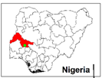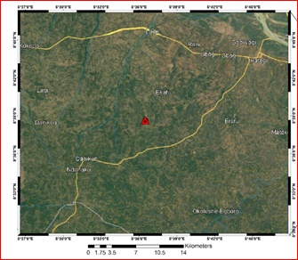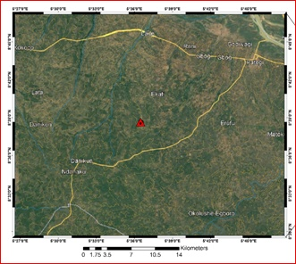
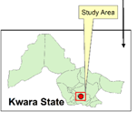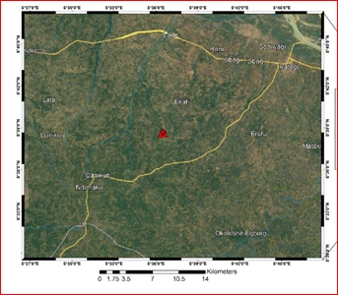
Fig 3.3a: Show the map Nigeria (Kwara State) showing the study area

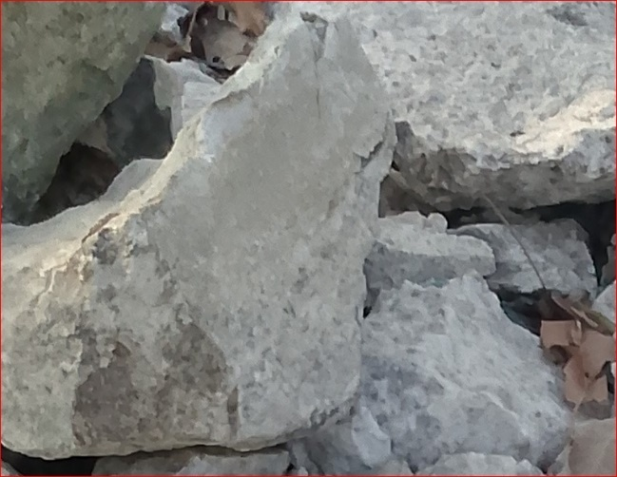
Fig 3.3b: shows the photograph of the study area

3.4 Sample collection
Fresh representative samples of lepidolite from location1, location 2 and location 3, were collected from three different points on the field using hammer, chisel, sample bags and GPS. The samples were labeled accordingly and were sent for analysis for petrographical analysis which was carried out at University of Ilorin Department of Geology and Mineral Science laboratory.
3.5 Sample preparation
Thin section was prepared by cutting an individual grab samples with a diamond saw, where by the slab cut is labeled on one side and the other side is lapped flat and smooth and grinding on a cast iron lap with 400 grit carborundum. The grinding sample is then finished on a glass plate with 600 gritcarbonrundum, allow to dry on a hot plate, then glue the sample to a glass slide with epoxy to the lapped face. The thickness is further reduced on thin section grinder to a 30 microns. After this thickness is achieved then the section is placed in a holder for petrographical or microscopic analysis.
3.5.1 Petrographical Analysis (Thin Section)
This analysis examine the microscopic structure of the samples in thin sections of rocks, minerals and other materials by identifying their textures, mineral composition and others critical properties which give information of origin, formation and characteristics of rocks and minerals.

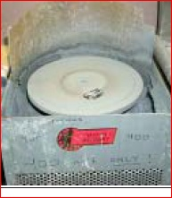
Figure 3.5a: 600 grit carborundom grinding machine
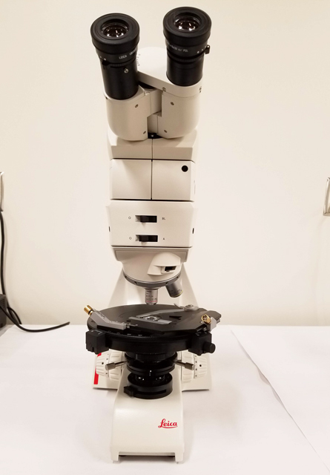
Figure 3.5b: Photograph of petrograhical microscope

CHAPTER FOUR
4.1 Microscopic description (Thin section)
The prepared thin section was examined and studied under plane polarized light (PPL) and cross polarized light (XPL). Photomicrographs of important sections (D&E) were analyzed from the thin section (Table 3). The minerals are recognized in plane polarized light view by lack of alteration and in cross polarized light view by their interference colour (Mackenzie et al., 1982).
4.2.1 Plane Polarized Light (PPL) Description
In the thin section (figure 4.3-4.5), quartz, muscovite mica, and biotite mica and plagioclase feldspar were the major rock forming minerals based on their characteristics. The quartz is colorless under plane polarized light (PPL) with low relief and no cleavage with absent pleochroism and its grain shape is anhedral. Plagioclase is gray in color with no pleochroism and low relief with anhedral grain shape. The biotite in L1 is light brown in color which standout with a moderate relief and strong pleochroism with a platy grain shape and one directional cleavage. The muscovite is brownish-red to red in color with moderate to strong pleochroism and one directional cleavage with low to moderate relief. The opaque mineral appears to be black in color with no cleavage and has subhedral grain shape.
4.3.2 Cross Polarized Light (XPL) Description
The samples was examine under crossed polarized light show properties such as birefringence and extinction (figure 4.4-4.6) The quartz displays low interference color, it is uniaxial, and it has undulose extinction which indicates dislocation walls in mineral grains, the plagioclase is anisotropic and it is identified by albite twinning which gives a series of fine lamellae and low birefringence. The muscovite is anisotropic with low to moderate birefringence
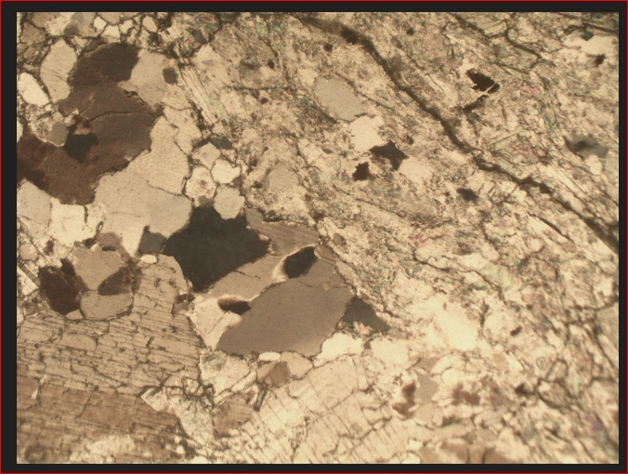
Figure 4.3: Photomicrograph of sample D under plane polarized light
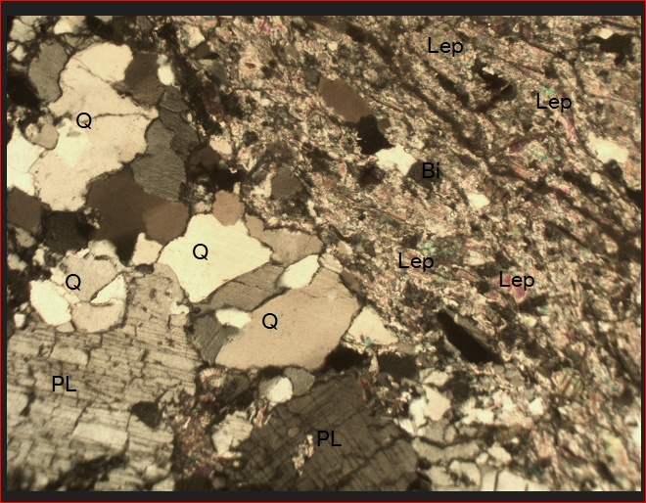
Figure 4.4 photomicrograph of sample D under crossed polarized light
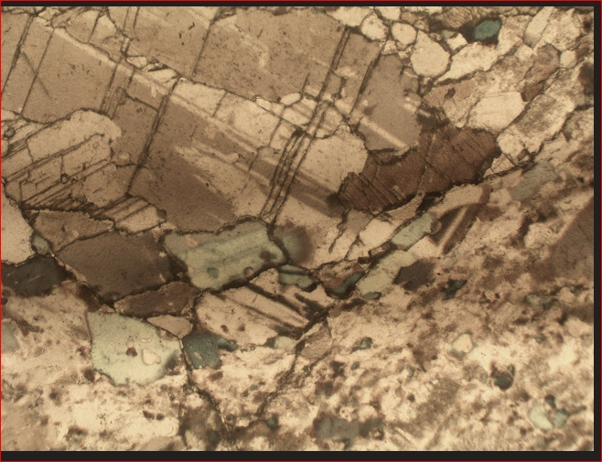
Figure 4.5 Photomicrograph of sample E under plane polarized light
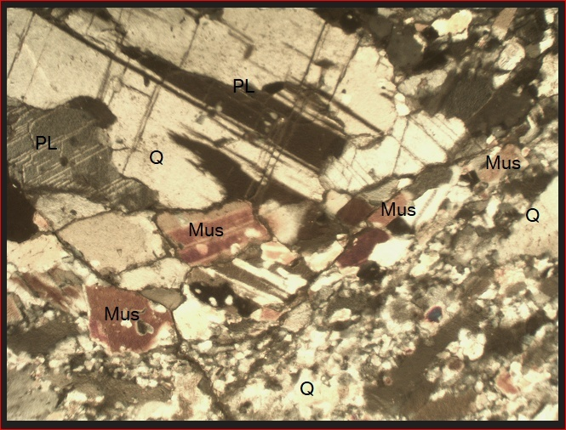
Figure 4.6 photomicrograph of sample E under crossed polarized light

Table3: Estimated modal composition of lepidolite in the study samples photomicrograph
Sample Name | % Composition of the Minerals Present in the Studied Samples |  |  |  | Grand Total (%)
Sample Name | Quartz | Mica | Feldspar | Lepidolite | Grand Total (%)
D | 27 | 3 | 20 | 50 | 100
E | 30 | 55 | 15 | -- | 100

Figure 4.7 Pie chart representation of modal composition of sample D

Figure 4.8 Pie chart representation of modal composition of sample E

4.4 Discussion
The result as shown from the table 3 and fig. 4.7 and 4.8 indicate that there is lithium ore with lepidolite ore in sample D while the other sample contain only appropriate minerals. The photomicrograph for both cross and plane polarized light revealed that there are some properties like twining, cleaverages, bireference and colours with opeone minerals. Mica has higher percentage sample E and lower percentage in sample D. The lepidolite dominate the sample D disappear in sample E.

CHAPTER FIVE
CONCLUSION AND RECOMMENDATIONS
5.1 Conclusion
In conclusion, the petrographic study of lepidolite reveals its distinctive mineralogical and textural characteristics. The mineral's lithium-rich composition and unique optical properties make it an important subject for investigation. Through microscopic examination, this study has provided valuable insights into lepidolite's mineralogical features, such as its crystal habit, cleavage, and alteration patterns. These findings contribute to a better understanding of lepidolite's geological significance and potential economic importance as a lithium-bearing mineral. Further research could build upon these results to explore lepidolite's applications in various industries, including energy storage and ceramics.
Based on field characteristics the pegmatite are intrusive bodies,occurring as small to large veins within biotite gneisses and amphibolite, with lepidolite being a significant mineral component.
5.2 Recommendation
The mineralogical composition of the studied pegmatites samples (A and B)indicates significant variability in their mineral constituents, particularly in the distribution of lepidolite, mica and feldspar. Sample A is notably rich in lepidolite (50%),suggesting strong lithium bearing potential, characteristic of LCT-type pegmatites. In contrast, sample B shows a high concentration of mica (55%) and quartz (30%) but lacks lepidolite, indicating a different phase of pegmatites evolution or possible non-lithium bearing variety.
Given these results, the following recommendations are proposed:
1. Targeted exploration for lithium: Sample A with its high lepidolite content should be prioritized for further detailed geochemical and mineralogical investigation to evaluate its lithium potential. Additional sampling in the surrounding areas may help delineate the extent of the lepidolite rich zone.
2. Petrogenetic studies: To better understanding the origin and evolution of these pegmatites, further petrographic and geochemical analysis (including whole rock geochemistry and isotopic studies) is recommended. This will help confirm the genetic relationship between the samples and their source magma.
3. Economic Assessment: An economic feasibility study should be conducted for the lepidolite bearing pegmatites, considering it’s potential use as a lithium are Recovery techniques and beneficiation processes should be evaluated in conjunction with mineralogy.

References
Adekeye, D. O., Ogunleye, A. A., &Alaba, F. A. (2019). Geology of the mineral resources in Kwara State, Nigeria: An overview. Journal of Applied Geology, 15(3), 45-56.
Adekeye, D. O., Ogunleye, A. A., &Alaba, F. A. (2019). Geology of the mineral resources in Kwara State, Nigeria: An overview. Journal of Applied Geology, 15(3), 45-56.
Adekeye, D. O., Ogunleye, A. A., &Alaba, F. A. (2019). Geology of the mineral resources in Kwara State, Nigeria: An overview. Journal of Applied Geology, 15(3), 45-56.
Hardy, L., &Vardon, P. (2021). Lithium extraction from Lepidolite: A critical review of current techniques. Minerals, 11(2), 112-130. https://doi.org/10.3390/min11020112
Hardy, L., &Vardon, P. (2021). Lithium extraction from Lepidolite: A critical review of current techniques. Minerals, 11(2), 112-130. https://doi.org/10.3390/min11020112
Hardy, L., &Vardon, P. (2021). Lithium extraction from Lepidolite: A critical review of current techniques. Minerals, 11(2), 112-130. https://doi.org/10.3390/min11020112
Hardy, L., &Vardon, P. (2021). Lithium extraction from Lepidolite: A critical review of current techniques. Minerals, 11(2), 112-130. https://doi.org/10.3390/min11020112
Hawthorne, F. C., Abraitis, P. V., & Liu, Z. (2018). Lithium-bearing minerals: Lepidolite. Mineralogical Magazine, 82(6), 1665-1683. https://doi.org/10.1180/minmag.2018.002
Hawthorne, F. C., Abraitis, P. V., & Liu, Z. (2018). Lithium-bearing minerals: Lepidolite. Mineralogical Magazine, 82(6), 1665-1683. https://doi.org/10.1180/minmag.2018.002
Hawthorne, F. C., Abraitis, P. V., & Liu, Z. (2018). Lithium-bearing minerals: Lepidolite. Mineralogical Magazine, 82(6), 1665-1683. https://doi.org/10.1180/minmag.2018.002
Meyer, G., & Schmidt, M. (2020). Geochemical analysis of Lepidolite: Advances in mineral identification. Geochemistry, 45(1), 22-38. https://doi.org/10.1016/j.geoche.2019.10.012
Meyer, G., & Schmidt, M. (2020). Geochemical analysis of Lepidolite: Advances in mineral identification. Geochemistry, 45(1), 22-38. https://doi.org/10.1016/j.geoche.2019.10.012
Meyer, G., & Schmidt, M. (2020). Geochemical analysis of Lepidolite: Advances in mineral identification. Geochemistry, 45(1), 22-38. https://doi.org/10.1016/j.geoche.2019.10.012
Meyer, G., & Schmidt, M. (2020). Geochemical analysis of Lepidolite: Advances in mineral identification. Geochemistry, 45(1), 22-38. https://doi.org/10.1016/j.geoche.2019.10.012
Schneider, L., & Lee, R. (2021). The role of PPL and XPL microscopy in mineralogical analysis. Journal of Microscopy and Spectroscopy, 35(4), 91-102. https://doi.org/10.1080/002227202013482
Schneider, L., & Lee, R. (2021). The role of PPL and XPL microscopy in mineralogical analysis. Journal of Microscopy and Spectroscopy, 35(4), 91-102. https://doi.org/10.1080/002227202013482
Schneider, L., & Lee, R. (2021). The role of PPL and XPL microscopy in mineralogical analysis. Journal of Microscopy and Spectroscopy, 35(4), 91-102. https://doi.org/10.1080/002227202013482
Schneider, L., & Lee, R. (2021). The role of PPL and XPL microscopy in mineralogical analysis. Journal of Microscopy and Spectroscopy, 35(4), 91-102. https://doi.org/10.1080/002227202013482
Zhao, Y., Liu, H., & Wang, X. (2022). Global lithium demand and the role of Lepidolite: A sustainable approach. Energy and Environmental Science, 15(3), 634-648. https://doi.org/10.1039/d2ee01483b
Zhao, Y., Liu, H., & Wang, X. (2022). Global lithium demand and the role of Lepidolite: A sustainable approach. Energy and Environmental Science, 15(3), 634-648. https://doi.org/10.1039/d2ee01483b
Zhao, Y., Liu, H., & Wang, X. (2022). Global lithium demand and the role of Lepidolite: A sustainable approach. Energy and Environmental Science, 15(3), 634-648. https://doi.org/10.1039/d2ee01483b
Zhao, Y., Liu, H., & Wang, X. (2022). Global lithium demand and the role of Lepidolite: A sustainable approach. Energy and Environmental Science, 15(3), 634-648. https://doi.org/10.1039/d2ee01483

APPENDICES
Appendix A: Glossary of Terms
- Lepidolite: A lithium – rich mica mineral that is an important sources of lithium.
- Pegmatite: A type of igneous rock that is characterized by a coarse-grained texture and is often host to economic minerals.
- Petrography: The study of the mineralogical composition and structure of rocks.
Appendix B: Tables and figures
- Table 1: Mineralogical and composition of lepidolite samples from the Kakafu Area
- Figure 1: Location map of the Kakafu area, Kwara State, Nigeria
- Figure 2: Photomicrograph of lepidolite sample from the Kakafu area
Appendix C: References
- List of references cited in the study
Appendix D: Fieldwork Data
- Field notes and observations from the study area
- Photographs of the study area and samples collected.
Appendix E: Laboratory Data
- Results of laboratory analysis of lepidolite samples
- X-ray diffraction patterns and scanning electron microscopy images of lepidolite samples.

These appendices provide additional information and data that support the findings of the study. They can be useful for researchers and readers who want to learn more about the study and it’s results.

