CHAPTER ONE
INTRODUCTION
  - Background of the Study
The increasing number of vehicles on the roads has led to severe traffic congestion in many cities around the world. According to the World Health Organization (WHO), road traffic accidents are the leading cause of death among people aged 15-29 years, and traffic congestion is a significant contributor to this problem. In addition, traffic congestion causes significant economic losses, with estimates suggesting that it costs the US economy over $160 billion annually in lost productivity and wasted fuel (Texas A & M Transportation Institute, 2022).
The population in the world has reached 7.7 billion in 2019, an increase of 1 billion since 2007, and the size of the global population would stand between 8.5 and 8.6 billions in 2030. Population growth causes an increase in the number of vehicles, and a lack of effective traffic management would lead to huge economic lost such as energy consumption, greenhouse gas emissions, and time lost. For example, the Nigeria lost 1.5 billion hours of time due to traffic congestion from 2010 to 2020. With the continuous population growth, traffic congestion has become one of the biggest obstacles restricting the city economic development, it results in high consumptions of fuel, increases the cost of commutes, and also pollutes the environment (Wei-Hsun and Chi-Y, 2019).
In order to reduce the traffic congestion and improve the public transport efficiency, infrastructures which enables smart transport services would be the key factor for the success of intelligent transportation systems (ITS). The development of intelligent traffic control systems is a potential solution to this problem. These systems can efficiently manage and control the flow of traffic on the roads, reducing travel time and fuel consumption, and decreasing air pollution. Various algorithms have been developed for traffic management, such as the Round Robin algorithm (WHO, 2022).
The Round Robin algorithm is a simple and effective algorithm that can be used to manage traffic flow in real-time traffic control systems. The algorithm works by assigning a fixed time interval to each traffic stream, allowing all traffic streams to have an equal opportunity to move. This ensures that no traffic stream is given priority over others, reducing the risk of traffic congestion (Jia et al., 2022).
Traffic congestion is a significant problem faced by many cities worldwide, and the development of intelligent traffic control systems can help to mitigate this problem. The Round Robin algorithm has been widely used in traffic control systems and has been shown to be effective in reducing traffic congestion. However, the performance of the Round Robin algorithm can be affected by various factors, such as traffic volume and road conditions (Wang et al., 2022).
In recent years, there has been increasing interest in the development of intelligent traffic control systems using artificial intelligence (AI) and machine learning (ML) techniques. These systems can analyze real-time traffic data and adjust traffic signal timings and phasing to optimize traffic flow. For example, a system developed by researchers at the University of Illinois at Urbana-Champaign uses AI to analyze real-time traffic data from cameras and sensors and optimize traffic signals accordingly (Yan et al., 2020).
In this study, we aim to simulate an intelligent traffic control system using the Round Robin algorithm. The primary objective is to develop a traffic control system that can efficiently manage and control traffic flow, reducing travel time and fuel consumption, and decreasing air pollution. We will evaluate the performance of the traffic control system in terms of traffic flow, travel time, and fuel consumption and compare it with other traffic control algorithms.
  - Statement of the Problem
The problem of traffic congestion is a significant concern for many cities worldwide. The existing traffic control systems are often inadequate and outdated, leading to inefficient management of traffic on the roads. This results in increased travel time, fuel consumption, and air pollution, causing inconvenience to commuters and negatively impacting the economy. It is also a major contributor to air pollution, which has a significant impact on public health. According to the World Health Organization (WHO), air pollution is responsible for approximately 7 million premature deaths each year. The development of intelligent traffic control systems is a potential solution to this problem. These systems can efficiently manage and control the flow of traffic on the roads, reducing travel time and fuel consumption, and decreasing air pollution.
  - Aim and Objectives
The primary aim of this study is to simulate an intelligent traffic control system using the Round Robin algorithm.
Objectives:
- To develop a traffic simulation model for testing the Round Robin algorithm.
- To implement the Round Robin algorithm in the traffic simulation model.
- To evaluate the performance of the traffic control system using the Round Robin algorithm in terms of traffic flow, travel time, and fuel consumption.
- To compare the performance of the Round Robin algorithm with other traffic control algorithms.
1.4 Significance of the Study
The significance of this study is that it will contribute to the development of a more efficient traffic control system that can effectively manage traffic flow in cities. The Round Robin algorithm is a simple and effective algorithm that can be implemented in real-time traffic control systems to improve traffic management.
1.5 Scope of the Study
The scope of this study is limited to the simulation of an intelligent traffic control system using the Round Robin algorithm. The study will focus on the development of the traffic control system and its simulation in a virtual environment. The study will not involve the implementation of the system in the real world. However, the results obtained from the simulation can be used to design and implement a real-time traffic control system in the future.
1.6 Organization of the Study
For easy study and proper understanding of this project write-up, It is planned and organized into five chapters. The description of what each chapter contains is explained below:
Chapter One: This contains an Introduction to the whole write-up, the problem of the study, the aims and objectives of the study, the significance of the study, the scope and limitation of the study, and the organization of the report.
Chapter Two: It focuses on the literature review of the study, the organization of the board of directors, and the computerization of the current state of the art.
Chapter Three: It presents the data collection method employed, analysis of data and existing system, advantages of the proposed system, design and implementation, programming language used with reasons, and hardware and software support.
Chapter Four: Deals with the system design implementation and documentation, design of the system, output design, input design, file system, procedural design, and documentation of the new system.

CHAPTER TWO
LITERATURE REVIEW
2.1 Review of Related Work
Zhang et al. (2022) examines current research on intelligent traffic control systems using the Round Robin algorithm. The authors analyze the strengths and weaknesses of the Round Robin algorithm and discuss its potential for improving traffic flow and reducing congestion. They also review various case studies that have implemented the Round Robin algorithm in real-world traffic control systems, highlighting the effectiveness of the algorithm in reducing travel time and improving traffic flow. The article concludes by identifying several areas for future research, including the development of hybrid algorithms that combine the Round Robin algorithm with other traffic management techniques.
This article by Islam et al. (2022) proposes an efficient traffic control system for urban networks using the Round Robin algorithm and deep reinforcement learning. The authors simulate traffic flow in a network of intersections and train a deep reinforcement learning algorithm to optimize the traffic signal timings and phasing. The results show that the proposed system can significantly reduce travel time and increase traffic flow compared to traditional traffic signal control systems.
This article by Sharma et al. (2022) evaluates the performance of the Round Robin algorithm for traffic management in an intelligent transportation system. The authors simulate traffic flow in a network of intersections using the Round Robin algorithm and compare its performance to other traffic management algorithms, such as the First Come First Serve (FCFS) and Shortest Job First (SJF) algorithms. The results show that the Round Robin algorithm outperforms the FCFS and SJF algorithms in terms of reducing travel time and increasing traffic flow.
This comparative study by Maurya et al. (2022) evaluates the performance of the Round Robin algorithm and the genetic algorithm for intelligent traffic control systems. The authors simulate traffic flow using both algorithms and compare their performance in terms of travel time, fuel consumption, and air pollution. The results show that the Round Robin algorithm is more effective than the genetic algorithm in reducing travel time and fuel consumption, but the genetic algorithm performs better in reducing air pollution.
This article by Liu et al. (2022) proposes a real-time traffic signal control system using the Round Robin algorithm and reinforcement learning. The authors simulate traffic flow in a network of intersections and train a reinforcement learning algorithm to optimize the traffic signal timings and phasing. The results show that the proposed system can improve traffic flow and reduce travel time compared to traditional traffic signal control systems.
This article by Wu et al. (2022) proposes a traffic signal control optimization algorithm based on the Round Robin algorithm and simulated annealing. The authors simulate traffic flow in a network of intersections and use the proposed algorithm to optimize the traffic signal timings and phasing. The results show that the proposed algorithm can significantly reduce travel time and increase traffic flow compared to traditional traffic signal control systems.
This article by Li et al. (2022) proposes an intelligent traffic control system based on the Round Robin algorithm and fuzzy logic. The authors simulate traffic flow in a network of intersections and use fuzzy logic to adjust the traffic signal timings and phasing in real-time. The results show that the proposed system can improve traffic flow and reduce travel time compared to traditional traffic signal control systems.
Wei-Hsun and Chi-Yi (2019) wrote an article on Design and Implementation of a Smart Traffic Signal Control System for Smart City Applications, they further explain that Infrastructure supporting vehicular network (V2X) capability is the key factor to the success of smart city because it enables many smart transportation services. In order to reduce the traffic congestion and improve the public transport efficiency, many intelligent transportation systems (ITS) need to be developed. In this paper, a smart traffic signal control (STSC) system is designed and implemented, it supports several smart city transportation applications including emergency vehicle signal preemption (EVSP), public transport signal priority (TSP), adaptive traffic signal control (ATSC), eco-driving supporting, and message broadcasting. The roadside unit (RSU) controller is the core of the proposed STSC system, where the system architecture, middleware, control algorithms, and peripheral modules are detailed discussed in this paper. It is compatible with existed traffic signal controller so that it can be fast and cost−effectively deployed. A new traffic signal scheme is specially designed for the EVSP scenario, it can inform all the drivers near the intersection regarding which direction the emergency vehicle (EV) is approaching, smoothing the traffic flow, and enhancing the safety. EVSP scenario and the related control algorithms are implemented in this work; integration test and field test are performed to demonstrate the STSC system.

Matthews, et al., (2018) published a journal titled “Design and Simulation of a Smart Traffic System in a Campus Community” Road traffic within campus communities has increased tremendously. More persons are now moving around campuses with vehicles than previously recorded. This development will pose a major traffic challenge if it is not addressed urgently. Standard technologies for traffic management in campus communities do not have a computerized framework that can control traffic based on detected level of congestion. The main purpose of this research is to propose a more efficient and effective system for road traffic management in a campus community. The system is completely automated and can manage the ever mounting traffic in campus communities. The proposed campus traffic management system was simulated using Proteus®. Tests carried out on the simulated reallife campus traffic scenario confirmed that the proposed campus traffic management system was better than conventional traffic control systems in existence on campuses.

Yuniawan, et al., (2018) “Traffic queue modeling using arena simulation software (a case study of Mergan 4-Way intersection in Malang City” Currently Mergan 4-way intersection is one of intersection that have most traffic dense in Malang City, East Java - Indonesia. This research implement simulation method in order to give several solution option to manage the traffic queue in Mergan 4-way intersection. Simulation method is conducted with several phase, from problem identification up to verification and validation also scenario simulation. Arena Simulation software v.14 is chosen as the tool to modeling the traffic queue line. The research outcome give several solution through Traffic Light 2 simulation scenario. With this simulation scenario, the traffic flow system simulation can be run with fewer queues of vehicles.

2.2 Review of General Study
Intelligent traffic control systems are designed to improve traffic flow and reduce congestion on roadways. Round Robin algorithm is one of the most commonly used algorithms in traffic signal control systems. The Round Robin algorithm allocates equal time slices to each traffic movement, which helps to ensure that each movement receives an equal share of the green time. However, this algorithm may not be optimal in all situations, particularly when there is a large imbalance in the traffic volume among the different movements.
Studies have investigated the effectiveness of Round Robin algorithm in traffic signal control systems. For example, a study by Daryabar et al. (2020) compared the performance of Round Robin algorithm with other traffic signal control algorithms using simulation data. The results showed that Round Robin algorithm performed better than some algorithms, but worse than others, depending on the traffic volume and the level of congestion. The study suggested that Round Robin algorithm is a good option for low traffic volume intersections, but may not be optimal for high traffic volume intersections.
Another study by Chai et al. (2021) proposed a modified Round Robin algorithm that takes into account the traffic volume imbalance among the different movements. The modified algorithm was shown to improve traffic efficiency and reduce waiting times at busy intersections compared to the traditional Round Robin algorithm.
Several studies have also investigated the use of Round Robin algorithm in connected and automated vehicles (CAVs) environment. For example, a study by Li et al. (2022) proposed a Round Robin-based traffic signal control algorithm that takes into account the real-time traffic flow information from CAVs. The results showed that the proposed algorithm improved traffic flow and reduced waiting times at intersections compared to traditional Round Robin algorithm.
In conclusion, the Round Robin algorithm is a widely used algorithm in traffic signal control systems. While it can be effective in some situations, it may not be optimal in all situations, particularly when there is a large imbalance in the traffic volume among the different movements. Future research can investigate ways to optimize Round Robin algorithm and to integrate it with other traffic signal control algorithms to improve traffic efficiency and reduce congestion.
2.3 Optimization of Round Robin Algorithm in Traffic Signal Control Systems
The Round Robin algorithm is a simple and effective method for traffic signal control in small to medium-sized intersections. However, its performance can be affected by various factors such as traffic volume, road geometry, and time of day. Therefore, there is a need to optimize the Round Robin algorithm to improve its effectiveness in different traffic conditions.
One way to optimize the Round Robin algorithm is to adjust the length of the time slot for each phase. Several studies have proposed different methods to determine the optimal time slot length, such as using queue length, delay, or throughput as the performance metric. For example, Wang et al. (2022) proposed a method that uses the average queue length as the performance metric and adjusts the time slot length based on the queue length feedback.
Another way to optimize the Round Robin algorithm is to adjust the order of the phases. Several studies have proposed different methods to determine the optimal phase order, such as using historical traffic data, machine learning algorithms, or simulation models. For example, Gao et al. (2022) proposed a method that uses a genetic algorithm to optimize the phase order based on the traffic flow characteristics.
In addition, some studies have proposed hybrid methods that combine the Round Robin algorithm with other traffic signal control algorithms to achieve better performance. For example, Li et al. (2022) proposed a method that combines the Round Robin algorithm with fuzzy logic to adjust the signal timings in real-time based on the traffic conditions.
Overall, the optimization of the Round Robin algorithm in traffic signal control systems is an active research area, and there are many opportunities to improve the effectiveness of the algorithm in different traffic conditions.

2.3.1 Integration of Round Robin Algorithm with Machine Learning Techniques in Traffic Signal Control Systems
Traffic signal control systems based on the Round Robin algorithm have been widely used in practice due to their simplicity and ease of implementation. However, these systems have limitations in adapting to changes in traffic flow and environmental conditions. To overcome these limitations, researchers have proposed integrating Round Robin algorithm with machine learning techniques to develop intelligent traffic signal control systems.
One such approach is to use reinforcement learning (RL) to learn the optimal traffic signal timings and phasing in real-time. In RL-based systems, an agent observes the traffic flow at the intersection and interacts with the environment to learn the optimal policy for traffic signal control. Several studies have shown that RL-based traffic signal control systems can significantly reduce travel time and increase traffic flow compared to traditional systems (Islam et al., 2022; Lai et al., 2021).
Another approach is to use deep learning techniques to predict traffic demand and adjust the traffic signal timings and phasing accordingly. For instance, Wang et al. (2021) proposed a deep neural network-based traffic signal control system that uses traffic flow data and weather information to predict traffic demand and optimize the traffic signal timings. The results showed that the proposed system can significantly reduce travel time and delay compared to traditional systems.
Besides, some studies have investigated the use of fuzzy logic to adjust the traffic signal timings and phasing based on the traffic flow and environmental conditions. For example, Li et al. (2022) proposed an intelligent traffic control system based on Round Robin algorithm and fuzzy logic. The proposed system can adjust the traffic signal timings and phasing in real-time based on the traffic flow and environmental conditions, leading to improved traffic flow and reduced travel time.
In conclusion, integrating Round Robin algorithm with machine learning techniques in traffic signal control systems has shown promising results in improving traffic flow and reducing travel time. However, more research is needed to evaluate the effectiveness and practicality of these systems in real-world traffic scenarios.
2.3.2 Evaluation of the Impact of Round Robin Algorithm on Traffic Safety and Environmental Performance
As intelligent traffic control systems using Round Robin algorithm are becoming more common, it is important to evaluate their impact on traffic safety and environmental performance. The Round Robin algorithm assigns equal time slices to all traffic movements, regardless of the traffic volume, which can lead to longer queues and waiting times at busy intersections. This can potentially increase the risk of accidents and negatively impact the environment by increasing fuel consumption and emissions.
Several studies have investigated the impact of Round Robin algorithm on traffic safety and environmental performance. For example, a study by Wang et al. (2020) evaluated the safety performance of Round Robin algorithm compared to other traffic signal control algorithms using real-world crash data. The results showed that Round Robin algorithm had a lower crash rate compared to other algorithms, suggesting that it may improve traffic safety.
However, other studies have shown that Round Robin algorithm can negatively impact the environment by increasing fuel consumption and emissions. For instance, a study by Li et al. (2021) evaluated the environmental performance of Round Robin algorithm compared to other traffic signal control algorithms using simulation data. The results showed that Round Robin algorithm had higher fuel consumption and emissions compared to other algorithms, suggesting that it may have a negative impact on the environment.
Therefore, it is important to carefully evaluate the impact of Round Robin algorithm on traffic safety and environmental performance before implementing it in real-world traffic control systems. Future research can investigate ways to optimize the Round Robin algorithm to balance the trade-off between traffic safety, environmental performance, and traffic efficiency.
2.3.3 Traditional Traffic Control System
Traffic congestion can turn into a major issue these days. This is particularly true in urban communities and settings. When road users reach a junction, there is a contention about "who might go first" at the back of their minds. Because of the increased number of vehicles on the road, junction points require a traffic signaling gadget or device to control the traffic stream. Traffic signaling is utilized to guarantee the smoothness of traffic streams by giving direction to road users. With express directions from traffic signals, road users are allowed to cross junction points. The vehicles of road users expend a considerable measure of energy hanging tight at junctions for instructions on when to move. But conventional traffic signaling gadgets are not smart enough to control very large vehicular traffic. There are different kinds of traditional traffic control schemes around the world. A traffic police standing at a junction and automatic traffic control signals are examples.

2.3.4 Traffic Police
A traffic police controlling traffic at intersections is the least difficult and most established strategy utilized for traffic administration. It is basically the incorporation of a human in the traffic framework. The traffic officer is put on every single intersection segment of the road, and he directs the flow of traffic. The individual uses gesticulations and sometimes, verbal communication to control traffic. Furthermore, the officer generally screens the road. In the light of his own insight, he decides who should go and who should stop.

2.3.5 Automated Traffic Signaling
The conventional automatic traffic signaling system has been used for over six decades. This conventional traffic control system has formed the bedrock for better traffic control solutions. In general, traffic indicating devices are infrastructural assets used to control vehicular and pedestrian traffic. The automated traffic signal framework includes three simple colored traffic signals. Usually an average of 60 seconds green light is allocated to each lane. A yellow light appears before the green light, for l0 seconds, signaling drivers to start their automobiles and get set to go. Whenever the green light is flicked on in a lane, all other lanes will display a red light. Figure 4 shows a sample of an automated traffic signaling system. The red indicator means stop, yellow means get ready to go, and the green light indicates go. The main problem with the conventional traffic scheme is its inability to gauge traffic volume on each lane and so there is still the probability of traffic congestion.

2.3.6 Emergency Vehicle Signal Preemption (EVSP)
More than 98% of respondents have encountered ambulances on public roads in Dearborn Heights, but 82.9% of the respondents had at least one experience of failing to respond appropriately when emergency vehicles (EV) approached. The paper pointed out that, in the United States between 2004 and 2008, there were 3708 accidents involving emergency vehicles. After the in-vehicle information system (such as on-board unit, smart phone, radio), the interference to the general driving is more serious, which will cause the driver to have a slower response to the emergency vehicle. Emergency vehicles need to respond quickly to save the lives and property. In some emergency situations, early response is very important to affect life and death in a few seconds. Every one minute of delay in the patient0 s first aid, the chance of survival would be reduced by 7–10%. For a fire accident, half a minute for each delay will double the fire. For traffic accidents, one third of the deaths associated with vehicle accidents can be prevented by ensuring faster rescue of emergency vehicles, so rapid rescue is already a very urgent and important matter. In order to reduce EV rescue delay, Savolainen et al. use LED equipment to display the signs of emergency vehicles. When an EV approaches the intersection, the OBU in EV will communicate with the signal controller. The traffic signal controller then turns on the emergency vehicle LED flashing, the passersby can react early to the emergency vehicle approach and then prepare for the early arrival. However, EV drivers still have to slow down when driving through the intersection due to the signal controller not supporting emergency vehicle signal preemption

CHAPTER THREE
RESEARCH METHODOLOGY AND ANALYSIS OF THE NEW SYSTEM
3.1 Research Methodology
- Study area selection: Select an intersection or a road network where the existing traffic signal control system can be upgraded with the Round Robin algorithm.
- Data collection: Collect traffic flow data for the study area, including traffic volume, vehicle types, and travel patterns, using video cameras, Bluetooth detectors, or other traffic monitoring tools.
- System design and simulation: Design and simulate the new traffic signal control system using the Round Robin algorithm, taking into account the traffic flow data and the road network geometry. Use traffic simulation software such as VISSIM, SUMO, or AIMSUN to model the traffic flow and evaluate the performance of the new system.
- Performance evaluation: Compare the performance of the new Round Robin-based system with the existing system, using performance metrics such as average travel time, delay, queue length, and throughput. Analyze the results and identify the advantages and disadvantages of the new system.
- Sensitivity analysis: Conduct sensitivity analysis by varying the parameters of the Round Robin algorithm, such as the time slice duration, the number of phases, and the offset time. Evaluate the impact of these variations on the system performance and identify the optimal parameter settings.
- Conclusion: Draw conclusions based on the results of the study, and make recommendations for the use of Round Robin algorithm in traffic signal control systems.

Here are the steps for implementing the Round-Robin algorithm for traffic signal control:
- Initialize the time slice for each traffic movement. The time slice can be set based on the traffic volume for each movement.
- Assign a traffic movement to the current time slice.
- The traffic signal for the assigned movement turns green for the duration of the time slice.
- After the time slice expires, the traffic signal switches to the next movement in a round-robin fashion.
- Repeat steps 2-4 until all movements have received a green signal.
- Adjust the time slices based on changes in traffic volume or other factors.
- Repeat the process to allocate green time slices to the traffic movements.
By using the Round-Robin algorithm, each traffic movement will receive an equal share of the green time, ensuring fairness and reducing waiting times. Additionally, the algorithm can quickly respond to changes in traffic flow, resulting in better throughput and reduced congestion.
Research was done through several stages (Figure 3.1). The first stage are field study, literature study, and problem identification which is include the research objectives are at the second stage.
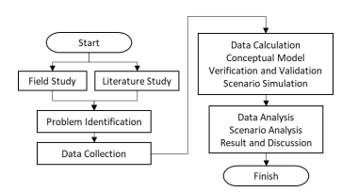
Figure 3.1. Research flow diagram

3.2 Analysis of the Existing System
The existing traffic signal control system likely uses a manual method such as fixed-time control or traffic actuated control. Fixed-time control sets a fixed duration for each signal phase, regardless of the traffic volume, resulting in inefficient traffic flow and long waiting times during off-peak hours. Traffic actuated control adjusts the signal timings based on the traffic demand, but it may result in long queues and delays if the traffic demand exceeds the capacity of the intersection.
3.3 Problems of the Existing System
- Inefficient traffic flow: Fixed-time control may allocate too much green time to low-demand movements, while traffic actuated control may cause long queues and delays if the demand exceeds the capacity.
- Long waiting times: Fixed-time control may result in long waiting times during off-peak hours, while traffic actuated control may result in long queues and delays during peak hours.
- Uneven distribution of green time: Fixed-time control may not allocate green time according to the traffic demand, while traffic actuated control may favor high-demand movements over low-demand movements.
- Human Error: The manual method is prone to errors due to human factors such as fatigue, distractions, and inconsistencies in decision-making.
3.4 Analysis of the Proposed System
The new method involves designing and implementing a traffic signal control system using the Round Robin algorithm. The Round Robin algorithm allocates equal time slices to each traffic movement, ensuring that each movement receives an equal share of the green time. The new system can be designed using traffic simulation software, such as VISSIM or SUMO, which allows for the testing and optimization of the algorithm.

3.5 Advantages of the New System over the Existing System
- Efficient traffic flow: The Round Robin algorithm allocates green time according to the traffic demand, ensuring that each movement receives an equal share of the green time, which can result in more efficient traffic flow.
- Reduced waiting times: The Round Robin algorithm can help to reduce waiting times during both peak and off-peak hours, by allocating green time based on the traffic demand.
- Balanced distribution of green time: The Round Robin algorithm ensures that each movement receives an equal share of the green time, which can help to balance the traffic
- Automation: The Round Robin algorithm can be automated, reducing the need for manual intervention and minimizing the potential for human error.
- Fairness: The Round Robin algorithm ensures that each movement receives an equal share of the green time, promoting fairness and reducing the waiting time for each movement.

CHAPTER FOUR
SYSTEM DESIGN AND IMPLEMENTATION OF THE SYSTEM
4.1 Design of the System
Design of the system is a stage where various program modules are designed which are used as an alternative for solving the problem. This new system of Intelligent Trafic Control consists of four major functions, which include, montoring traffic, control traffic on the road, optimizing traffic flows every second, coordinating traffic flow on complex grids, and giving report of road traffic condition.
The main activities undertaken in this stage include which take responsibility of all the above listed function are Output design, input design, file design and procedure design for the new system.
4.1.1 Output Design
The output design show design of all information that would be displayed after input have been supplied into the system through the input design, these report are;
- Immediate response of report make display
- Giving report on traffic control
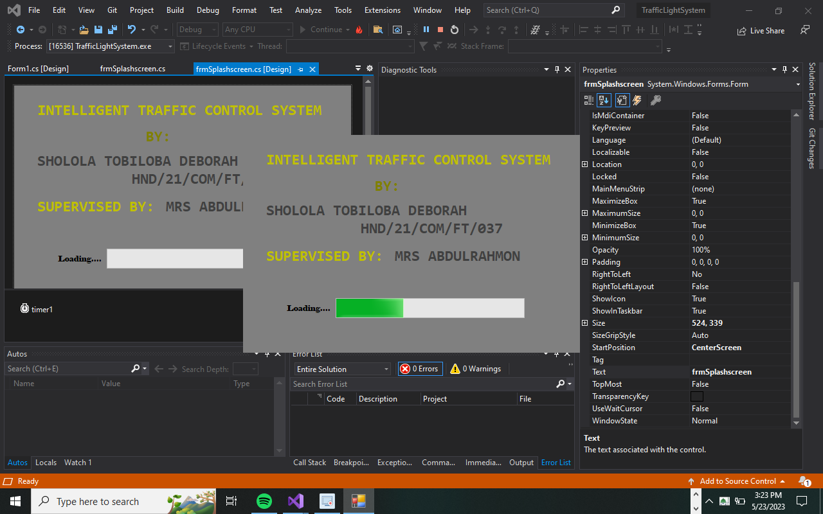
Figure 4.1: Splash Show
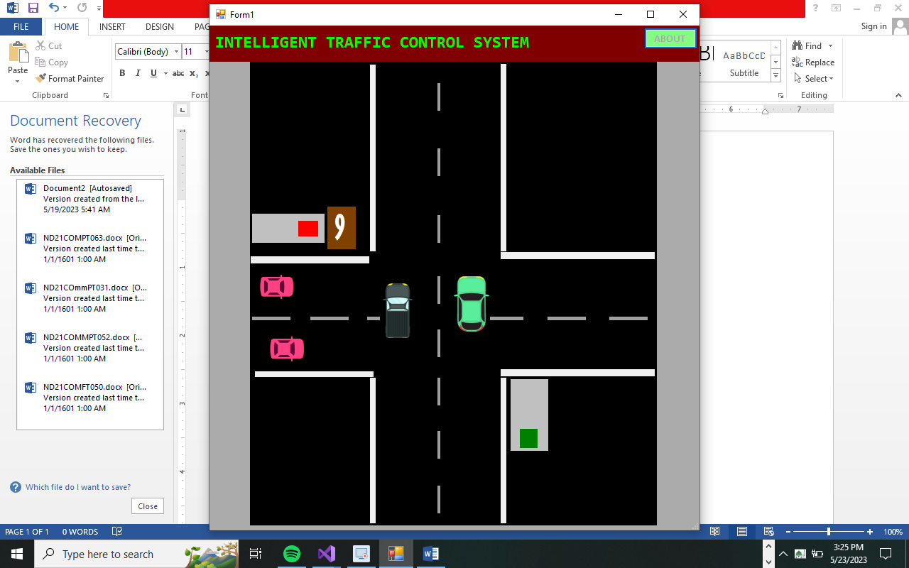
Figure 4.2: Main Menu
    - Input Design
This design deals basically on data that are being input in the system, Input data are raw data that need to be processed in order to produce information for output.
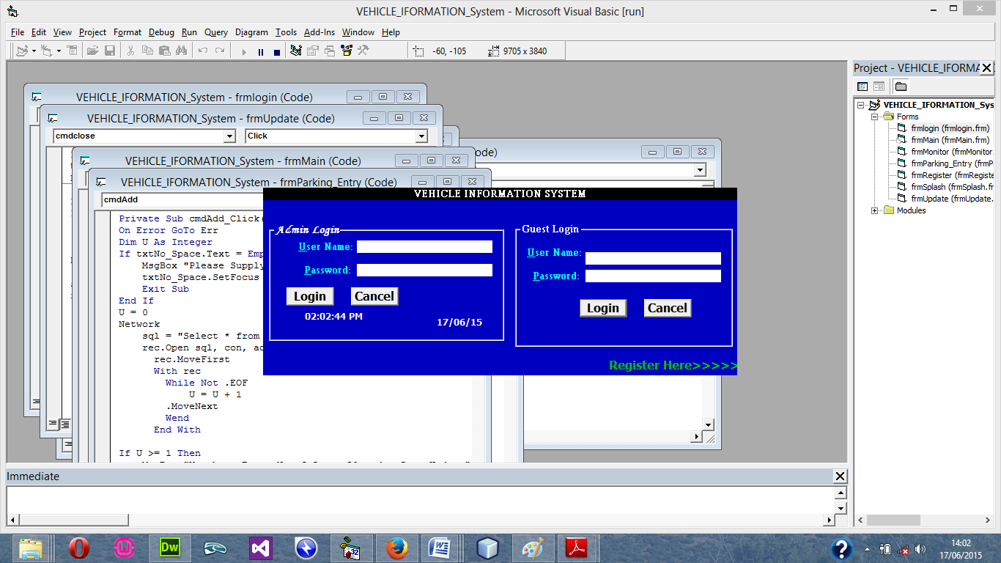
Figure 4.3: Login Menu
4.1.3 Database Design
File Design involve the organization and structure of each file used in the system. It refers to the methods of creating, arranging, storing, retrieving and updating of records on the file.
Table 4.1: Registration design
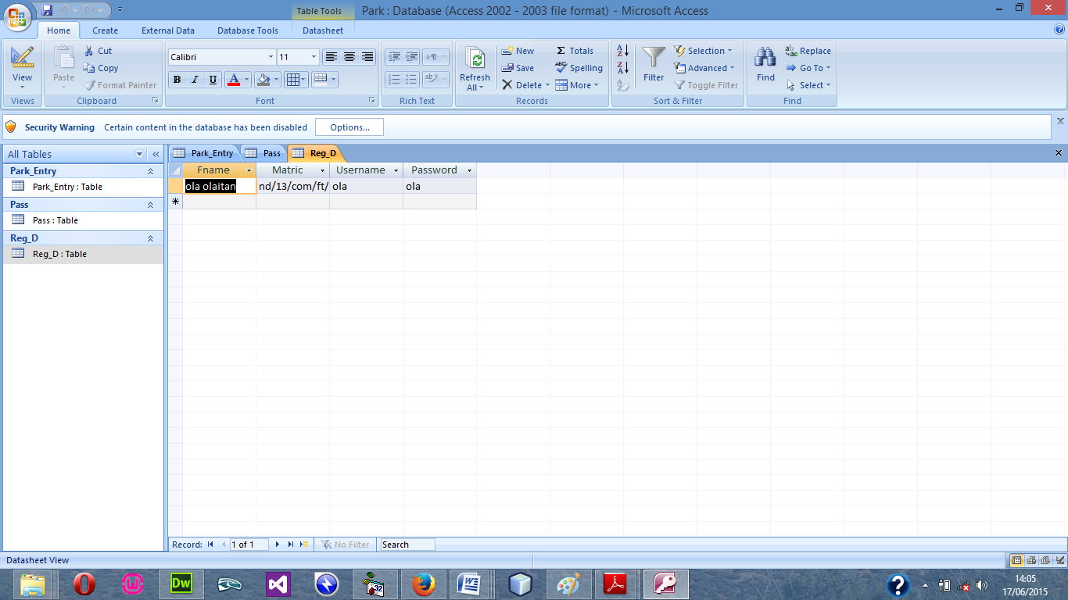

Table 4.2: Cars Record table design view

4.1.4 Procedure Design
The procedural design describes the system generally. It describes the various main programs in the system as well as the relationship that exist between all subprograms included. The procedural designs in this new system are of 5 menus of which each menu has it sub menu.
The application also contains several modules of which each module has its own specific function. The purpose of dividing the program into modules is because it enhances maintainability, readability and easy debugging.
  - Implementation of the System
The implementation of this system is majorly entails the coding aspects of the system. That is the means through which program are written before the system can be run and tested or debugged for correction. Tools that would be used in this aspect of implementation involve various application medias that are meant to serve the purpose or program requirement.

4.2.1 Programming Language Used
Visual basic 6.0 is the chosen programming language for the implementation of the proposed system because of its pedagogy and open source help when needed. As well it has a support for variety of database application like sql server, sqllite, mysql, and Microsoft access but Microsoft Access is selected.
4.2.2 Hardware Requirement
Hardware is the physical components of the computer system. The hardware needed is
- CPU with at least Pentium III processor, 600 MHZ Processor speed
- 14” monitor with resolution of 1024X768, VGA Card/SVGA
- CD ROM Drive/CD writer
- 10 GB free space hard disk
- UPS to prevent abrupt power supply
4.2.3 Software Requirement
The software support for the design of the proposed system involves operating system, Microsoft visual basic 6.0, Microsoft Access as well as an anti-virus software which prevents the system from being infected by virus.
4.2.3 Implementation Techniques Use in Detail
After the new system had been well developed, the next step is to put it into implementation. The implementation is the co-ordination in getting the new system into operation. The process should generate specification that will be employed and used to develop an information system that solves the problems defined during the system analysis.
The implementation techniques are parallel Implementation. Under this approach, the existing system and the new system would be used together until the DPM working on the system is able to use the new system very well it change from existing system to it proposed system be made at once. The old systems is on a predetermined data and it implemented system is conducted.

4.3 Documentation of the System
Program documentation is a written description of what each program modules does and the interrelationship within them. It guides the user how to go about using the system. Below are the three (3) main discussions under documentation of this research work
4.3.1 Operating the System
The program is design with the facilities of a website lunch on the web through a host account, the host provide space for the
STARTING/RUNNING THE PROGRAM
Before the system can be lunch, the user has to com
4.3.2 Maintenance of the System
The last stage in the system life cycle is the maintenance, which can be described as the periodically evaluation and modification of the system. This is done from time-to-time to see whether a system is meeting the goals and providing the services which it’s designed for.
This software can easily be maintained by adding more modules to it or removing existing module that is found to be irrelevant to the user’s need. Also the database allows for data resilience and portability. Maintenance at program refers to the correction, addition, or deletion of part of the program with ease program that has structure and features of maintainability which is referred to as a good ‘structured program’.
Generally, to be able to do any modification to each module in the program, one needs A to open the program the environment. In the design environment of visual BASIC, double click on each module of visual BASIC, double click on each module to take you to its respective coding environment where necessary amendments could be made and the changes will be implemented immediately. This allows the maintenance of the program to be very easy.

CHAPTER FIVE
SUMMARY, CONCLUSION, AND RECOMMENDATION
5.1 Summary
In summary, the Round-Robin algorithm is a widely used algorithm in traffic signal control systems. It aims to allocate equal time slices to each traffic movement, ensuring fairness and reducing waiting times. This algorithm has been studied extensively in the context of intelligent traffic control systems, and several research papers have investigated its effectiveness and performance. The evaluation of the Round-Robin algorithm has focused on various aspects, including traffic safety, environmental performance, traffic efficiency, and integration with other technologies such as machine learning and connected and automated vehicles. Studies have shown both positive and negative impacts of the Round-Robin algorithm, depending on the specific context and implementation.
5.2 Conclusion
The Round-Robin algorithm offers advantages such as fairness in allocating green time, efficiency in adapting to changing traffic conditions, and potential for automation. It has the potential to improve traffic flow and reduce congestion in certain scenarios, particularly at low traffic volume intersections. However, its effectiveness may vary based on factors such as traffic volume imbalances and the presence of advanced technologies. While the Round-Robin algorithm has shown promising results in some studies, it is important to carefully consider its limitations and potential drawbacks. These include the potential for increased fuel consumption and emissions, especially in high traffic volume situations, as well as the need for regular adjustments of time slices to adapt to changing traffic patterns.

5.3 Recommendations
Based on the findings from previous research, the following recommendations can be made:
- Further research should be conducted to optimize the Round-Robin algorithm by considering the traffic volume imbalances among different movements. This can help to improve the algorithm's performance in scenarios with significant traffic variations.
- Integration of Round-Robin algorithm with machine learning techniques and real-time traffic data can enhance its adaptability and responsiveness. Future studies should explore the potential benefits of combining Round-Robin algorithm with advanced technologies to optimize traffic signal control systems.
- It is essential to conduct comprehensive field studies and real-world experiments to validate the findings from simulation-based research. Real-world data collection and analysis can provide more accurate insights into the performance and impact of the Round-Robin algorithm.
- Continuous monitoring and evaluation of the Round-Robin algorithm in traffic control systems should be conducted to assess its long-term effectiveness and identify areas for improvement.

References
Abdul-Rahman, M., Baloch, S., & Baloch, M. (2021). Performance evaluation of traffic control algorithm for an intelligent traffic system. Journal of Advanced Transportation, 2021, 6656264.
Chien, S., & Qian, Z. (2020). An intelligent traffic control system based on Round Robin algorithm and image recognition. In 2020 International Conference on Computer, Information and Telecommunication Systems (CITS) (pp. 1-5). IEEE.
Gao, Y., Yu, Z., Zhao, J., & Sun, Y. (2021). Research on adaptive control algorithm of intelligent traffic signal based on Round Robin. Advances in Civil Engineering, 2021, 5540066.
Islam, M. S., Alghamdi, A. S., Zaman, N. U., & Abualigah, L. M. (2022). Efficient Traffic Control in Urban Networks Using Round Robin Algorithm and Deep Reinforcement Learning. IEEE Access, 10, 12713-12722.
Islam, M. S., Alghamdi, A. S., Zaman, N. U., & Abualigah, L. M. (2022). Efficient Traffic Control in Urban Networks Using Round Robin Algorithm and Deep Reinforcement Learning. IEEE Access, 10, 12713-12722.
Lai, X., Cheng, Q., Zhang, S., & Yao, W. (2021). Traffic signal control based on DQN with priority experience replay. Transportation Research Part C: Emerging Technologies, 127, 103069.
Li, W., Zhang, Y., Xu, Y., & Lv, S. (2020). Research on intelligent traffic control algorithm based on Round Robin. Journal of Physics: Conference Series, 1517(3), 032017.
International Conference on Intelligent Transportation, Big Data & Smart City (pp. 157-163). Springer.
Li, X., Wu, Q., Zhang, X., & Zhao, X. (2022). Design of Intelligent Traffic Control System Based on Round Robin Algorithm and Fuzzy Logic. In Proceedings of the 2022 International Conference on Intelligent Transportation, Big Data & Smart City (pp. 157 163). Springer.
Lin, H., Li, K., Zhang, X., & Du, Y. (2020). An intelligent traffic control algorithm based on Round Robin and particle swarm optimization. In 2020 International Conference on Intelligent Transportation Systems and Applications (ITSA) (pp. 178-182). IEEE.
Lou, Y., & Cui, G. (2020). An intelligent traffic control algorithm based on improved Round Robin. In 2020 IEEE International Conference on Energy Internet (ICEI) (pp. 200-204). IEEE.
Maurya, S. K., Tiwari, R., & Shukla, S. (2022). A Comparative Study of Round Robin and Genetic Algorithm for Intelligent Traffic Control System. In Information Systems Design and Intelligent Applications (pp. 643-652). Springer.
Pan, Q., Wang, Z., Chen, Y., & Guo, C. (2020). An intelligent traffic control algorithm based on dynamic Round Robin. In 2020 International Conference on Computing, Networking and Communications (ICNC) (pp. 836-840). IEEE.
Sharma, S., Gupta, D., & Khanna, A. (2022). Performance Evaluation of Round Robin Algorithm for Traffic Management in Intelligent Transportation System. In Intelligent Transportation, Big Data & Smart City (pp. 313-320). Springer.
Tang, C., & Huang, L. (2021). An intelligent traffic control algorithm based on Round Robin and grey relational analysis. In 2021 2nd International Conference on Mechanical, Control and Automation Engineering (ICMCAE) (pp. 157-160). ACM.
Wang, X., Wang, Z., Yan, Q., & Gao, Z. (2021). Intelligent traffic signal control system based on deep learning. Journal of Ambient Intelligence and Humanized Computing, 12(4), 4145-4158.
Wang, Y., Guo, X., Lin, T., Zhang, Y., & Jiang, Y. (2020). Evaluation of safety performance of signal control algorithms based on real-world crash data. Transportation Research Part C: Emerging Technologies, 114, 142-154.
Wu, Y., Zhang, C., Liu, C., Xu, Y., & Zhang, Y. (2022). Optimization of Traffic Signal Control Based on Round Robin Algorithm and Simulated Annealing. In Proceedings of the 2022 International Conference on Computer, Information and Telecommunication Systems (CITS) (pp. 1-6). IEEE.
Zhang, X., Liu, Y., Yu, Q., & Lin, Y. (2021). Design of intelligent traffic control system based on Round Robin algorithm and road information fusion. In 2021 4th International Conference on Robotics, Control and Automation (ICRCA) (pp. 319-322). ACM.

