TITLE PAGE
INVESTIGATION OF CAUSES OF CRACKS IN THE BUILDING WALLS AT BUDO-NUHU AREA, AIRPORT

By
Michael Oluwadamire OBATOLA
ND/23/MPE/FT/0034

SUBMITTED TO:
THE DEPARTMENT OF MINERALS AND PETROLEUM RESOURCES ENGINEERING TECHNOLOGY INSTITUTE OF TECHNOLOGY, KWARA STATE POLYTECHNIC, ILORIN
IN PARTIAL FULFILLMENT OF THE REQUIREMENT FOR THE AWARD OF NATIONAL DIPLOMA (ND) IN MINERALS AND PETROLEUM RESOURCES ENGINEERING TECHNOLOGY

AUGUST, 2025

CERTIFICATION

This is to certify that this project was carried out and submitted by Micheal Oluwadamilare OBATOLA of Matric number ND/23/MPE/FT/0034 to the Department of Minerals and Petroleum Resources Engineering, Kwara State Polytechnic, Ilorin in partial fulfillment of the Requirement for the Award of National Diploma in Minerals and Petroleum Resources Engineering Technology.

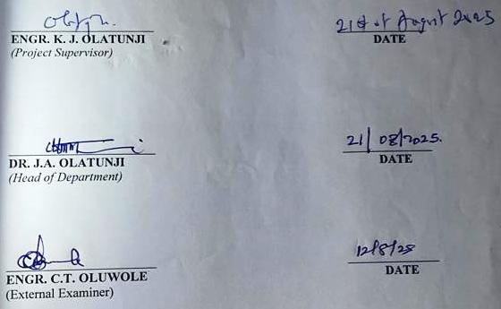

DEDICATION

I am delighted to dedicate this project to Almighty GOD, the creator of all universe who gave me the grace and opportunity to complete my ND program and this research, may His name be glorified.

ACKNOWLEDGEMENT

I exalt God of gods, King of kings, Omnipotent God. I thank Him for His faithfulness. I thank Him for protection against evil decrees. There is none worthy of my praise but Him; I will forever praise Him. “Unless the Lord builds a house, the work of the builders is useless; unless the Lord protects, the guards will do no good” — so I give glory to God who brought me this far, despite all errors and challenges.
My sincere appreciation goes to my supervisor, Dr. Olatunji K.J., for his job dedication and for his constructive criticism. He is the epitome of an excellent supervisor.
I am grateful to my parents, Mr. and Mrs. OBATOLA , and the entire OBATOLA family, for their consistent and immense support — spiritually, emotionally, and financially.
I also use this medium to thank my H.O.D, Dr. Olatunji J.A., again for his leadership. My profound gratitude also goes to my lecturers, Mr. Odediran and Engr. S. Agbalajobi . I pray that God blesses you all. Amen.
Lastly, I must not forget to say a big thank you to my project partners: Muhammad Basambo,Bamidele, Israel, Ibrahim Seyi, OlagokeOyinkansola, and AyinlaRidwan. God bless you all abundantly.

TABLE OF CONTENTS

TITLE PAGE i
CERTIFICATION ii
DEDICATION iii
ACKNOWLWDGEMENT iv
TABLE OF CONTENTS v
LIST OF FIGURE vii
LIST OF TABLE viii
ABSTRACT ix
CHAPTER ONE 1
1.0 INRODUCTION 1
1.1 AIM AND OBJECTIVES 1
1.2 SCOPE OF THE STUDY 1
1.3 PROBLEMS AND STATEMENT 2
1.4JUSTIFICATION OF STUDY 2
CHAPTER TWO 3
2.0 LITERATURE REVIEW 3
2.1 GEOTECHNICAL PROPERTIES OF SOIL 3
2.2 GEOPHYSICAL METHOD OF SUBSURFACE INVESTIGATION TECHNIQUES 3
2.3 GEOTECHNICAL PROBLEM IN BUILDING CONSTRUCTION 4
CHAPTER THREE 6
3.0 MATERIAL AND METHODOLOGY 6
3.1 DESCRIPTION OF THE STUDY AREA 6
3.2 DESCRIPTION OF THE GEOTECHNICAL SUBSURFACE PROPERTIES OF SOIL USING GEOPHYSICAL APPROACH IN THE STUDY AREA. 7
3.3 DETERMINATION OF GEOTECHNICAL SUBSURFACE PROPERTIES OF SOIL USING GEOPHYSICAL APPROACH IN THE STUDY AREA. 8
3.4 INVESTIGATING THE RELATIONSHIP BETWEEN THE GEOTECHNICAL PROPERTIES AND THE GEOPHYSICAL PROPERTIES OF THE STUDY AREA 13
CHAPTER FOUR 14
4.0 RESULTS AN DISCUSSION 14
4.1 GEOTECHNICAL PROPERTIES OF SOIL IN STUDY AREA 14
4.1.1 ATTERBERY LIMIT 14
4.1.2 SHEAR STRESS 14
4.1.3 SIEVE ANALYSIS 17
4.2 GEOPHYSICAL PROPERTIES OF SOIL IN STUDY AREA 19
4.3 RELATIONSHIP BETWEEN GEOTECHNICAL AND GEOPHYSICAL PROPERTIES OF SOIL IN THE STUDY 22
CHAPTER FIVE 23
5.0 CONCLUSION AND RECOMMENDATION CONCLUSION 23
5.2 RECOMMENDATIONS 23
REFERENCES 25

LIST OF TABLES

Table | Description | Page
Table 4.1 | Plasticity characteristics | 20
Table 4.2 | Shear stress of Sample A | 21
Table 4.3 | Shear stress of Sample B | 22
Table 4.4 | Shear stress of Sample C | 22
Table 4.5 | Percentage fraction of Sample A | 23
Table 4.6 | Percentage fraction of Sample B | 24
Table 4.7 | Percentage fraction of Sample C | 24
Table 4.8 | Lithologiesand depth | 26

LIST OF FIGURES

Figure | Description | Page
Fig 3.1 | Map of Kwara State showing Ilorin South LGA | 13
Fig 3.2 | The map of study area | 14
Fig 3.3 | The picture of the Casagrande apparatus | 16
Fig 3.4 | The picture of the shear box and proving ring | 17
Fig 3.5 | The picture of sieve shaker, sieve pan and sieve lid | 18
Fig 4.1 | Normal Stress vs Shear stress (KN/m²) of Sample A | 21
Fig 4.2 | Normal Stress vs Shear stress (KN/m²) of Sample B | 22
Fig 4.3 | Normal Stress vs Shear stress (KN/m²) of Sample C | 23
Fig 4.4 | The resistivity of the first profile | 25
Fig 4.5 | The resistivity of the second profile | 25
Fig 4.6 | The resistivity of third Profile | 26

ABSTRACT

This study investigates the geotechnical and geophysical properties of the subsurface soil in the checking Point area of Ilorin, Kwara State. The aim is to examine the reason why buildings are developing cracks in the study area. Standard geotechnical tests were conducted on three soil samples labeled A, B, and C. These tests included Atterberg limits, sieve analysis, and shear stress, which were carried out to determine the physical and mechanical behavior of the soil. The sieve analysis revealed that: Sample A is composed of very sandy gravelly soil, Sample B is gravelly sand soil, and Sample C is very sandy gravelly soil. Atterberg limits tests showed the following results: Sample A: Liquid limit = 27.5%, Plastic limit = 15.1%, Plasticity index = 12.4%. Sample B: Liquid limit = 22.0%, Plastic limit = 17.2%, Plasticity index = 4.8%. Sample C: Liquid limit = 24.5%, Plastic limit = 11.8%, Plasticity index = 10.4%. Shear stress tests showed the angle of internal friction as follows: Sample A = 26°,Sample B = 15.3°,Sample C = 41°. Electrical Resistivity Imaging (ERI) was used to evaluate subsurface conditions and detect possible anomalies. The results revealed that the soil is predominantly sandy clay with moderate plasticity and fair shear strength, indicating average load-bearing capacity. The combination of both geotechnical and geophysical methods provided a comprehensive understanding of the subsurface conditions. This study emphasizes the importance of integrated soil investigations in minimizing construction failures and enhancing effective environmental planning.

CHAPTER ONE
1.0. INTRODUCTION
Soil is a complex heterogeneous medium that comprises various layers, each with the distinct geological and geochemical properties, understanding construction, environmental recombination and natural resources management (Das, 2010).
Geotechnical sub layers of soil refers to the distinct layers of soil that exhibit unique engineering properties such as strength, stiffness and hydraulic conductivity (Das, 2010). These properties are critical in determining the behavior of soil under various loads and environmental conditions (Holtz and Kovacs, 1981). Geotechnical sublayers are formed through various geological processes, including sedimentation, weathering and erosion,(Lambe and Whiteman, 1979).
Geochemical sublayers of soil refers to the distinct layers of soil that exhibit unique chemical properties soil such as; (pH nutrient content and contamination levels (Brady and Weil, 2008).
These properties are crucial in determining the fertility and environmental health of soil (Sposito,2008).
1.1. AIMS AND OBJECTIVES.
The Aim is to determine why building walls crack in the study area and also to investigate the study area.
The objectives are as follows:
i. Investigating the geotechnical properties of sublayers of soil including strength and stiffness of the study area.
ii. Determine the type of soil layers and their Atterberg limits
iii. Collect the geophysical and geotechnical engineering implications.
1.2 SCOPE OF THE STUDY AREA.
This study will focus on other geophysical and geological properties of sublayers of soil in the study area.
i. Geophysical field investigations using vertical electrical soundings.
ii. Data analysis and interpretation to identify correlations and implications for construction.
1.3 PROBLEM STATEMENTS.
Buildings cracks can be significant concern for homeowners, architects and engineers , there are some common problems and statements that justify why building cracks occurs ,
i. Setting foundations: overtime the foundation of a building can settle causing cracks in the wells and floors.
ii. Poor construction: inadequate construction particles, such as insufficient reinforcement or poor concrete making can lead to cracks in buildings.
iii. Soil movement: changes in soil moisture or composition can cause ground to shift, leading to cracks in buildings.
1.4 JUSTIFICATION OF STUDY.
i. Understanding the geotechnical properties of sublayers of soil unable engineers to design more stable and durable foundations for buildings and infrastructure.
ii. Studying cracks contributes to a deeper understanding of material behavior,properties and performances, driving innovation in materials.
iii. Analyzing cracks patterns and causes enables the development of building codes and standards ones are designed and built with cracks prevention in mind.

CHAPTER TWO

2.0 LITERATURE REVIEW

2.1 GEOTECHNICAL PROPERTIES OF SOIL
Geotechnical properties of soil are fundamental characteristics that influence the behavior of soil under various loading and environmental conditions. These properties are critical in the design and construction of foundations, earthworks, roads, and other civil engineering structures. According to Das (2010), geotechnical properties refer to measurable parameters that define the strength, permeability, compressibility, and compaction characteristics of soil.
One of the key geotechnical properties is soil texture, which is determined by the proportions of sand, silt, and clay particles. The texture influences water retention, permeability, and shear strength (Coduto et al., 2011). Moisture content and dry density are also essential indicators of soil compaction, which in turn affects the load-bearing capacity of the soil (Holtz and Kovacs, 1981).
Atterberg limits—including the liquid limit, plastic limit, and shrinkage limit—help classify fine-grained soils and assess their plasticity and compressibility (Head, 1992). These limits are crucial in predicting soil behavior during wetting and drying cycles.
Another important property is the permeability of soil, which describes how easily water can flow through soil pores. This parameter is significant in drainage design and in assessing the potential for soil erosion (Craig, 2004). Similarly, shear strength, governed by cohesion and internal friction angle, determines the soil's ability to resist sliding or failure under stress (Terzaghi and Peck, 1967).
Additionally, the specific gravity of soil particles, usually between 2.60 and 2.75, is useful in calculations involving soil weight and void ratio (Das, 2010). The void ratio and porosity indicate how much empty space exists in the soil structure, affecting its compressibility and water-holding capacity.
In summary, the understanding of geotechnical properties is vital for assessing the suitability of soil for engineering purposes. These properties vary depending on soil type, location, and environmental conditions, hence the need for thorough site investigation.

2.2 GEOPHYSICAL METHOD OF SUBSURFACE INVESTIGATION TECHNIQUES
Geophysical methods are non-invasive techniques used to investigate the physical properties of subsurface materials. These methods are crucial in geological, geotechnical, hydrogeological, and environmental studies as they provide valuable data about the subsurface without disturbing the soil. Unlike geotechnical methods which involve direct sampling, geophysical approaches rely on measuring variations in physical parameters such as resistivity, magnetic susceptibility, seismic velocity, and gravitational force.
Among the most commonly used geophysical methods for subsurface investigation are the electrical resistivity method, seismic refraction, ground penetrating radar (GPR), and magnetic methods. Each method is chosen based on the nature of the investigation, soil type, depth of interest, and the physical properties of the subsurface layers.
The Electrical Resistivity Method, particularly the Vertical Electrical Sounding (VES) technique, has gained wide application in civil and environmental engineering. It is used to map subsurface stratigraphy, detect voids, and locate groundwater. In this method, an electric current is introduced into the ground through electrodes, and the resulting potential difference is measured. Variations in subsurface resistivity help in identifying different soil layers (Telford et al., 1990).
Seismic methods, including seismic refraction and reflection, involve the measurement of seismic wave velocities through subsurface layers. These techniques are highly effective in delineating the depth to bedrock, determining soil stiffness, and assessing the mechanical behavior of the ground (Kearey et al., 2002).
Ground Penetrating Radar (GPR) is another valuable tool that transmits high-frequency electromagnetic waves into the ground. Reflected signals from subsurface interfaces provide information about the depth and continuity of soil layers. GPR is suitable for detecting shallow features like buried utilities, voids, and groundwater levels (Daniels, 2004).
Geophysical investigations are increasingly integrated with geotechnical methods to enhance the reliability of subsurface models. The combination allows for the correlation between physical properties (measured geophysically) and engineering parameters (measured geotechnically), leading to a more comprehensive understanding of the subsurface (Loke, 2000).

2.3 GEOTECHNICAL PROBLEM IN BUILDING CONSTRUCTION
Geotechnical problems in building construction are a major concern in civil and environmental engineering due to their significant impact on the stability, safety, and durability of structures. These problems arise primarily from inadequate soil investigation, inappropriate foundation design, and complex subsurface conditions.
One of the most common geotechnical issues is differential settlement, which occurs when the underlying soil compresses unevenly, causing parts of a structure to sink more than others. This often leads to structural cracks, tilting, and even partial collapse (Das and Sobhan, 2018). This problem is typically associated with clayey soils, organic soils, or heterogeneous ground conditions.
Soil bearing capacity failure is another critical concern. If the soil under a foundation cannot support the imposed load, it can lead to excessive settlement or shearing, ultimately compromising the integrity of the building (Budhu, 2010). Improper estimation of bearing capacity due to limited geotechnical testing is a leading cause of this failure.
Expansive soils, such as lateritic or black cotton soils common in tropical regions, pose a unique challenge. These soils swell when wet and shrink when dry, leading to significant seasonal ground movement. Structures built on such soils without proper design consideration are susceptible to heaving, cracking, and foundation instability (Nelson and Miller, 1992).
Groundwater issues also play a vital role in geotechnical failures. High water tables or fluctuating moisture conditions can weaken soil strength and lead to instability, especially in sandy or silty soils. Water infiltration may also lead to soil erosion and piping, further destabilizing foundations (Craig, 2004).
Slope instability and landslides, particularly on sloped sites or filled land, pose risks during and after construction. These are caused by poor drainage, undercutting, or loading slopes without adequate support or reinforcement (Coduto et al., 2016).
Inadequate or absent site investigation is a root cause of many geotechnical problems. According to Terzaghi et al. (1996), comprehensive subsurface investigation and proper soil classification are essential for selecting appropriate foundation types and for anticipating potential geotechnical issues during the design phase.
Mitigating these problems requires a multidisciplinary approach involving geophysical surveys, laboratory soil testing, proper foundation design (e.g., deep foundations or soil stabilization techniques), and good drainage practices.

CHAPTER THREE
3.0 MATERIAL AND METHODOLOGY
3.1 DESCRIPTION OF THE AREA
The study was conducted at checking point area in north central region of Nigeria. The checking point area is situated along a major highway leading into the city, serving as a major seeing and transport checkpoint. Geographically, Ilorin has between latitudes 8°24 and 8°36 N and longitude 14°30'E and 4°45'E.
The area experienced a tropical Savannah climate characterized by two main seasons. The rainy season (April to October). Average annual rainfall ranges from 100mm to 150mm and temperatures vary between 22°C and 35°C throughout the year.
Topographically, the area is generally flat to gently undulating, making its suitable for construction, road development and light agriculture. The dominant soil of the region is sandy loamy which supports moderate agricultural activities and drainages.
The checking point area is semi-urban with an increasing residential and commercial development. It is also an important transit zone, often experiencing heavy vehicles traffic due to it location on a major route into Ilorin.
The purpose of the study is to determine the geotechnical and physical properties of the soil within the checking point area.

Fig. 3.1 shows the location of the study area on the map of Asa LGA, Ilorin, Kwara State, Nigeria.
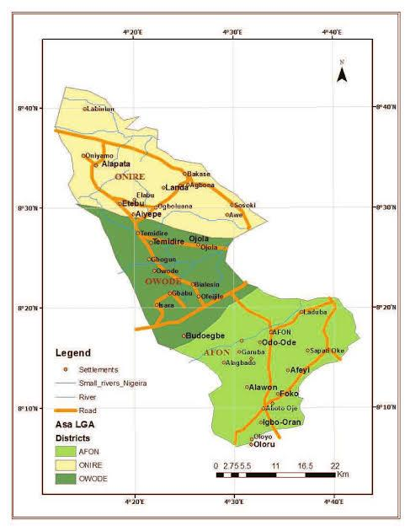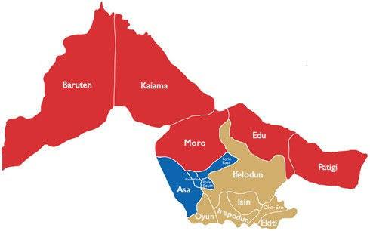
Fig. 3.1: the location of the study area on the map of Asa LGA, Ilorin, Kwara State, Nigeria.
Fig. 3.2 shows the picture of research team on field work.
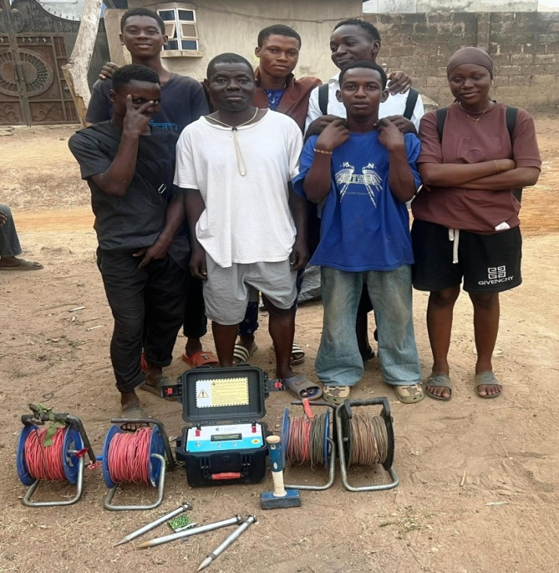
Fig. 3.2: Picture of research team on field work.
3.2 DESCRIPTION OF THE GEOTECHNICAL SUBSURFACE PROPERTIES OF THE SOIL USING GEOPHYSICAL APPROACH IN THE STUDY AREA
The geophysical approach to investigating geotechnical subsurface properties of soil involves the use of non-invasive method is evaluate the physical condition of subsurface material, this method help determine key soil properties such as density, moisture content, stiffness, stratification and depth to bedrock without the need for extensive drilling or sampling.
Material used in the study area
Material used are terameter model Herojatplo
Electrodes cable clip, measuring meter, hammer, GPS instrument.
This following procedure were used for measuring the geophysical properties of the soil layers of the soil in the study area.
i. Site Preparations: the ground of the area was cleared and a straight line survey was selected where electrodes can be planted.
ii. Choosing an Electrode Configuration: there are different array types, but schlumberger array was used which has good depth penetration and high resolution.
iii. Electrode placement: Eight electrodes were used, four for current injection (c₁, c₂) and four for potential measurement (p₁, p₂). The electrodes were inserted to the ground along a straight line, also the electrodes was hammered deep to get high resolution.
iv. Connection of the cable: the electrodes were connected to the terameter using color-cadel cables ensured tight connection good electrodes soil contact. Also the electrodes were placed at 5m current to 5m potential spacing.
v. Using of a handled GPS instrument: a hand GPS device was used in the study area to determine the latitude and longitude of the study area.
vi. Ground resistivity measurement: the terremeter was switched on and the electrode are set in spacing (AB/2) and (MN/2) set. The terameter injects current (I) through the current electrodes and their voltage (V) across the potential electrodes were measured. The device calculates apparent resistivity (pa) using $Pa =K×\frac{V}{I}$where (K) is the geometric factor depending on the spacing of the electrodes.
vii. Measuring electrodes spacing: To investigate deeper subsurface layers, the electrode spacings (AB/2 and MN/2) were increased. The spacing of the current electrodes was increased from 5 m to 10 m, along with adjustments to the potential electrodes. After taking the readings on the Terameter, the spacing was further increased to 15 m, and additional readings were recorded. This approach helps to detect changes in subsurface resistivity, which are related to variations in soil layer composition, moisture content, and the presence of buried artifacts.
viii. Data recording: values of (AB/2), (MN/2) spacing, voltage (V), current (I) and apparent resistivity (Pa) were recorded. Measurements were also carried out two other profiles to create a 2D image of the subsurface.
ix. Data interpretation: the data taken were transferred to a computer for inversion using RES 20 INV software. The output resistivity or pseudo section showing different soil layers.
Fig 3.3 shows the terameter model herojat
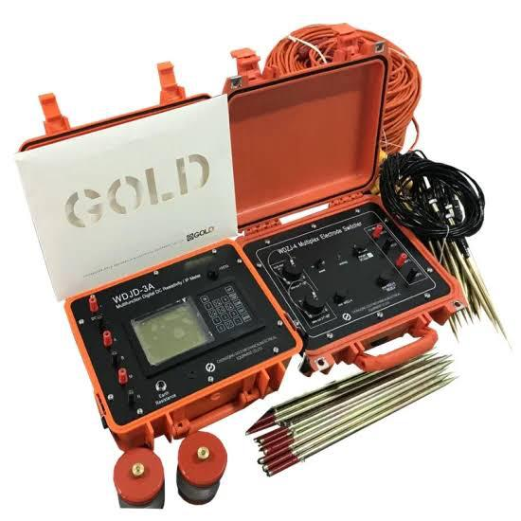
Fig. 3.3:TheTerameter
3.3 DETERMINATION OF GEOTECHNICAL SUBSURFACE PROPERTIES OF SOIL USING GEOPHYSICAL APPROACH IN THE STUDY AREA.
3.3.1 Atterberg Limits
Apparatus used: Casagrande apparatus, weighing balance, 2 spatulas, oven, moisture cans, a mixing plate.
The atterberg limt are a basic measure of the critical water content of a fine grained soil, its shrinkage limit, plastic limit and liquid limit.
The atterberg limit can be defined as the liquid limit and plastic limit of a soil. These two limits are used internationally for soil identification, classification and strength correlation. When clay minerals as present in fined grained soil, the soil can be recorded in the presence of some moisture without crumbling. This cohesiveness caused by the absorbed water surrounding the clay particles.
Procedure
i. Little portion of the sample was mixed before adding more water into the laterite sample.
ii. The soil was rolled into the boll shape.
iii. The ball was cuts and we use our palm to rub it on a smooth surface until the water was removed and it formed to about 3mm diameter before it.
iv. The procedure was repeated for the other two samples.
v. the three tin can was measured separately with different samples in it.
vi. The weight of the tin was measured with each sample on it.
v. The weight of the new can was measured with sample in them.

Fig. 3.4 shows the picture of Oven, Casagrande apparatus and weighing balanceShear Stress
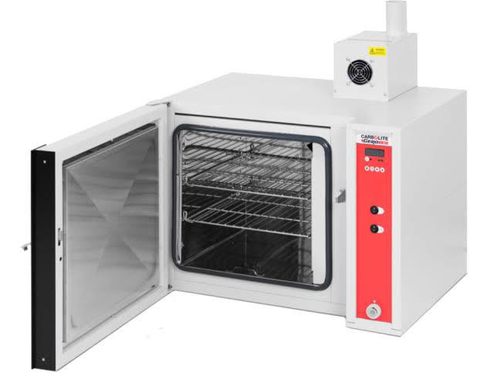
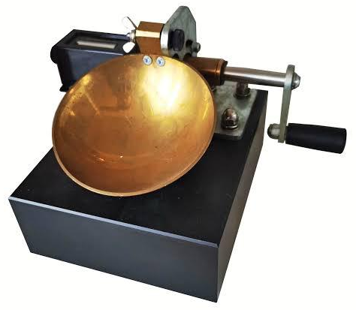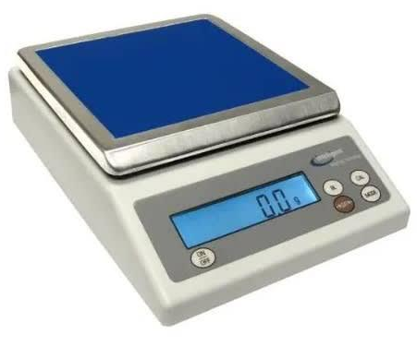
Fig. 3.4: The picture of Oven, Casagrande apparatus and weighing balance
Shear Stress
Shear stress is typically defined as a resistance in terms of effective internal friction angle (Terzaghi et al.,1996).
Procedure.
i. The shear box was assembled
ii. The soil sample was field into the 60mm by 60mm box.
iii. The gear level was disengaged to the shear Machine and the soil sample was covered with the toothed perforated grid
iv. The box was covered and then loaded with frame and also 5kg of the slotted weight by balancing the bubble tube in the effective arm holding the weight.
v. The gear was then engaged and the machine is switch on.
vi. The Reading on the load gauge were observed and taken down for every revolution of the displacement.
vii. The readings were taken with the load gauge was observed to move backwards with further increase, the number of the revolution.
viii. The maximum reading on the load gauges was observed and the gear level was disengaged.
ix. The machine was switch off and soil sample was unleaded sequentially the way it was loaded.
x. Soil was removed from the box and was replaced by a fresh sample. This was repeated for 10kg and 15kg of the slotted weight
Apparatus
- Direct shears balance
- Loading pad
- Loading frame.
- Loading Yoke
- proving ring capacity
- Dial gauge accuracy 0.01mm, 2mm.
- Stratill or dynamic compaction devices.
- Spatulus.

Fig 3.5 shows the picture of the shear box and proving ringSieve analysis
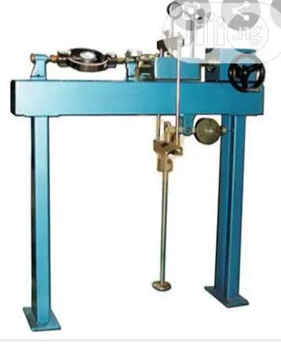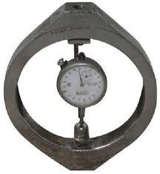
Fig 3.5: The picture of the shear box and proving ringSieve analysis
Sieve analysis of a powder or granular material or particles dispersed in fluids a list of values or a mathematical function that defines the relative amount typically by mass of particles present according to size.
Apparatus
Sieve of different size
Sieve lid
Weighing balance
Sieve with pan
Sieve shocking machine.
Procedure
i. Each scene pan was clean with wash in case of any stick particles stock in between
ii. The weight of sieve pen was measured on the weighing balance
iii. The specimen was dried in the oven for 3-4 min to get the dried specimen
iv. The Specimen was weighed and recorded.
v. The sieve was arranged in order from the opening sieve to the last and larger opening sieve to the top.
vi. The recorded specimen was poured into the sieve as the smallest opening sieve to the last and larger opening sieve to the top.
vii. The shaker was a welled to with 5-10min and recorded the weight of each sieves and retrieving pen separately.
viii. The cumulative % was calculated for each sieve pen.
ix. The graph was plotted passing through the sieve size.
Fig. 3.6 shows the picture of sieve shaker, sieve pan and sieve lid
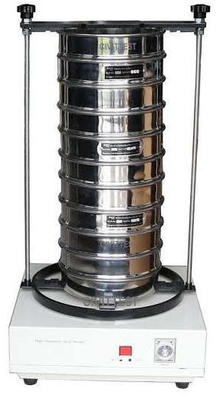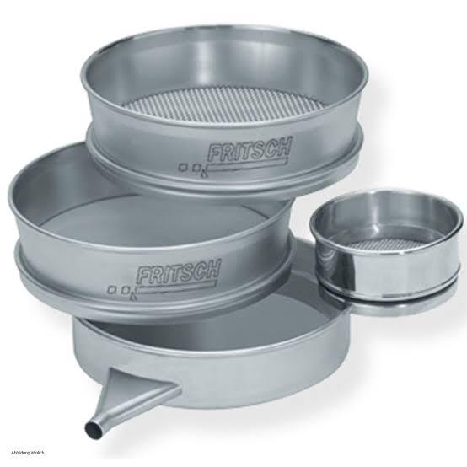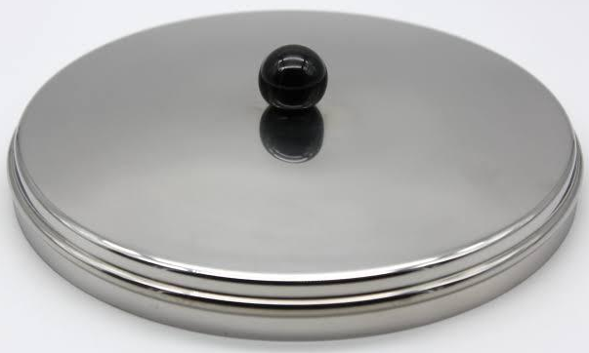
Fig. 3.6: The picture of sieve shaker, sieve pan and sieve lid
3.4 INVESTIGATING THE RELATIONSHIP BETWEEN THE PROPERTIES AND THE GEOPHYSICAL PROPERTIES OF THE STUDY AREA.
The relationship between geotechnical and geophysical properties of soil within the directing point area was analyzed by comparing geophysical reactivity data with laboratory geotechnical parameter.

CHAPTER FOUR

4.0 RESULTS AN DISCUSSION
The chapter explained the results of tests carried out, which involved the Atterberg limits including the liquid limit, plastic limit, plasticity index – as well as sieve analysis and shear stress and geophysical study.

4.1 GEOTECHNICAL PROPERTIES OF SOIL IN STUDY AREA

4.1.1 ATTERBERG LIMIT
Table 4.1 presents the plasticity properties of the soil sample obtained.
Table 4.1: Plasticity Properties
Sample | Liquid Limit (%) | Plastic Limit | Plasticity Index
SAMPLE A | 27.5 | 15.1 | 12.1
SAMPLE B | 22.0 | 10.3 | 11.7
SAMPLE C | 25.0 | 12.9 | 12.1

The objective of Atterberg limit test is to determine the percentage of clay or to classify soil based on its clay contents. According to soil classification, a soil sample with a liquid limit at less than or equal 35% is classified as (CL) that is low clay content. A soil with a liquid limit above 35% and less than or equal to 50% is categorized as (CL), meaning intermediate clay content, furthermore, soil with a liquid limit between 50% and 75% is classified as (CH), indicating high clay content. Any soil with a liquid limit greater than 75% is also classified as high clay content but such soil are particularly difficult to work with due to their elastic properties (Das, 2010).

4.1.2 SHEAR STRESS
These test stimulates how soil behave under the shear load

Table 4.2: Shear stress of Sample A
Load (kg) | Normal Stress (KN/m²) | Load Dial Reading | Shear (Kn/M²)
5 | 188.0 | 232 | 112
10 | 324.3 | 646 | 311
15 | 460.5 | 961 | 463
20 | 598.8

Shear stress of sample A
Fig 4.1shows normal stress vs shear stress of sample A
400 Angle of friction
= 34⁰
300

200

100
0
100 200 300 400 500
Fig 4.1: Normal stress vs shear stress of sample A (KN/m²)

Table 4.3 shows shear Stress of Sample B
Table 4.3:The shear stress sample B
Load (kg) | Normal Stress (KN/m²) | Load Dial Reading | Shear (Kn/M²)
5 | 122.0 | 225 | 108
10 | 324.3 | 392 | 189
15 | 460.3 | 582 | 280
20 | 596.3
Normal Stress (Kn/M²)
Fig 4.2shows normal stress vs shear stress of sample B (KN/m²)
500 Angle of internal friction
= 31⁰
400

300

200

100
0 100 200 300 400 500 600
Fig 4.2: Normal stress vs shear stress of sample B (KN/m²)
Table 4.4 shows the shear stress of sample C
Table 4.4: Shear Stress of Sample C
Load (kg) | Normal Stress (KN/m²) | Load Dial Reading | Shear (Kn/M²)
5 | 188.0 | 335 | 161
10 | 324.3 | 665 | 320
15 | 460.5 | 1007 | 485

Fig 4.3 shows normal stress vs shear stress of sample C (KN/m²)
500 Angle of Friction = 44⁰

400

300

200

100
0 100 200 300 400 500
Fig 4.3: Normal stress vs shear stress of sample C (KN/m²)
Soil can be classified base on their angle of Internal fractionwhich is akey parameter used to evaluate the shear strength of the soil. This angle indicates the soils resistance to sliding along surface with the soil massbased on the internal resistance. Soil are categorizedinto different Strength Classes. An angle of friction between 10⁰ and 20⁰ is considered very soft soil, between 20⁰ and 30⁰ is classified as stiff soil, any angle above 35° is considered hard soil (Das, 2016)

4.1.3 SIEVE ANALYSIS
Sieve analysis is used to determine the particle size distribution of soil. The result indicate how soil particles are spread across various sizes, which aid in the classification of the soil.
Table 4.5 shows the Percentage of the soil fraction in Sample A
Table 4.5: Percentage of the soil friction
Key | Sample  A | Depth (m) | D10  0.425 | DB0  1.40 | D60  4.00 | C4  9.41 | CC  1
Key | 63% | Gravel
Key | 37% | Sand
Name: Very Sandy Gravel Soil
Classification: Well graded gravel soil
Table 4.6 Shows the percentage of the soil Friction in Sample B
Table 4.6: Percentage of the soil Friction.
Key | Sample  B | Depth (m) | D10  0.212 | D30  0.800 | D60  0.800 | C4  3.8 | CC  1.5
Key | 11% | Gravel
Key | 81% | Sand
Name: Gravity Sand Soil
Classification: Poorly Graded Sandy Soil
Table 4.7show the percentage of the soil friction in sample C
Table 4.7: Percentage of the soil Friction
Key | Sample  C | Depth (m) | D10  0.425 | D30  1.40 | D60  4.00 | C4  9.41 | CC  1
Key | 55% | Gravel
 | 45% | Sand
Name: Very Sandy Gravel
Classification: Well Graded Gravel
According to the co-efficient of uniformity ((v) and co-efficient of curvature (cc)), the Cu for gravel must be greater than 6, and the cc must also be uses in engineering construction to classify and select suitable materials (Das, 2016). The well-graded, sandy gravel soils provides good support and drainage, reducing the risk of foundation settlement and moisture movement which are common causes of wall cracks. Its stable nature helps prevent uneven sinking of the building making cracks in walls less likely as long as the soil is properly compacted and the foundation is well-designed (Das, 2016).

4.2 GEOPHYSICAL PROPERTIES OF SOIL IN STUDY AREA
This category revealed the Raw-Resistivity result collected in the field.
Fig 4.8: Shows the Raw-Resistivity of first profile.
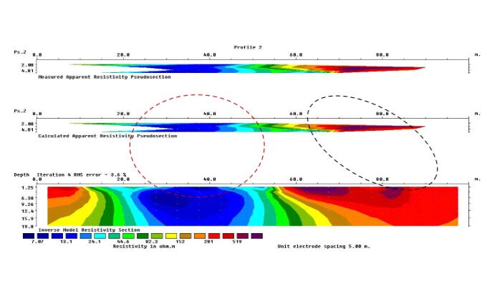
Fig 4.8: The Raw-Resistivity of first profile.
The data were acquired along a 100meter lateral spread, reaching a maximum depth of 2meters. The survey recorded an error margin of 10.4 to 206.1 ohm. A well compacted layer of lateritic clay is embedded from 0 to 35 meters along the lateral extent and is also observed at a depth of 5 meters. Additionally, from the surface layer between 70 to 100 meters laterally there is a dominant presence of clay, likely represent loose sediment. This clayey layer trend downward and extend to depth of approximately 19 meters. (Aderemi, 2022).
Fig 4.9 Shows the second profile
Fig 4.9:The second profile
The data is acquired over a 100-meter lateral spread, reach a maximum depth of 2meters. The survey recorded a 3.6% error and the. Resistivity values range from 7 to 105.9 ohms. The area with the lowest resistivity values indicates the presence of clay material or looses clays material observed from 20 meter to 55 meters along the lateral extent and dipping to a depth of 5 meters. The high resistivity region may represent lateric clay, trending from 60 meters to 100 meters along the profile (Ajayi, 2022)

Fig 4.10 Shows Third Profile.
Fig 4.10: Third Profile.
These reaching a maximum depth of 2meters. The profile indicate the presence of lateritic clay between 15 meters and 20 meters along the lateral spread at a depth of 19.8 meters. The lateritic clay is surrounded by loose clay or clay particles which predominantly dominate the entire profile (Aroyehun, 2018).
Red Signify the Lateritic Soil
Green Signify the Sand
Blue Signify Clay
Lithologies and Depth
LITHOLOGIES | DEPTH
Top Soil | 35, 0hm.m
Clay | 10, 0hm.m
Lateritic Clay | 201, 0hm.m
Source: (Telford, et al., 1990, Keller and Frisch Knecht, 1996, and Olorunfemi and Fawuyi, 1993)
The Electrical Resistivity Imaging (ERI) data shown variation in subsurface strength due to changes in resistivity. Zones with low resistivity indicates weak, clayey or water logged soils are more likely to cause foundation settlement and wall cracks. High resistivity zones are stronger but can be problematic if found beneath weaker layers, mixed resistivity layers increase the risk of cracks due to uneven foundation behavior (Kearey et al., 2002).

4.3 RELATIONSHIP BETWEEN GEOTECHNICAL AND GEOPHYSICAL PROPERTIES OF SOIL IN THE STUDY
The geotechnical and geophysical investigation revealed the clay content in the study area is high consequently the ground was unstable, which negatively affect the load bearing capacity of the soil. This instability increase the likelihood of the differential settlement or vibration under loading activity associated with clayey soil which correspond to low resistivity value. (Das, 2010)
Furthermore, the geophysical survey was conducted at a depth of 2 meter added to 3meter cover the full latent extent of the study area, this limited the ability to replace the compare the complete resistivity distribution. The geophysical result indicated that the top soil was predominantly clayey, while the lower later was composed of lateritic material, which is generally more stable. (Das, 2010).

CHAPTER FIVE

5.0 CONCLUSION AND RECOMMENDATION CONCLUSION
This study explored the underground features of the soil by applying both geotechnical and geophysical techniques in the designated location combining these approaches offer a detailed insight into the soil layers and their engineering behavior
The geophysical investigation particularly through Electrical Resistivity Imaging (ERI) showed different in Resistivity reading,reflecting distinct underground strata. These strata are associated with various soil types including lateritic clay, sandy soil and potentially wealthered rock. Analyzing the Resistivity result enable the recognition of both sat able and weak zone beneath the ground surface.
The geotechnical study which involved laboratory examination like sieve analysis, atterberg limit and shear strength text, offered essential details regarding the soil strength, stability and loading ability. The outcome revealed that certain layer possessed medium to high bearing capacities appropriate for construction purpose where as other especially those with elevated plasticity or moisture levels might need stabilization measure.
The intergration of both techniques proved to be more efficient in enhancing the accuracy of subsurface evaluation. The geophysical investigation offered a wide scale perspective of underground condition, while the geotechnical texting confirmed the physical and mechanical characteristics of the collected soil specimen.

5.2 RECOMMENDATIONS
From the result obtained in the study area the following suggestions are provided:
A combined methodology is recommended for future site assessment utilizing both geotechnical and geophysical to attain a more precise and economical interpretation subsurface condition.
Ground enhancement is necessary in zone with soft or clay rich soil that display load and bearing strength or elevated plasticity such area should be treated using appropriate methods like lime, cement or other chemical additives pior to auto construction work.
Substructure planning in location with heterogeneous subsurface condition should be carried out according to the site to prevent different settlement or structural failure.
Continuous observation is recommended for site with bonded line or fluctuating subsurface condition particularly during and following construction to ensure that soil performance remain consistent overtime.

REFERENCES
Adeoye, A. S. (2022). Geophysical post-foundation studies of Ministry of Justice building.
Ajayi, C. A. (2022). Geophysical post-foundation studies of Ministry of Justice building.
Aroyehun, M. T. (2018). Application of geophysics in post-foundation study.
Brady, N. C., and Weil, R. R. (2008). The nature and properties of soils (14th ed.). Prentice Hall, pg. 133.
Budhu, M. (2010). Soil mechanics and foundations (3rd ed.). Wiley, pg. 87.
Coduto, D. P., Yeung, M. C. R., and Kitch, W. A. (2011). Geotechnical engineering: Principles and practices. Pearson Education, pg. 76.
Coduto, D. P., Yeung, M. C. R., and Kitch, W. A. (2016). Geotechnical engineering: Principles and practices (2nd ed.). Pearson, pg. 68.
Craig, R. F. (2004). Craig’s soil mechanics (7th ed.). Spon Press, pg. 95.
Daniels, D. J. (2004). Ground penetrating radar (2nd ed.). IET, pg. 59.
Das, B. M. (2010). Principles of geotechnical engineering (7th ed.). Cengage Learning, pp. 34 – 36.
Das, B. M., and Sobhan, K. (2018). Principles of geotechnical engineering (9th ed.). Cengage Learning, pg. 102.
Head, K. H. (1992). Manual of soil laboratory testing: Volume 1, Soil classification and compaction tests. Pentech Press, pg. 54.
Holtz, R. D., and Kovacs, W. D. (1981). An introduction to geotechnical engineering. Prentice Hall, pg. 127.
Kearey, P., Brooks, M., and Hill, I. (2002). An introduction to geophysical exploration (3rd ed.). Wiley-Blackwell, pg. 145.
Lambe, T. W., and Whiteman, R. V. (1979). Soil mechanics. John Wiley and Sons, pg. 98.
Loke, M. H. (2000). Electrical imaging surveys for environmental and engineering studies: A practical guide to 2-D and 3-D surveys. [Self-published/manual], pg. 33.
Nelson, J. D., and Miller, D. J. (1992). Expansive soils: Problems and practice in foundation and pavement engineering. Wiley, pg. 61.
Sposito, G. (2008). The chemistry of soils (2nd ed.). Oxford University Press, pg. 150.
Telford, W. M., Geldart, L. P., and Sheriff, R. E. (1990). Applied geophysics. Cambridge University Press, pg. 172.
Terzaghi, K., and Peck, R. B. (1967). Soil mechanics in engineering practice. Wiley, pg. 205.
Terzaghi, K., Peck, R. B., and Mesri, G. (1996). Soil mechanics in engineering practice (3rd ed.). Wiley-Interscience, pg. 310.

