INVESTIGATION OF CAUSES OF CRACKS IN BUILDING WALLS AT BUDO-NUHU AREA, AIRPORT, ILORIN

BY

Shukurah Oyinkansola OLAGOKE

ND/23/MPE/FT/0023

BEING A RESEARCH PROJECT SUBMITTED TO THE
DEPARTMENT OF MINERALAND PETROLEUM RESOURCES ENGINEERING TECHNOLOGY,
INSTITUTE OF TECHNOLOGY,
KWARA STATE POLYTECHNIC, ILORIN

IN PARTIAL FULFILLMENT OF THE REQUIREMENT FOR THE AWARD OF NATIONAL DIPLOMA (ND) IN MINERALAND PETROLEUM RESOURCES ENGINEERING TECHNOLOGY.

AUGUST, 2025

CERTIFICATION

This is to certify that this research project work INVESTIGATION OF CAUSES OF CRACKS IN BUILDING WALLS AT BUDO-NUHU AREA, AIRPORT, ILORIN was carried out by Shukurah Oyinkansola OLAGOKE with matric. Number ND/23/MPE/FT/0023, submitted to Department of Mineral and Petroleum Resources Engineering Technology, Institute of Technology (IOT), Kwara State Polytechnic, Ilorin, in partial fulfillment for the requirement of award ofNational Diploma (ND) in Mineral and Petroleum Resources Engineering Technology.



DEDICATION

I dedicate this project to ALLAHfor His endless grace and guidance and my family for their unwavering love, support, and belief in me every step of the way.

ACKNOWLEDGMENT

First and foremost, I would like to thank my creator, Almighty Allah for granting me the strength and wisdom to under take this task. I thank my parent, sibling and love ones for been constantly by my side for the moral support in any endeavour I take.

I would also thanks my supervisor Dr.OlatunjiK. J. for his valuable guidance, encouragement, and support at every stage of this work. His insights and suggestions were instrumental in shaping the project.

My special thanks also goes to my amiable lecturer, Engr. I. S Usman and Dr. Obaro, mr, Odediran, Mr. Hammed and others, God bless you all

I am also grateful to my department for providing me with the opportunity and facilities to carry out this project.

My sincere gratitude to my parents Mr.andMrs.Olagoke for their help and cooperation in making this possible for me to achieve.

Lastly, I must not forget to say a big thank you to my project partners in person Mohammed Basambo, Ibrahim Seyi, Obatola Micheal, Ayinla Ridwan, Ayodele Isreal.

Thank you all.

TABLE OF CONTENTS
Section | Page
Title Page | i
Certification | ii
Dedication | iii
Acknowledgement | iv
Table of Contents | v
List of Tables | vii
List of Figures | viii
Abstract | ix
CHAPTER ONE: INTRODUCTION | 1
1.0 Introduction | 1
1.1 Aims and Objectives | 2
1.2 Scope of the Study Area | 2
1.3 Problem Statements | 3
1.4 Justification of Study | 3
CHAPTER TWO: LITERATURE REVIEW | 4
2.0 Literature Review | 4
2.1 The Geotechnical Properties of Soil | 4
2.2 The Geophysical Methods of Subsurface Investigation | 7
2.3 Geotechnical Problems in Building Construction: A Detailed Review | 10
CHAPTER THREE: MATERIAL AND METHODOLOGY | 13
3.0 Material and Methodology | 13
3.1 Description of the Area | 13
3.2 Description of the Geotechnical Subsurface Properties of the Soil Using Geophysical Approach in the Study Area | 14
3.3 Determination of Geotechnical Subsurface Properties of Soil Using Geophysical Approach in the Study Area | 15
3.3.1 Atterberg Limits | 15
3.3.2 Shear Stress | 17
3.3.3 Sieve Analysis | 18
3.4 Investigating the Relationship Between the Properties and the Geophysical Properties of the Study Area | 19
CHAPTER FOUR: RESULT AND DISCUSSIONS | 20
4.0 Result and Discussions | 20
4.1 Geotechnical Properties of Soil in the Study Area | 20
4.1.1 Atterberg Limit | 20
4.1.2 Shear Stress | 21
4.1.3 Sieve Analysis | 23
4.2 Geophysical Properties of Soil in the Study Area | 25
4.3 Relationship Between Geotechnical and Geophysical Properties of the Soil | 27
CHAPTER FIVE: CONCLUSION AND RECOMMENDATIONS | 28
5.0 Conclusion and Recommendations | 28
5.1 Conclusion | 28
5.2 Recommendations | 29
References | 30

LIST OF TABLES

Table | Description | Page
Table 4.1 | Plasticity characteristics | 20
Table 4.2 | Shear stress of Sample A | 21
Table 4.3 | Shear stress of Sample B | 22
Table 4.4 | Shear stress of Sample C | 22
Table 4.5 | Percentage fraction of Sample A | 23
Table 4.6 | Percentage fraction of Sample B | 24
Table 4.7 | Percentage fraction of Sample C | 24
Table 4.8 | Lithologiesand depth | 26

LIST OF FIGURES

Figure | Description | Page
Fig 3.1 | Map of Kwara State showing Ilorin South LGA | 13
Fig 3.2 | The map of study area | 14
Fig 3.3 | The picture of the Casagrande apparatus | 16
Fig 3.4 | The picture of the shear box and proving ring | 17
Fig 3.5 | The picture of sieve shaker, sieve pan and sieve lid | 18
Fig 4.1 | Normal Stress vs Shear stress (KN/m²) of Sample A | 21
Fig 4.2 | Normal Stress vs Shear stress (KN/m²) of Sample B | 22
Fig 4.3 | Normal Stress vs Shear stress (KN/m²) of Sample C | 23
Fig 4.4 | The resistivity of the first profile | 25
Fig 4.5 | The resistivity of the second profile | 25
Fig 4.6 | The resistivity of third Profile | 26

ABSTRACT
This study investigates the geotechnical and geophysical characteristics of subsurface soils in the checking Point area of Ilorin, Kwara State, with the aim of identifying the cause of structural cracks observed in buildings within the study area. Three soil samples, designated as A, B, and C, were subjected to standard geotechnical tests including Atterberg limits, sieve analysis, and shear strength tests, as well as geophysical assessment using Electrical Resistivity Imaging (ERI).Sieve analysis classified Sample A as very sandy gravel, Sample B as gravelly sand, and Sample C as very sandy gravelly soil. Atterberg limit tests revealed liquid limits of 27.5%, 31.0%, and 24.5% for Samples A, B, and C respectively, with corresponding plastic limits of 15.1%, 22.0%, and 11.5%, and plasticity indices of 12.4%, 17.2%, and 10.4%. Shear strength results showed angles of internal friction of 15°, 13.5°, and 14° for Samples A, B, and C respectively.ERI results identified low-resistivity zones, suggesting the presence of clayey layers or high moisture content areas, which correlate with reduced bearing capacity. The soils in the study area are predominantly sandy clay with moderate plasticity and fair shear strength, indicating average load-bearing performance.The integration of geotechnical and geophysical methods provided a comprehensive understanding of the subsurface conditions. This study highlights the importance of integrated soil investigations in mitigating structural failures and supporting effective environmental and construction planning.

CHAPTER ONE
1.0. INTRODUCTION
Soil is a complex heterogeneous medium that comprises various layers, each with the distinct geological and geochemical properties, understanding construction, environmental recombination and natural resources management (Das, 2010).
Geotechnical sub layers of soil refers to the distinct layers of soil that exhibit unique engineering properties such as strength, stiffness and hydraulic conductivity (Das, 2010). These properties are critical in determining the behavior of soil under various loads and environmental conditions (HoltzandKovacs,1981).Geotechnical sublayers are formed through various geological processes, including sedimentation, weathering and erosion,(Lambeandwhiteman , 1979).
Geochemical sublayers of soil refers to the distinct layers of soil that exhibit unique chemical properties soil such as;(pH nutrient content and contamination levels (Brady andWeil,2008).
These properties are crucial in determining the fertility and environmental health of soil (Sposito,2008).
Geochemical sublayers of soil are formed through various biochemical processes, including weathering, leading and nutrient (Jeney, 1941).
1.1. AIMS AND OBJECTIVES.
The Aim is to determine why building walls crackin the study area and also to investigate the study area.
The objectives are as follows:
i. Investigating the geotechnical properties of sublayers of soil including strength and stiffness of the study area.
ii. Determine the type of soil layers and their Atterberg limits
iii. Collect the geophysical and geotechnical engineering implications.

1.2 SCOPE OF THE STUDY AREA.
This study will focus on other geophysical and geological properties of sublayers of soil in the study area.
i. Geophysical field investigations using vertical electrical soundings.
ii. Data analysis and interpretation to identify correlations and implications for construction.
1.3 PROBLEM STATEMENTS.
Buildings cracks can be significant concern for homeowners,architects and engineers , there are some common problems and statements that justify why building cracks occurs ,
i. Setting foundations:overtime the foundation of a building can settle causing cracks in the wells and floors.
ii. Poor construction:inadequate construction particles, such as insufficient reinforcement or poor concrete making can lead to cracks in buildings.
iii. Soil movement: changes in soil moisture or composition can cause ground to shift, leading to cracks in buildings.
1.4 JUSTIFICATION OF STUDY.
i. Understanding the geotechnical properties of sublayers of soil unable engineers to design more stable and durable foundations for buildings and infrastructure.
ii. Studying cracks contributes to a deeper understanding of material behavior,properties and performances, driving innovation in materials.
iii. Analyzing cracks patterns and causes enables the development of building codes and standards ones are designed and built with cracks prevention in mind.

CHAPTER TWO
2.0 LITERATURE REVIEW
2.1 THE GEOTECHNICAL PROPERTIES OF SOIL
Soil is a fundamental material in geotechnical engineering, influencing the stability and strength of foundations, embankments, and other civil engineering structures (HoltzandKovacs, 1981). The geotechnical properties of soil are determined by factors such as particle size, mineral composition, moisture content, and shear strength (Das, 2010),This article explores various geotechnical properties of soil with detailed references to key authors in the field.
i. Soil Composition and Particle Size Distribution
The particle size distribution of soil determines its classification as gravel, sand, silt, or clay. Soil texture significantly influences its permeability, strength, and compaction characteristics (HoltzandKovacs, 1981). The classification of soil based on particle size is governed by systems such as the Unified Soil Classification System (USCS) and the American Association of State Highway and Transportation Officials (AASHTO) system (Das, 2009).
ii. Soil Moisture Content
Water plays a crucial role in soil behavior. The moisture content of soil is defined as the ratio of the weight of water to the weight of dry soil. It affects the shear strength, compressibility, and permeability of the soil (Craig, 2004). The Atterberg limits—liquid limit, plastic limit, and shrinkage limit—define the consistency and plasticity of fine-grained soils (Casagrande, 1932).
iii. Soil Permeability
Permeability refers to the ability of soil to transmit water through its voids. Darcy’s Law is used to describe the relationship between permeability and the hydraulic gradient (Terzaghi, 1943). Soils with high clay content have lower permeability due to the small size of pores, whereas sandy soils exhibit higher permeability (LambeandWhiteman, 1969).
iv. Soil Compaction and Density
Compaction increases the density of soil, reducing void spaces and increasing shear strength. The Proctor Compaction Test (Proctor, 1933) is widely used to determine the optimum moisture content for achieving maximum soil compaction. Soil density is measured using bulk density and dry density, which influence the load-bearing capacity of the soil (Bowles, 1996).
v. Shear Strength of Soil
The shear strength of soil is its resistance to shear stress and is influenced by cohesion, internal friction, and pore water pressure. The Mohr-Coulomb failure criterion is used to describe soil shear strength (Terzaghiand Peck, 1967). Laboratory tests such as the direct shear test, triaxial shear test, and vane shear test are commonly used to assess soil shear strength (Bishop and Henkel, 1962).
vi. Soil Consolidation and Settlement
Soil consolidation refers to the gradual reduction of volume due to expulsion of water under load. Terzaghi’s Consolidation Theory (Terzaghi, 1943) explains primary consolidation, which occurs as pore water dissipates. Secondary consolidation, or creep, occurs due to the reorientation of soil particles over time (Skempton and Bjerrum, 1957).
vii. Swelling and Shrinkage of Expansive Soils
Expansive soils, rich in clay minerals like montmorillonite, undergo significant volume changes with moisture variation. This causes structural damage in foundations and pavements (Holtzand Gibbs, 1956). The swelling potential of soil is determined using tests like the free swell index and swelling pressure test (Chen, 1988).
viii. Bearing Capacity of Soil
Bearing capacity is the ability of soil to support structural loads. Terzaghi’s Bearing Capacity Theory (Terzaghi, 1943) provides equations to calculate ultimate bearing capacity based on soil type and load conditions. Factors such as water table depth, soil type, and foundation shape influence bearing capacity (Meyerhof, 1963).
ix. Soil Erosion and Stability
Soil erosion, caused by wind and water, reduces soil stability and load-bearing capacity. Factors such as soil cohesion, vegetation cover, and slope gradient influence erosion susceptibility (Hudson, 1981). Methods to control soil erosion include geotextiles, retaining walls, and vegetation cover (Morgan, 2005).
x. Soil Classification Systems
Different classification systems are used for soil identification, including:
• Unified Soil Classification System (USCS) – developed by Casagrande (1948), based on grain size and plasticity.
• AASHTO Classification System – used in highway engineering to classify soil based on suitability for road subgrades (AASHTO, 1945).
2.2 THE GEOPHYSICAL METHODS OF SUBSURFACE INVESTIGATION
Geophysical methods are essential tools in subsurface investigations, enabling the non-invasive study of geological formations, groundwater, mineral deposits, and engineering sites. These methods rely on physical properties such as electrical conductivity, density, magnetism, and seismic velocity to characterize subsurface materials. This article explores various geophysical methods, referencing key authors and providing full citations.
Seismic Methods
Seismic techniques measure the propagation of seismic waves through subsurface materials. The two primary methods include:
i. Seismic Refraction
Seismic refraction studies variations in wave velocity to delineate subsurface layers. The method is based on Snell’s Law, describing wave refraction at layer interfaces (DobrinandSavit, 1988). It is widely used in engineering and groundwater investigations (Telford et al., 1990).
ii. Seismic Reflection
Seismic reflection records the return of waves from subsurface layers, commonly used in petroleum exploration (Sheriff and Geldart, 1995). The method provides high-resolution imaging of geological structures (Yilmaz, 2001).
iii. Electrical Resistivity Method
This method involves injecting electrical currents into the ground and measuring the resulting voltage differences to determine subsurface resistivity (Griffiths and King, 1981). Low resistivity typically indicates water-saturated zones, while high resistivity suggests rock or dry soil (Reynolds, 2011). The Wenner and Schlumberger arrays are common configurations for resistivity surveys (Loke, 2004).
iv.Electromagnetic (EM) Methods
EM methods detect variations in subsurface conductivity using primary and secondary electromagnetic fields (McNeill, 1980).
v.Ground Penetrating Radar (GPR)
GPR uses high-frequency EM waves to detect objects and stratigraphy in shallow subsurface layers (Davis and Annan, 1989). It is widely applied in archaeology, civil engineering, and environmental studies (Jol, 2008).
vi. Very Low Frequency (VLF) Method
The VLF method uses distant radio transmitters to map conductivity variations related to faults and groundwater flow (Telford et al., 1990).
vii.Magnetic Method
Magnetic surveys measure variations in Earth’s magnetic field caused by subsurface materials (Blakely, 1995). It is extensively used in mineral exploration, detecting ferrous materials (Reynolds, 2011). The total field and gradient measurements provide insights into subsurface anomalies (Nabighian et al., 2005).
viii.Gravity Method
The gravity method detects density variations in subsurface materials by measuring gravitational acceleration changes (Telford et al., 1990). High-density materials, such as ore bodies, produce positive anomalies, while voids or low-density sediments create negative anomalies (Hinze et al., 2013).
ix.Induced Polarization (IP) and Self-Potential (SP) Methods
IP and SP techniques measure electrical charge buildup in subsurface materials. IP surveys detect chargeability, useful for mineral exploration (Pelton et al., 1978), while SP surveys identify groundwater flow and sulfide deposits (Corwin and Hoover, 1979).
x.Radiometric Method
Radiometric techniques measure natural gamma radiation from rocks and soil to identify lithological variations (Telford et al., 1990). These methods are crucial in uranium exploration and environmental monitoring (Dickson and Scott, 1997).
xi.Borehole Geophysics
Downhole geophysical techniques, including gamma logging, resistivity logging, and acoustic logging, provide detailed subsurface data in drilled wells (Hearst et al., 2000). These methods enhance hydrogeological and petroleum studies.
2.3 GEOTECHNICAL PROBLEMS IN BUILDING CONSTRUCTION: A DETAILED REVIEW
Building construction projects often face geotechnical challenges that can compromise structural integrity, safety, and cost-effectiveness. These challenges arise from factors such as soil properties, groundwater conditions, and external loads. This article discusses key geotechnical problems in building construction, citing relevant authors, followed by full references at the end.
i. Differential Settlement
Cause and Effect
Differential settlement occurs when different parts of a structure settle at varying rates due to soil heterogeneity, leading to foundation cracks, tilting, or structural failure (Coduto, 2001). This is commonly seen in areas with expansive clay or poorly compacted fill materials (Das, 2010).
Mitigation Strategies
•Conducting detailed geotechnical site investigations before construction (Bowles, 1996).
•Using deep foundations, such as pile or pier foundations, in problematic soils (Holtzet al., 2011).
•Employing soil stabilization techniques like grouting or compaction (Das andSobhan, 2013).
ii. Expansive and Collapsible Soils
Expansive Soils
Expansive soils, such as montmorillonite clay, swell upon water absorption and shrink when dry, causing foundation heaving and cracking (Nelson and Miller, 1992). Inadequate soil moisture control leads to foundation movement and structural damage.
Collapsible Soils
Loess and silty sands are collapsible when saturated, causing sudden settlement and failure (Houston et al., 2001). Poor compaction or leaching processes exacerbate this issue.
Mitigation Strategies
•Pre-construction soil treatment using lime or cement stabilization (Fredlund and Rahardjo, 1993).
•Designing flexible foundation systems that accommodate soil movement (Das, 2010).
•Proper site drainage to prevent moisture variations (Holtz et al., 2011).
iii. Liquefaction
Cause and Consequence
Liquefaction occurs in saturated, loose sandy soils during seismic activity, causing ground loss of strength and resulting in foundation failure (Seed and Idriss, 1971). This phenomenon is prevalent in coastal and riverine areas.
Mitigation Strategies
•Soil densification using vibro compaction (Mitchell, 2008).
•Implementing deep foundations such as drilled shafts to bypass liquefiable layers (Das and Sobhan, 2013).
•Using geosynthetic reinforcement to improve ground stability (Holtz et al., 2011).
iv. Groundwater Issues
Effects on Foundations
Excess groundwater weakens soil shear strength, leading to foundation instability and increased hydrostatic pressure on basement walls (Terzaghi et al., 1996). Poor drainage design can cause water logging and deterioration of construction materials.
Mitigation Strategies
•Installing proper drainage systems, such as French drains or dewatering wells (Coduto, 2001).
•Using waterproofing membranes for below-ground structures (Bowles, 1996).
•Designing foundations resistant to buoyancy forces (Das, 2010).
v. Weak and Compressible Soil
Soft clay and peat exhibit high compressibility and low bearing capacity, leading to excessive settlement (Burland, 1987). Buildings on such soils require additional reinforcement.
Mitigation Strategies
•Using geogrids and stone columns to improve soil strength (Mitchell, 2008).
•Constructing floating foundations or raft foundations (Holtzet al., 2011).
•Implementing preloading with vertical drains to accelerate soil consolidation (Das and Sobhan, 2013).
vi. Slope Instability and Landslides
Causes
Unstable slopes due to weak soil, heavy rainfall, or seismic activity can lead to landslides that endanger buildings (Terzaghi et al., 1996).
Mitigation Strategies
•Reinforcing slopes with retaining walls and soil nailing (Bowles, 1996).
•Implementing proper surface and subsurface drainage systems (Holtz et al., 2011).
•Employing rock bolts and anchors in steep slopes (Das, 2010).
vii. Frost Heave
Cause and Effect
In cold regions, water in soil freezes and expands, causing foundation lifting and structural damage (Penner, 1970). This is common in fine-grained soils like silts and clays.
Mitigation Strategies
•Using deep foundations to reach below the frost line (Coduto, 2001).
•Installing thermal insulation layers to prevent freezing (Das, 2010).
•Improving drainage to prevent water accumulation in the soil (Holtz et al., 2011).

CHAPTER THREE
3.0 MATERIAL AND METHODOLOGY
3.1 DESCRIPTION OF THE AREA
The study was conducted at checking point area in north central region of Nigeria. The checking point area is situated along a major highway leading into the city, serving as a major seeing and transport checkpoint. Geographically, Ilorin has between latitudes 8°24 and 8°36 N and longitude 14°30'E and 4°45'E.
The area experienced a tropical Savannah climate characterized by two main seasons. The rainy season (April to October). Average annual rainfall ranges from 100mm to 150mm and temperatures vary between 22°C and 35°C throughout the year.
Topographically, the area is generally flat to gently undulating, making its suitable for construction, road development and light agriculture. The dominant soil of the region is sandy loamy which supports moderate agricultural activities and drainages.
The checking point area is semi-urban with an increasing residential and commercial development. It is also an important transit zone, often experiencing heavy vehicles traffic due to it location on a major route into Ilorin.
The purpose of the study is to determine the geotechnical and physical properties of the soil within the checking point area.

Fig. 3.1 shows the location of the study area on the map of Asa LGA, Ilorin, Kwara State, Nigeria.
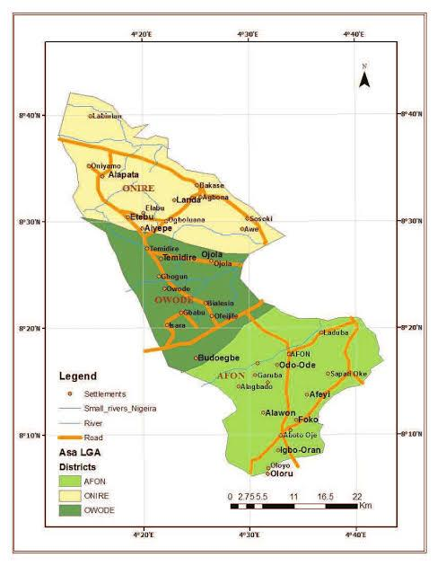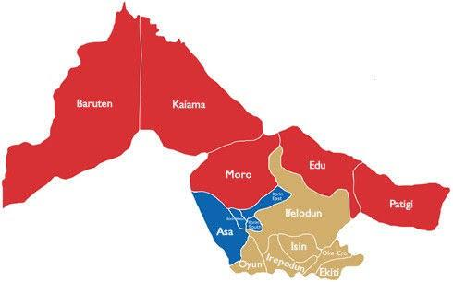
Fig. 3.1: the location of the study area on the map of Asa LGA, Ilorin, Kwara State, Nigeria.
Fig. 3.2 shows the picture of research team on field work.
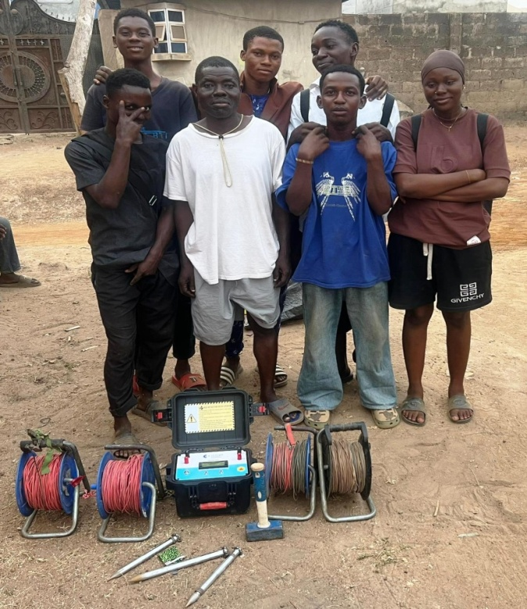
Fig. 3.2:Picture of research team on field work.
3.2 DESCRIPTION OF THE GEOTECHNICAL SUBSURFACE PROPERTIES OF THE SOIL USING GEOPHYSICAL APPROACH IN THE STUDY AREA
The geophysical approach to investigating geotechnical subsurface properties of soil involves the use of non-invasive method is evaluate the physical condition of subsurface material, this method help determine key soil properties such as density, moisture content, stiffness, stratification and depth to bedrock without the need for extensive drilling or sampling.
Material used in the study area
Material used areterrameter model Herojatplo
Electrodes cable clip, measuring meter,hammer, GPS instrument.
This following procedure were used for measuring the geophysical properties of the soil layers of the soil in the study area.
i. Site Preparations: the ground of the area was cleared and a straight line survey was selected where electrodes can be planted.
ii. Choosing an Electrode Configuration: there are different array types, but schlumberger array was used which has good depth penetration and high resolution.
iii. Electrode placement: Eight electrodes were used, four for current injection (c₁, c₂) and four for potential measurement (p₁, p₂). The electrodes were inserted to the ground along a straight line, also the electrodes was hammered deep to get high resolution.
iv. Connection of the cable: the electrodes were connected to the terrameter using color-cadel cables ensured tight connection good electrodes soil contact. Also the electrodes were placed at 5m current to 5m potential spacing.
v. Using of a handled GPS instrument: a hand GPS device was used in the study area to determine the latitude and longitude of the study area.
vi. Ground resistivity measurement: the terremeter was switched on and the electrode are set in spacing (AB/2) and (MN/2) set. The terremeter injects current (I) through the current electrodes and their voltage (V) across the potential electrodes were measured. The device calculates apparent resistivity (pa) using $Pa =K×\frac{V}{I}$where (K) is the geometric factor depending on the spacing of the electrodes.
vii. Measuring electrodes spacing: To investigate deeper subsurface layers, the electrode spacings (AB/2 and MN/2) were increased. The spacing of the current electrodes was increased from 5 m to 10 m, along with adjustments to the potential electrodes. After taking the readings on the Terrameter, the spacing was further increased to 15 m, and additional readings were recorded. This approach helps to detect changes in subsurface resistivity, which are related to variations in soil layer composition, moisture content, and the presence of buried artifacts.
viii. Data recording: values of (AB/2), (MN/2) spacing, voltage (V), current (I) and apparent resistivity (Pa) were recorded. Measurements werealso carried out two other profiles to create a 2D image of the subsurface.
ix. Data interpretation: the data taken were transferred to a computer for inversion using RES 20 INV software. The output resistivity or pseudo section showing different soil layers.
Fig 3.3 shows the terrameter model herojat
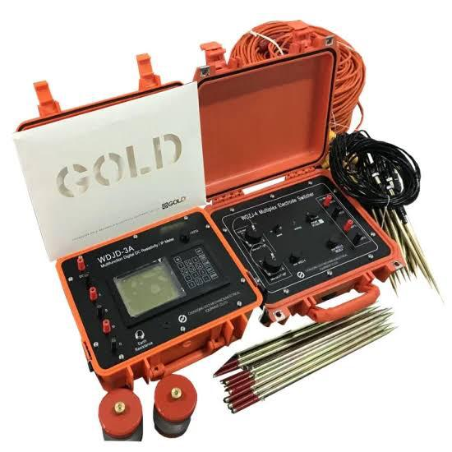
Fig. 3.3: The Terra-meter
3.3 DETERMINATION OF GEOTECHNICAL SUBSURFACE PROPERTIES OF SOIL USING GEOPHYSICAL APPROACH IN THE STUDY AREA.
3.3.1 Atterberg Limits
Apparatus used: Casagrande apparatus, weighing balance, 2 spatulas, oven, moisture cans, amixing plate.
The atterberglimt are a basic measure of the critical water content of a fine grained soil, its shrinkage limit, plastic limit and liquid limit.
The atterberg limit can be defined as the liquid limit and plastic limit of a soil. These two limits are used internationally for soil identification, classification and strength correlation. When clay minerals as present in fined grained soil, the soil can be recorded in the presence of some moisture without crumbling. This cohesiveness caused by the absorbed water surrounding the clay particles.
Procedure
i. Little portion of the sample was mixed before adding more water into the laterite sample.
ii. The soil was rolled into the boll shape.
iii. The ball was cuts andwe useour palm to rub it on a smooth surface until the water was removed and it formed to about 3mm diameter before it.
iv. The procedure was repeated for the other two samples.
v. the three tin can was measured separately with different samples in it.
vi. The weight of the tinwas measured witheach sample on it.
v. The weight of the newcanwas measured with sample in them.

Fig. 3.4 shows the picture of Oven, Casagrande apparatus and weighing balanceShear Stress
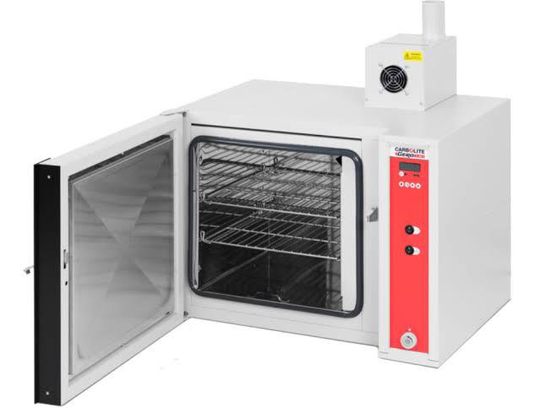
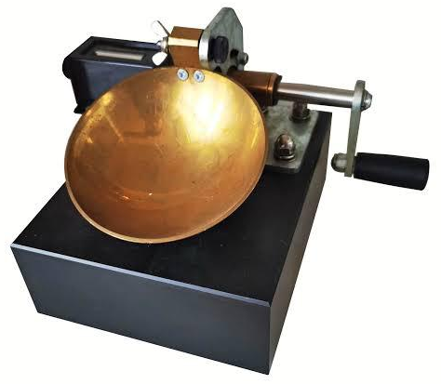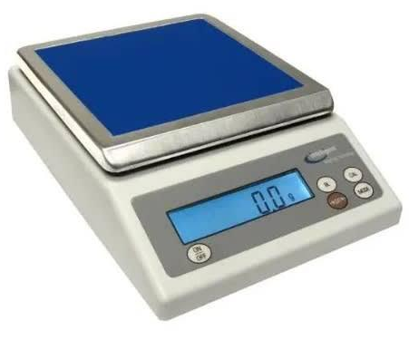
Fig. 3.4: The picture of Oven, Casagrande apparatusandweighing balance
Shear Stress
Shear stress is typically defined as aresistance interms of effective internal friction angle (Terzaghi et al.,1996).
Procedure.
i. The shear box was assembled
ii. The soil sample was field into the 60mm by 60mm box.
iii. The gear level was disengaged to the shear Machine and the soil sample was covered with the toothed perforated grid
iv. The box was covered and then loaded with frame and also 5kg of the slotted weight by balancing the bubble tube in the effective arm holding the weight.
v. The gear was then engaged and the machine is switch on.
vi. The Reading on the loadguage were observed and taken down for every revolution of the displacement.
vii. The readings were taken with the load guage was observed to move backwards with further increase, the number of the revolution.
viii. The maximum reading on the load guageswas observed and the gear level was disengaged.
ix. The machine was switch off and soil sample was unleaded sequentially the way it was loaded.
x. Soil was removed from the boxand was replaced by a fresh sample. This was repeated for 10kg and15kg of the slotted weight
Apparatus
- Direct shears balance
- Loading pad
- Loading frame.
- Loading Yoke
- proving ring capacity
- Dial guage accuracy 0.01mm, 2mm.
- Stratill or dynamic compaction devices.
- Spatulus.

Fig 3.5 shows the picture of the shear box and proving ringSieve analysis
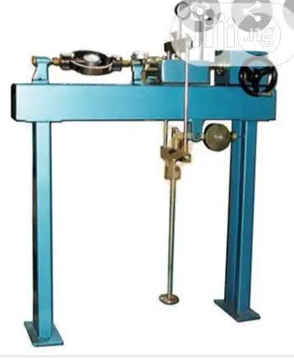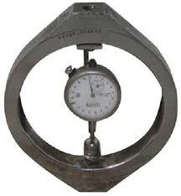
Fig 3.5: The picture of the shear box and proving ringSieve analysis
Sieve analysis of a powder or granular material or particles dispersed in fluids a list of values or a mathematical function that defines the relative amount typically by mass of particles present according to size.
Apparatus
Sieve of different size
Sieve lid
Weighing balance
Sieve with pan
Sieve shocking machine.
Procedure
i. Each scene pan was clean with wash in case of any stick particles stock in between
ii. The weight of sieve pen was measured on the weighing balance
iii. The specimen was dried in the oven for 3-4 min to get the dried specimen
iv. The Specimen was weighed and recorded.
v. The sieve was arranged in order from the opening sieve to the last and larger opening sieve to the top.
vi. The recorded specimen was poured into the sieve as the smallest opening sieve to the last and larger opening sieve to the top.
vii. The shaker was awelled to with 5-10min and recorded the weight of each sieves and retrieving pen separately.
viii. The cumulative % was calculated for each sieve pen.
ix. The graph was plotted passing through the sieve size.
Fig. 3.6 shows the picture of sieve shaker, sieve pan and sieve lid
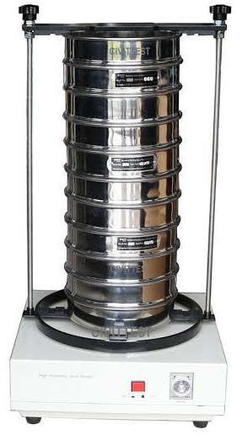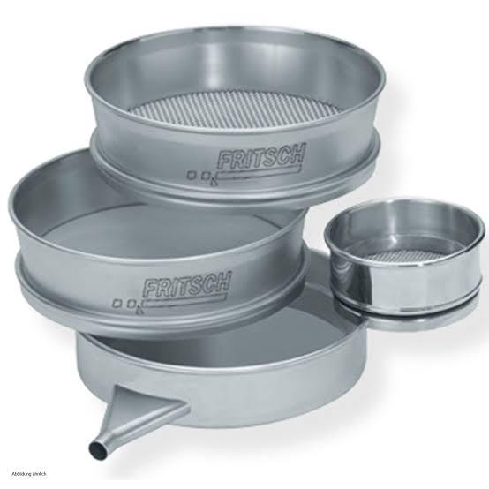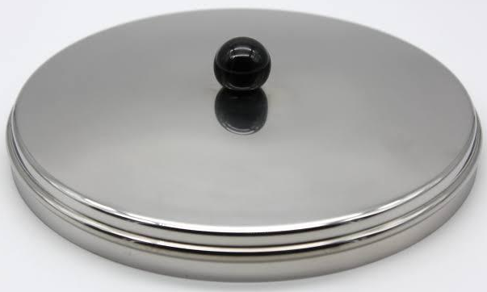
Fig. 3.6: The picture of sieve shaker, sieve pan and sieve lid
3.4 INVESTIGATING THE RELATIONSHIP BETWEEN THE PROPERTIES AND THE GEOPHYSICAL PROPERTIES OF THE STUDY AREA.
The relationship between geotechnical and geophysical properties of soil within the directing point area was analyzed by comparing geophysical reactivity data with laboratory geotechnical parameter.

CHAPTER FOUR
4.0 RESULT AND DISCUSSIONS
4.1 GEOTECHNICAL PROPERTIES OF SOIL IN THE STUDY AREA
4.1.1 Atteberg Limit
The table 4.1 shows plasticity characteristics
Table 4.1:Plasticity characteristics
Sample | Liquid limit % | Plastic limit | Plastic index
Sample A | 27.5 | 15.1 | 12.1
Sample B | 22.0 | 10.3 | 11.7
Sample C | 25.0 | 12.9 | 12.1

The purpose of atteberglimits.
Theplastic index of geotechnical soil in determine the geotechnical properties of soil. The soil sample A has Liquid Limit of 27.5%and plastic limit of 15.1% and plastic index of 12.1. Sample B has22%of liquid limit and plastic limit of 10.3%and plastic index of 11.7%. Sample Chas aliquid limit of 25.0 and plastic limit of 12.9% and plastic index 12.1%.
Liquid limit below 30% indicate low plasticity, values between 50%and70% indicate high plasticity. Therefore the soil is categorized as low plasticity. They are very difficult soilto work with because of it plasticity. Soil with low plasticity settlement more quickly but undergo total settlement. This is becausethey are compressible have higher permeabilityand exhibit minimal secondary (creeps) settlement (Das, 2013).
4.1.2 Shear Stress
These tests simulate how soil will behave under shear loads. Soil can be classified based on their angle of internal friction. Sample A has cohesion of 10kn/m²and angle on fraction of 34°, Sample B has cohesion 5kn/m² with internal friction of 44° while.Sample C has cohesion of 10kn/m² and internal fraction of 31°. Angle of friction within 10°-20° is classified as weak on loose soil structures with limited resistance to shear (i.e. is low). Angle between the ranges of 20°-30° is moderate, angle between 20°-35° is high and above 35° is very high.High angle of fraction above 35°typically dense sands and grave, a high strength and low compressibility which strongly influence ssettlement behaviour (Das, 2019).
The table 4.2 shows shear stress of sample A
Table 4.2: Shear stress of Sample A
Load (kg) | Normal stress kn/m² | Load dial reading | Shear stress (kn/m²)
5 | 188.0 | 232 | 112
10 | 324.5 | 646 | 311
15 | 460.5 | 961 | 463

Fig. 4.1 shows normal stress vs shear stress of sample A
Angel of friction = 31°
Fig. 4.1: Normal Stress vs shear stress (KN/m²) of sample A

The table 4.3 shows shear stress of sample B
Table 4.3: Shear stress of Sample B
Load (kg) | Normal stress kn/m² | Load dial reading | Shear stress (kn/m²)
5 | 188.0 | 225 | 108
10 | 324.3 | 392 | 189
15 | 460.5 | 582 | 280

Fig. 4.2 shows normal stress vs shear stress of sample B
Angel of friction = 44°
Fig. 4.2: Normal Stress vs shear stress(KN/m²) of sample B

The table 4.4 shows shear stress of sample C
Table 4.4: Shear stress of Sample C
Load (kg) | Normal stress kn/m² | Load dial reading | Shear stress (kn/m²)
5 | 188.0 | 335 | 161
10 | 324.3 | 665 | 320
15 | 460.5 | 1007 | 485

Fig. 4.3 shows normal stress vs shear stress of sample C
Angel of friction = 34°
Fig. 4.3: Normal Stress vs shear stress(KN/m²) of sample C
4.1.3Sieve analysis
Sieve analysis is use to determine the particles size distribution of soil.The result show how soilparticles are distributed. Across different sizes which helps in classifying the soils.

The table 4.5 shows the percentage fraction in sample A
Table 4.5: percentage fraction of sample A
Key | Sample | Depth (m) | D10 | D30 | D60 | C1 | C2
 | A |  | 0.425 | 1.40 | 4.00 | 9.41 | 1.2
 | 63% gravel
 | 37% sandy
Name: very sandy gravel soil
Classification: well graded gravel soil

The table 4.6 shows the percentage fraction in sample B
Table 4.6: percentage fraction of sample B
Key | Sample | Depth (m) | D10 | D30 | D60 | C1 | C2
 | B |  | 0.212 | 0.800 | 0.800 | 3.8 | 1.3
 | 11% gravel
 | 81% sandy
Name: gravelly sand soil
Classification: poorly graded sandy soil

The table 4.7 shows the percentage fraction in sample C
Table 4.7: percentage fraction of sample C
Key | Sample | Depth (m) | D10 | D30 | D60 | C1 | C2
 | C |  | 0.250 | 1.00 | 4.38 | 17.5 | 1.0
 | 55% gravel
 | 45% sandy
Name: very sandy gravel soil
Classification: well graded gravel soil

Discussions
Sample A: The result of the sample have 63% gravel and 37% of sandy. Sample Band has 11% of gravel 89% of sandy , Sample C has 55% of graveland 45% of sand.
Sample A: A very sand gravel soil is classified as well graded gravel soil with affect soil in foundation because it has very low settlement and use its dense drains water fast and does not compress made. A provides a strong and stable base foundations (Das, 2013).
Sample B: is named generally send soil, this may contain or may contain clay is it usually result in low and fast settlement especially if they are well competed. If loose they can show immediate settlement especially under collaboration or dynamic loads (Das, 2013).
Sample C: very sand graved soil settles may little and vary quantity mostly during a nightafter loadings. It does experience long terms delayed settlement especially when will compacted(Das, 2013).
4.2 GEOPHYSICAL PROPERTIES OF SOIL IN THE STUDY AREA
The section shows the resistivity value collected in the field.

Fig 4.4: The resistivity of the first profile
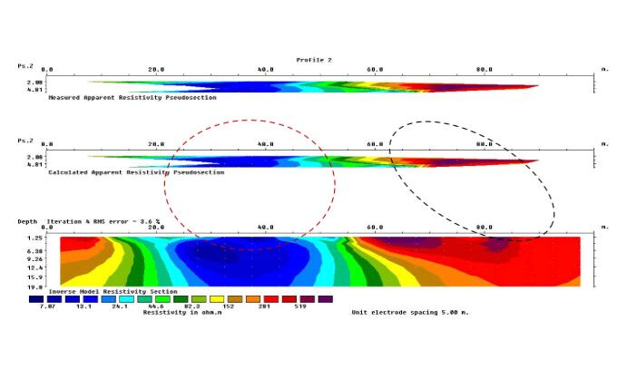
This data is acquired over 100 meter lateral spreading reaching the maximum depth of 2 meters. The survey has 10.1% error and the resistivity values ranges from 10.4 to 2061 ohms. There is an embedded of well compacted lateritic clay from 0m to 35m on the lateral extent and at 5mdenth, also from the top there are also a well dominant clay probably a loose sediment at the top from 70metets to 100 meters on the lateral extent and it trends downward to the depth of 19 meters (Aderemi ,2022).
Fig 4.5: The resistivity of the second profile
The data is acquired over 100 meter lateral spreading reaching the maximum depth of 2 meters. The survey has 3.6% error and the resistivity values ranges from 7.07 to 519 ohms. The area having the lowest resistivity value indicate the presence of clayey material or a loose clayey material which is seen at from 20m to 55m on the lateral spread and dipping to a 5m depth, the high resistivity region might be a lateritic clay trending from 60m to 100m (Ajayi,2022).

Fig 4.6: The resistivity of third Profile
This profile show has the RMS value of 4.4% and it spread from 0m to 100m with the maximum depth of 2 meters. The region is profile shows lateritic clay at 15m to 20m on the lateral spread with a depth of 19.8m, with a loose clay or clay particles surrounding it and it mostly dominated the profile (Aroyehun,2018).
The blue colour signify clay or loose soil.
The green colour signify sand or fairly soil.
The red colour signify lateritic soil

Table 4.8 shows lithologiesand depth
Table 4.8: lithologiesand depth
Lithologies | Depth
Top soil | 35ohmm
Clay | 10ohmm
Lateritic clay | 201 ohmm
Source:(Telford et al.,1990,Keller andFrischknecht, 1996) and (Olorunfemi and Fasuyi, 1993)
The Electrical resistivity image reveals variation in subsurface due to changes in resistivity zones with low resistivity suggests weak, water saturated or clayey soils, which are more likely to cause foundations settlement and cracks in walls. Area with high resistivity indicates stronger soils, but they can also pose problems if they overlie weaker layers . The presence of alternating resistivity layers increases the risk of cracking due to inconsistent foundation performance (Kirsch and Yaramanci, 2002).
4.3RELATIONSHIP BETWEEN GEOTECHNICAL AND GEOPHYSICAL PROPERTIES OF THE SOIL
The geotechnical and geophysical investigations conducted in the study area revealed that the topsoil consists predominantly of clay. This high clay content reduces the soil’s stability, thereby decreasing its load-bearing capacity. Clayey soils are known for their high conductivity due to the presence of water and fine particles, which results in low apparent resistivity values in electrical surveys (Sharma, 1997; Telford et al., 1990).
The geophysical survey, whose result started at a depth of 2 meters, provided only partial subsurface information and did not fully capture the lateral resistivity variations across the study area. Have their findings can not be completely aligned with the geotechnical results: the upper soil layer is clayey, while the underlying layer is lateritic. Lateritic soils generally have higher resistivity because of their lower clay content and better drainage properties, which also enhance their strength and suitability for structural foundations (Parasnis, 1997).
These results indicate a clear relationship between geotechnical and geophysical soil properties. Areas with high clay content exhibit low resistivity values due to higher conductivity, whereas the more competent lateritic layers are associated with higher resistivity, reflecting their ability to support structural loads effectively (Koefoed, 1979).

CHAPTER FIVE
5.0 CONCLUSION AND RECOMMENDATIONS
5.1 CONCLUSION
The Study investigated the subsurface characteristic of soil using both geophysical and geotechnical methods within selected areas. The integrations of these techniques provided a comprehensive understanding of the soil profile and its properties.
The geophysical survey specifically Electrical Resistivity Imaging (ERI),revealed variations in resistivity values, indicating differences in subsurface layers. These variations correspond to different soils types such as Lateritic clay, sandy soil and resistivity weathered rock. Interpretation of the resistivity data enabled the identification of competent and weak zones within the subsurface.
The geotechnical investigations, which involved laboratory tests such as atteberg limit, sieve analysis and shear strength test. Result showed that some layers possess moderate to high bearing capacity, making them suitable for construction, while others particularly with high plasticity or moisture content only require stabilization.
Combining both methods has proven to significantly enhance the reliability of subsurface analysis. The geophysical survey offered a broad overview of subsurface conditions, while geotechnical tests validated the physical and mechanical properties of the soil samples.
5.2 RECOMMENDATIONS
Based on the finding in the study area, the following recommendations are as made
1. Future site investigation should combine electrical resistivity imaging with laboratory geotechnical testing.
2. Soil Improvement: area with plasticity or moisture content should be identified early to plan appropriate stabilization techniques such as cements or other chemical addictive before any construction.
3. Foundation Design: structural foundation in areas with varying subsurface conditions should be design based on the specific soil properties of the study area to avoid settlement of failure.
4. Regular Monitoring: site with marginal or variable subsurface conditions should undergo routine monitoring especially during or after construction to ensure soil behavior remain stable over time.

REFERENCES
Ajayi, C. A., Adeoye, A. S., Ilugbo, S. O., Adebo, B. A., and Adewumi, O. A. (2022). Geophysical post-foundation studies of Ministry of Justice building, Ekiti-State Secretariat, Ado-Ekiti, Ekiti-State, Nigeria. Geological Behaviour, 6(2), 88–92.
American Association of State Highway and Transportation Officials. (1945). Standard specifications for transportation materials and methods of sampling and testing. Author.
Aroyehun, M. T., andAkintorinwa, O. J. (2018). Application of geophysics in post foundation study: A case study of the Faculty of Social Science building, Phase I, Federal University, Oye-Ekiti, Southwestern Nigeria. Journal of Geology and Geophysics, 7(1), Article 324. https://doi.org/10.4172/2381-7193.1000324
Bishop, A. W., and Henkel, D. J. (1962). The measurement of soil properties in the triaxial test. Edward Arnold.
Blakely, R. J. (1995). Potential theory in gravity and magnetic applications. Cambridge University Press.
Bowles, J. E. (1996). Foundation analysis and design (5th ed.). McGraw-Hill.
Brady, N. C., and Weil, R. R. (2008). The nature and properties of soils (14th ed.). Prentice Hall.
Burland, J. B. (1987). Settlements of foundations on sandand gravel. Proceedings of the Institution of Civil Engineers, 83(1), 1325–1376. https://doi.org/10.1680/iicep.1987.29568
Casagrande, A. (1932). Research on the Atterberg limits of soils. Public Roads Journal, 13(8), 121–136.
Casagrande, A. (1948). Classification and identification of soils. Proceedings of the ASCE, 74(4), 113–147.
Chen, F. H. (1988). Foundations on expansive soils. Elsevier.
Coduto, D. P. (2001). Foundation design: Principles and practices (2nd ed.). Prentice Hall.
Corwin, R. F., and Hoover, D. B. (1979). The self-potential method in geothermal exploration. Geophysics, 44(2), 226–245. https://doi.org/10.1190/1.1440964
Craig, R. F. (2004). Soil mechanics (7th ed.). Spon Press.
Das, B. M. (2009). Principles of geotechnical engineering (7th ed.). Cengage Learning.
Das, B. M. (2013). Principles of foundation engineering (8th ed.). Cengage Learning.
Davis, J. L., and Annan, A. P. (1989). Ground-penetrating radar for high-resolution mapping of soil and rock stratigraphy. Geophysical Prospecting, 37(5), 531–551. https://doi.org/10.1111/j.1365-2478.1989.tb02221.x
Dickson, B. L., and Scott, K. M. (1997). Interpretation of aerial gamma-ray surveys—Adding the geochemical factors. AGSO Journal of Australian Geology and Geophysics, 17(2), 187–200.
Dobrin, M. B., andSavit, C. H. (1988). Introduction to geophysical prospecting (4th ed.). McGraw-Hill.
Fredlund, D. G., andRahardjo, H. (1993). Soil mechanics for unsaturated soils. John Wiley and Sons.
Griffiths, D. H., and King, R. F. (1981). Applied geophysics for geologists and engineers: The elements of geophysical prospecting. Pergamon Press.
Hearst, J. R., Nelson, P. H., and Paillet, F. L. (2000). Well logging for physical properties: A handbook for geophysicists, geologists, and engineers (2nd ed.). Wiley.
Hinze, W. J., von Frese, R. R. B., and Saad, A. H. (2013). Gravity and magnetic exploration: Principles, practices, and applications. Cambridge University Press.
Holtz, R. D., and Gibbs, H. J. (1956). Engineering properties of expansive clays. Transactions of ASCE, 121, 641–663.
Holtz, R. D., andKovacs, W. D. (1981). An introduction to geotechnical engineering. Prentice Hall.
Holtz, R. D., Kovacs, W. D., and Sheahan, T. C. (2011). An introduction to geotechnical engineering (2nd ed.). Pearson Education.
Houston, S. L., Houston, W. N., and Zapata, C. E. (2001). Geotechnical engineering practice for expansive soils. Geotechnical and Geological Engineering, 19(3–4), 333–355. https://doi.org/10.1023/A:1013129915855
Hudson, N. W. (1981). Soil conservation. B.T. Batsford.
Jenny, H. (1941). Factors of soil formation. McGraw-Hill.
Jol, H. M. (Ed.). (2008). Ground penetrating radar: Theory and applications. Elsevier.
Kirsch, R., and Yaramanci, U. (2002). Geophysical methods for environmental studies. Springer.
Koefoed, O. (1979). Geosounding principles 1: Resistivity sounding measurements. Elsevier Scientific Publishing.
Lambe, T. W., and Whitman, R. V. (1969). Soil mechanics. John Wiley and Sons.
Loke, M. H. (2004). Tutorial: 2D and 3D electrical imaging surveys. Geotomo Software.
McNeill, J. D. (1980). Electromagnetic terrain conductivity measurement at low induction numbers (Technical Note TN-6). Geonics Ltd.
Meyerhof, G. G. (1963). Some recent research on bearing capacity of foundations. Canadian Geotechnical Journal, 1(1), 16–26.
Mitchell, J. K. (2008). Fundamentals of soil behavior (3rd ed.). John Wiley and Sons.
Morgan, R. P. C. (2005). Soil erosion and conservation. Blackwell Publishing.
Nabighian, M. N., Grauch, V. J. S., Hansen, R. O., LaFehr, T. R., Li, Y., Peirce, J. W., Phillips, J. D., and Ruder, M. E. (2005). The historical development of the gravity method in exploration. Geophysics, 70(6), 63ND–89ND. https://doi.org/10.1190/1.2133785
Nelson, J. D., and Miller, D. J. (1992). Expansive soils: Problems and practice in foundation and pavement engineering. John Wiley and Sons.
Parasnis, D. S. (1997). Principles of applied geophysics (5th ed.). Chapman and Hall.
Penner, E. (1970). Mechanisms of frost heaving. Canadian Geotechnical Journal, 7(3), 436–446. https://doi.org/10.1139/t70-048
Proctor, R. R. (1933). Fundamental principles of soil compaction. Engineering News Record, 111(9), 245–248.
Reynolds, J. M. (2011). An introduction to applied and environmental geophysics (2nd ed.). Wiley-Blackwell.
Seed, H. B., and Idriss, I. M. (1971). Simplified procedure for evaluating soil liquefaction potential. Journal of the Soil Mechanics and Foundations Division, ASCE, 97(9), 1249–1273.
Sharma, P. V. (1997). Environmental and engineering geophysics. Cambridge University Press.
Sheriff, R. E., andGeldart, L. P. (1995). Exploration seismology (2nd ed.). Cambridge University Press.
Skempton, A. W., andBjerrum, L. (1957). A contribution to the settlement analysis of foundations on clay. Geotechnique, 7(4), 168–178.
Sposito, G. (2008). The chemistry of soils (2nd ed.). Oxford University Press.
Telford, W. M., Geldart, L. P., and Sheriff, R. E. (1990). Applied geophysics (2nd ed.). Cambridge University Press.
Terzaghi, K. (1943). Theoretical soil mechanics. John Wiley and Sons.
Terzaghi, K., and Peck, R. B. (1967). Soil mechanics in engineering practice (2nd ed.). John Wiley and Sons.
Terzaghi, K., Peck, R. B., andMesri, G. (1996). Soil mechanics in engineering practice (3rd ed.). John Wiley and Sons.
Yilmaz, Ö. (2001). Seismic data analysis: Processing, inversion, and interpretation of seismic data (Vols. 1 and 2). Society of Exploration Geophysicists.

