AUTOMATED EYE DEFECT DIAGNOSIS SYSTEM USING COMPUTER HTML 5 API

BY
ADEBAYO SAMAD AKANNI
ND/23/COM/PT/0334
A PROJECT SUBMITTED TO
THE DEPARTMENT OF COMPUTER SCIENCE, INSTITUTE OF INFORMATION AND COMMUNICATION TECHNOLOGY
KWARA STATE POLYTECHNIC, ILORIN

IN PARTIAL FULFILLMENT OF THE REQUIREMENTS FOR THE AWARD OF NATIONAL DIPLOMA (ND) IN
COMPUTER SCIENCE
JUNE, 2025

CERTIFICATION
This is to certify that this project work was carried out by ADEBAYO SAMAD AKANNI with Matriculation Number ND/23/COM/PT/069. The project has been read and approved as part of the requirement for the award of National Diploma (ND) in Computer Science Department, Institute of information and communication technology, Kwara state polytechnic, Ilorin.

__________________________ _____________________
MRS. ADEMOLA R. DATE
PROJECT SUPERVISOR

______________________ ___________________
MR. OYEDEPO F. S. DATE
HEAD OF DEPARTMENT

______________________ ___________________
EXTERNAL SUPERVISOR DATE

DEDICATION
This project specially dedication to Almighty God for His love, protection, guidance and supports for me especially in my academic career. Also, to my beloved parents for their care and full support during my course, may Almighty God bless them abundantly (AMEN).

ACKNOWLEDEGEMNT
All praise is due to the Almighty God the Lord of universe. I praise and thank Him for giving me the strength and knowledge to complete my ND programme and also for my existence on earth.
I appreciate the utmost effort of my supervisor, MRS ADEMOLA R., whose patience, support and encouragements have been the driving force behind this research work. She took time out of her tight schedules to guide me and go through this project. She gave useful corrections, constructive criticisms, comments, recommendations, advice and she always ensured that excellent research is done.
My sincere gratitude goes to Head of Department and other members of staffs of the Department of Computer Science, Kwara State Polytechnic, Ilorin for their constant cooperation, constructive criticisms and encouragements throughout the programme.

ABSTRACT
This project, electronic diagnosis system, is a software system tailored for use in the diagnosis and analysis of diseases. The software is an expert system with a database containing an expert knowledge. The user only uses it to determine whether he or she has any of the diseases within its domain. The software has been designed to be interactive with audio capability eliciting from the user if they have symptoms of the diseases. The user response helps the expert system to determine the level at which the disease is present. The user is further advised on what next to do. This software is implemented in visual basic programming environment; Health care facility should be accessible by all at all time. But some of the people that should access these facilities are far removed from these facilities. It would be of great necessity to provide a computerized system that will provide a complementary medical service, such as medical disease diagnosis in places where accessibility is a problem as well as health care facilities where qualified experts are lacking, hence this topic, design and implementation of electronic diagnosis system.
TABLE OF CONTENTS
Title page i
Certification ii
Dedication iii
Acknowledgements iv
Abstract v
Table of Contents vi
CHAPTER ONE
1.1 Introduction 1
1.2 Aim and Objectives of the Study 2
1.3 Statement of the Problem 2
  - Significance of the Study 2
1.5 Scope and Limitation 3
1.6 Organization of the Report 3
CHAPTER TWO
2.1 Review of Related Works 4
2.2 Expert System 7
2.3 Description of E-Diagnosis 8
2.3 Types of Eye Problems 8
CHAPTER THREE
3.1 Research Methodology 12
3.2 Description of Existing System 12
3.3 Problem of Present System 13
3.4 Description of the Proposed System 14
3.5 Advantages of the proposed System 15
CHAPTER FOUR
4.1 Design of the System 16
4.1.1 Output Design 16
4.1.2 Input Design 17
4.1.3 Database Design 18
4.1.4 Procedure Design 19
4.2 Implementation of Techniques Used in Details 19
4.2.1 Programming Language Used with Reasons 19
4.2.2 Hardware Support 20
4.2.3 Software Support 20
4.3 System Documentation 20
4.3.1 Program Documentation 20
4.3.2 Operating the System 21
4.3.3 Maintenance of the System 21
CHAPTER FIVE
5.1 Summary 22
5.2 Conclusion 22
5.3 Recommendations 23
Reference 24
Appendix 1 Flowchart 25
Appendix 2 Source Code 30

Chapter One
1.1 Introduction
Since the introduction of electronic devices into the medical world, the functions and operations of the medical world have been easy with most of the electronically device that are in place to assist the medical personnel in their diagnosis and analysis of patients in various medical illness. Now doctors and nurses or any medical personnel can now carry out a test on a patients and get the analysis from the device used in diagnosing the patience which are electronic apparatus or device, giving numerous advantages over the previous daces of manual means of disease and illness. There is a wide array of electronic devices used to test and diagnose patients. (Chiu, D.K, 2013)
Barhoumi, (2013), stated in his research that medical establishments like hospitals, rehabilitation centers, health-saloons etc. are seen as figures of hope when struck with illness. Just like other organizations, medical establishments are also well-organized, following rigid and complex processes. In recent years, records have shown an increase in inaccuracy and imprecision in medical diagnosis as most patient who are unable to a clinic for proper diagnosis end up treating sickness inappropriately. The advent of computer and internet has made it possible for millions to access proper medical diagnosis and are administer correct treatment procedures. Today, several algorithms, models and technologies are put in place to ensure accurate and precise diagnosis on patient which in turns has reduce the rate of mortality in the country and world at large. One of such technologies is fuzzy logics.
Online Eyes Medical Diagnosis Software (OEMDS) automates the whole process of patience diagnosis with accurate and precise result using a well detail and proven algorithm to achieve it desire output, one of such algorithm is fuzzy logic a branch of artificial intelligent. Using the software will remove all such complexities as it helps you retrieve your information accurately.
1.2 Statement of the Problem
This research work was undertaken to uncover some of the problems that characterized the traditional method of medical diagnostic which has taken many lives. Here patient take drugs base on ancient myth, past experience and drugs availability not knowing that same symptom can cut across several eyes defects and thereby engaging in drugs abuse. The propose Eyes Diagnosis Software (EDS) is meant to diagnose various eyes diseases using an expert system such as
1.3 Aim and Objectives of the Study
This project is aimed at implementing Online Medical Eye Diagnosis System (OMEDS) with the following objectives:
- develop a system that shall diagnose and display accurate result from the selected symptom selected by the patient or users.
- Design an enable flexibility in access to information through the World Wide Web or comprehensive knowledge bases.
- Develop modern interactive diagnostic software that will aid clinicians in diagnostic procedures.
- To implement the above in Visual Studio (C# Programing Language)
1.4 Significance of the Study
This research work will provide a reliable way of handling patient diagnosis as the results are gotten from well know medical institutions. This research work which will be deployed online will be readily available to everyone not able to access a professional consultant or health practitioners. Furthermore, it will aid structural document representation of drugs and symptoms for all Eyes disease cover in this system.
1.5 Scope of the Study
Due to the fact that it is difficult to develop an expert system for diagnosing all diseases at a time, financial and time constraints, this research is limited to medical diagnosis and treatment for Cataract, Glaucoma and Retina Diseases.
The therapy covers severe and uncomplicated cases of the treatment of extreme or severe associated cases in patients such as Retina Diseases. The study will also involve method(s) of diagnosis especially the patient history, physical examination and request for clinical laboratory test but will not go into how these tests are carried out. Rather, it will only make use of the laboratory and treatment.

1.6 Organization of the Report
Chapter one introduces the project to the reader by explaining the Introduction, Statement of problems the project is supposed to solve, Aim and objectives of the study, Significance of the study, Scope of the Study and Organization of the Report. Chapter two deals with the literature review and this chapter discusses literature review, what people have published related to this research work and their shortcoming, how this present research can improve their shortcomings. Chapter three deals with the system design methodology i.e. collection of tools methods and practices for achieving a task; the requirement specification states the expectation of the system analysis, and design which is the blueprint of what the system would carry out. Chapter four has to do with the implementation, system testing strategies, target computer system requirement, software maintenance etc. Chapter five discusses the recommendations and conclusion part of the research work and how this work can be applied to the problem domain.

Chapter Two
2.1 Review of Related Works
Diagnostic systems are increasingly becoming essential tools in modern healthcare, facilitating the efficient delivery of high-quality services. These systems are built on vast computerized databases, primarily designed to manage, communicate, and store health and administrative information. One such innovation is the Eye Diagnosis Software (EDS), a system comprising multiple integrated components that span from department-specific applications (e.g., clinical or financial) to advanced, knowledge-based systems that assist in diagnosis and intervention.
The implementation of EDS is recognized as an organizational process involving information technology integration across various user communities. In the healthcare context, these users include physicians, nurses, administrators, health IT professionals, and researchers. Ignoring any stakeholder group may result in an incomplete understanding of the system’s needs, leading to overlooked expertise, requirements, and user expectations. User expectations, formed through exposure to system marketing, peer discussions, and institutional policies, play a critical role in adoption. Recent studies emphasize that managing user expectations is a key determinant for the successful deployment and long-term utilization of EDS (Nguyen et al., 2022).
Healthcare management continues to evolve as a profession, with increasing relevance in both direct care (e.g., hospitals, clinics) and non-direct care settings (e.g., insurance, health tech vendors). According to Malik and Grant (2023), direct care settings involve organizations delivering services directly to patients, whereas non-direct care environments support these services through tools, infrastructure, and policy development.
The development of electronic diagnostic systems, such as EDS, significantly enhances a hospital’s diagnostic capabilities, improves management decisions, and boosts overall operational efficiency. Modern hospitals are now equipped with integrated platforms built around electronic medical records and clinical pathways. These platforms are pivotal in raising patient satisfaction levels, promoting healthcare safety, optimizing operational workflows, and reducing overall costs (Okoro & Mensah, 2023).
Hospitals today are considered information-intensive environments driven by advanced technologies. As noted by Clarke and Emmanuel (2024), such institutions often adopt decentralized, democratic control structures where decision-making incorporates input from diverse stakeholders. A recent survey involving over 3,000 hospital administrators in Europe revealed that digital technologies significantly influence service delivery, patient care models, and organizational performance (Almeida et al., 2024). Moreover, future healthcare funding models are expected to rely heavily on sophisticated diagnosis and patient classification systems, where digital diagnostics and treatment networks play a central role.
One of the core innovations in this space is the Clinical Decision Support System (CDSS). CDSS aims to organize and manage biomedical knowledge to improve clinical decision-making. It does this by leveraging artificial intelligence, data mining, and predictive analytics. A CDSS integrates patient-specific data with clinical knowledge to generate tailored recommendations, assisting healthcare professionals in diagnosing, prescribing, and determining care pathways (Bennett & Xu, 2021).
These systems operate using well-structured knowledge bases, often integrated with a hospital’s electronic health records. Users—clinicians, nurses, or even patients—can either manually enter data or have it automatically extracted from electronic records. CDSS platforms are now being used to support preventive care, chronic disease management, medication safety, diagnostic accuracy, and personalized treatment plans (Rahman et al., 2023).
Advancements in artificial intelligence and machine learning have led to increasingly sophisticated CDSS platforms that support dynamic, data-driven clinical decision-making. These systems can identify risk patterns, predict disease progression, and suggest interventions in real-time, thereby improving outcomes and operational efficiency (Leung et al., 2023). Defined broadly, medical diagnostic systems are intelligent programs that assist healthcare providers with critical decision-making tasks based on patient-specific variables.
However, while CDSS holds tremendous promise, experts caution that these systems must be designed and evaluated carefully. Poorly developed systems risk introducing errors into clinical workflows. According to Gomez and Taylor (2024), the lack of regulatory standards and insufficient user testing in some CDSS implementations could lead to negative patient outcomes. As such, CDSS must be rigorously evaluated, continuously updated, and integrated with care pathways in a manner that complements rather than complicates clinicians' roles.
CDSS is a critical component within the broader Clinical Information System (CIS), which houses structured clinical data—patient history, diagnostics, treatments, and clinical interactions. To support effective decision-making, three essential elements must be present, as identified by Fields and Morgan (2022):
- High-quality, accurate data
- Relevant and current knowledge
- Effective problem-solving skills
Clinicians often work in high-pressure settings, such as intensive care units, where they must process large volumes of data from monitors, electronic records, and lab reports. In such environments, excessive or poorly organized information can overwhelm decision-makers. Thus, systems must balance data availability with clarity to avoid clinical errors (Chowdhury & Lin, 2023).
Furthermore, the knowledge base that informs decision-making must be evidence-based and up to date. It is crucial for clinicians to have access to validated clinical guidelines and the latest research to ensure best practices are followed. CDSS platforms need to be regularly updated with these guidelines to remain effective (Vargas & Liu, 2022).
Equally important are clinicians’ problem-solving skills. These professionals must set clear objectives, evaluate options, and weigh the risks, benefits, and costs of each decision. A well-designed CDSS supports this cognitive process by offering data-driven insights while allowing clinicians to maintain autonomy and clinical judgment (Singh & Olayinka, 2024).
In summary, to design functional and reliable clinical decision systems like EDS, developers must understand the cognitive processes behind medical reasoning. Systems that ignore how clinicians think and make decisions risk being ineffective and underutilized. As Patel and Dawson (2023) emphasize, aligning CDSS design with clinical workflows and mental models is critical to achieving real-world success and improving healthcare delivery.
2.2 Overview Expert System
Expert systems divide into two classes that topic field of Expert knowledge (computer program means the information necessary to act intelligently) knowledge base to store and the solution topic to save on general knowledge, reasoning engine. Expert system structure compose knowledge base module, inference engine module and user interface module figure 1.

Figure 1: Expert system block diagram Source: (Ikonne, 2018)
2.3 Description of E-Diagnosis
Diagnosis can be defined as the task of identifying the cause of a fault that is manifested by some observed behavior. Then there are some methods of determining what fault has occurred is required. This is most often considered to be a two stage process: firstly, the fact that fault has occurred must be recognized – what is referred to as fault detection. Secondly, the nature should be determined such that appropriate remedial action may be initiated. Besides the human expert that is usually performing the diagnostic project, one needs tools that will help, and what is most desired, will perform diagnosis automatically. Such tools are a great challenge to design engineers that pertains to the fact that the diagnostic problem is generally under determinate. Thus, as mentioned earlier, this is why the methods applied in large companies and small services were generally based on experience, and proprietary knowledge.
2.4 Types of Eye Problems
The eye is one of the most sensitive organs of the human body. It is an optical medium of luminosity and vision, made up of a network of light receptive cells and neurons which transfer information directly to the brain. According to Wikipedia, the eye is a complex optical system made up of photoreceptive cells which react to light and allow vision (“The Human Eye”, 2019). A problem with the eye affects the overall functioning of the body system and the overall well-being of an individual as such, it is important to care for and protect it.
2.4.1 Eye Health: The eyes are complex organs, with many parts that must work together to produce clear vision. Here is a basic overview of eye anatomy.
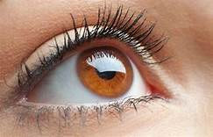
Figure 2.1: Eye Health Source: (Nagasubramani, 2018)
2.4.2 Cornea: The cornea is a layer of clear tissue at the front of the eye that helps focus light.
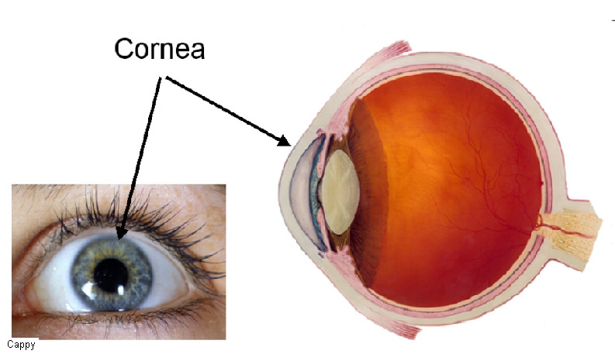
Figure 2.2: Cornea Source: (Steven, 2015)

2.4.3 Tear Ducts: Located at the corner of each eye, tear ducts drain tears secreted by the lacrimal gland to the surface of the eye. Tears keep the cornea lubricated and clear of debris.
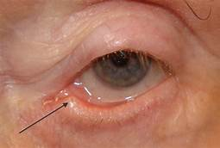
Figure 2.3: Tear Ducts Source: (Fattepur, 2016)
2.4.4 Iris and Pupil: The colored part of the eye is the iris. It is a muscle that controls the pupil, the opening in the middle of the eye that controls the amount of light coming in.
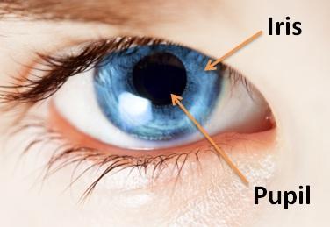
Figure 2.4: Iris and Pupil Source: (Liang, 2018)

2.4.5 Glaucoma: Glaucoma is increased pressure of the fluid inside the eye, which can cause optic nerve damage. Glaucoma is a common cause of blindness, particularly in diabetic patients.
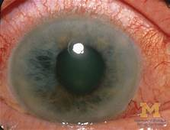
Figure 2.5: Glaucoma Source: (Rajvir, 2018)
2.4.6 Cataract: Cataract is a clouding of the lens, causing blurry or color-tinted vision. People with cataracts often report “haloes” surrounding objects that they are looking at, particularly at night. It is most common in older people, and cataracts can be removed by surgery that replaces the lens with an artificial lens.
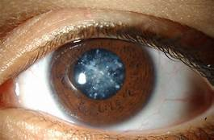
Figure 2.6: Cataract Source: (Kimbi, 2011)

Chapter Three

3.1 Research Methodology
This is a description of methods chosen to achieve the objectives of the proposed system. It will go on to describe the techniques of data collection that will be employed in the research study of the proposed systems. In order to achieve the aim and the objectives in chapter 1.
- The System Development Life Cycle (SDLC) we chose to use the iterative waterfall model. In this model, the system follows a series of events from the requirement definition, system and software design, implementation and unit testing, integration and system testing and operational maintenance.
- During each phase of the lifecycle, a set of well-defined activities are carried out for instance at the Analysis stage (Structured Analysis of Requirement) was specifically carried out in focus of the functionality of dataflow of the system. The system and structured analysis was then transformed into software design (software architecture to decompose the system into modules and representation of relationships among the modules, data structures and algorithms for the modules to be designed.
- The approach used in designing the system is the structured design approach. It consists of starting with the “Big picture” of the proposed system that is gradually decomposed into more and more detail until it is fully understood.
- The system was carefully study and understood before the development of the system and the tools which was used in design the system is PHP, HTML and MYSQL as the database.
3.2 Analysis of Data and the Existing System
This aims at objectively evaluating the existing system of diagnostics of eye treatment in the hospital with a view to highlighting its limitations. It also seeks to proffer solutions by offering a knowledgeable expert system which would aid clinicians in diagnostic procedures. The existing system of medical diagnosis eye and drug prescription in most hospitals involves manual activities. A proper diagnosis is the first step towards proper medical care. This was the consensus opinion reached by all respondents interviewed. An investigation into how diagnosis is carried out revealed that anytime patients visit the hospital, they are subjected to long waiting hours just to undergo the regular card verification and clearance. Patients queue accordingly for several hours on a first come first serve (FCFS) basis. A new patient usually registers into the hospital by filling the patient form which signifies that the person is now registered with that hospital. It also, gives the person access to own a hospital folder which is used to record basic information about the diagnoses and drug prescriptions to the patient. He/she is then referred to a doctor for examination and testing. This examination helps the doctor to determine exactly what a patient may be suffering from. Testing is a great way to find out a medical condition early before it deteriorates. However, it was the widespread practice that in attending to registered patients the attending staff usually retrieved his hospital folder using the patient’s form. This form is then sent to the doctor who peruses it, before examining the patient and carrying out the appropriate test. Any treatment proffered to the patient by the doctor must be recorded in the patient’s folder to aid future diagnostic references. This procedure is usually a long and tedious one with attendant bottlenecks.
3.3 Problems of the Existing
Some shortcomings were noticed in the existing system after thorough analysis. They include:
a. Manual documentation of patients’ records
It was noticed in the course of investigation that the existing system was heavily dependent on manual methods of entering, storing and retrieval of patients’ data. This implied patient had to wait for quite long before being referred for diagnosis.
b. Error in diagnosis:
It was discovered that in some cases, wrong diagnosis was given for diseases because they (the diseases) were relatively new and the physician had limited knowledge about it. The situation was even made worse because at the point of medical examination, the physician could not access a wider knowledge base for guidance.

c. Stalling of treatment due to doctor’s absence:
Another discovery was that patients had to wait indefinitely in the event of a doctor’s prolonged absence and sometimes, end up not accessing treatment. This has led to a further deterioration of their health conditions and in some cases resulted in death of patient.
3.4 Description of Proposed System
The proposed system is built with the benefit of an object-oriented approach. The system seeks to build a computational model of some problem domain and therefore tends to be exploratory in nature. The flow of data in the proposed system is in such a way that when a particular disease is highlighted from the disease menu, it will display an interactive submenu that includes the symptoms. The central concepts of the object oriented paradigm are introduced namely: encapsulation, inheritance and polymorphism.
Process Description
After the inputs are collected, the system analyzes the data and queries its knowledge base for the actual or related medical condition. Data mining may be conducted to examine the patient’s medical history in conjunction with relevant clinical research. Such analysis can help predict events, which can range from drug interactions to disease symptoms.

Output Analysis
The system with the aid of its knowledge base, applies rules to patient data using an inference engine and displays the results to the end user(clinician) via his monitor screen. The output here can be
- Clinician diagnosis
- Preventive and control mechanisms
- Drug prescription
3.5 Advantage of Proposed System
It is expected that with the introduction of new system, a lot of positive changes will be noticed.
- In the design of the Eye diagnostic system, conscientious effort is made to create an effective knowledge based system which would be successfully implemented into the workflow, providing the clinician with the necessary support in their decision making abilities.
- The system will also significantly improve health workers’ performance and improve patient outcome thus affecting the gross quality of health care delivery.
- The system will also significantly improve health workers’ performance and improve patient’s outcome thus, affecting the gross quality of health care delivery.
- It is expected that with the introduction new system, a lot of positive changes will be noticed.
Chapter Four
Design and Implementation of the System
  - Design of The System
The proposed system is designed in modules with each modules working together to perform the goal of system in order to enhance the performance of the existing system and ensure security in the use of expert system as earlier discussed in chapter three.
The ability to analyze and give focus to the system is explained in the following formats which are output design, input design, database design and procedure design.
4.1.1 Output Design
This is the area that deals with the kind of input to be supplied to the new or proposed system to be implemented.

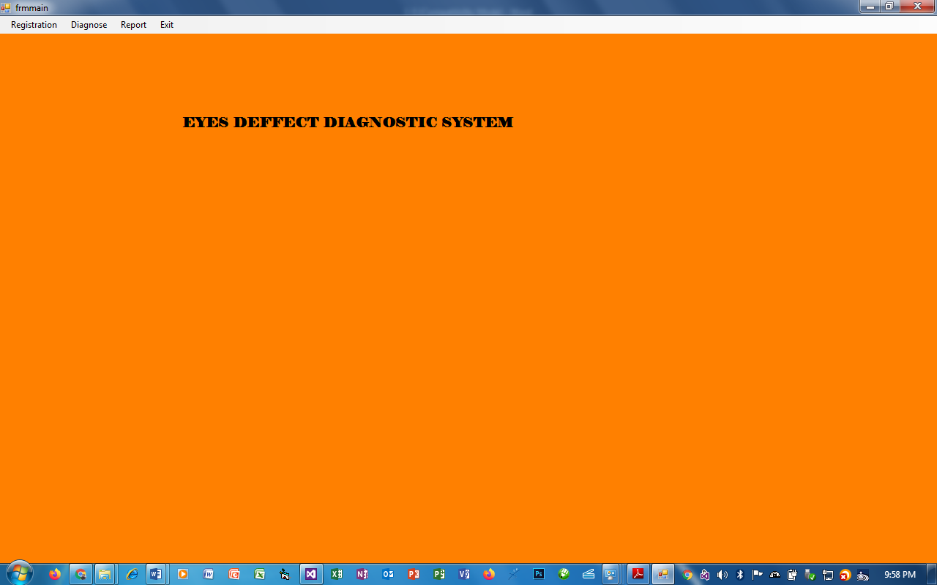
Figure 4.1: home page
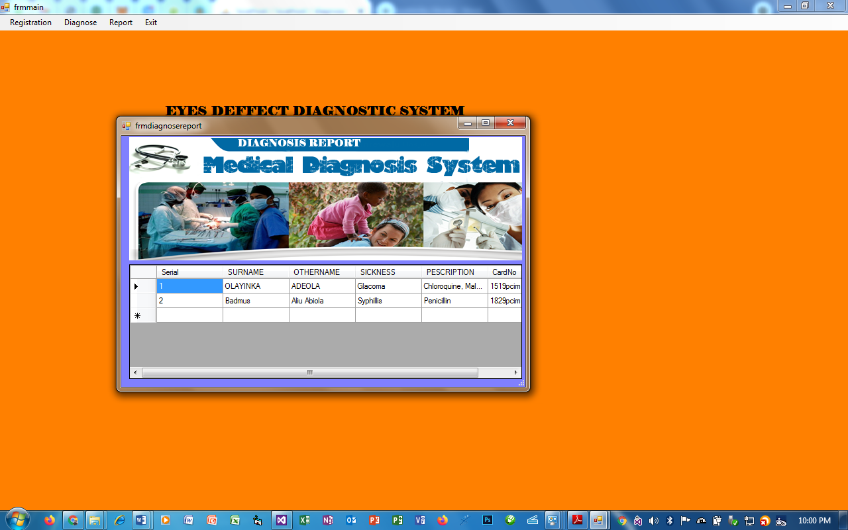

Figure 4.2: Prescription Page
4.1.2 Input Design
This is the area that deals with the description of the input of the new or proposed system to be implemented.
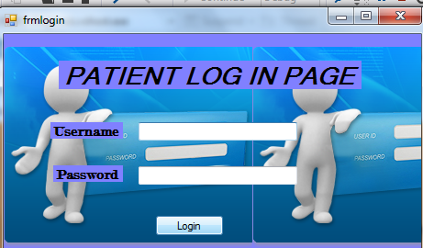
Figure 4.3: Patient login page

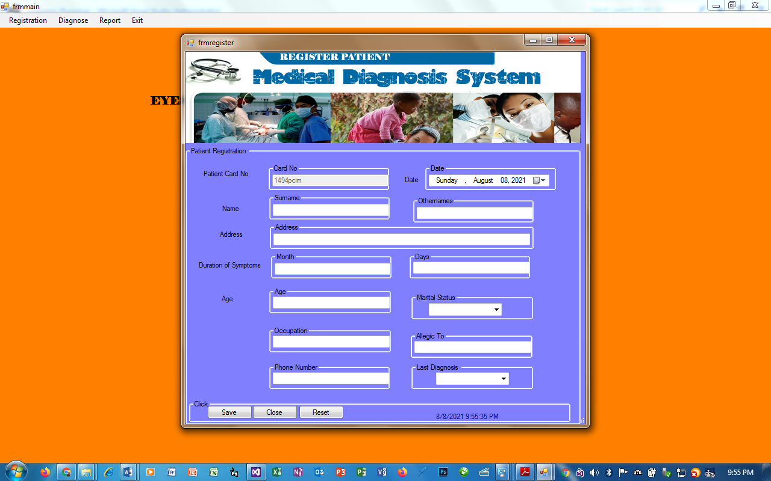

Figure 4.4: Registration page

    - Database Design
This involves the list of tables used in the database design the tables are listed as follows
Fig 4.1: Snapshot of Patient account table
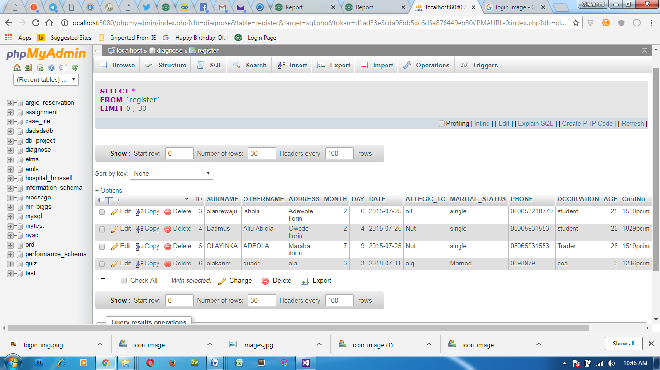
Fig 4.2: Snapshot of Treatment History
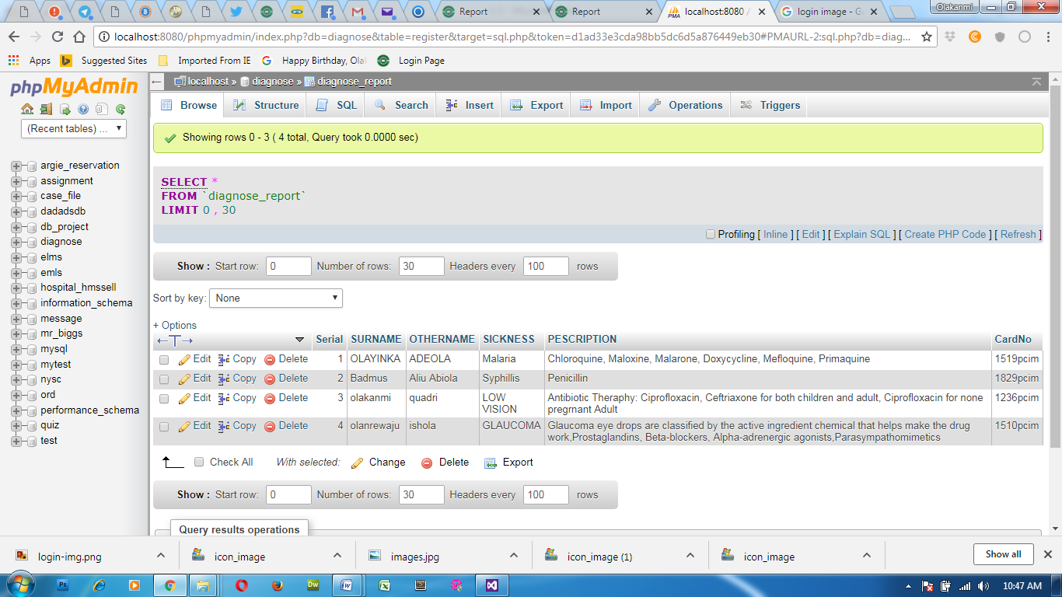
    - Procedure Design
This refers to the step by step method of using the proposed system. The proposed system comprises of five modules namely New User, Treatments Form, Diagnosis. The steps to use the proposed system are as follows
- Click on start button on the desktop.
- Point to all programs
- Select Security System and the welcome screen come up followed by the main page.
  - Implementation of the System
    - Choice of Programming Language
Visual Studio (C#) is the chosen programming language for the implementation of the proposed system because of its pedagogy and open source help when needed. As well it has a support for variety of database application like sql server, sqllite, mysql, and Microsoft access but Microsoft Access is selected.
    - Hardware Support
The hardware that is required in the successful completion of this project include monitor, CPU, keyboard, mouse, printer and an uninterrupted power supply (UPS).
    - Software Support
The software support for the design of the proposed system involves operating system, Microsoft visual basic dot net, Microsoft Access as well as anti-virus software which prevents the system from being infected by virus
    - Implementation Techniques Used in Detail
The implementation technique to be use in the system is parallels, a system that support the current system along-side with the proposed system. This means that to adopt the proposed system a paper and pen method that is currently in used will still be in existence so that a failure in the proposed system will not lead to total loss of applicants.
  - Documentation of the system
    - Program documentation
In order for the proposed system to be used on any computer system it takes the following ways
- Boot the system
- Put the software in the CD or flash drive into its appropriate drive.
- Open the content from “my computer” icon on the desktop or clicking the start button.
- Double click the set up icon from the content of the package folder in the device (flash, CD).
Follow the instruction and click on the appropriate button and the installation will be completed in a few moments.
4.3.2 Operating the System
In order for the proposed system to be used on any computer system it takes the following ways
The installed program can be use using the stated points below.
- Click on the start button on the desktop.
- Point to all program
- Select the program name i.e Expert system
4.3.3 Maintaining the System
The system is flexible enough to entertain any future amendment which might be required when the need arise. The system requires regular update which necessitates the function of an administrator for regular information that is needed in the system.
Chapter Five
5.1 Summary
The primary goal of clinical decision support systems development, as for any branch of biomedical research, is to improve the overall health of the population. electronic medical records diagnosis system may contribute to this by improving the quality of healthcare services, as well as by controlling the cost-effectiveness of medical examinations and treatment.
The ultimate acceptance of electronic medical records diagnosis system systems will depend not only on the performance of the computerized method alone, but also on how well the human performs the task when the computer output is used as an aid and on the ability to integrate the computerized analysis method into routine clinical practice. This project is well designed with reliability and efficiency as our mainstay, have come just in time to correct those weaknesses and anomalies, which exist in the existing manual method. The achievements made this design can be summarized thus;
- Result of high processing speed of the computerize system
- Patient’s records can now be retrieved easily.
- Similarly, there is also an easy access to clinical reports for research purpose and decision making

5.1 Conclusion
The coupling of expert system technology with evidence-based medicine brings together two potentially powerful methods for improving health care quality. To realize the potentials of this synergy, literature-based and practice-based evidence must be captured into computable knowledge bases, technical and methodological foundations for evidence-adaptive must be developed and maintained, and public policies must be established to finance the implementation of electronic medical records diagnosis system and to reward health care quality improvement. In the implementation of this project much has been done to eliminate data redundancy, inconsistency and measures that have been taken to improve on the integrity of the data stored in the system. The software model used is the waterfall model. Structured design was also employed in the design stage. The security of the computerized system was also employed to avoid unauthorized person or persons having access to data or the operation of the computer base system as a whole.
5.2 Recommendations
Based on the remarkable successes recorded by electronic medical records diagnosis system in robust health care delivery, this research work is therefore recommended to approved health institutions such as: hospitals, primary health centers, medical laboratories etc to further enhance diagnostic processes by clinicians hereby guaranteeing efficiency in drug or therapy prescription and ultimately ensuring effective treatment.

References

Autonomy, I. (2009). Autonomy Technology Overview. U.S.A: Macmillan Press.

Bassingthwaighte, J. B. (2000). ―Strategies for the physiome project‖ Ann Biomed Eng 28(8): 1043-

1058 Biomed

Berner, E. S. (2007). Clinical decision support systems: Theory and Practice. New York: Springer

Inc.

Bohanec, M., Zupan, B., & Rajkovič, V. (2000). Applications of qualitative multi-attribute decision

models in health care. Int J Med Inform, 58-59, (2000) 191 – 205.

Burke, J. P., & Classen, D. C. (1991). "The HELP system and its application to infection control." J

Hosp Infect 18 Suppl A: 424-431.

Bury, J., C. Hurt, et al. (2004). "A quantitative and qualitative evaluation of LISA, a decision support

system for chemotherapy dosing in childhood acute lymphoblastic leukaemia." Stud Health Technol Inform 107(Pt 1): 197-201.

Chan, K.; Felson, D.; Yood, R.; Walker, A. (1994). "The lag time between onset of symptoms and

diagnosis of rheumatoid arthritis". Arthritis and rheumatism 37 (6): 814–820.doi:10.1002/art.1780370606. PMID 8003053.

Coiera, E. (2003). Guide to health informatics. London : Oxford University Press.

Dombal, F. T., & Leaper, D. J. (1972). "Computer-aided diagnosis of acute abdominal pain." Br Med

J 2(5804): 9-13.

Doyle, B. J., & Callanan, A. (2009). "Vessel asymmetry as an additional diagnostic tool in the

assessment of abdominal aortic aneurysms." J Vasc Surg 49(2): 443-454.

Garg, A. X., & Adhikari, N. K. (2005). "Effects of computerized clinical decision support systems on

practitioner performance and patient outcomes: a systematic review." JAMA 293(10): 1223-1238.

Goldstein, M. K., & Coleman, R. W. (2004). "Translating research into practice: organizational issues

in implementing automated decision support for hypertension in three medical centers." J Am Med Inform Assoc 11(5): 368-376.

Horstmanshoff, H. F. J. (2004). Magic and Rationality in Ancient Near Eastern and Graeco-Roman

Medicine. Germany: Brill Publishers,

Johnson, P. E., Duran, A. S., Hassebrock, F., Moller, J., Prietula, M., Feltovich, P. J., & Swanson, D.

B. (1981). "Expertise and Error in Diagnostic Reasoning". Cognitive Science 5 (3): 235–283.doi:10.1207/s15516709cog0503_3. "Online Etymology Dictionary".

Treasure, W. (2011). Diagnosis and Risk Management in Primary Care: words that count, numbers

that speak. Oxford: Radcliffe Publishers.
Appendix 2: Source Listing
Public Class frmmain

Dim DataGridViewRow As DataSet

Private Sub RegisterToolStripMenuItem_Click(sender As System.Object, e As System.EventArgs) Handles RegisterToolStripMenuItem.Click
frmregister.ShowDialog()

End Sub

Private Sub ExitToolStripMenuItem_Click(sender As System.Object, e As System.EventArgs) Handles ExitToolStripMenuItem.Click
Application.Exit()
End Sub

Private Sub PatientToolStripMenuItem_Click(sender As System.Object, e As System.EventArgs) Handles PatientToolStripMenuItem.Click
frmpatientreport.ShowDialog()

End Sub

Private Sub DiagoniseToolStripMenuItem_Click(sender As System.Object, e As System.EventArgs) Handles DiagoniseToolStripMenuItem.Click
frmdiagnosis.ShowDialog()
End Sub

Private Sub DiagnoseToolStripMenuItem_Click(sender As System.Object, e As System.EventArgs) Handles DiagnoseToolStripMenuItem.Click
frmdiagnosereport.ShowDialog()
End Sub

Private Sub AboutToolStripMenuItem_Click(sender As Object, e As EventArgs)
End Sub

Private Sub frmmain_Load(sender As Object, e As EventArgs) Handles MyBase.Load

End Sub
End Class
Public Class frmlogin

Private Sub Button2_Click(sender As System.Object, e As System.EventArgs) Handles Button2.Click
On Error Resume Next
If txtpass.Text = "admin" And txtusername.Text = "admin" Then
Me.Dispose()
frmmain.Show()
Else
MsgBox(" you are not grant access to the program")
End If
End Sub

Private Sub frmlogin_Load(ByVal sender As System.Object, ByVal e As System.EventArgs) Handles MyBase.Load

End Sub
End Class
Imports MySql.Data.MySqlClient
Imports System.Data.Sql
Imports System
Imports System.Data
Imports System.Text.RegularExpressions
Public Class frmdiagnosis
Dim connectionString As String = "Server=localhost; User Id=root; Password=; Database=diagnose"
Dim SQLConnection As MySqlConnection = New MySqlConnection
Dim oDt_sched As New DataTable()
Public Function rrefresh()
Dim areturn As Boolean
txtoname.Text = ""
txtsname.Text = ""
txtsearch.Text = ""
txtsick.Text = ""
txtpesc.Text = ""
chkapp.Checked = False
chlchilly.Checked = False
chkfat.Checked = False
chkconst.Checked = False
chkdia.Checked = False
chkmus.Checked = False
chkfever.Checked = False
chksore.Checked = False
Me.Size = New Size(545, 231)
txtsearch.Focus()
Return areturn
End Function
Public Function InsertCar() As Boolean
'Code for a button where the InsertCar() function is called at the beginning//

SQLConnection = New MySqlConnection()
SQLConnection.ConnectionString = connectionString
Dim iReturn As Boolean
Using SQLConnection As New MySqlConnection(connectionString)
Using sqlCommand As New MySqlCommand()
With sqlCommand

.CommandText = "INSERT INTO diagnose_report (`SURNAME`, `OTHERNAME`, `SICKNESS`, `PESCRIPTION`, `CardNo`) values (@SN,@ON,@SK,@PS,@CN)"
.Connection = SQLConnection
.CommandType = CommandType.Text
.Parameters.AddWithValue("@SN", txtsname.Text)
.Parameters.AddWithValue("@ON", txtoname.Text)
.Parameters.AddWithValue("@SK", txtsick.Text)
.Parameters.AddWithValue("@PS", txtpesc.Text)
.Parameters.AddWithValue("@CN", txtsearch.Text)

End With
Try
SQLConnection.Open()
sqlCommand.ExecuteNonQuery()
iReturn = True
Catch ex As MySqlException
MsgBox(ex.Message.ToString)
iReturn = False
Finally
SQLConnection.Close()
End Try
End Using
End Using

Return iReturn

End Function
Private Sub Button1_Click(sender As System.Object, e As System.EventArgs) Handles Button1.Click
If (txtsearch.Text <> "") Then

Dim query As String = "select * from REGISTER where CardNo like '%" + txtsearch.Text + "%'"
Dim connStr As String = "Server=localhost; User Id=root; Password=; Database=diagnose"
Dim connection As New MySqlConnection(connStr)
Dim cmd As New MySqlCommand(query, connection)
connection.Open()
Dim reader As MySqlDataReader
reader = cmd.ExecuteReader()
If reader.Read() = True Then

txtsname.Text = reader.Item("SURNAME").ToString
txtoname.Text = reader.Item("OTHERNAME").ToString
Me.Size = New Size(545, 581)
Else
MsgBox("You CAN ONLY DIAGNOSE REGISTERED PATIENT,Search with PATIENT ID ", , "DIAGNOSIS")
Me.Size = New Size(545, 231)
txtsearch.Focus()
End If

Else
MsgBox("You CAN ONLY DIAGNOSE REGISTERED PATIENT,Search with PATIENT ID ", , "DIAGNOSIS")
Me.Size = New Size(545, 231)
txtsearch.Focus()

End If
End Sub

Private Sub frmdiagnosis_Load(sender As System.Object, e As System.EventArgs) Handles MyBase.Load
Me.Size = New Size(545, 231)
txtsearch.Focus()
End Sub

Private Sub TextBox2_TextChanged(sender As System.Object, e As System.EventArgs) Handles txtpesc.TextChanged

End Sub

Private Sub Button2_Click(sender As System.Object, e As System.EventArgs) Handles Button2.Click
If chkhead.Checked = True Or chlchilly.Checked = True Or chkfever.Checked = True Then
txtsick.Text = "GLAUCOMA"
txtpesc.Text = "Prostaglandins Capsule, 2 Times A day 'Morning and Night'"
ElseIf chlchilly.Checked = True Or chktire.Checked = True Or chkconst.Checked = True Then
txtsick.Text = "CATARACT"
txtpesc.Text = "L-lysine salt of bendazac, To be taken everyday before going to Bed for Seven days"
ElseIf chksore.Checked = True Or chkhead.Checked = True Or chkfever.Checked = True Or chkswl.Checked = True Or chkfat.Checked = True Then
txtsick.Text = "COLOR BLINDNESS txtsick.Text = "GLAUCOMA"
txtpesc.Text = "Prostaglandins Capsule, 2 Times A day 'Morning and Night'"
ElseIf chlchilly.Checked = True Or chktire.Checked = True Or chkconst.Checked = True Then
txtsick.Text = "CATARACT"
txtpesc.Text = "L-lysine salt of bendazac, To be taken everyday before going to Bed for Seven days"
ElseIf chksore.Checked = True Or chkhead.Checked = True Or chkfever.Checked = True Or chkswl.Checked = True Or chkfat.Checked = True Then
txtsick.Text = "COLOR BLINDNESS txtsick.Text = "GLAUCOMA"
txtpesc.Text = "Prostaglandins Capsule, 2 Times A day 'Morning and Night'"
ElseIf chlchilly.Checked = True Or chktire.Checked = True Or chkconst.Checked = True Then
txtsick.Text = "CATARACT"
txtpesc.Text = "L-lysine salt of bendazac, To be taken everyday before going to Bed for Seven days"
ElseIf chksore.Checked = True Or chkhead.Checked = True Or chkfever.Checked = True Or chkswl.Checked = True Or chkfat.Checked = True Then
txtsick.Text = "COLOR BLINDNESS txtsick.Text = "GLAUCOMA"
txtpesc.Text = "Prostaglandins Capsule, 2 Times A day 'Morning and Night'"
ElseIf chlchilly.Checked = True Or chktire.Checked = True Or chkconst.Checked = True Then
txtsick.Text = "CATARACT"
txtpesc.Text = "L-lysine salt of bendazac, To be taken everyday before going to Bed for Seven days"
ElseIf chksore.Checked = True Or chkhead.Checked = True Or chkfever.Checked = True Or chkswl.Checked = True Or chkfat.Checked = True Then
txtsick.Text = "COLOR BLINDNESS txtsick.Text = "GLAUCOMA"
txtpesc.Text = "Prostaglandins Capsule, 2 Times A day 'Morning and Night'"
ElseIf chlchilly.Checked = True Or chktire.Checked = True Or chkconst.Checked = True Then
txtsick.Text = "CATARACT"
txtpesc.Text = "L-lysine salt of bendazac, To be taken everyday before going to Bed for Seven days"
ElseIf chksore.Checked = True Or chkhead.Checked = True Or chkfever.Checked = True Or chkswl.Checked = True Or chkfat.Checked = True Then
txtsick.Text = "COLOR BLINDNESS "
txtpesc.Text = ", Colour filters or contact lenses can be used in some situations to enhance the brightness,"

Private Sub frmlogin_Load(ByVal sender As System.Object, ByVal e As System.EventArgs) Handles MyBase.Load

End Sub
End Class

