PERFORMANCE EVALUATION OF MULTI-OIL EXPRESSION MACHINE ON WALNUT SEED (Tetracarpedium Conophorum)

BY

OLANIYI, Temitayo Victoria
HND/23/ABE/FT/0106

DEPARTMENT OF AGRICULTURAL AND BIO-ENVIRONMENTAL ENGINEERING INSTITUTE OF TECHNOLOGY, KWARA STATE POLYTECHNIC, ILORIN.

INPARTITAL FULFILLMENT OF REQUIREMENT FOR THE AWARD OF HIGHER NATIONAL DIPLOMA (HND) IN AGRICULTURAL AND BIO-ENVIRONMENTAL ENGINEERING TECHNOLOGY.

JULY, 2025

DECLARATION
I hereby declare that this research project titled: Performance Evaluation of Multi-oil Expression Machine on Walnut Seed (Tetracarpedium Conophorum) using Mechanical oil Expeller is my own work and has not been submitted by any other person for any degree or qualification at any Higher Institution. I also declare that the information provided therein are mine and those that are not mine are properly acknowledged.

________________ __________________
Name of Students Date and Signature

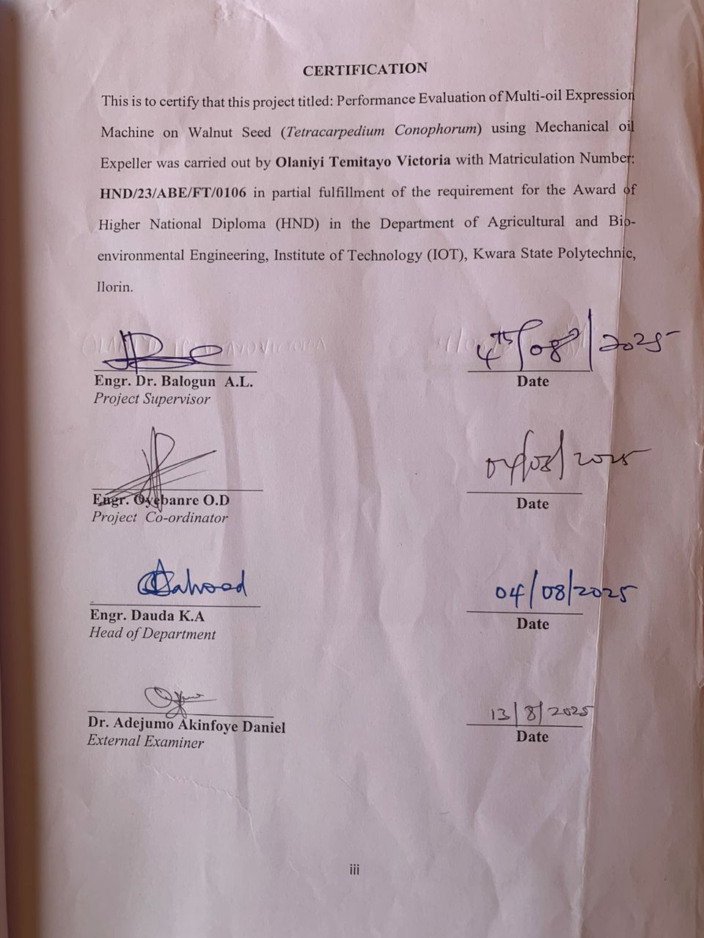
CERTIFICATION
This is to certify that this project titled: Performance Evaluation of Multi-oil Expression Machine on Walnut Seed (Tetracarpedium Conophorum) using Mechanical oil Expeller was carried out by Olaniyi Temitayo Victoria with Matriculation Number: HND/23/ABE/FT/0106 in partial fulfillment of the requirement for the Award of Higher National Diploma (HND) in the Department of Agricultural and Bio-environmental Engineering, Institute of Technology (IOT), Kwara State Polytechnic, Ilorin.

_____________________ _______________
Engr. Dr. Balogun A.L. Date
Project Supervisor

______________________ ______________
Engr. Oyebanre O.D Date
Project Co-ordinator

______________________ ______________
Engr. Dauda K.A Date
Head of Department

________________________ ______________
Dr. Adejumo Akinfoye Daniel Date
External Examiner
DEDICATION
This project is dedicated to Almighty God and to my beloved parent Mr. Ojewande Olaniyi and Mrs Olaniyi Abosede who has been standing as a mentor to me, I say thank you ma and sir, God bless you.

ACKNOWLEDGEMENT
My thanks goes to the Almighty God, for his love, care and protection over me and my family. I express my profound gratitude to my project supervisor, in person of Engr. Dr. A.L. Balogun for dedicating his time in reading through this manuscript and making valuable corrections and for his fatherly advice, I say a big thank you and God bless.
Also to the entire staff of Agricultural and Bio-Environmental Engineering Technology of Kwara State Polytechnic, Ilorin, Engr. Mrs Olayaki, Engr. Obalowu, Engr. Mrs. Utman, Engr. Mrs Onipede, and to my HOD, Engr. Dauda K.A. and I also appreciate the effort of Engr. Ahmed Kazeem Jatto.
I really appreciate the selfless love from my fiancée in person of Idogbe Olayemi Philip for his support and encouragement when I needed it most. I say a big thank you.
To my project partner, Abegunde Victorial Temitope, Omotosho Samson and Adebayo Ibrahim it was really great working with you and also to all my wonderful HND II graduate of Agricultural and Bio-Environmental Engineering Technology Department of set 2024/2025, thanks for your support. I love you all.

TABLE OF CONTENT
Title page i
Declaration ii
Certification iii
Dedication iv
Acknowledgment v
Table of Content vi
List of Table viii
List of Plate ix
Abstract x
CHAPTER ONE
1. Introduction 1
1.1 Background to the Study 1
1.2 Problem Statement of Study 3
1.3 Aims and Objectives of the Study 3
1.4 Justification of the Study 3
1.5 Scope of the Study 4
CHAPTER TWO
2. Literature Review 5
2.1 Oil-Seeds and Nuts. 5
2.2. Oil Extraction Process 5
2.3 Modern Methods of Extracting Oil 12
2.4 Composition and Uses of Walnut 14
2.5 Ecological Requirement of Walnut Plant. 15
2.6 Oil-Bearing Seed Processing Technologies 16
2.7 Clarification and Refining of Oil Extracted 18
2.8 Review of Previous Studies on Oil-bearing Seeds 18
CHAPTER THREE
3. Materials and Method 21
3.1 Materials 21
3.2 Methods 23
CHAPTER FOUR
4. Results and Discussions 27
4.1 Results 27
4.2 Discussions 27
CHAPTER FIVE
5. Conclusions and Recommendations 29
5.1 Conclusions 29
5.2 Recommendations 29
References

LIST OF TABLE
Table 2.1 Oil-seed Processing Technologies 17
Table 4.1 The summary of the result obtained 27

LIST OF PLATE
Plate 3.1. Electrical Laboratory Oven 21
Plate 3.2 Digital Weighing Balance 21
Plate 3.3: Stop watch 22
Plate 3.4: Oil Expeller machine with instrumentation 22
Plate 3.5: Tachometer 23
Plate 3.6a: Walnut Plant 23
Plate 3.6b: Walnut Seed 23

ABSTRACT
The performance evaluation on mechanically expressed walnut oil was investigated at the Department of Agricultural and Bio-Environmental Engineering, Kwara State Polytechnic, Ilorin. The input variables used for the study were machine speed at four levels (30, 50, 70, and 90 rpm). The moisture content of 15% was made to be constant while the feed rate of 1kg was equally made constant. The pressing time varied between 0.17 to 0.37hr. The result revealed that the highest oil yield of 41% was obtained at machine speed of 30rpm and throughput capacity of 2.05kg/hr with pressing time of 20minute. The lowest oil yield of 12% was obtained at machine speed of 90rpm and throughput capacity of 0.71kg/hr. The machine performed satisfactorily but more work should be carried out on other factors to improve the oil recovery and efficiency of the machine and minimize the expression loss.

CHAPTER ONE
INTRODUCTION
1.1 Background of the Study
Oil extraction is the process of recovering oil from oil-bearing agricultural products through manual, mechanical, or chemical extraction (Ibrahim and Onwualu, 2005). The agricultural products are classified into oil seeds (cotton, castor, sunflower etc), nuts (coconut, groundnut, sheanut, etc.) and Mesocarps or fruits (oil palm). Plants bearing these agricultural Products have greatly contributed to the economic development of many countries especially the development of West African Countries where the products are grown for commercial purposes (Ibrahim and Onwualu et al, 2005). The many types of oil that can be obtained from these products, only few are very significant in terms of world production and traded as major commodities, however the oil extracted from these Products have diverse domestic and industrial uses (Ibrahim and Onwualu et al, 2005).
The oil serves as a major source of vegetable oil that constitutes a good percentage of meal in the diets of common people. The oil as well as the by - Products are also useful as food and non-food materials for the production of snacks, cake, margarine, biscuit, detergent, plastics, etc (Ibrahim and Onwualu et al, 2005). Oil production is important not only among small-to- medium scale industrialists, but also to rural populace, employing quite a substantial workforce, serving as a source of income to many communities engaging in the exercise (Ibrahim and Onwualu, 2005). African Walnut (Tetracarpidium) is a member of the euphorbiaceae family. It is found in the west parts of Eastern and Western Nigeria as well as Western Africa in general. It is known in Eastern Nigeria as Ukpa (Igbo), Western Nigeria as "Awusa or Asala" (Yoruba),"Okhue or Okwe" (Edo) (Dauda, 2020)· African Walnut (Tetracarpidium) is a climbing Shrub of about 10 -20 ft long, it is normally planted under an Indigenous tree so That can Provide Strong support for the heavy weight of the climber when fully established on the crown of the tree, and in some cases where they cannot be harvested manually, they are left till full maturation after which the pods fall off and are picked, removed from The rotten pods, Washed and sold in the market (Dauda, 2020).
The walnut shells could be black or brown from the plant the nut is whitish upon cracking from the shell and there is usually a thin layer in between two halves of the nut when it is divided into two equal parts (Ayoola, 2011). Studies have indicated that African walnut is rich in protein, fat and carbohydrate but low in fibre and ash contents (Ayoola, 2011). Research has proved nuts to be very good sources of Vitamins A, B1, B2, B6, E, folate, Sodium, Potassium, manganese, copper, chloride, iron and ascorbic acid. The green hulls or the immature fruits are found as good sources of Vitamin C. The nut is a good source of energy as it has about (16.9%) Carbohydrate and Calories of about 600. It is also an excellent source of poly unsaturated fatty acids such as alpha - linolenic acid (ALA) (Dauda, 2020). The nuts of walnut (Tetracarpidium) is an excellent source of anti- inflammatory omega-3 essential fatty acids. In terms of phytonutrients, walnuts contain antioxidants and anti-inflammatory Compounds including more than a dozen Phenolic acids, and a wide variety of flavionides. It also contains a very high composition of vitamin E, most especially, gamma-tocophenol (Kanu, 2015). Expelling has been an operation Prevalant in India for several centuries and still continues to support rural households.

1.2 Problem Statement of the Study.
Most of the expeller in the market are too complex and not suitable for small scale processors. The farmers cannot even afford it and the spare parts are not readily available. The study aim at using an existing ediginous oil expeller suitable for the expression of oil from walnut to maximize the oil yield, expression efficiency and minimized expression efficiency and minimized expression loss and Energy used during the expression process. The process will improve the quality and quantity of oil expression and reduce time and labour input.
1.3 Aim and Objectives of the Study.
The aim of the study is to carryout oil expression using walnut seed in order to obtain quality oil for end users.
The Specific objectives are to:
- study an existing multi oil expression machine
- Evaluate the machine on walnut seed
1.4 Justification of the Study
The expression of oil from oil bearing seeds is an important processing operation to provide quality grade oil for human utilization. The traditional method of extraction oil from oil seed, is time consuming, tedius, unhygenic and with low oil recovery. The use of oil expeller in the recovery of oil from walnut will improve the quality and quantity of oil expressed from the nut. This process will go a long way in providing job opportunity for the rural farmer that engage in the business this will totally improve economic development and growth of the community that involved in the production of walnut into oil product. Adopting this machine for the oil expression will solved the problem associated with the traditional methods of oil extraction process.
1.5 Scope of the Study
The project work is limited to:
- Africa Walnut seed
- Processing factors (i.e moisture content, heating temperature, Duration of roasting)
- Output parameter (i.e oil yield, extraction efficiency and extraction loss)

CHAPTER TWO
2. LITERATURE REVIEW
2.1 Oil-Seeds and Nuts.
Oil-bearing seeds and nuts are found in the roots, stems, fruits and leaves of some tropical and sub-tropical plants. They are mostly grown as annual crops and constitute the major source of vegetable oil for domestic and industrial uses. Some of the most common oil seeds and nuts Cultivated in The tropics, Subtropics and temperate regions include groundnut, sheanut, castor, sunflower, sesame, oil Palm (Ibrahim and Onwualu, 2005).
2.2 Oil Extraction Process.
Oilseed is a process of extracting oil from various oil bearing materials such as soyabeans, canola or rapeseed, sunflower seeds, peanuts, walnuts, almonds and many others. Some processors may use the mechanical expression process using a screw press also known as an or expeller, while others use solvent extraction or other equipment. Each processing method has its own advantages and disadvantages (Siraj and Zakiuddin, 2016).
Extraction of oil from oil- bearing products could be done in two major ways: traditional and improved methods. The traditional method is usually a manual process and involves preliminary processing and hand pressing. The improved method consist of chemical extraction and mechanical expression. The chemical extraction method requires the use of organic solvents to recover the call from the products. The mechanical method involves the application of pressure to already pre-treated- oil bearing products. It employs the use of devices like screw and hydraulic presses as a means of applying the pressure. Other mechanical devices include oil expellers and improved ghanis which are used for seeds and nuts because of the high pressure required to express the oil (Ibrahim and Onwuolu, 2005) reported that the field and quality of the oil extracted depend on the content adjustment, heating time, pressure application, operating temperature.
Although processing of oil-seeds, nuts and fruit for oil production is achieved by both traditional and improved techniques, oil extraction techniques have not changed significantly over the years as the bulk of this trade is still in the hands of rural women employing traditional systems only. Apart from discouraging many oil producers from continuing with the trade especially at old age, this difficult task also limits the capacity and oil fields of those determined to continue with the trade. (IAR, 1992). Accessibility to modern equipment and spare parts, degree of complexity of the equipment, maintenance and the availability of power source constitute other major setbacks.
2.2.1 Methods of Oil Extraction.
Extraction of oil from oil-bearing seeds could be done in two major ways, traditional and Improved methods.
2.2.2 Traditional Methods of Extracting Oil.
Traditional oil expellers are simple mechanical devices that are hand and animal operated. These equipment’s work on the principle of mechanical compression and require no electricity fuel for operation. They are fabricated using inexpensive components that can often be manufactured locally (Siraj and Zakiuddin, 2016).
Types of traditional expellers are;
(i). Indigenous method (Traditional Domestic Methods).
(ii). Granis (Granite Grani, Wooden Ghani, Bengal Ghani).
(iii). Presses (Plate presses and Ram presses).
(iv). Screw Presses
(v). Hydraulic Press.

(i) Indigenous Method (Traditional Domestic Methods).
Hot water floatation is probably the simplest method and is still used in many rural areas (figure 2.1) seeds are ground manually unless a local mill is both accessible and affordable. The paste is heated, alone at first, and then with boiling water. The mixture is stirred and brought to the boil. After boiling, the mixture is allowed to cool during which time the oil gathers at the top and is scooped off. In traditional methods of processing oil seeds the extraction efficiency is about 40%. (extraction efficiency refers to the percentage of oil extracted based on the total theoretical content, which of course is never in practice obtained) (TDRI, private communication) The extraction efficiency is generally low, and problems often occur with the formation of oil - water emulsions which makes the final separation difficult. In some cases salt is used to break such emulsions. It can be used to process oil seeds at the village level as: groundnut Sunflower seeds, Palm Kernels, coconuts, Sesame seed, rape - seed, castor seed and sheanuts (Siraj and Zakiuddin, 2016).

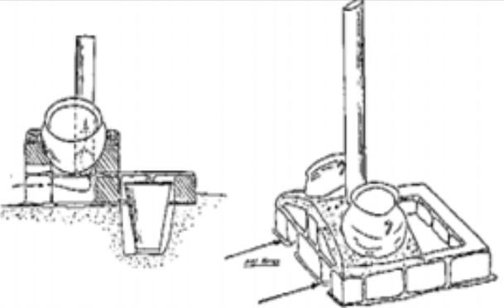
Figure 2.1 Heating Oven (KIT)
(ii) Ghanis (Granite Ghani, Wooden Gnani, Bengal Gnani).

Ghanis (figure 2.2) originated in India where they are primarily used to express oil from mustard and sesame seeds, although in some cases they can be used for coconut and groundnut processing. Traditionally ghanis are operated by animals and can be manufactured locally. They consist of a wooden morter and wood or stone pestle, the morter is fixed to the ground while the pestle, driven by one or a pair of bullocks or drought animals is located in the morter where the seeds are crushed by friction and pressure. Depending on the size of mortal and types of seeds, an animal powered ghani can express about 10kg of seeds every two hours (TDRI, Private communication).
The grani operated by one bullock (The equivalent of 0.35kw) can process 5kg oilseed in about one hour: Hence 0.3515 or 0.07kwh is required to process 1kg of an oilseed into oil, this energy consumption is about equal to the maximum amount of energy required by small oil expellers (Siraj and Zakiuddin, 2016).

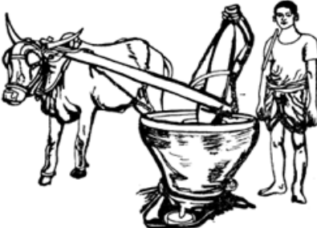

Figure 2.2 Animal Powered Extraction (Ghani)

(iii) Application of oil Expression
Mechanical presses are discuss below:
(a) Plate Presses
Many different types of mechanical press are in use but they fall into two basic types, plate presses and rams presses. In the first type a plate or piston (figure 2.3) is forced into a perforated cylinder containing the oil bearing material by means of a worm. In some cases hydraulic jacks have been used. Care is needed to make sure there is no leakage of hydraulic fluid that might contaminate the edible oil (Siraj and Zakiuddin, 2016).

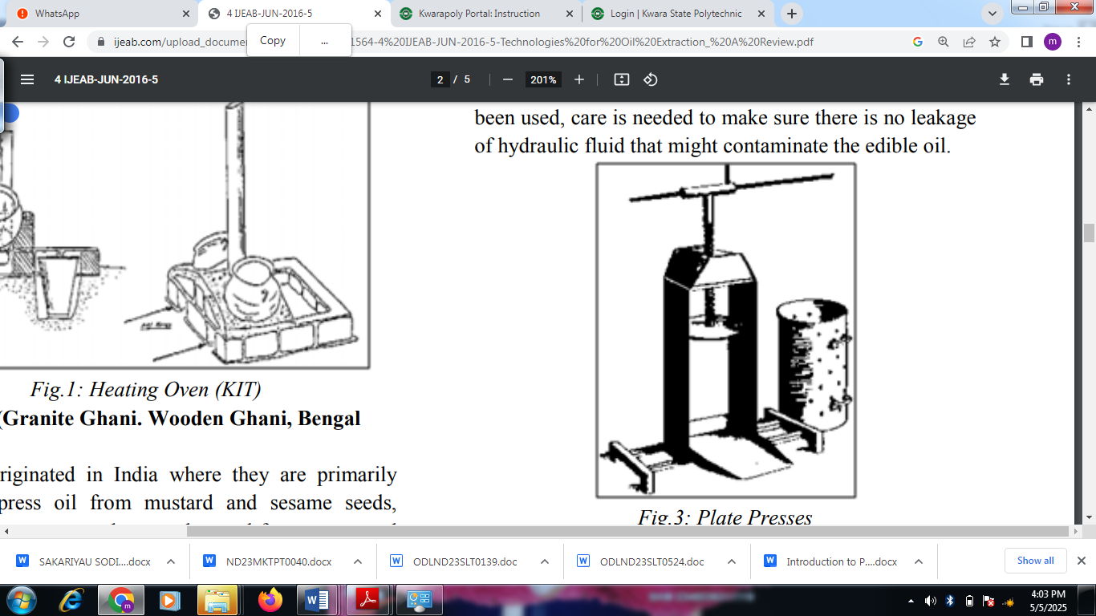

Figure.2.3: Plate Presses

(b) Ram Presses
The ram press (figure 2.4) is a manually operated mechanical press capable of pressing a range of oil -seeds including sunflower, sesame and groundnuts, as well as seeds from pumpkin, rape, water melon, mustard, and Jatropha Curcas. The ram press can be operated continuously without the need to remove cake (Siraj and Zakiuddin, 2016). The capacity of the press is 14 litres of oil for an eight-hour shift, which approximately amounts to pressing a 55-kg bag of seeds, although the capacity wound depend on the type oilseed and its temperature at the time of pressing. Operation of the presses very simple and therefore an operator can be trained to use the equipment in about one hour, Maintenance is limited to simple routine cleaning and general checks (Siraj and Zakiuddin, 2016).

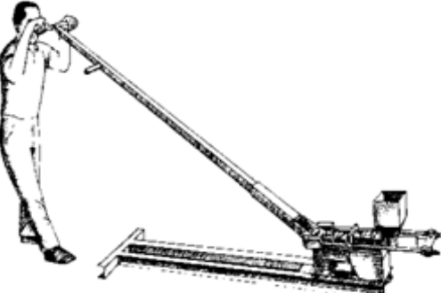

Figure. 2.4: Ram Presses
(iv) Screw Press
In screw press (figure 2.5) that is manually operated the substance from which the oil is to be expressed is Pressed slowly and with maximum pressure by plunger (round steel plate), forced down by a screw and into a cylinder with a large number of small holes (Siraj and Zakiuddin, 2016).
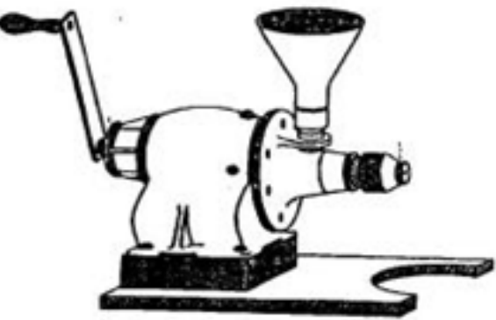

Figure.2.5: Screw Press

(v) Hydraulic Press.
In Hydraulic Press (figure 2.6) that can be manually or power operated, pressure is exerted by hydraulic device such as a lorry jack. They require a heavy, rigid frame structure, because of the weight of such a structure the press must be stationary and cannot be moved as easily as a screw press. Hydraulic Presses Can Process mesocarp (fruits), oil - seeds and nuts are as they generate greater pressure than a screw essential to ensure that hydraulic fluid, which may be toxic, does not come into contact with the food stuff. (Siraj and Zakiuddin, 2016).

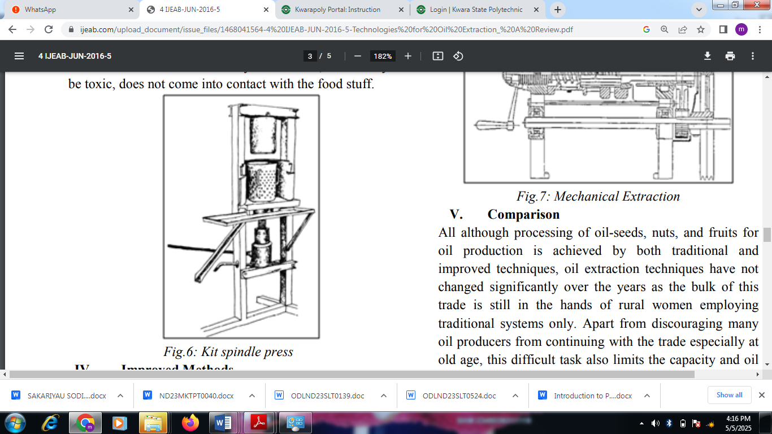
Figure. 2.6: Kit spindle press
2.3 Modern Methods of Extracting Oil
Modern methods Involves the application of pressure to already pre-treated oil-bearing products as reported by.
The modern methods of oil extraction involve solvent, supercritical (CO₂) and mechanical methods.
(1). Solvent Extraction.
Solvent extraction is a common method of extraction of oilseeds that involves using petroleum based solvents, such as hexane, to extract the oil. The seeds are first ground flaked and conditioned, and then the solvent is added to the material in the solvent extractor. The solvent separates dissolves the oil from the solids. The oil distillation process: The solids also have to be desolventized in a separate desolventizer - toaster (DT) (Siraj and Zakiuddin, 2016).
Solvent extraction is generally considered to be a more efficient method of extraction than mechanical pressing for larger capacity processes above 500 tons per 24hour day, and it can be used to extract oil from a wide variety of oilseeds (Siraj and Zakiuddin, 2016). This process can typically reduce the oil content in the solids to less than 2.0 % and on some materials down to 1.0 % or less (Siraj and Zakiuddin, 2016). However the use of solvents can be a safety concern, and it can also affect the quality of the resulting oil as the oil is exposed to high temperature in the final stage to evaporate out the hexane and minute amounts of solvents can remain.
(ii) Supercritical CO₂ Extraction.
Supercritical CO₂ extraction is a relatively new method of oilseed extraction that uses carbondioxide, liquified under high pressure as a solvent. The seeds are first ground into a fine powder. Then they are exposed to supercritical CO₂, which separates the oil from the solids. The resulting oil is then separates from The CO₂ (Siraj and Zakiuddin, 2016).
This process is typically used for specialty, high value products and operates at much lower Capacities than solvent extraction, supercritical CO₂ extraction of oilseeds is generally considered to be a safe and efficient method of extraction that produces high -quality oil (Siraj and Zakiuddin, 2016).. However, it requires specialized equipment, which can be expensive, and it may not be suitable for all types of oilseeds.

(iii) Mechanical Extraction.
All headings mechanical method (figure 2.7) involves the application of pressure to already pre-treated oil bearing products. The essential components of a typical small-scale expeller is driven either by an electric motor or by a diesel engine. At the heart of the machine is powered worm shaft which rotates inside a closely cage. The oil-seed is fed continuously into the press through a hopper is crushed as it is transported through the cage by the worm shaft (Siraj and Zakiuddin, 2016)..
Pressure is exerted on the system by restricting the gap at the end of the cage through which the oil cake is discharged from the press, the expelled oil drains out of the cage through small gaps (Siraj and Zakiuddin, 2016).

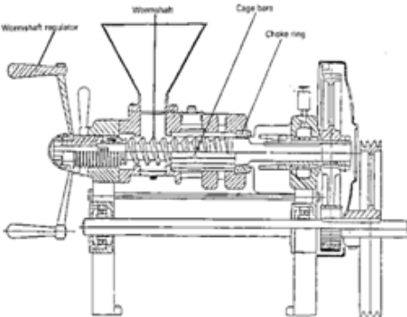
Figure. 2.7: Mechanical Extraction

2.4 Composition and Uses of Walnut.
The composition and uses of walnut is as discussed below; kernel of walnut, the edible portion, constitute about half the total fruit weight and its composition. Walnut is rich in proteins, fat and minerals and is concentrated source of energy. It contains a good amount of various vitamins of B group and is the richest in vitamin B-6 among all the other nuts (Ozakhan, 2005). The walnut leaves can be used as an Infusion as well as eyewash. It is beneficial for skin disorders and irritations in the eyes, and can also be used to stimulate poor appetite. At the same time, infusions prepared from the walnut leaves can be applied for skin diseases like eczema or to heal wounds and scratches. A tincture prepared with the walnut leaves and water is useful in treating hair loss. People suffering from baldness may use infusions as a battle for hair loss for effective results (Ozakhan, 2005). Oil prepared from the walnut nut is immensely beneficial for women suffering from menstrual dysfunction. Walnut oil is almost colourless or pale yellow with pleasant aroma. It is used for edible purposes, artists oil colours, varnishes and soap making. The kernals contain about 60 -70 % fat and oil, the major components of which are conoleic acid (49.2%), oleic acid (25.7%) and linolenic acid (18.2%).

Walnut shell flour is extensively used as an ingredient in plastic fillers, battery cases, moulding resin forms, industrial tice and as insecticide spreader. It is also used on large scale adilutents for agricultural insecticides as lignin and cutin contents of the flour easily absorb and retain active toxic chemicals (Ozkhan, 2005). The inner bank of the walnut may be used both as decoction as well as tincture. The decoction may be used to heal constipation, slow digestion, as a stimulant for the liver or even to cure skin diseases (Ozkhan, 2005).
2.5 Ecological Requirement of Walnut Plant.
It requires Cool Period in autum to promote leaf fall and the physiological of plant hardening and induction of formancy. The plant can tolerate as low as – 11ºc during deep dormancy without serious damage (Ozkhan, 2005) but late spring frosts are detrimental. As soon as growth commences after dormancy, the temperature even two or three degree below freezing point (0℃) kill leaves, shoots and flowers and thus resulting into crop failure (Ozkhan, 2005).
The tree normally grows well in cool climates that are free from frost during spring but does not thrive in areas with hot cummers (Ozkhan, 2005). It is not recommended in areas where late spring or early fall frost is common or freezing temperature kills the growing point of walnut trees and severely affect production. High temperature at 38% cause sun burning of hulls black nuts, severe damages are further aggravated if the humidity is low and temperature exceeds 40℃ (Ozkhan, 2005). The Walnut requires 760 - 800mm rainfall or irrigation equivalent to obtain high yield avoid planting walnut in drought prone areas spring rainfall is associated with increased problem from Walnut blight (Ozkhan, 2005). The plant can grow and crop much slowly if exposed to persist winds. It is also susceptible to lime bitterness. Thus shelter is essential to promote good growth during establishment (3 years). Walnut requires slightly acidic soils between PH 5.5-6.5 (Ozkhan, 2005). It is prone to zinc and boron deficiencies, hence select a site where recent soil analysis show reasonable levels of zinc and slightly acidic PH. The walnut grows best on deep, friable loamy soil and silt or clay loam well supplemented with lime and rich in humus, where roots can develop to a depth of 3-4m (Ozkhan, 2005).
2.6 Oil-Bearing Seed Processing Technologies
In most of the developing countries, there has been a steady rise in the demand of edible oil, both for domestic and industrial uses (Siraj and Zakiruddin, 2016). Therefore, continuous review of existing methods of oil expression or extraction from oil-bearing agricultural products will no doubt continue to reveal the current state of the art especially on aspects that require further improvement (Siraj and Zakiruddin, 2016). The different methods that are used to extract oil from oil bearing seeds are listed in table 2.1. All these technologies have been applied in Eastern and Southern Africa for seeds including cottonseed, Soyabean, Sunflower and groundnut (Siraj and Zakiruddin, 2016).

Table 2.1: Oil-seed Processing Technologies
Technology | Description | Capacity
Solvent | Industrial technology; oil seeds rolled to reduce them to flakes, which are dissaved in a solvent that extracts the oil | 120 tons/day
Intermediate | Power-driven technology. Oil seeds continuously fed, pre-heated, crashed and pressed (Cscrew expellers) technology to expel oil as it pass through the machine | (90 Kg/h)
Oil-Plate method | plunger /cylinder Presses, either screw operates or hydraulically operates | 15kg/h
Indigenous methods | Traditional domestic method: pounding, boiling and skimming | few kg per day
Lever Operated Ram Presses | Manually Operates mechanical press, seeds are fed continuously, and oil separates from cake. | 55kg/shift
Source: Siraj and Zakiruddin, 2016
Out of the five methods, The ram press technology is the most adaptable to small-scale rural Activity. The ram press technology is based on a manually operated machine but allows for continuous feed of the seeds with no need for stopping the pressing in order to feed the seeds. It is less efficient than the industrial-based methods (sowen extraction and using screw expellers) that require special and expensive machinery electrically powered and strict hygienic conditions that we cannot be easily obtained at the small scale rural level. Indigenous methods on the other hand are not efficient; some of them (like hot water extraction) are very laborous and time consuming.
2.7 Clarification and Refining of Oil Extracted:
The extracted oil contains a suspension of finely divided seed debris, which needs to be cleared. Clear oil can be obtained by allowing the oil to stand for a few hours or days in a clean container (Ibrahim and Onwualu, 2005). The finely seed debris then settle at the bottom of the container leaving an upper layer of clear oil which can be decanted. Alternatively, the oil should be filtered through a filter press or locally by using a plastic procedure can also be applied to crude oil expressed using a hydraulic or screw press. Refining consists of alkali-refined to neutralize the free fatty acids using sodium hydroxide, bleaching to improve flavour stability and odour, using distillation under vacuum (Ibrahim and Onwualu, 2005).
2.8 Review of Previous Studies on Oil-bearing Seeds
Many scholars have worked on different oil seeds, among which are:
Fashina and Ajibola (1989) observed that an increase in the application of pressure from 10 to 20MPa increased oil yield while a further increase to 25MPa decreased or leveled off the oil yield for soya bean. This is because an increase in pressure or its duration increased the shearing of the oil cells which allow for expression of oil. Too high pressure or too long pressing duration however eventually seals off the capillaries thus leveling off or decreasing oil yield. Therefore optimum pressure and pressing time for each oilseed has to be identified so as to achieve maximum oil yield.
Tunde-Akintunde et al., (2001) worked on the effect of processing factors on yield and quality of mechanically expressed soybean oil. The result revealed that the oil yield increased as the moisture content was varied from 7.3 to 10.2%, pressure from 28 to 41MPa, heating temperature from 70 up to 80°C and heating time from 15 up to 30minutes. However at higher values of heating temperature and time (i.e 90°C and 45minutes) there was a decrease in oil yield. The highest oil yield of 10.4% was obtained when samples at 10.2% moisture content were heated for 45minutes at a temperature of 80°C and pressed for 41MPa for 15minutes.
Akerele and Ejiko (2015) studied the design and construction of groundnut oil expeller has an average extraction efficiency and capacity of 72.94% and 61.4kg/hr respectively. The machine comes with a production cost of ₦197,000.
Adeeko and Ajibola (1990) made research on the processing factors affecting yield and quality of mechanically expressed Groundnut oil. The research result revealed that Increasing the temperature did not improve the oil yield after 25minutes of heating, oil yield increased with pressures up to 20MPa beyond which the yield either levelled off or decreased. The rate of oil expression was increased by an increase in temperature, time of heating, and particle size. An increase in the heating temperature and time increased the fatty acid, peroxide value, and the colour intensity of the oil expressed.
Adeeko and Ajibola (1990) stated that prepressing conditions such as particle size, heating temperature, heating time and moisture content are known to affect the yield and quality of oil during expression. Efficient mechanical expression, therefore, involves a careful establishment of optimum processing conditions for different seed's because the best preparation is somewhat different for each oil-bearing seed.
Adebija (2012) worked on the modification and performance evaluation of a palm kernel seed oil press to a castor seed oil screw press. The result obtained showed that shaft /screw speed and feeding rate had significant effect on the oil output of the machine shaft speed, feeding rate and the temperature of seed at production have significant effect on the output of meal all at 5% significance level. The highest oil extraction efficiency and output were obtained at a screw speed of 140rpm and feeding rate of 50kg/hr, giving an efficiency and output temperature was not high on the oil output due to the fact that friction within the cylindrical chamber developed heat that enhanced the process. The study showed that the higher the speed of the screw beyond 140rpm, the lower the oil output. This was evident in the result obtained at screw speeds 150rpm and 160rpm, the oil output went low while the meal output increased. The resultant drop in oil output due to increase in shaft speed beyond 140rpm brought about a drop in efficiency of the machine from 64% to 59% respectively. The machine operated at this high shaft/screw speed ie 150 rpm and 160rpm resulted in the increase in meal output of the system. The meal output increased from 30% to 40%.

CHAPTER THREE
MATERIALS AND METHOD
3.1 Materials
The materials used for the study are discussed below.
3.1.1 Electronic oven: The electronic oven (plate 3.1) with the model number (B0V-30V) was used to determine the moisture content of the walnut seeds.
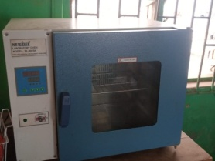

Plate 3.1. Electrical Laboratory Oven
3.1.2 Digital weighing scale: The digital weighing scale (plate 3.2) is an electronic and computerize device that was used to determine the mass of the sample to be processed.
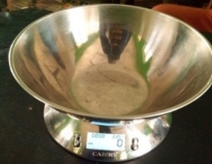

Plate 3.2 Digital Weighing Balance
3.1.3 Stop watch: The stop watch (plate 3.3) was used to monitor the roasting time and the duration of pressing.


Plate 3.3: Stop watch
3.1.4 Temperature monitoring and control system: The temperature monitoring and control system is a computerize equipment that was used to detect the roasting temperature of the expeller.
3.1.5 Seed roaster: This is in form of conical shape. It is welded to the base hopper of the expeller. It is used in roasting the seeds before expression of oil from the walnut seeds.
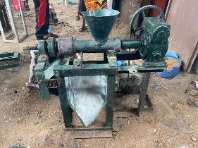
3.1.6 Oil expeller: The oil expeller (plate 3.4) was used in the expression of walnut oil from the walnut seeds,it consist of the following component parts : worm shaft,male and female cone, barrel, hopper, cake outlet, oil outlet, toaster, gear box, electric motor, thermocouple and pressure transducer, pulley.

Plate 3.4: Oil Expeller machine with instrumentation
3.1.7 Tachometer: This is a device that was used in measuring the speed of an expeller machine (plate 3.5).
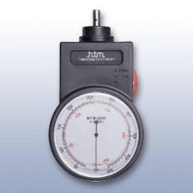
Plate 3.5: Tachometer

3.2 Methods
The method adopted for the study is as presented below:

3.2.1 Experimental Materials
The walnut seeds used for the study was purchased from a produce merchant in Ile-Ife in Osun State, Nigeria. Plate 3.6a and 3.6b present the walnut plant and seed.
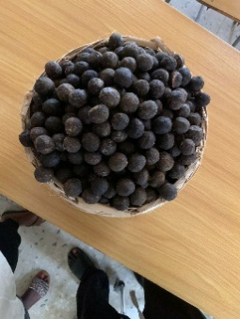
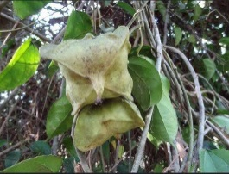

Plate 3.6a: Walnut Plant Plate 3.6b: Walnut Seed

3.2.2 Sample Preparation
The walnut seed was shelled, cleaned sorted for the good ones for the study. The initial moisture content of the sample was obtained by oven-drying for 6 hours at 105°C as recommended by Young et al (1982) for oil seeds and used by Ajibola et al., (1990) for rubber seed and Tunde Akintunde et al., (2001) for soybean. The samples was divided into three equal parts and conditioned by adding a calculated quantity of water required to obtain the desired moisture contents selected. The added moisture was allowed to equilibrate by placing the conditioned seeds in a refrigerator for minimum of 5hrs after which the moisture content was obtained using a moisture analyzer. Calculated quantity of water was obtained from equation 3.1 as expressed by Akintoso (2016).
Q = 3.1
where: A = Initial Mass of the sample, kg
a = Initial moisture content of the sample, % wet basis (wb)
b = Final (desired) moisture content of sample, % wb
Q = Mass of water to be added, kg.
3.2.3 Experimental Design and Layout
The factors considered were the speed of machine at 4 levels (30, 50, 70 and 90rpm), roasting temperature at 3 levels (90ºC, 100ºC, 110 ºC), the roasting time was also at 3 levels (15, 20 and 25 minutes), the pressing varied between 17 to 37 minutes, the moisture content of 15% was made constant and the feedrate of 1kg was equally made constant.

3.2.4 Experimental procedure
The oil expeller was allow to run for 1 hour to enable the machine to attain the required or selected temperature.
1kg of the sample prepared was transferred into the expeller hopper. The sample was roasted at 3 levels (90, 100, 110ºC) of roasting temperature for 15 minutes and expressed at 3 levels (15, 20, 25min) of roasting time, the duration of the expression was obtained by the time the last drop of oil was noticed at the oil outlet.
3.2.5 Output Parameters: The output parameters considered for this study are:
(i) Oil yield: The oil yield was obtained as the ratio of weight of oil expressed to the total weight of sample before expression. Adeeko and Ajibola (1989) expressed it mathematically as stated in equation 3.2
3.2
where; OY = oil yield (%)
W_{US} = Original weight of sample before expression (g);
W_{OE} ₌ weight of oil expressed (g)
(ii) Throughput capacity (C_{osm}): The throughput capacity is the quantity of roasted seed introduce into the hopper of the oil expeller per unit time as expressed in equation 3.3..
$C_{osm}= \frac{M_{os}}{T} x 100$ 3.3

Where;
C_{osm} is the capacity of the oil seed machine (kg/hr)
M_{os} is the mass of the roasted oil seed (kg)
T is the time taken to express the oil from the seed (h)
CHAPTER FOUR
RESULTS AND DISCUSSIONS
4.1 Results
The summary of the result obtained from the study is as presented in Table 4.1
Table 4.1 The results of input and output parameter of the oil expeller
S/N | Weight of sample (kg) | Speed (rpm) | Pressing Time (h) | Oil yield (%) | Capacity (kg/hr)
1. | 1kg | 30 | 0.37 | 28 | 0.76
2. | 1kg | 50 | 0.27 | 24 | 0.89
3. | 1kg | 70 | 0.18 | 16 | 0.89
4. | 1kg | 90 | 0.17 | 12 | 0.71
5. | 1kg | 30 | 0.33 | 27 | 0.82
6. | 1kg | 50 | 0.27 | 31 | 1.15
7. | 1kg | 70 | 0.20 | 20 | 1.00
8. | 1kg | 90 | 0.17 | 15 | 0.88
9. | 1kg | 30 | 0.20 | 41 | 2.05
10. | 1kg | 50 | 0.19 | 38 | 2.00
11. | 1kg | 70 | 0.22 | 33 | 1.50
12. | 1kg | 90 | 0.00 | 0 | 0.00

4.2 Discussions
4.2.1 Discussion on oil yield
Table 4.1 present the results of the experiment conducted on walnut using multi-oil expression machine. The oil yield ranged between 0 to 41%. The highest oil yield of 41% was obtained at machine speed of 30 rpm, and throughput capacity of 2.05kg/hr with pressing time of 20 minutes. The lowest oil yield of 12% was obtained at machine speed of 90rpm and throughput capacity of 0.71kg/hr. This is an indication that the oil expeller should be operated at low speed for higher oil recovery.
4.2.2 Discussion on Throughput Capacity
The throughput capacity from Table 4.1 shows that the mean value obtained from the study ranged between 0 to 2.05kg. The highest throughput of 2.05kg/hr obtained at machine speed of 30rpm and pressing time of 20 minutes.

CHAPTER FIVE
CONCLUSIONS AND RECOMMENDATIONS
5.1 Conclusions
The following conclusion were drawn from the study:
- from the study, the highest oil yield was recorded to be 41%
- the highest capacity was obtained to be 2.05kg/hr
5.2 Recommendations
The following suggestions were hereby recommended for further research:
- more input variables need to be investigated (such as roasting temperature, roasting time, applied pressure etc)
- the varieties of the walnut need to be evaluated to know which can give higher oil yield

REFERENCES
Adebija J.A (2014) Modification and Performance Evaluation of a Palm Kernel Seed oil screw press to a castor seed oil screw press: National Centre for Agricultural Mechanization (NCAM), P.M.B.1525, Ilorin, Kwara State.
Adeeko K.A and Ajibola O.O. (1990). Processing Factors affecting Yield and Quality of Mechanically Expressed Groundnut Oil. Journal of Agricultural Engineering Research (JAER) 45 45 (1): 31-43
Adeeko, K. A., and Ajibola, O. O. (1990). Processing Factors affecting Yield and Quality of Mechanically Expressed Groundnut Oil. Journal of Agricultural Engineering Research (JAER), 45(1), 31-43.
Akerele O. V. and Ejiko, S.O. (2010) Department of Mechanical Engineering: Design and Construction of Groundnut Oil Expeller The Federal Polytechnic Ado-Ekiti, Ekiti State
Ayoola, P. B., Adeyeye, A., Onawumi, O. O. and Faboya, O. O. P. (2011). Phytochemical and nutrient evaluation of Tetracarpidium conophorum Root. International Journal of Research and Reviews in Applied Sciences. 7(2): 197 – 202.
Dada, A. and Aguda, O. (2015). Dietary effects of African walnut (Tetracarpidium conophorum) on the reproductive indices in male African catfish (Clarias gariepinus) broodstock. Journal of Coastal Life Medicine 3(6):471–475.
Dauda, A. O., Abiodun, O. A., Akintayo. O. A., Babayeju, A. A., Salami, K. O. and Oyekanmi, I. A. (2020). Influence of walnut on the nutritional and physicochemical properties of biscuits made from whole wheat Agrosearcch, 20(1): 45-58
Fashina O.O. and Ajibola O.O. (1989). Mechanical Expression of Oil for Conophur Nut. Journal of Agricultural Engineering Research, 44:275-278.
Ibrahim and A. P. Onwualu (2005) University of Calabar, Nigeria. Department of Agricultural Engineering University of Nigeria, Nsukka, “Technologies for Extraction of Oil from Oil-Bearing Agricultural Products: A Review”, Journal of Agricultural Engineering and Technology (JAET). Volume 13, 73-79.
Ozkhan Gulcan, and Koyuncu M Ali (2005). Physical and chemical composition of some walnut (Juglans regia L) genotypes‬ grown in Turkey (free). Grasasy Aceites (Consejo Superior‬ de Investigaciones Cien tíficas) 56 (2): 141–146‬‬‬‬‬‬

