A PROJECT REPORT ON PROPOSED DAYCARE CENTRE
FOR (FLOWER GARDEN AREA, ILORIN)
KWARA STATE.
BY

MUSTAPHA AHMAD ABOLAJI
ND/23/ARC/PT/0029

BEING A PROJECT REPORT SUBMITTED TO
THE DEPARTMENT OF ARCHITECTURAL TECHOLOGY, INSTITUTE OF
ENVIRONMENTAL STUDIES,
KWARA STATE POLYTECHIC, ILORIN.

INPARTIAL FULFILMENT OF THE REQUIREMENT FOR
THE AWARD OF NATIONAL DIPLOMA (ND)
IN ARCHITECTURAL TECHNOLOGY.

JULY, 2025
DECLARATION
I declare that this Project/Dissertation is a project of my personal research works. It has not been
Presented for the award of any ND in any polytechnic. The ideas, Observations, Comments, and Suggestions here in represent my own convictions except quotations, which have been acknowledged.
In accordance with conventional academic traditions.

MUSTAPHA AHMAD ABOLAJI
ND/23/ARC/PT/0029

________________________
SIGNATURE & DATE

CERTIFICATION
I certify that this research project/Dissertation entitled A DAYCARE CENTRE was carried out by MUSTAPHA AHMAD ABOLAJI under my supervision ARC. FAMILUA O.S. has been approved. As meeting the requirement for the award of ND in Architectural Technology, Kwara State Polytechnic, Ilorin, Kwara State.

ARC. FAMILUA O. S ___________________
Project Supervisor SIGNATURE & DATE

ARC OLAREWAJU F.A ___________________
Project Coordinator SIGNATURE & DATE

ARC J.M TOMORI ___________________
Head of Department SIGNATURE & DATE
___________________
EXTERNAL EXAMINER SIGNATURE & DATE

ACKNOWLEDGEMENT
My profound gratitude goes to Almighty Allah, the creator of universe and fountain of all wisdom whose umbrella of guard and guide. I seek refuge through thick and thin of years of study.
I will also like to appreciate my project supervisor in person of ARC FAMILUA O. S. whose contribution Prepare me for the challenges in the field and for his immense contribution is all ramification towards the completion of this research work. He encourage me and open the door of interaction with him. I pray Almighty Allah will shower his blessing and mercy over him, your family and may you live to reap the fruit of your labour.
I also want thank and appreciate the effort of all the Lectures in Architectural Technology Department ARC. TOMORI, ARC ADEYEMI, ARC. CHUKS, ARC. SHEERO, AND ARC. BOLAKALE, who taught and give lasting advice’s that led to the success of my program, Almighty Allah will meet everyone at the point of needs.
I would also show my profound gratitude to my parents MR and MRS MUSTAPHA for their Immeasurable motivation, advices, efforts, and prayers on me for the completion of this program.
My Lovely sisters: AFUSAT, BILIKIS, AISHAT, MARYAM and FATIMOH. Almighty Allah shower his endless blessing, mercy, unlimited grace, joy, happiness without sorrow, sound health overall and may Almighty Allah meet everyone at the point of your needs.
Precious friends: My lovely friends AHMAD, SA’AD, TAJUDEEN AND SULYMAN. Almighty Allah shower his blessing, grace, and happiness with sound health over you all and our prayer (AMEEN).
Lastly ,I would like to appreciate the effort of my colleagues in department, school, and hostel, I whole heartedly say a VERY BIG THANK YOU, I appreciate you all, May Almighty Allah bless you all.
Above all, my utmost thanks go to the all sufficient God, the fountain of my wisdom, for his great and protection over my life, for his undying love, support and guidance throughout my period of learning and also for in sighting writing this project without him am nothing.
ABSTRACT
This project focuses on the design and development of a functional Daycare Centre that caters to the physical, emotional, and developmental needs of infants and young children. The aim is to create a safe, stimulating, and sustainable environment that supports early childhood care and education.
The study outlines the importance of spatial organization, natural lighting, ventilation, safety, accessibility, and the integration of outdoor play areas in the design. The project also considers climatic factors and cultural relevance specific to Ilorin, Kwara State, Nigeria.
Relevant case studies, data analysis, and architectural standards were employed to develop a design that meets user needs while aligning with modern trends in childcare facilities. This work contributes to the improvement of childcare services and serves as a model for future developments.

TABLE OF CONTENTS
CONTENT
1.0. Title Page. i
2.0 Certification Page. ii
3.0 Dedication. iii
4.0 Acknowledgement. iv
5.0 Abstract. v
6.0 Table of Content. vi

CHAPTER ONE – INTRODUCTION
1.1 Background of Study 2
1.2 Statement of Problem 3
1.3 Aim of the Study 3
1.4 Objective of the Study 4
1.5 Scope of the Study 4
1.6 Justification of the Study 5
1.7 Research Methodology 5
1.8 Project Motivation 6
1.9 Project Location 7

CHAPTER TWO – LITERATURE REVIEW
2.1 Concept of Daycare Centers 8
2.2 Importance of Early Childhood Development 8
2.3 Standard and Guidelines for Daycare Design 9
2.4 Child-Centered Design Principles 10
2.5 Case Studies 11
2.6 The Role of Outdoor Spaces in Child Development 13
2.7 Key Findings from Literature and Case Studies 14
2.8 Summary 15

CHAPTER THREE – SITE ANALYSIS
3.1 Introduction 16
3.2 Site Location and Description 16
3.3 Climatic Analysis 17
3.4 Access and Circulation 18
3.5 Utilities and Infrastructure 19
3.6 SWOT Analysis of the Site

CHAPTER FOUR – DESIGN CONCEPT AND PLANNING
4.1 Introduction 21
4.2 Design Philosophy and Approach 21
4.3 Design Objectives 22
4.4 Zoning and Functional Spaces 23
4.5 Circulation Pattern 24
4.6 Lighting and Ventilation 25
4.7 Acoustics and Noise Control 25
4.8 Materials and Finishes 26
4.9 Security and Safety Features 27
4.10 Sustainability Consideration 27

CHAPTER FIVE – DESIGN PRESENTATION
5.1 Introduction 28
5.2 General Description of Proposed Design 28
5.3 Structural Design Description 29
5.4 Interior Design Features 30
5.5 Landscape Design and Outdoor Environment 31
5.6 Sustainability Features in the Design 31

CHAPTER SIX – CONCLUSION AND RECOMMENDATION
6.1 Conclusion 32
6.2 Challenges Encountered During the Design 33
6.3 Recommendations 34
REFERENCES
APPENDICES (Schedules, Sketches, Site Photos, etc.)

CHAPTER ONE:
INTRODUCTION
1.1 Background of the Study
The early stages of a child’s life are crucial to their overall development, and much of that development occurs outside the home, particularly for children of working-class parents. The daycare center, also known as a nursery or crèche, serves as a foundational educational and care-giving institution for children between the ages of 3 months to 5 years.

With urbanization, rising employment among mothers, and the breakdown of extended family structures, the need for well-structured daycare centers has become a necessity. In many parts of Nigeria, especially in urban environments like Ilorin, there is increasing demand for organized and secure facilities where children can be cared for, stimulated, and socialized in a structured environment during the day.

This architectural project proposes the design of a functional, safe, and educationally stimulating daycare center that addresses both the emotional and physical needs of the child, while providing practical solutions for caregivers and staff.

1.2 Statement of the Problem
Despite the increasing need for early childhood education and care in Nigeria, many existing daycare centers are either adapted residential buildings or inadequately designed structures that fail to meet the needs of children.
These facilities often lack:
• Proper spatial organization
• Safety measures (e.g., child-safe materials, exits)
• Sanitary conveniences suited to children
• Adequate ventilation and lighting
• Dedicated play areas or educational environments

Therefore, there is a pressing need for purpose-built daycare facilities that comply with modern design standards and are tailored to children’s developmental and safety needs.

1.3 Aim of the Study
The aim of this project is to design a purpose-built daycare center that provides a safe, functional, and stimulating environment for infants and young children.

1.4 Objectives of the Study
To achieve the above aim, the following objectives have been set:
1. To study the space requirements and design standards for daycare centers.
2. To incorporate child psychology, safety, and comfort into the design.
3. To design functional spaces that meet administrative, educational, and recreational needs.
4. To ensure that the building integrates passive design principles for lighting, ventilation, and energy conservation.
5. To provide outdoor and indoor play areas that support child development.

1.5 Scope of the Study
The scope of this study includes the architectural design of a single-storey daycare center that caters for 40–60 children, aged between 6 months to 5 years. The study covers:
• Site selection and analysis
• Spatial programming and planning
• Design of classrooms, sick bay, kitchen, admin, playroom, toilets, etc.
• Integration of natural lighting, ventilation, and safety measures
• Proposal of construction materials and finishes suitable for children
Structural detailing, services design (electrical, plumbing), and cost estimation are not the primary focus but are considered briefly in terms of spatial implications.

1.6 Justification for the Study
This study is justified by the need to create learning environments that match the unique needs of children in their early developmental stages. By designing a functional and purpose-specific daycare center:
• Children are placed in a safe, clean, and nurturing environment.
• Parents are relieved of anxiety, knowing their children are in capable hands.
• Teachers and caregivers work in organized spaces that enhance supervision and service delivery.
• The community benefits from a structure that encourages early education and social development.

1.7 Research Methodology
This study utilizes both qualitative and analytical research methods. These include:
• Case studies of existing daycare centers (locally and internationally)
• Site analysis of the chosen project location (Tanke, Ilorin)
• Literature review on early childhood development and architectural standards for daycare centers
• Design exploration using sketching, zoning diagrams, space planning, and model studies
Information was gathered from architectural textbooks, field visits, journals, interviews with early childhood educators, and official building codes.

1.8 Project Motivation
The increasing number of young parents who need child-care services during work hours has led to a higher demand for daycare centers, especially in academic and urban communities like Ilorin. Unfortunately, many of these facilities are either informal or substandard.

This motivated the researcher to create a modern, sustainable, and child-centered design that aligns with 21st-century expectations. As an architectural student, this project also provides an opportunity to creatively respond to a social challenge using built-form solutions.

1.9 Project Location
The site selected for this design proposal is in Flower garden area, Ilorin South L.G.A., Kwara State. The location is ideal due to:
• Proximity to residential estates, schools, and workplaces
• Adequate road access and security
• A moderate topography suitable for construction
• Low ambient noise level — ideal for children’s rest and activities
• Access to basic services such as water, power, and sanitation
CHAPTER TWO:
LITERATURE REVIEW AND CASE STUDIES

2.1 Concept of Daycare Centers
A daycare center is a facility that provides early childhood education and care for children, typically from infancy to about age 5. These centers aim to promote the social, cognitive, emotional, and physical development of children in a safe and structured environment. In the context of this project, the daycare center is envisioned as a specialized building where children engage in various activities that stimulate learning and interaction.

Daycare centers typically serve as both educational and recreational spaces, balancing structured activities like learning and unstructured activities such as play. These centers are essential in areas where parents are working, providing a nurturing environment while supporting the development of the child.

2.2 Importance of Early Childhood Development
Research in child psychology emphasizes the significance of the early childhood years (0–5 years) as a critical period for cognitive and emotional development. Children in this age group require an environment that fosters both structured learning and unstructured play to stimulate creativity, problem-solving skills, and social interactions.

A well-designed daycare facility should incorporate spaces for:
• Sensory stimulation (bright colors, textures)
• Cognitive development (learning areas, books, puzzles)
• Social interaction (group play areas, communal dining areas)
• Physical development (playgrounds, active zones)
According to the National Association for the Education of Young Children (NAEYC), daycare centers should be designed with attention to the developmental milestones of early childhood.

2.3 Standards and Guidelines for Daycare Design
International standards for daycare center design are established by several organizations, including UNICEF, the World Health Organization (WHO), and local regulatory bodies such as the Nigerian Building Code. Key design considerations include:

Space Requirements
• Children’s Areas: 2.75–4.5 m² per child (indoor)
• Outdoor Play Area: At least 7 m² per child
• Ceiling Height: Minimum of 2.5–3 meters
• Windows: Should constitute 20% or more of the floor area for natural daylighting
Safety Measures
• Rounded corners for furniture
• Slip-resistant flooring
• Child-sized toilets
• Shatterproof windows
• Secure fencing around outdoor play areas
The architectural design should ensure that the spaces are ergonomically designed to cater to the physical scale of children while meeting the operational needs of caregivers.

2.4 Child-Centered Design Principles
Daycare center design must prioritize children’s needs in both functional and aesthetic terms. Key principles include:
1. Child-Scale: Spaces must be designed with children’s physical proportions in mind, from door handles to toilets, windows, and furniture.
2. Security and Safety: Childproof elements such as safety locks, non-toxic paints, and secure outdoor play areas.
3. Natural Light and Ventilation: Use of windows, skylights, and ventilation systems that support good air quality and daylight.
4. Flexibility of Space: Rooms should be versatile to accommodate various activities (group play, learning, nap time).
5. Sensory Stimulation: Colors, textures, and materials that engage children’s senses and create an inviting environment.
These principles ensure that the daycare center not only meets the physical and safety requirements but also fosters an engaging, stimulating environment for the children.

2.5 Case Studies
To better understand the challenges and best practices for designing a daycare center, two international case studies were analyzed:
Case Study 1: Early Years Academy, Ibadan, Nigeria
• Design Features:
• Purpose-built, single-storey daycare facility
• Large, open playroom connected to outdoor playground
• High ceilings and large windows for natural light
• Secure perimeter fence with child-friendly gates
• Colorful interiors and engaging materials for children
• Key Observations:
• The central playroom is the focal point, creating a sense of openness and connection with the outdoor area.
• The building successfully integrates indoor and outdoor spaces, ensuring a seamless transition between environments.
• Noise control could be improved due to the open-plan design, but overall, the facility supports children’s developmental needs effectively.

Case Study 2: Theories Daycare center, Irabon street Ilorin.
• Design Features:
• Converted residential bungalow into a daycare center
• Separate areas for infants and toddlers, each with appropriate
furniture and equipment
• Large windows and shaded areas for outdoor play
• Recycled and locally sourced materials for furniture and decor
• Key Observations:
• Despite being a converted building, the daycare center’s design
focuses on functionality, using modular furniture to maximize
space.
• The integration of a garden and vegetable patch for educational purposes enhances the children’s connection with nature.
• The security of the outdoor play area is well-maintained, but the building’s limited space restricts the number of children that can be accommodated.

2.6 The Role of Outdoor Spaces in Child Development
Outdoor play areas are crucial for the development of young children. The American Academy of Pediatrics emphasizes that outdoor spaces should be designed with safety, variety, and accessibility in mind. These spaces provide opportunities for:
• Physical development: Running, climbing, and jumping activities help build motor skills.
• Social development: Group play teaches cooperation, sharing, and conflict resolution.
• Cognitive development: Outdoor exploration encourages problem-solving, creativity, and engagement with nature.

2.7 Key Findings from Literature and Case Studies
From the literature review and case studies, the following key findings emerge:
• Design Flexibility: Daycare centers must be flexible in design to accommodate children’s changing needs.
• Visibility and Supervision: Open-plan designs or clear sight lines are essential for child supervision.
• Safety and Security: The safety of children should always come first, with secure perimeters, non-toxic materials, and childproof features.
• Outdoor Integration: Outdoor spaces are as important as indoor spaces for promoting child development and should be integrated seamlessly into the design.

These principles will guide the design of the proposed daycare center, ensuring it meets the developmental needs of children while being safe and functional for staff and parents.

2.8 Summary
This chapter has reviewed existing literature on daycare center design, the importance of early childhood development, and the standards and guidelines for creating safe and stimulating environments for children. The case studies provided further insights into practical applications of design principles and have helped shape the proposed design concept.

The following chapter will focus on the site analysis for the proposed daycare center and evaluate its suitability for the intended purpose.
CHAPTER THREE:
SITE ANALYSIS

3.1 Introduction
Site analysis is a critical component of architectural design. It involves studying the physical, environmental, and socio-cultural characteristics of the chosen site to determine its suitability for the intended building. In this project, the proposed site is located in Flower garden area, Ilorin South Local Government Area, Kwara State.

The site was selected based on accessibility, security, proximity to residential communities, and availability of infrastructure. Understanding the environmental and physical features of this location will ensure that the daycare center is optimally situated for functionality, safety, and child development.

3.2 Site Location and Description
• Location: The site is situated off University Road, near Tanke Junction, Ilorin South L.G.A.
• Coordinates: Approximately 8.456°N, 4.566°E
• Land Use: Primarily residential with small-scale commercial activities.
• Site Area: Approximately 1,500 square meters.
• Topography: Fairly flat with a gentle slope (about 3°), suitable for construction without major earthwork.
• Soil Type: Lateritic soil, well-drained and stable for shallow foundations.
• Existing Use: The land is currently undeveloped and covered with grasses and light shrubs.

3.3 Climatic Analysis
Understanding the climate is essential for designing a daycare center that is comfortable, naturally ventilated, and energy-efficient. Ilorin’s climate is characterized by:
• Climate Zone: Tropical Savannah
• Temperature Range: 23°C – 36°C
• Rainfall: Approximately 1,200 mm annually, mostly between April and October
• Relative Humidity: 55%–85%
• Prevailing Wind Direction: South-West to North-East
• Sun Path: The sun moves east to west, with high solar intensity around midday
Implication for Design:
• Orientation should reduce exposure to harsh afternoon sun.
• Overhangs and shaded play areas are recommended.
• Cross-ventilation is vital due to warm temperatures.
• Proper drainage design is necessary due to seasonal rainfall.

3.4 Access and Circulation
• Access Roads: The site is accessible via a 6-meter wide tarred road from Tanke Junction, which connects to University Road and other major routes.
• Circulation: The area experiences moderate vehicular and pedestrian movement, especially during school and work hours.
• Public Transport: Tricycles (keke), motorcycles, and taxis are available, making the site easily reachable for staff and parents.

Design Implication:
A dedicated drop-off and pick-up area will be incorporated to ease traffic flow during peak periods. Pathways within the site will be designed to allow safe pedestrian movement for children and staff.

3.5 Utilities and Infrastructure
• Water Supply: Borehole and public water lines are available in the area.
• Electricity: Served by public power supply (IBEDC), with provision for a backup generator.
• Drainage: Open roadside drainage exists but requires improvement to manage stormwater effectively.
• Telecommunication: The area is well-covered by major network providers.

3.6 SWOT Analysis of the Site
Strengths:
• Flat, buildable land
• Proximity to residential areas and schools
• Good access and infrastructure
• Quiet environment suitable for children

Weaknesses:
• Open drainage system needs upgrade
• Slight exposure to afternoon sun on western side

Opportunities:
• Potential to serve a growing population of working parents
• Space allows for future expansion or incorporation of a nursery class
Threats:
• Noise from occasional traffic on the main road
• Risk of flooding if drainage is not addressed

CHAPTER FOUR:
DESIGN CONSIDERATIONS AND PLANNING

4.1 Introduction
This chapter outlines the design philosophy, spatial planning, functional requirements, and key considerations guiding the development of the proposed daycare center. Every decision—from circulation patterns to zoning and material use—is guided by the core aim: creating a safe, child-friendly, and developmentally appropriate environment.

The design responds to the site context, climate, users’ needs (children, caregivers, and parents), and statutory requirements, including health, safety, and educational standards.

4.2 Design Philosophy and Approach
The design adopts a child-centered approach, emphasizing:
• Simplicity of form
• Safety and supervision
• Accessibility
• Stimulation through spatial variety, color, and light
• Interaction with nature (indoor-outdoor integration)

The building layout and materials are selected to reduce anxiety, encourage exploration, and promote independent learning. Visual connectivity across spaces supports easy monitoring by staff and encourages interaction among children.

4.3 Design Objectives
The main objectives of the proposed daycare design include:
1. Providing a safe and secure environment for children.
2. Encouraging learning through play and exploration.
3. Facilitating easy supervision by caregivers.
4. Promoting natural lighting and ventilation.
5. Ensuring accessibility for all users.
6. Including outdoor and indoor activity zones.
7. Creating a welcoming atmosphere for children and parents.

4.4 Zoning and Functional Spaces
To ensure organization and functionality, the daycare center is divided into the following key zones:

A. Entrance/Reception Area
• Welcoming parents and visitors
• Security check
• Waiting area
B. Administrative Zone
• Head teacher’s office
• Staff room
• Sick bay (for minor medical attention)

C. Children’s Activity Zones
• Infant room (0–1 year)
• Toddler room (1–3 years)
• Preschool room (3–5 years)
• Sleeping/rest area
• Dining area
• Toilet facilities (child-sized WCs and basins)

D. Service Areas
• Kitchen and pantry
• Laundry room
• Store

E. Outdoor Play Area
• Secure, fenced play zone
• Sandpit, swings, slides, tricycles
• Shaded seating and green lawn
Each of these areas is designed for ease of circulation, visibility, and safety.
4.5 Circulation Pattern
The circulation system within the daycare center promotes:
• Separation of child circulation from service and adult movement
• Direct visibility for supervision across all classrooms and corridors
• Smooth transition between indoor and outdoor areas
Corridors are 1.5–2.0 m wide and well-lit. Internal doors are wide enough (minimum 900 mm) for easy movement, including strollers or small wheelchairs.

4.6 Lighting and Ventilation
To ensure thermal comfort and visual quality:
• Large windows are installed at child eye-level (500–700 mm from floor)
• Cross ventilation is achieved using opposing windows and louvers
• Skylights and translucent roofing are used to bring in natural light
• Shading devices (louvers, canopies) reduce direct heat gain

Artificial lighting uses warm LED fixtures to create a calm atmosphere. Natural light remains the primary source during daytime hours.

4.7 Acoustics and Noise Control
Children are sensitive to noise, so the design incorporates:
• Acoustic ceiling tiles to reduce echo
• Partition walls with sound insulation
• Soft floor finishes (e.g., rubber tiles, padded mats) to minimize impact noise

Play and learning areas are located away from the road to minimize external disturbances.

4.8 Materials and Finishes
Material selection prioritizes:
• Safety (non-toxic, rounded edges, smooth finishes)
• Durability (easy to clean, resistant to wear and moisture)
• Aesthetics (bright colors and child-friendly textures)

Recommended materials include:
• Floors: Vinyl, rubber, terrazzo
• Walls: Emulsion-painted plaster, mural-friendly finishes
• Ceilings: POP or acoustic panels
• Windows: Aluminum with protective grilles

4.9 Security and Safety Features
Child safety is a top priority in all design decisions. Features include:
• Secure perimeter fencing with controlled entry points
• CCTV surveillance and security lighting
• Fire alarms, extinguishers, and exits clearly marked
• Non-slip floors and child-height railings
• Emergency exits located near classrooms and play areas
All electric outlets are installed above child reach (minimum 1.2 m) and covered.

4.10 Sustainability Considerations
The proposed daycare center integrates environmental sustainability through:
• Rainwater harvesting for non-potable use
• Natural lighting and ventilation to reduce energy use
• Use of local materials to minimize environmental impact
• Vegetated landscaping to reduce heat island effect and promote biodiversity
CHAPTER FIVE:
DESIGN DESCRIPTION

5.1 Introduction
This chapter gives a detailed description of the proposed architectural design. It highlights the building’s layout, structure, material selections, space organization, and landscape integration. Every design feature is intentional—centered on child safety, developmental needs, and staff functionality. The design reflects a balance between aesthetics, efficiency, sustainability, and user experience.

5.2 General Description of the Proposed Building
The proposed daycare center is a single-storey detached structure with a U-shaped configuration, wrapping around a central courtyard play area. The main building has three wings:
• Administrative and Entry Wing
• Children’s Activity and Classrooms Wing
• Service and Utility Wing

Each wing is organized to minimize travel distances, enhance supervision, and ensure maximum daylight penetration.
• Total Floor Area: ~750–900 m²
• Site Coverage: ~50%
• Number of Users (Capacity): 50–70 children + 10–15 staff
• Building Height: 4.5 m to eaves level
• Roof Type: Low-pitched hipped roof with extended eaves for shading
• Construction Type: Load-bearing blockwork with reinforced concrete frame

5.3 Structural Design Description
• Foundation: Strip foundation (due to lateritic soil and single-storey design)
• Walling: 225 mm sandcrete blocks
• Beams & Columns: Reinforced concrete (150x150 mm min.)
• Roofing: Wooden trusses + Aluminum long-span roofing sheets
• Ceilings: POP in main areas, PVC in service areas
• Floors: Polished concrete with anti-slip vinyl tiles in child zones
• Finishes:
• Interior walls: Plaster + washable emulsion
• Exterior walls: Textured paint with child-themed murals
• Openings: Aluminum casement windows with protective mosquito netting

5.4 Interior Design Features
• Child-friendly furniture with rounded edges
• Visual colors for different rooms to aid memory and orientation
• Low shelves and cubbies for personal items
• Whiteboards, bulletin boards, and story-time zones
• Interactive wall art to encourage learning through visuals

Safety First:
• Socket outlets at 1.2 m height
• Fire extinguishers at strategic points
• Rubber flooring in infant room and play zones

5.5 Landscape Design and Outdoor Environment
The landscape is designed to complement the building and support children’s physical and cognitive development:
• Central Courtyard: Serves as a visual and recreational heart of the facility
• Lawn Area: For running and group activities
• Shaded Seating Benches for caregivers and visitors
• Outdoor Learning Spaces: Raised planters for simple gardening
• Security Fence: 2.0 m high with visual slats
• Trees and Shrubs: Provide shading and natural aesthetics

5.6 Sustainability Features in the Design
• Natural Ventilation: Cross-flow windows + vents
• Rainwater Harvesting: Gutter channels to underground tank
• Solar Panels (optional future plan): For lighting and fans
• Low-VOC Paints and Eco-Friendly Flooring used for children’s
health
• Native Vegetation: To reduce maintenance and watering needs
• Energy-Efficient Lighting (LED) throughout
CHAPTER SIX:
CONCLUSION AND RECOMMENDATIONS

6.1 Conclusion
The design of a daycare center is a critical architectural project due to its direct impact on early childhood development. This project addressed the need to create a safe, functional, and stimulating environment for children aged 0–5 years.

By incorporating child-centric design principles, efficient spatial planning, sustainable building materials, and thoughtful landscaping, the proposed design ensures that both caregivers and children operate within an environment that encourages health, creativity, comfort, and learning.

The layout promotes:
• Easy supervision and safety,
• Logical zoning and smooth circulation,
• Integration of indoor and outdoor activities,
• Use of natural light and ventilation to support wellness.
Through detailed analysis and application of architectural knowledge, the proposed daycare center satisfies functional, aesthetic, and environmental standards.

6.2 Challenges Encountered During the Design
Some notable challenges during the design process included:
1. Balancing safety with creative freedom — ensuring play areas stimulate without posing risks.
2. Site constraints — such as limited land area vs. zoning needs for indoor and outdoor spaces.
3. Climatic considerations — managing heat gain while maintaining sufficient natural light.
4. Budgeting limits — making affordable material choices that still reflect durability and quality.

Despite these challenges, each was addressed with practical design responses and innovations.

6.3 Recommendations
Based on research, design planning, and analysis of existing daycare centers, the following recommendations are made:
1. Child development professionals (e.g., caregivers, pediatricians) should be involved in space planning.
2. Government regulations for daycare facilities must be enforced to ensure the safety and quality of services.
3. Periodic upgrades and maintenance of daycare facilities should be prioritized to maintain hygiene and structural integrity.
4. Use of green building features like solar panels and recycled water systems should be encouraged.
5. Stakeholders should promote parental feedback systems for ongoing improvement of services.
6. Future daycare projects should prioritize scalability, allowing for later expansion as population demands increase.

Appendix I: Concept Development Sketch Summary
• Concept: “Safe Circle” — Inspired by the need for enclosed safety while maintaining open visual supervision. The U-shaped building layout surrounds the central courtyard, symbolizing care and protection.
• Zoning Diagram: Shows separation between service areas, classrooms, and quiet zones.
• Form Justification: Low-rise, child-scale building with curved edges, natural materials, and open sight lines.
• Color Strategy: Soft, vibrant tones (blue, yellow, green) to encourage comfort, creativity, and cognitive association.
Appendix II: Site Plan Description
• Orientation: Long axis runs east-west to minimize heat gain.
• Entry Point: Positioned away from traffic congestion for safety.
• Security: Fenced perimeter with controlled gate entry.
• Vehicular Circulation: Drop-off bay with pedestrian footpath leading to main entrance.
• Landscaping: Trees planted along boundary wall; soft play areas positioned within parent-supervised view.

Appendix III: Materials and Finishes Summary
Element. Material
Foundation. Reinforced concrete
Walling. Sandcrete blocks, plastered
Flooring. Non-slip tiles, rubber mat zones
Windows. Aluminum + mosquito netting
Roof. Wood truss + aluminum sheeting
Ceiling. POP (main) + PVC (wet areas)
Paint. Emulsion (low-VOC), washable ty
Doors. Flush doors with rounded edges

REFERENCES
1. Neufert, E. (2012). Architects’ Data. Wiley-Blackwell.
2. Olusanya, O. (2015). Designing Educational Spaces for Early Childhood. Ibadan University Press.
3. Nigerian Building Code (2006). National Building Code of Nigeria.
4. UNICEF (2019). Child-Friendly Spaces Guidelines.
5. Oyebanji, A. (2017). Principles of Architectural Design for Public Buildings. Lagos: Matrix Publishers.
6. Chudleigh, S. (2020). Early Learning Environments and Architecture. Routledge.
7. Kwara State Physical Planning Authority (2023). Zoning and Planning Regulations.
8. National Association for the Education of Young Children (NAEYC). (2020). Design Standards for Early Childhood Centers.
9. Omole, F. (2011). Urban Design: Principles and Techniques. FUTA Press.
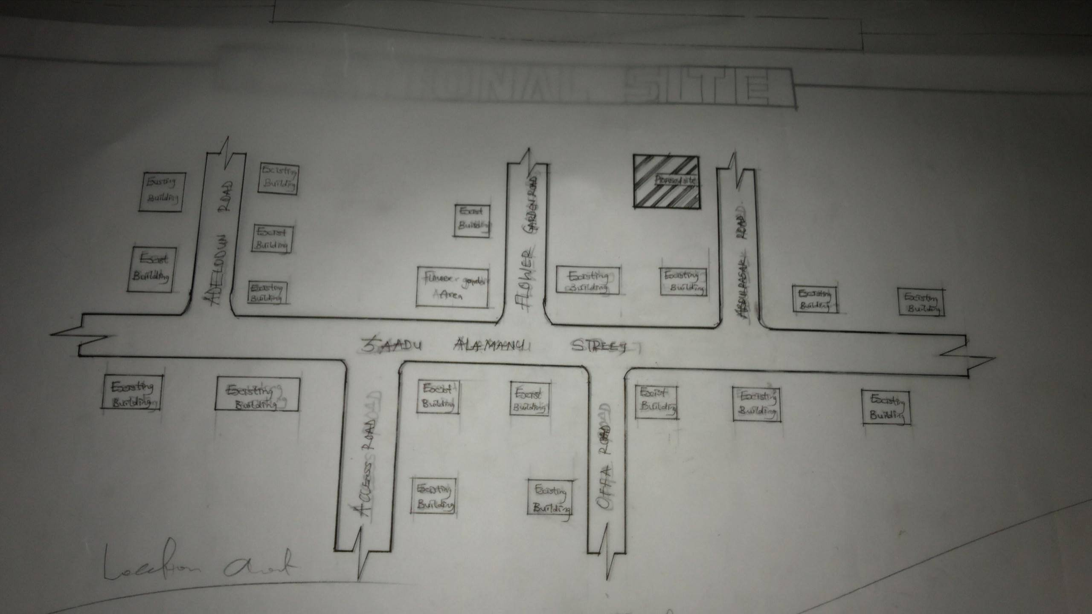

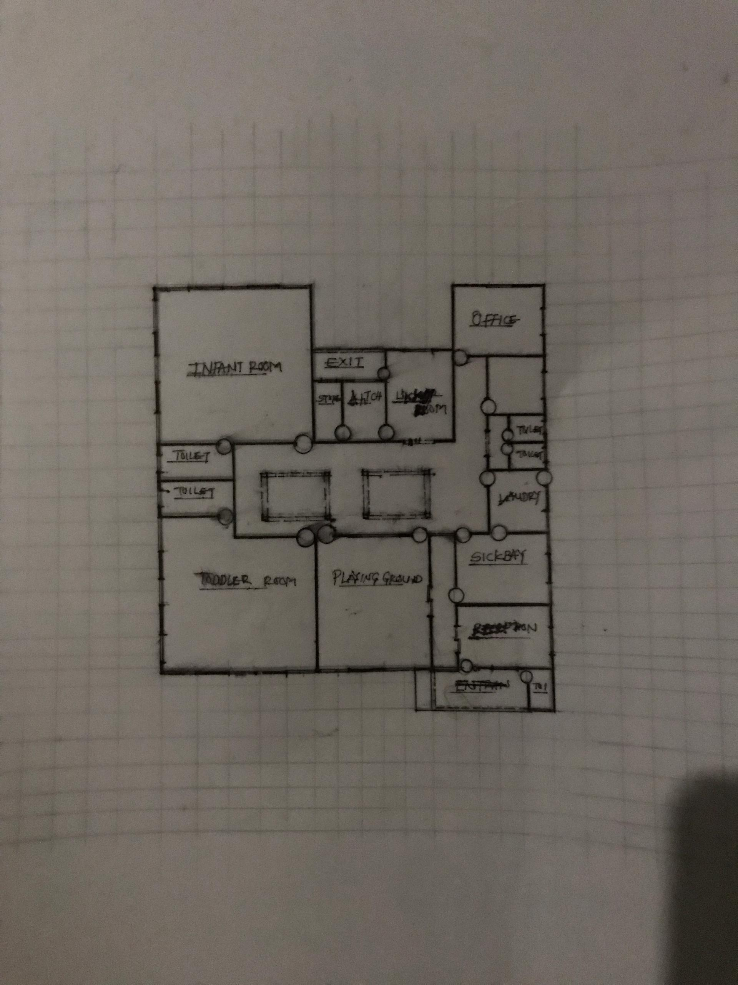Fig. 1 SHOWING THE LOCATION OF PROPOSED SITE

Fig. 2 SHOWING THE PROPOSED DAYCARE FLOOR PLAN
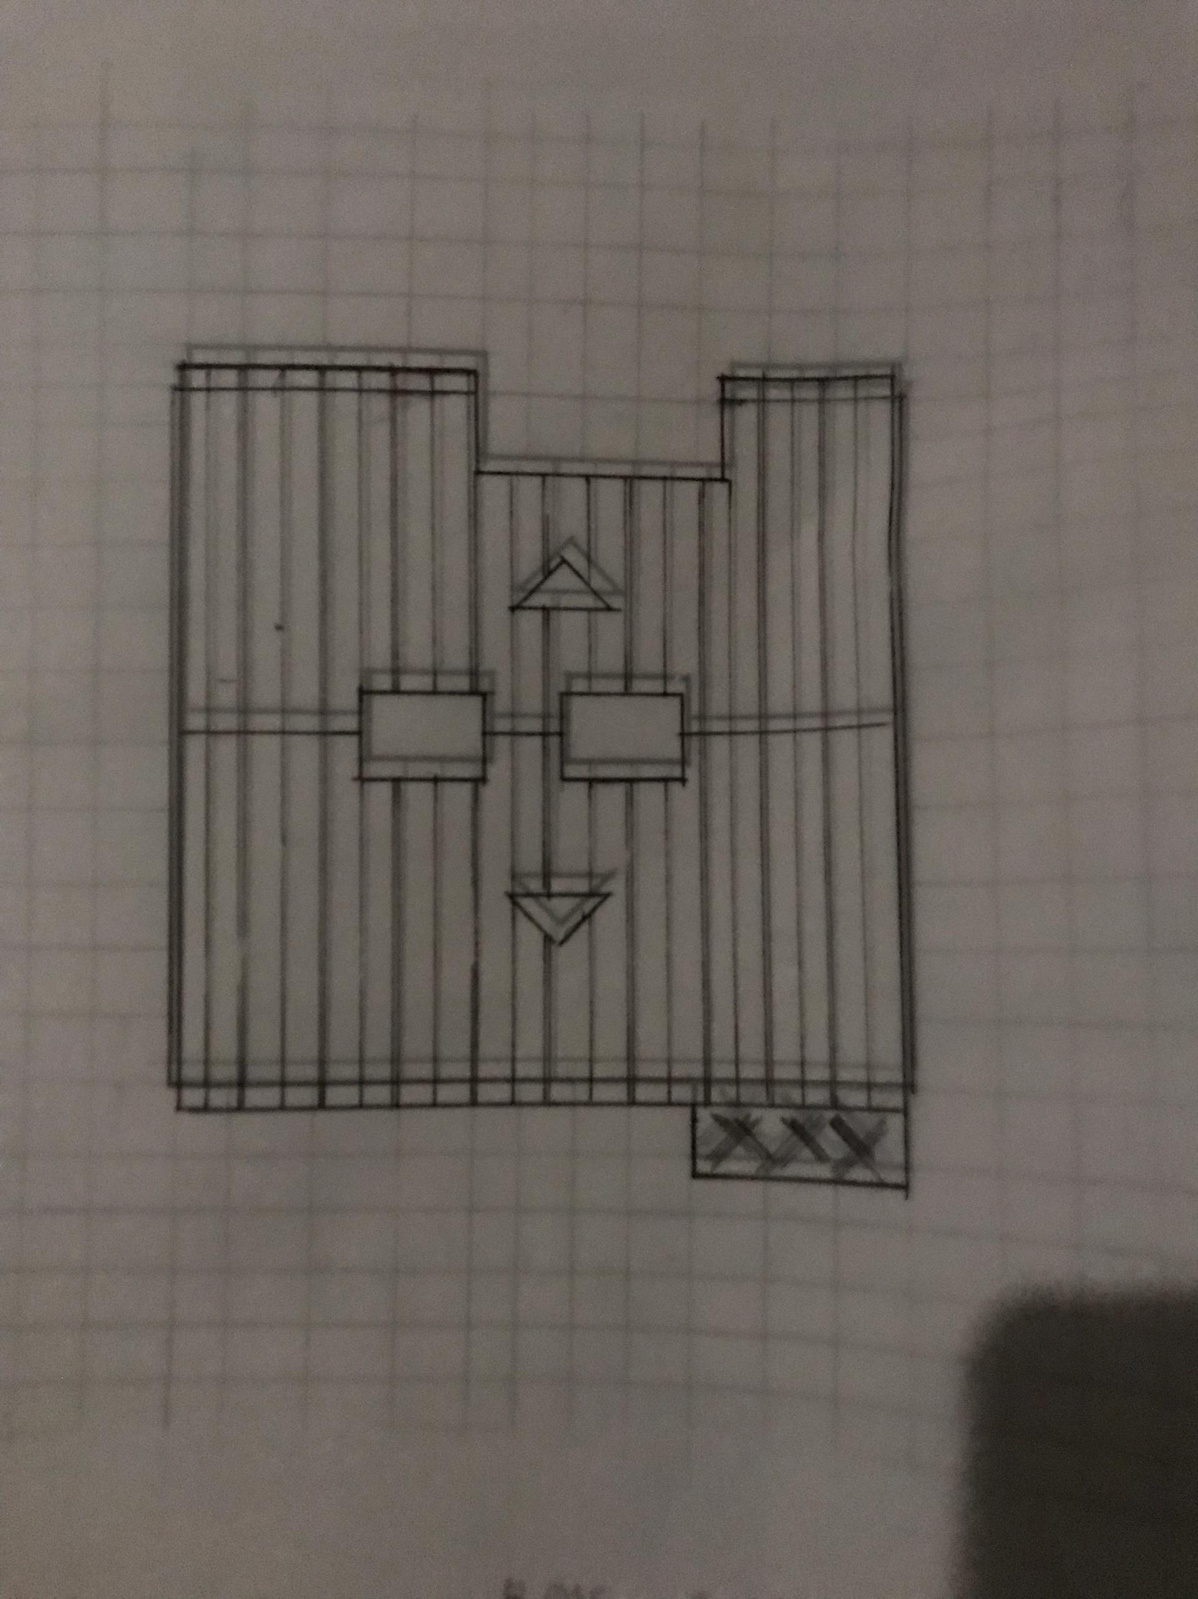

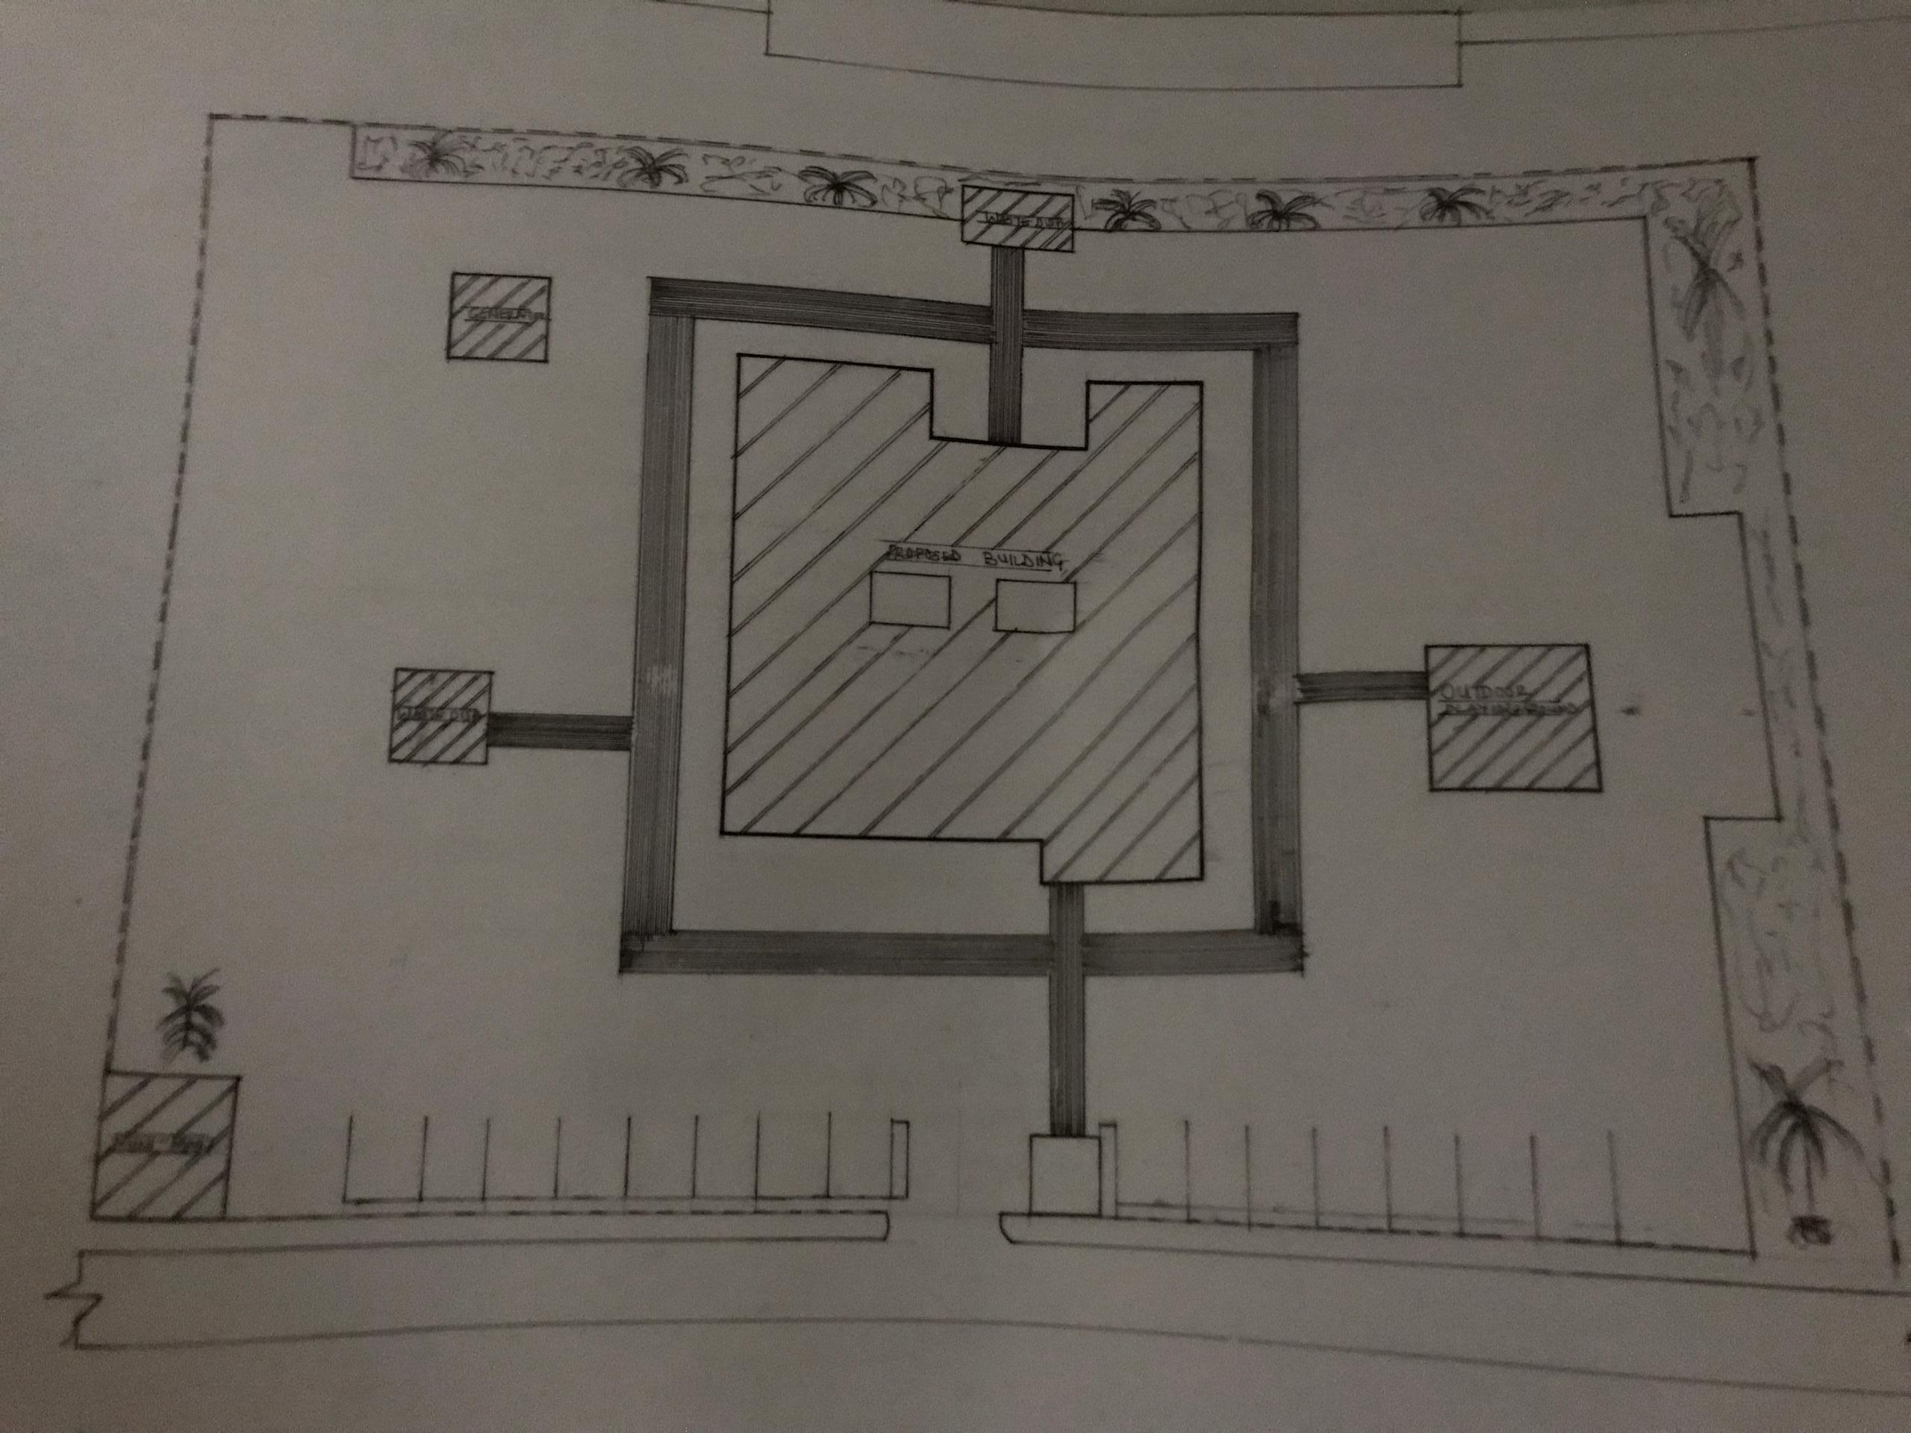Fig. 3 SHOWING THE ROOF PLAN

Fig. 4 SHOWING THE PROPOSED SITE PLAN
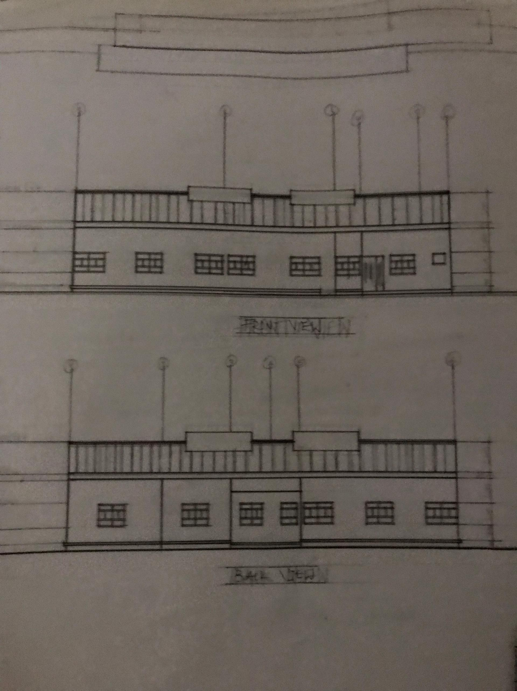

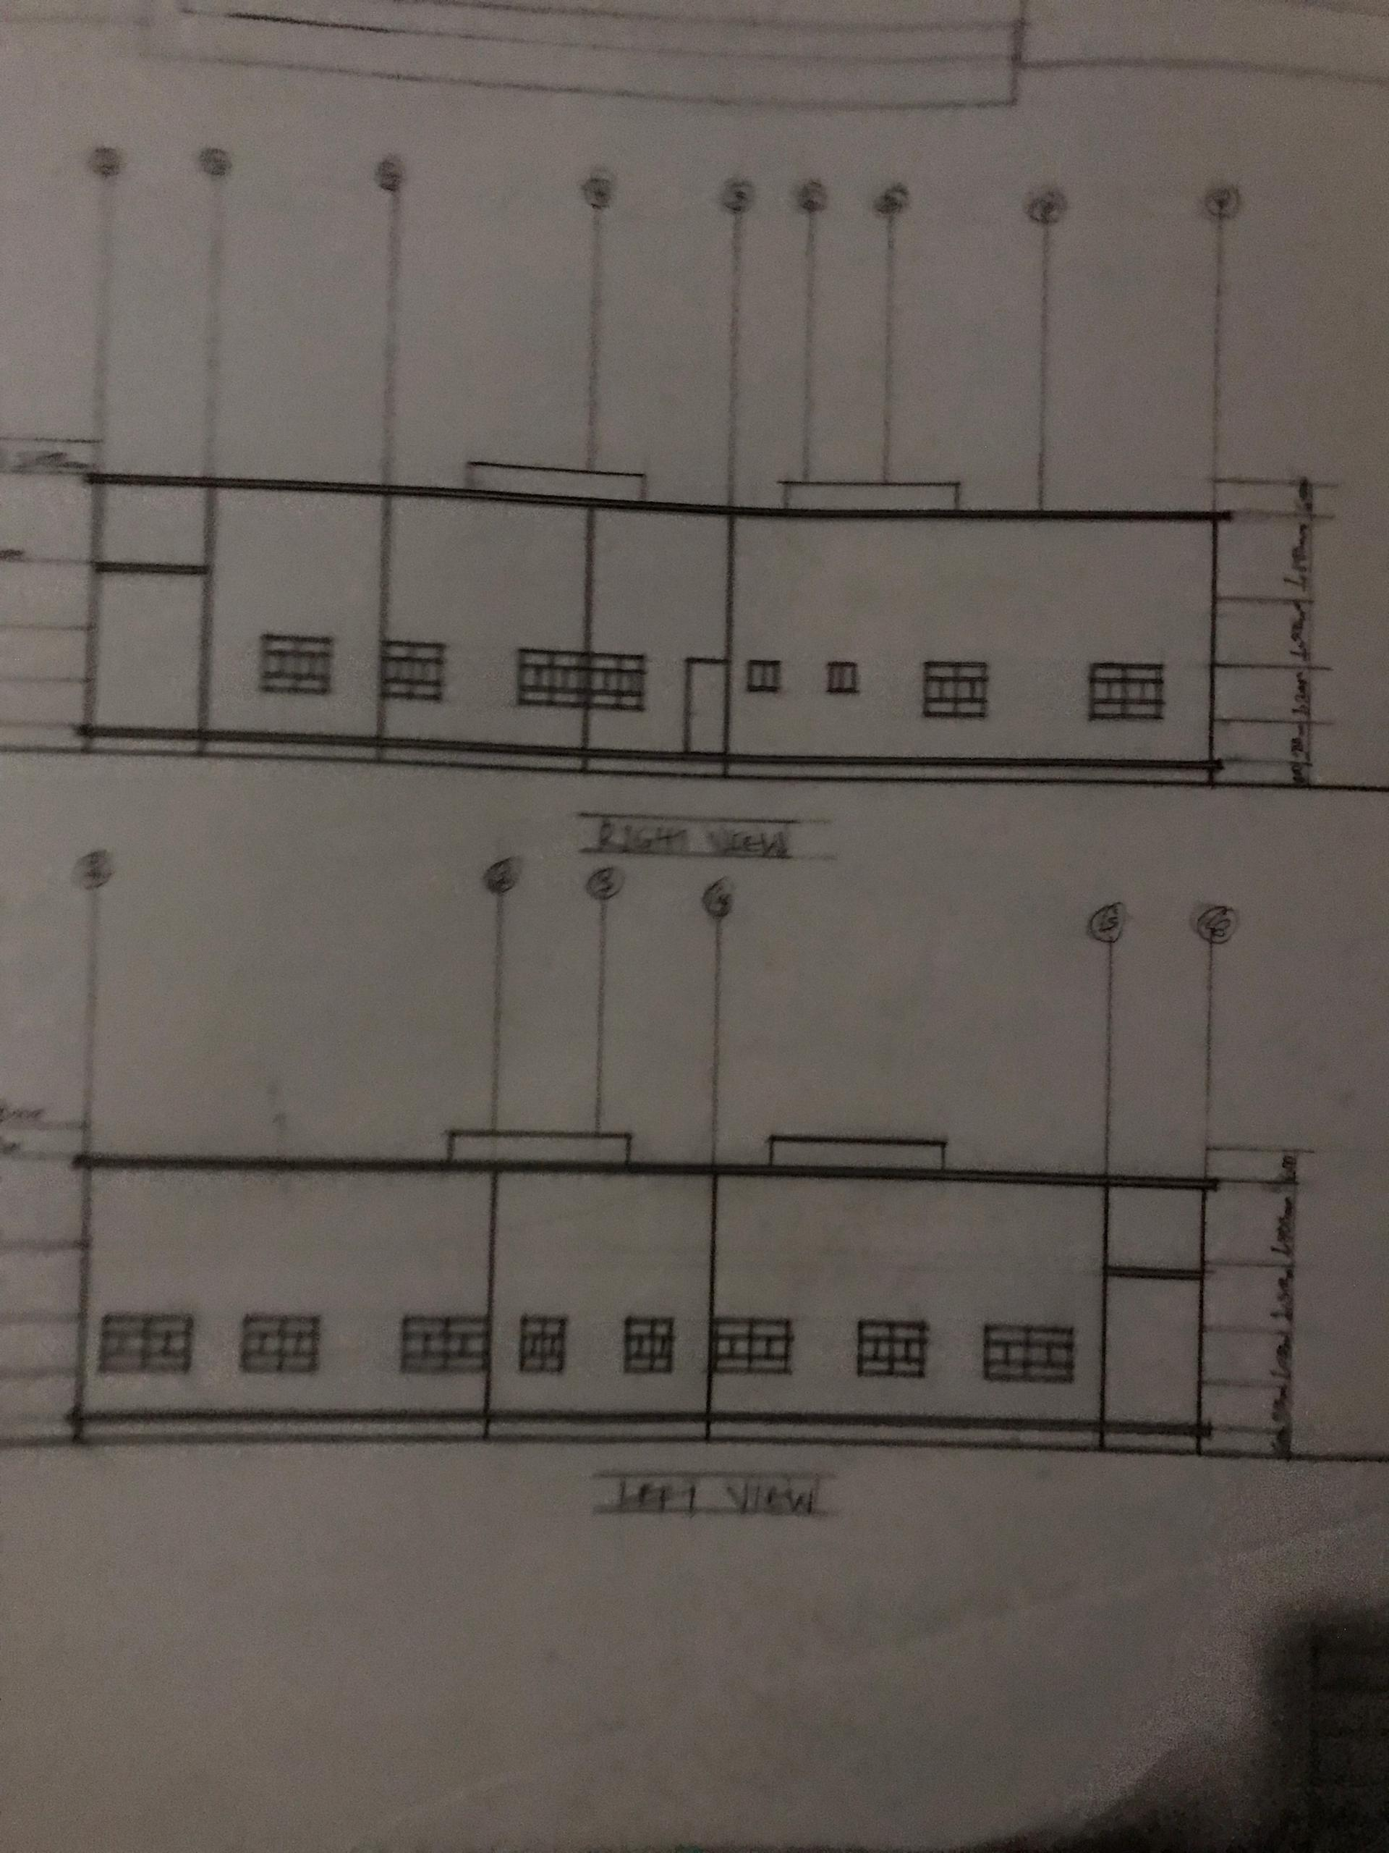Fig. 5 SHOWING THE FRONT AND BACK ELEVATIONS

Fig. 6 SHOWING THE RIGHT AND LEFT ELEVATIONS

