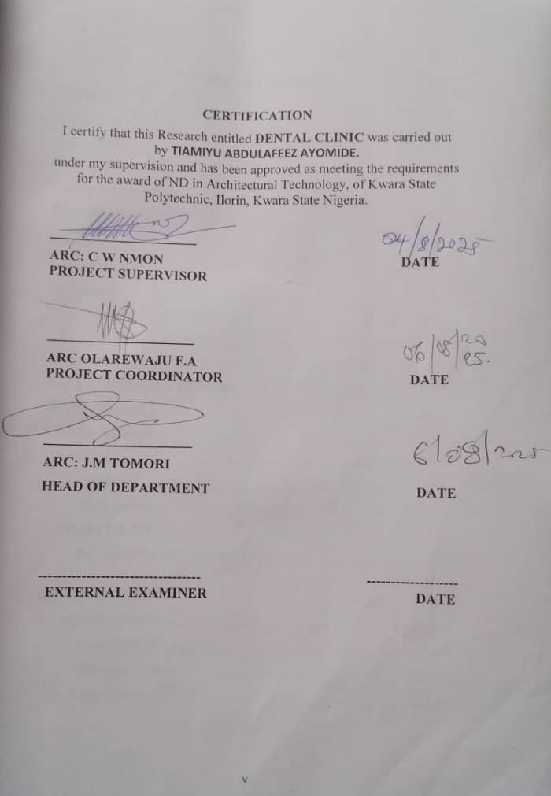

KWARA STATE POLYTECHNIC
ILORIN KWARA STATE



INSTITUTE OF ENVIRONMENTAL STUDIES (I.E.S)

DEPARTMENT OF ARCHITECTURAL TECHNOLOGY

A PROJECT REPORT

ON

DENTAL CLINIC
AT
TAIWO ISALE ROAD, ILORIN, KWARA STATE

By
TIAMIYU ABDULAFEEZ AYOMIDE

ND/23/ARC/FT/0009

SUBMITTED TO:
THE DEPARTMENT OF ARCHITECTURAL TECHNOLOGY
INSTITUTE OF ENVIRONMENTAL STUDIES, (I.E.S)
KWARA STATE POLYTECHNIC ILORRIN, KWARA STATE.

IN PARTIAL FULFILLMENT OF THE REQUIREMENTS FOR THE AWARD OF NATIONAL DIPLOMA (ND) IN ARCHITECTURAL TECHNOLOGY

JULY, 2025

DEDICATION
I would like to dedicate this work to the Almighty Allah, whose overflowing love and infinite mercy protected me, i gave the grace, favor and strength to pass through the hurdles of the final year project successfully despite the challenges.
I also dedicate this report to my parents, MR. & MRS. TIAMIYU, who supported me.

ACKNOWLEDGMENT
All praise and adoration and glorification to Almighty ALLAH, the creator of the universe that gave me the privilege to take part in this project.

First and foremost, I am grateful to my able Hardworking project supervisor ARC C W NMON and the member staff of the Architecture Department, Kwara State Polytechnic, Ilorin for their encouragement, expert advice and continuous kind assistant and supervision that made the completion of this study successful.
I deeply thank my guardian, Alhaji OLOHUNKEMI ARADEMI, for his continuous support and for helping me through this phase.
Finally, my special thanks go to my family. I remain grateful for your constant prayers, encouragement, and emotional support. Most especially my beloved sister LATEEFAT TIAMIYU, whose her support remains solemnly in my hearth.

DECLARATION
I HEREBY DECLARE THAT THIS PROJECT REPORT ENTITLED DENTAL CLINIC IS MY ORIGINAL WORK CARRIED OUT AS PART OF MY FINAL YEAR PROJECT IN PARTIAL FULFILLMENT OF THE REQUIREMENTS FOR THE AWARD OF NATIONAL DIPLOMA (ND) IN ARCHITECTURAL TECHNOLOGY THE WORK PRESENTED IN THIS REPORT HAS NOT BEEN SUBMITTED TO ANY OTHER INSTITUTION OR UNIVERSITY FOR THE AWARD OF ANY DEGREE, DIPLOMA OR CERTIFICATE

ME: TIAMIYU ABDULAFEEZ AYOMIDE
MATRIC NO: ND/23/ARC/FT/0009

_______________

Signature & Date

CERTIFICATION
I certify that this Research entitled DENTAL CLINIC was carried out by TIAMIYU ABDULAFEEZ AYOMIDE.
under my supervision and has been approved as meeting the requirements for the award of ND in Architectural Technology, of Kwara State Polytechnic, Ilorin, Kwara State Nigeria.
_____________________
ARC: C W NMON DATE
PROJECT SUPERVISOR

_____________________
ARC OLAREWAJU F.A
PROJECT COORDINATOR DATE

_____________________
ARC: J.M TOMORI
HEAD OF DEPARTMENT DATE

---------------------------------- -------------------
EXTERNAL EXAMINER DATE

TABLE OF CONTENTS
Title page
Declaration…………………………………………………….....……..IV
Dedication………………………………………………………….....…iii
Certification ………………….……………………………………...…iv
Acknowledgement………………………………………………………III
Table of content………………………………………….……..VI-VII
Abstract……………………………………………........…………..VII
CHAPTER ONE
Introduction……………………………………………..……….…..1
Background of the Study…………………………………………..2
Definition of the Study…………………………...………….…….2
Justification………………………………………………………..…2
Aim and Objectives of the Project……….…………………….…..2
Scope of Design…………………………………………………….3
Problem Statement…………………………………………….……3
Deduction……………………………………….....………………4
Limitation …………………………………....………...….……4
Methodology…………………………………....………….….…4
CHAPTER TWO
Review of Relevant Literature....................................................7&8

CHAPTER THREE
What is Case Studies........................................................................9
Case Study One…………………………...……………………10
Case Study Two………………………………….….……….....11
Case Study Three…………………………..………….……….12&13

CHAPTER FOUR
Background of the Site Location Town.....................................15
Site Location/Description............................................................16
Site Location Criteria...................................................................17
Geographical/Climate Data…………………...………...……..17
Design Criteria................................................................................20
Brief Analysis................................................................................21
Space Allocation/schedule of accommodation…………………22
Conceptual Development...............................................................23

CHAPTER FIVE
Appraisal of Proposed Scheme……………………………22--27
Construction Methodology and Material...………………...…….25
Service, Installation, Acoustic, Waste, Disposal, Lighting, Plumbing and Electrical installation, Acoustic, Waste Disposal, Fire Protection and External Works……………………………………………………………28 Recommendation………………………… …………….....…….….28
Conclusion…………………………………………..........………….28
Appendix…………………………………………......……………..29-33

ABSTRACT
Access to timely, hygienic, and dignified oral care is limited by cramped waiting areas, confusing circulation, and inadequate infection-control zoning. This project proposes a neighborhood-scale dental clinic that improves wayfinding, separates clean and dirty flows, and uses passive strategies for comfort. Objectives are to develop a clear spatial program, optimize patient–staff movement, integrate sterilization workflows, and achieve good daylight without glare.
The work combines literature review on dental facility planning and healthcare wayfinding with two to three architectural case studies. It applies site and climate analysis to generate a context-sensitive concept, tested through functional diagrams, adjacency matrices, and iterative sketch models.
The study identifies four critical drivers for small clinics: a readable public-to-clinical gradient from entrance to operatory; a central sterilization hub with one-way instrument flow; short, staff-only back-of-house spines; and tempered daylight to chairs with controlled views for privacy. The schedule of accommodation and relationships are resolved into a compact, phased layout.
The proposal shows that clear zoning, daylight design, and simple circulation can reduce patient stress and support staff efficiency. Future work should explore modular expansion, photovoltaic integration, and digital radiography rooms sized for newer equipment
CHAPTER ONE
- INTRODUCTION TO DENTAL CLINIC
Oral health is an essential component of overall well-being, and the demand for functional, accessible, and hygienic dental facilities has significantly increased in both urban and rural communities. A dental clinic is a healthcare facility specifically designed to provide a wide range of oral and maxillofacial treatments, including preventive care, diagnostics, restorative procedures, and oral surgeries. As an integral part of public and private healthcare systems, dental clinics serve individuals across all age groups, offering services that range from routine check-ups and cleanings to complex treatments like root canals, extractions, and cosmetic procedures.
The design and planning of a dental clinic require more than just accommodating dental chairs and equipment. It must take into consideration patient comfort, infection control, staff workflow, privacy, ventilation, lighting, and accessibility. A well-designed dental clinic should offer a calming environment that minimizes anxiety for patients, especially for children and the elderly who may experience fear or discomfort during dental visits. At the same time, the layout must promote efficiency, allowing dental professionals to carry out treatments smoothly while maintaining high standards of hygiene and safety.
In contemporary architectural practice, designing a dental clinic involves integrating modern healthcare standards with sustainable and responsive building solutions. This includes creating a spatial arrangement that distinguishes between public, semi-public, and clinical areas; establishing a one-way flow system for sterilization and waste disposal; and ensuring the operatory rooms receive adequate natural light while protecting patient privacy. The inclusion of sterilization zones, X-ray and imaging rooms, waiting lounges, consultation areas, and staff support spaces reflects the growing complexity of dental practice and the corresponding architectural responses needed to support it.

- DEFINITION OF THE STUDY
This study involves the architectural design and spatial planning of a purpose-built dental clinic aimed at providing efficient oral healthcare services in a safe, comfortable, and functional environment. It focuses on developing a healthcare facility that not only meets the clinical and operational needs of dental professionals but also enhances patient comfort, privacy, and accessibility.
The project addresses the core principles of health facility design, including zoning, circulation flow, environmental responsiveness, and infection control. It seeks to explore how architecture can support and improve the workflow in a dental setting—ranging from the reception and waiting areas to the operatory rooms, sterilization spaces, imaging rooms, and support facilities. Special attention is given to factors such as daylighting, ventilation, hygiene, and material selection to ensure a healthy, welcoming, and user-friendly space for both staff and patients.
- JUSTIFICATION FOR THE STUDY
The growing demand for accessible and hygienic dental healthcare services has highlighted the urgent need for well-designed dental clinics that meet both functional and emotional needs. In many communities, especially in urban and semi-urban areas, dental facilities are often located in poorly adapted spaces, such as converted residential buildings, that lack proper zoning, adequate ventilation, patient privacy, and infection control systems. These limitations not only compromise patient experience but also affect the efficiency and safety of dental practitioners.
Designing a purpose-built dental clinic offers a unique opportunity to create a space that is tailored specifically to the demands of oral healthcare. It allows for better organization of spaces such as waiting areas, operatory rooms, sterilization zones, and support facilities. With the right spatial planning, patient flow can be improved, cross-contamination risks reduced, and comfort levels enhanced. A well-planned dental clinic can also accommodate new technologies, encourage better hygiene practices, and support the mental well-being of patients—especially children, elderly, and those with dental anxiety.
This project is justified not only by the technical need for improved dental infrastructure but also by the social impact it can have. A well-designed clinic promotes trust, increases patient satisfaction, and ensures that dental professionals can work more efficiently in a safe and supportive environment. Through thoughtful architecture, this project aims to contribute to the broader goal of enhancing public health and raising the standard of dental care delivery in the community.

- AIM OF THE PROJECT
The aim of this project is to design a functional, hygienic, and patient-friendly dental clinic that meets modern oral healthcare standards, improves patient experience, and supports efficient clinical operations through proper architectural planning and environmental design.
Objectives of the Project
- To develop a comprehensive spatial arrangement that separates public, semi-public, and clinical zones for smooth patient and staff circulation
- To integrate infection control principles by designing effective zoning for clean and dirty flows, sterilization areas, and waste disposal
- To enhance patient comfort through the use of natural lighting, ventilation, acoustics, and soothing interior materials
- To accommodate essential clinical areas such as dental operatory rooms, imaging rooms, sterilization units, recovery spaces, and administrative offices
- To ensure accessibility for all users, including people with disabilities, through thoughtful layout and barrier-free design
- SCOPE OF THE DESIGN
The scope of this project covers the full architectural design of a purpose-built dental clinic from conceptual planning to detailed design presentation level. The focus is on creating a functional, hygienic, and patient-centered facility that meets modern healthcare standards while responding to the specific needs of a small-to-medium-scale dental practice.
The design includes the planning of essential spaces such as the reception and waiting areas, consulting and operatory rooms, sterilization and utility spaces, imaging/X-ray room, staff offices, restrooms, pharmacy or dental store, and other support zones. The layout will clearly define public, semi-public, and restricted clinical areas to ensure smooth circulation and minimize cross-contamination.
The project also covers external works, including landscaping, parking layout, accessible entry routes, and designated waste collection points. Services integration will be considered, such as plumbing for dental units, electrical layout, lighting, mechanical ventilation, and provision for dental gases and suction systems. The structure will be designed to meet comfort, safety, and hygiene requirements using materials suitable for a clinical environment.
Additionally, the design scope includes environmental analysis and site response, ensuring the building takes advantage of natural lighting, ventilation, and climate orientation where possible. Deliverables will consist of site plans, floor plans, sections, elevations, conceptual sketches, 3D views, and relevant architectural details sufficient for academic presentation and review. Structural, mechanical, and quantity surveying components are outside the full detailing scope but may be referenced for coordination.
- PROBLEM STATEMENT
Access to quality dental care is essential for maintaining overall health, yet many dental clinics—especially those located in densely populated or underserved areas—operate in buildings that were not originally designed for clinical use. These facilities often lack proper spatial organization, leading to overcrowded waiting areas, poor infection control, inadequate ventilation, and inefficient workflow for both patients and dental staff.
In many cases, public and private dental clinics function in adapted residential structures or poorly planned spaces that fail to meet healthcare standards. The absence of clearly defined zones for sterilization, consultation, treatment, and recovery compromises hygiene and creates a risk of cross-contamination. Additionally, the lack of attention to patient comfort, privacy, accessibility for people with disabilities, and environmental considerations such as lighting and ventilation contributes to patient anxiety and an overall unsatisfactory experience.
These challenges highlight the need for a purpose-built dental clinic that is designed with the specific requirements of oral healthcare delivery in mind. There is a growing demand for modern dental facilities that can support smooth circulation, patient safety, operational efficiency, and a calming treatment environment. Addressing these issues through thoughtful architectural planning is essential in improving the quality and accessibility of dental services in our communities.
- DEDUCTION
From the analysis of existing dental clinics and the challenges observed in their spatial and functional organization, it is evident that many facilities fall short of the basic standards required for efficient healthcare delivery. These shortcomings often stem from poor planning, inadequate zoning, lack of proper infection control measures, and insufficient consideration for patient comfort and staff workflow.
It can therefore be deduced that a well-designed dental clinic should not only address the technical aspects of oral treatment but also integrate thoughtful architectural solutions that enhance hygiene, circulation, accessibility, and environmental comfort. A clearly defined layout, proper separation of clean and contaminated zones, effective daylighting, adequate ventilation, and user-friendly design are all critical in creating a dental facility that is safe, functional, and welcoming.
This project confirms that architecture plays a vital role in healthcare delivery, especially in specialized fields like dentistry, where space planning directly affects the quality of care. The proposed design aims to solve the identified problems and set a standard for future developments of dental clinics within the community.
- LIMITATION OF THE STUDY
This project is focused strictly on the architectural design of a dental clinic and does not cover full structural calculations, electrical load analysis, mechanical system detailing, or cost estimation. While the design integrates space requirements for plumbing, dental gases, suction systems, lighting, and ventilation, the exact specifications and engineering designs of these services are beyond the scope of this study and are only represented schematically for design coordination purposes.
In addition, this work does not include the preparation of construction drawings for execution on-site, tender documents, or a full bill of quantities. Equipment layout is based on standard dimensions and assumed functional requirements, not brand-specific models or supplier recommendations. All medical zoning and planning are guided by general best practices and case study observations, rather than compliance with any specific health ministry or international accreditation.
Time constraints, access to real case studies, and limited field data also posed some restrictions on the depth of analysis and validation of the design solutions. Despite these limitations, the project remains a strong academic exploration of dental clinic design principles, aimed at providing a practical and thoughtful architectural response to the growing demand for quality oral healthcare environments.

- Research Methodology
The methodology adopted for this project is a combination of qualitative architectural research and design-based problem-solving. The goal is to understand the functional and environmental requirements of a dental clinic and translate them into a well-organized, efficient, and patient-friendly architectural design. The approach follows a logical progression from data gathering and analysis to conceptual development and final design presentation.
The study began with a thorough literature review, focusing on healthcare architecture, dental clinic design standards, infection control practices, spatial zoning strategies, and environmental comfort in clinical settings. This provided the foundational knowledge needed to establish the basic principles for designing a functional oral healthcare facility.
Next, case studies of existing dental clinics were carried out to observe practical applications of design principles in real-life situations. These included site visits, plan analyses, and evaluation of architectural merits and shortcomings. Attention was paid to circulation flow, spatial arrangements, daylighting, privacy, service integration, and patient experience. The lessons learned from these examples helped shape the design direction of this project.
A detailed site analysis was then conducted to assess the chosen location in terms of topography, orientation, climate, access roads, noise levels, and environmental constraints. This analysis informed decisions on site layout, building placement, entry orientation, and natural ventilation strategies.
After gathering and synthesizing this information, the design development phase began. This involved creating bubble diagrams, adjacency matrices, zoning layouts, and massing studies to refine spatial relationships and circulation. Concepts were tested through sketches and iterations until a coherent and functional layout was achieved. Environmental design strategies such as daylight control, cross ventilation, and thermal comfort were also integrated into the planning.
The project concludes with the production of detailed architectural drawings, including site plan, floor plans, sections, elevations, 3D views, and key design features. These drawings visually communicate the final proposal and demonstrate how the research has been translated into a thoughtful and practical dental clinic design.
CHAPTER TWO

REVIEW OF RELEVANT LITERATURE
The design of dental clinics has evolved significantly over time, moving from simple treatment rooms to fully integrated healthcare environments that prioritize hygiene, comfort, workflow, and patient psychology. Literature on healthcare architecture emphasizes that the spatial quality and functional arrangement of clinical spaces directly impact service efficiency, patient safety, and staff productivity.
Evolution and Typology of Dental Clinics
Dental facilities have developed alongside advancements in dentistry, equipment technology, and infection control protocols. Early dental spaces were primarily treatment-focused, often lacking proper sterilization zones or recovery areas. Modern clinics, however, are guided by clearly defined zones—public, semi-public, and clinical—each serving a specific role in patient experience and clinical workflow. The World Health Organization (WHO) and various healthcare design bodies emphasize that dental clinics must be designed with infection control, accessibility, staff efficiency, and patient comfort at their core.
Dental clinics can be classified into various types based on scale and specialization—ranging from solo private practices and group clinics to pediatric, orthodontic, and surgical dental facilities. Each type requires a slightly different layout, but they all follow the same general principles: controlled access to treatment rooms, proper ventilation, clean/dirty workflow separation, and easy wayfinding.
Spatial Relationships and Zoning Principles
A major focus in the literature is the importance of efficient spatial relationships. According to design guidelines by organizations such as the Facility Guidelines Institute (FGI), dental clinics should prioritize direct adjacency between sterilization areas and operatories to ensure proper instrument flow. Similarly, waiting areas should be visually and acoustically separated from treatment spaces to enhance privacy and reduce anxiety. Literature also recommends unidirectional flow paths that separate staff and patients to prevent congestion and contamination.

Studies further suggest that open-plan operatories may be efficient in terms of layout but often compromise acoustic privacy and patient comfort. Closed or semi-private rooms are now favored in many cases, especially where minor surgical procedures are performed. The position and access to imaging rooms, recovery areas, consultation rooms, and dental labs must also follow a logic that supports smooth clinical operations.
Technological and Environmental Considerations
Dental equipment, such as chairs, X-ray machines, and suction systems, require precise integration with building services. Literature highlights the need for well-planned service routes for plumbing, electrical systems, dental gases, and compressed air. Mechanical ventilation systems are crucial in maintaining clean air circulation, especially in operatory zones and sterilization areas. Infection control standards now recommend negative pressure rooms for aerosol-generating procedures.
In terms of environmental comfort, numerous studies confirm that natural lighting has a calming effect on patients and helps reduce anxiety, especially in pediatric and geriatric care. However, care must be taken to avoid direct glare on dental chairs during procedures. Therefore, design strategies such as clerestory windows, diffused glazing, light shelves, and landscape views are often encouraged in modern clinic design.
Sub-Topic Focus: Patient Experience and Anxiety Reduction
Several architectural studies have explored how design affects patient psychology. The literature notes that many people feel anxious or fearful about visiting a dentist. This fear can be reduced through calming interiors, use of natural materials, soft lighting, acoustic control, and pleasant waiting areas. Wayfinding, signage, and spatial legibility also play a major role in helping patients feel confident and comfortable within the facility. As such, architecture becomes an active agent in enhancing not just physical care but emotional well-being.

CHAPTER THREE
- CASE STUDIES
Case studies are in-depth investigations of existing buildings or projects that are similar in purpose, scale, or function to the one being proposed. In architectural design, case studies help designers and students learn from real-world examples by observing how certain design problems were solved, how different spaces were arranged, and how various materials, services, and technologies were used effectively.
In this project, case studies are conducted on selected dental clinics—either local or international—that reflect relevant design principles. These case studies focus on examining the layout of the clinics, spatial relationships between rooms, circulation patterns, zoning for public and clinical areas, methods of infection control, environmental comfort strategies, and patient-centered features such as privacy, lighting, and accessibility.
By analyzing floor plans, sections, elevations, photographs, and site characteristics of these clinics, the study identifies both the strengths (merits) and weaknesses (demerits) of each design. These findings provide valuable insights that guide the development of a more functional and efficient design for the proposed dental clinic.
CASE STUDY ONE
NAME: ASHUBIARO HOSPITAL
LOCATION:OSUN, OSHOGBO.
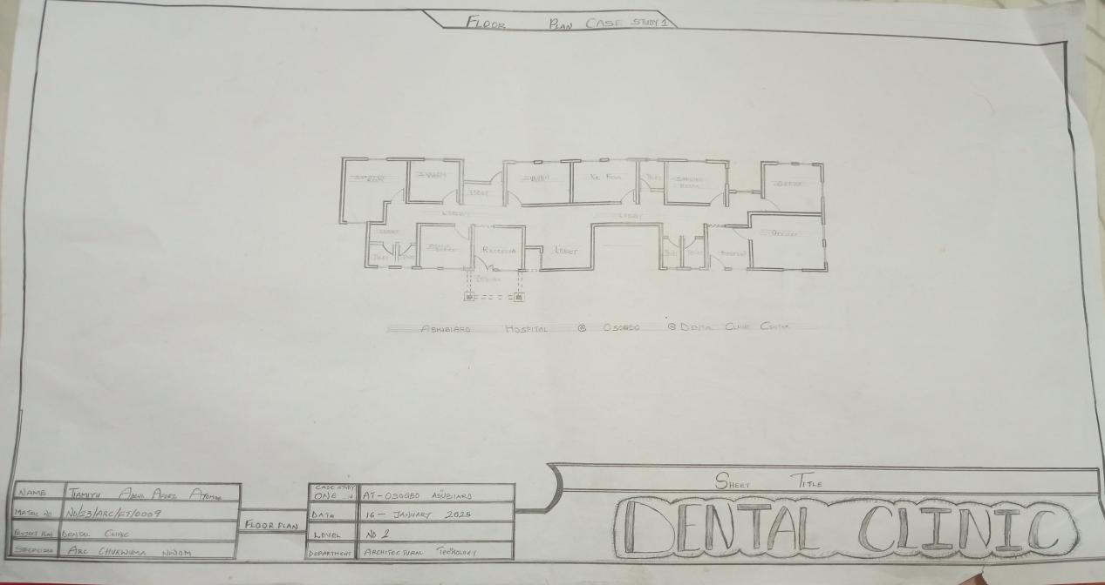
FIG1.1: FLOOR PLAN

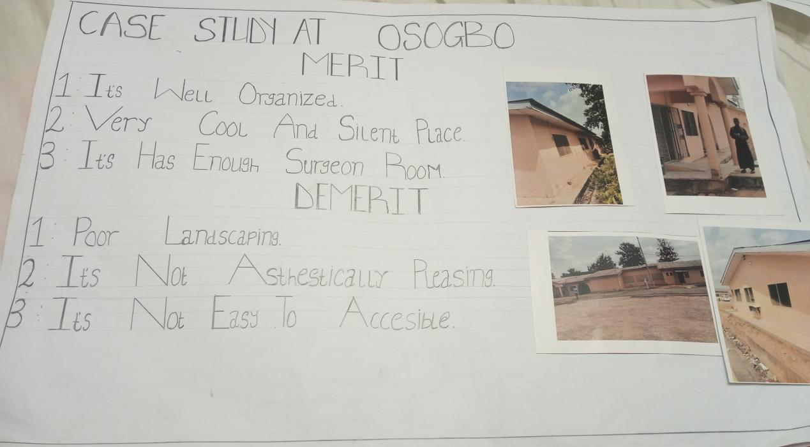

FIG 1.2. CASE STUDY 1 MERIT & DEMERIT

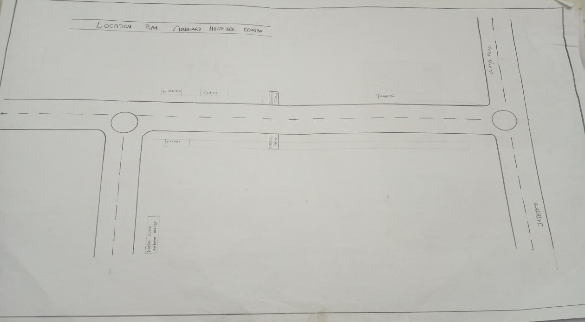

FIG 1.3 LOCATIONAL PLAN

CASE STUDY TWO

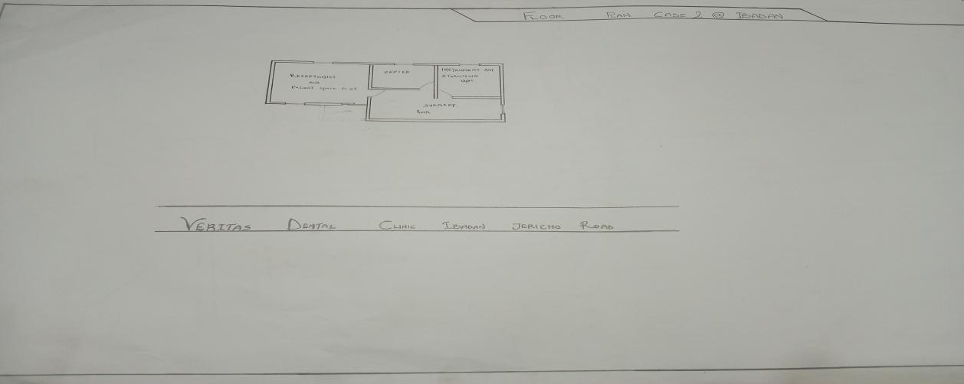
FIG1.4: FLOOR PLAN

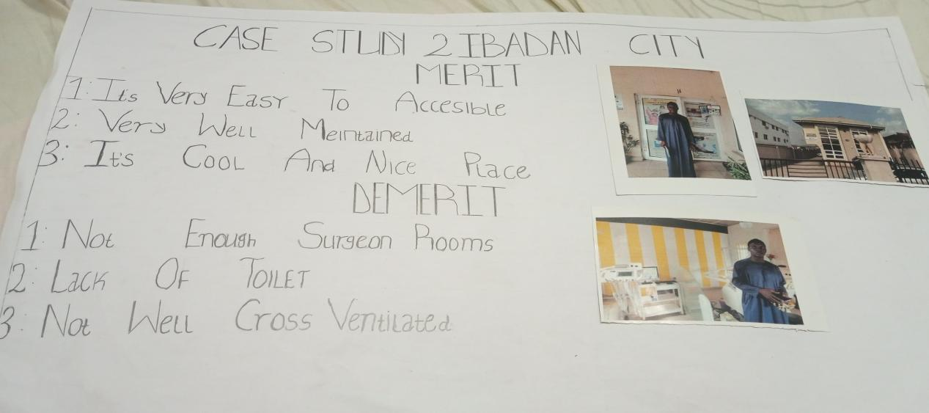
FIG 1.5. CASE STUDY 2 MERIT & DEMERIT
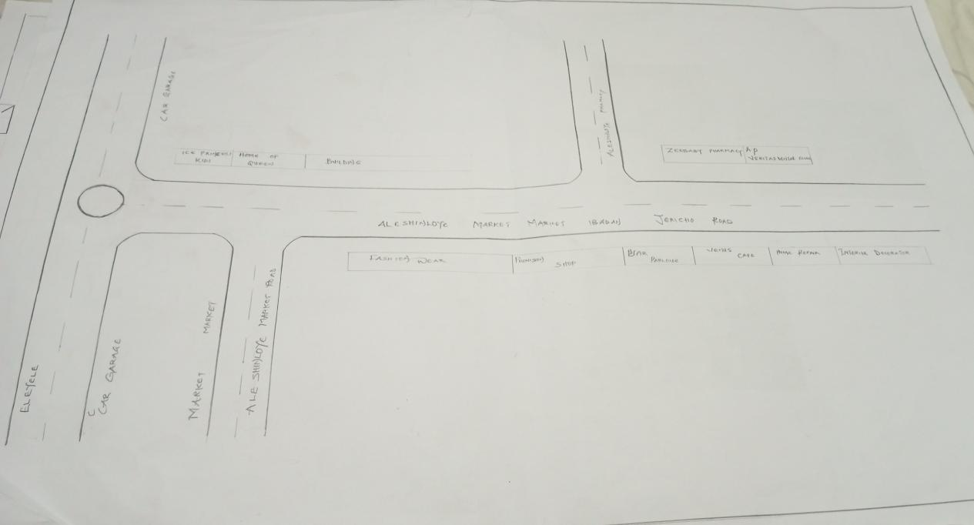
FIG 1.6 LOCATIONAL PLAN

CASE STUDY THREE
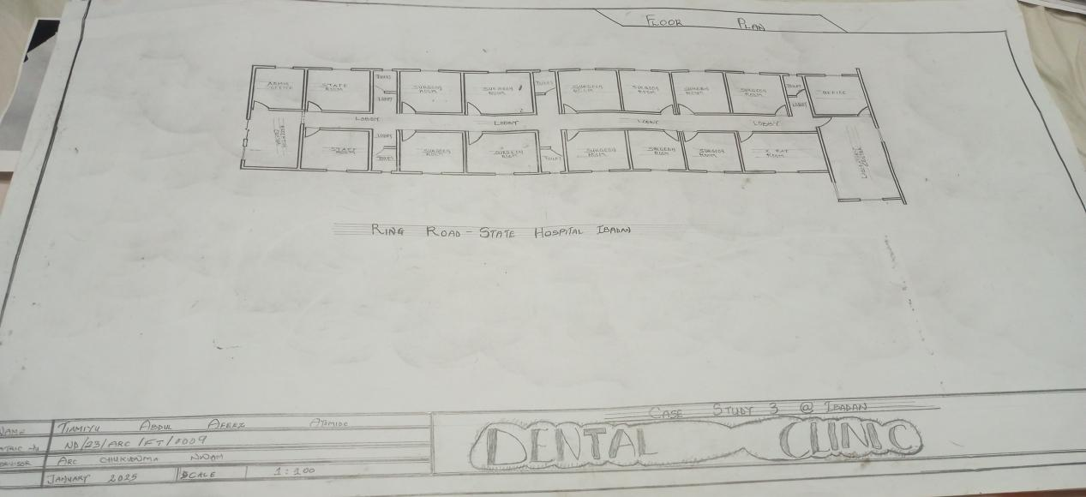
FIG1.7: FLOOR PLAN

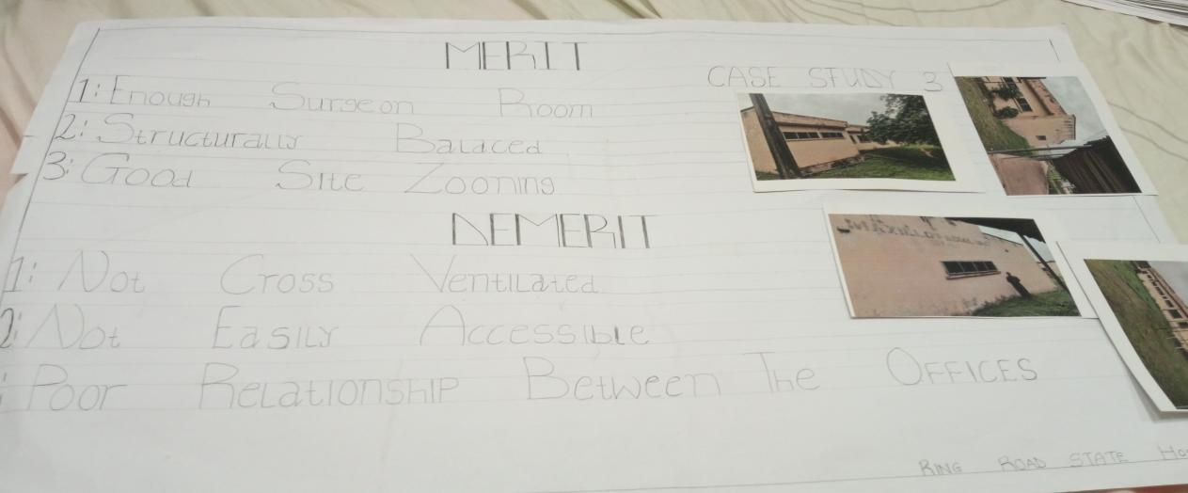
FIG 1.8. CASE STUDY 2 MERIT & DEMERIT

ONLINE CASE STUDY

NAME: ONTARIO HOSPITAL
LOCATION:GERMANY & DUBAI

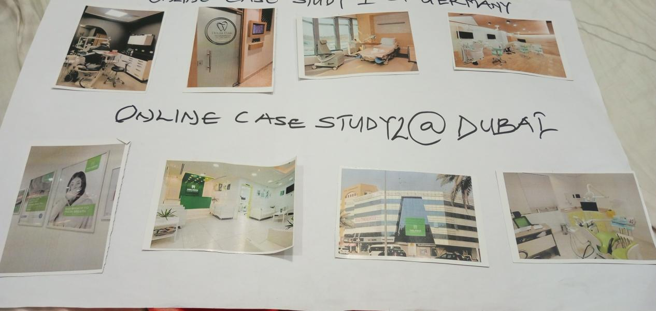
FIG 1.9. ONLINE CASE STUDY

CHAPTER FOUR
- BACKGROUND OF THE SITE LOCATION TOWN (ILORIN, KWARA STATE)
Ilorin is the capital city of Kwara State, located in the North-Central geopolitical zone of Nigeria. Strategically positioned between the northern and southern parts of the country, Ilorin serves as a vital link and melting pot of diverse cultures, traditions, and ethnic groups, particularly the Yoruba, Fulani, and Nupe. It is one of the most historically rich cities in Nigeria, known for its Islamic heritage, traditional craftsmanship, and academic institutions.
Over the years, Ilorin has evolved from a quiet traditional town into a growing urban center with increasing demand for infrastructure, social amenities, and healthcare services. As the city expands, the need for modern health facilities—including specialized services like dental care—has become more apparent. The existing dental clinics in Ilorin are either government-run or privately operated within repurposed residential buildings, many of which fall short in terms of modern spatial planning, infection control, and patient comfort.
The city is home to several educational institutions including the University of Ilorin, Kwara State Polytechnic, and multiple secondary schools and vocational training centers, which contribute to a growing, youthful population. This creates a pressing demand for accessible and efficient healthcare systems to cater to students, staff, families, and the general public.
Ilorin experiences a tropical wet and dry climate, with a defined rainy season and a dry harmattan period. This climatic condition influences the design approach for buildings in the area—particularly in terms of ventilation, natural lighting, roofing, and protection from dust and heat. The availability of relatively flat land, good road networks, and proximity to existing residential neighborhoods make Ilorin a practical and impactful location for a purpose-built dental clinic.
In view of its urban growth, diverse population, and rising healthcare needs, Ilorin offers a suitable setting for the development of a modern dental clinic that meets the standards of hygiene, accessibility, and patient comfort required in today’s oral healthcare practice.

- SITE LOCATION AND DESCRIPTION
The proposed site for the dental clinic is located along Taiwo Isale Road, in the heart of Ilorin, the capital city of Kwara State, Nigeria. Taiwo Isale is one of the busiest and most well-known roads in Ilorin, serving as a vital link between the city center and several surrounding residential and commercial districts. The road connects various neighborhoods and is known for its vibrant mix of activities, including retail shops, schools, religious centers, and healthcare facilities.
The site lies within an urbanized area that enjoys good road accessibility and proximity to essential services and amenities. It is easily reachable by both private and public transportation, making it convenient for patients from different parts of the city. The area is well populated and attracts regular foot and vehicular traffic, which is favorable for the visibility and accessibility of a public-oriented health facility such as a dental clinic.
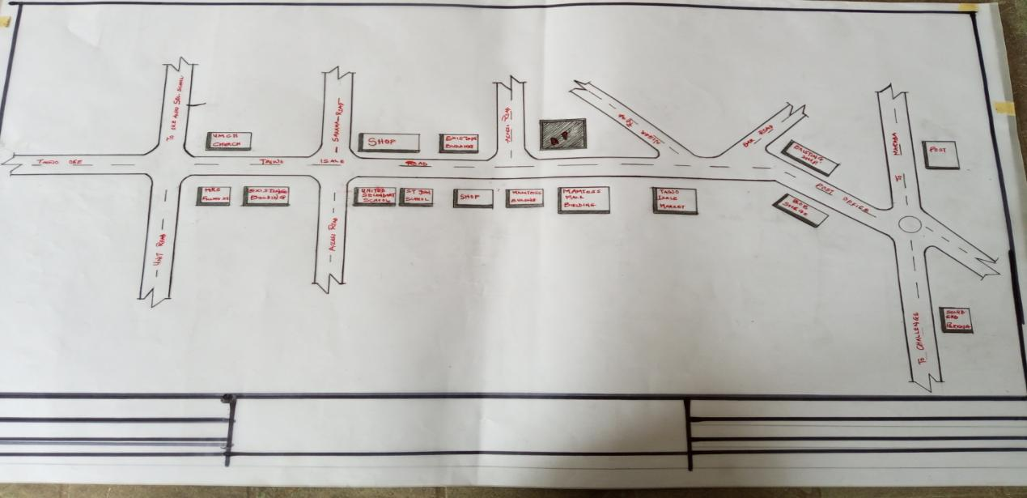
FIG 2.0. LOCATION PLAN
Topographically, the site is generally flat with slight natural drainage that can be effectively managed during the design process. The surrounding buildings are a mix of low-rise commercial and residential structures, which makes the proposed use compatible with the neighborhood context. The site also benefits from an open frontage along Taiwo Isale Road, allowing for clear access points, controlled parking, and visibility for signage and branding.

In terms of climate, Ilorin falls within the tropical wet and dry zone, and this specific site receives good exposure to natural light and prevailing winds, which will aid in the application of passive design strategies such as cross-ventilation and daylighting. However, design considerations will also have to account for dust from nearby traffic and noise pollution from the busy road.
- SITE LOCATION CRITERIA
The selection of a suitable site is a critical part of healthcare facility planning, especially for a specialized service like a dental clinic. For this project, the site selection was based on a set of functional, environmental, and urban criteria to ensure that the location would support smooth operations, accessibility, and user comfort. The following criteria were considered in choosing the site along Taiwo Isale Road, Ilorin:
1. Accessibility
The site is easily accessible via a major road—Taiwo Isale—which ensures visibility and convenience for both private vehicle users and those relying on public transportation. Proximity to public bus stops and road connectivity to other parts of Ilorin makes the location ideal for patient access.
2. Visibility and Exposure
Being located along a busy and well-known road enhances the public visibility of the clinic, which is beneficial for attracting patients and promoting healthcare awareness. High pedestrian and vehicular traffic in the area supports the clinic’s functional relevance in a community setting.
3. Environmental Suitability
The site receives sufficient natural light and air movement, making it conducive for implementing passive design strategies. Its orientation and openness allow for cross ventilation, which improves thermal comfort and reduces reliance on mechanical systems.
4. Safety and Security
Taiwo Isale is generally a stable and active area with low crime reports and visible community activity. This enhances the safety of both patients and staff, particularly during early morning and late afternoon appointments.

5. Parking and External Space Potential
The site is large enough to accommodate essential external features such as a drop-off zone, on-site parking for staff and patients, landscaping, and waste management zones without over-congesting the surrounding area.
- GEOGRAPHICAL AND CLIMATE DATA
Ilorin, the capital of Kwara State, is located in the North-Central region of Nigeria. Geographically, the city lies between latitudes 8°24′N and longitudes 4°34′E, covering a mix of gently undulating plains and lowland terrain. The city sits at an elevation of approximately 290 meters (951 feet) above sea level, making it generally flat with mild slopes that assist natural drainage. The site for the proposed dental clinic, located along Taiwo Isale Road, falls within this flat terrain, which makes it ideal for construction and easy site development.
GEOGRAPHICAL CONTEXT
The city is bordered by various communities and towns such as Ganmo, Asa Dam, Sango, and Olorunsogo. Taiwo Isale Road itself is a central urban corridor surrounded by both residential and commercial developments. The area features paved roads, electricity infrastructure, and access to water and communication services. The geological makeup of the region includes granite and basement complex rocks, with sandy-loam surface soil that supports stable foundations for building structures.
CLIMATE CHARACTERISTICS
Ilorin experiences a tropical wet and dry climate (Aw under the Köppen-Geiger classification), which is characterized by distinct wet and dry seasons. The rainy season typically starts in April and ends in October, while the dry season spans from November to March. This seasonal rhythm has a direct influence on building design, especially with respect to drainage, roofing, and natural ventilation.
- Average Annual Rainfall: Between 1,100 mm and 1,300 mm, with peak rainfall occurring between July and September.
- Temperature Range: The average daily temperature ranges from 21°C to 34°C, with the hottest months being February to April.
- Humidity Levels: Humidity is generally high during the rainy season, ranging between 70% and 85%, and relatively lower in the dry season.
- Wind Patterns: The city enjoys light to moderate wind flow throughout the year. The Harmattan winds from the northeast dominate the dry season, carrying fine dust particles.
- Sunlight: Ilorin receives ample sunlight throughout the year, averaging 6–8 hours per day, making it suitable for daylighting strategies and potential solar energy integration.
- DESIGN CRITERIA
The design criteria for the proposed dental clinic serve as the foundational guidelines that shape the planning, layout, spatial organization, service integration, and environmental response of the project. These criteria ensure that the final design meets functional, operational, hygienic, and user-centered goals. Based on the site conditions, programmatic needs, and healthcare design standards, the following design criteria were established:
1. Functional Efficiency
The layout must support a smooth and logical flow of activities, minimizing unnecessary movement and reducing patient waiting times. Spaces such as reception, waiting areas, consultation rooms, operatories, sterilization units, and staff zones must be well-connected to enhance operational efficiency.
2. Spatial Zoning and Circulation Flow
Clear zoning between public, semi-public, and restricted clinical areas is required. Patient circulation must not intersect with clinical instrument routes or waste disposal paths. There must be a unidirectional workflow for instruments—from dirty to clean—to support infection control. Staff circulation should be separated from patient areas where necessary.
3. Schedule of Accommodation
The design must incorporate all required spaces including:
- Reception and Records Area
- Waiting Area with comfortable seating
- Public Restrooms (including accessible WC)
- Dental Operatory Rooms (3–5 units)
- Imaging/X-ray Room with shielding
- Sterilization/CSSD (Central Sterile Supply Department)
- Dirty and Clean Utility Rooms
- Staff Offices and Lounge
- Pharmacy or Store
- Changing Rooms and Staff WC
- Plant Room (for compressor, suction, and HVAC systems)
- Waste Holding Area
- Landscaped outdoor spaces and designated parking
4. Infection Control and Hygiene
Surfaces, materials, and finishes must be easy to clean and disinfect. Coved junctions, non-slip flooring, and anti-microbial wall coatings are recommended. The CSSD should support a one-way workflow with defined dirty and clean sides. Hand-washing sinks and hand sanitizer points must be located throughout clinical areas.
5. Environmental Comfort
The design should promote natural ventilation and daylight while avoiding glare on dental chairs. Openings should be strategically placed to allow cross-ventilation in waiting areas and staff rooms. Operatory rooms should be shaded, and windows should ensure privacy while still allowing filtered light. Artificial lighting should be bright but soothing.
6. Accessibility
The facility must comply with universal access design. Ramps, wide doorways, barrier-free restrooms, and clear internal pathways must be incorporated to accommodate people with disabilities, the elderly, and children.
7. Privacy and Acoustics
Each operatory must provide visual and acoustic privacy for patients. Waiting and treatment zones should be acoustically separated to reduce stress and noise disturbance. Doors and partitions must be selected with appropriate sound insulation.
8. Building Services Integration
The design must account for the early coordination of essential services such as:
- Plumbing to each operatory for sinks and dental chair connections
- Electrical and data outlets for dental equipment and computers
- Mechanical ventilation and air conditioning systems
- Dental gases (oxygen, compressed air, suction)
- Medical waste management, fire protection, and emergency lighting
9. Safety and Regulations
The design must comply with local planning and building codes. Fire exits, extinguishers, signage, accessible pathways, and emergency routes must be clearly indicated. The layout must allow for fast evacuation and safe access for emergency services.

10. Site and Environmental Response
Building orientation should maximize shading and daylight while protecting clinical spaces from direct sun. Roof overhangs, window hoods, and landscaping should be used for passive environmental control. Rainwater drainage must be handled effectively on-site.
- BRIEF ANALYSIS
The brief for the proposed dental clinic outlines the client’s intention to establish a modern, purpose-built facility that delivers efficient oral healthcare services in a clean, accessible, and patient-friendly environment. The project is expected to respond to both functional and emotional needs of users—patients, dental practitioners, and support staff.
The core requirements include a welcoming reception and waiting area, multiple fully equipped operatory rooms, an imaging room, a central sterilization and supply unit (CSSD), clean and dirty utility rooms, a pharmacy or small dental store, staff offices, and support facilities such as WCs, lockers, and a plant room. Accessibility, infection control, privacy, comfort, and workflow efficiency are top priorities.
The client also emphasized the need for easy circulation paths for both patients and staff, with zoning that separates public from clinical and service areas. A clear and logical layout is required to minimize confusion and reduce anxiety, especially for first-time visitors or elderly patients.
Environmentally, the brief calls for a building that can make use of natural lighting and ventilation where possible, while maintaining patient privacy and indoor comfort. Externally, the design should accommodate drop-off space, parking, service areas, and basic landscaping that improves the aesthetic value of the clinic.
- CONCEPTUAL DEVELOPMENT
The conceptual development of the proposed dental clinic is rooted in creating a health-focused, user-friendly environment that responds to both functional needs and emotional comfort. The goal is to design a facility that simplifies movement, enhances cleanliness, maximizes daylight, and reduces patient anxiety—while ensuring efficient operations for dental professionals.

The primary design concept is built around the “LETTER E” principle.
The administrative and support areas, including the dentist’s office, nurses' station, pharmacy, and staff lounge, are placed toward the rear of the building, allowing privacy and focused work. These areas are directly linked to the clinical zone but remain isolated from public circulation.
Environmental sustainability is also a core element of the concept. The building is oriented to take advantage of natural ventilation and daylighting, reducing reliance on artificial systems. Operatory rooms are designed with clerestory windows or high-level openings to allow daylight while preserving patient privacy. Roof overhangs, window hoods, and internal blinds help reduce glare and thermal gain.
Outdoor elements such as parking, landscaping, and the waste zone are thoughtfully arranged for functionality and aesthetics. Parking is located near the entrance for convenience, while landscaped green buffers reduce heat and improve the visual experience for patients and staff.

CHAPTER FIVE
- APPRAISAL OF THE PROPOSED SCHEME
The proposed dental clinic design presents a well-structured and functional architectural response to the challenges commonly faced in existing oral healthcare facilities. It demonstrates a strong understanding of spatial organization, hygiene protocols, user comfort, and operational efficiency.
One of the key strengths of the proposed scheme is the clear zoning between public, semi-public, and private areas. The separation of patient flow from staff and equipment circulation enhances both user experience and infection control. The linear layout of the operatory rooms along a central corridor ensures efficient movement while maintaining privacy and acoustic control.
The incorporation of a sterilization unit with a one-way instrument flow system shows a strong commitment to hygiene and safety. By placing the CSSD near the operatory rooms and keeping it isolated from patient zones, the design reflects a professional understanding of clinical workflow in dental environments.
Another notable feature is the integration of passive design strategies. The building takes advantage of natural light and ventilation, reducing energy consumption and creating a more calming environment for patients. The placement of operatory rooms with clerestory lighting, the shaded waiting area, and the use of cross-ventilation in key zones help improve thermal comfort and indoor air quality.
Accessibility is also commendably addressed. Ramps, wide doorways, and barrier-free restrooms ensure that people with disabilities and the elderly can access all parts of the clinic comfortably and independently. The exterior layout includes clear vehicular drop-off zones, organized parking spaces, and landscaped buffers, enhancing functionality and aesthetics.
Furthermore, the allocation of support spaces—such as a pharmacy/store, staff lounge, imaging room, and janitor's closet—demonstrates that the design goes beyond the basics of treatment to cover the full spectrum of operational needs.

- CONSTRUCTION METHODOLOGY AND MATERIAL
The construction methodology for the proposed dental clinic is centered around durability, hygiene, cost-effectiveness, ease of maintenance, and responsiveness to the local climate. The materials selected are chosen to support both the clinical functions of the facility and the architectural intent of creating a clean, calm, and comfortable healthcare environment.
1. Foundation and Substructure
The building will be constructed on a reinforced concrete strip or pad foundation system, depending on the soil conditions on-site. The flat topography of the Taiwo Isale location supports this type of foundation, and proper damp-proofing measures will be introduced to prevent moisture ingress. Anti-termite treatment and hardcore filling will also be applied before concrete blinding.
2. Superstructure (Walls)
The external and internal walls will be built using 150 mm to 225 mm thick sandcrete blocks. These blocks offer strength, cost efficiency, and good thermal mass. Internal partitions between operatory rooms and other sensitive clinical spaces will be sound-insulated using double layers or hollow-core blocks to maintain privacy and acoustic separation. All walls will be finished with smooth cement plaster, ready to receive washable paint or tiles.
3. Roofing System
The roofing will be a lightweight pitched truss system using timber or mild steel trusses, covered with long-span aluminum roofing sheets. This type of roof allows easy drainage during the rainy season and reduces heat build-up. A suspended ceiling system will be used beneath the trusses to conceal electrical wiring, ducts, and services while providing acoustic absorption in the waiting and operatory areas.
4. Flooring
Floor finishes in clinical zones such as operatories, sterilization areas, and restrooms will be anti-slip ceramic tiles or epoxy flooring for easy cleaning and moisture resistance. Public areas like the reception and waiting room will have polished vitrified tiles, while staff and storage rooms may use screeded floors with durable PVC tiles or vinyl sheet finishes. Skirtings will be coved to aid cleaning and hygiene.

5. Doors and Windows
External doors will be made of steel or security-grade aluminum with powder-coated finishes, while internal doors in clinical zones will be flush solid-core wooden doors with PVC-coated or laminated surfaces for moisture resistance. Windows will be aluminum casement types with mosquito netting, frosted or tinted glass in treatment rooms for privacy, and louvered openings or clerestories in ventilation areas.
6. Finishes and Wall Treatments
Internal wall finishes in clinical rooms will use emulsion or antimicrobial paints for hygiene. Areas like the sterilization room, dirty utility, and restrooms will receive ceramic tiles to at least 1.5 m height. External walls will be finished with weather-resistant paint or textured plaster to handle dust and moisture.
7. Plumbing and Drainage
The plumbing system will include cold-water supply pipes connected to storage tanks (overhead or ground-level) and pressure pumps for consistency. Wastewater will be managed via a PVC drainage system with grease traps and inspection chambers, channeling flow into a soakaway or public sewer network. Operatory rooms will each have a sink with foot-operated or sensor taps to reduce contamination risk.
8. Electrical Installations
The building will be supplied with 220–240V electricity with a well-structured wiring layout. The electrical system will include lighting points, power outlets, sockets for dental equipment, emergency lighting, and a backup generator. LED lights will be used for energy efficiency, and task lighting will be included over treatment chairs. Surge protectors and circuit breakers will be installed for safety.
9. Mechanical Installations
Provision will be made for air-conditioning units in treatment rooms and the reception area. Ceiling fans and extract fans will be installed where necessary to enhance airflow. Suction systems and compressed air units for dental operations will be housed in a separate plant room with soundproofing.
10. External Works and Site Development
The external environment will include paved walkways, a drop-off zone, parking spaces, landscaping with shade trees and shrubs, water drainage channels, a waste collection zone, and security lighting. A signpost will be installed at the entrance for visibility.

- SERVICES, INSTALLATION, AND ENVIRONMENTAL SYSTEMS
To ensure the smooth operation of the proposed dental clinic, all building services have been carefully considered and integrated into the design. These include mechanical, electrical, and plumbing systems (MEP), as well as fire safety, acoustics, waste management, and external site services.
1. Acoustic Control
Acoustic comfort is crucial in a dental clinic to reduce anxiety for patients and ensure privacy between treatment rooms. Sound-insulated partition walls and solid-core doors will be used to separate operatories. Acoustic ceiling panels or sound-absorbing tiles will be installed in the waiting area, operatory rooms, and staff offices. Soft finishes like rugs or upholstered furniture may be introduced in the reception to reduce ambient noise levels.
2. Waste Disposal System
A well-organized waste management system will be implemented to ensure the safe handling of both general and medical waste. The clinic will include:
- General waste bins in public areas and restrooms
- A secure waste holding room near the service exit for temporary storage before collection by licensed medical waste handlers
3. Lighting Installation
The lighting system is designed to enhance visibility, comfort, and energy efficiency:
- Natural daylighting is maximized in public and staff zones through well-placed windows, clerestories, and shaded opening
- LED lights are used throughout the clinic for low energy consumption and long life
- Task lighting is provided directly above each dental chair for precision during procedures
- Ambient lighting in the waiting and consultation rooms will use soft, warm tones to reduce stress
- Emergency lighting will be installed in corridors, exit paths, and critical areas to maintain visibility during power outages
4. Plumbing System
A reliable plumbing system is essential to support clinical functions:
- Cold water supply lines will run to sinks in all operatories, restrooms, sterilization rooms, and utility areas
- Hot water units (instant or centralized) will be installed in treatment zones and staff areas requiring hygiene
- Hand-washing sinks with foot-operated or sensor taps will be provided in clinical zones
- Drainage lines will be connected to PVC pipes leading to septic tanks or municipal sewers
- Provision will be made for floor drains in wet zones like restrooms and sterilization units
5. Electrical Installation
The electrical system is designed for safety, redundancy, and operational ease:
- The clinic will be supplied with single-phase 220–240V electricity, distributed through a main distribution board and sub-circuits
- Dedicated outlets for dental chairs, suction units, X-ray equipment, autoclaves, and computers will be installed
- Switches and sockets will be mounted at standard accessible heights
- Power backup will be provided by a standby generator or inverter system, especially for sensitive dental and sterilization equipment
- Surge protectors and MCBs (Miniature Circuit Breakers) will be installed to prevent electrical damage
6. Fire Protection
To ensure occupant safety and meet regulatory requirements, the following fire safety provisions will be included:
- Fire extinguishers (dry powder and CO₂ types) placed in strategic zones: reception, operatory corridor, sterilization room, and plant room
- Smoke detectors in electrical and storage areas
- Fire alarm system with manual break-glass points near exits
- Clearly marked and illuminated emergency exits
- Fire-resistant internal doors, particularly in utility and plant areas
- Safe egress paths leading to open assembly areas outside the building

7. External Works
The external works complement the function and appearance of the clinic and include:
- Parking bays for staff and patients, including at least one accessible space for persons with disabilities
- Drop-off zone at the entrance for elderly or emergency arrivals
- Paved walkways and ramps with anti-slip finishes for ease of access
- Drainage channels and soakaways to manage stormwater runoff
- Perimeter fencing and gate for security, with provisions for future CCTV installation
- External lighting to enhance safety at night, particularly along walkways and entry points
- Waste holding area designed and screened for hygiene and environmental compliance

- RECOMMENDATION
Based on the findings, design process, and functional needs addressed in the proposed dental clinic, it is recommended that future dental healthcare facilities—especially in urban areas like Ilorin—should adopt purpose-built architectural designs rather than relying on converted residential buildings. This will help to properly accommodate zoning requirements, infection control systems, and spatial standards necessary for safe and effective oral care delivery.
Architectural designers should continue to prioritize user-centered planning that promotes smooth circulation for both staff and patients, visual and acoustic privacy, and the integration of passive design strategies such as natural ventilation and daylighting. Clinics should also be equipped with properly designed sterilization zones and one-way instrument flow systems to ensure hygienic practices.
In future developments, more attention should be given to sustainability features such as the incorporation of solar energy systems, rainwater harvesting, energy-efficient appliances, and low-maintenance building materials to reduce operational costs and environmental impact.
Furthermore, future studies and designs can explore the integration of digital technologies in dental facilities—such as teledentistry zones, smart booking systems, and digital imaging suites—to meet the demands of modern dental practice and improve service delivery.
- CONCLUSION
The design of a modern dental clinic requires a thoughtful balance between clinical functionality, patient comfort, hygiene, and environmental responsiveness. This project has successfully addressed these needs through a purpose-built facility that ensures smooth circulation, proper zoning, effective infection control, and an overall supportive environment for oral healthcare delivery.
By analyzing existing case studies, understanding spatial and environmental requirements, and applying architectural principles tailored to healthcare design, the proposed scheme demonstrates how architecture can improve the quality of both patient experience and clinical workflow. The integration of natural lighting, ventilation, acoustic control, and accessibility features further enhances the performance and usability of the space.
The clinic’s spatial arrangement—including clearly separated public and clinical areas, strategically placed sterilization units, and user-friendly service installations—proves that a well-designed facility can support not only technical efficiency but also emotional wellness and long-term adaptability.

APPENDIX
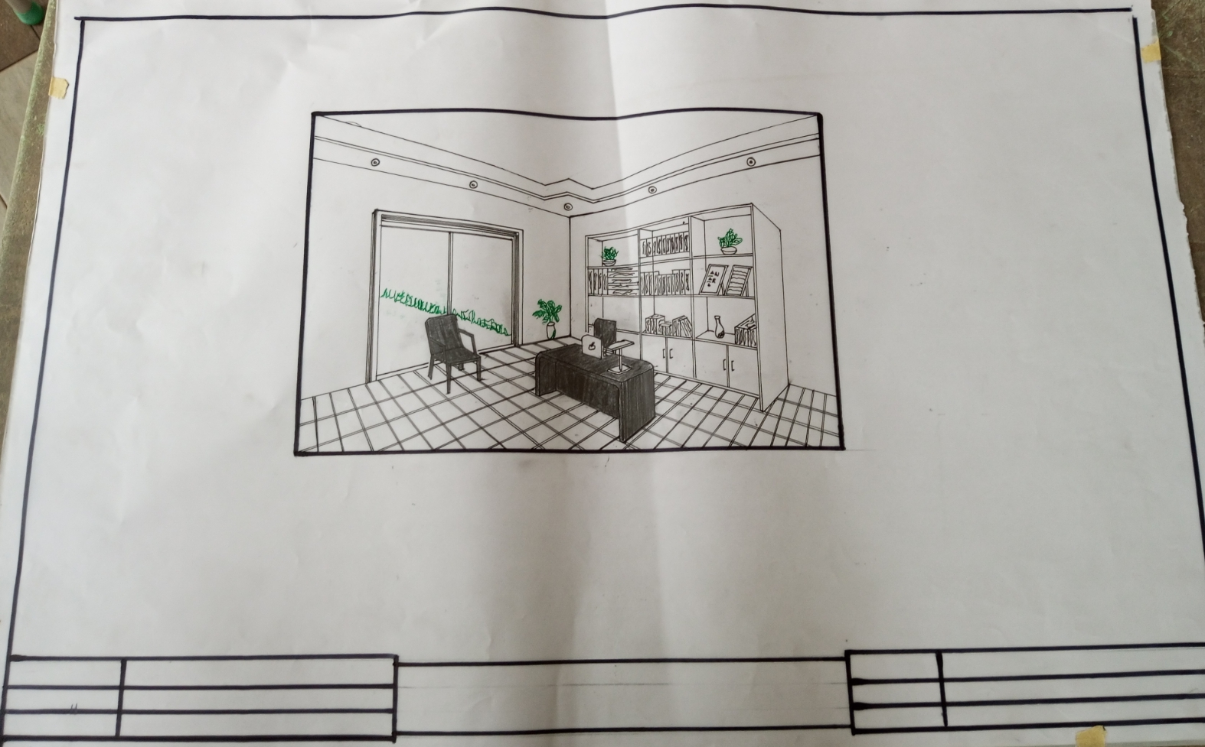
FIG 2.1. INNER PERSPECTIVE

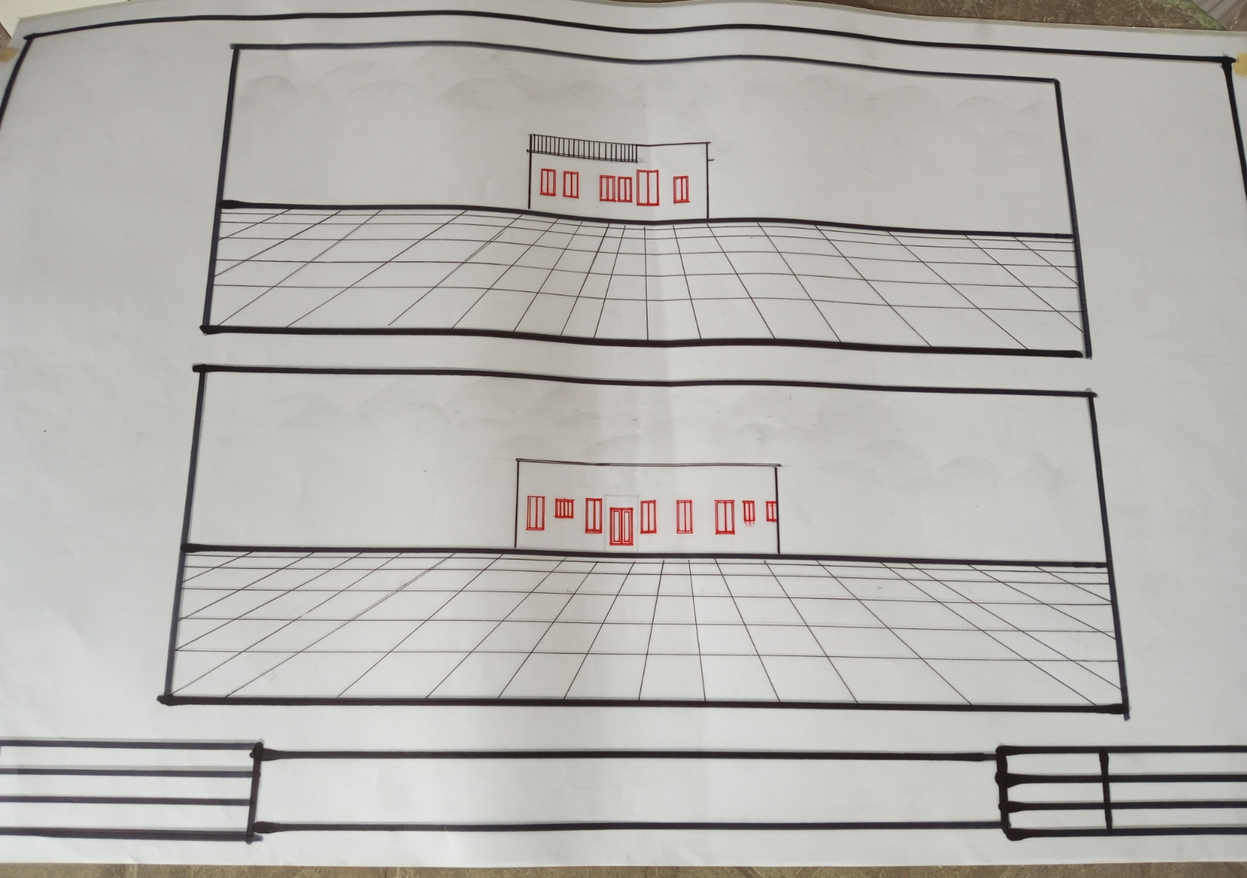
FIG 2.2. ELEVATION

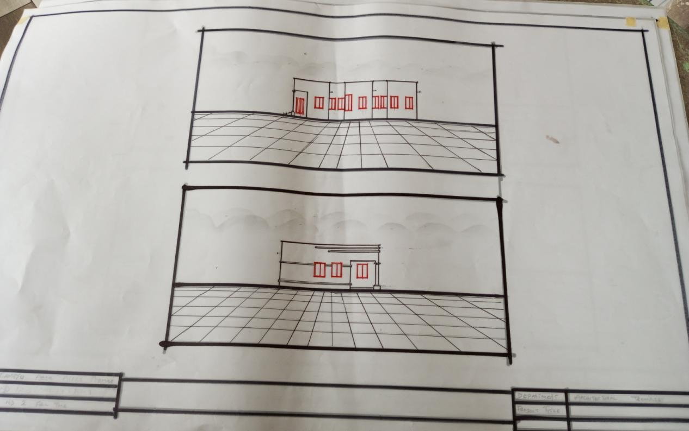
FIG 2.3.ELEVATION

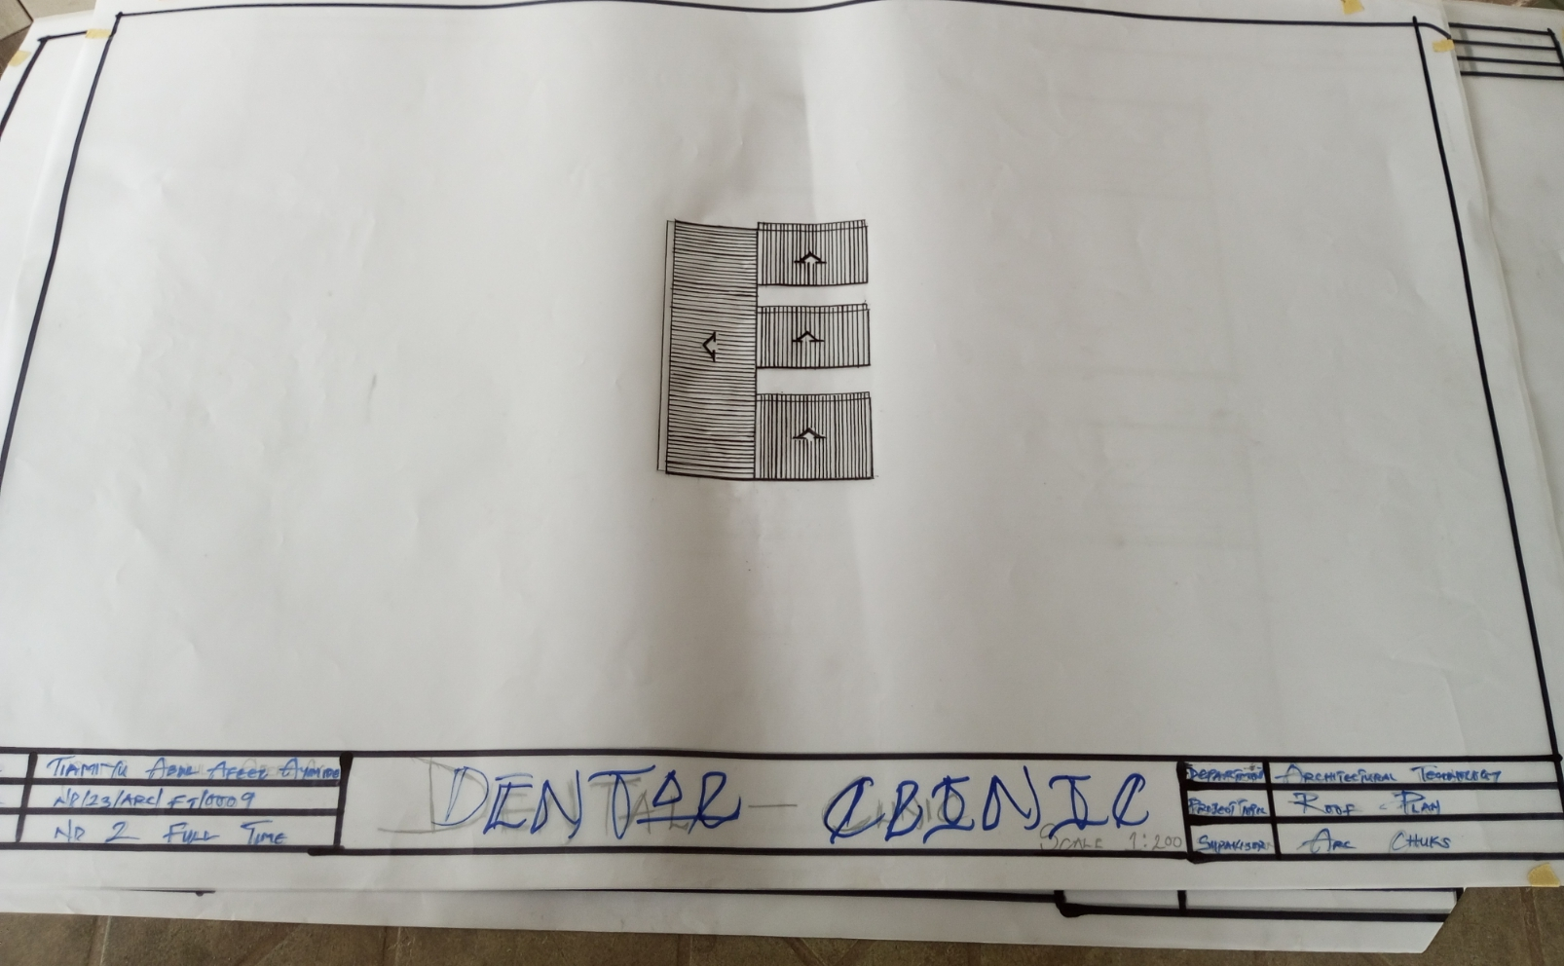
FIG 2.4. ROOF PLAN

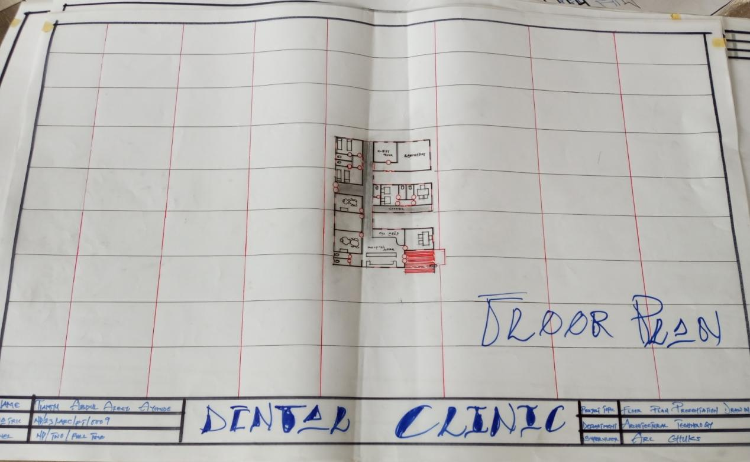
FIG 2.5. FLOOR PLAN

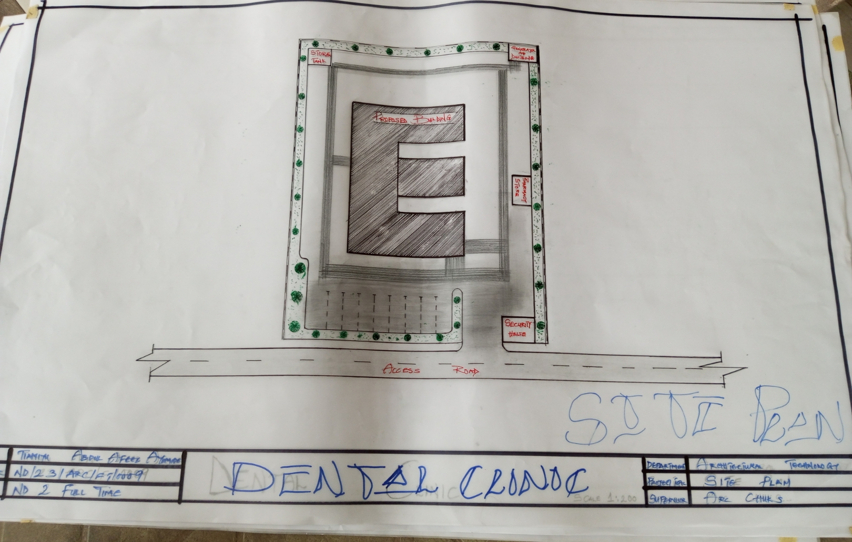
FIG 2.6. SITE PLAN

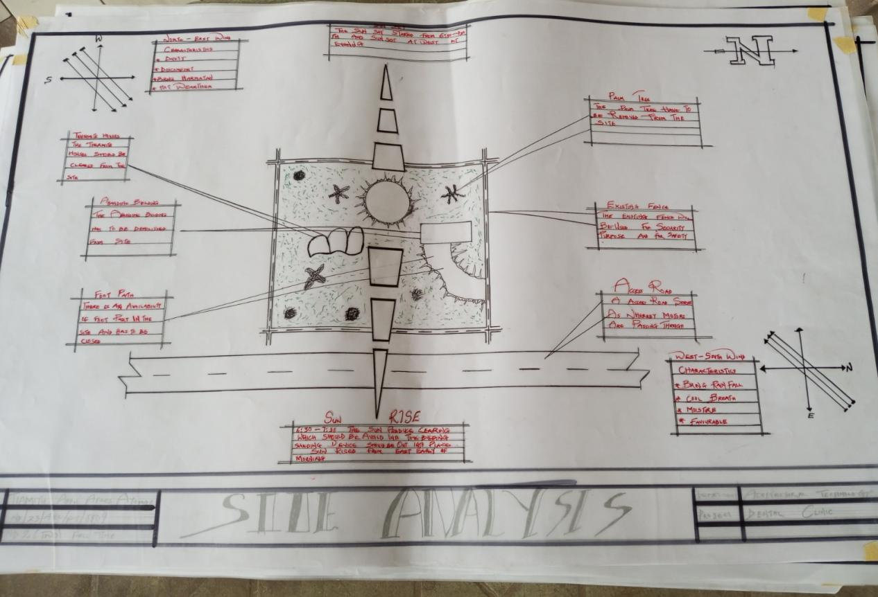
FIG 2.7.SITE ANALYSIS

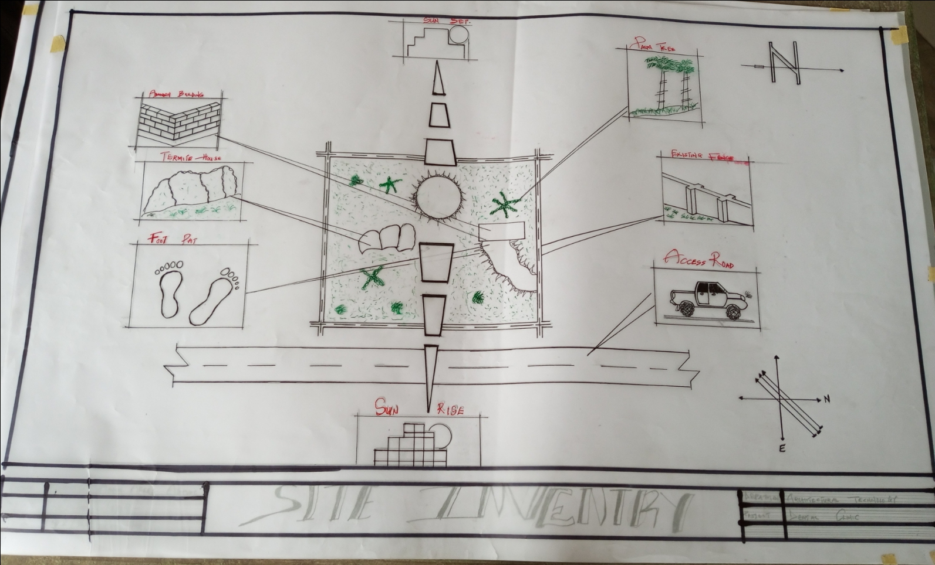
FIG 2.8. SITE INVENTORY

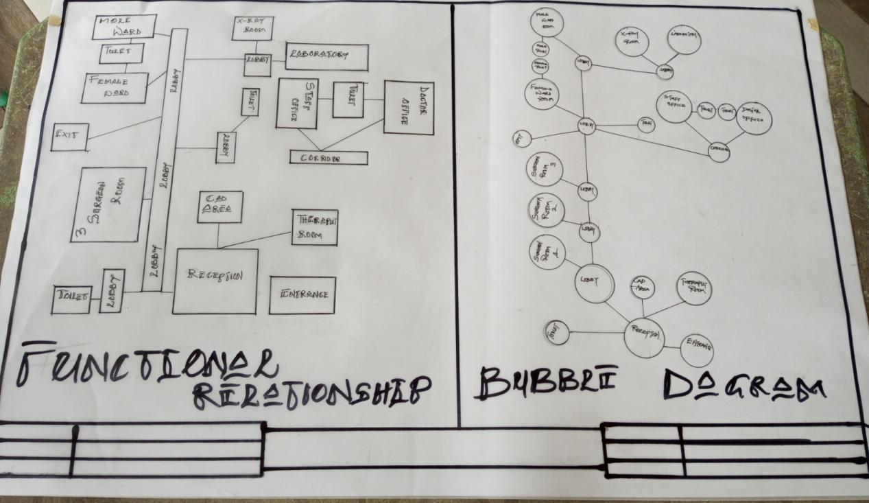
FIG 2.9.FUNCTIONAL RELATIONSHIP & BUBBLE DIAGRAM

