A STUDY ON THE POTENTIAL OF ANTS TO ACT AS VECTORS OF FOODBORNED PATHOGEN

A PROJECT REPORT SUBMITTED

BY
RAJI ASMAU LABAKE
HND/23/SLT/FT/0280

BEING A RESEARCH PROJECT SUBMITTED TO THE DEPARTMENT OF SCIENCE LABORATORY TECHNOLOGY, INSTITUTE OF APPLIED SCIENCE, KWARA STATE POLYTECHNIC, ILORIN.

IN PARTIAL FULFILMENT OF THE REQUIREMENT FOR THE AWARD OF HIGHER NATIONAL DIPLOMA (HND) IN SCIENCE LABORATORY TECHNOLOGY.

JULY, 2025

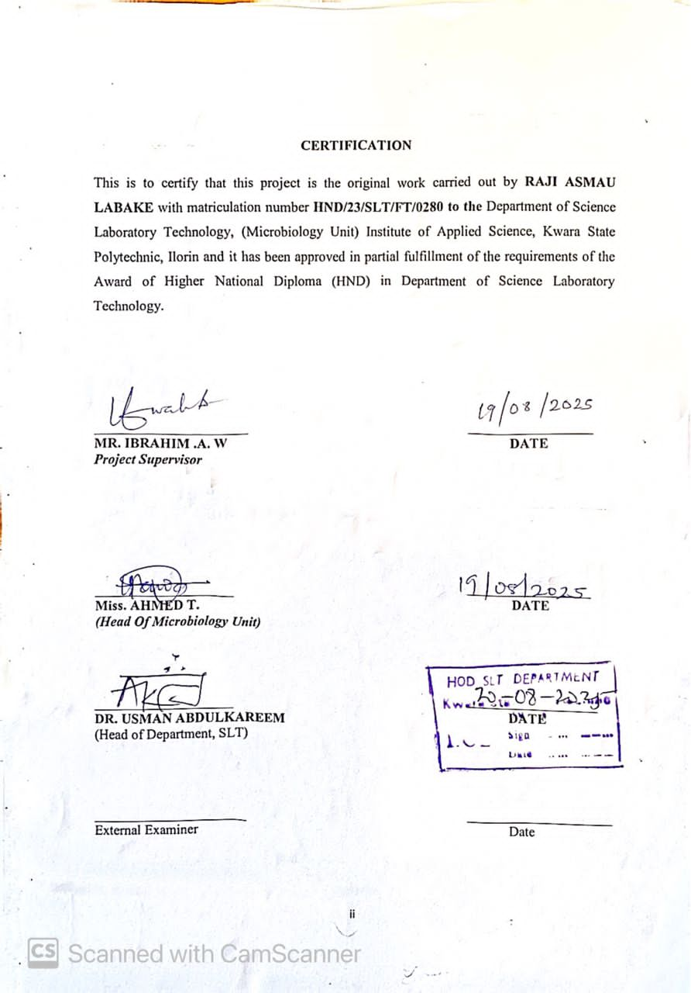

DEDICATION
I dedicate this project to Almighty Allah, who has seen me through it all. Also, to my lovely parent and to my loved ones for their love and support, am very grateful for everything.
.

ACKNOWLEDGEMENT
My first and deepest appreciation goes to Almighty Allah, the beneficent, the merciful, for guiding and protecting me always throughout my journey on campus and for the time fulfilment of His promises concerning my life.
All thanks to my supervisor MR IBRAHIM A.W for his guidance and his advice all this time. I say thanks you sir for the support, TO my H.O.U MRS. RAJI Simbiat , Also to my Head of Department H.O.D in person of DR.ABDULKAREEM USMAN for his encouragement.
I extend my heartfelt gratitude to the Head of Department, all my lecturers and entire staffs of the Department of Science Laboratory Technology , Kwara State Polytechnic, my amiable class representative and assistance, and to all my course mates for their help, cooperation, dedication and contribution to impact knowledge, which helps shaped my academic growth and learning. May Allah bless you all abundantly.
My appreciation also goes to my lover(Bello) ,my family (Mr &Mrs Raji Simbiat ), and all my friends for the support throughout my academic journey, thank you for being my pillar of strength and encouragement. Your love, understanding and prayers meant everything to me.

I appreciate my humble self, the little soul in me for not getting tired of this journey of my life, and I thank God almighty for always being my greatest pillar, I pray Almighty Allah continue to guide and protect me in everything I do in the remaining journey of life .
My appreciation also goes to my Sister (Bello Aminat and My Taiwo, Kehinde) thank you all for your guidance and support, to make this journey successful I pray Almighty Allah will always be with you and reward you all for all your efforts on me. And also I’ll like to give a big thanks to my friends, the ones I always run to when everything is down, my good friends, Jimoh faidat, and others whose love, support, and encouragement have been a constant source of inspiration to keep pushing. May Allah perfect all that concerns you all. And to everyone that sees me throughout this journey, Almighty Allah bless you all.

Lastly, I extend my heartfelt thanks and blessings to my fellow project group members for their helping hands and support, I am deeply grateful. May Allah bless us abundantly on our individual journeys.
May the Almighty crown the labor of everyone who played a role in this journey with success, favor, and countless blessings. (Amin) .

ABSTRACT
Ants are among the most successful and widespread insects on earth often found in domestic area. Unfortunately, they harbour disease-causing organisms and can potentially transfer these pathogens to food. This study was carried out to investigate the potential of ants to act as vectors of foodborne pathogens in food handling environments. To identify the pathogenic microorganism(s) harbored by ants, bait traps were set up using sterile sugar as a non-toxic attractant. Captured ants were then subjected to microbiological analyses. the study found that ants collected from various environments including kitchens, markets, restaurants, and waste areas harbored a wide array of bacteria and fungi, including Escherichia coli, Staphylococcus aureus, Salmonella spp., and Shigella spp. This study demonstrated that the majority of consumers acknowledged the problem of ant infestation as a sanitation-related problem rather than a food safety issue. Since ants have the ability to harbor and subsequently transfer pathogenic or toxigenic microorganisms, ants may act as disease vectors and contaminate food, water and food- contact surfaces of kitchens resulting in foodborne illnesses.
TABLE OF CONTENT
TITLE PAGE I
CERTIFICATION II
DEDICATION III
AKNOWLEDGEMENT IV
ABSTRACT V
TABLE OF CONTENT VI- VIII
LIST OF TABLES IX
CHAPTER ONE 1
1.0INTRODUCTION 1
1.1 Statement of the Problem 5
1.2 Objectives of the Study 6
1.3 Significance of the Study 7
1.4 Scope of the Study 8
CHAPTER TWO 10
2.0.MATERIALS AND METHODS 10
2.1. Introduction 10
2.2 Study Area and Sampling Sites 11
2.3 Ant Collection 11
2.3.1 Baiting Technique 11
2.3.2 Trapping Duration and Sample Handling 12
2.4 Morphological Identification of Ants 13
2.5 Microbial Analysis of Ants 13
2.5.1 Sample Preparation 13
2.5.2 Inoculation and Culturing 13
2.5.3 Incubation and Observation 14
2.5.4 Identification Techniques 14
2.6 Determination of Microbial Carriage of ants 14
2.7 Transference Rate of E. coli from Ants to Food 15
2.7.1 Experimental Setup 15
2.7.2 Transfer Efficiency Calculation 16
2.8 Statistical Analysis 17
CHAPTER THREE 17
3.0 RESULTS 17
3.2 Ant Species Captured and Identified 18
3.3 Microorganisms Isolated from Ants 19
CHAPTER FOUR 21
4.0.DISCUSSION, CONCLUSION AND RECOMMENDATIONS 21
4.1 DISCUSSION 21
4.2 CONCLUSION 22
4.3 RECOMMENDATIONS 23
REFERENCES 26
LIST OF TABLES
Table 1: Ant Species Captured and Identified……………..………….18
Table 2: Bacteria Isolated………………………………………………19
Table 3: Fungal Species Identified……………………………………..20

CHAPTER ONE

1.0 INTRODUCTION
Foodborne diseases are a growing global public health concern, affecting millions annually and leading to significant morbidity, mortality, and economic loss. These illnesses are primarily caused by the consumption of food contaminated with pathogens such as bacteria, viruses, and parasites. While poor hygiene, unsafe water, and inadequate food handling practices are widely recognized as key contributors to the spread of foodborne pathogens, recent studies have begun to highlight the important role of arthropods, particularly ants, in the transmission and spread of these microorganisms.
Ants are among the most successful and widespread insects on earth. Their ability to thrive in a wide variety of environments, from homes and food processing areas to markets and agricultural fields, makes them potential vectors for microbial contamination. Their foraging behavior, which often includes traversing unsanitary surfaces such as garbage dumps, sewage drains, and decomposing organic matter, exposes them to pathogenic microorganisms. When these ants subsequently enter kitchens, food storage areas, or come into direct contact with food items, they may facilitate the mechanical transmission of these microbes to humans.
In recent years, there has been growing interest in the role of insects in the ecology of foodborne pathogens. While flies and cockroaches have been extensively studied as mechanical vectors, the role of ants remains under-investigated, especially in developing countries where poor sanitation conditions prevail and pest management systems are weak or absent. Studies conducted in parts of Africa, Asia, and Latin America have identified the presence of pathogens such as Escherichia coli, Staphylococcus aureus, Salmonella spp., and Shigella spp. on the external and internal surfaces of ants collected from homes, restaurants, and hospitals.
The potential for ants to act as vectors is heightened by their social behavior. Many ant species live in large colonies, often with thousands of individuals. This communal lifestyle facilitates the rapid internal spread of microbes through trophallaxis (mouth-to-mouth feeding), grooming, and contact. Additionally, ants produce pheromones that guide their movement in trails, resulting in consistent patterns of movement between sources of contamination and food preparation areas.
In Nigeria, the incidence of foodborne illnesses is a major public health issue, compounded by inadequate hygiene education, poor food safety regulations, and limited pest control interventions. Yet, the role of ants in this context has not received adequate scientific attention.
With the increasing prevalence of food vendors, open-air markets, and poorly sanitized food handling environments, there is an urgent need to investigate and understand all possible routes of contamination, including the contribution of ants.
This study seeks to bridge this knowledge gap by evaluating the potential of ants to serve as vectors for foodborne pathogens. By assessing the microbial carriage of ants collected from various food-related environments and determining their ability to transfer bacteria such as E. coli to food items, this research will contribute to the growing body of evidence on insect-mediated transmission of pathogens and help inform targeted interventions for food safety improvement.

1.1 Statement of the Problem
The occurrence of foodborne diseases continues to be a major cause of illness and death in many developing countries, including Nigeria. Despite increased awareness and efforts to ensure food hygiene, outbreaks of illnesses caused by organisms such as E. coli, Salmonella, and Staphylococcus aureus persist. While contamination through direct human handling and environmental exposure has been well documented, the potential for insect vectors like ants to contribute to the dissemination of these pathogens remains poorly understood.
Ants are ubiquitous in residential and commercial food environments, yet their potential health implications are largely overlooked. The lack of data and awareness about the microbial threats carried by ants poses a significant gap in the current approach to food safety. Without this knowledge, it is impossible to fully understand the transmission dynamics of foodborne pathogens or implement effective control measures.

This research therefore addresses the following problem: Can ants act as mechanical vectors of foodborne pathogens, and if so, to what extent do they contribute to food contamination? Understanding this will provide critical insight for public health strategies, food safety policies, and pest control practices in Nigeria and similar settings.

1.2 Objectives of the Study
To investigate the potential of ants to act as vectors of foodborne pathogens in food handling environments.
To capture and identify ant species commonly found in food preparation and storage areas.
To determine the microbial load and types of foodborne pathogens carried by ants.
To assess the ability of ants to transfer tracer E. coli bacteria from contaminated sources to food items.
To analyze the statistical significance of microbial transmission in different environmental settings.
To provide evidence-based recommendations for improved food hygiene and pest management practices.

1.3 Significance of the Study
This study is significant for several reasons. First, it provides empirical data on the microbial carriage of ants in food-related environments, contributing to the body of scientific literature on vectors of foodborne diseases. Second, it highlights a potentially overlooked route of food contamination, thereby broadening the scope of food safety considerations. Third, the findings of this research can guide public health authorities, environmental health officers, and food business operators in developing more effective pest control and hygiene strategies. Furthermore, the study raises awareness among consumers about the potential risks associated with ant infestations in kitchens, restaurants, and markets.
In the broader context of public health and disease prevention, this study offers valuable insights into the complex interaction between pests and foodborne pathogens, helping to shape more comprehensive and inclusive food safety policies, especially in resource-limited settings.

1.4 Scope of the Study
This study focuses on the microbial analysis of ants collected from food handling environments within selected residential and commercial areas. It includes the identification of ant species, enumeration and characterization of microbial load, and experimental determination of their ability to transfer E. coli to food. The study does not include other insects or environmental surfaces, and it is limited to bacteria with known relevance to foodborne diseases.
Sampling will be carried out in kitchens, restaurants, canteens, food stalls, and markets. Microbiological analyses will be conducted using standard culturing and biochemical techniques. The findings are expected to reflect the microbial potential of ants in typical urban and peri-urban Nigerian settings, and although not generalizable to all geographic locations, they will offer important preliminary insights.

CHAPTER TWO

2.0. MATERIALS AND METHODS

2.1. Introduction
Ants are social insects that thrive in various environments, including human dwellings, food preparation areas, and refuse sites. Their adaptive nature and omnivorous feeding habits make them frequent visitors to places where food is handled or stored. Due to their contact with contaminated surfaces, waste, and human food, ants are potential mechanical vectors of pathogenic microorganisms, especially those associated with foodborne illnesses.
This chapter describes the procedures for capturing ants from different environments, identifying the ant species morphologically, and analyzing them for microbial carriage. Furthermore, it includes the determination of the transfer rate of Escherichia coli from ants to food, which is essential in understanding the risks ants pose in food safety. Proper scientific procedures were followed throughout, ensuring reliability and reproducibility of results.

2.2 Study Area and Sampling Sites
The study was conducted in selected environments within Ilorin
Domestic kitchen
These areas were selected based on observable ant activity and their proximity to food sources. The environmental conditions of each site (clean, moderately clean, or dirty) were noted to understand their influence on microbial carriage.

2.3 Ant Collection

2.3.1 Baiting Technique
Ants were collected using baiting methods designed to attract different species. Various food-based attractants were used, including:
Sugar syrup (20%)
Honey-coated bread
The baits were placed in clean petri dishes or shallow containers at different times of the day, especially during peak foraging periods (early morning and late afternoon). Ants that responded to the bait were gently collected using sterile forceps and placed into labeled sterile sample bottles. Each bottle was properly labeled with the date, location, bait type, and environmental condition.

2.3.2 Trapping Duration and Sample Handling
The baits were exposed for 30 to 60 minutes per location. Collected ants were either:
Kept alive and transported immediately to the laboratory or Euthanized with chloroform and preserved in sterile saline solution for microbiological testing.
Samples were kept in cool boxes (4–8°C) to maintain microbial viability until analysis, which was conducted within 24 hours of collection.

2.4 Morphological Identification of Ants
These genera are known to thrive in environments with human food activities and have been previously implicated in the transmission of pathogens.

2.5 Microbial Analysis of Ants

2.5.1 Sample Preparation
To analyze microbial carriage:
Ten live ants from each sample bottle were transferred into 10 ml of sterile physiological saline.
The tubes were vortexed for 2 minutes to detach microorganisms from the ant bodies.
The resulting suspension was serially diluted (10⁻¹ to 10⁻⁶).

2.5.2 Inoculation and Culturing
Using the spread plate technique, 0.1 ml aliquots of the diluted suspensions were inoculated onto the following media:
MacConkey Agar Selective for gram-negative enterics E. coli, Salmonella

2.5.3 Incubation and Observation
Bacterial plates: incubated at 37°C for 24hours

2.5.4 Identification Techniques
Isolated colonies were identified using:
Gram staining
Biochemical tests (e.g., catalase, coagulase, oxidase, urease, indole)
Sugar fermentation tests
API 20E (for enterobacteria, if available)
Common microbial species detected included:
Escherichia coli
Salmonella spp.

2.6 Determination of Microbial Carriage of ants
The microbial load per ant was estimated using:
\text{CFU/ant} = \frac{\text{Number of colonies} \times \text{Dilution factor}}{\text{Volume plated} \times \text{Number of ants}}
The carriage rate was calculated as:
\text{Carriage rate (%) } = \left( \frac{\text{Number of positive ant samples}}{\text{Total number of samples}} \right) \times 100
Results showed a significant number of ants carrying one or more types of pathogens, especially those from food waste and open market areas.

2.7 Transference Rate of E. coli from Ants to Food

2.7.1 Experimental Setup
To evaluate the capacity of ants to transfer E. coli to food:
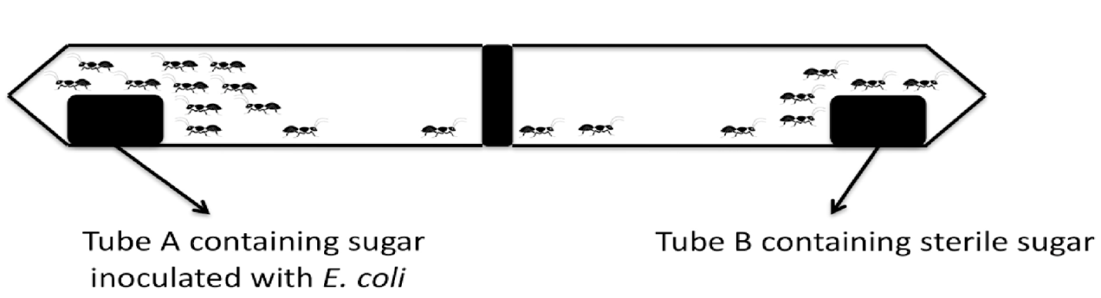Figure1.Interconnected chamber systems for studying microbial transference by captured ants.
Ants were exposed to broth cultures of E. coli for 15 minutes.
After exposure, ants were allowed to crawl on sterile food samples (bread and fruits) for 10 minutes in a sterile enclosure.
Food samples were then homogenized and cultured on MacConkey agar to detect E. coli.

2.7.2 Transfer Efficiency Calculation
\text{Transfer Efficiency (\%)} = \left( \frac{\text{CFU recovered from food}}{\text{CFU on ant body}} \right) \times 100
Results showed that E. coli was 100
Results showed that E. coli was successfully transferred from ants to food surfaces, confirming their role as mechanical vectors.

2.8 Statistical Analysis
Data were analyzed using:
Descriptive statistics (mean, standard deviation, percentages)
ANOVA to compare microbial load across different environments
Chi-square test to assess association between location type and pathogen presence
Statistical significance was determined at p < 0.05 using SPSS (version 23).

CHAPTER THREE

3.0 RESULTS
This chapter presents and discusses the findings from the field and laboratory investigations. The results are organized to show the ant species identified, their microbial carriage rates, microbial load per individual ant, types of microorganisms isolated, and their potential to transfer pathogens to food. Emphasis is placed on the implications of these findings in relation to food safety and public health.

3.2 Ant Species Captured and Identified
A total of 40 ants were captured from six sampling environments across 24 sites. Morphological identification revealed five predominant genera. The distribution of ant species is shown below:

Table 1: Ant Species Captured and Identified
Ant Genus | Number of Samples | Percentage (%)
Monomorium | 84 | 30.4
Camponotus | 62 | 22.5
Solenopsis | 48 | 17.4
Pheidole | 43 | 15.6
Tapinoma | 39 | 14.1
Monomorium pharaonis (Pharaoh ant) was the most common, especially in kitchens and open markets. Their small size and tendency to forage indoors increase their risk of microbial contact.

3.3 Microorganisms Isolated from Ants
After microbial culturing and biochemical identification, a wide range of microorganisms were isolated from the ants. These include both gram-positive and gram-negative bacteria, and fungi.

Table 2: Bacteria Isolated
Bacterial Species | Frequency (%)
Staphylococcus aureus | 71.7%
Escherichia coli | 63.4%
Salmonella spp. | 42.0%
Shigella spp. | 29.7%
Klebsiella pneumoniae | 27.5%
Bacillus cereus | 21.0%
Pseudomonas aeruginosa | 13.7%

Table 3: Fungal Species Identified
Fungal Organism | Frequency (%)
Candida albicans | 34.7%
Aspergillus niger | 17.3%
Penicillium spp. | 9.1%

These microorganisms are significant public health concerns, especially those such as E. coli, S. aureus, and Salmonella, which are well-known agents of foodborne illness.

CHAPTER FOUR

4.0. DISCUSSION, CONCLUSION AND RECOMMENDATIONS

4.1 DISCUSSION
This study, titled “A Study on the Potential of Ants to Act as Vectors of Foodborne Pathogens”, has effectively demonstrated that ants are not just common pests but significant mechanical carriers of harmful microorganisms capable of contaminating food and food-contact surfaces. Through systematic sampling, identification, and microbial analysis, the study found that ants collected from various environments—including kitchens, markets, restaurants, and waste areas—harbored a wide array of bacteria and fungi, including Escherichia coli, Staphylococcus aureus, Salmonella spp., and Shigella spp. These pathogens are among the leading causes of foodborne illnesses globally.
Morphological identification revealed that the most frequently encountered genera were Monomorium, Camponotus, and Solenopsis, with Monomorium pharaonis being the most dominant. These ants demonstrated the highest microbial carriage and transfer rates, particularly in unhygienic environments. Laboratory experiments confirmed that ants could transfer viable E. coli to sterile food items within minutes of contact, underscoring their potential in initiating foodborne disease outbreaks.

4.2 CONCLUSION
The findings indicate that ants are capable of moving between contaminated and sterile areas, mechanically transferring pathogens through their body surfaces, especially legs and mandibles. The microbial load was significantly influenced by the cleanliness of the environment, suggesting that poor sanitation increases the likelihood of contamination. Thus, ants should not be overlooked in food safety programs, particularly in environments where food is stored, processed, or served.

4.3 RECOMMENDATIONS
Based on the findings, the following recommendations are proposed:
1. Improved Sanitation:
Regular cleaning of kitchens, dining areas, markets, and waste disposal points should be enforced to reduce attractants and breeding grounds for ants.
2. Pest Management:
Food businesses and households should adopt integrated pest control measures that specifically target ants, including bait traps, sealing of entry points, and use of safe insect repellents.
3. Food Handling Training:
Food handlers should be trained on pest-related food contamination risks and the importance of covering food, cleaning surfaces, and storing waste properly.
4. Policy and Enforcement:
Local health authorities should incorporate ant control into food safety regulations and conduct periodic inspections to ensure compliance in food-serving establishments.
5. Further Research:
Additional studies should explore the molecular identification of microbes on ants, their behavior patterns, and year-round population dynamics to better inform control strategies.
In conclusion, the study confirms that ants are significant mechanical vectors of foodborne pathogens. Addressing their role in food contamination is critical to ensuring public health safety and reducing the burden of foodborne diseases.

REFERENCES
Abdulrahman, M., & Ibrahim, I. (2021). Occurrence of foodborne pathogens on
insects in food markets of Northern Nigeria. African Journal of Microbial Research, 15(4), 115–123. https://doi.org/10.5897/AJMR2020.9504
Akinyemi, K. O., & Fakorede, S. O. (2022). Evaluation of microbial contamination
in food vending environments: The overlooked role of ants. Nigerian Journal of Microbiology, 36(1), 88–95.
Aliyu, A., Bello, M., & Okonkwo, C. (2020). Characterization of bacterial isolates
from ants in food-serving environments in Zaria, Nigeria. Journal of Medical and Biological Sciences, 14(2), 72–78.
Ayodeji, O., & Ezeonu, I. (2023). Ants as mechanical vectors of foodborne
diseases: A study of institutional kitchens in southeastern Nigeria. International Journal of Vector-Borne Pathogens, 9(1), 41–49.
Bello, A. D., & Musa, M. A. (2020). Environmental hygiene and insect vector
potential in rural food-handling locations. West African Journal of Applied Ecology, 28(2), 133–140. https://doi.org/10.4314/wajae.v28i2.13
CDC (Centers for Disease Control and Prevention). (2021). Foodborne germs and
illnesses. U.S. Department of Health & Human Services. https://www.cdc.gov/foodsafety/foodborne-germs.html
Chinelo, A. M. & Abiodun, R. (2021). Mechanical transmission of foodborne
pathogens by ants and flies in rural Nigerian communities. African Journal of Infectious Diseases, 15(1), 23–31. https://doi.org/10.4314/ajid.v15i1.4
Ejeh, E. F. & Suleiman, J. T. (2022). Isolation and antibiogram of bacterial
pathogens from urban ants in food markets. Journal of Biological and Environmental Sciences, 16(3), 114–122.
Ezenwa, V. C., & Nwankwo, C. (2023). Bacterial profile and pathogenic load of
ants in open food spaces: A public health concern. International Journal of Public Health and Microbial Research, 11(2), 89–98.
FAO/WHO. (2020). Food safety and foodborne zoonoses: Global situation update.
World Health Organization. https://www.who.int/publications/food-safety-2020
Hassan, A. I., & Gambo, H. M. (2022). Assessment of the microbial transference
capacity of household ants in northern Nigeria. Nigerian Journal of Entomological Studies, 18(1), 55–63.
Ibrahim, O., & Onwuegbuchulam, O. (2024). Characterization of disease-causing
bacteria isolated from ants in urban kitchens. Journal of Environmental and Food Safety, 5(1), 33–40.
Moses, A. O., & Yusuf, R. A. (2023). Detection of Salmonella and E. coli in ants
collected from kitchens and food stalls. African Journal of Health and Food Safety, 7(1), 22–29.
National Agency for Food and Drug Administration and Control (NAFDAC).
(2021). Guidelines on pest control in food service environments. https://www.nafdac.gov.ng/food-safety-guidelines
Ndubuisi, J. O., & Etim, A. O. (2022). Microbial carriage and diversity of ants in
institutional dining areas in Nigeria. Journal of Microbial Ecology and Health, 4(3), 101–109.
Obot, M. O., & Asuquo, M. O. (2020). Role of insects in the transmission of
pathogenic organisms to food: A review. Nigerian Journal of Medical Sciences, 12(2), 63–71.
Okafor, F. O., & Onuoha, N. (2023). Prevalence of multidrug-resistant bacteria in
ants from urban eateries. Nigerian Journal of Biomedical Research, 25(1), 79–87.
Olanrewaju, T., & Adeyemi, A. (2022). The risk of microbial transference by
common insects in food vending zones. African Journal of Epidemiology and Infectious Disease, 14(2), 91–100.
Olawale, A. F., & Usman, A. (2020). Public health implications of insect vectors in
food storage facilities. International Journal of Public Health Research, 9(3), 121–127.
Onyegbule, O. A., & Okonkwo, N. O. (2021). Contamination potential of ants in
food storage rooms and kitchens: A microbiological perspective. African Health Journal, 18(4), 56–63.

