DESIGN AND IMPLEMENTATION OF AN ELECTRONIC VOTING SYSTEM USING RSA ALGORITHM

BY
OJEKUNLE AKINYODE JOSHUA
ND/23/COM/FT/0100

A Project Submitted to the Department of Computer Science, Institute of Information and Communication Technology, Kwara State Polytechnic, Ilorin

In Partial Fulfillment of the Requirements for the Award of National Diploma (ND) in Computer Science

June, 2025
CERTIFICATION
This is to certify that this project was carried out by Ojekunle Akinyode Joshua with Matric Number ND/23/COM/FT/0100 as part of the requirements for the award of National Diploma (ND) in Computer Science.

………………………………. ……………………………….
MR BOLAJI ADETOR D.F Date
(Project Supervisor)

………………………………. ……………………………….
Mr. Oyedepo, F. S. Date
(Head of Department)

………………………………. ……………………………….
External Examiner Date

DEDICATION
This project is dedicated to the creator of the earth and universe, the Almighty God. It is also dedicated to my parents for their moral and financial support.

ACKNOWLEDGEMENT
All praise is due to the Almighty God the Lord of the universe. I praise Him and thank Him for giving me the strength and knowledge to complete my ND programme and also for my continue existence on the earth.
I appreciate the utmost effort of my supervisor, MR BOLAJI ADETORO D.F whose patience support and encouragement have been the driving force behind the success of this research work. He gave useful corrections, constructive criticisms, comments, recommendations, advice and always ensures that an excellent research is done. My sincere gratitude goes to the Head of the Department and other members of staff of the Department of Computer Science, Kwara State Polytechnic, Ilorin, for their constant cooperation, constructive criticisms and encouragements throughout the programme.
Special gratitude to my parents who exhibited immeasurable financial, patience, support, prayers and understanding during the periods in which I was busy tirelessly in my studies. Special thanks go to all my lovely siblings.
My sincere appreciation goes to my friends and classmates.

TABLE OF CONTENTS
Title page i
Certification ii
Dedication iii
Acknowledgement iv
Abstract v
Table of Contents vi
Chapter One: General Introduction
1.1 Background to the Study 1
1.2 Statement of Problems 3
1.3 Aim and Objectives 3
  - Significant of the Study 4
1.5 Scope of the Study 4
1.6 Organization of the Report 5
Chapter Two: Literature Review
2.1 Review of Related Work 7
2.2 Review of Related Concepts 13
2.2.1 Overview of an Election 13
2.2.2 Concepts of Election 14
2.2.3 Electronic Voting Systems 14
2.2.4 Certified Direct Recording Electronic System 15
2.2.5 RSA Algorithm 16
Chapter Three: Methodology And Analysis of the Existing System
3.1 Research Methodology 17
3.2 Analysis of the Existing System 17
3.3 Problems of the Existing System 18
3.4 Description of the Proposed System 19
3.5 Advantages of the Proposed System 17
Chapter Four: Design, Implementation and Documentation of the System
  - Design of the System 18
    - Output Design 18
    - Input Design 25
    - Database Design 29
    - Procedure Design 32
  - Implementation of the System 33
4.2.1 Hardware Support 33
    - Software Support 33
4.3 Documentation of the System 34
4.3.1 Program Documentation 34
4.3.2 Operating the System 35
4.3.3 Maintaining the System 36
Chapter Five: Summary, Conclusion and Recommendations
5.1 Summary 37
5.2 Conclusion 37
5.3 Recommendation 38
References
Appendices

ABSTRACT
Using the decade old election system to collect votes from the citizens is no longer considered efficient due to the various recurring errors. So time has arrived that the paper based primordial voting system which has already proven itself an inefficient and slow procedure is changed immediately. The system that is being followed currently, from data collection procedure to counting of the votes is a manual process. Here we are proposing an automated electronic voting system. Electronic voting systems offer a secure, efficient, and transparent method for casting and counting votes, replacing traditional paper-based systems. This project explores the design and implementation of an electronic voting system utilizing the Rivest–Shamir–Adleman (RSA) algorithm for secure and reliable operations. The system leverages cryptographic techniques to ensure the integrity, confidentiality, and authentication of voters’ data, mitigating risks of electoral fraud and unauthorized access. The proposed solution aims to enhance the electoral process by combining technological advancements with stringent security protocols and it will be developed using HTML, CSS, Java-Script for the frontend while PHP (postscript hypertext pre-processor) and MySQL will be use as the database management tools.

CHAPTER ONE
GENERAL INTRODUCTION
  - BACKGROUND TO THE STUDY
The democratic process relies on the credibility and transparency of elections. In recent years, traditional voting systems have been increasingly scrutinized for their susceptibility to fraud, logistical challenges, and inefficiency. As societies embrace digital transformation, the application of electronic voting systems presents a promising alternative to address these concerns. However, transitioning to electronic platforms introduces new challenges, particularly in safeguarding the security and privacy of voters' data (Sundar et al., 2018).
One basic feature of democracy that cuts across all different tribes is the act of election. Democracy thus encourages individual freedom according to the rule of law, so that people may behave and express themselves as they choose. This not only gives people a chance to choose their leaders, but also to freely express their views on issues. In response to the 1948 Universal Declaration of Human Rights which places importance on the necessity of free elections, nations aim at new and improved voting procedures that are of relevance to elections in the 21st century. With the passage of time, voting, which was mainly manual, has been influenced by Information Technology, with debates arising about the relevance or not, of computerized/online voting (Suwarjono et al., 2021).
Cryptography has emerged as a cornerstone technology in addressing these challenges, ensuring the integrity and confidentiality of sensitive information. Among various cryptographic algorithms, Rivest–Shamir–Adleman (RSA) stands out for its robust security features, making it an ideal candidate for electronic voting systems. RSA's public-key cryptography provides a reliable framework for secure data transmission and authentication in a distributed and potentially hostile environment (Afrin & Satao, 2021).
Ebenezer (2019) noted that the Rivest–Shamir–Adleman (RSA) algorithm plays a crucial role in the design of secure electronic voting systems by ensuring data confidentiality, integrity, and authentication. Its application in e-voting addresses key challenges such as voter impersonation, ballot tampering, and unauthorized access, thereby enhancing the trustworthiness of the electoral process. The RSA algorithm is a public-key cryptographic system widely recognized for its robustness in securing data. In electronic voting systems, RSA serves as a critical component for maintaining the confidentiality, authenticity, and integrity of electoral data. By enabling secure communication between voters and election servers, RSA ensures that sensitive information, such as voter credentials and cast ballots, remains protected from unauthorized access.
Elections are the cornerstone of democracy, serving as a mechanism for citizens to express their will and choose their representatives. Traditional voting systems, while widely adopted, have demonstrated vulnerabilities such as ballot tampering, vote miscounting, and logistical inefficiencies. These challenges have underscored the need for innovative solutions to modernize the electoral process. The advent of electronic voting systems represents a significant leap in addressing these challenges. By digitizing the voting process, electronic systems aim to reduce errors, streamline operations, and enhance voter confidence. Despite these advantages, security remains a paramount concern. Cryptographic algorithms, such as RSA, offer a potential solution to ensure that electronic voting systems are both secure and trustworthy (Carrera, 2020).
With the fast and strong evolution of computer science and technology, people propose new alternatives to the traditional voting process based on computers and the internet. There is a big discussion about the most secure, faster and better way to implement them, but not only the implementation problem is holding this process, also there is a human indecision. A lot of them think that this method is not secure or it will be even worse than the traditional one, as it happened with bank accounts and internet payments, not everyone can use and trust them. Probably they can be right, because of the hundreds hacking attacks on bank systems proving that they have vulnerabilities (Ahubele & Oghenekaro, 2022).
In this project the researcher aims to integrate the RSA algorithm into an electronic voting system to establish a secure, scalable, and user-friendly platform. By leveraging modern technologies, the proposed system seeks to address existing gaps in electoral processes, ensuring that elections are free from manipulation and accessible to all eligible voters. Furthermore, the study delves into the design, development, and evaluation of the system, highlighting its advantages over conventional approaches.
1.2 STATEMENT OF THE PROBLEMS
Traditional voting systems are fraught with inefficiencies, inaccuracies, and vulnerabilities to fraud. Despite advancements in electronic voting technologies, many systems fail to provide adequate security measures, leaving them susceptible to cyberattacks and data breaches. The lack of voter authentication and data integrity mechanisms undermines trust in the electoral process. This project seeks to address these issues by designing and implementing an electronic voting system fortified with the RSA algorithm to enhance security and reliability.
1.3 AIM AND OBJECTIVES OF THE STUDY
The aim of this project is to design and implement a secure electronic voting system using the RSA algorithm. The objectives are to:
- integrate RSA cryptographic techniques into an electronic voting platform;
- develop a user-friendly interface for the proposed voting system;
- evaluate the security, efficiency, and scalability of the proposed system; and
- develop the proposed system using HTML, CSS and Javascript.
1.4 SIGNIFICANCE OF THE STUDY
This project contributes to the ongoing discourse on enhancing electoral processes by providing a secure, transparent, and efficient electronic voting system. The integration of RSA cryptography ensures data integrity, confidentiality, and voter authentication, addressing critical security concerns. The findings of this research are expected to benefit stakeholders, including electoral commissions, policymakers, and the general public, by offering insights into the adoption of technology in democratic processes.
1.5 SCOPE OF THE STUDY
The project focuses on the design and implementation of an electronic voting system incorporating the RSA algorithm for security. It examines the technical, operational, and security aspects of the system, with a primary emphasis on ensuring data integrity and voter authentication. The research is limited to the conceptualization, development, and evaluation of a prototype system and does not cover large-scale deployment or integration with national election systems.
1.6 ORGANIZATION OF THE PROJECT
This project is organized into five distinct chapters. Chapter one discusses the general introduction and overview of the whole project. It also discusses the statement of the problem, aim and objectives of the proposed system, significance of the study, scope and limitations of the project, organization of the report. Chapter two deals the literature review, the review of related concepts of the project topic which include overview of E-voting, Manual Voting System RSA Algorithm and so on. Chapter three deals with analysis of the system which include the data collection method employed, the description of the existing system and its problems and the description of the proposed system and possible advantages the proposed system will provide over the manual system. While chapter four deals with the design, implementation and the description of the proposed system. It covers description of the output design, input design, database design and procedure design. The implementation techniques used, the programming language used in developing the new system and system requirements for running the system. And also it talks about the program documentation as well user documentation. Lastly, chapter five presents a brief summary of the work done, conclusion and recommendations.

CHAPTER TWO
LITERATURE REVIEW
2.1 REVIEW OF RELATED WORK
A lot of researches have been conducted to revolutionized the manual voting system, some journals related to this topic of study are reviewed below.
Fashoto et al., (2019) worked on securing a scalable e-voting system using the RSA
algorithm: the case of a group voting process in a tertiary school. The paper shows that RSA (Ron Rivest, Adi Shamir and Leonard Adleman) cryptography algorithm can be incorporated into E-voting process as a whole. The RSA cryptography algorithm ensures that votes casted are secured, thus maintaining the privacy of votes. The performance of the cryptography algorithm is tested on a university E-voting system over a public network. The E-voting process is initiated by a server system that other computer nodes are connected to. The system is such that when the votes are cast on the nodes, the RSA technique encrypts the vote that is sent to the server system using both node and vote identity number. The system performs consistently and reliably which in return gives good level of confidence of votes count.
Sundar (2018) developed a secure e-voting system using RSA and Md5 algorithms using random number generators. In the paper the researchers used RSA and MD5 algorithms for security purposes. Their proposed system provided a new e-voting system which fulfills the security requirements of e-voting process. In their project they have total three steps that are required in e-registration of voter, vote uploading and result display. Proposed system provides secure and efficient e-vote uploading and also paper ballot system if e-voting failed.
Suwarjono et al., (2021) worked on cryptography implementation for electronic voting security. The study implements cryptographic methods as a password security for voter accounts, and the results of voting, so that the secrecy of the voters' data and the results of voting are maintained. RSA algorithm to implement cryptographic techniques based on two mathematical problems, namely factorization and modulo operations on composite numbers, which use two different keys for encryption and decryption processes. The public key is used encryption process to encode text, and the private key is used description process, namely translating ciphertext into plaintext.
Ahubele and Oghenekaro (2022) secured electronic voting system using RSA key capsulation mechanism. In the paper, a secured voting system using RSA Key Encapsulation Mechanism with two layers-Symmetric and Public key Layers was presented. RSA consist of three functions such as key generation, encryption, and decryption. In RSA-KEM, KDF3 built upon SHA-256, induction function is mainly for key generation. AES key wrap (Advanced-Encryption-Standard) provides key wrapping functionality.
Afrin and Satao (2021) implemented an E-voting system for on duty persons using
RSA algorithm with kerberos concept. This E-Voting system is mainly for those people
who are public servants they are not capable to come to the voting booth due to on duty. In voting system there are some important processes. This system having main four processes: first one is application control process which involves the identification and authentication phases for the applied citizens. Second one is the voting process which will be done by voter. In Third section confirmation process, in this system check scan copy of voter ID and passport size photograph send by voter. Finally the election server, administrator will sort out valid voter, schedule date of election and display final result by decipher the received encrypted information using public key cryptography.
Ebenezer (2019) proposed an analysis, design and implementation of a voting system using a novel oblivious and proxy signature. In the thesis, the researcher analyzed and implemented an existing EVS. We used the proxy and oblivious signature for our security. The proxy signature helps curb the aspect of impersonation in the EVS which is a part of the signature that allows A as an original signer to assign her/his signing privilege to someone else called B as a proxy signer. This is very useful since that a scheme will allow an assigned person B (proxy signer) to produce proxy signatures on behalf of the original signer A. Additionally, B (proxy signer) can check the identity of a person R (voter). If the person is eligible to vote, he is given the privilege to exercise her/his franchise, otherwise he or she is denied access from voting. This enables curbing impersonation during the electoral process.
The oblivious signature in the EVS scheme is to help R‟s (the voter’s) choice not to be known by anyone including the proxy signature. This has to do with having n messages as a signature in which R (the voter) could choose 1 -of- n messages to get his message signed while the proxy signer will not be able to find out on which message the voter R has got the signature. The oblivious and proxy signature is efficient in communication, computation and security. The researcher studied and provided proofs for the Electronic Voting System, made design, implemented and tested the EVS. We also conducted experiments with the EVS. They carried out the experiments based on six phases of the existing EVS time in, compared the existing and the implemented systems. We conclude that the implemented system has a better computation time (in milliseconds) than that of the existing system.

2.2 REVIEW OF RELATED CONCEPTS
2.2.1 Overview of an Election
An election is a formal decision-making process by which a population selects individuals to hold public office. It is a cornerstone of democratic systems, allowing citizens to exercise their right to participate in governance. Elections are typically held at regular intervals and vary in scale, from local elections for municipal roles to national contests for leadership positions like presidents or prime ministers. The process ensures that government remains accountable to the people by providing a mechanism for evaluating and renewing mandates.
The election process usually involves several key stages. First, candidates declare their intention to run, often representing political parties or standing as independents. Campaigning follows, where candidates present their policies and vision to voters through rallies, debates, advertisements, and other platforms. Voter registration ensures that eligible citizens are recorded and can participate. On election day, registered voters cast their ballots, either electronically or using paper forms, at designated polling stations.
The outcome of an election is determined by the voting system in place, such as first-past-the-post, proportional representation, or ranked-choice voting. Votes are counted, and winners are declared based on the majority or specific thresholds set by the election rules. Election observers and independent monitors often oversee the process to ensure fairness and transparency. Results can influence national policies, shape public discourse, and impact international relations.
Elections are not without challenges. Issues such as voter suppression, misinformation campaigns, and concerns over electoral fraud can undermine public trust in the process. Additionally, low voter turnout can signal apathy or barriers to participation. Despite these challenges, elections remain a vital instrument of democracy, serving as a means for the public to express their will, hold leaders accountable, and shape the future of their society (Abdul-Rahim et al., 2023).
2.2.2 Concepts of Election
The choice of electoral system is one of the most important institutional decisions for any democracy. In most all cases the choice of a particular electoral system has a profound effect on the future political life of the country concerned, and electoral system, once chosen, often remain fairly constant as political interests solidify around and respond to the incentives presented by them. However, while conscious design has become far more prevalent recently, traditionally it has been rare for electoral systems to be consciously and deliberately selected. Often the choice was essentially accidental, the result of an unusual combination of circumstances, of a passing trend, or of a quirk of history, with the impact of colonialism and the effects of influential neighbors often being especially strong.
Elections allow the populace to choose their representatives and express their preferences for how they will be governed. Naturally, the integrity of the election process is fundamental to the integrity of democracy itself. The election system must be sufficiently robust to withstand a variety of fraudulent behaviors and must be sufficiently transparent and comprehensible that voters and candidates can accept the results of an election. Unsurprisingly, history is littered with examples of elections being manipulated in order to influence their outcome.
The design of a “good” voting system, whether electronic or using traditional paper ballots or mechanical devices must satisfy a number of sometimes competing criteria. The anonymity of a voter’s ballot must be preserved, both to guarantee the voter’s safety when voting against a malevolent candidate, and to guarantee that voters have no evidence that proves which candidates received their votes. The existence of such evidence would allow votes to be purchased by a candidate. The voting system must also be tamper-resistant to thwart a wide range of attacks, including ballot stuffing by voters and incorrect tallying by insiders.
Another factor, as shown by the so-called “butterfly ballots” in the Florida 2000 presidential election, is the importance of human factors. A voting system must be comprehensible to and usable by the entire voting population, regardless of age, infirmity, or disability. Providing accessibility to such a diverse population is an important engineering problem and one where, if other security is done well, electronic voting could be a great improvement over current paper systems. Flaws in any of these aspects of a voting system, however, can lead to indecisive or incorrect election results (Fashoto, 2019).
2.2.3 Overview Electronic Voting Systems
Electronic voting systems have evolved significantly, transitioning from simple ballot-scanning machines to complex digital platforms. Research highlights the potential of these systems to enhance electoral efficiency while identifying challenges such as security vulnerabilities and accessibility issues. There have been several studies on using computer technologies to improve elections. These studies caution against the risks of moving too quickly to adopt electronic voting machines because of the software engineering challenges, insider threats, network vulnerabilities, and the challenges of auditing.
As a result of the Florida, USA 2000 presidential election, the inadequacies of widely-used punch card voting systems have become well understood by the general population. Despite the opposition of computer scientists, this has led to increasingly widespread adoption of “direct recording electronic” (DRE) voting systems. DRE systems, generally speaking, completely eliminate paper ballots from the voting process. As with traditional elections, voters go to their home precinct and prove that they are allowed to vote there, perhaps by presenting an ID card, although some states allow voters to cast votes without any identification at all. After this, the voter is typically given a PIN, a smartcard, or some other token that allows them to approach a voting terminal, enter the token, and then vote for their candidates of choice. When the voter’s selection is complete, DRE systems will typically present a summary of the voter’s selections, giving them a final chance to make changes. Subsequent to this, the ballot is “cast” and the voter is free to leave.
The most fundamental problem with such a voting system is that the entire election hinges on the correctness, robustness, and security of the software within the voting terminal. Should that code have security relevant flaws, they might be exploitable either by unscrupulous voters or by malicious insiders. Such insiders include election officials, the developers of the voting system, and the developers of the embedded operating system on which the voting system runs. If any party introduces flaws into the voting system software or takes advantage of pre-existing flaws, then the results of the election cannot be assured to accurately reflect the votes legally cast by the voters.
2.2.4 Certified Direct Recording Electronic Systems (DRE)
Many government entities have adopted paperless DRE systems without appearing to have critically questioned the security claims made by the systems’ vendors. Until recently, such systems have been dubiously “certified” for use without any public release of the analyses behind these certifications, much less any release of the source code that might allow independent third parties to perform their own analyses. Some vendors have claimed “security through obscurity” as a defense, despite the security community’s universally held belief in the inadequacy of obscurity to provide meaningful protection (Kerckhoffs, 2020).
Indeed, the CVS source code repository for Diebold’s AccuVote-TSDRE voting system recently appeared on the Internet. This appearance announced by Bev Harris and discussed in her book, Black Box Voting (Harris, 2003) gives us a unique opportunity to analyze a widely used, paperless DRE system and evaluate the manufacturer’s security claims. Jones discusses the origins of this code in extensive detail. Diebold’s voting systems are in use in 37 states, and they are the second largest and the fastest growing vendor of electronic voting machines. We only inspected unencrypted source code, focusing on the AVTSCE, or AccuVote-TS version 4, tree in the CVS repository. This tree has entries dating from October 2000 and culminates in an April 2002 snapshot of version 4.3.1 of the AccuVote-TS system. From the comments in the CVS logs, the AccuVote-TS version 4 trees are an import of an earlier AccuTouch CE tree. We did not have source code to Diebold’s GEMS back-end election management system (Mohammad, 2020).
2.2.5 Cryptographic Algorithms in Voting
The application of cryptography in electronic voting is well-documented, with RSA emerging as a preferred choice due to its robustness in securing sensitive data. Studies reveal that RSA's public-key infrastructure effectively mitigates risks associated with data breaches and unauthorized access. Rivest–Shamir–Adleman (RSA) algorithm plays a crucial role in the design of secure electronic voting systems by ensuring data confidentiality, integrity, and authentication. Its application in e-voting addresses key challenges such as voter impersonation, ballot tampering, and unauthorized access, thereby enhancing the trustworthiness of the electoral process. The RSA algorithm is a public-key cryptographic system widely recognized for its robustness in securing data. In electronic voting systems, RSA serves as a critical component for maintaining the confidentiality, authenticity, and integrity of electoral data. By enabling secure communication between voters and election servers, RSA ensures that sensitive information, such as voter credentials and cast ballots, remains protected from unauthorized access (Mohammed, 2020).
2.2.6 Challenges in Electoral Integrity
Maintaining electoral integrity is a persistent challenge, exacerbated by advancements in cyber threats. Literature emphasizes the need for comprehensive security measures, including encryption, access controls, and audit trails, to protect electoral data. Cryptography ensures the confidentiality, integrity, and authenticity of electoral data. RSA, as a public-key algorithm, provides a secure mechanism for encrypting and decrypting sensitive information, safeguarding against unauthorized access. The architecture of an electronic voting system comprises key components such as voter registration, ballot casting, and result tabulation. Integrating RSA enhances the security of each component, ensuring a seamless and secure voting process. Data integrity ensures that votes are recorded and counted accurately. The RSA algorithm supports audit trails and verification processes, enabling stakeholders to validate the authenticity of electoral outcomes (Mahdi & Farouk, 2019).

CHAPTER THREE
RESEARCH METHODOLOGY AND ANALYSIS OF THE EXISTING SYSTEM
3.1 RESEARCH METHODOLOGY
The method used in the implementation of the proposed system is parallel, simply because parallel system supports the use of the existing system together with the proposed system and when their system failure information will not be totally lost and will not be back to square one for the users. Below is the block diagram for a typical E-voting process.
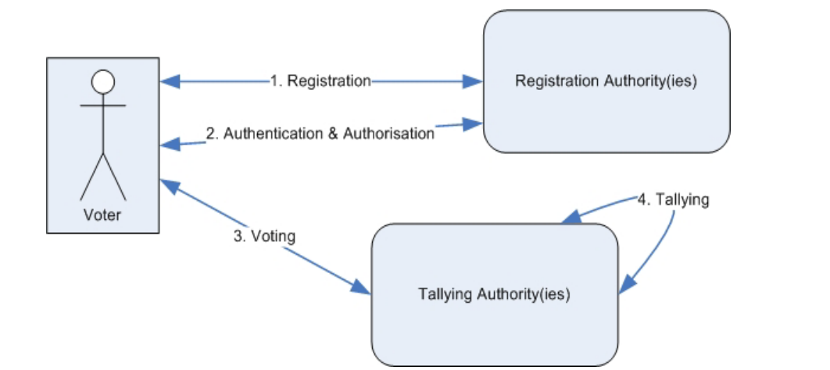
Figure 3.1: A typical E-voting process.
3.1.1 Implementation Algorithm
RSA is chosen for this project to secure the E-voting system. The RSA algorithm is implemented using Asymmetric and Public Key Encryption as shown in Figure 3.2 below.
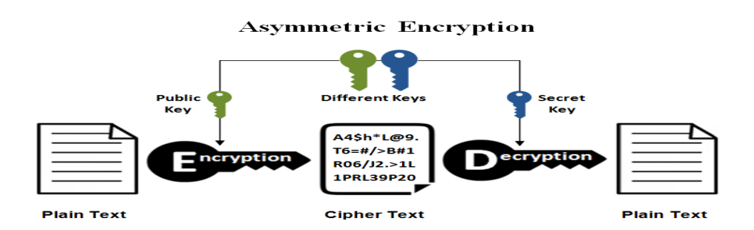
Figure 3.2: RSA - An Example of Asymmetric Key Cryptography Source (Afrin & Satao, 2019)
RSA key implementation
Step 1. Let Ck₁, Ck₂...c1c0 be the binary representation of c
Step 2. Set the variable E to 1.
Step 3. Repeat steps 3a and 3b for i = k, k − 1... 0:
Step 1: Let C_{k},C_{k−1},…,C₁,C₀ be the binary representation of c, where c is the ciphertext.
Step 2: Set the variable E to 1.
Step 3: Repeat steps 3a and 3b for i=k, k−1,…,0:
Step 3a: Square E, and reduce it modulo n:
E=(E×E) mod n
Step 3b: If Ci=1: Multiply E by M (message), and reduce it modulo n:
E=(E×M) mod n
Step 4: After the loop, E contains the decrypted message.

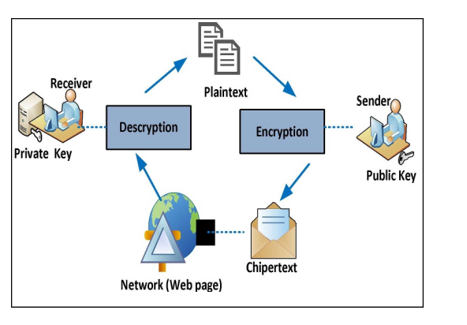
Figure 3.3: Cryptography Implementation Diagram
3.2 ANALYSIS OF THE EXISTING SYSTEM
The existing voting systems exhibit significant vulnerabilities, including susceptibility to ballot tampering, vote miscounting, and cyberattacks. These issues compromise the credibility of electoral outcomes. Traditional systems are often plagued by logistical challenges, resulting in delays and reduced voter participation. Accessibility remains a critical issue, particularly for remote and disabled voters. Also the lack of robust security measures in current systems leaves them open to manipulation. Encryption and authentication mechanisms are often inadequate, exposing sensitive electoral data to unauthorized access.
3.3 PROBLEMS OF THE EXISTING SYSTEM
The existing manual method of voting are faced with the following problems:
- Susceptibility to fraud and tampering.
- Inefficient voter authentication mechanisms.
- Lack of transparency and auditability.
- Inaccessibility for certain voter demographics.
3.4 DESCRIPTION OF THE PROPOSED SYSTEM
The proposed system leverages RSA cryptography to provide a secure, transparent, and efficient voting platform. It integrates voter authentication, secure ballot casting, and encrypted data storage. RSA encryption ensures data confidentiality and integrity. The system is developed using a modular architecture, with separate components for voter registration, ballot casting, and result computation. RSA is integrated into each module to ensure end-to-end security. The developed system has the following modules:
Administrator Environment: The administrator environment entails the following
- Add a Voter Detail
- Add Contestant
- View Result
- List of Contestant
- Voted User
- Not Voted User
- Registered Voter
Voters Environment
The voters’ environment prompts the user to supply the previously saved password for comparison with the one in the database. If there is a match between the supplied password and the user has not yet voted then the voting environment will be displayed for the user to vote otherwise if the user has voted a message will be displayed for the user.
3.5 ADVANTAGES OF PROPOSED SYSTEM
The proposed E-voting system has the following advantages:
- Enhanced security through RSA encryption.
- Improved accessibility for diverse voter demographics.
- Streamlined operations and reduced logistical challenges.
- Increased voter confidence through transparency and auditability.

CHAPTER FOUR
DESIGN, IMPLEMENTATION AND DOCUMENTATION OF THE SYSTEM
4.1 DESIGN OF THE SYSTEM
This is the computation of the particulars of a new system and the determination of what the new system would be and the function it is to perform. This may involve changing from one system to another or modifying the existing system operation. The most challenging phase of the system life cycle is the change from manual operation to a faster and more accurate one.
The proposed system is designed in modules with each modules working together to perform the electronic voting system in order to enhance the performance of the existing system as earlier discussed in chapter three. The ability to analyze and give focus to the system is explained in the following formats which are output design, input design, database design and procedure design.
    - Output Design
The input and output extracted from the proposed system are as shown below

Figure 4.1: Result Page
This page is displayed the result of the vote where the list of contestant with the total vote each contestant has will be displayed consecutively

Figure 4.2: List of Contestant
This page displays the total list of the contestant with the post they are aiming for, deletion can also be done in this page.

Figure 4.3: List of Voters Page
This page shows the list of all voters who has voted, voters who have not vote will not be included in this page

Figure 4.4: List Eligible Voters
This page displays the list of voters all eligible voters that are yet to vote.
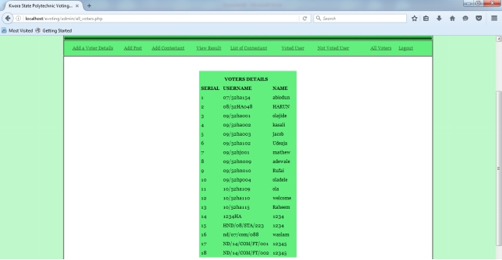
Figure 4.5: List of all Voters
This page displays the total list of all eligible voters that has been saved to the database of the system.
    - Input Design
The input to run this software is obtained from electronic voting system. The administrator is expected to safeguard the files and document using encryption. The input design describes the input interface for data entry into the program. Data entry interfaces need to be considered in developing a new system to ensure users’ friendliness. Data entry is done through the use of keyboard, camera, and in some cases selection from the dropdown combos and list boxes are done using mouse selection. The interface descriptions are as shown below:

Figure 4.6: Admin Login Form
This image above is the admin login form where he / she will have to present his/her username and password for authentication.

Figure 4.&: Admin Panel
This page serves as the main page for the admin, this page is displayed after the admin has successfully login to the system.

Figure 4.8: Voters Registration Interface
This form is used to add voters details where the voter matric number will serve as username and the password will be created by the user.

Figure 4.98: Add Post Interface
This form is used to add a contesting post before adding a contestant that will be contesting for the post.

Figure 4.10: Contestant Interface
This form is use to add contestant that will be contesting for a post, and his/ her details will be entered through the keyboard and his/her picture will be uploaded as well.
4.1.3 Database Design
This consist of the figures and tables used in the implementation of the proposed system.
Table 4.1: Contestant Table
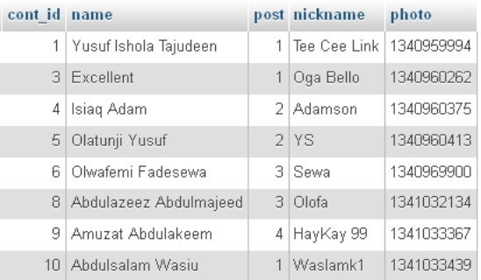

This table contains the details of the contestants.
Table 4.2: User Login Details
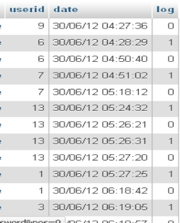
This table contains the details of user session that is the duration of time that user used to vote together with his details.
Table 4.3: Post Table

This table contains the contestants post details

Table 4.4: Voters Table
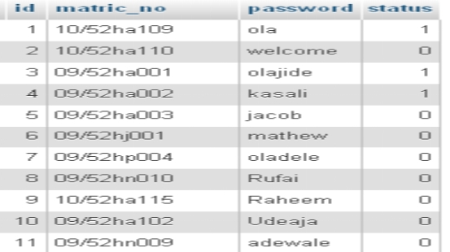
The voters table contains the details of all the voters that are eligible to vote.
4.1.4 Procedure Design
There are registered people in the system (Administrator and Voters). Each one of them may have some exclusive privileges (admin, for example, could add new voters to the system whereas voters cannot but be accredited).
- A voter should be able to
  - Login to the system through the initial screen of the system
  - Vote for his /her preferred candidate
  - Submit the vote
  - View result of the election
  - And finally, logout
- The administrator should be able to
- login to the system/change his password after logging in and so on
- Add Post to contest for
- Add Contestant Details with his/her preferred contesting post
- Add voters’ details
- View the list of all accredited student
- View the list of voted voters
- View the list of un-voted student
- Check result
4.2 IMPLEMENTATION OF THE SYSTEM
4.2.1 Hardware Support
The hardware requirements for this program are:
- PC: The computer should be minimum of Pentium IV with 1000GHs processor speed but preferably Dua Core Processor for greater efficiency
- Memory: This system requires a Higher RAM not less than 512MG, 1GB RAM is recommended.
- Storage: the storage capacity must be 80GB and above.
- VDU: Visual Display Unit required should be a very high resolution not less than 1024 x 768 with 256 colour capability.
- Printer: This system also requires a printer
- Input: The input device required is a mouse, Optical Mouse should be provided for easy use.
4.2.2 Software Requirements
The software requirements for the operation of this program are as follows:
- Window Operating System
- XAMPP or WampServer (for Apache server on localhost)
- Web Browser e.g Mozila Firefox
- Macromedia dreamweaver
4.2.3 Choice of Programming Language
The Application was developed in a .net (dot net) integrated development environment (.net IDE). The Application IDE is chosen following the fact that extracted information needs to be presented in an enhanced pictorial/graphical format and easy communication with the database for program flexibility in windows platform.
4.3 DOCUMENTATION OF THE SYSTEM
4.3.1 Program Documentation
In order for the proposed system to be used on any computer system it takes the following ways
- Boot the system
- Copy the folder to www inside wamp folder of the drive C: after WAMP server is installed onto the system.
- Open any browser on the system (Microsoft internet Explorer, Mozilla Firefox, Netscape Navigator, Opera, Flock, Safari and so on)
- Type http://localhost/evoting/index.php on the address bar and press the return key or enter key.
4.3.2 Operating the System
This refers to the step-by-step method of using the proposed system. The proposed system comprises of Add a Voter Details, Add Post, Add Contestant, View result, List of Contestant, Voted User, Not Yet Voted User, All Voters. The steps to use the proposed system are as follows
- On the address bar of any browser type http://localhost/www.kpsugvoting/index.php
- You are prompted to supply the username and password this verifies that you are a registered voter and has the privileged to vote.
- If the username and password supplied are correct as that of the voter you are prompted with the home page with the list of contestant based on their post and with their picture and at the end you click on submit to validate your votes.
- The username and password are in two formats as an administrator as well as a user.
- As an administrator you are to type http://localhost/kpsugvoting/admin/index.php on the address bar.
- As an administrator you are prompted with the administrator page where the back end of the voting exercise is carried out.
4.4 MAINTAINING THE SYSTEM
The system maintenance refers to making modification to an already existing application/program without necessarily re-writing everything from start. Program maintenance of a program includes modification of the program to meet-up with certain requirements of the users. In this course, additional features can be added, errors corrected, ambiguous interfaces redesigned to eliminate confusions and unnecessary features removed.
Maintaining this program can be done in Visual studio code environment. Any future modification can be by re-running the program source code in a web environment making necessary changes and updates and recompile the application into an upgrade version of the existing version of the mini word processing application. Further versions of this program can be named following their year of release or it can be given a different version number.

CHAPTER FIVE
SUMMARY, CONCLUSION AND RECOMMENDATIONS
5.1 SUMMARY
By using information technology, E-voting system can cast and count votes with higher convenience and efficiency, even make the electoral procedures simple and reduce the mistake rate of ballot examination. In this research, I designed and implemented an E-voting prototype system with PHP as the server side language while WAMP server is used as the backend. The proposed electronic voting system addresses critical issues in traditional systems, providing a secure, efficient, and transparent alternative. The integration of RSA enhances the system’s reliability and scalability. By addressing security and usability concerns, the study demonstrates the feasibility of adopting electronic voting systems on a larger scale. The findings highlight the potential to modernize electoral processes while maintaining democratic integrity. Further research could explore scalability, integration with biometric authentication, and deployment in large-scale elections to validate the system’s effectiveness.
5.2 CONCLUSION
In conclusion, the design and implementation of an electronic voting system using RSA cryptography offer a viable solution to modernize electoral processes. The system’s emphasis on security, usability, and transparency ensures its suitability for addressing challenges in traditional voting methods.
5.3 RECOMMENDATIONS
Based on the findings of this project the following were recommended:
- Future studies should prioritize optimizing system performance to handle high voter turnout efficiently.
- Additional security measures, such as biometric verification, should be integrated to enhance voter authentication.
- Pilot tests in real-world scenarios are necessary to validate the system’s effectiveness and user acceptance.
- Research into compatibility with diverse technological infrastructures can support broader adoption.

REFERENCES
AbdulRahim, A. K., Folorunso, A. & Sharma, S. K. (2020). An Improved Dynavote E-Voting Protocol Implementation, International Journal of E-Adoption, 3(3). Pp. 44-46. DOI: https://www.doi.org/10.56726/IRJMETS45853
Afrin, M. T. & Satao, K. J. (2020). E-Voting System for on Duty Persons using RSA Algorithm with Kerberos Concept, International Journal of Innovative Research in Computer and Communication Engineering. Vol. 1, Issue: 7. Pp. 2-3.
Ahubele, B. O. & Oghenekaro, L. U. (2022). Secured Electronic Voting System Using RSA Key Encapsulation Mechanism, EJECE, European Journal of Electrical Engineering and Computer Science. 2(4). Pp. 16-17. DOI: http://dx.doi.org/10.24018/ejece.2022.6.2.427
Carrera, T. F. (2021). Design and implementation of an Electronic Voting System based on Homomorphic Tallying of Votes, World of Computer Science and Information Technology Journal (WCSIT). Pp. 23-24. IOP Publishers
Cetinkaya, O. & Cetinkaya, D. (2017). Verification and Validation Issues in Electronic Voting. The Electronic Journal of E-Government, 1(1). Pp. 7-8. Johor Bharu, Johor Malaysia.
Ebenezer, O. I. (2019). Analysis, Design and Implementation of a Voting System Using a Novel Oblivious and Proxy Signature, International Journal of Advanced Computer Science and Applications. Vol. 13. Issue: 8.
Fashoto, S. G., Adeyeye, M. Uzoka, F. M. & Usthman, F H. (2021). Securing a Scalable E-Voting System Using the RSA Algorithm: The Case of a Group Voting Process in a Tertiary School. Computer Technology and Application. 2(5). Pp. 11-17. doi: 10.17265/1934-7332/2016.01.002
Infoplease. 2012. Election Ballots: Types and History. Retrieved May 9, 2025, from Infoplease Website: http://www.infoplease.com/spot/campaign2000ballot.html.
Mohammad, I. W. (2021). Electronic Voting System, A.B.U Zaria Mathematics Department, B.sc Project - Unpublished.
Mahdi A. M. & Farouk M. A. (2021). Design of Electronic Voting Systems for Reducing Election Process, International Journal of Recent Technology and Engineering (IJRTE) 2(1). Pp. 14-15. DOI 10.1109/SIMS.2014.31
Sundar, N. A., Kishore, M. K. & Suresh, C. (2018). A Secure E-Voting System Using RSA and Md5 Algorithms Using Random, International Journal of Applied Engineering Research Vol. 13, Issue: 11. Pp. 9468-9473. India Publications.
Suwarjono, S., Sumaryanti, L. & Lamalewa, L. (2018). Cryptography Implementation for Electronic Voting Security, E3S Web Conferences. Pp. 56-57. doi.org/10.1051/e3sconf/202132803005
Yekini, N. A., Oyeyinka, I. K., Oludipe, O. O. & Lawal, O. N. (2019). Computer-Based Automated Voting Machine (AVM) for Elections in Nigeria, International Journal of Computer Science and Network Security (IJCSNS). 12(5). Pp. 57-62. DOI: https://www.doi.org/10.56726/IJACSA45853

