A TECHNICAL PROJECT REPORT
ON
PROPOSE ABATTOIR
ILORIN SOUTH L.G.A, EYEKORIN KWARA STATE
BY
ABDULRAHEEM MUSA BABATUNDE
ND/23/ARC/PT/0045

BEING A DESIGN PROJECT SUBMITTED TO THE DEPARTMENT OF ARCHITECTURAL TECHNOLOGY, INSTITUTE OF ENVIRONMENTAL STUDIES, (I.E.S) KWARA STATE POLYTECHNIC ILORIN KWARA STATE.
IN PARTIAL FULFLMENT OF THE REQUIREMENT FOR THE AWARD OF NATIONAL DIPLOMA (ND) IN ARCHITECTURAL TECHNOLOGY, KWARA STATE POLYTECHNIC.
JULY, 2025

ACKNOWLEDGEMENT

Everything that has beginning must surely have an end therefore, all praise and adoration is unto Almighty ALLAH for the strength and courage he has recorded me into the process of this project.

Especially thanks to my supervisorARC. CHUKWUMA N. for his time to go through my research work, may Almighty Allah bless her abundantly.

Above all, I would like to express my gratitude to my capable, diligent, and hardworking project supervisor, ARC O.F ADEYEMI, as well as the members of the Architecture Department staff at Kwara State Polytechnic, Ilorin, RECTOR ENGINER/ARC: ABDUL JIMOH MOHAMMED, DIRECTOR: ARC ABDULAZEEZ B.F.Y, H.O.D: ARC TOMORI J.M, ARC: SOLOMON FAMILIAR S.O, PROJECT CODINATOR: ARC OLAREWAJU F.A. for their support, knowledgeable counsel, and unwaveringly helpful assistance and supervision, all of which were crucial to the successful completion of this study.
My deepest appreciation goes to my parent MR. and MRS.ABDULRAHEEM and my Boss ONIYANGI and the entire member of JAGBARA family for the supports towards my education.
I also appreciate my friends in person of ONIYANGI and loving sisters, brothers and course mates as they have contributing immensely to my success of the project.
There is no number of words that I can best describe you all, I am indeed overwhelmed of your supports and I pray Almighty Allah will bless you all.

Thanks you all.

DEDICATION
This design project is dedicated to almighty Allah, the all sufficient and the most beneficent God for his guidance and Grace toward me to complete this program successfully and also to my parents and the entire family of ARC. ONIYANGI for their supports morally, spiritually, financially and in every other way to see that my program was successful.

TABLE OF CONTENTS
Title Page Page
Declaration i
Certification ii
Acknowledgement iii
Dedication iv
Table of Content
CHAPTER ONE
1.0 INTRODUCTION 1
1.1 BACKGROUND OF THE STUDY 2
1.2 STATEMENT OF THE DESIGN PROBLEM 4
1.3 AIMS AND OBJECTIVE OF THE STUDY 6
1.4 SCOPE OF THE PROJECT 8
1.5 SIGNIFICANCE OF THE STUDY 10
1.6 JUSTIFICATION OF THE PROJECT 13
1.7 RESEARCH METHODOLOGY 17
1.7.1 RESEARCH DESIGN 17
1.7.2 DATA COLLECTION METHODS 17
1.7.3 DATA ANALYSIS METHODS 18
1.7.4 DESIGN METHODOLOGY 18
1.7.5 VALIDATION OF DESIGN 19
1.7.6 LIMITATION OF THE METHODOLOGY 19
CHAPTER TWO
2.1 LITERATURE REVIEW 21
2.1.1 CONCEPT OF ABATTOIRS 21
2.1.2 HISTORICAL EVOLUTION OF ABATTOIR DESIGN 21
2.1.3 KEY COMPONENTS OF MODERN ABATTOIR DESIGN 22
2.1.4 SANITATION AND ENVIRONMENTAL CONCERNS 22
2.1.5 HEALTH AND OCCUPATIONAL SAFETY 23
2.1.6 REGULATORY FRAMEWORKS AND STANDARDS 24
2.1.7 CASE STUDIES AND BEST PRATICE 24
2.1.8 GAPS IN LITERATURE AND NEED FOR 25
LOCALIZED DESGIN
CHAPTER THREE
3.0 CASE STUDY 26
3.1.1 INTRODUCTION 26
3.1.2 OVERVIEW OF THE EYENKORIN ABATTOIR, ILORIN 26
3.1.3 OBSERVED CONDITIONS AND CHALLENGES 29
3.1.4 ENVIRONMENTAL INPACT OF THE CURRENT SYSTEM 31
3.1.5 SOCIO ECONOMICS IMPLICATIONS 31
3.1.6 EFFORTS TOWARD IMPROVEMENT 31
3.1.7 KEY LESSONS FOR DESGIN PROPOSAL 32
3.1.8 PROPOSED DESIGN INNOVATIONS 32
CHAPTER FOUR
4.0 PROJECT ANALYSIS AND DESIGN CRITERIA 33
4.1.1 INTRODUCTION 33
4.1.2 PROJECT ANALYSIS 33
4.1.3 DESIGN CRITERIA 35
4.2 APPROACH TO THE DESIGN 36
4.3 DESIGN REALIZATION 37
CHAPTER FIVE
5.1 RECOMMENDATION AND CONCLUSION 39
5.1.1 RECOMMENDATIONS 39
5.1.2 CONCLUSION 40
REFERENCES
APPENDIX
APPENDIX A: ABATTOIR DESIGN LAYOUT
APPENDIX B: STANDARD OPERATING PROCEDURES
APPENDIX C: TRAINING MATERIAL

ABSTRACT
This study focuses on the design and operational improvement of the abattoir in Ilorin, Nigeria. The aim is to enhance animal welfare, meat safety, and environmental sustainability while ensuring efficient operations. A comprehensive analysis of the existing abattoir infrastructure and operations was conducted, and recommendations were made for upgrading facilities, implementing sustainable practices, and providing training for staff. The proposed design incorporates modern abattoir management principles, including humane animal handling and slaughtering, efficient waste management, and quality control measures. The study's findings and recommendations can inform the development of sustainable and efficient abattoir operations in Ilorin and similar contexts.

CHAPTER ONE
1.0 INTRODUCTION
Livestock production and meat processing constitute a vital component of the agricultural sector and play a central role in food security, public health, and economic development in Nigeria. With rapid urbanization, population growth, and increasing consumer demand for animal protein, the need for efficient and hygienic meat processing infrastructure has become more urgent. The abattoir, or slaughterhouse, is a critical facility in this value chain, responsible for the humane slaughter, inspection, processing, and packaging of meat destined for human consumption.
In developed nations, abattoirs are designed to meet strict regulatory standards for animal welfare, hygiene, environmental sustainability, and public health. Conversely, in many parts of Nigeria, including lorin the capital city of Kwara State-existing abattoir facilities fall far below acceptable standards. The traditional and semi-mechanized slaughterhouses in Horin are characterized by poor infrastructure, inadequate water supply, unregulated animal handling, improper waste disposal, and minimal veterinary oversight. These conditions not only compromise meat quality but also expose both workers and consumers to significant health risks, including zoonotic diseases such as tuberculosis, brucellosis, anthrax, and salmonellosis.
Moreover, environmental degradation caused by improper disposal of abattoir waste-including blood, feces, bones, and untreated wastewater-has contributed to pollution of nearby water bodies, unpleasant odors, and public complaints from surrounding communities. These challenges highlight the need for a modern, well-planned, and environmentally compliant abattoir system that aligns with global best practices and national regulations.
This project focuses on designing a modem abattoir suitable for the unique environmental, social, and economic context of florin, Kwara State. It examines the limitations of the current facilities through field research, community engagement, and stakeholder interviews Furthermore, it proposes a detailed design solution that incorporates key principles of spatial planning, sanitation, animal welfare, environmental sustainability, and operational efficiency.
The overall objective is to develop a scalable, cost-effective, and sustainable abattoir model that can serve as a blueprint for future developments not only in Ilorin but also across other urban centers in Nigeria facing similar challenges. By integrating modem technologies, regulatory compliance, and community participation, this project seeks to promote safe meat production, protect public health, and mitigate the environmental impacts associated with traditional slaughtering practices.
1.1 BACKGROUND OF THE STUDY
The livestock industry is a cornerstone of agricultural economies across the globe, playing a significant role in food production, employment generation, and trade. In Nigeria, the consumption of meat particularly beef, goat, sheep, and poultry-continues to rise due to population growth, urbanization, rising incomes, and changing dietary preferences. As a result, the demand for organized and hygienic systems of animal slaughter and meat processing is more critical than ever.
An abattoir, also known as a slaughterhouse, is a facility where livestock is slaughtered under regulated conditions for consumption. It forms an essential link in the food supply chain by providing safe, inspected, and processed meat to the public. Ideally, abattoirs are expected to comply with national and international standards of hygiene, animal welfare, environmental safety, and public health Properly designed and operated abattoirs help reduce the risk of food borne illnesses, promote safe meat handling, facilitate meat inspection and certification, and prevent environmental contamination.
Despite the strategic importance of abattoirs, many in Nigeria especially those located in medium-sized cities like florin, Kwara State operate under substandard conditions. Most existing abattoirs in Ilorin are either outdated or poorly managed. Basic infrastructural components such as clean water supply. drainage systems, waste treatment facilities, veterinary inspection posts, and hygienic slaughter areas are either inadequate or non-functional. Slaughtering activities are often carried out on bare floors, exposed to flies, rodents, and environmental pollutants, thus compromising meat quality and public health.
The Ipata Abattoir, one of the major slaughter facilities in Ilorin, serves a large portion of the city's meat demand. However, site visits and observational studies have revealed critical flaws in its design and operations. These include indiscriminate disposal of animal waste into nearby drains, lack of adequate lairage (animal resting pens), limited cold storage capacity, and absence of modern meat processing equipment. In addition, there is minimal enforcement of veterinary inspections, posing serious risks for the spread of zoonotic diseases. These issues are compounded by the growing population of florin and increasing urban sprawl, which places pressure on existing abattoir infrastructure and worsens its environmental footprint.
Furthermore, the lack of trained personnel, poor funding, and absence of public- private partnerships contribute to the continued deterioration of abattoir conditions. These problems have serious consequences, including:
- Pollution of rivers and water bodies due to untreated abattoir effluents.
- Spread of diseases from animals to humans.
- Offensive odors and environmental degradation affecting nearby communities.
- Economic losses due to meat spoilage, theft, and inefficient handling.
There is, therefore, an urgent need for a comprehensive review and redesign of abattoir systems in Ilorin to bring them in line with modern standards. A well- designed abattoir will not only improve meat safety and hygiene but also promote sustainable urban development, enhance occupational safety for butchers and meat handiers, and support the broader goals of public health and environmental management.
This study aims to assess the existing challenges of abattoir operations in Ilorin and propose a functional and modern abattoir design tailored to the local context. By leveraging principles of architectural planning, environmental engineering. and food hygiene, the project seeks to provide a sustainable solution to the problems plaguing meat processing in the city. It also envisions an abattoir that integrates technology, ensures humane handling of animals, supports waste-to- resource innovations, and can serve as a replicable model across other urban centers in Nigeria.
1.2 STATEMENT OF THE DESIGN PROBLEM
The increasing population and urban expansion in Ilorin, Kwara State, have significantly heightened the demand for animal protein, especially red meat. However, the infrastructure and facilities supporting meat processing in the city have not kept pace with this demand. Existing abattoirs, such as the Ipata Abattoir and several other informal slaughter points, are operating under poor hygienic and structural conditions. These facilities are largely inadequate in terms of size, equipment, waste management systems, and regulatory compliance.
The most pressing issue is the absence of a properly planned, standardized, and sustainable abattoir facility in Ilorin. The current slaughterhouses often lack essential components such as proper lairage (animal holding pens), clean and dirty area separation, drainage systems, blood and solid waste disposal units, meat inspection zones, and cold storage. This has led to unhygienic meat processing environments where slaughtering is done on bare concrete or open grounds, with blood and waste openly discharged into nearby water channels, leading to serious public health and environmental risks.
Additionally, these abattoirs are not equipped to handle large volumes of animals daily. There is no streamlined process for the humane handling of animals, no standardized post-mortem inspection system, and no integration of modern technologies such as waste-to-energy systems, digital monitoring of hygiene conditions, or traceability of meat products. The lack of training and protective facilities for workers also contributes to occupational hazards and inefficiencies in meat processing.
From an environmental standpoint, the uncontrolled disposal of blood, offal, and wastewater contributes to:
- Ground and surface water pollution.
- The breeding of disease vectors like flies and rodents.
- Offensive odors that reduce the quality of life for nearby residents.
Moreover, there is no effective enforcement of existing national or local guidelines for abattoir operation, largely due to infrastructural limitations and insufficient governmental oversight.
These realities indicate that the current abattoir infrastructure in Ilorin:
- Fails to meet public health and environmental safety standards.
- Is incapable of supporting the growing meat demand of the city.
- Lacks functional and structural components essential for modern meat processing.
- Poses a risk to food safety, worker health, and urban environmental sustainability.
Thus, the design problem this project seeks to solve is the creation of a modern, hygienic, scalable, and environmentally sustainable abattoir that addresses the structural, operational, and regulatory deficiencies currently affecting meat production in Ilorin. The proposed design must:
- Comply with international (WHO/FAO) and national standards.
- Provide proper animal handling, slaughtering, and meat processing zones.
- Include functional waste management systems (blood collection, effluent treatment, offal disposal).
- Ensure public health, environmental protection, and operational efficiency.
- Integrate future expansion possibilities to meet long-term urban growth.
This design problem is not just architectural or technical-it is multi-dimensional, requiring a holistic approach that blends public health engineering, food safety. animal welfare, environmental planning, and sustainable architecture. Solving this problem will help reposition florin as a model city for safe, efficient, and modern meat processing infrastructure in Nigeria
1.3 AIMS AND OBJECTIVES OF THE STUDY
Aim of the Study
The primary aim of this study is to design a modern, hygienic, and environmentally sustainable abattoir facility in Ilorin. Kwara State, that aligns with international best practices in meat processing, public health, and environmental safety, while also meeting the current and future demands of the growing urbsan population.

Specific Objectives
To achieve the stated aim, the study has the following specific objectives:
1. To assess the current condition of existing abattoirs in ilorin, particularly in terms of infrastructure, hygiene practices, operational procedures, waste management, and compliance with regulatory standards.
2. To identify the major challenges associated with traditional and semi- modern slaughterhouses in florin, including public health risks, environmental degradation, animal welfare concems, and occupational hazards for workers.
3. To investigate local, national, and international guidelines and standards governing the design and operation of abattoirs, including those provided by the World Health Organization (WHO), Food and Agriculture Organization (FAO), and Nigerian regulatory bodies.
4. To propose a functional and adaptable architectural design for a modern abattoir that includes essential features such as:
- Animal holding pens and lairage
- Slaughter halls with clean and dirty zone separation
- Meat inspection and processing areas
- Cold storage and meat packaging units
- Proper drainage and effluent treatment systems
- By-product recovery and waste-to-energy facilities
- Staff and administrative areas
5. To integrate sustainability principles into the abattoir design, including the use of renewable energy sources (eg, solar power), rainwater harvesting, efficient waste management, and environmental protection buffers
6. To ensure that the proposed design meets the socio-economic realities of Ilorin, including affordability, cultural acceptability, scalability, accessibility, and community involvement.
7. To develop a replicable model of abattoir design that can serve as a framework for similar urban centers in Nigeria and across sub-Saharan Africa
8. To recommend strategies for the effective implementation. management, and regulation of the proposed facility, including public- private partnership models, capacity building for workers, and continuous monitoring and evaluation systems.
This combination of aims and objectives ensures that the project not only proposes a physical structure but also addresses broader issues related to food safety, environmental health, and sustainable urban infrastructure development in Ilorin and beyond.
14 SCOPE OF THE PROJECT
This project is focused on the conceptualization, assessment, and design of a modern abattoir facility that responds to the increasing demand for hygienic meat processing and environmental safety in Ilorin, Kwara State. It encompasses various interrelated aspects of architectural design, public health, environmental engineering, and urban planning to create a comprehensive solution for the identified slaughterhouse deficiencies in the area.
The scope of the project is defined as follows:
1. Site Evaluation and Needs Assessment
- Survey and analysis of existing abattoir facilities in florin (eg.. Ipata Abattoir and informal slaughter slabs).
- Identification of gaps in infrastructure, operational processes, environmental impact, and regulatory.compliance.
- Collection of demographic, geographic, and consumption data to determine the scale and capacity of the proposed facility.
2. Design and Planning of the Abattoir Facility
- Development of a functional site layout, incorporating essential components such as:
- Lairage (animal holding pens)
- Ante-mortem inspection areas
- Slaughter halls (for cattle, goats, sheep)
- Meat processing, packaging, and inspection areas
- Cold rooms and storage facilities
- By-product processing units (blood, hides, bones)
- Waste management systems (including effluent treatment)
- Staff welfare facilities (toilets, changing rooms, offices, canteens)
- Administrative and veterinary inspection blocks
- Security, fencing, and parking zones
- Application of clean and dirty zone separation principles in the layout.
3. Integration of Sustainability and Environmental Controls
- Design of effective solid and liquid waste disposal systems, including:
- Grease traps
- Septic/araerobic digesters
- Waste-to-energy conversion mechanisms (optional)
- Incorporation of environmentally friendly systems such as:
- Solar energy for powering critical operations
- Rainwater harvesting systems for non-potable use
Landscape buffering to reduce odor and improve aesthetics
4. Health, Safety, and Regulatory Compliance
- Consideration of WHO, FAO, and Nigerian meat hygiene and abattoir operation standards.
- Provisions for occupational safety of workers (ventilation, lighting, anti- slip flooring, PPE stations).
- Layout and design features that enable easy inspection, sanitation, and monitoring.
5. Social and Economic Consideration
- Consideration of cultural slaughter practices, market proximity, and case of access for butchers, livestock supplies, and buyers.
- inclusion of local building materials and labor to enhance affordability and community participation
- Evaluation of public-private partnership models for construction and long- term management.
6. Limitations and Exclusions
The project is limited to the design and planning stage only. It does not include the physical contraction or commissioning of de proposed abattoir.
Economic feasibility studies, environmental impact assessments (EIA). and legal compliance documentation are referenced hut not fully implemented in this project due to time and scope constraints.
The project focuses on red test (cattle, sheep, and goat) and does not cover poultry, piggery, or fish slaughter facilities.
In summary, the scope of this project extends from field investigational analysis of current abattoir conditions to the development of a detailed architectural and operational design. It integrates hygiene, efficiency, safety, sustainability, and compliance while being adaptable to the local needs and future population growth of Ilorin.
1.5 SIGNIFICANCE OF THE STUDY
The design of a modern abattoir in Ilorin, Kwara State, holds significant relevance mat only for public health and environmental sustainability but also for economic development, urban planning, and social wellbeing. This project addresses critical gaps in the exiting slaughtering infrastructure and provides a holistic solution to the multifaceted challenges facing meat processing operations is the region. The study 'y significance is highlighted through the following dimension.
1. Promotion of Public Health and Food Safety
The current state of abattoir facilities in florin poses serious public health threats due to unhygienic slaughtering practices, lack of veterinary inspections, and improper meat handling. Contaminated meat is a major vector for zoometric diseases such as tuberculosis, anthrax, and brucellosis. This study is significant as it proposes a design that ensures:
- Sanitary slaughtering and processing of meat.
- Clean-dirty zone separation to prevent cross-contamination.
- Provision of veterinary inspection and meat certification areas
- Availability of cold storage to preserve meat quality.
Through these provisions, the project supports the supply of safe, healthy meat to consumers and reduces the burden of food borne illnesses.

2. Environmental Protection and Waste Management
Uncontrolled discharge of animal blood, offal, and wastewater into the environment is a leading cause of land and water pollution in many Nigerian cities. The proposed design integrates environmentally friendly features such as:
- Wastewater treatment systems.
- Blood collection and rendering units.
- Composting and waste-to-energy solutions.
- Buffer landscaping to reduce odor and noise pollution.
By addressing these issues, the study contributes to environmental conservation and sustainable urban sanitation.
3. Economic and Employment Benefits
A properly designed and managed abattoir creates jobs and enhances economic activity across the meat value chain. This includes:
- Employment for butchers, cleaners, meat inspectors, and facility managers.
- Opportunities for hides and skins processing industries.
- Enhanced meat quality, leading to increased consumer confidence and higher market value.
The study is therefore significant in its potential to generate local employment, increase economic output, and encourage investment in the meat sector.
4. Enhancement of Urban Infrastructure and Planning
Ilorin is expanding rapidly, and without modern infrastructure, such growth will continue to exert pressure on outdated systems. This project aligns with urban development goals by:
- Decentralizing meat processing activities from congested urban cores.
- Improving city sanitation and aesthetic appeal.
- Providing structured access roads, parking areas, and utility systems.
The study thus contributes to the modernization of Ilorin's urban planning framework.
5. Compliance with National and International Standards
Nigeria is a member of global public health and environmental organizations, and there is an increasing push toward regulatory compliance. This study supports that goal by:
- Aligning with WHO and FAO guidelines for abattoir design.
- Supporting the implementation of Nigeria's Environmental Sanitation Regulations (2009).
- Encouraging adherence to the National Meat Inspection Service (NMIS) protocols.
Compliance ensures that meat produced in llorin can meet export standards and consumer safety expectations, both locally and internationally.
6. Educational and Research Value
This project serves as a reference point for:
- Students and researchers in architecture, environmental health, veterinary science, and agricultural engineering.
- Policymakers and local governments looking to replicate sustainable slaughterhouse models in other cities.
- NGOs and development agencies working on food security, health, and sanitation
By documenting challenges, solutions, and design strategies, the project contributes to the knowledge base required for future infrastructural development In Nigeria.
7. Replicability and Long-Term Impact
One of the most significant aspects of this study is its potential for replication across other Nigerian urban centers. Many cities face similar challenges, and this project provides a practical, context-specific, and scalable model that can be adapted to meet diverse needs across the country.
This study is a vital contribution to the intersection of architecture, public health. Environmental sustainability, and urban development. It offers actionable solutions to longstanding challenges and provides a foundation for transforming meat production and processing systems in florin and beyond.
1.6 JUSTIFICATION OF THE PROJECT
The justification for the development and design of a modern abattoir in Ilorin, Kwara State, stems from the urgent need to address the prevailing challenges associated with meat processing, environmental pollution, public health risks, and urban infrastructure deficiencies. The current slaughtering practices within florin are not only unsanitary and environmentally unsound but also inadequate to meet the growing meat demand of the city's expanding population. This project is, therefore, a timely and necessary intervention for the following reasons:
1. Rising Demand for Hygienically Processed Meat
The population of Ilorin is steadily increasing, accompanied by a corresponding rise in the consumption of meat products. Traditional slaughter slabs and outdated abattoirs are incapable of meeting this demand in a hygienic and efficient manner. The lack of proper meat handling, inspection, and cold storage facilities results in the distribution of contaminated meat, putting the public at risk. A modern abattoir design is justified as a strategic solution to safeguard food safety and ensure a steady supply of hygienically processed meat,
2. Poor Sanitation and Environmental Degradation
One of the most visible consequences of poorly managed abattoirs is environmental pollution. In Ilorin, open discharge of blood, faeces, wastewater, and animal remains into surrounding water bodies and public drains contributes to:
- Groundwater contamination.
- Offensive odors,
- Mosquito and fly breeding, and
- The spread of zoonotic diseases.
These conditions are not only unsightly but also dangerous. A well-designed abattoir with integrated waste management systems such as septic tanks, grease traps, and effluent treatment plants-would significantly reduce the environmental footprint of meat processing activities.
3. Inadequacy of Existing Abattoir Facilities
The few functional slaughterhouses in florin, such as Ipata Abattoir, lack the basic Infrastructure and capacity to process large numbers of animals while maintaining acceptable hygiene standards. There is no proper zoning for clean and dirty operations, minimal veterinary presence, inadequate equipment, and poor worker safety. This project is justified as it provides a facility that incorporates essential components including:
- Separate slaughter lines for different species,
- Proper lairage (animal resting areas),
- Meat inspection and packaging zones,
- Cold chain infrastructure, and
- Occupational health provisions for workers.
4. Public Health Protection
Numerous public health concerns such as foodborne infections, zoonotic diseases, and occupational hazards--can be traced back to unregulated slaughter practices. These diseases not only affect meat consumers but also workers in the meat sector and communities living around abattoirs. This project will incorporate standards outlined by the World Health Organization (WHO) and Nigeria's National Meat Inspection Service (NMIS), thereby reducing the risk of disease transmission and enhancing the general health of the population.
5. Economic and Social Impact
A well-structured abattoir has far-reaching socio-economic benefits. It creates employment for butchers, veterinarians, meat inspectors, cleaners, waste management personnel, and transporters. Furthermore, by improving meat quality and reducing wastage, it can contribute significantly to local food security and income generation. The project also encourages the development of allied industries such as leather processing, tallow production, bone meal, and biogas generation-thus contributing to the circular economy and poverty alleviation.
6. Urban Planning and Aesthetic Improvement
Current abattoir locations in Ilorin are often situated in densely populated or unplanned urban environments, leading to noise, odor pollution, and traffic congestion. This project proposes a purposefully located, well-zoned, and visually appealing facility that aligns with modern principles of urban planning. It will improve the image of the city, promote tourism, and reduce public complaints about the unsightly nature of existing facilities.
7. Legal and Regulatory Compliance
Nigeria's environmental, public health, and livestock regulations call for properly managed abattoirs with appropriate waste control, hygiene, and inspection systems. The continued operation of illegal and substandard slaughterhouses violates these laws and exposes municipal authorities to liability. This project supports government efforts toward policy implementation and regulatory compliance by offering a model facility that meets both national and intemational guidelines.
8. Replicability and Research Contribution
The design of a modern, adaptable, and sustainable abattoir can serve as a model for other Nigerian cities and West African countries facing similar challenges. Additionally, the project contributes to academic research in architecture, public health engineering, food safety, and urban development. It provides a practical case study for future students, researchers, policymakers, and development practitioners.
Given the severity of health, environmental, infrastructural, and regulatory challenges posed by the current abattoir systems in Ilorin, the justification for this project is clear and compelling. The proposed modern abattoir will not only address these problems but also position Ilorin as a leading example of safe and sustamable meat processing in Nigeria. This project is both a necessity and an opportunity for innovation, transformation, and long-term impact.
1.7 RESEARCH METHODOLOGY
This research adopts a multidisciplinary and practical approach to investigating the current challenges of abattoir operations in llorin and developing a sustainable and functional abattoir design. The methodology combines both qualitative and quantitative techniques to ensure a comprehensive understanding of existing conditions, stakeholder needs, and the technical requirements for a modern abattoir facility. The research process was structured in phases as outlined below:
1.7.1 RESEARCH DESIGN
The study employed a descriptive and exploratory research design. The descriptive aspect was used to assess the current state of slaughterhouse operations in llorin, while the exploratory component helped identify design gaps, propose innovative solutions, and formulate a context-specific abattoir model suitable for Ilorin and similar urban environments.
1.7.2 DATA COLLECTION METHODS
To gather relevant data, the study utilized the following methods:
A. Field Observation
Site visits were conducted to existing abattoirs in Ilorin, particularly Ipata Abattoir and other informal slaughter slabs within the metropolis.
Observations focused on:
- General facility layout and spatial organization
- Infrastructure quality (walls, floors, drainage, water supply)
- Sanitation and hygiene practices
- Slaughtering methods and animal handling
- Waste management and disposal methods
- Environmental conditions around the abattoir (odors, water pollution, proximity to residential areas)

1.7.3 DATA ANALYSIS METHODS
The data collected were analyzed as follows:
- Qualitative Data Analysis: Observational notes, interview transcripts, and open-ended questionnaire responses were coded thematically to identify common trends, concerns, and design implications.
- Quantitative Data Analysis: Descriptive statistics such as frequency distributions, percentages, and bar charts were used to analyze questionnaire results, using Microsoft Excel and SPSS where applicable,
- SWOT Analysis: A Strengths, Weaknesses, Opportunities, and Threats analysis of current abattoir systems was conducted to guide design decisions.
1.7.4 DESIGN METHODOLOGY
The design of the proposed modern abattoir was informed by the research findings and guided by best practices in architectural design, public health engineering, and environmental management. The design methodology included: Site Selection Criteria: Based on accessibility, environmental safety. availability of utilities, and distance from residential zones.
- Zoning and Layout Planning: Clean and dirty arca separation, logical animal flow from arrival to meat dispatch, staff circulation rosates, and visitor access control
- Functional Components Integration Inclusion of essential units such as lairage, slaughter halls, cold rooms, meat inspection and packaging areas, waste treatment systems, staff welfare facilities, etc.
- Sustainability Considerations: Solar energy systems, rainwater harvesting, natural ventilation and lighting, green buffers, and waste-to- energy technologies
- Scalability and Adaptability: Design allows for future expansion and modular development.
Conceptual sketches and layout diagrams were produced using AutoCAD, Revit, and SketchUp for visualization and technical evaluation.
1.7.5 VALIDATION OF DESIGN
- Preliminary designs were reviewed by a panel of experts, including architects, veterinarians, environmental health officers, and public sector officials
- Their feedback was incorporated to ensure the design is functional, compliant, and contextually appropriate.
1.7.6 LIMITATIONS OF THE METHODOLOGY
- Some stakeholders were reluctant to participate in interviews or surveys due to suspicion or lack of awareness.
- Limited access to current official records or government blueprints on existing abattoirs
- Financial constraints restricted physical modeling and on-site prototype testing.
- The study is primarily limited to cattle, gouts, and sheep, poultry and piggery systems were not included.
The research methodology adopted for this project ensures a comprehensive, participatory, and evidence-based approach to addressing the challenges of abattoir design in florin. By combining fieldwork, stakeholder cogagement. literature synthesis, and design best practices, the project delivers a context sensitive and technically sound abattoir model that can be adapted for future use across similar regions in Nigeria.

CHAPTER TWO
2.1 Literature Review
The design, development, and operation of abattoirs-also known as slaughterhouses are closely tied to public health, environmental safety, food hygiene, animal welfare, and sustainable urban infrastructure. This literature review explores theoretical frameworks, best practices, regulatory guidelines, and previous studies that inform the planning and execution of modern abattoirs, particularly within the Nigerian and sub-Saharan African context.
2.1.1 Concept of Abattoirs
An abattoir is a facility where animals are slaughtered and processed for human consumption under controlled and hygienic conditions. According to the Food and Agriculture Organization (FAO), a standard abattoir must ensure
- Humane handling and slaughter of animals
- Sanitary meat processing environments
- Adequate waste management systems
- Routine veterinary inspection and meat certification
The World Health Organization (WHO) also underscores the importance of abattoirs in maintaining food safety and preventing the spread of zoonotic diseases such as tuberculosis, brucellosis, anthrax, and salmonellosis
2.1.2 HISTORICAL EVOLUTION OF ABATTOIR DESIGN
Historically, animal slaughter was done in open or semi-structured spaces with little regard for hygiene. In the carly 20th century, increasing urbanization and industrialization led to the establishment of centralized municipal abattoirs. Over time, abattoir design evolved to reflect
- The need for efficient slaughtering operations
- Public health concerns
- Technological advancement in meat processing
- Environmental regulations regarding waste disposal
In recent years, abattoir design has incorporated sustainability principles such as waste-to-energy systems, renewable energy sources, green building materials, and automation technologies.
2.1.3 KEY COMPONENTS OF MODERN ABATTOIR DESIGN
According to FAO (2019) and WHO technical reports, a well-designed abattoir typically includes the following functional zones:
1. Lairage (holding pens) for animal rest and pre-slaughter inspection
2. Stunning and slaughter halls
3. Bleeding, de-hiding, and evisceration areas
4. Post-mortem inspection zones
5. Meat cutting, packaging, and cold storage
6. Waste treatment and by-product recovery units
7. Veterinary and administrative offices
8. Sanitary facilities for workers and meat handlers
Effective zoning and separation of clean and dirty areas are essential to prevent cross-contamination and ensure smooth workflow.
2.1.4 SANITATION AND ENVIRONMENTAL CONCERNS
In many developing countries, improper abattoir design and operation have contributed significantly to environmental degradation. Studies by Adegoke and Oyedum (2018) found that most abattoirs in Nigeria discharge untreated effluents into nearby rivers and public drains, causing water and soil pollution. Such practices violate national sanitation laws and have serious health implications.
According to Aniebo and Wogu (2014), the environmental impact of abattoirs includes:
- Water pollution from blood and feces
- Air pollution from offensive odors and buming of waste
- Soil degradation due to seepage of waste
- Emergence of disease vectors like flies and rodents
Integrated waste management is therefore a non-negotiable aspect of modem albattoir planning, requiring systems such as:
- Effluent treatment plants (ETPS)
- Grease traps and septic tanks
- Blood and bone meal recovery units
- Composting and biogas production
2.1.5 HEALTH AND OCCUPATIONAL SAFETY
Workers in traditional abattoirs are often exposed to unsanitary conditions, physical injuries, and disease risks. Research by Olaoye and Onifade (2017) highlighted the lack of
- Personal protective equipment (PPE)
- Proper ventilation and lighting
- Health insurance or medical coverage
- Training in meat hygiene and sanitation
WHO and FAO guidelines emphasize the need for:
- Regular training of meat handlers
- Provision of water, soap, and disinfection stations
- Structural materials that are easy to clean (eg, stainless steel, epoxy flooring)
These safety measures not only protect workers but also contribute to public confidence in meat quality.
2.1.6 REGULATORY FRAMEWORKS AND STANDARDS
Several laws and regulatory agencies govern the operation of abattoirs in Nigeria, including
- National Environmental (Sanitation and Waste Control) Regulations, 2009
- National Meat Inspection Service (NMIS) guidelines
- Environmental Health Officers Registration Council of Nigeria (EHORECON)
- Livestock and Animal Welfare Bills (state level)
Despite the presence of these laws, compliance remains low due to
- Poor funding and infrastructure
- Lack of enforcement
- Ignorance among operators
- Corruption and weak institutional frameworks
This underscores the need for design solutions that are regulatory-compliant, user-friendly, and economically feasible.
2.1.7 CASE STUDIES AND BEST PRACTICES
Ghana, Kenya, and South Africa have made notable progress in establishing structured and hygienic slaughter facilities. For instance:
- The Kenya Meat Commission (KMC) abattoir incorporates advanced meat processing equipment, biogas digesters, and automated slaughter lines. 24
- In South Africa, large abattoirs are integrated with processing plants, cold chains, and transportation hubs ensuring farm-to-table tractability.
- In Ghana, decentralized community abattoirs with proper waste management have improved rural meat hygiene.
These examples illustrate the feasibility of replicating similar models in florin, provided that cultural, financial, and technical factors are adapted to local needs.
2.1.8 GAPS IN LITERATURE AND NEED FOR LOCALIZED DESIGN
While global models exist, most literature does not sufficiently address the context-specific challenges of Nigerian urban centers like Ilorin. Factors such as
- Unregulated slaughtering practices
- Urban encroachment on abattoir land
- Cultural meat preferences and religious slaughtering methods (c.g.. halal)
- Resistance to from informal change -require unique architectural and management responses.
This project fills the gap by proposing a localized, functional, and scalable abattoir design, informied by field data, community participation, and sustainable planning principles.
The reviewed literature underscores the complex and multidisciplinary nature of abattoir planning, involving architecture, public health, sanitation, environmental engineering, and urban policy. It also reveals the deficiencies in existing facilities in Nigeria and the urgent need for modern, hygienic, and sustainable slaughterhouse systems. This study builds upon these insights to develop a contest-appropriate abattoir model for florin, with the potential to influence national standards and promote healthier meat processing systems across Nigeria.

CHAPTER THREE
3.0 CASE STUDY: Ilorin Abattoir System, Kwara State, Nigeria
3.1 INTRODUCTION
Ilorin, the capital of Kwara State, serves as a major commercial and administrative hub in North-Central Nigeria. With a population of over 1 million people and a significant portion engaged in livestock farming and meat trading the city relies heavily on abattoir facilities for meat production. However, the abattoir system in Horin, particularly the Ipata Abattoir the largest and most active-suffers from poor design, environmental degradation, and substandard operational practices. This case study examines the condition, challenges, and opportunities for redesigning abattoirs in llorin to meet modern hygienic, environmental, and regulatory standards.
3.2 OVERVIEW OF THE SOBI BARACK ROAD, ABATTOIR, ILORIN
CASE STUDY I
NAME: Dr Abubakar Bukola Saraki, Memorial Abattoir
LOCATION: Sobi Barack Road, lorin, kwara state
MERITS
It is easy to accessible from the road
The is well layout
It is room top board meeting
DEMERITS
Poor maintenance
Dump and stepping space
Untidy drying space
It is not well organized
Room for pressure expansion.
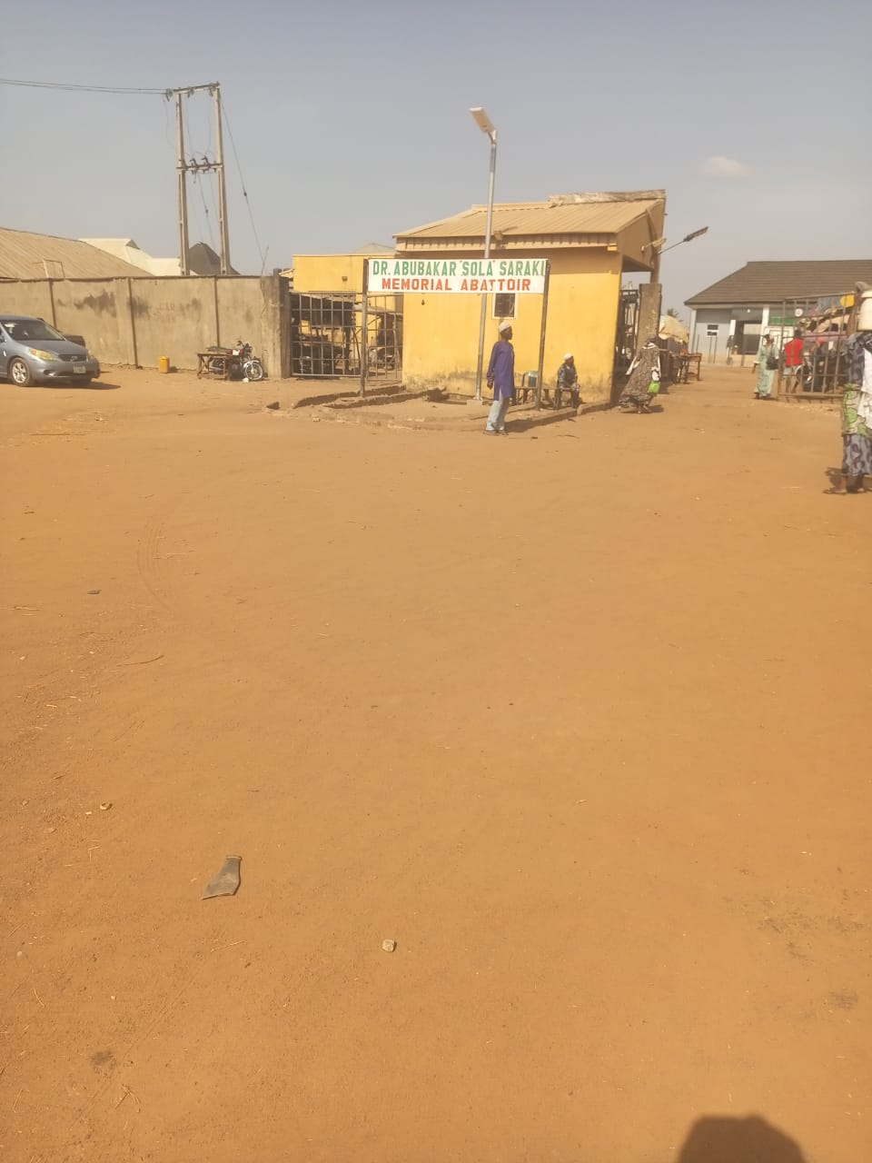

FIG 3.2.1:Doctor Abubakar Sola Saraki Memorial Abattoir, Ilorin, Kwara State
CASE STUDY 2
NAME: ODAGBODO SLAUGHTER
LOCATION: 42, Asubiaro Street Isale Jeleye, Osogbo, Osun State.
MERITS
Durable and easy clean
Sutable lighting and climatic condition
Cross ventilation
DEMERITS
Poor accessibility
Poor waste disposal
Poor landscaping
Inadequate water supply
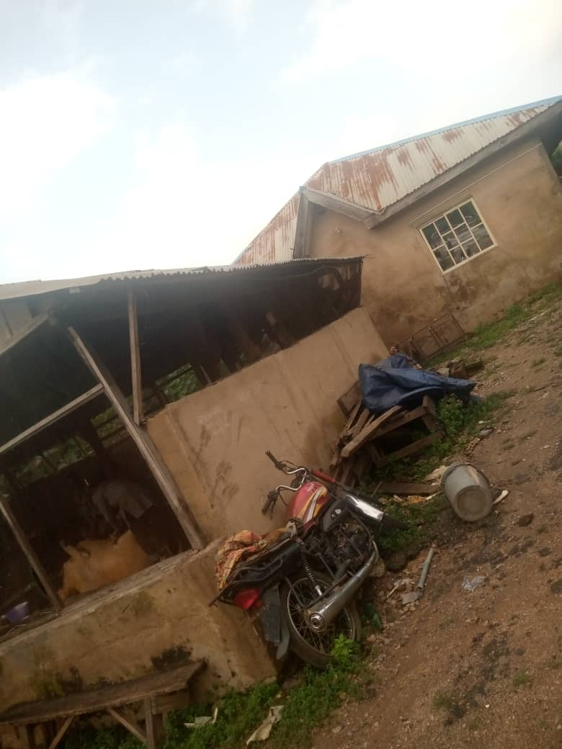
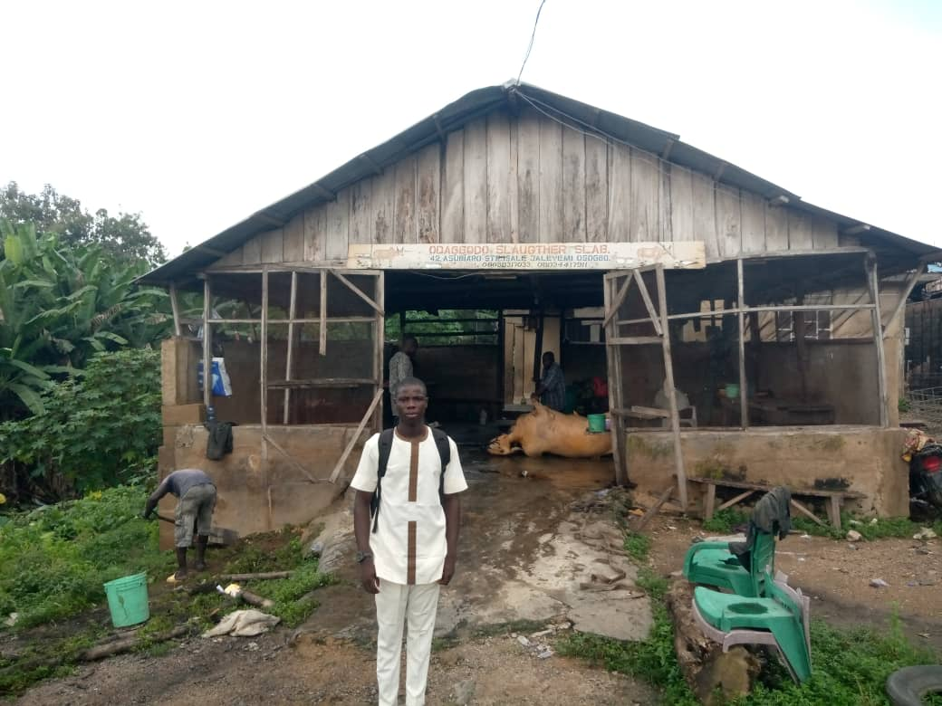
Damp pollution
3.2.2: SABO ABATTIOR OSHOGBO OSUN STATE
CASE STUDY 3
NAME Waso market
Location: Sabo waso, Oshogbo oyo state
MERITS
There is enough toilet for the workers
It has cross ventilation
DEMERITS
There is adequate water for cleaning and sanitation
Drop and stepping The is not coal point
There is not proper waste management
The building is surrounding with bush
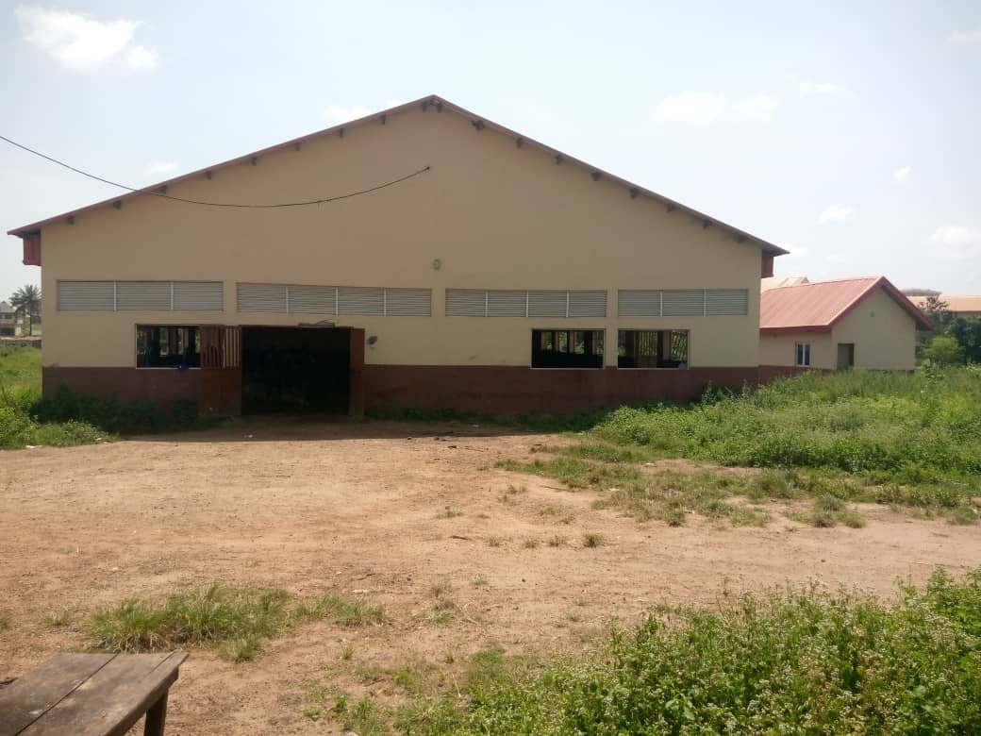
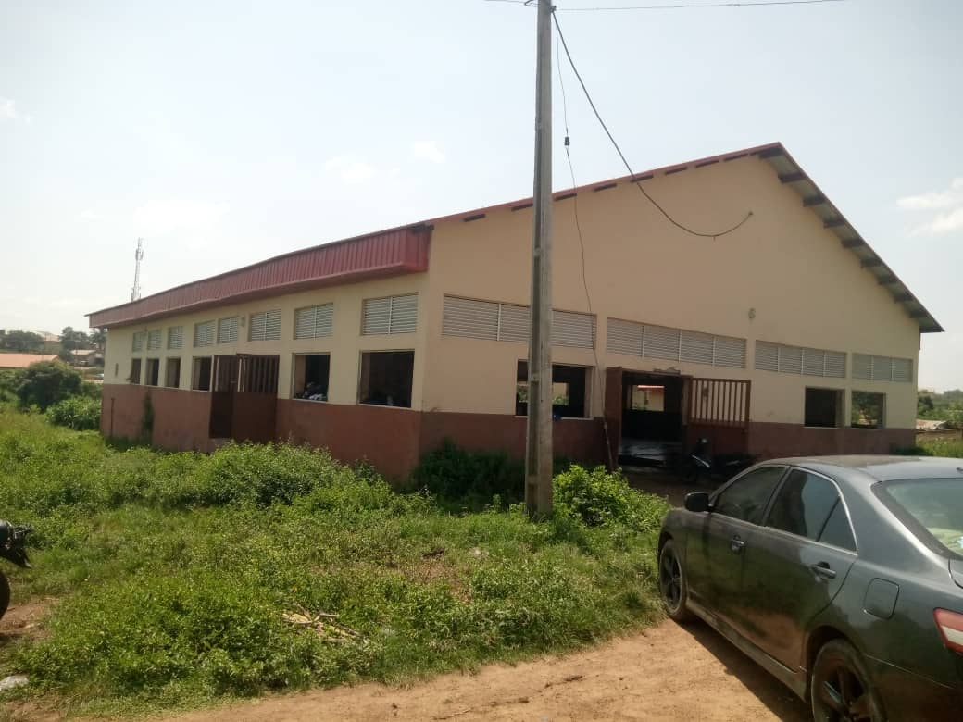
It is not away from top the board meeting
3.1.3 OBSERVED CONDITIONS AND CHALLENGES
1. Sanitation and Hygiene Issues
- Slaughtering is often carried out on bare concrete or uncleaned surfaces
- No proper separation of clean (meat handling) and dirty (slaughtering) zones
- Animals are sometimes slaughtered without veterinary inspection
Meat is transported without cold storage, exposing it to contamination
2. Waste Management Deficiencies
- Blood, offal, and wastewater are discharged into open drains or nearby streams
- No effluent treatment plant; heavy pollution of adjacent Asa River
- Accumulated waste attracts flies, rodents, and causes foul odour
- No system for reuse or conversion of by-products (eg., bone meal or biogas)

3. Structural and Design Limitations
- Absence of designated zones for animal holding, slaughtering, dressing. and inspection
- Inadequate lairage for pre-slaughter animal rest
- Poor lighting, ventilation, and roof drainage
- No provision for workers' hygiene (eg, handwashing, changing rooms)
4. Health and Safety Concerns
- Butchers work without personal protective equipment (PPE)
- Risk of zoonotic infections such as brucellosis, anthrax, and tuberculosis
- Overcrowded working environment increases likelihood of injuries
- Meat often comes in contact with dung, dirty surfaces, and rusted equipment
5. Regulatory and Institutional Gaps
- Poor enforcement of sanitation and animal welfare laws
- Lack of consistent meat inspection and documentation
- Weak collaboration between veterinary services, public health officers, and market author
3.1.4 ENVIRONMENTAL IMPACT OF THE CURRENT SYSTEM
The existing abattoir practices in Ilorin pose serious environmental threats:
- Water pollution: Runoff from slaughter sites contaminates surface and groundwater
- Soil degradation: Dumping of solid wastes (eg, bones, skin, hooves) destroys arable land
- Air pollution: Burning of waste materials leads to emission of toxic gases
- Biodiversity loss: Continuous discharge into natural ecosystems harms aquatic and terrestrial life
3.1.5 SOCIO-ECONOMIC IMPLICATIONS
Despite its flaws, the Ipata Abattoir plays a key role in llorin's economy:
- It provides employment for hundreds of individuals across the meat supply chain
- It serves as a major meat supply center for urban and rural markets in Kwara State
- It facilitates trade in hides and skin, bones, and animal fats However, the lack of a structured, hygienic facility undermines its potential economic and health benefits.
3.1.6 EFFORTS TOWARD IMPROVEMENT
Several attempts have been made by the Kwara State government and development partners to rehabilitate or modernize the abattoir, including
- Provision of water tanks and boreholes
- Training workshops for butchers and meat handlers
- Public-private partnerships for equipment upgrades
- Sanitation campaigns during disease outbreaks (e.g., Lassa fever)
Nevertheless, these interventions have largely been cosmetic and unsustainable due to poor maintenance, lack of stakeholder cooperation, and infrastructural decay
3.1.7 KEY LESSONS FOR DESIGN PROPOSAL
This case study provides practical insights that inform the proposed abattoir design für Ilorin:
1. Hygienic Zoning: The need for strict separation of clean and dirty areas to avoid cross-contamination.
2. Waste Treatment: The integration of a functional effluent treatment plant and by-product recovery systems.
3. Worker Welfare: Provision of PPE, sanitary facilities, rest areas, and training programs for abattoir staff.
4. Veterinary Oversight: Inclusion of veterinary inspection rooms, laboratories, and meat certification points.
5. Cold Chain Infrastructure: Design of cold rooms and refrigerated trucks to maintain meat quality.
6. Community Engagement: Stakeholder participation in design and management to ensure sustainability.
3.1.8 PROPOSED DESIGN INNOVATIONS
The project aims to integrate best practices based on this case study:
- Centralized, mechanized slaughter lines to improve speed and hygiene
- Bio-digesters for energy recovery from animal waste
- Modular lairage units for ease of expansion
- Perimeter fencing and surveillance systems for biosecurity
- Rainwater harvesting systems and solar energy panels for sustainability

CHAPTER FOUR
4.0 PROJECT ANALYSIS AND DESIGN CRITERIA
4.1.1 INTRODUCTION
Project analysis and design criteria serve as the backbone of any architectural development. In the case of abattoir design,
this involves careful consideration of environmental, functional, spatial, regulatory, and socio-economic factors to develop a facility that is efficient, hygienic, sustainable, and adaptable to future needs. This section presents the analytical framework and core criteria used in developing the proposed abattoir design for liorin, Kwara State.
4.1.2 PROJECT ANALYSIS
A. Functional Analysis
The primary function of an abattoir is the humane slaughtering and hygienic processing of animals for human consumption. In addition, modern abattoirs must incorporate:
- Meat inspection and certification
- Waste management and by-product utilization
- Meat storage, cooling, and dispatch systems
- Administrative and veterinary oversight
- Employee welfare and sanitation facilities
B. Site and Environmental Analysis
The choice of site and its surrounding environment are crucial in abattoir design. The selected site must:
- Be sufficiently distant from residential zones to reduce nuisance (noise, odor, pests)
- Have good road accessibility for livestock transportation and product distribution
- Allow for natural drainage and flood resistance
- Be suitable for integration with waste treatment systems
- Support utilities like water, electricity, and internet connectivity
C. Climatic and Ecological Considerations
Ilorin lies in a tropical savannah climate zone characterized by:
- A wet season (April to October) with heavy rainfall
- A dry season (November to March) with dusty Harmattan winds
- High humidity and temperatures between 24°C and 34°C
Design responses to climate must include:
- Proper ventilation to prevent heat stress and odor buildup
- Rainwater harvesting and stormwater control systems
- Use of locally available, thermally efficient materials
- Natural lighting for energy conservation and sanitation
D. Socio-Economic Context
- The abattoir must cater to:
- A mix of traditional butchers, livestock traders, and government stakeholders
- Varying levels of literacy and professional skill
- Consumers who demand affordable yet hygienically processed meat
- Cultural and religious sensitivities (eg, Halal processing for Muslims)
E. Technological and Regulatory Standards
Design must conform to:
- National and international hygiene and safety standards (FAO, WHO, NMIS)
- Zoning regulations from the Kwara State Urban and Regional Planning Bourd
- Environmental regulations from the Federal Ministry of Environment (FMEnv)
- Requirements for meat inspection, disease control, and humane animal handling
4.1.3 DESIGN CRITERIA
The design of the abattoir is guided by the following key criteria:
1. Site Layout and Zoning
- Logical workflow from animal reception to meat dispatch
- Clear segregation of Clean areas (chilling, packaging, inspection)
- Dirty areas (slaughter, bleeding, offal removal)
- Intermediate zones (stunning, washing)
Dedicated entry and exit routes for:
- Livestock
- Processed meat
- Staff and visitors
- Adequate space for:
- Future expansion
- Vehicle parking
- Green buffer zones and waste treatment areas
2. Spatial Requirements
- Lairage pens: Enough space for holding animals for 24-48 hours
- Slaughter halls: Minimum height of 4-6 meters for airflow and animal handling
- Cold rooms. Designed to maintain 0-4°C for meat preservation
- Waste zones: Blood pit, fat rendering area, composting or bio-digester units
- Staff areas: Locker rooms, toilets, showers, offices, and restrooms
4.2 APPROACH TO THE DESIGN
The approach to designing a modern abattoir low lorin was moted in tunctionality, hygiene, environumental sustainability, and cultural relevance. The design methodology followed a user-centered and process-based architectural philosophy, where the primary concern was the flow of animals, meat, workers, and waste within the space, while also prioritizing public health, environmental protection, and compliance with statutory regulations.
Key Principles Guiding the Design Approach:
1. Process Flow Optimization.
The design was organized based on a linear workflow-froen animal reception to final meat dispatch ensuring a seamless and non contaminating process. Each zone (dirty, clean, semi-clean) is clearly defined anal physically separated.
2 Zoning and Functional Layout
The facility was divided into key zones:
- Animal Reception and Lairage
- Slaughter Hall
- Evisceration and Dressing Area
- Meat Inspection and Chilling Unit
- By-product Processing Section
- Waste Treatment Units
- Administrative and Support Services
3. Environmental Sustainability:
Use of natural ventilation and daylighting to reduce energy use.
Integration of waste-to-energy systems like biodigesters
Inclusion of green buffer zones to manage odors and enhance aesthetics.
4. Cultural and Religious Sensitivity:
The design included Halal-compliant slaughter facilities, wash stations for butchers, and designated prayer spaces for staff of Islamic faith, considering the religious demography of florin
5. Local Material and Construction Methods: Where possible, locally available materials such as laterite blocks, stabilized earth bricks, and galvanized roofing were considered to reduce cost and increase acceptability.
43 DESIGN REALIZATION
Conceptual Framework:
The abattoir was conceptualized as a modular and scalable system, allowing for phased construction and future expansion. The forms were geometric and functional, avoiding overly complex designs that could hinder efficiency or increase cost,
Spatial Realization:
Lairage Area: Covered pens with water troughs and casy-wash floors. Designed to hold different animal types (goats, cattle, sheep). Slaughter Hall High ceilings with mechanical ventilation, anti-slip flooring, and clear workflows separating live animals from carcasses, Evisceration & Dressing. Well-fit, tiled workspaces with running hot and cold water, tool sterilization units, and stainless steel work surfaces.
Chill Rooms & Cold Storage: Walk-in cold rooms capable of maintaining meat at 0-4°C to prevent spoilage.
Waste Management
- Effluent Treatment Plant (ETP) to treat blood and wastewater.
- Solid waste bins for offals, bones, and hide.
- Biodigester to generate energy from organic waste
- Administrative Block: Includes offices, inspection labs, locker rooms, prayer areas, toilets, and training rooms for butchers and stall
- Landscape & Circulation: Well-defined roads for delivery trucks, pedestrian walkways, landscaped green buffers, and separate entrances for livestock and finished products

CHAPTER FIVE
5.1 RECOMMENDATIONS AND CONCLUSION
5.1.1 Recommendations
Based on the findings, analysis, and design proposals of this project, the following recommendations are made to ensure the successful implementation and long- term sustainability of a modern abattoir in lorin, Kwara State:
1. Government Intervention and Policy Enforcement
The Kwara State Govemment, in collaboration with relevant national agencies such as the National Environmental Standards and Regulations Enforcement Agency (NESREA) and the Federal Ministry of Agriculture, should invest in constructing and maintaining modern abattoirs that comply with national and international health standards. Enforcement of existing public health and environmental laws related to laughterhouses should be strengthened to ensure safe meat handling and waste disposal.
2. Public-Private Partnerships (PPP)
The development and management of the proposed abattoir should involve public-private partnerships to ensure efficiency, innovation, and accountability. This can also attract sustainable funding and reduce govemmert overheads
3. Capacity Building and Training
Continuous training programs should be provided for abattoir workers, including butchers, veterinary officers, waste handlers, and management staff. Training should cover hygiene practices, meat inspection protocols, animal welfare, and waste management.

4. Integration of Sustainable Systems
The proposed abattoir should include renewable energy sources (e.g., solar panels), rainwater harvesting systems, and an anaerobic biodigester for waste-to-energy conversion. These systems will reduce operating costs and enhance environmental sustainability.
5. Community Engagement
The local community should be actively involved in the planning. operation, and monitoring of the facility. Community buy-in is essential for the abattoir's security, cleanliness, and public acceptance.
6. Ilealth and Environmental Monitoring
Regular health inspections by veterinary and environmental health officers must be institutionalized. Similarly, waste management should be continuously monitored to avoid pollution of nearby land and water bodies.
7. Replication and Policy Integration
The proposed design model should be documented and made available to other states and municipalities as a replicable solution for sustainable slaughterhouse infrastructure. It should also be integrated into bronder urban planning policies and development strategies.
5.1.2 CONCLUSION
This project bas addressed a critical gap in the urban infrastructure of florin by proposing a modern, sustainable, and health-compliant abattoir design tailored to the specific challenges and opportunities within the city. It provides a solution to the pressing issues of poor sanitation, environmental pollution, public health risks, and disorganized meat production that currently characterize abattoirs in many Nigerian urban centers.
Through a multidisciplinary approach combining architectural design, environmental engineering, public health considerations, and socio-cultural awareness, this project has demonstrated that an abattoir can be more than just a place for animal slaughter. When thoughtfully designed and strategically managed, it becomes a comerstone of urban food safety, economic development, and environmental sustainability.
The proposed abattoir design incorporates best practices in workflow efficiency, waste treatment, animal welfare, and staff welfare. It also integrates local materials and traditional knowledge with modern technology to create a facility that is both functional and culturally relevant.
In conclusion, this project affirms that transforming the meat processing industry in Nigeria begins with transforming its physical infrastructure. A well-planned and well-maintained abattoir is not only a public health necessity but also a symbol of a city's commitment to hygiene, sustainability, and development. The case study of florin serves as a viable prototype that can be adapted and expanded to other regions in Nigeria and across West Africa.

REFERENCES
Alonge, D. O. (2017) Meat safety in Nigeria: Challenges and opportunities. University of Ibadan Press
FAO (2014) Guidelines for slaughtering, meat cutting and farther processing Food and Agriculture Organization of the United Nations.
Adetunji, V. O. & Odeiokun, 1. A. (2015). Assessment of microbial contamination of meat in abattoirs in Nigeria. Journal of Food Safety, 38(2), 12446
Olokor, 1.0, & Ekenyong. E. 1. (2019). Evaluation of abattoir operations and meal safety in Nigeria. Journal of Animal Production Rescarch, 29(1), 1-10
World Health Orpmization (2018) Food safety. World Health Organization.
Food and Agriculture Organization of the United Nations (2019). Livestock production and health. Food and Agriculture Organization of the United Nations.
Adeyemi, K. D. (2020). Assessment of abattoir operations and meat safety in southwestern Nigeria [MSc thesis, University of Thadan]
Ogunleye, A. O (2019). Evaluation of microbial contamination of meat in abattoirs in Nigeria [PhE) dissertation, University of Ilorin)
World Organization for Animal Health (OIE) (2020). Terrestrial animal health code. Retrieved from link unavailable
Food Safety and Inspection Service (FSIS). (2020), Meat, poultry, and egg products inspection. Retrieved from (link unavailable)
These references provide a mix of local and international perspectives on abattoir operations, meat safety, and animal welfare.

APPENDIX
Appendix A.
Abattoir Design Layout
A detailed layout of the abattoir design, including:
1. Facility Layout: A diagram showing the location of different areas, such as slaughtering, meat processing, and waste management
2. Equipment Layout: A diagram showing the location and type of equipment used in the abattoir.
Appendix B:
Standard Operating Procedures (SOPs)
A list of SOPs for abattoir operations, including
SOP for Slaughtering: A detailed procedure for humane slaughtering of animals
SOP for Meat Processing: A detailed procedure for meat processing. including handling, storage, and packaging
SOP for Waste Management. A detailed procedure for managing waste and hy-products in the abattoir.
Appendix C
Training Materials
A list of training materials for abattoir staff, incloding:
1. Animal Welfare Training Training materials on animal welfare, including handling and slaughter practices.
2. Meat Safety Training. Training materials on mcat safety, including handling. storage, and packaging practices.
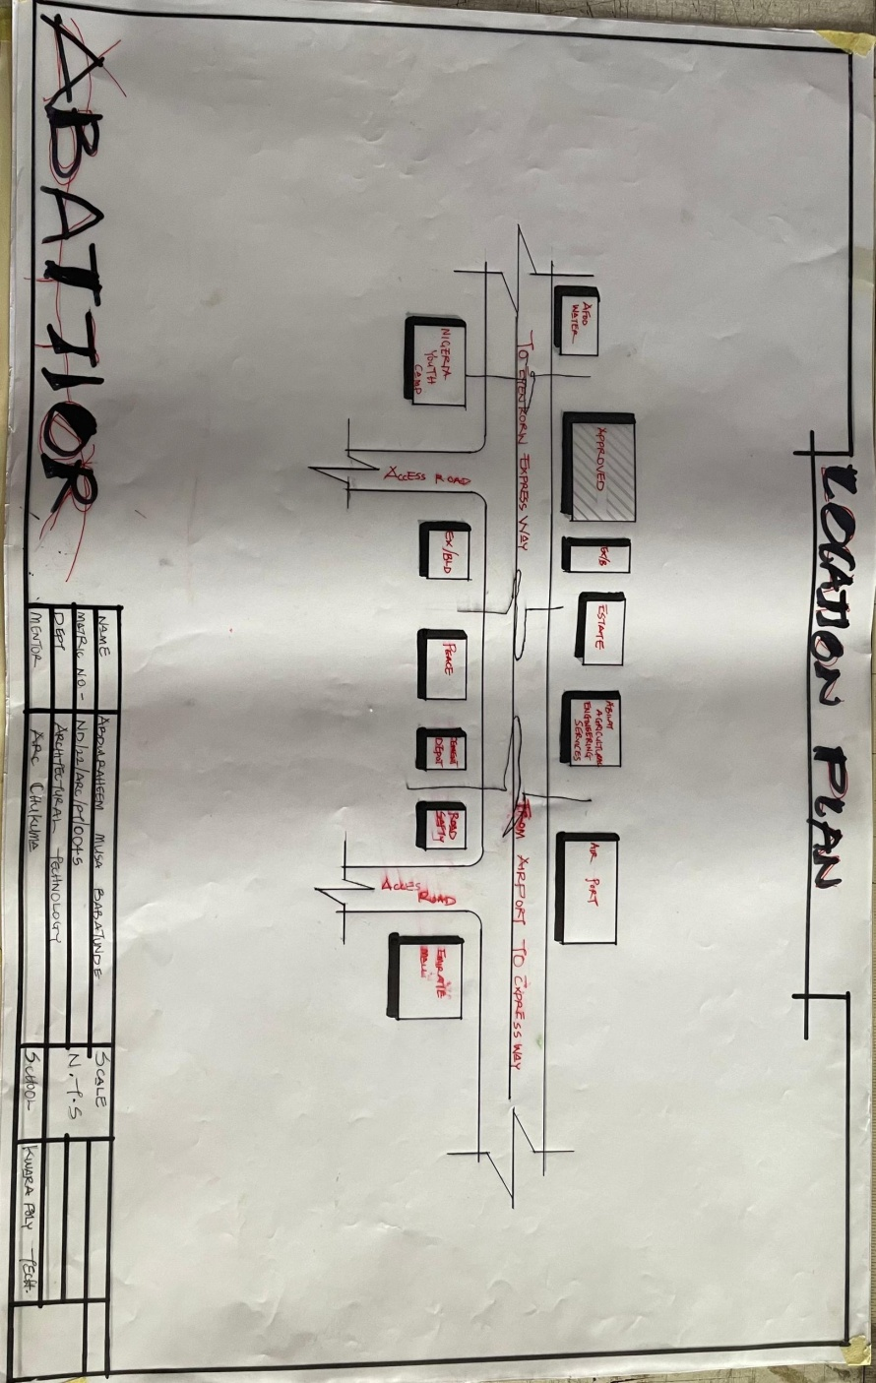
3. Equipment Operation Training Training materials on equipment operation and maintenance.
These appendices provide additional information and resources that support the main text and can be useful for readers who want more detailed information on specific topics

LOCATION PLAN

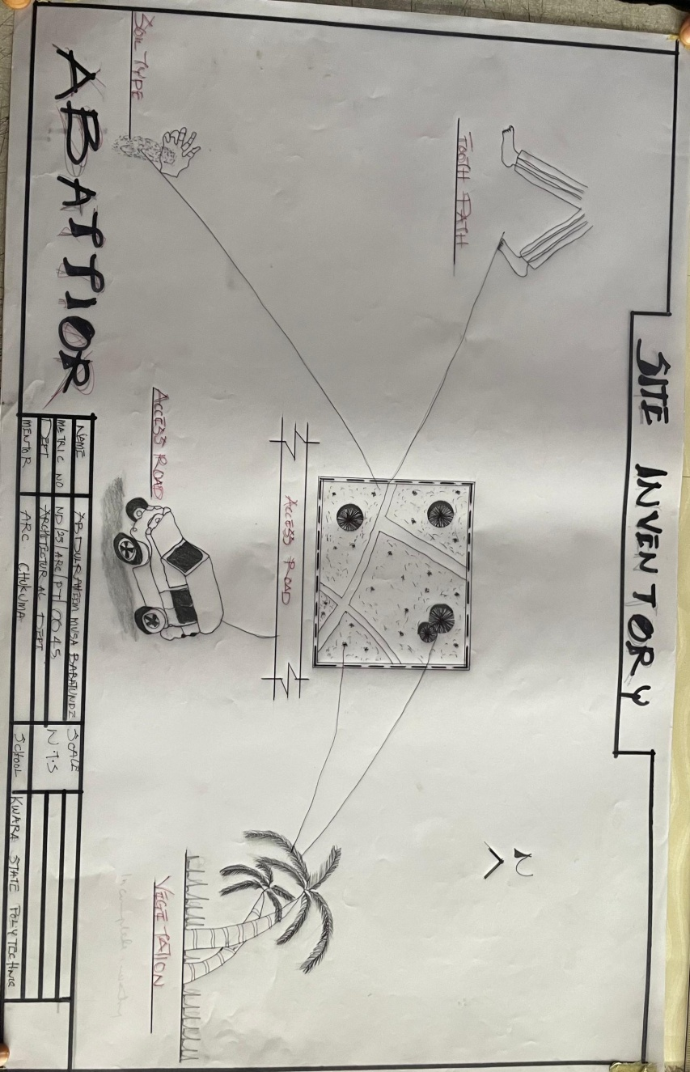
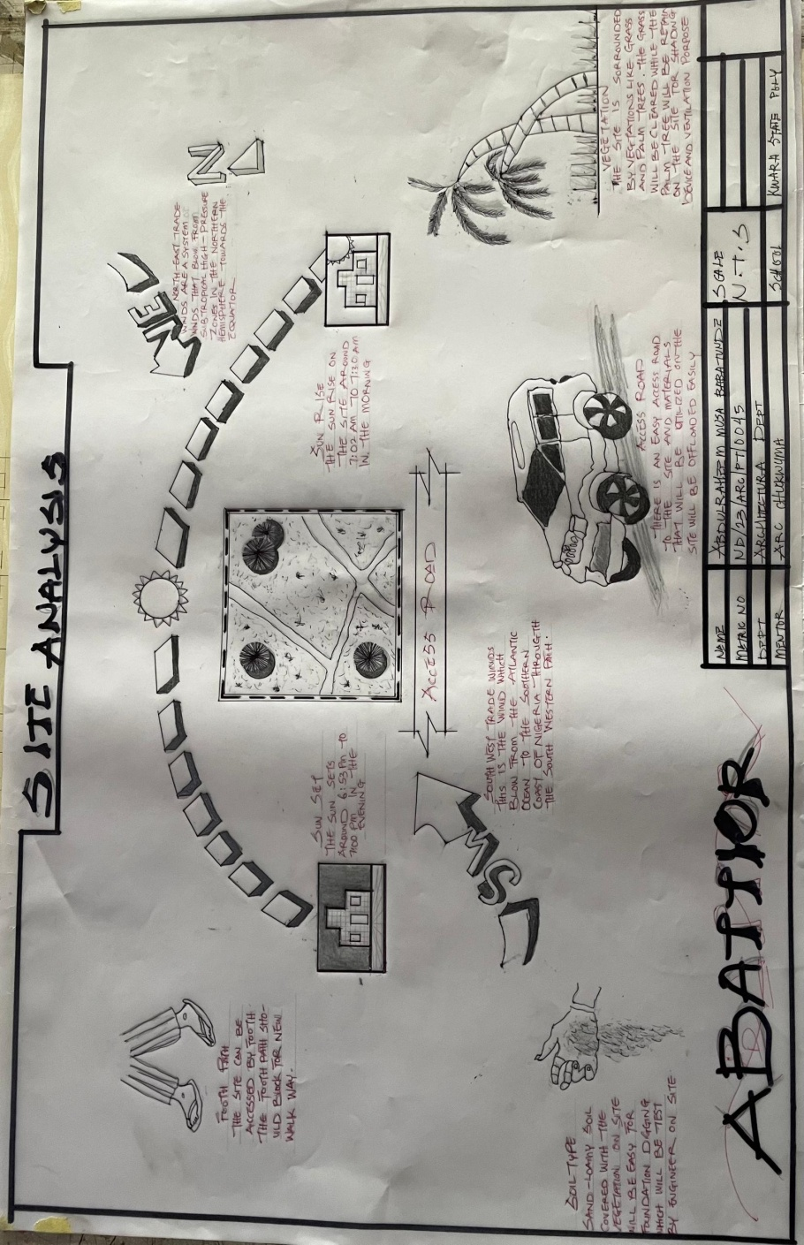
SITE ANALYSIS

SITE INVENTORY
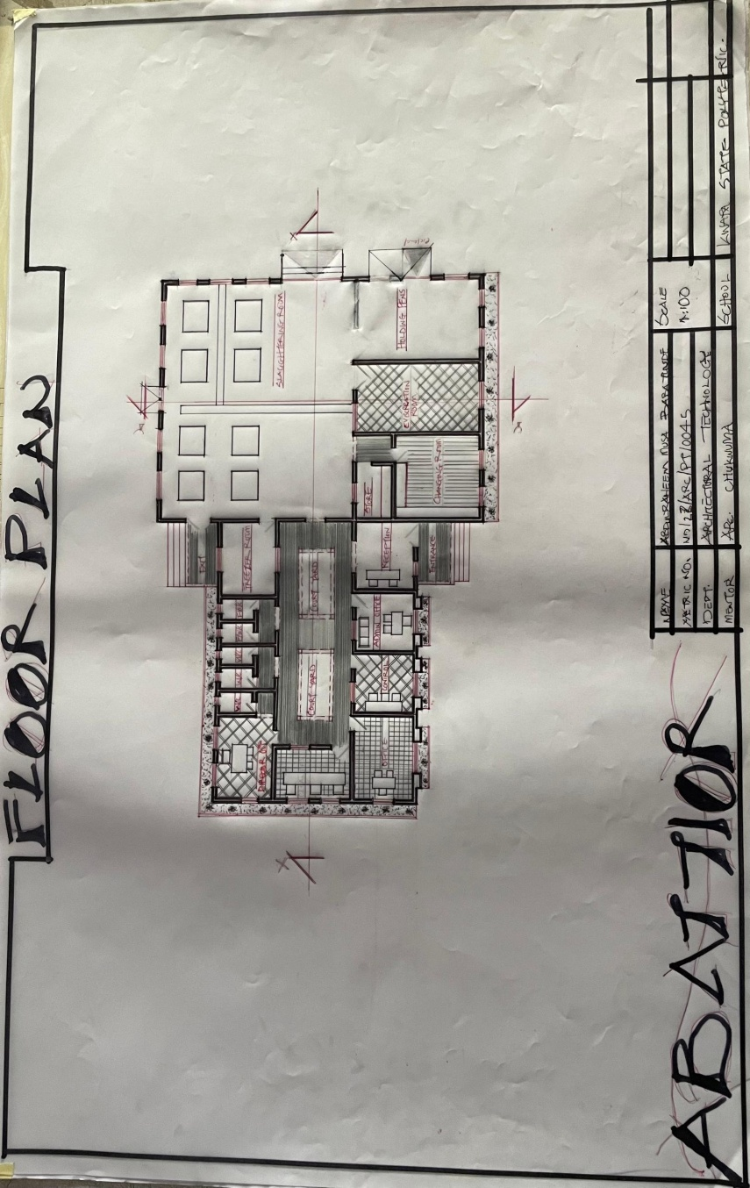
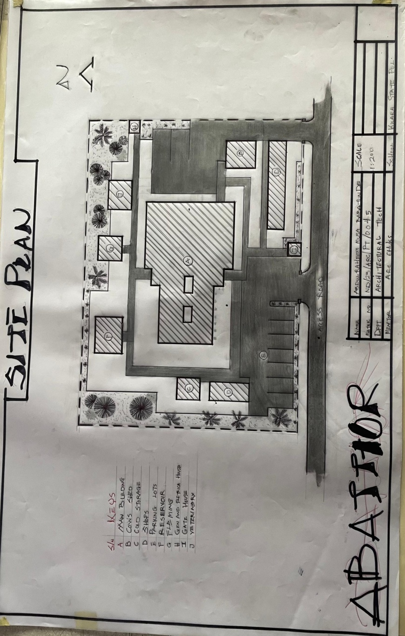
SITE PLAN
FLOOR PLAN
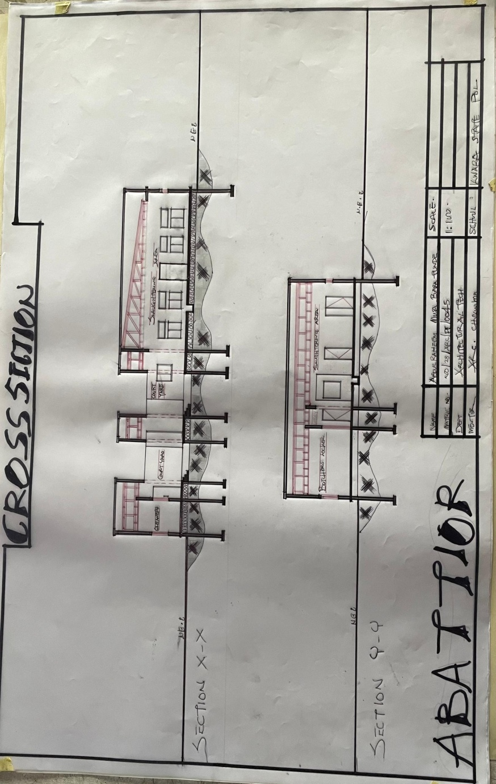
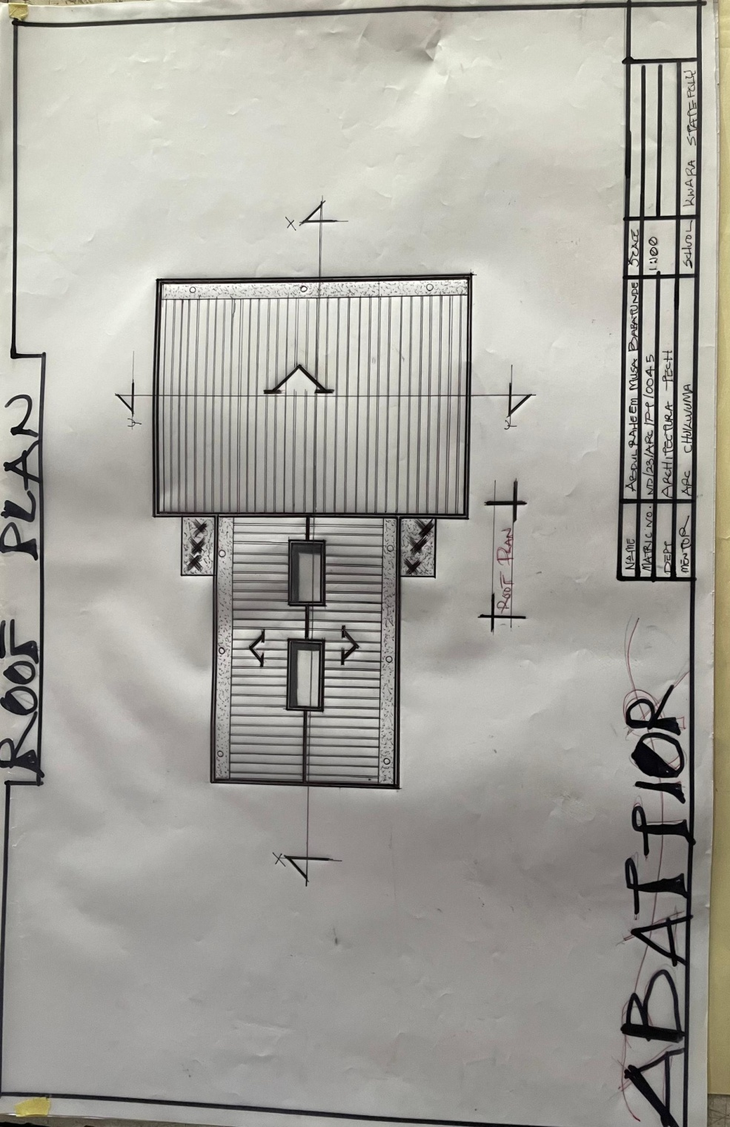
ROOF PLAN
CROSS SECTION
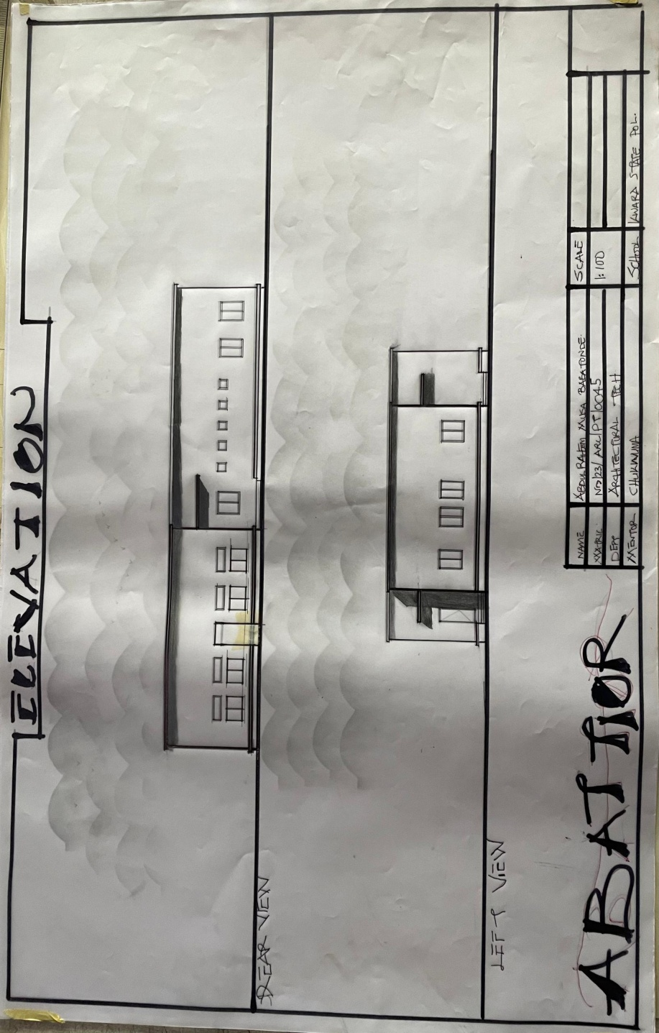
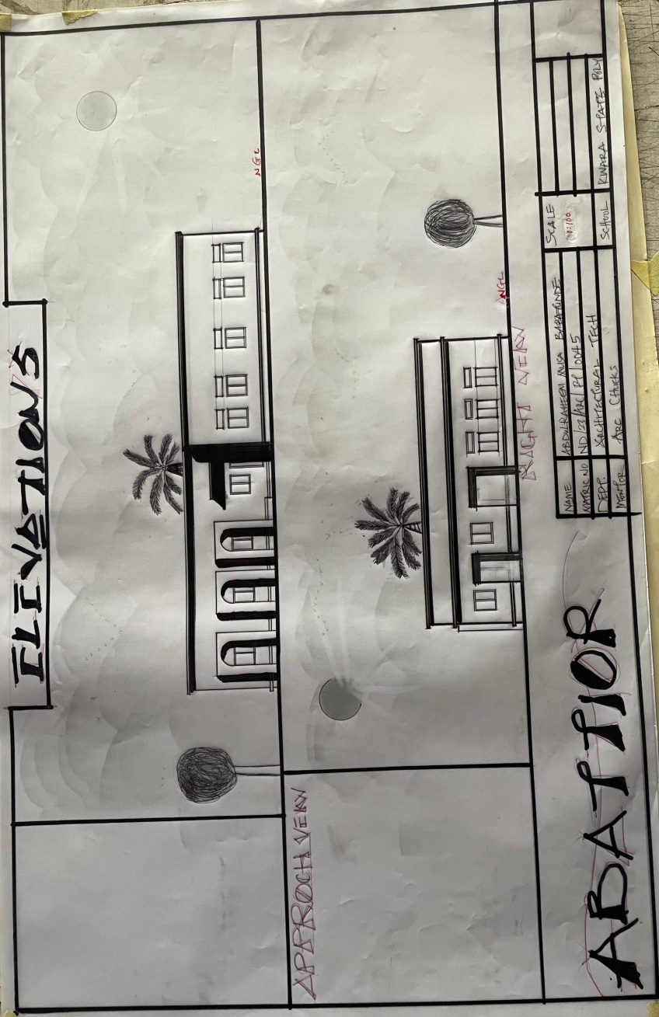
ELEVATION
BACK AND LEFT ELEVATION

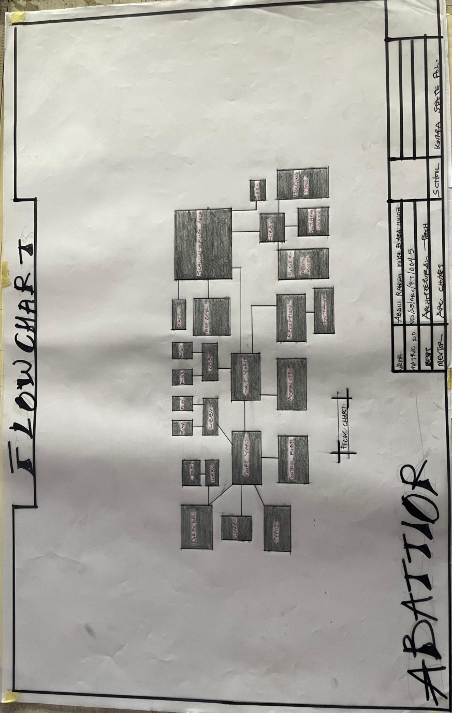
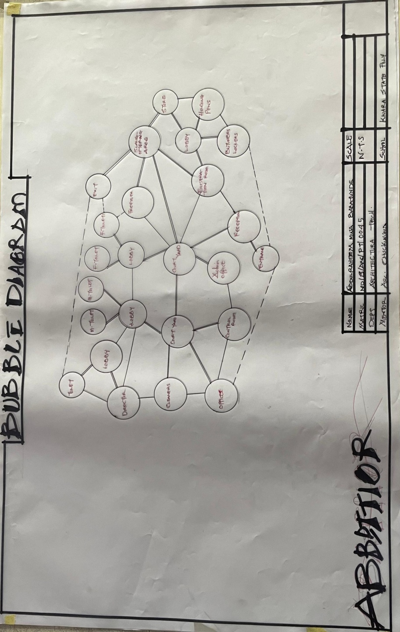
BUBBLE DIAGRAM
FLOW CHART
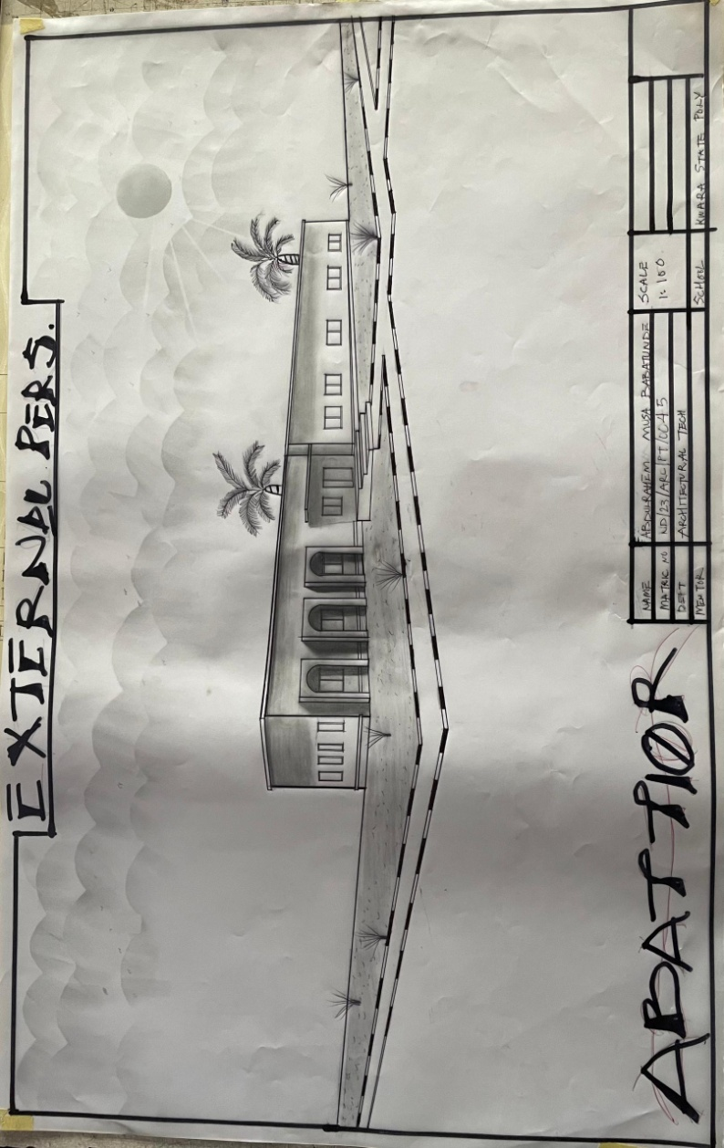

EXTERNAL PERSPECTIVE

