A PROJECT REPORT
ON
A PROPOSED DENTAL CLINIC FOR FEMI ADEBAYO SALAMI

BY:
Oluwasegun Christianah Ibukunolwa
ND/23/ARC/PT/0011

BEING A PROJECT REPORT SUBMITTED TO
THE DEPARTMENT OF ARCHITECTURAL TECHNOLOGY,
INSTITUTE OF ENVIRONMENTAL STUDIES,
KWARA STATE POLYTECHNIC, ILORIN.

INPARTIAL FULFILMENT OF THE REQUIREMENTS FOR THE
AWARD OF HIGHER NATIONAL DIPLOMA (ND)
IN ARCHITECTURAL TECHNOLOGY.

JULY 2025
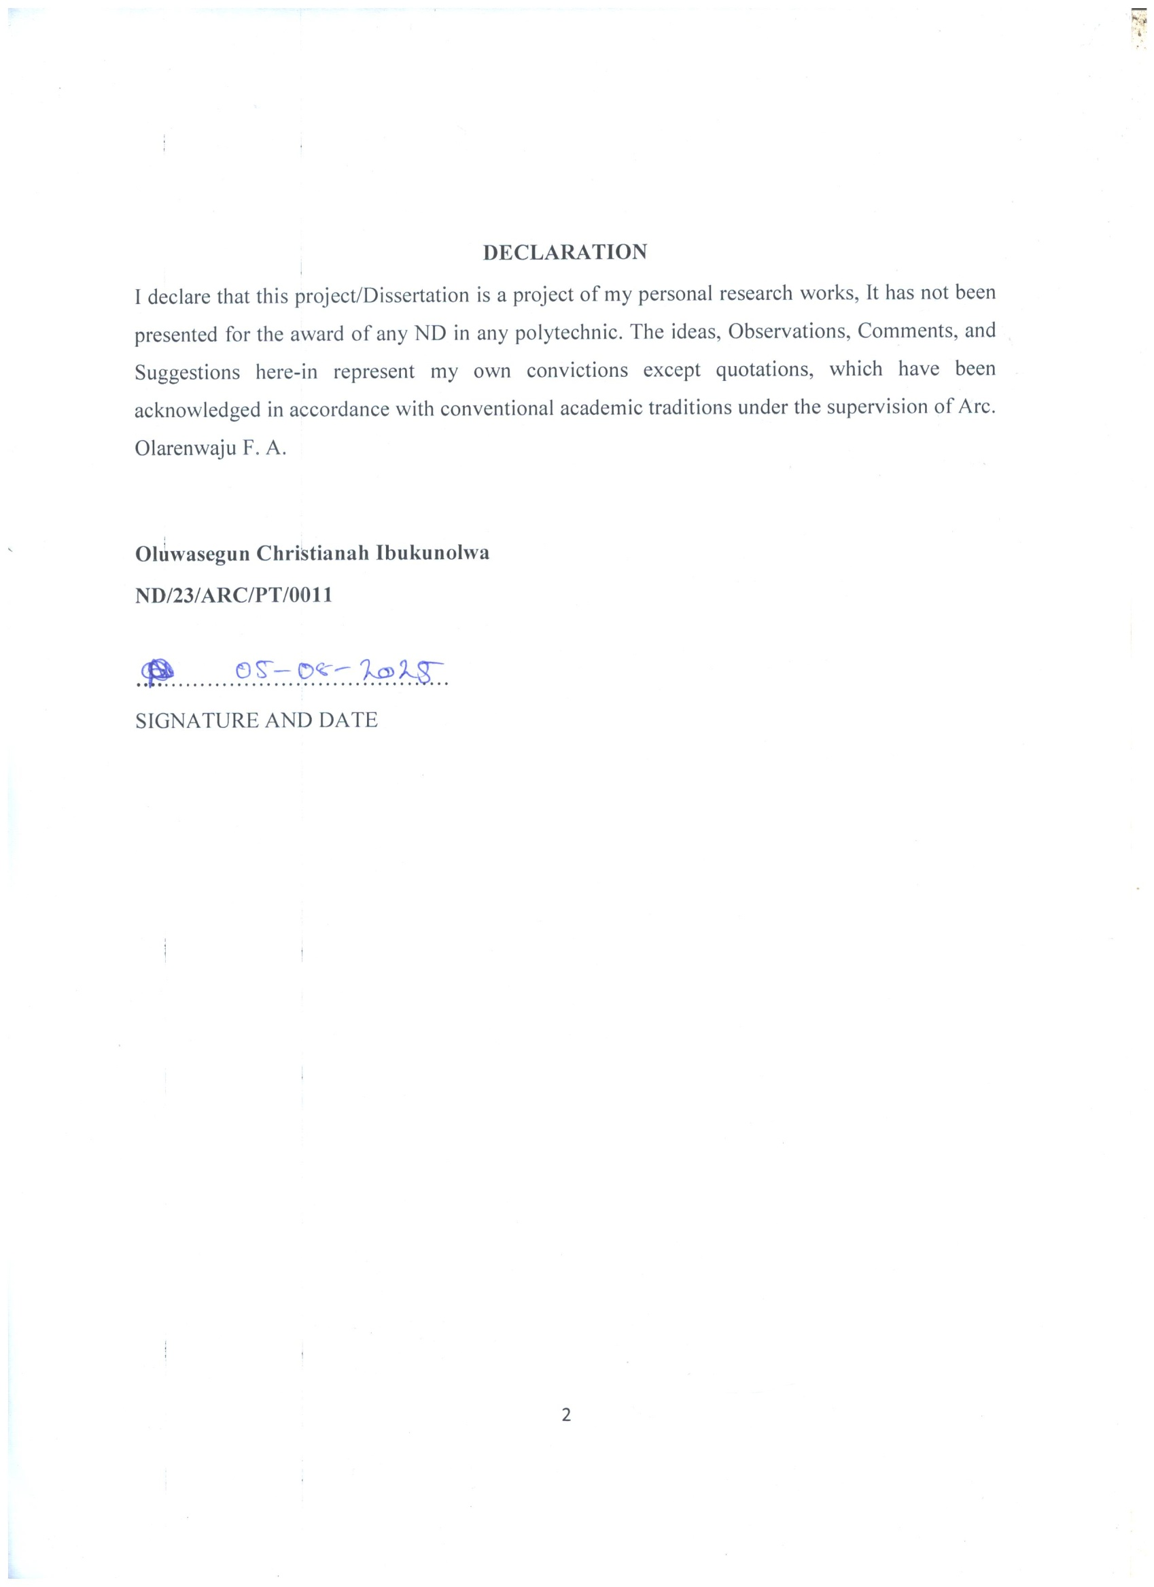
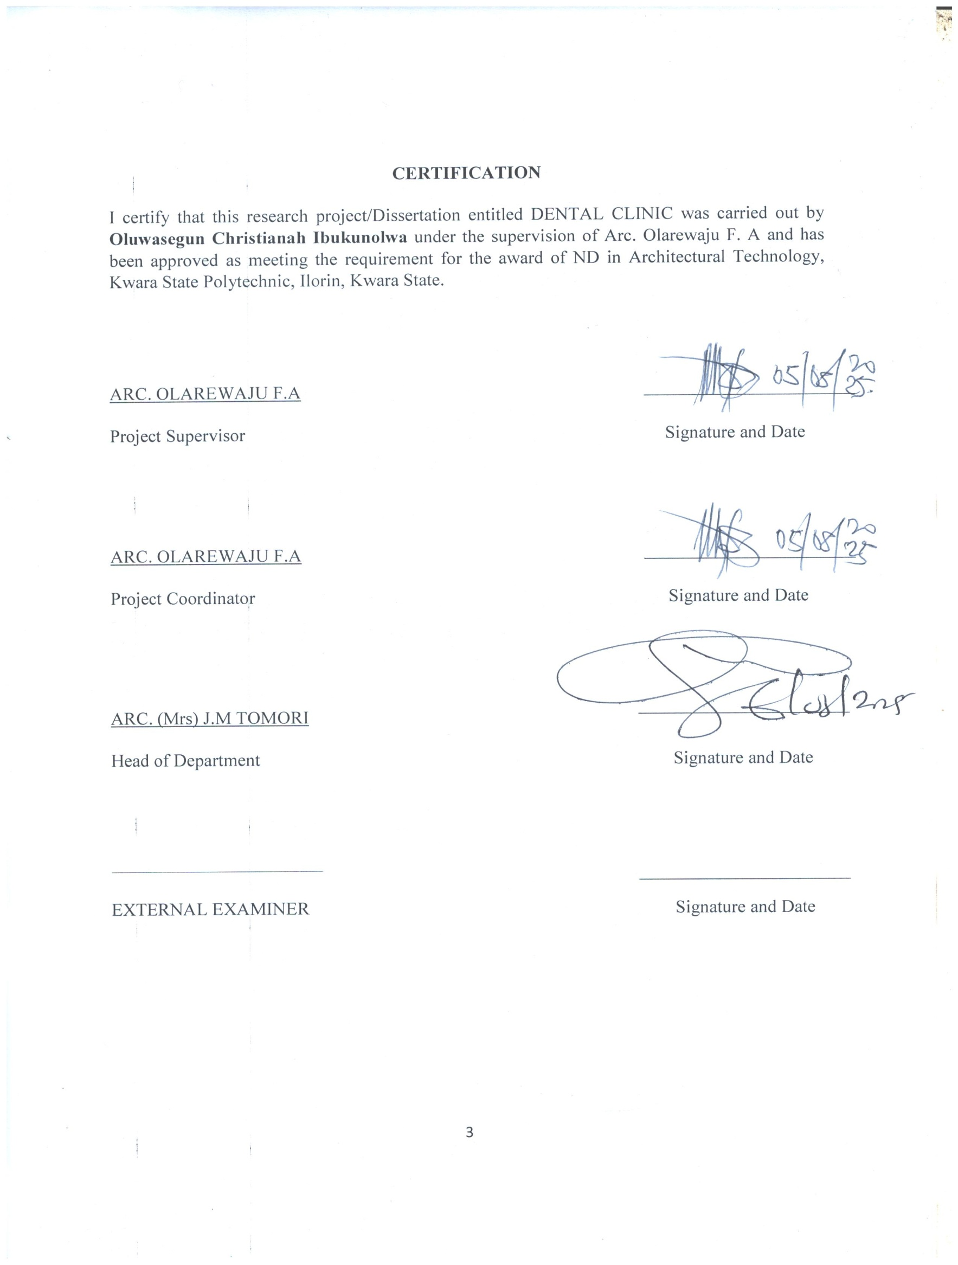
ACKNOWLEDGEMENT
My profound gratitude goes to Almighty God, the creator of the universe and fountain of all wisdom whose umbrella of guard and guide. I seek refuge through thick and thin of years of study.
I will also like to appreciate my project supervisor in person of Arc. Olarewaju F.A whose contribution prepares me for the challenges in the field and for his immense contribution in all ramifications towards the completion of this research work. He encouraged me and opened the door of interaction with him. I pray Almighty God will shower his blessing and mercy over him, your family and may you live to reap the fruit of your labor.
I also thank and appreciate the effort of my project coordinator in person of Arc. Olarewaju F.A for is guidance and his immense contribution towards my project, I pray Almighty God will shower his blessing and mercy over him.
And a very big thank you to my Head of Department in person of Arc. (Mrs) J.M Tomori for her work in the department, may the Lord reward her abundantly.
I also thank and appreciate the effort of all the Lecturers in Architectural Technology Department, who taught and gave lasting advice's that led to the success of my programed, Almighty God will meet everyone at the point of their needs.
I would also show my profound gratitude to my mother (MRS) Oluwasegun for her Immeasurable motivation, advices, efforts, and prayers on me for the completion of this program.
I would also show my appreciation for the effort of an unforgettable Mr. Oyetola Ajao ( Big Daddy) who’s advise me to carry on my journey. Almighty Allah bless you and grant your heart desires, good health over you.
Precious friends: My lovely friends: Aremu Omowunmi Kausarat . Almighty God shower his blessing, grace, and happiness with sound health over you all and our prayer (AMEEN)
Lastly ,I would like to appreciate the effort of my colleagues in department, school, and hostel, I whole heartedly say a VERY BIG THANK YOU, I appreciate you all, May Almighty Allah bless you all.
Above all, My utmost thanks go to the all sufficient God, the fountain of my wisdom, for his great and protection over my life, for his undying love, support and guidance throughout my period of learning and also for in sighting writing this project without him am nothing.

DEDICATION
This project work is dedicated to Almighty God who has been providing all my needs for His blessing and mercy over me all through the programed. And my parents, Mr Oluwasegun
And Mrs.Oluwasegun my brothers, friends, love one’s and my supervisor who assist me financially, spiritually, mentally and guide me through my academic pursuit. May Almighty God shower his blessing and mercy over you all?

ABSTRACT
This research work was carried out on the project topic "Dental Clinic for IlorinEast Local Government Kwara State". I felt caring out this project in Ilorin EastLocal Government will bring out meaningful results. For easy analysis and understanding, the study is being put into five chapters. Chapter One throws light on a general introduction, definition of the project, historical background information of the project title, project justification, aim and objectives of the study, and scope of the study, Chapter two, a detailed literature review of some books, case studies and deduction from case studies. The third chapter three also mentions the historical background of the study area, site location and description, site analysis, and geographical location, climatic data, population of the area, social services, and health services. The fourth chapter deals with design criteria, design analysis, space allocation and planning principle. Chapter five deals with design appraisal, construction methodology, services, summary, conclusion and references.

TABLE OF CONTENT
Title page……………………………………………………………………………………………..i
Declaration……………………………………………………………………………………………ii
Certification……………………………………………………………………………………………iii
Acknowledgement………………………………………………………………………………………iv
Dedication………………………………………………………………………………………………..v
Abstract………………………………………………………………………………………….vi
Table of contents……………………………………………………………………………………..vii-x
List of tables………………………………………………………………………………………………xi
List of figures……………………………………………………………………………………………xii
List of plates…………………………………………………….………………………………….xiii-xiv
List of Appendices……………………………………………………………………………………..xv
CHAPTER ONE
- INTRODUCTION……………………………………………………………………………1
1.1 DEFINITION………………………………………………………………………...............2
1.2 HISTORICAL BACKGROUND……………………………………………………………..2
1.3 AIM OF THE PROJECT……………………………………………………………………..3
1.4 OBJECTIVES OF THE PROJECT…………………………………………………………..3
1.5 PROJECT JUSTIFICATION…………………………………………………………………3
1.6 SCOPE OF THE PROJECT…………………………………………………………………..3
1.7 RESEARCH METHODOLOGY……………………………………………………………..4

CHAPTER TWO
2.0 LITERATURE REVIEW AND CASE STUDIES
2.1 HISTORICAL BACKGROUND……………………………………………………………..5
2.2 CONCLUSION………………………………………………………………………………6
CHAPTER THREE
3.0 CASE STUDIES……………………………………………………………………………..7
3.1 SELECTED CASE STUDIES…………………………………………………………….....7
3.2 CASE STUDY ONE…………………………………………………………………………7
3.3 CASE STUDY TWO……………………………………………………………………….12
3.4 CASE STUDY THREE…………………………………………………………………….16
3.5 CASE STUDY FOUR……………………………………………………………………….19
3.6 ONLINE CASE STUDY ONE………………………………………………………………22
3.6.1 ONLINE CASE STUDY TWO……………………………………………………………25
CHAPTER FOUR
4.1 BRIEF HISTORICAL BACKGROUND………………………………………………….28
4.2 LOCATION AND SETTING OF ILORIN TOWN……………………………………….28
4.3 POPULATION……………………………………………………………………………..29
4.4 SITE INVENTORY………………………………………………………………………...30
4.5 SITE ANALYSIS………………………………………………………………………….31
4.5.1 SITE SELECTION/JUSTIFICATION…………………………………………………..32
4.5.2 LOCATION………………………………………………………………………………32
4.5.3 ACCESSIBILITY…………………………………………………………………………32
4.5.4 INFRASTRUCTURE FACILITIES………………………………………………………32
4.5.5 TOPOGRAPHY………………………………………………………………………….33
4.5.6 SOIL STRUCTURE………………………………………………………………………33
4.6 GENERAL CLIMATIC CONDITION……………………………………………………..33
4.6.1 RELATIVE HUMIDIY…………………………………………………………………..33
4.6.2 WIND……………………………………………………………………………………..33
4.6.3 TEMPERATURE…………………………………………………………………………33
4.6.4 VEGETATION……………………………………………………………………………34
4.7.1 ROAD…………………………………………………………………………………….34
4.7.2 WATER AND ELECTRICITY………………………………………………………….34
4.8.0 DESIGN CRITERIA………………………………………………………………………34
4.8.1 DESIGN BRIEF…………………………………………………………………………..34
4.8.2 DESIGN ANALYSIS……………………………………………………………………35
4.8.3 SPACIAL ALLOCATION………………………………………………………………35
CHAPTER FIVE
5.1 APPRAISAL OF PROPOSED SCHEME………………………………………………….38
5.2 CONSTRUCTION METHODOLOGY……………………………………………………38
5.3 SERVICES………………………………………………………………………………….38
5.3.1 VENTILATION………………………………………………………………………….39
5.3.2 LIGHTING……………………………………………………………………………….39
5.3.3 PLUMBING………………………………………………………………………………..39
5.3.4 ELECTRICAL INSTALLATION…………………………………………………………39
5.3.5 WASTE DISPOSAL……………………………………………………………………….39
5.3.6 FIRE PROTECTION………………………………………………………………………40
5.3.7 RAIN PROTECTION……………………………………………………………………40
5.3.8 EXTERNAL WORK…………………………………………………………………….40
5.4 SUMMARY………………………………………………………………………………….40
5.4.1 CONCLUSION…………………………………………………………………………….40
5.4.2 RECOMMENDATION………………………………………………………………… 41
REFERANCES…………………………………………………………………………………..42
APPENDICES…………………………………………………………………….……………..43

LIST OF FIGURES
FIG 1; SHOWING LOCATION PLAN OF CASE STUDY ONE………………………………8
FIG 2; SHOWING GROUND FLOOR PLAN OF CASE STUDY ONE………………………..8
FIG 3; SHOWING UPPER FLOOR PLAN OF CASE STUDY ONE…………………………..9
FIG 4 SHOWING LOCATION PLAN OF CASE STUDY TWO………………………………13
FIG 5 SHOWING GROUND FLOOR PLAN OF CASE STUDY TWO……………………….13
FIG 6; SHOWING UPPER FLOOR PLAN OF CASE STUDY TWO…………………….…14
FIG 7; SHOWING LOCATION PLAN OF CASE STUDY THREE…………………………17
FIG 8; SHOWING FLOOR PLAN OF CASE STUDY THREE………………………………17
FIG 9; SHOWING LOCATION PLAN OF CASE STUDY FOUR……………………………20
FIG 10; SHOWING FLOOR PLAN OF CASE STUDY FOUR…………………….………….20
FIG 11; SHOWING SITE INVENTORY OF THE PROPOSED SITE…………………………31
FIG 12; SHOWING SITE ANALYSIS OF THE PROPOSED SITE…………………………...32

77LIST OF PLATES
PLATE 1; SHOWING FRONT VIEW OF CASE STUDY ONE……………………………...10
PLATE 2; RECEPTION AREA OF CASE STUDY ONE…………………………………….11
PLATE 3; SHOWING TREATMENT ROOM OF CASE STUDY ONE…………………….11
PLATE 4; SHOWING CONFERENCE ROOM OF CASE STUDY ONE……………………12
PLATE 5; SHOWING FRONT VIEW OF CASE STUDY TWO…………………………….14
PLATE 6; SHOWING BACK VIEW OF CASE STUDY TWO……………………….……..15
PLATE 7; SHOWING RECEPTION AREA OF CASE STUDY TWO……………………….15
PLATE 8; SHOWING TREATMENT ROOM OF CASE STUDY TWO……………………16
PLATE 9; SHOWING FRONT VIEW OF CASE STUDY THREE……………………………18
PLATE 10; SHOWING RECEPTION AREA OF CASE STUDY THREE…………………..18
PLATE 11; SHOWING TREATMENT ROOM OF CASE STUDY THREE………………..19
PLATE 12; SHOWING FRONT VIEW OF CASE STUDY FOUR………………………….21
PLATE 13; SHOWING RIGHT VIEW OF CASE STUDY FOUR………………………….…21
PLATE 14; SHOWING BACK VIEW OF CASE STUDY FOUR……………………………..22
PLATE 15; SHOWING TREATMENT ROOM OF CASE STUDY FOUR…………………..22
PLATE 16; SHOWING GOOLGE MAP OF ONLINE CASE STUDY ONE………………...23
PLATE 17; SHOWING FRONT VIEW OF ONLINE CASE STUDY ONE………………….23
PLATE 18; SHOWING RIGHT VIEW OF ONLINE CASE STUDY ONE…………………..24
PLATE 19; SHOWING TREATMENT ROOM OF ONLINE CASE STUDY ONE…………..24
PLATE 20; SHOWING GOOGLE MAP OF ONLINE CASE STUDY TWO………….……25
PLATE 21; SHOWING FRONT VIEW OF ONLINE CASE STUDY TWO…………………25
PLATE 22; SHOWING RECEPTION AREA OF ONLINE CASE STUDY TWO………….…26
PLATE 23; SHOWING TREATMENT ROOM OF ONLINE CASE STUDY TWO…………26

CHAPTER ONE
- INTRODUCTION
A dental clinic is a healthcare facility that specializes in the diagnosis, prevention, and treatment of diseases and conditions of the oral cavity. It is staffed by a team of dental professionals, including dentists, dental hygienists, and dental assistants, who work together to provide comprehensive dental care.
Services offered at a dental clinic can range from routine dental exams and cleanings to more complex procedures such as root canals, orthodontics, and oral surgery. Dental clinics plays a crucial role in promoting oral health and hygiene in the community.
Dentistry, the branch of medicine focused on the teeth, gums, and mouth, is often the main focus of a dental clinic. It consists of the study, diagnosis, prevention, management, and treatment of diseases, disorder, and conditions of the mouth.
Dental education has arrived at a crossroads. During the last 150 years, it has evolved from a prelude to apprenticeship into a comprehensive program of professional education. Advances in science, technology, and public health programs have greatly reduced tooth decay and tooth loss. Dentists are respected professionals, and dental schools are part of many of the nation's leading public and private universities.
This progress notwithstanding, the position of dental education within the university is being questioned as is its relationship to medicine and the larger health care system. Six dental schools—all private—have closed in the last decade, and others among the 54 remaining schools are in jeopardy. The dental profession is at odds with itself on a number of issues including work force policies, licensure, and health care restructuring. Tensions between practitioners and educators can undercut the profession's position within the university.
The future of dental education will be shaped, in part, by scientific, technological, political, and economic factors that are largely beyond the profession's control. Nonetheless, dental educators—individually and collectively—have important choices to make. They may attempt to preserve the status quo—in effect, a path toward stagnation and eventual decline. Alternatively, they can choose a more difficult path of reassessing and renewing their missions of education, research, and patient care so that they contribute more—and more visibly—to the university and the community. Taking this latter path will require more vigor in implementing long-standing recommendations for educational reform as well as attention to new issues and objectives. For dental educators to pursue change successfully, they will need the active cooperation of the larger dental community as well as support from university officials and state and national policymakers.
  - DEFINITION OF DENTAL CLINIC
A dental clinic is a place where an infected tooth partially cleaned with flint tools. The reconstruction of this ancient form of dentistry showed that the methods used were reliable and effective.
Dental clinics are often associated with university or a hospital and they serve to educate dentists in training, conduct dental research or provide dental care to a community and total people in need.
  - HISTORICAL BACKGROUND
Dentistry is one of the oldest medical professions, dating back to 7000 B.C. with the Indus Valley Civilization. However, it wasn’t until 5000 B.C. that descriptions related to dentistry and tooth decay were available. At the time, a Sumerian text described tooth worms as causing dental decay, an idea that wasn’t proven false until the 1700s!
In ancient Greece, Hippocrates and Aristotle wrote about dentistry, specifically about treating decaying teeth, but it wasn’t until 1530 that the first book entirely devoted to dentistry—The Little Medicinal Book for All Kinds of Diseases and Infirmities of the Teeth—was published.
By the 1700s, dentistry had become a more defined profession. In 1723, Pierre Fauchard, a French surgeon credited as the Father of Modern Dentistry, published his influential book, The Surgeon Dentist, a Treatise on Teeth, which for the first time defined a comprehensive system for caring for and treating teeth. Additionally, Fauchard first introduced the idea of dental fillings and the use of dental prosthesis, and he identified that acids from sugar led to tooth decay.
In 1840, the first dental college (Baltimore College of Dental Surgery) opened, establishing the need for more oversight. In the United States, Alabama led the way by enacting the first dental practice act in 1841, and nearly 20 years later, the American Dental Association (ADA) was formed. The first university-affiliated dental institution, the Harvard University Dental School, was founded in 1867.
By 1873, Colgate had mass produced the first toothpaste, and mass-produced toothbrushes followed a few years later.
What may come as a surprise is that the first African American to earn a dental degree dates all the way back to 1869, and the first female dental assistant was employed in New Orleans in 1885. What might be most surprising of all is that most Americans did not adopt good brushing habits until after World War II, when soldiers stationed abroad brought the concept of good oral health back to the United States.
  - AIM
The aim of designing a dental clinic is to provide a functioning, safe, comfortable and attractive environment for both patients and staffs.
  - OBJECTIVES
- To design a facility that will functionally and aesthetically fulfill the need for a standard modern dental clinic in Enugu State.
- To design a modern dental clinic that naturally meets up with both architectural and structural standards.
- To provide spaces that are large enough to accommodate the workers and equipments/machinery and encourage a seamless overlap between the two.
- To contribute to the architectural beauty of the area and the appreciation of the built environment.
- Provision of adequate spaces for various dental treatments.

  - PROJECT JUSTIFICATION
These are some motivation factors which justify the choice and location of this project at sobi. One of it is major influencing factors is the creation of new dental hospital. Hence It become a things of necessity of provide a conducive and habitable environment to care for the new hospital.
  - CLIENT BACKGROUND
Femi Adebayo is a Nigerian actor, director, and lawyer, born on December 31, 1978, in Lagos, Nigeria. He hails from Ilorin, Kwara State, and is the son of veteran actor Adebayo Salami (Oga Bello). Adebayo has a background in law, holding both a bachelor's degree and a master's degree in the field. He is also known for his roles in Yoruba movies and has served as the Special Adviser on Arts, Culture, and Tourism to the Governor of Kwara State.
  - SCOPE OF THE PROJECT
- Proposed Building
- Quarters
- Cafeteria
- Security Post
- Power House
- Parking Lot
- Green Park
- Access Road
  - RESEARCH METHODOLOGY
Various avenues were expressed as regards the method of research on order to arrive at a functional and appealing design concepts. The following research methods were employed.
Literature Review (Survey): References to the existing literature on dental clinic design. Search on articles, books, and online resources that discuss the best practices in the field.
Key Factors: Identifying the key factors that contribute to an effective dental clinic design. These might include patient comfort, efficient use of space, accessibility, and infection control measures.
Data Collections: Data on the factors are collected, this could involve surveys, or interviews with dental professionals and patients or observational studies of existing dental clinics.
Analysis: Analyzing the data to determine which factors are most important in dental clinic design. Using statistical methods to identify trends and corrections.
Personal Observation: Personal initiative coupled with inquisitive measure, interview and visualize the daily activities that take place within vicinity and necessary pictures were taken in order to attain the required motive.
Case Study: This involves the thorough synthesis and analysis of similar existing structure (building) Based on the data collected and better deduction was made for realization of the best.

CHAPTER TWO
- LITERATURE REVIEW
  - HISTORICAL BACKGROUND OF DENTAL CLINIC
Dentistry is one of the oldest medical professions, dating back to 7000 B.C. with the Indus Valley Civilization. However, it wasn’t until 5000 B.C. that descriptions related to dentistry and tooth decay were available. At the time, a Sumerian text described tooth worms as causing dental decay, an idea that wasn’t proven false until the 1700s!
In 1840, the first dental college (Baltimore College of Dental Surgery) opened, establishing the need for more oversight. In the United States, Alabama led the way by enacting the first dental practice act in 1841, and nearly 20 years later, the American Dental Association (ADA) was formed. The first university-affiliated dental institution, the Harvard University Dental School, was founded in 1867.
Dental health care in Nigeria faces numerous challenges, including limited access to services, inadequate workforce, and poor infrastructure. This review aims to explore the current state of dental clinics in Nigeria, focusing on accessibility, workforce, infection control, and the impact of recent global events such as the COVID-19 pandemic.
Access to dental care in Nigeria is significantly limited, especially in rural areas. A study highlighted the need for more dental clinics to improve the availability and accessibility of oral health services. The expansion of the dental workforce, including training junior cadre dental professionals and incorporating community health practitioners, is essential to address this gap.
The dental workforce in Nigeria is insufficient to meet the population’s needs. Strengthening the oral health system requires expanding the workforce through training and education. University-based initiatives have shown success in improving access to oral health care in rural and remote areas by training dental and allied health students. These programs have enhanced students’ competencies and increased their adoption of rural practices.
Cross infection control practices among Nigerian oral health care workers need significant improvement. Research has underscored the importance of implementing stringent infection control measures to ensure the safety of both patients and healthcare providers. The COVID-19 pandemic further highlighted the need for robust infection control protocols in dental settings
The COVID-19 pandemic had a profound impact on dental service utilization in Nigeria. Fear of infection significantly reduced the use of dental services, with many patients avoiding clinics due to concerns about contracting the virus. The main sources of COVID-19 information for patients were mass media and social networks, with only a small percentage receiving information from dental professionals.
Government involvement and policy implementation are crucial for improving dental care in Nigeria. Increased government spending on oral health care and better regulation of medication access are necessary steps. National policies on oral health need to be well disseminated and implemented to achieve the overall goals of the oral health system.
Community participation plays a vital role in sustaining improvements in the oral health system. Engaging and empowering communities can lead to better oral health outcomes and more effective implementation of health policies. Programs that involve community members in oral health education and basic care delivery have shown positive results.
  - CONCLUSION
Improving dental care in Nigeria requires a multifaceted approach, including expanding the workforce, enhancing infection control, increasing government support, and fostering community participation. Addressing these areas can lead to significant advancements in the accessibility and quality of dental services in Nigeria.

CHAPTER THREE
3.0 CASE STUDIES
This is a research or an exercise that is carried out on existing building which is similar to the one researcher is writing on. The objective of a case study is to take a critical appraisal of existing related project with a view to identify the positive and negative aspect of such projects. It is only with time that a project can be adjusted so that it can be successful. The information obtained from the appraisal will guide the designer of new and similar project, the positive aspect of it shall be incorporated in the view proposal while attempts will be made to solve the problem of negative aspects.it is only through this that a designer can better enhance the quality and efficiency of building in the society. For a comprehensive analysis their case studies have been conducted.
  - SELECTED CASE STUDIES
Case studies are of paramount important. It is an experimental research or analysis carried out on existing building or group of building functionally similar to the one which the research is working.
For any technical design to be meaningful there is always the need for preliminary research effort to be made on this proposal as a very necessary ground work.
The following are case studies of some dental hospital:
- Schubbs Dental Clinic at Ikeja, Lagos State.
- Choice Dental Clinic at Ikeja, Lagos State.
- Emirate Dental Clinic at Asa-Dam Road, Ilorin, Kwara State.
- Bozid Dental Clinic at 52, Oyo Road, Ibadan, Oyo State.

  - CASE STUDY ONE (1)
Location: Schubbs Dental Clinic at Ikeja, Lagos State.
Observation
Merits
- Highly qualified team
- Wide range of services
- Well architecturally organized design/concept
- Calm and peaceful environment
- It is well landscaped
Demerits
- No space for future expansion

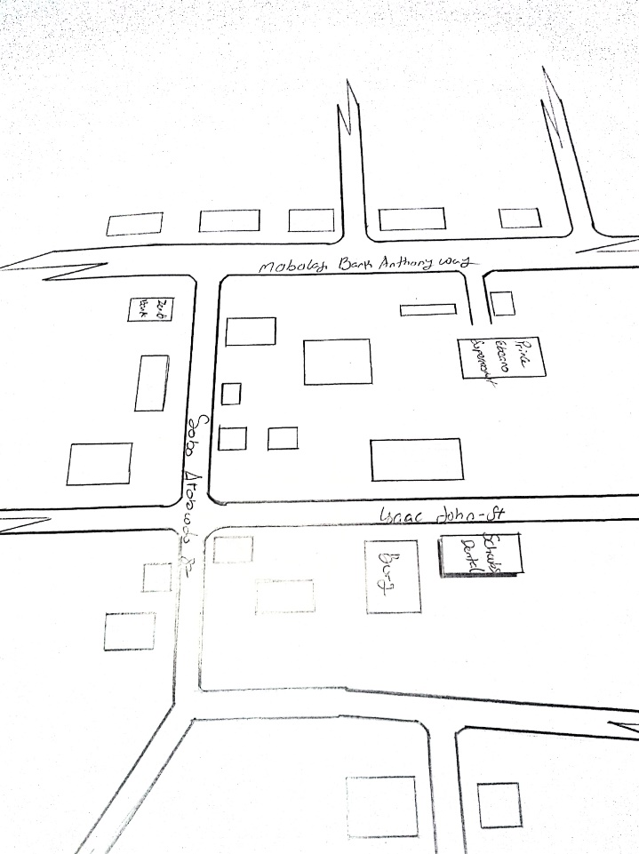
FIG 1; SHOWING LOCATION PLAN OF CASE STUDY ONE
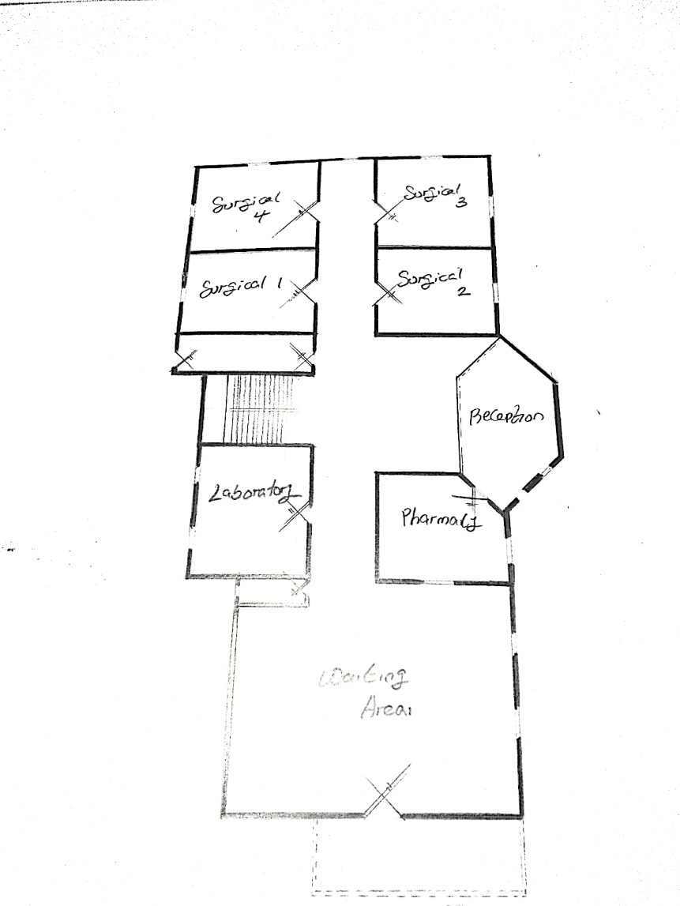
FIG 2; SHOWING GROUND FLOOR PLAN OF CASE STUDY ONE
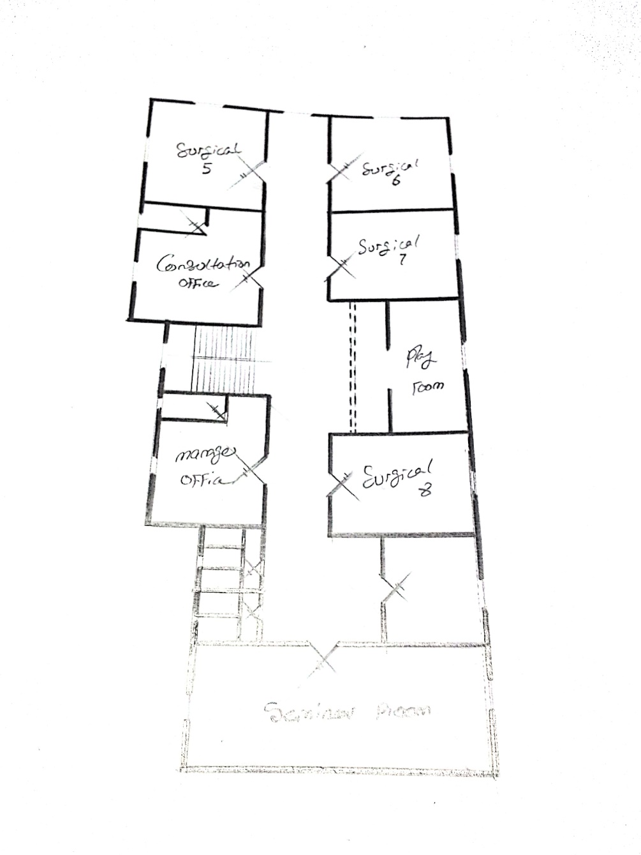
FIG 3; SHOWING UPPER FLOOR PLAN OF CASE STUDY ONE
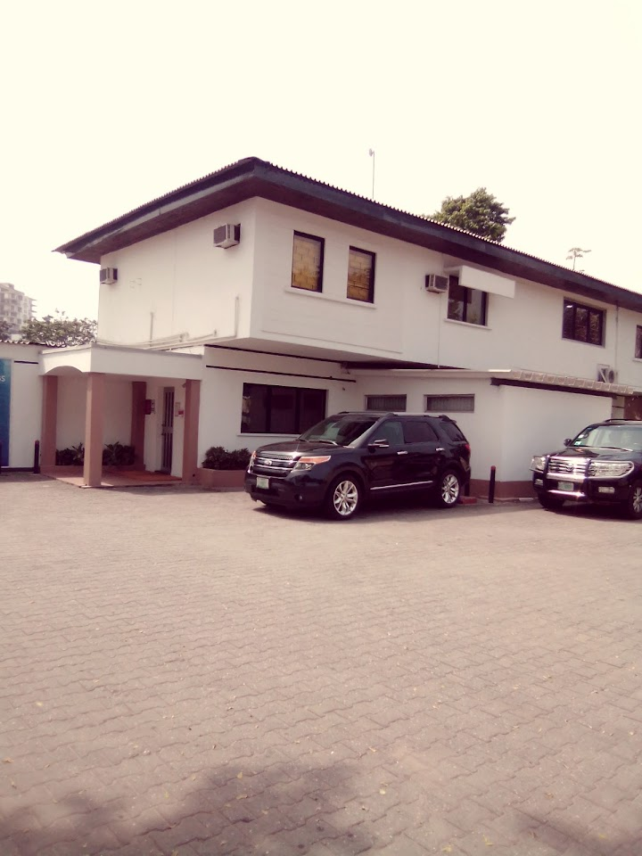
PLATE 1; SHOWING FRONT VIEW OF CASE STUDY ONE
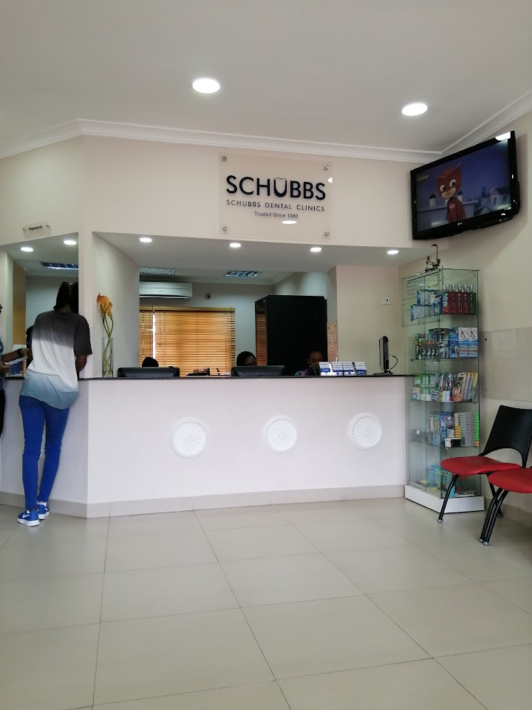
PLATE 2; SHOWING RECEPTION AREA OF CASE STUDY ONE
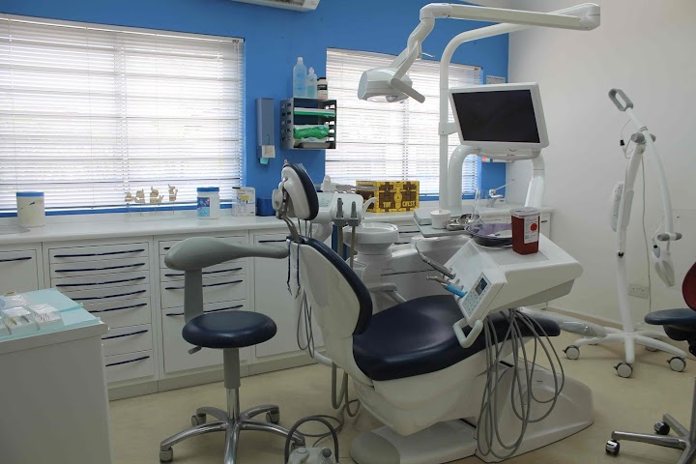
PLATE 3; SHOWING TREATMENT ROOM OF CASE STUDY ONE
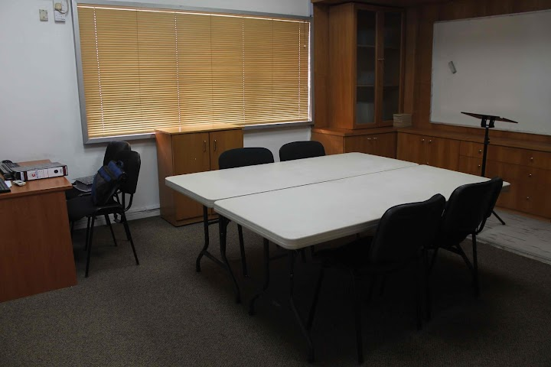
PLATE 4; SHOWING CONFERENCE ROOM OF CASE STUDY ONE
  - CASE STUDY TWO (2)
Location: Choice Dental Clinic at Ikeja, Lagos State.
Observation
Merits
- State of-the-art equipment
- Wide range of services
- Standard operating system
- Adequate parking space

Demerits
- Inadequate drainage system
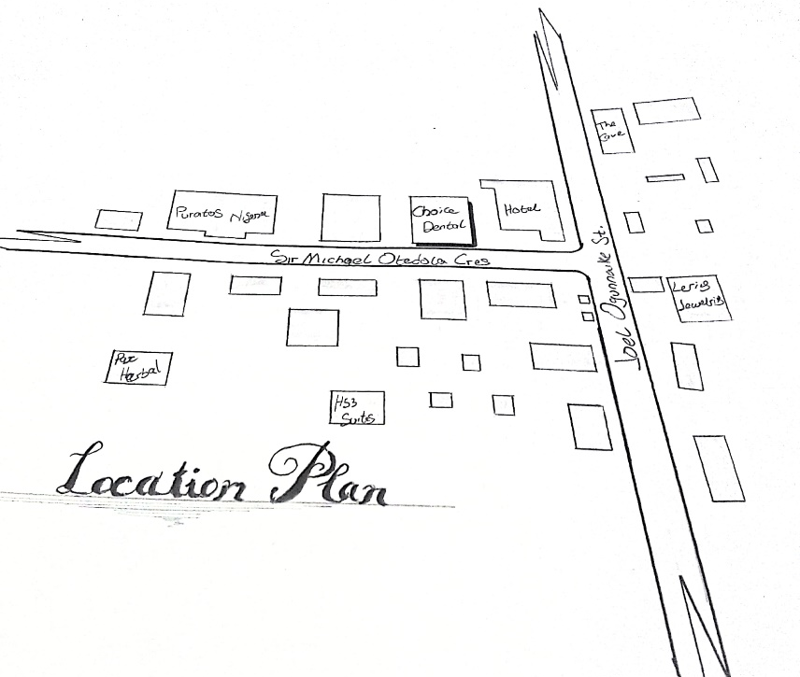
FIG 4; SHOWING LOCATION PLAN OF CASE STUDY TWO
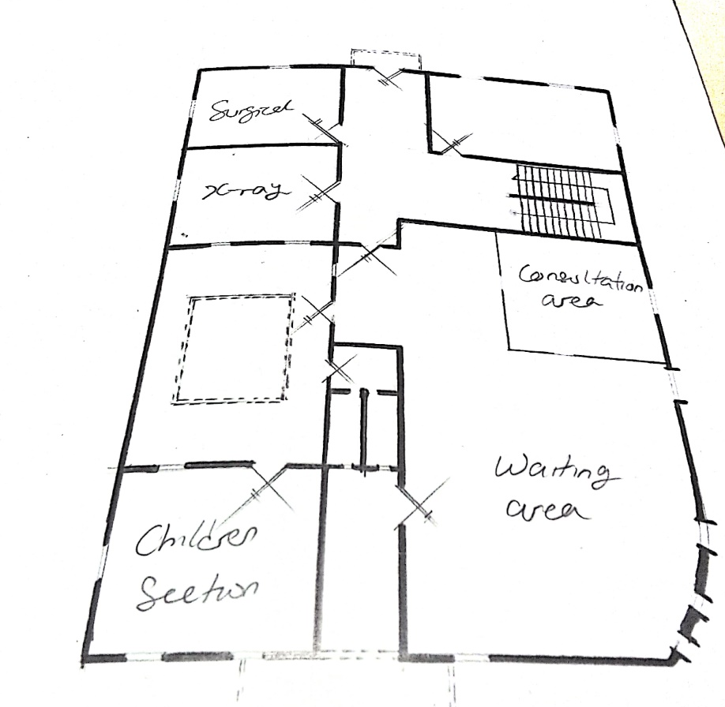
FIG 5; SHOWING GROUND FLOOR PLAN OF CASE STUDY TWO
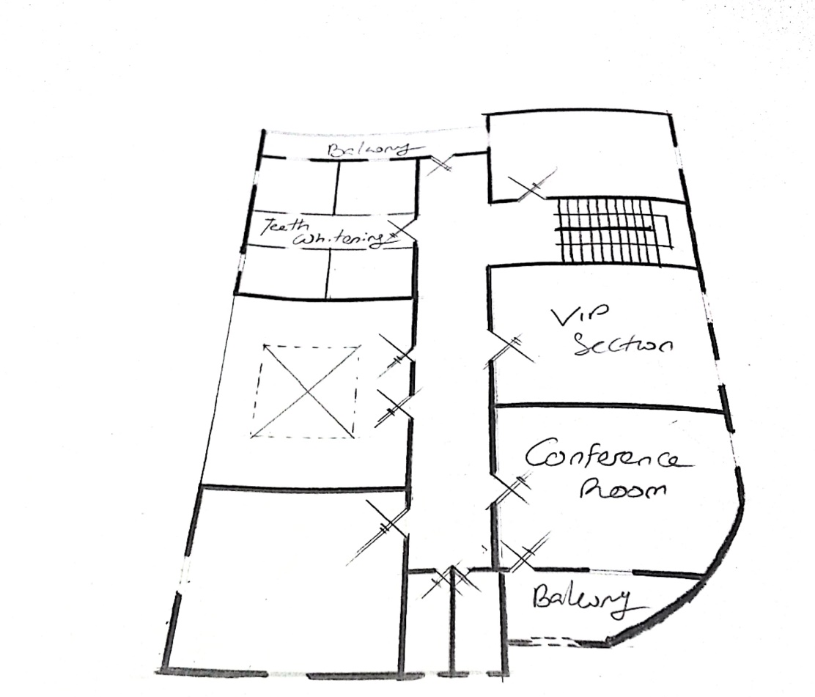
FIG 6; SHOWING UPPER FLOOR PLAN OF CASE STUDY TWO

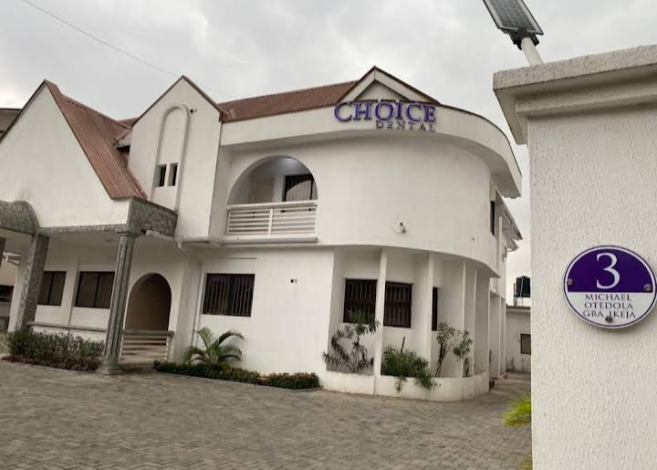
PLATE 5; SHOWING FRONT VIEW OF CASE STUDY TWO
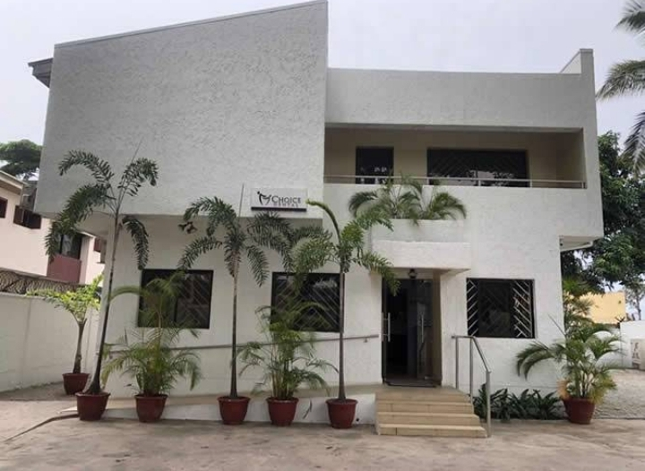
PLATE 6; SHOWING BACK VIEW OF CASE STUDY TWO

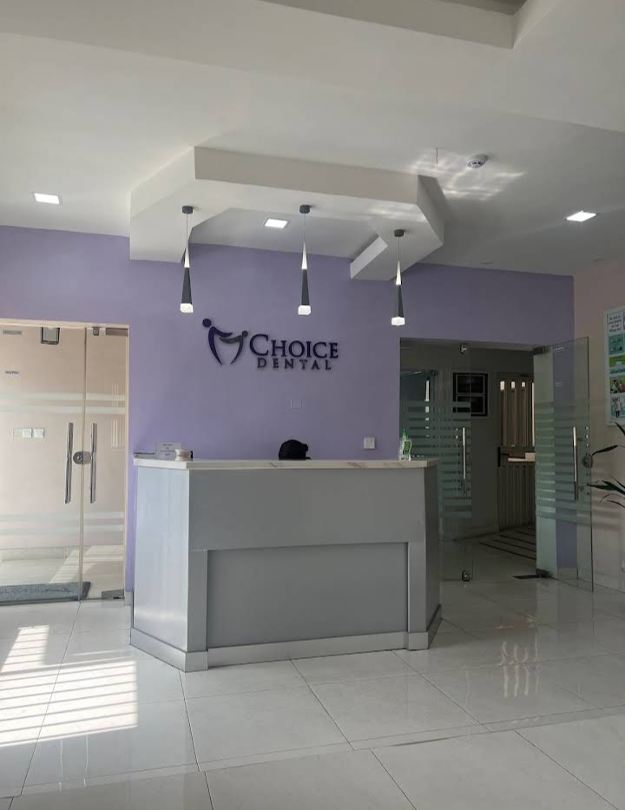
PLATE 7; SHOWING RECEPTION AREA OF CASE STUDY TWO
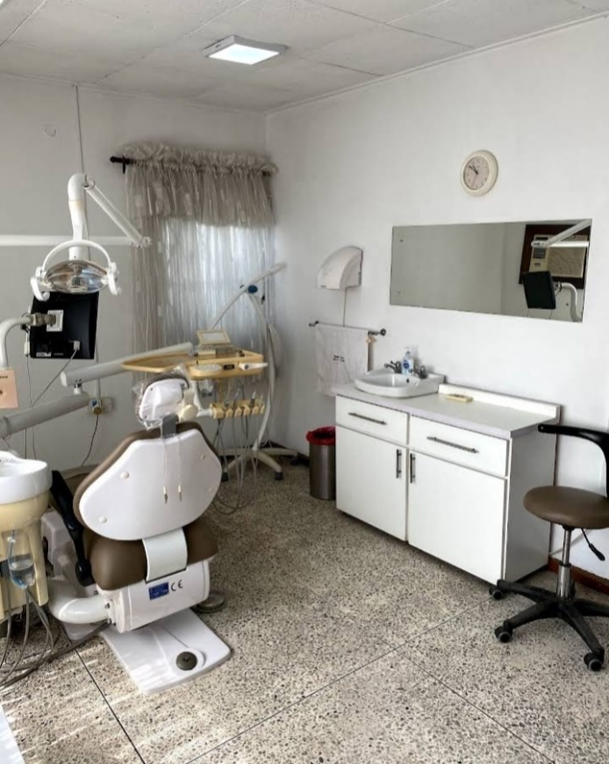
PLATE 8; SHOWING TREATMENT ROOM OF CASE STUDY TWO

  - CASE STUDY THRE (3)
Location: Emirate Dental Clinic at Asa-Dam Road, Ilorin, Kwara State.
Observation
Merits
- Provision of parking space
- Availability of dental services

Demerits
- Lack of proper sterilization equipment
- Improper care of dentistry equipment
- It is not well landscaped
- Not in a conductive environment
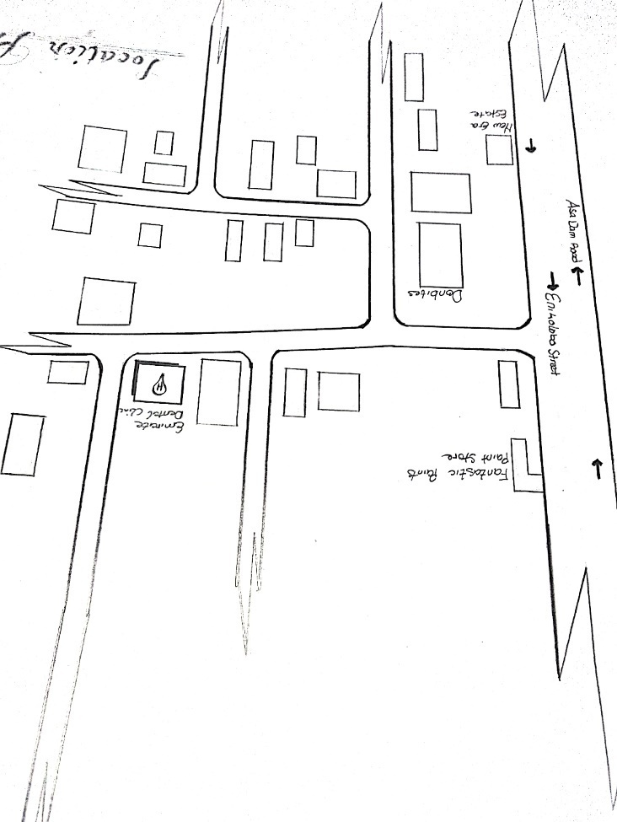
FIG 7; SHOWING LOCATION PLAN OF CASE STUDY THREE
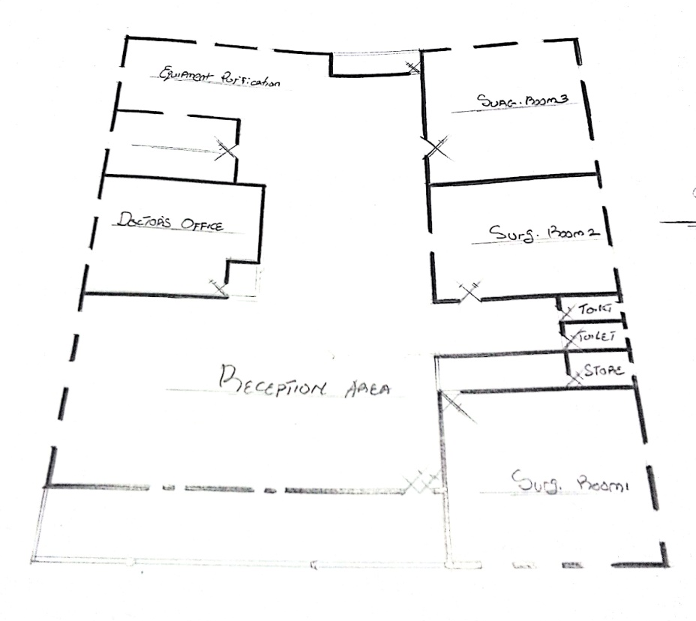
FIG 8; SHOWING FLOOR PLAN OF CASE STUDY THREE
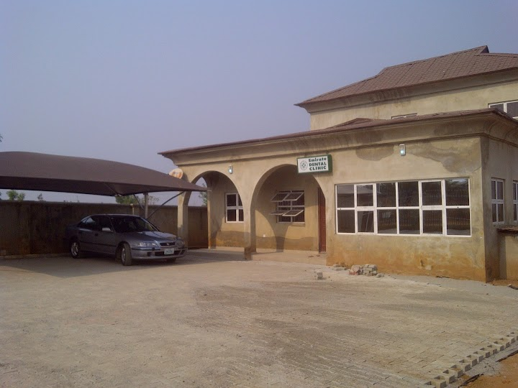
PLATE 9; SHOWING FRONT VIEW OF CASE STUDY THREE
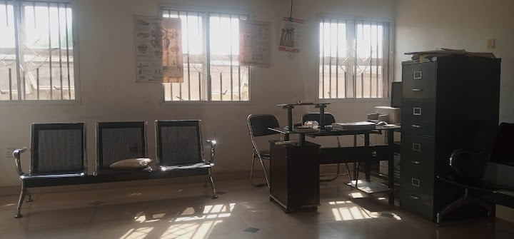
PLATE 10; SHOWING RECEPTION AREA OF CASE STUDY THREE
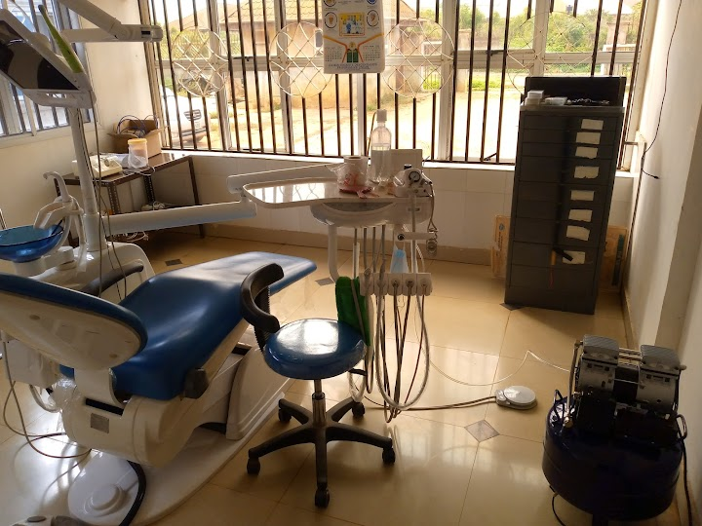
PLATE 11; SHOWING TREATMENT ROOM OF CASE STUDY THREE
  - CASE STUDY FOUR (4)
Location: Bozid Dental Clinic at 52, Oyo Road, Ibadan, Oyo State.
Observation
Merits
- Proper care of patients
- Well equipped facility
- Adequate parking space
- Easily accessible from the gate
- Good security arrangement

Demerits
- No space for future expansion
- Lack of sufficient storage facilities

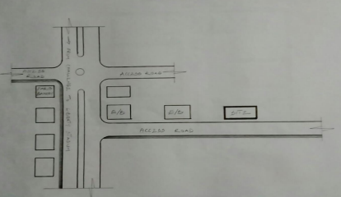
FIG 9; SHOWING LOCATION PLAN OF CASE STUDY FOUR

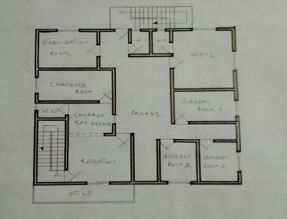
FIG 10; SHOWING FLOOR PLAN OF CASE STUDY FOUR
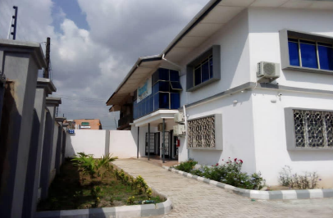
PLATE 12; SHOWING FRONT VIEW OF CASE STUDY FOUR

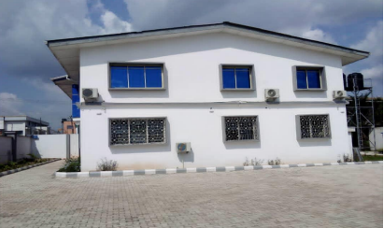
PLATE 13; SHOWING RIGHT VIEW OF CASDE STUDY FOUR
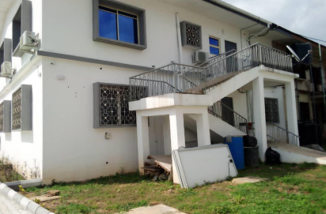
PLATE 14; SHOWING BACK VIEW OF CASE STUDY FOUR

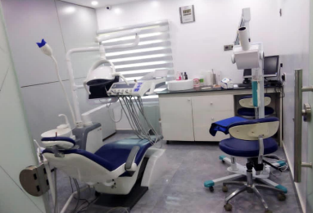
PLATE 15; SHOWING TREAMENT ROOM OF CASE STUDY FOUR

  - ONLINE CASE STUDY (1)
Location: UR Medicine Eastman Dental at Elmwood Ave, Rochester, New York.
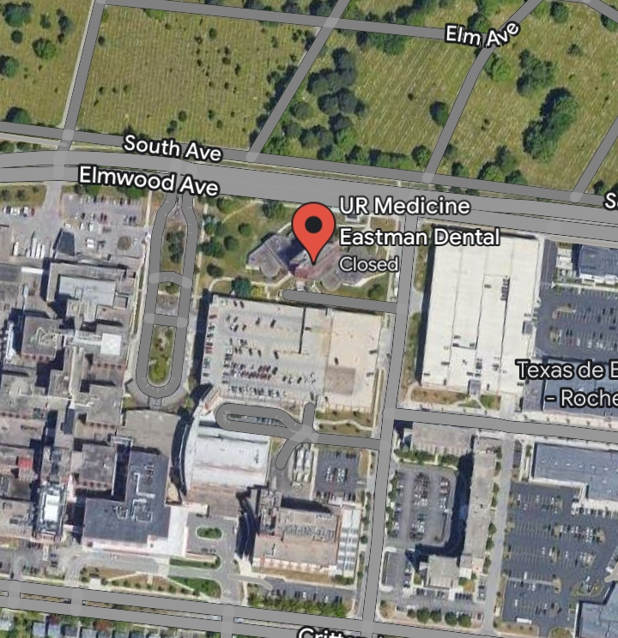
PLATE 16; SHOWING GOOGLE MAP OF ONLINE CASE STUDY ONE
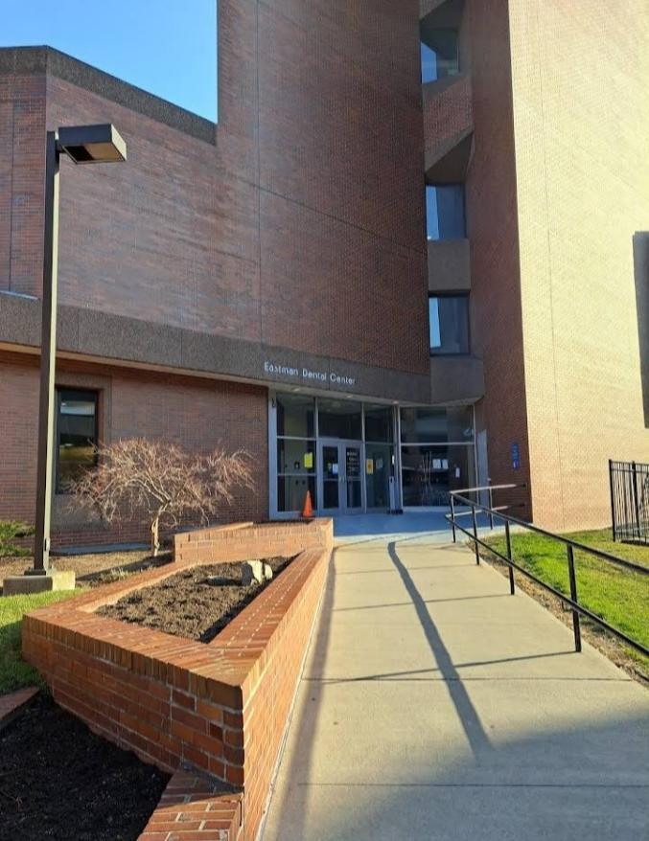
PLATE 17 SHOWING FRONT VIEW OF ONLINE CASE STUDY ONE
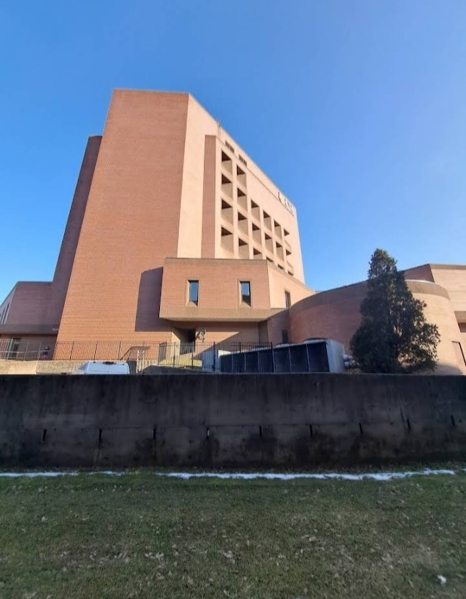
PLATE 18; SHOWING RIGHT VIEW OF ONLINE CASE STUDY ONE
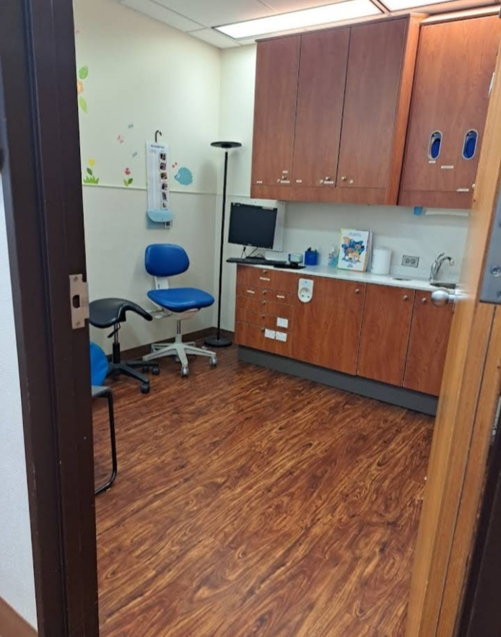
PLATE 19; SHOWING TREATMENT ROOM OF ONLINE CASE STUDY ONE
3.6.1 ONLINE CASE STUDY TWO (2)
Location: All Dent Dental Center Zahnzentrum at Zahnzentrum, Germany.
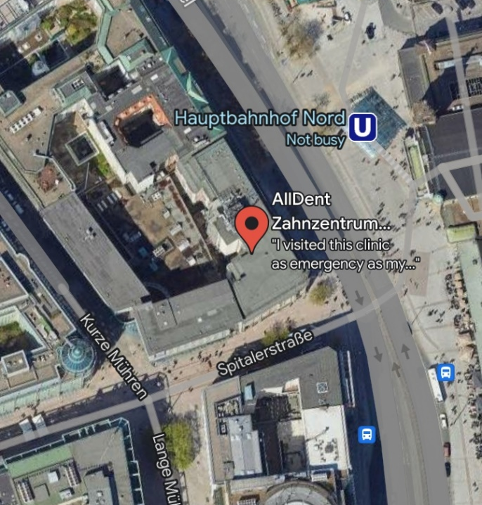
PLATE 20; SHOWING GOOGLE MAP OF ONLINE CASE STUDY TWO
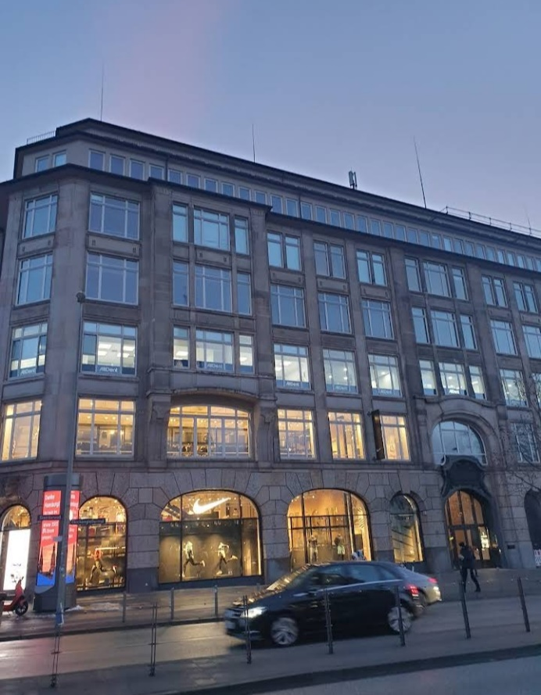
PLATE 21; SHOWING FRONT VIEW OF ONLINE CASE STUDY TWO
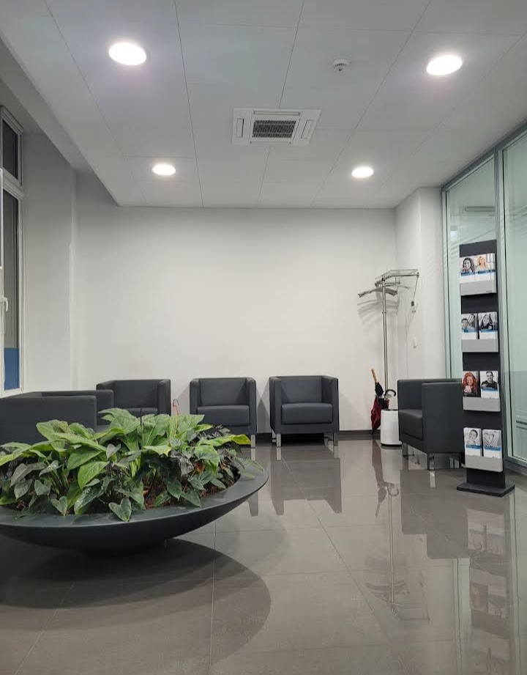
PLATE 22; SHOWING RECEPTION AREA OF ONLINE CASE STUDY TWO
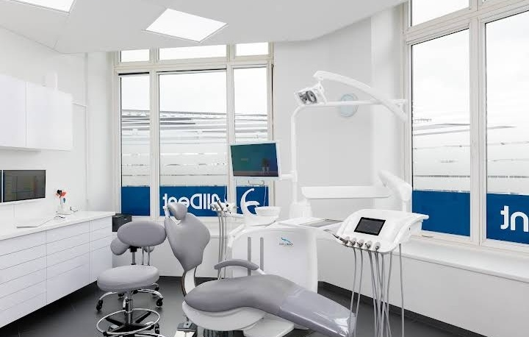
PLATE 23; SHOWING TREATMENT ROOM OF ONLINE CASE STDY TWO

  - DEDUCTON FROM CASE STUDIES
During my visit to the dental hospitals. I was opportunities of see what is obtaining in the hospital, I made proper studies of their related function and analysis were made on their present situation with the aim of incorporation their merit in my own final proposal.
The following were deduced from case studies:
- Location and accessibility: All the clinics are conveniently located and easily accessible.
- Range of services: All the clinics offers a wide range of dental services.
- Qualified staff: The clinics employ highly qualified and trained staff to provide the best possible care to their patients.
- The units in the hospital should be properly and well linked.
- Good architectural land scraping.

CHAPTER FOUR
- PROJECT LOCATION
4.1 BRIEF HISTORICAL BACKGROUND OF ILORIN EAST L.G.A
Ilorin east local government area is situated in Kwara state, a Northcentral geopolitical enclave of Nigeria. The headquarters of the LGA are in the town of OkeOyi with the LGA made up of towns and districts such as Temidire, Badari, Ibagun, Adwole, Baboko, and OkeOyi. The estimated population of Ilorin East LGA is 185,744 inhabitants with the area hosting members of diverse ethnic affiliations such as Nupe, Yoruba, and Fulani. The Yoruba language is one of the commonly spoken languages in Ilorin East LGA while notable landmarks in the area include the KwaraState College of Education.
GEOGRAPHY OF ILORIN EAST L.G.A
Lorin East LGA covers a total area of 486 square kilometers and has an average temperature of 29 degrees centigrade. The average humidity level of the area is 52 percent while the average wind speed in the LGA is 10 km/h.
ECONOMY OF ILORIN EAST L.G.A
Ilorin East LGA hosts a number of markets where a variety of commodities are bought and sold and these include the Ipata and the Baboko markets. Ilorin East LGA also hosts several publicly and privately owned institutions, industries, hotels and banks. Other important economic activities engaged in by dwellers of Ilorin East LGA include textile weaving, blacksmithing, and woodwork.
ORGANIZATION STRUCTURE
An organizational structure is a system that outlines how certain activities are directed in order to achieve the goals of an organization. These activities can include rules, roles, and responsibilities. The organizational structure also determines how information flows between levels within the hospital.
4.2 LOCATION AND SETTING OF ILORIN TOWN
Ilorin is the capital city of Kwarastate in westernNigeria. It is situated on the AwunRiver, a minor tributary of the Niger. Founded in the late 18th century by Yorubapeople, Ilorin became the capital of a kingdom that was a vassalstateoftheOyoempire. Throughout the 19th century, Ilorin served as a major trade center between the Hausa of the north and the Yoruba of the south. It strongly resisted British rule, and only in 1897, when the army of the Royal Niger Company arrived after conquering Bida, did Ilorin recognize British supremacy. Today, modern Ilorin is mainly inhabited by MuslimYorubapeople, although its traditional ruler is a Yoruba-speaking Fulaniemir. The city is an industrial, commercial, and educational center, known for its local crops, cattle, and handicrafts.
4.3 POPULATION
NAME | Population Census.  1991-11-26 | Population Census.  2006-03-21 | Population Projection.  2022-03-21
ILORIN EAST | 108,715 | 207,462 | 311,500
TABLE 1: SHOWING THE POPULATION OF ILORIN EAST L.G.A
Ilorin East
311,500 Population [2022] – Projection
473.7 km² Area
657.6/km² Population Density [2022]
2.6% Annual Population Change [2006 → 2022]
Ilorin-East: Local Government Area in Kwara State, Nigeria
Nigeria Federal Republic 88,992,220 140,431,790 216,783,400
Source: National Population Commission of Nigeria (web), National Bureau of Statistics (web).
Explanation: The population projection assumes the same rate of growth for all LGAs within a state. The undercount of the 1991 census is estimated to be about 25 million. All population figures for Nigeria show high error rates; census results are disputed. Area figures are computed using geospatial data.
Further information about the population structure:
Gender (C 2006)
Males | 104,801 | 50.5%
Females | 102,661 | 49.5%
TABLE 2; SHOWING GENDER GROUP

Age (C 2006)
0-14 years | 85,180 | 44.4%
15-64 years | 115,064 | 51.9%
65+ years. | 7,218 | 3.7%
TABLE 3; SHOWING AGE GROUP (C 2006)

Age Distribution (C 2006)
0-9 years | 61,832
10-19 years | 44,827
20-29 years | 38,767
30-39 years | 24,426
40-49 years | 16,703
50-59 years | 9,759
60-69 years | 5,944
70-79 years | 3,039
80+ years | 2,165
TABLE 4; SHOWING AGE DISTRIBUTION

4.4 SITE INVENTORY
In the proposed site, some shrubs will be retained on site. It used to reduce sky glare and also serve as soft landscape and wind breaker.
Presence of road network which would serve as a means of accessibility to the site. Presence of electricity pole which serve as source of electricity to the site. Some trees would be retained while some will be removed if they disrupt the construction of building.
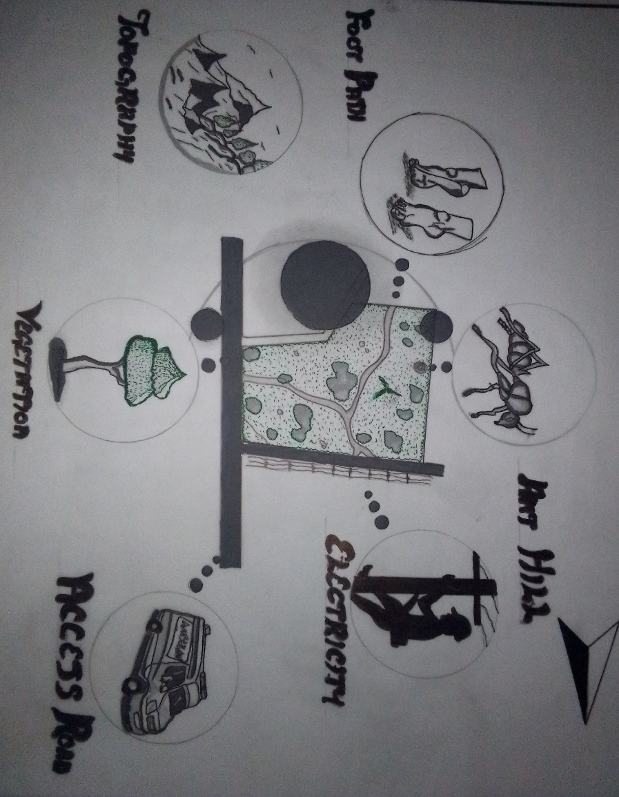
FIG 11; SHOWING SITE INVENTORY OF THE PROPOSED SITE

4.5 SITE ANALYSIS
The site is benefitted with loamy soil which is a very good soil for grass and shrubs. It has a gentle slope towards the south east. Some of the grasses, shrubs and trees on the site are to be retained to enhance landscape patter of the site while some are to be removed and replanted where necessary. The two noticeable winds are to be directed into the building using landscape pattern to improve ventilation. Noise generated from vehicle traffic is controlled through proper planning, good landscaping and proper orientation of building. Generally, all the feature on the site are best put into different uses to aid control through proper planning, landscape and orientation.
Certainly, steps are considered to obtain vital information of the site, this information is the analyzed in details. For design purpose, the information includes soil condition, geology, topography, vegetation etc. It also involves carrying out a preliminary survey of the site.
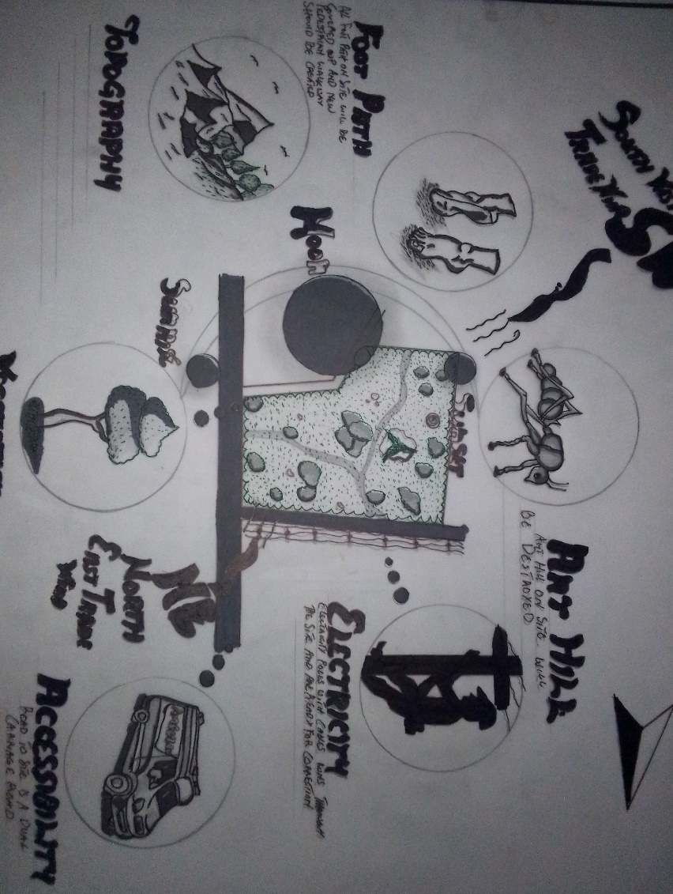
FIG 12; SHOWING SITE ANALYSIS OF THE PROPOSED SITE

4.5.1 SITE SELECTION/JUSTIFICATION
In the site selection provision is made for interesting facilities that worth emulating since the overall success and efficiency of any project depend not on the functionality of the design but also on a careful choice of site. The site of this project has been carefully selected which is located in the premises of Ilorin, Ilorin East Local Government Kwara state, Sobi Road.

4.5.2 LOCATION
The site is located at Sobi Road, Ilorin, Kwara state.

4.5.3 ACCESSIBILITY
The site is easily accessible from the access road off from the main road that goes to sobi barrack.

4.5.4 INFRASTRUCTURAL FACILITIES
Facilities such as water electricity, telephone network and road network are all in Ilorin, hence it can easily be tapped to the proposed site.

4.5.5 TOPOGRAPHY
The topography of the land is gentle slope which can be filled and levelled up to balance round all the site levels.

4.5.6 SOIL STRUCTURE
It is made up of clayish laterite soil, which is good for building construction.

4.6 GENERAL CLIMATIC CONDITION
The city (Ilorin) has a topical climatic. The summer here have a good deal of rainfall, while the winter have very little. According to Koppen and Geiger, this climatic is classified as AW. In Ilorin, the average animal temperature is 26.50C the rainfall here average 1217mm. The least amount of rainfall occurs in January, the average in the month is 10mm. Almost of the precipitation here falls in September, averaging 232mm. The temperature are highest on average in March at around 29.00C. August is the coldest month with temperature average 24.50C.

4.6.1 RELATIVE HUMIDITY
The town is under the influence of high humidity throughout the year with a monthly relative humidity remaining above 60%. This is even higher between May and September with a relative humidity figure of about 80% average.

4.6.2 WIND
There are two prevailing winds namely: The rain bearing south-west monsoon wind which blows across the Atlantic Ocean between the month of May and October. This is called wet season. The dusty north-east trade wind which laden with dust blows through the Sahara desert during the month of November to April with very title rainfall toward April. This is called the dry season and it brings along Harmattan during its driest period.

4.6.3 TEMPERATURE
The monthly average temperature is quite uniform having February and March as the hottest months recording a higher average of about 48°C (about 85"F). July and August are the coolest (lowest monthly average of 76'F).

4.6.4 VEGETATION
The proposed site is covered with grasses few trees and shrubs. Some will be removed before the construction while some will be retained for ornamentation.

4.7 SOCIAL SERVICES

4.7.1 ROAD
There are only two access to the site
The eastern access which serve as the main entrance also main access road and southern access which serve as service road.

4.7.2 WATER AND ELECTRICITY
There are pipe born water networks and borehole water which serves the habitant of Ilorin. There is electricity supply from NEPA that serve the Ilorin east in general.

  - DESIGN CRITERIA
There are three (3) methods of designing of any project which are:
- Function before form method
- Form before function method
- Combination of Shapes
Designing projects, the function, before form method used in line with this method, the following are the design criteria for this project:
Functional: in term of functional requirement, the following design criteria must be considered. Sustainability, Site and Location, Flexibility, Circulation, Accessibility, Organization, Maintenance, Environment and Services.

4.8.1DESIGN BRIEF
After research and planning, the next step in the series of the project formation is design itself. To achieve functional and well-established design there must be a brief to work on. This brief depends generally on the scope of individual design. The brief of this project is therefore based on the various activities that take place in the hospital. To have enough brief for the proposed dental hospital, case studies were carried out on the existing dental hospital. The studies also give me the opportunity to know the nature of the various dental treatment and how they are related to each other.

4.8.2 DESIGN ANALYSIS
This is the process of itemizing units within the component of the entire design with a view to establishing a solid understanding and appreciation of the space relationships.
The units of the design are in two division,
The unit of the project division are as follows:
GROUND FLOOR:Entrance, Reception, Card room, Stair Hall, Operative Dentistry Office, Doctors Office, Pharmacy, Children zone, Gingivitis Surgery Room, Maxillofacial Surgery Room, Cosmetic Room Theatre, X – Ray Room, Wards, Cloak Room, Store, Convenience, Exit

UPPER FLOOR: Stair Hall, Conference Room, Laboratory, Orthodontic Room, Mini Library, Dental Therapist Office, Accountant Office, Chief Surgeon Office, Secretary Office, Staff Lounge Room, Tooth Filling, Implant Room, Crown Tooth Room, Trauma Room, Endodontics Room, Ward, Convenience, Store, Sit Out.

4.8.3 SPACIAL ALLOCATION
Units | No. Required | Length (m) | Breadth (m) | Area (m2 )
Entrance | 1 | 6.8m | 1.8m | 12.24m
Reception | 1 | 7.2m | 7.2m | 51.84m
Card Room | 1 | 4.6m | 3.2m | 14.72m
Stair Hall | 4 | 6.4m | 2.5m | 16m
Operative Dentistry Office | 1 | 6.0m | 4.0m | 24m
Doctors office | 1 | 5.5m | 5.0m | 27.5m
Pharmacy | 1 | 6.0m | 5.0m | 30m
Children Zone | 1 | 6.2m | 4.0m | 24.8m
Gingivitis Room | 1 | 6.2m | 4.0m | 24.8m
Maxillofacial Room | 1 | 6.2m | 4.0m | 24.8m
Cosmetic Room | 1 | 6.2m | 4.0m | 24.8m
Theatre | 1 | 6.2m | 4.0m | 24.8m
X-Ray Room | 1 | 6.2m | 4.0m | 24.8m
Wards | 2 | 6.2m | 5.5m | 34.1m
Cloak Room | 2 | 4.2m | 3.0m | 12.6m
Store | 1 | 5.3m | 3.2m | 16.96m
Conveniences | 7 | 2.0m | 1.0m | 2m
Exit | 1 | 2.2m | 1.2m | 2.64m
TABLE 5; SHOWING SPACIAL ALLOCATION OF GROUND FLOOR

Units | No. Required | Length (m) | Breadth (m) | Area (m2 )
Entrance | 1 | 6.8m | 1.8m | 12.24m
Reception | 1 | 7.2m | 7.2m | 51.84m
Card Room | 1 | 4.6m | 3.2m | 14.72m
Stair Hall | 4 | 6.4m | 2.5m | 16m
Operative Dentistry Office | 1 | 6.0m | 4.0m | 24m
Doctors office | 1 | 5.5m | 5.0m | 27.5m
Pharmacy | 1 | 6.0m | 5.0m | 30m
Children Zone | 1 | 6.2m | 4.0m | 24.8m
Gingivitis Room | 1 | 6.2m | 4.0m | 24.8m
Maxillofacial Room | 1 | 6.2m | 4.0m | 24.8m
Cosmetic Room | 1 | 6.2m | 4.0m | 24.8m
Theatre | 1 | 6.2m | 4.0m | 24.8m
X-Ray Room | 1 | 6.2m | 4.0m | 24.8m
Wards | 2 | 6.2m | 5.5m | 34.1m
Cloak Room | 2 | 4.2m | 3.0m | 12.6m
Store | 1 | 5.3m | 3.2m | 16.96m
Conveniences | 7 | 2.0m | 1.0m | 2m
Exit | 1 | 2.2m | 1.2m | 2.64m
TABLE;6 SHOWING SPACIAL ALLOCATION OF UPPER FLOOR

CAPTER FIVE

- GENERAL REQUIREMENTS

5.1 APPRAISAL OF PROPOSED SCHEME
The proposed scheme is to satisfy the appropriate building regulation. The project design is to confirm with the intended use of building taking into consideration with both natural factors and human that can pose a threat on the validity and stability of the project design.

5.2 CONSTRUCTION METHODOLOGY AND MATERIAL
The construction is to be carried out following the due process of construction ranging from.
- Preliminary: this involves the clearing of the site, setting out and excavation of foundation trench, foundation works down to the basement level.
- Sub-Structure: this process also entails the positioning and erection of column and beams, masonry work etc. Gypsum board: is to be used for the Acoustic purpose of the building. This material is often called dry wall, wall board or plaster board. It creates a continuous surface suitable for most types of interior decoration. It comes in different size ranging length of 2.4m, 3.0m, also in thickness of 1/ inch, 3/8 in
5.3 SERVICES
A building can be said to be good when it performs the serves required by it. In other to have a well-function building design, there calls for an installation of underground water. This is a means of providing brightness naturally by sun or moon or artificially by lamps. Good natural and artificial lighting is important in lecture rooms, and workshop. It is always easy to make mistake and time the eye in a situation of poor lighting floor. For the purpose of this project, effort is made as much as possible to light up the entire building naturally before the use of artificial lighting. In this project, to obtain maximum lighting more openings are provided for the lecture rooms, workshop and admin. Artificial source of light will still be provided for in case where there is call for the use of it at night or in a situation where the weather condition warrants it.

5.3.1 VENTILATION
As it's relates to architectural, is the intentional introduction of outside AIT into a space through openings (like window/doors and mechanical means (ACs) to provide maximum thermal comfort for human satisfaction. In this design, both means of ventilation ate introduce but majority concentration on the mechanical means of ventilation for all units in the design for the purpose of extracting the used air and introducing fresh air within all spaces for human’s consumption and satisfaction.
This is done through installation of mechanical (artificial) ventilation ducts horizontally and vertically all within the units of the design to allow easy floe of free movement of air passage through the ventilation channels and providing well, proper and adequate ventilation for each and every units in the design project.

5.3.2 LIGHTING
This is a means of providing brightness naturally by sun or moon or artificial by lamps. Good natural and artificial lighting is important in all units. It is always easy to make mistake and time the eye in a situation of poor lighting floor. For the purpose of this project, effort is made as much as possible to light up the entire building naturally before the use of artificial lighting.

5.3.3 PLUMBERING
The plumbing system in this project design is made easy for waste extraction and brain water extraction through the means of service duct channel and roof gutter drainage. All waste water and soil waste from the toilet/convenience are extracted through means of drainage pipe running through the walls down to the inspection chamber situated in the service duct, flowing down to the septic tank and soak away for final waste extractions.

5.3.4 ELECTRICAL INSTALLATION
The type of wiring system chosen should be conduct system of wiring, technical are should be wired with strong durable and light current resistance cables because of the power requirements and consumption of the equipment to be used and installed in them. Connection and distributing cable signal. Also electrical installation is to be done to allow for the use quality electrical fittings and fixtures in the whole of the hospital.
5.3.5 WASTE DISPOSAL
Waste disposal are to be put in the building and also some specific areas necessary, this waste bins should be disposed in the incinerator which will be provided within the proposed site premises. The waste should therefore, be burn in the incinerator or taken away from the site.

5.3.6 FIRE PROTECTION
Electrically, fire alarms and sensor are to be installed in the building in generally. This should be done in case of the fire occurrence. Fire extinguishers are to be placed at a certain distance in the lobbies and some other necessary areas. It is also serving as protection in case of fire outbreak.

5.3.7 RAIN PROTECTION DEVICES
The rainfall of a place generally determines the living condition and all comfort associated with that environment hence provision should be made for fast dispersal of the rain water as well as the associated condition with rainfall. This calls for the need to study the nature of rainfall of the area. To control the heavy rainfall during the wet season (April - October) the use of simple sloppy system roofing has been adopted. This is provided with roof gutter system which is linked to the ground drainage network by the use of P.V.C.

5.3.8 EXTERNAL WORKS
The external works are to be earned out generate, kerbs land and shrubs, flowers, grasses and trees planted. Concrete interlocking pavement tiles to be adopted before hard landscape for walk ways and parking spaces and car access roads must be tarred with asphalt finishes.

5.4 SUMMARY
This project, generally, has seriously widen my view and knowledge affecting my observation beyond my expectation. I have been able to deduct what it takes or entails and how to go about designing and achieving a good design of any form of this related project with total seriousness as this project has given out the facts and precise information it comprises.

5.4.1 CONCLUSION
It is obvious that majority of our patients still visit dental clinic for symptomatic treatment and pain account for the reason why majority present in the clinic. However, some factors such as low level of dental awareness and financial constraint of patient could have led to this pattern of presentation. Nevertheless, the possibility of peoples’ negligence of their health, lack of time and fear of undergoing treatment in dental clinic cannot be ruled out. This suggest that Dental surgeons and dental health workers have not been playing their role adequately in facilitating public enlightenment that people may appreciate the need for regular dental care and make adequate and proper use of the available dental care facilities.

5.4.2 RECOMMENDATION
There is need to emphasize more on the preventive aspect of dentistry. There is need to improve on the present state of dental awareness programs. The issue of cost of dental care should be better addressed than it is presently being done, e.g. through the National health insurance scheme program (NHIS).

REFERENCES
1. Brown L.J. and Lazer V. Dental care utilization: How saturated is the patient’s market? J Am Dent Assoc 1999; 130: 573-580.
2. Allukian M. Dentistry at the crossroads: The future is uncertain: The challenges are many. Am J Public Health 1982; 72: 653-654.
3. Grembowski D., Comrad D. and Milgrom P. Utilisation of dental services in the United States and an insured Population. Am J Public Health 1985; 75: 87-89.
4. Douglas C.W. and Cole K. Utilization of dental services in the US. J Dent Educ 1979 43:223- 38.
5. Savage K.O. and Arowojolu M.O. Perception of gingival bleeding by Nigerian. Afr J Med Sci; 26: 91-93.
6. Ainamo J. and Ainamo A. Prevention of Periodontal Diseases in a mixed dentition. Int Dent J 1981; 31:125-132.
7. de Lacerda J.T., Simionato E.M., Peres K.G., Peres M.A., Traebert J. and Marcenes W. Dental pain as the reason for visiting a dentist in a Brazilian adult population. Rev SaúdePública 2004; 38 (3): 1-6.
8. Kolude B. and Gbadebo S.O. Orofacial Pain: Pattern of Presentation at Dental Clinic University College Hospital Ibadan. MDS Thesis, 2007.
9. Famuyiwa O.O., Olorunsola D.A. and Derin A. Some family factors in sickle cell anemia in Lagos, Nigeria. Nig Med Practitioner 1998; 35:70-73.
10. Woosung S., Amid I., Ashley A., James L. Determinants of Dental care visits among low-income African-American children: J.Am Dent Ass 2007; 138:301-318
11. Lo G.L. The use of Dental services by adult Singaporeans. Singapore Dent J 1993; 18:22- 25.
12. Manski R.J. and Moeller J.F. Use of dental services An analysis of visits, procedures, and providers, 1996. J Am Dent Assoc 2002; 133: 167-175.
13. Sa’adu and Abdulraheem. Oral health care practice and socio-demographic findings among the physicians in Ilorin, Nigeria. Niger J Med 2003; 12: 211-216.
14. Manski R.J., Moeller J.F., and Maas W.R. Dental services: use expenditures and sources of payment, 1987. J Am Dent Assoc 1999; 130: 500-508.

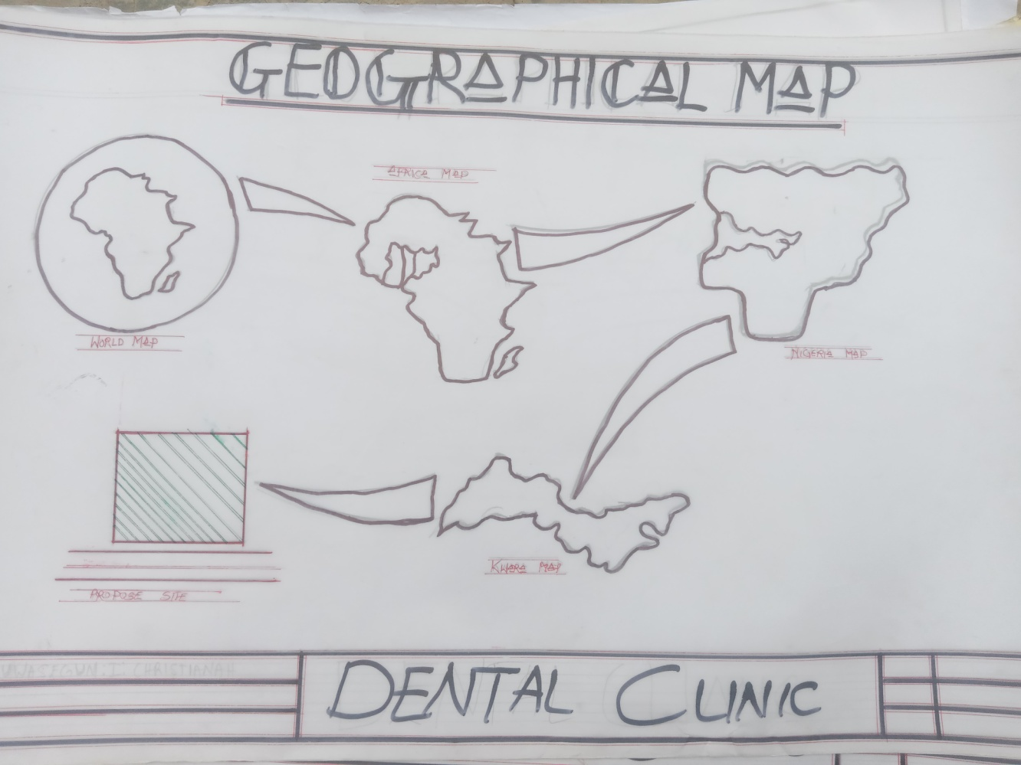
APPENDIX 1; SHOWING GEOGRAPHICAL MAP OF THE PROPOSED PROJECT
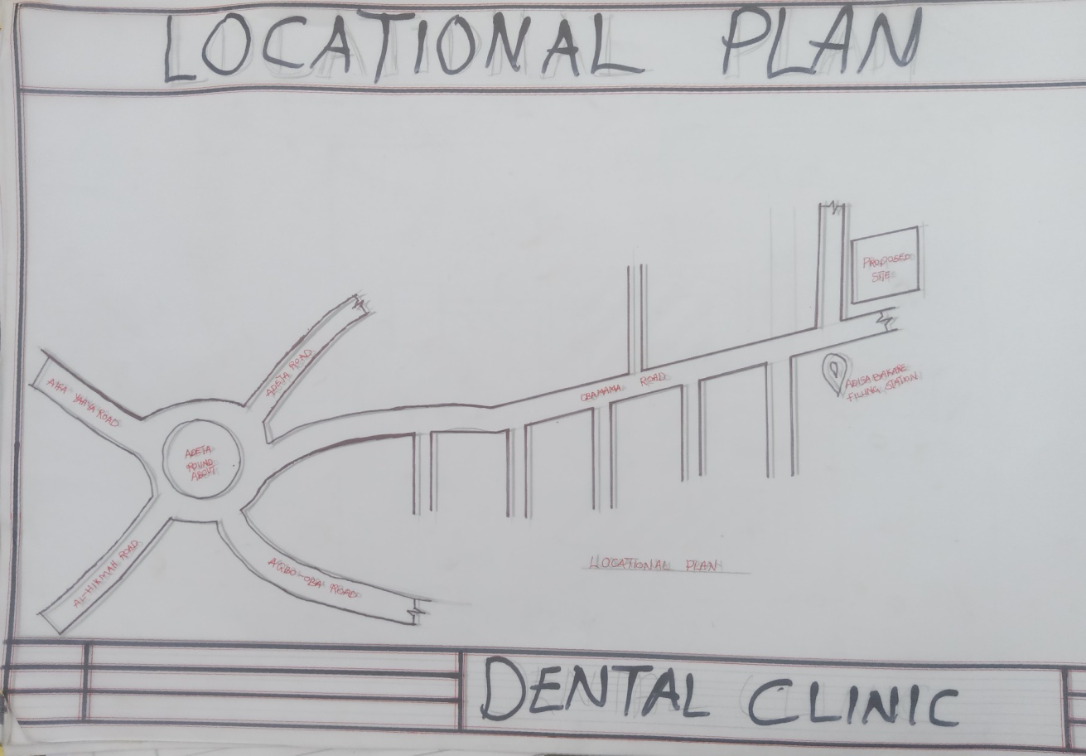
APPENDIX 2; SHOWING LOCATION PLAN OF THE PROPOSED PROJECT

.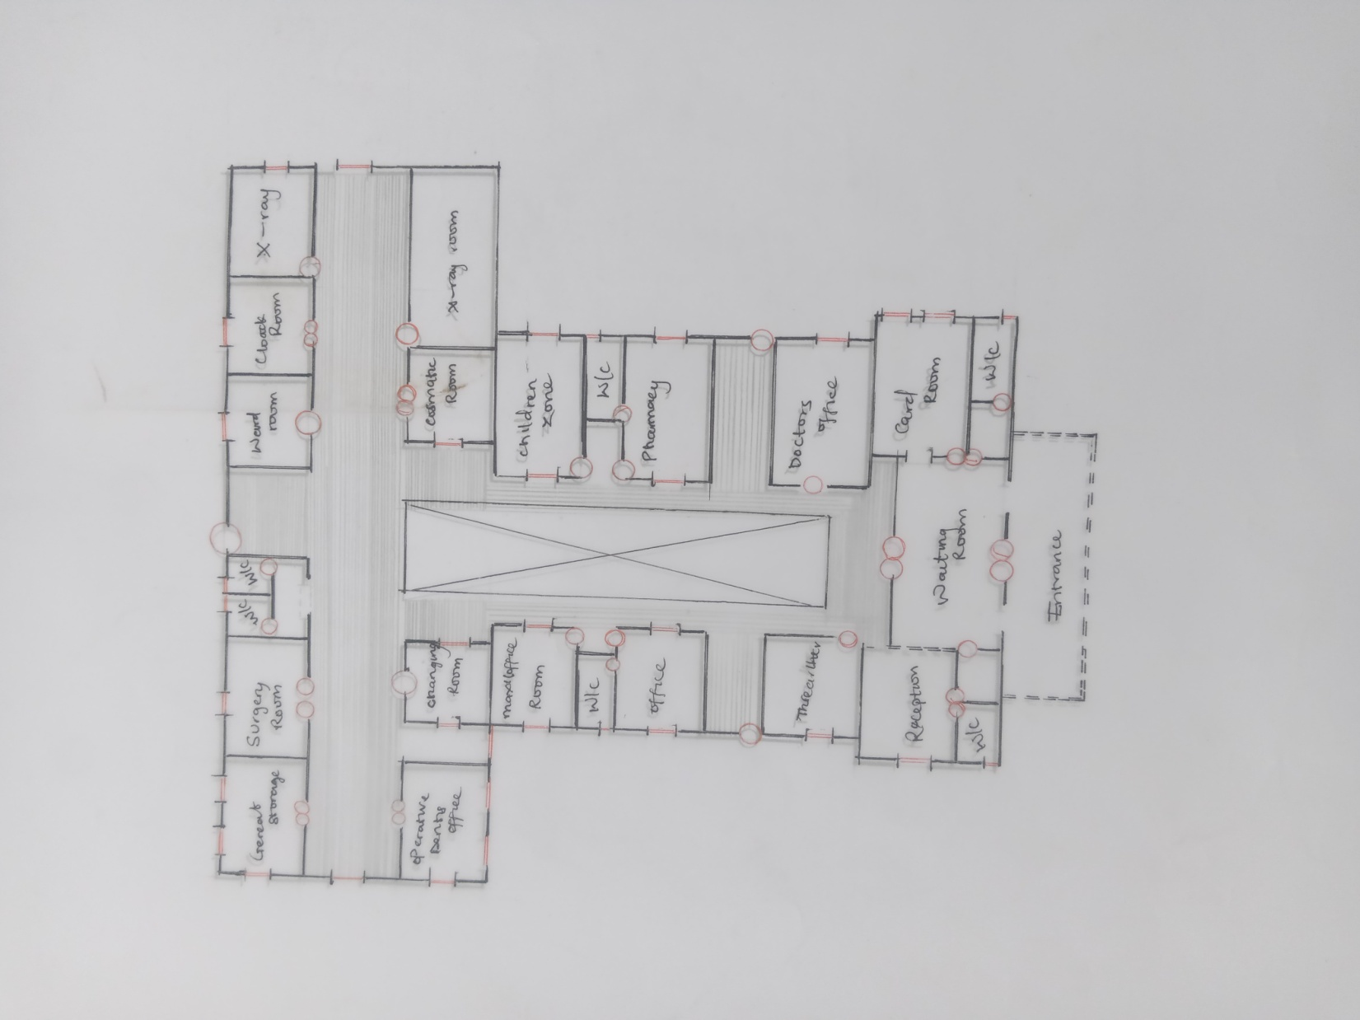
APPENDIX 5; SHOWING FLOOR PLAN OF THE PROPOSED PROJECT
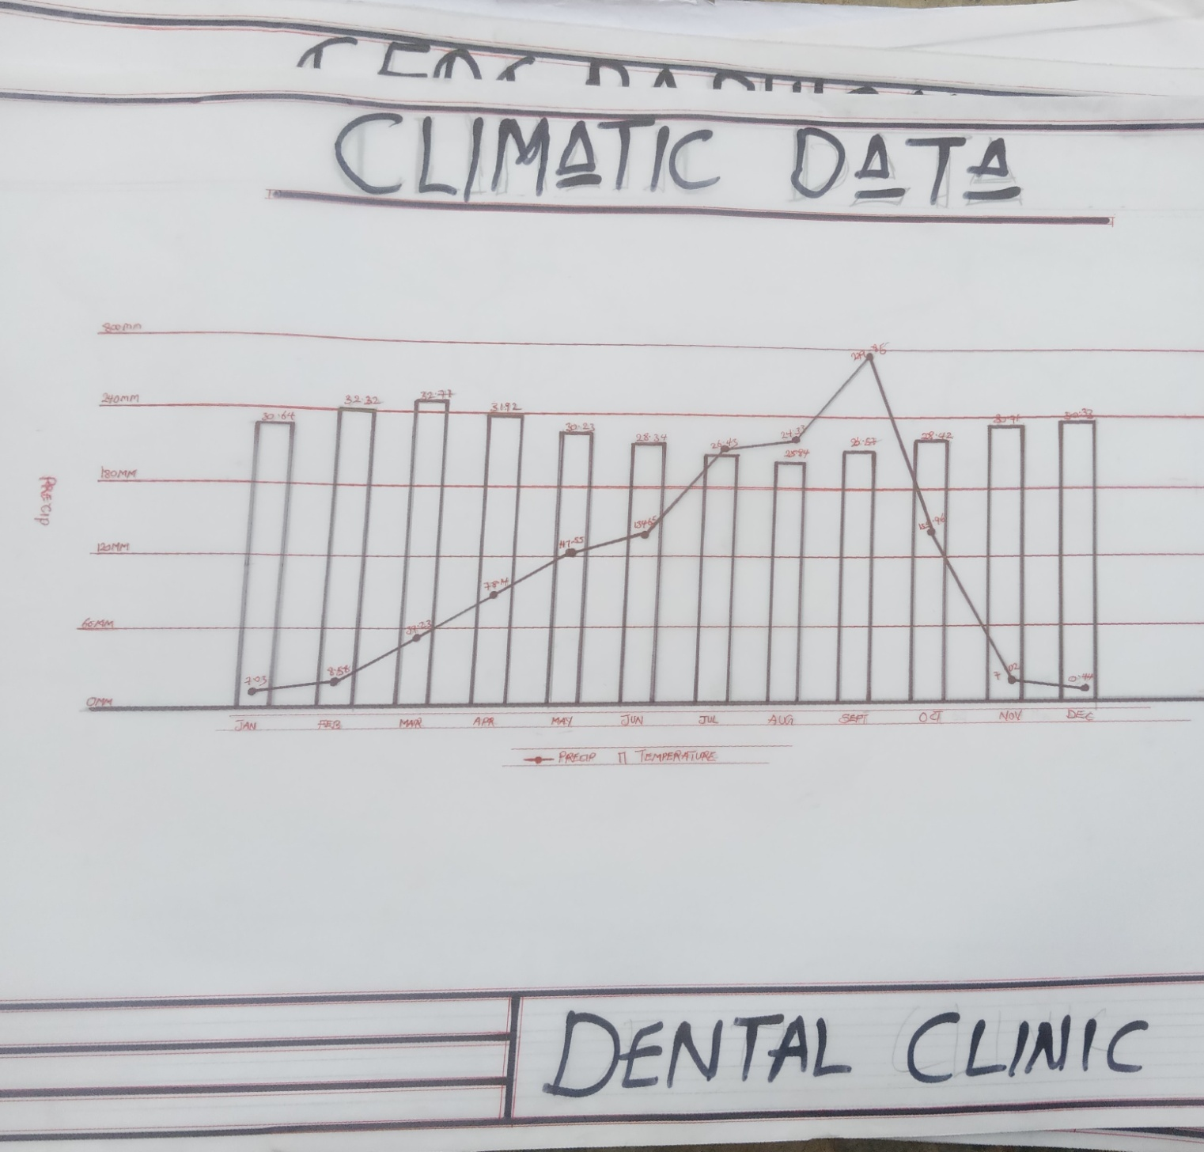
APPENDIX 6; SHOWING CLIMATIC DATA OF THE PROPOSED PROJECT
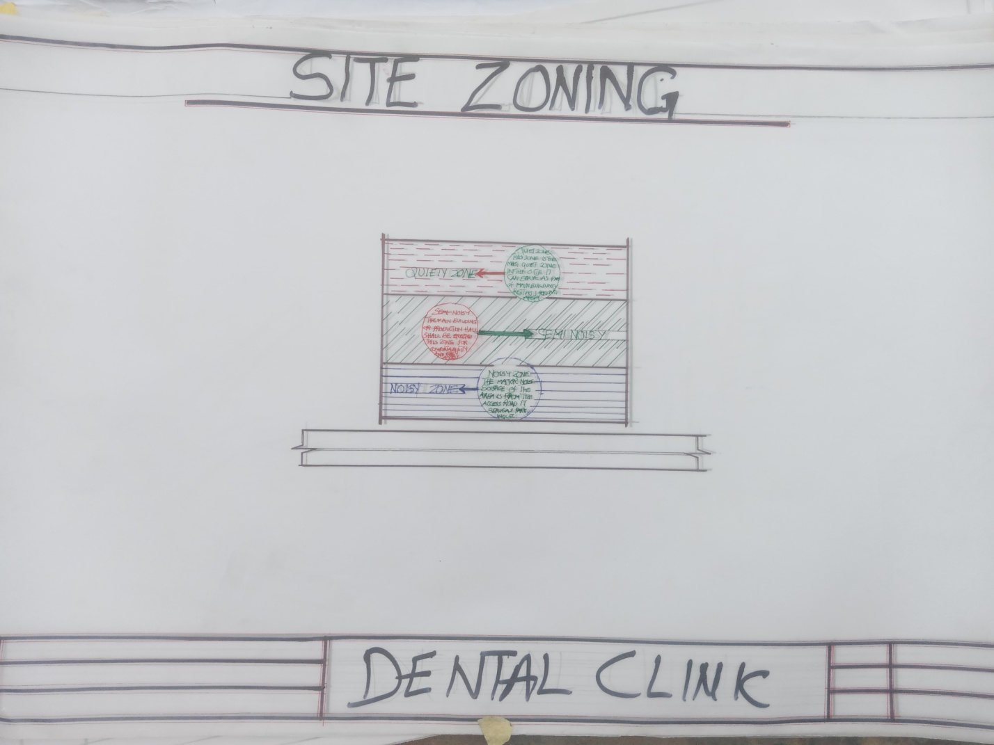
APPENDIX 9; SHOWING SITE ZONING OF THE PROPOSED PROJECT

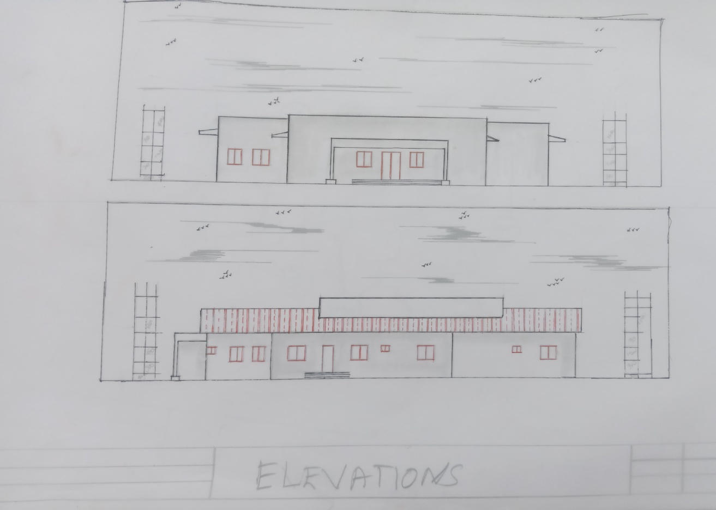
APPENDIX 10; SHOWING ELEVATION OF THE PROPOSED PROJECT

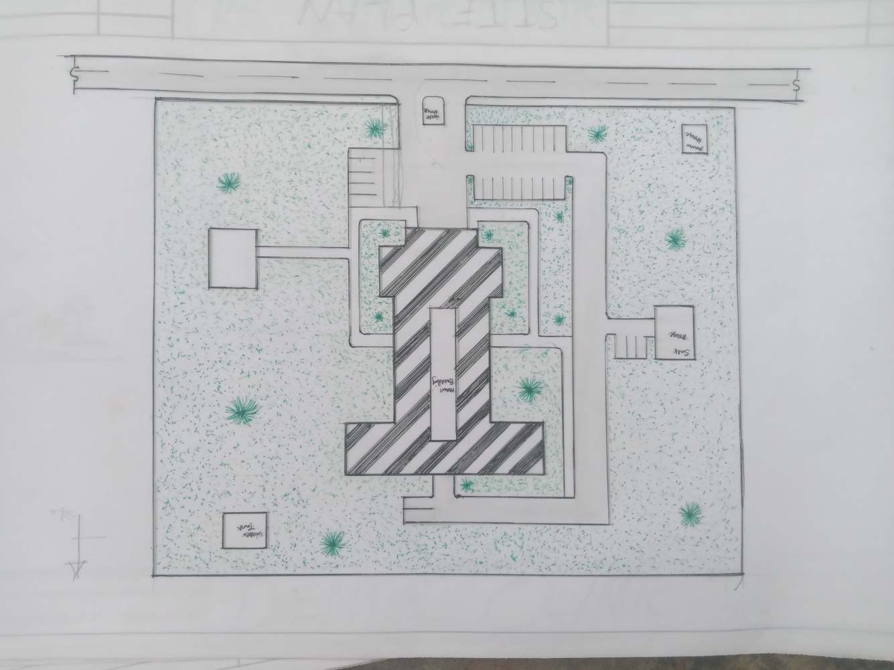
APPENDIX 11; SHOWING SITE PLAN OF THE PROPOSED PROJECT

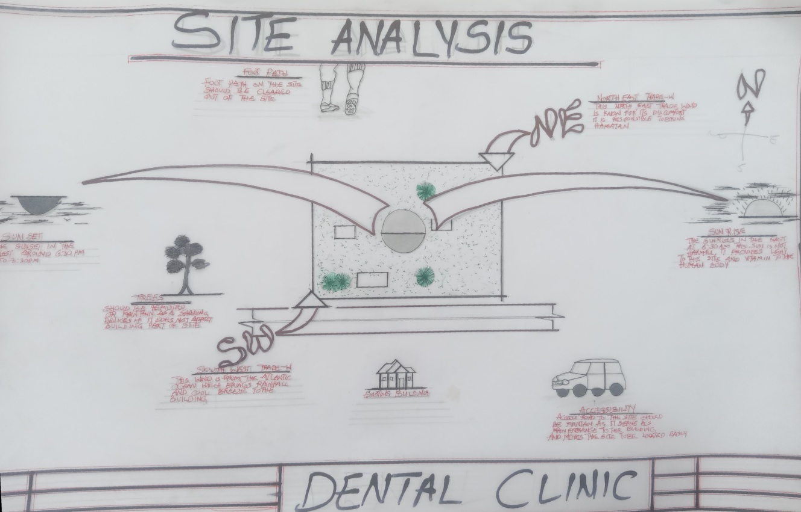
APPENDIX 12; SHOWING SITE ANALYSIS OF THE PROPOSED PROJECT

