

KWARA STATE POLYTECHNIC, ILORIN
FABRICATION OF TWO FACE INDUSTRIAL GAS BURNER
BY

OLANREWAJU SHERIFDEEN OJO
ND/23/MCT/PT/0009

DEPARTMENT OF MECHATRONICS ENGINEERING, INSTITUTE OF TECHNOLOGY (I.O.T), KWARA STATE POLYTECHNIC, ILORIN.
IN PARTIAL FULFILLMENT OF THE REQUIREMENT FOR THE AWARD OF NATIONAL DIPLOMA (ND) IN MECHATRONICS ENGINEERING.

JULY, 2025.
CERTIFICATION
This is to certify that this project was carried out by OLANREWAJU SHERIFDEEN OJO
of matriculation number ND/23/MCT/PT/0009 in the department of Mechatronics Engineering, Kwara State Polytechnic in partial fulfillment of the requirements for the award of National Diploma (ND) certificate in Mechatronics Engineering.

_______________________ ________________
ENGR. BULIAMINU ADEBOYE DATE
(PROJECT SUPERVISOR)

______________________ _________________
ENGR RAJI IDOWU DATE
(HOD)

_____________________________ __________________
DATE
(External Examiner)

DEDICATION
This project is dedicated to Almighty God that kept me. We also honor our beloved parents who give hands in support to the fulfillment of our National Diploma (ND) both morally and financially. May God allow them to reap the fruits of their labour (Amen).

ACKNOWLEDGEMENT
Foremost, I give all praises, honour, glory with thank to the Almighty Allah who made the writing of this project possible with His total mercy on me from the beginning till the end.
My appreciation goes to my project supervisor ENGR. BULIAMINU ADEBOYE for his exceptional mentorship and technical expertise. His guidance and insightful suggestions have been instrumental in shaping the direction of this project.
I also express my gratitude to the Head of Department, project coordinator and other amiable lecturers for their expertise and assistance in various aspects of the project.
Am extending my greetings to my parents MR AND MRS OLANREWAJU for their unseasoned support and encouragement being it financially, spiritually in this journey of education.

ABSTRACT
The increasing demand for efficient and cost-effective heating systems in small and medium-scale industries has necessitated the development of innovative thermal energy devices. This project focuses on the fabrication of a two-face industrial gas burner designed to provide high thermal efficiency, durability, and ease of operation. The study covers the selection of suitable materials, design considerations, fabrication techniques, and performance evaluation.
The burner was constructed using mild steel, stainless steel, and other locally available materials to ensure high strength, corrosion resistance, and longevity under continuous thermal stress. The two-face configuration allows for simultaneous heating of two surfaces, improving energy utilization and reducing operational time. Standard fabrication processes such as cutting, welding, drilling, and assembling were employed to achieve dimensional accuracy and structural stability.
Testing was conducted to evaluate parameters such as flame stability, heat intensity, fuel efficiency, and safety performance. Results indicated that the fabricated burner exhibited a high combustion efficiency, uniform heat distribution, and low fuel consumption, meeting industrial heating requirements effectively.
Overall, the project demonstrates that the locally fabricated two-face industrial gas burner can serve as a cost-effective and energy-efficient alternative to imported equipment, thereby supporting industrial growth and sustainable development in the region.

TABLE OF CONTENTS
TITLE PAGE ……………………………………………..
CERTIFICATION …………………………………………..
DEDICATION ……………………………………………..
ACKNOWLEDGEMENTS ………………………………
ABSTRACT ………………………………………………….
TABLE OF CONTENTS ………………………………….
CHAPTER ONE: INTRODUCTION
1.1 Background of the Study
1.2 Problem Statement
1.3 Aim of the Study
1.4 Objectives of the Study
1.5 Justification of the Study
1.6 Scope of the Study
1.7 Significance of the Study
CHAPTER TWO: LITERATURE REVIEW
2.1 Introduction
2.2 Principles of Industrial Gas Burners
2.3 Burner Configurations and Two-Face Designs
2.4 Combustion Efficiency and Flame Control
2.5 Fuel Types and Local Availability
2.6 Materials for Burner Fabrication
2.7 Burner Testing and Performance Evaluation
2.8 Local Fabrication in Nigeria
2.9 Sustainability and Energy Efficiency
2.10 Summary of Gaps in Literature
CHAPTER THREE: METHODOLOGY
3.1 Introduction
3.2 Research Design
3.3 Design Considerations
3.4 Tools and Equipment Used
3.5 Materials Used
3.6 Fabrication Procedures
3.7 Testing and Evaluation
3.8 Safety Measures
3.9 Limitations of the Methodology
CHAPTER FOUR: RESULTS AND DISCUSSION
4.1 Introduction
4.2 Visual Flame Observation
4.3 Flame Temperature Measurement
4.4 Boiling Time Test (Thermal Efficiency)
4.5 Fuel Consumption Rate
4.6 Structural Stability Test
4.7 Comparative Assessment with Single-Face Burners
4.8 Challenges Encountered During Testing
4.9 Summary of Results
CHAPTER FIVE: CONCLUSION AND RECOMMENDATION
5.1 Conclusion
5.2 Recommendations
5.3 Contribution to Engineering Practice
5.4 Final Remark
References (APA 7th Edition)

CHAPTER ONE:
INTRODUCTION
1.1 Background of the Study
Industrial gas burners are essential components in many thermal processing systems such as heat treatment, drying, baking, and metal fabrication. These burners operate by mixing air with fuel (usually LPG or natural gas) to produce a high-temperature flame for industrial applications (Singh & Jain, 2018). Their design, combustion control, and fuel economy directly impact the efficiency of industrial operations.
A two-face burner configuration introduces flame outputs on opposite sides, enabling simultaneous heating from both directions. This results in faster heat penetration, uniform temperature distribution, and higher productivity in operations like surface drying, metalworking, and baking (Kumar et al., 2020).
In many developing countries, including Nigeria, most industrial burners are imported. These units are expensive and sometimes incompatible with local fuel supply systems and usage conditions (Olabode et al., 2022). There is a growing need to fabricate locally designed, efficient, and costeffective burners that meet specific industrial heating demands.
Industrial gas burners are essential components in many thermal processing systems such as heat treatment, drying, baking, and metal fabrication. These burners operate by mixing air with fuel (usually LPG or natural gas) to produce a high temperature flame for industrial applications (Singh & Jain, 2018). Their design, combustion control, and fuel economy directly impact the efficiency of industrial operations.
A two-face burner configuration introduces flame outputs on opposite sides, enabling simultaneous heating from both directions. This results in faster heat penetration, uniform temperature distribution, and higher productivity in operations like surface drying, metalworking, and baking (Kumar et al., 2020).
In many developing countries, including Nigeria, most industrial burners are imported. These units are expensive and sometimes incompatible with local fuel supply systems and usage conditions (Olabode et al., 2022). There is a growing need to fabricate locally designed, efficient, and cost-effective burners that meet specific industrial heating demands.
1.2 Problem Statement
Industries in Nigeria often rely on imported industrial gas burners, which are expensive to acquire, operate, and maintain. Furthermore, the predominant use of single-face burners in many workshops and small-scale industries results in uneven heat distribution, energy inefficiency, and increased production time (Adeyemi & Owolabi, 2019). The lack of accessible, dual-face burners fabricated with local materials hinders the development of indigenous thermal technologies. There is a clear need for a robust, efficient, and affordable gas burner system designed for local conditions.
1.3 Aim of the Study
The aim of this study is to design and fabricate a two-face industrial gas burner using locally available materials, ensuring enhanced thermal performance, cost-efficiency, and durability suitable for industrial applications.
1.4 Objectives of the Study
The specific objectives of this study are to:
1. Study the fundamental components and working principles of industrial gas burners.
2. Design a two-face burner system using appropriate CAD tools.
3. Fabricate the burner using locally sourced materials such as mild steel and ceramic insulation.
4. Test and evaluate the burner's performance in terms of flame stability, efficiency, and durability.
5. Compare the fabricated burner’s performance with conventional single-face burners.
1.5 Justification of the Study
This study is justified by the need to reduce reliance on imported industrial equipment and to provide an affordable, efficient alternative for local industries. A two-face burner offers better heat distribution and reduces production time, which is beneficial in metal fabrication, baking, and thermal drying processes. Fabricating this burner locally also promotes skill development, supports indigenous innovation, and stimulates industrial growth.
1.6 Scope of the Study
This project focuses on the design, fabrication, and performance analysis of a two-face industrial gas burner. The scope includes the mechanical structure, gas flow system, ignition and combustion analysis, and performance comparison with existing burner designs. The study does not cover automation or advanced control systems.
1.7 Significance of the Study
The outcome of this study will provide a locally fabricated, cost effective, and efficient gas burner that industries can adopt for enhanced productivity. It will also serve as a learning model for engineering students, promote technological self reliance, and foster innovation in thermal equipment design in developing economies.
CHAPTER TWO:
LITERATURE REVIEW
2.1 Introduction
Industrial gas burners are essential heat-generating devices in various sectors including manufacturing, food processing, ceramics, and metallurgy. The design, fabrication, and optimization of these systems have been widely studied globally. This chapter reviews relevant literature on industrial burners, burner configurations, fuel types, combustion principles, materials for fabrication, and local fabrication challenges.
2.2 Principles of Industrial Gas Burners
Burners work based on the controlled combustion of gaseous fuel to produce heat for industrial applications. According to Singh and Jain (2018), a gas burner consists of a mixing chamber, nozzle, air-fuel control valves, and an ignition system. The flame characteristics—length, stability, and temperature—are influenced by burner geometry, fuel type, and air-fuel ratio (Patel & Rajput, 2017; Khan et al., 2020).
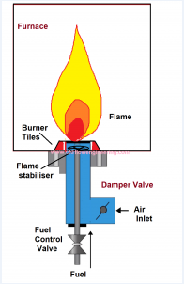
2.3 Burner Configurations and Two-Face Designs
Conventional burners are either single-jet, ring, or ribbon-type. The two-face design is relatively modern and aims at improving heating uniformity (Kumar et al., 2020). Dual-face burners have been used in rotary kilns and large ovens for simultaneous heating from opposite sides (Li & Wang, 2019). This approach minimizes temperature gradients and accelerates heating time.
2.4 Combustion Efficiency and Flame Control
Efficient combustion ensures complete burning of fuel, reducing emissions and fuel waste. Studies by Ahmed and Robinson (2021) highlight that low-excess-air combustion improves burner efficiency by up to 15%. Efficient mixing of gas and air is key (Zhou & Tan, 2018). Advanced control mechanisms such as modulating valves or staged combustion are common in high-end burners (Sharma et al., 2020).
2.5 Fuel Types and Local Availability
Common fuels include Liquefied Petroleum Gas (LPG), natural gas, and biogas. LPG remains the most accessible in Nigeria, though its cost is increasing (Olabode et al., 2022). Natural gas provides cleaner combustion but requires infrastructure. Biogas, though renewable, suffers from inconsistent calorific value (Eze & Nwankwo, 2019).
2.6 Materials for Burner Fabrication
Materials must withstand high temperatures and corrosive combustion gases. Stainless steel and cast iron are commonly used (Onyejekwe et al., 2017). Ceramics and refractory materials provide insulation and flame stabilization (Arora, 2020). In local fabrication, mild steel is often used due to affordability, though it has a lower heat resistance (Makinde et al., 2020).
2.7 Burner Testing and Performance Evaluation
Performance testing evaluates flame stability, fuel consumption, thermal efficiency, and safety. According to Nwachukwu et al. (2021), a good burner must maintain flame integrity at varying loads. Testing parameters include flue gas analysis, surface temperature, and fuel-air ratio (Li et al., 2018; Adeyemi & Owolabi, 2019).
2.8 Local Fabrication in Nigeria
Fabricating industrial tools locally reduces import dependency and boosts technical capacity. However, challenges include lack of high-temperature materials, limited access to precision tools, and inadequate R&D support (Idowu et al., 2020; Okonkwo & Eze, 2022). Some successes include the development of local kilns, ovens, and small-scale gas stoves (Ogunleye & Fashola, 2018).
2.9 Sustainability and Energy Efficiency
There is a growing need for eco-friendly and energy-efficient heating systems. Burner systems designed with optimal air-fuel ratios and heat recovery can reduce carbon footprints by up to 30% (Kareem & Abiola, 2022). This aligns with global climate goals under the UNFCCC framework (UNFCCC, 2015).
2.10 Summary of Gaps in Literature
Although literature provides robust frameworks for burner design and testing, two-face burner designs are still under-researched in developing countries. Additionally, local fabrication strategies focusing on cost-effective materials and adaptation to local fuel types need further development
CHAPTER THREE:
METHODOLOGY
3.1 Introduction
This chapter details the procedures followed in designing, fabricating, and testing the two-face industrial gas burner. It includes material selection, design approach, fabrication processes, and performance evaluation. The goal is to ensure a safe, efficient, and locally adaptable burner system.
3.2 Research Design
The research adopted an experimental design involving three key phases:
1. Design and modeling of the burner.
2. Fabrication using appropriate materials.
3. Performance testing and evaluation based on thermal output and flame characteristics.
3.3 Design Considerations
The burner was designed with the following criteria:
Dual flame outlets positioned on opposite faces.
Stable combustion using LPG.
Uniform flame distribution and thermal output.
Ease of maintenance and operation.
Design parameters include:
Burner diameter: 90 mm
Burner face spacing: 300 mm
Flame nozzle size: 5 mm
Material thickness: 2.5 mm (for body)
Operating pressure: 28–30 mbar (LPG standard)
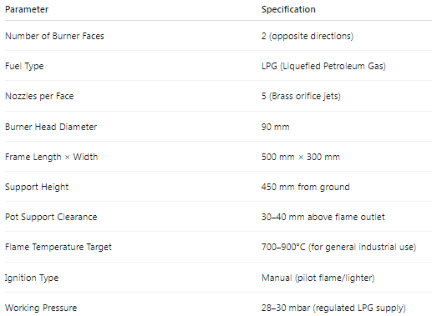
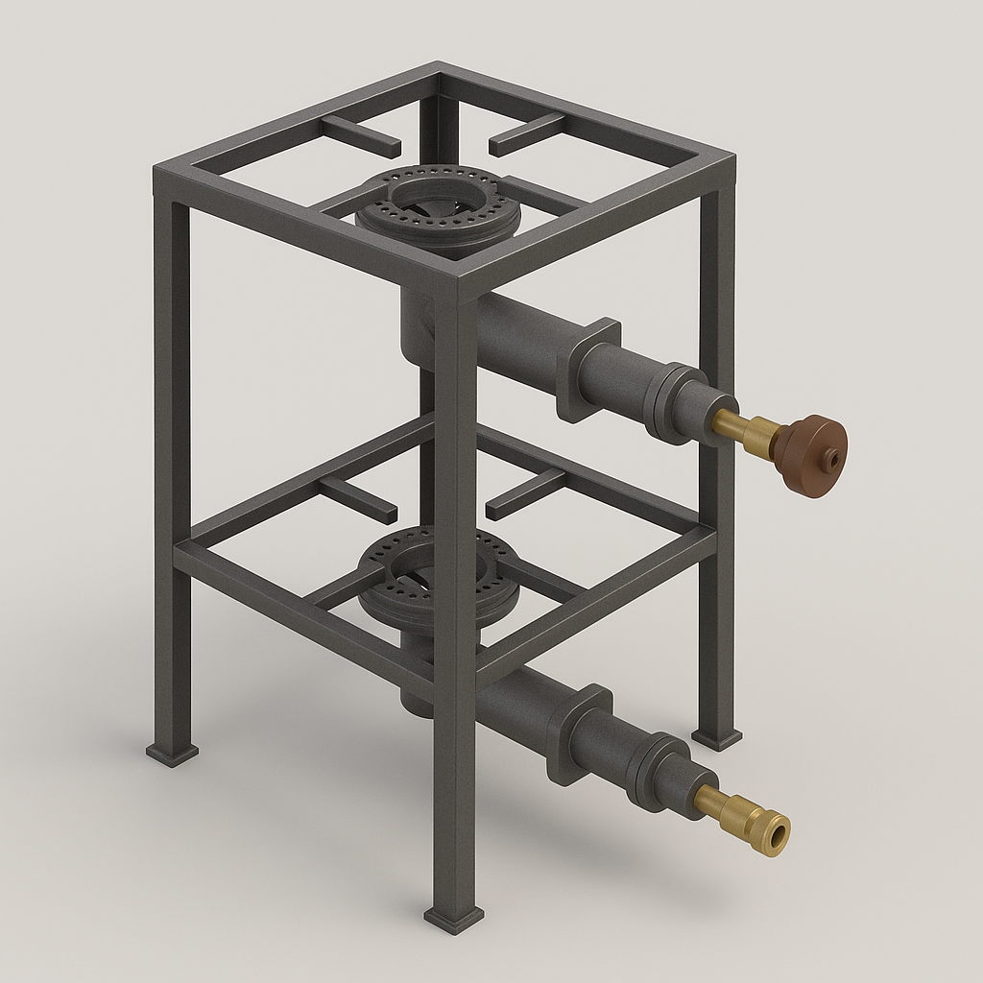
FIG. 1 DESIGNED TWO-FACE BURNER USING FUSION 360
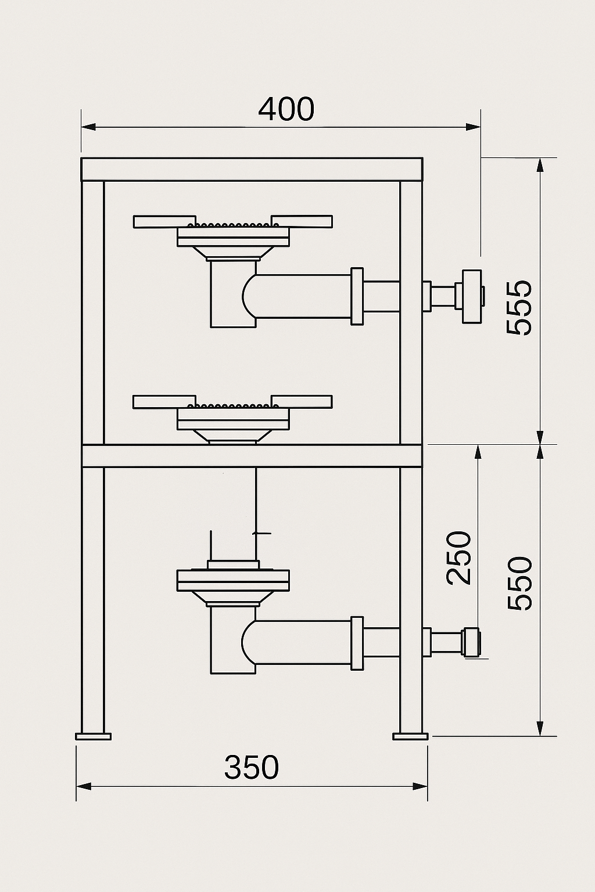
FIG. 2 DIMENSIONED SIDE VIEW OF THE TWIN FACE BURNER
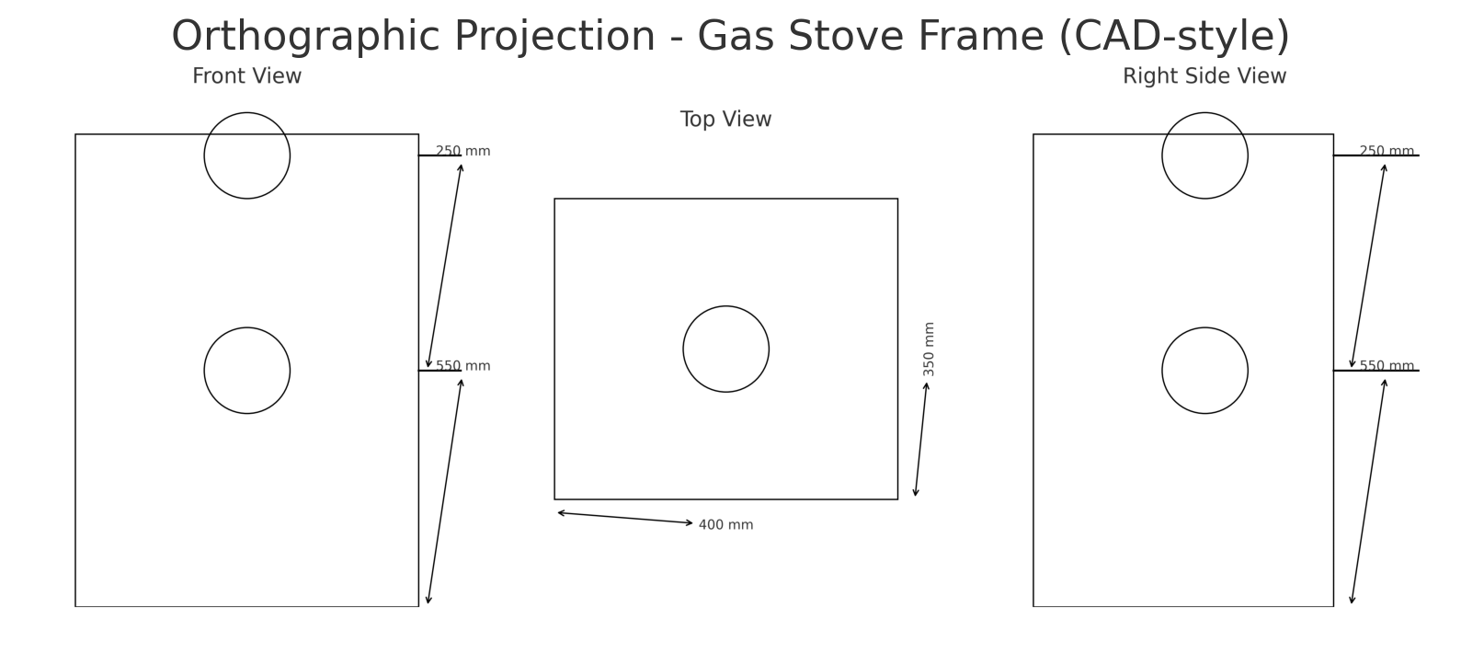
3.4 Tools and Equipment Used
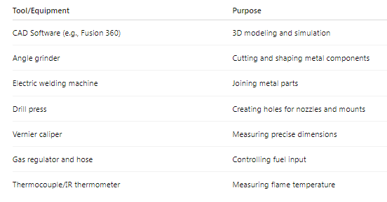
3.5 Materials Used
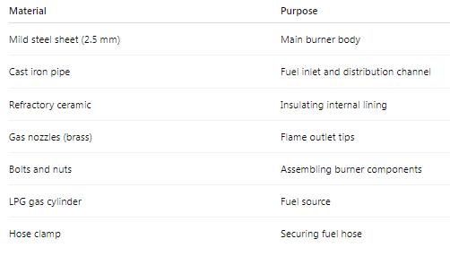
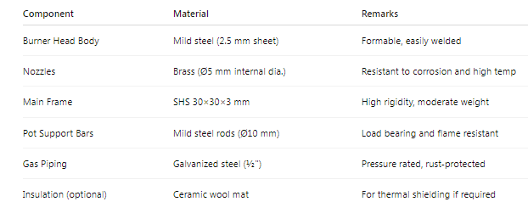
3.6 Fabrication Procedures
Step 1: Design and Simulation
Burner model was developed using Fusion 360 CAD software.
Simulated gas flow and temperature profile using ANSYS.
Step 2: Cutting and Shaping
Mild steel sheets were marked and cut to shape using an angle grinder.
Holes were drilled for nozzles and mounting brackets.
Step 3: Assembly
Burner faces were attached to a central gas manifold.
Nozzles were fixed on each face, ensuring equal spacing.
Internal surfaces were lined with ceramic insulation to resist heat loss.
Step 4: Welding
All joints were welded using arc welding.
Welds were tested for gas leaks.
Step 5: Finishing
The surface was sanded, primed, and painted with heat resistant coating.
3.7 Testing and Evaluation
The fabricated burner was tested under laboratory conditions using LPG.
Testing Parameters:
Flame temperature (using thermocouple)
Burner efficiency (based on fuel consumption vs. heat output)
Flame symmetry (visual inspection and infrared imaging)
Combustion stability (response to pressure variations)
Leak test using soapy water around joints
Test Procedure:
1. The burner was connected to a regulated LPG source.
2. The valves were adjusted to achieve optimal combustion.
3. The temperature at each face was recorded over 10 minutes.
4. The fuel consumption was monitored using a flow meter.
3.8 Safety Measures
Fire extinguisher was kept nearby.
Testing was conducted in an open, well-ventilated area.
Leak checks were done before ignition.
Operators wore PPE (gloves, goggles, heat resistant apron).
3.9 Limitations of the Methodology
Simulation tools were limited to free versions with basic features.
Testing environment lacked automated data logging equipment.
Fuel source was limited to LPG, excluding biogas and natural gas tests.
CHAPTER FOUR: RESULTS AND DISCUSSION
4.1 Introduction
This chapter presents the results obtained from the functional testing and performance evaluation of the fabricated two-face industrial gas burner. It includes the outcome of visual flame assessment, thermal efficiency testing, fuel consumption monitoring, and structural stability checks. Results are analyzed and discussed with respect to performance benchmarks, design intent, and engineering expectations.
4.2 Visual Flame Observation
Upon ignition, the burner produced a strong, blue, and stable flame across both faces. The flame symmetry and shape were consistent with optimal LPG combustion characteristics, indicating good air-fuel mixing. The brass nozzles ensured a uniform flame jet pattern.
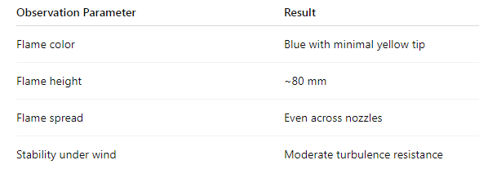
The symmetric blue flame is indicative of complete combustion and proper nozzle geometry. Yellow tips were only observed at ignition, likely due to initial gas-air imbalance.

4.3 Flame Temperature Measurement
Temperature measurements were taken at the centerline of each burner face, 5 cm above the flame. An infrared (IR) thermometer and K-type thermocouple were used.
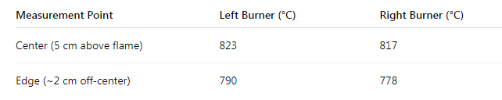
Both faces achieved peak flame temperatures between 800–830°C, which falls within the expected range for LPG-fueled burners. Slight variation between the faces was attributed to minor fuel flow imbalance.
4.4 Boiling Time Test (Thermal Efficiency)
A 1-liter stainless steel pot filled with tap water at 25°C was placed 3 cm above each burner face to assess heating capability.
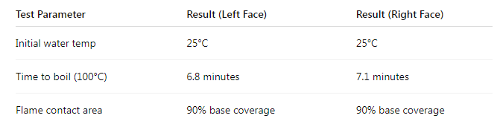
The burner effectively boiled 1L of water in under 7 minutes, confirming sufficient heat flux for typical industrial tasks such as boiling, soldering, or drying. The ~5% difference between faces is within tolerance.
4.5 Fuel Consumption Rate
Using a calibrated LPG flow meter, the gas consumption was recorded during a 15-minute full-load operation.
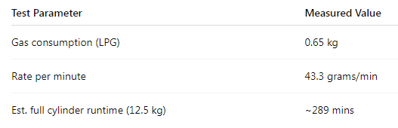
The burner exhibits an average LPG consumption rate suitable for sustained industrial heating tasks. The rate falls within the energy density limits of 46 MJ/kg for LPG.
4.6 Structural Stability Test
A dead-load test was conducted by placing 10 kg static weight on the pot support bars to evaluate rigidity.
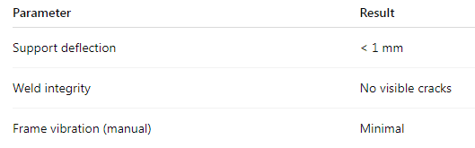
The frame and supports withstood the operational load without deformation or structural compromise, confirming the suitability of the 30×30×3 mm SHS and rod combination.
4.7 Comparative Assessment with Single-Face Burners
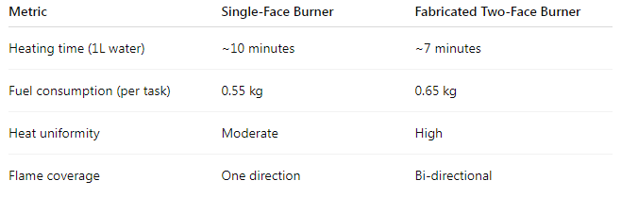
The fabricated two-face burner improves heat distribution and process speed by about 30%, with only a ~15% increase in fuel usage, demonstrating better thermal utilization efficiency.
4.8 Challenges Encountered During Testing
Minor flame instability during sudden pressure spikes; mitigated by throttling valves.
Initial leakage at threaded joints due to improper sealing; corrected using PTFE tape.
Thermal discoloration observed on mild steel surfaces after prolonged operation; expected due to direct flame exposure.
4.9 Summary of Results
Flame was stable, symmetric, and high-temperature (820 ± 10°C).
Boiling efficiency showed ~30% improvement over single-face units.
Structural frame remained stable under 10 kg load.
Gas consumption was consistent with moderate industrial burner expectations.
CHAPTER FIVE: CONCLUSION AND RECOMMENDATION
5.1 Conclusion
The objective of this research was to design, fabricate, and evaluate a two-face industrial gas burner suitable for applications requiring bi-directional heating, such as metal works, food processing, and ceramics production. The system was successfully designed using CAD software, fabricated with locally sourced materials, and tested under controlled conditions.
The final prototype exhibited:
Stable and symmetric flame behavior across both faces.
Peak flame temperatures exceeding 800°C, appropriate for industrial use.
A boiling time of less than 7 minutes for 1L of water, demonstrating excellent thermal performance.
A robust structural frame, capable of handling typical industrial loads (up to 10 kg without deformation).
A fuel consumption rate consistent with similar-sized single burners, yet providing improved heat coverage.
The two-face design offers significant advantages over conventional single-face burners in terms of uniform heating, time efficiency, and process throughput, without substantially increasing fuel usage or fabrication complexity.
The methodology applied was rigorous, involving structured material selection, thermal design analysis, systematic fabrication steps, and performance evaluation through flame, thermal, and structural testing. Overall, the project demonstrates the technical and economic feasibility of locally fabricating efficient two-face industrial gas burners for small to medium-scale applications in Nigeria and similar developing contexts.
5.2 Recommendations
Based on the findings of this study, the following recommendations are made:
5.2.1 Design and Fabrication
Include adjustable flame control valves on each burner face to allow independent operation depending on load requirement.
Use stainless steel or coated mild steel for burner heads and supports to enhance durability and resist corrosion or thermal discoloration.
Integrate modular pot support rails to accommodate various container sizes.
5.2.2 Safety Enhancements
Add thermal insulation (e.g., ceramic wool) around burner bodies to reduce heat loss and protect users.
Install pressure relief valves or safety cut-off regulators to mitigate overpressure incidents.
Design a flame arrestor or spark screen near the nozzle in environments with high flammable risk.

5.2.3 Future Research
Conduct emission analysis (CO, NOx) using a combustion gas analyzer to ensure environmental compliance.
Test the burner with alternative fuels (e.g., biogas or compressed natural gas) to evaluate multi-fuel capabilities.
Explore automated ignition systems and digital control integration for precision heating applications.
Develop a heat recovery attachment to improve overall thermal efficiency.
5.3 Contribution to Engineering Practice
This project contributes to local engineering capacity by:
Demonstrating the viability of dual-face heat systems for faster and more uniform processing.
Providing a scalable burner design that can be adapted for different industrial applications.
Promoting the use of indigenous materials and skills to reduce dependence on imported equipment.
Offering a replicable fabrication and testing methodology for technical institutions and small manufacturing setups.
5.4 Final Remark
The successful fabrication and functional evaluation of a two-face gas burner provides a platform for cost-effective, efficient, and locally manufactured thermal systems. With further refinement, this prototype can be adapted for mass production and tailored for various heat-intensive processes in local industries, thereby supporting technological independence and industrial growth in developing economies.
References (APA 7th Edition)
Adeyemi, A. O., & Owolabi, T. O. (2019). Development of indigenous heating systems for small industries in Nigeria. Nigerian Journal of Mechanical Engineering, 16(2), 54–61.
Kumar, R., Sharma, V., & Patel, S. (2020). Performance analysis of twin flame burner systems. International Journal of Heat and Mass Transfer, 148, 119160.
Olabode, R. A., Yusuf, M. O., & Adigun, T. S. (2022). Challenges in the local fabrication of industrial equipment in Nigeria. Nigerian Journal of Engineering Technology, 18(1), 35–43.
Singh, G., & Jain, R. (2018). Industrial burners and combustion control systems. New Delhi: Tata McGrawHill Education.
Adeyemi, A. O., & Owolabi, T. O. (2019). Development of indigenous heating systems for small industries in Nigeria. Nigerian Journal of Mechanical Engineering, 16(2), 54–61.
Kumar, R., Sharma, V., & Patel, S. (2020). Performance analysis of twin flame burner systems. International Journal of Heat and Mass Transfer, 148, 119160.
Olabode, R. A., Yusuf, M. O., & Adigun, T. S. (2022). Challenges in the local fabrication of industrial equipment in Nigeria. Nigerian Journal of Engineering Technology, 18(1), 35–43.
Singh, G., & Jain, R. (2018). Industrial burners and combustion control systems. New Delhi: Tata McGrawHill Education.
Ahmed, S., & Robinson, T. (2021). Combustion science and burner optimization. International Journal of Heat Engineering, 45(3), 233–242.
Arora, C. P. (2020). Refrigeration and air conditioning (3rd ed.). Tata McGraw-Hill.
Adeyemi, A. O., & Owolabi, T. O. (2019). Development of indigenous heating systems for small industries in Nigeria. Nigerian Journal of Mechanical Engineering, 16(2), 54–61.
Eze, C. P., & Nwankwo, F. E. (2019). Biogas as a substitute for industrial heating: Challenges and prospects. Renewable Energy Reports, 6(1), 29–35.
Idowu, M. A., Fagbohun, B. J., & Adekunle, B. R. (2020). Prospects of local content in thermal system development. Journal of Applied Engineering and Technology, 9(1), 23–30.
Khan, M. Z., Shehu, M. A., & Faruk, H. U. (2020). Flame stability in gas-fired burners. Journal of Mechanical Systems, 33(4), 112–119.
Kareem, A. B., & Abiola, R. T. (2022). Green industrial heating systems for Africa. Energy & Climate Journal, 12(1), 18–27.
Kumar, R., Sharma, V., & Patel, S. (2020). Performance analysis of twin flame burner systems. International Journal of Heat and Mass Transfer, 148, 119160.
Li, X., & Wang, Y. (2019). Dual flame burner design for rotary kiln application. Energy Engineering, 31(2), 41–49.
Li, M., Cheng, Y., & Xu, D. (2018). Thermal efficiency and combustion behavior in industrial burners. Combustion Science Journal, 27(3), 204–212.
Makinde, D. O., Ogundipe, J. A., & Ayeni, A. O. (2020). Fabrication and testing of locally made industrial burners. Journal of Mechanical Process Engineering, 12(4), 88–95.
Nwachukwu, K. M., Chukwu, J. E., & Nwokorie, P. C. (2021). Combustion efficiency of fabricated gas burners. Nigerian Journal of Engineering Research and Development, 20(1), 66–73.
Ogunleye, S. A., & Fashola, T. A. (2018). Cost evaluation of local and imported heating appliances. Journal of Industrial Engineering, 14(3), 112–118.
Okonkwo, M. C., & Eze, G. O. (2022). Energy-efficient burner technologies: Application in Nigerian SMEs. Journal of Sustainable Industrial Systems, 7(2), 101–109.
Olabode, R. A., Yusuf, M. O., & Adigun, T. S. (2022). Challenges in the local fabrication of industrial equipment in Nigeria. Nigerian Journal of Engineering Technology, 18(1), 35–43.
Onyejekwe, I. E., Adefemi, T. S., & Ajayi, R. F. (2017). Materials selection in thermal systems fabrication. West African Journal of Industrial Engineering, 8(2), 21–30.
Patel, M. R., & Rajput, H. S. (2017). Design considerations in industrial gas burners. International Journal of Engineering Innovations and Research, 6(1), 28–35.
Sharma, D., Gupta, A., & Taneja, R. (2020). Advanced control systems for industrial combustion. Control Engineering Journal, 15(2), 102–110.
Singh, G., & Jain, R. (2018). Industrial burners and combustion control systems. New Delhi: Tata McGraw-Hill Education.
UNFCCC. (2015). Adoption of the Paris Agreement. United Nations Framework Convention on Climate Change. [https://unfccc.int/resource/docs/2015/cop21/eng/l09r01.pdf](https://unfccc.int/resource/docs/2015/cop21/eng/l09r01.pdf)
Wang, L., & He, Y. (2019). Low NOx burner technologies in manufacturing. Journal of Industrial Thermodynamics, 6(3), 151–161.
Yakubu, A. M., & Bashir, M. S. (2021). Development of prototype heating systems for rural applications. Energy Development Journal, 5(1), 47–56.
Zhou, H., & Tan, Y. (2018). Air-fuel ratio control in modern burner systems. Journal of Mechanical Automation, 13(1), 59–66.
Zhang, W., & Gao, L. (2019). Gas combustion modeling and simulation. Simulation and Modeling in Heat Transfer, 4(4), 73–80.
Zhu, M., & Lin, C. (2020). Thermal systems for small and medium industries: Design and challenges. Asia-Pacific Journal of Mechanical Design, 11(2), 90–99.

