
THE CRITICAL EVALUATION OF THE COOKING POWER EFFICIANCY OF STANDING SOLAR

BY

MUDASHIRU USMAN
ND/23/SLT/PT/0752

A RESEARCH PROJECTSUBMITTED TO THE DEPARTMENT OF SCIENCE LABORATORYTECHNOLOGY, (SLT) INSTITUTEOF APPLIED SCIENCE (IAS) KWARA STATE POLYTECHNIC,ILORIN
INPARTIALFULFILMENTFORTHEEQUIREMENTFORAWARD OF NATIONAL DIPLOMA(ND) INSCIENCE LABORATORY TECHNOLOGY(SLT)

Supervised by: DR. OLAOREK.O
JULY,2025

CERTIFICATION
This is to certify that this project was carried out by Mudashiru Usman with matriculation number ND/23/SLT/PT/0752 And it was read and approved as meeting the requirement of the Department of Science Laboratory Technology, Institute of Applied Science, Kwara State Polytechnic, Ilorin for the award of the National Diploma (ND) in the Department Science Laboratory Technology.

DR. OLAORE K. O DATE

Project Supervisor

MR. SHITTUS. A DATE
Co-ordinator

DR. USMAN ABDULKAREEM DATE
Head of Department (H.O.D)

EXTERNAL SUPERVISOR DATE

ii

DEDICATION
ThisresearchworkisdedicatedtoAlmightyGodforhisinfinite blessingandmerciesuponme.Itisalsodedicatedtomydearparent fortheirsupport,generallyspiritually,morallyandphysicallysincethe beginningof my life till the presentmomentandforever.

ACKNOWLEDGEMENT

We give thanks to Almighty God for He is good and His mercies endure forever.
My special appreciation goes to my parents, Mr. and Mrs Mudashiru for their moral and financial support throughout my academic may you
My appreciation goes to my project supervisor in person of DR. K.O. OLAORE who have been there for us before and during my project work, thanks for being our father during this journey. I sincerely appreciate you sir, my prayer for you is that God should grant you more understanding and success in all your endeavor, and for your children, May God's favor locate them wherever they go in life. I as well celebrate and give kudos to all the amazing and brilliant lecturers as well as the technologist of the department of science laboratory technology (Physics/Electronics Unit). God bless you all(AMEN).

TABLEOFCONTENT

Content Page

Titlepage i
Certification ii
Dedication iii
Acknowledgement iv
Tableofcontent v
Abstract viii
CHAPTERONE:
Introduction 1
Backgroundofthestudy 1
Statementoftheproblem 2
Justificationofthework 3
Aimandobjectives 4
CHAPTERTWO:
LiteratureReview 5
Classificationofsolarcookers 12
Workingprincipleofsolarboxcooker 16
CHAPTERTHREE:METHODOLOGY
Studysite 18
Materialforconstruction 18
Boxframe 18
Innerbox 19
Reflectingmirror 19
Glasslid 20
Absorber/potcoating 20
Insulatingmaterial 20
Experimentalequipment 21
Testprocedure 24

Cookingpower 26
Overallthermalefficiency 27
CHAPTERFOUR:RESULTANDDISCUSSION 29
CHAPTERFIVE:CONCLUSION 33

RECOMMENDATIONS 34
REFRENCES 35
APPENDIXI 38
APPENDIXII 40

ABSTRACT
Biomass and fossil fuel aremostly used in the rural areasof thedeveloping countries for cooking. These energy resources have negative impacts on environment andhumanhealthmainly due todeforestationandgreenhouse emission. Nigeriais havingproblemofepilepticsupplyofelectricitywhichhascauseddifferent economic challenges to the populace. The aim of this project is to test and determine the thermal efficiency of the constructed standing solar box cooker which was designed using locally available material. The test was carried out on the 23rd ofApril, 2023 at Kwara State Polytechnics using 140gram of spaghetti with 0.5kg of water under average solar radiation of 912w/m². It was shown in the result that the maximum absorber plate temperature was 80.5°c attained at 2:56pm having solar radiation of 1159.6w/m². The cooking time for the spaghetti was 1hour 15minutes using the constructed Standing Solar Box Cooker. Conclusively, Standing Solar Box Cooking is simple, safe and it is convenient to cook food without consuming fuel and cooksatmoderatetemperaturetohelppreservethefoodnutrient.

CHAPTERONE

INTRODUCTION

BackgroundofStudy

Solar energy is outstanding among other methods for reducing the utilization of non- renewable resources. Solar cooking is reckoned as a technically and commercially viable option for cooking, drying food, vegetables, and fish etc. especially in areas with abundant solar radiation. Solar cooking offers an effective method of utilizing solar energy for meeting a considerable demand of cooking energy and hence, protecting environments (Ishan, 2005).
Many solar cookers currently in use are relatively inexpensive, low-tech devices, although someare as expensive astraditional stoves, advanced and large-scale.Solar
cooker uses no fuel and cost nothing to operate. Researchers are promoting their use worldwide in other to help reduce fuel costs, air pollution, and slow down the deforestation and desertification (Wikipedia.org).
Gathering firewood for coking is a form of outdoor cooking and is often used in a situationwhereminimalfuelconsumptionisimportant,orthedangerofaccidental fire is high, health and environmental

consequenceofalternativesaresevere(www.solarcooking.wikia.org).

Many types of solar cookers exist, including parabolic solar cookers, solar boxcookers and panel solar cookers. The box type solar cooker, however, is still the preferred option for individual family needs, mainly because of its small size and simple handling and operational requirements. Depending on the latitude andweather,food canbe cook eitherearlyorlaterinthe day. A solarbox cookeris smoke free unlike other forms of cookers which uses smoky cooking fires whichresult to eyes and lung disease among others. Solar box cooking system helps to reduce the demand for wood and prevent deforestation, saving fossil fuel andlowering utilitybills (Ishan, 2005).
Fortunately,Nigeriaisamongthetwenty-onecountrieswiththehighestpotential for solar cooking. Nigeria lies within a high sunshine belt and thus, has an enormous solar energy potential(www.solarcooking.wikia.org).

StatementoftheProblem

Priortotheemergenceofrenewableenergy,fossil fuelsconstitutetheprimary energy resources that has been used to power human technological advancement,since the industrial revolution. But there are consequences, for instance, high volume of fossil fuel emission is harmful to public health and its environment. While the use of fire wood not only causes health damages, deforestation but loss of habitat for millions of species.
All the problems stated above can be reduced or eradicated by using the smokeless standing solarbox cooker, which was constructedfrom cheapand locallymaterials.

Justificationofthe Work

With the high cost of cooking fuels in Nigeria and the epileptic supply of electricity, majority of Nigerians are left with no option but to use fire wood for cooking. The health and environmental hazards associated with this practice cannot be over emphasized. As such, standing solar box cooker would provide an alternative to reducetotaldependence onfossil fuel,electricityand firewood for cooking.

AimsandObjectives

Theaimofthisprojectistodesign,constructandtestsolarboxcookerthatwould be technically efficient, user friendly and cost effective to cook food for family offive.

Thespecificobjectivesoftheworkare:

    - Select appropriate materials (bearing inmind cost, availabilityanddurability) for the various partsof the standingsolarbox cooker.
    - Determinetheperformanceevaluationofthestandingsolarboxcookerby measuring the following parameter:
      - Theabsorberplatetemperature

      - Thecookingfluidtemperature

      - Thecoverpottemperature

      - Thesideofthecookingpot temperature

      - Theairgaptemperature

      - Thesolarradiation

    - Determinethethermalefficiencyofthestandingsolarboxcooker

CHAPTER TWO LITERATURE REVIEW
Asolarcookerisadevicethatcooksfoodusingonlysolarradiationandcansave

conventional fuels to a significant amount. It is the simplest, safest, most convenient way to cook food without consuming fuels or heating up the kitchen. It however, supplements the cooking fuels but cannot replace it in total. In recent times, rigorous studieswerecarriedout onthemethodofutilizingsolarenergy.Solarcookerlike the standing solar box type and concentrator types have offered important tools for these studies. Efforts have been totally geared towards the design, development and testing of these devices across the globe. Out of these types of solar cooker, the standing solarbox type whichare simplerinterms ofoperationandfabrications, havesofar beenstudiedextensivelywithinNigeria,otherWest Africancountries and across the globe (www.solarcookers.org).
Nyi Nyi Soeet’al (2019),intheirpaperpresentedthe designandconstructionof solar box cooker using locally available material while building the solar box cooker, the consideration of heat principles are heat gain, heat storage and heat loss.According tothe testing ofsolarbox cookerconstructed,the average cooking time for eggs was about 1.5 hour, for rice about 2.25 hour and 4 hours for prawn. In their paper,itwasconcludedthatstandingsolarbox cookingissimple,safe,convenient

to cook food without consuming fuel or heating up the kitchen, cook at moderate temperatureand helpsto preserve food nutrient.
Uhuegbu (2010), in his paper constructed a wooden solar box cooker successfully withcheapandlocallyavailablematerial havingthermal efficiencyof96%.From hisvariousexperimentsthatwerecarriedout,thehighesttemperaturegottenboth on the ground floor and at the top of the roof were 72 both on the days with air temperature of 38 and 35 respectively. In his result, the efficiency was found to increase with decreasing temperature difference between collector temperature and ambient temperature. He further stated that, the increase in temperature does not necessarily lead to increase in efficiency while its efficiency decreased with decreasing solar radiation.
Pryse, et.al (2019),in their paper designed and fabricated50cm X 50cm X 30cm solar box cooker. Their new design was an improvement for an existing solar box cooker.Theirworkfocusedontheimprovement onincreasingthesolarcollector area of the existing type from 0.52m2 to 0.9171m2. The improved solar box cooker was evaluated by conducting a no-load and a load test and also the solar cooking efficiency was calculated. The results of their test showed a progressive increase in solar cooking chamber harvested temperature and cooking capacity over a period of 60minsand100minsduringnoloadandloadtestconditionsrespectively.Itwas

concluded that the solar box cooker constructed have a cooking efficiency of about 2.8%.
Ogunwole(2006), designedandconstructedasolarbox cooker,thesolarcooker was made of casing and absorber. The absorber he used during construction was a squarebasepot,blackened with smoke, and itwas made ofstainless steel. The casing was made of two boxes to minimize heat loss and also used an aluminum foil as reflectors. His test involves cooking and it was observed that the rice took 1hour 45mins, beans took 2hours 30mins, and yam 1hour 30minutes. In his experimental result, an average temperature of100 was obtained from the collector from anambient temperature of 34.
Ishan etal, (2007) modeled a box typesolar cooker employing anon tracking planar reflectors which was designed and fabricated for the purpose of cooking. Its thermal performance wasinvestigatedexperimentally. Intheirresult, the cooking power of the laboratory modeled box type solar cooker was found to be 20-25% higher thanthat of a conventional cooker in various pre-specified test conditions. It was also concludedintheirpaperthatthesolarcookerutilizingnon-trackingreflectors provide increased heat collection and faster cooking, compared to the conventional box type solar cooker.

Rahul Aadiwal, et al, (2017) stated in theirstudy thatcookingis the major necessity for people all overthe world. They also stated intheir paper, that cooking accounts foramajorshareofenergyconsumptionindevelopingcountries.Theyfurther agreedthat,solarcookersare commonly usedin the domestic sectorinmost countries with abundant solar radiation. In their research, it was reported that according to Indian government survey, over 77% of rural households in the country were estimated to depend on firewood and chips for cooking. Also, over 7% useddung cake and only 9% used Liquid Petroleum Gas while in urban areas, Liquid PetroleumGaswastheprimarysourceofenergyinnearly62%ofhouseholds.It was also stated in their result that, replacing the traditional cooking methods by solar energy can be considered as an alternative for meeting the energy crisis and also the advantages of the use of solar cookers would result in the reduction of the release of CO2 in the environment.
Kimbabo (2007), in their work stated various parameters and affirm that results obtained from this study that under various conditions of insulation and wind,different types of solar cookers are superior to others. He further stated that, underbest respective conditions, solar box cookers have lower performance compared to reflector cookers. He also reported that, the reflector cooker with glass reflector achieve the highest temperatures and accordingly shortest cooking time than anyothercookerstestedundersunny dayswithno cloudcover.Herecommendedthat,

it is the most suitable type of solar cooker in areas with long duration of high solar radiation with no cloud cover and low wind interference. He further affirms that, the reflector cooker with polished aluminum reflectors has significantly lower performance than that of the glass reflector under clear sky condition while the reflector cooker with unpolishedaluminum reflector has the poorest performance of all solar cookers even the solar box cookers under clear sky condition. He therefore concluded that, the ordinary unpolished aluminum should therefore never be used as reflector for solar cookers. He further explained that, he discovered the solar box cooker was able to cook 2kg of rice which is sufficient for a moderate family in Tanzania.According to his result, it was discovered that many solar box cookers can be used to cook food for households in areas with medium and high isolation with appropriate selectionofthe type and specificationof the cookers.
Mahaveretal.(2012),intheir paperpresentedthedesign,development,thermal and cooking performance studies of a solar cooker; it was named as Single Family Solar Cooker (SFSC) which is small in size, convenient to design, inexpensive, lightweighthybridinsulationandspeciallydesignedlightweightpolymericglaze was considered the main features of the solar box cooker constructed. It was further stated that the thermal profiles of various components of SFSC on different daysunder different conditions was measured. During testing, it was recorded that the highestplatestagnationtemperatureunderno-loadconditionapproached144in

which the two figures of merits F1 and F2 are found to be 0.116Cm2/W and 0.466, respectively, which were according to the Bureau of Indian Standards. It was also included in their paper that, cooking power regression curve is fairly linear with the regression coefficientR2 =0.948 withinitial cooking power103.5W and the heat losslevel 1.474W/; placeit intheregionofsmall cookerwithgoodinsulation,as perInternationalStandard.Theyfurtherstatedthat,thermalandcooking performance of Single-Family Size cooker (which is small in size and has been fabricated by using new efficient materials for glaze, insulation and casing) were found to satisfy Bureau of Indian Standards and International Standard. They also calculated F1 and F2 values indicate that the cooker can be used for consecutive cooking on a sunny day. The values of the initial adjusted cooking power, heat loss coefficient and adjusted cooking power at a temperature difference of 50 were within the range of the parameters obtained by Funk (2000) for small size good insulation solar cookers. According to their results, the cooking of different items ascertains its goodcookingperformancefor cookingrequirementoftwopersons for twomeals and thestagnationtemperatureachievedby SingleFamilySizeCookerwas 144.
Grocery et al, (2010), intheir paper designed and constructed a Heaven Flame solar box cooker capable of boiling 1.8litres of waterunder the air temperature of about110 in the solar box cooker for 45minutes. During the test, they displayed the solar box cookerinthesunfor 3daystotestthework abilityaswellastotesttheeffect

oftemperaturefromlatehoursofearlymorning uptolateintheeveningwiththe aid of inserted thermometers (0 - 360). The results from their test shows that the best time to cook with the solar box cooker is between the hours of 11:00 am to 4:00pm (Nigeria time) on sunny days, while the incorporation of heavy materials such as piecesof stonesasheat storagematerialsinside the box cookers helpstomaintain.

ClassificationofSolarCookers

A solar cooker is a device which uses the energy of direct sunlight to heat, cook or pasteurizefood ordrink. Basically,thereare 3 typesof solarcookers, namely:
- Solarpanelcookers:

- Solarparaboliccookers

- Solarbox cookers

- Solar panel cookers may be considered the simplest type available due to their ease of construction and low-cost material. In solar panel cookers, sunlight is concentrated from above. Panel cookers have a flat panel which reflects and focuses sunlight for cooking and heating. This methodof solar cooking is notvery desirablesince itprovides a limitedcooking power.

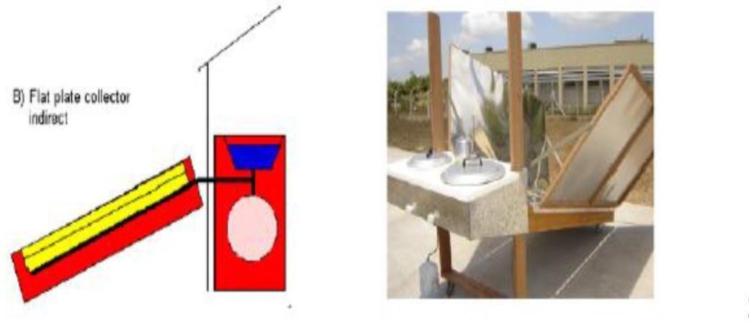

Fig2.2.1ASolarpanel cooker

  - Solar parabolic cookers can reach extremely high temperatures in a very short time and unlike the panel cookers or box cookers; they do not need a special cooking vessel.However, a parabolic cooker includes risk of burning the food if left unattended for any length of time because of the concentrated power. A solar parabolic cooker simply consists of a parabolic reflector with a cooking pot whichislocatedonthefocuspoint ofthecookerandastandtosupport the cooking system.

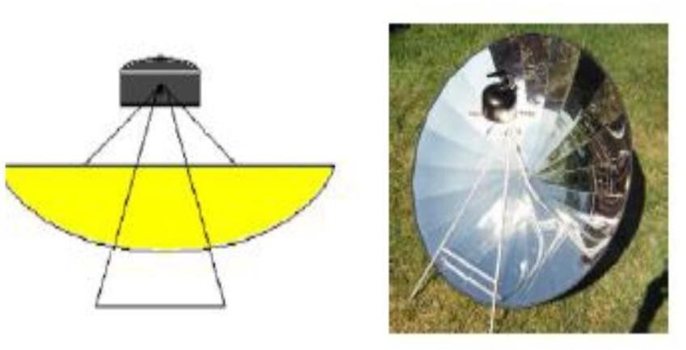

Fig2.2.2AParabolicsolarcooker

  - A box type solar cooker is the most common and inexpensive type of solar cookers.These boxcookershave averysimpleconstructionandtheyare made of low-cost materials, which essentially consist of a black paintedmetallic trapezoidal tray (cooking tray) and is usually covered with a double glass window. It is kept in a metal or fibre-glass outer casing and the space between the cooking tray and outer casing is filled withthe insulation likeglass wool. The incoming solar radiation falls onto the double glass lid and passes throughit tostrike the blackenedcooking pots andthe cooking tray. The glass covers, while transmitting radiation of short wavelength which form major part of solar spectrum, is almost opaque to low temperature radiation emittedwithinthe box.Thus,thetemperature ofthe box risesuntila balance is reachedbetween the heat receivedthrough glazingandheat lost byexposed

surface (greenhouse effect). In addition, a plane reflecting mirror (booster mirror) ofabout equal sizeasthat theapertureareaisusedforaugmentation of solar radiation on the aperture. Thecooking tray is insulated on the sidesand bottom.Theheat is absorbed by theblackened surfaceand gets transferred to the food inside the pots to facilitatecooking.
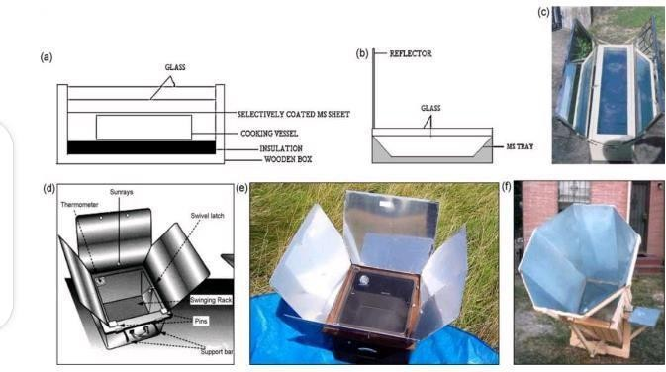

Fig2.2.3Boxtypesolarcooker

Workingprincipleofsolarboxcooker
  - Concentratingsunlight:Amirroredsurfacewithhighspecularreflectionis usedtoconcentratelightfromtheSun intoa smallcooking area.Depending

onthegeometryofthesurface,sunlightcouldbeconcentratedbyseveral

orders of magnitude producing temperatures high enough to melt salt andmetal. Such high temperatures are not really required for most household solar cookingapplications.Solarcookingproductsaretypicallydesignedto achievetemperaturesof65°C(150°F)(bakingtemperatures)to400°C (750°F) (grilling/searingtemperatures)on a sunny day.
  - Converting light energytoheat energy: Solarcookers concentratesunlight onto a receiversuch as a cookingpan.Theinteraction between the light energy and the receiver material converts light to heat and this is called conduction. The conversion is maximized by using materials that conduct and retain heat. Pots and pans used on solar cookers should be matte blackincolor to maximizeabsorption.
  - Trapping heat energy: It is important to reduce convectionby isolating the air inside the cooker from the air outside the cooker. Simply using a glass lid on yourpotenhanceslightabsorptionfromthetopofthepanandprovides a greenhouse effectthat improves heat retention and minimizes convectionloss. This "glazing" transmits incoming visible sunlight but is opaque to escaping infrared thermal radiation. In resource constrained settings, a high- temperatureplasticbagcanserveasimilarfunction,trappingairinsideand

makingitpossibletoreachtemperatureson coldandwindydayssimilarto those possible on hot days (en.m.Wikipedia.org).

CHAPTER THREE METHODOLOGY

Studysite

The thermal efficiency of the constructed standing solar box cooker wasexperimented on the 23rd of April, 2023, in Kwara State Polytechnic, Ilorin, Kwara State, Nigeria.

MaterialsforConstruction

In order to constructan effectivestandingsolar box cooker, thechoiceof the material was given several thoughts. The materials are structurally sound, able to withstand hightemperature, safe, andeffective withregardtocapture solar energyandretain the heat. The construction of standing solar box is described by the box frame, inner box, cooking pot, Insulation material, glass lid, reflector, rubber lining, hinges and handles.

Boxframe

Plywood was used asthe boxframe becauseit isvery cheapand locallyavailable. It is anopaque substance anddoes not allowlight topass throughit.It containsa natural polymer based on the cellulose molecules. It is firm on the ground and can withstanda moderate wind speed(vikaspedia.in).

Innerbox

A flat metal plate was used as the inner box and also act as the absorber. The innerpart of the box is painted black to absorb the heat and trap the heat needed forcooking. Ablack surface is a good emitter and absorber of radiation. Ablack surface absorbsall theradiation that falls on it,but reflects, and transmitsnone. Theradiation that was refracted by the glass is absorbed by the black metal plate and converted to heat for cooking (vikaspedia.in).

ReflectingMirror

Mirror is used in the standing solar box cooker to increase the radiation input on the absorbing space and is fixed on the inner side of the main cover of the box. Sunlight fallingon the mirror gets reflected from itand enters into the tray through the double glass lid. This radiation is in addition to the radiation entering the box directly and helps to quicken the cooking process by raising the inside temperature of the cooker(vikaspedia.in).

Glasslid

Adouble plane glass was use as cover for the inner box. This cover is slightly larger than the inner box. The two glass sheets are fixed in a wood frame with a spacing of fewcentimeters between the twoglasses.This space contains air which insulates and

preventsheat escaping frominside.A rubber stripisaffixedonthe edgesofthe frame to prevent any heat leakage.(vikaspedia.in).

Absorber/potcoating

Blackpaintwasselectedfortheabsorber/potcoating.Itwasselectedover other color coatings because of its higher absorptivity at angles other than normal incidence, adherence and durability when exposed to weathering, sunlight and high temperatures, cost effectiveness, and protection to the absorber material (vikaspedia.in).

Insulatingmaterial

The space between the outer box and inner box including bottom of the inner box is packed with insulating material such as wool pads to reduce heat losses from the cooker. This insulating material is free from volatile materials, has the capacity of retaining heat for a long period of time and prevent the heat from escaping thecooking system (vikaspedia.in).

ExperimentalEquipment

- Weighing balance: It is use to determine the weight or mass of the food substance use as test load. They are available in a wide range of sizes with multipleweighingcapacities.ithashighaccuratelargecapacityof 5000gx

0.1g, weighing modes of g/oz/ct/tl with product dimensions of 228(L)x160(W)x42(H)mm.Itiswhiteincolorandhashigh-precision straining resistance sensor. It is also a standard weight auto calibration and it has Auto off after180seconds of inactivity(konga.com).

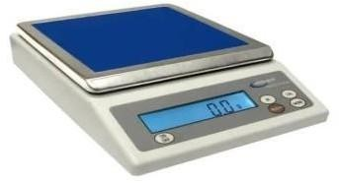

Fig.3.3.1WeighingBalance

- Pyranometer: it is an instrument used for measuring the solar irradiance. It converts the heat to an electrical signal that can be recorded. It is positioned toward the direction of the sun for accurate recordings. The SI units of irradiance are watts per square meter (W/m²). Traditionally pyranometer were mainly used for climatologically research and weather monitoring purposes, however in this project, it is used for measuring the solar radiation available during the experiment (Wikipedia.org).

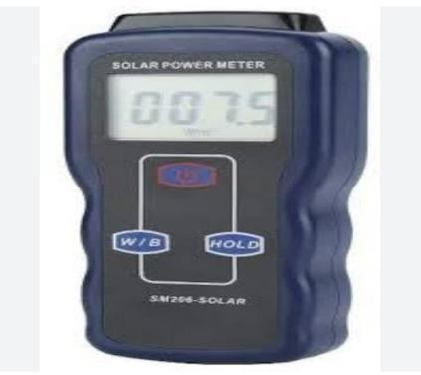

Fig3.3.2Pyranometer

- Thermocouple: it is a thermoelectric device used to accurately measure temperature. It consists of a wire with two leads of dissimilar metals that are joined at one end. Heating the joint produces an electric current which is converted toa temperaturereadingwith a TC monitor.
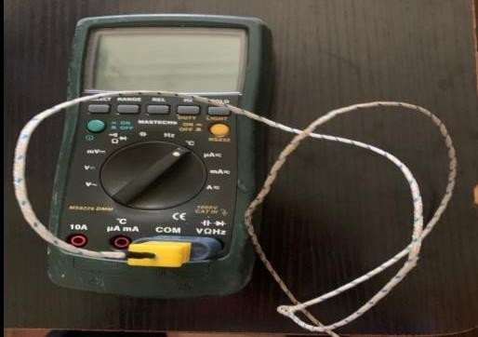

Fig3.3.3AThermocouple

- Cooking pot: it is used for cooking and boiling of food substances. They are either made from stainless steel, Aluminum, cast iron, ceramics or glass. Aluminumcookingpotwaschosenfortheproject.Thealuminumcooking

pot waspaintedblackfrom outside,inordertoabsorb andretainthe heatfor a longerperiod of time during cooking.
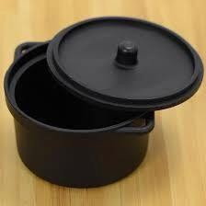

Fig.3.3.4cookingpot

- MeasuringTape: it is a flexible tool for measuring length, widthand breadth ofanobject.Itismadeupofmaterialslike,fiberglass,plastic,metalribbon or strip. It is marked in centimeters and inches. Tape measures are often designed for specific uses or trades. Tapes may have different scales, be made of different materials, and be of different lengths depending on the intendeduse.
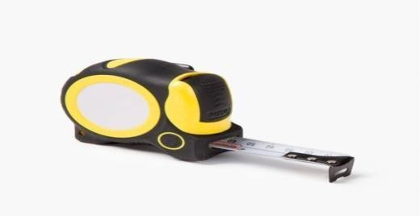

Fig.3.3.5MeasuringTape

TestProcedure

- The thermal efficiency test for the constructed standing solar box cookerstarted at 2:41pmon the 23rd of April, 2023.
- A weighing balance was used to measure the desired quantity of 140gram of spaghetti.
- The weighingbalance was also used to weigh the quantity of water which will be enough to cook the weighed spaghetti of 140gram (0.5kg of water was measured).
- A thermocouple was usedto measure the initial temperature of waterand it was recorded to be 28.9℃.
- Then, the constructed solar box cooker was brought out from Physics Laboratory B of Kwara State Polytechnic to an open space behind the laboratory.
- The constructed standing solar box cooker reflector was positioned facing the East (direction of the sun).
- A clean aluminum cooking pot painted black was then placed inside the cooking system (on top of theabsorber plate).
- The weighed 0.5kg of water having initial temperature of 28.9℃is thenpoured into thealuminumcooking pot and wascovered

- Thermocouple was used to measure the initial temperature of ambient temperature, absorber plate temperature, cooking pot temperature, cover pot temperature,cooking fluid temperaturerespectivelyand wasrecorded.
- A pyranometer was also used to take the solar radiation available and was recorded.
- The stopwatch was set at 15minutes to take the reading for each parameter during thethermal testof theconstructedstandingsolar box cooker.
- The water in thecooking pot was continued to beheated until itshows bubbles at about 69.3℃, the weighed spaghetti of 140gram was then poured into the boiling water and was covered.
- The readings were continued to betaken at 15minutes interval for the absorber plate temperature, cooking pot temperature,coking fluidtemperature, cover pot temperature and the ambient temperature wererecorded respectively using the thermocouple tillit is done cooking.
- Also, pyranometer was used to take readings for solar radiation availableduring the thermal test and was also recorded at 15minutes interval till the cooking substance is done cooking.

Cookingpower

The cooking power, P, is defined as the rateof useful energyavailableduring heating period. It is measured in watt.The cooking power of the constructed standing solar boxcooker was calculatedusing the equation given by Kundapur and Sudhir (2009)as follows:
P=MwC_{w}(T_{f}-T_{i})

t

Where,
P=Cookingpower(w)
T_{f}= Initial water temperature ( ℃ ) T_{i} = Final water temperature (℃) M_{w} = Mass of water (kg)
C_{w}=Waterheatcapacity(4182J/kgk℃)

P=0.5×4182(69.3–28.9)
900
P=93.86W

StandardizedCookingPower

Todeterminethestandardizedcookingpower,P_{s} fromthecookingpower,each power is correctedto a standard radiationof 700W/m²
P_{s}=P×700
I_{s}

WhereP_{s=}standardcookingpower(W),Pisintervalcookingpower(W),I_{s} is interval average solar radiation (W/m²).
P_{s}=93.8×700
912

P_{s}=71.99W

OverallThermalEfficiency

The overall thermal efficiency was calculatedbyusing the following equation given by El-Sebaiiand Ibrahim (2005):
ŋ=M_{f}C_{f}∆T_{f}

I_{av}A_{c}∆T
Where,
ŋ = Overall thermal efficiency M_{f}= Massof cooking fluid (kg)
C_{f=}Specificheatofcookingfluid(j/kg℃)
∆T_{f}=Differencebetweenthetemperature
I_{av}=Averagesolarintensity(W/m²)duringthetimeinterval
A_{c}=Aperturearea(m²)ofthecooker
∆T=Timerequiredtoachievemaximumtemperatureofthecookingfluid(s)

ŋ=0.5×4182×19.2 ŋ=40147.2
0.5×912×900 410400

ŋ=9.87%

CHAPTER FOUR RESULT AND DISCUSSION
The experiment took place on the 23rd of April, 2023, in an open space behind physics laboratory A, at Kwara state Polytechnic Ilorin. The experiment began at 2:41pmand ends at 3:56pmduring sunset.
w/m²to780.5w/m².

CHAPTER FIVE CONCLUSION
Generally, standing solar box cooker is simple to design with locally availablematerial and they are safe in operation. The standing box type solar cooking is still preferred option because it can be used without any technical know-how, userfriendly, safe and retain food nutrients. Solar cooking does not require fuel or electricity but uses solar energy for cooking. Depending on the weather, cooking is done at anytime ofthe day.The cookingtime forthe140gramofspaghetti was 1hour 15minutes under available solar radiation varying between 692.1 W/m² to 1159.6W/m²onthat day.Theefficiencywasfoundsatisfactoryinwhichresult to the fact that the standing solar boxcooker can be used to cookvarieties of food under abundantsolarradiation.Therefore,the useofthistechnologyforcookingpurpose in rural areas will reduce deforestation and total dependence on fossil fuels in urban areas as solar energy is readily available, free and environmentally friendly for cooking purpose.

RECOMMENDATIONS

- In this era of high cost of fuel and erratic supply of electricity, even the commonly used cooking stoves have caused disappointment at a certaintime when in used. Therefore, we recommended the introduction ofstanding solar box cooker to the rural area and poor urban dwellers will greatly reduce deforestation, pollution, health problems associated with the useof firewood andalsoover dependenceon fossilfuelfor cooking.
- We recommended that the Federal Government should invest into the renewable solarenergysectorandalsofund the agencyincharge.
- We recommended that an alternative construction material should beexplore with the view of reducing the size and weight of the standing solar box cooker for easy handlingand transportation.

REFRENCES

Kimambo C Z M (2007), “Development and performance testing of solar cookers”, Journal of Energyin SouthernAfrica,vol.8 pp.41- 51.

Gregoery A, Alozie I.M, Mejeha, Oluwasogo A, Ogungbenro G.I, Nwandikom and Chidi Akujor, (2010).“Designand construction of a solar box cooker as an alternative in Nigerian kitchens”. Department. of Physics, Federal University of Oweri, Imo StateNigeria.Vol 6 No 9 – May2010(57-62).ISESCO.

IshanPurohite, (2005). “Designandtesting of a box type solar cooker employing non-trackingreflectors”. Department of Applied and Sciences and Humanities, G.B Pant EngineeringCollege, Uttaranchal-246001,Indian.

Ishan P., PallavP., and Negi B. (2007). “Instrumentation error analysis of a box type solar box cooker, energy conversion and management”, 50(2), 365-375. Retrieved June 2012.

Mahavar S., Sengar N., Rajawat P., Verma M., and Dashora P., (2012).“Design and performance studies ofanovel single-familysolar cooker”. Renewableenergy47, 67-76.RetrievedDecember19,2013from www.elsevier.com/locate/renenew.

Nyi Nyi Soe, Aung Ko Win, Naw Kay Thida Min, (2019) “Design and Constructionof Solar Box System”, Department of Mechanical Engineering, Technological University, hpa-An, Myanmar, Jul 2019| IRE Journals| Volume 3 Issue 1 | ISSN:2456-8880

OgunwoleO.A(2006).“Flatplatecollectorsolarcooker”.Departmentof mechanical engineering”, Federal University of Technology Minna, Niger State, Nigeria.

Opiriari Pryse Princewill, SundayInnocent (2019),“Improvement ofanexisting solar box cooker in Rivers State”, Department of Agricultural and Environmental Engineering,Rivers State University,vol.7 No. 4, 2019ISSN 2056-5860.

Rahul Aadiwal, Manish Hassani, Pradeep Kumar, (2017).“An overview study of solar cooker. Junior Engineering Rajasthan State, Road Transport Corporation, RajasthanIndian. Vol 4 issue 10.ISSN-2395-0056.IRJET.

Uhuegbu,Chid.C,“Designandconstructionofawoodensolarboxcookerwith

performance and test efficiency”, Department of physics, J. Basic.Appl.Sci.Res., 1(7)533-538,2011,ISSN 2090-424X.

APPENDIXI

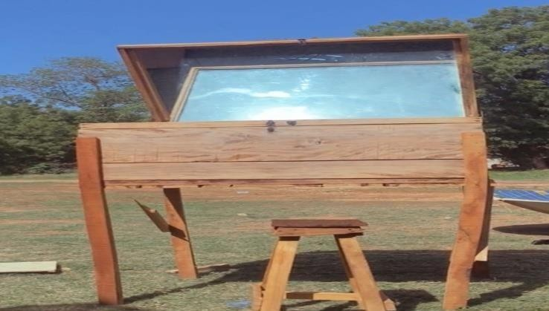

Fig 1. The ConstructedStanding Solar BoxCooker Reflector positioned facing the direction of the sun (East).
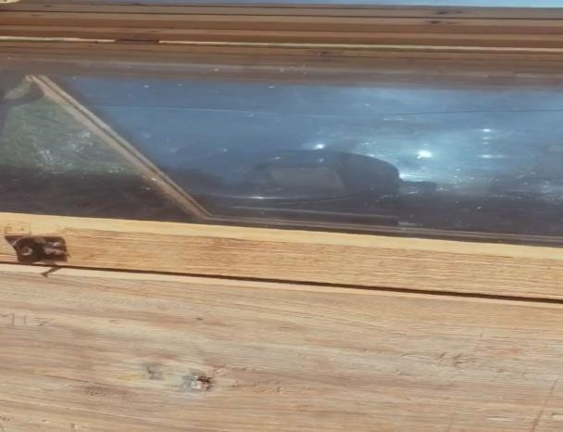

Fig2.BlackAluminumCookingpotinsidetheinnerbox.

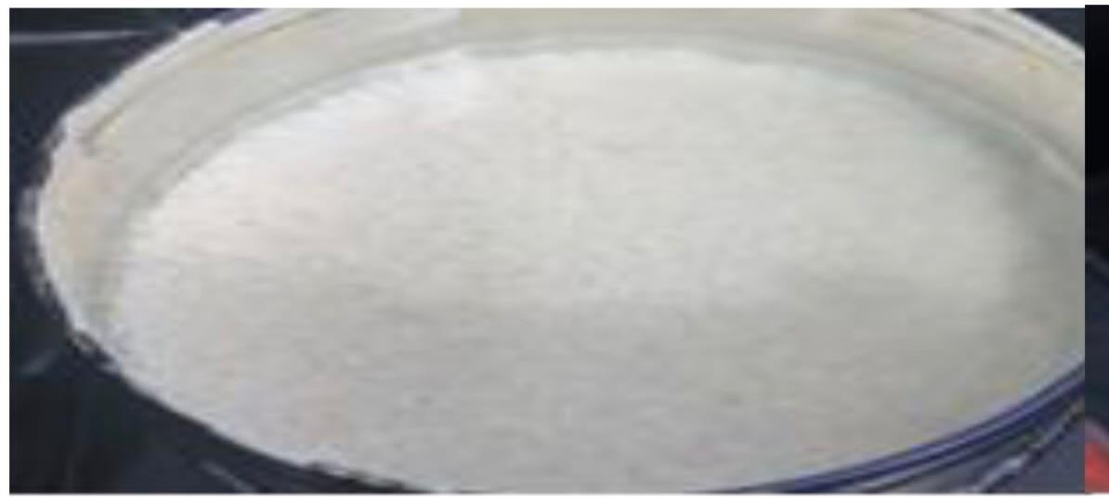

Fig3.Boilingwater

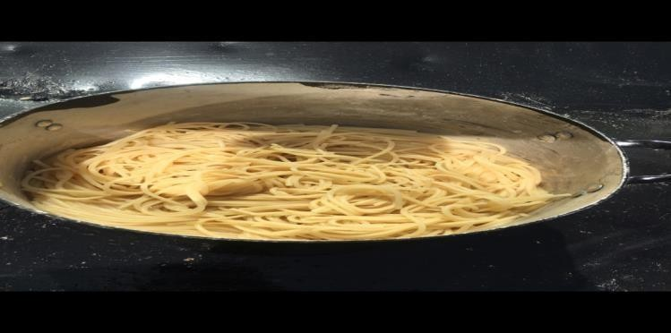

Fig4.Cookedspaghetti

