CHAPTER ONE
1 INTRODUCTION
Until now, people around the globe depend on fossil fuels for their energy needs. Fossil fuels are limited in amount, expensive and polluting the environment. Therefore, a lot of research and developments have been proposed to solve those serious problems. One of the ways is to utilize renewable energy resources. Such resources are free of cost and also available in abundance. For our region solar energy is the most ample, direct and clean form of renewable energy especially in the united Arab emirate. Total solar energy absorbed by the Earth is about 3,850,000 extra joules (EJ) in one year, which is even twice as much as all the non-renewable resources on the earth found and used by human being, including coal, oil, natural gas, and uranium. Taking this idea into consideration, we are designing a solar powered LED street lights with mobile application for FPA campus. This technique utilizes energy-saving technology to reduce energy consumption, and hence improve utilization of solar energy available to us. Maintenances of public lighting system can be a hassle without proper monitoring system. In this project we are incorporating an all in one light monitoring system, which has motion sensor and dimming function.

The main consideration in the present field technologies are Automation, Power consumption and cost effectiveness. Providing street lighting is one of the most important and expensive responsibilities of a city. Energy efficient technologies and design mechanism can reduce cost of the street lighting drastically. There are various numbers of control strategy and methods in controlling the street light system to ensure that it consumes less energy and is efficient in terms of money and usage.

1.1 AIM AND OBJECTIVE
The main objective of this project is to provide a better solution to minimize the electrical wastage in operating street lights, in this electronic era human restless. Manual control is prone to errors and leads to energy wastages and manually dimming during mid night is impracticable. A rapid advancement in embedded systems had paved path for the virtual mechanisms based on micro-controllers. This paper presents an automatic street light controller using light dependent resistor(LDR) which is also known as photo resistor made cadmium sulfide, a 8052 microcontroller which is programmed using C language to act as a pulse width modulator. The circuit also consists of a charging circuit and a measurement of the solar cell is done using a microcontroller of PIC16F8 family. The light intensity is monitored using an LDR sensor, the voltage by voltage divider principle, the current by current sensor and the temperature by temperature sensor. All these data are displayed on a 16X2 LCD interfaced to the PIC microcontroller.

1.2 STATEMENT OF PROBLEM
The idea of designing a new system for the streetlight that do not consume huge amount of electricity and illuminate large areas with the highest intensity of light is concerning each engineer working in this field. Inefficient lighting wastes significant financial resources every year, and poor lighting creates unsafe conditions. Energy efficient technologies and design mechanism can reduce cost of the street lighting drastically.

CHAPTER TWO
2 IMPLEMENTED METHOD FOR STREET LIGHTING
This circuit consists of a battery charge controller circuit that is charged by the solar panel. The battery gives supply to the micro-controller which is programmed to work as a PWM connected to the LDR which gives high/low signal based on the light intensity. When the microcontroller gives a high signal to the MOSFET the LED is OFF. Once the MOSFET gets a low signal it turns ON and the LED glows. The circuit also consists of measurement circuit for the measurement of photovoltaic power and the variation of light for the amount of sunlight obtained. The current is sensed by the current sensor, and temperature by the temperature sensor and voltage is noted by the potential divider circuit.
2.1 THEORETICAL CONCEPTS
SOLAR POWERED LED STREET LIGHT WITH AUTO INTENSITY CONTROL
USAGE AND DESCRIPTION
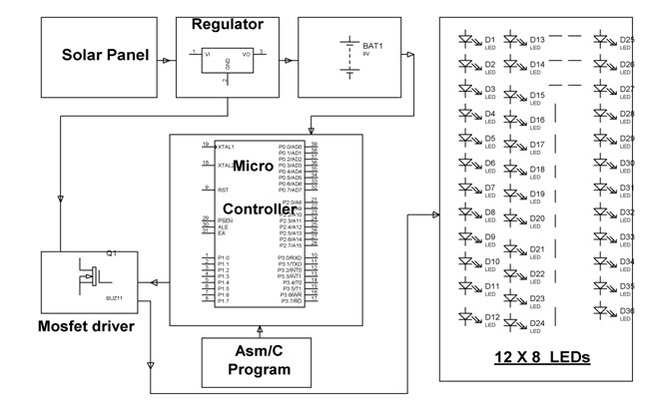

Figure (1) BLOCK DIAGRAM OF (SPLSLWAIC).

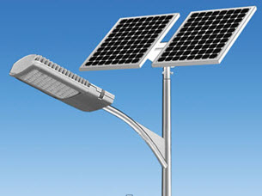

Figure (2) A TYPICAL DIAGRAM OF AUTO INTENSITY STREET LIGHT.
As we know that, nowadays energy sources are limited and energy consumption has increased, so renewable energy sources are used to meet the increase in the demand for energy. Keeping this in mind in this article, we are discussing a solar-powered LED street light with auto intensity control. This project is driven by solar energy used to control the light intensity from morning to evening based on the brightness. A case study is also done to demonstrate the advantages of this solar LED Street light compared to the traditional street light. Because this solar-powered street light can conserve a large amount of electricity compared to the other lights which are a light to their maximum intensity at all times after they are turned on Solar Powered Led Street Light with Auto Intensity Control Circuit and Its Working.
The solar-powered street light works on the principle of solar cells or PV cells to absorb solar energy in the daytime. The PV cells convert solar energy to the electrical energy. The converted energy is stored in the battery and the solar street lights use solar energy. Nowadays solar street lights are available beside the roads. At night time, the lamps start automatically and it uses the electrical energy which is stored in the battery. Every day this process continues
Light-emitting diode comprises of the chemical compound. When the direct current from the battery passes through the light, then it gives the light. Solar LEDs are available in different shapes, styles, and sizes. Generally, the life span of the light-emitting diode is very high and it requires very little current.
Working of a Solar Powered Led Street Light with Auto Intensity Control Circuit and Its Working
The solar-powered led street lights activate from dusk to dawn. The LED Street light automatically turns ON after the dusk and turns OFF after the dawn. The designing of the entire system includes: Solar panels, LED light, Rechargeable battery, Controller, Pole, and interconnecting cables.
Solar Panels
The solar panel or PV cell in the solar street light is one of the most essential parts. These cells are available in two types: monocrystalline and polycrystalline. The monocrystalline conversion rate is higher than the polycrystalline. The light energy used by the solar panels from the sun is used to change solar energy into electricity, which can be used in various applications.
Electrical connections of this project are made in series to achieve an o/p voltage and to afford current facility connections are made in parallel. The majority of the modules use silicon (Si) but most of the solar panels are fixed. . The electron and hole are then separated with electrons going to the negative terminal and holes to the positive terminal. Hence the generation of electrical power. Most of the available solar cells are made of silicon. The benefit of using silicon is its mature processing technology. The large abundance in the crust of the earth, and its non-toxicity makes it a wise and obvious choice. The silicon is used in PV cells for mono crystalline (single crystalline) and multi crystalline photovoltaic module production. In mono crystalline silicon, the crystal lattice of the entire sample is continuous with no grain boundaries. Multi crystalline are composed of a number of smaller crystals or multiple small silicon crystals. In general, mono crystalline silicon wafer is better in performance than the multi crystalline silicon wafers. The voltage of the electric current from a single or multi-crystalline silicon solar cell is 0.5 volts. This results from the voltage across the N/P barrier layer of the solar cell. The current or amperage of the solar cell is dependent on the number of electrons that are knocked into the conduction band. This current is proportional to the amount of solar radiation incident on the solar cell. The current from the solar cell can be increased by increasing the area of the solar cell or by increasing the amount of solar radiation incident on the solar cell. Solar cells can be thought of as solar batteries. If solar cells are connected in series, then the current stays the same and the voltage increases. If solar cells are connected in parallel, the voltage stays the same, but the current increases

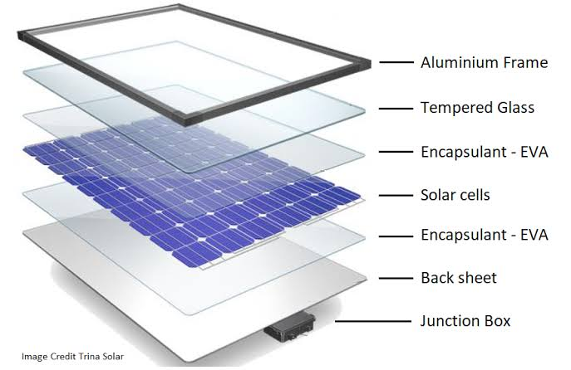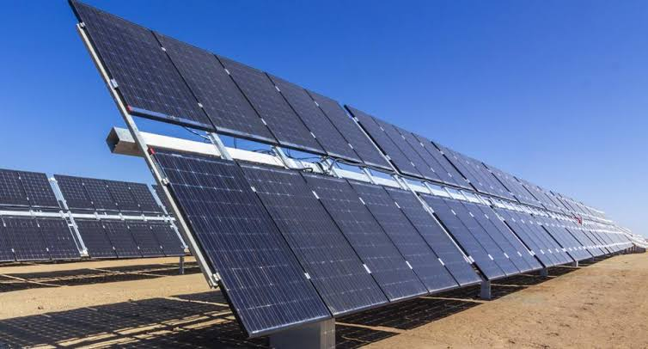
Figure (3): Solar Panel

Light Emitting Diode
LEDs are used in modern street lights to provide brighter light with low energy consumption. The energy consumption of the LED fixture is lesser than the high-pressure sodium fixture, which is commonly used in traditional street lights. Compare to the other lamps, LED lights do not produce light in all directions. The design of lamps can be affected by the uniqueness of the LEDs. The single LED o/p is not equal to the incandescent and fluorescent lamps. But, a bunch of LEDs will give bright light than these two lamps. The advantages of LEDs mainly include Eco-friendly, durable, zero UV emissions, and long life. This will give a full view on the lighting system of solar power. There are numerous styles, shapes, sizes, and types of solar lighting. All of them were designed to be aesthetically and visually pleasing. The entire range of solar motion light is great and there are literally tons of products that can fit your style and needs. Solar lighting can be installed in different areas. From homes to parking lots, sensitive areas and remote locations where no grid infrastructure exists, it removes the costs of trenching and wiring which is why it is considered as the cheapest solution in numerous cases. Solar lightning is classified into two major categories knowns as Outdoor solar light and indoor solar light. The outdoor solar light can be very useful when it comes to lightning of gardens paths during the night, homes, backyards and terrace There are no wires required which means you can place as many solar light as many as you can solar outdoor lightning system are very effective when it comes to reduces in cost of electricity bill because energy use in providing energy at night are themed to be totally free compared to making use of other sources of energy system in which the rate of energy conserved for light environment at night is approximate to the amount of resources used to generate lightning.

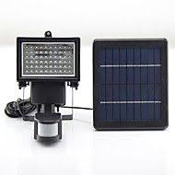

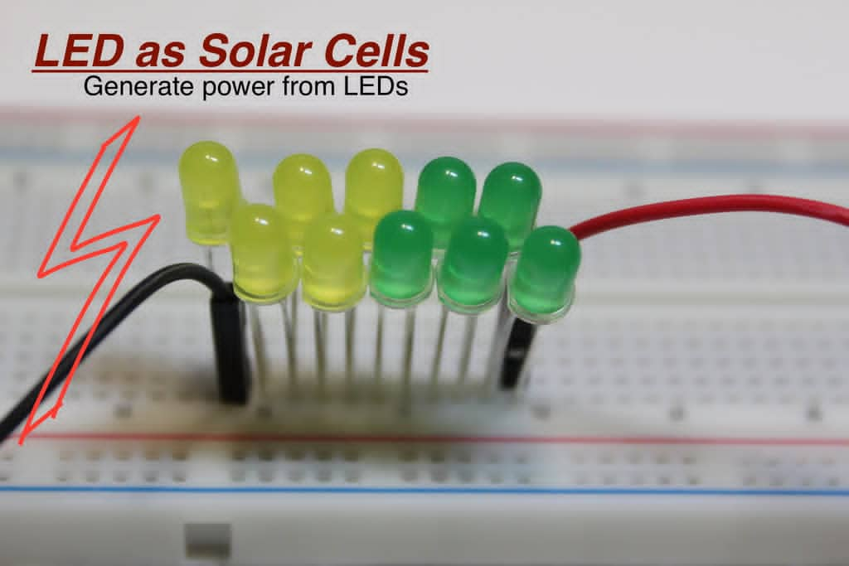

Fig 2.4

Figure 4: Light Emitting Diode (LED)
Rechargeable Battery
The rechargeable battery is one kind of electric battery and it has electro-mechanical reactions to adjust so it is also called a secondary cell. Generally, there are two kinds of batteries, namely gel cell deep cycle, and lead-acid battery. A rechargeable battery is used in solar LED street lights, this battery is used to store electricity generated from the solar panel during the sunrise to afford energy in the sunset. The lifetime and capacity of the rechargeable battery are essential as they affect the backup power days of the lights. . A battery convert’s energy stored in the chemical bonds of a material into electrical energy via a set of oxidation/reduction (redox) reactions. Redox reactions are chemical reactions in which an electron is either required or produced. For primary batteries, this is a one-way process – the chemical energy is converted to electrical energy, but the process is not reversible and electrical energy cannot be converted to chemical energy. This means that a primary battery cannot be recharged. For a secondary battery, the conversion process between electrical and chemical energy is reversible, – chemical energy is converted to electrical energy, and electrical energy can be converted to chemical energy, allowing the battery to be recharged
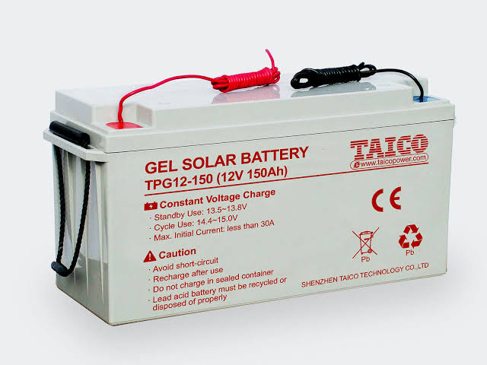

Figure 5: (Gel Cell Solar Battery)
Controller
A controller is a very significant device in the solar street light, used to decide the status of the charging and lighting by a switch on or switch off. Some recent controllers are pre-programmed and it consists of a battery charger, a Led lamp driver, a driver, a secondary power supply, an MCU, and a protection circuit. The battery can be controlled by the controller from the under and overcharging conditions. The battery can be charged by the power received from the solar panels in the sunrise and while in the sunset it charges the battery. Without charge control, the current from the module will flow into a battery proportional to the irradiance, whether the battery needs to be charging or not. If the battery is fully charged, unregulated charging will cause the battery voltage to reach exceedingly high levels, causing severe gassing, electrolyte loss, internal heating and accelerated grid corrosion. Actually charge controller maintains the health and extends the lifetime of the battery.
Solar Charge controller can be configured to stop the flow of current to the battery when the rated current level of the battery is reached. Charge controllers can also be referred to as Charge Regulators. A series charge controller or series regulator disables further current flow into batteries when they are full. A shunt charge controller or shunt regulator diverts excess electricity to an auxiliary or "shunt" load, such as an electric water heater, when batteries are full, Simple charge controllers stop charging a battery when they exceed a set high voltage level, and re-enable charging when battery voltage drops back below that level. Pulse width modulation (PWM) and maximum power point tracker (MPPT) technologies are more electronically sophisticated, adjusting charging rates depending on the battery's level, allow charging closer to its maximum capacity. Charge controllers may also monitor battery temperature to prevent overheating. Some charge controller systems also display data, transmit data to remote displays, and data logging to track electric flow over time
- Pulse Width Modulation (PWM): Pulse Width Modulation (PWM) is a very effective means to ensure constant voltage battery charging by switching the solar system controller’s power devices. When in PWM regulation, the current from the solar array flows according to the battery’s recharging needs and condition. In the past simple on-off regulators were used to limit the rate at which batteries gas out when a solar panel produced excess energy. On-off regulators have been earlier known for battery failures and increasing load disconnections. PWM is the first significant advance in solar battery charging. PWM solar chargers use technology close to other modern battery chargers. When a battery voltage reaches the manufacturer’s rated voltage, the PWM algorithm slowly decreases the charging current to avoid heating and gassing of the battery, but the charging continues to return the maximum amount of energy to the battery in the shortest time. The benefits are a higher charging efficiency, fast recharging, and a healthy battery always at full capacity.
- Maximum Power Point Tracking (MPPT): The PV array has a highly non-linear current-voltage characteristic varying with the irradiance and temperature that substantially affects the array power output. The maximum power point tracking (MPPT) control of the PV system is therefore critical for the success of a PV system. MPPT algorithms, ranging from simple hill-climbing algorithms to fuzzy logic and neural network algorithms are used in the application of MPPT. The three main versions of the hill climbing algorithm, P&O, MP&O and EPP, are described below
- Switching Unit: This unit is essential for the switching on and off of the luminaires. In the evening when the sun is setting, the switching unit switches the outdoor lights on. Also when the sun is rising at dawn the switching unit switches the lights off. The switching unit functions by switching the path of current. At dawn the switching unit switches current path from solar panel to luminaires to solar panel to battery. This change switches off the luminaires and charges the battery bank during the day. Likewise, at dusk the switching unit switches current path from solar panel to the battery to solar panel to luminaires. This change stops the charging of the battery and then powers the luminaires.

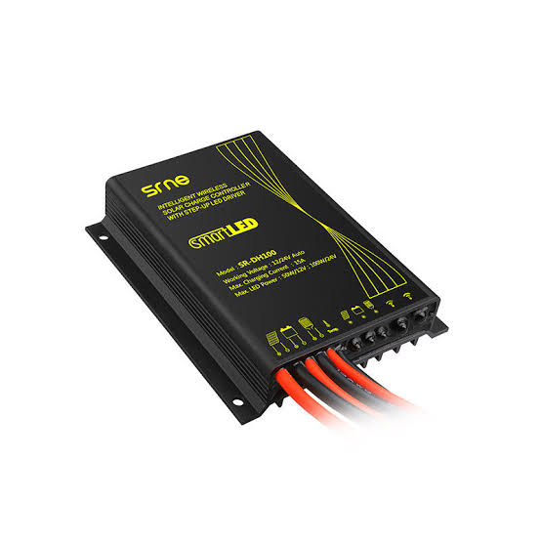
Figure 6: (Controller)

Pole

A strong pole is mandatory for every street light and also for a solar street light. There are various components such as panels, batteries, and fixtures fixed on the top of the pole. In this light, the input operating voltage is 12V DC which is a nominal system voltage, and the light output at the height of 12 feet is a minimum of 09 LUX (unit of luminance). The pole is of mild steel pipe with a height of 3.5 meter (approximately 12 feet) above the ground level after grounding and final installation. The pole has a moveable platform which ensures the mobility of the pole from one place to another. The pole will have the provision to hold all weather proof lamp housing. A galvanized metallic frame structure was fixed on the pole to hold the pole to the solar panel. The frame structure has provision to adjust its angle of inclination to the horizontal between 0-90⁰, so that it can be installed at the specified tilt angle.

Figure 7: (Pole)

Interconnecting Cables
The cable is used to interconnect the LED, solar panel and battery box which is fixed on the top of the pole. This cable is used to connect a Photovoltaic module to the controller, controller to the lamps, and battery. The size and length of the cable depend on the current being carried to the LED lights and the height of the pole. The assembling of the entire solar LED street light system can be connected using all the above components which use solar energy to give the power to the LED lamps fixed on street pole
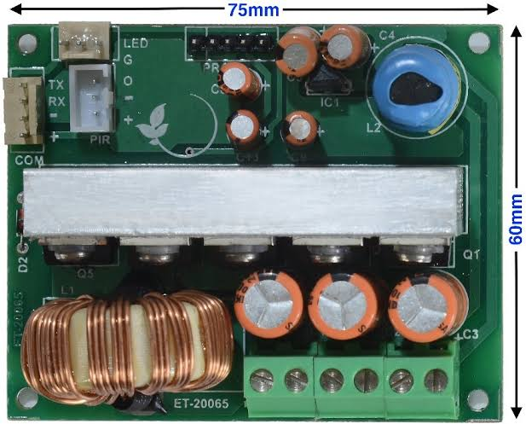
Figure 8: (Interconnecting PCB)
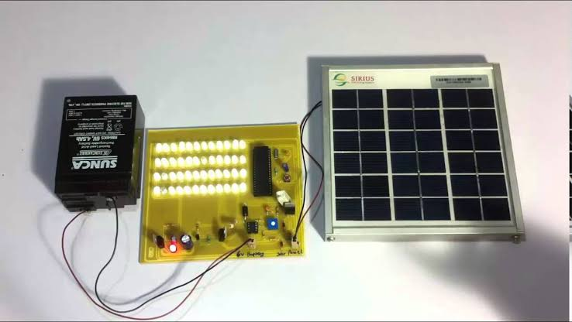

Figure 9: (Interconnecting Cable and Component)

CHAPTER THREE
3. DESIGN METHODOLOGY
This circuit consists of a battery charge controller circuit that is charged by the solar panel. The battery gives supply to the micro-controller which is programmed to work as a PWM connected to the LDR which gives high/low signal based on the light intensity. When the microcontroller gives a high signal to the MOSFET the LED is OFF. Once the MOSFET gets a low signal it turns ON and the LED glows. The circuit also consists of measurement circuit for the measurement of photovoltaic power and the variation of light for the amount of sunlight obtained. The current is sensed by the current sensor, and temperature by the temperature sensor and voltage is noted by the potential divider circuit.
WORKING
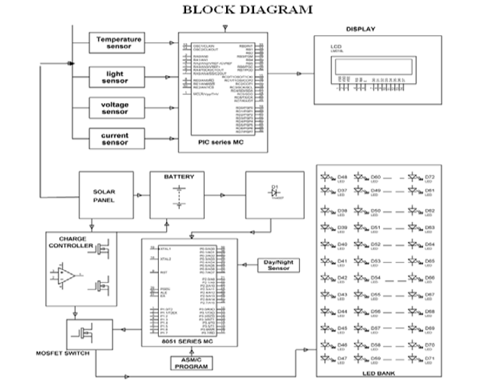
3.1 Solar Panel Section

Figure (10) A BLOCK DIAGRAM OF INTERCONNECTED CABLES
Battery B1 is charged via D10 and fuse. When battery gets fully charged Q1 conducts from output of comparator. This results Q2 to conduct and divert the solar power through D11 and Q2 such that battery is not over charged. We use IC LM324 having 4 op-amps used as comparators that is U1: A, B, C, D. U1:A is used for sensing over charging of the battery to be indicated by action of U1:B output fed D1(red)and D12(green) for indicating battery status. Diodes D5 to D8 all connected in series are forward biased through R14 and D3 .This provides a fixed reference voltage of 0.65*4= 2.6v at anode point of D8 which is fed to pin 2 U1:A through R11, pin 13 of of U1:D, pin 6 of U1:B via R9 and pin 10 of U1:C via 5K variable resistor. While the battery is fully charged the voltage at cathode point of D10 goes up. This results in the set point voltage at pin 3 of U1:A to go up above the reference voltage. This will switch ‘ON’ the transistor Q1. MOSFET is triggered to drive a led D1 indicating battery is being fully charged. During overload U1:C going low to remove the drive to the gate of MOSFET Q2 that disconnects the load. The correct operation of the load in normal condition is indicated by D9 while the MOSFET Q2 conducts.
3.2 Control of Street Lighting Circuit
Here we use a LDR to sense the daylight, based on that we switch ON the LEDs. As we made a potential divider with 100K and LDR. While in the daylight light falls on LDR its resistance will go down, as resistance go down voltage drop across it will go down. voltage drop across 100K go increase. The voltage drop across LDR will go to 39th pin of MC as LOW logic. When night falls there will be no light on LDR so resistance of LDR go increase so voltage drop across will increase, this voltage drop goes to MC as HIGH logic sensing as Night. Based on light intensity falling on LDR decided the duty cycle of output LEDs . The MOSFET switches ON between its drain and source that completes its path of current flow through the LEDs. Therefore with varying duty cycle from 90% to 10% the current flowing through the LEDs reduces that result in lesser intensity as described earlier.
  - Measurement of Solar Photovoltaic Power Circuit
In the measurement circuit the Voltage from the solar panel is fed to the MC pin no 4 through a potential divider comprising of R4 & R5. A resistance is used as load in series with another resistor R7 of 10ohm, 10W. The voltage drop across the resistor R7 is proportional to the load current which is fed to pin 5 of MC. Light input is sensed by LDR which is fed to MC pin 2. A temperature sensor LM35(U3) is connected to pin 3 of MC. Thus, four analog varying voltage parameters are fed to the internal ADC of the MC out of total availability of 8 channels. A LCD is used to display all the output parameters such as light intensity, temperature, voltage and current of solar panel.
  - Smart street light system with energy saving function based on the sensor network
here are some attempts being made to reduce the energy wastes of street lamps, such as, a sensor light which will be controlled by a light sensor and optionally a motion sensor are used. But there is a delay in switching on the light using the motion sensor because the person or vehicle should be in close proximity to the street lamp instead it should switch on before the desired object comes close so that it lights up the street. Some companies and universities have developed central systems to control the street lights smartly using one central computer. These systems are suitable for controlling street lamps on large scale and are not at all suitable for small scale project.

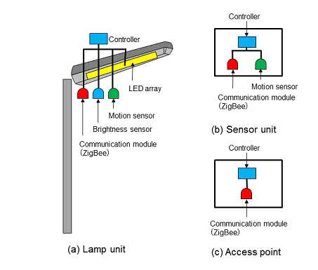

Figure 11: Components for the Smart Street Light

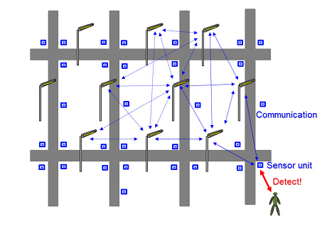

Figure 12: Object Detection Network

3.5Assumptions and Dependencies
In this project, our team is proposing a green and efficient solution for AUS campus street lighting. This solution saves energy by consuming less power and saves annual expenses of the country. After comparing different light sources, our team agreed upon using LEDs lamps because there are several advantages over the other types. The design of this project involves a solar system to save energy and power, LEDs to help in producing dimmable lightning and higher life span, and a motion sensor to control the switch ON/OFF of the system at night I different periods.

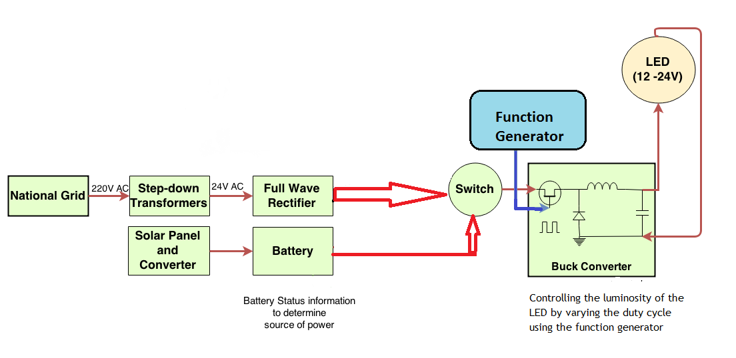

Figure 13: (Overall System)
3.6 System Decomposition
The following are the main parts used for the SSL project:
- Solar Panel
Solar panel is one of the most important parts of solar street lights, as solar panel will convert solar energy into electricity. There are 2 types of solar panel: mono-crystalline and poly-crystalline. Conversion rate of mono-crystalline solar panel is much higher than poly-crystalline.
- Lighting Fixture
LED (Light Emitting Diode) is a solid state semiconductor device which can convert electrical energy into visible light. It is usually used as lighting source of modern solar street light. It is because of the fact that it has small size, low power consumption ad long service life. The spectrum of the LED is mostly concentrated in the visible light spectrum, so it has a high luminous efficiency. Also the energy consumption of LED fixture is at least 50% lower than HPS (High Pressure Sodium) fixture which is widely used as lighting source in traditional street lights. Another advantage is that LED lacks warm up time that adds to its efficiency.
- Rechargeable Battery
The electricity from solar panel is stored in the battery during the day and it provides energy to the fixture during night. The life cycle of the battery is very important to the lifetime of the light and the capacity of the battery will affect the backup days of the lights. A battery convert’s energy stored in the chemical bonds of a material into electrical energy via a set of oxidation/reduction (redox) reactions. Redox reactions are chemical reactions in which an electron is either required or produced. For primary batteries, this is a one-way process – the chemical energy is converted to electrical energy, but the process is not reversible and electrical energy cannot be converted to chemical energy.
- Controller
It is the controller which decides the switch on /off, charging and lighting and the dimming of the (SLSL). Solar Charge controller can be configured to stop the flow of current to the battery when the rated current level of the battery is reached. Charge controllers can also be referred to as Charge Regulators. A series charge controller or series regulator disables further current flow into batteries when they are full. A shunt charge controller or shunt regulator diverts excess electricity to an auxiliary or "shunt" load, such as an electric water heater, when batteries are full, Simple charge controllers stop charging a battery when they exceed a set high voltage level, and re-enable charging when battery voltage drops back below that level. Pulse width modulation (PWM) and maximum power point tracker (MPPT) technologies are more electronically sophisticated, adjusting charging rates depending on the battery's level, allow charging closer to its maximum capacity. Charge controllers may also monitor battery temperature to prevent overheating. Some charge controller systems also display data, transmit data to remote displays, and data logging to track electric flow over time

- Pole
Strong Poles are necessary to all street lights, especially to solar street lights as there are components mounted on the top of the pole: Fixtures, Panels and sometime batteries. And wind resistance should also be taken into consideration when choosing the pole.
3.7 Operation principle
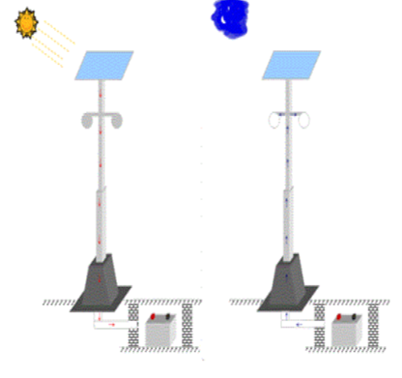

Figure 14: Operation Principle

Solar Panel
Controller
LED
Battery

Figure 15: System Work Flow

According to principle of photovoltaic effect, the solar panels receive solar radiation during the day time and then convert it into electrical energy through the charge and discharge controller, which is finally stored in the battery. When the light intensity reduced to about 10 lx during night and open circuit voltage of the solar panels reaches at a certain value, the controller has detected voltage value and then acts. The battery offers the energy to the LED light to drive the LED emits visible light at a certain direction.
Battery discharges after certain time passes, the charge and discharge controller will act again to end the discharging of the battery in order to prepare next charging or discharging again
.

Figure 16: Solar Power- Pictorial Diagram

Requirement Specifications
Therefore to select an appropriate LED we had to know their technical specifications in order to quote them to a company. By thorough research we found companies which would suit our requirements to implement for the real time model. The UAE Solar Energy is one of the leading companies in LED industry which fulfills the standard requirement. The following shows the specifications of the street light.

Product Details:
    - Model JNYT-40W -Solar panel
    - Max power 18v/65W
    - Life time 25 years
    - Battery type : Lithium-FePo4battery
    - Capacity 12.8V/30AH
    - Life time 5 years
    - LED Lamp
    - Max power :12V/40W
    - Led chip :Bridge lux from USA
    - Lumen (LM) :4800-5200lmlm
    - Led chip :40pcs
    - Life time :50000hours
Product Parts:
- Solar Panel
- Li-Fe Battery
- LED
- MPPT controller
- Human intelligence induction System

Product Properties:
- Angle 120 degrees
- Charging by sun light :7 hours
- Full power more than 10hours
- Half power more than 20hours
- Work temp range (*C) : 30-70
- Color temp range(k) :3000-6000
- Height range (m):4-5m
- Space range (m) :8-10m
- Material aluminum alloy
- Certificate CE / ROHS/ IP65
- Warranty 2 years

3.8 Implemented Model Details
We wanted to implement the real system in our project, but due to the high cost of an actual system we decided to build a scaled down model on which we can implement our lighting control and mobile application. The cost of one entire set is AED 3500 and this was beyond the allowed range for us students. However, when the university is buying it in bulk, the cost reduces and also the university has to afford only its initial cost of setting up the solar powered LED. Because once it is set up, the LED then completely works on solar power, thus reducing the overall power consumption .The following are the details of our miniature model. Electrical students had to build the buck convertor on their own to interface the buck converter with the rest of the model.
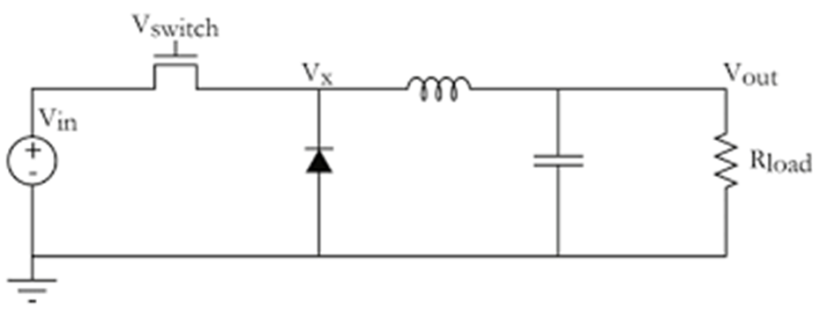
Figure 17: (Simple Buck Converter Circuit)

The figure [17] above shows a basic buck converter circuit. The buck converter is used in our project to control the dimming function of the LED light using a power MOSFET. The MOSFET works as a switching regulator. In other words, the MOSFET voltage depends on the time of the duty cycle in order to have the solar panels voltage (input voltage) to vary by turning the MOSFET ON/OFF in order to control the voltage transferred to the load. Our system is made up of a solar panel that supply energy of 12 volts and store it in a battery, the battery discharge this energy to the buck converter input voltage. The switching voltage of the MOSFET is a control signal that control the duty cycle. When the input voltage is high, the MOSFET turns ON allowing the input voltage to pass which is greater than the output voltage. Then the current through the inductor starts to increase and charges the capacitor. When the MOSFET turns OFF the current through the inductor
starts pass through the diode producing a voltage equals to approximately zero. This voltage is less than the output voltage. Then the current through the inductor decreases and the capacitor starts to supply current to the load. This will produce a controllable buck converter in which it reduces the input voltage to any required output voltage for the load.

The Buck Convertor Specifications:
- Output Power: P = 7 Watts
- Input Voltage : Vinput = 12V
- Current through one Led: I led = P / V = 7/12 = 0.5833A
Here we assume the load has 4 LEDs: Total current through
the load:
- Current (I) through load =4*0.5833= 2.5 A
- Duty Cycle: D = 0.5
- Vout = D* Vin =6 V
- Ripple Current: Ir =30% * I load =0.75A
- L=(Vin-Vout)*D)/Iripple*Frequency)
Assuming frequency to be 6Khz
- L≥0.77mH
- Vripple =100mV
- Capacitance=((1-D)*I load*D*T)/Vripple >= 1.04mF
- Diode should be able to handle current greater than 2.5A
- Mosfet >= 3* Vin => More than 30V
- Capacitance = ((1-D)*I load*D*T)/Vripple >= 1.04mF
  - Diode should be able to handle current greater than 2.5A
  - MOSFET >= 3* Vin => More than 30V

3.9 COST analysis
- Sodium lamps (Current system)
- Energy Consumption for 705 lamp posts each with 4 lamps:

  - 705 x 250W x 4 bulbs = 705 kW Per day consumption:

  - 705kW x (12 hours/day) = 8460 kW.hr

- Annual consumption in MW.hr:
  - 8460 x (365days) = 3087.8 MW.hr

- Annual consumption in AED, per fils rate 0.45 fils/KW.hr
- Cost = AED 1,389,510 / annum

LED’s (proposed solution):
- Energy Consumption for 705 lamp posts each with 4 lamps:
- 705 x 40 W x 4bulbs = 112.8 kW
- Per day consumption
- 112.8kW x (12hours/day) = 1353.6 kW.hr
- Annual consumption in MW.hr
- 1353.6kW.hr x (365 days) = 494.064 MW.hr
- Annual consumption in AED, per fils rate 0.45 fils/KW.hr
- Cost = AED 222,328.8 / annum
- This cost estimation leads us to a ratio of 1: 6.24
- Cost of electrical components which includes lamp post, control box, solar panel, LEDs and battery = AED 3500[14]
- Initial Cost of setting up 705 Led lamp posts = AED 3500*705 = AED 2,467,500
Implemented Model Cost:
- Solar Panel with the controller and the battery = AED 500
- LED (7 W- Dc Dimmable) = AED 70
- Buck Convertor Components = AED 40
- Total Cost = AED 610

Simulations:
During the second phase of the project (ELE 491), we build the buck convertor and interfaced with solar charged battery and function generator and tested the ON/OFF as well as dimming of the 7 Watts Led. The only problem we faced was the heating up of the mosfet. The problem was solved by using a heat sink with the mosfet.

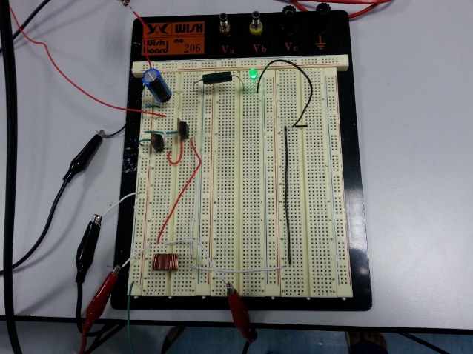
Figure 18: Buck Convertor with Small LED
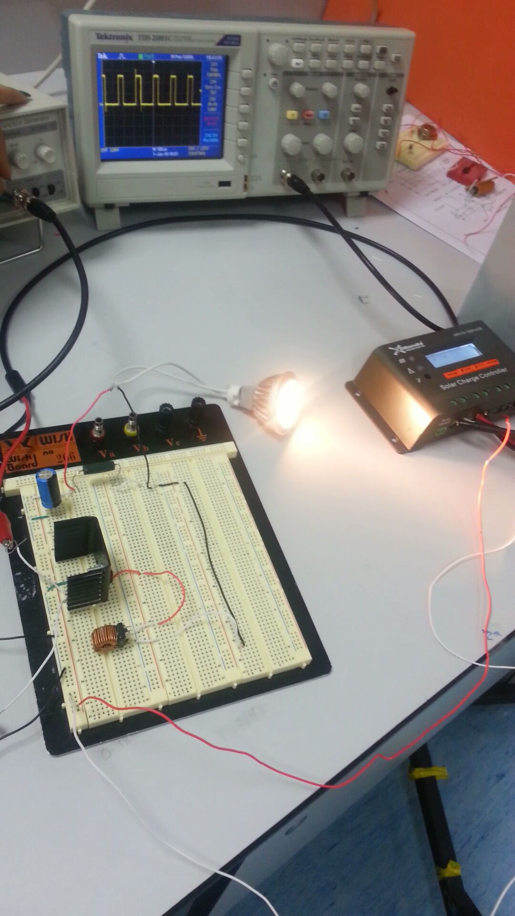

Figure 19: Dimming the 7Watt LED by Varying the Duty Cycle

CHAPTER FOUR
4. RESULTS AND DISCUSSION
The result comprises the successful operation of the ‘SOLAR POWERED LED STREET LIGHT WITH AUTO INTENSITY CONTROL ’. The circuit is stationed in a suitable location that is exposed to sunlight so that immediately it is dark the system automatically switches “ON” the lamps and when the illumination is above 50 lux the lamps are automatically switched “OFF”. The values of illumination, voltage, current and temperature is noted from the LCD.
  - : As observed on Friday, 20/ 03 / 2021 at 1 :22 pm in the AEC LAB of NEW HORIZION COLLEGE OF ENGINEERING :
Table 1 (Observation of the useage of power in HORIZON COOLLEGE OF ENGINEERING)
S/N; | Current (A) | Voltage (V) | Illumination (lux) | Temperature ( ºC ) | Status of LED
1 | 0.012 | 0 | 69.2 | 22 | OFF
2 | 0.011 | 0 | 53.5 | 22 | ON but Dim
3 | 0.01 | 0 | 46.7 | 22 | ON and Slightly bright
4 | 0.011 | 0 | 3 | 23 | ON and glowing brightly

5 Future Scenario
This design can be enhanced using the following:
1. Solar and Wind Powered Street Lights
2. Time Programmed Sun Tracking Solar Panel

CHAPTER FIVE
5.0 Conclusion
This project ‘SOLAR POWERED LED STREET LIGHT WITH AUTO INTENSITY CONTROL’ is a cost effective, practical, eco-friendly and the safest way to save energy. It clearly tackles the two problems that world is facing today, saving of energy and also disposal of incandescent lamps, very efficiently. According to statistical data we can save more that 40 % of electrical energy that is now consumed by the highways. Initial cost and maintenance can be the draw backs of this project. With the advances in technology and good resource planning the cost of the project can be cut down and also with the use of good equipment the maintenance can also be reduced in terms of periodic checks.
The LEDs have long life, emit cool light, donor have any toxic material and can be used for fast switching. For these reasons our project presents far more advantages which can over shadow the present limitations. Keeping in view the long term benefits and the initial cost would never be a problem as the investment return time is very less.
The project has scope in various other applications like for providing lighting in industries, campuses and parking lots of huge shopping malls. This can also be used for surveillance in corporate campuses and industries.
This paper elucidates the design and implementation of an automatic street light control system. The design works efficiently to turn street lamps ON/OFF. The LDR sensor is the only sensor used in this circuit. The lamps will come “ON” immediately darkness falls and go “OFF” once the illumination exceed 50 lux. With this design, the drawback of the street light system using timer controller is overcome and human intervention is completely eliminated. By this energy consumption and cost are drastically reduced.
The Automatic Street Light Control System based on Light intensity & traffic density, in the todays up growing countries will be more effective in case of cost, manpower and security as compare with today's running complicated and complex light controlling systems.
5.1 Appendices
1. ATMEL 89S52 Data Sheets.
2. PIC16F877A Data Sheets.
3. VOLTAGE REGULATOR 7805
4. ZENER DIODE
5. LM35
6. LED
7. LDR
8. DIODE IN4007

REFERENCE

Kapse Sagar Sudhakar (2013) “Automatic Street Light Control System” AbhInternational Journal of Scientific & Engineering Research, Volume 7, Issue 7, July-2016 37 ISSN 2229-5518. Bhaskar Student of Department of Computer Engineering, University of Pune (Maharashtra), INDIA International Journal of Emerging Technology and Advanced Engineering Website: www.ijetae.com (ISSN 2250-2459, ISO 9001:2008 Certified Journal, Volume 3, Issue 5, May).
M. A. Dalla Costa ; L. Schuch ; L. Michels ; C. Rech ; J. R. Pinheiro (2015) Autonomous street lighting system based on solar energy and LEDs” Author(s) :; G. H. Costa Federal University of Santa Maria - UFSM, GEPOC - GEDRE, Av. Roraima N° 1000, CEP 97105- 900, Santa Maria - RS - Brasil Cited by IEEE Publications
Mahmoud I. Masoud (2015) Department of Electrical and Computer Engineering, Sultan Qaboos Street lighting using solar powered LED light technology: Sultan Qaboos University Case Study University, Muscat, Oman Published in: GCC Conference and Exhibition (GCCCE), 2015 IEEE 8th Date of Conference: 1-4 Feb. Sakshee Srivastava Automatic Street Lights by Electronics And Communication Engineering, Institute Of Technology And Manag
Isah Abdulazeez Watson, Oshomah Abdulai Braimah, Alexander Omoregie (2015) Design and Implementation of an Automatic Street Light Control, Department of Electrical/Electronic Engineering, Auchi Polytechnic, Auchi, Nigeria
Mustafa Saad, Abdalhalim Farij, Ahamed Salah And Abdalroof Abdaljalil (2012) Automatic Street Light Control System Using Microcontroller, Department of Control Engineering College of Electronic Technology/ Baniwalid Baniwalid- Libyas
Sharath Patil G.S1, Rudresh S.M2 (2005) Design and Implementation of Automatic Street Light Control Using Sensors and Solar Panel, Kallendrachari.K3 ,M Kiran Kumar4, Vani H.V5
M. A. Dalla Costa ; L. Schuch ; L. Michels ; C. Rech ; J. R. Pinheiro ; G. H Autonomous street lighting system based on solar energy and LEDs” Author(s) :. Costa Federal University of Santa Maria - UFSM, GEPOC - GEDRE, Av. Roraima N° 1000, CEP 97105- 900, Santa Maria - RS - Brasil Cited by IEEE Publications
Mahmoud I. Masoud, (2015), Department of Electrical and Computer Engineering, Sultan Qaboos University, Muscat, Oman on Street lighting using solar powered LED light technology: Sultan Qaboos University Case Study Published in: GCC Conference and Exhibition (GCCCE), 2015 IEEE 8th Date of Conference: 1-4 Feb. Mokhtar Ali ; Mohamed Orabi ; Emad Abdelkarim ; Jaber A. Abu Qahouq, Design and development of energy-free solar street LED light system bAPEARC, South Valley University, Aswan 81542, Egypt
Anshul Tiwari , Chetan Varshney , Ankit Shukla, (2010) Concept Of Smart Solar Street Light Ims Engineering College, Ghaziabad. International Advanced Research Journal In Science, Engineering And Technology (Iarjset) National Conference On Renewable Energy And Environment (Ncree-2015) Ims Engineering College,

