Development of secure cloud access control system using two authentication methods

BY
BADMUS SULTAN ADEDEJI
ND/22/COM/PT/0483

A Project Submitted to the Department of Computer Science, Institute of Information and Communication Technology, Kwara State Polytechnic, Ilorin

In Partial Fulfillment of the Requirements for the Award of National Diploma (ND) in Computer Science

July, 2025
CERTIFICATION
This is to certify that this project was carried out by BADMUS, Sultan Adedeji with matric number ND/22/COM/PT/0483, has been read and approved as meeting part of the requirements for the award of National Diploma (ND) in Computer Science.

………………………………. ……………………………….
Mr. Murtala .K. Date
(Project Supervisor)

………………………………. ……………………………….
Mr. Oyedepo, F. S. Date
(Head of Department)

………………………………. ……………………………….
External Examiner Date

DEDICATION
This project is dedicated to the creator of the earth and universe, the Almighty God. It is also dedicated to my parents for their moral and financial support.

ACKNOWLEDGEMENT
All praise is due to the Almighty God the Lord of the universe. I praise Him and thank Him for giving me the strength and knowledge to complete my OND programme and also for my continue existence on the earth.
I appreciate the utmost effort of my supervisor, Mr. MURTALA, whose patience support and encouragement have been the driving force behind the success of this research work. He gave useful corrections, constructive criticisms, comments, recommendations, advice and always ensures that an excellent research is done. My sincere gratitude goes to the Head of the Department and other members of staff of the Department of Computer Science, Kwara State Polytechnic, Ilorin, for their constant cooperation, constructive criticisms and encouragements throughout the programme.
Special gratitude to my parents who exhibited immeasurable financial, patience, support, prayers and understanding during the periods in which I was busy tirelessly in my studies. Special thanks go to all my lovely siblings.
My sincere appreciation goes to my friends and classmates.

TABLE OF CONTENTS
Title Page i
Certification ii
Dedication iii
Acknowledgements iv
Abstract v
Table of Contents vi
CHAPTER ONE: GENERAL INTRODUCTION
  - Background to the Study 1
  - Statement of the Problem 3
  - Aim and Objectives of the Study 4
  - Significance of the Study 4
  - Scope of the Study 5
  - Organization of the Report 5
CHAPTER TWO: LITERATURE REVIEW
2.1 Review of Related Works 6
2.2 Review of Related Concepts 10
CHAPTER THREE: RESEARCH METHODOLOGY AND ANALYSIS OF THE EXISTING SYSTEM
  - Research Methodology 15
  - Analysis of the Existing System 17
  - Problems of the Existing System 17
  - Description of the Proposed System 18
  - Advantages of the proposed system 29
CHAPTER FOUR: DESIGN, IMPLEMENTATION AND DOCUMENTATION OF THE SYSTEM
  - Design of the System 21
    - Output Design 21
    - Input Design 25
    - Procedure Design 27
  - Implementation of the System 28
    - Hardware Support 28
  - Documentation of the System 29
    - Maintaining the System 29
CHAPTER FIVE: SUMMARY, CONCLUSION AND RECOMMENDATION
  - Summary 30
  - Conclusion 30
  - Recommendation 31
References 32
Appendices
Appendix 1 Flowchart 32
Appendix 2 Flowchart 33
Appendix 3 Robot Direction Flowchart 34

ABSTRACT
Cloud computing has become a fundamental component of modern technology infrastructure, offering unparalleled convenience and scalability. However, security concerns remain paramount, particularly in ensuring that only authorized users can access sensitive data stored in the cloud. This abstract presents the development of a robust cloud access control system that employs two-factor authentication methods to enhance security. The proposed system integrates two authentication factors: something the user knows (e.g., a password or PIN) and something the user possesses (e.g., a token or biometric identifier). By combining these factors, the system mitigates the risk of unauthorized access, significantly enhancing the security posture of cloud-based applications and data. The design and implementation of the system prioritize usability without compromising security. Users interact with a user-friendly interface to provide their credentials, with the system seamlessly verifying their identity through the dual authentication process. Additionally, the system incorporates measures to protect against common security threats, such as brute force attacks, phishing attempts, and unauthorized access attempts. The system architecture is designed to be scalable and adaptable, allowing for integration with various cloud service providers and accommodating evolving security requirements. Robust encryption techniques are employed to safeguard data both in transit and at rest, ensuring confidentiality and integrity throughout the access process. Through comprehensive testing and evaluation, the effectiveness and reliability of the proposed cloud access control system are demonstrated. Results indicate that the system effectively balances security and usability, providing a secure yet accessible solution for organizations seeking to leverage cloud computing resources while maintaining stringent security standards.

CHAPTER ONE
GENERAL INTRODUCTION
  - BACKGROUND TO THE STUDY
In recent years, the proliferation of cloud computing has revolutionized the way organizations manage and store data. However, with the convenience and scalability offered by cloud platforms comes a significant concern: security. Ensuring the confidentiality, integrity, and availability of data stored in the cloud is paramount, particularly as cyber threats continue to evolve and become more sophisticated. Traditional authentication methods, such as passwords, are no longer sufficient to protect against unauthorized access, necessitating the adoption of more robust security measures (Kaur, 2022).
The continuous improvement in computing infrastructure, in the last two decades, has produced a flood of data demanding improvement in large-scale data processing technologies. Cloud computing has emerged with major advantages in data storage technology and sharing of resources. We have to pay only for the resources and computer services that we use. We are witnessing a continuous growth of computational technologies and consequent data generation during the past few decades. With the development of web technologies, users now generate and consume large amounts of data on the Internet. Cloud computing has provided a pattern change in the distribution of resources across the network, reducing the administrative costs associated with the IT infrastructure. With such progress, we find the necessity of new approaches to harness the potential of cloud in data storage and processing. Many issues and challenges exist in cloud computing. Some problems are safety, identity managing, source managing, cyber security, energy and energy managing, source obtainability and source heterogeneity. Among all these problems, security is important concern in the cyber world (Otta et al., 2023).
The evolution of cloud computing has revolutionized the way businesses operate, offering unparalleled flexibility, scalability, and cost-effectiveness. Organizations across industries rely on cloud services for a myriad of functions, including data storage, application hosting, and collaborative work environments. However, this widespread adoption of cloud technology has also raised concerns about the security of sensitive data stored in the cloud. Cyberattacks, data breaches, and unauthorized access attempts pose significant risks to organizations, potentially resulting in financial losses, reputational damage, and regulatory penalties (Mahmood, 2019).
In response to these challenges, access control mechanisms play a pivotal role in safeguarding data and resources in cloud environments. Traditionally, access control has relied on single-factor authentication methods, such as passwords or PINs, which are susceptible to various vulnerabilities, including password guessing and credential theft. The limitations of single-factor authentication underscore the need for more robust and multifaceted security measures to protect against increasingly sophisticated cyber threats. The concept of multi-factor authentication (MFA) has gained traction as a means of enhancing security by requiring users to provide multiple forms of verification before gaining access to a system or application. By combining different authentication factors, such as knowledge-based (something the user knows), possession-based (something the user possesses), and inherence-based (something the user is), MFA significantly strengthens access controls and reduces the likelihood of unauthorized access (Mulimani et al., 2017).
Patel et al, (2018) asserted that, despite the clear benefits of MFA, its adoption in cloud environments has been relatively slow, primarily due to concerns about usability, implementation complexity, and interoperability with existing systems. Additionally, the effectiveness of MFA relies heavily on the implementation of secure and reliable authentication mechanisms, as well as user education and awareness. As such, there is a pressing need for research and development efforts aimed at designing and implementing MFA solutions tailored to the unique requirements of cloud computing.
This project addresses this gap by focusing on the development of a secure cloud access control system that leverages two authentication methods to enhance security while minimizing usability barriers. By combining the strengths of two-factor authentication (2FA), which typically involves the use of a password or PIN in conjunction with a secondary authentication factor such as a token or biometric identifier, the proposed system aims to strike a balance between security and usability.
1.2 STATEMENT OF THE PROBLEM
As organizations increasingly rely on cloud-based services to store and manage their data, the need for robust access control mechanisms becomes more pressing. Traditional authentication methods, such as passwords, are susceptible to various security threats, including brute force attacks, phishing, and password theft. Moreover, the reliance on single-factor authentication introduces a single point of failure, leaving systems vulnerable to exploitation. By incorporating multiple authentication factors, such as something the user knows (that is, a password) and something the user possesses (that is, a token or biometric identifier), the proposed system aims to bolster security and enhance protection against unauthorized access attempts.

1.3 AIM AND OBJECTIVES OF THE STUDY
The aim of this project is to develop a secured cloud access control system utilizing two authentication methods to strengthen security measures in cloud computing environments. The objectives are to:
- design and develop a prototype of the cloud access control system incorporating dual authentication methods;
- implement and test the prototype in a simulated environment to assess its effectiveness and reliability;
- evaluate the usability, scalability, and performance of the developed system.
1.4 SIGNIFICANCE OF THE STUDY
The significance of this project lies in its contribution to enhancing the security of cloud computing environments. By developing a secure access control system that integrates multiple authentication methods, organizations can better protect their sensitive data from unauthorized access and cyber threats. Furthermore, the study's findings and insights can inform the development of future security solutions and contribute to the body of knowledge in the field of cloud security.
  - SCOPE OF THE STUDY
This project focuses specifically on the development of a secure cloud access control system using two authentication methods. The scope includes the design, development, implementation, and evaluation of the system within a simulated environment. While the study aims to provide insights into the effectiveness and usability of the proposed system, it does not encompass the deployment of the system in a production environment or the assessment of its long-term performance in real-world scenarios. Additionally, the study does not address broader issues related to cloud security beyond access control mechanisms and authentication methods.
1.6 ORGANIZATION OF THE REPORT
This is the overall organizational structure of the work as presented in this project. Chapter one of this project deals with the general introduction to the work in the project. It also entails the aim and objectives of the project, significance of the study, the scope and organization of the project. Chapter two deals with the literature review and discussion of related aspect of the project topic. Chapter three covers the methodology, the analysis of the existing system, description of the current procedure, problems of existing system (procedure) itemized, description of the proposed system and the basic advantages of the proposed child abuse database management system. Chapter four entails design, implementation and documentation of the system. The design involves the system design, output design form, input design form, database structure and the procedure of the system. The implementation involves the implementation techniques used in details, choice of programming language used and the hardware and software support. The documentation of the system involves the operation of the system and the maintenance of the system. Chapter five deals with summary, conclusion and recommendation.
1.7 Definition of Technical Terms
Authentication: The process of verifying the identity of a user, device, or system to ensure they are authorized to access resources.
Two-Factor Authentication (2FA): A security mechanism requiring two separate methods of verification to confirm a user's identity.
Multi-Factor Authentication (MFA): Similar to 2FA but may involve more than two verification factors.
One-Time Password (OTP): A password that is valid for only one login session or transaction, often sent via SMS, email, or generated by an app.
Time-Based One-Time Password (TOTP): A type of OTP that changes periodically, typically every 30 seconds, synchronized with a server clock.

CHAPTER TWO
LITERATURE REVIEW
2.1 REVIEW OF RELATED WORKS
Rahman et al., (2017) proposed a two-step factor based authentication control to access cloud services. In the paper, the highlights of different access control systems are examined, and a novel structure of access control was proposed for distributed computing, which gives a multi-step and multifaceted confirmation of a client. The model proposed is an efficient and provably secure arrangement of access control for remotely facilitated applications.
Patel et al., (2018) developed an access control framework using multi-factor authentication in cloud computing. . In the article, the authors have proposed a systematic method for authenticating clients, namely by using a password, biometrics, and out-of-band-based access control mechanisms that are suitable for access control. The proposed system involves user ID/password, biometrics characteristics, and a mobile phone as a software token for one-time password generation.
Donald et al, (2019) proposed a securing data with authentication in mobile cloud environment; methods, models and issues. The proposed system integrated the advantages of the cloud computing and the mobile communication environment. It also carried necessary issues related to Network Latency, Limited bandwidth, availability, heterogeneity, privacy and security, computing offloading and data access. But security is the main obstacles that obstruct cloud from being widely adopted. These concerns are originated from the public clouds as it holds the sensitive data in which the data owner hesitates to trust. It is so important to segregate assets logically and physically from one another which acts as a key to deploy security policies that address authentication and authorization issues. The paper discussed various security issues related to authentication and Identity Management and the way it works.
Kaur et al (2022) designed a secure two-factor authentication framework in cloud computing. The researchers proposed possible counter measures for the cloud ecosystem. Hence, the paper presented a novel one way hash and nonce-based two-factor secure authentication scheme with traditional user IDs, password, and OTP verification procedure that resist brute force attack, session and account hijacking attack, MITM attacks, and replay attacks.
Mahmood, (2019) developed a secure cloud computing system by using encryption and access control model. The paper utilizes cryptography and access control to ensure the confidentiality, integrity, and proper control of access to sensitive data. The researchers proposed a model that can protect data in cloud computing. Their model was designed by using an enhanced RSA encryption algorithm and a combination of role-based access control model with extensible access control markup language (XACML) to facilitate security and allow data access. This paper proposes a model that uses cryptography concepts to store data in cloud computing and allows data access through the access control model with minimum time and cost for encryption and decryption.
Manimaran et al., (2019) implemented a two-factor authentication access control in web-based services with cloud computing using C#.net. In the project, the researchers proposed preventing private information leakage at the phase of access authentication. I introduces two access control mechanism here: (1) user secret key and (2) security device. Our proposed mainly consists of two entities; they are attribute-issuing authority and trustee. Attribute-issuing authority is responsible to generate user secret key for each user. Trustee is responsible for initializing the security device. Secret key cannot use by user in another device. Security device content store inside the security device is not accessible nor modifiable once it is initialize. User can access the system means and both mechanisms are need. Detailed security analysis shows that the proposed two-factor authentication access control system achieves the desired security requirements.
Otta et al., (2023) worked on a systematic survey of multi-factor authentication for cloud infrastructure. The paper covered an extensive and systematic survey of various factors towards their adoption and suitability for authentication for multi-factor authentication mechanisms. The inference drawn from the survey is in terms of arriving at a unique authentication factor that does not require any additional, specialized hardware or software for multi-factor authentication. Such authentication also uses the distinct biometric characteristics of the concerned user in the process. This arrangement augments the secured and robust user authentication process. The mechanism is also assessed as an effective means against impersonation attacks.
Megouache et al., (2020) worked on ensuring user authentication and data integrity in multi-cloud environment. The article proposes a new model that provided authentication and data integrity in a distributed and interoperable environment. In the paper, the authors first analyzed some security models used in a large and distributed environment, and then, we introduce a new model to solve security issues in this environment. Their approach consists of three steps, the first step, was to propose a private virtual network to secure the data in transit. Secondly, we used an authentication method based on data encryption, to protect the identity of the user and his data, and finally, we realize an algorithm to know the integrity of data distributed on the various clouds of the system. The model achieved both identity authentication and the ability to inter-operate between processes running on different cloud’s provider. A data integrity algorithm will be demonstrated. The results of this proposed model can efficiently and safely construct a reliable and stable system in the cross-cloud environment.
Fotiou et al., (2019) implemented an access control as a service for the cloud. In the paper, the researchers presented the design of a lightweight access control solution that overcomes these problems. With our solution access control is offered as a service by a third trusted party, the Access Control Provider. Access control as a service enhances end-user privacy, eliminates the need for developing complex adaptation protocols, and offers data owners flexibility to switch among Cloud providers, or to use multiple, different Cloud providers concurrently. As a proof of concept, we have implemented and incorporated our solution in the popular open-source Cloud stack OpenStack. Moreover, they have designed and implemented a Web application that enables the incorporation of our solution into Google Drive.
Hakobyan (2022) proposed an authentication and authorization systems in cloud environments. The thesis research focused on identity-security solutions for cloud environments. More specifically, architecture of a cloud security system is designed and proposed for providing two identity services for cloud-based systems: authentication and authorization. The main contribution of the research was to design these services using service-oriented architectural approach, which will enable cloud-based application service providers to manage their online businesses in an open, flexible, interoperable and secure environment. First, the architecture of the proposed services was described. Through this architecture all system entities that are necessary for managing and providing those identity services are defined. Then, the design and specification of each service was described and explained. These services are based on existing and standardized security mechanisms and frameworks. As a demonstration, a prototype system of an authorization service is implemented and tested based on the designed authorization solution. The implementation is done using Web Service technology respective to the service-oriented design approach. It was shown that both services were at least computationally secure against potential security risks associated with replay attacks, message information disclosure, message tampering, repudiation and impersonation. The designed security system ensures a secure and reliable environment for cloud-based application services which is very easy to deploy and exploit on cloud-based platforms.
2.2 REVIEW OF RELATED CONCEPTS
2.2.1 Overview of Secure Identity Management Systems
Secure identity management systems play a pivotal role in modern cybersecurity frameworks, serving as the cornerstone for controlling access to digital resources and protecting sensitive information. These systems are designed to authenticate and authorize users, devices, and applications, ensuring that only authorized entities are granted access to specific resources or functionalities. Identity management encompasses a range of processes, including user provisioning, authentication, authorization, and identity lifecycle management, all of which are essential for establishing and maintaining trust in digital interactions.
One of the key components of secure identity management systems is authentication, which verifies the identity of users or entities attempting to access a system or application. Traditional authentication methods, such as passwords or PINs, are increasingly being augmented or replaced by more robust authentication mechanisms, such as multi-factor authentication (MFA) and biometric authentication. MFA requires users to provide multiple forms of verification, such as passwords and one-time codes generated by mobile authenticator apps or hardware tokens, significantly enhancing security by adding an additional layer of authentication (Hakobyan, 2022).
2.2.2 Cloud Computing Challenges & Security Issues
Cloud computing security is still in its infancy, which means that it still requires further investigation and mitigation of prevailing security issues to help ensure its mass adoption. These issues include secure data management, risk from malicious insiders, data segregation, authentication and authorization, confidentiality, integrity and availability of personal and business critical information stored at Cloud. Enumerated below are some of the most critical problems faced by Cloud service consumers today.
Confidentiality Privacy: is one of the main concerns in the Cloud environment, which is ensured by maintaining the confidentiality of data and information. Confidentiality is somewhat related to authentication and aims to prevent unauthorized disclosure of the protected data. Since Cloud is ubiquitous, it can be accessed through various devices and applications causing an increase in the number of access points, which consequently, adds to the threat of unauthorized disclosure. On the other hand, delegation of complete access control rights to the Cloud service provider, whose trustworthiness is rather uncertain, add to the risk of data compromise. Therefore, some methods must be introduced to maintain the confidentiality of the data stored at the Cloud, such as encryption; however encryption brings about critical issues of its own, such as key management problems and querying the encrypted information and so on. The common modes of encryption are the implementation of algorithms such as Data Encryption Standard (DES) and Advanced Encryption Standard (AES).
Data Integrity: Data integrity is a key component of information security, which means that information will be protected against illegal modification, fabrication and deletion. It is a serious issue in the multi-tenant Cloud environment for which authorization mechanisms are applied. Authorization specifies and enforces the access rights for every authenticated user. However, due to the increase in access points and system entities, it is crucial to be ensured that only authorized entities are allowed to access the protected data. Another common method used for ensuring the integrity is to use digital signatures. The corporate methods used for hashing and digital signatures include Digital Signature Algorithm (DSA), algorithm by Rivest, Shamir and Adleman (RSA), SHA1 and SHA2 (Fotiou et al, 2019).

2.2.3 Secured Cloud Access
Secured cloud access is a critical aspect of modern cybersecurity strategies, given the widespread adoption of cloud computing services across various industries. Securing access to cloud resources involves implementing robust authentication mechanisms, stringent access controls, and encryption protocols to safeguard sensitive data and prevent unauthorized access. Multi-factor authentication (MFA) has emerged as a cornerstone of secure cloud access, requiring users to provide multiple forms of verification, such as passwords, biometrics, or tokens, before gaining access to cloud-based applications or data.
In addition to MFA, access control policies play a crucial role in ensuring that only authorized users and devices can interact with cloud resources. Role-based access control (RBAC) and attribute-based access control (ABAC) are commonly used frameworks for defining and enforcing access policies in cloud environments. RBAC assigns permissions based on predefined roles, while ABAC dynamically evaluates access requests based on various attributes, such as user roles, location, and device characteristics. These access control mechanisms help organizations enforce the principle of least privilege, limiting user access to only the resources necessary for their roles or tasks.
Encryption is another fundamental component of secured cloud access, protecting data both at rest and in transit. End-to-end encryption ensures that data remains encrypted throughout its lifecycle, from storage to transmission between client devices and cloud servers. Advanced encryption algorithms, coupled with secure key management practices, help mitigate the risk of data breaches and unauthorized interception. Additionally, encryption techniques such as homomorphic encryption enable secure computation on encrypted data, allowing for data processing and analysis without compromising privacy and confidentiality.
Securing cloud access requires a holistic approach that encompasses authentication, access control, and encryption strategies tailored to the unique requirements of cloud computing environments. By implementing robust security measures and adopting best practices, organizations can mitigate the risk of unauthorized access, protect sensitive data, and maintain compliance with regulatory requirements. As cloud technology continues to evolve, ongoing efforts to enhance cloud security will be essential in addressing emerging threats and safeguarding digital assets in an increasingly interconnected world (Otta et al, 2023).
2.2.4 Two Factor Authentication Method
Two-factor authentication (2FA) is a security mechanism that requires users to provide two forms of identification before gaining access to a system, application, or online service. Unlike traditional single-factor authentication methods, such as passwords or PINs, which rely solely on something the user knows, 2FA adds an additional layer of security by incorporating a second factor of authentication. This second factor typically falls into one of three categories: something the user possesses (e.g., a physical token or smartphone), something the user knows (e.g., a password or PIN), or something the user is (e.g., biometric data like fingerprint or facial recognition).
One of the most common implementations of 2FA involves combining a password or PIN with a one-time code generated by a mobile authenticator app or sent via SMS to a registered device. This method, known as time-based one-time password (TOTP) or SMS-based authentication, ensures that even if an attacker manages to obtain a user's password, they would still need access to the second factor (e.g., the user's smartphone) to successfully authenticate. This significantly reduces the risk of unauthorized access, as an attacker would need to compromise both factors of authentication.
Another popular form of 2FA is hardware tokens, which are physical devices that generate one-time passwords or cryptographic keys. These tokens are typically carried by users on keychains or stored in a secure location, providing an additional layer of security beyond traditional passwords. Hardware tokens are especially useful in environments where mobile devices or internet connectivity may not be readily available, such as remote or offline settings. However, they require careful management to prevent loss or theft, and the overhead of distributing and maintaining physical tokens may pose logistical challenges for large-scale deployments.
Biometric authentication, such as fingerprint or facial recognition, is also increasingly being used as a second factor in 2FA implementations. Biometric identifiers are unique to each individual and difficult to replicate, making them inherently more secure than traditional passwords. However, biometric authentication systems must address concerns related to privacy, accuracy, and potential spoofing attacks. Additionally, biometric data is immutable and cannot be easily changed if compromised, highlighting the importance of robust security measures to protect biometric templates and ensure their integrity. Despite these challenges, biometric authentication offers a convenient and user-friendly approach to 2FA, particularly in mobile and consumer-facing applications (Otta et al, 2023).

2.2.5 Secure Cloud Access Control System using Two Authentication Methods
A secure cloud access control system employing two authentication methods represents a robust approach to safeguarding cloud resources and data against unauthorized access. This system combines the strengths of multiple authentication factors to strengthen security measures while simultaneously addressing usability concerns. Typically, the two authentication methods employed involve something the user knows, such as a password or PIN, and something the user possesses, such as a token or biometric identifier. The primary objective of such a system is to mitigate the risks associated with single-factor authentication, such as password-based attacks, credential theft, and unauthorized access attempts. By requiring users to provide two independent forms of verification, the system significantly enhances access controls and reduces the likelihood of successful unauthorized access. This multifaceted approach not only bolsters security but also aligns with industry best practices and compliance requirements for protecting sensitive data in cloud environments.
Implementation of a secure cloud access control system using two authentication methods involves several key components and considerations. Firstly, the system must incorporate user-friendly interfaces for seamless interaction and authentication. Whether through web portals, mobile apps, or other means, users should be able to easily provide their credentials and additional authentication factors without undue complexity or friction. Additionally, the system architecture should prioritize scalability and interoperability, allowing for seamless integration with existing cloud infrastructure and applications. Furthermore, the secure cloud access control system must employ robust encryption techniques to protect data both in transit and at rest. This includes secure communication protocols, such as TLS/SSL, to encrypt data transmission between client devices and cloud servers, as well as encryption of stored data using strong cryptographic algorithms. Key management practices are also essential to ensure the confidentiality and integrity of encryption keys, preventing unauthorized access to sensitive information.
Moreover, the system should include mechanisms for monitoring and auditing access activities, enabling administrators to detect and respond to suspicious behavior or security incidents promptly. This may involve logging access attempts, tracking user activity, and implementing automated alerts for anomalous behavior. Regular security assessments and penetration testing are also crucial to identify and remediate potential vulnerabilities in the system. A secure cloud access control system utilizing two authentication methods offers a comprehensive solution for protecting cloud resources and data from unauthorized access. By combining multiple authentication factors, implementing robust encryption measures, and adopting best practices in system design and management, organizations can enhance security posture and maintain the confidentiality, integrity, and availability of their cloud-based assets (Otta et al., 2023).

CHAPTER THREE
RESEARCH METHODOLOGY AND ANALYSIS OF THE EXISTING SYSTEM
3.1 RESEARCH METHODOLOGY
To protect the data, we use a hybrid system, which combines the effectiveness of symmetric-key systems with the practicality of public-key systems. Particularly, the Key/Data Encapsulation Mechanism (KEM/DEM) option is used for both of the proposed dual access control systems. An effective symmetric-key encryption strategy is used to encrypt the message, as opposed to the ineffective public-key scheme, which solely employed to encrypt and decrypt a brief key value. We use the following methods to meet the security criteria of anonymous data sharing, data confidentiality, and access control on shared data technique as the fundamental cornerstone. The Cloud Architecture Model and Multi Step Authentication of Cloud user are explained in the diagrams below:
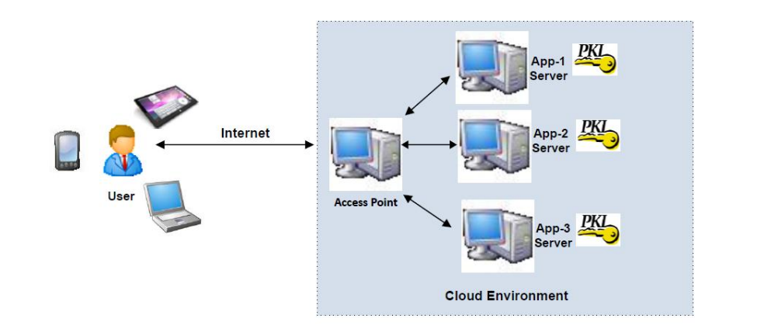
Figure 3.1: Cloud Architecture Model, Source (Fotiou et al., 2019. Source: Encyclopedia)
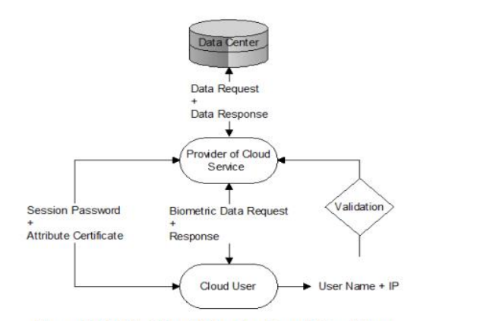
Figure 3.2: A Multi Step Authentication of Cloud User (Source: Encyclopedia)
3.2 ANALYSIS OF THE EXISTING SYSTEM
The existing system for cloud access control typically relies on single-factor authentication methods such as passwords or biometrics. While these methods provide some level of security, they are susceptible to various vulnerabilities such as brute-force attacks, password guessing, and phishing attacks. Additionally, single-factor authentication does not provide robust protection against unauthorized access, especially in cases where passwords or biometric data are compromised.
In further examining the existing system for cloud access control, several key aspects come into focus, shedding light on its strengths and weaknesses:
i. Authentication Methods: Single-factor authentication, such as passwords or biometrics, is the primary method used in the existing system. While these methods are widely adopted and familiar to users, they lack the robustness needed to withstand sophisticated attacks. Password-based authentication is particularly vulnerable to password guessing, brute-force attacks, and password reuse. Weak password policies and lack of enforcement further exacerbate these vulnerabilities.
Biometric authentication, although more secure than passwords in some respects, is not foolproof. Biometric data can be spoofed or replicated, compromising its reliability as a sole authentication factor.
ii. Security Risks: The reliance on single-factor authentication exposes the system to various security risks, including credential theft, phishing attacks, and unauthorized access. Weak authentication mechanisms make it easier for attackers to compromise user accounts, gain unauthorized access to sensitive data, and perpetrate malicious activities within the cloud environment. Lack of multi-layered authentication leaves the system vulnerable to exploitation by attackers employing increasingly sophisticated methods.
iii. User Experience: While single-factor authentication methods may be convenient for users, they can also introduce friction points, especially when stringent password policies are enforced. Users may struggle to remember complex passwords, leading to password fatigue and increased likelihood of password reuse, further compromising security. Biometric authentication, while touted for its ease of use, may present challenges for individuals with disabilities or in scenarios where biometric data cannot be reliably captured or verified.
3.3 PROBLEMS OF THE EXISTING PROBLEM
The existing method of cloud access system has the following problems:
- Security Vulnerabilities: Single-factor authentication methods are prone to security vulnerabilities, including password theft and biometric spoofing.
- Lack of Flexibility: The existing system often lacks flexibility in accommodating different user preferences and security needs.
- Limited Protection: Single-factor authentication offers limited protection against sophisticated attacks, such as credential stuffing and social engineering.
- User Experience: Some authentication methods in the existing system may lead to poor user experience, such as complex password requirements or inconvenient biometric scans.
3.4 DESCRIPTION OF THE PROPOSED SYSTEM
The proposed system aims to enhance cloud access control by implementing a two-factor authentication (2FA) mechanism. This system combines two different authentication methods to strengthen security and mitigate the vulnerabilities associated with single-factor authentication. The two authentication methods include something the user knows which is password and something the user possesses which is token. The proposed system will require users to authenticate themselves using both methods before granting access to cloud resources. For example, a user will first enter their password (knowledge factor) and then verify their identity through a token generated by a mobile app (possession factor). This two-step verification process adds an extra layer of security, making it more difficult for unauthorized users to gain access.
3.5 ADVANTAGES OF THE PROPOSED SYSTEM
The proposed system will possess the following advantages:
- Enhanced Security: By employing two-factor authentication, the proposed system significantly enhances security compared to single-factor authentication methods. Even if one factor is compromised, the attacker would still need to bypass the second factor to gain access.
- Mitigation of Vulnerabilities: Two-factor authentication helps mitigate various vulnerabilities associated with single-factor authentication, such as password theft and biometric spoofing.
- Improved User Experience: While adding an extra layer of security, the proposed system can still provide a relatively seamless user experience, especially if the second factor involves user-friendly methods like push notifications or QR code scanning.
- Flexibility: The proposed system offers flexibility in choosing different authentication methods for the two factors, allowing organizations to adapt to their specific security requirements and user preferences.
- Compliance: Implementing two-factor authentication may also help organizations comply with regulatory requirements and industry standards related to data security and access control.

CHAPTER FOUR
DESIGN, IMPLEMENTATION AND DOCUMENTATION OF THE SYSTEM
4.1 DESIGN OF THE SYSTEM
This is the computation of the particulars of a new system and the determination of what the new system would be and the function it is to perform. This may involve changing from one system to another or modifying the existing system operation.
The most challenging phase of the system life cycle is the change from manual operation to a faster and more accurate one; system design stage covers the technical specifications that will be employed in the implementation of the new system in order to modify the previous system. Some factors are put in consideration. These factors include input design, output design, definitions file and procedure designs and other documentation.
4.1.1 OUTPUT DESIGN
This incorporates the objectives of solving the existing system problems and challenges. This involves the structuring of the desired information and also to enhance efficient and effective 2FA. Things taken into consideration in determining the output are represented below:

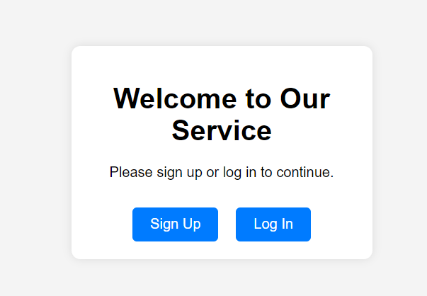
Figure 4.1:index Page
This is a page that will first displayed and it consists of links
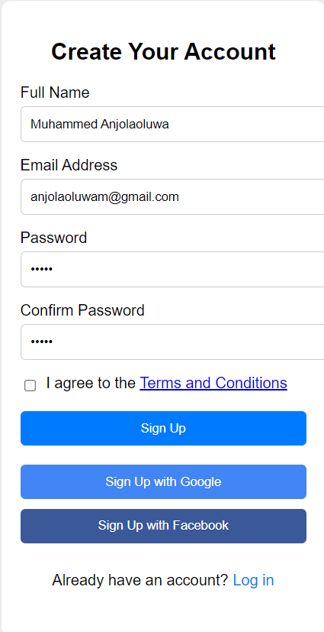
Figure 4.2: Signup
This interface allows allow users to register their information
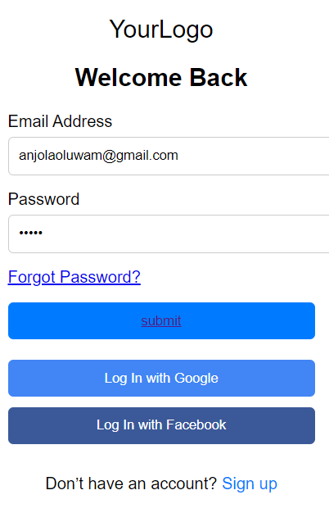
Figure 4.3: Login Page.
This is a where users enter their login credentials
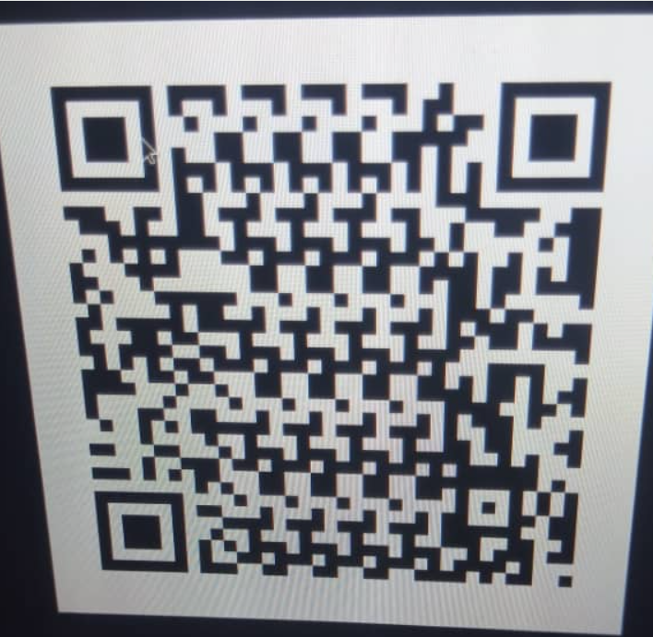
Figure 4.4: Barcode authentication
This is a page where users scan the barcode in other to have access to the cloud environment.
4.1.2 INPUT DESIGN
The input to run this software is obtained from Menstrual cycle monitoring system administrator. The administrator is expected to register any User information. He can achieve this by typing via the keyboard. The input required from the Users is their personal data and answer?
To the questions set by the administrator. It can serve as the various input layouts from the various modules first from the collection of data and module then from the assessment module and input from User respectively.
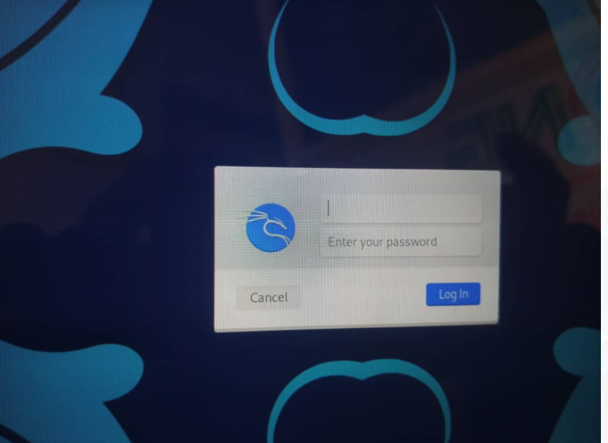
Figure 4.5: Login Interface
This interface allows the user to enter/supply his/her login credentials

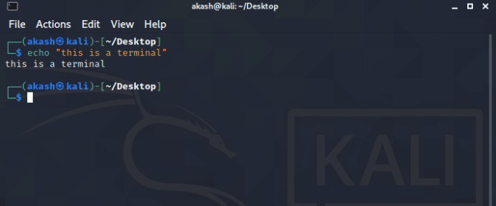
Figure 4.6: Linux Terminal interface
This is where you enter your commands for execution .
4.1.3 PROCEDURE DESIGN
These are the steps involved in unifying the whole process to produce the desired output. It involves computer procedures which start from the original input lessons to the output result file. This allows the processing of User information and result to be possible. Menu is provided to aid User in the processing of the output file.
4.2 IMPLEMENTATION OF THE SYSTEM
This entails the choice of the programming language employed to implement the software which should-be suitable for Menstrual cycle monitoring system. The software is designed for the use of Menstrual cycle monitoring system which should serve as an assistant. It is also expected to be used in conjunction with the User. The Menstrual cycle monitoring system admin will prepare data base while the admin will provide personal data about the User.
4.2.1 CHOICE OF PROGRAMMING LANGUAGE
The Application was developed in a .net (dot net) integrated development environment (.net IDE). The Application IDE is chosen following the fact that extracted information needs to be presented in an enhanced pictorial/graphical format and easy communication with the database for program flexibility in windows platform.
4.2.2 HARDWARE REQUIREMENT
i. 500 Hz minimum with CD ROM drive etc.
ii. Hard disk of capacity 10GB Minimum
iii. 126-512 megabyte of RAM
iv. An Uninterrupted power supply (UPS)
v. A voltage stabilizer
vi. A power generating set etc.
4.2.3 SOFTWARE REQUIREMENT
i. Windows operating system such as Windows 7 etc
ii. Dream Weaver
iii. Server Query Language (SQL).
4.3 DOCUMENTATION OF THE SYSTEM
4.3.1 PROGRAM DOCUMENTATION
The program is packaged for use in any system irrespective of either it runs visual studio application or not. After developing a program in Visual studio, there is a facility provided in Microsoft Visual Studio suite called “Package and Deployment Wizard” that is used in Visual studio application packaging and deployment.
4.3.2 MAINTAINING OF THE SYSTEM
The system maintenance refers to making modification to an already existing application/program without necessarily re-writing everything from start. Program maintenance of a program includes modification of the program to meet-up with certain requirements of the Users. In this course, additional features can be added, errors corrected, ambiguous interfaces redesigned to eliminate confusions and unnecessary features removed.
Maintaining this program can be done in a Visual studio environment. Any future modification can be by re-running the program source code in a visual studio environment making necessary changes and updates and recompile the application into an upgrade version of the existing version of the mini word processing application. Further versions of this program can be named following their year of release or it can be given a different version number.

CHAPTER FIVE
SUMMARY, CONCLUSION AND RECOMMENDATIONS
5.1 SUMMARY
The development of a secure cloud access control system using two authentication methods (password and token) offers a significant enhancement over existing single-factor authentication systems. By combining two distinct authentication factors, such as knowledge-based (e.g., passwords) and possession-based (e.g., tokens or smartphones), this proposed system provides a multi-layered defense against unauthorized access and security threats. Through rigorous analysis of the existing system's shortcomings, including vulnerabilities, user experience issues, and compliance challenges, the need for a more robust authentication mechanism becomes evident. The proposed system addresses these deficiencies by leveraging two-factor authentication, thereby bolstering security, improving user experience, and enhancing regulatory compliance within cloud environments.
5.2 CONCLUSION
The development of a secure cloud access control system utilizing two authentication methods represents a proactive and effective approach to mitigating security risks and ensuring the integrity of cloud-based resources. By implementing a multi-layered authentication framework, organizations can significantly reduce the likelihood of unauthorized access, data breaches, and compliance violations. Moreover, the proposed system offers a balance between security and usability, accommodating diverse user preferences while maintaining stringent security standards. As cloud computing continues to proliferate and cyber threats evolve, investing in robust access control mechanisms, such as two-factor authentication, is imperative for safeguarding sensitive data and preserving organizational trust.
5.3 RECOMMENDATIONS
Based on the analysis and conclusions drawn, the following recommendations are proposed for the development and implementation of a secure cloud access control system using two authentication methods:
- A thorough risk assessment should be conducted to identify potential vulnerabilities and security threats within the existing cloud environment. This assessment should inform the design and implementation of the two-factor authentication system.
- Prioritize user experience in the design of the authentication process by offering intuitive and user-friendly authentication methods. Consider user feedback and preferences to ensure widespread adoption and acceptance of the system.
- Implement mechanisms for continuous monitoring of authentication processes and promptly address any emerging security issues or vulnerabilities. Regular updates and patches should be applied to ensure the system remains resilient to evolving threats.
- Ensure alignment with relevant regulatory requirements and industry standards governing data security and access control. Regular audits and assessments should be conducted to verify compliance and address any non-compliance issues proactively.
- Provide comprehensive training and awareness programs to educate users about the importance of two-factor authentication and best practices for maintaining security in the cloud environment. Empowering users to recognize and respond to security threats is critical for the success of the system.

REFERENCES
Byali, R., Jyothi, H. & Shekadar, M. C. (2022). Dual Access Control for Cloud-Based Data Sharing and Storage Security, International Journal of Research Publication and Reviews. Vol. 1, Issue: 1. Pp. 4-5.
Donald, A. C. & Arockiam, T. L. (2019). Securing Data with Authentication in Mobile Cloud Environment: Methods, Models and Issues, International Journal of Computer Applications. Vol. 94, Issue: 1. Pp. 1288-1289.
Fotiou, N., Machas, A., Polyzos, G. C. & Xylomenos, G. (2019). Access control as a service for the Cloud, In: Proceedings of the 17th ACM Conference on Computer and Communications Security. CCS ’10. ACM, New York, NY, USA. Pp. 735–737.
Gokila, R., Manimaran, A. & Kumar, K. (2018). Implementation of Two-Factor Authentication Access Control in Web Based Services with Cloud Computing using C# .Net, International Journal of Pure and Applied Mathematics. Vol. 119, Issue: 10. Pp. 1881-1908.
Harshavardhan, H. A. (2015). Integrity Auditing for Outsourced Dynamic Cloud Data with Group User Revocation, International Journal of Computer Engineering in Research Trends. Vol. 2, Issue: 11. Pp. 877-881.
Kaur, S., Kaur, G. & Shabaz, M. (2022). A Secure Two-Factor Authentication Framework in Cloud Computing, Journal of Security and Communication Networks. Vol. 4. Pp. 34-36.
Lal, N. A., Prasad, S. & Farik, M. (2016). A Review of Authentication Methods, International Journal Of Scientific & Technology Research Vol. 5, Issue: 11. Pp. 2277-8616.
Liao, I. E., Lee, C. C. & Hwang, M. S. (2016). A Password Authentication Scheme Over Insecure Networks. Journal of Computer and System Sciences, 72(4). Pp. 727–740. Doi:10.1016/J.Jcss.2005.10.001
Mahmood, G. S., Huang, D. J. & Jaleel, B. A. (2019). A Secure Cloud Computing System by Using Encryption and Access Control Model, Journal of Information Process System. Vol. 15, Issue: 3. Pp. 538-549.
Megouache, L., Zitouni, A. & Djoudi, M. (2020). Ensuring user Authentication and Data Integrity in Multi-Cloud Environment, The 5th IEEE international conference on future internet of things and cloud (FiCloud). Pp. 56-58.
Mudarri, K. & Al-Rabeei, S. (2019). Security Fundamentals: Access Control Models, International Journal of Interdisciplinarity in Theory and Practice. Vol. 1, Issue: 2. Pp. 3-5.
Otta, P., Panda, S., Gupta, M. & Hota, C. (2023). A Systematic Survey of Multi-Factor Authentication for Cloud Infrastructure, International Journal of Scientific & Technology Research Vol. 2, Issue: 11. Pp. 77-78.

Patel, S. C., Jaiswal, S., Singh, R. S. & Chauhan, J. (2018). Access Control Framework Using Multi-Factor Authentication in Cloud Computing, International Journal of Green Computing. Vol. 9, Issue: 2. Pp.
Rahman, M. S., Ahmed, M. K. & Rao, G. S. (2017). Two Step Factor Based Authentication Control to Access Cloud Services, International Journal of Computer Engineering In Research Trends. Vol. 4, Issue: 10. Pp. 431-440.
Shekinah, P. (2015). Decentralized Fine-grained Access Control Scheme for Secure Cloud Storage Data, International Journal of Computer Engineering in Research Trends. Vol. 2, Issue: 7. Pp. 421- 424.
Somorovsky, J., Mayer, A., Schwenk, J., Kampmann, M. & Jensen, M. (2019). Security Fundamentals: Access Control Models, In: Proc. of the 21st USENIX Security Symposium. USENIX Association, Berkeley. Vol. 12. Pp. 21–21.

