A PROJECT REPORT

ON

PROPORSED MATERNITY HOME

FOR

(ILORIN WEST STATE GOVERNMENT) KWARA STATE

BY

OGUNNIRAN OMOWUMI ABIGEAL
ND/23/ARC/PT/0033

BEING A PROJECT REPORT SUBMITTED TO THE DEPARTMENT OF ARCHITECTURAL TECHOLOGY, INSTITUTE OF ENVIRONMENTAL STUDIES, KWARA STATE POLYTECHIC, ILORIN. INPARTIAL FULFILMENT OF THE REQUIREMENT FOR THE AWARD OF NATIONAL DIPLOMA (ND) IN ARCHITECTURAL TECHNOLOGY.

JULY, 2025

DECLARATION
I declare that this Project/Dissertation is a project of my personal research works. It has not been presented for the award of any ND in any polytechnic. The ideas, Observations, Comments, and Suggestions here in represent my own convictions except quotations, which have been acknowledged. In accordance with conventional academic traditions.

OGUNNIRAN OMOWUMI
ABIGEAL
ND/23/ARC/PT/0033

________________________
SIGNATURE & DATE

CERTIFICATION
I certify that this research project/Dissertation entitled MATERNITY HOME was carried out by OGUNNIRAN OMOWUMI ABIGEAL under my supervision MRS ARC J.M TOMORI has been approved. As meeting the requirement for the award of ND in Architectural Technology, Kwara State Polytechnic, Ilorin, Kwara State.

ARC (MRS) TOMORI J.M. ____________________
Project Supervisor SIGNATURE & DATE

ARC OLAREWAJU F. A. _____________________
Project Coordinator SIGNATURE & DATE

ARC (MRS) TOMORI J. M. ______________________
Head of Department SIGNATURE & DATE

_________________________ _____________________
EXTERNAL EXAMINER SIGNATURE & DATE

DEDICATION
This project work is dedicated to Almighty GOD who has been providing all my need for his blessing and mercy over me all through the program.
And to my parent, my sisters, my brothers, friends, love one’s and supervisor who assist me financially, spiritually, mentally and guide me through my academic pursuit. May Almighty GOD shower his blessing and mercy over you all.

ACKNOWLEDGEMENT
My profound gratitude goes to Almighty GOD, the creator of universe and fountain of all wisdom whose umbrella of guard and guide. I seek refuge through thick and thin of years of study.
I will also like to appreciate my project supervisor in person of ARC (MRS) TOMORI J. M. whose contribution Prepare me for the challenges in the field and for his immense contribution is all ramification towards the completion of this research work. He encourage me and open the door of interaction with him. I pray Almighty GOD will shower his blessing and mercy over him, your family and may you live to reap the fruit of your labour.
I also want thank and appreciate the effort of all the Lectures in Architectural Technology Department, who taught and give lasting advice’s that led to the success of my program, Almighty GOD will meet everyone at the point of needs.
I would also show my profound gratitude to my parents MR and MRS. OGUNNIRAN for their Immeasurable motivation, advices, efforts, and prayers on me for the completion of this program.
My Lovely sisters: Miss Yomade, Adeshola, Hannah. Almighty GOD shower his endless blessing, mercy, unlimited grace, joy, happiness without sorrow, sound health over all and may Almighty GOD meet everyone at the point of your needs.
Precious friends: My lovely friends Oyeleke, Marvellous, Mayourkun. Almighty GOD shower his blessing, grace, and happiness with sound health over you all and our prayer (AMEEN)
I would also show my appreciation for the effort of an unforgettable to my pastor Rev. A.T Oladosu , who advise me to carry on my journey. May Almighty God bless you and grant your heart desires, good health over you.
Lastly ,I would like to appreciate the effort of my colleagues in department, school, and hostel, I whole heartedly say a VERY BIG THANK YOU, I appreciate you all, May Almighty GOD bless you all.
Above all, my utmost thanks go to the all sufficient God, the fountain of my wisdom, for his great and protection over my life, for his undying love, support and guidance throughout my period of learning and also for in sighting writing this project without him am nothing.

TABLE OF CONTENT
Title page……………………………………………………………………………i
Declaration………………………………………………………………………….ii
Certification…………………………………………………………………………iii
Dedication…………………………………………………………………………...iv
Acknowledgement…………………………………………………………………..v
Table of Contents…………………………………………………………………...vii
List of tables…………………………………………………………………………ix
List of figures………………………………………………………………………...x
List of plates…………………………………………………………………………xi
List of Appendices…………………………………………………………………..xii
Abstract……………………………………………………………………………...xiii
CHAPTER ONE:
1.1 INTRODUCTION……………………………………………………………..1
1.2 DEFINITION…………………………………………………………………...1
1.3 HISTORICAL BACKGROUND……………………………………………….2
1.4 AIM AND OBJECTIVES ……………………………………………………...3
1.5 PROJECT JUSTIFICATION …………………………………………………..3
1.6 CLIENT BACKGROUND……………………………………………………...3
1.7 SCOPE OFTHEPROJECT……………………………………………………...3
1.8 RESEARCHMETHODOLOGY………………………………………………..4
CHAPTER TWO:
2.1 LITERATURE REVIEW……………………………………………………… 5
2.2 HISTORICALBACKGROUND………………………………………………5
CHAPTER THREE:
3.1 CASE STUDIES…………………………………………………………….....8
3.2 SELECTED CASE STUDIE…………………………………………………...8
3.3 CASE STUDY ONE……………………………………………………………8
3.4 CASESTUDYTWO……………………………………………………………11
3.5 CASE STUDY THREE………………………………………………………..12
3.5 ONLINE CASE STUDY………………………………………………………15
3.6 DEDUCTION………………………………………………………………….16
CHAPTE RFOUR:
4.1 BRIEF HISTORICAL BACKGROUND…………………………………16
4.2 LOCATION AND SETTING OUT…………………………………..…..16
4.3 POPULATION……………………………………………………………17
4.4 SITE INVENTORY……………………………………………..………..18
4.5 SITE ANALYSIS…………………………………………………….…...19
4.5.1 SITE SELECTION AND JUSTIFICATION… …………………....…..19
4.5.2 LOCATION ………………………………………………………..…..19
4.5.3 ACCESSIBILITY…….……………………………………………..….20
4.5.4 INFRASTRUCTURE FACILITES….………………………………....20
4.5.5 TOPOGRAPHY…………………………………………………….......20
4.5.6 SOIL STRUCTURE…………………………………………………....20
4.6 GENERAL CLIMATE CONDITION.…………………………………..20
4.6.1RELATIVE HUMIDITY…………………………………………………….20
4.6.2 WIND….......................................................................................................20
4.6.3 TEMPERATURE……………………………………………………………20
4.6.4 VEGETATION………………………………………………………………20
4.7 SOCIAL SERVICES…………………………………………………………..21
4.7.1 ROAD………………………………………………………………………..21
4.7.2 WATER AND ELECTRICITY……………………………………………..21
4.8 DESIGN CRITERIA…………………………………………………………..21
4.9 DESIGN BRIEF ………………………………………………………………..21
4.10 DESIGN ANALYSIS… ………………………………………………....21
4.11 SPACIAL ALLOCATION …………………………………………………22
4.12 PLANNING PRINCIPLE…………………………………………………….22
CHAPTER FIVE:
5.1 APPRAISAL OF PROPOSED SCHEME……………………………………..23
5.2 CONSTRUCTION METHODOLOGY………………………………………..23
5.3 SERVICES………………………………………………………………………23
5.3.1 VENTILATION………………………………………………………………23
5.3.2 LIGHTING………………………………………………………………….…24
5.3.3 PLUMBING…………………………………………………………………...24
5.3.4 ELECTRICAL INSTALLATION…………………………………………….24
5.3.5 WASTE DISPOSAL………………………………………………………..…24
5.3.6 FIRE PROTECTION……………………………………………………….…24
5.3.7 RAIN PROTECTION…………………………………………………………24
5.3.8 EXTERNALWORK…………………………………………………………..24
5.4 SUMMARY……………………………………………………………………...25
5.5 CONCLUSION…………………………………………………………………..25
5.6 RECOMMENDATION………………………………………………………….25
5.7 REFERENCES…………………………………………………………………..26
5.8 APPENDICES……………………………………………………………….......27

LISTOFTABLES
TABLE 4.1;SHOWING THE POPULATION OF THE GENDER……………….18
TABLE 4.2;SHOWING SPACIAL ALLOCATION OF FLOOR PLAN………….21

LIST OF FIGURES
FIG 3.1;SHOWING LOCATION PLAN OF CASE STUDY ONE…………………9
FIG 3.2;SHOWING FLOOR PLAN OF CASE STUDY ONE………………………9
FIG3.3;SHOWING LOCATION PLAN OF CASE STUDY TWO…………………11
FIG3.4;SHOWING FLOOR PLAN OF CASE STUDY TWO………………………11
FIG3.5;SHOWING LOCATION PLAN OF CASE STUDY THRE………………...13
FIG3.6;SHOWING FLOOR PLAN OF CASE STUDY THREE……………………14
FIG4.1;SHOWING LOCATIONAL PLAN OF THE PROPOSED SITE……….…17
FIG4.2;SHOWING SITE INVENTORY OF THE PROPOSED SITE………….…18
FIG4.3;SHOWING SITE ANALYSIS OF THE PROPOSED SITE………………..19

LIST OF PLATES
PLATE3.1:SHOWING FRONT VIEW OF CASE STUDY ONE…………………..10
PLATE3.2:SHOWING RIGHT VIEW OF CASE STUDY ONE …………………..10
PLATE3.3:SHOWING FRONT VIEW OF CASE STUDY TWO………………….12
PLATE3.4:SHOWING RIGHT VIEW OF CASE STUDY TWO………….…….…12
PLATE3.5:SHOWING FRONT VIEW OF CASE STUDY THREE……………….14
PLATE3.6:SHOWING RIGHT VIEW OF CASE STUDY THREE………………..14

LIST OF APPENDICES
APP1;SHOWING SITE PLAN OF THE PROPOSED PROJECT ……………….28
APP2;SHOWING GROUND FLOOR PLAN OF THE PROPOSED PROJECT…28
APP3;SHOWING ROOF PLAN OF THE PROPOSED PROJECT……………….29
APP4;SHOWING CROSS SECTION OF THE PROPOSED PROJECT…………29
APP5;SHOWING FRONT VIEW OF THE PROPOSED PROJECT……………..29
APP6;SHOWING SIDE VIEW OF THE PROPOSED PROJECT…………………29

ABSTRACT
This researcher work was carried out on the project topic "Maternity home for Ilorin West Kwara State". I felt caring out this project in Local Government will bring out meaningful result.
For easy analysis and understanding, the study is being put into five chapters. Chapter one throws light on general introduction, definition of the project, historical background information of the project title, project justification, aim and objectives of the study, scope of the study, Chapter two, a detailed literature review of some books, case studies and deduction from case studies.
The third chapter three also mention about the historical background of the study area, site location and description, site analysis, and geographical location, climatic data, population of the area, social services, and health services. The fourth chapter deals with design criteria, design analysis, space allocation and planning principle. Chapter five deals with design appraisal, construction methodology, services, summary, conclusion and references.

CHAPTER ONE
1.0 INTRODUCTION
A maternity home, also known as a maternity hospital or birthing center, is a specialized facility dedicated to providing care for women during pregnancy, childbirth, and the postpartum period. These homes offer a supportive environment for expectant mothers, focusing on safe delivery and comprehensive maternal and newborn care. Below is an introduction to the concept of a maternity home:
1.1 INTRODUCTION TO MATERNITY HOMES
Maternity homes are healthcare facilities designed to cater to the unique needs of pregnant women, ensuring a safe and comfortable birthing experience. They provide a range of services, including prenatal care, delivery assistance, and postnatal care, under the supervision of trained professionals such as midwives, obstetricians, and nurses. Unlike general hospitals, maternity homes focus exclusively on maternal and neonatal health, creating a nurturing and family-centered environment.
The primary goal of a maternity home is to promote the health and well-being of both the mother and the newborn. These facilities often offer personalized care plans, birthing options (such as natural birth, water birth, or cesarean section), and education on breastfeeding, newborn care, and postpartum recovery. Some maternity homes also provide additional support, such as counseling, nutritional guidance, and community resources, to help mothers transition into parenthood.
Maternity homes vary in size and scope, ranging from small, home-like birthing centers to larger institutions integrated within hospitals. They may cater to low-risk pregnancies or be equipped to handle high-risk cases with advanced medical technology. Many emphasize a holistic approach, combining medical expertise with emotional and psychological support to ensure a positive birthing experience.
In addition to medical care, maternity homes often serve as safe havens for women who may lack adequate support systems, such as young mothers, single parents, or those facing financial or social challenges. Some maternity homes, particularly those run by non-profit organizations or charities, offer temporary housing, life skills training, and assistance with adoption or parenting decisions.
1.2 DEFINITION OF MATERNITY HOME
A maternity home is a type of residential facility that provides support and accommodation for pregnant women, particularly those who may be facing difficult circumstances or are unmarried. These homes often offer a range of services, including housing, counseling, parenting classes, and sometimes even adoption-related support. They can be seen as a form of supportive housing for pregnant women, helping them navigate their pregnancies and prepare for motherhood.
1.3 HISTORICAL BACKGROUND
Maternity homes have a complex history, evolving from institutions focused on moral reform and social support for unwed mothers to facilities providing medicalized childbirth and adoption services. Initially, they often served as a refuge for women facing societal stigma, particularly those who were unmarried and pregnant. Over time, the focus shifted towards providing medical care during pregnancy and childbirth, and eventually, adoption became a significant aspect of their operations.
In 1883, the first Florence Crittenton home opened in New York as a place to reform unmarried “fallen women,” who were encouraged to keep their children.That goal changed by the middle of the 20th century, when maternity homes began placing most babies with adoptive families.The so-called “baby boom” was happening not only among married couples. A rise in premarital sex coupled with a lack of sex education and little access to contraception led to more unplanned pregnancies for unmarried women and girls. Abortion was not yet legal nationwide, and single motherhood bore a heavy social stigma.Between the end of World War II and 1973, in what became known as the “Baby Scoop Era,” more than 1.5 million American infants were surrendered for adoption. An untold number of their mothers were sent away to maternity homes before giving birth.
Prior to the 1980s, housing for pregnant women was offered in larger, institution-like settings that were strongly adoption-oriented. In these homes, confidentiality was a priority due to the social stigma around unwed births and the policies reflected the adoption laws and practices of the time. From these settings grew many of the narratives around maternity homes that continue to this day (e.g. women forced into adoption; preventing birth mothers from seeing their new borns; concealing placement details).
In the 1970s and 1980s, the adoption process began to grow in flexibility (e.g. changes to father notification, no longer making short-term placements of adopted babies into foster care, making use of probate court adoptions rather than solely via adoption agencies, increased inter-state adoptions.) Offering a more flexible housing option via a new model paralleled the more flexible adoption process. The large, institutional maternity homes began to close during this time.
In the early 1970s, Anne and Jim Pierson were pioneers in the host home model and publicly recognized by President Reagan for their family-style method of welcoming pregnant women. Shepherding or host homes grew in popularity in the 1980s and 1990s as a new type of housing resource. In this model, pregnant women in crisis pregnancies were housed within the spare bedrooms in the homes of passionate volunteers during their pregnancy. Several longstanding maternity homes used some version of a host home living environment as the launching point for developing a housing program. Additionally, many founders of longstanding maternity homes (and other pregnancy help organizations) began by welcoming women into their own home.
1.4 AIM AND OBJECTIVES OF THE PROJECT
AIM OF THE PROJECT
To design a functional, efficient, and user-friendly maternity home that provides quality maternal and child health care, promotes comfort, privacy, and hygiene, and responds to the local climatic, social, and cultural conditions of Ilorin West, Kwara State.
OBJECTIVES OF THE PROJECT
- To Provide a Safe and Hygienic Environment for Childbirth
- To Create Appealing Landscaping that Promote Comfort and Psychological Wellbeing
- To Ensure Functional Spatial Planning
- To Promote Accessibility and Inclusivity
- To Accommodate Future Expansion and Flexibility
1.5 PROJECT JUSTIFICATION OF THE PROJECT
The establishment of maternity home is justified as they provide a process built environment that supports the unique physical, emotional and social needs of mother and babies promoting and comforting a safe and empowering experience.
1.6 CLIENT BACKGROUND
Dr. Steve OnotuArigidi
The chief medical director at the State Specialist Hospital Sobi in Ilorin, Kwara State.
Dr. Steve OnotuArigidi is the chief medical director at the State Specialist Hospital Sobi in Ilorin, Kwara State. For most of his career, he has worked in resource-poor communities as a public health physician with a specialization in reproductive health. During earlier years, Dr. Arigidi observed that the majority of the pregnant women attending his clinics were not receiving any form of pregnancy counseling and were not registered with a facility, thus increasing the risk of complications of prolonged and/or unattended labor.
1.7 SCOPE OF THE STUDY
- Proposed Building
- Visitors unit
- Gate House
- Generator House
- Parking Lot
- Emergency park
- Access Road
1.8 RESEACH METHOLODY
Various avenues were expressed as regards the method of research on order to arrive at a functional and appealing design concepts. The following research methods were employed.
CASE STUDY: This is the method that carried out in which to gain more detailed experience and an my project topic maternity home
ORAL INTERVIEW: An oral interview in the method I carried out to collect more information by directly engaging with individualse.g manager the workers, the citizens and other to gain more experience on my project
LITERATURE REVIEW: This is the process by which I carried out in the process of reach, articles, niddles and others materials on my project.
CHAPTER TWO
2.0 LITERATURE REVIEW
2.1 HISTORICAL BACKGROUND OF A MATERNITY HOME
MATERNITY HOME
In January, 1972, a study form was developed and mailed to all known maternity homes in this country. The sources of lists of maternity homes were: Directory of maternity Homes and Residential Facilities for Unmarried Mothers, National Council on Illegitimacy, May, 1966, and list of member agencies of (Florence Crittenden Association of America, Inc., (June 1, 1971). In the above mentioned directory, a maternity home is defined as a private agency licensed to provide residential care for unmarried mothers. In all, 201 maternity homes were queried. There were a total of four mailings of the study form to the non-respondents. These follow-up mailings occurred during the period February-June, 1972, with a final cutoff on August 31, 1972.Of the 201 maternity homes listed in the sources mentioned above, 163 replied to the study (81.1 per cent). A number of tables have been omitted to conserve space; the significant data are described in the text.
Responses were received from 17 of the 18 maternity homes (94.4 per cent) that were reported to be under the auspices of the Protestant church. Next highest in response rates were the Crittenton maternity homes (84.3 per cent) and those sponsored by the Catholic church (82.7 percent). The Booth maternity homes (including the Salvation Army homes) and "other" maternity homes each had a75.0 per cent response rate. Maternity homes that were open and sponsored by the Catholic and Protestant churches were categorized on thebasis of their admission policies, as stated in the Directory mentioned above. It should be noted that among the maternity homes of these two church-sponsored groups of maternity homes, most of them did not restrict admission.
About 40 per cent (51) of the maternity homes reporting their year of opening and still open had been in existence before 1900. The Crittenton group led in this respect with 62.5 per cent dating back to the last century, while the Protestant-sponsored group had the smallest percentage (8.3) that dated that far back. Slightly less than one-fifth of the maternity homes (23) had been in existence since 1900-1919, and about the same number (22) had been in existence since 1920-1939. It is interesting to find that 14 maternity homes (11.0 per cent) had opened in the decade 1960-69. Most maternity homes are small. For example, 50.9 percent (58) of those reporting number of beds at the time of survey had less than 30 beds; about three-fourths (87) were reported to have less than 40 beds. Forty-six per cent of the maternity homes (36) reporting occupancy rate had a 1970 occupancy rate of less than 70 per cent. Another 36 per cent (28) reported occupancy of 80 per cent or more. During 1970, 91 maternity homes reporting the number of girls cared for stated that they cared for a total of 13,362 girls; this would represent about 4.2 per cent of the total annual reported live births out-of-wedlock in the U.S.A. for 1968 (318,000). However, it should be mentioned that another 41 maternity homes were not able to report data for 1970 on number of girls cared for. If it is assumed that, in general, these 41 homes had caseloads similar in size to those able to report, the 132 maternity homes responding to the survey would have given care to girls whose newborn infants represented about 6 per cent of the U.S.A. reported out-of-wedlock live births for 1968. During 1970, caseloads were relatively small. Forexample, about one-third (31) of the homes reporting caseloads cared for under 100 girls; about 65 per cent of the homes (59) cared for under 150 girls. Half of the responding maternity homes reported data on number of girls cared for during the period 1960-1970. The mean number of girls cared for during the period 1960-1964 was compared with the mean number of girls cared for during the period 1966-1970 for each maternity home. Fifty-one homes showed increases, and 15 showed decreases in number of girls cared for. Occasionally, these differences between the two 5-year periods were minor. In order to determine whether, in general, an upward trend was also apparent in the difference in numbers of girls cared for between 1969 and 1970, a review of these differences was undertaken for the 66 responding maternity homes that had been studied for trend during the period 1960-1970. Surprisingly, 55 of the 66 homes showed decreases between 1969 and 1970. It would appear thatsuch drops in caseloads are related to the striking increase in closures of maternity homes. The 88 maternity homes that were able to report their budgets for 1970 had combined total annual budgets of $15,145,020. Of these, 66 maternity homes were able to report the number of girls cared for in that year and the per diem cost. They cared for a total of 9,617 girls at a total budget of $10,095,954 or a mean cost of $1,049.80 per girl. Since the mean per diem cost of this group of maternity homes was $13.71, it would appear that the mean stay of the girls was 77 days or about 2-3/5 months. Ninety-four maternity homes reported per diem costs for 1970. About one-third of these reported a per diem cost of less than $10.00. Slightly over one-half reported a per diem cost of less than $12.50. Major sources of funds for the maternity homes are United Fund, fees, gifts, public agencies, and special funds (such as in the case of the Salvation Army).
Maternity homes in the United Kingdom have a rich history shaped by evolving medical practices, social changes, and architectural advancements. Originally, childbirth was predominantly a home-based event, attended by midwives or family members. However, rising concerns over maternal and infant mortality in the 18th and 19th centuries prompted the development of specialized maternity hospitals. Hospitals designed with functionalist and modernist principles emerged, focusing on efficient layouts, sterile environments, and patient safety. Dedicated labor wards, operating theaters, and neonatal intensive care units (NICUs) became standard. The establishment of the National Health Service (NHS) in 1948 further accelerated the modernization and expansion of maternity services across the UK.
Until the 1750s all births took place at home – except of course where birth occurred unexpectedly! A labour and the recovery afterwards were known as ‘lying-in’. The lying-in period was typically a month, during which the new mother at first recuperated bed-bound, then remained in the house, gradually returning to her household duties. Lying-in ended with the public cleansing and thanksgiving ritual of ‘churching’ performed in the local Church of England.
Lying-in did not take place just anywhere in the home but involved carefully remaking the master bedroom into a dark and airless lying-in chamber. At the first signs of labour, extra linen was draped onto and around the bed and over the windows and doors. The fire was stoked up, and all openings in the room closed – sometimes even gaps and the keyhole were stuffed with fabric. It was thought air and light were harmful, and may lead to the dreaded puerperal fever, a tremendously dangerous illness (essentially an infection) experienced after childbirth. Men were removed from the room, and replaced by a gathering including the midwife and at least five women to aid the birth, called the ‘gossip’. The room was darkened further after birth, as it was thought light could damage the new mother’s eyesight, already weakened by the effort of childbirth.

CHAPTER THREE
3.1 CASE STUDIES
This is are search or an exercise that is carried out on existing building which is similar to the one researcher is writing on. The objective of a case study is to take a critical appraisal of existing related project with a view to identify the positive and negative aspect of such projects. It is only with time that a project can be adjusted so that it can be successful. The information obtained from the appraisal will guide the designer of new and similar project, the positive aspect of it shall be incorporated in the view proposal while attempts will be made to solve the problem of negative aspects. It is only through this that a designer can better enhance the quality and efficiency of building in the society. For a comprehensive analysis their case studies have been conducted.
3.2 SELETED CASE STUDIES
Case studies are of paramount important. It is an experimental research or analysis carried out on existing building or group of building functionally similar to the one which there search is working.
For any technical design to be meaningful there is always the need for preliminary research effort to be made on this proposal as a very necessary ground work.
The following are case studies of some maternity home.
3.1.1 Redeemers chapel maternity home, Ilorin Kwara state,
3.1.2 Glad tiding maternity home, Ogbomosho, Oyo state
3.1.3 Government maternity home, Okeamola, Osun state
3.3 CASE STUDY ONE
Redeemers ChapelMaternity Home
LOCATION: Ilorin, Kwara State
OBSEVERATION
MERITS
- It easily accessible
- Adequate parking lots
- The building is well oriented.

DEMERITS
- Poor ventilation
- Low personality for patients
- Changing room is not enough for the staff.

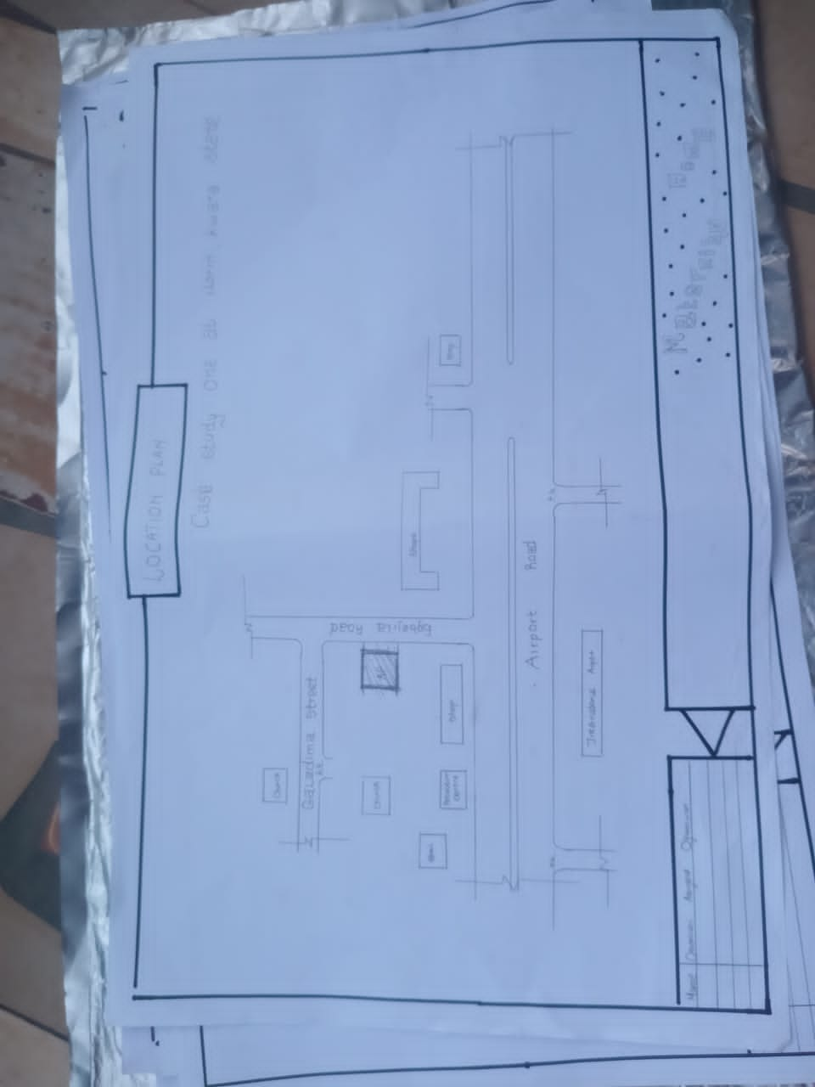

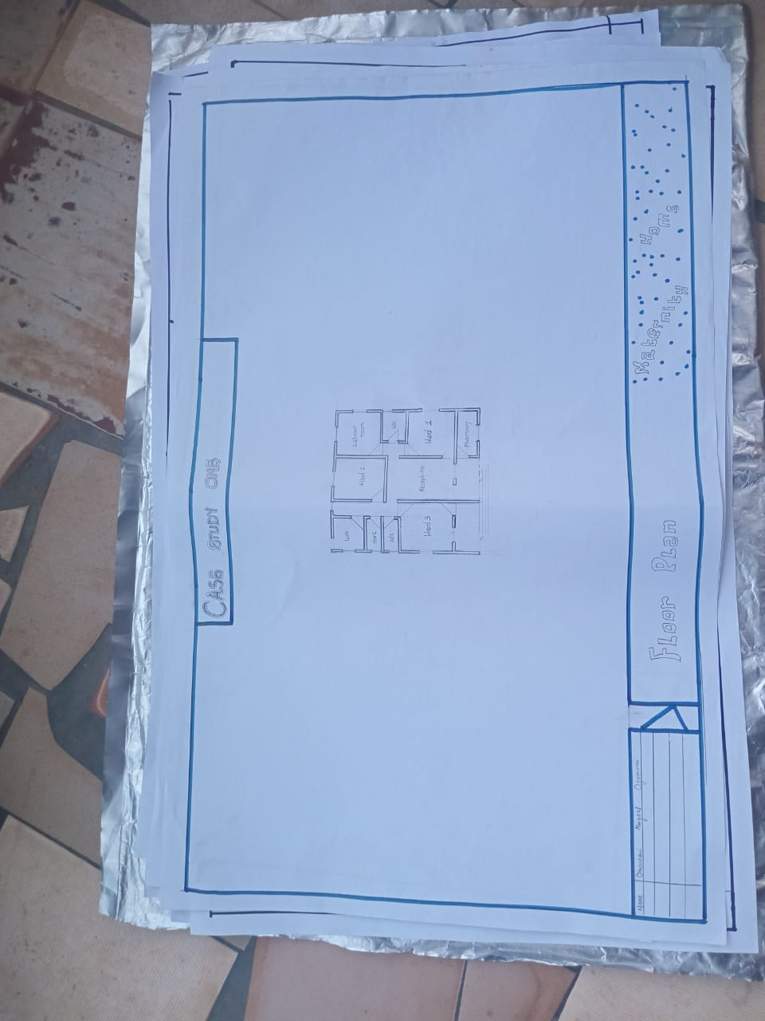

Fig 3.1 LOCATIONAL PLAN OF CASE STUDY ONE

Fig 3.2 FLOOR PLAN OF CASE STUDY ONE
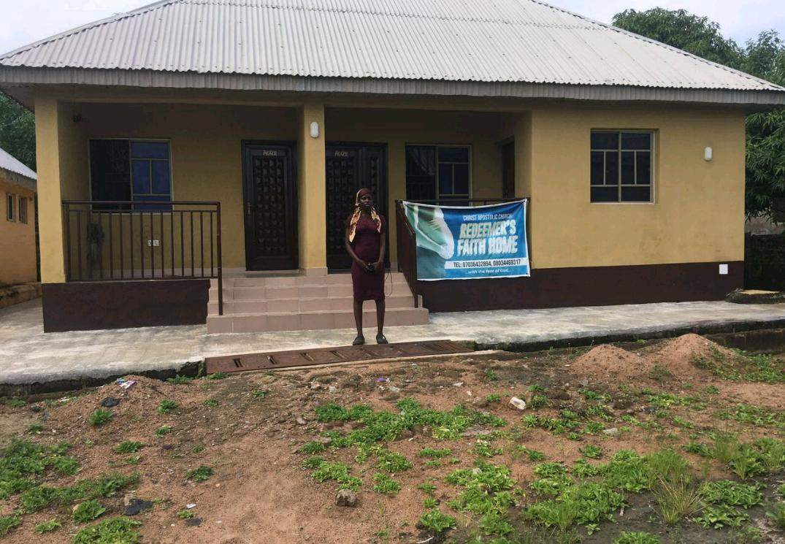
Plate 3.1 FRONT VIEW OF CASE STUDY ONE
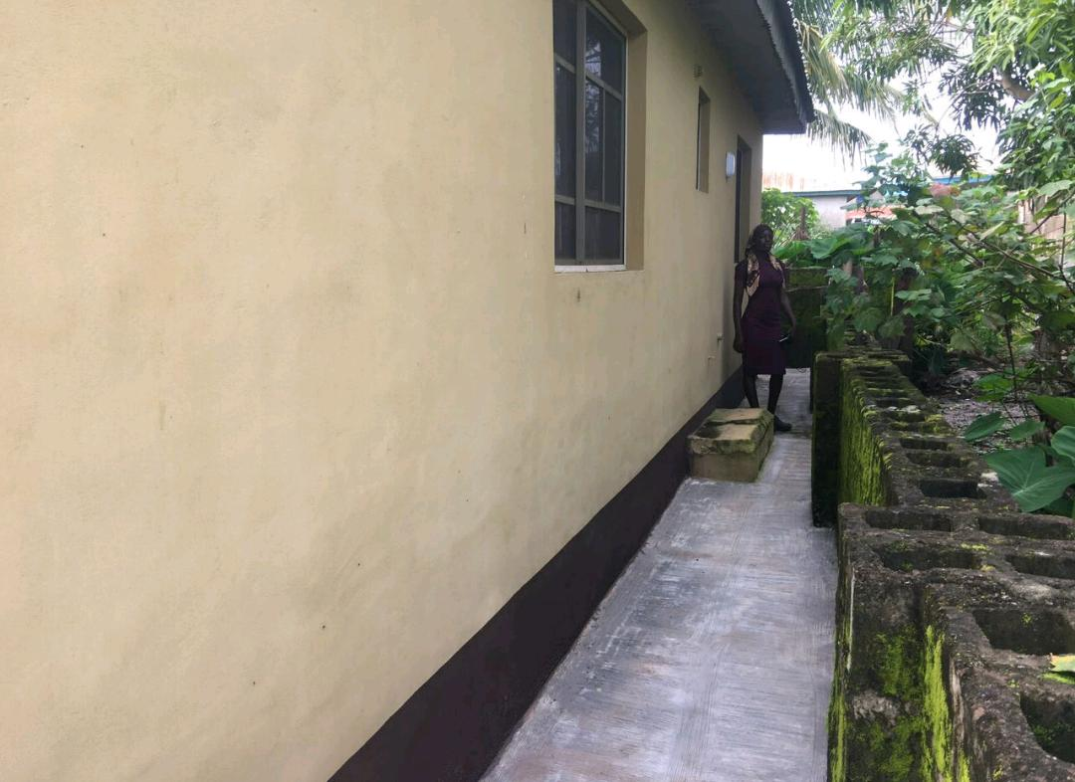
Plate 3.2 SIDE VIEW OF CASE STUDY ONE
3.4 CASE STUDY TWO (2)
Glad Tiding Maternity Home
LOCATION: Ogbomosho, Oyo State
OBSERVATION
MERITS
- It easily accessible
- Provision of drainage facilities
- Eco-conscious features.
DEMERIT
- Lack of cross ventilation
- Still under pilot in some areas.
- Lack of waste treatment facility.

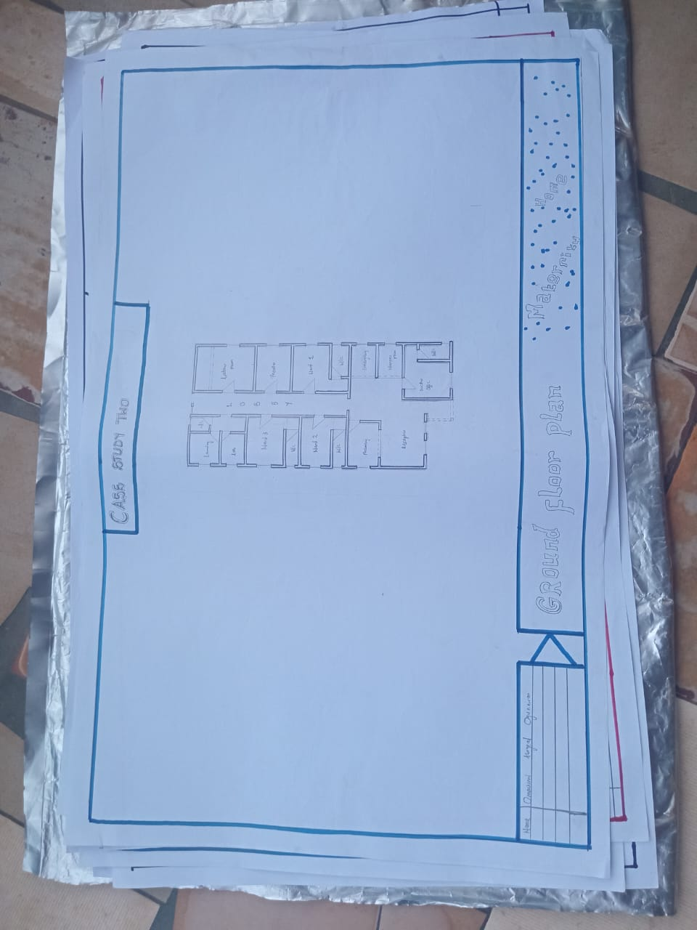

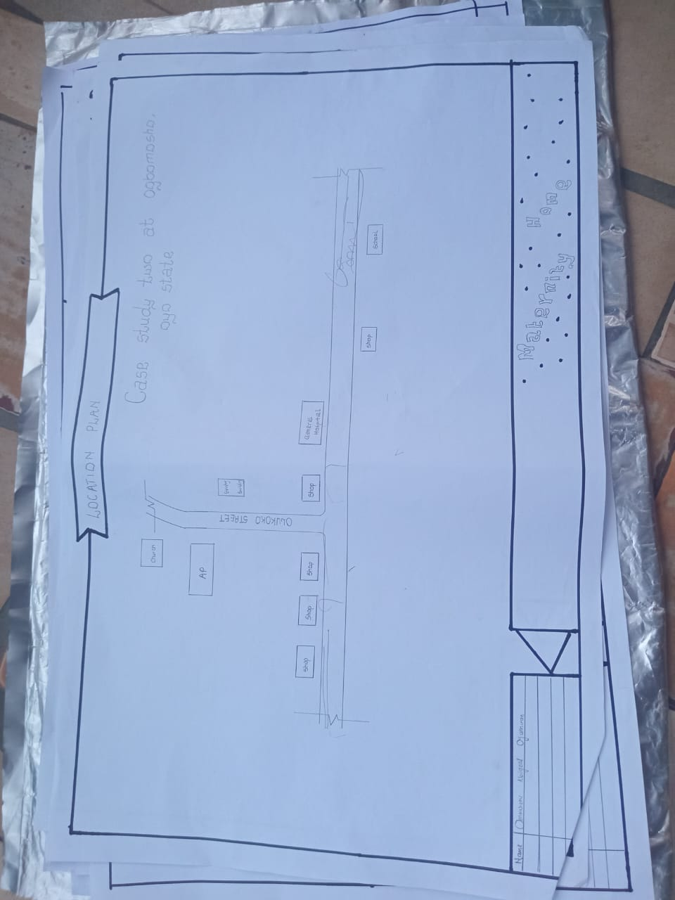

3.3 FLOOR PLAN OF CASE STUDY TWO

Fig 3.4 LOCATIONAL PLAN OF CASE STUDY TWO
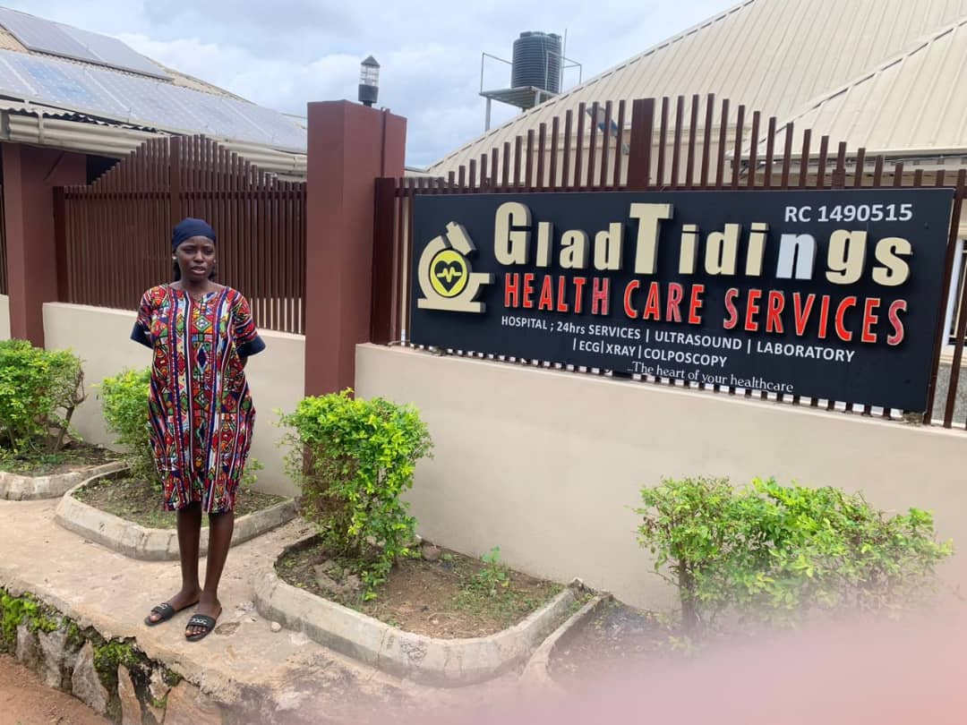
Plate 3.3 FRONT VIEW OF CASE STUDY TWO
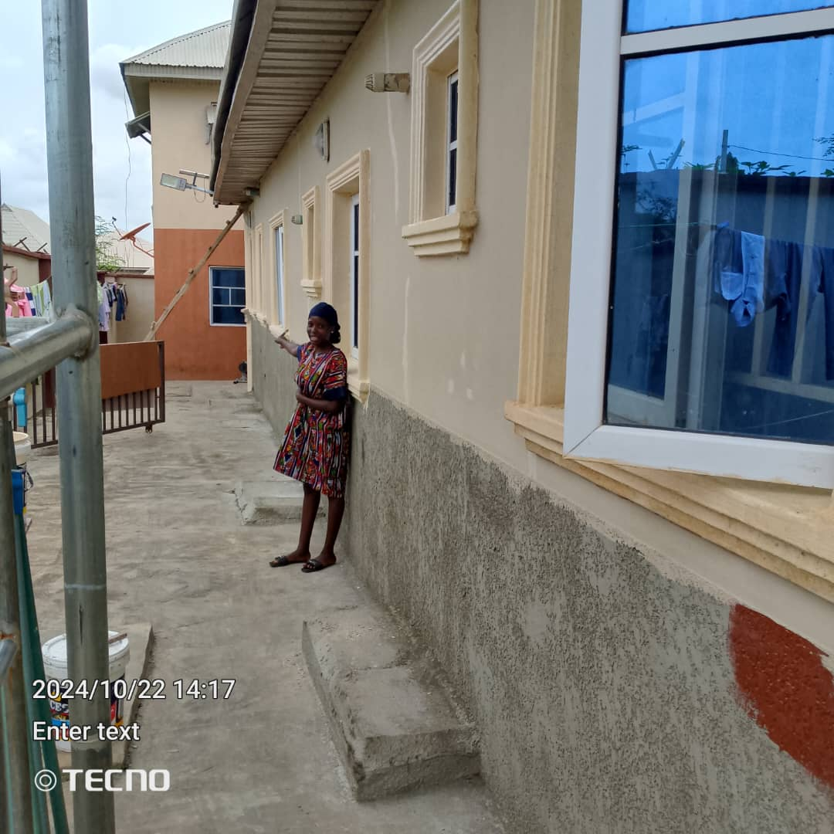
Plate 3.4 SIDE VIEW OF CASE STUDY TWO

3.5 CASE STUDY THREE (3)

Government Maternity Home
LOCATION: OkeAmola, Osun State
MERITS
- Easy to locate
- Well landscaping
- Spacious and Well-Organized Layout

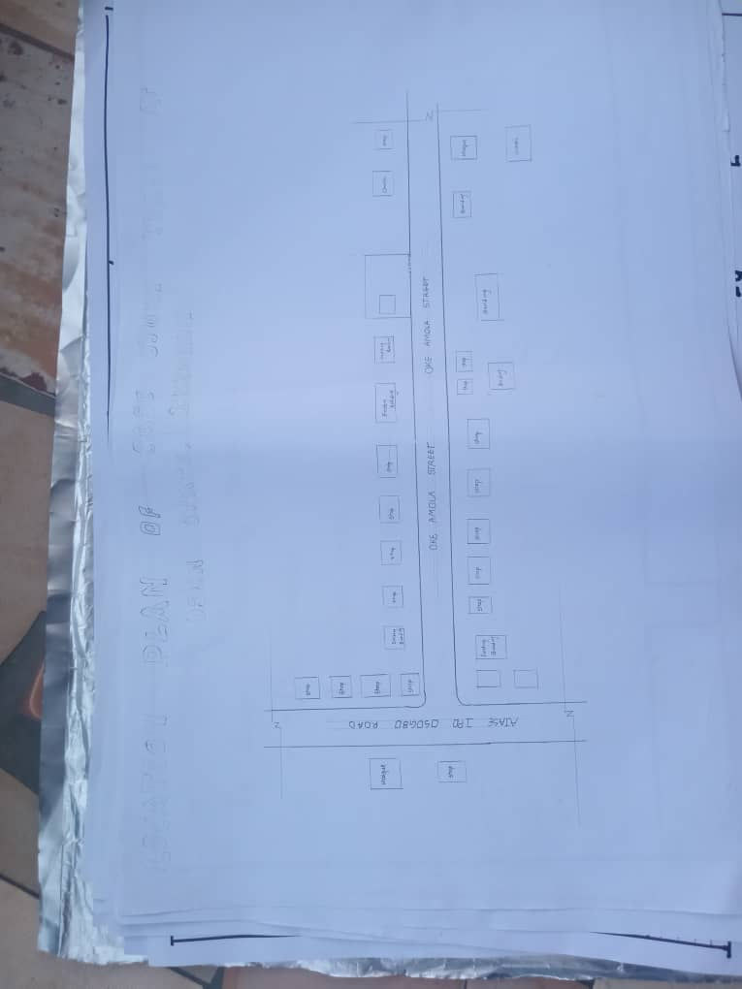
DEMERITS
- In adequate parking space
- Noisy area
- Poor ventilation control

Fig 3.6 LOCATION PLAN OF CASE STUDY THREE

Fig 3.7 LOCATION PLAN OF CASE STUDY THREE

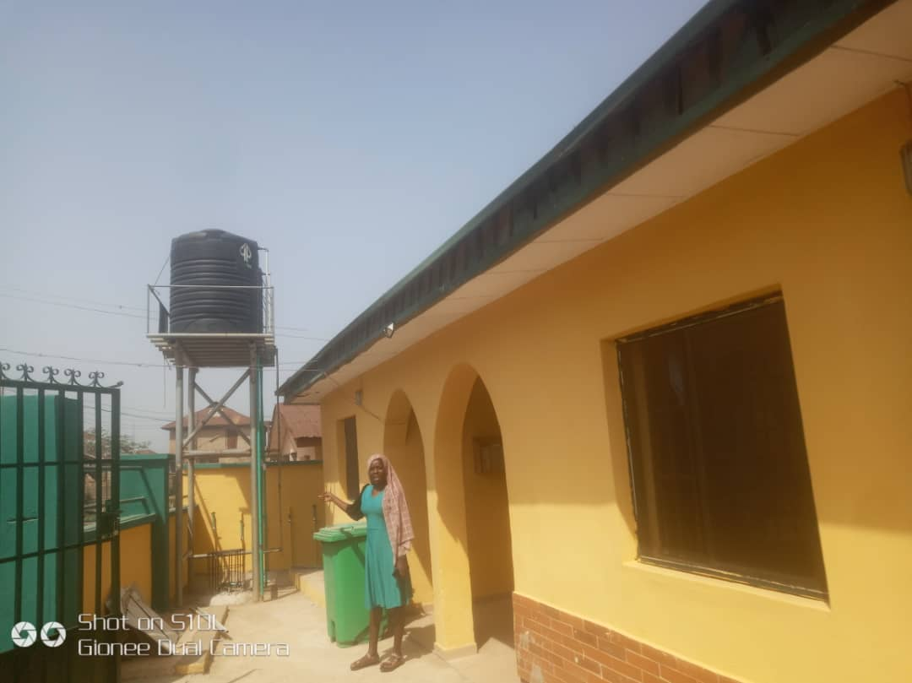

Plate 3.6 SIDE VIEW OF CASE STUDY THREE

3.6 ONLINE CASE STUDY
ONLINE CASE STUDY ONE
PROJECT NAME: MUGUNDA MATERNITY CLINIC
LOCATION: NKWESHOO, MOUNT KILIMANJARO IN NORTH TANZANIA
ARCHITECT: VEDHANT MAHARAJ
YEAR: 2013
AREA: 485m
ONLINE CASE STUDY TWO
PROJECT NAME: BALLARAT COMMUNITY HEALTH
LOCATION: ASHATIN REGION, GHANA
ARCHITECT: STEFAN NOVAKOVIC
YEAR: 2018
AREA: 355m
DEDUCTION FROM CASE STUDIES
During my visit to the maternity home. I was opportunities to see what was obtain in the health care, I made a proper studies of their related function and analysis were made to their present situation with the aim of incorporation with their merit in my own final proposal.
The following were deduce from my case study
- Adequate natural ventilation and lighting.
- Good architectural landscaping.
- The units in the hospital should be properly and well linked.
- There is need for consultation rooms.
- Parking spaces should be well defined.
- Good drainage system.

CHAPTER FOUR
4.0 PROJECT LOCATION
4.1 BRIEF HISTORICAL BACKGROUND OF KWARA STATE
Kwara (Yoruba: Ìpínlẹ̀ Kwárà) is a state in Western Nigeria, bordered to the east by Kogi State, to the north by Niger State, and to the south by Ekiti, Osun, and Oyo states, while its western border makes up part of the international border with Benin. Its capital is the city of Ilorin and the state has 16 local government areas.
Of the 36 states of Nigeria, Kwara is the ninth largest in area but the sixth least populous with an estimated population of about 3.2 million as of 2016.Geographically, Kwara is split between the West Sudanian savanna in the east and the Guinean forest–savanna mosaic ecoregion in the rest of the state. Important geographic features include rivers with the Niger flowing along the northern border into Lake Jeba before continuing as the border while the Awun, Asa, Aluko, and Oyun rivers flow through the interior. In the far northwest of the state is the Borgu section of the Kainji National Park, a large national park that contains populations of grey heron, kob, hippopotamus, African bush elephant, olive baboon, and roan antelope, along with some of the last remaining West African lions on earth. In the far southwest, a small part of the Old Oyo National Park contains crowned eagle, martial eagle, African buffalo, oribi, and patas monkey populations.
4.1.2 ECONOMY OF KWARA STATE
Agriculture is the main source of the state's economy and the principal cash crops are: cotton, cocoa, coffee, kola nut, tobacco, sesame and palm produce. Kwara state is home to Shonga Farms, a product of the Back-to-Farm project of one of the past administrators of the state, Dr. AbubakarBukolaSaraki. Shonga Farms is made up of 13 commercial farmers. Mineral resources in the state are Petroleum, Gold, limestone, marble, feldspar, clay, kaolin, quartz and granite rocks, and laterite found majorly in omuaran.
4.1.3 ORGANIZATION STRUCTRE
An organizational structure is a system that outline shows certain activities that are direct in order to achieve the goals of an organization. These activities can includes rules, roles and responsibilities. The organizational structure also determine show information flows between levels within the Resturant.
4.2 LOCATION AND SETTING OF KWARA STATE
Kwara State was created on 27 May 1967, when the Federal Military Government of General Yakubu Gowon broke the four regions that then constituted the Federation of Nigeria into 12 states. At its creation, the state was made up of the former Ilorin and Kabba provinces of the then Northern Region and was initially named the West Central State but later changed to "Kwara", a local name for the River Niger, in the Hausa language.
Kwara state has since 1976 reduced considerably in size due to further state creation exercises in Nigeria. On 13 February 1976, the Idah/Dekina part of the state was carved out and merged with a part of the then Benue/Plateau state, to form Benue state.
On 27 August 1991, five Local Government areas, namely Oyi, Yagba, Okene, Okehi and Kogi were also excised to form part of the new Kogi state, while a sixth, Borgu Local Government Area, was merged with Niger state. The major populated local governments are Ilorin and Offa.
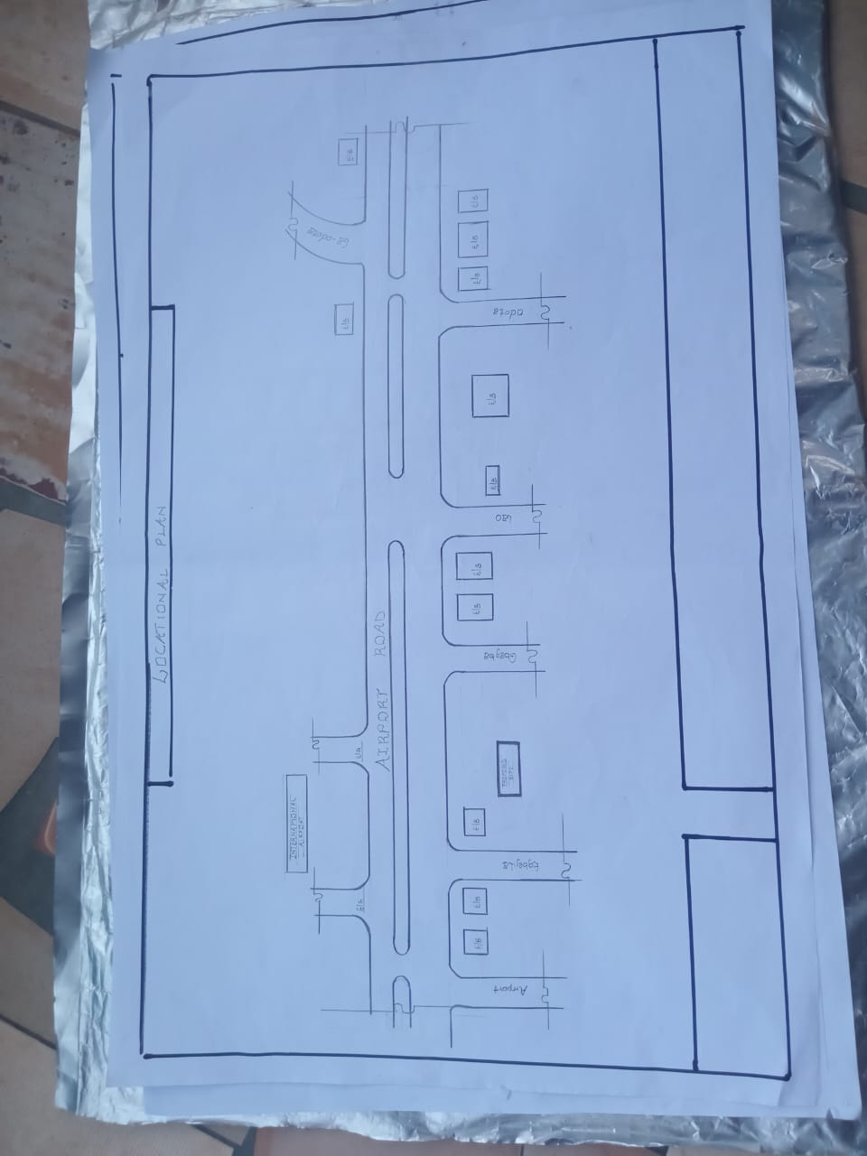
Kwara state has numerous mineral resources such as tourmaline, tantalite, and many mineral deposits in the northern part. Cocoa and Kolanut in the Southern parts Oke - Ero, Ekiti and Isin LGA.

FIG 4.1; SHOWING LOCATION OF THE PROPOSE SITE
4.3 POPULATION
The population development of kwara state as well as related information and services.
The current metro area population of Ilorin in 2025 is 1,100,000, a 3.38% increase from 2024.
The metro area population of Ilorin in 2024 was 1,064,000, a 3.3% increase from 2023.
The metro area population of Ilorin in 2023 was 1,030,000, a 3% increase from 2022.
The metro area population of Ilorin in 2022 was 1,000,000, a 2.67% increase from 2021
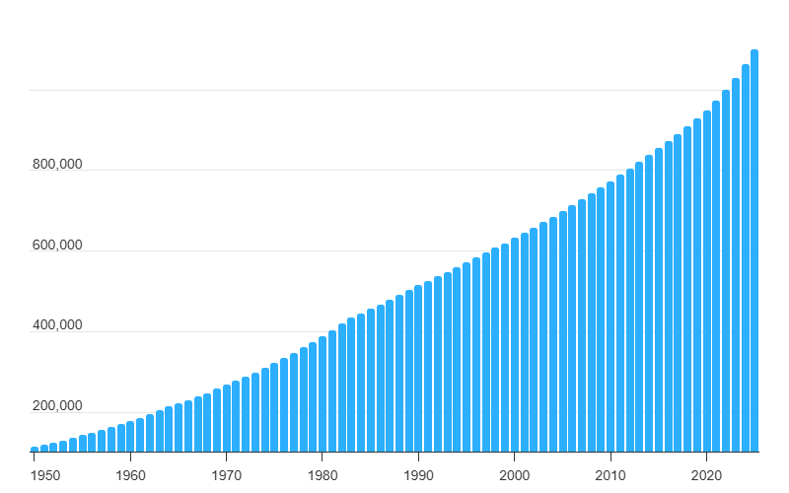
Table 4.2; SHOWING GENDER GROUP
4.4 SITE INVENTORY
In the proposed site, some shrubs will be retained on site. It used to reduce sky glare and also serve as soft landscape and wind breaker.
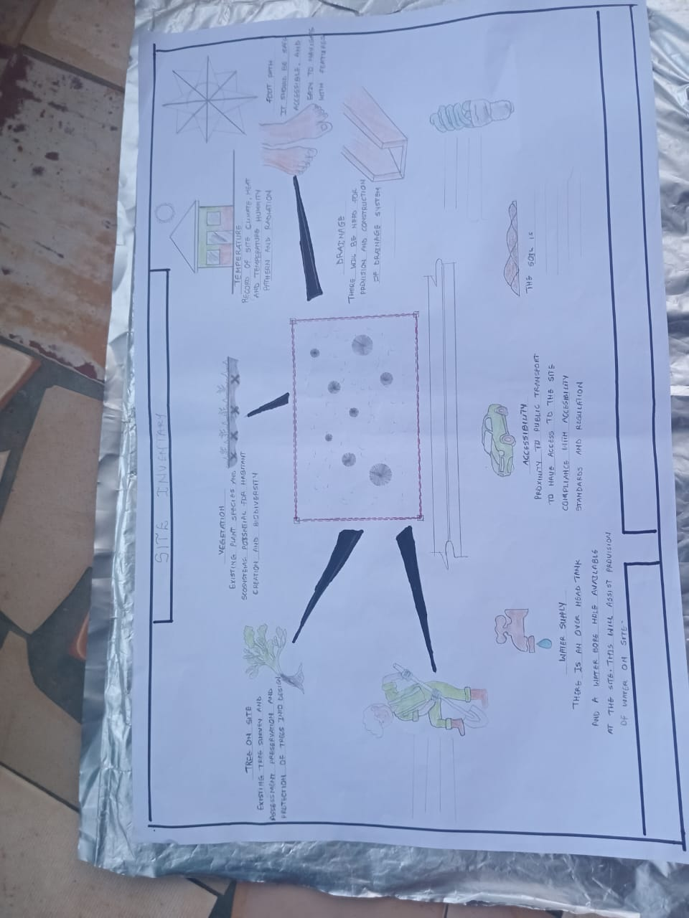
Presence of road network which would serve as a means of accessibility to the site. Presence of electricity pole which serve as source of electricity to the site. Some trees would be retained while some will be removed if they disrupt the construction of building.

FIG 4.2; SHOWING SITE INVENTORY OF THE PROPOSED SITE
4.5 SITE ANALYSIS
The site is benefitted with loamy soil which is a very good soil for grass and shrubs. It has a gentle slope towards the south east. Some of the grasses, shrubs and trees on the site are to be retained to enhance landscape patter of the site while some are to be removed and replanted where necessary. The two noticeable winds are to be directed into the building using landscape pattern to improve ventilation. Noise generated from vehicle traffic is controlled through proper planning, good landscaping and proper orientation of building. Generally, all the feature on the site are best put into different uses to aid control through proper planning, landscape and orientation.
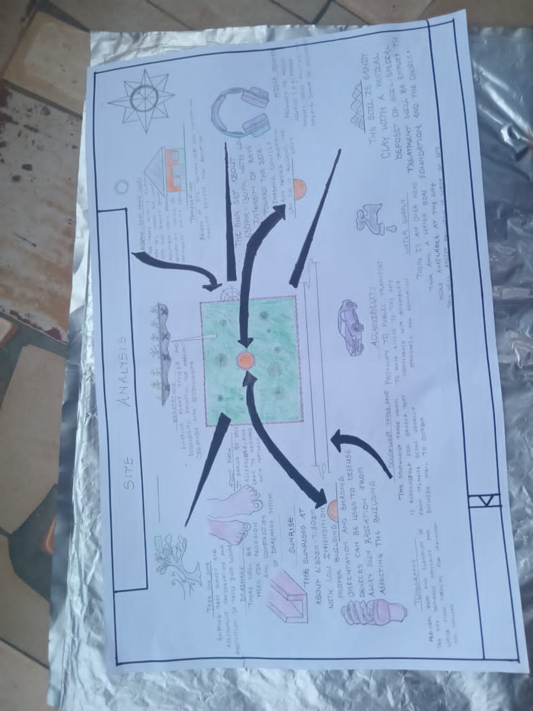
Certainly, steps are considered to obtain vital information of the site, this information is the analysed in details. For design purpose, the information include soil condition, geology, topography, vegetation etc. It also involves carrying out a preliminary survey.

FIG 4.3; SHOWING SITE ANALYSIS OF THE PROPOSED SITE
4.5.1 SITE SELECTION/JUSTIFICATION
In the site selection provision is made for interesting facilities that worth emulating since the overall success and efficiency of any project depend not on the functionality of the design but also on a careful choice of site. The site of this project has been carefully selected which is located in the premises of Ilorin west. The proposed site is located at Opposite Ilorin International Airport, km 8, Ilorin-Jebba road, Ilorin Kwara state, Nigeria.

4.5.2 LOCATION
The site is located at
ILORIN WEST, KWARA STATE
Ilorin west is one of the most prominent commercial corridors in Ilorin. The road is characterized by High vehicular and pedestrian traffic, a mix of commercial establishments such as eateries, banks, retail stores, and offices.
4.5.3 ACCESSIBILITY
Easy accessibility from different parts of the city, making it a strategic location for commercial developments such as eateries, restaurants, and retail outlets.
4.5.4 INFRASTRUCTURAL FACILITIES
Facilities such as water electricity, telephone network and road network are all in Ilorin, hence it can easily be tapped to the proposed site.
4.5.5 TOPOGRAPHY
The topography of the land is gentle slope which can be filled and levelled up to balance round all the site levels.
4.5.6 SOIL STRUCTURE
It is made up of clayish laterite soil, which is good for building construction.
4.6 GENERAL CLIMATIC CONDITION
Kwara State generally experiences a tropical savanna climate (Aw) with distinct wet and dry seasons. The temperature is warm throughout the year, with an average around 29.54°C (85.17°F). Rainfall varies, with an annual average of about 101.45 millimeters (3.99 inches), and the state has around 148.38 rainy days annually.
4.6.1 RELATIVE HUMIDITY
Relative humidity is higher during the rainy season, ranging from 75% to 88%, and lower during the dry season, ranging from 35% to 80%.
4.6.2 WIND
The prevailing winds are the south-west monsoon wind and the north-east continental wind.
4.6.3 TEMPERATURE
Kwara State is characterized by warm temperatures year-round, with January being the coolest month and April being the hottest. Temperatures can range from a minimum of 14°C (58°F) in January to an average of 27°C (81°F) throughout the year, with April experiencing intense heat that can reach 43°C (109°F).
4.6.4 VEGETATION
The proposed site is covered with grasses few trees and shrubs. Some will be removed before the construction while some will be retain for ornamentation.

4.7 SOCIAL SERVICES
4.7.1 ROAD
There are only two access to the site
From general which serve as the main access to the place and also from offa garage
4.7.2 WATER AND ELECTRICITY
There are pipe born water networks and borehole water which serves the habitant of Ibadan. There is electricity supply from NEPA that serve the Kwara state in general
4.8 DESIGN CRITERIA
There are three (3) methods of designing of any project which are: Function before form method
Form before function method Combination of Shapes
Designing projects, the function, before form method used in line with this method, the following are the design criteria for this project:
Functional: in term of functional requirement, the following design criteria must be considered.
Sustainability, Site and Location, Flexibility, Circulation, Accessibility, Organization, Maintenance, Environment and Services

4.9 DESIGN BRIEF
After research and planning, the next step in the series of the project programed is design itself. To achieve functional and well established design there must be a brief to work on. This brief depends generally on the scope of individual design. The brief of this project is therefore based on the various activities that take place in the hospital. To have enough brief for the proposed Restaurant, case studies were carried out on the existing restaurant. The studies also give me the opportunity to know the nature of the various unit in building and how they are related to each other.
4.10 DESIGN ANALYSIS
This is the process of itemizing units within the component of the entire design with a view to establishing a solid understanding and appreciation of the space relationships.
Ground Floor Plan, Reception, Pharmacy, Antenatal Room, Store, Consulting Room, Ward, W/C, Theater Room, Labour Room, Delivery Room, LAB, Laundry Room, Kitchen, Doctor Office, Nurses Room, Family Planning, Rest Room, Exit.
S/N | UNITS | LENGTH[m] | BREATH[m] | AREA[m2]
1 | RECEPTION | 3.4 | 8.0 | 27.2
2 | PHARAMACY | 4.5 | 3.0 | 13.5
3 | ANTENATAL ROOM | 3.5 | 2.0 | 7.0
4 | STORE | 4.0 | 2.0 | 8.0
5 | CONSULTING ROOM | 4.4 | 3.0 | 13.0
6 | WARD 1 | 3.5 | 3.4 | 12.25
7 | W/C | 3.0 | 1.5 | 4.5
8 | THEATER ROOM | 3.5 | 3.0 | 10.5
9 | LABOUR ROOM | 2.5 | 6.8 | 17.0
10 | DELIVERY BAY | 3.0 | 6.8 | 20.4
11 | LAB | 2.5 | 2.4 | 6.0
12 | LAUNDRY ROOOM | 2.0 | 4.6 | 9.5
13 | KITCHEN | 3.0 | 2.0 | 6.0
14 | DOCTOR OFFICES | 4.0 | 3.0 | 12.0
15 | NURSES ROOM | 4.0 | 3.5 | 14.0
16 | FAMILY PLANNING | 4.0 | 2.0 | 8.0
17 | WARD 2 | 4.0 | 4.0 | 16.0
18 | STAFF REST ROOM | 2.5 | 7.5 | 18.75
19 | EXIT 1 | 4.9 | 6.5 | 31.35
20 | EXIT2 | 3.0 | 3.3 | 9.9
21 | EXIT 3 | 2.0 | 2.0 | 4.0
TABLE 4.2 ; SHOWING SPACIAL ALLOCATION OF FLOOR PLAN
Necessary units in the building. A borehole system of water supply is to be adopted alongside the government supplied services and a storage facility is to be provided for effective management of water supply.
4.12 PLANNING PRINCIPLE
The planning principle is one of the most important aspects of any design. The planning of various units taking into consideration the activities performed in each unit, how they are related to one another and the users of the various units in the design. In respect to the above factors.

CHAPTER FIVE
5.0 GENERAL REQUIREMENTS
5.1 APPRAISAL OF PROPOSED SCHEME
The proposed scheme is to satisfy the appropriate building regulation. The project design is to confirm with the intended use of building taking into consideration with both natural factors and human that can pose a throat on the validity and stability of the project design.
5.2 CONSTRUCTION METHODOLOGY AND MATERIAL
The construction is to be carried out following the due process of construction ranging from.
Preliminary: this involves the clearing of the site, setting out and excavation of foundation trench, foundation works down to the basement level.
Sub-Structure: this process also entails the positioning and erection of column and beams, mansonry work etc.
Gypsumboard: is to be used for the Acoustic purpose of the building. This material is often called dry wall, wall board or plaster board. It creates a continuous surface suitable for most types of interior decoration. It comes in different size ranging length of 2.4m, 3.0m, also in thickness of 1/ inch, 3/8 inch.
5.3 SERVICE
A building can be said to be good when it performs the serves required by it. In other to have a well-function building design, there calls for an installation of underground water. This is a means of providing brightness naturally by sun or moon or artificially by lamps. Good natural and artificial lighting is important in lecture rooms, and workshop. It is always easy to make mistake and time the eye in a situation of poor lighting floor. For the purpose of this project, effort is made as much as possible to light up the entire building naturally before the use of artificial lighting. In this project, to obtain maximum lighting more openings are provided for the lecture rooms, workshop and admin. Artificial source of light will still be provided for in case where there is call for the use of it at night or in a situation where the weather condition warrants it.
5.3.1 VENTILATION
As it's relates to architectural, is the intentional introduction of outside AIT into a space through openings (like window/doors and mechanical means (ACs) to provide maximum thermal comfort for human satisfaction. In this design, both means of ventilation ate introduce but majority concentration on the mechanical means of ventilation for all units in the design for the purpose of extracting the used air and introducing fresh air within all spaces for humans consumption and satisfaction.
This is done through installation of mechanical (artificial) ventilation ducts horizontally and vertically all within the units of the design to allow easy floe of free movement of air passage through the ventilation channels and providing well, proper and adequate ventilation for each and every units in the design project.

5.3.2 LIGHTING
This is a means of providing brightness naturally by sun or moon or artificial by lamps. Good natural and artificial lighting is important in all units. It is always easy to make mistake and time the eye in a situation of poor lighting floor. For the purpose of this project, effort is made as much as possible to light up the entire building naturally before the use of artificial lighting.

5.3.3 PLUMBING
The plumbing system in this project design is made easy for waste extraction and brain water extraction through the means of service duct channel and roof gutter drainage.
All waste water and soil waste from the toilet/convenience are extracted through means of drainage pipe running through the walls down to the inspection chamber situated in the service duct, flowing down to the septic tank and soak away for final waste extractions.
5.3.4 ELECTRICAL INSTALLATION
The type of wiring system chosen should be conduct system of wiring, technical are should be wired with strong durable and light current resistance cables because of the power requirements and consumption of the equipment to be used and installed in them. Connection and distributing cable signal. Also electrical installation is to be done to allow for the use quality electrical fittings and fixtures in the whole of the hospital.
5.3.5 WASTE DISPOSAL
Waste disposal are to be put in the building and also some specific areas necessary, this waste bins should be disposed in the incinerator which will be provided within the proposed site premises. The waste should therefore, be burn in the incinerator or taken away from the site.
5.3.6 FIRE PROTECTION
Electrically, fire alarms and sensor are to be installed in the building in generally. This should be done in case of the fire occurrence. Fire extinguishers are to be placed at a certain distance in the lobbies and some other necessary areas. It is also serving as protection in case of fire outbreak.

5.3.7 RAIN PROTECTION DEVICES
The rainfall of a place generally determines the living condition and all comfort associated with that environment hence provision should be made for fast dispersal of the rain water as well as the associated condition with rainfall. This calls for the need to study the nature of rainfall of the area. To control the heavy rainfall during the wet season (April - October) the use of simple sloppy system roofing has been adopted. This is provided with roof gutter system which is linked to the ground drainage network by the use of P.V.C.
5.3.8 EXTERNAL WORKS
The external works are to be earned out generate, kerbs land and shrubs, flowers, grasses and trees planted. Concrete interlocking pavement tiles to be adopted before hard landscape for walk ways and parking spaces and car access roads must be tarred with asphalt finishes.
5.4 SUMMARY
This project, generally, has seriously widen my view and knowledge affecting my observation beyond my expectation. I have been able to deduct what it takes or entails and how to go about designing and achieving a good design of any form of this related project with total seriousness as this project has given out the facts and precise information it comprises.
5.5 CONCLUSION
The design of a restaurant extends beyond the creation of a functional space; it shapes the dining experience, reflects brand identity, and significantly impacts operational efficiency. Through this project, it is evident that the architectural planning of a restaurant directly influences customer satisfaction, staff productivity, and overall business success.
The case study and design process revealed that a successful restaurant requires careful attention to space zoning, circulation, ventilation, lighting, acoustics, and aesthetics. A well-planned layout ensures seamless movement for both customers and staff, creating a comfortable, efficient, and visually appealing environment.
Moreover, the incorporation of sustainability principles such as energy-efficient lighting, passive cooling, and the use of eco-friendly materials aligns the project with modern architectural practices and environmental responsibility.
The research also highlighted challenges such as limited urban spaces, high construction costs, and the need to balance aesthetic appeal with functionality. Addressing these challenges requires strategic planning, creative design solutions, and efficient space management.
5.6 RECOMMENDATION
This project underscores the role of architecture in creating functional, aesthetically pleasing, and customer-centered restaurant spaces. A well-designed restaurant not only enhances the dining experience but also contributes to operational efficiency, staff well-being, and the overall success of the business. By combining functionality, sustainability, and brand identity, the proposed restaurant design reflects modern architectural values and meets the expectations of both the client and the end-users.

REFERENCE
Bureau of Indian Standards. (2016). National Building Code of India (NBC) New Delhi: BIS.
Ching, F. D. K. (2014). Architecture: Form, Space, and Order (4th ed.). Wiley.
Day, C. (2002). Spirit and Place: Healing Our Environment. Architectural press.
Department of Health (UK). (2001). Health Building Note 09-02: Maternity are Facilities.
Department of Health and Human Services (USA). (2019). Guidelines for design and Construction of Hospitals and Outpatient Facilities.
Frampton, K. (2007). Modern Architecture: A Critical History. Thames & Hudson.
Jain, V. K. (2013). Planning and Designing of Hospitals. CBS Publishers.
Kumar, S. (2017). Designing Hospitals for Comfort and Safety. Journal of Hospital Architecture, 9(2), 22–30.
Lang, J. (1987). Creating Architectural Theory: The Role of the Behavioral Sciences in Environmental Design. Van Nostrand Reinhold.
Lawson, B. (2010). Healing Architecture. Arts & Health, 2(2), 95–108.
Ministry of Health and Family Welfare. (2012). Indian Public Health Standards (IPHS): Guidelines for 50 Bedded Hospitals. Government of India.
Neufert, E., &Neufert, P. (2012). Architects’ Data (4th ed.). Wiley-Blackwell.
NHS Estates. (2005). Improving the Patient Experience: Healing Environments. Department of Health, UK.
Schneider, T. (2007). Hospital Architecture. Wiley.
Sternberg, E. M. (2009). Healing Spaces: The Science of Place and Well- being. Harvard University Press.
Ulrich, R.S., Zimring, C., Quan, X., Joseph, A., &Choudhary, R. (2004). The Role of the Physical Environment in the Hospital of the 21st Century. The Center for Health Design.
WBDG (Whole Building Design Guide). (2020). Healthcare Facility Design. National Institute of Building Sciences.
World Health Organization (WHO). (2016). Standards for Improving Quality of Maternal and Newborn Care in Health Facilities. Geneva: WHO Press.



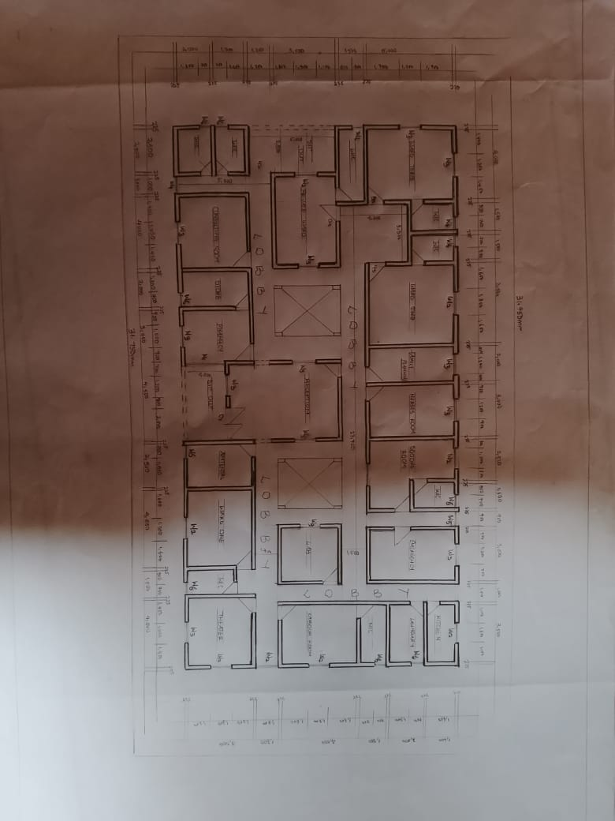
APP 1: SHOWING THE PROPOSED PROJECT FLOOR PLAN
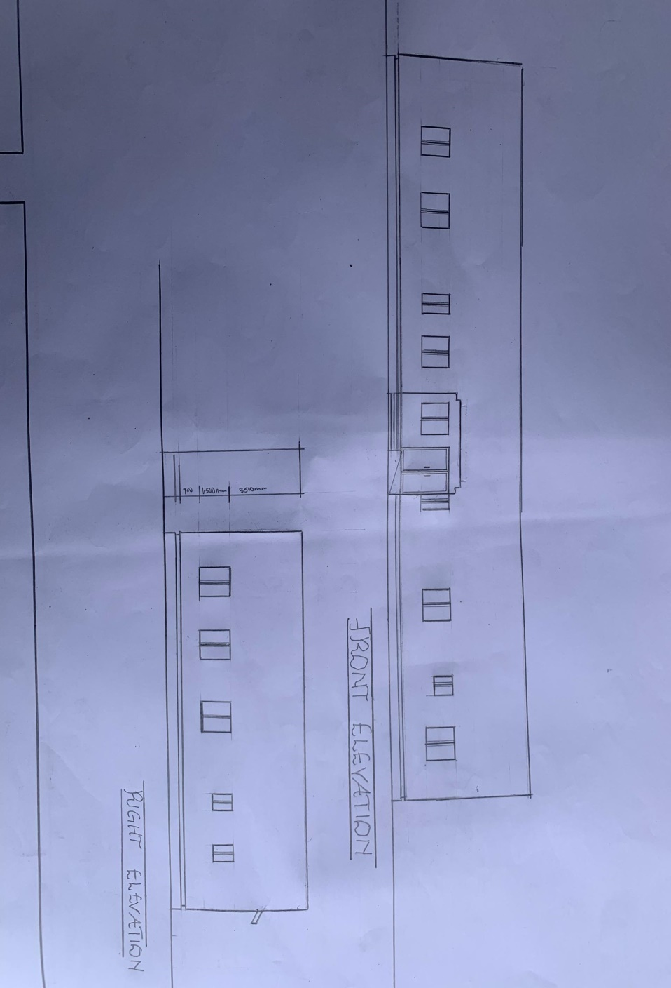
APP 2: SHOWING THE PROPOSED PROJECT ELEVATIONS
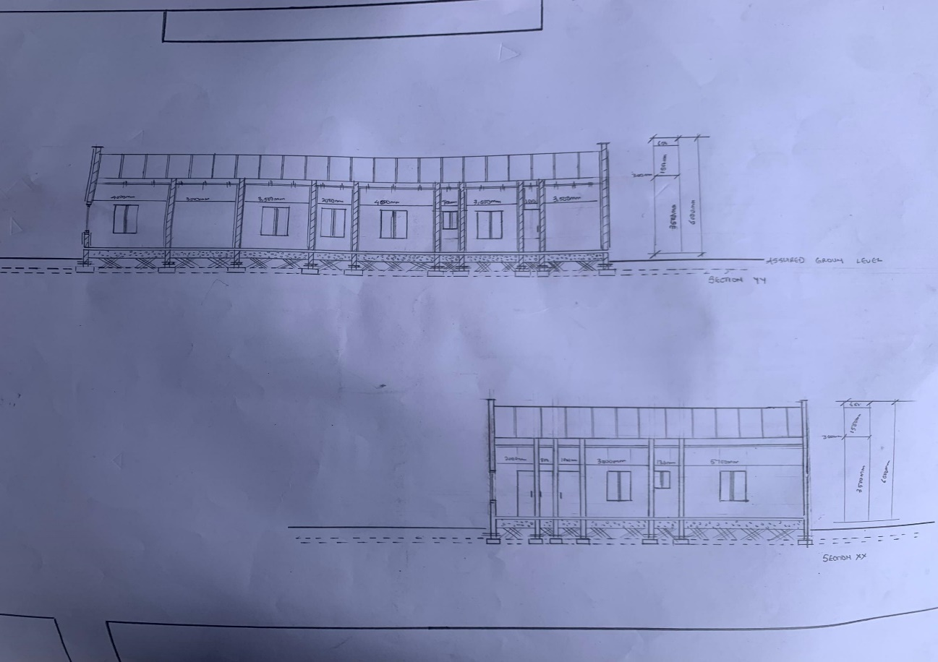
APP3: SHOWING THE PROPOSED PROJECT SECTION
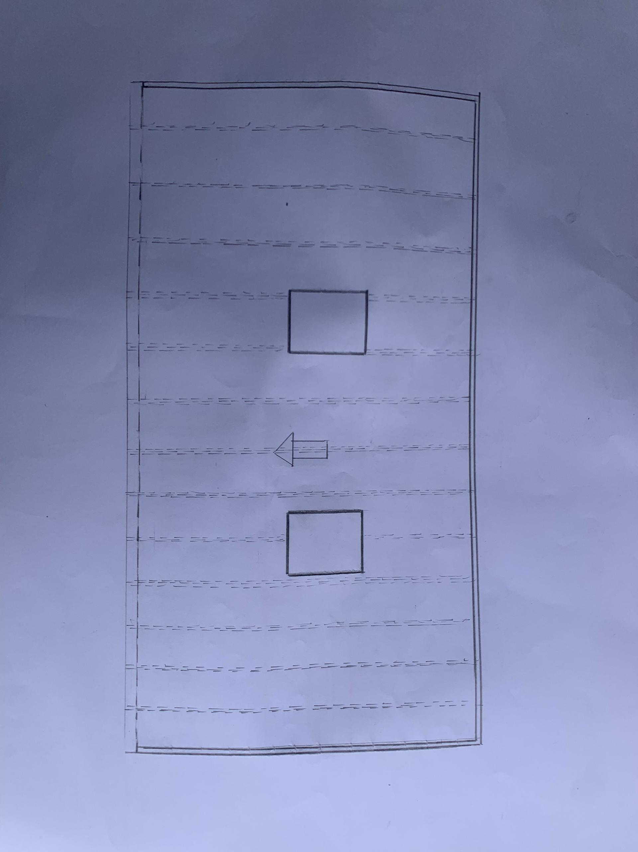
APP4: SHOWING THE PROPOSED PROJECT ROOF PLAN

