

PROJECT ON
FABRICATION OF STANDARD WHEELBARROW
WRITTEN BY
BALOGUN ENOCH OLAMILEKAN - ND/23/MET/FT/0024
SUBMITTED TO THE DEPARTMENT OF METALLURGICAL ENGINEERING, INSTITUTE OF TECHNLOGY, KWARA STATE POLYTECHNIC, ILORIN

SUPERVISED BY
ENGR BABALOLA S.A
APRIL, 2025
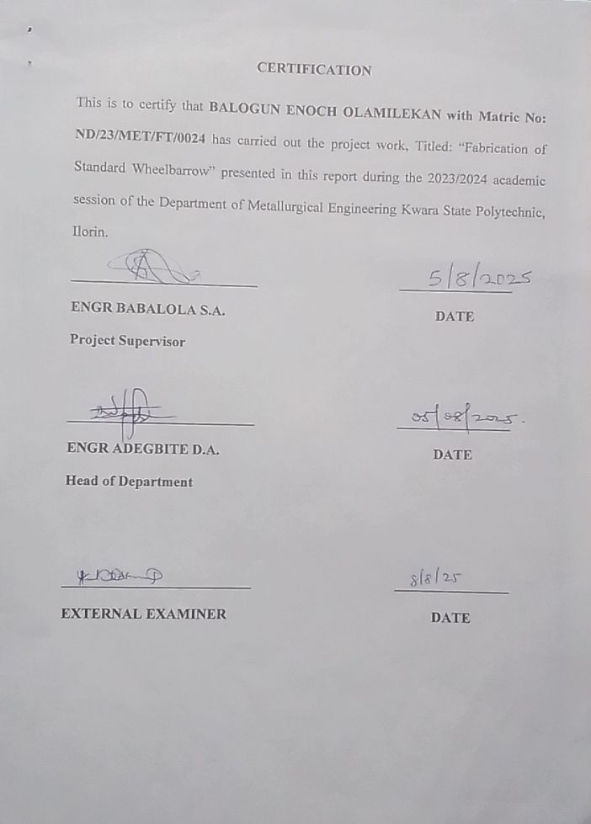
DEDICATION
This project write up is dedicated to the God Almighty, our beloved parents, our brothers, our sisters, our friends and all our well-wishers.

ACKNOWLEDGEMENT
Without doubt, the success of this project to a large extent depends on the help of Almighty God. The Alpha and Omega for bringing us to a successful end of the course in peace, to Him alone be all the glory.
Our sincere gratitude goes to our project supervisor in person of Engr Babalola S.A. for supplying useful information and advised in order that the project does not contain frivolities, may God bless him and his family abundantly.
We equally wish to extend our deep appreciation to our beloved parents for making the completion of this course a reality and we are also grateful to our brothers and sisters for the part they played in making the course a successful one.
Our immeasurable thanks goes to our entire department lecturers for their advice, we pray Almighty Allah will bless you all.

ABSTRACT
The project is the fabrication of a standard wheelbarrow which aim for the conveyance of good from one place to the other. The material used for the construction of the wheelbarrow is galvanized metal plate, iron rod, 1 inch pipe, Boris, tyre wheel, handle grip, flat bar which are then bent to various shape to meet the aim of the project. The wheelbarrow was well constructed with good materials so it can be used for a longer period of time without damaging and is capable of carrying a load of 200kg with maximum satisfaction and durability.

TABLE OF CONTENTS
Title Page ----------------------------------------------------------------------------------
Certification -------------------------------------------------------------------------------
Dedication ---------------------------------------------------------------------------------
Acknowledgement ------------------------------------------------------------------------
Abstract -------------------------------------------------------------------------------------
Table of Contents --------------------------------------------------------------------------
CHAPTER ONE
1.0 INTRODUCTION ---------------------------------------------------------------------
1.1 STATEMENT OF THE PROBLEM ------------------------------------------------
1.2 SIGNIFICANCE OF THE RESEARCH WORK ----------------------------------
1.3 AIM OF THE PROJECT --------------------------------------------------------------
1.4 OBJECTIVE OF THE PROJECT ----------------------------------------------------
1.5 JUSTIFICATION OF THE PROJECT ----------------------------------------------
1.6 SCOPE OF THE PROJECT ----------------------------------------------------------
CHAPTER TWO
2.0 LITERATURE REVIEW -------------------------------------------------------------
2.1 EXISTING TYPE OF WHEEL BARROW ---------------------------------------
2.2 OTHER AGRICULTURAL CONVEYING EQUIPMENT --------------------
CHAPTER THREE
3.0 MATERIALS AND METHOD -----------------------------------------------------
3.1 HEAD COVER------------------------------------------------------------------------
3.2 HANDLE FRAME -------------------------------------------------------------------
3.3 STANDING LEG (BRACING LEG) ----------------------------------------------
3.4 ASSEMBLING ------------------------------------------------------------------------
3.5 PAINTING -----------------------------------------------------------------------------
3.6 DIMENSION OF WHEELBARROW ---------------------------------------------
CHAPTER FOUR
4.0 RESULTS AND EVALUATION --------------------------------------------------
4.1 TEST RUNNING ---------------------------------------------------------------------
4.2 MAINTENANCE ---------------------------------------------------------------------
4.3 PRECAUTION ------------------------------------------------------------------------
4.4 BILL OF THE PROJECT -----------------------------------------------------------
CHAPTER FIVE
5.0 CONCLUSION AND RECOMMENDATION -----------------------------------
5.1 CONCLUSION ------------------------------------------------------------------------
5.2 RECOMMENDATION --------------------------------------------------------------
REFERENCES

CHAPTER ONE
1.0 INTRODUCTION
Wheelbarrow is a hand pushed vehicle consisting of a dish shaped body supported on two shaft arranged in a V-shape with hand. It is used by laborers, farmer and gardener and other's for transporting loads too heavy bulky to be carried by hand and is similar to hand truck used by warehouse men and industrial workers except that it has two wheels. Modern wheel barrows are made of wood or a light metal such as aluminum with a rubber on the wheel. A two wheel vehicle for carrying garden materials is more properly called a garden cart.
The purpose of the production of this machine is to reduce, alleviate and possibly eliminate the suffering, time money, wastage of manpower and more especially the need for technological breakthrough and self-reliance which has been major concern of the federal government. Moreover, this project at hand has delved into simplicities and the construction of this machine that can be used to carry different types of heavy load to any distance.
The wheelbarrow like any technology in the common place was a story to tell. The west was very slow to invent the wheelbarrow. The earliest known Europeans wheel barrow gleams down from a stained glass window in Charles cathedral.
But the Chinese have had wheel barrow for millennia. They celebrate a half mythical inventor named Ko Yo it is not known when he lived but since then, the Chinese have shaped wheel barrow in enormous variety of ways. They have used them in every kinds of task.
It also helps to consider just what an individual wheel barrow is. It combines the advantages of both the wheel and the leveler. The load is centered behind a single wheel that way you have to lift only a small part of the load. The two handle give an intimacy of control you don't have with four wheel chart cart.
Chinese armies made the first use of the wheelbarrow which gave them such advantage in moving goods that was kept secret.
It was not until the seventeenth century. When direct contact was between Europe and China as a result of trade, each area had its own distinct form of wheelbarrow although by this time both were frequently modified to serve other needs than those for which they were designed.
1.1 STATEMENT OF THE PROBLEM
For the less privilege farmer coveying load is such a crude, time consuming, tedious and energy consuming activity. The method of using the hand, head and shoulder in carrying animal dung to the farm, carrying of farm tools and equipment to the farm, conveying finished products from the farm to the house and also to the market for sale is very tedious.
In as much as the method is credited, it makes a man weak and easily tired. In an attempt to erase completely the sweat and difficulties encountered in transporting loads, there arises the need to construct simple transporting device to meet the comfort of man in the convergence of goods hence the birth of wheelbarrow which is the basis of the project.
1.2 SIGNIFICANCE OF THE RESEARCH WORK
The purpose of the production of the machine is to reduce difficulties and probably eliminate the suffering, time, money, cost of man-power and most especially the need for technological breakthrough and self-reliance which have been a major concern of the human being.
1.3 AIM OF THE PROJECT
- To design and construct a standard wheelbarrow that provides a safe, efficient, and reliable means of transporting heavy loads.
- To select materials that offer a good balance of strength, weight and corrosion resistance.

1.4 OBJECTIVE OF THE PROJECT
The objectives of the study are;
- To construct a wheelbarrow using mild steel sheet of dimension
- To ensure the wheelbarrow is stable and strong
1.5 JUSTIFICATION OF THE PROJECT
- To solve the problem farmers encounter in conveying Agricultural products and material through untarred road which the trailer and other vehicle does not have access to within a short time.
- To increase the comfort of agricultural and other transportation.
- To solve problem of farmer who cannot afford to purchase heavy transportation machinery due to their high cost of purchasing and maintaining.
- To convey small equipment from workshop to another area within the workshop.
- To save time and reduce number of trip in transporting agricultural products on the farm.
- To facilitate the conveyance of harvested crop from the point of utilization i.e. (storage structure).
1.6 SCOPE OF THE PROJECT
The wheelbarrow has various designs, shapes and sizes but only one particular wheelbarrow will be made. The dimension of the wheelbarrow is 26.22cm capacity weight 53 pounds, and are often size 63.5 (length) x 30 (height) inches (76.2cm).

CHAPTER TWO
2.0 LITERATURE REVIEW
The earliest wheelbarrow with archeological evidence in the form of a one wheel cart came from 2nd century Han Dynasty emperor Huis tomb mural and brick tomb relief.
The painted tomb mural of a man pushing a wheelbarrow was found in a tomb at Chengdu Sichuan province dated precisely to 114AD. (Andreal Matthies 1994).
The stone carved relief of a man pushing a wheelbarrow was found in the tomb of shenFunju in Sichuan province dated circa 150AD and the story of the pious Dong Yuan pushing his father around in a single wheel luche barrow, depicted in a mural of the WU LIANG tomb shrine of Dhandong dated 147 (Andreal Matthies 1994)
The Chinese historical text of Sanguozhi (Record of the three Kingdom) compiled by the ancient historian chenshou (233-297AD) credited the invention of the wheel barrow to the Prince Minister ZhugeLiang (181-243 AD) of Shuttan from 197-234 AD. [Needham 1965].
Wheelbarrow in China came in two types the more common types after the 3rd century haa a large centrally mounted wheel prior types where the universally front wheels barrows. The centrally wheel barrow could generally transport six human passengers at once and instead of a laborious amount of energy exacted upon the animal or human driver pulling the wheelbarrow, the weight of the burden was distributed equally between the wheel and the puller. [Joseph Needham 1965]
Europeans visitors to China from the 17th century onwards had an appreciation from and ways given a considerable amount of attention by a member of the Dutch East, Indian Company, Andreas Evarardus, and Van BraamHouckgeest. In his writing of 1797 (who accurately describe it, sign and ability to hold large amount heavy baggage).
As of the 1960s, traditional wheelbarrow in China was still in wide use.
The first wheelbarrow in Europe appeared sometimes between 1170 and 1250. Medieval wheel barrow Universe featured a wheel at or near the front (in contrast to their Chinese counterparts, which typically had a wheel in the center of the barrow). The arrangements universally found on wheelbarrow. [Andreal. Matthias Medieval 1994]
By the 13th century, the wheelbarrow proved useful in building, construction, mining operations and agriculture. However, going by surviving document and illustrations, the wheelbarrow remained a relative reality until 15th century. It also seemed to be limited to England, France and the Low Countries. [M.J.T. Lewise 2014].
In 1970s British inventors James Dyson introduced the ball barrow, an injection mould plastic wheel barrow with a spherical ball on the front and instead of a wheel compared to a conventional design the large surface area of the ball made the wheel easier to use in soil and more laterally stable with heavy load on uneven ground (M.J.T. Levis 2014).
The Honda HPE60, an electrical power assisted wheel barrow was produced by a number of different manufacturers. [Robin lane fox penguin 2006].
Power wheel barrow are used in a range of application, the technology has improved to enable them to take much heavier load beyond weight that human could transport alone without assistance. Motorized wheelbarrow is generally either diesel powered or electric-battery powered often used in a small scale contribution where access to large plant machinery might be restricted. [Robin lane fox penguin 2006].
Wheelbarrow has existed for a long time, the existence started from India and China. The first wheelbarrow was constructed with local material. The wheelbarrow was constructed in M.C. SHENGS in NEW YORK (Matt, U.K. $Bhatt B.S, 1986).
The wheelbarrow consists of the following component part namely: container, frame, handle, rubber wheel or tyre, leg brace / Ade Shaft, bearing and Axle.
The component part where welded together using the electric arc welding machine the wheel are fixed to it to allow proper movement.
2.1 EXISTING TYPE OF WHEEL BARROW
- Ordinary Wheel barrow:- This is made up of galvanized sheet with a single wheel fixed in proper position for easy movement. It is used for carrying agricultural materials.
It is also subdivided into three part depending on the mode of operation is needed for.
- Chinese wheel barrow:- This type of wheel barrow is used extensively in China for labor-based construction. In is potentially a very useful method of haulage because of high capacity. The height of the wheelbarrow is specially made in relation to the operation position (Matt. U.K, and Bhatt, B.S. 1986).
- Aggregate spreading wheelbarrow:- This type of wheel barrow consists of standard metal tray with a discharge shaft or about 200m square in the bottom of the tray. If a sliding plate is open the aggregated is discharged into a rotating speed disc which is connected by a drive shaft pin to the main wheel with the sliding plate closed. It functions as an ordinary Wheel barrow (Matt U.K and Bhatt, B.S. 1986).
- Western wheel barrow:- This type have different tray because the volume of the material that could be carried by the barrow.
Since the load is normally lowered, this under estimated the volume that can be carried but does not give precise measurement of capacity. (Matt U.M and Bhatt B.S 1986).
- Food Wheel Barrow:- The food wheel barrow is used in conveying agricultural product only. It is constructed with a galvanized mild steel plate. The barrow was first constructed in Geroge H.F United Kingdom (Matt. U.K and Bhatt B.S 1986).
- Self Loading Motorized Wheel Barrow:- This wheel barrow is self propelled and self loading type. It is fitted with a 3.75kw for stroke petrol engine. The engine drives the motor cultivator type wheel through a centrifuged transmission.
Forward and reverse gear were provided and the differential gear can be locked to aid the barrow over difficult ground when loaded.
- Hay Wheel Barrow:- This is just cart by the container is constructed in such a way as to allow for easy conveying of hay from the farm to the poultry house (Matt, U.K and Bhatt, B.S 1986).
- Water Wheel Barrow:- This wheel barrow is used to fetch water. The barrow has been constructed to help solve the problem of carrying for domestic used over a considerable distance and a tabular steel frame which support four large spherical flashes is fitted with a large diameter single wheel mounted in the frame which lower the centre of gravity, this making the barrow stable [Matt, U.K. and Bhatt, B.S 1986].
2.2 OTHER AGRICULTURAL CONVEYING EQUIPMENT
According to [LAN 1986], there are some other types of conveying equipment; they may include cart: this is divided into many types depending on the type of source of power needed to pull or push them and also we have trucks and transverse.
Furthermore, farm transport equipment wheel include farm trucks, farm tricycle and farm transport boats are new types of farm transport machinery which are developed to suit the situation and characteristics of rural area. (LAN 1986)
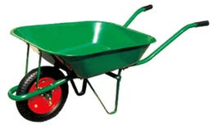
Farm Trucks:- The farm mainly included two types; one with diesel engine and the water with gas – Olin engine and both are registered and used in rural areas especially in China. The farm truck carrying capacities are from 2 to 5 tons (Matt U.K and Bhatt, B.S 1986). From 2 to 5 tons (Matt U.K. and Bhatt, B.S 1986).

A WHEELBARROW
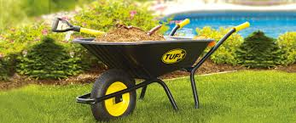
Farm Tricycle:- Their carrying capacities are from 0.5 to 0.75 tons and highest speed is limited under 40 hour traffic safety and their capacity of being driven up hill is greater or equal to 10% (LAN, 1986).

A WHEEBARROW
CHAPTER THREE
3.0 MATERIALS AND METHOD
3.1 HEAD COVER
Material Used:- 2 inche metal plate, 2 electrodes and flat bar.
Tools Used:- Steel scriber, tape rule, drilling machine table, welding machine, folding machine, cutting machine
Method Used:- 1 inch pipe, Boris, Handle grip, flat bar
The metal plate was placed on the table for marking out with the steel scribber using the tape rule for measuring the plate in other to mark out the template. It is then carried to the folding machine to fold in a trapezoidal shape and the edge of the plate with the hand.
A10mm iron rod is folded with the folding machine and was fixed to the folded edge of the plate and then welded together.
Holes were drilled inside the metal plate for the bolt and nut which was used to join the metal plate and pipe when assembling.
3.2 HANDLE FRAME
Material Used:- 1 inch pipe, Boris, handle grip, flat bar
Tool Used:- Folding machine, electrode, welding machine, drilling machine and hammer.
Method Used
The pipe is cut into three pieces one for the tyre section and the other two for the handle section.
The pipe for the tyre is folded with the folding machine having a curved surface and the two handle is folded in such a way that they could hold the metal plate firmly when assembling.
The two pipes are forced to the folded tyre pipe and then tightened together to form the shape of the wheelbarrow frame. The tyre frame was then welded on the bended part at the extreme end with a rod. A flat bar was then used to create a housing ball bearing for the tyre which was welded at both side of the frame (wheel section), the junction at which the frame handle and the metal plate will be joined was drilled and the handle grip was forced to the two handle pipes.
The Ball bearing was also fixed into the housing ball bearing and a flat bar was placed to the top and bottom of the ball bearing and then welded together.
3.3 STANDING LEG (BRACING LEG)
Material Used:- Flat bar, tape rule.
Tools Used:- Welding machine, electrode, and hack saw
Method use
The flat bar was measure with the tape rule and then cut to the normal length of the stand into two pieces. It was then bend and joined with iron rod before welding them together.
3.4 ASSEMBLING
The tyre was put within the ball bearing with a rod fixed together then braze with the joint angle. The two bent standing leg pieces was welded together with the handle frame and tightened together using the bolt and nut.
The metal plate was then placed on the handle frame and tightened together using the bolt and nut.
3.5 PAINTING
Materials used:- Gloss (Green Color), Kerosene
Tools used:- Spraying machine
Method used
The tyre was covered with paper to prevent paint from touching it. The wheelbarrow was painted to prevent it from corroding quickly. The gloss paint was use because of the force of adhesion between the molecule of water and kerosene.
After the paint has become dried, the paper was removed from the tyre.
3.6 DIMENSION OF WHEELBARROW
Wheelbarrow sizes to consider with some of the latest features on modern wheelbarrow.
Frame
Study and durable and wheelbarrows have powerful frame. As some folks in the capentry and mansory job would say, its all in the frame.
Before setting on wide wheelbarrow, sizes, consider first the make at the frame look for those with steel or aluminum frames with extra supporting studs underneath for extra strength. Check out the back brance and steel nose piece. Carriage bolt wheelbarrow dimensions should be at least 8 pieces of 318inches machine bolts with two pieces of 318 inches U-bolts.
Common wheelbarrow dimensions flat enable wheel barrow to perform well in load. Carrying job are the following; they have a 26.22cm capacity weight 53pounds, and are often size 63.5 (length) x 25 (width) x 30 (height) inches (76.2cm). Consider also those with a volume capacity of 205.74cm wheelbarrow size near these measurements are dependable for transporting medium size construction work loads.
Wheel Bearing and Hubs
Option for wheel tires with studs and tube. Tires with 4 pieces measuring 16 inches are often adequate for heavy – duty work. For all wheelbarrow sizes, chose wheel helps with heavy duty gauge. Look for shaft collars and axle with 1- inches size. Huge wheelbarrows dimension should have accurately engineered and scaled bearings preferably with gauge 6205.
Weight
The weight of an object is defined as the force acting on it due to gravitational pull or gravity. So the weight of an object can be measured by attaching it to a spring balance and nothing the spring extension, as the extension is proportional to the force.
Suppose the weight of an object at mass m is donated by w, if the object is released so that it falls freely to the ground, it acceleration is g, f =ma so the force acting on it or it weights given by w = mg.
If the mass is 1kg, then since g = 9.8ms⁻², the weight w = 1 x 9.8 = 9.8N
Weight have a unit at Newton, it varies on earth surface.
The wheelbarrow is designed to distribute the weight of its load between the wheel and the operator so enabling the convenient carriage at heavier and bulkier loads than would be possible were the weight carried entirely by the operator. As such it is on second – class lever.
Description of component parts
- Frame and Handle:- The component is a pipe made of mild steel and coated with paint to prevent corrosion and it bent to shape.
- Rotating Shaft: The material used for this part must be able to withstand shock when carrying load on the wheelbarrow. Also, as it will constantly be under axial force and bending moment great tensile strength is required. High carbon steel was used to ensure rigidity under operating conditions.
- Kneel: This component required a great mechanical property like toughness, tensile strength and malleability. The part is needed for supporting the wheelbarrow and the entire body. They are two similar metal of mild-steel which was folded to shape of the kneels through bending.
- Front Supporting Bars: These are two strips of mild steel bar curved at one end and welded to the front of the body of the wheelbarrow. Their function is to support the main body at the front.
- Reinforcing Pipe: This is a mild steel pipe flattened at both ends drilled and bolted to the frame to reinforce the handles.
- Wheel: A smooth, steady and unobstructed rotational movement of the barrow is necessary for it’s objectives to be justified. Tube type which usually reduces repair and maintenance cost was used.
- Body: Mild steel metal steel at 1.5mm thickness was used for this part. It can withstand great stress when carrying heavy load.
- Paint: Paint is considered necessary in the finishing at the wheelbarrow. Green paint was sprayed on it before applying the blue paint to prevent corrosion and exposure to moisture and sun as well as for beautification.

CHAPTER FOUR
4.0 RESULTS AND EVALUATION
4.1 TEST RUNNING
After assembling the component parts of the wheelbarrow, four (4) bags of cement (approximately 200kg) was carried with the wheelbarrow around the school premises which after been tested, it does not develop fault.
The parts of the wheelbarrow that can easily get spoilt are the wheel bearing, handle and the standing leg (brazing leg).
4.1 MAINTENANCE
The wheelbarrow should be maintained properly to prevent it from damaging easily. Parts to be maintained are:-
- The wheelbarrow should be lubricated weekly if operation is carried on it every day.
- The bolt and nut for joining the tray and the pipe should be retightened weekly to prevent worn-out.
- The tray (galvanized plate) should be cleaned regularly after being used.
4.2 PRECAUTION
- During the process of construction, accurate dimensions were taken before cutting out.
- Ensure proper chipping of the slag during welding
- Ensure proper grinding of the welded part to get smooth surfaces.
- Appropriate tools were used for different sections of the wheel barrow.
- Ensure appropriate folding of the flat bar (barazing leg), iron rod and metal plate (tray).

4.3 BILL OF THE PROJECT
TABLE 4.1:- PRODUCTION COST
MATERIALS | AMOUNTS
Metal Plate (1mm) | 12,500
Pipe (Iron Rod) [1 diameter] | 3,500
Flat bar (Leg) [30mm by 710mm] | 2,000
Flat bar [Joint] [30mm] | 1,500
Ball bearing [outer/inner diameter 50mm by 20mm] 2 pieces | 4,000
Tyre (Feldspar) | 5,000
Bolt and Nut (13mm by 60mm) | 1,000
Bolt and Nut (13mm by 30mm) | 1,500
Handle grip | 1,000
Gauge 12 electrode (3 dozen) | 3,000
Paint [Blue colour] | 2,000
Workmanship | 10,000
TOTAL | 47,000

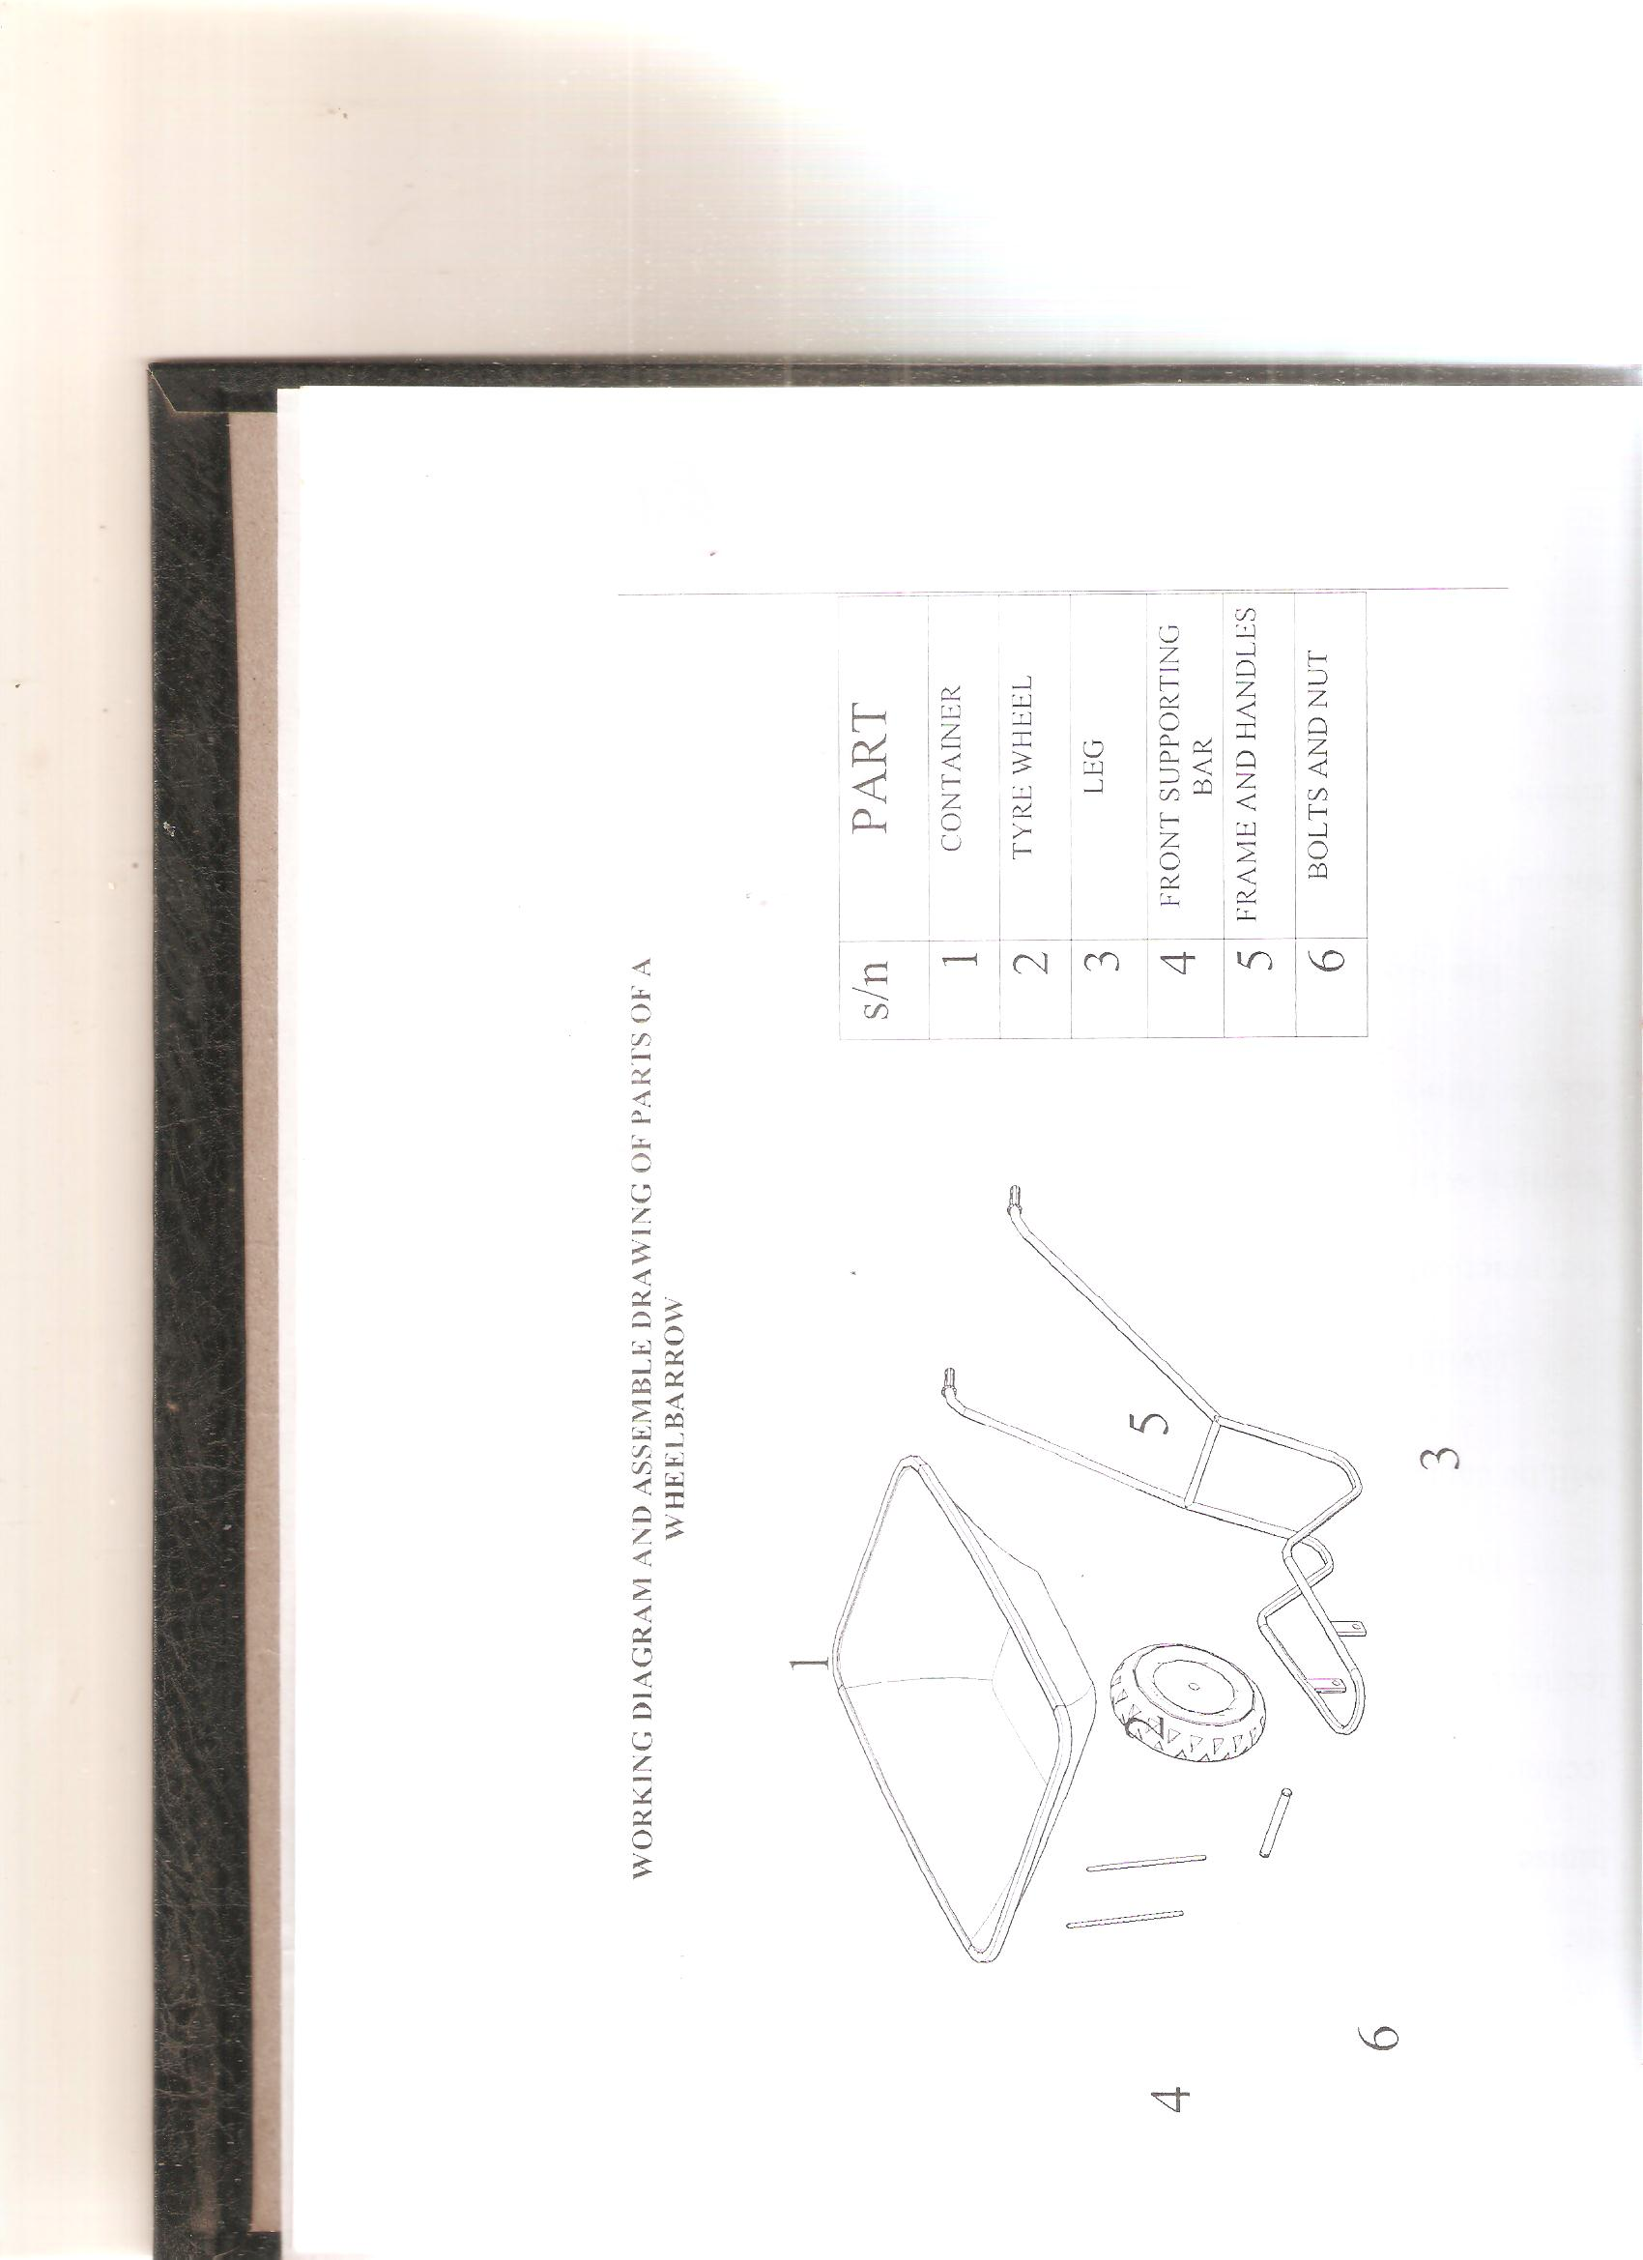
CHAPTER FIVE
  - CONCLUSION AND RECOMMENDATIONS
5.1 CONCLUSION
The aim and objectives of the project as achieved because the wheel barrow is capable of carrying a load of about 200 kilogram.
This project has been constructed with belief to follow standard and precaution for the execution of the project. It is our belief that this project will be widely accepted in the Nigeria market.
5.2 RECOMMENDATION
In designing and construction of a project, student should give himself/herself and encouragement if he wants to develop technologically. The student must be used to the library and attend lectures.
This country also needs a modern technological orientation that will be capable of producing local machine with our local materials.
Ensure that the practical are make mandatory to all students in every aspect of learning which will make it easy for them to face any challenges in the nearest future.
The institution should make sure that all out dated machines should be taken care of and modern machine should be purchased to enable students do their work themselves in the school workshop to enable the students to be more efficient in projects construction.

REFERENCES
Abboh A.F (1980), “A level Physics, Second Edition Catyer Upper School, London, (page 56 – 57).
Andreal .L. Matthias “the Medieval Wheelbarrow Technology and Culture Vol.35. No, 3 (July 1994)
Balogun (2003): Strength of Materials for ND student I.O.T Kwara State Polytechnic, lecture note unpublished
Joseph Needham, Science and Civilization in China vol. 4 Cambridge 1965
M.J.T Lewis “The Origin of the Wheelbarrow” 35 July 1994.
Matt and Bhatt, B.S (1986), Mechanization Technology for Tropical Agricultural, Page (135-140), unpublished
Robin Lane fill penguin (2006) Classical world.
Samara A.B.U Terminal Report (1992), Agricultural Mechanization Research Programme, Institute for Agricultural Research.

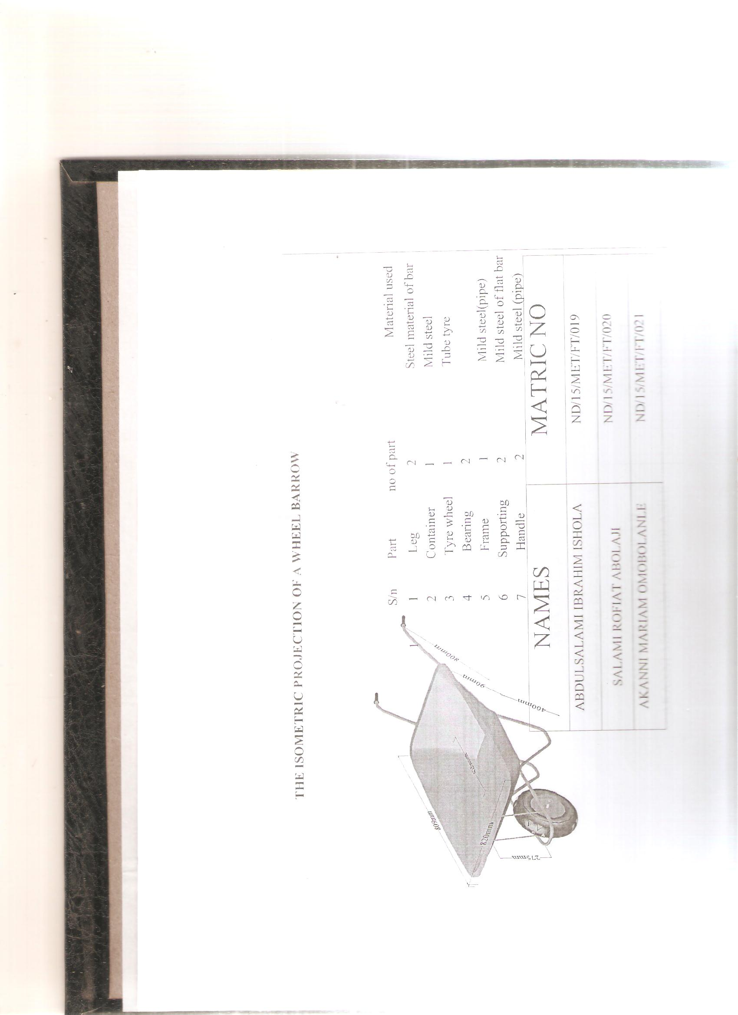
ISKILU IDRIS ADEBOWALE
ND/23/MET/FT/0001
JOSEPH OZAVESHE TOLUWASE
ND/23/MET/FT/0033
BALOGUN ENOCH OLAMILEKAN

ND/23/MET/FT/0024
ISKILU IDRIS ADEBOWALE
ND/23/MET/FT/0001
JOSEPH OZAVESHE TOLUWASE
ND/23/MET/FT/0033
BALOGUN ENOCH OLAMILEKAN

ND/23/MET/FT/0024
