BENEFICIATION OF SPODUMENIC ROCK FROM LADE , KWARA STATE , FOR RECOVERY OF LITHIUM AND SOME OTHER CRITICAL MINERALS

BY
Gabriel APPOLUS
HND/23/MNE/FT/ 0013

SUBMITTED TO THE
DEPARTMENT OF MINERAL AND PETROLEUM RESOURCES ENGINEERING TECHNOLOGY,
INSTITUTE OF TECHNOLOGY,
KWARA STATE POLYTECHNIC, ILORIN

IN PARTIAL FULFILLMENT OF THE REQUIREMENT FOR THE AWARD OF HIGHER NATIONAL DIPLOMA (HND) IN MINING ENGINEERING TECHNOLOGY

JULY 2025

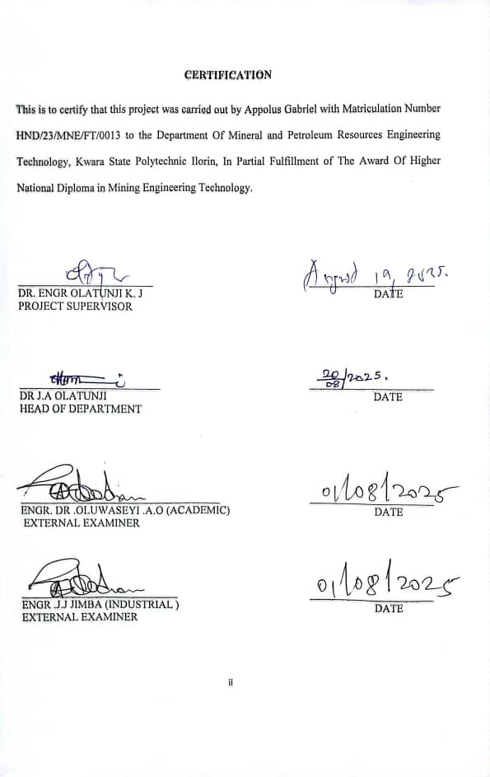
DEDICATION
I dedicate this project work to almighty God for his sufficient mercy over me throughout the course of the project

Acknowledgments
My sincere gratitude goes to God Almighty for granting me the opportunity to study and complete my High National Diploma in Kwara State Polytechnic, Ilorin. I express my gratitude and appreciation to my parents late Mr. and Mrs. Appolus For their parental love, moral and financial support showered on me from scratch to the level before their departure. My appreciation goes to my able and amiable supervisor in person of Dr. Olatunji K.J. for his guidance and intellectual contribution that made this project a success, No wonder the Bible say seest thou a man diligent in his business? He shall stand before king's; he shall not stand before mean men (Proverb 22 vs 29). Have seen you as a wonderful lecturer and great man who impact knowledge efficiently, which give me opportunity and privilege when I see myself under your supervision. Thank you sir.
I also appreciate all the lecturers in the Department for their contribution in one way or other, to the success of my education. Thank to you all. My sincere gratitude goes to my elder brothers Mr Appolus Raphael, Appolus Solomon for their understanding, care, love, word of advised , financial assistance and prayer committed towards successful completion of my High National Diploma and project. You are brothers who stood by me as a father. God will continue to bless both of you. Amen.
Lastly, I cannot conclude this acknowledgement without mention the name Mary Bolajoko Olabode for her love, care, understanding and prayer committed on me toward completion of my program. I said thanks you, may God reward you all abundantly. Amen.

Abstract
This study investigates the beneficiation potential of spodumenic rock from the Lade area, Kwara State Nigeria, with a focus on assessing lithium recovery and identifying other valuable mineral constituents. spodumene, a lithium - bearing mineral commonly associated with pegmatite, has gained global significance due to rising demand for lithium in battery and advanced technology applications. To evaluate the economic prospects of the deposit, froth flotation test were carried out using sodium oleate as the primary collector, calcium chloride as an activator to enhance mineral surface reactivity, and sodium silicate as a depressant to suppress gangue flotation. Although the rock exhibited spodumenic characteristic, analytical results revealed no detectable lithium content. Nonetheless, post-flotation chemical analysis of the concentrate and tailings showed significant enrichment in silicate minerals. The concentrate contained notably high silicon dioxide (SiO₂) levels, along with appreciable amounts of Aluminum oxide (A1₂O₃) and iron oxide (fe₂O₃).

TABLE OF CONTENTS
Title Page i
Certification ii
Dedication iii
Acknowledgements iv
Abstract v
Table of Contents
List of tables
List of figures
Chapter One – Introduction
  - Aims
  - Objectives 1
1.3Statement of the Problem 2
1.4 Justification 2
1.5Scope of the Study 3
1.6 limitation of the study 3
Chapter Two – Literature Review
2.1 Physical and Chemical Properties of Lithium and Other Critical Minerals 4
2.2 Formation and Occurrence of Lithium and Other Critical Minerals 8
2.3 Industrial Applications of Lithium and Other Critical Minerals 11
2.4 Froth Flotation of the Spodumenic Ore 12
Chapter Three – Materials and Methods
3.1 Description of the Study Area 14-15
3.2 Sample Collection 15-18
3.3 Sample Preparation 18=19
3.4 Laboratory Procedures of Froth Flotation of the Ores 18
Chapter Four – Results and Discussion
4.1 Grades of the Ore 20-21
4.2 Result of the Froth Flotation Procedures 22
4.3 Change In The Concentration After Beneficiation 25-26
Chapter Five – Conclusion and Recommendations
5.1 Conclusion 27
5.2 Recommendations 27-28
References 29-30

List of Figures
Fig 3.1: Map Of Kwara State Showing The Location of Lade Pategi Local Government 10
Fig 3.2 Spodumenic Rock 11
Fig 3.3 Geoligic Hammer 11
Fig 3.4 Jaw Crusher 12
Fig 3.5: Ball Mill 12
Fig 3.6: Sieved Mineral 13
Fig 3.7: Flotation Cell 14
List of tables
Table 4.1: Elemental And Oxides Of Crititcal Minerals In Crude 15
Table 4.2: Result Of Beneficiation 17
Table 4.3: Change In The Concentration After Beneficiation 19

CHAPTER ONE INTRODUCTION
Unique properties makes lithium a key metal for modern life with its low density, electrochemical activation, high redox potential, and high specific heat capacity.(Swain, 2017). The present tendency for the development of portable devices and the application of batteries as power sources in electric cars and tools are creating an extra demand for lithium, being one of the most important strategic raw materials for many industries,(Levich, 2009).
Batteries are considered the most suitable option for conservation, storage and transmission of renewable energy. The capability of storing a large amount of energy within a given volume to-mass ratio in a short period of time is considered the most critical characteristic of any battery and the lithium ion batteries are considered the most promising way to capture energy. (Bach,1985).
Due to that fact, the application of lithium ion batteries in the rechargeable batteries technology would be essential for the industrial growth, to reduce the environmental constraint linked to the traditional energy transmission technologies, to enhance the energy security, and to improve the daily life condition (Swiatowska et.al,2015).
Lithium has become a critical minerals due to its increasing demand in battery technologies, electric vehicles and rewenable energy storage systems.(Sadoway, et.al.,1998).

  - AIM AND OBJECTIVE
The aim of this study is to adopt and optimize beneficiation technique for spodumene rock from Lade, Patigi Local Government Area, Kwara State, Nigeria for recovery lithium and some other critical minerals.
1.2 OBJECTIVES
- Collect sample from site and determine their grades for Lithium and other critical minerals
- Use froth flotation experiment methods to determine the effective approach to beneficiate the ore from the study area.
1.3 STATEMENT OF PROBLEM
The beneficiation of lithium faces challenges such as low recovery rates, impurity removal, and high processing costs, limiting efficiency and sustainability.
1.4 JUSTIFICATION
Despite the abundance of spodumene deposits, traditional lithium extraction particles are often selective and disregard other potentially valuable components in the ore. This leads to low resource efficiency and environmental burdens due to increased waste generation. Lithium,a critical component in modern technology has seen a surge in demand due to its use In batteries for electric vehicles, smartphones, and energy storage system. This increased demand has spurred exploration and mining of lithium ores world wide . The distribution of benefits from this industry is uneven, with certain stakeholders benefiting more than others.

1.5 SCOPE OF THE STUDY
This study focuses on the beneficiation of lithium-bearing ore through the froth flotation method, with particular emphasis on spodumene ores. This project will cover key aspects of the flotation method, including ore characterisation, reagent selection, flotation circuit design,and process optimisation laboratory-scale experiments with be conducted to evaluate the influence of factors such as pH, collector type and dosage on frother concentration, conditioning time,and pulp density on minineral recovery and concentrate grade.
1.6 LIMITATION OF THE STUDY
The study is limited to the beneficiation of lithium ores using froth flotation and does not extend to other beneficiation technique such as magnetic separation, gravity separation on chemical leaching. This project focuses primarily on a specific type of lithium bearing ore (spodumene) and the location area is Lade.

CHAPTER TWO
LITERATUIRE REVIEW 2.1 PHYSICAL AND CHEMICAL PROPERTIES OF LITHIUM ORES AND SOME OTHERS CRITICAL MINERALS.
Lithium (LI)- ELemental properties lithium is a soft, silver-white metal and the lightest of all metals. It belongs to the alkaline metal group in the periodic table.
Table 2.1 shows the physical properties of Lithium (LI)- Elemental lithium
Table 2.1: Physical properties of Lithium (LI)- Elemental lithium
PROPERTY  Atomic number  Atomic mass  Density  Melting point  Boiling point  Hardness  Electrical conductivity  Thermal conductivity  Appearance | VALUE  3  6.94/mol  0534g/cm ( lightest metal )  180.5 0c ( 356.9f)  1342c ( 2448f )  Very soft, can be cut with a knife  High  High  Silvery white but tarnisher quickly in air
Source: (Garrett, 2004)

CHEMICAL PROPERTIES OF LITHIUM.
LITHIUM
Highly reactive; reacts quickly with water, forming lithium hydroxide (Li0H) and hydrogen gas. -Oxidation state; it usually for Li + ion, Flammability; burns with a bright red flame when exposed to air, Reacts with air; forms lithium oxides (Li2⁰) or lithium nitride (li₃N), and Solubility; lithium salts (e.g lithium carbonate) are highly soluble in water (Earnshaw et.al,1997).
LITHIUM ORES
Lithium is found in nature as part of lithium -bearing minerals or in brine deposits. The most common lithium ores.
Table 2.2 shows the Physical and Chemical Properties SPODUMENE
Table 2.2: Physical and Chemical Properties SPODUMENE
SPODUMENE (LiAIsi₂0₆)  PROPERTY  Hardness  Density  Color  Crystal structure  Chemical composition  Lithium content | PRIMARY LITHIUM ORE  VALUE  6.5-7 (mohscale  3.0-3.2g/cm  Green, yellow, pink or transparent  Monoclinic  LiAIsi₂0₆  3.0-7.5% li2
Source: (Bertau et.al 2017)

Table 2.3 shows the Physical and Chemical Properties of LEPIDOLITE
Table 2.3: Physical and Chemical Properties of LEPIDOLITE
LEPIDOLITE K (Li, AI)₃ (Si, AI)₄0₁₀  PROPERTY  Hardness  Density  Color  Crystal structure  Chemical composition  Lithium content | (F,OH)₂ – LITHIUM MICA  VALUE  2.3-4(moh’s scale)  2.8-30g/cm3  Pink/purple or liac  Monoclinic  K (Li, AI)₃ (Si, AI)₄0₁₀ (F,0H)₂  3.5-4.5% li₂0
Source: (Gaines et.al, 1997)
2.1.1. PHYSICAL AND CHEMICAL PROPERTIES OF CRITICAL MINERALS.
Physical properties of silicon (si) : Atomic number 14, Appearance: grey metallic Luster, brittle crystalline solid Hardness: 6.5-7 on Mohs scale Density:2.33g/cm³ and melting point:1,414⁰c. CHEMICAL PROPERTIES OF SILICON (Si)
Tetravalent, forms covalent bonds, Reacts with halogens and alkalis but not with acids, Forms c1ompounds like silicates and silicon dioxide (sio₂) (callister et.al, 2020).

PHYSICAL PROPERTIES OF ALUMINIUM (AL).
Appearance: silvery -white, soft, lightweight metal, Density :2.70g/cm³, melting point:660.3⁰c, Boiling point:2,470⁰c, Electrical conductivity: high (about 60% of copper).
CHEMICAL PROPERTIES OF ALUMINIUM
Reactivity: reacts with oxygen to form a protective oxide layer(AL2O3), Amphoteric: reacts with both acids and bases, Forms: Typically forms+3 oxidation state(Al3+).(Haynes,2016). PHYSICAL PROPERTIES OF POTASSIUM.
Appearance:soft,silver metal, Density:0.86g/cm³, Melting point:759⁰c, Very low hardness (can be cut with a knife).
CHEMICAL PROPERTIES OF POTASSIUM.
Highly reactive, especially with water (forms Koh and H₂ oxidizes rapidly in Always forms a+1 oxidation state (k+). Stored in oil to prevent reaction with mosture and air(Greenwood et.al, 2012)
PHYSICAL PROPERTIES OF MAGNESIUM.
Appearance: silvery -white, lightweight metal, Density:1.74g/cm,Melting point:650⁰c.
Boiling point:1,090⁰c, Low electrical conductivity (compared to other metal).
CHEMICAL PROPERTIES OF MAGNESIUM.
Burns with a bright White flame in air (forms mgo), React with water slowly, faster with steam.
Forms+2 oxidation state (mg2+). (Alkins et.al, 2010).
PHYSICAL PROPERTIES OF TITANIUM
Appearance; lustrous, silvery-grey metal. Density; 4.51g/cm³, Appearance; silvery-white, lightweight metal. Density; 1.74g/cm³, Melting point;650⁰c, Boiling point;1,090⁰c, Low electrical and conductivity (compared to other metal).
CHEMICAL PROPERTIES OF TITANIUM
Forms a stable oxide layer(Tio2),Resistant to corrosion is sea water and chlorine, Common oxidation states+3(Tie+),+4(Ti4+) and Reacts with oxygen and halogens at high temperatures (Cotton et.al,1999).
2.2 FORMATION AND OCCURRENCE OF LITHIUM AND OTHER CRITICAL MINERALS.
FORMATION OF LITHIUM
Lithium (Li) is a light alkali metal that was formed during the big bang nucleosynthesis but is relatively rare in the earth crust. It primarily occurs in mineral and brine deposits due to geological processes over millions of years. The formation of lithium deposit is influenced by magnetic, hydrothermal, and sedimentary processes (Evans, 2014).

MAGMATIC PROCESSES: Lithium is concentrated in pegmatite rocks when magma cools slowly, allowing lithium - bearing minerals like SPODUMENIC, Lepidolite and petalite to crystallize (Winter, 2010).
HYDROTHERMAL PROCESSES: Lithium -rich fluids circulating through fractures in rock can deposit lithium in veins or outer surrounding rock to form lithium- bearing minerals (Pirajno,1992).
SEDIMENTARY PROCESSES: weathering of lithium rich rock can lead to lithium accumulation in clay minerals, such as hectorite or in evaporative, lake basins, forming lithium bruises (Earnshaw, 1997).
OCCURRENCE OF LITHIUM.
Lithium occurs in different geological settings
Hard rock deposit (lithium minerals in pegmatite)these deposit are associated and contain lithium bearing minerals such as spodumene, Lepidolite, petalite (Kesler et.al, 2012).
LITHIUM BRINES DEPOSIT: Lithium brines are formed by the evaporation of lithium -rich ground water in closed basin over long periods. These deposits are found in salt flats, Geothermal brines, oil field brines (Kesler et.al, 2012).
LITHIUM CLAY DEPOSIT: Lithium clay form in sedimentary basins from the weathering of voleanic ash and other lithium bearing minerals. The main clay mineral is hectoriate (Benson et.al, 2023).

FORMATION AND OCCURRENCE OF CRITICAL MINERALS.
Formation of silicon (si). Silicon is formed in stars via nuclear fusion primarily from carbon burning. On earth, it is produced through geological processes involving the weathering of silicate rocks over millions of years
Occurrence of silicon (si) second most abundant element in compound form as silica (si0₂) (Greenwood et.al, 2017).
FORMATION OF ALUMINIUM(AL).
Aluminum is formed in stars during the fusion of heavier elements (mostly from carbon and oxygen nuclei) on Earth, aluminum minerals form through weathering and Hydrothermal processes, especially in tropical climate (Haynes, 2016).
OCCURRENCE OF ALUMINIUM (AL).
Most abundant metal is Earth crust (8.1%) rarely occurs in native form due to high reactivity (Haynes, 2016).
FORMATION OF POTASSIUM (K).
Formed in stars during the explosive nucleosynthesis of heavier elements Terrestrially, it forms from igneous and sedimentary processes, concentrating is salts and minerals as rocks weather and dissolve.
OCCURRENCE OF POTASSIUM (K).
Seventh most abundant element in the earth crust (-2.6%) never found free in nature due to its extreme reacting. Common minerals sylvite (kcl), camallite (KMgCI₃ 6H₂0) and orthoclase feldspar (kAlsi₃), extracted from potash deposits and evaporate minerals (Greenwood et.al, 2012).

FORMATION OF MAGNESIUM (Mg).
Produced in large stars during the nuclear fusion of carbon in stellar interiors.on earth, magnesium minerals form during igneous rock crystallisation and precipitation from sea water (Armand, 2001).
OCCURRENCE OF MAGNESIUM (MG).
Eighth most abundant element in earth crust (~2.1%) and third in seawater Common minerals Dolomite CaMg (CO₃)₂. magnesite (MgC0₃) olivine (Mg,Fe)₂ Si0₄ (Atkins et.al, 2010).
FORMATION OF TITANIUM (TI)
formed in supernovea explosions through the fusion of calcium and helium Found on earth, through igneous and metamorphic processes concentrating in heavy mineral sands and ores.
OCCURRENCE OF TITANIUM (TI)
Ninth most abundant element in earth crust (~0.6) often found in beach sands, igneous rocks, and placer deposits (Cotton et.al,1999).
2.3 INDUSTRIAL APPLICATION OF LITHIUM.
Below are some keys industrial applications of lithium
GLASS AND CERAMICS.
Application: lithium compound improves glass and ceramics strength, reduce thermal expansion and enhance durability used in cook ware and ceramics tiles (Gaines, 2018).

BATTERY TECHNOLOGY.
Application: lithium - ion(Li-ion) and lithium polymer (LiPo) batteries and widely used in electric vehicles (EVs), consumer electronics (smartphone, laptops) and renewable energy storage (Armand, 2001).
LUBRICATING GREASES
Application: lithium stearate is a key component in lithium based grease, which provides thermal stability and water resistance. used in auto - motive and industrial machinery lubrication (Balazs, 2002).
PHARMACEUTICALS AND MEDICINE.
Application: lithium carbonate is widely used in treating bipolar disorders and depression (Tanious, 2011).
2.4 FROTH FLOTATION OF SPODUMENIC ROCK
Froth flotation is a widely used beneficiation process for lithium -bearing minerals, particularly spodumenic (LiAlsi₂O₆), the most commercially important lithium ore. This technique relies on the different in surface properties of minerals to separate valuable lithium minerals from gangue materials using air bubbles and selective reagents and process of froth flotation for lithium ore are crushing and grinding flotation conditioning air bubbling and separation froth collection and drying.

Froth flotation is a key mineral processing technique used in the beneficiation of spodumene-bearing rocks for the recovery of lithium. Spodumene (LiAlSi₂O₆) is one of the most commercially important lithium-bearing minerals found in pegmatitic rocks. Due to the increasing demand for lithium in energy storage applications, especially lithium-ion batteries, efficient extraction techniques such as froth flotation have gained significant attention.
Froth flotation is a physicochemical separation process that exploits differences in surface properties of minerals. In the case of spodumene beneficiation, flotation separates lithium-bearing spodumene from gangue minerals such as quartz, feldspar, and mica based on their surface hydrophobicity after chemical treatment with reagents.
Grinding and Liberation
The ore is crushed and ground to liberate spodumene crystals from the surrounding gangue minerals.
Collectors (e.g., fatty acids, amine-based reagents, or hydroxamates) are used to make the surface of spodumene hydrophobic.
Depressants (e.g., sodium silicate or starch) are used to prevent the flotation of gangue minerals.
pH modifiers such as NaOH or H₂SO₄ adjust the pulp pH, usually in the range of 4–11, depending on the reagent system (Wagh et.al, 2021).

CHAPTER THREE
MATERIALS AND METHOD
3.1 Description of Study Area
Lithium ore samples was collected from deposit at Lade, Pategi Local Government Area of Kwara State. Lade is a rural community located in the Pategi Local Government Area of Kwara State, Nigeria. The area is predominantly inhabited by the Nupe speaking people, who have traditionally engaged in farming as their primary occupation. In recent years, Lade has experienced a significant shift in its economic activities due to the discovery of lithium deposits in the region, this has led many residents to transit from farming to artisanal mining.
This transformation has turned Lade into a notable site for lithium extraction, attracting attention from various stake holders interested in the minerals potential. The climate of the area Lade; located in the Guinea Savannah zone of Nigeria, experiences a tropical Savanah climate characterized by two main seasons which are rainy season; April to October and dry season; November to March, average annual rainfall is around 1000 to 1500mm. The natural vegetation is that of the Guinea Savannah, featuring tall grasses and scattered trees, during the rainy season, the area becomes lush and green, while the dry season brings browner, sparser vegetation due to moisture loss.
However, recent Mining in Lade have started to impact the natural landscape and may lead to gradual vegetation degradation if not managed sustainably. Geographically it lies at approximately on 8.7589%N latitude and 5.616 longitude, with an elevation of about 83 meters (272 feet) above sea level (Geonames,2024).
Fig 3.1 shows map of Kwara state showing the location of Lade

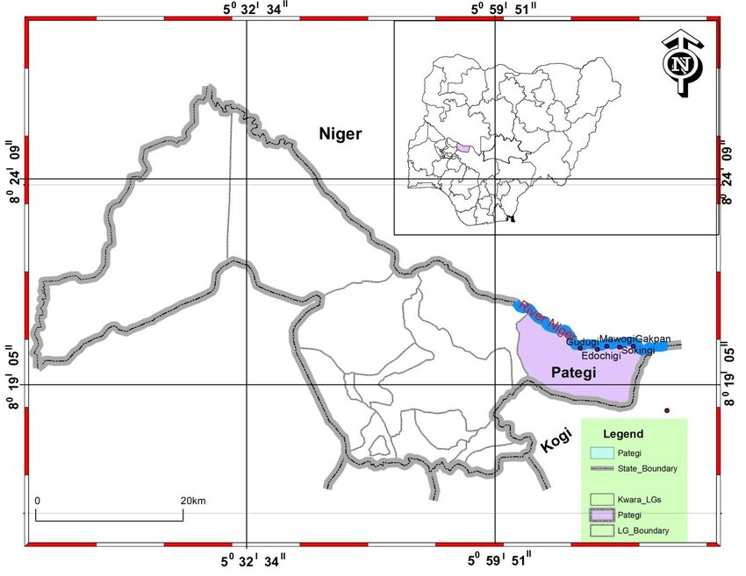
Fig. 3.1: map of Kwara state showing the location of Lade Pategi Local Government ( Abiodun olabode,. 2011).
3.2 Sample Collection
Fifty kilogram (50kg) of lithium ore was collected from Lade , Pategi Locak Government Area of Kwara State Nigeria. The sizes of grains of ore sample was reduced to about 50mm using a geologic hammer, it was further reduced to 5mm using a Denver laboratory jaw crusher and subsequently, the sample was further reduce to a fine particle by a ball mill.

Fig 3.2 shows the photograph of Spodumenic rock collected from site
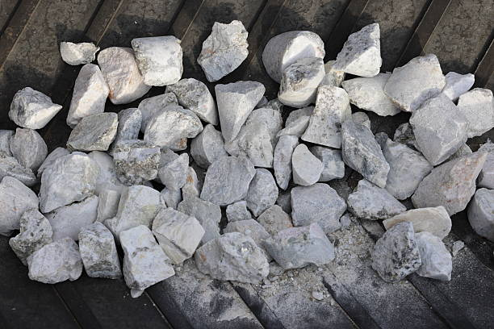
Fig. 3.2: Spodumenic rock
Fig 3.3 shows the equipment used to reduce the particle size
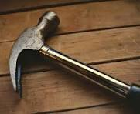
Fig 3.3: Geologic hammer
Fig 3.4: shows the equipment to ground the spodumenic rocks
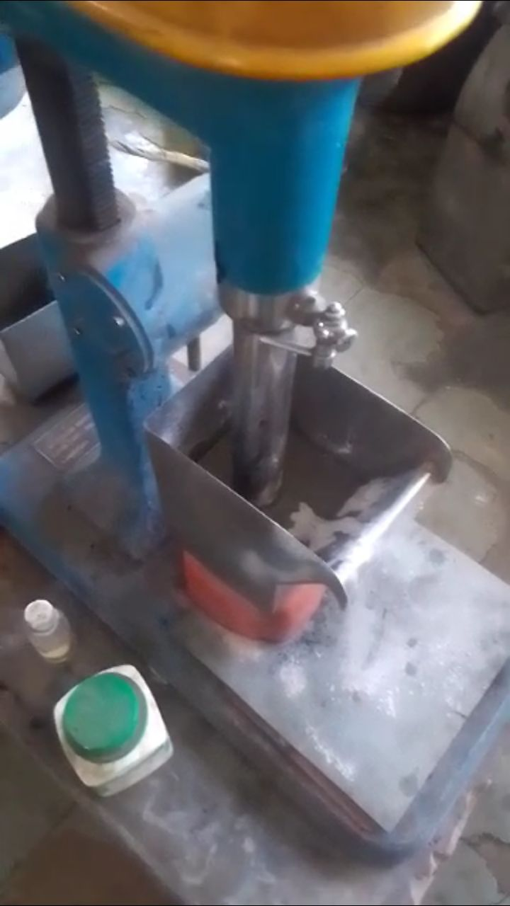
Fig 3.4: Jaw crusher
Fig: 3.5: shows the Ball mill
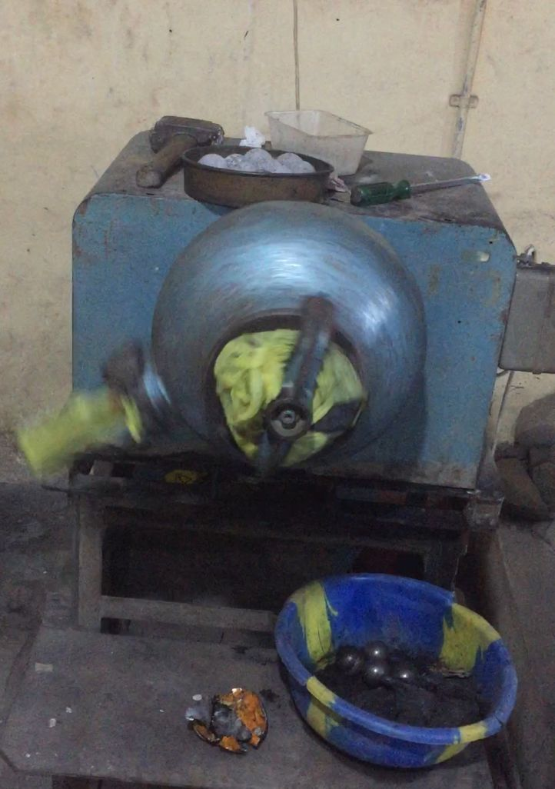
Fig 3.5: Ball mill
3.3 sample preparation
After the particle were milled by the ball mill machine , the particle were sieved so that the mineral can be easier separation from the critical mineral , the fraction were sieved using fitter paper size 125mm diameter , After the lithium sample was ready for laboratory procedure
Fig 3.6 shows the Sieved mineral

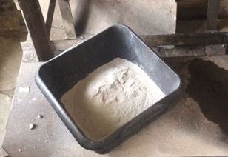
Fig 3.6: Sieved mineral
3.4 Laboratory Procedure of Froth Flotation of the ores
The laboratory procedure begins with the sieving analysis . The fraction sieve technique was employed to determine particle size distributions of the grounded ore. Mainly oleic acid and sodium oxate were used as collector and the slurry was agitated for another 2 minutes before being transferred into the flotation cell, where it agitated for another 2 minutes. Methyl Isobuty Carbinol (MIBC) was added as a fr other and the mixture was agitated for a total of 10 minutes in the sun and sampled randomly for chemical analysis. The entire process was repeated for each particle sizes of 180um, 125um, 90um as specified.
Fig 3.7 shows the flotation cell

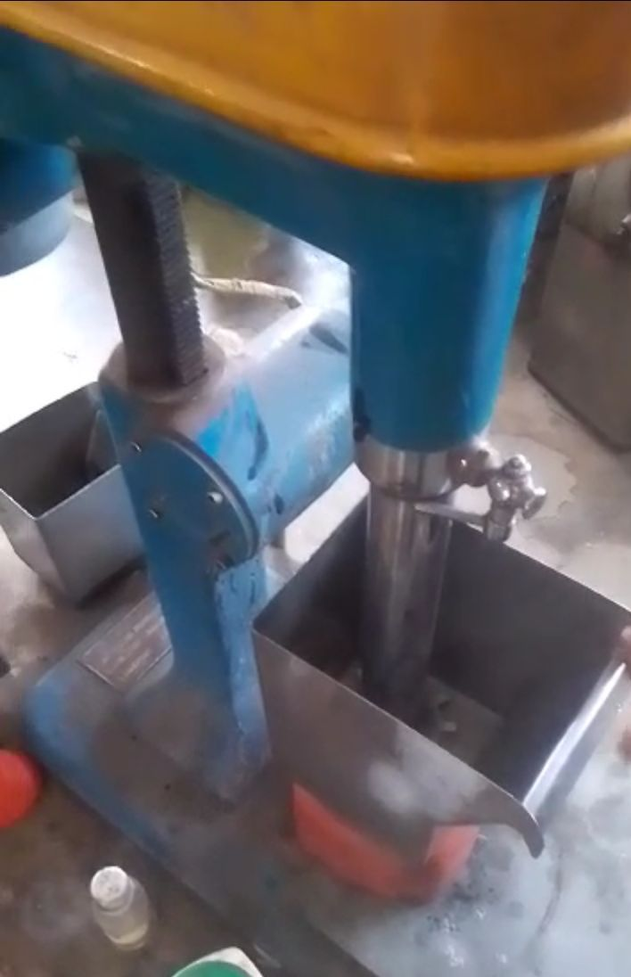
Fig 3.7: Flotation cell

CHAPTER FOUR
RESULTS AND DISCUSSION
4.1 Grade of the Ore
Table 4.1 shows the elemental and oxides of critical minerals in crude
Table 4.1: Elemental and oxides of critical minerals in crude
Mineral Oxide Formula XRF (%) Element AAS (%)
Silicon SiO₂ 74.385 Si 34.791
Aluminum Al₂O₃ 11.930 Al 6.314
Potassium K₂O 7.961 K 6.609
Manganese MnO 0.801 Mn 0.620
Chromium Cr₂O₃ 0.04 Cr 0.037
Chlorine Cl 1.053 Cl 1.053
Magnesium MgO 0.00 Mg 0.00
Calcium CaO 0.403 Ca 0.288
Titanium TiO₂ 0.027 Ti 0.016
Vanadium V₂O₅ 0.00 V 0.00
Iron (Ferrous) Fe₂O₃ 1.112 Fe 0.778
Phosphorus P₂O₅ 0.105 P 0.047
Sulphur SO₃ 0.076 S 0.031

Table 4.1 presents the oxide and elemental composition of spodumenie rock and associated critical minerals in the studied spodumene-bearing ore. Understanding the chemical composition of the ore is essential, as it directly influences its beneficiation potential and economic viability (Gupta & Yan, 2016). The analysis, conducted using both X-ray fluorescence (XRF) and Atomic Absorption Spectroscopy (AAS), provides complementary insights into the mineralogical makeup.
Silicon dioxide (SiO₂) dominates the ore, with XRF indicating 74.385% and AAS showing 34.791%. This high silica content likely originates from the presence of gangue minerals such as quartz and feldspar, which are commonly associated with spodumene-bearing pegmatites. Elevated silica levels can significantly dilute the lithium content and pose challenges during beneficiation, necessitating effective separation techniques to enhance spodumenie recovery (Kesler et al., 2012; Abaka-Wood et al., 2019).
A comparative geochemical assessment was carried out between the Lade spodumene ore (Pategi LGA, Kwara State) and similar spodumene-rich deposits from Gikil and Magalam (Tafawa Balewa LGA, Bauchi State). The pegmatites in these locations also exhibit high silica content, ranging from 63.3% to 72.7%, with an average of 68.7%. Aluminum oxide (Al₂O₃) concentrations vary between 10.9% and 17.8%, averaging 14.6%. These differences reflect variations in mineral assemblages, particularly in the proportions of SiO₂, Al₂O₃, and TiO₂ (Černý, 1991).
Geochemical discrimination diagrams based on elemental ratios—such as K/Rb vs. Cs and Ba/Rb vs. Sr—indicate that the pegmatites from Gikil are highly evolved and enriched in rare metals. These rocks display significant mineralization in tantalum (Ta) and beryllium (Be), with lithium oxide (Li₂O) concentrations reaching up to 2.4%, though Ta and Be levels are comparatively lower (Ogaba et.al., 2025). Such mineralogical evolution is indicative of fractional crystallization processes common in rare-element pegmatite systems (London, 2008).

4.2 Result of Froth Flotation Procedure
TABLE 4.2 shows the result of beneficiated ores
TABLE 4.2: RESULT OF BENEFICIATION
MINERALS | Crude  XRF( %) |  | Crude  AAS ( %) |  | 0.25g of  XRF |  | 0.25g  AAS |  | 0.5g  XRF |  | 0.5g  AAS |  | 0.75g  XRF |  | 0.75g  AAS |  | 1.0g  XRF |  | 1.0g  AAS
MINERALS |  |  |  |  | CONC. | TAILING | CONC. | TAILING | CONC. | TAILING | CONC. | TAILING | CONC. | TAILING | CONC. | TAILING | CONC. | TAILING | CONC. | TAILING
silicone | Sio2 | 74.385 | si | 34.791 | 70.099 | 70.22 | 52.768 | 34.695 | 69.865 | 70.942 | 32.658 | 33.161 | 69.070 | 69.26 | 32.29 | 32.38 | 34.78 | 66.95 | 31.57 | 31.30
alumininum | Al2o3 | 11.930 | Al | 6.314 | 16.447 | 11.51 | 8.71 | 6.11 | 13.78 | 17.12 | 9.30 | 9.06 | 16.43 | 15.92 | 8.69 | 8.43 | 6.31 | 12.36 | 8.26 | 6.55
pottasium | K2o | 7.961 | k | 6.6.9 | 7.492 | 7.99 | 6.23 | 6.03 | 8.30 | 6.32 | 6.96 | 5.24 | 6.92 | 7.01 | 5.74 | 5.82 | 6.60 | 6.65 | 6.32 | 5.36
maganese | mno | 0.801 | mn | 0.620 | 0.882 | 0.65 | 0.68 | 0.50 | 0.78 | 0.51 | 0.61 | 0.59 | 0.65 | 0.60 | 0.50 | 0.47 | 0.62 | 0.07 | 0.56 | 0.40
crominum | Cr203 | 0.04 | cr | 0.037 | 0.078 | 0.04 | 0.05 | 0.08 | 0..8 | 0.06 | 0.06 | 0.03 | 0.06 | 0.00 | 0.03 | 0.03 | 0.04 | 0.07 | 0.05 | 0.03
chlorine | cl | 1.053 | Cl | 1.053 | 0.682 | 1.30 | 0.68 | 1.30 | 0.96 | 0.59 | 0.96 | 0.59 | 1.05 | 0.75 | 1.04 | 0.75 | 1.05 | 0.46 | 0.46 | 0.36
magnesium | mgo | 0.000 | Mg | 0.000 | 0.000 | 0.00 | 0.00 | 0.00 | 0.00 | 0.82 | 0.00 | 0.49 | 0.00 | 2.22 | 0.00 | 1.33 | 0.00 | 2.08 | 1.25 | 5.94
calcum | cao | 0.403 | Ca | 0.288 | 0.841 | 0.95 | 0.60 | 0.61 | 1.04 | 0.63 | 0.74 | 0.45 | 1.70 | 0.63 | 1.21 | 0.45 | 0.28 | 1.04 | 0.74 | 0.24
titanium | Tio2 | 0.027 | Ti | 0.016 | 0.000 | 0.06 | 0.00 | 0.03 | 0.01 | 0.02 | 0.01 | 0.01 | 0.09 | 0.00 | 0.05 | 0.00 | 0.01 | 0.04 | 0.02 | 0.02
Vanadium | V205 | 0.000 | v | 0.000 | 0.011 | 0.04 | 0.01 | 0.02 | 0.00 | 0.01 | 0.00 | 0.03 | 0.01 | 0.07 | 0.01 | 0.04 | 0.00 | 0.00 | 0.00 | 0.00
ferrous | Fe203 | 1.112 | Fe | 0.778 | 1.023 | 0.92 | 0.72 | 0.69 | 2.14 | 0.69 | 1.49 | 0.48 | 1.83 | 0.83 | 1.28 | 0.58 | 0.78 | 1.99 | 1.39 | 0.48
phosphorus | P203 | 0.105 | P | 0.047 | 0.042 | 0.42 | 0.12 | 0.18 | 0.00 | 0.13 | 0.00 | 0.05 | 0.10 | 0.00 | 0.04 | 0.00 | 0.42 | 0.00 | 0.00 | 0.69
sulphur | So3 | 0.076 | s | 0.031 | 0.098 | 0.00 | 0.04 | 0.03 | 0.17 | 0.49 | 0.08 | 0.19 | 0.00 | 0.57 | 0.00 | 0.23 | 0.03 | 0.84 | 0.34 | 0.15

Flotation Test Results and Interpretation
Flotation experiments were conducted using finely ground spodumene-bearing ore with a particle size of 90 µm and a pulp density of 30%. For each flotation run, 500 g of ore was treated using a collector system composed of oleic acid and sodium oleate, known for enhancing the hydrophobicity of spodumene under alkaline conditions. The collector dosage was systematically varied at 0.25 g, 0.5 g, 0.75 g, and 1.0 g to assess its effect on lithium grade and recovery.
At a low dosage of 0.25 g, flotation yielded low lithium grades and recovery, indicating insufficient collector concentration to effectively hydrophobize the surface of spodumene particles. This inefficiency resulted in poor floatability and low concentrate quality.
This behavior aligns with findings from previous studies. For instance, (Meshram et.al.,2020 and Ferreira et.al, 2019). reported that increasing collector dosage enhances spodumene flotation performance only up to an optimal point, beyond which selectivity decreases due to gangue entrainment. Similarly, (Bulatovic, 2007) emphasized that excessive fatty acid collectors can compromise flotation selectivity in lithium-bearing ores by promoting unwanted gangue flotation.
Upon increasing the collector dosage to 0.5 g and 0.75 g. there was a marked improvement in both the grade and recovery of lithium and other critical minerals. This suggests enhanced interaction between the collector and spodumene surfaces, improving flotation selectivity and concentrate enrichment.
The optimal performance was achieved at 0.75 g. where high lithium grade and recovery were obtained with minimal gangue mineral carryover. This dosage ensured sufficient adsorption of the collector on spodumene particles, improving their floatability while maintaining selectivity.
However, at a collector dosage of 1.0 g, although the recovery of critical minerals remained high, a slight decline in grade was observed. This decline is attributed to the non-selective adsorption of excess collector, leading to the unintended flotation of gangue minerals and dilution of the concentrate (Bulatovic, 2007).

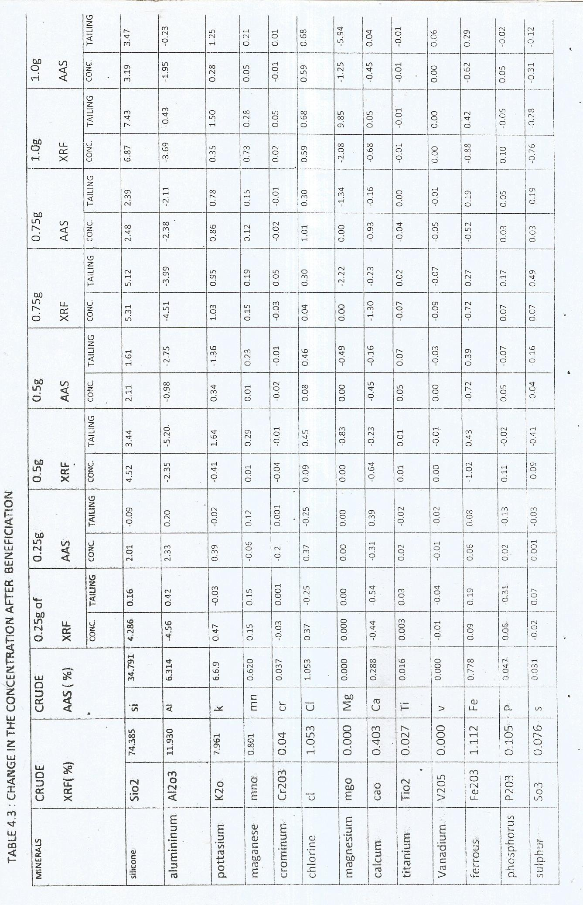
Table 4.3 shows the changes in the concentration after beneficiation

Table 4.3 illustrates the progressive changes in elemental concentrations as a result of the beneficiation process. A notable decrease was observed in the content of oxides such as Fe₂O₃ (iron oxide), MgO (magnesium oxide), CaO (calcium oxide), and TiO₂ (titanium oxide) in the concentrate. This decline indicates that these heavier, undesirable gangue minerals were effectively rejected during flotation
Conversely, there was a steady increase in SiO₂ (silicon dioxide) concentration across the range of collector dosages, suggesting the successful flotation and concentration of silicate-rich minerals. The enrichment in SiO₂ implies that light silicate minerals—such as quartz, feldspar, and mica—were preferentially recovered. This may be attributed to their natural floatability or surface modification by flotation reagents like calcium chloride and sodium oleate, which enhance their hydrophobicity.
The concurrent increase in Al₂O₃, Na₂O, and K₂O further supports the selective recovery of feldspathic and micaceous minerals. In contrast, the suppression of Fe₂O₃, CaO, MgO, and TiO₂ points to the rejection of iron oxides, carbonates, and possible amphibole phases.
Although lithium was not directly detected in the concentrate, the effective upgrading of the acidic silicate fraction is significant. In lithium-bearing pegmatites, the enrichment of SiO₂ and associated alkali elements often correlates with the presence of lithium-bearing silicates such as spodumene or lepidolite. Therefore, the flotation process demonstrates potential for concentrating lithium carriers, even if present in trace or cryptic forms.

CHARPTER FIVE
5.0 CONCLUSION AND RECOMMENDATIONS
5.1 Conclusion
In the absence of detectable lithium, silicon (SiO₂) emerged as the most significantly enriched element in the flotation concentrate. This consistent increase indicates the successful beneficiation of silica-rich minerals—likely including feldspar and mica. The flotation results demonstrate efficient separation of light silicate minerals from gangue components, underscoring the selectivity and effectiveness of the flotation process even in ores lacking lithium-bearing phases.
Although spodumene or other lithium minerals were not detected, the applied flotation conditions proved effective in concentrating silicate phases such as quartz, feldspar, and mica, while reducing the content of iron, magnesium, calcium, and titanium oxides. These outcomes suggest that flotation techniques can be repurposed for the recovery of industrial minerals from pegmatitic rocks. Moreover, the findings provide a valuable foundation for future mineralogical and geochemical studies aimed at optimizing recovery and exploring new resource opportunities.
5.2 Recommendations
Based on the findings of this study, the following recommendations are proposed:
Scale-up and Pilot Testing: The flotation parameters developed in this study should be tested in larger-scale or pilot plant operations to assess their efficiency and economic viability under industrial conditions.
Implementation of Cleaner Flotation Stages: Incorporating one or more cleaner flotation stages—especially following the rougher flotation at 0.75 g collector dosage—could significantly enhance the quality and purity of the final concentrate.

REFERENCES
Abiodun, O. D. (2011). Map of Kwara State. Adekunle Ajasin University, Akungba
Akoko.
Achagnes, A., and Seiatewska, J. (2015). Lithium process chemistry: Resources,
extraction, batteries and recycling. Elsevier Science.
Atkins, P., Overton, T., Rourke, J., Weller, M., and Armstrong, F. (2010). Shriver
and Atkins’ inorganic chemistry (5th ed.). Oxford University Press.
Bach, R. O. (1985). Lithium: Current applications in science, medicine and
technology. In Southeastern Regional Meeting, American Chemical Society. Wiley.
Bertau, M., Offerman, P., Plass, L., Schmidt, F., and Wark, M. (2017). Silicon:
Chemistry, production, properties, application. De Gruyter.
Bertau, M., Offermans, H., Plass, L., Schmidt, F., and Warkentin, J. (2017).
Recovery of rare earths and other critical metals from electronic waste. Springer. https://doi.org/10.1007/978-3-662-54001-6
Callister, W. D., and Rethwisch, D. G. (2020). Materials science and engineering:
An introduction (10th ed.). Wiley.
Cotton, F. A., Wilkinson, G., Murillo, C. A., and Bochmann, M. (1999). Advanced
inorganic chemistry (6th ed.). Wiley-Interscience.
Evans, R. K. (2014). An overview of the lithium industry. Lithium Americas Corp.
Evans, R. K. (2014). An overview of the lithium industry and the role of lithium
carbonate in the chemical processing of spodumene ore. Industrial Minerals, pp1–10.
Earnshaw, A. and Greenwood, N. N., (1997). Chemistry of the elements (2nd ed.).
Butterworth-Heinemann.
Gaines, R. V., Skinner, H. C. W., Foord, E. E., Manson, B., and Rosenzweig, A.
(1997). Dana’s new mineralogy: The system of mineralogy of James Dwight Dana and Edward Salisbury Dana (8th ed.). Wiley.
Garreth, D. E. (2004). Handbook of lithium and natural calcium chloride. Academic
Press.
Gupta, A., and Krishnamurthy, N. (2005). Extractive Metallurgy of Rare Earths.
CRC Press.
Greenwood, N. N., and Earnshaw, A. (2012). Chemistry and physics of the elements
(2nd ed.). Butterworth-Heinemann.
Haynes, W. M. (Ed.). (2016). CRC handbook of chemistry and physics (97th ed.).
CRC Press.
Kesler, S. E., Gruber, P. W., Medina, P. A., and Eyal, M. (2012). Global lithium
resources: Relative importance of pegmatite, brine, and other deposits. Ore Geology Reviews, 48, 55–69. https://doi.org/10.1016/j.oregeorev.2012.05.006
Levich, B. (2009). A five-year strategic outlook for the lithium industry. In Metal
Bulletin. London.
Meshram, P., Pandey, B. D., and Mankhand, T. R. (2020). Recovery of lithium from
primary and secondary resources and its application. Minerals Engineering, 147, 106158.
Ogaba, S. O., Abubakar, M. B., and Yusuf, A. M. (2025). Geochemistry and mineral
potential of pegmatite-hosted spodumene in Bauchi State, Nigeria. Nigerian Journal of Geological Sciences, 31(2), pp 44–56.
Pirajno, F. (1992). Hydrothermal mineral deposits. Springer.
Poggi, F., Gualtieri, A. F., and Gemelli, A. (2017). Mineralogical and chemical characterization
of pegmatite-hosted feldspar ores. Journal of Geochemical Exploration, 115, pp 34–45. https://doi.org/10.1016/j.gexplo.2012.06.003
Sadoway, D. (1998). Toward new technologies for the production of lithium. JOM,
50(7), 24–26. https://doi.org/10.1007/s11837-998-0128-2
Swain, B. (2017). Recovery and recycling of lithium: A review. Separation and
Purification Technology, 172, pp388–403. https://doi.org/10.1016/j.seppur.2016.08.031

