
A PROJECT TECHNICAL REPORT WRITTING
ON

PROPOSED PRIMARY SCHOOL FOR ADENIKE
INVESTMENT, BOLAKALE STREET, CHECK POINT, ILORIN, KWARA STATE.
BY
AKINTOLA MOYINOLUWA

ND/23/ARC/FT/0007
SUBMITTED TO: THE DEPARTMENT OF ARCHITECTURAL TECHNOLOGY
INSTITUTE OF ENVIROMENTAL STUDIES
KWARA STATE POLYTECHNIC, ILORIN

2025

DECLARATION
I declare that this Project/Dissertation is a product of my personal research work. It has not been presented for the award of any degree in any Polytechnic/University. The ideas, observations, comments, suggestions herein represent my own convictions, except quotations, which have been acknowledged in accordance with conventional academic traditions.

AKINTOLA MOYINOLUWA AYOMIDE
ND/23/ARC/FT/0007 SIGNATURE/DATE

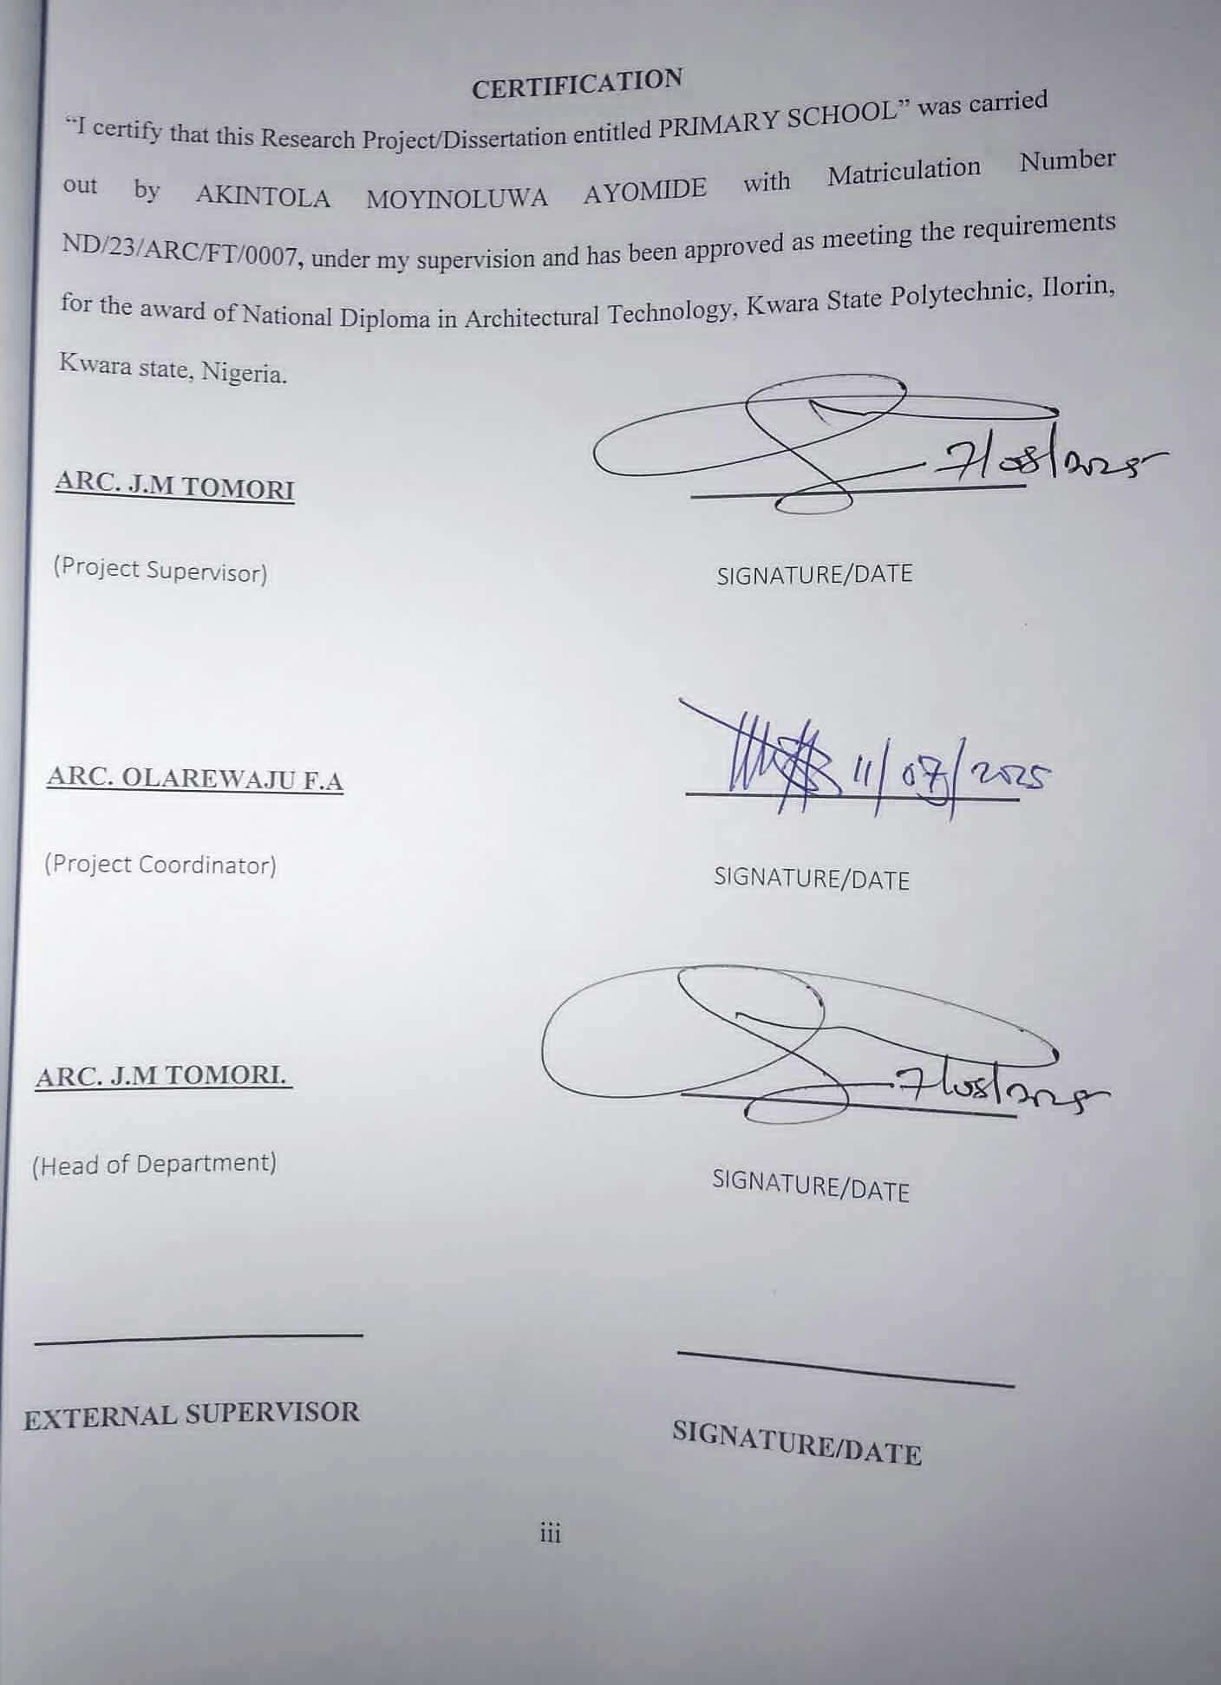

DEDICATION
I dedicate this project to Almighty God for His grace, strength and wisdom throughout the course of this work. I also dedicate it to my parents and mentors for their continuous support and encouragement.

ACKNOWLEDGMENT
This ultimate dominion still belongs to Almighty GOD. All praises to GOD, no partner has He, there is no deity worthy of worship than Him, He is the final resurrection.
Peace and blessing be upon the lord Almighty Allah. and His family, His companion and every one of us who adhere to his teaching till the day of judgement.
I also recognize the support love, care and guidance of my precious parents in person of MR and MRS AKINTOLA, I pray Almighty GOD reward you abundantly, may you reap the fruit of your labour and shall be blessed more than your imagination (Amen)
My sincere gratitude goes to my supervisor ARC. J.M TOMORI for sparing his time to take me through all the stages and exhaustible efforts and constructive remarks in writing this project.
All thanks be to my Lecturers ARC OLAREWAJU F. A., ARC ABDULAZEEZ B. Y. F., ARC CHUKUMA NMOM, ARC SOLOMON FAMILUA AND ARC SHERO.
Lastly I want to appreciate my lovely friends who render their service for me when I needed them may Almighty GOD bless you all abundantly. (AMEN)

TABLE OF CONTENTS
TITTLE PAGE ………………….………….…………..………………… i
DECLARATION ii
CERTIFICATION iii
DEDICATION iv
ACKNOWLEDGMENT v
TABLE OF CONTENTS vi

ABSTRACT………………….………….……………….…………………….vii
LIST OF FIGURES………………….………….……………….………….. ix

CHAPTER ONE
1.0 INTRODUCTION………………….………….……………….……… 1
1.1 BACKGROUND OF THE STUDY…………………………………… 1
1.2 STATEMENT OF DESIGN …………………………….…………… 1
1.3 AIM AND OBJECTIVE……………….……………………..…..……. 1
1.4 JUSTIFICATION OF THE PROJECT…………………….…………... 2
1.5 CLIENT’S BACKGROUND AND PHYLOSOPHY …………………..2
1.6 SCOPE OF STUDY……………………………………………………. 2
1.7 LIMITATION OF STUDY ……………………………………………..3
1.8 RESEARCH METHODOLOGY………………………………………. 3

CHAPTER TWO
2.0 LITERATURE REVIEW …………..………………..…………………..4
2.1 HISTORICAL OVERVIEW …………..………….…………..…………4
2.2 CLASSIFICATION OF SCHOOL TYPE …………………………….....4
2.3 SPACE FUNCTIONAL AND RELATIONSHIP ……………..………,,,4
2.4 TECHNOLOGICAL AND ENVIRONMENTAL CONSIDERATION…5

CHAPTER THREE
3.1 CASE STUDY………………………………………………..………….6
3.2 CASE STUDY TYPICALLY INVOLVE …………..…………………..6
3.3 OUTLINE OF CASE STUDY …………..………………………..……..6
3.4 CASE STUDY ONE ……………..………………….…………..………7
3.5 CASE STUDY TWO …………..………………………..………………9
3.6 CASE STUDY THREE …………………………………………………11
3.7 ONLINE CASE THREE …………..………………………..…………...15
3.8 ONLINE CASE STUDY …………..………………………..…………..16

CHAPTER FOUR
4.0 STUDY AREA/SITE ANALYSIS …………..……………………..…..17
4.1 STUDY AREA INTRODUCTION …………..…………………………17
4.2 SITE SELECTION CRITERIAL …………..…………………………...17
4.3 SITE INVENTORY …………..…………………………………………18
4.4 CLIMATIC DATA …………………………………………...…..……..18
4.5 DESIGN CRITERIAL …………………………………………….…….19
4.6 CONCEPT DEVELOPMENT …………..………………………………19

CHAPTER FIVE
5.0 DESIGN APPROCH/REALIZATION …………..……………………..20
5.1 DESIGN CONCEPT …………..……………...……………………..….20
5.2 SKETCHES AND GRAPHIC …………...………………..…………….20
5.3 ENVIRONMENTAL AND TECHNOLOGICAL INTERGRATION…..20
5.4 CONSTRUCTION AND MATERIAL……………...………..…………20
5.5 SERVICE ……………………………………………..…..……………..21
5.6 CONCLUSION AND RECOMMENDATION …………..……………..21

LIST OF FIGURES
FIGURE 3.4: LOCATIONAL PLAN CASE STUDY ONE…………………..….7
FIGURE 3.4: FLOOR PLAN OF CASE STUDY ONE …………………..……..7
FIGURE 3.5: LOCATIONAL PLAN OF CASE STUDY TWO……...………...9
FIGURE 3.5: FLOOR PLAN OKELERIN CASE STUDY TWO ……………...9
FIGURE 3.6: LOCATIONAL PLAN OF CASE STUDY THREE.…..………...11
FIGURE 3.6: FLOOR PLAN OF CASE STUDYTHREE… …………….........11
FIGURE 4.6 BUILDING CONCEPT ………………………………………….19

LIST OF PLATES

PLATE 3.7 .PICTURES OF CASE STUDY THREE…….…………..…........12

PLATE 3.7 .PICTURES OF CASE STUDY THREE…….…….......................13

PLATE 3.8 .PICTURES OF ONLINE CASE STUDY FOUR.........................15

PLATE 3.9 .PICTURES OF ONLINE CASE STUDY FIVE...........................16

LIST OF APPENDIX

APPENDIX 5 .7; SHOWING FLOOR PLAN…….………………………….…...22
APPENDIX 5. 8; SHOWING ROOF PLAN…….......………………….….….….22
APPENDIX 5. 9; SHOWING SITE PLAN…….…………..…………….….…....23

APPENDIX 5. 10; SHOWING ELEVATION…………..………………..….…....23

APPENDIX.5;11 SHOWING EXTERNAL PERSPECTIVE………….……….24
APPENDIX.5;12 SHOWING SECTION…………………..………….………..24

ABSTRACT
The design of a primary school is an essential response to the growing need for childfriendly and functional educational facilities in Nigeria. The project aims to create a conducive learning environment that addresses the physical, social and psychological development of pupils at the foundational stage of their education. The specific objectives include the provision of adequate classrooms, administrative spaces, play areas and support facilities that enhance academic performance and well-being.
To achieve these goals, the research adopted a mixed-method approach involving literature review, case studies of existing schools, site analysis and user interviews. These methods enabled the identification of space standards, circulation patterns and functional relationships essential for an effective school environment.
The findings revealed key deficiencies in existing public school designs, such as poor lighting, inadequate ventilation, lack of play zones and insufficient spatial planning. These issues were addressed in the proposed design by incorporating natural ventilation, modular classroom layouts, shaded outdoor areas and the use of sustainable materials.
The project concludes that a well-designed primary school not only enhances learning but also contributes to the overall growth of pupils. It recommends that government agencies and private developers adopt child-centered design principles and environmentally responsive approaches in future educational infrastructure projects.

CHAPTER ONE

1.0 INTRODUCTION 1.1 BACKGROUND TO THE STUDY
Education is a foundational pillar for societal development. Primary schools serve as the first formal educational environment for children, nurturing basic literacy, numeracy and social interaction skills. In Nigeria, the Universal Basic Education policy underscores the necessity of quality educational facilities, especially at the primary level. However, many schools operate in substandard buildings, lacking child-centered design, ventilation, lighting and security.

1.2 STATEMENT OF DESIGN PROBLEM
Many public primary schools in Nigeria are poorly planned, lack adequate learning spaces, proper sanitary facilities and safe outdoor environments. These deficiencies negatively affect the learning and health of children.

1.3 AIM AND OBJECTIVES OF THE PROJECT
AIM:
To design a functional and child-friendly primary school that supports learning, development and well-being.
OBJECTIVES:
To provide flexible classroom layouts for various teaching methods
To incorporate natural lighting and ventilation
To include recreational and assembly spaces
To ensure child safety and accessibility
To integrate sustainable materials and design

1.4 JUSTIFICATION FOR THE PROJECT
This project is essential to bridge the gap between current poorly designed schools and the need for modern, engaging learning environments. It aims to create a model for future public school development.

1.5 CLIENT’S BACKGROUND AND PHILOSOPHY
The client is a state ministry of education aiming to improve public primary school infrastructure. Their goal is to foster inclusive, accessible and quality education.

1.6 SCOPE OF STUDY
THE DESIGN WILL COVER:
- Classrooms (Nursery–Primary 6)
- Administrative offices
- Library
- ICT room
- Health bay
- Multipurpose hall
- Playgrounds and landscaping • Toilets and storage
- Parking and circulation paths

1.7 LIMITATION OF STUDY
The study focuses on school design within urban constraints and may not address rural infrastructure, budget limitations, or detailed construction documents

1.8 RESEARCH METHODOLOGY
- Literature review on school design
- Case studies of existing primary schools
- Environmental and site analysis
- Interviews with teachers and pupils
- Functional analysis and space programming

CHARPTER TWO
INTRODUCTION
2.0 LITERATURE REVIEW
A. REVIEW ON THE BUILDING TYPE

2.1 HISTORICAL OVERVIEW
Traditional primary schools were based on colonial-style layouts—linear blocks and rigid structures. Modern schools now integrate flexible, interactive learning environments with biophilic and child-centered designs.

2.2 CLASSIFICATION OF SCHOOL TYPES
- Public vs. Private Schools
- Day vs. Boarding Primary Schools
- Montessori and Conventional Schools

2.3 SPACE FUNCTIONS AND RELATIONSHIPS
- Key functional spaces:
- Classrooms grouped by age/grade
- Close adjacency between administration and reception
- Library central to classrooms
- Multipurpose hall accessible for school and community events
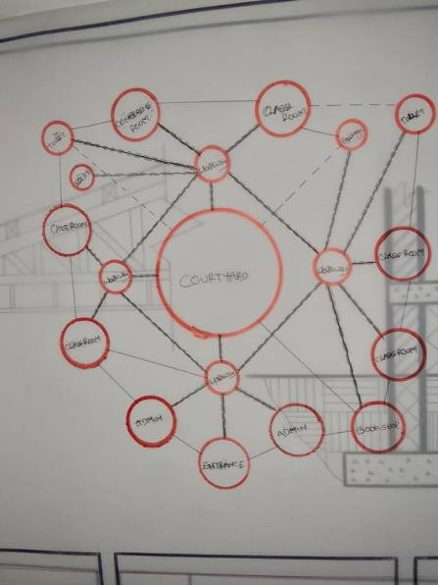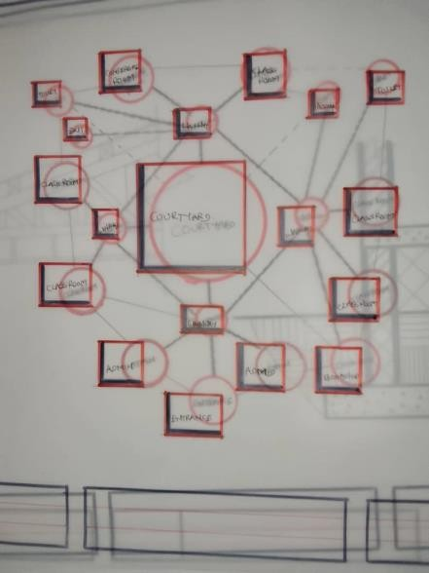

2.4 TECHNOLOGICAL AND ENVIRONMENTAL CONSIDERATIONS
- Use of passive ventilation and daylighting
- Rainwater harvesting
- Eco-friendly materials like earth blocks, bamboo
- Solar-powered lighting
- Inclusive design for all abilities
B. REVIEW OF SUB-TOPIC:

CHILD-CENTERED LEARNING ENVIRONMENTS
Designing spaces that reflect the physical scale and psychological needs of children is crucial. Color, furniture size, safety features and interactive environments contribute to
improved learning outcomes.

CHAPTER THREE

3.1 CASE STUDY
A case study is a research methodology that involves an in1depth examination of a specific individual, group, organization, or phenomenon. It is a detailed analysis of a real1world situation or event, aiming to gain a deeper understanding of the underlying issues, relationships and dynamics.

3.2 CASE STUDIES TYPICALLY INVOLVE
- In1depth data collection: Gathering detailed information through various methods, such as interviews, observations, documents and surveys.
- Contextual analysis: Examining the case within its specific context, including historical, cultural, social and economic factors.
- Thematic analysis: Identifying patterns, themes and relationships within the data.
- Interpretation and conclusion: Drawing conclusions and making recommendations based on the findings.

3.3 OUTLINE OF CASE STUDIES
- Ilorin kwara state
- Lagos state
- Ogun state
- Online case study in United State
- Online case study in France

3.4 CASE STUDY ONE
GOOD HEART NURSERY & PRIMARY SCHOOL
Ogbomosho, Oyo State.

FIGURE 3.4: FLOOR PLAN OF CASE STUDY ONE
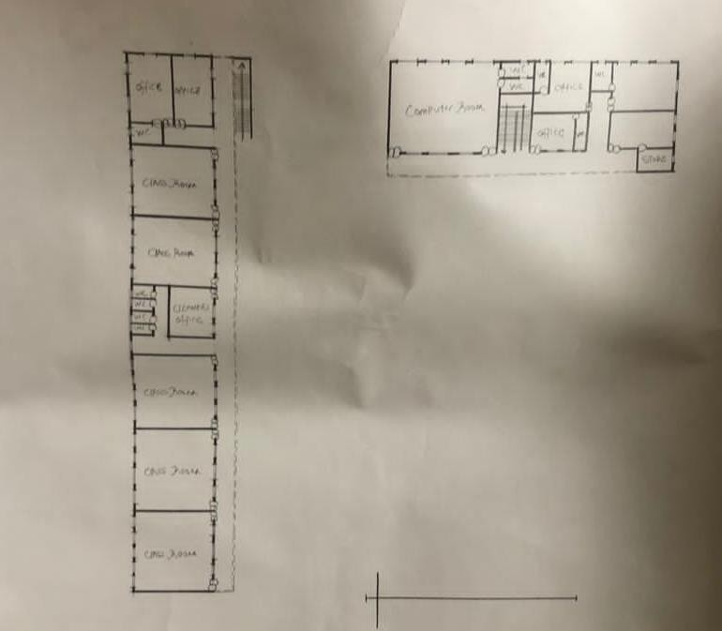

FIGURE 3.4: LOCATIONAL PLAN AND SITE PLAN CASE STUDY ONE
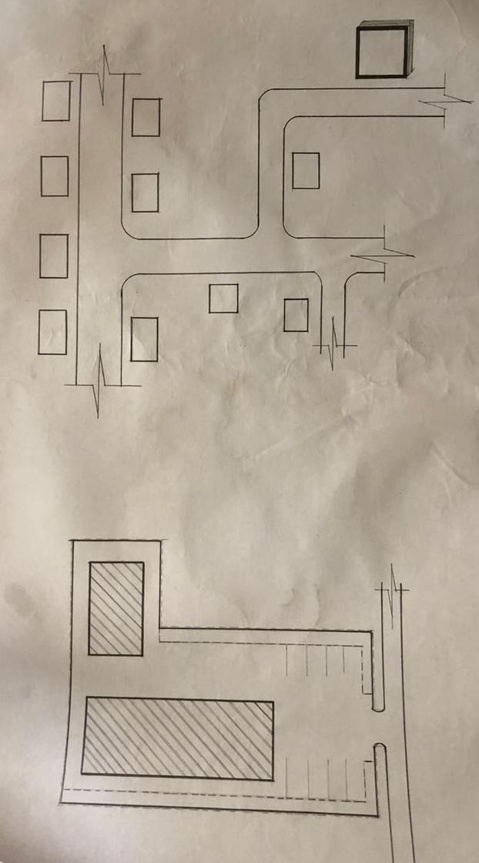

MERIT:

i. Easy accessible ii. Brief precise iii. Structurally balance

DEMERIT:

i. The examination center is too expose d ii. Poor landscaping iii. Insufficient convenience

3.5 CASE STUDY TWO
ADEJOKE NURSERY & PRIMARY SCHOOL
Ado-Ekiti, Ekiti State
FIGURE 3.5: FLOOR PLAN OKELERIN CASE STUDY TWO
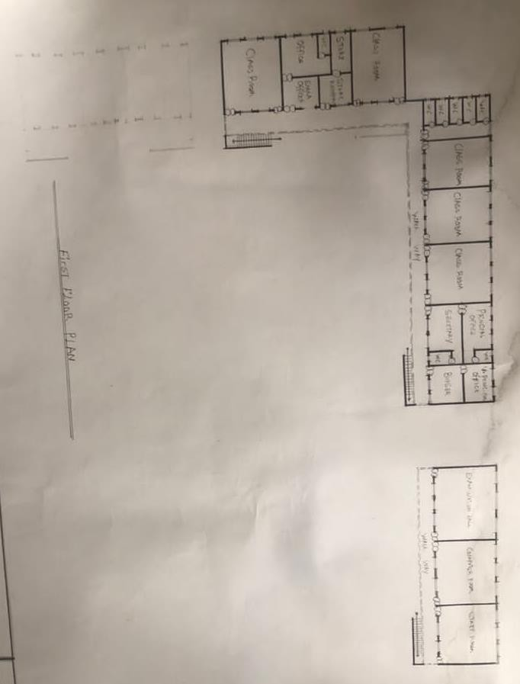
FIGURE 3.5: LOCATIONAL PLAN AND SITE PLAN OF CASE STUDY TWO
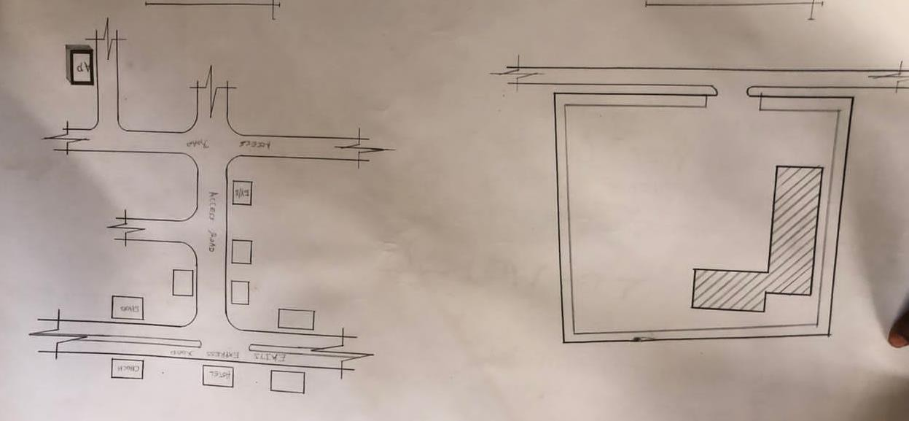

MERIT:

i. It is easily accessible ii. Structurally balanced iii. Brief precise

DEMERIT:

i. No packing space ii. No landscaping
iii. Lack of proper site zoning

3.6 CASE STUDY THREE
OKC NURSERY & PRIMARY SCHOOL
Ilorin, Kwara State.
FIGURE 3.6: FLOOR PLAN OF CASE STUDYTHREE
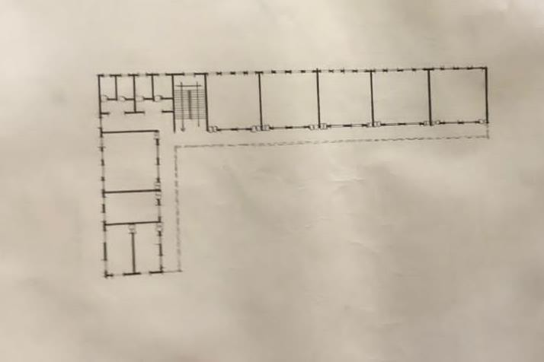

FIGURE 3.6: LOCATIONAL PLAN AND

SITE OF CASE STUDY THREE
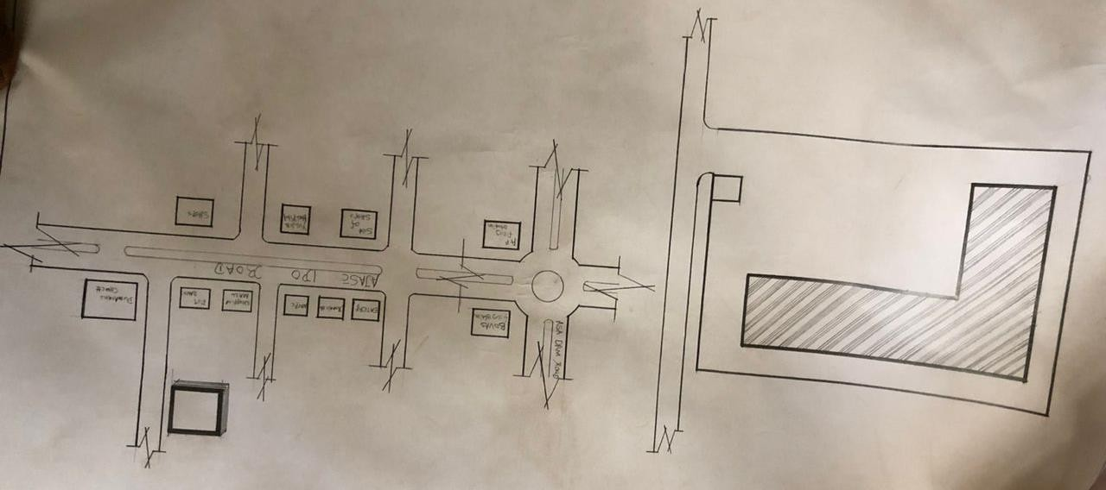

PLATE 3.7. PICTURES OF CASE STUDY THREE
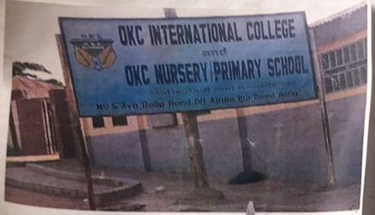

PLATE 3.7 .PICTURES OF CASE STUDY THREE
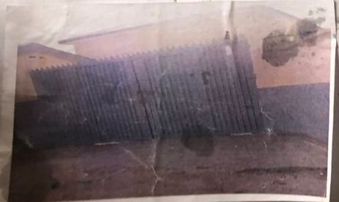

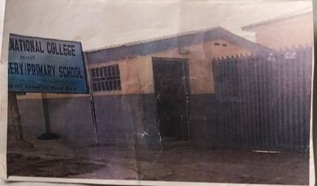

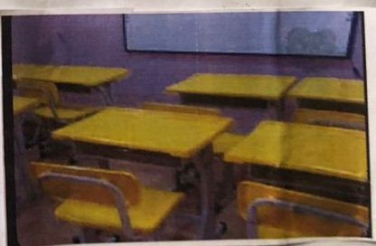

MERIT:

i. It is easily accessible ii. Structurally balanced iii. Aesthetically balanced

DEMERIT:

i. Low packing space ii. Main entrance not properly placed iii. Lack of proper site zoning

3.7 CASE STUDY FOUR
ONLINE CASE STUDY
PLATE 3.8 .PICTURES OF ONLINE CASE STUDY FOUR
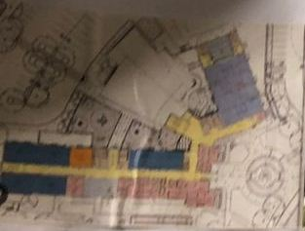
FLOOR PLAN
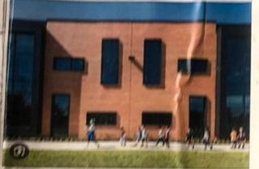
SIDE VIEW
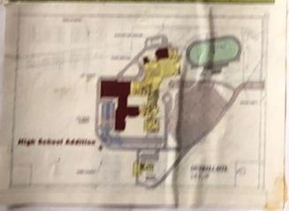
LOCATION PLAN

3.7 CASE STUDY FIVE
ONLINE CASE STUDY

PLATE 3.9 .PICTURES OF ONLINE CASE STUDY FIVE
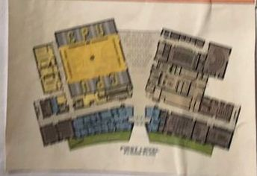
FLOOR PLAN
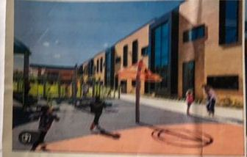
EXTERNAL VIEW

INTERNAL VIEW

CHAPTER FOUR

4.0 STUDY AREA/SITE ANALYSIS SITE DESCRIPTION AND ANALYSIS 4.1 STUDY AREA INTRODUCTION
The proposed site is located in Bolakale street, checking point, Ilorin, Kwara State. It is in a residential neighborhood with easy access to the main road and nearby community amenities.
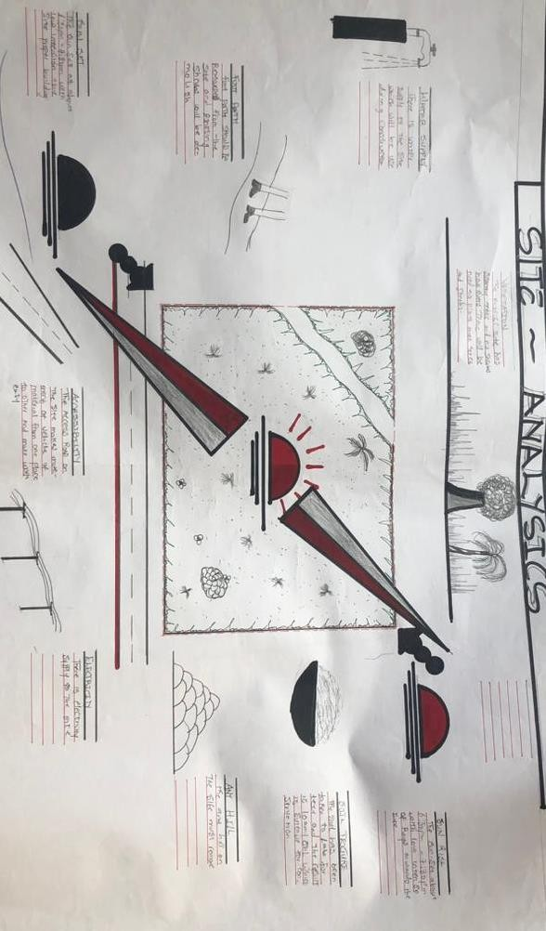

4.2 SITE SELECTION CRITERIA
- Proximity to population center
- Safety from industrial zones
- Level ground with good drainage
- Availability of basic utilities (water, electricity)

4.3 SITE INVENTORY
- Vegetation: Mostly grassland and shrubs
- Soil: Sandy-loam, good for foundation
- Slope: Gentle 2–5% incline
- Existing Structures: None
- Access: 6m-wide access road
- Utilities: Electricity poles nearby, borehole potential
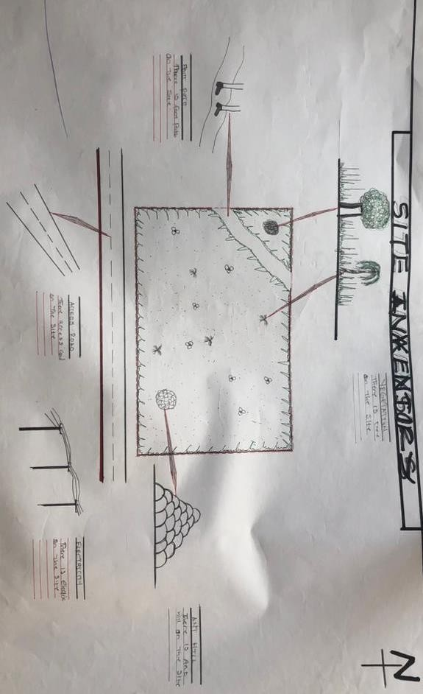

4.4 CLIMATE DATA
- Avg. Temperature: 28°C
- Rainfall: April–October
- Prevailing Wind: SW–NE
- Solar Path: East–West

4.5 DESIGN CRITERIA
PROJECT GOALS
- Design a conducive, safe and interactive primary school for children aged 3–11.
SPATIAL AND FUNCTIONAL REQUIREMENTS
- 12 classrooms
- 1 library
- 1 ICT room
- Admin and staff offices
- Multipurpose hall
- Health bay
- Sanitary blocks
- Playground and assembly area

4.6 CONCEPTUAL DEVELOPMENT
A courtyard layout promoting central gathering, passive ventilation and child-safe circulation.
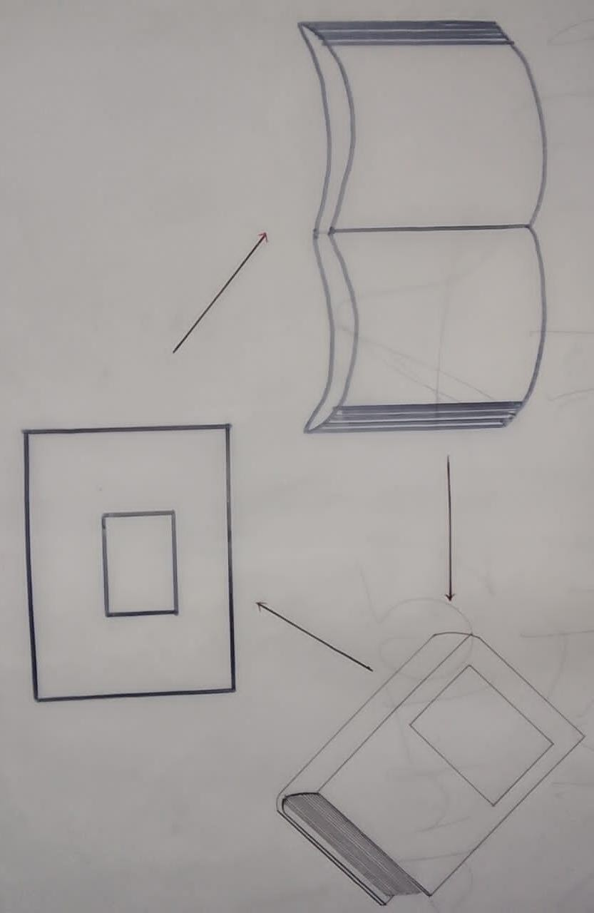

CHAPTER FIVE

5.0 DESIGN APPROACH/REALIZATION 5.1 DESIGN CONCEPT
The design follows a child-centered and eco-friendly approach, with emphasis on scale, natural ventilation, visibility and playful landscape. The school layout adopts a U-shaped courtyard, enhancing safety and social interaction.

5.2 SKETCHES AND GRAPHICS
Conceptual bubble diagrams
Zoning and circulation flow
3D perspective and walkthrough sketches

5.3 ENVIRONMENTAL AND TECHNOLOGICAL INTEGRATION
- Passive cooling through cross-ventilation
- Natural lighting via clerestory windows
- Rainwater collection for irrigation and toilets
- Solar-powered lighting
- Green spaces and shaded play zones

5.4 CONSTRUCTION AND MATERIALS
- Reinforced concrete frame
- Stabilized earth block walls
- Long-span metal roofing
- Terrazzo floor for durability

5.5 SERVICES
- PLUMBING: Borehole with overhead tanks
- POWER: National grid + solar backup
- WASTE: Soakaway and refuse collection
- SECURITY: Perimeter fence with gatehouse

5.6 CONCLUSION AND RECOMMENDATIONS
CONCLUSION
The proposed primary school offers a well-integrated, safe and child-friendly environment that promotes learning, creativity and social interaction. It addresses both infrastructural gaps and child development needs through thoughtful spatial design and sustainable practices.
RECOMMENDATIONS
- Government should prioritize sustainable school design in rural and urban areas
- Future research can explore post-occupancy evaluation of designed schools
- Adoption of modular and prefabricated structures for quick school deployment

APPENDIXES

APPENDIXES 1
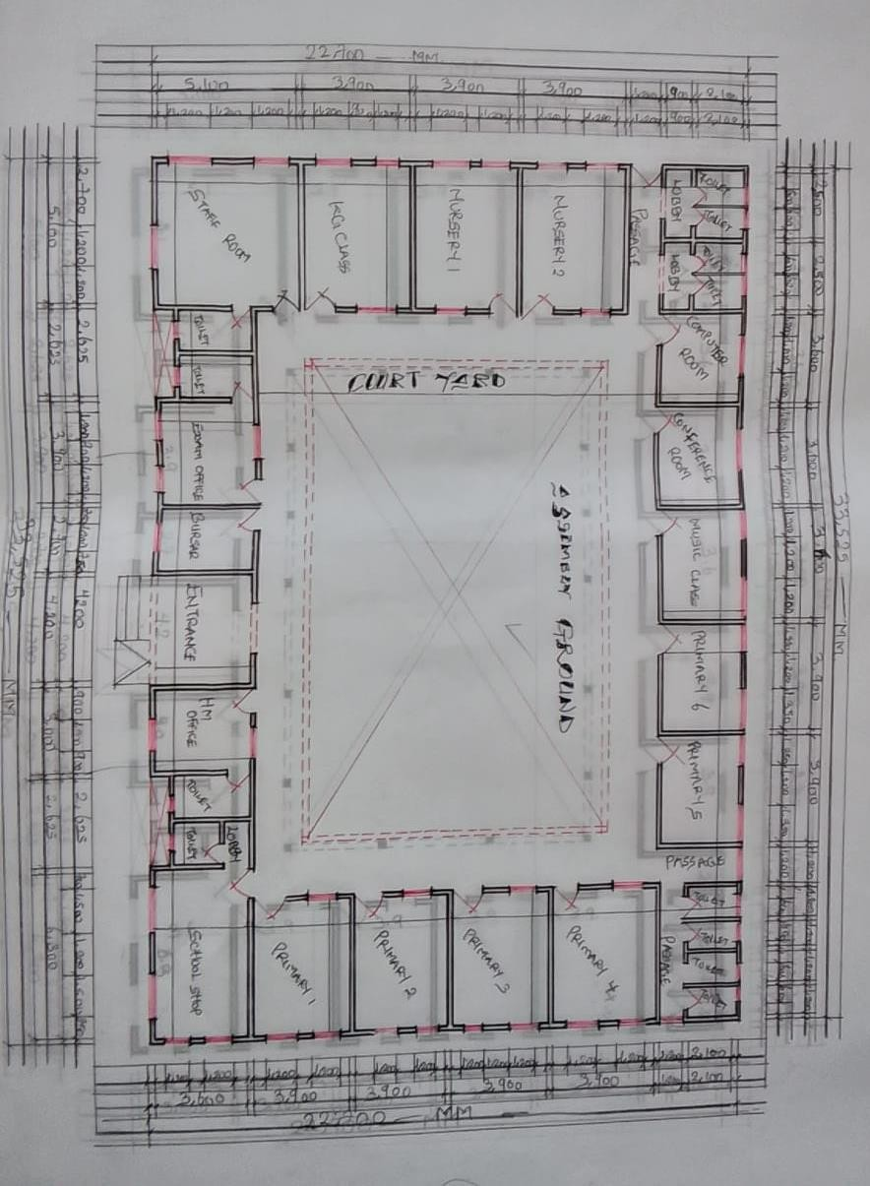
FLOOR PLAN

APPENDIXES 2
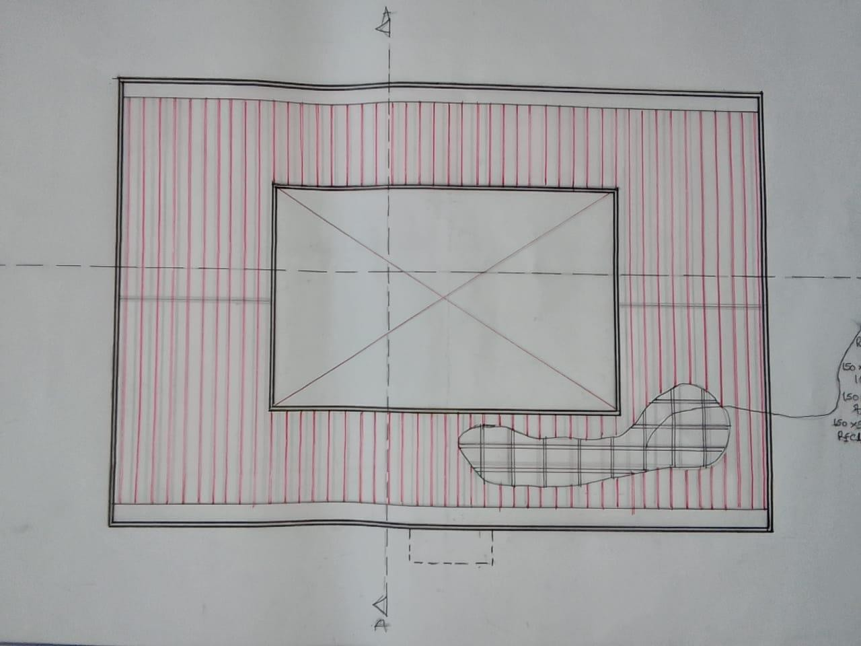
ROOF PLAN
APPENDIXES 3
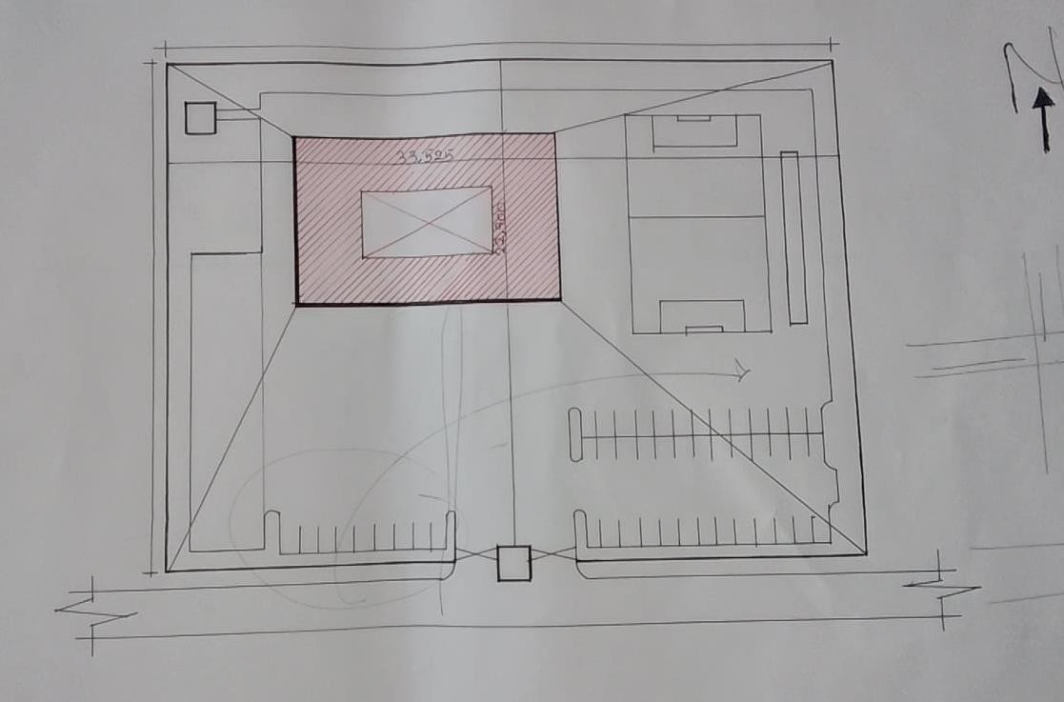
SITE PLAN
APPENDIXES 4
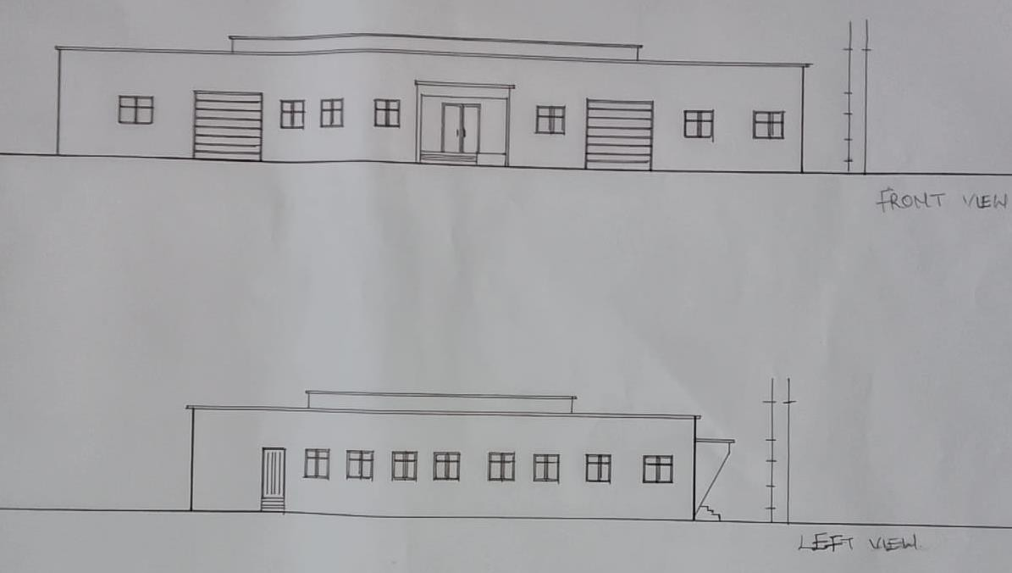
ELEVATIONS
APPENDIXES 5
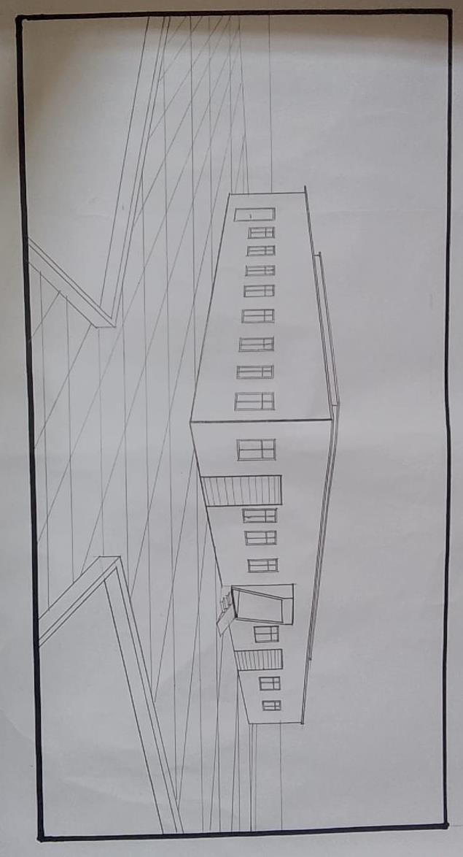
EXTERNAL PRESPECTIVE
APPENDIXES 6
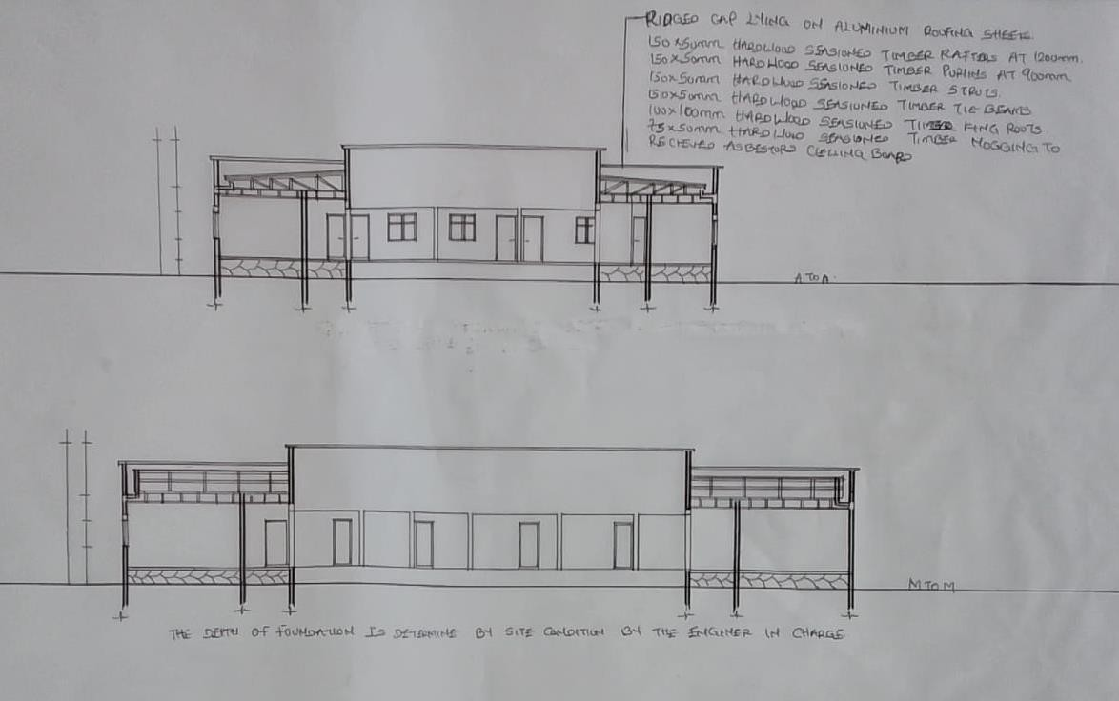
SECTIONS

