STUDY OF THE STRUCTURE OF THE OVERBURDEN LAYER AT A DUMPSITE

BY:

OHUNMAKIN IQMAT IFEOLUWA
ND/23/SLT/PT/0085

BEING A PROJECT REPORT SUBMITTED TO THE DEPARTMENT OF SCIENCE LABORATORY TECHNOLOGY (PHYSICS/ELECTRONIC UNIT), INSTITUTE OF APPLIED SCIENCES, KWARA STATE POLYTECHNIC ILORIN

IN PARTIAL FULFILMENT OF THE REQUIREMENTS FOR THE AWARD OF NATIONAL DIPLOMA (ND) IN SCIENCE LABORATORY TECHNOLOGY (SLT), KWARA STATE POLYTECHNC, ILORIN, KWARA STATE

SUPERVISED BY:
DR. J.A. SUNDAY
JUNE, 2025
CERTIFICATION
This is to certify that this project was carried out by above name and matriculation numbers, submitted to the Department of Science Laboratory Technology, Physics/Electronics unit, Institute of Applied Science (IAS), Kwara State Polytechnic, Ilorin, in partial fulfilment for the requirement of the award of National Diploma (ND) in Science Laboratory Technology (SLT).

___________________ _______________
Dr. J.A. Sunday Date
Project Supervisor

___________________ _______________
Mr. Lukman I. A. Date
SLT PT Coordinator

___________________ _______________
Dr. Abdulkareem Usman Date
Head of Department

___________________ _______________
External Examiner Date

DEDICATION
This project is dedicated to Almighty God, the provider and sustainer of life, Whose grace has made this journey of my National Diploma (ND) possible, and also to my parents, my pillar of support. May God continue to bless and protect you.

ACKNOWLEDGEMENT
I am indeed thankful and grateful to Almighty God for giving me the opportunity, courage, energy, grace, and assistance needed to successfully achieve one of my desired academic heights in life.
With humility and appreciation, my foremost acknowledgement goes to my amiable supervisor, DR, AJ SUNDAY, who despite his busy schedule, found time to guide and mentor me in my quest to achieve excellence. Hence, he has played a pivotal role in bringing this study to completion. I pray that God in His boundless mercy, fulfil all his heart desires.
I extend my heartfelt gratitude to all my lecturers in the Department of SLT, Kwara State Polytechnic, Ilorin, may God bless you all abundantly.
I would like to express my sincere appreciation to my parents, for their constant support and prayers, I pray you live long to eat the fruits of your labour (Amen).
My appreciation also goes to my siblings, whose love, support, and encouragement have been a constant source of inspiration, may God perfect all that concerns you. And to all people around me, God bless you all.
Lastly, I extend my heartfelt thanks and blessings to my fellow students for their camaraderie and support, I am deeply grateful. May God bless us abundantly on our individual journeys

TABLE OF CONTENTS
TITLE PAGE
CERTIFICATION
DEDICATION
ACKNOWLEDGMENT
TABLE OF CONTENT
CHAPTER ONE:
1.1 INTRODUCTION
1.2 AIM AND OBJECTIVES OF THE STUDY
1.3 LOCATION OF THE STUDY AREA
CHAPTER TWO
2.1 MAGNETIC SURVEYING
2.1.1 GROUND AND AIRBORNE SURVEYS
2.1.2 BOREHOLE MAGNETIC SURVEYS
2.1.3 MARINE MAGNETIC SURVEYS
2.2 MAGNETIC SURVEY INSTRUMENT
2.2.1 HISTORICAL DEVELOPMENT OF MAGNETIC INSTRUMENT
2.2.2 FLUXGATE MAGNETOMETER
2.2.3 PROTON PRECESSION MAGNETOMETER
2.2.4 ALKALI VAPOR MAGNETOMETERS
2.3 ROCK MAGNETIC PROPERTIES
2.4 MAGNETIC DATA PROCESSING
2.4.1 GLOBAL FIELD MODELS
2.4.2 EXTERNAL (TIME-VARYING) FIELD REMOVAL
2.4.3 DECULTURING
2.5 MAGNETIC DATA FILTERING
2.6 DEPTHS-TO-SOURCE ESTIMATION TECHNIQUES
2.6.1 EULER DECONVOLUTION
CHAPTER THREE: METHDOLOGY, DATA ACQUISITION AND ANALYSIS
3.1 DATA ACQUISITION
3.2 DATA PROCESSING
3.2.1 ANALYTICAL SIGNAL MAP
3.2.2 DEPTH TO MAGNETIC SOURCES
CHAPTER FOUR: RESULTS AND DISCUSSION
4.1 MAGNETIC DATA RESULTS
4.2 DISCUSSION
CHAPTER FIVE: CONCLUSION
5.1 CONCLUSION
REFERENCES

CHAPTER ONE
INTRODUCTION
  - Preamble
From the point of view of geomagnetism, the earth may be considered as made up of three parts: core, mantle and crust (Figure 1.1). Convection processes in the liquid part of the iron core give rise to a dipolar geomagnetic field that resembles that of a large bar-magnet aligned approximately along the earth's axis of rotation (Figure 1.2). The mantle plays little part in the earth's magnetism, while interaction of the (past and present) geomagnetic field with the rocks of the Earth's crust produces the magnetic anomalies recorded in detailed (e.g. aeromagnetic) surveys carried out close to the earth's surface (Reeves, 2005).

Figure 1.1: The main divisions of the Earth’s volume (after Reeves, 2005)
1.2 Brief History of Geophysics
The word “Geophysics”, as far as is known, was first used in 1834 by Julius Frobel. He discussed geophysics in letters to his former teacher, Christian Friedrich Schonbein, Carl Friedrich Naumann used the term in 1849 in a new context in his Lehrbuch der Geognosie, portraying geophysics as one of three parts of the “geognosy of the whole Earth”, along with geodesy and Abyssologie the science of the deep Earth. He also discussed a geognosy of the peripheral parts of the Earth; geology of the crust, hydrograph, and atmospharologie. Naumann used geophysics with a more restricted meaning.
The problem of foundation of geophysics as an independent scientific discipline has been discussed by (Schroder, Wilfried 1982). General research into the history of geophysics has done by the “commission for history of geophysics and cosmical physics” (Bremen) under the direction of Wilfried Schroder, which publish the journal Berichte der Geschichte der Geophysics and Kosmische Physik.
The historical development of geophysics has been motivated by two factors. One of these is the research curiosity of humankind related to planet, Earth and its several component, its events and its problems. The second one is economical usage of Earth resources (or eleposits, petroleum, water resources, etc.) and Earth – related hazards such as earthquakes, volcanoes, tsunamis, tides and floods.
1.3 AIM AND OBJECTIVES
The aim of this project to study the structure of the overburden layer of the study area and to identify any region within the area that could be targeted for underground water prospect. The objectives include:
- To carry out revenant geophysical survey (VES) on the study area
- To analyze the acquired data
- To merge the results with the local geology of the study area in order to identify suitable location for groundwater exploration.
1.4 THE STUDY AREA
    - LOCATION OF THE STUDY AREA
The study area is located around CBS, University of Ilorin (main campus) which lies entirely within the basement rocks in the western part of central Nigeria bounded by longitude 4⁰39’ 51.6” – 4⁰40’ 02.50” E and Latitudes 8⁰27’ 54.2” - 8⁰28’ 4.7” N (fig 1). It falls within the Eastern part of Ilorin. The project areas are generally accessible by major road and several footpaths, although the road from Kwara poly to the project area is tarred.
    - CLIMATE AND WEATHER OF THE STUDY AREA
The western part of the university is made up of gneiss rocks with strike foliation in NW-SE direction and dipping 10⁰ - 45⁰ westerly. In the eastern part, granite rock suites emplaced in the NE – SW direction dip 70⁰ - 90⁰ easterly. The area appears to have been isoclinically folded into a south plunging anti-form with a steep eastern limb several joints trending 120⁰ - 160⁰ dominated the rocks in the area as presented by (Olasehinde, 1984). The study area lies within the crystalline basement complex of Nigeria consisting of high-grade metamorphic rocks in the form of gneiss migmatites and granite suites found occasionally.
    - VEGETATION OF THE STUDY AREA
The study zone is a semi-arid region of Nigeria with vegetation mainly of the guinea savannah type with shrubs and undergrowth. Rugged troughs and crests due to erosions characterize the topography of the area. The main river within the campus is river Oyun which flows from southeast-northwest direction. Ilorin township is underlain by the Precambrian to Cambrian basement complex rocks represented basically by migmatite-gneisses, granitic gneisses and met sediments such as quartzite’s.
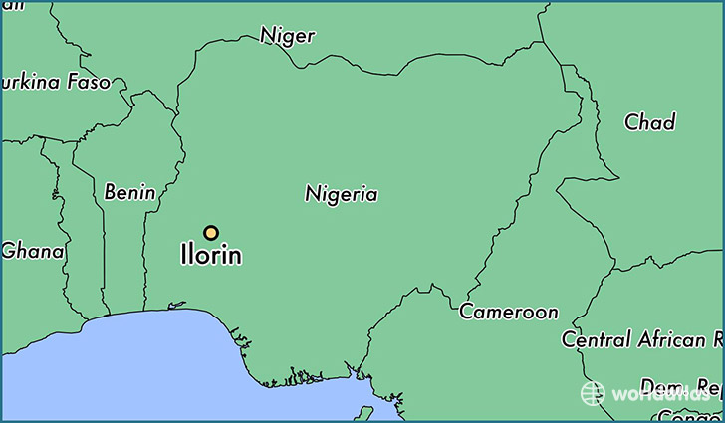

CHAPTER TWO
LITERATURE REVIEW
2.0 REVIEW OF PAST GEOPHYSICAL RESEARCHES
Studies have shown that groundwater could be explored using electrical methods (Olorunfemi and Fasoyi, 1993; Olasehinde, 1999; Alile et al., 2008). Previous works had been done within the University of Ilorin while utilizing electrical resistivity technique. Fracture pattern was elucidated using radial electrical resistivity sounding and profiling by Olasehinde et al. (1986) and at the same time they evaluated a prospective site for a weir on River Oyun using electrical methods. Nwankwo et al. (2004) determined the structural disposition of the area using electrical resistivity pseudosection method while a combination of ground magnetic and electrical resistivity studies were used by Olasehinde (1999) to evaluate the groundwater potential of the Southern portion of the university with great success.
Where it is difficult to locate aquifers such as water-saturated zones in hard rock, it is also difficult to select suitable sites for water drilling. The 2D resistivity technique has improved the chance of drilling successes by identifying the fractured and weather zones in these areas (Singh et al., 2006). Therefore, the use of such technique for groundwater exploration has earned an important place in recent years despite some interpretive limitations (Dogara et al., 1998; Singh et al., 2006). It is therefore expected that the results obtained from this work would produce detailed groundwater condition.
Several other geophysical investigations have been carried out on University of Ilorin (main campus) and across other regions in Ilorin. Geophysical investigations within the University campus include the work of Akande (1984) that produces a residential magnetic anomaly map of the campus. This established magnetic trend of the campus. Similar magnetic survey was carried out by Adebayo (1985) but the structural trend of the area surrounding the dam site. However, detailed geophysical investigations were not carried out.
Olasehinde (1984) was also able to infer the structural trend on the campus using results from radial vertical electrical surroundings. The results revealed the trend of the joints, fractures and faults as Northwest-Southwest. This was in close agreement with the topographic lineaments in the campus.
Toyin (2011) also carried out geophysical investigations within the University of Ilorin. Olasehinde et al, (2012) employed Vertical Electrical Sounding (VES) Method to determine the groundwater potential of Orisunmibare Village in the neighborhood of federal government college, Ilorin. This is to determine the feasibility of a portable water borehole in the area.
2.1 OVERVIEW OF GEOPHYSICAL METHODS
Various geophysical survey methods have been and are being used on land and offshore. Each of these methods measures something that is related to subsurface rocks and their geologic configurations. Rocks and minerals in the earth vary in several ways. According to (Gadallah , et al., 2009), these include:
• Density– mass per unit volume. The gravity method detects lateral variations in density. Both lateral and vertical density variations are important in the gravity method.
• Magnetic susceptibility– the amount of magnetization in a substance exposed to a magnetic field. The magnetic method detects horizontal variations in susceptibility.
• Propagation velocity– the rate at which sound or seismic waves are transmitted in the earth. It is these variations, horizontal and vertical, that make the seismic method applicable to petroleum exploration.
• Resistivity and Induced Polarization– Resistivity is a measure of the ability to conduct electricity and induced polarization is frequency-dependent variation in resistivity. Electrical methods detect variations of these over a surface area
• Self-Potential- ability to generate an electrical voltage. Electrical methods also measure this over a surface area.
• Electromagnetic wave reflectivity and transmissivity: reflection and transmission of electromagnetic radiation, such as radar, radio waves and infrared radiation, is the basis of electromagnetic methods etc.
2.1.1 Gravity Method
In gravity surveying, subsurface geology is investigated on the basis of variations in the Earth’s gravitational field arising from differences of density between subsurface rocks. An underlying concept is the idea of a causative body, which is a rock unit of different density from its surroundings. A causative body represents a subsurface zone of anomalous mass and causes a localized perturbation in the gravitational field known as a gravity anomaly. On a small scale, buried relief on a bedrock surface, such as a buried valley, can give rise to measurable anomalies. On a larger scale, small negative anomalies are associated with salt domes. Modern instruments capable of rapid gravity measurements are known as gravity meters or gravimeters (Al-Chalabi , 1972).

2.1.2 Electrical Methods
There are many methods of electrical surveying. Some makes use of fields within the Earth while others require the introduction of artificially-generated currents into the ground. These methods include;
- Direct current resistivity
- Electromagnetic
- Mise-a-la-masse
- Induced polarization
- Self-potential
The resistivity method is used in the study of horizontal and vertical discontinuities in the electrical properties of the ground, and also in the detection of three-dimensional bodies of anomalous electrical conductivity. It is routinely used in engineering and hydro geological investigations to investigate the shallow subsurface geology (Aspinall, et al., 1975).
The Induced Polarization method makes use of the capacitive action of the subsurface to locate zones where conductive minerals are disseminated within their host rocks. When using a standard four-electrode resistivity spread in a DC mode, if the current is abruptly switched off, the voltage between the potential electrodes does not drop to zero immediately. After a large initial decrease the voltage suffers a gradual decay and can take many seconds to reach a zero value (Aspinall, et al., 1975).
The capacitive property of the ground causes both the transient decay of a residual voltage and the variation of apparent resistivity as a function of frequency. The two effects are representations of the same phenomenon in the time and frequency domains, and are linked by Fourier transformation.
The self-potential method makes use of natural currents flowing in the ground that are generated by electrochemical processes to locate shallow bodies of anomalous conductivity. The self-potential (or spontaneous polarization) method is based on the surface measurement of natural potential differences resulting from electrochemical reactions in the subsurface. Typical SP anomalies may have amplitude of several hundred millivolts with respect to barren ground. They invariably exhibit a central negative anomaly and are stable over long periods of time. They are usually associated with deposits of metallic sulphides, magnetite or graphite (Corry, 1985).
Electromagnetic (EM) surveying methods make use of the response of the ground to the propagation of electromagnetic fields, which are composed of an alternating electric intensity and magnetizing force. Primary electromagnetic fields may be generated by passing alternating current through a small coil made up of many turns of wire or through a large loop of wire. The response of the ground is the generation of secondary electromagnetic fields and the resultant fields may be detected by the alternating currents that they induce to flow in a receiver coil by the process of electromagnetic induction (Raab, et al., 1984).
2.1.3 Radiometric Method
Radiometric surveying is employed in the search for deposits necessary for this application, and also for non-radioactive deposits associated with radioactive elements such as titanium and zirconium. Radiometric surveys are of use in geological mapping as different rock types can be recognized from their distinctive radioactive signature. The elements of principal interest in radiometric exploration are uranium (238U), thorium (232Th) and potassium (40K). Probably the most common application of radiometric techniques is in geophysical borehole logging(Gadallah M. et al., 2009).
2.1.4 Seismic Method
Reflection seismology (or seismic reflection) is a method of exploration geophysics that uses the principles of seismology to estimate the properties of the Earth's subsurface from reflectedseismic waves.
At its most basic, the seismic reflection technique consists of generating seismic waves and measuring the time taken for the waves to travel from the source, reflect off an interface and be detected by an array of receivers (or geophones) at the surface. By Knowing the travel time from the source to various receivers, and the velocity of the seismic waves, a geophysicist then attempts to reconstruct the pathways of the waves in order to build up an image of the subsurface (Sheriff et al., 1995).
2.1.5 Magnetic Method
The aim of a magnetic survey is to investigate subsurface geology on the basis of anomalies in the Earth’s magnetic field resulting from the magnetic properties of the underlying rocks. Although most rock-forming minerals are effectively non-magnetic, certain rock types contain sufficient magnetic minerals to produce significant magnetic anomalies (Horsfall, 1997).
2.2 AQUIFER
An aquifer is a body of saturated rock through which water can easily move or an aquifer is an underground layer of water-bearing rock. Water-bearing rocks are permeable, meaning that they have openings that liquids and gases can pass through. Sedimentary rock such as sandstone, as well as sand and gravel, are examples of water-bearing rock. The top of the water level in an aquifer is called the water table. An aquifer fills with water from rain or melted snow that drains into the ground. In some areas, the water passes through the soil on top of the aquifer; in others, it enters through joints and cracks in rocks. The water moves downward until it meets less permeable rock. Aquifers act as reservoirs for groundwater. Water from aquifers sometimes flows out in springs. Wells drilled into aquifers provide water for drinking, agriculture, and industrial uses.
Figure 1: Diagram of an aquifer
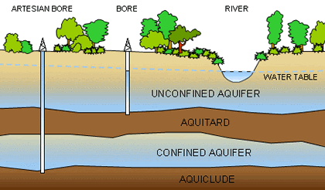
Aquifers can dry up when people drain them faster than nature can refill them, because aquifers are filled with water that drains from the surface of the earth. An aquifer can be contaminated by many things we do at and near the surface of the earth. Contaminants reach the water table by any natural or manmade pathway along which water can flow from the surface to the aquifer.
Deliberate disposal of waste at point sources such as landfills, septic tanks, injection wells and storm drain wells can have an impact on the quality of ground water in an aquifer. In general, any activity which creates a pathway that speeds the rate at which water can move from the surface to the water table has an impact.
The study of water flow in aquifers and the characterization of aquifers are called Hydrogeology.
2.1.1 FORMATION OF AQUIFER
Figure 2: How aquifer is formed
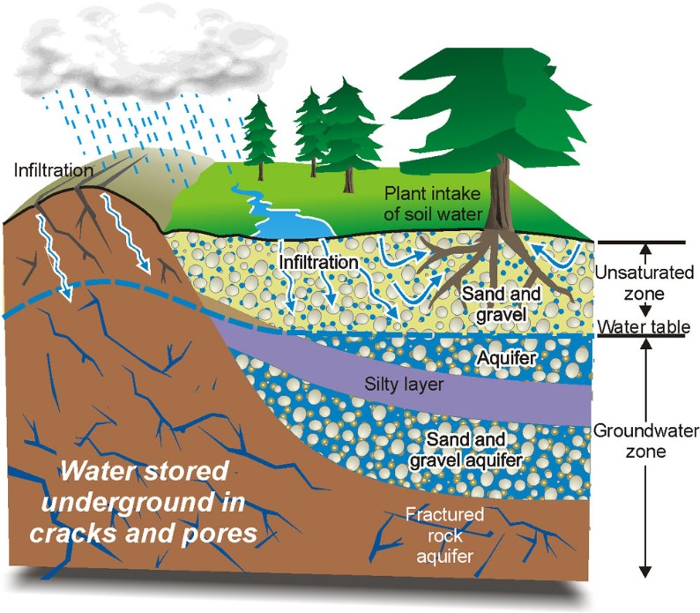
Aquifers are form as result of long term geologic and tectonic activities resulting in fault and other geologic structures which can hold fluid. Water then infiltrates into the soil through pores, cracks, and other spaces until reaches the zone of saturation where all of the faults formed are filled with water. The zone of saturation occurs because water infiltrating the soil reaches an impermeable layer of rocks so that it is not able to penetrate any further into the earth (this impermeable layer is known as an "aquitard").
2.2.2 WATER MOVEMENT IN AQUIFERS
Water movement in aquifers is highly dependent of the permeability of the aquifer material. Permeable material contains interconnected cracks or spaces that are both numerous enough and large enough to allow water to move freely. In some permeable materials groundwater may move several meters in a day; in other places, it moves only a few centimeters in a century. Groundwater moves very slowly through relatively impermeable materials such as clay and shale. (Source: Environment Canada).
Two main forces drive the movement of groundwater. First, water moves from higher elevations to lower elevations due to the effect of gravity. Second, water moves from area of higher pressure to area of lower pressure. Together these two forces make up the driving force behind moving groundwater which is known as the hydraulic head.
After entering an aquifer, water moves slowly toward lower lying places and eventually is discharged from the aquifer from springs, seeps into streams, or is withdrawn from the ground by wells. Groundwater in aquifers between layers of poorly permeable rock, such as clay or shale, may be confined under pressure. If such a confined aquifer is tapped by a well, water will rise above the top of the aquifer and may even flow from the well onto the land surface. Water confined in this way is said to be under artesian pressure, and the aquifer is called an artesian aquifer.
2.2.3 CONFINED AND UNCONFINED AQUIFERS
All aquifers have an impermeable layer beneath them that stops the groundwater from infiltrating further. If an aquifer has an impermeable layer below it but the layers above it are permeable, then it is considered to be an unconfined aquifer. In other case, a permeable layer can be trapped between two impermeable layers producing a confined aquifer.
2.2.4 RECHARGE AND DISCHARGE OF AQUIFERS
Water from the surface - rain or melting snow moves slowly down through the ground to the aquifers. This is called recharge. Recharge is the primary method through which water enters an aquifer. This process usually occurs in the vadose zone below plant roots and is often expressed as a flux to the water table surface. Recharge occurs both naturally (through the water cycle) and through anthropogenic processes (i.e., "artificial groundwater recharge"), where rainwater and or reclaimed water is routed to the subsurface. Water will move more easily and quickly through loose soils, sand and gravel so these areas have high recharge rates. Areas where there is a lot of fractured bedrock close to the surface also have high recharges rates.
Moraines, such as the Waterloo and Galt-Paris moraines have high recharge rates, which is one reason why they are also rich sources of water.
Water moves easily through the sandy soil down to the aquifers.
Changes to the land in recharge areas can affect both the quality and the amount of water that moves from the surface into the ground. Paving over these areas, or installing tile drainage, can result in loss of top soil resulting into reduction in the amount of water that soaks into the ground. Use of groundwater, especially for irrigation, may also lower the water tables.
Groundwater recharge is an important process for sustainable groundwater management, since the volume-rate abstracted from an aquifer in the long term should be less than or equal to the volume-rate that is recharged.
2.3. Geophysical methods for determining aquifer characteristics and Geoelectric parameters in groundwater studies.
The purpose of every geophysical research is the delineation and study of the properties of the subsurface layer, or/and the delineation and study of subsurface anomalies arising from buried objects etc., or constitute natural anomalies due to for examples faults, underground water etc.
Depending on the final objective of each research, the mode of execution, method and instrumentation of geophysical research is selected, with the purpose of achieving the most accurate, fastest and cheapest possible extraction of results conclusions. In the geophysics section bearing in mind the available equipment, the following methodologies can be applied.
- Ground Penetrating Radar Method (GPR)
- Geoeletrical Tomography Method (GT)
- Very Low Frequency Method (VLF)
- Self-Potential Method (SP)
- Induced Polarization Method (IP)
- Well Logging
- Seismic Method
- Electromagnetic Induction Method (EM)
- Magnetic Method
- Gravity Method
- Electrical Resistivity imaging
This methods can be used interchangeably, but each of them is suited for a specific purpose/goal. The method specifically used for this research is electrical resistivity method due to its wide applicability in mineral resources exploration, mitigation of natural hazards and environmental protection, delineation of subsurface layers to predict subsequent earth evolution, engineering services and environmental remediation and underground water detection;
The importance of geophysical surveys is that unlike in the arbitrary drilling of boreholes or wells without prior geophysical surveys which might lead to abortive boreholes or wells subsequently creating artificial faults or cracks which during the period of isostasy when the earth is compensating for its overall faults and cracks might lead to environmental hazards and also a waste of finance. Prior geophysical surveys provide important information which tells us whether or not to drill for groundwater in a particular location.
The main fields of application of geophysical surveying, together with an indication of the most appropriate surveying methods for each application, are listed in Table 1.1.
Table 1.1 Geophysical surveying applications (Source: Keary et al., 2002).
Application | Appropriate survey methods*
Exploration for fossil fuels (oil, gas, coal) | S, G, M, (EM)
Exploration for metalliferous mineral deposits | M, EM, E, SP, IP, R
Exploration for bulk mineral deposits (sand and gravel) | S, (E), (G)
Exploration for underground water supplies | E, S, (G), (Rd)
Engineering/construction site investigation | E, S, Rd. (G), (M)
Archaeological investigations | Rd, E, EM, M, (S)
* G, gravity; M, magnetic; S, seismic; E, electrical resistivity; SP, self-potential; IP, induced polarization; EM, electromagnetic; R, radiometric; Rd, ground-penetrating radar. Subsidiary methods in brackets,
Generally, natural field method can provide information on earth properties to significantly greater depths and are logistically simpler to carryout than artificial source methods. However, are capable of producing a more detailed and better resolved picture of the subsurface geology. Several geophysical surveying methods can be used at sea or in the air. The higher capital and operating costs associated with marine or airborne work are offset by the increase speed of operation and the benefit of being able to survey area where ground access is difficult or impossible.
A wide range of geophysical surveying method exists, for each of which there is an “operative” physical property to which the method is sensitive. The methods are listed in Table1.2.

Method | Measure parameter | Operative physical property
Seismic | Trane times of reflected/refracted seismic waves | Density and elastic moduli, which determine the propagation velocity of seismic waves
Gravity | Spatial variations in the strength of the gravitational field of the earth | Density
Magnetic | Spatial variation in the strength of the geomagnetic field | Magnetics susceptibility and resonance
Electrical resistivity | Earth resistance | Electrical conductivity electrical capacitance
Induced polarization | Polarization voltages  Or frequency  Dependent ground resistance | Electrical conductivity Electrical capacitance
Self potential | Electrical potentials | Electrical conductivity
Electron magnetic | Response to  Electromagnetic radiation | Electrical conductivity  and inductance
Radar | Travel times of reflected radar pulses | Dielectric constant

The type of physical property to which a method responds clearly determines its range of applications. Thus for example, the magnetic method is very suitable for locating buried magnetic ore bodies because of their high magnetic susceptibility. Similarly, seismic or electrical method are suitable for the location of a buried water table because saturated rock may be distinguished from dry rock by its higher seismic velocity and higher electrical conductivity.
Other considerations also determine the type of methods employed in a geophysical exploration program. For example, reconnaissance surveys are often carried out from the air because of the high speed of operation. In such cases the electrical or seismic methods are not applicable, since these require physical contact with the ground for the direct input of energy.

CHAPTER THREE
METHODOLOGY
3.0 BACKGROUND
The theory and field methods used for resistivity surveys are based on the use of direct current, because it allows greater depth of investigation than alternating current and because it avoids the complexities caused by effects of ground inductance and capacitance and resulting frequency dependence of resistivity. Resistivity surveys are made to satisfy the needs of two distinctly different kinds of interpretation problems: (1) the variation of resistivity with depth, reflecting more or less horizontal stratification of earth materials; and (2) lateral variations in resistivity that may indicate soil lenses, isolated ore bodies, faults, or cavities. For the first kind of problem, measurements of apparent resistivity are made at a single location (or around a single center point) with systematically varying electrode spacing. This procedure is sometimes called vertical electrical sounding (VES), or vertical profiling. Surveys of lateral variations may be made at spot or grid locations or along definite lines of traverse, a procedure sometimes called horizontal profiling.
Data from resistivity surveys are customarily presented and interpreted in the form of values of apparent resistivity ρ_{a}. Apparent resistivity is defined as the resistivity of an electrically homogeneous and isotropic half-space that would yield the measured relationship between the applied current and the potential difference for a particular arrangement and spacing of electrodes. An equation giving the apparent resistivity in terms of applied current, distribution of potential, and arrangement of electrodes can be arrived at through an examination of the potential distribution due to a single current electrode. The effect of an electrode pair (or any other combination) can be found by superposition. Consider a single point electrode, located on the boundary of a semi-infinite, electrically homogeneous medium, which represents a fictitious homogeneous earth. If the electrode carries a current I, measured in amperes (a), the potential at any point in the medium or on the boundary is given by:
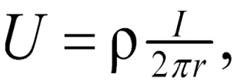 (1)
where U = potential, in V,
ρ = resistivity of the medium,
r = distance from the electrode.
The mathematical demonstration for the derivation of the equation may be found in textbooks on geophysics, such as Keller and Frischknecht (1966).
For an electrode pair with current I at electrode A, and -I at electrode B (figure 1), the potential at a point is given by the algebraic sum of the individual contributions:
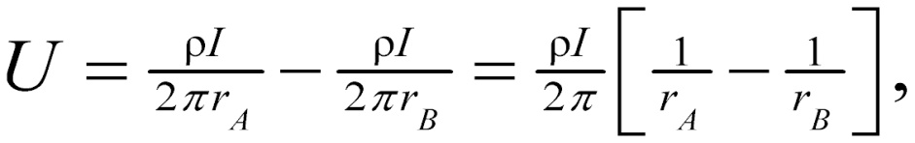 (2)
where r_{A} and r_{B} = distances from the point to electrodes A and B
Figure 1 illustrates the electric field around the two electrodes in terms of equipotentials and current lines. The equipotentials represent imagery shells, or bowls, surrounding the current electrodes, and on any one of which the electrical potential is everywhere equal. The current lines represent a sampling of the infinitely many paths followed by the current, paths that are defined by the condition that they must be everywhere normal to the equipotential surfaces.
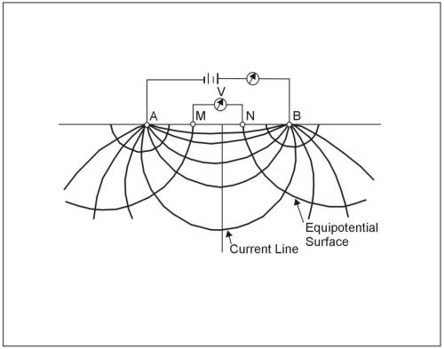
Figure 1. Equipotentials and current lines for a pair of current electrodes A and B on a homogeneous half-space.
In addition to current electrodes A and B, figure 1 shows a pair of electrodes M and N, which carry no current, but between which the potential difference V may be measured. Following the previous equation, the potential difference V may be written
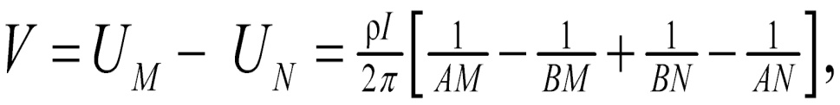 (3)
where U_{M} and U_{N} = potentials at M and N,
AM = distance between electrodes A and M, etc.
These distances are always the actual distances between the respective electrodes, whether or not they lie on a line. The quantity inside the brackets is a function only of the various electrode spacings. The quantity is denoted 1/K, which allows rewriting the equation as:
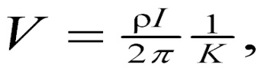 (4)
where K = array geometric factor.
This Equation can be solved for ρ to obtain:
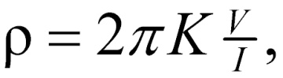 (5)
The resistivity of the medium can be found from measured values of V, I, and K, the geometric factor. K is a function only of the geometry of the electrode arrangement.
3.1 MATERIALS AND METHODS
The location of each sounding station was recorded in Universal Traverse Mercator (UTM) coordinates with the aid of a GERMIN 12 channel personal navigator (GPS) unit. Schlumberger vertical electrical soundings (VES) measurements were conducted with maximum electrode spacing (AB/2) of 100 m. The method employed for this project is the vertical electrical sounding, which was used in other to determine the apparent resistivity changes with depth at various locations. This gives the prediction to where ground water depth in various locations, of the VES points (1- 7) which were located 5meters away from the Dam along the bank and flank. The survey was carried out during the rainy season to allow good contact resistance of the electrodes in the ground for high conductivity of the subsurface. A total of 2 profile lines were occupied covering a maximum spread of 350 m at each location. The ABEM SAS 300C Terrameter was used to collect the VES data. Field resistivity structures of sounding data were determined by the software, IPIWIN (version 3.0.1) developed.
The field of data consisting of apparent resistivity (ρ_{a}) and the electrode spacing(AB/2) were partially curve matched and plotted against each other on a bi-logarithmic scale(log-log scale) with the apparent resistivity (ρ_{a}) on the ordinate and the electrode spacing (AB/2) on the abscissa using a computer known as IP2Iwin. The result of the partial curve matching gave the layer of the VES points the apparent resistivity (ρ_{a}) of each layers, the thickness (h) of each layer. These parameters were again iterated with IP2Iwin computer software with a minimised root mean square error to get the sounding curves, the true resistivity (ρ) of the layers, their real saturated aquifer thickness (h).
These sounding curves show the four and five layers with their respective true resistivity (ρ) and thickness (h) and the total depth of overburden on the aquifer.
3.2 VES Data interpretation
For the different number of layers of sounding curves obtained after curve matching and computer iteration(IPI2win),various types of curves were determined by the relationship existing between the layer resistivity values ρ1, ρ2, ρ3 ... ρn. It was discovered the different curves types which were shown in table 4.2. Samples of the curves are presented in Fig: 4.1 – 4.4
It can be deduced from the result of the interpretation that the test file has at least four major lithology layers with the top-most layer, the second layer being clay/sand, the third being weathered basement and the fourth and fifth being fractured basement the range of the value of thicknesses of each layer for the whole VES points are given as:
- Topsoil ranges from 0.5m-1.61m while the resistivity varies from 213 Ωm – 1352 Ωm.
- Second layer between 0.4m-1.8m while the resistivity varies from 25.2 Ωm - 1615 Ωm.
- Third layer between 0.4m – 6.35m while the resistivity varies from 69.3Ωm – 84324Ωm.
- Forth layer between 2.4m – 35.6m while resistivity varies from 15.5Ωm - 526512Ωm.
The high resistivity of the top most soil and some part weathered basement imply that the test site has been left untouched for a while and the top most soil are hard and caked thereby increasing its resistivity. The area and volume of the gravel deposit in the study area is determine from the high and low anomalous resistivity values obtained from the area if interest.
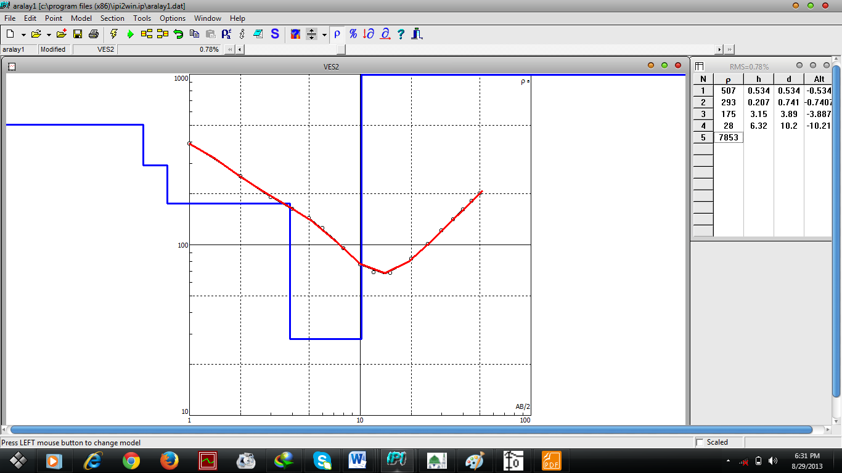
Fig. 4.1:Plot apparent resistivity(ohmm) against current electrode distance (AB/2)(m)) along ves 2.
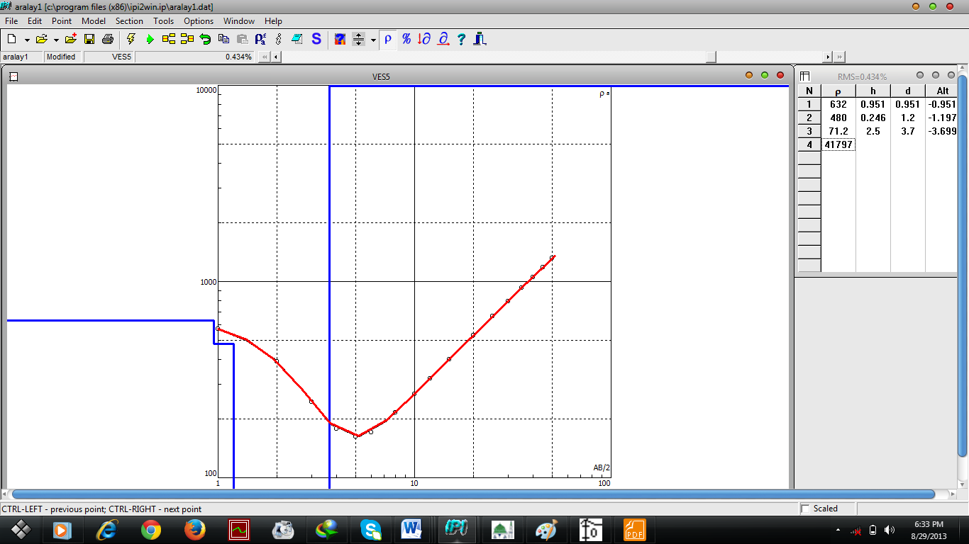
Fig. 4.2:Plot apparent resistivity(ohmm) against current electrode distance (AB/2)(m)) along ves 5.

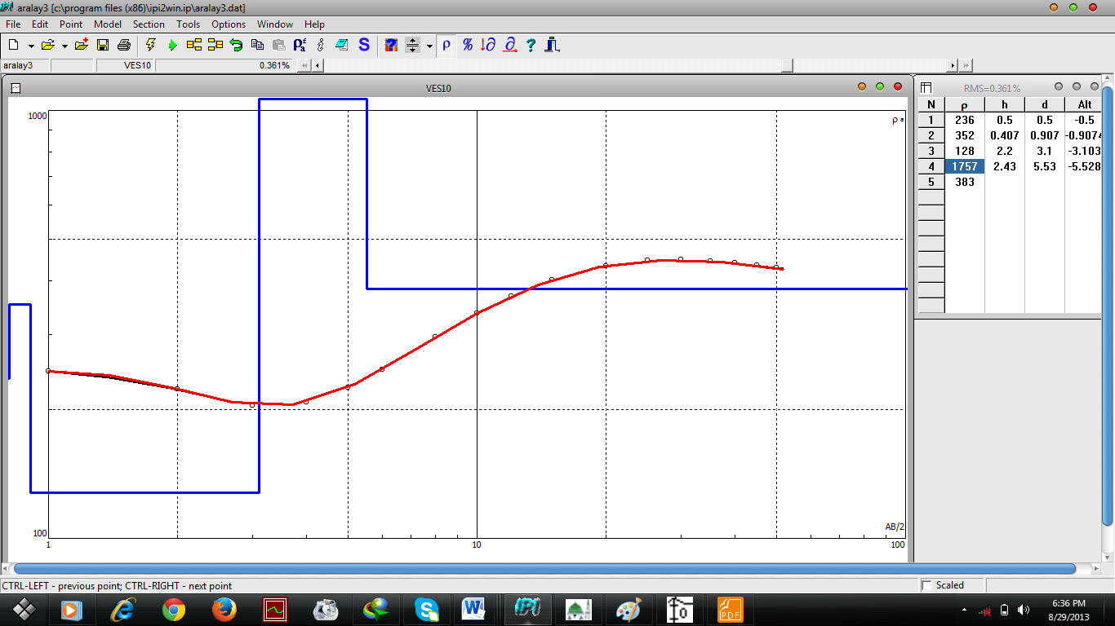
Fig. 4.3:Plot apparent resistivity(ohmm) against current electrode distance (AB/2)(m)) along ves 10.
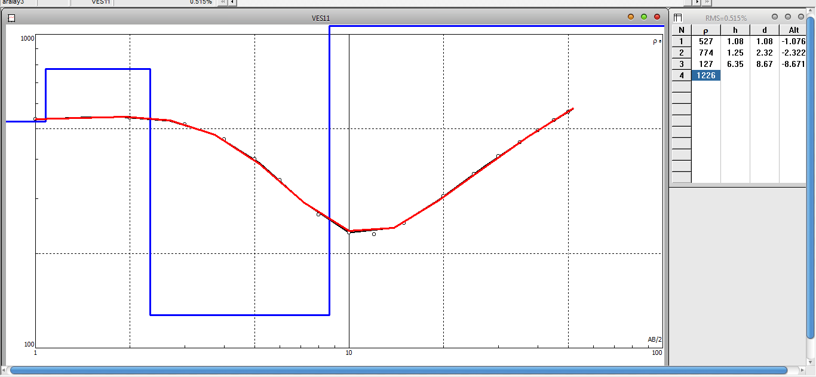
Fig. 4.4:Plot apparent resistivity(ohmm) against current electrode distance (AB/2)(m)) along ves 11.

After partial curving and computing, the geo-electrical parameter was generated, a table showing the lithologic delineation and protective thickness of the study area is given in Table 4.0
VES | LAYER | RESISTIVITY  (Ωm) | Thickness,  h(m)
VES 1 | 1  2  3  4  5 | 227  25.2  153  20.1  12376 | 1.51  1.31  2.98  6.1
VES2 | 1  2  3  4  5 | 464  92.6  268  21.9  7397 | 0.819  0.631  1.65  5.03
VES3 | 1  2  3  4 | 222  266  87.4  61583 | 1.37  0.929  2.82
VES4 | 1  2  3  4  5 | 861  419  69.3  170  14062 | 0.713  1.41  3.25  35.6
VES5 | 1  2  3  4 | 632  480  71.2  41792 | 0.906  1.67  2.82
VES6 | 1  2  3  4  5 | 349  91.2  1813  526512  18167 | 0.96  1.36  0.428  31.8
VES7 | 1  2  3  4 | 1110  1615  157  162800 | 0.5  0.65  2.35
VES8 | 1  2  3  4  5 | 1352  369  84324  1437  63134 | 0.651  0.825  2.93  8.19
VES9 | 1  2  3  4  5 | 213  54.5  380  15.5  4685 | 1.63  1.8  4.83  8.23
VES10 | 1  2  3  4  5 | 236  352  128  1757  383 | 0.5  0.407  2.2  2.42
VES11 | 1  2  3  4 | 527  774  124  1226 | 1.08  1.25  6.35

Table 4.0 Interpreted Results of the Lithologic Section

CHAPTER FOUR
DISCUSSIONS, RECOMMENDATION AND CONCLUSSION.
4.0 Pseudo-section and Resistivity Section of the Study Area
The pseudo-section and resisitivity Section of the spatial distribution of the layers of resulting map was drawn and generated by the computer Software called IPI2Win. This map is meant show the spatial variation of the resistivity of all the layers which compare with the surface. The section show apparent resistivity value variations and the characteristics at the different depths. The North Central part has the lowest values on the map with black color legend scale in Ves 1 , which suggests the area to be likely composed of sandy clay. The pseudo and resistivity section of the curve give spatial distribution of overburden zone of the study area, these were shown in fig 4.5, 4.6. The shale and the gravels could not be distinctly differentiated on the basis of resistivity values because they are characterized by low (black – blue color scale) and high (orange – red color scale) resistivity values respectively. The low resistivity value which is from black to blue color scale is the characteristic of the Northcentral part of the map and corresponds to the area occupied by the Gravels. The green color scale of intermediate resistivity values distributed throughout the Ves points in profile 1 and almost all subsurface layers of Ves11 with resistivity less than 1200 ohm-m.

Fig 4.5 Pseudo-Section and Resistivity Section for Profile 1 of Ara-Study Area

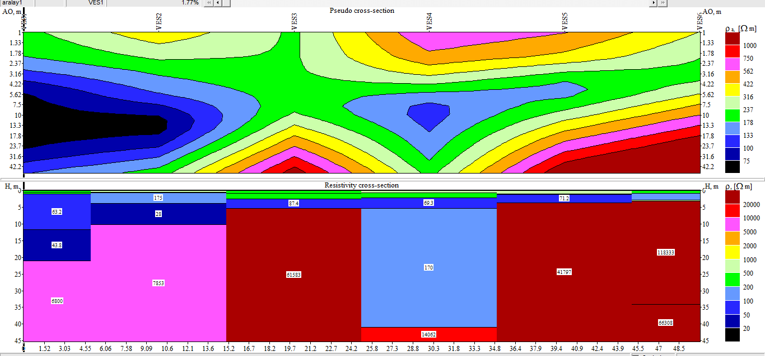
Fig 4.5 Pseudo-Section and Resistivity Section for Profile 1 of Ara-Study Area

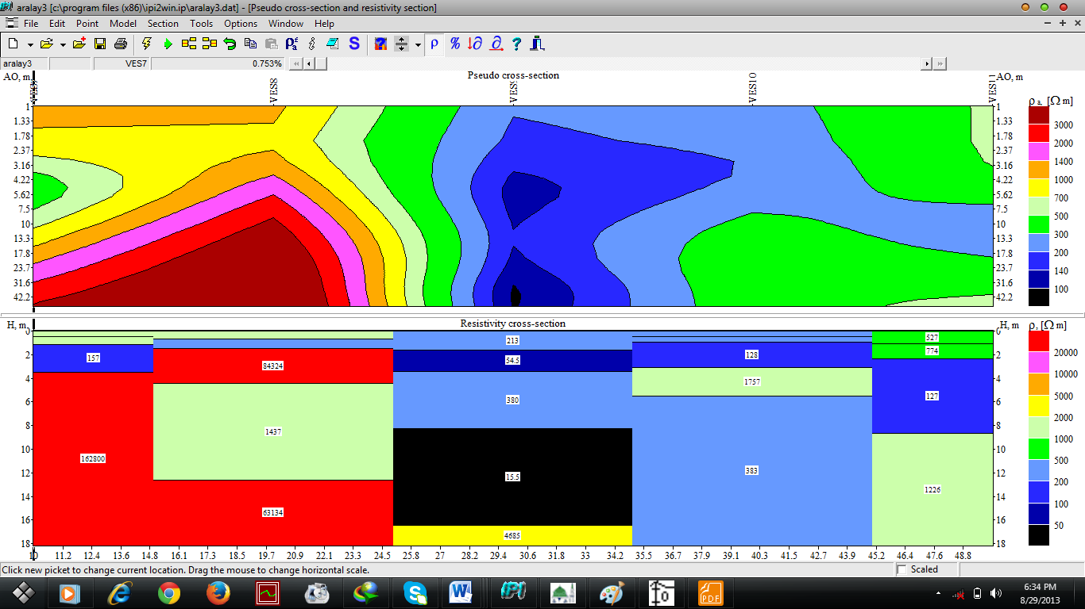
Fig 4.6 Pseudo-Section and Resistivity Section for Profile 2 of Ara-Study Area
4.1 Qualitative interpretation of the Study Area
Qualitative interpretation shows visual inspection and the spatial distribution of the analysed data. The software used was GOLDEN SUPER9 which gave the 3D topographic/surface maps of the study area in fig 4.7. There is high elevation in the North-Western part of the Study area.
Fig. 4.7: The Topography Map in 3D of Study Area.
4.2 Isopach Map of the Overburden Zone
The isopach map was produces using the thickness of the second layer at the each Ves points in Figure 4.8. The map was produced to determine how the thickness of the weathered layer varies from place to place within the study area. As can be seen from the map, the thickness of the weathered basement in the study area has maximum value of 6.35m around the western region. These was shown that the thickness varies from 2.69m to 8.25m. The thickest overburden is observed at the north-western and south-eastern parts while relatively thin overburden were observed at the south Central, South- western parts.
Fig.4.8: The Isopach Map of the Overburden in the Study Area.
4.3 Presenting the Results in the Form of Geological Column and Formation
The inferred results of the interpreted Ves Curves and Apparent Resistivity Pseudo-Section were used to draw geologic formation along the Ves Stations to show the 3D Vertical Electrical model and 2D Lithologic correlation Cross – section along the Study Area in Figures 4.9 – 4.10. The vertical distribution of the rock medium corresponds to the resistivity within the volume of the earth in the investigated areas. The geo-electric section show both vertical and lateral in the layer of Three - Four Sub-Surface Geo-unit were delineated beneath these Sections shown in figures 4.13 – 4.14.

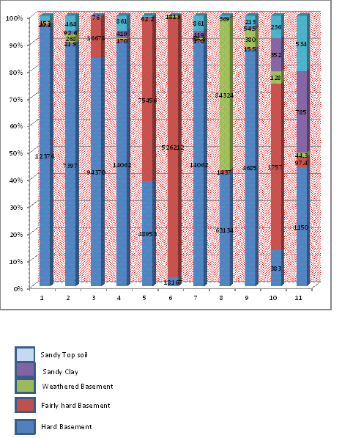
Fig 4.13 Showing 3D Vertical Electrical Resistivity Model

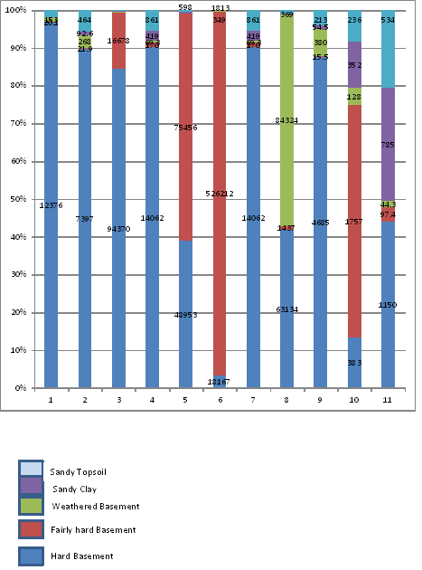Fig. 4.14: Ves Points Lithologic Correlation Cross Section Along Ara Village

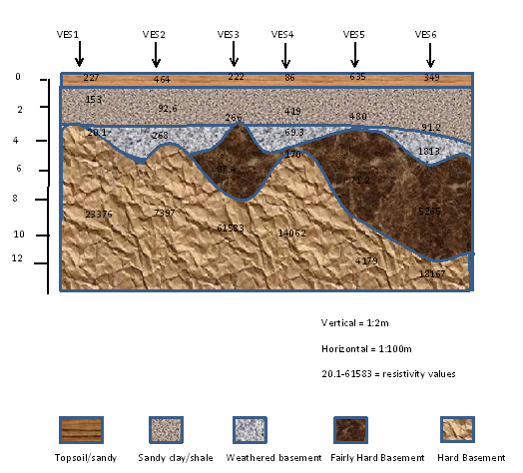

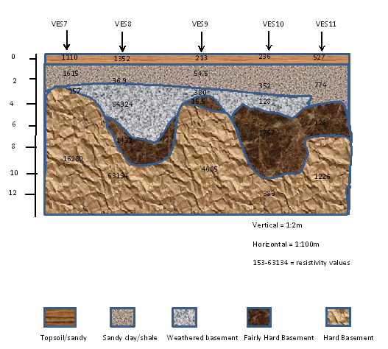
4.4 Estimation Of Size Of Deposit
The survey area data yield the following information from equations 4.1, 4.2 and 4.3: N = 11, $\sum{hi}$= 172.679
Area of the Study area = 120000 m²
= VES POINTS

A = 120000m²
T = 15.6981m
Estimated Volume therefore becomes
Volume (V) = A (Area) X T (Summation Thickness of the overburden)
V = 1883770.909m³
To determine the tonnage of the reserve, one needs to determine the mass in kilograms, if we assume the mean density of the wet gravel in sedimentary rocks to be 2.00 X 10³ kg/m³ (Telford et al., 1976) then the estimated mass of the deposit within the project area could be determine from the relation.
M(kg) = 1883770.909m³ X 2.00 X 10³ kg/m³ = 3767541818kg
The tonnage = 10⁸Tonnes
The present study suggests that gravel deposits occur below the 11 sounding points. Their thickness appear variable possibly as a result of the paleo-topography of the deposited basin: areas of thickness gravel deposits particularly at Ves3, Ves4, Ves5, Ves8, Ves6, Ves8, Ves10 appear to correspond to paleo-lows in topography whereas areas of thin deposition correspond to paleo-highs. The gravel thickness of 35.6m which was interpreted to be Ves4 appears anomalous.
Table 4.2: Layers Number, Overburden Thicknesses, Curve types and Gravel Thickness
LOCATION | NUMBER OF LAYERS | OVERBURDEN DEPTH (m) | CURVES TYPES | APPROX. GRAVEL THICKNESS (m)
VES 1 | 5 | 5.81 | KH | -
VES 2 | 5 | 3.1 | QH | -
VES 3 | 4 | 4.86 | KA | 6.98
VES 4 | 5 | 5.37 | QA | 35.6
VES 5 | 4 | 3.37 | QA | 8.47
VES 6 | 5 | 2.75 | HK | 31.8
VES 7 | 4 | 2.69 | KA | 9.15
VES 8 | 5 | 4.4 | HH | 8.19
VES 9 | 5 | 8.25 | HH | 8.23
VES 10 | 5 | 3.1 | KK | -
VES 11 | 4 | 3.61 | KA | -

4.5 CONCLUSION
From the data interpretation, Electrical resistivity surveys successfully employ to outline overburden of the study area. The overburden varies from 3.1m – 8.25m
The depth of overburden to the gravel deposit and the high resistive top soil and weathered basement indicate that the aquifer zone not free from surface. Gravel deposit varies from 6.98m – 35.6m with high variation of resistivities values underlies the low resistivity values of shale.
It is likely that a fault zone or fault plane was traversed during the profiling. The fault general is difficult to map within sedimentary formations because they are usually masked by thick overburden. The fault zone suggested by the profiling result requires confirmatory drilling because of its engineering and erosional implication.
4.6 RECOMMENDATIONS
It is highly recommended that other geophysical methods like the electromagnetic induction method (EM) and the very low frequency method (VLF) be used on that same site to verify the result of the experiment.

REFERENCES
Aweto K.E. International Journal of Physical Sciences, Vol.6 (33), Pp. 7574-7583, 2011.
Badmus B.S and Olatineu O.B. African Journal of Environmental Science Technology, Vol.4(6), Pp 328-342, 2010.
Egbai J.C. Journal of Emerging Trends in Engineering and Applie Science (JETEAS), Vol.2(6), Pp 226-230, 2011.
Olasunkanmi et al.,. Scholars Research Library, Archives of Physics Research, Vol.3 (3), Pp221-231, 2012.
Oyeneye, I. Oladapo, and S. Folami , Geoelectrical study of Dam Site of Federal College of Agriculture. South Western Nigeria, Journal of Medwell online,Vol., 2, No. 10, PP 1048 – 1056, 2007,

