KWARA STATE POLYTECHNIC, ILORIN
CONSTRUCTION OF 1KVA INVERTER
BY
SALAWU ABDULMAJID ADEYEMI
ND/23/EEE/PT/0071

A PROJECT SUBMITTED TO DEPARTMENT OF ELECTRICAL AND ELECTRONIC ENGINEERING
IN PARTIAL FULFILMENT OF THE REQUIREMENT FOR THE AWARD OF NATIONAL DIPLOMA (ND) IN ELECTRICAL AND ELECTRONIC ENGINEERING, INSTITUTE OF TECHNOLOGY, KWARA STATE POLYTECHNIC ILORIN, NIGERIA.

AUGUST, 2025

CERTIFICATION
The undersigned certified that this project report prepared by SALAWU ABDULMAJID ADEYEMI with the matric number ND/23/EEE/PT/0071 Titled: “Construction of 1KVA inverter” meets the requirement of Department of Electrical and Electronic Engineering for the award of National Diploma in Electrical and Electronic Engineering.

________________________ ________________
ENGR. DR. M.Z OBA Date
Project Supervisor

________________________ ________________
Engr. A.O LAWAL Date
Head of Department

________________________ ________________
Engr. K. LATEEF Date
Part time coordinator

________________________ ________________
External Supervisor Date

DEDICATION
This project is dedicated to Almighty God who has leaded us throughout our National Diploma (ND) program also to my lovely parent for their support morally and financially

ACKNOWLEDGEMENTS
All praise and adoration to Almighty God for His infinite mercy on me.
I acknowledge the effort of my supervisor ENGR. DR. M.Z OBA for giving us the opportunity to work on this project under his supervision, support, guidance and encouragement from initial stage to the end has enable us to understand the concept of this project work.
I also acknowledge the effort of my parent for their support morally and financially.
Not forgetting our HOD Engr. A.O Lawal for the moral knowledge he gave us and all our departmental lecturers, workshop technicians, technologists and non-teaching staffs for their support.

ABSTRACT
This project focuses on the design and construction of a 1kVA (1000 VA) power inverter, aimed at providing an alternative source of electricity for domestic and small-scale applications in areas with unreliable power supply. The inverter converts 12V DC power from a battery into 220V AC power suitable for running household appliances such as fans, televisions, laptops, and energy-saving bulbs.
The construction integrates key components such as a DC battery source, oscillator circuit, MOSFET switching transistors, a driver circuit, and a step-up transformer. The oscillator generates a square wave signal that controls the switching transistors, which in turn drive the transformer to convert low-voltage DC to high-voltage AC output. Additional features like heat sinks, fuses, cooling fans, and LED indicators are incorporated for safety, stability, and user monitoring.
This project highlights not only the technical know-how required in electronics and power systems but also promotes local innovation by utilizing affordable and easily sourced components. The inverter is tested under varying loads to ensure its performance, stability, and efficiency. The success of this project demonstrates the potential of low-cost inverters in reducing dependency on the national grid and promoting energy sustainability in Nigeria and other developing countries.

TABLE OF CONTENT
TITLE PAGE i
CERTIFICATION ii
DEDICATION iii
ACKNOWLEDGEMENT iv
ABSTRACT v
TABLE OF CONTENT vi
CHAPTER ONE: GENERAL INTRODUCTION
1.1 INTRODUCTION 1
1.2 AIM 2
1.3 OBJECTIVES 2
1.4 STATEMENT OF THE PROBLEM 2
1.5 LIMITATIONS 3
CHAPTER TWO: LITERATURE REVIEW
2.1 BRIEF HISTORY OF INVERTER 4
2.2 TYPES OF INVERTER SYSTEMS 5
2.3 THE OFF-LINE (STANDBY) INVERTER SYSTEM 5
2.4 THE ON-LINE INVERTER SYSTEM 6
2.5 LINE-INTERACTIVE INVERTER 9
2.6 COMPONENTS OF A INVERTER 9
2.7 INVERTER SIZING AND RATING 11
CHAPTER THREE: METHODOLOGY
3.1 PRINCIPLE OF OPERATION 12
3.2 SECTION OF THE INVERTER 14
  - ELECTRONIC COMPONENT USED IN THE PROJECT 17
3.4 EFFECT OF 1KVA INVERTER 21
CHAPTER FOUR: CONSTRUCTION
  - INTRODUCTION 22
4.2 CASING 22
4.3 CONSTRUCTION OF INVERTER 23
CHAPTER FIVE: CONCLUSION AND RECOMMEDATION
5.1 CONCLUSION 28
5.2 RECOMMENDATIONS 29
REFERENCES 31
BILL OF ENGINEERING MEASUREMENT AND EVALUATION 32

CHAPTER ONE
GENERAL INTRODUCTION
1.1 INTRODUCTION
Electricity could be said to be one of the greatest inventions of man. This is because many other inventions and processes depend on it for proper functioning. The most common source of this important energy is the utility lines that come from hydroelectric power stations. However, the ac supply from utility lines is subject to power surges, voltage shortage, complete power failure and wide variations in the electric current frequency. The epileptic and unreliable power supply by the authority in Nigeria, especially in recent times, is a major issue of concern to every well meaning Nigerian. The need for a constant supply of electricity has always been the priority of the power authority yet they can not boast of supplying power constantly for a running day. Due to such, a need arose for the Construction of 1KVA inverter
For ordinary household appliances such as incandescent lamps, heaters, fans and fridges, the common mains ac supply could be used casually, that is, without giving thought to its inherent shortcomings, because the performance of these appliances are seldom affected by power variations or interruptions. This is not the case with sophisticated and sensitive electronic instruments/equipment such as computers, medical equipment and telecommunication systems which require a stable and interruption free power supply.
Inverter) is an electrical apparatus that provides emergency power to a load when the input power source, typically mains power, fails. It provides near-instantaneous protection from input power interruptions, by supplying energy stored in batteries. The on-battery runtime of most uninterruptible power sources is relatively short (only a few minutes) but sufficient to start a standby power source or properly shut down the protected equipment.
1.2 AIM
The aim of this project is to construct a 1KVA Inverter.
1.3 OBJECTIVES
The following are objectives of 1kva Inverter:
- Greater reliability of household, office and industrial equipment and appliances which use AC power supply.
- Prevention of Memory and data loss in computers which occur due to unexpected power failure.
- Smoother operation of business ventures that use electrical and electronic equipment as the INVERTER powers the equipment when there is a power failure until an alternative power source is available.

1.4 STATEMENT OF THE PROBLEM
Unexpected power disruption in homes, offices and industries could cause injuries, fatalities, serious business disruption or data loss. Of the myriad of devices, processes and systems which rely on ac power, computers are the most sensitive to power disturbances and failures. Interruptions in power supply may cause the contents of a memory to be lost or corrupted, the entire system to malfunction or fail, or even variety of components failures to occur, all of which not only result in inconvenience but also loss of money. The problems can be summarized thus:
- Unexpected power disruption could cause the malfunction of certain life support equipment used in hospitals which may result in injury or even death.
- In telecommunication and data centers, an unexpected power disruption could cause hardware malfunction, data loss or temporary closure of business, all of which incur greater expenses to the business owner.
- In homes and small offices, unexpected power disruption cause malfunction and memory loss in personal computers which result in loss of time, energy and money.
The power disruptions could be any of the following:
- Voltage spike or sustained over voltage.
- Momentary or sustained reduction in input voltage.
- Noise, defined as a high frequency transient or oscillation, usually injected into the line by nearby equipment.
- Instability of the mains frequency.
- Harmonic distortion, defined as a departure from the ideal sinusoidal waveform expected on the line.
1.5 LIMITATIONS
INVERTER systems could have ratings that are up to several thousand kVA, but we are limited to the construction of 1KVA Inverter, thus the components and parameters used will be limited to that of a Inverter.

CHAPTER TWO
LITERATURE REVIEW
2.1 BRIEF HISTORY OF INVERTER
The first INVERTER system was devoloped by Noel and Barbara Kirk Lay and was used mainly by communication industries to protect their equipments (Domhoff, 1999). These rugged units produced AC but were only about 50% efficient and needed to be worked on to improve on the efficiency. The present day inverter is about 90% efficient, the remaining 10% can be accounted for due to losses during the energy conversion process. The loss may be due to heat and other factors. DC to AC power conversion was accomplished using rotary converters or motor-generator sets (M-G sets) since the late nineteenth century through the middle of the twentieth century. In the early twentieth century, vacuum tubes and gas filled tubes began to be used as switches in inverter circuits. The most widely used type of tube was the thyratron.
Significant technological advancement made in power electronics has led to the production of more intelligent, reliable, efficient and rugged Inverter power units, which has gone a long way in conforming to and meeting the power demand of various computer loads, mostly in developed countries. However, in Nigeria today, most of the produced Inverter units are imported from various European, asian and American countries having slightly different power demands for both the Inverter and various computer equipment. Between 1948 and 1953, sequel to the advancement in modern technology, the initial static (electromechanical) Inverter has been degenerated into what we regard to as Off-Line Inverter, Line-Interactive Inverter and On-Line (True) Inverter.
Basically, all Inverter system operate under the same principle and condition; the taking in of DC energy; converting DC into AC (low amount) through the help of the oscillator, amplifying the AC voltage by the help of either transistors, silicon controlled rectifiers SCRs or tunnel diodes and further stepping up the AC voltage to appropriate value through the help of a step up transformer, inverter is suitable for low and medium output.
2.2 TYPES OF INVERTER SYSTEMS
There are three distinct types of inverter namely, Off-line (standby) inverter, On-line inverter, and the Line interactive inverter which will be extensively explained in this chapter.
2.3 THE OFF-LINE (STANDBY) INVERTER SYSTEM
In Offline inverter system, the primary source is the line power from the utility and the secondary power source is the battery. It is called Stand-by inverter because the battery and inverter are normally not supplying power to the equipment. An Offline inverter system (see Figure2.1), redirects the electric energy received from the AC input to the load and only switches to providing power from the battery when a problem is detected in the utility power. Performing this action usually takes a few milliseconds, during which time the power inverter starts supplying electric energy from the battery to the load. In stand-by INVERTER the battery charger is using the line power to the battery and the battery/charger are waiting on standby until they are needed.

Surge suppressor Filter Transfer
Switch

Load
AC Input Battery Charger Battery Inverter

- + += +

Figure 2.1 Block diagram of offline Inverter system
Advantages of an off-line Inverter
- it has the simplest configuration
- It is less expensive
Disadvantages of an off-line Inverter
There is a delay called transfer time within the switch transfers to the backup (battery) as power goes off.

2.4 THE ON-LINE INVERTER SYSTEM
The history of modern (on-line) Inverter system started with the invention of semi-conductor devices, silicon-controlled rectifier in 1955. An Online inverter (see Figure 2.2), combines the two basic technologies, with rectifiers and inverter systems working all of the time. In Online inverter the mains Power provide two DC power lines which feed both the charger and the inverter which is permanently turned on providing the AC power to the application. When the mains fails, the inverter instantaneously draws its DC supply from the battery instead of the mains. As utility power is again established, the inverter continues to supply power to the connected devices, while the rectifier resumes its activity, recharging the battery. This design is sometimes fitted with an additional transfer switch for bypass during a malfunction or overload. The Online inverter is especially useful for sensitive and critical equipments / devices.

Rectifier Inverter
o/p
DC - AC
AC - DC

Batteries

Figure 2.2 Block Diagram of on-line INVERTER system

This distinction between on-line and standby INVERTER operation is very clear.
One interesting difference between the standby and on-line INVERTER mode of operation is the operation during an input AC power failure, in the case of the standby INVERTER operation , the transfer switch must operate to switch over to the battery/inverter backup power source.
However, in the case of the on-line INVERTER operation, failure of the AC power source does not cause activation of the transfer switch because the input AC source is not the primary source, but is rather the backup source.Therefore, during an AC power failure, on-line INVERTER operation results in no transfer time.
The on-line mode of operation exhibits a transfer time when the power from the primary battery charger/battery inverter power path fails. This can occur when any of the blocks in this power path fails.
The power can also drop briefly, causing transfer, if the inverter is subjected to sudden changes in load or if the inverter experiences an internal control fault.
Actual on-line inverter systems do not exhibit transfer as frequently as standby type inverter systems; however, on-line inverter transfer are not related to AC power failure as they are in standby inverter. The size of the battery charger is greatly affected by the choice of standby and on-line operation of the general inverter. When used in the on-line mode the battery charger must be large enough to handle all of the output power in order to prevent the battery from discharging. When used in the standby mode, the battery needs only a supply of comparatively small battery charging power.
The heat generated by the inverter is much larger when the general inverter is operated in the on-line mode. The flow of power through the battery charger and inverter causes some percentage of power loss, this power loss generates heat which shortens the life time of the electrical component in the inverter and drastically reduces the life time of the battery, this effect can be eliminated if the battery is placed in a separate cabinet. When operated in standby mode the power loss of the filter and surge suppressor are insignificant.
Considering the life time of the inverter, the cost of extra-wasted electricity required when the inverter is oparated in the on-line mode will be a significant fraction of the original cost of the inverter system itself.

2.5 LINE-INTERACTIVE INVERTER
A Line-Interactive inverter (see Figure 2.3), always relays electric energy through the battery to the load. When AC mains power is available, the battery is being charged continuously. At the same time, the inverter regulates the AC output voltage and the lag related to coupling the inverter is nearly zero. When a power outage occurs, the transfer switch opens and the electric energy flows from the battery to the load (Stored Energy mode). Due to these characteristics, continuous inverter systems tend to be somewhat more expensive than an offline inverter.

Transfer switch

AC Input
Inverter
Charging Normal Battery

- +

Discharging (power Failure)

Figure 2.3 Block diagram of line-interactive inverter
2.6 COMPONENTS OF A INVERTER
The INVERTER system comprises of the following component;
- Rectifier circuit
- Battery bank
- Inverter circuit
- Static by-pass switch
1. Rectifier/battery charger
This changes the mains supply AC voltage and current into the levels of DC voltage and current needed in order to charge the battery and power the inverter. As it works directly with line voltage, it is provided with an RF for eliminating radio noise interference, a circuit for power factor correction, and protection against over currents and deep battery discharges. The rectifier circuit is made up of either a rectifier single piece IC or four discrete diodes along with filtering components (capacitor).
2. Battery bank (storage unit)
The battery bank is normally, a battery which stores DC electrical energy and power for periods from several minutes to many hours and provides a backup source in the case of power failure from the rectifier. In the normal operating condition the battery is under charging to offset any self discharge if left for a long time. If there is power cut, the battery supplies the load through the inverter only temporarily for a few minutes until power is restored.
When the main power is restored, the system reverts to its normal operating mode and the battery is brought back to its fully charged state. The battery charger intelligently manages the battery recharge and maximizes the lifetime of the battery. The most common battery used by INVERTER manufacturers is the sealed or valve regulated lead acid battery (VRLA). This is because it is seen as environmentally friendly, has low maintenance requirement, and is reasonably inexpensive. Energy storage for (INVERTER) can come from batteries, very high speed flywheels, or a combination of both. They can provide the electrical supply to a critical load through the inverter for a short period.
2.7 INVERTER SIZING AND RATING
Sizing a inverter means determining how big the inverter needs to be to protect the load.
The following step should be considered.
- List of all equipment that requires protection such as monitors, terminals, internal hard drives etc.,
- Each device has a voltage and amperage requirement (there figures can be found on the back of the equipment) multiply their figures to determine (VA) volts/amps.
- Add the required AV of all component
- Request for a inverter with a VA capacity that corresponds with the value of all the equipment.
- A capacity of load that is higher than the capacity of inverter rating should not be applied on the inverter system.
AC power measurements are rated as follows:
Watts = V.A x power factor = volts x amps power factor
Volts = 220 or 240 typical
Amp = load current
Power factor = between 0 and 1
Power factor is a number between 0 and 1 which represents the fraction of the load current which provides useful energy (watts) to the load.

CHAPTER THREE
METHODOLOGY
3.1 PRINCIPLE OF OPERATION
The inverter converts the dc voltage from the rectifier into an ac signal that is filtered and sent to the load. The filer reduced the harmonic contents in the Inverter output voltage. It is made up of an oscillator circuit and a power amplifier circuit along with a step up transformer.
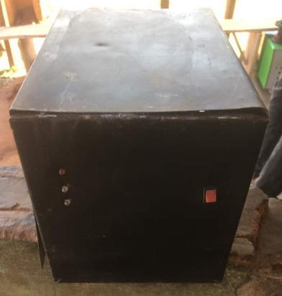
The oscillator circuit serves to convert the direct current (DC) signals into alternating current (AC) signals as depicted below:

Fig. 3.1 The Inverter

Input signal (DC) Inverter Output signal (AC)
Figure 3.2 Systematic diagram of inverter waveform
The output signal/waveform which is sinusoidal in nature is very small/weak. Therefore, it will be amplifier by the use of power transistors and step-up transformer to the required 220Vac and expected power range. By cascading the power transistor, a high power range could be achieved. Most modern inverters are designed using pulse-width modulation (PWM) technology. By means of the pulse-width control, the inverter is able to produce a constant output, despite variable battery voltage and fluctuating load.
4. Static by-pass switch
The static transfer switch ensures a no-break transfer, this form the Inverter main or battery inverter in the event inverter failure or line disturbance respectively. Interruption-free switching will be achieved by means of thyristor switch i.e thyristor connected back to back.
An inverter converts a dc voltage battery to an ac voltage signal, by the help of an oscillator, the ac signal is then amplified by a booster ic to a higher voltage able to drive a power transistor, whose function is to increase the power level of the inverter, the voltage which is a twelve volt power is send to a transformer, which boost the voltage level from twelve to about 230/240v. This inverter device is a square wave system.
Output waveform
An inverter can produce different waveform as its output waveform, they include square wave, modified sine wave, puslse width modulated wave and lastly sine wave, depending on the inverter circuit design. The two main type of wave used are the modified sine wave and sine wave.
Square wave: this is one of the simplest wave form an inverter design can produce and is best suited to low sensitivity applications such as lightings and heating. The output of square wave can produce humming when connected to audio equipment.
Sine wave: a sine wave inverter produces a multiple step sinusoidal ac waveform. Sine wave output is more suitable because many electrical products are engineered to work best with a sine wave ac power source.
Modified sine wave: this is the sum of two square waves one of which is phase shifted 90 degrees relative to the other. The result is three level waveform with equal intervals of zero volts; peak positive volts; zero volts; peak negative volts and zero volts. The resultant wave very roughly resembles the shape of a sine wave.
Output frequency: the frequency is the same as standard power line frequency of 50 or 60 hertz
Output voltage: the ac output voltage of a power inverter is often regulated to be the same as the grid line voltage, typically 120 or 240 VAC at distribution level.
Output power: A power inverter will often have overall power rating expressed in watts or kilowatts. This is the power hat will .be available to the device the inverter is driving the inverter is rated 1000watts , but it’s about 1300 watts , in other to handle overload or power increase due to faulty appliance.
3.2 SECTION OF THE INVERTER
The device is sub divided into four sections which comprises of; Oscillator section, Static power switcher section, charging section and the power supply section (battery).
Oscillator section: The oscillator section is the heart beat of the inverter device, because an electrical transformer device cannot transform a dc power source. Therefore, we need to convert the dc (direct voltage) signal into an AC (alternating voltage). This is where the oscillator section comes in.
The oscillator device in this inverter project is made with integrated circuit chip CD4047. The oscillator is based on RC network which determines the oscillating frequency of the oscillator. The formula used to get the oscillating frequency is:
½.2*R*C=F
With this formula we calculated our inverter oscillating frequency C=100nf, R=50,000 ohms variable resistor. To get the value of resistance we used a variable ratio metric carbon traced resistor which work fine and resulted to a very good oscillator. Due to the fact we used a cmos logical gate chip (CD4047) for an oscillator we had 1% frequency drift with temperature and voltage drift, which is okay for a power supply device and not for a lifesaving machine that operates in real time mode where frequency stability is paramount e.g. a drift of 1% is far from okay to run a human incubator, space shuttle etc.
Static Power Switcher Section: This section is the output section of the inverter device. This is where the step up transformer steps up the amplified ac signal generated by the oscillator chip (CD4047). The oscillator generates and AC signal which the signal is then boosted up by CD4093 chip, this boosted signal is now strong enough to drive the mosfet power transistors, it is these power transistors that amplifies the ac signal enough as to power the transformer when the output is being loaded. This section of the inverter device determines the output power of the inverter. The two main components that determine the power of the inverter device are:
- Transformer
- MOSFET power transistors
The transformer power rating is determine by the transformer wire gauge and the laminator size use to make the transformer, in this device we designed a transformer that can supply 1320W of power, even though we rated the inverter as 650W. the transformer is step up transformer that steps 12Vac to 220Vac, the primary turns which is N1 is 30 turns of gauge 16swg (standard wire gauge) while N2 the secondary is 600 turns of gauge 24swg. With these gauges of wire used to make the transformer, the transformer is capable of handling 1320W according to HM wire international. The turns ratio used is
Turns ratio 1:20
Where N1=1 and N2=20
The mosfet power transistors used are capable of handling 100amp of current each, since we used a square wave signal to drive the mosfet each group of 2 mosfet is switched on and off in turns. Since we are using a full wave transformer device for our inverter, we have two group of 2 power mosfet making a total of 4 mosfet used. In making a 1000W inverter one need to switch 83amp of current at 12V as to be able to supply 1000W. However, we design our inverter mosfet transistor network to be able to switch 110amp at each square wave phase. So as the load increases so is the switching current.
The charging section: This involves a transformer and a rectifier to rectify the ac supply from the transformer to charge the battery. This means the input of the transformer would be 220v and the output would be 15v because the charging section need to produce a much higher voltage to be able to charge the battery and the core of the transformer need to be increase to handle more current.
The Power supply section: The supply of the inverter is a 75ah 12v automobile battery.it does not mean an inverter is only limited to 75ah battery. In direct case an inverter uses deep cycle battery and it can be of any amperage (100ah, 120ah, 200ah). The run time of the inverter is dependent on the battery power and the amount of power being drawn from the inverter to a given time. As the amount of equipment using the inverter increases, the runtime will decrease in other to prolong the runtime, additional batteries can be added to the inverter. On attempting to add more batteries there are two basic options for installation
Series configuration: if the purpose is to increase the voltage of the inverter, one can connect batteries in series configuration, here if a single battery dies, the other batteries will not be able to power the load
Parallel configuration: if the purpose is to increase capacity and prolong the runtime of the inverter, batteries can be connected in parallel, this increase the overall ampere hour of the battery set. Other batteries discharge through a single battery.
  - ELECTRONIC COMPONENT USED IN THE PROJECT
The following are electronic component used in the project: The cd4047 oscillator, Transistor, Led, Diode, Resistor, Transformer, Relay and operational amplifier.
The cd4047 oscillator: the cd4047 is a 14 pin IC used for the generation of ac voltage , when supplied with dc voltage, the pin 5,4,6, and 14 are being connected to source(VCC), while pin 7,8,9 and 12 are being connected ground, pin 1,2,3 are used to form an RC circuit, to generated frequency of 50 HZ, pin 10 and 11 are the output the goes to the signal booster IC cd4093.

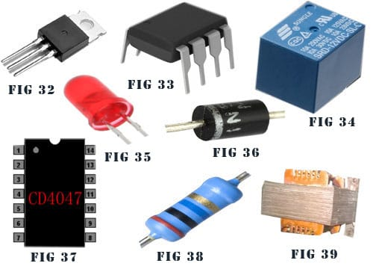

Fig 3.3 cd4047 oscillator
Transistor: this is the transistor that is responsible for the generation of power in the inverter, it generates the power, and sends the signal to the transformer, which further increases the voltage to a signal voltage able to handle the required power of the inverter.

Fig 3.4 Transistor
The transformer: there are two types of transformer used for the construction of the inverter, they are the push pull transformer, and the H bridge transformer, but the H bridge type of transformer is assumed to be the most reliable .the transformer for this inverter was well wounded by me, this coil gauges of 16 and 24.

Fig 3.5 Transformer
Led: this is used for indication, the inverter has two led the first is to indicate that the inverter is functioning, the second is located at the charging section of the inverter, to show that the inverter is charging the battery.

Fig 3.5 Led
Relay: the relay is used in the charging part of the inverter to cutoff the charging of the battery when the battery is fully charged, the relay has two point the normally connected part and the open load part, when the battery is being charged, the relay stays in the normally connected part, until wen the battery is fully charged, then the relay quickly claps and moves to the open circuit part, and the battery stops charging.

Fig 3.6 Relay

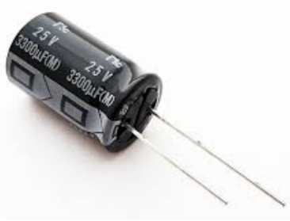
Resistors and capacitors: resistors and capacitors are of different types and sizes, and they are of different functions too. Resistors are used for the resisting of signal moving in a particular direction, while capacitors are used to store charges and also used for filtering of signals.
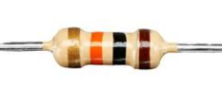

Fig 3.7 Resistor and capacitor
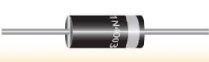
Diode: is a two-terminal electronic component that conducts electric current primarily in one direction. It acts like a one-way valve for electricity, allowing current to flow easily in one direction (forward bias) while significantly restricting it in the other (reverse bias). This property makes diodes essential in various electronic circuits, including rectifiers, voltage regulators, and circuit protection.

Fig 3.8 Diode

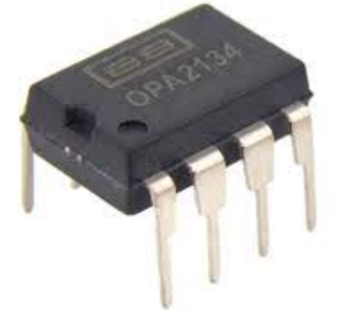
An operational amplifier (op-amp): is a high-gain electronic voltage amplifier with a differential input and usually a single-ended output. It's a versatile building block used in a wide range of analog circuits for signal processing, filtering, and mathematical operations.

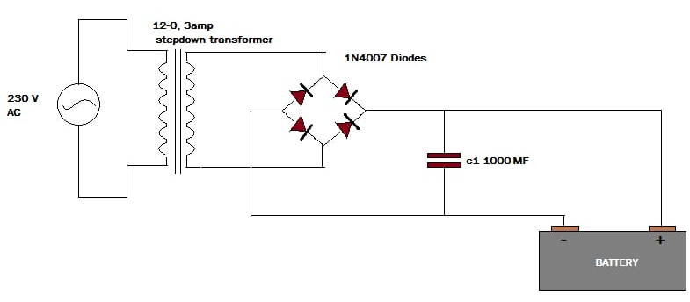
Fig 3.9 operational amplifier

3.4 EFFECT OF 1KVA INVERTER
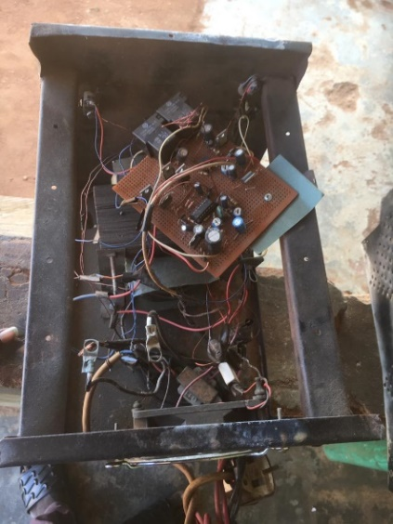
Exceeding the inverter's capacity (80% of 1 kVA, or 800 watts, is a safe guideline) can cause overheating and component failure.

CHAPTER FOUR
CONSTRUCTION
4.1 INTRODUCTION
The aim of construction of an inverter is improve power supply and reduce the risk of lack of power supply, and also carry out necessary experiment with the variation of load on the inverter as course project, which is one of the necessities of obtaining a b-tech degree in my institution. The main and generally purpose of having an inverter or building one, is to improve power ,and .the necessary place where power is mostly need are the same places where an inverter can be applied, the include industries, factories, warehouse, offices, ships, offshore rigs, space machines(planes and jets), homes etc. As regards to the construction and design of an inverter , the in necessary to lay more emphasis on how improve the power and efficiency of the inverter, such as the production of original components used for the construction of the inverter. And care as to be taken in terms of safety.
  - CASING
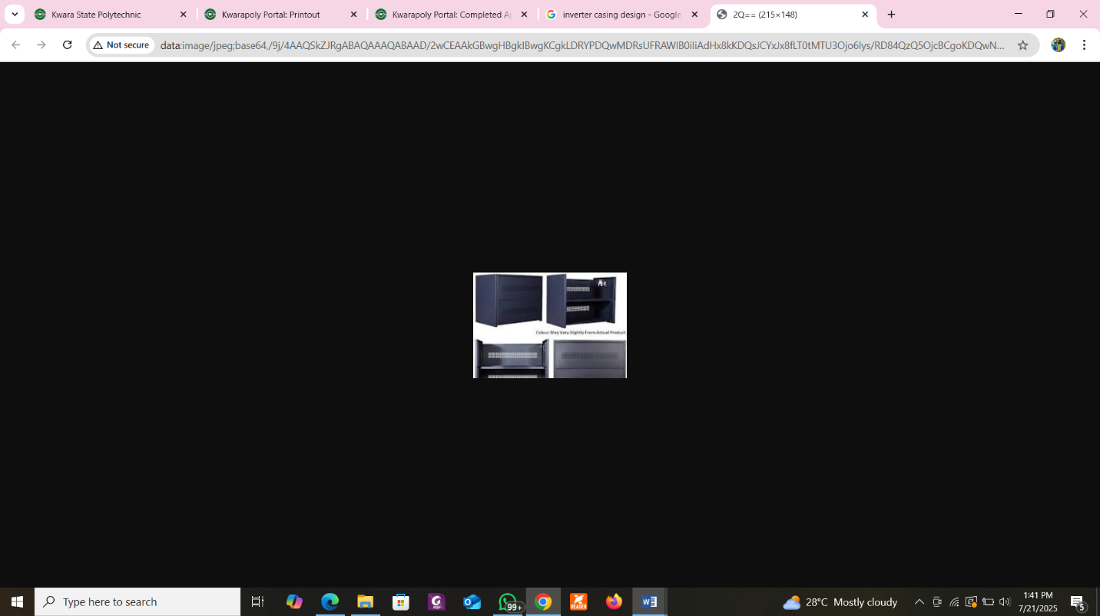
The casing of an inverter plays a critical role in its functionality, safety, durability, and aesthetics. It houses all the components — such as the control circuit, transformer, heat sinks, battery terminals, and cooling fans — in a protective and organized manner.

Fig 4.1 Casing
Functions of Casing
- Protection: Shields the internal components from dust, moisture, mechanical damage, and electrical interference.
- Safety: Prevents users from accidental contact with live wires or hot components like MOSFET heat sinks or transformers.
- Thermal Management: Includes ventilation holes, heat sinks, and sometimes cooling fans to dissipate heat.
- Mounting & Portability: Provides mounting slots for PCB, transformers, fans, and display panels.
Makes the inverter portable, especially for low-to-mid-power models (e.g. 1kVA).
- Aesthetic Appeal: Enhances the professional look of the inverter, especially if it's to be used in homes or offices.
4.3 CONSTRUCTION OF INVERTER
The Vero board (also called stripboard or prototype board): is a perforated circuit board used in electronics prototyping. In the construction of an inverter, a Vero board can be used to assemble and test the circuit before final implementation on a printed circuit board (PCB). Here's a breakdown of how it relates to inverter design
When building a 1kVA inverter or similar project, Vero board is useful during the testing and development phase. Here's how:
- Circuit Prototyping: You can solder the oscillator circuit (based on ICs like NE555 or CD4047) to generate the required square wave.
- Testing Logic: Ideal for assembling and debugging the control circuit. Test connections for low-voltage sections (not for high-power AC output side).
- Microcontroller Interface: Helpful for circuits with PWM control, such as Arduino or PIC-based inverters.
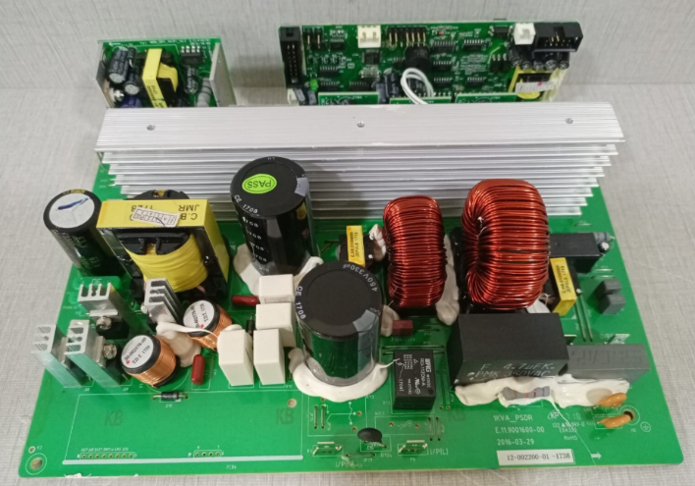
- Signal Conditioning: You can mount components like capacitors, diodes, resistors, and small relays.

Fig 4.2 Vero board
A heat sink: is a vital component in an inverter system, especially in power electronic circuits where high-current components like MOSFETs, IGBTs, diodes, and voltage regulators generate heat during operation.
Functions of Heat Sink
Dissipates Heat: Transfers heat away from high-power components to prevent overheating.
- Protects Components: Prevents thermal damage to transistors, ICs, and voltage regulators by maintaining a safe temperature range.
- Improves Efficiency: Electronic components perform better and more reliably at lower temperatures.
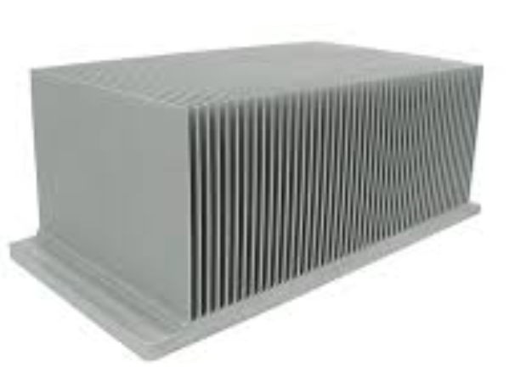

Fig 4.3 heat sink
Fan: is a cooling mechanism designed to help manage heat generated by key power components such as MOSFETs, transformers, and voltage regulators during operation. It’s especially important in medium to high-power inverters (≥500W or 1kVA and above).
Functions of a Fan
- Enhances Cooling: Increases airflow across heat sinks and hot components.
- Prevents Overheating: Keeps critical components below their thermal limits.
- Improves System Efficiency: Cooler components function better and more reliably.
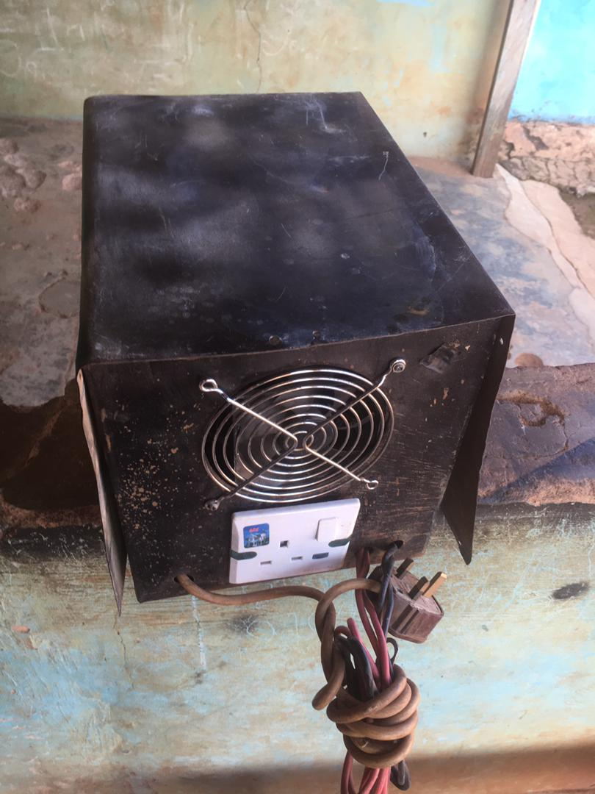

Fig 4.4 fan
Cables: in an inverter system are critical for delivering power, carrying control signals, and ensuring safety. Choosing the right type and size of cable directly affects the inverter’s performance, efficiency, and reliability.
Functions of Cables
- Power Transmission: Carry DC input from the battery to the inverter circuit. Carry AC output from the inverter to the load.
- Signal Transmission: Transmit control signals between circuit boards (e.g., PWM signals).
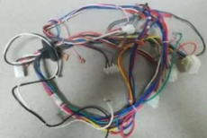
- Grounding: Provide a path for fault currents and safety grounding.

Fig 4.5 Cable
LED: Light Emitting Diodes (LEDs) are used in inverters as indicator lights to visually communicate the status and working condition of the inverter. These indicators improve usability and maintenance by giving instant feedback to the user.

Fig 4.6 Led

Table Fig 1. Common LED Indications
LED Color | Label | Meaning
Green | Power ON | Inverter is powered and functioning normally
Red | Fault/Error | Indicates an issue like overload, short circuit, or battery fault
Yellow/Orange | Charging | Battery is being charged
Blue/White | Inverter Mode | Indicates the inverter is supplying power from battery

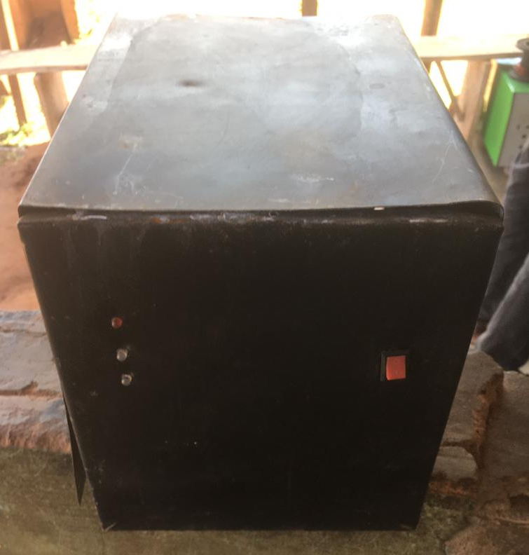

Fig 4.7 COMPLETE OF 1KVA INVERTER

CHAPTER FIVE
CONCLUSION AND RECOMMENDATION
5.1 CONCLUSION
The inverter is rated 650VA but was built up to 1000KVA to be able to occupy more load. The project was a success as we were able to learn how to build an inverter and carry out various experiments on it.
The construction of a 1kVA inverter marks a significant achievement in the development of an efficient and affordable alternative power source for residential and small-scale applications. The process involved the integration of key components such as a transformer, oscillators, MOSFET switches, a heat sink, control circuitry, and protective elements such as fuses and fans to ensure safe operation and longevity of the system.
The completed inverter is capable of converting 12V or 24V DC power from a battery source into 220V AC power, which is suitable for powering essential household appliances like lighting systems, fans, televisions, and small computers. The design emphasizes energy efficiency, portability, cost-effectiveness, and ease of maintenance, making it particularly suitable for areas with frequent power outages.
The success of this project demonstrates a practical application of electronic and electrical engineering principles, including circuit design, soldering, component selection, and thermal management. It also provides a platform for future improvements, such as the incorporation of automatic charging systems, solar integration, and digital monitoring interfaces.

In summary, the construction of the 1kVA inverter not only serves as a solution to erratic power supply issues but also offers a valuable learning experience in the fabrication and operation of renewable energy systems.
5.2 RECOMMENDATIONS
To ensure the successful construction of a 1kVA inverter, it is highly recommended that only high-quality electrical components such as MOSFETs, capacitors, resistors, transformers, and control ICs are used. These components must be carefully selected based on their ratings to match the desired power output and operating conditions. Using durable and tested components enhances the overall reliability and performance of the inverter, reducing the risk of failure during operation. The design should accurately support a continuous output of 1000VA, with the ability to manage peak surge loads for short periods. In addition, the inverter should be paired with a well-sized battery system, preferably deep-cycle batteries, which provide consistent power and longer operational life.
Furthermore, the inverter design should incorporate appropriate battery protection mechanisms such as overcharge protection, low-voltage cut-off, and battery level monitoring. This ensures both the inverter and battery are safeguarded against damage and can function efficiently for extended periods. Proper heat management is also essential; therefore, it is recommended to include heat sinks and a DC cooling fan that activates automatically when internal temperatures rise above normal. These cooling features help prevent overheating, especially when the inverter is under heavy load.
It is beneficial to add LED indicators or an LCD display to provide the user with real-time feedback on inverter operation, including battery status, load levels, and fault conditions. The casing of the inverter should be made of metal or strong plastic, with sufficient ventilation to allow air circulation. All internal wiring should be neatly arranged and securely soldered to prevent short circuits or poor connectivity, which could cause component failure. Safety precautions must be taken seriously by integrating protective features such as overload, short-circuit, reverse polarity, and thermal shutdown protection. These safeguards not only protect the inverter components but also ensure user safety during operation.
Inverter efficiency can be significantly improved by using ferrite-core transformers and employing modern switching techniques like Pulse Width Modulation (PWM). Testing and calibration are crucial after the construction phase; the inverter should be tested with both resistive and inductive loads to confirm stability, voltage regulation, and waveform quality. Lastly, it is advisable to label all terminals and provide brief documentation or user guidance on the operation and safety measures of the inverter. These steps will not only improve user understanding but also enhance the overall functionality and reliability of the inverter system.

REFERENCE
- Mohan, N., Undeland, T. M., & Robbins, W. P. Power Electronics: Converters, Applications, and Design (3rd ed.). Wiley, Covers inverter principles, control systems, and switching techniques. 2003.
- Rashid, M. H. Power Electronics: Circuits, Devices, and Applications (4th ed.). Pearson. A foundational text that explains inverter circuits, pulse-width modulation (PWM), and inverter protection. 2013
- Bimbra, P. S. Power Electronics. Khanna Publishers, Useful for circuit diagrams and component selection for small inverters like 1kVA. 2012.
- Ajayi, O. O., & Adewale, A. A. Design and Implementation of a Pure Sine Wave Inverter. International Journal of Engineering Research and Technology (IJERT), 7(4). https://www.ijert.org 2018
- Salihu, H. A., & Olatunji, J. A. Design and Construction of a 1kVA Inverter for Alternative Power Supply, Nigerian Journal of Technological Development, 16(1), 43–48, Includes real case studies and local component sourcing. 2019
- Instructables.com DIY guides like “How to Make a Simple 1000W Inverter”. https://www.instructables.com
- All about Circuits: Offers circuit diagrams and explanations of inverter topologies. https://www.allaboutcircuits.com
- Electronics Tutorials; Detailed tutorials on DC-AC conversion, MOSFET driving, and PWM control. https://www.electronics-tutorials.ws
- Adedeji, S. A. Design and Development of a Low-Cost 1kVA Inverter.
Bachelor’s Thesis, Department of Electrical Engineering, University of Ilorin. Available through institutional repositories or request from university library. 2020

BILL OF ENGINEERING MEASUREMENT AND EVALUATION
S/N | LIST OF ITEM | DESCRIPTION | QTY | PRICE | AMOUNT
1. | BATTERY | 12V/3AH | 1 | 8000 | 30,000.00
2. | LED | 5AH | 113 | 20 | 2260.00
3. | RESISTOR | 4.7K | 3 | 5 | 15.00
4. | RESISTOR | 100K | 1 | 5 | 5.00
5. | CAPACITOR | 0.1µF | 3 | 30 | 90.00
6. | CAPACITOR | 1000µF | 2 | 30 | 60.00
7. | SEVEN SEGMENT DECODER | CD4033 AND CD4027 | 4 | 300 | 1200
8. | MICRO-CONTROLLER | ATMEGA328 | 1 | 3000 | 3000
9. | TRANSFORMER |  | 1 | 2000 | 2000
10. | CONNECTOR | 8 PINS | 2 | 300 | 600
11. | CONNECTOR SOCKET | 8 PINS | 4 | 50 | 200
12. | CASING |  |  | 1 | 2000
13. | CRYSTAL OSCILLATOR | 4 PIN | 2 | 100 | 200
14. | BOLTS AND NUTS |  | 6 | 40 | 240
15. | PRINTED CIRCUIT BOARD + DESIGN |  | 1 | 3500 | 10000
16. | COVER OF PCB |  | 1 | 200 | 200
17. | TRANSFORMER |  | 1 | 150,000 | 105,000
18. | DRILLING BIT |  | 1 | 150 | 150
19. | SOLDERING IRON |  | 1 | 1350 | 1350
20. | MISCELLANEOUS |  |  | 3000 | 3000
21 | SOLDERING LED |  | 1 | 300 | 300
 | FIELD EFFECT TRANSISTOR |  | 2 | 5000 | 10,000
 |  |  |  | TOTAL | 173,870

