A TECHNICAL DESIGN REPORT
ON
PROPOSED MODERN ABATTOIR
FOR
IBADAN OYO STATE

PRESENTED BY:
RASHEED USMAN AJIBOLA
HND/22/ARC/FT/087

SUBMITTED TO
THE DEPARTMENT OF ARCHITECTURE TECHNOLOGY, INSTITUTE OF ENVIROMENTTAL STUDIES, KWARA STATE POLYTECHNIC, ILORIN KWARA STATE.

IN PARTIAL FULFILLMENT OF THE REQUIREMNT FOR THE AWARD OF HIGHER NATIONAL DIPLOMA (HND) IN THE ARCHITECTURAL TECHNOLOGY
JULY 2025

DECLARATION
I RASHEED USMAN AJIBOLA, MATRIC NO: HND/22/ARC/FT/087 hereby declare that this project is product of my personal research work under the supervision of ARC FAMILUA. O.S It has not been presented for award of any degree in any polytechnic. The ideas, observations, comments, suggestions herein represent my own convictions, Except quotations, which have been acknowledge in accordance with conventional academic traditions."

________________ ________
Signature Date

DECLARATION
1 RASHEED USMAN AJIBOLA, MATRIC NO: HND/22/ARC/FT/087 hereby declare that this project is product of my personal research work under the supervision of ARC FAMILUA. O.S It has not been presented for award of any degree in any polytechnic. The ideas, observations, comments, suggestions herein represent my own convictions, Except quotations, which have been acknowledge in accordance with conventional academic traditions."

______________ ___________
Signature Date

CERTIFICATION
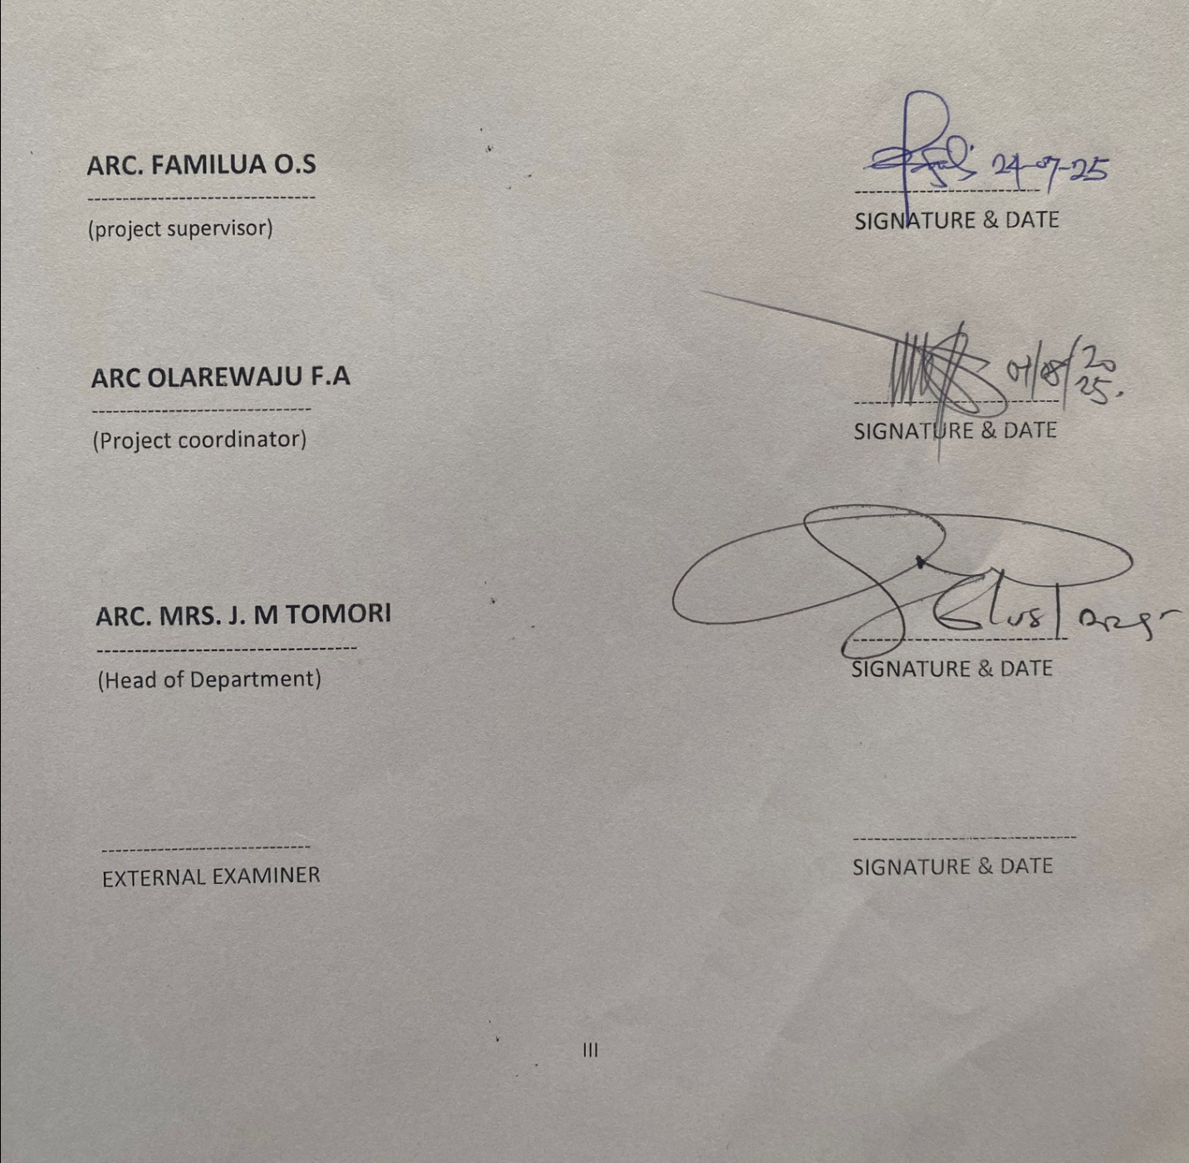
"I certify that this research project titled "MODERN ABATTOIR" was carried out by RASHEED USMAN AJIBOLA, MATRIC NO HND/22/ARC/FT/087 under the supervision of ARC FAMILUA. O.S, and has been approved as meeting the requirements for the award of higher National Diploma (HND) in Architectural Technology, Kwara state Polytechnic Ilorin, kwara State Nigeria.

DEDICATION
This report is dedicated to Almighty Allah for making it possible and also to my Parent and all Architects in the world.

ACKNOWLEDGEMENT
I return all the glory, honor, praise, and adoration to the Almighty Allah, the most merciful and benevolent that has given me the privilege of seeing the end of this program of him alone is the glory.
My immediate gratitude goes to my amiable supervisor ARC. FAMILUA O.S who has been supportive throughout this project, may Allah continue to reward you and your family.
My gratitude also goes to the Department of Architectural Technology entire staff, both teaching staff and non- staff, may Allah continue to reward them.
My sincere gratitude goes to my parent, Mr. and Mrs. Rasheed who brought me to this world, may you eat the fruit of your labor
However, my gratitude also goes to all my helpers, Brother, Sister, and my friend for their encouragement and financial support.
I can't forget the help of my friend's Rasheed Toheeb Olanrewaju Ope, Ayomide, Samuel and my course mates and my loved ones, may almighty Allah bless you all.

TABLE OF CONTENTS
TITLE PAGE i
DECLARATION ii
CERTIFICATION iii
DEDICATION iv
ACKNOWLEDGEMENT V
TABLE OF CONTENTS vi
LIST OF TABLES vii
LIST OF FIGURES ix
LIST OF PLATES X
ABSTRACT
CHAPTER 1:
1.0 Introduction 1
1.1 Background of Study 2
1.2 Statement of Problem 6
1.3 Aim and Objective 7
1.4 Project Justification 7
1.5 Scope of the Study 8
1.6 Client Brief 8
1.7 Limitation of the Study 8
1.8 Research Methodology 9
CHAPTER 2:
2.0 Literature Review 10
CHAPTER 3
3.0 Case studies 16
3.1 Case Study one 20
3.2 Case Study Two 13
3.3 Case Study Three 25
3.4 Case Study Four 29
CHAPTER 4:
4.0 History of the Study Area 33
4.1 Site Location 34
4.2 Site Location Criteria 34
4.3 Site Analysis/ Inventory 35
4.4 Geographical/Climatic data 36
4.5 Design Criteria 36
4.6 Site Selection 36
4.7 Design Scope 37
4.8 Design Brief 38
4.9 Spatial Allocation 40
4.10 Functional Relationship 40
CHAPTER 5:
5.0 Design Appraisal 41
5.1 Construction Methodology 41
5.2 Design Characteristics 43
5.3 Building Structure 47
5.4 Materials and Finishes 48
5.5 Services 48
5.6 Recommendation 49
5.7 Conclusion 49
REFERENCES 50
APPENDICES 51

LIST OF TABLE
Table: 4.1 Spatial Allocation (Ground Floor). 27
Table: 4.2 Spatial Allocation (Upper Floor). 28

LIST OF FIGURES
Fig: 2.1: Site Plan of Case Study One.. 13
Fig: 2.2: Ground Floor Plan of Case Study Two..... 13
Fig: 2.3: Site Plan of Case Study Two.. 16
Fig: 2.4: Ground Floor Plan of Case Study Three.. .16
Fig: 2.5: Upper Floor Plan of Case Study Three.. 20
Figure; 3.1 Image Showing Proposed Location Plan.. 22
Figure; 3.2 Image Showing Site Analysis 22
Figure;: 4.1 Image Showing Functional Relationship 28
\

LIST OF PLATES
Plate: 2.1 Image Showing Production Area of Case Study On e 11
Plate: 2.2 Image Showing Site of Case Study One 12
Plate: 2.3 Image Showing Production Area of Case Study Two 14
Plate: 2.4 Image Showing Silo and Machines of Case Study Two 14
Plate: 2.5 Image Showing Site of Case Study Three 17
Plate: 2.6 Image Showing Bagging Room and Exterior View of Case Study Three ... 17

LIST OF APENDICES
APPENDIX 1: Proposed Site Plan. 38
APPENDIX 2: Proposed Ground Floor Plan.. 39
APPENDIX 3: Proposed Upper Floor Plan.. 40
APPENDIX 4: Proposed Roof Plan. 42
APPENDIX 5: Proposed Section. 42
APPENDIX 6: Proposed Elevation (Approach View). ...43
APPENDIX 7: Proposed Elevation (Right-Side View). ..44
APPENDIX 8: Proposed Elevation (Rear View).. 45

ABSTRACT
The need to reduce the challenges of manual rice production and importation of rice into the country as well as making it cheap in our society has been of a front Issue in recent time in Oyo State and the Nigerian Nation at large. Rice is one of the major stable foods in Nigeria today; there is hardly anyone in this part of the world who does not include rice in his or her diet at least once in a week.
The aim of this project is to design achieved a functional and suitable rice mill in Ibadan, Ori-ire Local Government Area of Oyo and beyond. The information gathered and used in facilitating this project was by visiting existing project, site visitation; oral interview, relevant books as well as journals and magazines. Some studies were made for functionality, structural and construction methods as could be applicable in the design.
The scope of this project is intended to properly handle the processing and milling of rice in Ibadan, with the use of automated machines for the benefit of increasing production and its ancillary product.

CHAPTER ONE
1.0 INTRODUCTION
An abattoir, also known as a slaughterhouse, is a facility where animals are slaughtered and dressed for human consumption. Modern abattoirs are designed with several key considerations to ensure efficient and hygienic operations. Let's explore some design concepts, new abattoirs are typically situated in vacant undeveloped areas. The site should have adequate space for the facility and related infrastructure, necessary utilities and facilities (such as water supply, electricity, drainage, and waste management) must be provided for the proper functioning of the building. Abattoirs can be classified into three main categories based on size: small, medium, and large. The design should consider the number of animals to lable land. The layout should facilitate a regulated and one-way flow of operations, from the arrival of raw materials (animals) to the packaging and shipping of finished products. Proper zoning and separation of different areas (slaughtering. processing, packaging, etc.) are essential for hygiene and safety, abattoirs require various specialized equipment for different stages of the process. These may include stunning devices, bleeding areas, carcass processing lines, and refrigeration units. The choice of equipment depends on the available capital and the specific services needed.
Sustainability and Social Considerations: Sustainable slaughterhouses take into account social, economic, ecological, technological, and institutional dimensions. Research on sustainability can assess factors such as waste management, microbe contamination, and community perception.
Modern abattoir designs prioritize hygiene, efficiency, and humane practices. By integrating these principles, we can create facilities that meet both industry standards and societal expectations.
1.1 BACKGROUND OF STUDY
The evolution of modern abattoir designs is a fascinating journey that reflects changing societal needs, technological advancements, and architectural innovations, before the emergence of modern abattoirs, animal slaughter and meat processing occurred in private slaughterhouses or decentralized locations. These early facilities lacked standardization, hygiene, and efficient processes. The mid-nineteenth century witnessed significant industrialization and urban growth. As cities expanded, the need arose for centralized and controlled spaces for animal killing and meat production. The public abattoir emerged as an institution across industrialized nations during this period. It aimed to
centralize and regulate animal slaughter, ensuring food safety and efficient production, the modern abattoir went beyond mere animal killing. It optimized the disassembling process, efficiently breaking down livestock into smaller pieces. It became one of the earliest building types to incorporate production-line principles into its spatial layout. Livestock were separated from people, and production was distinct from consumption, all within specialized areas hidden from public view, Shanghai Municipal Abattoir (1933) a notable example is the Shanghai Municipal Abattoir, completed in 1933, deliberately designed as a "machine for killing," it applied production-line efficiency to animal slaughter.
Mechanization Takes Command: Architectural historian Sigfried Giedion recognized the abattoir's role in modernity. The slaughter line, where animals were hooked onto pulleys and rails, exemplified mechanization's impact on abattoir design. The shift to modern abattoirs had implications for communities and workers, research on the consequences of these facilities in "post domestic" societies sheds light on their impact, the historical journey of modern abattoir designs reflects a blend of functionalism, efficiency, and societal transformation. From decentralized slaughterhouses to purpose-built "machines for killing," these facilities continue to shape our food production landscape
INTRODUCTION TO MODERN ABATTIOR IN NIGERIA
Modern abattoirs play a crucial role in ensuring food safety, efficient meat production, and hygienic practices. In Nigeria, as in many other countries, the transition from traditional slaughterhouses to modern abattoirs has been essential for public health and sustainable meat processing. Let's explore the key aspects of modern abattoir designs in Nigeria: The need for modern abattoirs arises from the inadequacies of older facilities. These new designs aim to, address hygiene, safety, and operational efficiency, traditional slaughterhouses faced challenges related to sanitation, waste management, and outdated infrastructure, modern abattoirs seek to overcome these limitations. The primary goal is to investigate and develop architectural design solutions for achieving a hygienic environment in meat production and processing.
Specific objectives include studying historical abattoir development, identifying problems, and proposing solutions Modern abattoirs contribute to public health by ensuring safe meat consumption. They also enhance economic productivity and environmental sustainability. study focuses on the Kara Market Abattoir in Ogun State, Nigeria The Kara Market Abattoir is situated in

Ogun State, providing a relevant context for the study. The research employs architectural analysis, planning, and design principles.
It aims to create practical solutions for a hygienic and efficient abattoir, modern abattoir designs in Nigeria aim to revolutionize meat processing, ensuring safety, sustainability, and improved practices for both consumers and workers.
1.2 STATEMENT OF PROBLEM
Modern abattoirs in Nigeria face critical challenges that hinder their effectiveness and impact on public health, environmental sustainability, and meat production. These challenges stem from various factors, including outdated facilities, poor waste management, and inadequate infrastructure. Let's delve into the specific problems faced by modern abattoir designs in Nigeria: Most abattoirs lack proper waste disposal systems, leading to environmental pollution, Inefficient waste management affects air quality due to foul odors, contaminates agricultural land, and poses risks to water sources and aquatic life.
Obsolete Facilities and Poor Design: Many abattoirs operate with outdated infrastructure that cannot meet the demands of a growing population. The lack of expansion and modernization results in overstretching existing facilities and deteriorating conditions.
abattoirs are situated in residential areas, causing conflicts with nearby communities, Some Inappropriate locations can exacerbate waste management issues and affect public health.
Government Apathy and Funding Constraints: State governments often neglect their responsibilities in establishing and managing abattoirs, Insufficient funding hampers necessary upgrades and improvements.
Health and Safety Risks: Inadequate clean water supplies, lack of refrigeration, and substandard processing facilities endanger both workers and consumers.
The absence of proper waste collection and storage facilities further compounds health risks.
In summary, addressing these challenges is crucial for transforming modern abattoir designs in Nigeria into efficient, hygienic, and sustainable facilities that benefit society and the environment.

ARCHITECTURAL PROBLEM
The architectural problem to be solved in this project includes:
Circulation: These must be adequate circulation to allow activities of staff and equipment.
Security: Cameras will be installed at strategic location to monitor vicinity at all time.
Functionality: The building will be design in such a way that is will serve the actual purpose it is for.
1.3 AIM AND OBJECTIVES
The primary goal is to investigate and develop architectural design solutions for achieving a hygienic environment in meat production and processing.
OBJECTIVES
➤ Investigate the historical evolution of abattoirs globally and specifically in Nigeria, understand how abattoirs have evolved over time and identify key trends and challenges.
➤ Examine the major problems encountered in abattoirs, highlight issues related to infrastructure, waste management, hygiene, and operational efficiency.
➤ Explore specific solutions and strategies to achieve and maintain a hygienic environment in modern abattoirs, focus on practices that enhance food safety, worker health, and overall cleanliness.
➤ Investigate existing facilities and services in specific abattoirs, such as the Kara market abattoir in Ogun State and others within and outside Nigeria, evaluate the adequacy of infrastructure, waste disposal systems, and overall functionality
1.4 PROJECT JUSTIFICATION
Modernizing abattoir designs in Nigeria is crucial for several compelling reasons, abattoirs often lack proper sanitation facilities, leading to unhygienic conditions during meat processing. Modern designs incorporate features like stainless steel surfaces, efficient drainage systems, and easy-to-clean materials, reducing the risk of contamination and foodborne illnesses, improved designs minimize the spread of diseases by ensuring proper waste disposal, ventilation, and separation of different animal species. This directly impacts public health and prevents zoonotic diseases, quality Meat Production: Efficiency: Modern abattoirs streamline processes, allowing for faster and more efficient meat production. Properly designed facilities reduce stress on animals, resulting in better-
quality meat, Adequate cold storage facilities prevent meat spoilage and maintain freshness. ensuring that consumers receive safe and high-quality products.
Waste Management: Traditional abattoirs generate significant waste, which often ends up polluting
the environment. Modern designs incorporate waste management systems, including anaerobic digesters, to convert waste into energy and minimize environmental impact, By adopting sustainable practices, such as utilizing renewable energy sources and optimizing water usage, modern abattoirs contribute to overall environmental conservation, Upgraded abattoirs can handle larger volumes of meat, meeting the growing demand for protein. This contributes to economic growth and job creation within the meat industry, modern facilities enhance Nigeria's ability to export meat products In summary, modern abattoir designs are essential for safeguarding public health, ensuring quality meat production, protecting the environment, and promoting economic development in Nigeria. The urgent need for modernization cannot be overstated, given the increasing demand for meat and the challenges posed by outdated facilities
1.5 SCOPE OF THE STUDY
The study on modern abattoir design encompasses several crucial aspects related to creating efficient, hygienic, and sustainable facilities for meat processing. Here are the key components, Historical Development of Abattoirs: Investigating the evolution of abattoirs globally and specifically in Nigeria, Understanding how abattoirs have transformed over time in terms of design, technology, and operational practices, analyzing the challenges faced by existing abattoirs, such as hygiene issues, environmental pollution, and outdated infrastructure, examining factors that hinder the production of safe and wholesome meat, developing strategies and solutions to achieve and maintain a hygienic environment, addressing sanitation, waste management, and disease prevention within the abattoir premises, Assessing the facilities and services available in specific abattoirs. including the Kara Market Abattoir in Ogun State, Nigeria, comparing these facilities with best practices and identifying areas for improvement.
Design Considerations: Proposing appropriate plant layouts and designs for modern abattoirs.
Incorporating factors such as stockyards, lairages, slaughter halls, cold storage, cutting rooms, packaging sections, and quality control laboratories, ensuring compliance with environmental regulations and pollution control, accessories and Ancillary Sections: Detailing essential ancillary sections like blood collection hide and skin storage, gut and tripe rooms, rendering plants, and equipment wash areas, addressing personnel facilities, veterinary offices, and effluent treatment

plants, evaluating the suitability of different slaughter systems (rail or floor) based on efficiency. safety, and animal welfare, the scope of the study on modern abattoir design encompasses historical analysis, problem identification, hygiene enhancement, facility investigation, and practical design solutions to create efficient and sustainable meat processing facilities warehouse, store, security post etc.
1.6 CLIENT BRIEF
The client want a well conducive and well ventilated modern abattoir in other to give a new look to Abattoir establishment and to improve hygiene in our environment and to prevent eating of infected meat.
1.7 LIMITATION OF THE STUDY
In carrying out this research, I was faced with some challenges and limitations, which are
Time constraints due to lectures.
Finance to travel for case studies.
Illness within the period.
Inability to access some area during case studies on related facilities and existing rice mill.
1.8 RESEARCH METHODOLOGY
➤ Case studies
Online research
➤ Verbal interviews
In order to arrive at financial design concept, the following research methods were carried out.
➤ Case Study: this is an exercise which involved experimental research or analysis carried out on existing similar building structures from date collected, a deduction for the realization of a better design for this project was derived.
➤ Literature Review: textbook were consulted in order to actually visualize the daily activities that take place within the school and photograph were taken were necessary.
Oral Interview: Members of staff as well as student of institute of environmental studies in some selected school were interview useful information were gathered from such interview deduction from those sources also influenced the final design. A
6
CHAPTER TWO
2.0 LITERATURE REVIEW
A literature review is a text of a scholarly paper, within includes the current knowledge including substantive findings, as well as theoretical and methodological contributions to a particular topic. Literature reviews are secondary sources, and do not report new or original experimental work.
Most often associated with academic oriented literature, such reviews are found in academic journals, and are not to be confused with book reviews that may also appear in the same publication. Literature reviews are a basis for research in nearly every academic field. Literature review also is part of graduate and post-graduate student work, including in the preparation of a thesis, dissertation, or a journal article.
Literature reviews are also common in a research proposal or prospectus (the document that is approved before a student formally begins a dissertation or thesis).
The design of modern abattoirs plays a crucial role in ensuring efficiency, safety, and compliance with regulatory standards. This literature review examines various aspects of abattoir design. including layout, equipment selection, and sustainability considerations.
Layout Design: The layout of an abattoir significantly influences workflow efficiency and hygiene
standards. Research by Smith et al. (2019) emphasizes the importance of a well-designed flow of operations, including separate areas for receiving animals, stunning, slaughtering, and processing. An efficient layout minimizes animal stress, reduces cross-contamination risks, and enhances worker safety.
Equipment Selection: The selection of appropriate equipment is critical for ensuring the smooth
operation of a modern abattoir. According to studies by Johnson et al. (2020), advanced machinery for stunning, bleeding, and carcass processing improves productivity and minimizes manual labor. Additionally, the integration of automated systems for cleaning and sanitation enhances hygiene standards and reduces the risk of microbial contamination.

Animal Welfare Considerations: Designing abattoirs with animal welfare in mind is essential for
ethical and regulatory compliance. Research by Grandin (2018) highlights the importance of facilities that prioritize humane handling practices, including non-slip flooring, proper lighting, and ergonomic restraining equipment. Implementing these design elements reduces stress on animals during handling and slaughter, leading to improved meat quality and consumer satisfaction.
Hygiene and Food Safety: Hygiene and food safety are paramount in abattoir design to prevent
contamination and ensure the production of safe meat products. Studies by Sharma et al. (2021) emphasize the need for facilities with robust sanitation protocols, including easy-to-clean surfaces, effective drainage systems, and designated areas for waste disposal. Adhering to strict hygiene standards minimizes the risk of bacterial contamination and foodborne illnesses.
Sustainability Considerations: In recent years, there has been a growing emphasis on sustainability
in abattoir design. Research by Khan et al. (2020) explores strategies for reducing environmental impact, such as energy-efficient lighting, water recycling systems, and waste management practices. Implementing sustainable design features not only reduces operating costs but also aligns with consumer preferences for environmentally responsible production practices.
Regulatory Compliance: Compliance with regulatory standards is a fundamental aspect of abattoir
design. Studies by Jones et al. (2019) highlight the importance of designing facilities that meet local and national regulations governing animal welfare, food safety, and environmental protection. Engaging with regulatory authorities early in the design process helps ensure that the facility meets all necessary requirements and obtains the required permits for operation.
The design of modern abattoirs encompasses various factors, including layout optimization, equipment selection, animal welfare considerations, hygiene standards, sustainability initiatives, and regulatory compliance. By integrating these elements into the design process, abattoirs can achieve operational efficiency, ensure food safety, enhance animal welfare, and meet the expectations of consumers and regulatory authorities.
This literature review provides an overview of key considerations in the design of modern abattoirs, drawing on research from various academic sources.

CHAPTER THREE
3.0 CASE STUDY
Case studies were conducted four existing modern Abattoir for this work, Introduction: In response to evolving consumer preferences, regulatory standards, and sustainability concerns, the management of Abattoir decided to transition their facility into a modern abattoir. This case study explores the process, challenges, and outcomes of this transformation.
Background: Abattoir, located in a rural area, had been operational for several decades, primarily focusing on traditional slaughtering methods. However, with changing market demands and increased awareness about animal welfare and environmental sustainability, the management recognized the need for modernization.
The first phase involved upgrading the infrastructure to meet modern standards. This included investing in advanced equipment for stunning, slaughtering, and processing, as well as constructing facilities for waste management and water treatment, abattoir integrated cutting-edge technologies such as CCTV monitoring, RFID tracking systems for animal identification and traceability, and automated processing machinery to streamline operations and enhance safety, o ensure smooth adoption of new processes and technologies, the staff underwent extensive training programs. This included training on animal handling techniques, sanitation protocols, and equipment operation, stringent quality control measures were implemented throughout the production process, from receiving animals to packaging the final products. This involved regular inspections, testing for pathogens, and adherence to industry best practices.
Abattoir implemented several sustainability initiatives, such as installing renewable energy systems, optimizing water usage, and implementing waste recycling programs to minimize environmental impact. throughout the transformation process, the abattoir management worked closely with regulatory authorities to ensure compliance with local and national regulations governing food safety, animal welfare, and environmental protection, the initial investment required for infrastructure upgrades and technology integration was substantial, posing a financial challenge for the management, some employees were resistant to change, particularly older workers who were accustomed to traditional methods. Overcoming this resistance required effective communication and ongoing training, Navigating the complex regulatory landscape, including obtaining permits and certifications, proved to be a significant challenge.
Integrating the modernized abattoir into the broader supply chain required coordination with suppliers, distributors, and retailers, which presented logistical challenges, the implementation of

modern slaughtering techniques and enhanced facilities led to a significant improvement in animal welfare standards, stringent quality control measures and advanced technology resulted in improved food safety standards, reducing the risk of contamination and foodborne illnesses, abattoir achieved notable sustainability gains through reduced energy consumption, water conservation, and waste management initiatives.
The adoption of automation and streamlined processes increased operational efficiency, leading to higher throughput and cost savings, my positioning itself as a modern, sustainable abattoir, Abattoir was able to differentiate its products in the market, attracting environmentally conscious consumers and premium buyers, the abattoir successfully maintained compliance with regulatory requirements, ensuring continued operations and market access, the transformation of Abattoir into a modern facility was a complex process that involved significant investment, technological integration, and regulatory compliance. However, the outcomes, including improved animal welfare, enhanced food safety, sustainability achievements, and operational efficiency gains, justified the efforts and positioned the abattoir for long-term success in a rapidly evolving industry landscape, this case study provides an overview of the steps involved in modernizing an abattoir and highlights the challenges and outcomes associated with such a transformation.
3.1 CASE STUDY ONE
Project Title: IBADAN OYO CENTRAL ABATTIOR
Location: JW67+8F5 200135, Ibadan Oyo Central Abattoir, Amosun Village, Akinyele
Local Government Area of Oyo State
BRIEF HISTORY
he Ibadan Central Abattoir, situated in Amosun Village, Akinyele Local Government Area of Oyo State, Nigeria, has a significant historical context. Let's delve into its origins and development: Origins and Establishment: The Ibadan Central Abattoir was conceived and initiated in 2009 during the tenure of former Governor Adebayo Alao-Akala.
It is a multi-billion naira project built on a 10-hectare piece of land in Amosun Village, the project operates under a build-operate-transfer (BOT) arrangement for 30 years.
Relocation and Purpose: The abattoir project aimed to address the challenges faced by the existing slaughterhouse in the Bodija Market due to unhygienic meat handling practices. In 2014, the license of the Bodija Market slaughterhouse was revoked, leading to the establishment of the Ibadan Central Abattoir as a more modern and hygienic alternative.
Facilities and Features: The Ibadan Central Abattoir is one of the largest abattoirs in West Africa, covering 15 hectares of land, It includes Stalls for 1000 meat sellers 170 shops, An administrative building, A clinic, A canteen, Cold storage facilities, An incinerator³, Public-Private Partnership (PPP): The abattoir operates as a PPP project, involving collaboration between the Oyo State Government, the 11 local governments and LCDAs in Ibadan, and a private firm, C & E Limited.
The partnership ensures efficient management, modern facilities, and improved meat processing practices.
Impact and Challenges: The Ibadan Central Abattoir has significantly enhanced meat handling
practices and hygiene standards. However, there have been challenges during its establishment, including clashes during the forcible relocation of butchers from the old slaughterhouse to the new facility, efforts to promote food safety practices among butchers have yielded positive results, but sustainability remains a concern, the Ibadan Central Abattoir represents a crucial step toward modernizing meat processing in the region, ensuring safer and more efficient practices for both consumers and traders
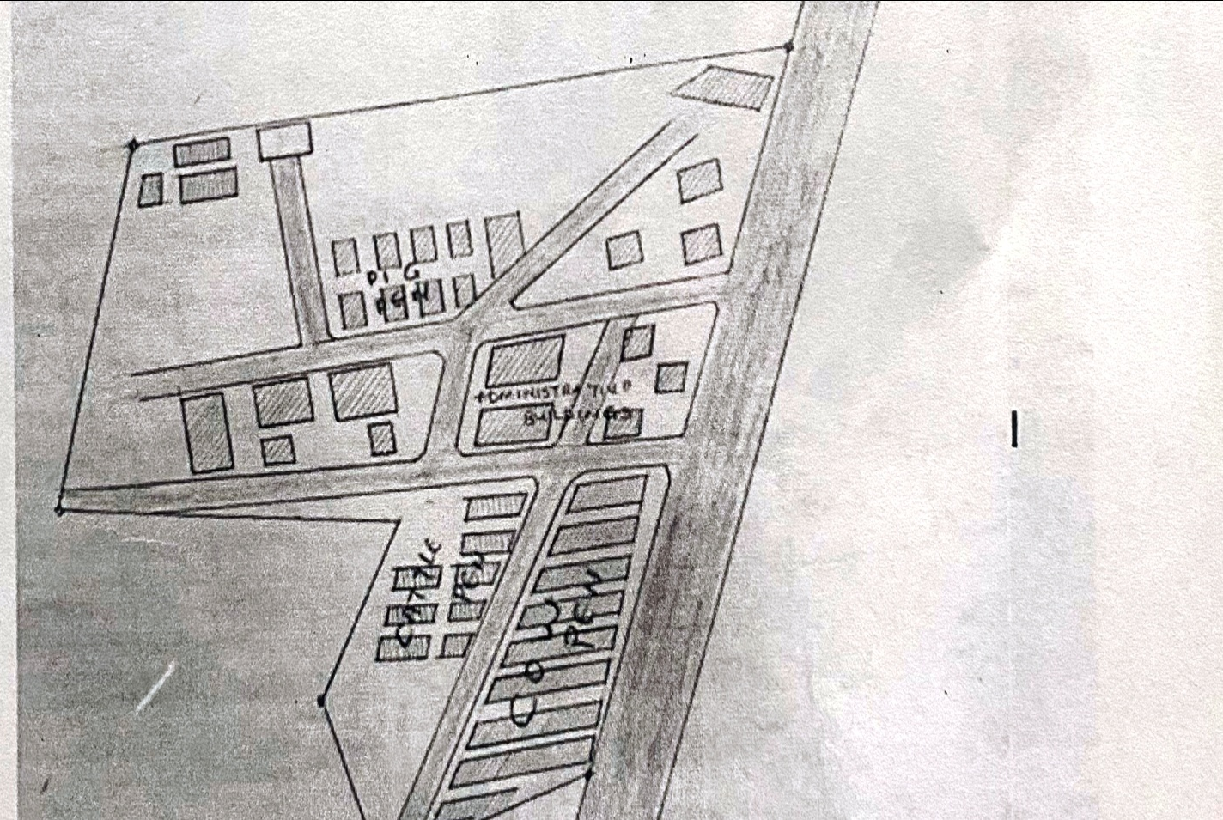

FIG 2.1: SITE PLAN OF CASE STUDY ONE LOCATED AT IBADAN OYO CENTRAL
ABATTOIR

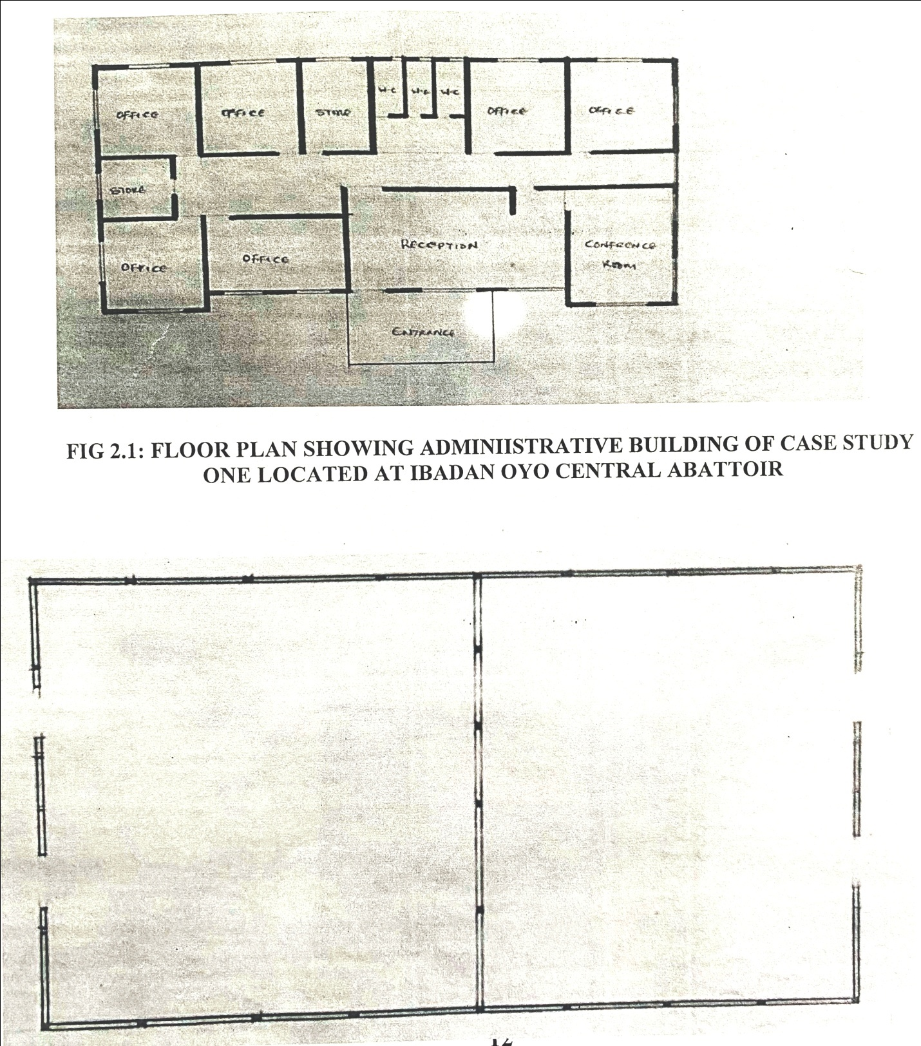

FIG 2.2: FLOOR PLAN SHOWING ADMINIISTRATIVE BUILDING OF CASE STUDY ONE LOCATED AT IBADAN OYO CENTRAL ABATTOIR
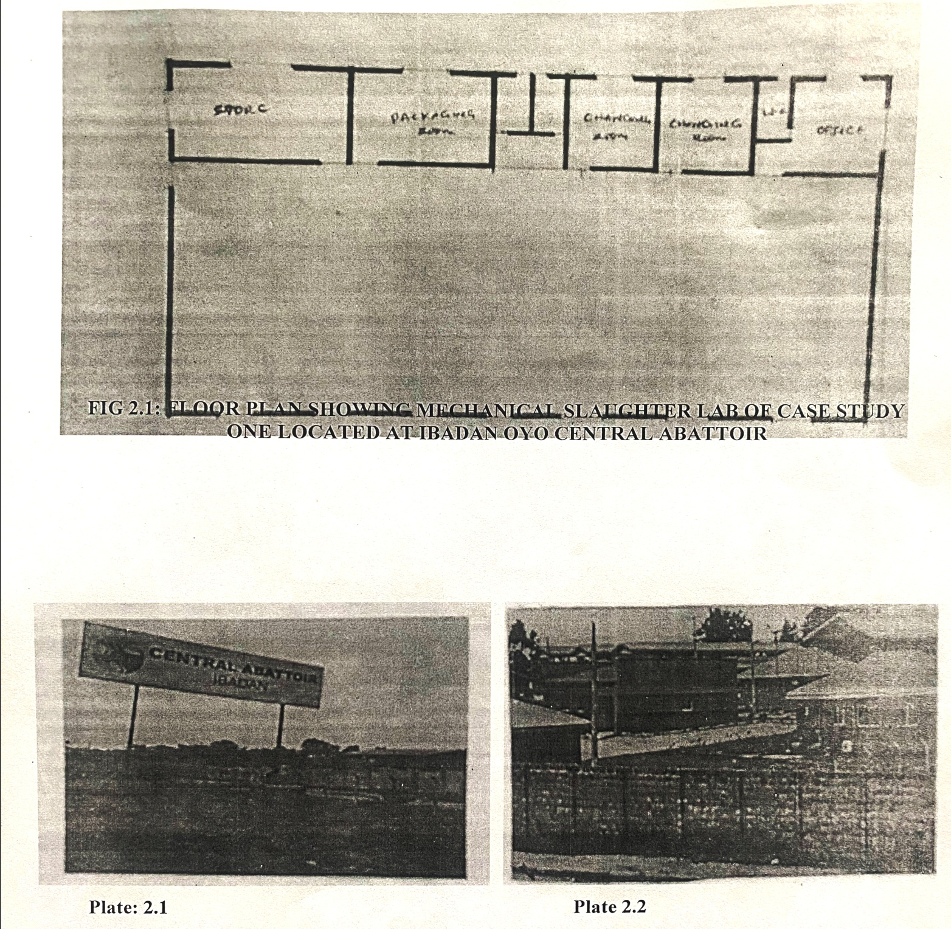
FIG 2.1: FLOOR PLAN MANNUAL SLAUGHTER SLAB OF CASE STUDY ONE LOCATED AT IBADAN OYO CENTRAL ABATTOIR

FIG 2.1: FLOOR PLAN SHOWING MECHANICAL SLAUGHTER LAB OF CASE STUDY ONE LOCATED AT IBADAN OYO CENTRAL ABATTOIR

PLATE 2.1: IMAGE SHOWING ENTRANCE AND ADMIN. BLOCK OF OYO CENTRAL AT ABATTOIR IBADAN AREA OF CASE STUDY ONE

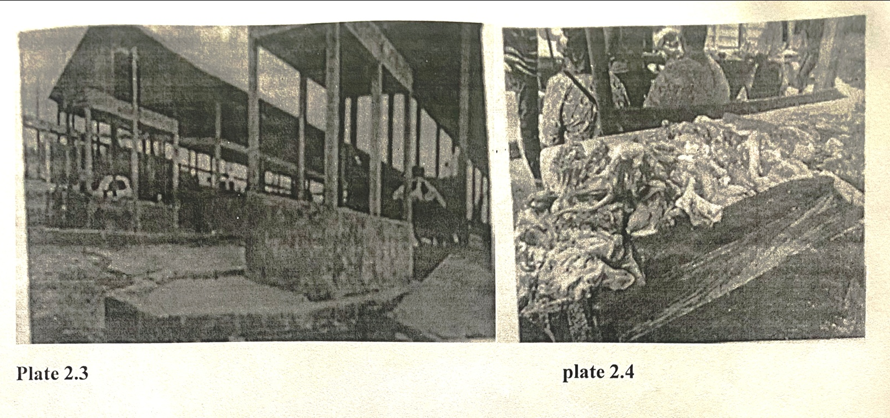

PLATE 2.2: IMAGE SHOWING PEN AND SLAUGHTER AREA OF CASE STUDY ONE

MERITS:
Effective Security.
Easy Access to Site.

DEMERIT:
No defined parking lot.
Poor head room
No defined landscape.
No store or no warehouse.

2.3 CASE STUDY TWO
PROJECT TITLE: LAGOS STATE GOVERNMENT ABATTOIR
LOCATION: Lagos State Government Abattoir Ifako Agege, Lagos State
HISTORICAL BACKGROUND
The abattoirs in Lagos State play a crucial role in ensuring food safety and hygiene, waste generation in Nigerian slaughterhouses poses a serious threat to the environment due to poor handling practices and adverse effects, In typical Nigerian abattoirs, improper wastewater channeling from dressing slaughtered animals and washings at the lairage leads to marshy surrounding land, Pollution occurs when solid wastes like bones, flesh, and dung are left unattended in open spaces, affecting nearby streams, transporting meat in passenger vehicles and motorcycles exposes it to disease vectors like flies and dust.
Lagos State's Efforts, Lagos, as the commercial nerve center of Nigeria and West Africa, faces significant demand for wholesome meat production.
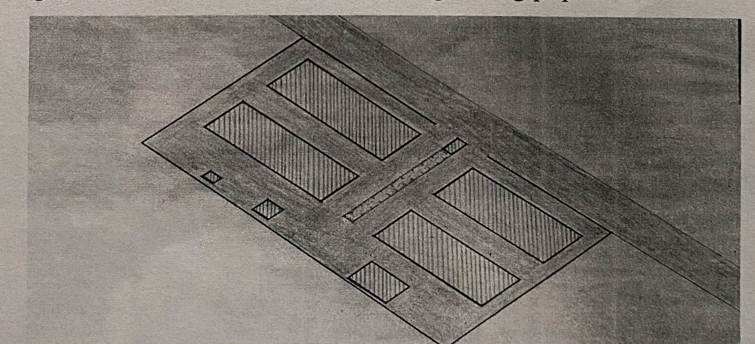
Over the years, Lagos State has upgraded its abattoirs to suit its mega city status, some of the upgraded abattoirs include Matori, Achakpo, Ikorodu, and Ibile Ilaje, with ongoing rehabilitation processes. the flagship abattoir in Lagos is the Oko Oba Abattoir in Agege, built in 1982 by former Governor Alhaji Lateef Kayode Jakande, the state government is currently rehabilitating the Oko Oba abattoir, including the construction of a transit camp and a head, hide, and stripe processing facility to improve meat processing hygiene, proper sanitation and hygiene are fundamental to good health and economic development, Lagos State's efforts toward ensuring healthy and hygienic abattoirs contribute to food safety and public well-being, Lagos State's commitment to upgrading and maintaining its abattoirs reflects its dedication to providing safe and wholesome meat for its growing population.

FIG 2.2: SITE PLAN OF CASE STUDY TWO LAGOS STATE GOVERNMENT ABATTOIR LOCATED AT IFAKO AGEGE LAGOS STATE

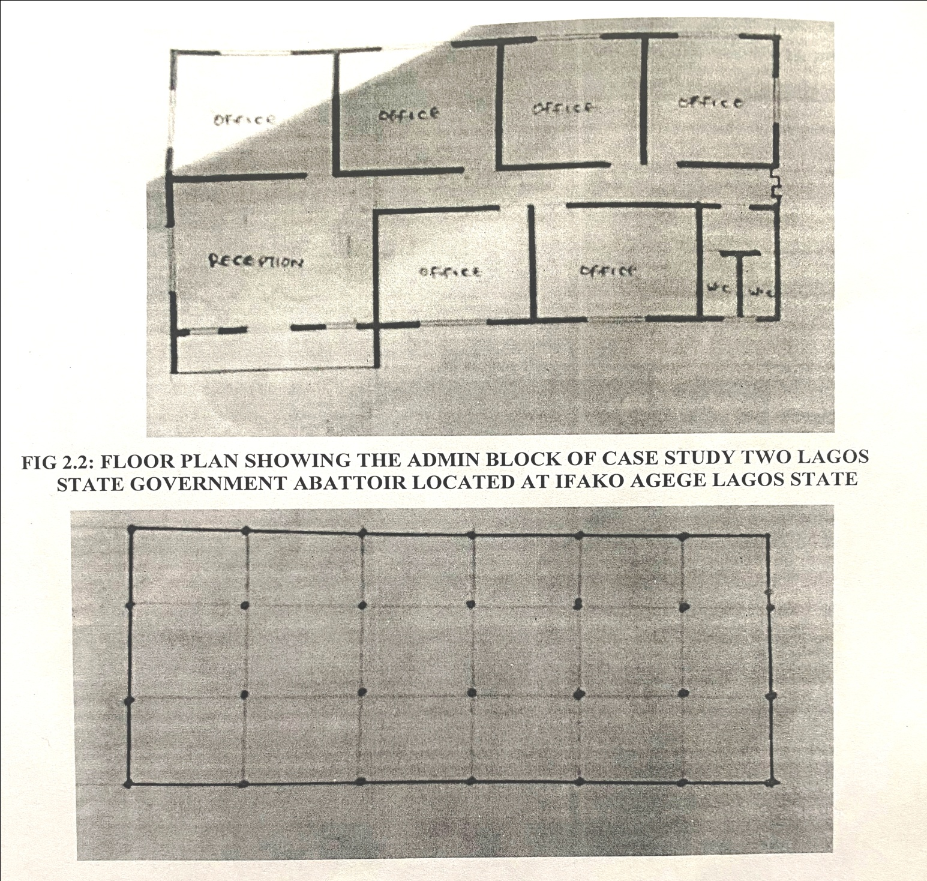

FIG 2.2: FLOOR PLAN SHOWING THE CATTLE PEN OF CASE STUDY TWO LAGOS STATE GOVERNMENT ABATTOIR LOCATED AT IFAKO AGEGE LAGOS STATE
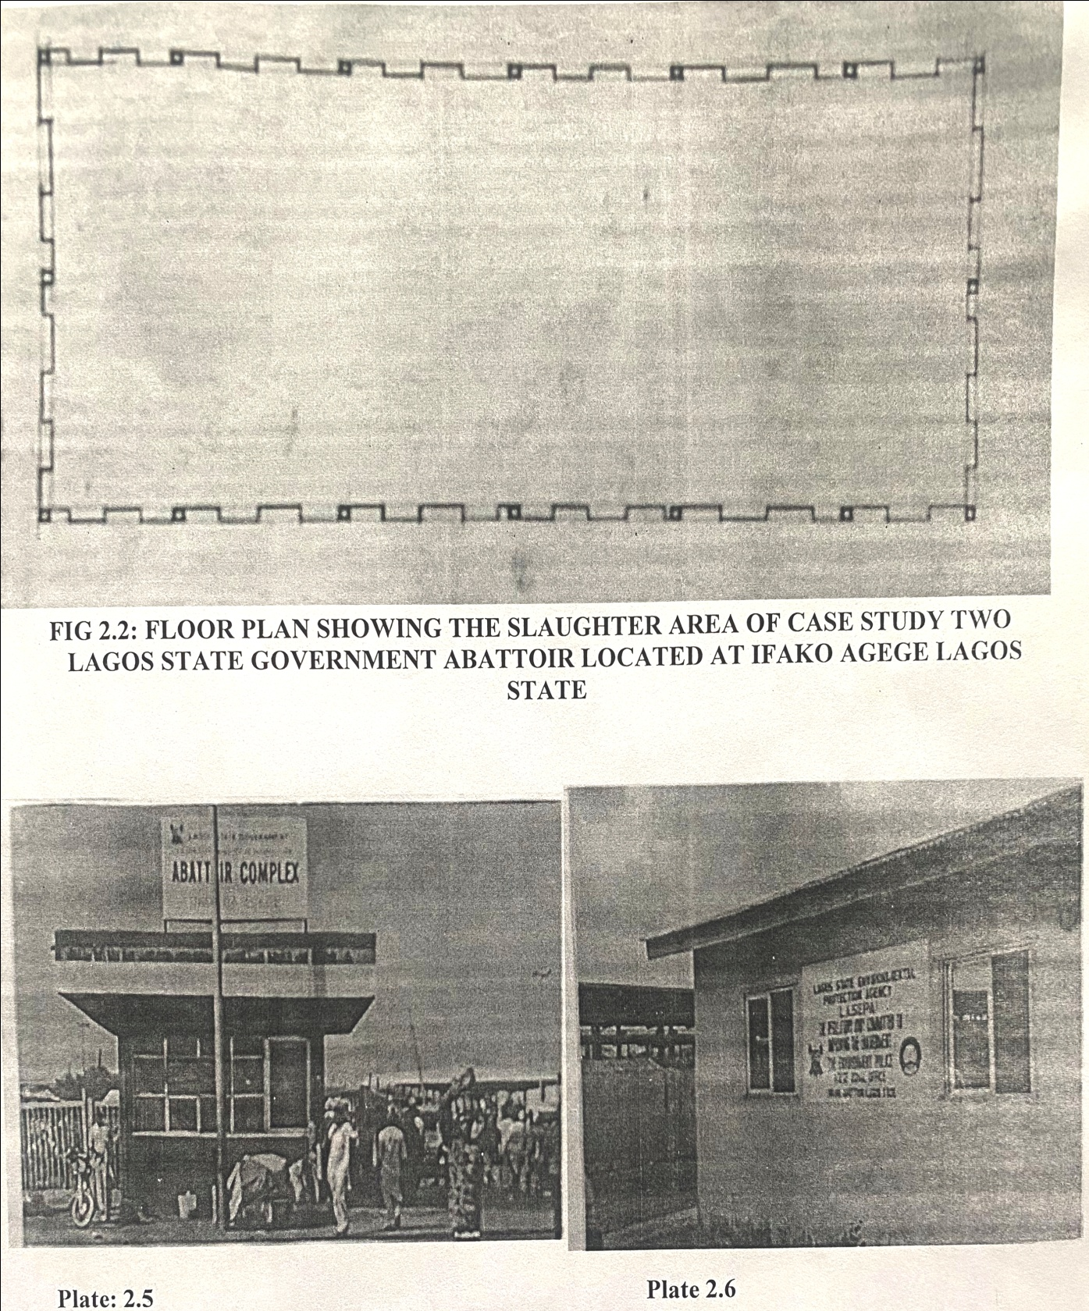

FIG 2.2: FLOOR PLAN SHOWING THE SLAUGHTER AREA OF CASE STUDY TWO LAGOS STATE GOVERNMENT ABATTOIR LOCATED AT IFAKO AGEGE LAGOS
STATE

PLATE 2.3: IMAGE SHOWING L.S.G ABATTOIR ENTRANCE AND ADMIN BLOCK OF CASE STUDY TWO

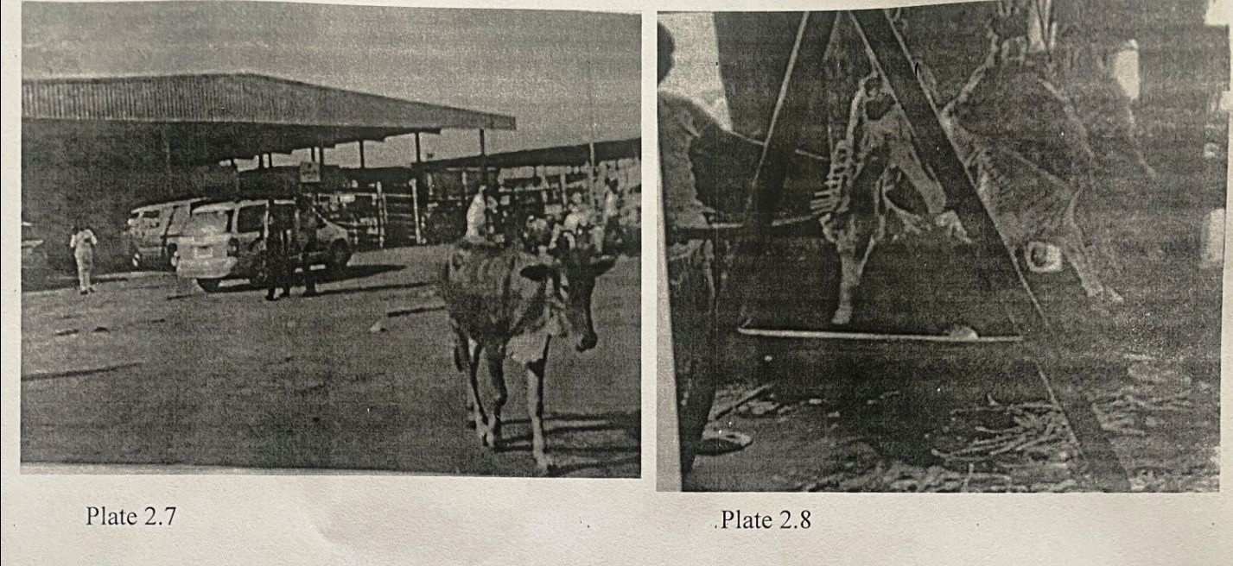

PLATE 2.3: IMAGE SHOWING PEN AND CARCASS, CUTTING, BONING ROOM OF
CASE STUDY TWO

MERITS:
Adequate circulation space
Properly Organized, arranged and spaced machine connection
Sufficient Day Light.
Effective Security.

DEMERITS:
Poor Drainage
Poor Maintenance Facilities
Lack of demarcated parking spaces
Lack of General rest room for visitors or clients
Bad sanitary services
* Insufficient storage Area

2.4 CASE STUDY THREE
PROJECT TITLE: PAL MEAT MECHANISED
LOCATION: Pal meat mechanized Line 1, Lagos State Abattior Complex, Oko-Oba Road Agege, Lagos State, Nigeria
HISTORICAL BACKGROUND
Since its establishment in 1993, Pal Meat Abattoir has been dedicated to providing animal slaughtering and abattoir services to private and commercial customers throughout Nigeria, Asia, and the Middle Eastern regions'. Here are some key points about Pal Meat Abattoir:
Quality and Hygiene: Pal Meat Abattoir ensures the delivery of the highest quality meat by combining dedicated craftsmanship with strict adherence to current hygiene regulations.
They take pride in being the sole Government-approved fully mechanized licensed slaughterhouse in Lagos, Nigeria.
Customer Satisfaction: Pal Meat Abattoir consistently upholds an unparalleled commitment to customer satisfaction, their standard of excellence has propelled their growth, making them an independent slaughterhouse.
Product Offerings: Pal Meat Abattoir provides a 100% HALAL, ORGANIC, FREE RANGE & GMO-FREE meat selection.
Every product leaving their premises is guaranteed 100% edible, Location: The abattoir is located at Mechanized Line 1. Lagos State Abattoir Complex, Oko Oba Agege, Lagos State, Nigeria, Pal Meat Abattoir's unwavering commitment to excellence and its reputation as a reliable meat supplier have made it a significant player in the Nigerian meat industry

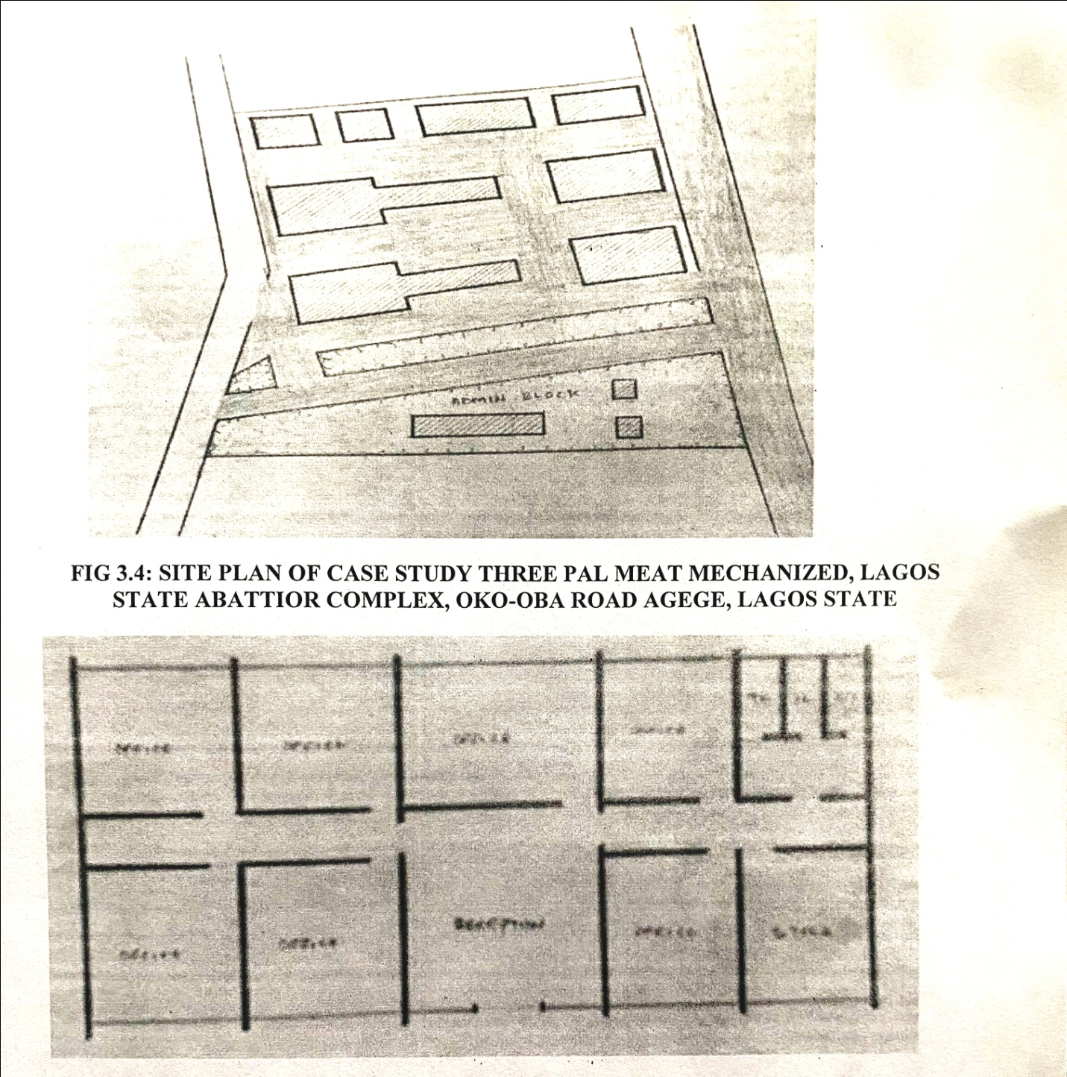

FIG 3.4: SITE PLAN OF CASE STUDY THREE PAL MEAT MECHANIZED, LAGOS STATE ABATTIOR COMPLEX, OKO-OBA ROAD AGEGE, LAGOS STATE

FIG 3.4: FLOOR PLAN SHOWIN ADMIN. BUILDING OF CASE STUDY THREE PAL MEAT MECHANIZED, LAGOS STATE ABATTIOR COMPLEX, OKO-OBA ROAD AGEGE, LAGOS STATE

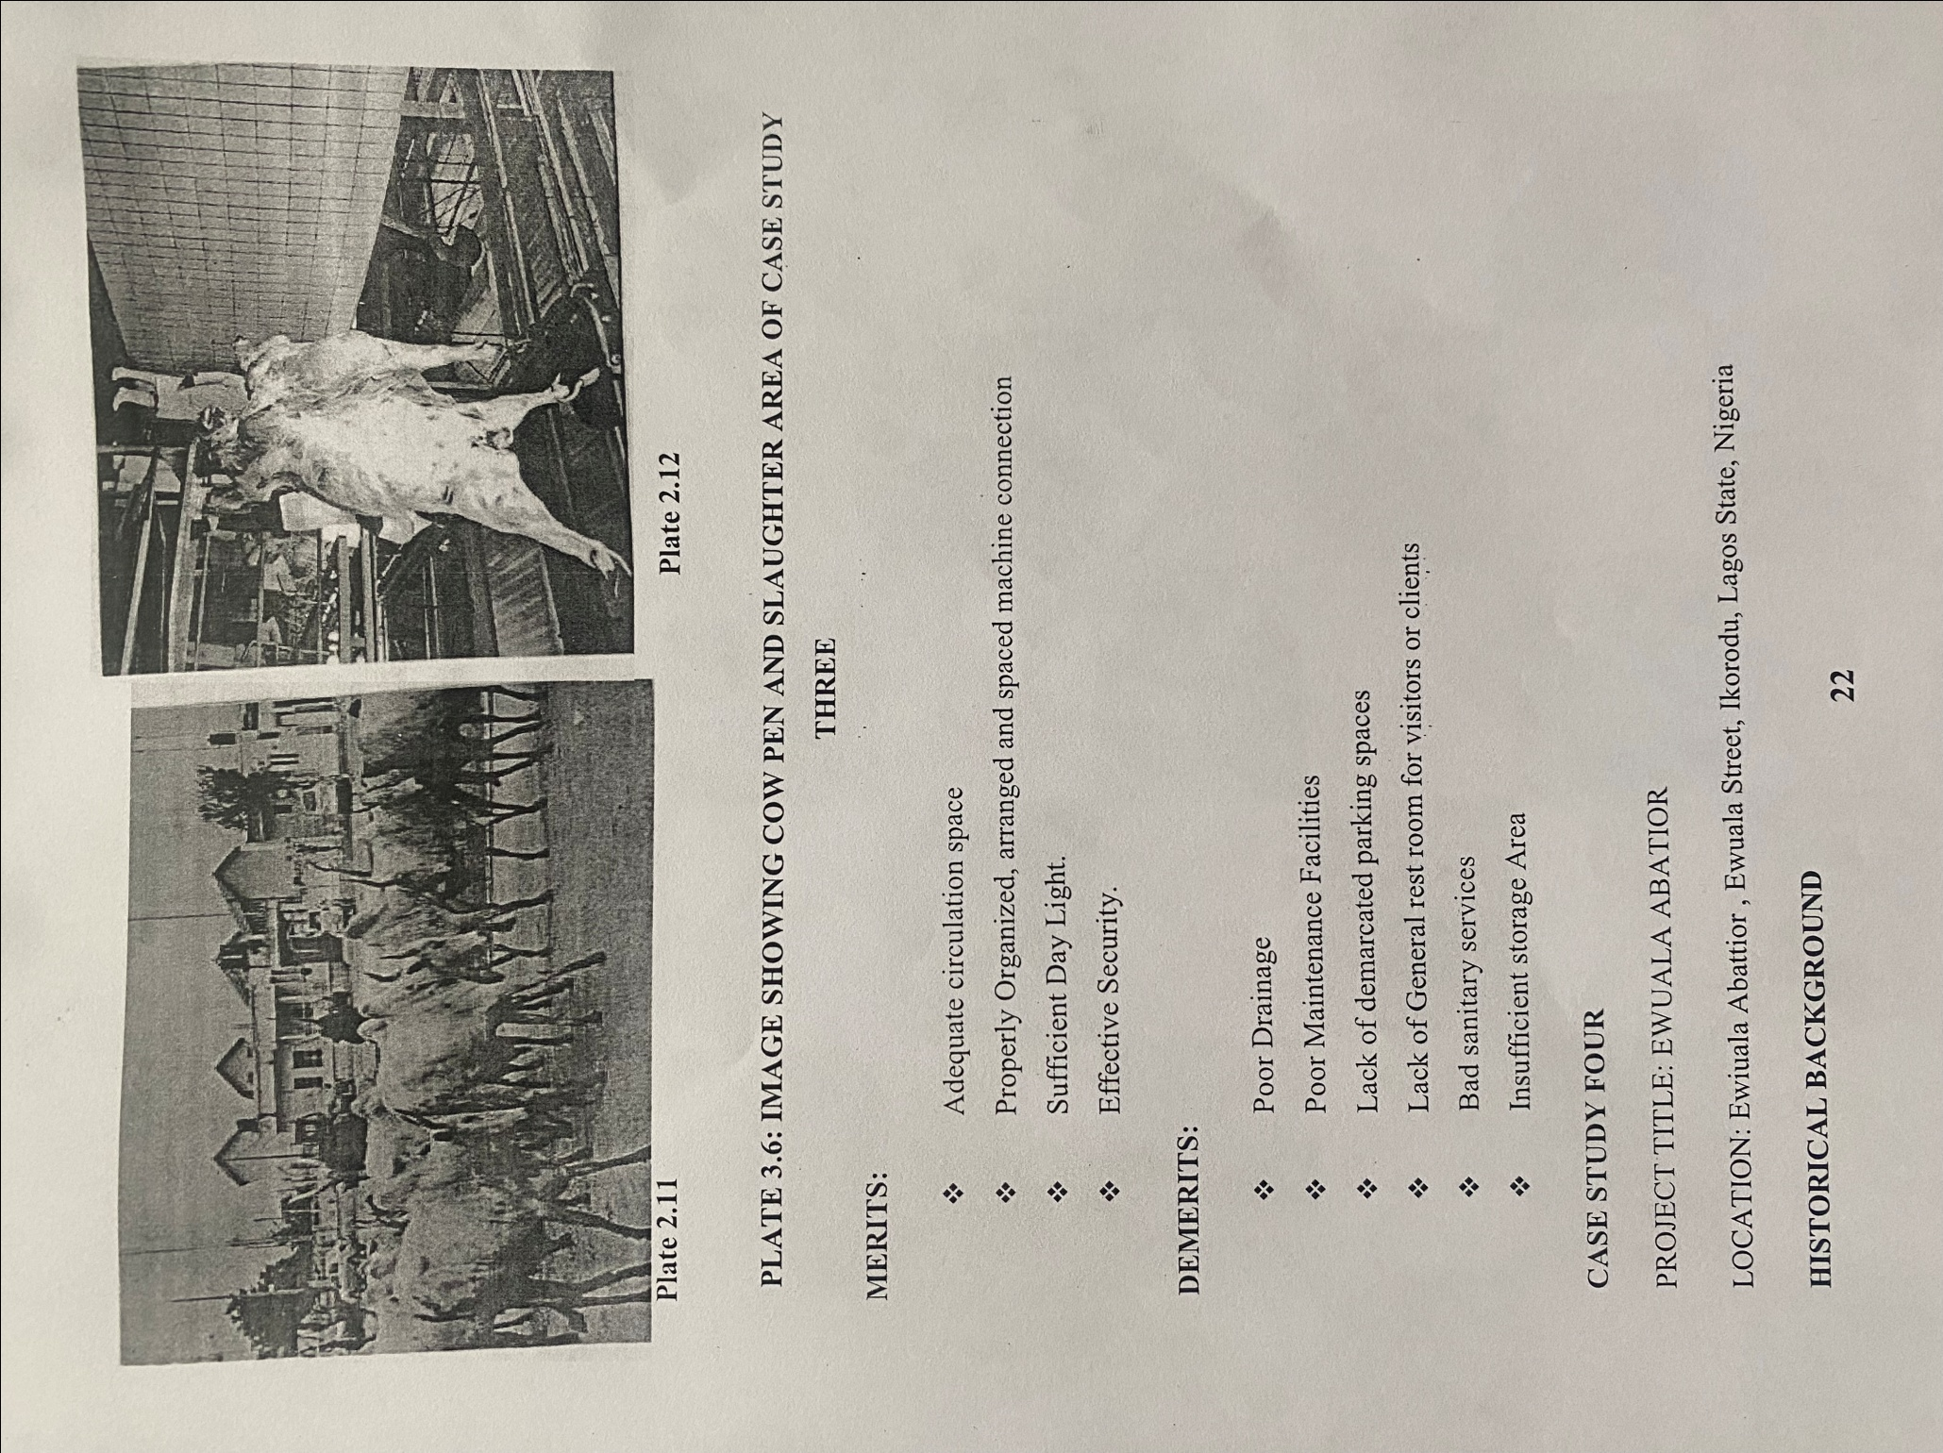

PLATE 3.6: IMAGE SHOWING COW PEN AND SLAUGHTER AREA OF CASE STUDY
THREE
MERITS:
Adequate circulation space
Properly Organized, arranged and spaced machine connection
* Sufficient Day Light.
Effective Security.
DEMERITS:
* Poor Drainage
* Poor Maintenance Facilities
Lack of demarcated parking spaces
Lack of General rest room for visitors or clients
Bad sanitary services
Insufficient storage Area
CASE STUDY FOUR
PROJECT TITLE: EWUALA ABATIOR
LOCATION: Ewiuala Abattior, Ewuala Street, Ikorodu, Lagos State, Nigeria
HISTORICAL BACKGROUND

The Ewuala Abattoir in Lagos State, Nigeria, has a unique history that reflects the evolution of meat production and the challenges faced by abattoirs. While specific details about Ewuala Abattoir are not readily available, I can provide some context based on general knowledge and the situation of abattoirs in Lagos.
Environmental Challenges: Like many abattoirs in Nigeria, Ewuala Abattoir likely faced environmental challenges related to waste disposal and hygiene.
Poor handling practices, improper wastewater management, and inadequate solid waste disposal can lead to pollution and health risks for nearby communities.
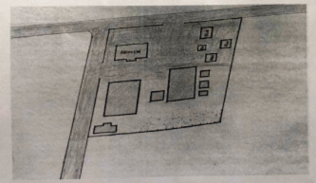

FIG 4.2: SITE PLAN OF CASE STUDY FOUR LOCATED AT EWUALA STREET,
IKORODU LAGOS STATE

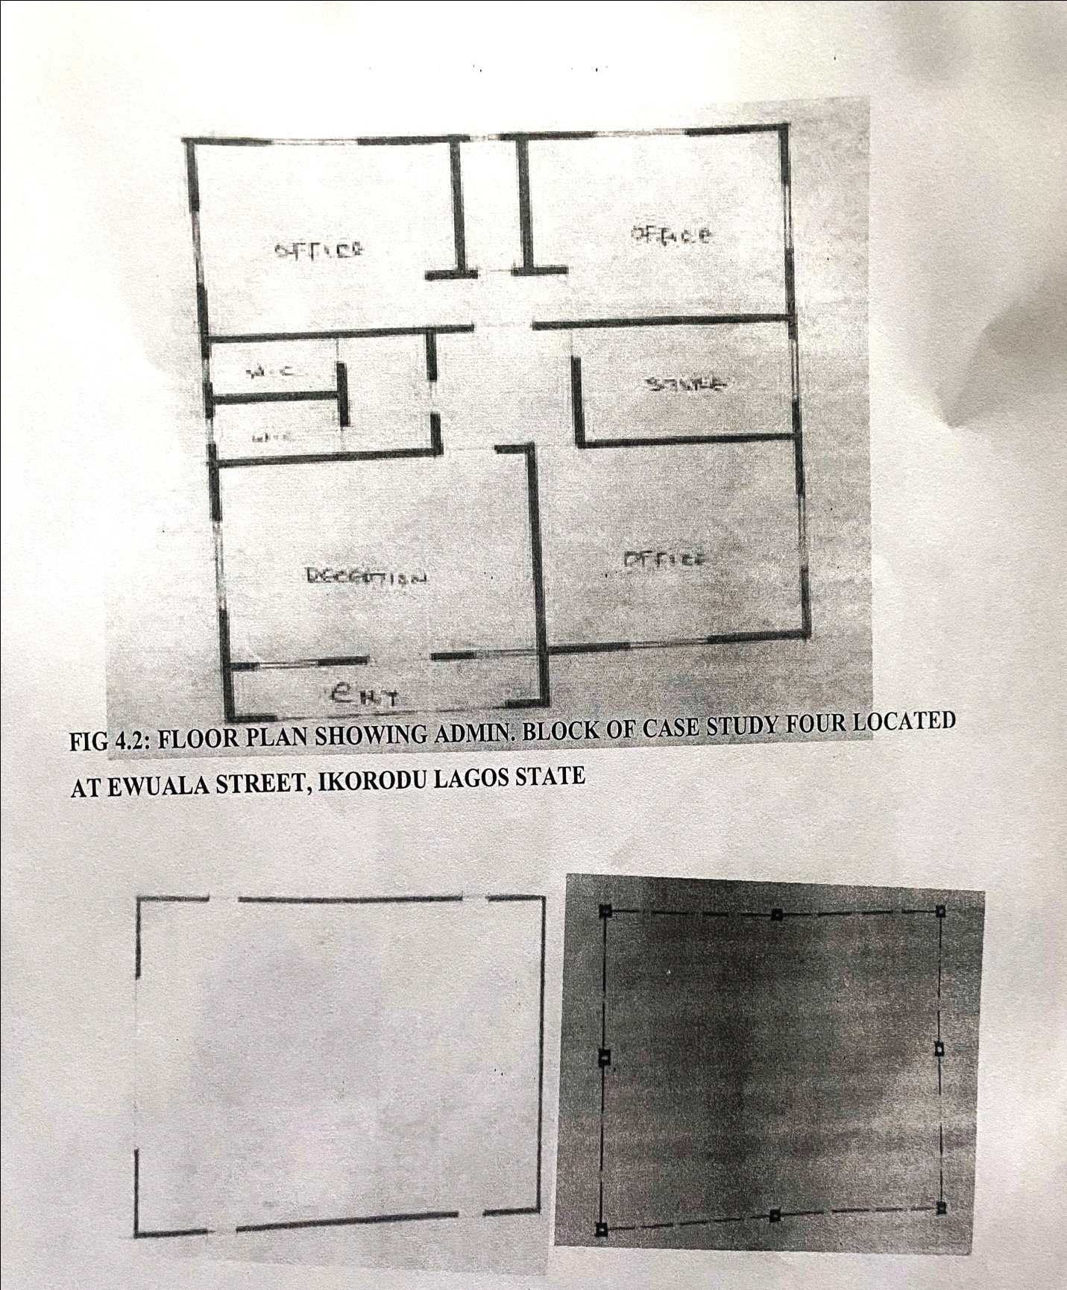

FIG 4.2: FLOOR PLAN SHOWING ADMIN. BLOCK OF CASE STUDY FOUR LOCATED AT EWUALA STREET, IKORODU LAGOS STATE

FIG 4.2: FLOOR PLAN SHOWING SLAUGHTER AND CATTLE PEN OF CASE STUDY FOUR LOCATED AT EWUALA STREET, IKORODU LAGOS STATE
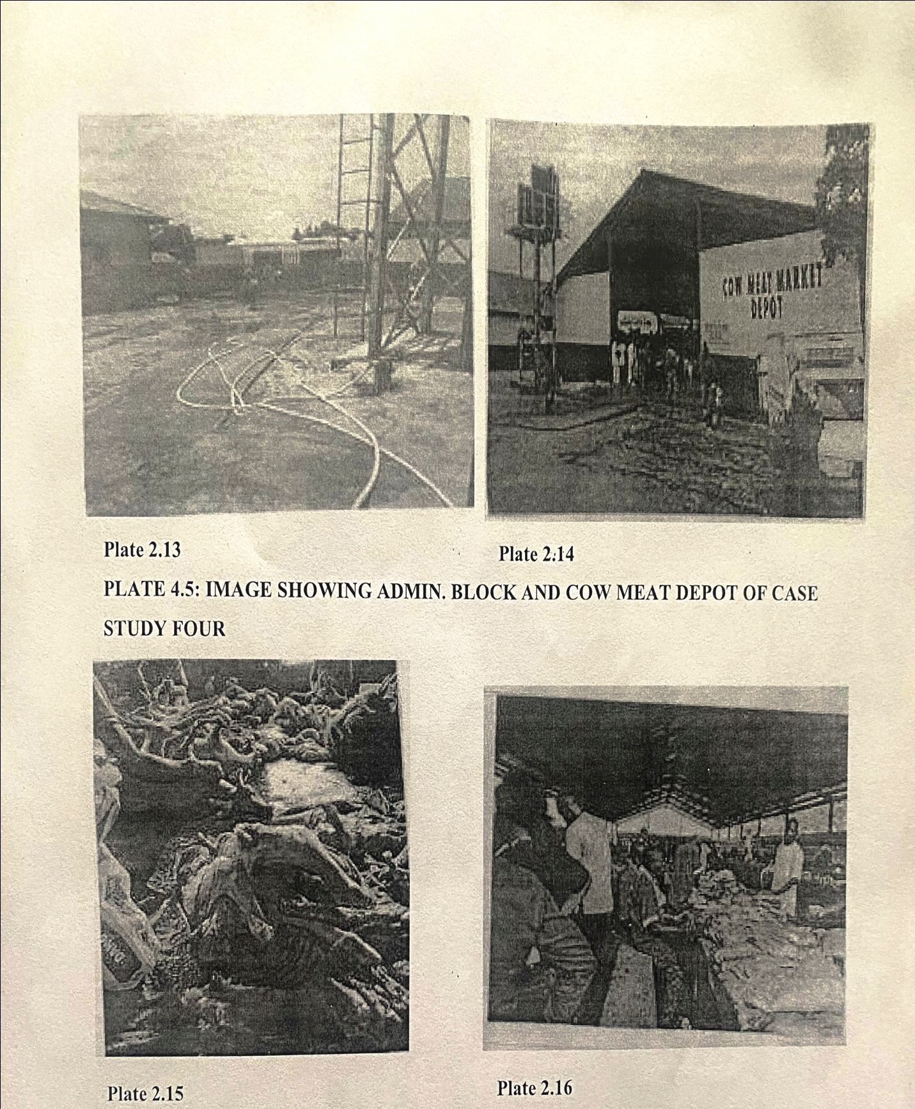

PLATE 4.5: IMAGE SHOWING ADMIN. BLOCK AND COW MEAT DEPOT OF CASE STUDY FOUR

PLATE 4.5: IMAGE SHOWING SLAUGHTER AREA AND CARCASS, CUTTING, BONNING ROOM OF CASE STUDY FOUR

CHAPTER FOUR
4.0 HISTORICAL BACKGROUND OF IBADAN OYO STATE
Ibadan was created in 1829 as a war camp for warriors coming from Oyo, Ife and Ijebu. A forest site and several ranges of hills, varying in elevation from 160 to 275 metres, offered strategic defence opportunities.
Ibadan, coined from the phrase "Eba Odan", which literally means 'by the edge of the meadow', came into existence in 1829, during a period of turmoil that characterized Yorubaland at the time. It was in this period that many old Yoruba cities such as old Oyo (Oyo ile), Ijaye and Owu disappeared, and newer ones such as Abeokuta, new Oyo (Oyo atiba) and Ibadan sprang up to replace them. According to local historians, Lagelu founded the city, and was initially intended to be a war camp for warriors coming from Oyo, Ife and Ijebu. As a forest site containing several ranges of hills, varying in elevation from 160 to 275 metres, the location of the camp offered strategic defence opportunities. Moreover, its location at the fringe of the forest (from which the city got its name) promoted its emergence as a marketing centre for traders and goods from both the forest and grassland areas.
The church and mission in Ibadan, Yoruba country, 1850's, In 1852, the Church Missionary Society sent David and Anna Hinderer to found a mission. They decided to build the mission and a church in Ibadan when they arrived in 1853.
Ibadan thus had initially begun as a military state and remained so until the last decade of the 19th century. The city-state also succeeded in building a large empire from the 1860s to the 1890s which extended over much of northern and eastern Yorubaland. It was appropriately nicknamed idi Ibon or "gun base", because of its unique military character.
In Ibadan, unlike other Yoruba cities with traditional kingship institutions, the warrior class became the rulers of the city as well as the most important economic group.
4.1 SITE LOCATION DESCRIPTION
The site is located at Samonda, Ibadan, Oyo state, Nigeria, It is surrounded with a built up environment with various commercial activities being taken up in the environment or area.

4.2 SITE LOCATION CRITERIA
The choice of site location is determined by some certain criteria. In other to have a good, well planned and functional project, the following criteria are needed to be put in place:
Road Network and Accessibility: There is a call for a need to have a site that is easily accessible. It must be bonded by good federal roads. In the case of this site location at Samonda, Ibadan, Oyo state, Nigeria.
Availability of service: This has to do with the existence and availability of basic amenities. The site must be close to industries so as to enjoy good and stable electricity as well as other amenities.
Proximity: Commercial broadcasting station needs business and corporate organizations for commercial relevance that is, the station needs to be closer to the area where are business entity and government parastatals for commercial relevance through patronage. This aim can only be achieved when the station is situated near different private and government owned organizations.
4.3 SITE ANALYSIS/INVENTORY
The site selected for the project is a very gentle slope, it is a site that has never been used for any form of building construction i.e it has not been developed in the past which makes it an abode for several trees and shrubs, It is also observed during the course of inventory that there some of the trees are to be removed as it could obstruct the construction of the project, while some are to be retained to help control the adverse of wind storm.
The soil is well compacted soil in nature with good soil texture. The sun rises Irom the eastern part of the site and sets on the western part. The construction does not need a special type of foundation due to the fact that the site is having a good bearing capacity and strength.

4.4 GEOGRAPHIC/CLIMATIC DATA
Ibadan has a tropical wet and dry climate, with a lengthy wet season and relatively constant temperatures throughout the year. Ibadan's wet season runs from March through October, though August sees somewhat of a lull in precipitation. This lull divides the wet season into two different wet seasons. November to February forms the city's dry season, during which Ibadan experiences the typical West African harmattan. The mean total rainfall for Ibadan is approximately 1,230 millimetres or 48 inches, falling over about 123 days. There are two peaks for rainfall, June and September. The mean daily temperature is 26.46 °C or 79.63 °F, the mean minimum 21.42 °C or 70.56 °F, and the relative humidity 74.55%.
The chapter focuses on the preliminary stage of the project construction, the site criteria and description as well as the geographical features of the area and of the site in general. Having considered all this features and their advantages to the site, it was regarded and seen to have satisfied the conditions for developing a Modern Abattoir on the proposed land and within the region
4.5 DESIGN CRITERIA
Building is a factor that is needed to be critically considered in designing a Modern Abattoir, There occurs a lot of vibration in a Modern Abattoir, and this is due to the noise produced by some equipment Used in transmission. Having considered these factors, there would also be a need to take into cognizance the walls and floors of some certain parts/units of the Modern Abattoir (such as studio area) how they are to be designed in order to meet the requirement and standard of operation.
BRIEF ANALYSIS (CLIENTS/USERS REQUIREMENTS)
In order to have a good and functioning space which serve the purpose that is has been proposed for, the following units given below by the client as a brief have been provided.
The proposed project has a ground floor with one floor (i.e upper floor) on the
4.5: DESIGN CRITERIA
Planning is an important activity which determines the success of any endeavor. It is often said that without plans, purposes are frustrated, planning is the first and most important steps in designing a MODERN ABATTOIR, so as to achieve aims of designing a good MODERN ABATTOIR the following criteria should be take into consideration.
4.6: SITE SELECTION
A number of factors necessary for site selection for a MODERN ABATTOIR are outlined below
a. Drainage.
b. Waste management.
c. Water.
d. Utilize and services (electricity, telephone, access drives etc.).
e. Orientation (air drainage and maximum sunshine may require orientation on a gentle Southerly slope.
f. Expansion.

4.7: DESIGN SCOPE
There are scope of designing a MODERN ABATTOIR which are the
➤ Inn and out main gate
➤ Security Post
➤ Testing Area
➤ Car washing Area
➤ Water Treatment
➤ Abattoir Production Factory
➤ Admin Building
➤ Staff Quarters
➤ Power Supplied System
➤ Vetinary Area
➤ Cattle Pet/ Yard
➤ Disposal Area

Carrah Place
➤ Pumping house
➤ Herdsman house
➤ Public toilet
➤ Admin park
➤ Lorry park
➤ Cattle gate out
4.8: DESIGN BRIEF
➤ Entrance.
➤ Sign in and out
➤ Supervisor office
➤ Male and female changing room
➤ Male and female convenience
➤ Control room
➤ Livestock receivers room
➤ Blood washing
➤ Material tools storage
➤ Laboratory room
➤ Horn, Bone Skin Storage
➤ Operator office
➤
Production manager office
➤ Director office
➤ Label and record room
➤ Coldroom storage
➤ Loading and offloading bay

PRODUCTION MACHINE FACILITIES
Livestock receiver
Slaughter machine
Bleeding area
Skin remover machine
Skin pelt and hides
Foot, and head remover
Splitting, evisceration
Fat removal
Cooling machine
Meat cut's off
Bone removal
4.9: SPATIAL ALLOCATION

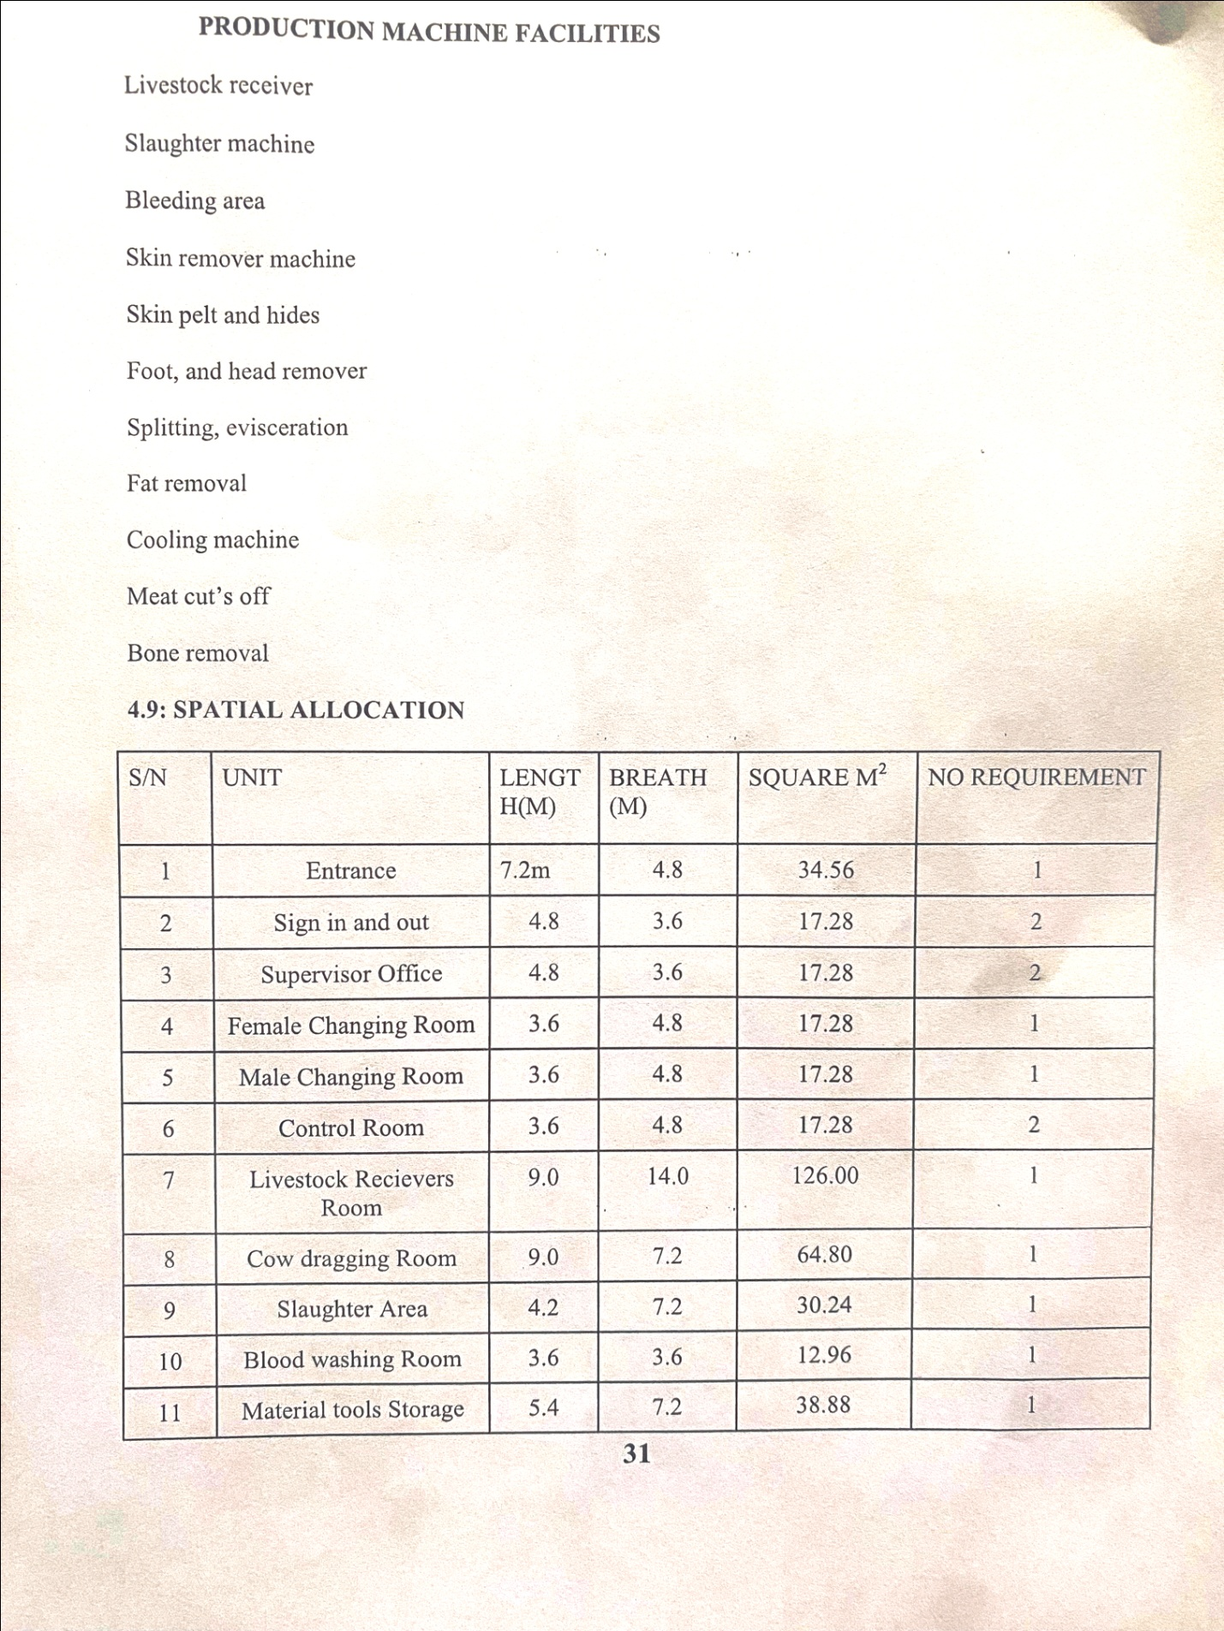

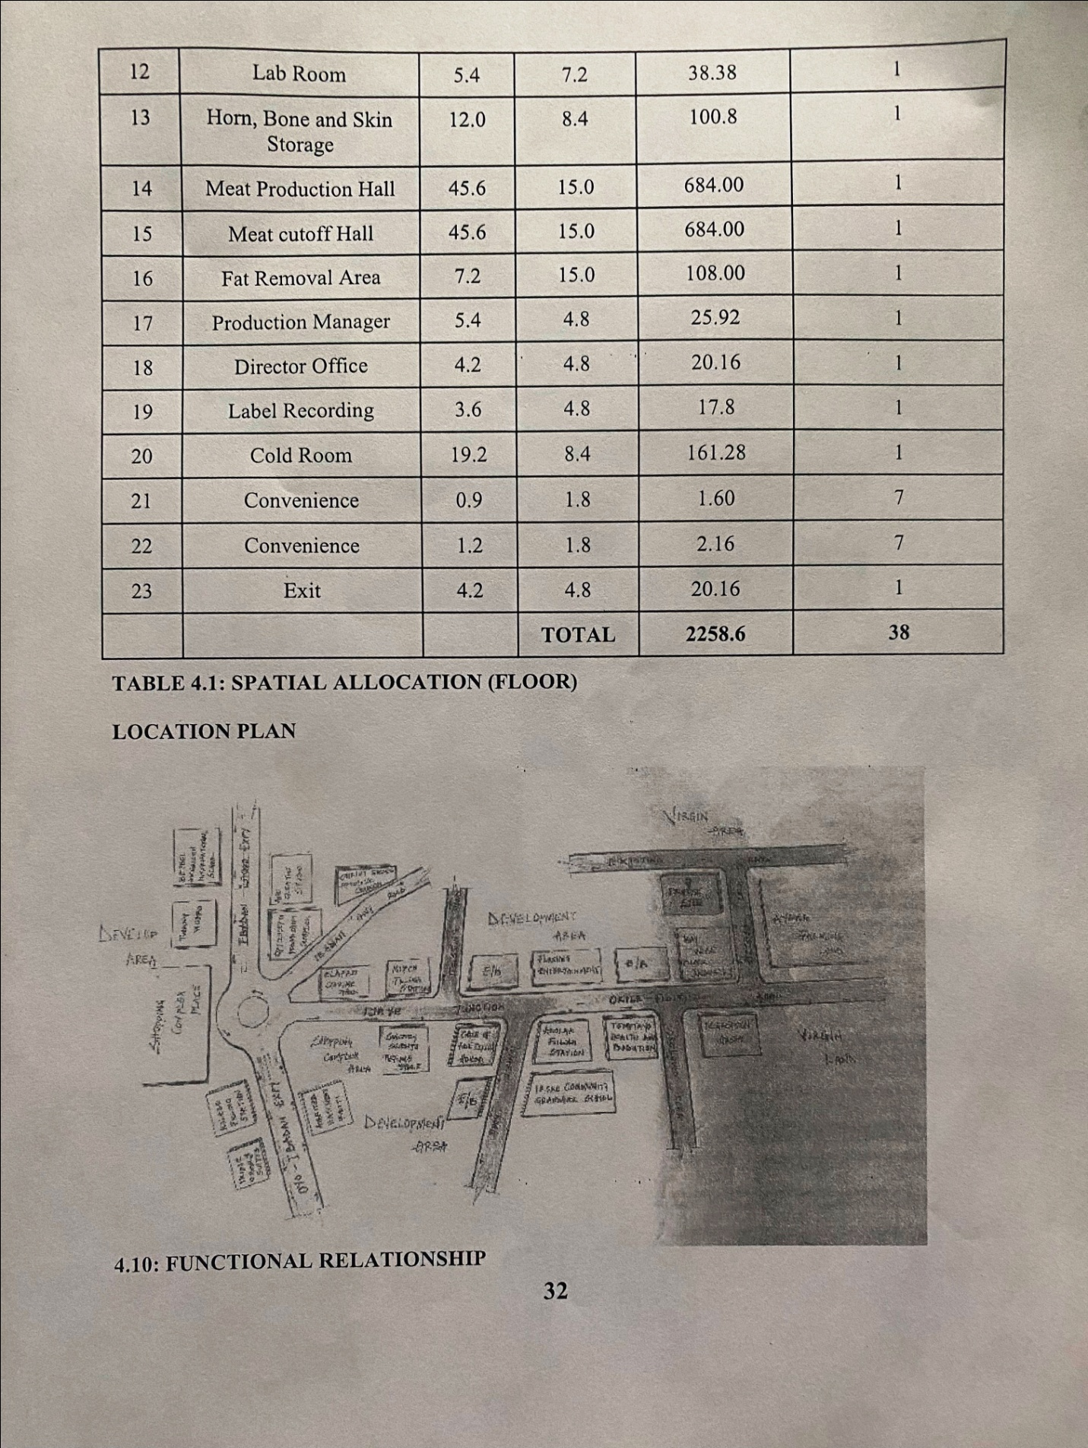

The MODERN ABATTOIR is well function; the units are so well related to each other.
PLATE 4.1: IMAGE SHOWING FUNCTIONAL RELATIONSHIP

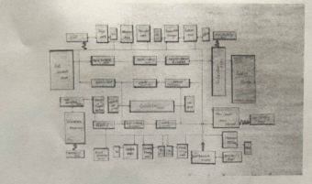

ONLINE CASE STUDY ONE
LOCATION: OKO-OBA ABATTOIR, LOCATED IN LAGOS,
Oko-Oba Abattoir, located in Lagos, Nigeria, is one of the largest and most prominent abattoirs in the country. It was established in the 1970s with the aim of providing a centralized facility for the slaughtering and processing of cattle and other livestock, the abattoir was set up by the Lagos State Government as part of an effort to modernize meat production and ensure sanitary conditions in the handling of livestock. It was designed to centralize meat processing and improve food safety standards.

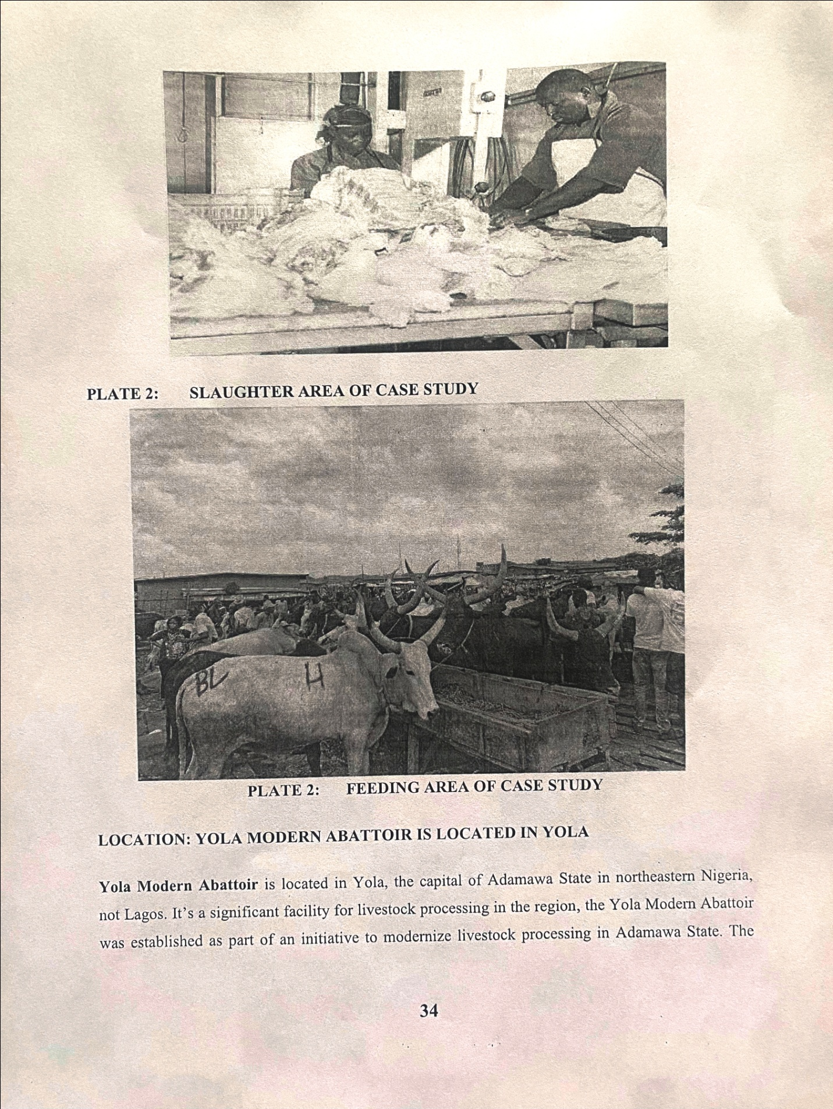

PLATE 2: 2: SLAUGHTER AREA OF CASE STUDY

PLATE 2: FEEDING AREA OF CASE STUDY
LOCATION: YOLA MODERN ABATTOIR IS LOCATED IN YOLA
Yola Modern Abattoir is located in Yola, the capital of Adamawa State in northeastern Nigeria, not Lagos. It's a significant facility for livestock processing in the region, the Yola Modern Abattoir was established as part of an initiative to modernize livestock processing in Adamawa State. The

goal was to provide a more efficient and sanitary facility for slaughtering cattle, sheep, and goats, addressing issues related to traditional slaughtering methods.
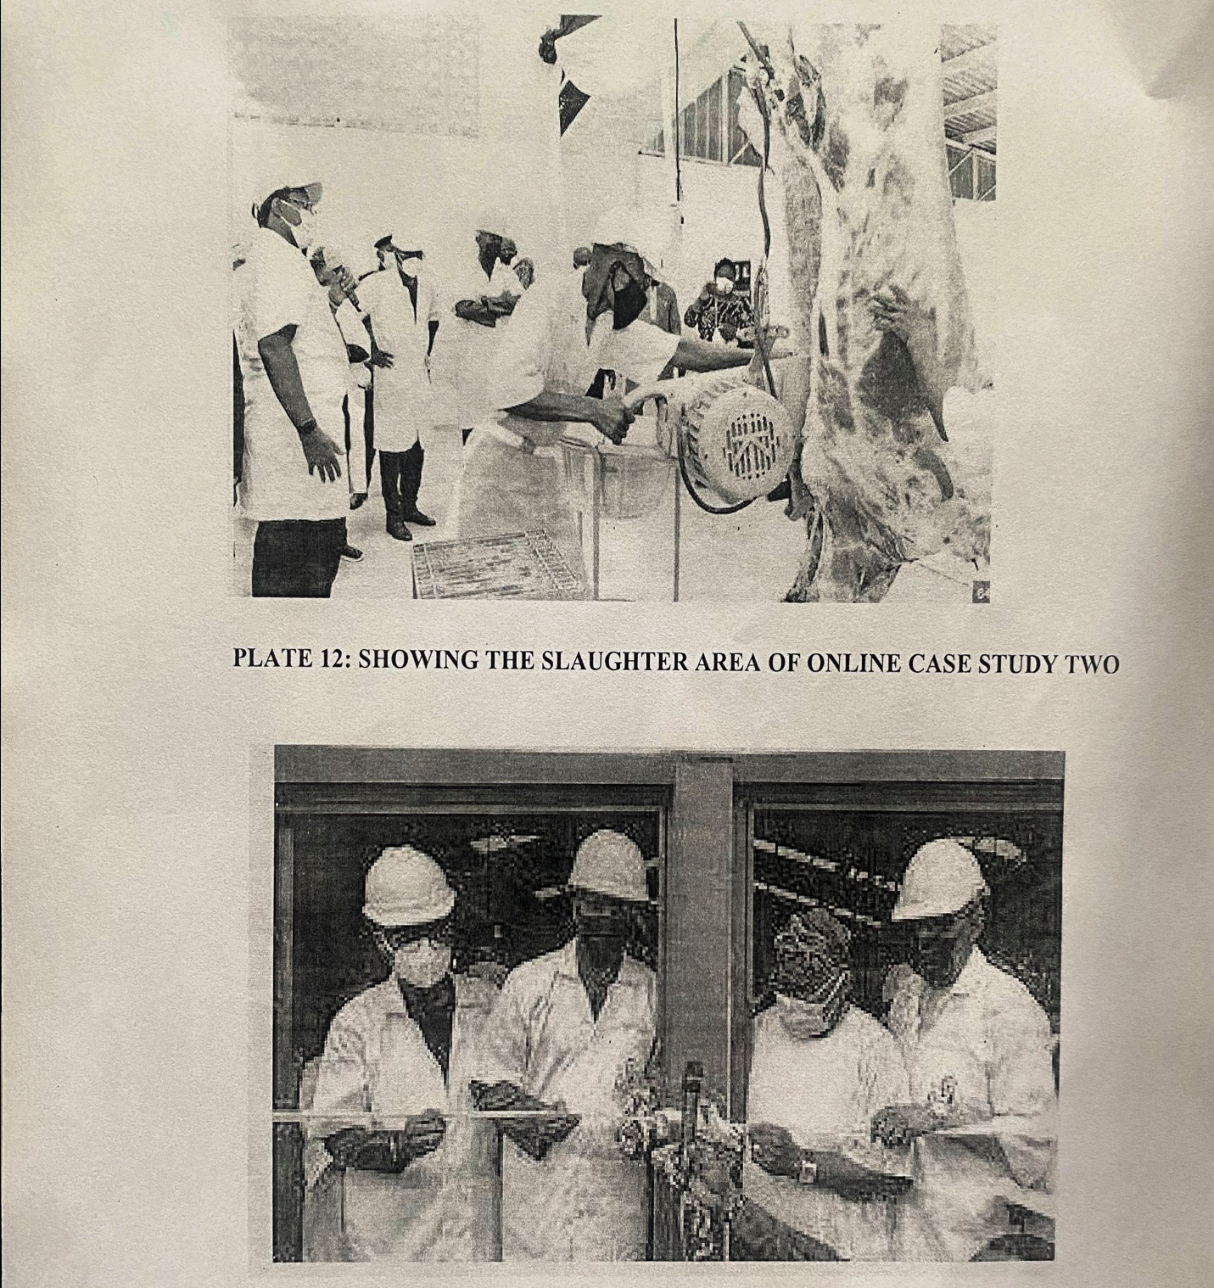

PLATE 12: SHOWING THE SLAUGHTER AREA OF ONLINE CASE STUDY TWO

PLATE 13: SHOWING THE EXTERNAL AREA OF ONLINE CASE STUDY TWO

CHAPTER FIVE
5.0 DESIGN APPRAISAL
In any project design, there are two basic factors that should be taken into consideration. These factors are functionality and aesthetics of the design.
Although to some designers, aesthetic and functionality of any building are incompatible but in the case of this project, both aesthetic and functionality of the design were taken care of to satisfy the highly demanded functional requirement and to create aesthetically and proportionally balanced design.
The functional efficiency of institute of business and vocational studies depends largely on the enclosures of the immediate section that are strongly related in function all these are being taken up as seen on the site and floor plans respectively.
5.1 CONSTRUCTION METHODOLOGY
The method of construction of this project will be more labor-intensive than the capital-intensive strategy because of the concerned professional in the building team. Also, the method of construction will be based on the modern method of technology.
The building form is Horizontal in development. The horizontal line is however contrasted with vertical windows to achieve unity. The entrance is used not only to ease movement but also to create a natural and peaceful setting.
The cement to be used should be Portland cement delivered in good condition to the construction site.
Require mixture of concrete should be used for the construction of the foundation footing, the production hall, etc. Is 1:2:4 mixed with concrete mixed
The supporting system of the building consists mainly of 225 x 225 x 450mm bond, walls, bearing. beams, and columns which are to be made of concrete. A normal strip foundation is considered valuable in the scheme.

The bearing capacity of the soil is adequate to support the structure. The floor of the MODERN ABATTOIR) 150mm thickness over-site concrete shall be used for all the floors in the MODERN ABATTOIR. The floor finish to be adapted for the units depends largely on the function for which the unit is meant to serve.
Floor finishes employed in MODERN ABATTOIR design may include Terrazzo, vitrified, ceramie tiles, vinyl, marble tiles, tiles, Cellotex board, cement screed, and PVC tiles. These finishes reduce the risk of infection from the floor easy to clean and maintain and allow suitable access. It is also used to withstand wear and tear.
ROOF
In Guinea Savannah region such as Ibadan where there is fair rainfall, roof should preferably be of light weight construction with parapet covering it and the external surface should absorb as little solar energy as possible. For these reasons, long span galvanized aluminum roofing sheets is recommended for all parts of the complex in addition to the reinforced concrete roof gutter and concrete roof slab. Steel is recommended as roofing the poultry other unit's timber are to be used.
CEILING
Suspended ceiling is used in some office roof with metal hangers with fanny ceiling at suitable center to center. The ceiling material is prepared to be attractive and easily cleaned. It should be of moderate cost for the above reasons the recommended furnishing of all the offices is cellotex.
WALL
The structural walls of the building are to be constructed with 225mm engine molded sand/cement hollow blocks. The column and beams are properly reinforced with wall the wall whole applicable column and beams are furnished with 25mm gauged smooth. Also most if the units are of framed structured which carried most of the loads. Load bearing masonry wall are also used and furnished

with 25mm thick wall rendering and finally painted according to colour specification schedule in the toilet/lavatories, the wall are to be furnished with ceramic tile to a height of about 2100mm.
DOORS
The doors type and size depends on the door location, but generally range from paneled door to panel folding doors of sizes from 750mm for toilets to 2400mm for the production hall, 1500mm for entrance, 900mm for offices, and 5000mm roller shutter door for lorry bay.
Some doors are purposely made swinging doors for durability, fire resistance and noise control.
WINDOWS
The windows that are to be used range from pivoted windows, projected and Naco louvers blade with metal and aluminum frame.
5.2 DESIGN CHARACTERISTICS
The idea of planning a good surrounding evolves from the primary function. It gives a good aesthetic view to the structure; it enhances the psychological feeling of the public, making use of the area: it make the entire environment healthy, as an adage says "cleanliness is next to godliness". A clean and well planned site is a healthy environment- In view of these the following had been adopted in planning the site.
Landform: As earlier discussed under the topography the land is gentle slope hence it will effect good planning.
Trees: Trees are planted within the institute building to effect natural ventilation. Trees which will not be more than 2.5m high when fully grown are to be planted at reasonable spacing to provide shade for the cat park. Shrubs and trees such as Amelina, Aborea, Flamboyant, Allernande etc. will good foliage are to be planted along the fence and some strategic places within the site to provide shade and serve as sun's and wig breakers. The trees also reduce the atmospheric temperature arid release of oxygen during photosynthesis makes the atmosphere cold,
Grasses: Grasses give good impression of an environment and also protect the land surface from erosion for this project, Bahamas grass is recommended for all the lawn area. Some courtyard that

are not busy arc covered with lawns, fines grasses like Kikuyu grass are planted in the courtyard and some part are cemented for relaxation purpose.
Flower beds: A well planned flower arrangement gives aesthetic to environment. Flower are grown along the walkways an around the main building generally except where it can obstruct vehicular pedestrian movement. Flower such as splender, Bryphallion roses, lady on boat, ice plant etc. are planted.
Hedges: Hedges are also planted along some part of the walkways. In the courtyard while shrubs are also used along vehicular ways. The following shrubs are used for the hedge. Dodonea viscosal (Josorevet). The vital (bush mil) casavatinal equstifollic (Whistling pic). Shrub such as spoted croton. Euphobia splender (desert rose) are planted for their beautiful leaves and good scents also for ornamentation.
Parking Space: Parking lots are located in front of administrative offices to service the administrative loading send concrete block should be Portland cement delivered in good condition to the construction site all the instruction given in civil engineering drawing will be thoroughly and strictly adhered to in order to avoid failure. The walkways should be constructed of concrete roof laid to fall with 2 layers of bitumen fact.
The roof member should be firmly secured. The mortar bed should be at least 25mm thick bond of block should be stretcher bond.
PROCESSING FLOW CHART MODERN ABATTOIR
mechanical
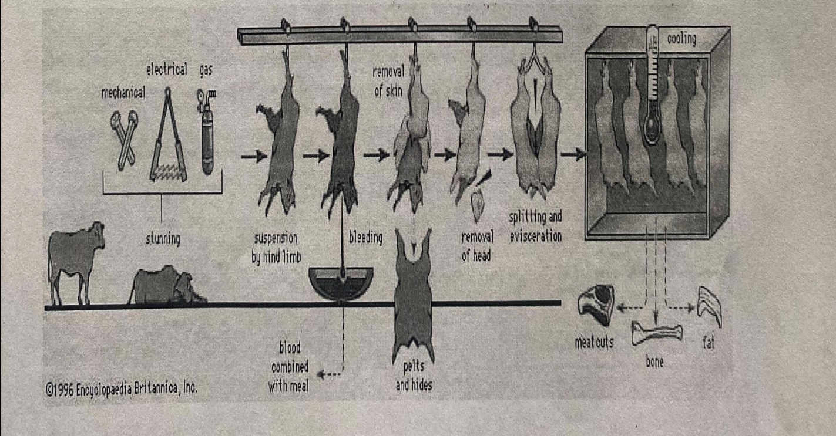

Creating a processing flow chart for a modern abattoir involves outlining the sequential steps involved in the slaughter, processing, and packaging of animals. Here's a simplified example of a processing flow chart for a modern abattoir:
Processing Flow Chart of Modern Abattoir
Receiving Area: Animals are received from farms or livestock markets, upon arrival, animals are unloaded from transport vehicles and directed to holding pens.
Pre-Slaughter Inspection: Veterinary inspectors conduct pre-slaughter inspections to assess the health and condition of animals, animals deemed unfit for slaughter are separated for further evaluation or treatment.
Stunning: Animals are moved to the stunning area, various stunning methods are employed, such as captive bolt stunning, electrical stunning, or gas stunning, depending on animal species and regulatory requirements, stunning renders animals unconscious and insensitive to pain before slaughter.
Bleeding and Sticking: after stunning, animals are moved to the bleeding and sticking area, a
skilled operator performs a precise incision to sever major blood vessels, facilitating blood drainage, proper bleeding ensures thorough exsanguination and minimizes carcass contamination.
Scalding and Dehairing (for certain species): Some species, such as pigs, undergo scalding and dehairing to facilitate hair removal, Carcasses are submerged in hot water to loosen hair follicles, followed by mechanical dehairing equipment.
Evisceration:Carcasses are transferred to the evisceration area, skilled workers remove interual organs, including the intestines, liver, lungs, and heart, care is taken to prevent contamination of the carcass with intestinal contents.
Carcass Splitting and Dressing: Carcasses are split into halves or quarters, depending on
processing requirements and market preferences, trimming and dressing operations may be performed to remove excess fat and connective tissue.

Chilling and Cooling:Carcasses are chilled to reduce temperature and inhibit bacterial growth, chilled carcasses are stored in refrigerated rooms or coolers until further processing or packaging.
Cutting and Fabrication: Carcasses or primal cuts are further processed into retail cuts or value-added products, skilled butchers use cutting equipment to portion meat according to customer specifications.
Packaging and Labeling: Processed meat cuts are packaged using vacuum sealing or modified
atmosphere packaging (MAP) techniques to maintain freshness, packages are labeled with product information, including weight, expiration date, and nutritional content.
Storage and Distribution: Packaged meat products are stored in refrigerated warehouses or distribution centers, products are distributed to retail outlets, restaurants, or other customers according to demand.
Waste Management: Waste materials, including offal, trimmings, and blood, are collected for disposal or rendering, effluent from processing operations is treated to comply with environmental regulations.
Conclusion: This processing flow chart provides a systematic overview of the steps involved in the operation of a modern abattoir, from receiving animals to packaging and distribution of meat products. By following a well-defined processing flow, abattoirs can ensure efficiency, quality, and compliance with regulatory standards.
This flow chart outlines the major steps involved in processing animals in a modern abattoir. Depending on the specific facility and processing requirements, additional steps or variations may exist.
5.3: BUILDING STRUCTURE
The whole MODERN ABATTOIR is a one storey building supported by beams and column at appropriate intervals. The type of structure for a MODERN ABATTOIR are;
1. Traditional Brick-and-Mortar Building: This is a conventional approach where the MODERN ABATTOIR is constructed using bricks, concrete, and steel. It typically consists of multiple floors,

with each floor dedicated to different stages of rice processing, including cleaning, hulling, polishing, grading, and packaging.
2. Steel Building: Steel structures offer flexibility in design and construction. Pre-engineered steel buildings are often used for industrial purposes, including rice mills. They are quick to assemble, cost-effective, and provide a clear span, allowing for efficient use of space. Steel structures can be customized to accommodate the required machinery, processing equipment, and storage areas.
3. Warehouse Conversion: An existing warehouse can be repurposed or converted into a
MODERN ABATTOIR. This option can be suitable if the warehouse meets the necessary requirements in terms of space, layout, and infrastructure. It may require modifications to incorporate specific areas for processing, storage, and administrative functions.
4. Modular or Prefabricated Structures: Modular buildings consist of pre-manufactured
components that are assembled on-site. These structures offer speed and ease of construction, making them a viable option for rice mill factories. They can be designed to meet the required specifications and can be expanded or relocated if needed.
5. Container-based Facility: Shipping containers can be modified and repurposed to create a
compact MODERN ABATTOIR. This option is suitable for smaller-scale operations or in areas with space constraints. Container-based facilities are portable, cost-effective, and can be customized to accommodate necessary machinery and equipment.
5.4 MATERIALS AND FINISHES
The influence of building material on construction works in form and its environs is similar to what prevails in the middle belt of the country. In the south the rainfall encourages the use of parapet wall to reduce falling out of the roof by heavy wind (either North-east or South-west trade wind). Concrete/sand Crete blocks in rectangular moulds are often used for wall construction with a standard of 100mm, 150mm and 25mm thickness.
The material choice and finishes are influence by a number of factors such as follows:
i. The durability and suitability of materials
ii. Geology and topography of the site
iii Availability of materials
iv The climatic condition
v. Properties of materials
vi. The coat of the materials
5.5 SERVICES
Electricity is tapped from the nearest pole of the project area. The main water pipeline is closely located to the site where drinking water can be tapped- Telephone line is within the area which makes connection casy.
The entire roof drains runs to the surrounding gutter which finally drains to the main gutter along the public drainage all the solid and liquid wastes are effectively disposed of by the soak away pits and septic tanks, A central AC system shall be fixed where appropriate.
5.6 RECOMMENDATION
Throughout the design process (from inception to the final detailed drawing). Consideration has been given to a simple hut functional design, which takes care of all problems in the existing farmstead, however this project is part of the pace to creating work, this will serve as means of food production and provision of job.
Since design generally are affected by various factors ranging from finance, nature of site, material choice and availability as well as various other factors, the design could vary but the approach and concept are basically within a range everywhere,
5.7 CONCLUSION
In conclusion, the deduction and experiences learnt and gained from the essential research which was carried out on the MODERN ABATTOIR design Nigerian, and online other country like USA, especially as I have realized from the research has follow functions that follow one another. It also enables me to know what is needed in the rice production, it make me understand, the unit and what they are used for, In my design, I have made sure the unit are well arranged because of the rice work that will be take place, the site is well functioned.

REFERENCES
Architect Data, Neufert E, (2013).
Architects data, Ernest Neufert (2010).
Alexander, C. (1997), the Timeless Way of Building. Oxford University Press.
Ваrrу г. (2013), Building construction (vol. ii and iii).
Barry, R. (1972), the Construction. Published by English Edition Book Society.
Bechelard, G. (1964), the Poetics of Space. New Edition, Published by Orion Press, Chicago.
Culvahouse, T. (Ed) (2007), Design and Persuasion: Princeton Press Publisher.
Flusty, S (1997), 'Building Paranoia' in New Edition Architecture of Fear, Princeton Architectural press, London.
Fredercik, M. (2007) 101, Things 1 Learned Architecture School, MIT Press.
Goffman, E. (1963), Behaviour in Public Places. Revised Edition, the Free Press, England.
Hornby, A. S. (1980), Oxford Advance Learner's Dictionary, (Latest Edition) Published by Oxford University Press.
Hornby A. (2011), Advance learner's dictionary oxford university press.
Morio, Salvadior, A. (1990), Why Buildings Stand Up: The strength of Architecture. Published by Norton Press.
Peter Smith's (2015), Strategy for Architectural designs.

APPENDICES

