A PROJECT REPORT
ON
PROPORSED PRIMARY SCHOOL
FOR MR OLAIDE OLUTAYO,
ILORIN, KWARA STATE.
BY
ADEAGA TIMILEYIN DEBORAH
ND/23/ARC/PT/0063

BEING A PROJECT REPORT SUBMITTED TO
THE DEPARTMENT OF ARCHITECTURAL TECHOLOGY, INSTITUTE OF
ENVIRONMENTAL STUDIES,
KWARA STATE POLYTECHIC, ILORIN.

IN PARTIAL FULFILMENT OF THE REQUIREMENT FOR
THE AWARD OF NATIONAL DIPLOMA (ND)
IN ARCHITECTURAL TECHNOLOGY.

JULY, 2025

DECLARATION
I hereby declare that this Project work is a record of original work carried out by me ADEAGA TIMILEYIN DEBORAH, under the supervision of ARC FAMILUA O.S. This project has not been previously submitted for the award of any degree diploma in this institution. All information and data collection from other source have been duly acknowledge.

ADEAGA TIMILEYIN DEBORAH


CERTIFICATION

I certify that this research project entitled PRIMARY SCHOOL was carried out by ADEAGA TIMILEYIN DEBORAH under the supervision ARC. FAMILUA O.S. has been approved. As meeting the requirement for the award of National Diploma in Architectural Technology, Kwara State Polytechnic, Ilorin, Kwara State.

ARC FAMILUA O.S ____________________
Project Supervisor SIGNATURE & DATE

ARC OLAREWAJU F.A _____________________
Project Coordinator SIGNATURE & DATE

ARC J.M TOMORI ______________________
Head of Department SIGNATURE & DATE

_____________________
EXTERNAL EXAMINER SIGNATURE & DATE

ACKNOWLEDGEMENT
I would like to express my sincere gratitude to Almighty God for giving me the strength, wisdom, and good health to carry out this project successfully.
My heartfelt appreciation goes to my supervisor, ARC FAMILUA O.S, for their valuable guidance, support, and constructive feedback throughout the course of this project. Their dedication and encouragement have been instrumental in the successful completion of this work.
I would also like to thank the entire staff of the Architectural Technology, Kwara State Polytechnic, our able H.O.D ARC. J.M TOMORI and the whole host of lectures. ARC. OLAREWAJU F.A, ARC. CHUKWUMA NMOM, ARC. MOH SHERO for providing a conducive environment and resources necessary for my research.
Special thanks to my family, my parent PASTOR AND MRS MOSES ADEAGA, MR FUNSO ADEAGA, MR YINKA ADEAGA, MRS FIKAYOMI OLWUNMI,ARC OLUTAYO my brothers and sisters, and friends for their continuous support, encouragement, and prayers during this project.
Lastly, I am grateful to everyone who contributed in one way or the other to the success of this work. Your support is deeply appreciated.
Thank you all.

DEDICATION
This project work is dedicated to Almighty God who has been providing all my need for his blessing and mercy over me all through the program and to my parent

TABLE OF CONTENT
TITLE PAGE i
DECLARATION… ii
CERTIFICATION… iii
ACKNOWLEDGEMENT… ..iv
DEDICATION… v
TABLE OF CONTENTS… vi
LIST OF TABLES… x
LIST OF FIGURES… xi
LIST OF PLATES… xii
LIST OF APPENDICES… xiii
ABSTRACT… xiv
CHAPTER ONE
  - INTRODUCTION……………………………………………………………………...1
1.2 DEFINITION… 3
1.3 HISTORICAL BACKGROUND 3
1.4 AIM AND OBJECTIVES … … 4
1.5 PROJECT JUSTIFICATION … .. 4
1.6 CLIENT BACKGROUND 4
1.7 SCOPE OF THE PROJECT 5
1.8 RESEARCH METHODOLOGY… 5
CHAPTER TWO
2.1 LITERATURE REVIEW………………………………………………………….....6
2.2 HISTORICAL BACKGROUND 6

CHAPTER THREE
3.1 CASE STUDIES……………………………………....………………………………6
3.2 SELECTED CASE STUDIES 6
3.3 CASE STUDY ONE 7
3.3 CASE STUDY TWO… 11
3.4 CASE STUDY THREE………………………………………………………………………13
3.5 ONLINE CASE STUDY……….……………………………………………………………..15
3.6 DEDUCTION …... ……………………………………………………………………...17
CHAPTERFOUR
BRIEF HISTORICAL BACKGROUND………………………………………………...18
LOCATION AND SETTING OUT…………….……………………………………...…....19
POPULATION……………………………………………………………………………..…….19
SITE INVENTORY……..………………………………………………………………………...21
SITE ANALYSIS…….…………………………………………………………………………...21
SITE SELECTION AND JUSTICATON……….…………………………………………….......22
LOCATION ….. ………………………………………………………………………………..22
ACCESSIBILITY………….……………………………………………………………………..22
INFRASTURE FACILITIES…………...……………………………………………………….. 23
TOPOGRAPHY…………………………………………………………………………………... 23
SOIL STRUCTURE…………………………………………………………………………….. 23
GENERAL CLIMATIC CONDITION…………….……………………………………………. 23
RELATIVE HUMIDITY…………………………………………………………………... 23
WIND…................................................................................................................................. 23
TEMPERATURE…………………………………………………………………………………24
VEGETATION…………………………………………………………………………………...24
ROAD…………………………………………………………………………………………24
WATER AND ELECTRICITY………………………………………………………………...24
DESIGN CRITERIA……………………………………………………………………………….25
DESIGN BRIEF 25
DESIGN ANALYSIS 25
SPACIAL ALLOCATION 26
PLANNING PRINCIPLE… 28
CHAPTERFIVE
APPRAISAL OF PROPOSED SCHEME…………………………………………………. 29
CONSTRUCTION METHODOLOGY…………………………………………………… 29
SERVICES…………………………………………………………………………………. 29
VENTILATION 30
LIGHTING..… 30
PLUMBING 30
ELECTRICAL INSTALLATION… 30
WASTE DISPOSAL 31
FIRE PROTECTION… 31
RAIN PROTECTION… 31
EXTERNALWORK… 31
SUMMARY… 31
CONCLUSION… 32
RECOMMENDATION… 32
REFERENCES 33
APPENDICES 34

LIST OF TABLES

TABLE1;SHOWING THE POPULATION OF THE GENDER 25

TABLE2;SHOWING SPACIAL ALLOCATION OF FLOOR PLAN… 30

LIST OF FIGURES
FIG1;SHOWING LOCATION PLAN OF CASE STUDY ONE… 10
FIG2;SHOWING FLOOR PLAN OF CASE STUDY ONE… 10
FIG3;SHOWING LOCATION PLAN OF CASE STUDY TWO… 13
FIG4;SHOWING FLOOR PLAN OF CASE STUDY TWO… 14
FIG5;SHOWING LOCATION PLAN OF CASE STUDY THRE… 16
FIG6;SHOWING FLOOR PLAN OF CASE STUDY THREE… 17
FIG7;SHOWING LOCATIONAL PLAN OF THE PROPOSED SITE… 24
FIG8;SHOWING SITE INVENTORY OF THE PROPOSED SITE… 26
FIG9;SHOWING SITE ANALYSIS OF THE PROPOSED SITE… 27

LIST OF PLATES

PLATE1; SHOWING FRONT VIEW OF CASE STUDY ONE… 11

PLATE2; SHOWING LEFT&RIGHT VIEW OF CASE STUDY ONE… 11

PLATE3; SHOWING FRONT VIEW OF CASE STUDY THREE… 14

PLATE4; SHOWING RIGHT VIEW OF CASE STUDY THREE… 15

PLATE5; SHOWING BACK VIEW OF CASE STUDY THREE 16

PLATE6; SHOWING LEFT VIEW OF ONLINE CASE STUDY 18

PLATE7; SHOWING FRONT VIEW OF ONLINE CASE STUDY 18

LIST OF APPENDICES
APP1; SHOWING SITE PLAN OF THE PROPOSED PROJECT 45
APP2; SHOWING FLOOR PLAN OF THE PROPOSED PROJECT 45
APP3; SHOWING ROOF PLAN OF THE PROPOSED PROJECT 46
APP4; SHOWING CROSS SECTION OF THE PROPOSED PROJECT 46
APP5; SHOWING FRONT VIEW OF THE PROPOSED PROJECT 47
APP6; SHOWING SIDE VIEW OF THE PROPOSED PROJECT 47

ABSTRACT
This research work was carried out on the project topic "Primary School". I felt caring out this project in local government will bring out meaningful result. For easy analysis and understanding, the study is being put into five chapters. Chapter one throws light on general introduction, definition of the project, historical background information of the project title, project justification, aim and objectives of the study, scope of the study, Chapter two, a detailed literature review of some books, case studies and deduction from case studies. The third chapter three also mention about the historical background of the study area, site location and description, site analysis, and geographical location, climatic data, population of the area, social services, and health services. The fourth chapter deals with design criteria, design analysis, space allocation and planning principle. Chapter five deals with design appraisal, construction methodology, services, summary, conclusion and references.

CHAPTER ONE
1.1 INTRODUCTION
Education is the cornerstone of societal development, and the foundation of this begins at the primary school level. A primary school serves as the initial formal environment where children acquire basic knowledge, skills, and values that shape their future learning and behavior. It is at this stage that children are introduced to literacy, numeracy, social interaction, and moral development.
This project focuses on the design, construction, and necessary facilities required for a standard primary school. The aim is to create a safe, functional, and stimulating learning environment that meets both educational and infrastructural standards. The school will include classrooms, administrative offices, toilets, a library, playground, and other essential services such as proper ventilation, lighting, plumbing, and fire safety systems.
The report provides a comprehensive overview of the planning, design methodology, construction processes, and services integrated into the school structure. It emphasizes how these elements collectively support effective teaching and learning, while ensuring the health, safety, and well-being of pupils and staff.
Education at the primary school level lays the foundation for all future learning and personal development. It is during these formative years that children begin to develop essential skills such as literacy, numeracy, critical thinking, and social interaction. The purpose of this project report is to provide a detailed overview of the primary school environment, focusing on various aspects such as infrastructure, facilities, teaching methods, learning resources, and student welfare.
This report was developed to explore how a well-structured and conducive school environment contributes to the academic and moral development of pupils. By examining key areas such as classroom settings, teacher-student relationships, extracurricular activities, and the overall learning atmosphere, the project seeks to highlight the importance of a solid educational foundation for children at the basic level.
Furthermore, this report aims to identify both the strengths and areas for improvement in the chosen school setting, using observations, interviews, and literature reviews. By doing so, it hopes to serve as a valuable reference for educators, school administrators, policymakers, and other stakeholders who are committed to enhancing the quality of education in primary schools.
In summary, this project emphasizes the critical role of primary education in shaping responsible, knowledgeable, and confident individuals who will become the leaders of tomorrow.

  - DEFINITION OF PRIMARY SCHOOL
A primary school is an educational institution that provides the first stage of formal education for children, typically between the ages of 5 and 11 years. It serves as the foundation of a child’s academic journey, where basic subjects such as reading, writing, mathematics, science, and social studies are introduced. Primary education aims to develop essential skills, knowledge, and values needed for personal development and future learning.

1.3 HISTORICAL BACKGROUND
The concept of primary education has its roots in ancient civilizations, where informal learning took place within families and communities. However, the idea of structured, formal education for young children began to take shape much later in history.
In ancient Egypt, Greece, and Rome, education was primarily reserved for the elite, and early forms of schooling were focused on philosophy, reading, and writing. During the Middle Ages in Europe, education was often provided by religious institutions, particularly the Church, and was mainly available to boys from wealthy families. The curriculum focused on religious studies, Latin, and arithmetic.
The idea of universal primary education began to emerge during the Enlightenment period in the 17th and 18th centuries, when philosophers like John Locke and Jean-Jacques Rousseau emphasized the importance of early childhood education and the right of every child to learn. In the 19th century, with the rise of industrialization, many governments recognized the need for an educated population and began to establish formal public education systems.
In England, the Education Act of 1870 marked a significant step in making primary education compulsory. Similar developments occurred across Europe and the United States. By the early 20th century, many countries had introduced laws making primary education free and mandatory.
In Nigeria, the development of primary education began during the colonial era. Christian missionaries played a significant role in establishing the first primary schools in the 19th century. The first primary school in Nigeria is believed to be the Nursery of Infant Church School, established in Badagry by the Wesleyan Methodist Mission in 1843. These early schools were primarily aimed at teaching literacy and religious knowledge. Over time, the government began to take more responsibility for education, leading to the introduction of universal primary education (UPE) in 1976.
Today, primary education is recognized globally as a fundamental human right and a necessary foundation for lifelong learning and development. It continues to evolve with changes in educational policy, technology, and teaching methods, but its core purpose—to provide children with the basic knowledge and skills they need to succeed in life—remains unchanged.

1.4 AIM AND OBJECTIVES OF THE PROJECT
AIM OF THE PROJECT
The primary aim of this project is to design a safe, functional, and child-friendly primary school that supports learning through proper layout, lighting, ventilation, and accessibility, while promoting comfort, safety, and sustainability.

OBJECTIVES OF THE PROJECT
To provide a safe and secure learning environment
To promote effective learning through spatial organization
To ensure flexibility and adaptability of spaces
To maximize natural light and ventilation
To promote accessibility and inclusiveness
To encourage outdoor learning and play
1.5 PROJECT JUSTIFICATION
As an architect, my justification for this project is o give foundational knowledge, cognitive development, character development, socialization and equal opportunities
1.6 CLIENT BACKGROUND
The name of my client is MR OLAIDE OLUTAYO
Mr Olaide Olutayo is a lawyer in one of the High Court here in Ilorin, He is known to be a trustworthy and reliable gentleman.
1.7 SCOPE OF THE STUDY
- Proposed Building
- Playing Ground
- Clinic
- Field
- Storex
- Power House
- Security House
- Parking Space

1.8 RESEACH METHOLODY
Various avenues were expressed as regards the method of research on order to arrive at a functional and appealing design concepts. The following research methods were employed.
CASE STUDY: This is the method that carried out in which to gain more detailed experience in my project topic daycare center.
ORAL INTERVIEW: An oral interview in the method I carried out to collect more information by directly engaging with individual e.g manager the workers, the citizens and other to gain more experience on my project
LITERATURE REVIEW: This is the process by which I carried out in the process of reach, articles, niddles and others materials on my project.
CHAPTER TWO
2.0 LITERATURE REVIEW
2.1 HISTORICAL BACKGROUND OF A PRIMARY SCHOOL
PRIMARY SCHOOL
The historical background of a primary school can be traced to the early efforts of societies to provide foundational education to young children. In most parts of the world, primary schools evolved out of the need to offer formal education to children during their early developmental years. Initially, education was informal and took place at home, where children learned through observation and participation in daily activities.
As societies advanced, the importance of organized learning became more evident. In many cultures, religious institutions such as churches and mosques were among the first to establish schools where children were taught to read, write, and understand religious texts. Over time, the curriculum expanded to include arithmetic, language, and moral instruction.
The concept of primary schooling as we know it today began to take shape during the 18th and 19th centuries, particularly in Europe, where governments began to recognize education as a tool for national development and social progress. Laws were enacted to make primary education compulsory and accessible to all children, regardless of their background.
In many developing countries, including those in Africa, the foundation of primary schools was largely influenced by colonial administrations and missionary efforts. Christian missionaries were among the first to establish primary schools in various regions, primarily for the purpose of religious education and literacy. These schools laid the groundwork for the modern primary education system.
Over the years, primary schools have evolved significantly, both in structure and function. Governments have taken over the responsibility of providing free and compulsory primary education to ensure that every child has access to basic learning. This has led to the construction of more schools, recruitment of trained teachers, and the development of national curricula designed to meet educational standards and prepare children for secondary education.
Today, primary schools are recognized as the foundation of formal education, playing a vital role in the cognitive, emotional, and social development of children. They are often the first structured environment where children learn discipline, cooperation, and problem-solving skills, making them essential to both individual and national development.

  - PRIMARY SCHOOL IN UK
The history of primary education in the United Kingdom is a story of gradual development, reform, and inclusivity, with the educational experience structured around the age of the child. Over centuries, the system has evolved to accommodate children from as early as age 3 in nursery, up to 11 in primary school, and beyond. Each age group has been historically integrated into the educational system through specific reforms, policies, and acts that reflect changing societal needs and government priorities.

Early Childhood (Ages 3–4): Nursery and Pre-school: Historically, children under the age of five were not part of any formal education system. Before the 20th century, children aged 3 to 4 often remained at home or were cared for by family while older siblings attended elementary schools. The need for early childhood education emerged during and after the Industrial Revolution, when working-class mothers increasingly worked in factories. This led to the establishment of day nurseries in the late 19th century, though these were more focused on care than education.
The idea of structured early learning gained momentum in the 20th century. In the 1960s and 70s, educational psychologists and social reformers pushed for early childhood education to prepare children socially and intellectually for school. The Education Act of 1981 and later the Childcare Act 2006 paved the way for state-supported nursery education. Today, nursery education is widely available and often state-funded for children aged 3 and 4, providing them with foundational experiences in communication, play, motor skills, and early literacy.

Reception (Age 4–5): Introduction to Formal Schooling: The concept of Reception — the first year of formal schooling — did not exist in the 19th century. Children typically entered school at age 5 or older. However, as early childhood education gained importance, the school system adapted to include a transitional year for 4-year-olds.
The introduction of the Early Years Foundation Stage (EYFS) in the Early 2000s formalized this stage of learning, emphasizing child development, learning through play, and school readiness. Reception became a standard part of primary school education for children aged 4 to 5, blending the informal nature of nursery with a structured learning framework.

Key Stage 1 (Ages 5–7): Infant Education: The origin of formal primary education in the UK began with children aged 5 to 7. The Elementary Education Act of 1870 (Forster Act) marked the beginning of publicly funded schooling for children from the age of 5. Although attendance was not compulsory at first, the Elementary Education Act of 1880 made schooling compulsory from age 5 to 10, gradually extended by later acts.
Children in this age group traditionally attended Infant Schools, which focused on basic literacy, numeracy, and moral instruction. The Education Act of 1944 further formalized this structure, dividing primary education into: Infant Schools (5–7 years), Junior Schools (7–11 years).
At this stage, children are introduced to the National Curriculum subjects such as English, Mathematics, Science, and Religious Education. Teaching methods during these years aim to build strong foundational skills in reading, writing, and numbers.

Key Stage 2 (Ages 7–11): Junior Education: Children aged 7 to 11 fall into the Key Stage 2 category, which corresponds to the Junior School phase established in the 20th century. In the earlier stages of UK education history, such as under the 1891 Education Act, children in this age bracket were still considered part of elementary education. Their learning focused on more advanced literacy and numeracy, along with moral and religious instruction.
Following the 1944 Education Act, junior education became a defined part of the newly structured primary education, separate from secondary education, which began at age 11. This act emphasized the need for children to receive a well-rounded education in their formative years, and school attendance was made compulsory until age 15 (later increased to 16 and now 18 for further education).
Key Stage 2 includes: Year 3 (Age 7–8), Year 4 (Age 8–9), Year 5 (Age 9–10), Year 6 (Age 10–11). During this stage, students are expected to master core subjects and prepare for Standard Assessment Tests (SATs) at the end of Year 6. The aim is to ensure they are ready for the transition to secondary education.

CHAPTER THREE
3.1 CASE STUDIES
This is are search or an exercise that is carried out on existing building which is similar to the one researcher is writing on. The objective of a case study is to take a critical appraisal of existing related project with a view to identify the positive and negative aspect of such projects. It is only with time that a project can be adjusted so that it can be successful. The information obtained from the appraisal will guide the designer of new and similar project, the positive aspect of it shall be incorporated in the view proposal while attempts will be made to solve the problem of negative aspects. It is only through this that a designer can better enhance the quality and efficiency of building in the society. For a comprehensive analysis their case studies have been conducted.

3.2 SELETED CASE STUDIES
Case studies are of paramount important. It is an experimental research or analysis carried out on existing building or group of building functionally similar to the one which there search is working.
For any technical design to be meaningful there is always the need for preliminary research effort to be made on this proposal as a very necessary ground work.
The following are case studies of some primary school.
    - ECWA ILORIN, KWARA STATE
    - PEGBA COMMUNITY SCHOOL IBADAN, OYO STATE
    - EGBEDORE NUR&PRIMARY OSOGBO, OSUN STATE

3.3 CASE STUDY ONE
    - Location: ECWA ILORIN, KWARA STATE

OBSEVERATION
MERITS
- Socialization and emotional development
- Well academic foundation

DEMERIT
- Limited resources
- Inflexible curriculum

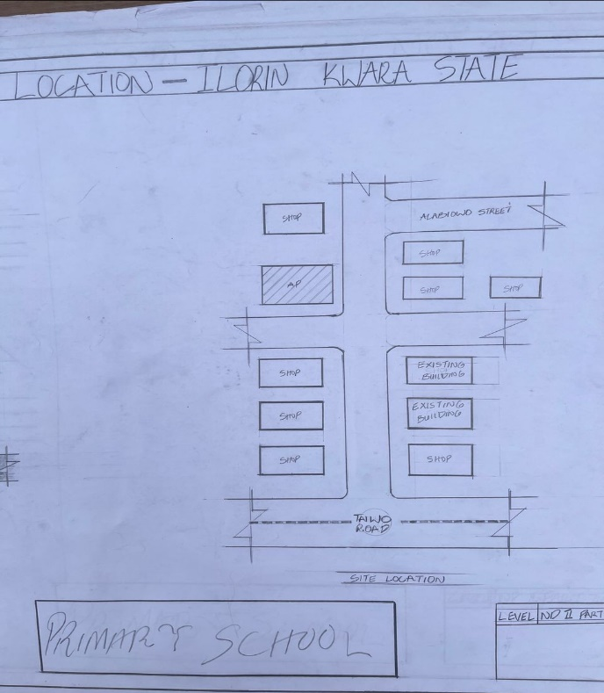

FIG1;SHOWING LOCATION PLAN OFCASE STUDY ONE

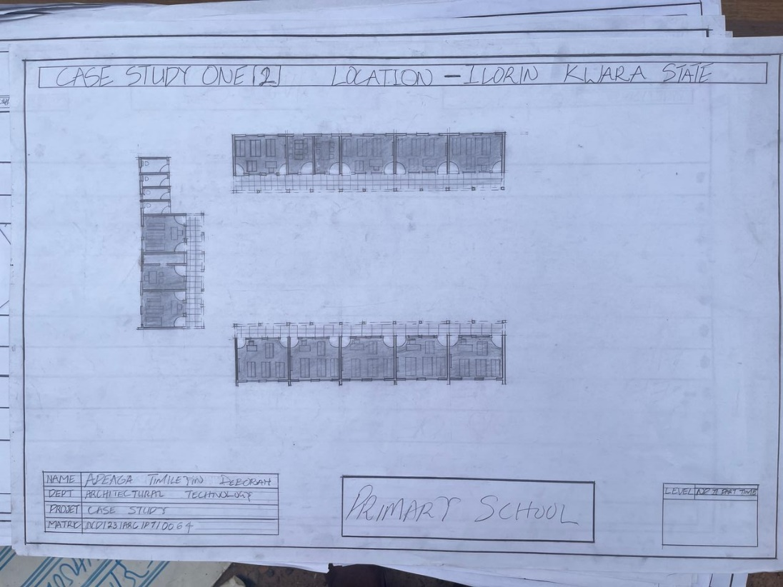

FIG2; SHOWING FLOOR PLAN OF CASE STUDY ONE


PLATE1; SHOWING FRONT VIEW OF CASE STUDY ONE

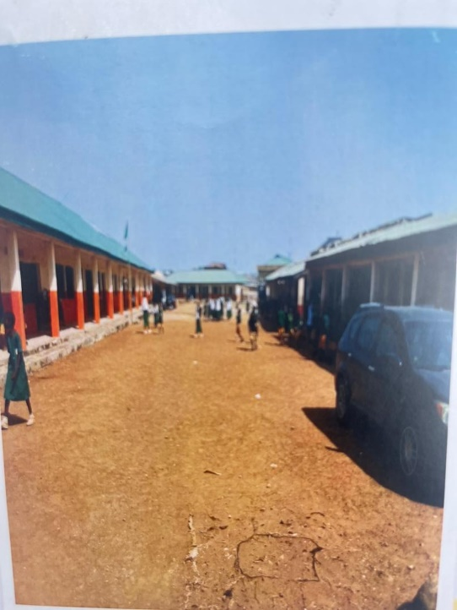

PLATE2; SHOWING LEFT&RIGHT VIEW OF CASE STUDY ONE

3.4 CASE STUDY TWO (2)
    - LOCATION: PEGBA COMMUNITY SCHOOL IBADAN, OYO STATE
MERITS
- Condusive learning space
- Experienced and qualify teacher
- Well arranged classsrooms

DEMERITS
- Inadequate security
- Lack of ventilation

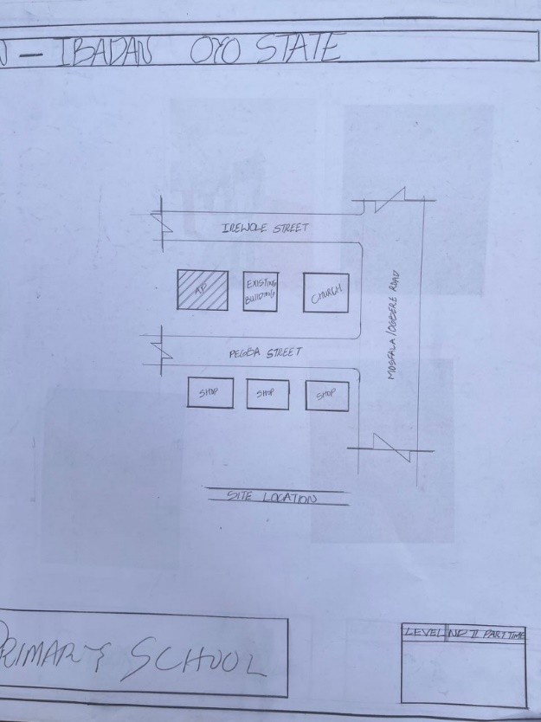

FIG3; SHOWING LOCATION PLAN OF CASE STURDY TWO
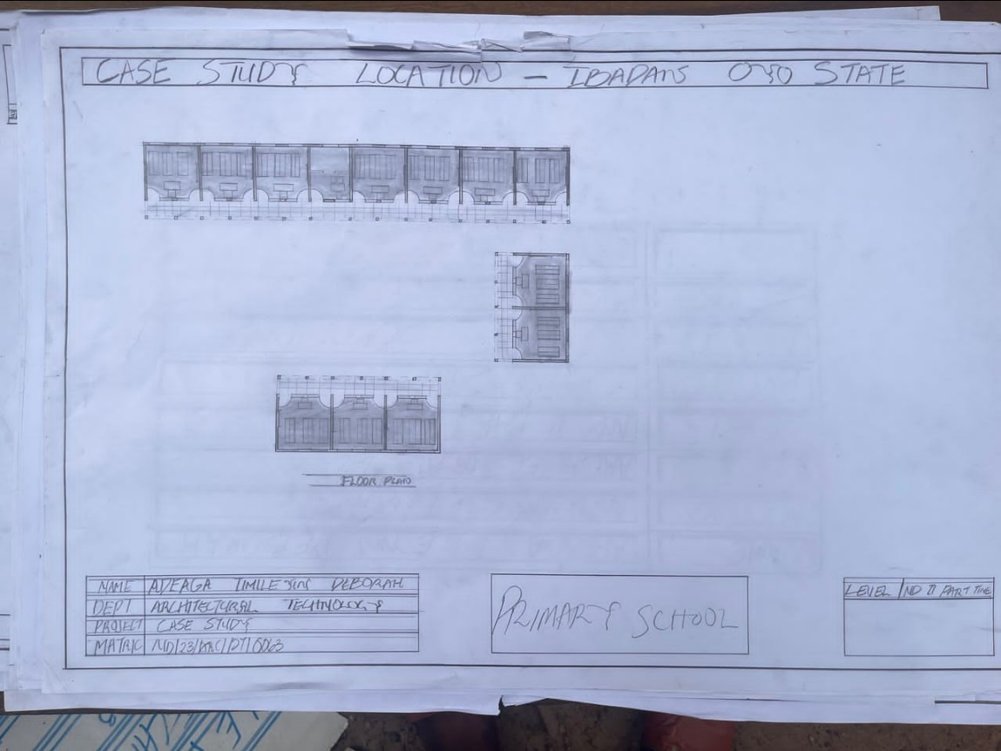
FIG 4; SHOWING THE FLOOR PLAN OF CASE STUDY TWO

  - CASE STUDY THREE (3)
3.1.5 LOCATION: EGBEDORE NUR&PRY SCHOOL OSOGBO, OSUN STATE

MERITS
- Condusive studying environment
- Well structured building
- Well arranged classrooms

DEMERIT
- In adequate ventilation
- Lack of restroom
- Ineffective playing ground

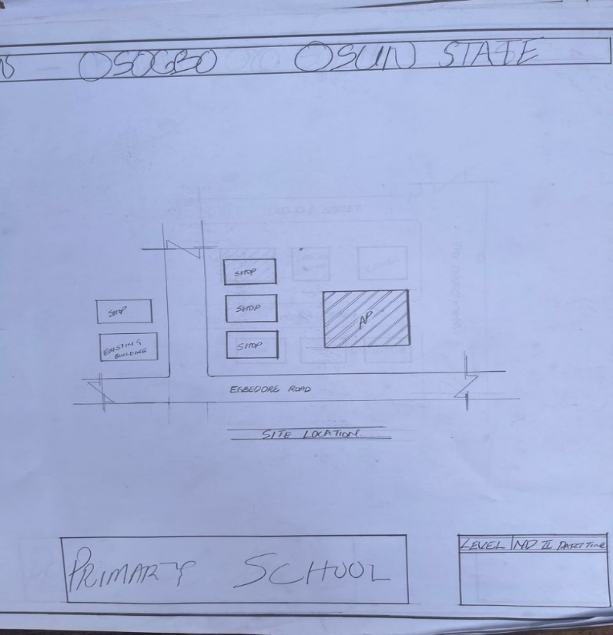

FIG 5; SHOWING LOCATION PLAN OF CASE STUDY THREE

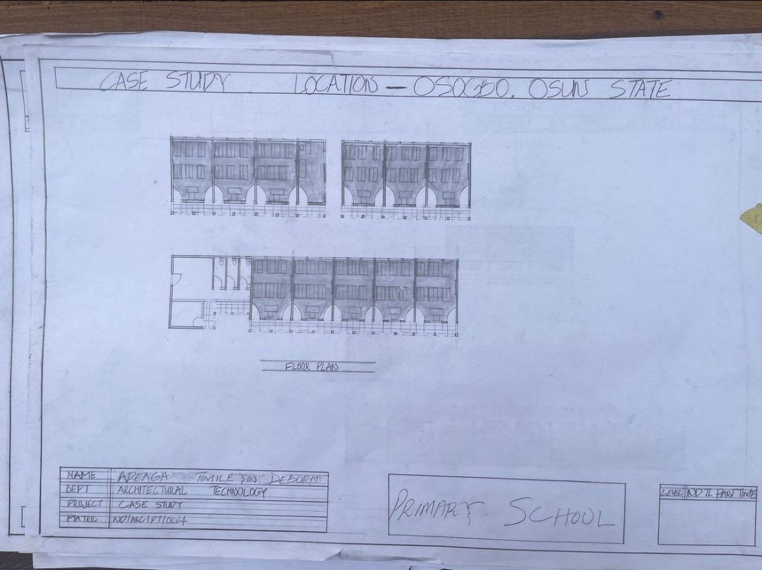
FIG 6; SHOWING FLOOR PLAN OF CASE STUDY THREE



PLATE 3; SHOWING FRONT VIEW OF CASE STUDY THREE

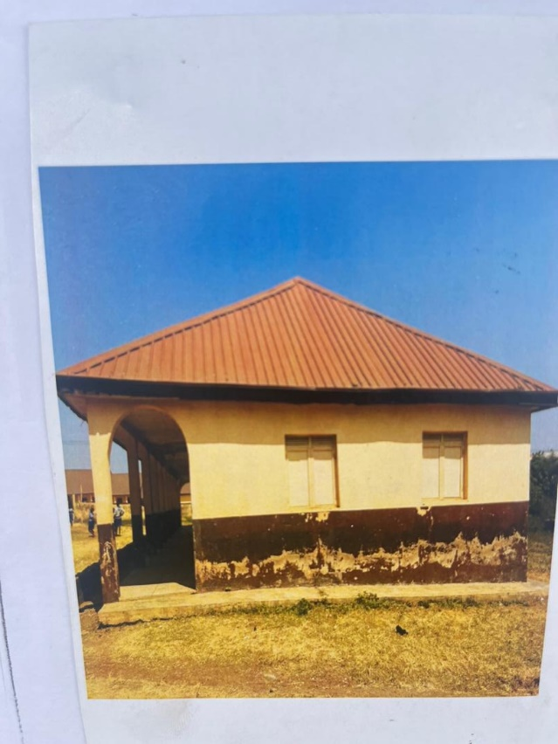

PLATE 4; SHOWING RIGHT VIEW OF CASE STUDY THREE

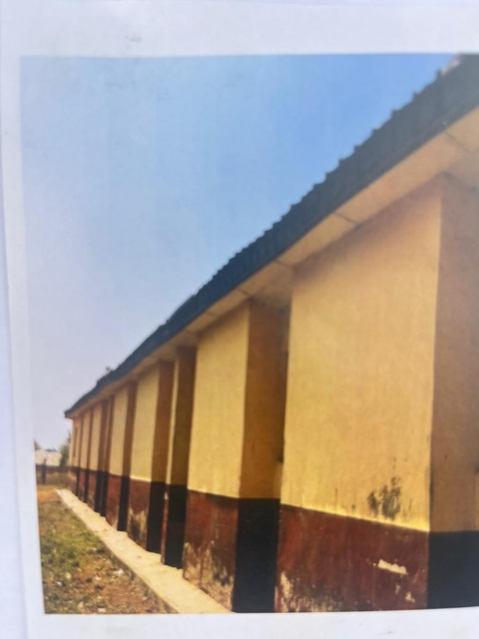
PLATE 5; SHOWING BACK VIEW OF CASE STUDY THREE

3.6 ONLINE CASE STUDY
ONLINE CASE STUDY ONE
LOCATION: UNITED STATE OF AMERICA
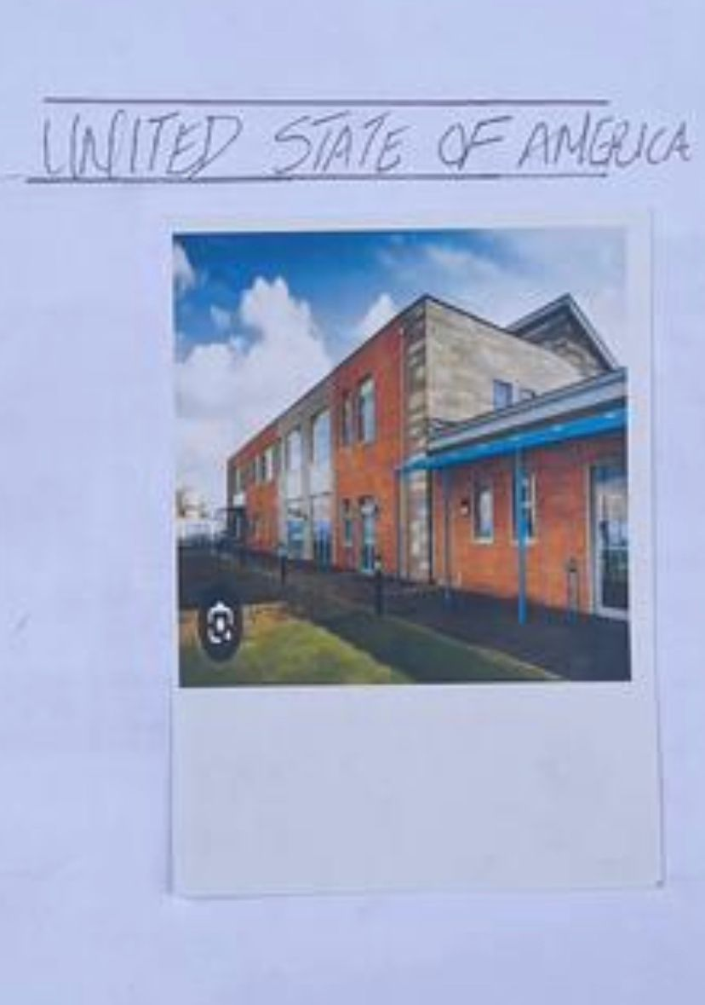
PLATE 6; SHOWING LEFT VIEW OF ONLINE CASE STUDY

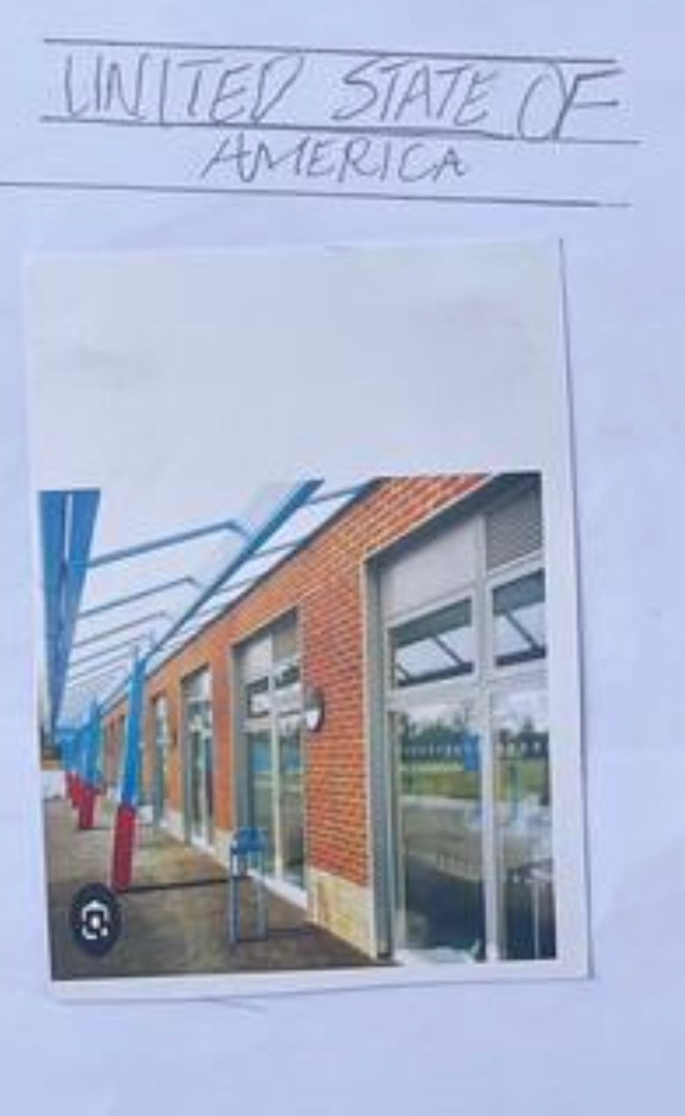
PLATE 7; SHOWING FRONT VIEW OF ONLINE CASE STUDY

DEDUCTION FROM CASE STUDIES
During my visit to the daycare. I was opportunities to see what was obtain in the center, I made a proper studies of their related function and analysis were made to their present situation with the aim of incorporation with their merit in my own final proposal.
The following were deduce from my case study
- Adequate natural ventilation and lighting.
- Good architectural landscaping.
- The units in the school should be properly and well linked.
- Parking spaces should be well defined.
- Good drainage system.
CHAPTER FOUR
4.0 PROJECT LOCATION
4.1 BRIEF HISTORICAL BAKGROUND OF ILORIN, KWARA STATE
Ilorin, the capital of Kwara State, is a city with a rich and diverse historical background. It was founded around the late 15th century as a small Yoruba settlement under the Oyo Empire. Its name "Ilorin" is believed to have originated from the word "Ilọ irin", meaning "sharpening of iron," as early hunters and blacksmiths used the area as a tool-sharpening site.
In the early 19th century, during the Fulani Jihad led by Shehu Usman Dan Fodio, Ilorin became a significant center. A Yoruba Muslim warrior named Afonja, who was then the Aare Ona Kakanfo (generalissimo) of the Oyo Empire, rebelled against the central authority with the help of Fulani warriors led by Alimi, a Fulani Islamic scholar and preacher.
However, after Afonja’s death, the Fulani forces, under Alimi's descendants, took control of Ilorin and established it as an Emirate under the Sokoto Caliphate, making it an Islamic and political hub in the region. This brought a blend of Yoruba and Fulani cultures, which is still evident in Ilorin today.
Ilorin became part of Kwara State upon its creation in 1967, during Nigeria’s state restructuring. Today, it is a center of Islamic scholarship, culture, and governance in Nigeria, serving as a bridge between the north and south of the country

GEOGRAPHY OF ILORIN, KWARA STATE
Ilorin, the capital city of Kwara State, is located in the North-Central region of Nigeria, also referred to as the Middle Belt. It lies approximately 306 km northeast of Lagos and 500 km southwest of Abuja. Ilorin sits on the transitional zone between the humid forest of the south and the savannah grassland of the

ECONOMY OF ILORIN, KWARA STATE
Ilorin, the capital of Kwara State, has a diversified economy that blends agriculture, commerce, manufacturing, and public sector employment. As a strategic city located between the north and south of Nigeria, Ilorin serves as an important commercial and administrative center in the Middle Belt region.

ORGANIZATION STRUCTRE
The organizational structure of Ilorin reflects the administrative and governance system within Kwara State, with a focus on local, traditional, and modern governmental frameworks. Ilorin functions as both a traditional emirate and a modern city under state and local government administration.

4.2 LOCATION AND SETTING OF KWARA STATE
Ilorin is located in the North-Central region of Nigeria and serves as the capital city of Kwara State. It lies at approximately latitude 8°30′N and longitude 4°33′E.
Geographically, Ilorin sits at the transitional zone between the forest region of southern Nigeria and the savannah of the north, making it a natural link between the two regions. The city is situated along major transport routes connecting Lagos, Abuja, and northern Nigeria, making it a key administrative and commercial hub.
Its setting includes gently rolling plains with scattered hills, crossed by rivers like the Asa River, and surrounded by savannah vegetation. The favorable location and terrain support agriculture, trade, and urban development.

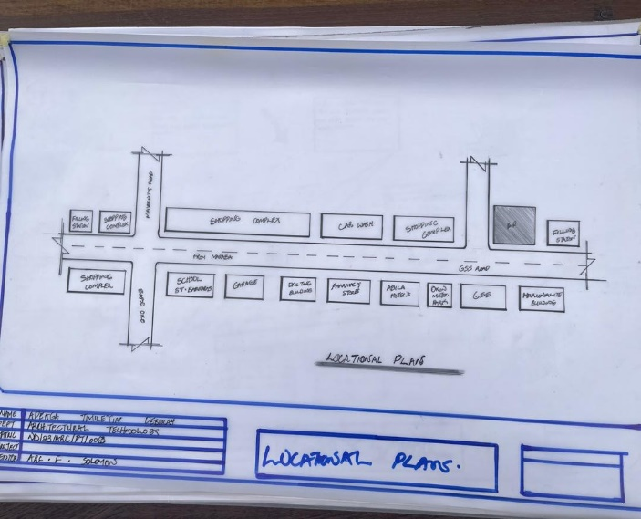
FIG 7; SHOWING LOCATION OF THE PROPOSE SITE
4.3 POPULATION
As of the latest estimates, the population of Ilorin, the capital city of Kwara State, is projected to be over 1 million people.
- Population Breakdown (Estimates):
- 2006 National Population Census:
- Ilorin West LGA: 365,221
- Ilorin East LGA: 204,310
- Ilorin South LGA: 208,691
- Total (2006): Approximately 778,222
- 2023/2024 Estimate (based on projected growth rates of 2.6%–3% annually):
  - Estimated Total Population: 1.1 to 1.3 million
- Demographic Features:
- Ethnic Composition: Predominantly Yoruba, with significant Fulani, Hausa, and Nupe communities.
- Religion: Majority Muslim, with vibrant Christian and traditional religious communities.
- Age Distribution: A youthful population, with a high proportion under 30 years of age.
Ilorin continues to experience population growth due to:
- Rural-to-urban migration
- Presence of universities and institutions
- Commercial and administrative opportunities
4.4 SITE INVENTORY
In the proposed site, some shrubs will be retained on site. It used to reduce sky glare and also serve as soft landscape and wind breaker.
Presence of road network which would serve as a means of accessibility to the site. Presence of electricity pole which serve as source of electricity to the site. Some trees would be retained while some will be removed if they disrupt the construction of building.

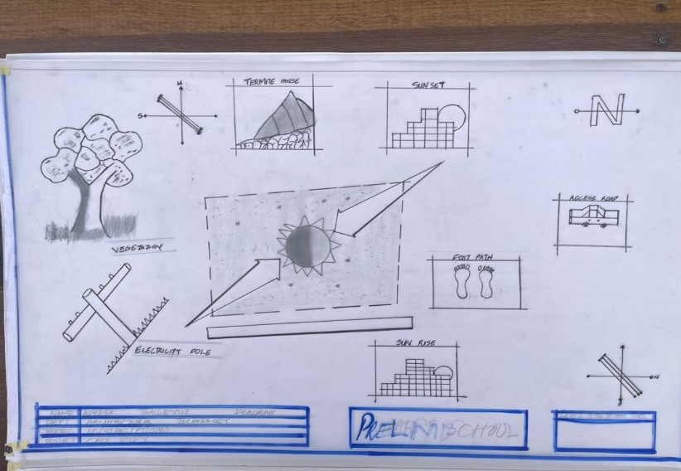
FIG 8; SHOWING SITE INVENTORY OF THE PROPOSED SITE

4.5 SITE ANALYSIS
The site is benefitted with loamy soil which is a very good soil for grass and shrubs. It has a gentle slope towards the south east. Some of the grasses, shrubs and trees on the site are to be retained to enhance landscape patter of the site while some are to be removed and replanted where necessary. The two noticeable winds are to be directed into the building using landscape pattern to improve ventilation. Noise generated from vehicle traffic is controlled through proper planning, good landscaping and proper orientation of building. Generally, all the feature on the site are best put into different uses to aid control through proper planning, landscape and orientation.

Certainly, steps are considered to obtain vital information of the site, this information is the analysed in details. For design purpose, the information include soil condition, geology, topography, vegetation etc. It also involves carrying out a preliminary survey of the site.

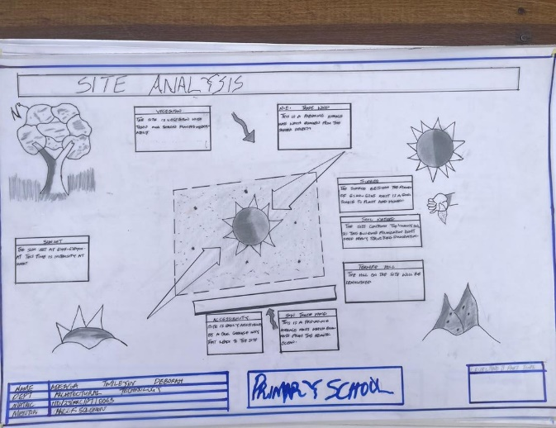
FIG 9; SHOWING SITE ANALYSIS OF THE PROPOSED SITE

4.5.1 SITE SELECTION/JUSTIFICATION
In the site selection provision is made for interesting facilities that worth emulating since the overall success and efficiency of any project depend not on the functionality of the design but also on a careful choice of site. The site of this project has been carefully selected which is located in the premises of Asadam, Ilorin Kwara state. The proposed site is located at Asadam road at Ilorin, Kwara state.
4.5.2 LOCATION
GSS Roundabout, often referred to as GSS Road, is a well-known traffic junction in Ilorin, positioned approximately at 8°29′47″ N, 4°34′36″ E, within Ilorin city in Kwara State
4.5.3 ACCESSIBILITY
The site is easily accessible from the access road off from the main road that goes to jubilee. The site can also be reached through the access road that lead to stadium.

4.5.4 INFRASTRUCTURAL FACILITIES
Facilities such as water electricity, telephone network and road network are all in Ilorin, hence it can easily be tapped to the proposed site.
4.5.5 TOPOGRAPHY
The topography of the land is gentle slope which can be filled and levelled up to balance round all the site levels.
4.5.6 SOIL STRUCTURE
The dominant soil type in Asadam is ferruginous tropical soil, formed under the influence of a seasonal tropical climate.
4.6 GENERAL CLIMATIC CONDITION
Ilorin, the capital of Kwara State, experiences a tropical wet and dry climate, classified as Aw under the Köppen-Geiger climate classification. This type of climate is typical of the Guinea Savannah zone in Nigeria.
- 1. Seasons
Ilorin has two distinct seasons:
- ✅ Rainy Season
- Duration: April to October
- Peak Months: June to September
- Rainfall: Average annual rainfall is 1,100 mm to 1,300 mm
- Rainfall is often accompanied by thunderstorms.
- ✅ Dry Season
- Duration: November to March
- Features: Dominated by Harmattan winds (dry and dusty winds from the Sahara)
- Little or no rainfall occurs during this period.
- 2. Temperature
- Average annual temperature: 27°C to 30°C
- Hottest months: February to April (can reach up to 35°C)
- Coolest months: December and January (can drop to around 18°C to 20°C at night)
4.6.1 RELATIVE HUMIDITY
Relative humidity in Ilorin varies throughout the year due to its tropical wet and dry climate (Köppen Aw classification), with significant differences between the rainy and dry seasons.
- Rainy Season (April – October):
- High humidity levels due to moist southwesterly winds.
- Range: 65% to 85%
- Peak Humidity: July to September (often exceeding 80% in the mornings).
- Dry Season (November – March):
- Lower humidity, especially during the Harmattan (Dec–Feb).
- Range: 20% to 50%
- The air becomes dry and dusty, with very low early morning humidity during peak Harmattan.
4.6.2 WIND
There are two prevailing winds namely: The rain bearing south-west monsoon wind which blows across the Atlantic Ocean between the month of May and October. This is called wet season. The dusty north-east trade wind which laden with dust blows through the Sahara desert during the month of November to April with very title rainfall toward April. This is called the dry season and it brings along Harmattan during its driest period
4.6.3 TEMPERATURE
Ilorin experiences a tropical climate with distinct wet and dry seasons, and its temperatures are generally warm to hot year-round. The city's average temperature reflects its location in Nigeria’s Southern Guinea Savannah zone.
4.6.4 VEGETATION
The proposed site is covered with grasses few trees and shrubs. Some will be removed before the construction while some will be retain for ornamentation.
4.7 SOCIAL SERVICES
4.7.1 ROAD
There are only two access to the site
The southern access which serve as the main entrance and also main access road
4.7.2 WATER AND ELECTRICITY
There are pipe born water networks and borehole water which serves the habitant of Asadam. There is electricity supply from NEPA that serve the Ilorin, Kwara state in general
4.8 DESIGN CRITERIA
There are three (3) methods of designing of any project which are: Function before form method
Form before function method Combination of Shapes
Designing projects, the function, before form method used in line with this method, the following are the design criteria for this project:
Functional: in term of functional requirement, the following design criteria must be considered.
Sustainability, Site and Location, Flexibility, Circulation, Accessibility, Organization, Maintenance, Environment and Services
4.9 DESIGN BRIEF
After research and planning, the next step in the series of the project programed is design itself. To achieve functional and well established design there must be a brief to work on. This brief depends generally on the scope of individual design. The brief of this project is therefore based on the various activities that take place in the school. To have enough brief for the proposed Primary school, case studies were carried out on the existing primary school.
4.10 DESIGN ANALYSIS
This is the process of itemizing units within the component of the entire design with a view to establishing a solid understanding and appreciation of the space relationships.
The units of the design are in three division, the unit of the project division are as follows:
GROUND FLOOR PLAN; Entrance, Reception, Secretary Office, Administration Office, Proprietors Office, HM Office, Bursar Office, Kindergarten Class, Primary Classroom, Nursery Classroom, Computer Room, LAB, Mini Mart, Bookshop, Office Toilet, Male Toilet, Female Toilet, Reception Toilet, Admin Toilet

4.11 SPACE REQUIREMENT
Units Area (m2)
Entrance 14.49m2
Reception 23.68m2
Secretary Office 12.48m2
Admin Office 16.38m2
Proprietor Office 21.00m2
HM Office 21.00m2
Bursar Office 21.00m2
Kindergarten Room 40.00m2
Primary classroom 210.00m2
Nursery classroom 70.00m2
Computer Room 35.00m2
LAB 40.00m2
Mini mart 21.00m2
Bookshop 9.00m2
Office toilet 97.20m2
Male toilet 10.08m2
Female toilet 10.08m2
Reception toilet 6.30m2
Admin Toilet 5.67m2

TABLE 2; SHOWING SPACIAL ALLOCATION OF FLOOR PLAN
Necessary units in the building. A borehole system of water supply is to be adopted alongside the government supplied services and a storage facility is to be provided for effective management of water supply.
4.12 PLANNING PRINCIPLE
The planning principle is one of the most important aspects of any design. The planning of various units taking into consideration the activities performed in each unit, how they are related to one another and the users of the various units in the design. In respect to the above factors.

CHAPTER FIVE
5.0 APPRAISAL OF PROPOSED SCHEME
The appraisal of a primary school project involves a comprehensive evaluation of its design, functionality, infrastructure, environment, and its overall effectiveness in meeting the educational needs of pupils. A well-designed and properly constructed primary school should provide a safe, stimulating, and supportive learning environment that promotes academic growth, creativity, and personal development.
This primary school project was appraised based on key criteria such as site suitability, architectural design, construction quality, available facilities, and the general learning environment. The location was found to be strategically positioned within a safe and accessible area, making it convenient for both pupils and staff. The layout of the school buildings was carefully planned to support smooth circulation, adequate ventilation, and natural lighting—essential factors for a conducive learning environment.
The classroom spaces were observed to be adequately sized and well-ventilated, providing comfort for the learners. The presence of essential facilities such as administrative offices, staff rooms, functional toilets, library, playground, and access to clean water reflects a strong commitment to providing a comprehensive educational experience. Attention was also paid to safety features such as perimeter fencing, emergency exits, and accessible pathways.
Furthermore, the appraisal considered environmental sustainability and inclusiveness. Efforts were made to ensure that the school is friendly to pupils with disabilities by including ramps and other accessibility features. The school premises were landscaped to include trees and green spaces, which not only enhance the aesthetics but also provide shade and a calm atmosphere for learning.
In conclusion, the primary school project meets the required standards for basic education infrastructure. It reflects a good understanding of the functional, social, and environmental factors necessary for delivering quality education at the primary level. The project is therefore considered successful in achieving its objectives and contributing positively to the development of the community.
5.1 CONSTRUCTION METHODOLOGY
The construction of the primary school project followed a systematic process:
- Site Preparation: The land was cleared, leveled, and marked out for building according to the approved drawings.
- Foundation: Trenches were dug, concrete was poured for strip or pad foundations, and damp-proof membranes were installed to prevent moisture rise.
- Substructure: Blockwork up to ground level was completed, backfilled, and compacted.
- Superstructure: Walls were built using sandcrete blocks, reinforced lintels and beams were cast, and columns were added for strength.
- Roofing: Wooden or steel trusses were installed, covered with long-span roofing sheets, and finished with ceiling boards.
- Finishing: Internal and external walls were plastered and painted. Floors were screeded and tiled or cement-finished. Doors and windows were fixed.
- Mechanical & Electrical: Electrical wiring and plumbing for toilets and water supply were installed.
- External Works: Drainage, walkways, fencing, and landscaping were done to complete the school environment.
5.3 SERVICES
The primary school is equipped with essential services to support learning and ensure the comfort and safety of pupils and staff. A constant water supply is provided through a borehole or connection to the public water system, with storage tanks installed to maintain water availability. Plumbing systems are in place to serve toilets, wash basins, and cleaning facilities.
Electricity is supplied from the national grid, with provisions made for backup power using a generator or solar system. The school is fully wired for lighting, fans, and electrical outlets in classrooms, offices, and staff areas.
Sanitary services include separate toilet facilities for pupils and staff, supported by a septic tank and soakaway system. Hand washing stations are installed near the toilets to promote hygiene.
Ventilation is achieved through large windows and ceiling fans to ensure air circulation and control indoor temperature. Natural lighting is enhanced with wide windows, while artificial lighting provides visibility during cloudy days or in the evening.
The school has a drainage system to channel rainwater away from buildings, preventing water accumulation and flooding. In modern settings, communication services such as internet access, public address systems, and notice boards may also be included to support administrative efficiency and information sharing.
5.4 VENTILATION
The primary school is designed with proper ventilation to ensure a healthy and comfortable learning environment. Large windows and louver openings allow for natural airflow, while ceiling fans help improve air circulation in the classrooms. This setup reduces heat and promotes fresh air intake for pupils and staff.
5.5 LIGHTING
The school is well-lit using a combination of natural and artificial lighting. Large windows allow daylight into classrooms, reducing the need for electricity during the day. At night or in low-light conditions, electric bulbs provide adequate lighting for safe and effective learning.
5.6 PLUMBING
The school is equipped with a basic plumbing system that supplies clean water to toilets, wash basins, and other facilities. Pipes are installed for both water supply and waste disposal, connected to a septic tank and soakaway system to ensure proper sanitation.
5.7 WATER DISPOSAL
The school has an effective water disposal system to manage wastewater from toilets and wash areas. It includes drainage pipes connected to a septic tank and soak away, ensuring safe and hygienic removal of waste from the school environment.
5.8 FIRE PROTECTION
The school includes basic fire protection measures such as fire extinguishers placed in key areas like classrooms and offices. Wide exit doors and open corridors are provided for easy evacuation, and the building materials are selected to reduce fire risk.
5.9 EXTERNAL WORK
The external work includes the construction of concrete walkways, drainage systems, fencing, and a main entrance gate. Landscaping with trees and grass was also done to create a clean, safe, and attractive school environment.
5.10 SUMMARY
This project report presents a comprehensive account of the design, planning, and construction of a primary school aimed at providing a conducive, safe, and inclusive learning environment for young learners. The project was initiated in response to the growing need for educational infrastructure that meets the basic academic and developmental needs of children at the foundational level of education.
The report outlines the methodology adopted in the construction of the school, beginning with site preparation and progressing through foundation work, structural framing, roofing, finishing, and the integration of essential building services. Each stage was executed using materials and techniques appropriate for the climate, location, and educational purpose of the facility. The construction adhered strictly to structural and safety standards, with the aim of creating a durable and functional school building.
Special consideration was given to the inclusion of vital services such as water supply, plumbing, sanitation, electricity, ventilation, and fire protection. These elements were incorporated to ensure the comfort, health, and safety of both pupils and staff. The classrooms were designed to be well-lit and well-ventilated, promoting effective learning and concentration. Additional facilities such as staff offices, playgrounds, walkways, and perimeter fencing were also included to provide a complete and secure academic setting.
In the appraisal section, the project was evaluated based on factors such as accessibility, functionality, environmental impact, and overall user-friendliness. The result revealed that the school meets the expected standards and is suitable for delivering quality primary education. The external works, including landscaping and drainage, were also recognized as important elements that contributed to the success of the project by improving aesthetics and safety.
This primary school project has successfully addressed the infrastructural needs of early childhood education in the community. It stands as a model for future school projects that prioritize sustainability, functionality, and child-centered design. The report demonstrates that with proper planning, adherence to construction standards, and attention to detail, quality educational facilities can be developed to support national and local education goals.
5.11 CONCLUSION
In conclusion, this primary school project report has provided a comprehensive overview of the planning, design, construction, and evaluation processes involved in delivering a functional and child-friendly educational facility. The successful execution of the project reflects a commitment to improving access to basic education and ensuring that pupils are provided with a safe, healthy, and conducive environment for learning and development.
From the early stages of site selection and preparation to the final stages of finishing and external works, each phase of the project was carefully planned and implemented with precision and adherence to established building standards. The architectural design considered both aesthetic and practical factors, resulting in structures that are not only visually appealing but also durable and fit for purpose. Structural elements such as foundations, walls, columns, and roofing systems were constructed using appropriate materials and methods that ensure long-term stability and resilience.
Special attention was given to essential services such as water supply, plumbing, drainage, electrical installations, and fire safety. These services were integrated into the school infrastructure to promote comfort, hygiene, safety, and efficient daily operations. Classrooms were designed to be spacious, well-lit, and ventilated, while offices and utility areas were strategically located to support administrative functions and maintenance needs. Sanitary facilities were also provided in line with public health requirements.
The construction process also included external works such as landscaping, fencing, walkways, and drainage, all of which contribute significantly to the overall usability and environmental quality of the school compound. These external features help to create a welcoming atmosphere, reduce risks of flooding, and enhance security for pupils and staff.
The project has been appraised positively based on its functionality, quality of construction, adherence to educational building standards, and potential to serve the community effectively. It demonstrates that with proper planning, community support, and the use of best construction practices, educational infrastructure can be successfully developed even in resource-constrained environments.
Overall, the completion of this primary school project stands as a meaningful step toward achieving universal basic education. It is a testament to the importance of investing in infrastructure that supports academic excellence and social development from the foundational level. It is hoped that this model will inspire similar initiatives aimed at promoting inclusive and quality education for all.

5.12 RECOMMENDATION
Based on the findings and observations from the planning, execution, and appraisal of this primary school project, several important recommendations are presented to guide future developments, ensure sustainability, and enhance the learning environment for pupils and staff.
Firstly, it is recommended that regular maintenance of the school facilities be prioritized. School buildings, like all physical structures, require periodic upkeep to ensure their durability and functionality. Maintenance schedules should include inspection and repair of roofs, plumbing systems, electrical installations, classroom furniture, and sanitation facilities. This will help prevent deterioration and prolong the lifespan of the school infrastructure.
Secondly, there is a need to invest in capacity building for the school’s administrative and maintenance personnel. Proper training should be provided to enable them to efficiently manage the school environment, handle minor repairs, and supervise the use of facilities. This would reduce long-term costs and improve the overall operation of the school.
Furthermore, it is strongly recommended that the school be equipped with modern educational tools and resources. This includes chalkboards or whiteboards, pupil desks, learning materials, digital devices (where applicable), and a well-stocked library. Such tools are essential for enhancing teaching and learning outcomes, especially as education becomes more technology-driven.
In terms of safety and health, it is advisable that fire safety measures be regularly reviewed and updated. Fire extinguishers, exit signs, and evacuation plans should be maintained and visible in all key areas. In addition, regular health and hygiene awareness campaigns should be conducted for pupils and staff, especially regarding the proper use of toilets, hand washing facilities, and waste disposal systems.
To further support learning, the provision of recreational and extra-curricular facilities is also recommended. A well-designed playground, open field, or sports area can significantly contribute to the physical and social development of children. These areas should be safe, clean, and supervised.
For future projects, it is also advisable that community participation be encouraged from the early planning stages. Involving parents, local leaders, and other stakeholders promotes a sense of ownership and responsibility, which in turn ensures better use, protection, and development of the school facilities.
Lastly, it is recommended that government agencies and relevant non-governmental organizations (NGOs) continue to provide funding and technical support for school construction and improvement projects. Public-private partnerships can be explored to sustain educational infrastructure, particularly in rural and underserved areas.
By implementing these recommendations, the quality, functionality, and sustainability of the school can be significantly enhanced, leading to better educational outcomes and stronger community development

REFERENCE
• Federal Ministry of Education (FME), Nigeria. (2013). National Policy on Education (6th Edition). Lagos: NERDC Press.
– Provided guidelines on the structure and goals of primary education and the basic requirements for educational facilities in Nigeria.
• UNICEF. (2012). Child-Friendly Schools Manual. New York: United Nations Children’s Fund.
– Offered global standards and design considerations for creating inclusive, safe, and child-centered learning environments.
• World Bank. (2015). School Infrastructure and Educational Outcomes: A Review of Evidence. Washington, DC.
– Informed the assessment of how school building quality impacts learning outcomes and the importance of adequate facilities.
• National Building Code of Nigeria. (2006). Abuja: Federal Ministry of Works and Housing.
– Guided the structural design, material specification, fire safety provisions, and health requirements in school construction.
• Tanner, C. K. (2009). Effects of School Design on Student Outcomes. Journal of Educational Administration, 47(3), 381–399.
– Supported the argument that physical learning environments significantly affect academic performance and behavior.
• WHO. (2009). Water, Sanitation and Hygiene Standards for Schools in Low-cost Settings. Geneva: World Health Organization.
– Provided standards and best practices for water supply, hygiene, and sanitation applicable to primary schools.
• Ajayi, M. O. & Ojo, T. A. (2011). Infrastructure Development and Maintenance in Nigerian Schools. Nigerian Journal of Educational Planning and Administration, 1(2), 45–57.
– Contributed insights into the challenges and solutions in sustaining school infrastructure in developing regions.
• British Council. (2018). Creating Inclusive Classrooms: A Guide for Teachers and School Designers. London: British Council Press.
– Helped shape recommendations for inclusive classroom layout and facilities planning.
• Olaleye, F. O. (2010). School Facilities and Academic Achievement of Primary School Pupils in South West Nigeria. Journal of Education and Practice, 1(2), 34–39.
– Supported the rationale for investing in improved classroom spaces and learning environments.
• International Labour Organization (ILO). (2011). Construction Guidelines for School Projects in Developing Countries. Geneva: ILO Publications.
– Provided general construction standards for safe, durable, and cost-effective educational buildings.

APPENDICES
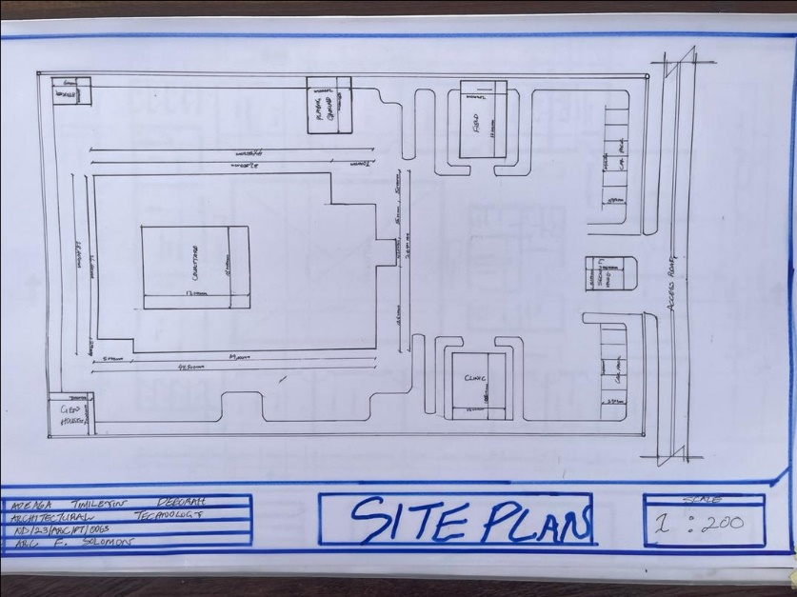
APP1; SHOWING SITE PLAN OF THE PROPOSED SITE
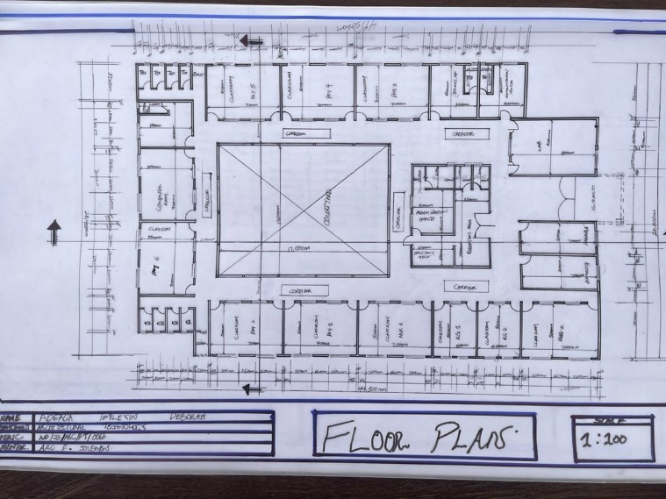
APP2; SHOWING FLOOR PLAN OF THE PROPOSED SITE
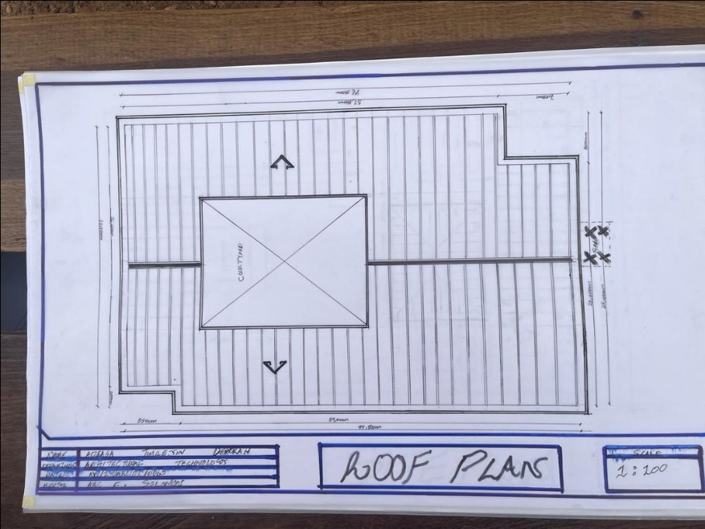
APP3; SHOWING ROOF PLAN OF THE PROPOSED PLAN
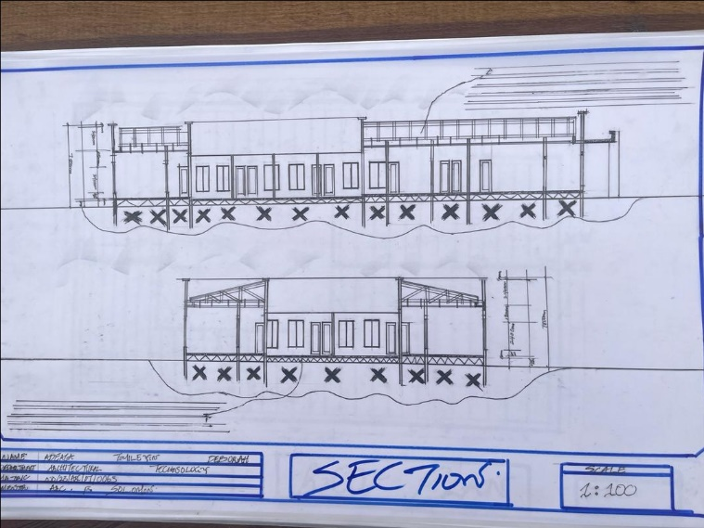
APP4; SHOWING CROSS SECTION OF THE PROPOSED PLAN

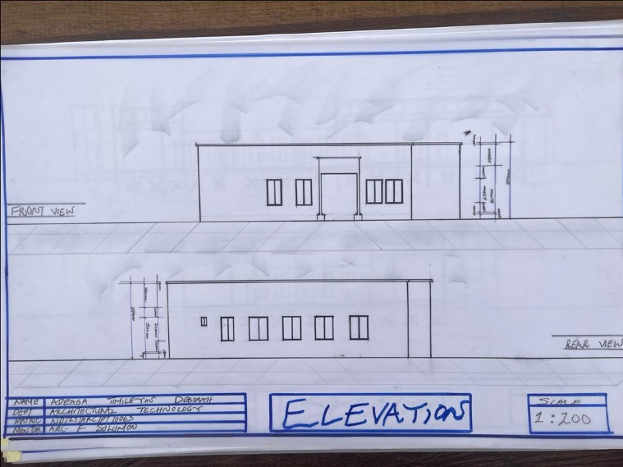
APP5; SHOWING FRONT&BACK VIEW OF THE PROPOSED PLAN
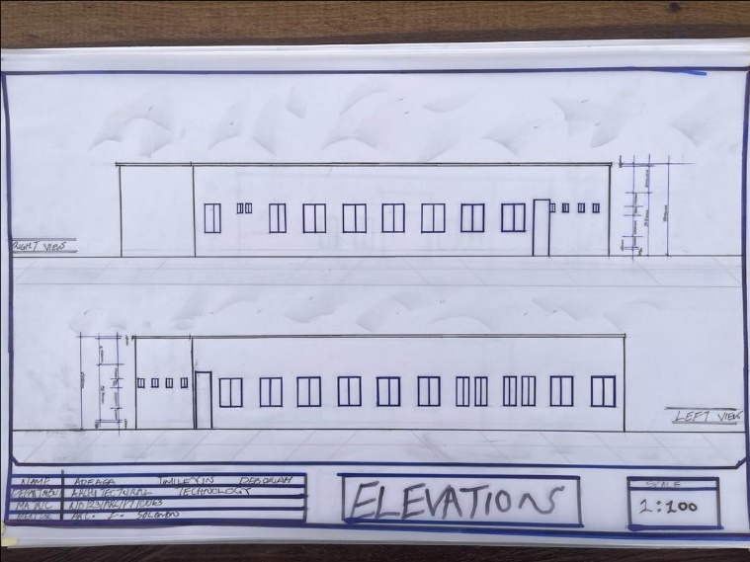
APP6; SHOWING RIGHT&LEFT VIEW OF THE PROPOSED PLAN

