EVALUATION OF PHYSICOCHEMICAL PROPERTIES OF KWARA STATE POLYTECHNIC UNDERGROUND WATER

BY
OLABAMIJI MARIAM MORENIKEJI
ND/23/WRE/PT/0004

A RESEACH PROJECT SUBMITTED TO DEPARTMENT OF WATER RESOURCES ENGINEERING, INSTITUTE OF TECHNOLOGY, KWARA STATE POLYTECHNIC, ILORIN.

IN PARTIAL FULFILLMENT OF THE REQUIREMENT FOR THE AWARD OF NATIONAL DIPLOMA IN WATER RESOURCES ENGINEERING, INSTITUTE OF TECHNOLOGY.

AUGUST, 2025

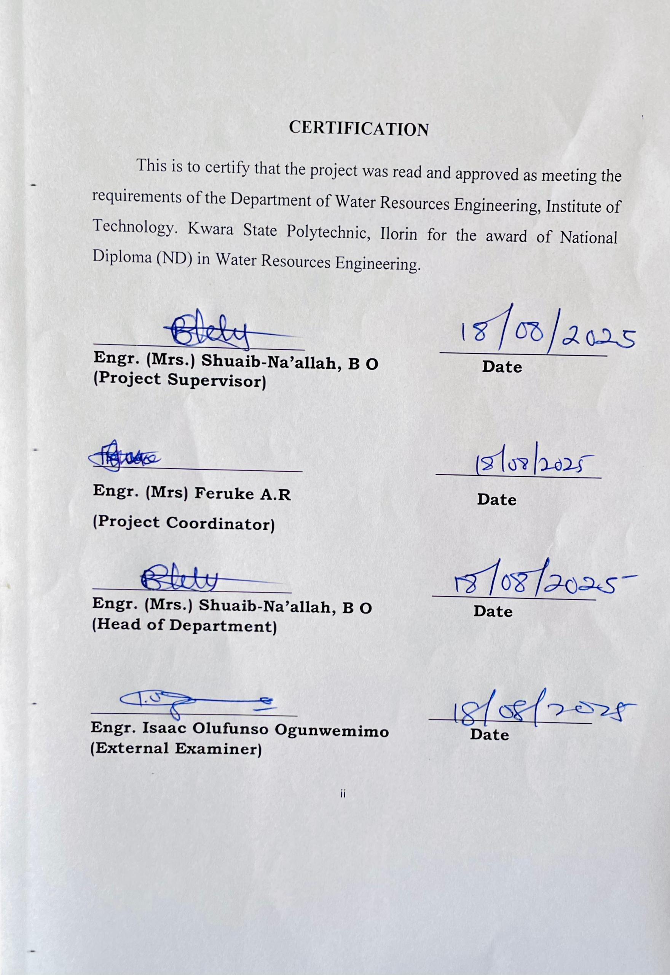DEDICATION
This project is dedicated to Almighty Allah for the grace given to me to fulfill this academic program, and to my imperatives parents, Mr. and Mrs Olabamiji who are the architect of my academic pursuit.
ACKNOWLEDGEMENT
All glory and honor is given to Almighty Allah, the most beneficent and most merciful for the accomplishment of my National Diploma (ND) in Kwara State Polytechnic.
My gratitude goes to my most able, diligent and distinguish and competent supervisor in person of Engr abd Mrs. Shuaib-Naallah,B.O for his fatherly care, guidance, concern and for taking pains of going through the manuscript for constructive criticism. I acknowledge his extensive academic, professional and practical experience he used to complement my knowledge in making up this project.
My ultimately gratitude goes to my forthright mother, Mr. and Mrs. Olabamiji, for her expedient, caring physically and mentally and financial support, and bareness, advice, optimistic thought of life to support me throughout my primary. Secondary and National Diploma (ND) program.
Also I will like to use medium to appreciate my loving and caring dad Mr. and Mrs. Olabamiji , for his continuous support, love, care he has showed me and I will also appreciate is support financially, morally, he has the pillar I can always rest on am grateful Dad.
Nothing could be said to say may Almighty Allah in his infinite mercy reward you both abundantly, and I also pray you both live long enough to reap the fruit of your labour (Amin). My prayers also do not end there, "with your walks of life, Almighty Allah will continue promoting you both higher Insha Allah.

ABSTRACT
Access to safe and potable water is essential for sustaining health, particularly in academic institutions where population density and human activities increase the risk of groundwater contamination. This study evaluated the physical and chemical properties of underground water sources within Kwara State Polytechnic, lorin, with a view to assessing their suitability for domestic use. The research adopted a quantitative design using stratified random sampling to collect groundwater samples from selected boreholes and wells across the campus. The samples were analyzed for parameters including pH, temperature, turbidity, total dissolved solids (TDS), electrical conductivity (EC), iron, nitrate, and lead using standard laboratory techniques. The study employed descriptive statistics and Chi-square tests to compare observed values against WHO, permissible limits. Findings revealed that while most physical parameters such as temperature and pH were within acceptable ranges, certain chemical indicators-particularly iron and lead exceeded recommended thresholds in some locations. The theoretical underpinning combined Hydrogeological Theory, which explains the natural vulnerability of aquifers due to local geology and recharge conditions, with Human Ecology Theory, which emphasizes the role of human activity and institutional behavior in environmental degradation. The integration of both theories provided a holistic framework for understanding the interplay between natural systems and anthropogenic influences. The study concludes that while the water sources at Kwara State Polytechnic may be partially suitable for use, regular monitoring, infrastructure upgrades, and public awareness initiatives are imperative to ensure safety. Il recommends implementing basic treatment technologies, relocating boreholes away from potential contamination points, and enforcing institutional water quality policies.
This research contributes to bridging empirical and methodological gaps in groundwater quality assessment in educational environments and provides data for evidence-based interventions.

TABLE OF CONTENTS
Title Page i
Certification ii
Dedication iii
Acknowledgement iv
Abstract v
Table of Contents vi
CHAPTER ONE
Introduction 1
1.1 Background of the Study 1
1.2 Aim of the Project 4
1.3 Specific Objectives of the Project 4
1.4 Scope of the Study 4
CHAPTER TWO
Literature Review 5
2.1 Preamble 5
2.2 Water 6
2.3 Water Properties 6
2.3.1 Physical Properties Of Water 7
2.3.1.1 Temperatures 7
2.3.1.2 Turbidity 7
2.3.1.3 Color 7
2.3.1.4 Taste and odor 7
2.3.2 Chemical properties of Water 8
2.3.2.1 Alkalinity 8
2.3.2.2 pH 8
2.3.2.3 Hardness 8
2.3.2.4 Total dissolved solid 9
2.3.2.5 The Electrical Conductivity 9
2.3.2.6 Nitrates 9
2.3.2.7 Iron 10
2.4 Major Water Compartments 10
2.4.1 Oceans and seas 10
2.4.2 Glaciers, Ice and Snow 10
2.4.3 Groundwater 11
2.4.4 Rivers and streams 11
2.4.5 Springs 12
2.4.6 Ponds and Lakes 12
2.4.7 Wetlands 13
2.4.8 Atmosphere 13
2.5 Significance Of Water 13
2.6 Hydrological Cycle 14
2.6.1 Evaporation 15
2.6.2 Transpiration 15
2.6.3 Condensation 15
2.6.4 Precipitation 16
2.6.5 Runoff 16
2.6.6 Percolation 16
2.7 Groundwater 16
2.8 Groundwater Quality 17
2.9 Groundwater Contamination 18
2.10 Sources of Water Pollution 20
2.10.1 Industrial Effluents 20
2.10.2 Agriculture Discharges: 20
2.10.3 Sewage and Domestic wastes 21
2.10.4 Fertilizers 21
2.10.5 Runoff from Urban Areas 21
2.10.6 Organic Chemicals 22
2.10.7 Inorganic Pollutants 22
2.10.8 Thermal Pollutants 22
2.10.9 Radioactive Pollutants 23
CHAPTER THREE
Methodology 24
3.1 Study Area 24
3.2 Water Sampling Procedure 26
3.3 Laboratory Analysis of the Water Samples 27
3.4 Analysis of parameters 27
3.4.1 Physical parameters 27
3.4.2.1 Temperature 27
3.4.2.2 Color / Odor 27
3.4.2.3 PH 27
3.4.2.4 Filterable solids 28
3.4.3 Chemical Analysis 28
3.4.3.1 Total hardness 28
3.4.3.2 Chloride 28
3.4.3.3 Sulphate 28
3.4.3.4 Nitrate 28
3.4.3.5 Trace Elements 29
3.5 Methods Of Data Analysis 29
CHAPTER FOUR
Result And Discussion 30
4.1 Results 31
4.1 Discussion 31
CHAPTER FIVE
Conclusion And Recommendation 34

5.1 Conclusion 34

5.2 Recommendations 34
References 35
CHAPTER ONE
INTRODUCTION
1.1 Background of the Study
Water is the world’s most abundant natural substance and it is in constant circulation. About 1460 petcitones (pt) (10 kg) of water covers 71% of the earth’s surface, mostly in oceans and other large water bodies, with 1.6% of water below ground in aquifers and 0.001% in the air as vapour, clouds and precipitation. It comprises about 70 to 90% of the weight of living organism. It is a dispersion medium for all biochemical reactions which constitutes the living process and takes part in many of these reactions. Without water, life cannot survive. It is absolutely essential to life, not only human but all life, plant and animal.
Water is one of the most indispensable resources and the elixir of life. Water constitutes about 70% of the body weight of almost all living organisms and no life is possible on this planet without it. About 97.2% of water on earth is salty and only 2.8% is present as fresh water from which about 20% constitutes groundwater (Goel, 2000).
Therefore, the quality of water is of vital concern for mankind since it is directly linked with human welfare. Over 97% of the total water supply is contained in the oceans and other saline bodies of water and is not readily usable for most purposes. Of the remaining 3%, a little over 2% is tied up in ice caps and glaciers (about 12.4%), 0.62% was found in groundwater supplies, the surface water like lakes and rivers cover about 0.019% and finally, the water vapour constitute 0.00%.
Groundwater is believed to be comparatively much clean and free from pollution than surface water. However, indiscriminate discharge of industrial effluents, domestic sewage and solid waste dump cause groundwater to become polluted and creates health problems (Patil and Patil, 2010). There are various ways in which groundwater is contaminated, amongst which are; the use of fertilizer in farming (Altman and Parizek 1995), seepage from effluent bearing water body (Adekunle, 2009). Most of the industries discharge their effluent mostly without proper treatment into nearby open pits or pass them through unlinked channels, resulting in the contamination of groundwater (Jinwal and Dixit, 2008).
The vast growth in urbanisation has further affected groundwater quality due to overexploitation of resources and improper waste disposal practises. Large volumes of waste are concentrated and discharged into a relatively small area (Rao and Mamatha, 2004). Hydro-geoche-mical conditions are also reported to be responsible for causing variations in water quality (Manhata et al., 2004).
Groundwater has usually higher total dissolved solid (TDS) concentration than the surface water because of mineral pick up from soils and rocks. Groundwater in some area is noted for high concentration of particular ions or elements such as magnesium, boron etc. Groundwater contains various types of pollutants and several other substances are dissolved in it. These substances may be useful for human body but in a specific limit (Ranjana, 2009).
Groundwater is a preferred source of water because of its high quality with respect to portability and the minimum treatment requirement. For individual homes, they find surface water in remote mountains is as attractive because of their more desirable chemical characteristics and reliability. In general, the importance of groundwater for existence of human society cannot be overemphasised.
Groundwater plays a vital role as an important source of potable water in both rural and urban areas of Nigeria. It remains the largest available source of fresh water, thus it forms a very important part of the water supply chain. There is a growing demand for groundwater in virtually all parts of Nigeria (Adeyemi et al.). This is due to rapid growth in population and increasing industrial activities. Naturally, surface water is highly susceptible to contamination, but groundwater is less susceptible. However, once groundwater is polluted, remediation is usually very difficult and expensive to undertake. Also, its quality cannot be restored by stopping the pollutants from the source (Purandara and Varadajan, 2003).
Generally, water pollution not only affects water quality but threatens human health, economic development and social prosperity (Milovanovic, 2007).
Groundwater quality depends on the quality of recharge water, atmospheric precipitation, in-land surface water, and on sub-surface geochemical processes. The physical and chemical parameters useful for water quality assessment are determined by the presence of both organic and inorganic compounds that are either suspended or dissolved in it. While some of the compounds are toxic to the ecosystem, some constitutes nutrients to aquatic organisms and others are responsible for aesthetics of the water body (Eletta and Adekola, 2005).
Nonetheless, groundwater remains the preferred source of water because of its high quality with respect to potability and the minimum treatment requirement in most cases (Okoro, 2012). Consequently, the need for protection and continuous monitoring of groundwater quality cannot be overemphasized.
Most rural areas in Nigeria have their water supply from rivers, streams and hand-dug wells while the urban settlement depends on treated pipe-borne water and boreholes for their water supply. The development of groundwater resources in Kwara State especially in rural areas has been a problematic issue prior to 1980.
Series of efforts have been made to overcome this problem by many corporate and government establishments (Kwara ADP project, UNICEF water and sanitation project, utilities Board, and Biwater (Nig.) Limited) as well as individual workers such as Ologe, 1989. The efforts have increased the rate of assessing, exploring and exploiting groundwater resources in the state. This study will provide useful information to Kwara State water board on quality of groundwater in the areas as serving as a good guide and reference for any other researcher who intends to work on any related study in the area.

1.2 Aim of the Project
The aim of the project is to determine the physical and chemical properties of Kwara State polytechnic Ilorin underground water for domestic purpose.
1.3 Specific Objectives of the Project
Specific objective of this project are to:
i. collect water sample
ii. determine the physical and chemical properties of the water samples, analyzed the result using descriptive statistics and compare the results with World Health Organization (WHO) standard.
1.4 Scope of the Study
The scope of this study is to collect water sample, determine and analysis the physical and chemical properties of Kwara State polytechnic underground water. And compare the result with World Health Organization (WHO) standard for drinking water quality

CHAPTER TWO
LITERATURE REVIEW
2.1 Preamble
Groundwater is an important source of water supply for municipalities, agriculture and industry. Therefore the capability to predict the behaviour of physical and chemical contaminates in flowing groundwater is of vital importance for) the reliable assessment of hazardous or risks arising from groundwater contamination problems, and b) the design of efficient and effective techniques to mitigate them. There are several studies reported in this filed. Reliable and quantitative prediction of contaminant movement can be made only if we understand the processes controlling the transport of contaminants. Physical, and chemical reactions that affect their soluble concentrations in groundwater.
Yadav and Rasayan (2010), Carried out experimental work on physico–chemical properties of ground water taken from four blocks (Suar, Milak, Bilaspur, Shahabad) of Rampur district, Uttar Pradesh, India from each block fifteen villages are under studied. It has been found that physico-chemical parameters of water indicate considerable variation. Most of ground water samples do not comply with WHO standards for drinking purpose only eight locations shows quality of ground water suitable for drinking water.
Shah (2012), report about quality of drinking water samples of kathalal territory, Gujarat from twenty different location bore wells water samples are collected for physico-chemical analysis. Studies shows that on an average, most of water samples in this area was suitable for drinking purpose and a very simple pre-treatment also enough to make the water potab
Neerja Kalra (2012), carried out work on to determine ground water quality from five blocks (Udwantnagar, Taratu, Chapokhar, Piro, Sahar) of Southern, Bhojpur (Bihar) for that purpose then ground water samples were collected from each block, physico-chemical analysis of different parameters compared with ICMR standards for drinking purpose shows that ground water indicate considerable variation, most of ground water samples do not comply with ICMR standards of drinking purpose ,few location from study area shows ground water suitable for drinking purpose. Aher Binano Frontier work was carried out to study physico-chemical parameters of water sample collected from tube well of selected villages in Kalwan Tahsil of Nasik district for present investigation. Water samples were collected randomly from five different stations. Result shows that physico-chemical parameters of collected water samples are within permissible limit in study area so water is suitable for irrigation and drinking purpose.
2.2 Water
Water is one of our most important natural resources and essential for the survival of all living things. Water is a made up of tiny units called molecules which are made of even tinier units called atoms. A molecule of water is made of three atoms - two hydrogen atoms and one oxygen atom. The chemical formula for water is H₂0. Water can be found in three physical states on earth: liquid, solid (ice) and gas (water vapour). Heat causes water to change from one state to another. The freezing point of water is 0˚C and the boiling point is 100˚C.
Water is a chemical substance with the formula H₂O, composed of hydrogen and oxygen atoms. It is essential for life on Earth, existing in liquid, solid (ice), and gaseous (water vapor) states. Water is a transparent, tasteless, and odorless liquid at standard temperature and pressure. It is a vital solvent for biological processes and a key component of the Earth's hydrosphere.
The properties of water make it suitable for human beings to survive in differing weather conditions. Water is characterized by complex anamolus properties that differentiate it from other substances. Water is the universal solvent due to its polar nature. It dissolves a large number of different chemical substances. Its properties are as follows:
2.3 Water Properties
Water possesses unique physical and chemical properties due to its molecular structure and hydrogen bonding. These properties make water essential for life and influence various natural phenomena. Key properties include its polarity, high specific heat capacity, high heat of vaporization, surface tension, and its ability to act as a versatile solvent (Reham, 2008).
2.3.1 Physical Properties Of Water
Water has many unique physical properties. It exists in all three physical states of matter: solid, liquid, and gas at atmospheric temperatures and pressures. Water has a very high specific heat capacity and a high heat of vaporization. Both properties arise due to extensive hydrogen bonding between water molecules (Reham, 2008).
2.3.1.1 Temperatures
Temperature is significant because biochemical reactions eg. uptake of oxygen by bacterial proceed more rapidly at a high temperature. Temperature also affect the solubility of oxygen in water, with less oxygen available for life at higher temperatures. This means that aquatic life is more vulnerable during the summer period when the flows are low and water temperature are high. Elevated temperatures can occur where thermal discharges form power stations and this can lead to thermal pollution (Reham, 2008).
2.3.1.2 Turbidity
The shadiness of water is called turbidity. The suspended particles in water, for example, mud, residue, natural material, tiny fish, and other particulate components are liable for turbidity. The presence of turbidity in water gives an unappealing appearance to drinking water (Reham, 2008).
2.3.1.3 Color
Water assumes the tone of disintegrated natural matter, like verdure, and inorganic trash, like soil, stones, and shakes, which is unpalatable for stylish as opposed to well-being reasons. Potable water ought to be liberated from variety (Reham, 2008).
2.3.1.4 Taste and odor
Unfamiliar matter, like natural toxins, inorganic mixtures, or disintegrated gases, can modify the taste and smell of water. These materials can emerge out of various spots, including normal, family, and farming sources. Elevated degrees of normally happening sodium, magnesium, or potassium might cause a pungent taste. Green or blue water: Usually brought about by erosion of copper plumbing. Dark or dull earthy colored water: The normal reason is because of manganese in water or line silt Brown, red, orange, or yellow water: Usually brought about by iron rust. Smooth white or overcast water: Usually brought about by minuscule air bubbles.
2.3.2 Chemical properties of Water
Water has many unique characteristics that make it ideal for life. Water is the chemical substance with chemical formula H₂O and bent shape. Water is a liquid at room temperature due to hydrogen bonding. In the water molecule both hydrogen atoms create a positive electrical charge while the oxygen atom creates a negative charge, therefore water molecules is polar in nature. Water is thermally stable but at higher temperatures dissociate into hydrogen and oxygen gases.
2.3.2.1 Alkalinity
Alkalinity alludes to the capacity of water to oppose fermentation. Alkalinity is impacted by the kind of rocks that encompass the stream. Phosphates, limestone, and borates increment the alkalinity and buffering limit of the water. A high alkalinity level in a waterway can assist with decreasing (McGowan, 2000)
2.3.2.2 pH
pH changes brought about by corrosive downpours, contamination, and different reasons. The Permissible Limit is 6.5-8.5 for drinking water. Assuming it surpasses it might contain carbonate, bicarbonate, and hydroxide intensifies that break up and go with the water, raising its pH level Kaushal et. al., 2013).
2.3.2.3 Hardness
The presence of solvent bicarbonates, chlorides, and calcium and magnesium sulfates causes water hardness. Dry skin and hair can be bothered by hard water. Washing your hair with hard water consistently can bother your scalp. The pH equilibrium of your skin can be modified by hard water minerals, making it less compelling as an obstruction against hurtful microbes and contaminations. The Permissible Limit is 600 mg/L. It structures scales in steaming hot water pipes, warmers, and boilers where the temperature of the water is expanded and leads to kettle erosion (Benjamin, 2015).
2.3.2.4 Total dissolved solid
The total dissolved solids (TDS) is a term used in describing the small amounts of organic matter and inorganic salts present in solution in water, calcium, carbonate, sulfate hydrogen carbonate, chloride magnesium, sodium, and potassium cations and nitrate anions are usually the principal constituents. When there is the presence of dissolved solids in water, the taste is affected. In relation to the TDS levels, the taste of water varies significantly as follows: excellent when it is less than 300 mg/litre, good when it is between 300 and 600 mg/litre fair when it is between 600 and 900 mg/litre, poor when it is between 900 and 1200 mg/litre, and unacceptable when it is greater than 1200 mg/litre (WRC, 2018)
2.3.2.5 The Electrical Conductivity
Pure water is a poor conductor of electricity thus acting as an insulator. However, increase in the level of ion concentration enhances the conductivity of water, therefore, the amount of dissolved solids in water are the ones which determines the electrical conductivity (EC) levels. The other factor that affects the electrical conductivity (EC) levels is the temperature where increase in temperature raises the electrical conductivity (EC) and the vice-versa. According to WHO standards, the acceptable values of EC should not exceeded 400 μS/cm (Meride and Ayenew, 2016).
2.3.2.6 Nitrates
Nitrate is mainly used in inorganic fertilizers. Also, it used in the production of explosives and acts as an oxidizing agent. Further, sodium nitrate is used in preservation of food such as cured meats and purified potassium nitrate is used in the production of glass. In other cases, nitrate is added to food and serves as a nitrite reservoir. There is a possibility that nitrate can reach the groundwater and surface water due to agricultural activities such as the use of manure and inorganic nitrogenous fertilizers. Nitrate can also reach the ground water and surface water through oxidation of nitrogenous waste materials from animal and human excreta such as the septic tanks. In industrial areas, concentrations of nitrate of about 5mg/l in rainwater have been witnessed (World Health Organization, 2011). In water, the permissible limit of nitrate is 10 mg/l (KEBS, 2010). Above this permissible level, they can result to oral and gastrointestinal diseases.
2.3.2.7 Iron
In terms of abundance, iron accounts for 5% of the earth’s crust and comes second after aluminum. Elemental iron is not easily found in nature as Fe3+ and Fe2+ combines readily with sulfur- and oxygen- containing compounds. This leads to the formation of carbonates, sulfide, oxides and hydroxides. In nature, iron is mostly found in oxide form. Groundwater contains iron (II) whose concentration can range between 0.05 and 0.1 mg/litre. However, this does not affect the turbidity or the color of the water when pumped from the well. Within distribution systems and waterworks, iron leads to undesirable growth of bacteria leading to deposition of coating on the pipes. The permissible level of iron in drinking water is 10 milligrams per liter (mg/L) (KEBS, 2010).
2.4 Major Water Compartments
Water compartments are a large area where water is stored. Water is stored in various global compartments. The major water compartments on earth are specified as follows:
2.4.1 Oceans and seas
The Ocean is a largest compartment of saline water that covers much of the Earth's surface. Oceans cover about 70% of the Earth's surface and the oceans contain roughly 97% of the Earth's liquid water. The Oceans and seas have great effect on the weather and temperature on earth. The Oceans moderate the Earth's temperature by absorbing incoming solar radiation. The biomass in the oceans is over the 4 billion Tons, World Health Organization (WHO), (2011).
2.4.2 Glaciers, Ice and Snow
Glaciers are slow moving rivers of ice. It takes a long time to from a glacier. Glacial ice often appears blue when it becomes very dense.
Glacier’s affect weather patterns, climate, and sea levels. Glacial ice is the largest reservoir of freshwater on Earth. Glaciers store about 75 percent of the world's total freshwater. Water in glaciers and ice caps is a small percentage of all water on the Earth, World Health Organization (WHO), (2011).
2.4.3 Groundwater
Ground waters are the hidden reserves that are connected to the surface water. Percolation is a hydrologic process in which water moves downward from surface water to groundwater. Groundwater is the subsurface water that fully saturates pores or cracks in soils. An aquifer is a geologic formation that contains sufficient saturated permeable material to yield significant quantities of water. Water added to aquifers naturally as water infiltrates into the soil. Water can removed from aquifers by drilling wells. Aquifers have been extremely important for livestock, irrigating crops, and as a source of municipal water Singh et al, 2011. The area in an aquifer, below the water table is zone of saturation in which all pores and fractures are saturated with water. Cone of depression is one of the valleys in the water table. Movement of contaminated water and dispersion within the aquifer spreads the pollutant over a larger area. Contamination of surface water in recharge zones and seepage of pollutants through wells has polluted many aquifers making aquifers unfit for uses Adhikary, et al, (2019).
2.4.4 Rivers and streams
Rivers are essential not only to humans, but to all form of life on the earth. Rivers and streams help to shape the features of the Earth. They help to drain rainwater and provide habitats for many species of plants and animals. Rivers make up only about 0.2 percent of all the fresh water on Earth. Rivers and streams carry water, organisms and important gases to many areas. Rivers are providing the power for hydroelectric plants. Ultimately rivers and streams deposit that water in the ocean World Health Organization (WHO), (2011).

2.4.5 Springs
Spring is a natural situation where groundwater naturally emerges from the Earth's subsurface in a defined flow. Springs are the most obvious and interesting evidence of groundwater. Springs can discharge fresh groundwater into the beds of rivers or streams, and into the ocean. The temperature of spring water is related to the amount and rate of groundwater flow World Health Organization (WHO), (2011).
2.4.6 Ponds and Lakes
A pond is a small area of fresh water. It is different from a river or a stream because it does not have moving water. The bottom of pond is usually covered with mud and Plants grow along the pond edge. Some ponds are formed naturally and some other ponds are man-made. Pond is a reservoir of rainwater. Pond is smaller than lake and lake is deeper than a pond.
Lakes are inland bodies of slowly moving water. Lakes are varied in terms of origin, occurrence, size, shape, depth and other features. Most lakes on Earth were formed by glacier activity. Lakes can be very deep or shallow. Lakes get water from precipitation, from rivers and streams and from underground water World Health Organization (WHO), (2011) as shown in plate 1 and 2.
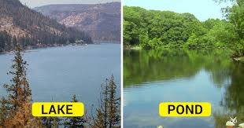
Plate 1: Lake Plate 2: Pond

2.4.7 Wetlands
Wetland is a place where the land is covered by water, either salty or fresh. These are some of the most productive habitats on the Earth. Wetlands are variable and dynamic water bodies where water covers the soil. They are freshwater, brackish or saline, inland or coastal, seasonal or permanent, natural or man-made. Wetlands are most important ecosystems to human survival and development. Wetlands are a critical part of our environment. They protect our shores to reduce the impacts of floods, absorb pollutants and improve water quality. Names of different type’s wetlands are swamp, marsh and bog. Many animals use wetlands for all of their life- cycle. The most significant social and economic benefit that wetlands provide is great volume of food. Human made wetlands are such as fish ponds, farm ponds, agricultural land, reservoirs, and canals World Health Organization (WHO), (2011).
2.4.8 Atmosphere
Atmosphere is the layer of gases that surrounds the Earth. The atmosphere is the smallest water reservoir of the earth. Water is located in the troposphere of the atmosphere. The water in the atmosphere presents only a very small percentage of the total water on Earth World Health Organization (WHO), (2011).
2.5 Significance Of Water
Water is the source of life and it is essential for all living forms and the environment health. It has the plentiful chemical substances on the Earth. It affects all form of life directly or indirectly Ramesh, Dharmaraj, Raj, (2019). The presence of water determines the location and activities of human on the earth. Water is a basic medium of metabolic functions in all life on earth. Water is used in every cell of body to transport nutrients, oxygen, and wastes to cells and organs. Water is a part of body’s temperature regulating system. Water also plays an important role in the prevention of disease. Clean and freshwater must be free of contaminants to ensure wellness Khan, (2011).
The quality of water is just as important as the quantity. Water is used for drinking, bathing, washing, sanitation, irrigation, air condition, power and steam generation, fisheries, ecology, recreation etc. water is widely used in production of atomic energy, chemicals, ice, paper, and steel. Water is the major component in the body required for all body functions such as respiration, perspiration, growth, digestion, waste elimination, reproduction and a host of other important activities. Water is a basic element of social and economic infrastructure. The consumptive and non-consumptive classifications of water are important. Water used consumptively reduce the source at the point of appropriation and is not available for other uses; whereas non-consumptive water use does not reduce the source and the water is available for further reuse.
2.6 Hydrological Cycle
The storage and movement of water between atmosphere, biosphere, lithosphere and the hydrosphere is the hydrological cycle. Water is stored on the earth as oceans, lakes, ponds, wetlands, in soils, rivers, as water vapor in atmosphere, as glaciers and groundwater. In the hydrological cycle, processes like evaporation, condensation, precipitation, deposition, runoff, infiltration, sublimation, transpiration, melting and groundwater flow occur Gebbie, (2000).
The oceans water evaporated in the atmosphere and the maximum amount of evaporated water returned to the oceans by way of precipitation but remaining amount of evaporated water is transported to areas over landmasses where precipitation occurs by climatic conditions. Precipitated water moves as groundwater flow and runoff into rivers, lakes, ponds and oceans Gillison R J and Patmont C R, 2023. The hydrological water cycle is a path way to transfer energy in between atmosphere and surface of the earth. Water is continuously cycled between various reservoirs, as shown in the figure 2.1
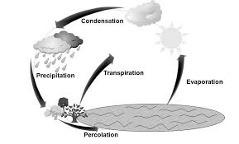
Figure 2.1: Hydrological cycle
2.6.1 Evaporation
The process by which water changes from a liquid to a gas is known as evaporation. Energy is required for evaporation that is used to break the bonds that hold water molecules together UN-Water, (2013).
2.6.2 Transpiration
The process by which plants return moisture to the air is known as transpiration. In transpiration plants lose some of the water through pores in their leaves. Transpiration is the evaporation of water into the atmosphere from leaves of plants. Transpiration accounts 10% of all evaporated water UN-Water, (2013).
2.6.3 Condensation
The cooling of water vapor until it becomes a liquid and turn directly into solid is known as condensation. In this process water vapor form tinny visible water droplets and these droplets are collect and form clouds UN-Water, (2013).

2.6.4 Precipitation
Precipitation is a process in which the moisture that falls from the atmosphere as rain, snow, sleet or hail. It varies in amount, and form by season and geographical location. The clouds will flow into streams or infiltrate into the ground UN-Water, (2013).
2.6.5 Runoff
The movement of water from precipitation across the earth’s surface toward oceans is known as runoff. Rainfall duration, intensity and ground’s slope affect the rate of runoff UN-Water, (2013).
2.6.6 Percolation
The downward movement of water through soil, gravel and rocks until it reaches the water table is known as percolation. The terms infiltration and percolation are used interchangeably (UN-Water, 2013).
2.7 Groundwater
Water that fills pores and fractures in the ground known as groundwater. The upper part of ground water is called the water table and between the water table and the land surface is the unsaturated zone. The water table is the level of water stands. The water table can be very close to the surface and very deep. In the unsaturated zone, water keeps moving downward to the water table to recharge the ground water (Basavarajappa and Manjunatha, 2015).
Groundwater is a hidden resource that saturates the tiny spaces between sand, gravel, silt, clay and fractures in rocks. Water in the soil is referred to as soil moisture and spaces between soil, gravel and rock are filled with water. Most groundwater is found in aquifers. Below the water table, soil and rocks are saturated with water (Gyananath, 2011). Groundwater is stored in layers of soil, sand and rocks called aquifers. An aquifer is a layer of porous substrate that contains groundwater (Gupta and Deshpande, 2004).
Ground water moves from locations of higher pressure to locations of lower pressure. Groundwater movement in rock fractures is relatively slow, whereas it is relatively rapid in sand and gravels. Upper level of an underground surface in which the soil is permanently saturated with water is known as water table. The water table is affected by climate change therefore it fluctuates both with the seasons and from year to year (Helmet, 2003).
Most ground water moves relatively slow through rock underground because the flow of ground water is affected by water pressure and elevation, water within the upper part of the saturated zone tends to move downward. Water rock pores are small then water moves slowly while when openings are large then the flow of water is more rapid. Spring is the place where water flows naturally from rock onto the land surface 66, 89. Groundwater is recharged by the addition of water to the saturated zone. A deep hole that is dug or drilled into the ground to penetrate an aquifer is called well (Hem, 2019).
Groundwater contaminated by pesticides, herbicides, fertilizers that are applied to agricultural crops that can find their way into ground water when rain or irrigation water leaches the poisons downward into the soil1 (Banerji, 2023). Other pollutants like as city waste, household chemicals and heavy metals such as mercury, lead, chromium, copper, and cadmium can also leach by rain into groundwater. Groundwater can contaminate by liquid and solid wastes from sewage plants, septic tanks, and animal waste and slaughterhouses (Nirdosh, et al, 2010). Radioactive waste can cause the pollution of ground water due to liquid radioactive wastes from the nuclear power industry Contaminated groundwater can be decontaminated by expensive long-term procedures. The groundwater quality must, in all cases, be controlled both before its use and during its use (Kaur and Singh, 2011).
2.8 Groundwater Quality
Groundwater is an important natural resource of drinking water. The chemical and biological character of ground water is acceptable for most uses but the quality of ground water is changed as a result of man’s activities (Gajendran and Thamarai , 2008).
The natural quality of groundwater alters as groundwater flows from springs or rivers and recharge areas. Groundwater contains most common dissolved mineral substances such as sodium, potassium, magnesium, calcium, bicarbonate, chloride and sulfate. (Ryznar John, 2016). The suitability of groundwater for various purposes depends on many factors such as dissolved minerals and organic substances present in ground water in different concentrations86. Some constituents are harmless, others are harmful, and a few may be highly toxic (Parihar et al, 2012).
Population growth is one of the major factors responsible for increased solid waste. Agriculture has wide impact on groundwater quality, where intensive practices take place. Urbanization and industrialization have significant impact on groundwater quality. In many parts of earth atmospheric conditions also alter the quality of the groundwater. Groundwater is not considered desirable for drinking if the quantity of dissolved minerals exceeds from permissible limit, (Suma Latha, 2019).
Groundwater in which dissolved minerals are present then its nature is saline. Dissolved minerals can be hazardous to animals and plants in large concentrations. Groundwater that contains a lot of calcium and magnesium is called hard water. The hardness of water is represented in terms of the amount of calcium carbonate (Verma, 2015). In recent years, the growth of industries, technology, and population has increased the stress upon water resources. The quality of groundwater has been degraded (Kumar, 2016).
2.9 Groundwater Contamination
Groundwater contamination occurs when man-made undesirable products get into the groundwater and cause it to become unsafe and unfit for human use. Serious health effects may be caused by contaminated groundwater. It has been assumed that contaminants can either be above or below ground (Kumar and Ahmed, 2003). Movement of groundwater and dispersion within the aquifer spreads the contaminants over a wider area. Surface water percolate through soil then it picks up minerals, salt, and organic compounds6. The water migrate downward therefore concentration of dissolved solids are increased. In some areas minerals concentration is enough high so that the groundwater is unfit for drinking and irrigation purpose without treatment. When the contaminated water seeps into the soil and enters an aquifer it results into ground water contamination (Meena, 2001).
Groundwater contamination comes from point and non-point sources. Point sources contamination comes from specific location such as septic system, underground storage tank and landfills but non-point sources contamination comes from a large area such as from agricultural waste (pesticides and fertilizers) and urban waste.
When the pollution originates from a single, identifiable source is known as a point source of contamination. Various types of point-source contaminants found in waters such as industrial, agricultural, and of urban sources. Point sources of pollution from agriculture may include animal waste storage and cleaning areas for pesticides, fertilizers. Municipal point sources include wastewater treatment plants, landfills (Datta, 2016). Due to all of these activities, hazardous substance may include in the raw material. Non-point sources pollution occur over extensive areas. When water moves over and through the ground it can pick up natural contaminates, synthetic contaminates depositing them into rivers, wetlands, lakes and underground water (Nirmala, et al 2012). Non-point sources contamination also occur by sediments, seepage of septic tanks and use of fertilizers. Irrigated agriculture is a significant source of groundwater non-point contamination.
Contamination of groundwater from septic tanks occurs under various conditions such as poor placement of septic leach fields, badly constructed percolation systems and high density placement of tanks1. If a septic system is not maintained properly then it can pollute drinking water (Singaraja, 2014).
A pollutants leak from sewer lines and sewage enter groundwater directly. Sewer leaks occur from soil slippage, seismic activity, sewage back up and loss of foundation. Residue of the chemical, biological, and physical treatment of municipal and industrial wastes is called sludge. Sludge contains organic matter, heavy matter and inorganic salts. In recent years the quality of groundwater is degraded due to large production of industrial and municipal waste. Groundwater contamination occurs because the wastewaters migrate down to the aquifer (Backman, 2018).
2.10 Sources of Water Pollution
Ground water is located below the surface of the earth in spaces between rock and soil and it is a substantial source of water. Ground water contaminants occur by both natural and human activity (Ballukraya and Ravi, 2019). The quality of groundwater is threatened by various sources of pollution, which are as follows.
2.10.1 Industrial Effluents
Industrial effluents contain various materials, depending on the industry such as chemical manufacturers, metal processers, steel plants, textile manufacturers. Industrial effluent consists of both organic substance and inorganic substances. The organic industrial effluents are produced by the industries such as pharmaceutical, organic dye, cosmetics, glue, soaps, synthetic detergents, herbicide, pesticide, textiles, paper plants (Mondal and Saxena, 2005), oil refining, metal processing and fermentation industries. The inorganic industrial effluents are produced mainly in the iron picking, electroplating plants, coal and steel industries (Mohapatra and Singh 1999). Untreated industrial effluents caused the serious pollution problem to the ground water resources, human’s life and an Environ Threat.
2.10.2 Agriculture Discharges:
Agriculture discharge occurs over a large area as non-point sources pollution, therefore its management and treatment is more difficult. Agricultural discharges contribute to degrade both ground and surface water. Chemicals from fertilizers, pesticides, insecticides, farm waste, plants and animal debris, inorganic material and manure slurry are reported to cause huge pollution to surface and groundwater. Fertilizer pollution is difficult to regulate and reduce. It contains high levels of nitrogen and phosphorous with smaller amounts of potassium.
Nitrogen fertilizers containing nitrates can contaminate groundwater easily because nitrates are highly soluble in water. Rainwater runoff brings fertilizers into rivers, streams, lakes and oceans (National Geographic, 2015).

2.10.3 Sewage and Domestic wastes
Sewage is a significant source of water pollution. Sewage is the term used for wastewater that often contains domestic and industrial wastes. Sewage is commonly water that is discharged after home or industrial use. Sewage contains human waste, soap, detergent, glass, metals, garden waste and sewage sludge. Industrial sewage is used water from chemical processes while domestic sewage carries used water from houses. Untreated sewage may contain nitrogen, phosphorus, organic matter, bacteria, viruses, protozoa, oils, greases, mercury, cadmium, lead, chromium, copper and many toxic chemicals. Sewage released into the lakes, rivers and oceans cause a threat to human health (National Geographic, 2015).
2.10.4 Fertilizers
Fertilizer isn’t a problem if it is used carefully but too much use of fertilizer at the wrong time easily wash off into storm drains and then flow untreated into lakes or streams. A fertilizer is natural or synthetic material that supply one or more plant nutrients essential to the growth of plants. Fertilizers are artificial or organic materials they can cause serious problems. Fertilizers are used mainly in agricultural fields they contain high levels of nitrogen and phosphorus so they cause ecological problems. Nitrogen fertilizers contaminate groundwater which is poison to humans at high levels. Due to fertilizer pollution biggest change occurs in algae populations (Algal blooms). The excess fertilizer use runs off into waterways, they cause algae blooms (National Geographic, 2015).
2.10.5 Runoff from Urban Areas
Urban areas runoff created is a major source of water pollution in urban communities. In urban areas, water is often unable to infiltrate into the soil as a result, urban runoff flows across roadways and urban landscapes. The pollutants from urban runoff include plant material, fertilizers, pesticides, and household chemicals waste. Urban runoff pollution is caused when the runoff, while traveling across the urban environment, acquires contaminants that affect water quality. Urban runoff pollution is nonpoint source pollution (National Geographic, 2015).
2.10.6 Organic Chemicals
A number of organic chemicals are used in chemical industries. A very small amount of the chemicals that may reach drinking-water from various sources is a serious threat to human health.
Synthetic organic chemicals enter into the ecosystem through various human activities. Synthetic pesticides, food additives, synthetic detergents, pharmaceuticals, insecticides, synthetic fibers, plastics, solvents and volatile organic compounds are important sources of toxic organic chemicals in water (National Geographic, 2015).
2.10.7 Inorganic Pollutants
Inorganic pollutants such as mineral acids, trace elements, inorganic salts, metals, metal compounds, cyanides and sulphates are results of human activities and percolate in groundwater aquifers. Inorganic pollutants are non-biodegradable and persist in the environment. Toxic inorganic materials adversely affect biological communities and aquatic ecosystem. Naturally occurring inorganic substance mainly contaminate groundwater (National Geographic, 2015).
2.10.8 Thermal Pollutants
Thermal pollution is defined as sudden change in temperature of natural sources of water which may be lake, river and oceans by human influence. Manufacturing and Production plants are major source of thermal pollution. Discharge of hot water from nuclear power plants, thermal power plants, and industries cause thermal pollution. The temperature of water body increases adversely affecting the aquatic animals such as fish, amphibians and other aquatic organisms. Thermal pollution can change the oxygen levels and affect local ecosystems and communities.
The warm temperature reduces the levels of Dissolved Oxygen in water. The warm water holds relatively less oxygen than cold water. Aquatic species are more sensitive to temperature changes because it causes significant changes in organism’s metabolism and other biological changes. Thermal pollution increases the metabolic rate of organisms as increasing enzyme activity; therefore stability of food chain disrupts and alters the balance of species composition (National Geographic, 2015).
2.10.9 Radioactive Pollutants
Radioactive waste has been created by humans as a co-product of various activities such as mining and refining of radioactive element, production and explosion of nuclear weapons, nuclear power plants, nuclear fuels and preparation of radioactive isotopes. Radioactive waste is a material that has been contaminated by radio nuclide. Radionuclide is unstable atoms of an element that decay emitting energy in the form of radiation.
Human activities produce large amount of radioactive elements into the environment. The radioactive materials are reaching into humans and animals body through food chains. The radioactive materials are reaching to water bodies where the aquatic species absorb them. Wastewaters containing these radioactive materials and they enter human body through food chains from wastewater. All organisms are affected by radiation pollution (National Geographic, 2015).

CHAPTER THREE
METHODOLOGY
3.1 Study Area
Kwara State Polytechnic, Ilorin campus is located in Moro L.G.A of Kwara State, Nigeria. It lies between latitude 8.5889$°$ N' and longitude 4.6687$°$ “E of the Greenwich meridian. It lies on altitude of approximately 372m which is about 1,220 feet. Figure 1 is the satellite imagery Kwara State Polytechnic, campus.
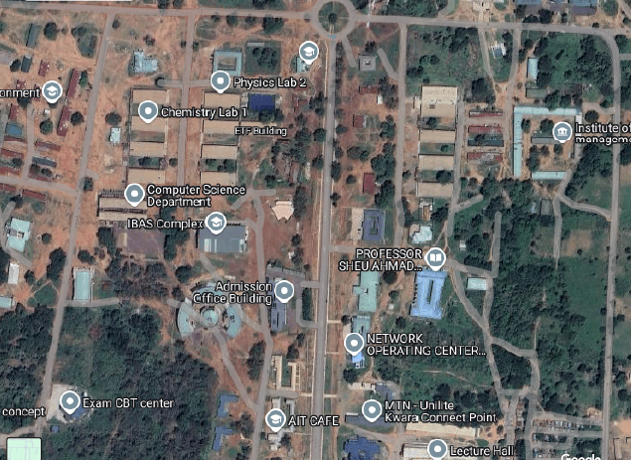
Figure 1: Satellite imagery of the study area
Source: www.goggle,com
3.2 Water Sampling Procedure
Selection of water sources was done by random sampling procedure. A total number of five groundwater samples were collected within Kwara State Polytechnic, campus: Two wells and three boreholes. The samples were collected separately in a sterilized bottle for rain season and dry season respectively. Before collecting the water samples, the bottle container was washed and rinsed thoroughly with water, as shown in 3.1 and 3.2.
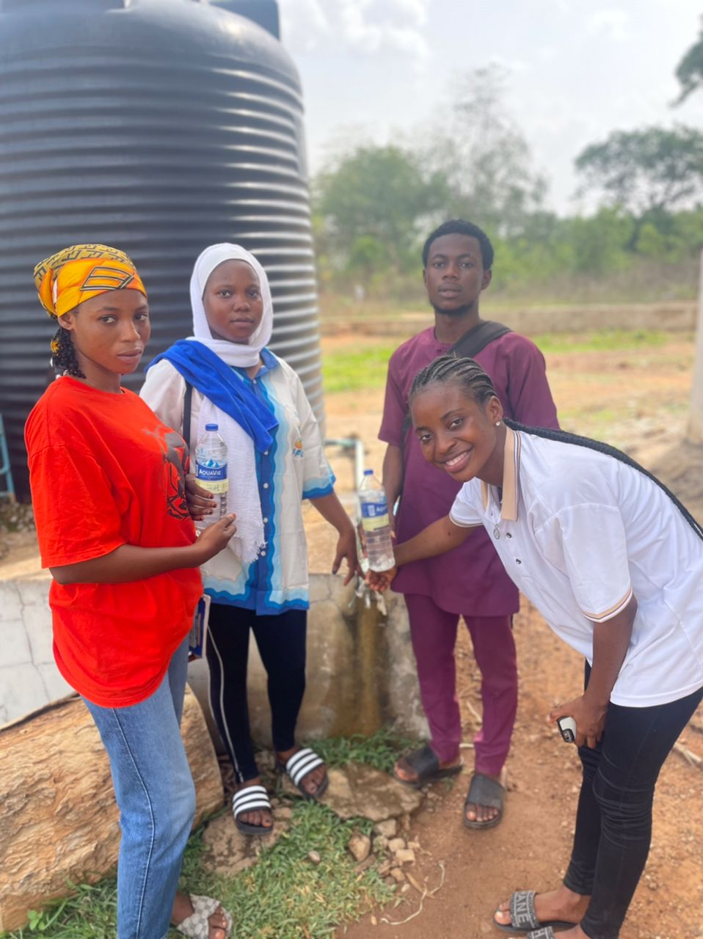
The water samples collected were taken to the laboratory for analysis using standard methods. The Global Position System (GPS) was used to determine the coordinates of the sampled points.
Plate 3.1: Borehole Water Sample Collection Point
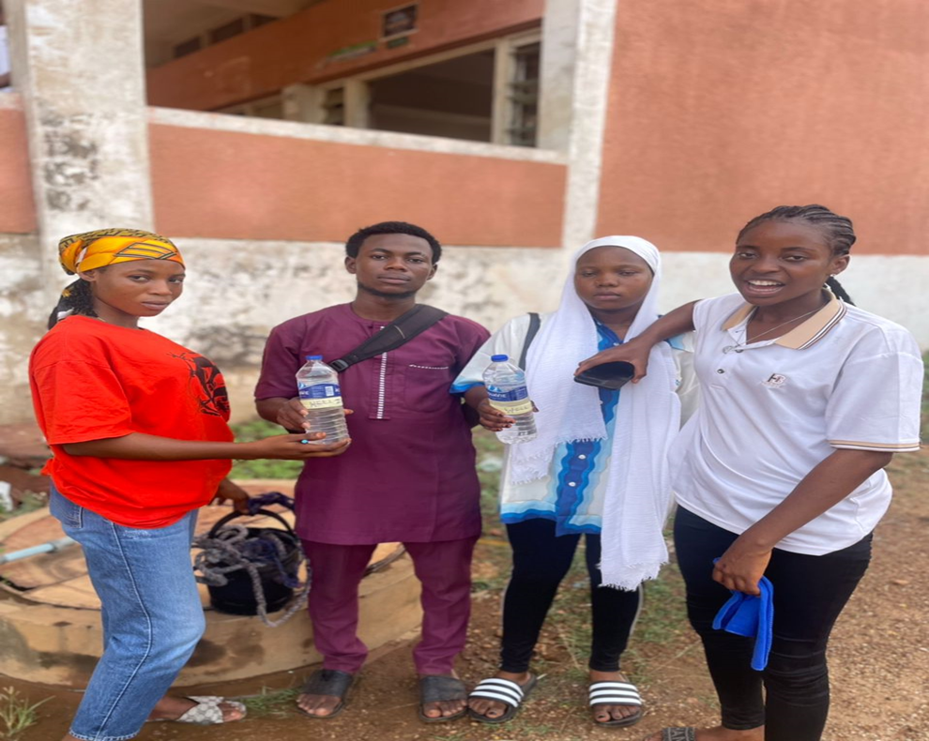
Plate 3.2: Well Water Sample Collection Point
3.3 Laboratory Analysis of the Water Samples
The Laboratory analysis of the water samples was carried out at Fisbol Geosciences and analytical service sabo oke Ilorin, Kwara State. The water samples were tested for selected physical and chemical properties.
The laboratory analysis was carried out using standard analytical methods and physical procedures for water quantity analysis.
3.4 Analysis of parameters
3.4.1 Physical parameters
A number of tests were carried out to determine physically parameters and there quantities in each ground water samples
3.4.2.1 Temperature
The temperature of each sample was measured directly at the collection site from the boreholes and wells using a thermometer.
3.4.2.2 Color / Odor
The Equipment use in determine color is colorimeter and odor is odor panel. Colour measure was carrying out using Lovi bond Computer with calibrated colour disc. A cell was filled to the mark with distilled water and placed in the left sample position on the comparator.
3.4.2.3 P^{H}
The Equipment for the P^{H} is pH meter. The pH of the raw ground water samples were measured immediately at site after collection according to (ASTM, 2004) standard method. 100cm3 of the sample was placed in a sample bottle after which the Orion 290A meter electrode was placed in the water sample and the instrument was electrically operated. This measured and recorded the pH reading directly.
3.4.2.4 Filterable solids
Determined by filtering the sample through a filter and then measuring the solids present in the filtrate.
3.4.3 Chemical Analysis
Tests varying in equipment and reagent used were carried out to analyze samples for chemical parameters
3.4.3.1 Total hardness
The total hardness, which includes both temporary and permanent hardness, was determined using the EDTA titrimetric method.
3.4.3.2 Chloride
Chloride concentration was determined using the Mohr titration method. Silver nitrate was titrated against the water sample, with potassium chromate (K,CrO4) used as the indicator.
3.4.3.3 Sulphate
Sulphate levels in water samples were determined using the turbidimetric method. The results were measured with a SpectroMec 20 Atomic Absorption Spectrophotometer and subsequently converted to mg/L.
3.4.3.4 Nitrate
Sulphate levels in water samples were determined using the turbidimetric method. The results were measured with a SpectroMec 20 Atomic Absorption Spectrophotometer and subsequently converted to mg/L.
3.4.3.5 Trace Elements
Zinc, Iron, copper, manganese, The results were directly obtained from the Atomic Absorption Spectrophotometer, Spectronic 20 model.
3.5 Methods Of Data Analysis
The data were analysis using statistical tools and the results obtained were presented in tables .

CHAPTER FOUR
RESULT AND DISCUSSION
4.1 Results
Table 4.1 shows the result of the physical and chemical properties of the underground water in Kwara State Polytechnic, Ilorin
Table 4.1: Result of Physical and chemical analysis of underground water of Kwara State Polytechnic, Ilorin
S/N Parameter A B C D E MIN MAX Mean STD
1 Temperature $°$C 30.2 30.4 30.6 31.8 30.9 30.2 30.9 30.78 0.626099
2 Colour Unit 42 17 12 49 61 12 61 36.2 21.01666
3 Turbidity N.T.U 25 9 8.5 21 20 9 25 16.7 7.496666
4 pH 7.7 8.1 7.6 7.1 7.2 7.1 8.1 7.54 0.403733
5 Total Dissolved 680 980 790 879 710.5 680 980 807.9 123.328
6 Electrical Cond. 1176 1850 1568 1758 1419 1176 1850 1554.2 269.5073
7 Chloride mg/1 22 38 64 45 30.7 22 64 39.94 15.93324
8 Nitrate mg/1 ND ND 24.1 23.43 18.6 18.6 24.1 22.04333 3.000772
9 Total Hardness mg/1 28 42 54 78 98.9 28 98.9 60.18 28.37714
10 Manganse Mn²⁺ mg/1 ND 0.1 0.1 0 0.3 0 0.3 0.125 0.149097
11 Iron Fe ³⁺ mg/1 0.05 0.05 0.02 0 0.36 0 0.36 0.096 0.149097
12 Copper ND ND 0.05 0.08 0.04 0.04 0.08 0.056667 0.020817
13 Zinc ND ND ND ND ND ND ND ND ND
 | A | BoreHore
 | B | BoreHore
 | C | wellWater
 | D | wellWater
 | E | wellWater

4.1 Discussion
Temperature
Table 4.1 shows the temperature mean (30.78ºc) is higher than the WHO’s recommended value (25ºc) which may affect taste and could encourage microbial growth, but it does not violate any health-based standard. Regular monitoring and, if possible, cooling of water before consumption is recommended for better acceptability and safety.
Colour
Table 4.1 shows the colour (A,B,D and E) exceed the WHO recommended colour limit (15units) for drinking water, except for sample C. While this does not pose a direct health risk, it suggests the presence of dissolved substances or metals and may affect taste, appearance, and consumer trust. Treatment and regular monitoring are advised to improve water quality.
Turbidity
Table 4.1 shows that all the parameters exceed WHO standard for drinking water, which may affect taste, appearance, and indicate possible contamination
pH
The pH values of all the samples fall between 7.1–8.1 the mean is 7.54 as shown in table 4.1 were all within the WHO recommended range for drinking water (6.5–8.5). This suggests the water is safe regarding pH, with no risk of corrosion or taste issues related to pH.

Total Dissolve Solid
Table 4.1 shows TDS values range from 680–980 mg/L, mean is 807.9 mg/L are below the WHO recommended maximum of 1000 mg/L, indicating the water is within acceptable limits for drinking . The samples meet the WHO standard for TDS in drinking water, indicating they are safe and acceptable for consumption in terms of dissolved solids
Electrical Conductivity
Samples B, C, and D, as well as the mean value, exceed the commonly referenced WHO standard of 1500 µS/cm, while A and E are within the acceptable range as shown in table 4.1. Samples B, C, and D which may affect palatability and signal the need for further investigation into specific dissolved ions. While not a direct health risk, consistently high EC warrants attention to overall water quality and potential sources of contamination.
Chloride and Nitrate
Chloride, all samples (22–64 mg/L) are well below the WHO guideline, indicating no taste or health concerns.Nitrate: All detected values (18.6–24.1 mg/L) are also below the WHO limit, suggesting no immediate health risk. “ND” (not detected) in some samples further supports safety, as shown in table 4.1. Both chloride and nitrate levels in the samples are well within World Health Organization WHO standards for drinking water, indicating the water is safe and acceptable for consumption regarding these parameters. Regular monitoring is still recommended to ensure ongoing safety.
Hardness and Manganese
Table 4.1 shoes all the water sample are soft, which is generally preferred for taste and household use .Manganese is levels are safe, but ongoing monitoring is wise, as high manganese can cause staining and health issues if above recommended levels, indicating the samples are safe and acceptable for drinking regarding these parameters. Regular monitoring remains important to ensure continued compliance.
Iron (Fe³⁺)
Table 4.1 shows samples (A–D) meet WHO standards and are health-wise acceptable Iron is not toxic at these levels and poses no direct health risk based on WHO criteria, Sample E (0.36 mg/L) exceeds the WHO guideline of 0.3 mg/L. This could lead to metallic taste, staining, or cloudiness in the water. Mean is 0.096 mg/L well below the WHO aesthetic limit and standard deviation is 0.149 indicates some variation among samples, mainly due to Sample E. further investigation or routine monitoring is recommended.

CHAPTER FIVE
CONCLUSION AND RECOMMENDATION

5.1 Conclusion
The analysis of water quality parameters in Table 4.1 reveals that most values fall within the acceptable limits set by the World Health Organization (WHO), indicating that the water is generally safe for consumption. Parameters such as pH, Total Dissolved Solids (TDS), chloride, nitrate, hardness, and manganese comply with WHO standards, ensuring no immediate health concerns. However, elevated values were observed in temperature, colour, turbidity, electrical conductivity, and iron (in Sample E), which may not pose direct health risks but can affect water palatability, appearance, and consumer perception.

5.2 Recommendations
- Temperature exceeds WHO's recommended value, consider cooling the water before consumption to enhance taste and limit microbial growth.
- Filtration or chemical treatment should be employ to reduce colour and turbidity levels, which can improve clarity and restore consumer confidence.
- For samples with high electrical conductivity (EC), further analysis should be carried out to identify specific dissolved ions and address any underlying contamination sources.
- Investigate and treat sample E to reduce iron content and prevent staining, taste issues, and water discoloration.
- Maintain routine water quality testing to ensure compliance with WHO guidelines and to detect any emerging contamination issues early.
- Educate consumers on the importance of safe water practices and the implications of various water quality parameters.

REFERENCES
Adekunle, A. J.(2009). Studies on the pollution of waterbody by textile effluents in . Lagos, Nigeria Studies On The Pollution Of Waterbody By Textile Industry Effluents In Lagos , Nigeria. (February).
Adeyemi A.A, O.J. Shotonwa, I.D. Okedeyi, O.O. Ajibade, A.A. Sallu, A.R. Olawore, M.A. and Okpe, K.A (2011). Monitoring metals pollution using water and sediments collected from Ebute Ogbo river catchments Ojo Lagos, Nigeria. African Journal of Pure and Applied Chemistry 5/8 219 – 223.
Adhikary, P.; Vishwakarma, M.; Rawtani, P.M. 2019: Assessment of Water Quality Parameters of Kerwa Dam for Drinking Suitability. Int. J. Theor. Appl. Sci., 1, 53– 55. [Google Scholar]
Altman and Parizek (1995). Contribution of nutrients and some trace metals from a huge Egyptian drain to the SE-Mediterranean Sea, west of Alexandria. J.Mediterranian Marine Sci., 7: 79–86.
APHA. (2005) Standard Methods for the Examination of Water and Waste Water, twenty first ed. American Public Health Association.
APHA: Washington, DC. Christensen, J. B., D. L. Jensen, C. Gron, Z. Filip and T. H. Christensen, (1998), Characterization of the dissolved organic carbon in landfill leachate-polluted groundwater, Water Res., 32, 125-135.
Chem., 2(4): 969-971.Gyananath K. (2011). Nitrate leaching from arable and horticultural land, soil use and management. pp. 145 – 151.
Benjamin, P. (2015). Quantitative Analysis of Environmental Samples.Instruction Manual. Ljublijana. p. 150.
Benerji, H., (2003). A preliminary study of heavy metal contamination in Yangize river intertidal zone due to urbanization. Marine Pollution Bulletin, 49:910-915.
Basavarajappa and Manjunatha (2015). Use of Water Quality Indices to Verify the Impact of Córdoba City (Argentina) on Suquía River. Water Res. 2000, 34, 2915–2926. [Google Scholar] [CrossRef]
Eletta and Adekola (2005). Trace metal distribution in surface water, sediment and tissues of fresh water catfish (Clarias gariepinus) from Oke-Afa canal, Lagos, Nigeria. http://aess.web.com/journal.detailphp?id=5011 retrieved 23rd March,2016.
Gebbie, I. (2000). Heavy metals concentration in fish of Lake Baloton, Lakes and Reservoirs. Journal of Research and Management, 5: 271-279.
Goel G. O., (2000). The current pollution status of the new Calabar river in the Niger Delta region of Southern Nigeria. A survey of antibiogram profiles of its bacterial isolates. African Journal of Environmental Science Technology, 2(6): 134-141.
Gupta, A and Deshpande (2004). Study of Physico-chemical Parameters of Groundwater Quality of Dudu Town in Rajasthan. Rasayan J.
Helmet, C. (2003). An Environmental hazard and its Management. NBRI, Lucknow. p 14.
Jinwal J.J Dixit L (2008). Evaluation of the Status of Heavy Metal Pollution of Water (Surface and Ground) and Aquatic Macrophyte (Ceratophyllumdemersum) of Agbabu Bitumen Deposit Area, Nigeria.British Journal of Applied Science & Hem, S. 2019: Generalized Buffering Algorithm. IEEE Access 2021, 9, 27140–27157. [Google Scholar] [CrossRef]
Khan P. (2011). Urban Water Quality Evaluation using multivariate analysis. Acta Montanistica Slovaca, 12(2): 150-158.
Manhata V, Rasheed, H.; Altaf, F.; Anwaar, K.; Ashraf, M. 2004. Drinking Water Quality in Pakistan: Current Status and Challenges; Pakistan Council of Research in Water Resources (PCRWR): Islamabad, Pakistan, 2021; p. 141.
Meride, SM and Ayenew (March 2016). Assessment of groundwater evaporation through groundwater model with spatio-temporally variable fluxes (PDF) (MSc). Enschede, Netherlands: International Institute for Geo-Information Science and Earth Observation
Neerja Karlar, Rajesh Kumar, Yadav S.S, Singh R.T, Water quality index assessment of ground water in Koilwar block of Bhojpur (Bihar), J. Chem. Pharm. Res, 4 (3), 2012, 1782-1786.
Nirdosh, M.L, Forstner, U. & Wittmann, G. T. W. (1981). Metal pollution in aquatic environment. New York: Springer http://dx.dor.org/10.1007/978-3-642-69385-4.
NSDQW., (2007), Nigerian Standard for Drinking Water Quality. Nigerian Industrial Standard NIS 554, Standard Organization of Nigeria, pp: 30.
Parihar, A., Osibanjo, O., Sridhar, M.K.C., and A. Sobande. (2002), “Evaluation of Groundwater Quality Characteristics near Two waste Sites in Ibadan and Lagos, Nigeria”. Water, Air, and Soil Poll. 140:307–333.
Patil and Patil , M. (2010). Bioremediation of polluted wastewater influent: Phosphorus and nitrogen removal. Scientific Research and Essays, 5(21), 3222–3230
Technology,3(2): 289-306
Purandara, A.A.; Varadajan, J. 2003: Risk Assessment of Physico-Chemical Contaminants in Groundwater of Pettavaithalai Area, Tiruchirappalli, Tamilnadu–India. Environ. Monit. Assess. , 123, 299–312. [Google Scholar] [CrossRef] [PubMed]
Ranjana, M.F. 2009. Analyzing the Status of Heavy Metals in Irrigation Water in Suburban Areas of Bahawalpur City, Pakistan. AEJAES 2014, 14, 732–738. [Google Scholar]
Milovanovic T.L. A 2007: Scaling Method for Priorities in Hierarchical Structures. J. Math. Psychol., 15, 234–281. [Google Scholar] [CrossRef]
Okoro, K. M., Sowa, O. and Osundu, O.C. (1992). Environmental contamination and other anthropogenic impacts on Otamiri and Nworie rivers, Owerri, Nigeria. Nigeria Journalof Minneral Geology., 26:28-29.
Ologe, G. A. (1989). The bioaccumulation of heavy metals form the lower reaches of River Niger. Journal of Chemical Society of Nigeria, 27(2): 173-176.
Raham, R. C,. (2008). Trace elements concentrations in fresh water muscles and macrophytes as related to those in their environments. Journal of Limnology, 62(1): 61-70
Ramesh M.M, Dharmaraj J, Raj K 2019: Oregon Water Quality Index a Tool for Evaluating Water Quality Management Effectiveness. J. Am. Water Resour. Assoc., 37, 125– 137. [Google Scholar] [CrossRef]
Shah D.G and Patel P.S, Water quality of some drinking water samples of Kathalal territory, Gujarat, J.Chem. Pharm. Res, 4 (4), 2012, 2285-2287.
Singh, S.; Masood, M.U.; Haider, S.; Anjum, M.N.; Hussain, F.; Ding, Y.; Shangguan, D.; Rashid, M.; Nadeem, M.U. 2011: Investigating the Effects of Climate and Land Use Changes on Rawal Dam Reservoir Operations and Hydrological Behavior. Water , 15, 2246. [Google Scholar] [CrossRef]
United Nation Water (UN) (2013). Guideline for drinking water quality. In Recommendation, Vol. 1, 2nd ed.World Health Organization, Genevapp.30–113.
World Health Organisation (WHO), (2011), Water for Pharmaceuticals Use. In: Quality Assurance of Pharmaceuticals: A Compendium of Guidelines and Related Materials. 2ndUpdated Edn.
UNEP/WHO (1996). Water Quality Monitoring – A Practical Guide to the design and implementation of fresh water. Quality Studies and Monitoring Programme.
United States Environmental Protection Agency (USEPA) (1997). http : // www.epa.gov/watertrain/ava/grossinghtml. Retrieved 15/8/2015.
Hughes A.W, (2004), Getting to grips with groundwater pollution protection in developing countries, National Resour. Forum 10(1): 51-60.
Yadav S.S and Rajesh Kumar, 2010: Assesment of physico–chemical properties of ground water taken from four blocks (Suar, Milak, Bilaspur, Shahabad) of Rampur district, Uttar Pradesh, India, Rasayan J.Chem, 3, , 589-596.

