A PROJECT REPORT
ON
PROPORSED DENTAL CLINIC
FOR
OBA OLAWALE HARUNA ILUFEMILOYE
ATSHARE, KWARA STATE

BY:
JIMOH PETER IYIMIDE
ND/23/ARC/PT/0009

BEING A PROJECT REPORT SUBMITTED TO
THE DEPARTMENT OF ARCHITECTURAL TECHOLOGY, INSTITUTE OF ENVIRONMENTAL STUDIES (IES),
KWARA STATE POLYTECHIC, ILORIN.
INPARTIAL FULFILMENT OF THE REQUIREMENT FOR
THE AWARD OF NATIONAL DIPLOMA (ND)
IN ARCHITECTURAL TECHNOLOGY.

JULY,2025

DECLARATION
I declare that this Project/Dissertation is a project of my personal research works. It has not been presented for the award of any ND in any polytechnic. The ideas, Observations, Comments, and Suggestions here in represent my own convictions except quotations, which have been acknowledged. In accordance with conventional academic traditions. Under the supervision of ARC OLAREWAJU F.A

JIMOH PETER IYIMIDE
ND/23/ARC/PT/0009

____________________
SIGNATURE & DATE

CERTIFICATION
I certify that this research project/Dissertation entitled DENTAL CLINIC was carried out byJIMOH PETER IYIMIDE under my supervision ARC OLAREWAJU F.A has been approvedas meeting the requirement for the award of National Diploma (ND) in Architectural Technology, Kwara State Polytechnic, Ilorin, Kwara State.


ARC OLAREWAJU F.A
(Project Supervisor)SIGNATURE & DATE

ARC OLAREWAJU F.A
(Project Coordinator)

ARC MRS TOMORI J.M
(Head of Department)

____________________
EXTERNAL EXAMINER SIGNATURE & DATE

ACKNOWLEDGEMENT
My profound gratitude goes to Almighty Allah, the creator of universe and fountain of all wisdom whose umbrella of guard and guide. I seek refuge through thick and thin of years of study.
I will also like to appreciate my project supervisor in person of ARC OLAREWAJU F.A whose contribution Prepare me for the challenges in the field and for his immense contribution is all ramification towards the completion of this research work. He encourage me and open the door of interaction with him. I pray Almighty Allah will shower his blessing and mercy over him, your family and may you live to reapthe fruit of your labour.
I also want thank and appreciate the effort of all the Lectures in Architectural Technology Department my H.O.D ARC MRS TOMORI and the host of lectures ARC FAMILUA O.S, ARC CHUCKWUMA NMOM, ARC MOH. SHERO, who taught and give lasting advice’s that led to the success of my program, Almighty Allah will meet everyone at the point of needs.
I would also show my profound gratitude to my parents MR and MRS JIMOH for their Immeasurable motivation, advices, efforts, and prayers on me for the completion of this program.
My Lovely sisters: Miss DORCAS JIMOH and My Lovely Brother: JIMOH STEPHEN. Almighty Allah shower his endless blessing, mercy, unlimited grace, joy, happiness without sorrow, sound health overall and may Almighty Allah meet everyone at the point of your needs.
Precious friends: My lovely friends OLA, IDOWU, WALE, AYOMIDE,VICTOR. Almighty Allah shower his blessing, grace, and happiness with sound health over you all and our prayer (AMEEN)
Lastly ,I would like to appreciate the effort of my colleagues in department, school, and hostel, I whole heartedly say a VERY BIG THANK YOU, I appreciate you all, May Almighty Allah bless you all.
Above all, my utmost thanks go to the all sufficient God, the fountain of my wisdom, for his great and protection over my life, for his undying love, support and guidance throughout my period of learning and also for in sighting writing this project without him am nothing.

DEDICATION
This project work is dedicated to Almighty Allah who has been providing all my need for his blessing and mercy over me all through the program.
And to my parent, my sisters, my brothers, friends, love one’s and supervisor who assist me financially, spiritually, mentally and guide me through my academic pursuit. May Almighty Allah shower his blessing and mercy over you All.

TABLEOFCONTENT
Titlepage………………………………………………………………………………....i
Declaration………………………………………………………………………………..ii
Certification………………………………………………………………………………iii
Acknowledgement………………………………………………………………………..iv
Dedication…………………………………………………………………………….......v
Tableofcontents………………………………………………………………………....vi
List of tables… .x
List of figures…………………………………………………………………………….xi
List of plates…………………………………………………………………………….xii
List of Appendices……………………………………………………………………..xiii
Abstract………………………………………………………………………………...xiv
CHAPTERONE
1.1 INTRODUCTION…………………………………………………………………...1
1.2 DEFINITION…………………………………………………………………………2
1.3 HISTORICALBACKGROUND……………………………………………………..3
1.4 AIMAND OBJECTIVES ……………………………………………………………4
1.5 PROJECT JUSTIFICATION ………………………………………………………...4
1.6 CLIENT BACKGROUND…………………………………………………………....5
1.7 SCOPE OFTHEPROJECT…………………………………………………………..5
1.8 RESEARCHMETHODOLOGY……………………………………………………..5
CHAPTERTWO
2.1 LITERATURE REVIEW……………………………………………………………6
2.2 HISTORICALBACKGROUND……………………………………………………6
CHAPTERTHREE
3.1 CASESTUDIES………………………………………………………………...........6
3.2 SELECTEDCASE STUDIES 6
3.3 CASESTUDYONE………………………………………………………………….7
3.4 CASESTUDYTWO………………………………………………………………..11
3.5 CASE STUDY THREE……………………………………………………………...12
3.5 ONLINECASESTUDY…………………………………………………………….15
3.6 DEDUCTION………………………………………………………………………..16
CHAPTERFOUR
4.1 BRIEF HISTORICAL BACKGROUND………………………………………18
4.2 LOCATION AND SETTING OUT………………………………………….....19
4.3 POPULATION………………………………………………………………….19
4.4 SITE INVENTORY……………………………………………..………………21
4.5 SITE ANALYSIS………………………………………………………………..21
4.5.1 SITE SELECTION AND JUSTIFICATION… ……………………… ..……22
4.5.2LOCATION …………………………………………………………………..22
4.5.3 ACCESSIBILITY………….………………………………………………….22
4.5.4 INFRASTRUCTURE FACILITES….………………………………………..23
4.5.5 TOPOGRAPHY………………………………………………………….........23
4.5.6 SOIL STRUCTURE…………………………………………………………...23
4.6 GENERAL CLIMATE CONDITION.…………………………………………..23
4.6.1RELATIVE HUMIDITY……………………………………………………………...23
4.6.2 WIND…........................................................................................................................23
4.6.3 TEMPERATURE……………………………………………………………………..24
4.6.4 VEGETATION………………………………………………………………………..24
4.7 SOCIAL SERVICES…………………………………………………………………….25
4.7.1 ROAD………………………………………………………………………………….24
4.7.2 WATER AND ELECTRICITY………………………………………………………..24
4.8 DESIGN CRITERIA……………………………………………………………………..25
4.9 DESIGN BRIEF ………………………………………………………………….………25
4.10 DESIGN ANALYSIS… …………………………………………………………...25
4.11 SPACIAL ALLOCATION …………………………………………………………...26
4.12 PLANNING PRINCIPLE……………………………………………………………….28
CHAPTERFIVE
5.1 APPRAISAL OF PROPOSED SCHEME………………………………………………..29
5.2 CONSTRUCTION METHODOLOGY…………………………………………………..29
5.3 SERVICES………………………………………………………………………………..29
5.3.1 VENTILATION…………………………………………………………………………29
5.3.2 LIGHTING………………………………………………………………………………30
5.3.3 PLUMBING……………………………………………………………………………..30
5.3.4 ELECTRICAL INSTALLATION………………………………………………………30
5.3.5 WASTE DISPOSAL…………………………………………………………………….31
5.3.6 FIRE PROTECTION…………………………………………………………………….31
5.3.7 RAIN PROTECTION……………………………………………………………………31
5.3.8 EXTERNALWORK……………………………………………………………………..31
5.4 SUMMARY………………………………………………………………………………..31
5.5 CONCLUSION…………………………………………………………………………….32
5.6 RECOMMENDATION……………………………………………………………………32
5.7 REFERENCES……………………………………………………………………………..33
5.8 APPENDICES……………………………………………………………………………...34

LIST OF TABLES

TABLE4.1; SHOWING THE POPULATION OF THE GENDER 25

TABLE4.2; SHOWING SPACIAL ALLOCATION OF FLOOR PLAN… 30

LIST OF FIGURES
FIG3.1; SHOWING LOCATION PLAN OF CASE STUDY ONE… 10
FIG3.2; SHOWING FLOOR PLAN OF CASE STUDY ONE… 10
FIG3.3; SHOWING LOCATION PLAN OF CASE STUDY TWO… 13
FIG3.4; SHOWING FLOOR PLAN OF CASE STUDY TWO… 14
FIG3.5; SHOWING LOCATION PLAN OF CASE STUDY THRE… 16
FIG3.6; SHOWING FLOOR PLAN OF CASE STUDY THREE… 17
FIG4.1; SHOWING LOCATIONAL PLAN OF THE PROPOSED SITE… 24
FIG4.2; SHOWING SITE INVENTORY OF THE PROPOSED SITE… 26
FIG4.3; SHOWING SITE ANALYSIS OF THE PROPOSED SITE… 27

LIST OF PLATES

PLATE3.1; SHOWING FRONT VIEW OF CASE STUDY ONE… 11

PLATE3.2; SHOWING RIGHT VIEW OF CASE STUDY ONE… 11

PLATE3.3; SHOWING BACK VIEW OF CASE STUDY ONE 12

PLATE3.4; SHOWING SURGERY ROOM OF CASE STUDY ONE… 12

PLATE3.5; SHOWING FRONT VIEW OF CASE STUDY TWO… 14

PLATE3.6; SHOWING WAITING AREA OF CASE STUDY TWO… 15

PLATE3.7; SHOWING SURGERY ROOM OF CASE STUDY TWO… 15

PLATE3.8; SHOWING FRONT VIEW OF CASE STUDY THREE 16

PLATE3.9; SHOWING RIGHT VIEW OF CASE STUDY THREE 18

PLATE3.10; SHOWING SURGERY ROOM OF CASE STUDY THREE 18

LISTOFAPPENDICES
APP1; SHOWING SITE PLAN OF THE PROPOSED PROJECT 38
APP2; SHOWING GROUND FLOOR PLAN OF THE PROPOSED PROJECT 39
APP3; SHOWING ROOF PLAN OF THE PROPOSED PROJECT 41
APP4; SHOWING CROSS SECTION OF THE PROPOSED PROJECT 42
APP5; SHOWING FRONT VIEW OF THE PROPOSED PROJECT 43
APP6; SHOWING SIDE VIEW OF THE PROPOSED PROJECT 44

ABSTRACT
This researcher work was carried out on the project topic "Dental clinic for Ilorin kwarastate". I felt caring out this project inIfelodun local government will bring out meaningful result. For easy analysis and understanding, the study is being put into five chapters. Chapter one throws light on general introduction, definition of the project, historical background information of the project title, project justification, aim and objectives of the study, scope of the study, Chapter two, a detailed literature review of some books. The third chapter three also mention about thecase studies and deduction from case studies. The fourth chapter deals withhistorical background of the study area, site location and description, site analysis, and geographical location, climatic data, population of the area, social services, and health services design criteria, design analysis, space allocation and planning principle. Chapter five deals with design appraisal, construction methodology, services, summary, conclusion and references.
CHAPTER ONE
1.1 INTRODUCTION
Dental clinic play a vital role in promoting oral health and hygiene by providing services that range from routine checkup to complex surgeries.
They cater to a wide range of patients, from those requiring preventive care to those needing specializing treatment like orthodontics, cosmetics dentistry or oral surgery. As the demand for dental services continues to grow.
The future of dental education will be shaped, in part, by scientific, technological, political, and economic factors that are largely beyond the profession's control. Nonetheless, dental educators—individually and collectively—have important choices to make. They may attempt to preserve the status quo—in effect, a path toward stagnation and eventual decline. Alternatively, they can choose a more difficult path of reassessing and renewing their missions of education, research, and patient care so that they contribute more—and more visibly—to the university and the community. Taking this latter path will require more vigor in implementing long-standing recommendations for educational reform as well as attention to new issues and objectives. For dental educators to pursue change successfully, they will need the active cooperation of the larger dental community as well as support from university officials and state and national policymakers.
This Institute of Medicine (IOM) study was prompted by concerns that the challenges confronting dental education, although generally recognized, were not understood or appreciated adequately and that effective responses had yet to be identified or presented in a persuasive manner. The purpose of the study was "to assess dental education in the United States and make recommendations regarding its future." It was overseen by an 18-member committee that was appointed after extensive consultation with dental and related organizations. The group included members with expertise and experience in dental practice and education, oral health and health services research, other areas of health professions and Higher education, health care delivery and financing, and public policy. The committee as a whole met six times between February 1993 and May 1994. As described in the Preface and summarized in Appendix 1.A, it undertook a wide range of activities to collect information and perspectives from all segments of the dental community and other relevant, interested groups. (The papers commissioned by the committee will be published in the Journal of Dental Education; they are listed in Appendix C.) This document, which was submitted for outside review in accordance with IOM and National Research Council procedures and policies, constitutes the committee's final report.

1.2 DEFINITION OF A DENTAL CLINIC
DENTAL can be define as anything related to teeth, including their structure, development and care.
CLINIC is an establishment or hospital department where outpatient are given medical treatment or advice, especially of specialist nature.
DENTAL CLINIC is a place where a dentist perform oral health treatment and dental procedures. Dental clinic is a place where patient can receive comprehensive dental care including routine cleaning.
1.3 HISTORICAL BACKGROUND
The history of dentistry is almost as ancient as the history of humanity and civilization, with the earliest evidence dating from 7000 BC to 5500 BC. Dentistry is thought to have been the first specialization in medicine which has gone on to develop its own accredited degree with its own specializations. Dentistry is often also understood to subsume the now largely defunct medical specialty of stomatology (the study of the mouth and its disorders and diseases) for which reason the two terms are used interchangeably in certain regions. However, some specialties such as oral and maxillofacial surgery (facial reconstruction) may require both medical and dental degrees to accomplish. In European history, dentistry is considered to have stemmed from the trade of barber surgeons.
Dental treatments are carried out by a dental team, which often consists of a dentist and dental auxiliaries (such as dental assistants, dental hygienists, dental technicians, and dental therapists). Most dentists either work in private practices (primary care), dental hospitals, or (secondary care) institutions (prisons, armed forces bases, etc.).
The modern movement of evidence-based dentistry calls for the use of high-quality scientific research and evidence to guide decision-making such as in manual tooth conservation, use of fluoride water treatment and fluoride toothpaste, dealing with oral diseases such as tooth decay and periodontitis, as well as systematic diseases such as osteoporosis, diabetes, celiac disease, cancer, and HIV/AIDS which could also affect the oral cavity. Other practices relevant to evidence-based dentistry include radiology of the mouth to inspect teeth deformity or oral malaises, haematology (study of blood) to avoid bleeding complications during dental surgery, cardiology (due to various severe complications arising from dental surgery with patients with heart disease), etc.
John M. Harris started the world's first dental school in Bainbridge, Ohio, and helped to establish dentistry as a health profession. It opened on 21 February 1828, and today is a dental museum. The first dental college, Baltimore College of Dental Surgery, opened in Baltimore, Maryland, US in 1840. The second in the United States was the Ohio College of Dental Surgery, established in Cincinnati, Ohio, in 1845. The Philadelphia College of Dental Surgery followed in 1852. In 1907, Temple University accepted a bid to incorporate the school.
Studies show that dentists that graduated from different countries, or even from different dental schools in one country, may make different clinical decisions for the same clinical condition. For example, dentists that graduated from Israeli dental schools may recommend the removal of asymptomatic impacted third molar (wisdom teeth) more often than dentists that graduated from Latin American or Eastern European dental schools.
In the United Kingdom, the first dental schools, the London School of Dental Surgery and the Metropolitan School of Dental Science, both in London, opened in 1859. The British Dentists Act of 1878 and the 1879 Dentists Register limited the title of "dentist" and "dental surgeon" to qualified and registered practitioners. However, others could legally describe themselves as "dental experts" or "dental consultants". The practice of dentistry in the United Kingdom became fully regulated with the 1921 Dentists Act, which required the registration of anyone practising dentistry. The British Dental Association, formed in 1880 with Sir John Tomes as president, played a major role in prosecuting dentists practising illegally. Dentists in the United Kingdom are now regulated by the General Dental Council.
In many countries, dentists usually complete between five and eight years of post-secondary education before practising. Though not mandatory, many dentists choose to complete an internship or residency focusing on specific aspects of dental care after they have received their dental degree. In a few countries, to become a qualified dentist one must usually complete at least four years of postgraduate study; Dental degrees awarded around the world include the Doctor of Dental Surgery (DDS) and Doctor of Dental Medicine (DMD) in North America (US and Canada), and the Bachelor of Dental Surgery/Baccalaureus DentalisChirurgiae (BDS, BDent, BChD, BDSc) in the UK and current and former British Commonwealth countries.
1.4 AIM AND OBJECTIVE OF THE PROJECT
AIM
To design and develop a functional, efficient, and patient-friendly dental clinic in SHARE that enhances healthcare delivery through optimal space utilization, hygiene, comfort, and modern dental technology integration, while adhering to architectural best practices and local building regulations.

OBJECTIVES
- Create a seamless workflow between different functional areas for efficient patient movement and staff operations.
- Incorporate universal design principles to make the clinic accessible for all patients, including those with disabilities (ramps, wide doorways, non-slip flooring).
- Use soundproofing materials to minimize noise transmission between treatment rooms and waiting areas.
- Utilize calming color schemes and biophilic design elements (plants, natural textures) to reduce patient anxiety.
- Ensure secured entry and exit points to regulate patient and staff movement.
1.5 PROJECT JUSTIFICATION
A modern, well-designed dental clinic in SHARE is essential to meet the growing demand for quality dental care, improve patient experience, ensure infection control, and promote sustainability. The project will enhance healthcare accessibility while creating a functional, efficient, and aesthetically pleasing environment for both patients and dental professionals.
1.6 CLIENT BACKGROUND
The name of my client is OBA OLAWALE HARUNA ILUFEMILOYE
The current OBA OF SHARE, IFELODUN LOCAL GOVERNMENT, ILORIN, KWARA STATE.
He was born on the October 27 1964 (60)
1.7 SCOPE OF THE STUDY
• Proposed Building
• Quarters
• Cafeteria
• Gate House
• Generator House
• Parking Lot
• Interlock
• Access Road

1.8 RESEACH METHOLODY
Various avenues were expressed as regards the method of research on order to arrive at a functional and appealing design concepts. The following research methods were employed.
LITERATURE REVIEW: Reference to tolerate for ideas of various writer were consulted in order to attain useful and important past work on similar project.
INTERNET: This is are search that was done and gained from the internet in other to get further information.
PERSONAL OBSERVATION: personal initiative coupled within quisitive measure, interview and visualize the daily activities that take place within vicinity and necessary pictures were taken in order to attain there quired motive
CASE STUDIES: This involves the thorough synthesis and analysis of similar existing structure (building) Based on the data collected and better deduction was made for realization of the best.

CHAPTER TWO
2.0 LITERATURE REVIEW
2.1 HISTORICAL BACKGROUND OF A DENTAL CLINIC
There is a movement in modern dentistry to place a greater emphasis on high-quality scientific evidence in decision-making. Evidence-based dentistry (EBD) uses current scientific evidence to guide decisions. It is an approach to oral health that requires the application and examination of relevant scientific data related to the patient's oral and medical health. Along with the dentist's professional skill and expertise, EBD allows dentists to stay up to date on the latest procedures and patients to receive improved treatment. A new paradigm for medical education designed to incorporate current research into education and practice was developed to help practitioners provide the best care for their patients. It was first introduced by Gordon Guyatt and the Evidence-Based Medicine Working Group at McMaster University in Ontario, Canada in the 1990s. It is part of the larger movement toward evidence-based medicine and other evidence-based practices, especially since a major part of dentistry involves dealing with oral and systemic diseases. Other issues relevant to the dental field in terms of evidence-based research and evidence-based practice include population oral health, dental clinical practice, tooth morphology etc.
It was between 1650 and 1800 that the science of modern dentistry developed. The English physician Thomas Browne in his A Letter to a Friend (c. 1656 pub. 1690) made an early dental observation with characteristic humour
The Egyptian Mummies that I have seen, have had their Mouths open, and somewhat gaping, which affordeth a good opportunity to view and observe their Teeth, wherein 'tis not easie to find any wanting or decayed: and therefore in Egypt, where one Man practised but one Operation, or the Diseases but of single Parts, it must needs be a barren Profession to confine unto that of drawing of Teeth, and little better than to have been Tooth-drawer unto King Pyrrhus, who had but two in his Head.
The French surgeon Pierre Fauchard became known as the "father of modern dentistry". Despite the limitations of the primitive surgical instruments during the late 17th and early 18th century, Fauchard was a highly skilled surgeon who made remarkable improvisations of dental instruments, often adapting tools from watchmakers, jewelers and even barbers, that he thought could be used in dentistry. He introduced dental fillings as treatment for dental cavities. He asserted that sugar-derived acids like tartaric acid were responsible for dental decay, and also suggested that tumors surrounding the teeth and in the gums could appear in the later stages of tooth decay.
Fauchard was the pioneer of dental prosthesis, and he invented many methods to replace lost teeth. He suggested that substitutes could be made from carved blocks of ivory or bone. He also introduced dental braces, although they were initially made of gold, he discovered that the teeth position could be corrected as the teeth would follow the pattern of the wires. Waxed linen or silk threads were usually employed to fasten the braces. His contributions to the world of dental science consist primarily of his 1728 publication Le chirurgiendentiste or The Surgeon Dentist. The French text included "basic oral anatomy and function, dental construction, and various operative and restorative techniques, and effectively separated dentistry from the wider category of surgery".
After Fauchard, the study of dentistry rapidly expanded. Two important books, Natural History of Human Teeth (1771) and Practical Treatise on the Diseases of the Teeth (1778), were published by British surgeon John Hunter. In 1763, he entered into a period of collaboration with the London-based dentist James Spence. He began to theorise about the possibility of tooth transplants from one person to another. He realised that the chances of a successful tooth transplant (initially, at least) would be improved if the donor tooth was as fresh as possible and was matched for size with the recipient. These principles are still used in the transplantation of internal organs. Hunter conducted a series of pioneering operations, in which he attempted a tooth transplant. Although the donated teeth never properly bonded with the recipients' gums, one of Hunter's patients stated that he had three which lasted for six years, a remarkable achievement for the period.
Major advances in science were made in the 19th century, and dentistry evolved from a trade to a profession. The profession came under government regulation by the end of the 19th century. In the UK, the Dentist Act was passed in 1878 and the British Dental Association formed in 1879. In the same year, Francis Brodie Imlach was the first ever dentist to be elected President of the Royal College of Surgeons (Edinburgh), raising dentistry onto a par with clinical surgery for the first time.
Within the field of dentistry, a variety of cleaning tools are used including piezoelectric and sonic scalers, and ultrasonic scalers and cleaners. While a majority of the tools do not exceed 75 dBA, prolonged exposure over many years can lead to hearing loss or complaints of tinnitus. Few dentists have reported using personal hearing protective devices, which could offset any potential hearing loss or tinnitus.

CHAPTER THREE
3.1 CASE STUDIES
This is are search or an exercise that is carried out on existing building which is similar to the one researcher is writing on. The objective of a case study is to take a critical appraisal of existing related project with a view to identify the positive and negative aspect of such projects. It is only with time that a project can be adjusted so that it can be successful. The information obtained from the appraisal will guide the designer of new and similar project, the positive aspect of it shall be incorporated in the view proposal while attempts will be made to solve the problem of negative aspects. It is only through this that a designer can better enhance the quality and efficiency of building in the society. For a comprehensive analysis their case studies have been conducted.
3.2 SELETED CASE STUDIES
Case studies are of paramount important. It is an experimental research or analysis carried out on existing building or group of building functionally similar to the one which there search is working.
For any technical design to be meaningful there is always the need for preliminary research effort to be made on this proposal as a very necessary ground work.
The following are case studies of some dental clinic.
1 IBUKUN OLU DENTAL CLINIC
2 EMIRATE DENTAL CLINIC
3 AYOOLA DENTAL CLINIC

CASE STUDY ONE
NAME: IBUKUN DENTAL CLINIC
LOCATION: ONIDUNDU ROAD, OGBOMOSO OYO STATE
MERITS
- It has cross ventilation and natural light
- It has well design surgery room
- There is enough parking space
- It is easily accessible from the main road
DEMERITS
- There is not enough toilet for the patient and staff.
- Lack of consultation room .
- Lack of ramps for the patient with disabilities.
- Poor landscaping.
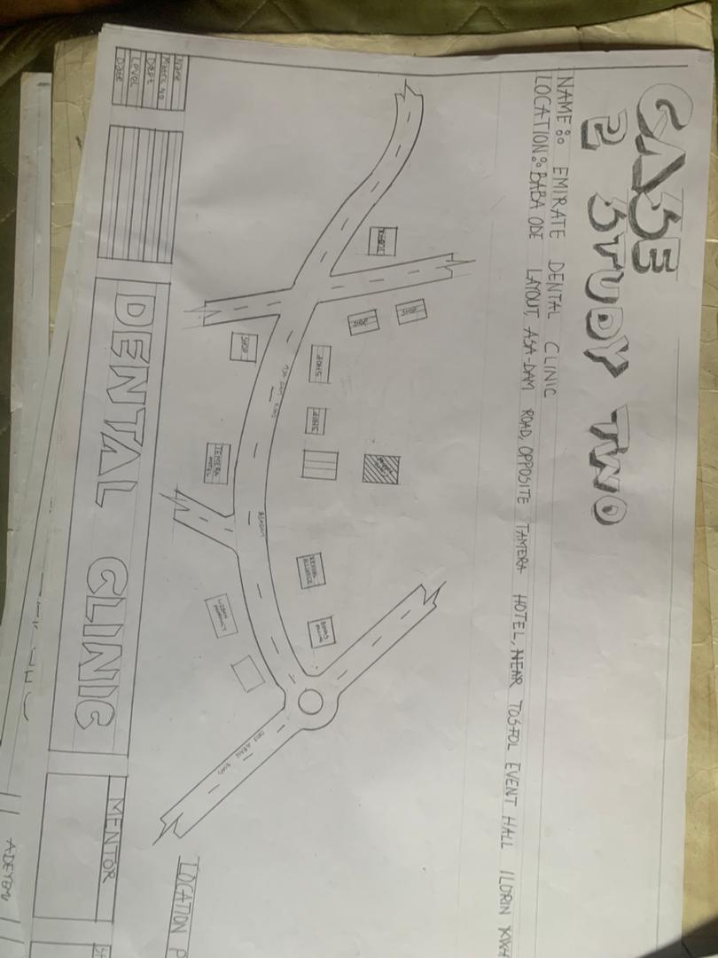
FIG3.1; SHOWING LOCATION PLAN OF CASE STUDY ONE
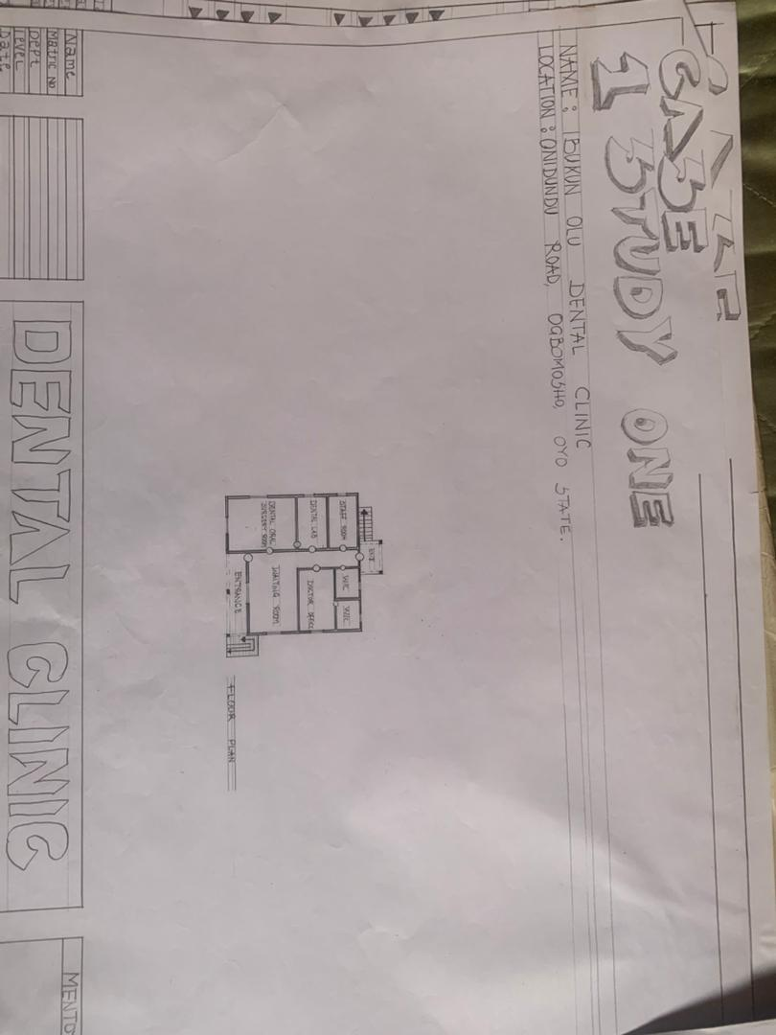
FIG3.2; SHOWING FLOOR PLAN OF CASE STUDY ONE
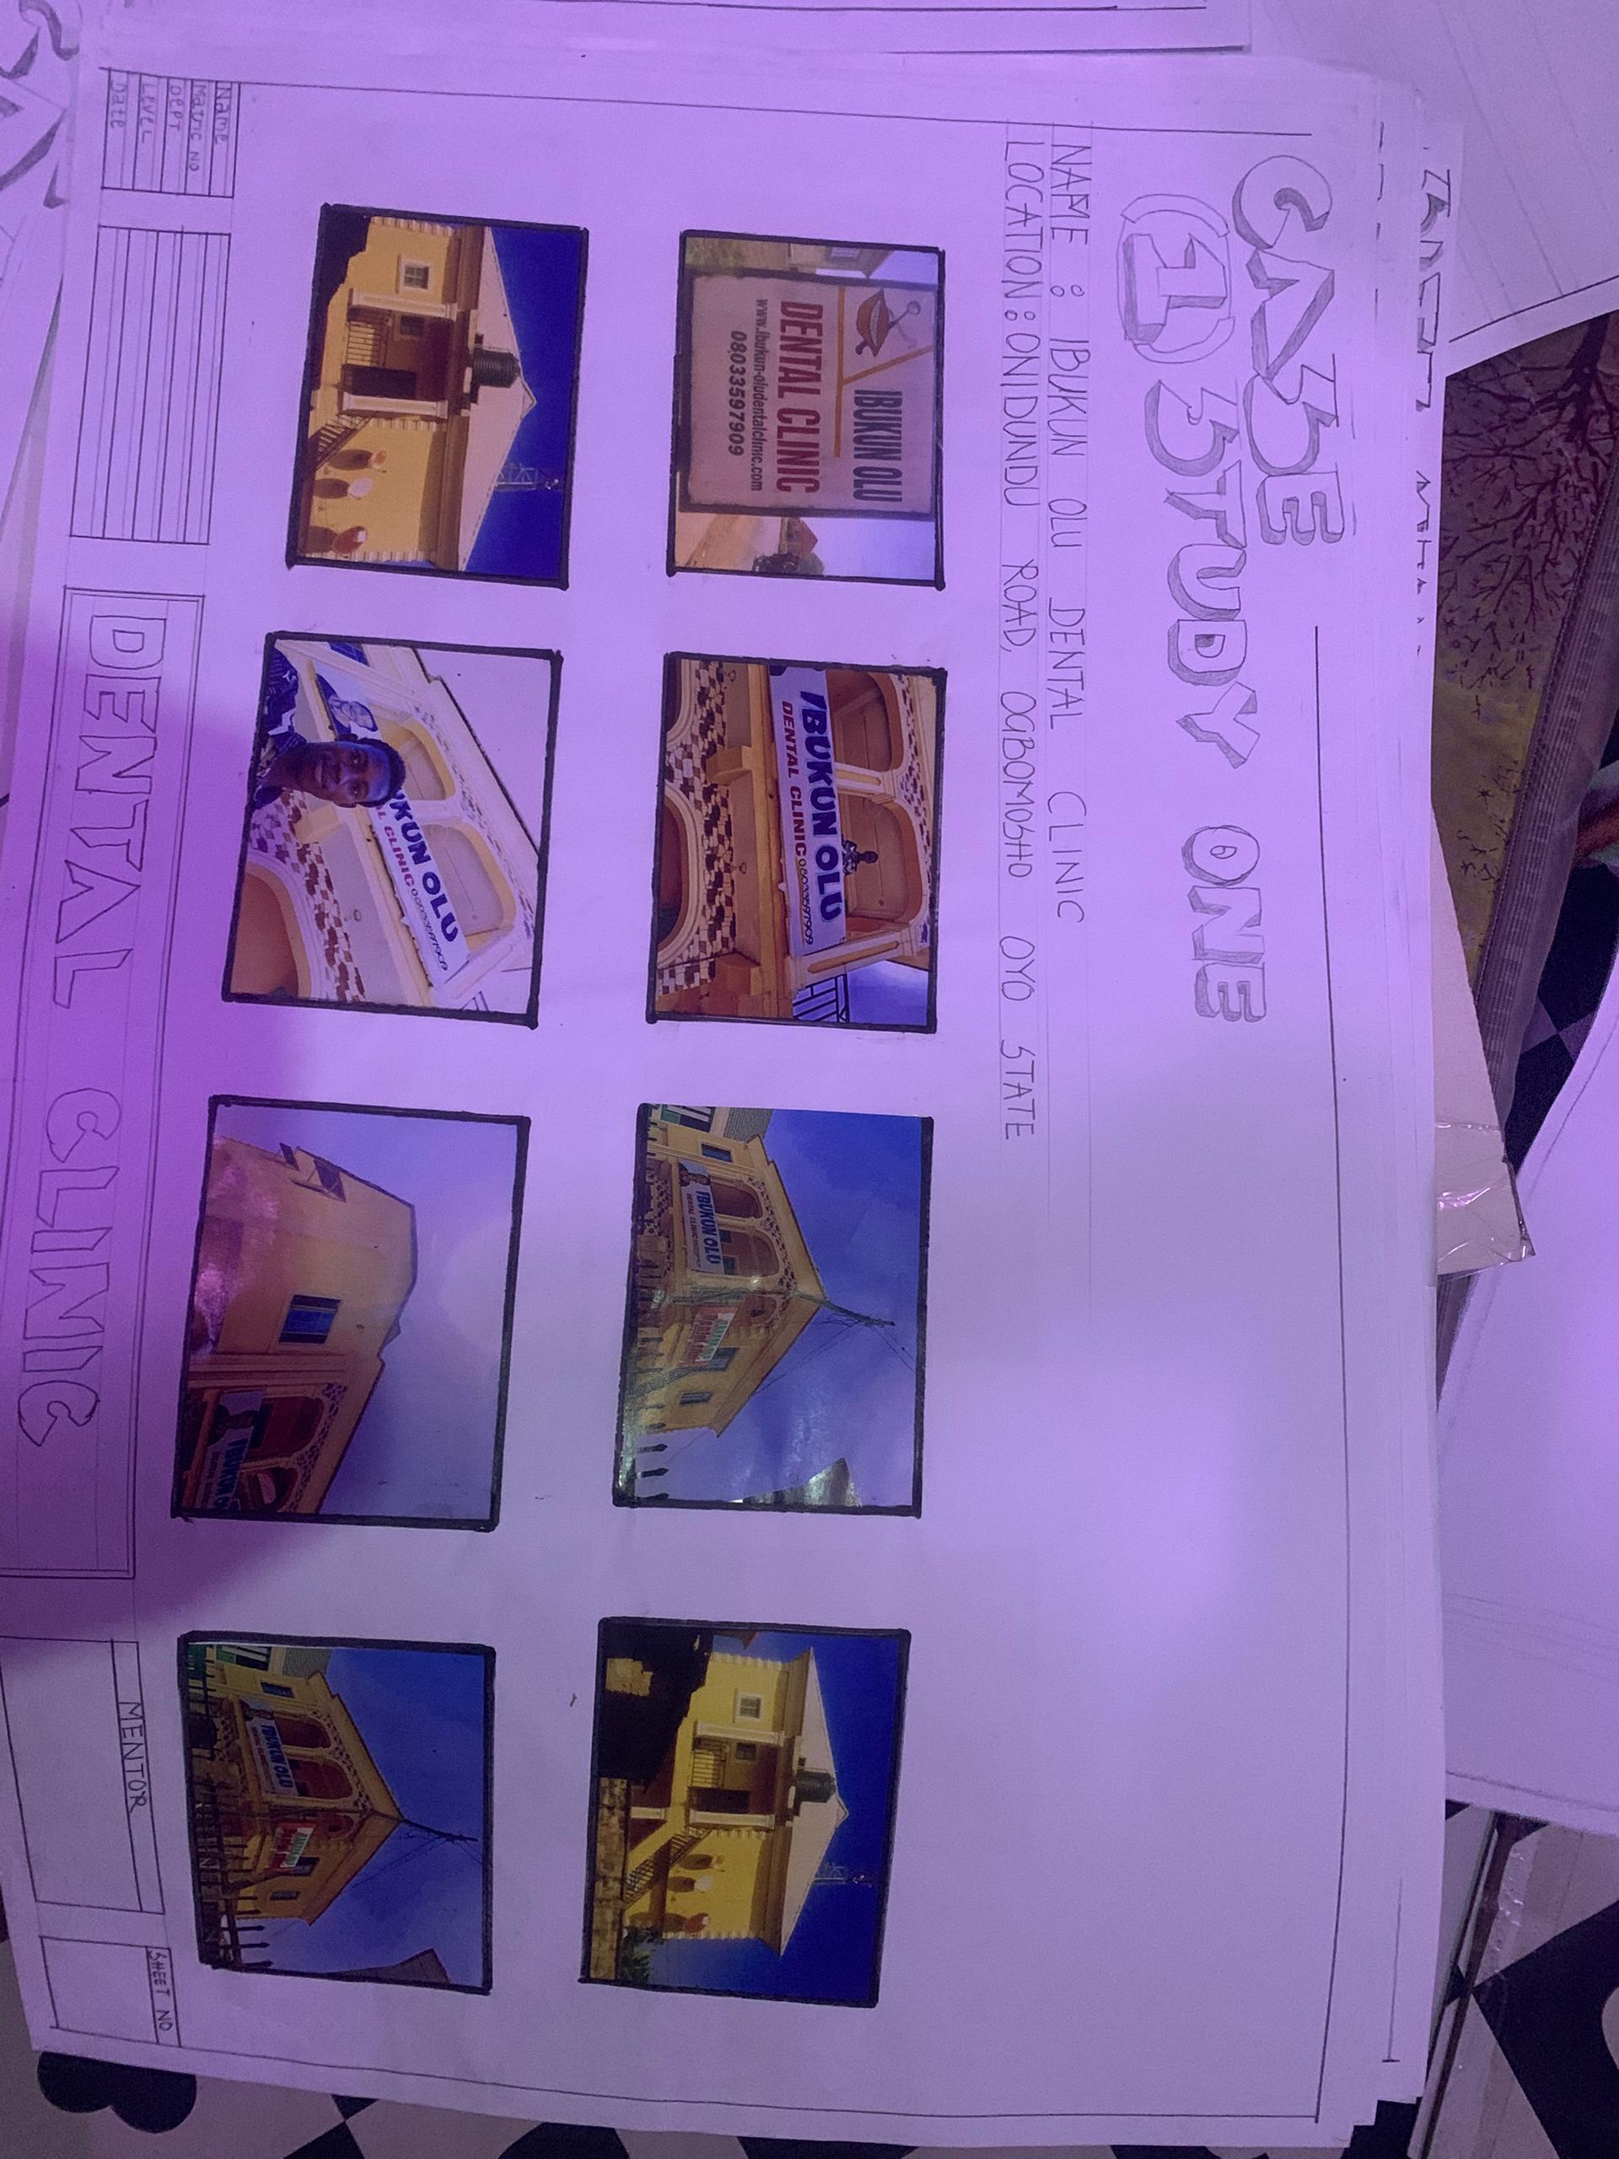
PLATE3.1; SHOWING THE VIEWS OF CASE STUDY ONE

CASE STUDY TWO
NAME: EMIRATE DENTAL CLINIC
LOCATION:BABAODE LAYOUT,ASA DAM ROAD,OPPOSITE TAMERA HOTEL,NEAR TOSFOL EVENT HALL ILORIN KWARA STATE
MERITS
- Well design waiting room.
- It has natural light and cross ventilation.
- It is well organized.
- It is easily accessible from the main road.
- Enough packing space
DEMIRTS
- There is not enough toilet for patient.
- Poor landscaping.
- Insufficient storage for equipment supplies and patient record.
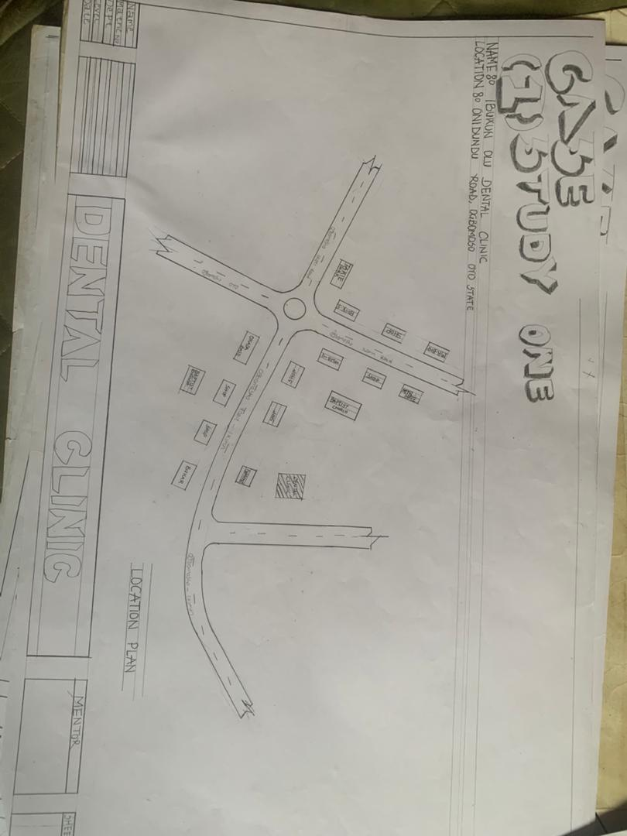
FIG3.3; SHOWING LOCATION PLAN OF CASE STUDY TWO
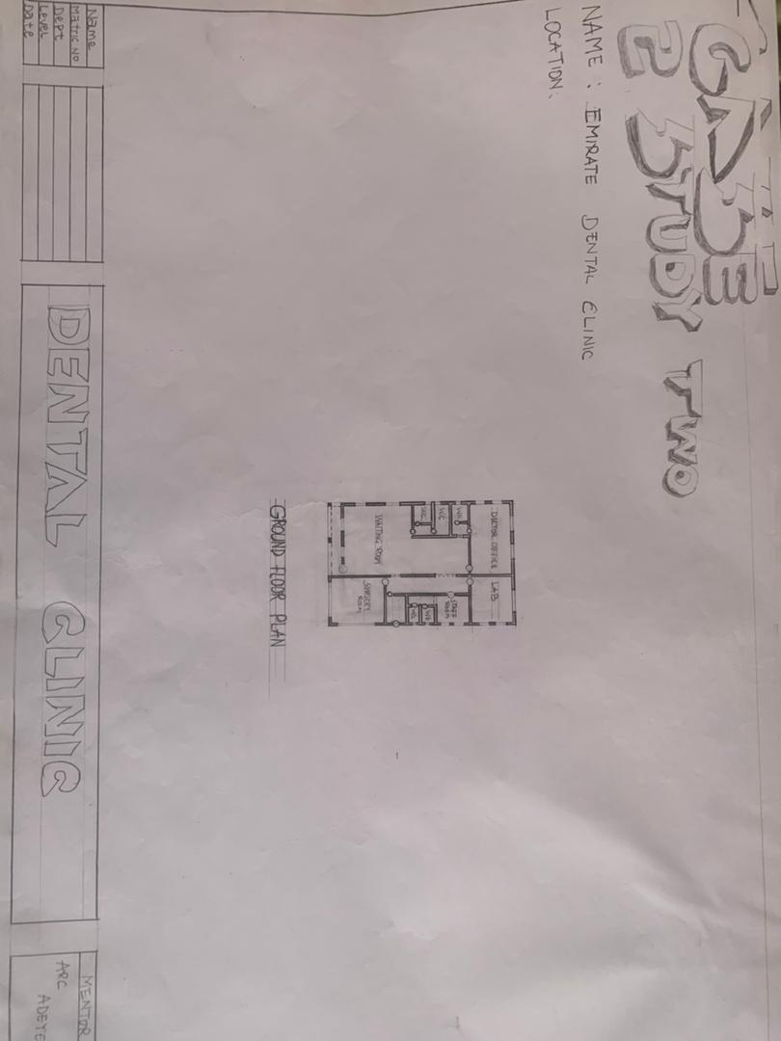
FIG3.4; SHOWING FLOOR PLAN OF CASE STUDY TWO
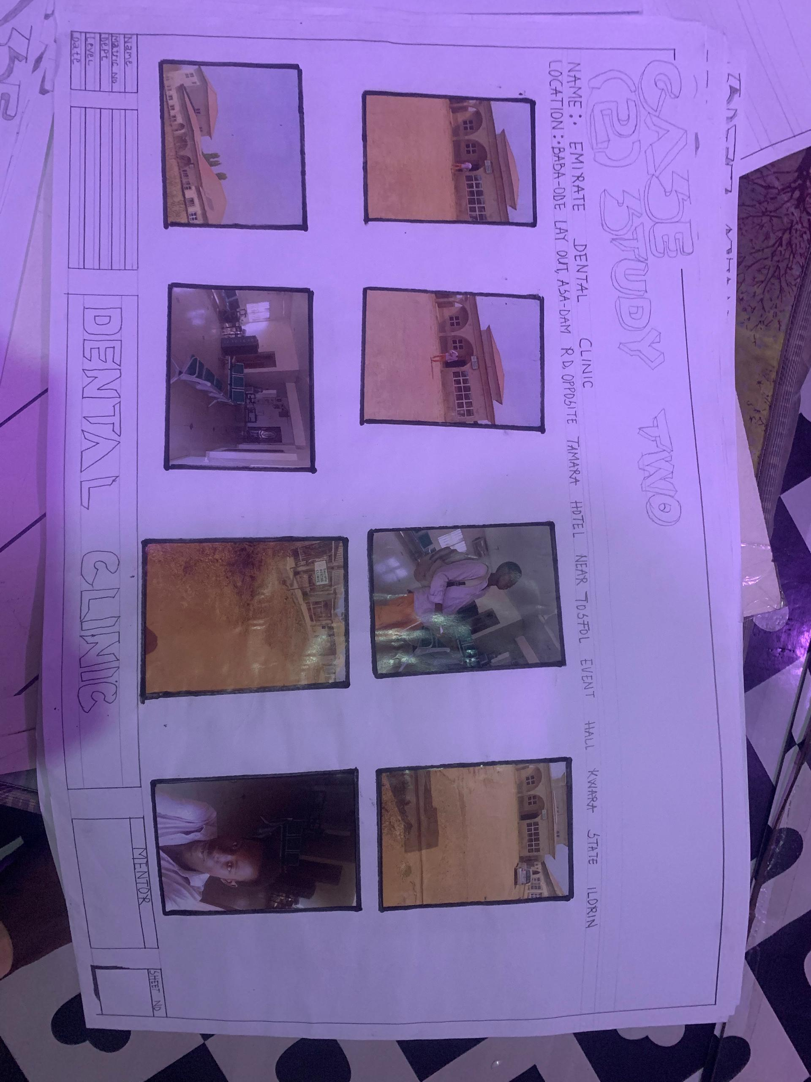
PLATE3.2; SHOWING THE VIEWS OF CASE STUDY TWO
CASE STUDY THREE
NAME:AYOOLA DENTAL CLINIC
LOCATION: STATION ROAD, OSOGBO, OSUN STATE
MERITS
- It has cross ventilation.
- It has natural light.
- It is easily accessible from the main road
DEMERITS
- There is no toilet.
- Poor maintenance.
- Lacks of ramps for people with disability.
- It is not well organized.
- Poor landscaping.
- Insufficient parking space.
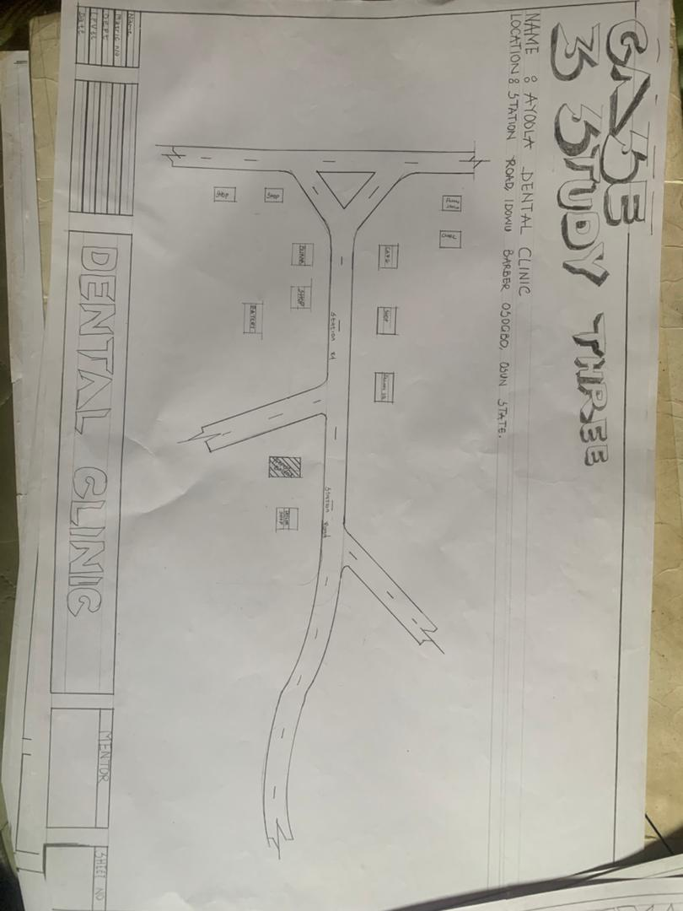
FIG3.5; SHOWING LOCATION PLAN OF CASE STUDY THREE
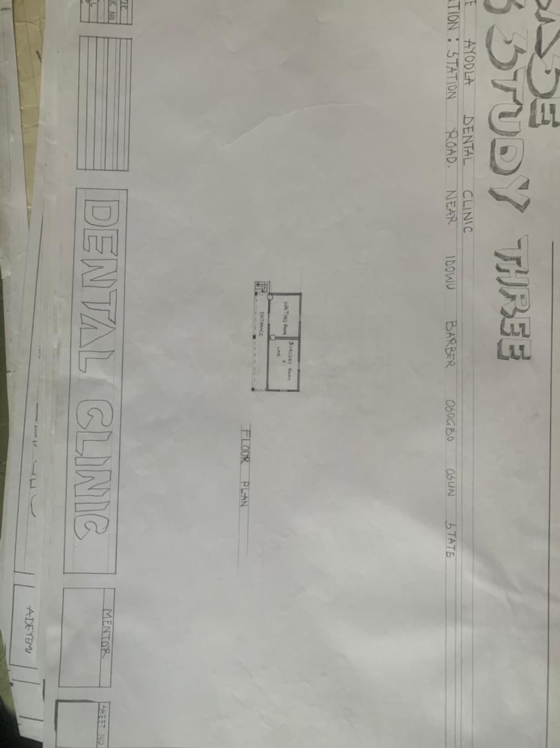
FIG3.6; SHOWING FLOOR PLAN OF CASE STUDY THREE
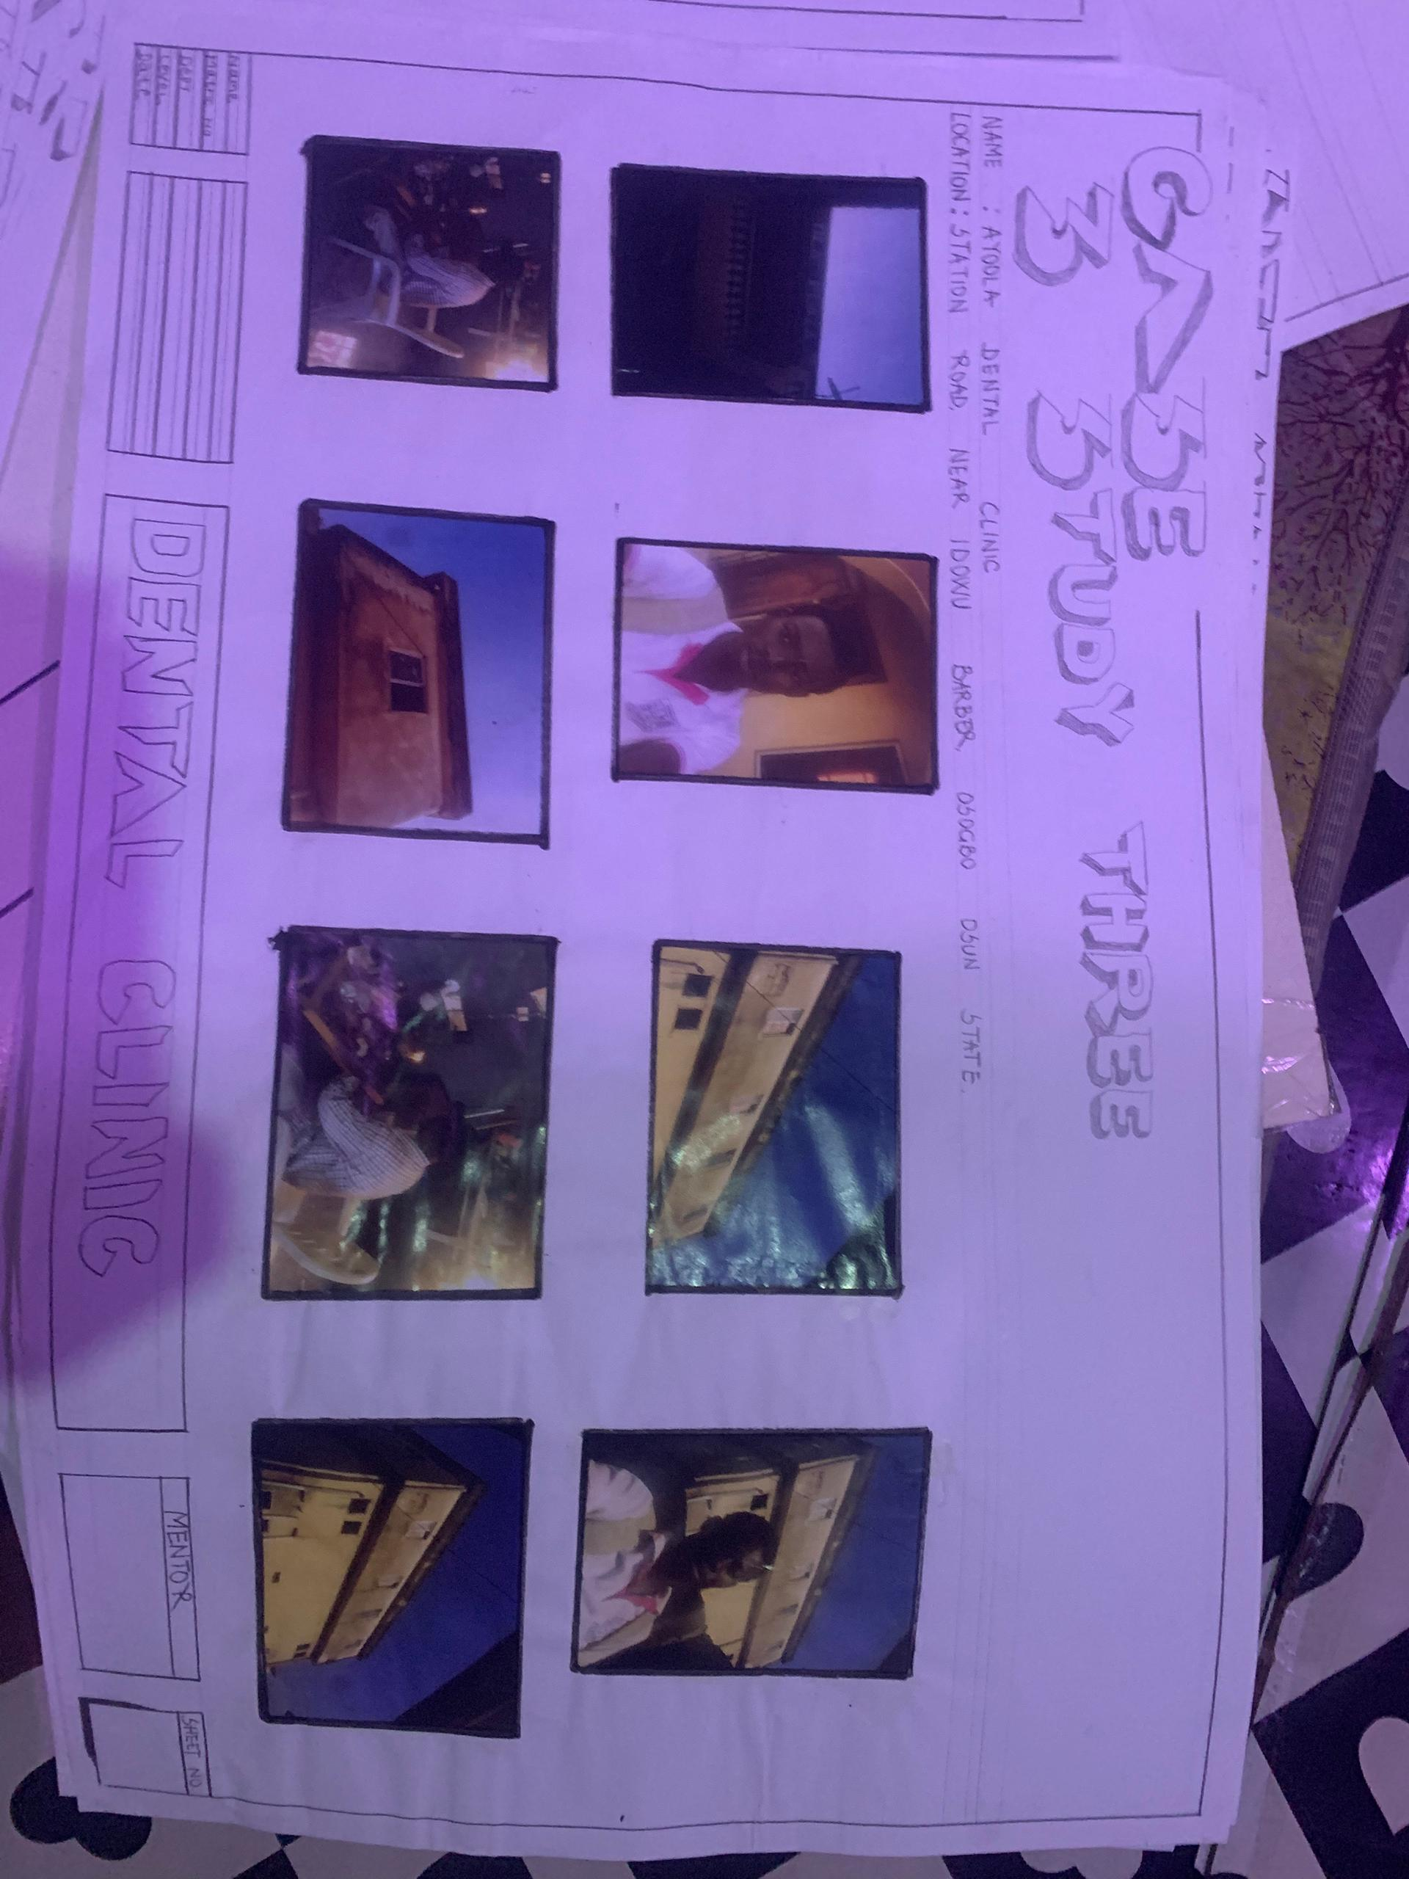
PLATE3.3; SHOWING THE VIEWS OF CASE STUDY THREE

ONLINE CASE STUDY
CASE STUDY ONE
NAME: US DENTAL CARE
LOCATION: 240S 40th ST 3,PHILADELPIA,PA 19104 UNITED STATE.

CASE STUDY TWO
NAME: DORSET DENTAL CLINIC
LOCATION: 3 LONGFLEET ROAD,POOLE BH15 2HN UNITED KINGDOM.

DEDUCTION
During my visit to the dental clinics. I was opportunities to see what was obtain in the clinic, I made a proper studies of their related function and analysis were made to their present situation with the aim of incorporation with their merit in my own final proposal.
The following were deduce from my case study
i. Adequate natural ventilation and lighting.
ii. Good architectural landscaping.
iii. The units in the clinic should be properly and well linked.
iv. There is need for consultation rooms.
v. Parking spaces should be well defined.
vi. Good drainage system.

CHAPTER FOUR
4.0 PROJECT LOCATION
4.1 BRIEF HISTORICAL BACKGROUND OF KWARA STATE
Kwara (Yoruba: Ìpínlẹ̀ Kwárà) is a state in Western Nigeria, bordered to the east by Kogi State, to the north by Niger State, and to the south by Ekiti, Osun, and Oyo states, while its western border makes up part of the international border with Benin. Its capital is the city of Ilorin and the state has 16 local government areas.
Of the 36 states of Nigeria, Kwara is the ninth largest in area but the sixth least populous with an estimated population of about 3.2 million as of 2016.Geographically, Kwara is split between the West Sudanian savanna in the east and the Guinean forest–savanna mosaic ecoregion in the rest of the state. Important geographic features include rivers with the Niger flowing along the northern border into Lake Jeba before continuing as the border while the Awun, Asa, Aluko, and Oyun rivers flow through the interior. In the far northwest of the state is the Borgu section of the Kainji National Park, a large national park that contains populations of grey heron, kob, hippopotamus, African bush elephant, olive baboon, and roan antelope, along with some of the last remaining West African lions on earth. In the far southwest, a small part of the Old Oyo National Park contains crowned eagle, martial eagle, African buffalo, oribi, and patas monkey populations.
4.1.2 ECONOMY OF KWARA STATE
Agriculture is the main source of the state's economy and the principal cash crops are: cotton, cocoa, coffee, kola nut, tobacco, sesame and palm produce. Kwara state is home to Shonga Farms, a product of the Back-to-Farm project of one of the past administrators of the state, Dr. AbubakarBukolaSaraki. Shonga Farms is made up of 13 commercial farmers. Mineral resources in the state are Petroleum, Gold, limestone, marble, feldspar, clay, kaolin, quartz and granite rocks, and laterite found majorly in omuaran.
4.1.3 ORGANIZATION STRUCTRE
An organizational structure is a system that outline shows certain activities that are direct in order to achieve the goals of an organization. These activities can includes rules, roles and responsibilities. The organizational structure also determine show information flows between levels within the clinic.

4.2 LOCATION AND SETTING OF KWARA STATE
Kwara State was created on 27 May 1967, when the Federal Military Government of General Yakubu Gowon broke the four regions that then constituted the Federation of Nigeria into 12 states. At its creation, the state was made up of the former Ilorin and Kabba provinces of the then Northern Region and was initially named the West Central State but later changed to "Kwara", a local name for the River Niger, in the Hausa language.
Kwara state has since 1976 reduced considerably in size due to further state creation exercises in Nigeria. On 13 February 1976, the Idah/Dekina part of the state was carved out and merged with a part of the then Benue/Plateau state, to form Benue state.
On 27 August 1991, five Local Government areas, namely Oyi, Yagba, Okene, Okehi and Kogi were also excised to form part of the new Kogi state, while a sixth, Borgu Local Government Area, was merged with Niger state. The major populated local governments are Ilorin and Offa.
Kwara state has numerous mineral resources such as tourmaline, tantalite, and many mineral deposits in the northern part. Cocoa and Kolanut in the Southern parts Oke - Ero, Ekiti and Isin LGA.
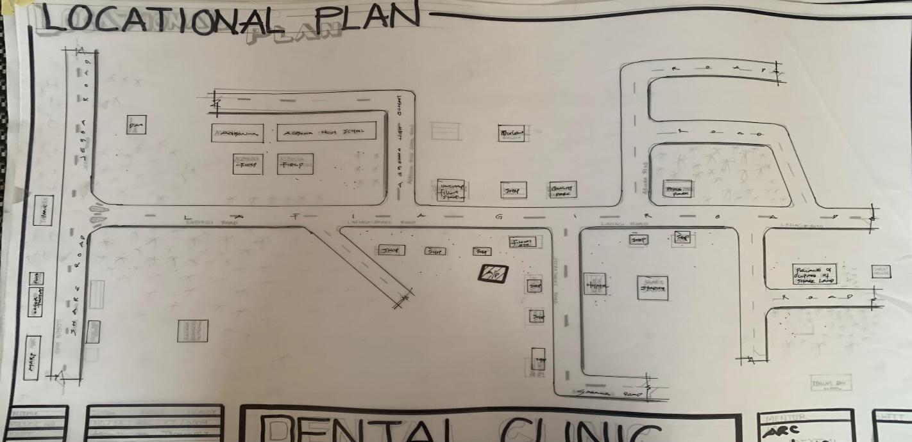
FIG 7; SHOWING LOCATION OF THE PROPOSE SITE
4.3 POPULATION
The population development of kwara state as well as related information and services.
The current metro area population of Ilorin in 2025 is 1,100,000, a 3.38% increase from 2024.
The metro area population of Ilorin in 2024 was 1,064,000, a 3.3% increase from 2023.
The metro area population of Ilorin in 2023 was 1,030,000, a 3% increase from 2022.
The metro area population of Ilorin in 2022 was 1,000,000, a 2.67% increase from 2021.
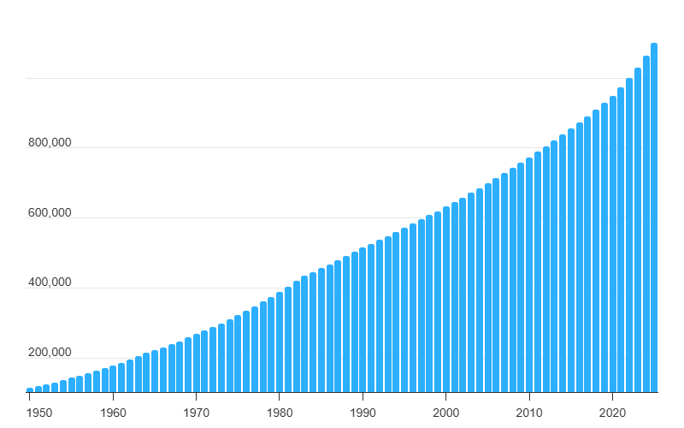
TABLE 1; SHOWING GENDER GROUP
4.4 SITE INVENTORY
In the proposed site, some shrubs will be retained on site. It used to reduce sky glare and also serve as soft landscape and wind breaker.
Presence of road network which would serve as a means of accessibility to the site. Presence of electricity pole which serve as source of electricity to the site. Some trees would be retained while some will be removed if they disrupt the construction of building.

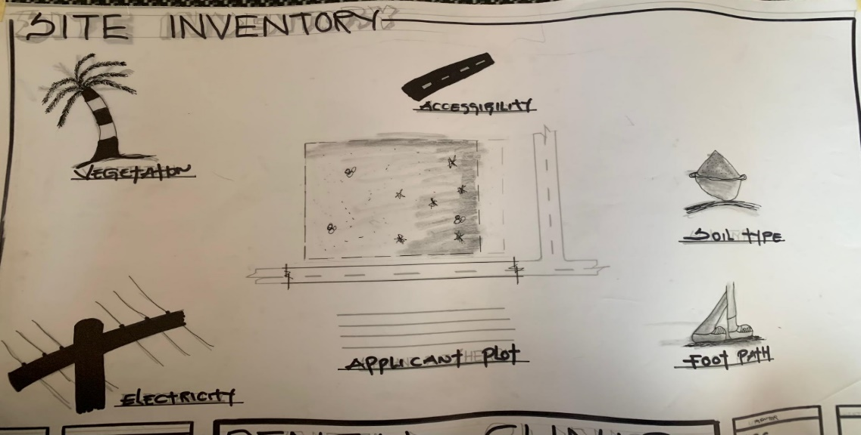
FIG 8; SHOWING SITE INVENTORY OF THE PROPOSED SITE
4.5 SITE ANALYSIS
The site is benefitted with loamy soil which is a very good soil for grass and shrubs. It has a gentle slope towards the south east. Some of the grasses, shrubs and trees on the site are to be retained to enhance landscape patter of the site while some are to be removed and replanted where necessary. The two noticeable winds are to be directed into the building using landscape pattern to improve ventilation. Noise generated from vehicle traffic is controlled through proper planning, good landscaping and proper orientation of building. Generally, all the feature on the site are best put into different uses to aid control through proper planning, landscape and orientation.
Certainly, steps are considered to obtain vital information of the site, this information is the analysed in details. For design purpose, the information include soil condition, geology, topography, vegetation etc. It also involves carrying out a preliminary survey of the site.
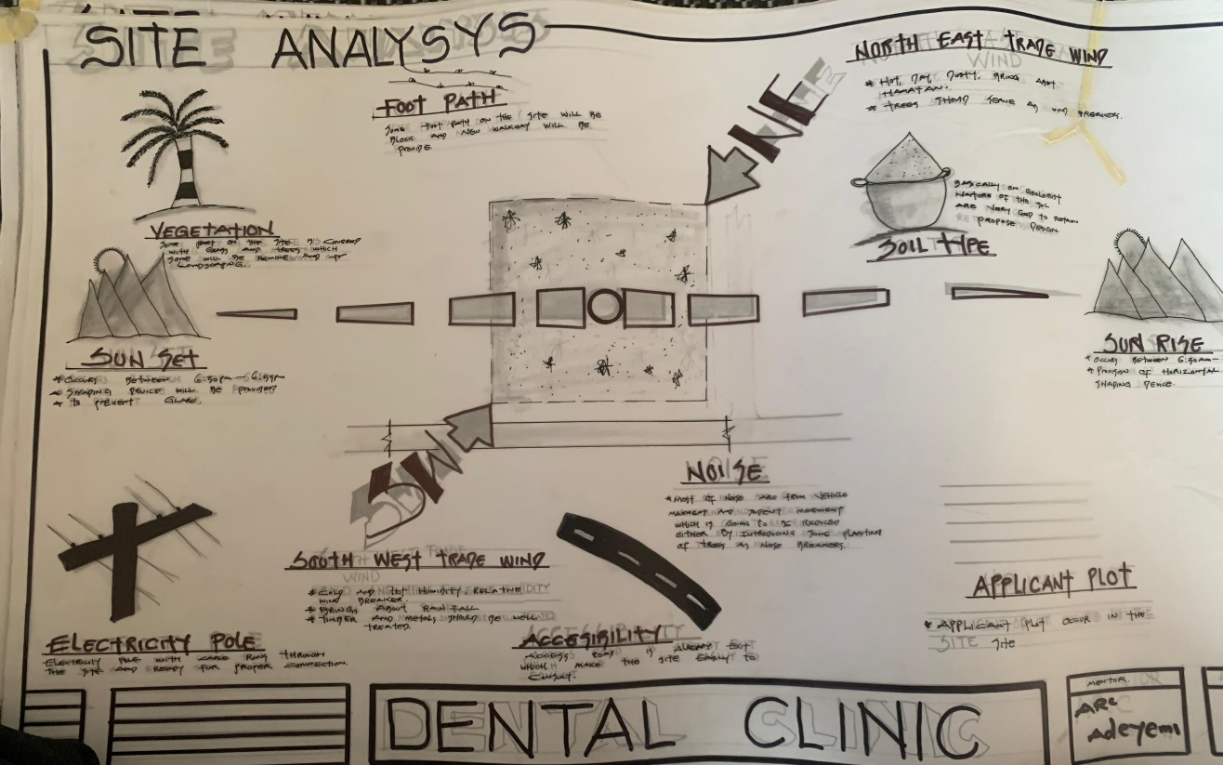
FIG 9; SHOWING SITE ANALYSIS OF THE PROPOSED SITE
4.5.1 SITE SELECTION/JUSTIFICATION
In the site selection provision is made for interesting facilities that worth emulating since the overall success and efficiency of any project depend not on the functionality of the design but also on a careful choice of site. The site of this project has been carefully selected which is located in the premises of Share, Ilorin local government Kwara state. The proposed site is located at Share at Ilorin, Kwara state.
4.5.2 LOCATION
The site is located
SHARE, Ifelodun local government, Ilorin, Kwara state Nigeria.
4.5.3 ACCESSIBILITY
The site is easily accessible from the access road off from the main road that goes to share road. The site can also be reached through the access road that lead to General.
4.5.4 INFRASTRUCTURAL FACILITIES
Facilities such as water electricity, telephone network and road network are all in Ilorin, hence it can easily be tapped to the proposed site.
4.5.5 TOPOGRAPHY
The topography of the land is gentle slope which can be filled and levelled up to balance round all the site levels.
4.5.6 SOIL STRUCTURE
It is made up of clayish laterite soil, which is good for building construction.
4.6 GENERAL CLIMATIC CONDITION
Kwara State generally experiences a tropical savanna climate (Aw) with distinct wet and dry seasons. The temperature is warm throughout the year, with an average around 29.54°C (85.17°F). Rainfall varies, with an annual average of about 101.45 millimeters (3.99 inches), and the state has around 148.38 rainy days annually.
4.6.1 RELATIVE HUMIDITY
Relative humidity is higher during the rainy season, ranging from 75% to 88%, and lower during the dry season, ranging from 35% to 80%.
4.6.2 WIND
The prevailing winds are the south-west monsoon wind and the north-east continental wind.
4.6.3 TEMPERATURE
Kwara State is characterized by warm temperatures year-round, with January being the coolest month and April being the hottest. Temperatures can range from a minimum of 14°C (58°F) in January to an average of 27°C (81°F) throughout the year, with April experiencing intense heat that can reach 43°C (109°F).
4.6.4 VEGETATION
The proposed site is covered with grasses few trees and shrubs. Some will be removed before the construction while some will be retain for ornamentation.
4.7 SOCIAL SERVICES
4.7.1 ROAD
There are only two access to the site
The southern access which serve as the main entrance and also main access road
4.7.2 WATER AND ELECTRICITY
There are pipe born water networks and borehole water which serves the habitant of Ibadan. There is electricity supply from NEPA that serve the Kwara state in general
4.8 DESIGN CRITERIA
There are three (3) methods of designing of any project which are: Function before form method
Form before function method Combination of Shapes
Designing projects, the function, before form method used in line with this method, the following are the design criteria for this project:
Functional: in term of functional requirement, the following design criteria must be considered.
Sustainability, Site and Location, Flexibility, Circulation, Accessibility, Organization, Maintenance, Environment and Services
4.9 DESIGN BRIEF
After research and planning, the next step in the series of the project programed is design itself. To achieve functional and well established design there must be a brief to work on. This brief depends generally on the scope of individual design. The brief of this project is therefore based on the various activities that take place in the Clinic. To have enough brief for the proposed Dental clinc, case studies were carried out on the existing Dental clinic. The studies also give me the opportunity to know the nature of the various unit in building and how they are related to each other.
4.10 DESIGN ANALYSIS
This is the process of itemizing units within the component of the entire design with a view to establishing a solid understanding and appreciation of the space relationships.
The units of the design are in three division, the unit of the project division are as follows:
GROUND FLOOR PLAN; Entrance, Reception, Laboratory
UNITS | S/N | LENGTH[M] |  | BREATH[M] | AREA[M2]
ENTRANCE | 1 | 5.4m |  | 4.2m | 12.5m2
WAITING ROOM | 1 | 8.9m |  | 10.0m | 46.5m2
RECEPTION | 1 | 4.5m |  | 4.0m | 12.2m2
W/C | 7 | 1.9m |  | 2.17m | 21.5m2
PHARAMACY | 1 | 6.0m |  | 5.5m | 3125m2
CONSULT ROOM | 1 | 5.0m |  | 3.0m | 15.0m2
COSMETIC ROOM | 1 | 5.0m |  | 5.0m | 25.0m2
WARD | 2 | 5.0m |  | 6.2m | 30.79m2
X-RAY | 1 | 5.0m |  | 6.0m | 30.0m2
SURGICAL ROOM | 1 | 5.0m |  | 7.2m | 28.2m
LAB | 1 | 5.0m |  | 4.2m | 21.5m2
DOCTOR ROOM | 1 | 5.0m |  | 5.0m | 25.0m2
STORAGE | 1 | 2.4m |  | 5.2m | 14.5m2
BOARD ROOM | 1 | 5.0m |  | 5.0m | 25.0m2
STERILIZATION | 1 | 5.0m |  | 3.0m | 9.0m2
TOTAL |  |  | 129.35m2
TABLE 2; SHOWING SPACIAL ALLOCATION OF FLOOR PLAN
Necessary units in the building. A borehole system of water supply is to be adopted alongside the government supplied services and a storage facility is to be provided for effective management of water supply.
4.12 PLANNING PRINCIPLE
The planning principle is one of the most important aspects of any design. The planning of various units taking into consideration the activities performed in each unit, how they are related to one another and the users of the various units in the design. In respect to the above factors.

CHAPTER FIVE
5.0 GENERAL REQUIREMENTS
5.1 APPRAISAL OF PROPOSED SCHEME
The proposed scheme is to satisfy the appropriate building regulation. The project design is to confirm with the intended use of building taking into consideration with both natural factors and human that can pose a throat on the validity and stability of the project design.
5.2 CONSTRUCTION METHODOLOGY AND MATERIAL
The construction is to be carried out following the due process of construction ranging from.
Preliminary: this involves the clearing of the site, setting out and excavation of foundation trench, foundation works down to the basement level.
Sub-Structure: this process also entails the positioning and erection of column and beams, mansonry work etc.
Gypsumboard: is to be used for the Acoustic purpose of the building. This material is often called dry wall, wall board or plaster board. It creates a continuous surface suitable for most types of interior decoration. It comes in different size ranging length of 2.4m, 3.0m, also in thickness of 1/ inch, 3/8 inch.
5.3 SERVICE
A building can be said to be good when it performs the serves required by it. In other to have a well-function building design, there calls for an installation of underground water. This is a means of providing brightness naturally by sun or moon or artificially by lamps. Good natural and artificial lighting is important in lecture rooms, and workshop. It is always easy to make mistake and time the eye in a situation of poor lighting floor. For the purpose of this project, effort is made as much as possible to light up the entire building naturally before the use of artificial lighting. In this project, to obtain maximum lighting more openings are provided for the lecture rooms, workshop and admin. Artificial source of light will still be provided for in case where there is call for the use of it at night or in a situation where the weather condition warrants it.
5.3.1 VENTILATION
As it's relates to architectural, is the intentional introduction of outside AIT into a space through openings (like window/doors and mechanical means (ACs) to provide maximum thermal comfort for human satisfaction. In this design, both means of ventilation ate introduce but majority concentration on the mechanical means of ventilation for all units in the design for the purpose of extracting the used air and introducing fresh air within all spaces for humans consumption and satisfaction.
This is done through installation of mechanical (artificial) ventilation ducts horizontally and vertically all within the units of the design to allow easy floe of free movement of air passage through the ventilation channels and providing well, proper and adequate ventilation for each and every units in the design project.
5.3.2 LIGHTING
This is a means of providing brightness naturally by sun or moon or artificial by lamps. Good natural and artificial lighting is important in all units. It is always easy to make mistake and time the eye in a situation of poor lighting floor. For the purpose of this project, effort is made as much as possible to light up the entire building naturally before the use of artificial lighting.
5.3.3 PLUMBING
The plumbing system in this project design is made easy for waste extraction and brain water extraction through the means of service duct channel and roof gutter drainage.
All waste water and soil waste from the toilet/convenience are extracted through means of drainage pipe running through the walls down to the inspection chamber situated in the service duct, flowing down to the septic tank and soak away for final waste extractions.
5.3.4 ELECTRICAL INSTALLATION
The type of wiring system chosen should be conduct system of wiring, technical are should be wired with strong durable and light current resistance cables because of the power requirements and consumption of the equipment to be used and installed in them. Connection and distributing cable signal. Also electrical installation is to be done to allow for the use quality electrical fittings and fixtures in the whole of the hospital.
5.3.5 WASTE DISPOSAL
Waste disposal are to be put in the building and also some specific areas necessary, this waste bins should be disposed in the incinerator which will be provided within the proposed site premises. The waste should therefore, be burn in the incinerator or taken away from the site.
5.3.6 FIRE PROTECTION
Electrically, fire alarms and sensor are to be installed in the building in generally. This should be done in case of the fire occurrence. Fire extinguishers are to be placed at a certain distance in the lobbies and some other necessary areas. It is also serving as protection in case of fire outbreak.
5.3.7 RAIN PROTECTION DEVICES
The rainfall of a place generally determines the living condition and all comfort associated with that environment hence provision should be made for fast dispersal of the rain water as well as the associated condition with rainfall. This calls for the need to study the nature of rainfall of the area. To control the heavy rainfall during the wet season (April - October) the use of simple sloppy system roofing has been adopted. This is provided with roof gutter system which is linked to the ground drainage network by the use of P.V.C.
5.3.8 EXTERNAL WORKS
The external works are to be earned out generate, kerbs land and shrubs, flowers, grasses and trees planted. Concrete interlocking pavement tiles to be adopted before hard landscape for walk ways and parking spaces and car access roads must be tarred with asphalt finishes.
5.4 SUMMARY
This project, generally, has seriously widen my view and knowledge affecting my observation beyond my expectation. I have been able to deduct what it takes or entails and how to go about designing and achieving a good design of any form of this related project with total seriousness as this project has given out the facts and precise information it comprises.
5.5 CONCLUSION
In conclusion, the design of a dental clinic plays a critical role in delivering effective oral healthcare services while ensuring patient comfort and operational efficiency. This project has explored the essential architectural considerations necessary for a modern dental facility, such as functionality, hygiene, accessibility, natural lighting, spatial organization, and technological integration. By studying existing case studies and aligning with standard healthcare design principles, the proposed design aims to foster a calming and welcoming environment for patients, while also providing a practical and well-equipped workspace for dental professionals. Ultimately, the project reflects the growing need for health-conscious architecture that supports both patient wellbeing and sustainable building practices.

5.6 RECOMMENDATION
It is recommended that future designs of dental clinics emphasize the importance of integrating patient-centered design principles with modern medical technology. Special attention should be given to the spatial flow between waiting areas, consultation rooms, and treatment areas to reduce stress and enhance efficiency. Materials and finishes should promote sterilization and infection control, while the overall layout must support easy navigation for all users, including those with disabilities. Additionally, the inclusion of green spaces, natural lighting, and noise control should not be overlooked, as these elements contribute significantly to the healing environment. Collaboration with dental professionals during the design process is also encouraged, to ensure that the clinic meets both functional and ergonomic requirements. These considerations will help shape a dental clinic that is not only efficient and modern but also humane and patient-friendly.

REFERENCES
•Ching, F. D. K. (2014). Architecture: Form, Space, and Order (4th ed.). John Wiley & Sons.
• Department of Health. (2013). Health Building Note 00-03: Clinical and Clinical Support Spaces. UK Government Publications. Retrieved from https://www.gov.uk
• Forbes, R., & Ahmed, A. (2011). Designing for Health: Architecture, Art and Design at the James Cook University Hospital. Routledge.
•Hesselgren, S. (2005). The Language of Architecture. Studentlitteratur AB.
• Joseph, A., & Ulrich, R. (2007). Improving the Healthcare Experience through the Built Environment. The Center for Health Design. Retrieved from https://www.healthdesign.org
•Karlen, M. (2016). Space Planning Basics (4th ed.). John Wiley & Sons.
• Lawson, B. (2010). Healing Architecture. The Arts in Psychotherapy, 37(1), 35–42.
•Malkin, J. (2002). Medical and Dental Space Planning: A Comprehensive Guide to Design, Equipment, and Clinical Procedures (3rd ed.). John Wiley & Sons.
•Nersessian, L. (2018). Dental Clinic Design: Planning for Efficient and Modern Practices. Journal of Healthcare Design, 11(2), 45–54.
•Neufert, E., &Neufert, P. (2012). Architects' Data (4th ed.). Wiley-Blackwell.
•Odedele, A. F. (2019). Design and Planning Considerations for Healthcare Facilities in Nigeria: A Case Study Approach. Nigerian Journal of Architecture, 5(2), 63–75.
•Olotuah, A. O. (2015). User Participation in Healthcare Design in Nigeria: A Study of Patients' Preferences in Clinic Environments. Journal of Environmental Design, 10(1), 72–88.
Ring, M. E. (1992). Pierre Fauchard: The Founder of Modern Dentistry. Quintessence Publishing.
• Ulrich, R. S., Zimring, C., Quan, X., Joseph, A., &Choudhary, R. (2004). The Role of the Physical Environment in the Hospital of the 21st Century: A Once-in-a-Lifetime Opportunity. The Center for Health Design.



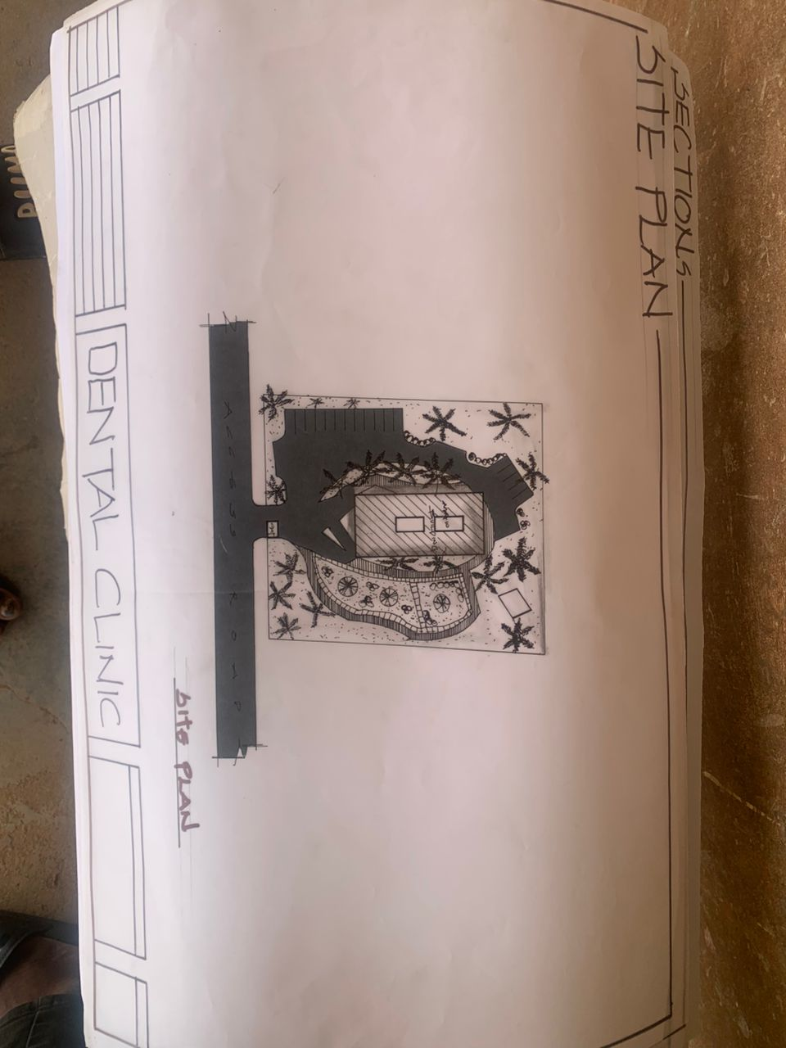
APP1: SITE PLAN OF PROPOSED PROJECT
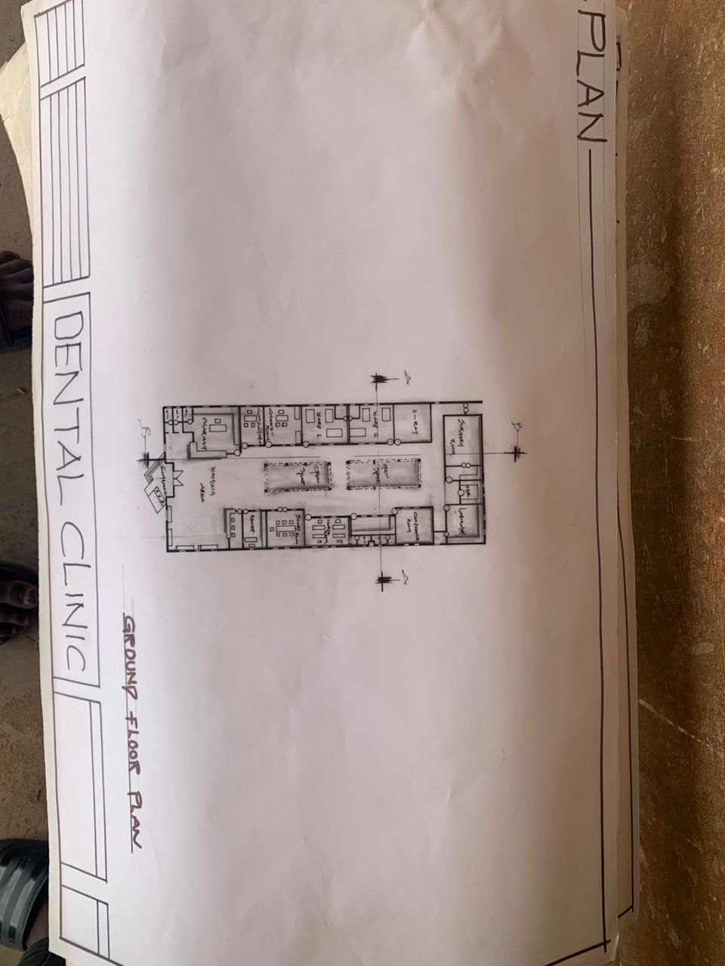
APP2: FLOOR PLAN OF PROPOSED PROJECT
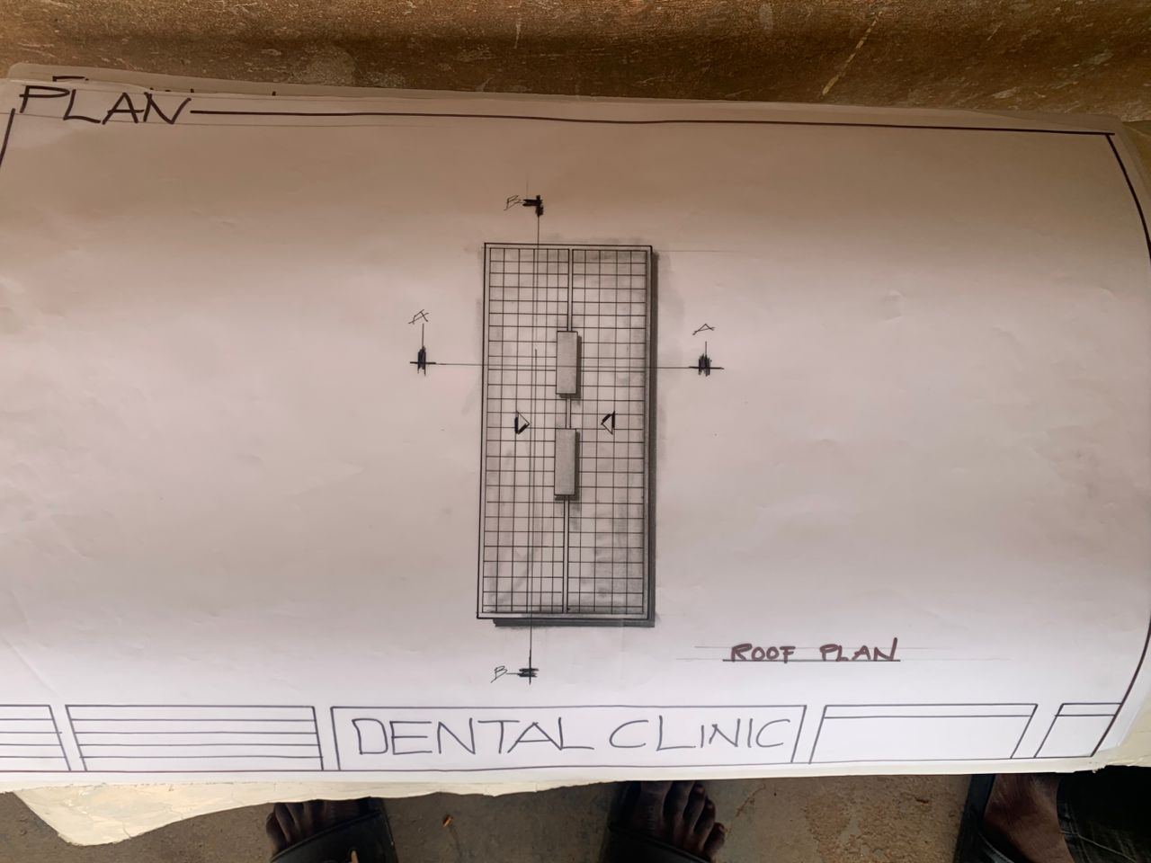
APP3: ROOF PLAN OF PROPOSED PROJECT
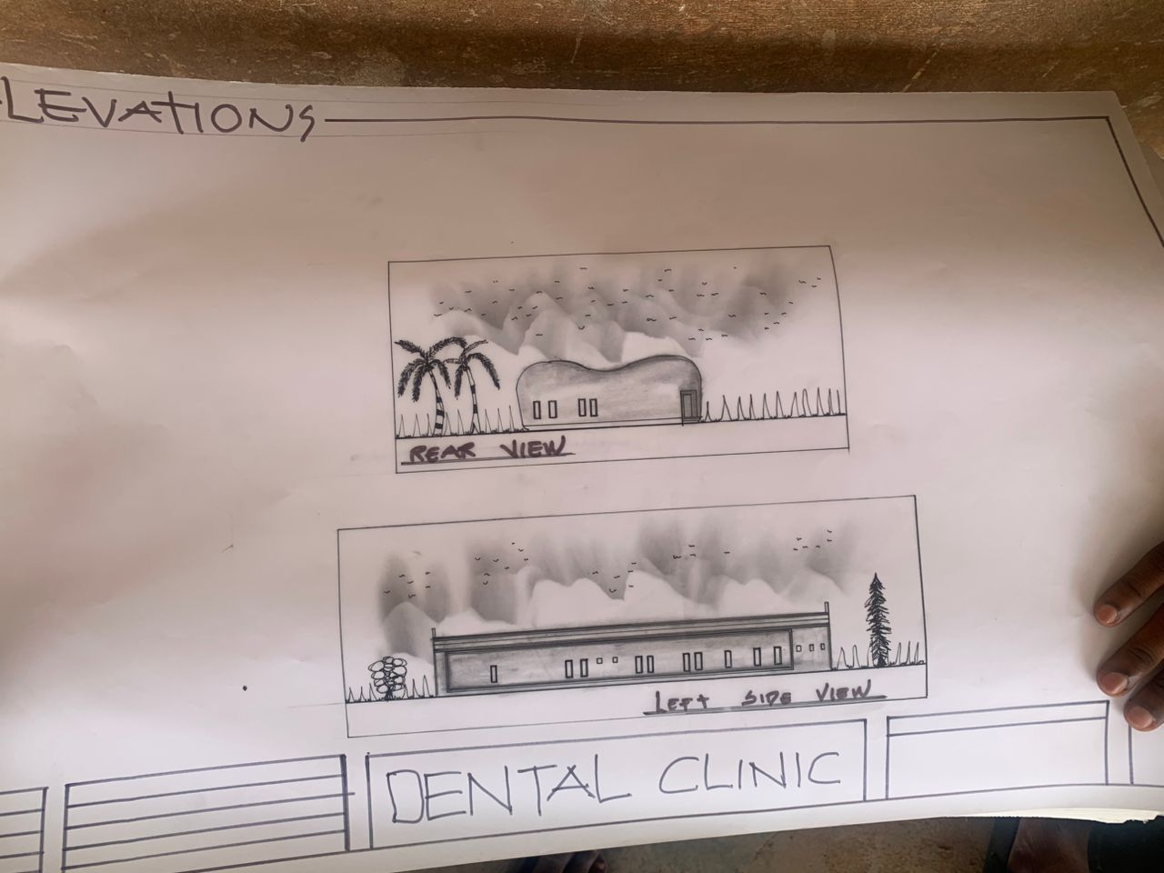
APP4: ELEVATION OF PROPOSED PROJECT

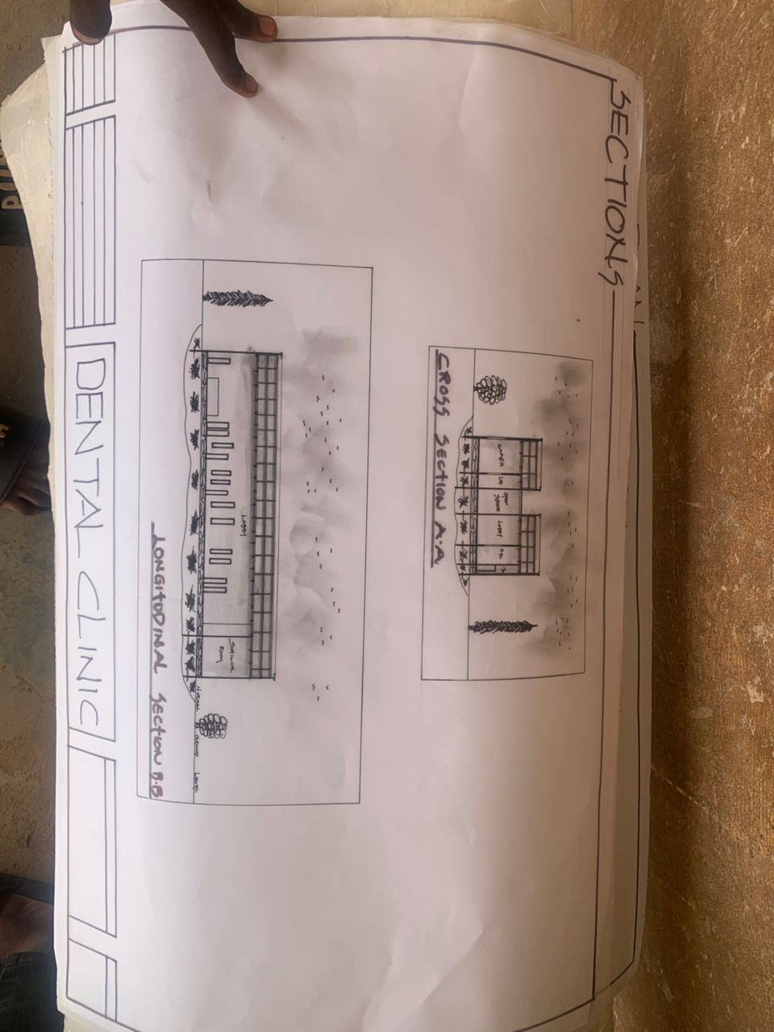
APP5: SECTION OF PROPOSED PROJECT
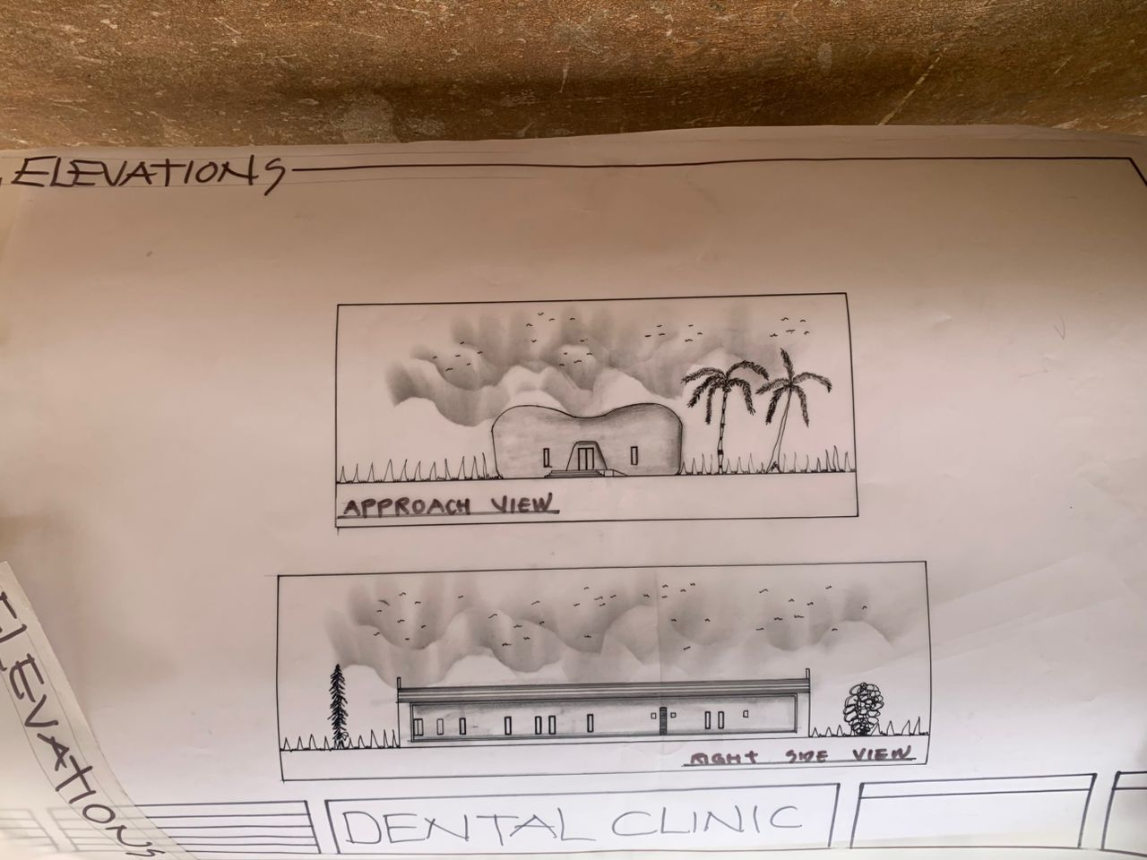
APP6: ELEVATION OF PROPOSED PROJECT

