A TECHNICAL REPORT
ON PROPOSED EVENT CENTER

FOR
KWARA STATE GOVERNMENT

BY
AJIBOLA KAMOLI ABIONA
ND/23/ARC/FT/0041

BEING A TECHNICAL REPORT SUBMITTED TO THE DEPARTMENT OF ARCHITECTURAL TECHNOLOGY, INSTITUTE OF ENVIRONMENT STUDIES, KWARA STATE POLYTECHNIC, ILORIN

IN PARTIAL FULFILMENT OF THE REQUIREMENTS FOR THE AWARD OF NATIONAL DIPLOMA (ND) IN ARCHITECTURAL TECHNOLOGY KWARA STATE POLYTECHNIC, ILORIN KWARA STATE

JULY, 2025

DECLARATION

I, Ajibola Kamoli Abiona (Matric No: ND/23/ARC/FT/0041), declare that this technical report titled “Proposed Event Center” is my original work submitted in partial fulfilment of the requirements for the award of National Diploma in Architecture at Kwara State Polytechnic Ilorin. It has not been submitted elsewhere for any other qualification.

_______________________ _______________________
Ajibola Kamoli Abiona Date
ND/23/ARC/FT/0041

CERTIFICATION
This is to certify that this technical report titled “Proposed Event Center” was carried out by Ajibola Kamoli Abiona, with matriculation number ND/23/ARC/FT/0041, In partial fulfillment of the requirements for the award of National Diploma in Architectural Technology, Kwara State Polytechnic, Ilorin

_______________________ ____________________
Arc Familua O.S Date
Project Supervisor

_______________________ ____________________
Arc Olanrewaju F. A Date
Project Coordinator

_______________________ ____________________
Arc Tomori J.M Date
Head of Department

DEDICATION
This work is dedicated to Almighty God for His guidance, wisdom, and protection throughout the course of this project. I also dedicate it to my beloved parents for their support.

ACKNOWLEDGEMENTS
I wish to express my profound gratitude to Almighty God for His grace, wisdom, and favour that saw me through this project successfully.
My sincere appreciation goes to my supervisor, Architect O.S Familua, for his invaluable guidance, corrections, and unwavering support throughout this work.
I also acknowledge all my lecturers in the Department of Architecture, Kwara State Polytechnic Ilorin, for their dedication, mentorship, and impact on my academic and professional development.
My heartfelt gratitude goes to my parents and siblings for their love, prayers, and constant encouragement. I am also grateful to my friends and course mates for their support, cooperation, and assistance during the preparation of this technical report.
Finally, I appreciate everyone who contributed in one way or the other towards the successful completion of my National Diploma program.

ABSTRACT
This project focuses on the design and development of a modern event center to cater for social, cultural, and corporate gatherings. The report outlines the objectives, design considerations, site analysis, and proposed architectural solutions to create a functional, aesthetically pleasing, and environmentally responsive event center. It also addresses spatial planning, circulation, structural systems, and building services to achieve an efficient design that meets user needs and enhances community development.
The study examines existing standards and case studies to establish design requirements, ensuring that the facility provides maximum flexibility to accommodate various events such as weddings, conferences, seminars, and exhibitions. Emphasis was placed on creating comfortable interior spaces with adequate natural lighting and ventilation, as well as incorporating sustainable design practices to reduce environmental impact. The project further includes presentation drawings such as site plan, floor plans, elevations, and 3D views to effectively communicate the design intent. Overall, this report demonstrates the application of architectural principles and creativity in solving design problems to improve the built environment.
.

TABLE OF CONTENTS
DECLARATION i
CERTIFICATION ii
DEDICATION iii
ACKNOWLEDGEMENTS iv
ABSTRACT v
CHAPTER ONE 1
1.0 INTRODUCTION 1
1.1 BACKGROUND OF THE STUDY 1
1.2 STATEMENT OF DESIGN PROBLEM 2
1.3 AIM AND OBJECTIVE 2
1.4 JUSTIFICATION OF THE STUDY 3
1.5 SCOPE OF THE STUDY 3
1.6 LIMITATIONS OF THE STUDY 4
CHAPTER TWO 5
2.0 LITERATURE REVIEW 5
2.1 INTRODUCTION 5
2.2 DEFINITION AND HISTORICAL BACKGROUND OF EVENT CENTER 6
2.2.1 DEFINITION 6
2.2.2 HISTORICAL BACKGROUND 6
2.2.3 SPATIAL RELATIONSHIPS 7
2.3 FUNCTIONS OF EVENT CENTERS 7
2.4 CLASSIFICATION AND TYPES 8
2.5 DESIGN CONSIDERATIONS FOR EVENT CENTERS 9
CHAPTER THREE 10
3.1 CASE STUDIES 10

CHAPTER FOUR 21
4.0 STUDY AREA / PROJECT SITE (ENVIRONMENTAL AND IMPACT ANALYSIS) 21
4.1 INTRODUCTION OF STUDY AREA / SITE SELECTION 21
4.2 SITE LOCATION, DESCRIPTION, AND SELECTION CRITERIA 21
4.3 SITE ANALYSIS 23
4.4 GEOGRAPHICAL AND CLIMATIC DATA 24
4.5 DESIGN PRELIMINARIES 26
4.6 DESIGN CRITERIA 29
4.7 CONCEPTUAL DEVELOPMENT 30
CHAPTER FIVE 31
5.0 APPROACH TO THE DESIGN / DESIGN REALIZATION 31
5.1 DESIGN AND CONCEPTS 31
5.2 TECHNOLOGICAL AND ENVIRONMENTAL CRITERIA 31
5.3 LEGAL ISSUES AND PLANNING REGULATIONS 32
5.4 BEHAVIORAL PATTERNS AND CONSIDERATIONS 32
5.5 CONCLUSION 33
5.6 RECOMMENDATIONS 33
REFERENCES 34
APPENDIX 36

LIST OF FIGURES
FIGURE 3.1.1: SHOWING THE FLOOR PLAN OF THE CASE STUDY ONE 11
FIGURE 3.1.2: FRONT ELEVATION OF THE CASE STUDY ONE 12
FIGURE 3.1.3: BACK ELEVATION OF THE CASE STUDY ONE 12
FIGURE 3.1.4: SHOWING THE FLOOR PLAN OF THE CASE STUDY TWO 14
FIGURE 3.1.6: BACK ELEVATION OF THE CASE STUDY TWO 15
FIGURE 3.1.7: SHOWING THE FLOOR PLAN OF THE CASE STUDY THREE 17
FIGURE 3.1.8: FRONT ELEVATION OF THE CASE STUDY THREE 18
FIGURE 3.1.9: BACK ELEVATION OF THE CASE STUDY THREE 18
FIGURE 3.1.10: ONLINE CASE STUDY ONE 19
FIGURE 3.1.11: ONLINE CASE STUDY TWO 20
FIGURE 4.2.1.1: LOATIONAL PLAN 22
FIGURE 4.3.1: SITE ANALYSIS 24
FIGURE 4.4.1: G.C.D.E 25
FIGURE 4.5.1.1: BUBBLE DIAGRAM 26
FIGURE 4.5.2.1: WINDOW AND DOOR SCHEDULE 27

LIST OF APPENDICES

APPENDIX 1: SITE PLAN 36
APPENDIX 2: FLOOR PLAN 37
APPENDIX 3: ROOF PLAN 38
APPENDIX 4: SECTION A 39
APPENDIX 5: SECTION B 39
APPENDIX 6: FRONT ELEVATION 40
APPENDIX 7: BACK ELEVATION 40
APPENDIX 8: RIGHT ELEVATION 41
APPENDIX 9: LEFT ELEVATION 41
APPENDIX 10: DETAILING 42
APPENDIX 11: INTERNAL PERSPECTIVE VIEW 43
APPENDIX 12: EXTERNAL PERSPECTIVE VIEW 44

CHAPTER ONE

INTRODUCTION

1.1 BACKGROUND OF THE STUDY
Event centers are essential facilities designed to accommodate various gatherings such as social, cultural, religious, and corporate functions. They serve as spaces where people come together to celebrate, interact, exchange ideas, and build relationships, thereby fostering community development and social cohesion. In recent times, the demand for event centers has increased significantly due to urban growth, population increase, and the rise in organized events requiring comfortable, secure, and well-designed spaces.
In Nigeria, especially in urban and semi-urban areas, event centers play a vital role in hosting weddings, naming ceremonies, birthdays, conferences, seminars, workshops, exhibitions, and religious programs. They are multipurpose facilities that contribute greatly to the social and economic development of their host communities by providing employment opportunities, boosting local businesses such as catering and decoration services, and enhancing the city’s aesthetics and reputation as a destination for events.
Despite their importance, many existing event centers in Nigeria are faced with several challenges ranging from inadequate planning and poor spatial organization to lack of modern architectural aesthetics and environmental considerations. Some of these facilities are overcrowded with insufficient space for parking, poor ventilation, inadequate lighting, and non-compliance with safety and accessibility standards, making them uncomfortable, inconvenient, and sometimes hazardous for users.
Furthermore, with the advancement of technology and changing user preferences, event centers should incorporate features such as modern audio-visual systems, effective acoustic treatments, and provision for ancillary facilities like lounges, VIP rooms, administrative offices, outdoor relaxation areas, and landscaped surroundings to enhance user experience.
This project, therefore, seeks to design a modern event center that will provide a well-planned, functional, and aesthetically pleasing facility that meets the needs of users while also contributing to the overall development and beautification of its environment. It will also address environmental considerations by incorporating sustainable design practices such as natural lighting, cross ventilation, and landscaping to create a comfortable and eco-friendly facility.

1.2 STATEMENT OF DESIGN PROBLEM
Event centers are important facilities for hosting social, cultural, religious, and corporate events. However, many existing ones face major challenges. Poor spatial planning and circulation often lead to congestion and discomfort for users, while inadequate parking creates traffic and accessibility issues. Additionally, insufficient natural lighting and ventilation result in uncomfortable indoor environments.
Most event centers do not fully comply with safety and accessibility standards, making them difficult to use for people with disabilities and unsafe during emergencies. Many also lack modern aesthetics, a unique architectural identity, and essential ancillary facilities such as lounges, VIP rooms, and mini shops that enhance functionality and user experience.
The design problem, therefore, is to create a modern event center that is functional, comfortable, safe, environmentally sustainable, and aesthetically pleasing, with efficient spatial planning, proper circulation, sufficient parking, and a unique identity that meets diverse user needs.

1.3 AIM AND OBJECTIVE

1.3.1 AIM
The aim of this project is to create a functional and aesthetically pleasing space for various events, provide a comfortable and safe environment for guests, enhance the overall event experience through innovative design, meet the needs of diverse clients and events, and establish a unique and memorable identity for the event hall.

1.3.2 OBJECTIVES
The objectives of this project are to:
- Create an inviting atmosphere through interior design and decor.
- Ensure accessibility and compliance with safety regulations.
- Incorporate sustainable and eco-friendly design elements.
- Provide adequate and well-planned spaces to accommodate various events efficiently.
- Design functional layouts with proper circulation, clear zoning of spaces, and ease of movement to enhance usability.
- Incorporate modern architectural aesthetics to create an attractive and visually appealing structure that complements its environment.

1.4 JUSTIFICATION OF THE STUDY
The design of a modern event center is necessary to meet the increasing demand for functional, safe, and attractive spaces for various events. Many existing centers lack proper planning, circulation, and user comfort, making them inconvenient and less effective.
This project will support economic growth by creating jobs and boosting businesses like catering, decoration, and event planning. It will also improve the architectural quality of the area by providing a modern facility with a unique identity.
Additionally, it promotes sustainability through energy-efficient lighting, natural ventilation, proper waste management, and green spaces to enhance comfort and urban biodiversity. The design ensures safety and accessibility for all users, including the elderly and physically challenged, while providing flexible spaces for different events and fulfilling academic requirements for the National Diploma.

1.5 SCOPE OF THE STUDY
This project focuses on the architectural design of a modern event center, addressing spatial planning, functionality, aesthetics, and sustainability to create a user-friendly facility.
The scope includes:
- Site analysis: assessing location, accessibility, topography, and climate.
- Design of spaces: main hall, mini lounge, exhibition hall, VIP rooms.
- Ancillary facilities: mini shop, car wash, offices, catering kitchen, storage, toilets, and changing rooms.
- Parking: provision for up to 100 vehicles.
- Amenities: camera and control rooms, outdoor relaxation areas.
- Services: provisions for event planning and management.
- Presentation drawings: site plan, floor plans, elevations, sections, and 3D views.
- Basic structural and services considerations for stability and user safety.
The study is limited to architectural design only and does not cover detailed engineering calculations or construction works.

1.6 LIMITATIONS OF THE STUDY
This project is limited to the architectural design stage and does not cover construction or supervision. Detailed structural, mechanical, and electrical calculations are excluded, with only basic considerations included.
Cost estimation and bills of quantities are not covered, as the focus is on design principles and presentation. The short time frame limits in-depth research and advanced detailing.
Interior design specifications and detailed furniture layouts are not fully explored, while environmental impact assessments and regulatory approvals are beyond the scope of this academic study.
Despite these limitations, the project presents a functional and aesthetically pleasing architectural solution that addresses user needs effectively.

CHAPTER TWO

LITERATURE REVIEW

2.1 INTRODUCTION
This chapter reviews relevant literature on event centers to provide a solid foundation for the proposed design. It examines their definitions, functions, historical development, classifications, design considerations, and sustainability approaches. Literature review is essential in architectural research as it enables designers to understand existing knowledge, identify gaps, and apply best practices to achieve functional, safe, and aesthetically pleasing designs.
Event centers have evolved from simple community halls and open grounds to modern multipurpose complexes equipped with advanced facilities. Reviewing existing literature helps to understand changing user needs, technological advancements, and the integration of sustainability in contemporary designs.
The review begins by defining event centers and highlighting their roles in social, cultural, religious, and economic development. It then examines their functions, emphasizing their multipurpose nature and relevance in society. The chapter also discusses design considerations such as site selection, spatial planning, circulation, aesthetics, safety, and environmental responsiveness, all critical for successful design outcomes.
Furthermore, the literature review explores standards and guidelines that inform event center design and construction, ensuring compliance with building codes, safety regulations, and accessibility requirements to enhance user safety and comfort. Sustainability considerations such as energy efficiency, waste management, and environmental impact reduction are also discussed to guide eco-friendly design decisions.
In summary, this literature review chapter provides the theoretical and practical background necessary for the design of a modern event center. It ensures that the proposed design is functional, user-oriented, environmentally responsible, and compliant with regulatory standards, thereby contributing positively to the built environment.

2.2 DEFINITION AND HISTORICAL BACKGROUND OF EVENT CENTER

2.2.1 DEFINITION
An event center is a versatile architectural space designed to host a variety of gatherings such as weddings, conferences, parties, religious programs, and exhibitions. It typically features large open areas with flexible layouts and essential amenities like audio-visual equipment, catering facilities, storage rooms, changing rooms, and restrooms. The design of event centers often emphasizes accessibility, safety, functionality, and user comfort, creating a welcoming environment for guests.

2.2.2 HISTORICAL BACKGROUND
The concept of event centers in Nigeria has evolved significantly over the years. Traditionally, large gatherings were held in family compounds, community halls, village squares, open fields, or places of worship, where space was often limited, and facilities were inadequate to cater for large crowds comfortably. Events such as weddings, funerals, naming ceremonies, and community meetings were hosted under temporary canopies or makeshift sheds, which did not provide sufficient protection against harsh weather conditions such as rain or extreme heat.
During these times, events were organized with minimal facilities, often without proper seating arrangements, sound systems, ventilation, or sanitary conveniences. This created discomfort for guests and sometimes posed safety concerns due to overcrowding, poor circulation, and lack of emergency provisions.
However, with urbanization, population growth, lifestyle changes, and increased demand for organized events, the need for dedicated modern event centers emerged. In the late 20th century, especially in the 1990s and early 2000s, Nigeria experienced a rise in the construction of purpose-built event centers, particularly in major cities such as Lagos, Abuja, Port Harcourt, and Ibadan, as well as developing towns. This period marked a shift towards formal event hosting, as individuals, religious organizations, and private investors began to establish event centers to provide spacious, comfortable, and well-equipped venues for various gatherings.
These new facilities introduced features such as air-conditioned halls, stage platforms, standard restrooms, ample parking spaces, catering services, modern lighting and sound systems, and security arrangements, significantly improving the quality and organization of events. Event centers also began to incorporate flexible layouts to accommodate different seating styles, banquet arrangements, and exhibition setups.
Today, event centers have become important landmarks within urban and semi-urban areas, serving as hubs for social, cultural, religious, and economic activities. They contribute to the architectural development and aesthetics of their environments by incorporating modern designs, innovative materials, and attractive facades that enhance the skyline of their host communities. They also create economic opportunities through job creation and support for businesses such as catering, event planning, decoration, photography, and entertainment.
Furthermore, modern event centers are now designed with sustainability, safety, and accessibility in mind, integrating features such as natural lighting, cross ventilation, energy-efficient systems, green spaces, and barrier-free access to cater to diverse user needs. This evolution reflects the continuous advancement in architectural design, user expectations, and the economic importance of the event industry in Nigeria and globally.

2.2.3 SPATIAL RELATIONSHIPS
The event center has a central main hall supported by offices, storage, and service areas, with multiple entry/exit points and sit-out spaces for smooth circulation. The main hall is centrally placed, surrounded by support functions like storage (for easy setup) and administrative offices with good oversight. Toilets are well distributed. The layout ensures operational efficiency by clustering service areas, separating staff and guest zones, and integrating indoor-outdoor spaces for flexible event use.

2.3 FUNCTIONS OF EVENT CENTERS
Event centers serve multiple purposes essential to community life. They host social events such as weddings, birthdays, and funerals, providing comfortable and organized spaces with proper seating, lighting, and sound systems.
They also accommodate religious functions like crusades and revivals, ensuring safety and convenience for large congregations. For corporate and educational events, they provide venues for conferences, seminars, and workshops due to their flexible layouts and audio-visual facilities.
Additionally, event centers host entertainment and cultural activities including concerts, comedy shows, and festivals, and support exhibitions and trade fairs by offering spacious display areas for businesses.
Economically, they create employment for various professionals and boost local businesses. They also foster community development by providing organized spaces for people to gather and interact.
In summary, event centers are multipurpose facilities that enhance social, cultural, religious, economic, and community activities through safe, functional, and comfortable environments.

2.4 CLASSIFICATION AND TYPES
Event centers can be classified based on their function, scale, and facilities:
- Banquet Halls: Primarily for social events like weddings and parties.
- Conference Centers: Designed for corporate events, meetings, and seminars with facilities like breakout rooms and ICT support.
- Multipurpose Halls: Flexible spaces that accommodate various event types such as exhibitions, religious gatherings, and entertainment shows.
- Exhibition Centers: Large open-plan facilities used for trade fairs, product displays, and art exhibitions.
Classification helps determine design requirements, capacity, circulation flow, and supporting facilities needed for each type.

2.5 DESIGN CONSIDERATIONS FOR EVENT CENTERS
Designing an event center requires careful planning to ensure functionality, safety, aesthetics, and comfort. Key considerations include:
- Site Selection: Accessible location with good topography, utilities, and free from hazards like flooding.
- Spatial Planning: Efficient layout for the main hall, VIP rooms, lounges, toilets, kitchens, and storage, with flexible spaces for different event setups.
- Circulation: Clear movement for guests and services, with separate routes for staff and supplies to avoid congestion.
- Parking: Adequate and secure parking spaces for guests and staff.
- Safety and Accessibility: Compliance with safety codes, emergency exits, fire equipment, and accessible features like ramps and wide doors.
- Acoustics and Lighting: Good sound control and lighting design for ambience and clarity, maximizing natural light to save energy.
- Aesthetics: Modern and attractive designs with quality finishes and landscaping to create a unique identity.
- Structure: Use of systems that allow large open spaces with minimal columns for flexibility.
- Sustainability: Incorporating natural lighting, ventilation, energy efficiency, waste management, and green spaces to reduce environmental impact.
- Building Services: Adequate electrical, plumbing, air conditioning, sound, and internet systems to support events.
These considerations ensure an event center that is safe, functional, user-friendly, and environmentally responsible

CHAPTER THREE

3.1 CASE STUDIES

CASE STUDY ONE: HIS GRACE HALL
LOCATION: Local Government, KM 1 Lameco - Stadium Road, Ring Road, Osogbo, Osun State
DESCRIPTION:
His Grace Hall is a purpose-built event center located along a major road in Osogbo. It is designed to host social, religious, and corporate events with adequate supporting facilities.
MERITS:
- The hall is strategically located very close to the main road, ensuring easy accessibility for guests and service providers.
- The building has a highly aesthetic architectural design with a visually appealing frontage and exterior finishes.
- There are sufficient toilet facilities provided for users, with separate conveniences for male and female guests, ensuring comfort and hygiene.
DEMERITS:
- The stage area is not spacious enough to accommodate elaborate performances or large event setups, limiting its functionality for some events.
- Maintenance of the windows and general façade elements is inadequate, affecting the building’s aesthetics and long-term durability.
- There is a low provision of soft landscaping within the site, reducing environmental quality and site aesthetics.

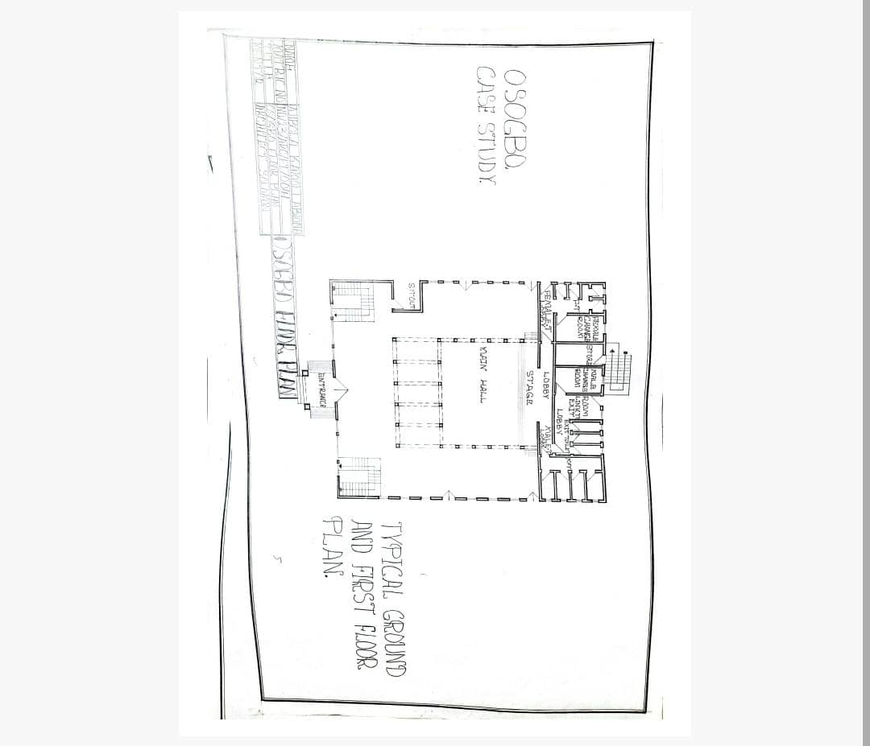
FIGURE 3.1.1: SHOWING THE FLOOR PLAN OF THE CASE STUDY ONE

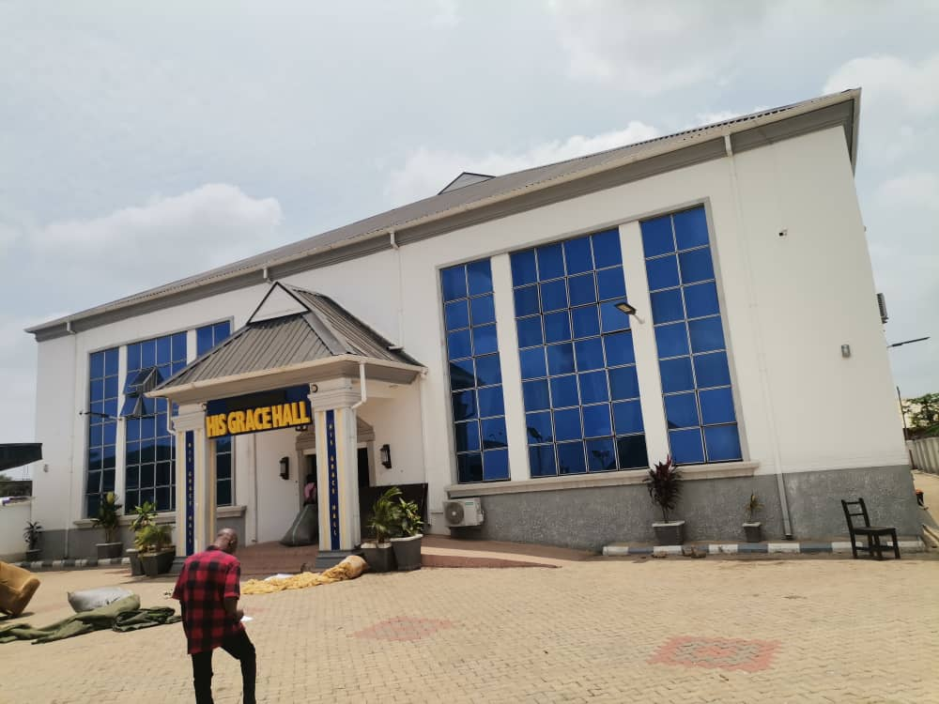
FIGURE 3.1.2: FRONT ELEVATION OF THE CASE STUDY ONE
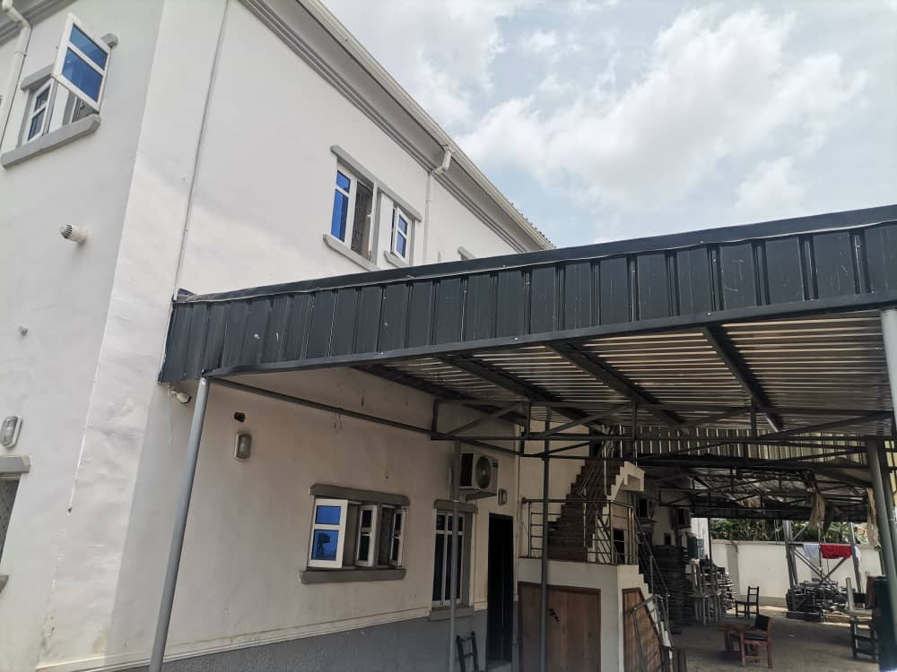
FIGURE 3.1.3: BACK ELEVATION OF THE CASE STUDY ONE

CASE STUDY TWO: DAPLAN EVENTS
LOCATION: Ibadan, Oyo State
DESCRIPTION:
Daplan Events is a modern event center in Ibadan designed to host various events, including weddings, conferences, and entertainment programs.
MERITS:
- The building is aesthetically pleasing, featuring a modern architectural design that creates a strong identity.
- It is located very close to the main road, enhancing accessibility for guests.
- The facility provides ample parking space for vehicles during events, ensuring convenience for users.
DEMERITS:
- There is limited soft landscaping within the premises, reducing the environmental aesthetics of the site.
- Parking spaces are not well defined or marked, leading to potential disorganization during large events.
- The store is not functional, affecting operational efficiency and storage management within the facility.

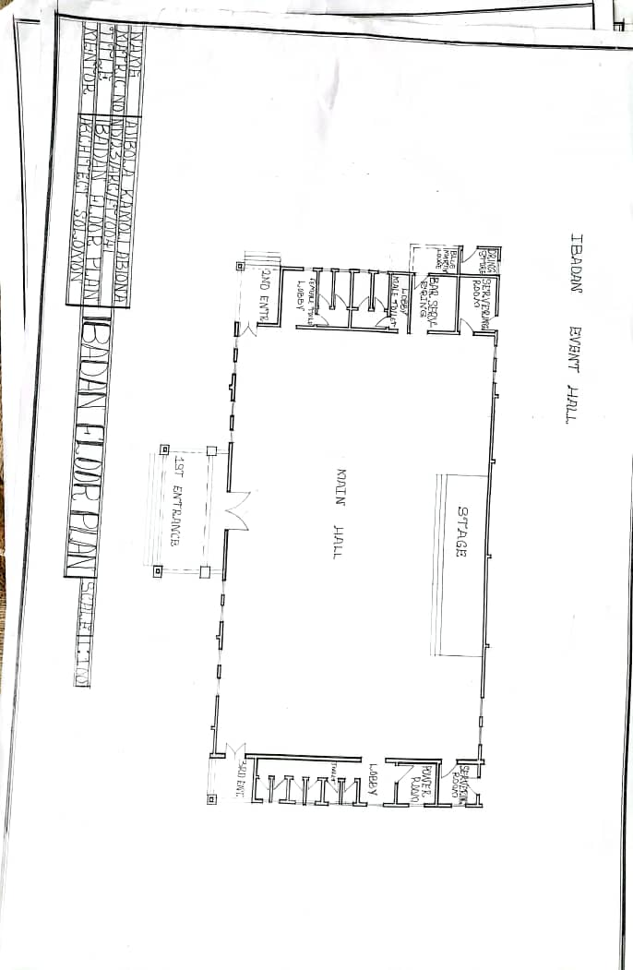
FIGURE 3.1.4: SHOWING THE FLOOR PLAN OF THE CASE STUDY TWO

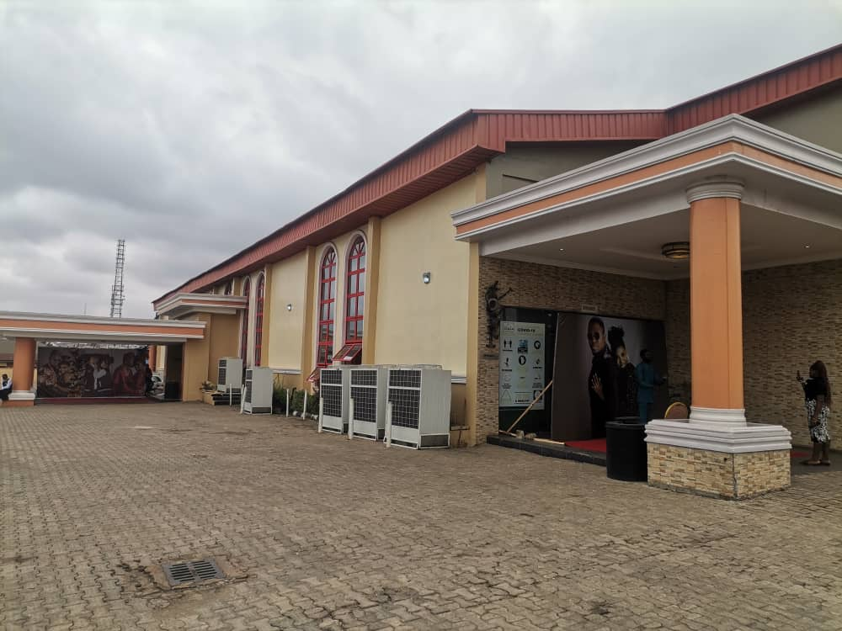FIGURE 3.1.5: FRONT ELEVATION OF THE CASE STUDY TWO
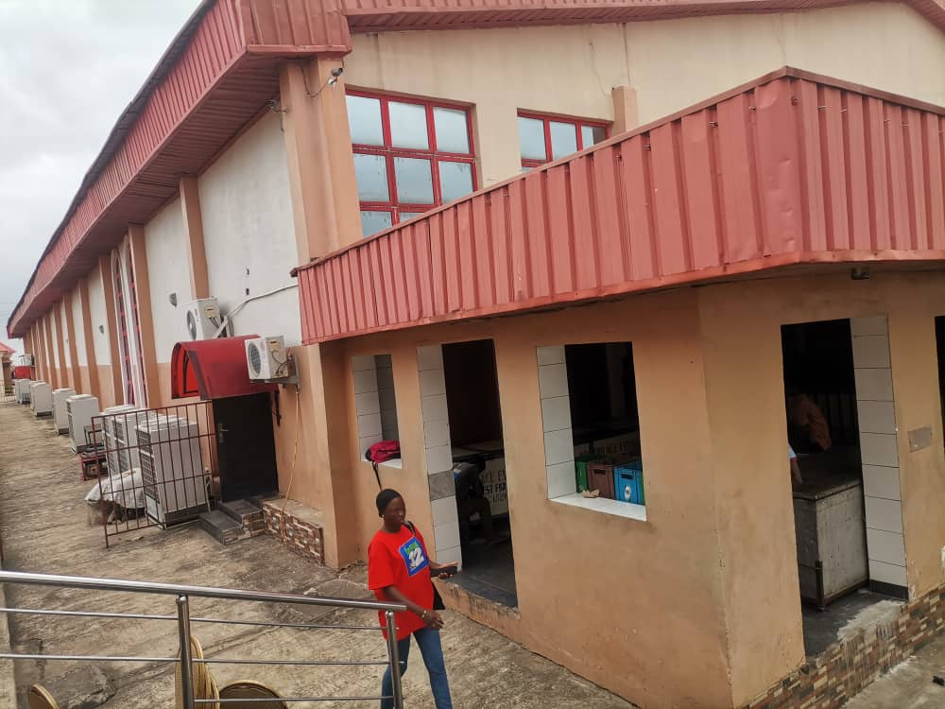
FIGURE 3.1.6: BACK ELEVATION OF THE CASE STUDY TWO

CASE STUDY THREE: M&M HALL
LOCATION: 23 Offa Road, Ilorin, Kwara State
DESCRIPTION:
M&M Hall is an event center located in Ilorin, used for social gatherings, conferences, and ceremonies.
MERITS:
- There is adequate parking space available, which provides convenience for guests and reduces congestion during events.
- The hall is very easy to locate due to its prominent location along Offa Road, making it accessible for both guests and service providers.
- The front façade of the building is aesthetically appealing, enhancing its identity and attractiveness.
DEMERITS:
- There is a general lack of maintenance of the facility, which affects its appearance, functionality, and user satisfaction.
- There is no backstage area, limiting the hall’s functionality for events requiring performance support or equipment storage.
- The conveniences (toilets) are not easily accessible from all parts of the building, which may cause discomfort for guests during events.

3.3 ONLINE CASE STUDIES
This section presents analyses of selected international event centers obtained through online research to understand global design standards, architectural expressions, and innovative features that can inform the proposed design.

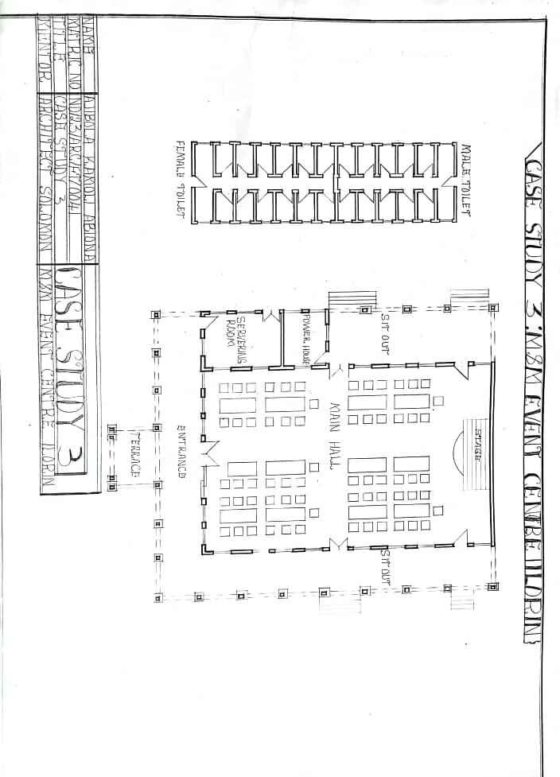
FIGURE 3.1.7: SHOWING THE FLOOR PLAN OF THE CASE STUDY THREE

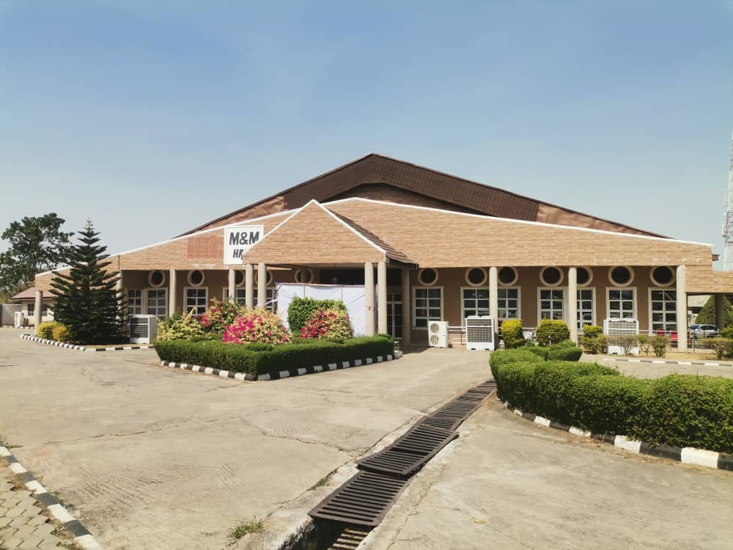
FIGURE 3.1.8: FRONT ELEVATION OF THE CASE STUDY THREE
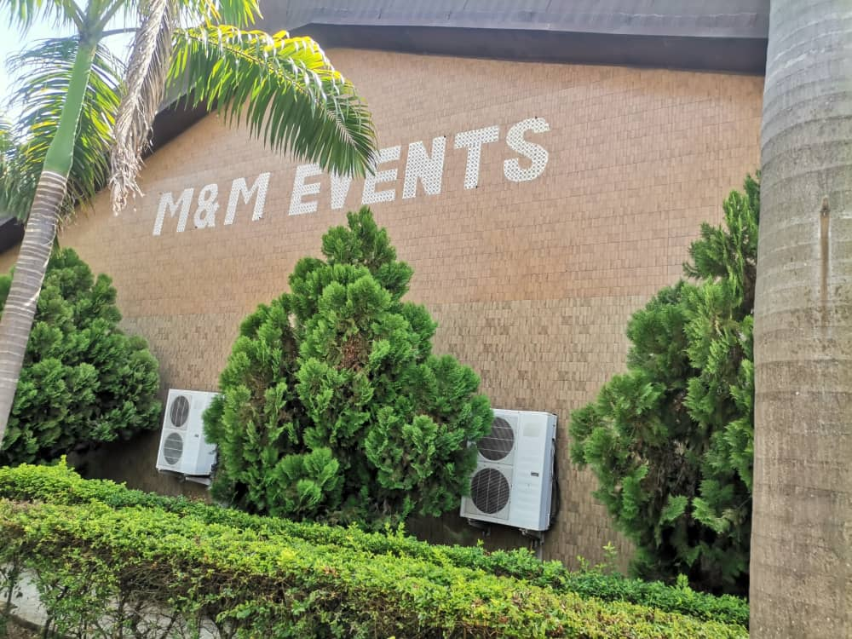
FIGURE 3.1.9: BACK ELEVATION OF THE CASE STUDY THREE
ONLINE CASE STUDY ONE

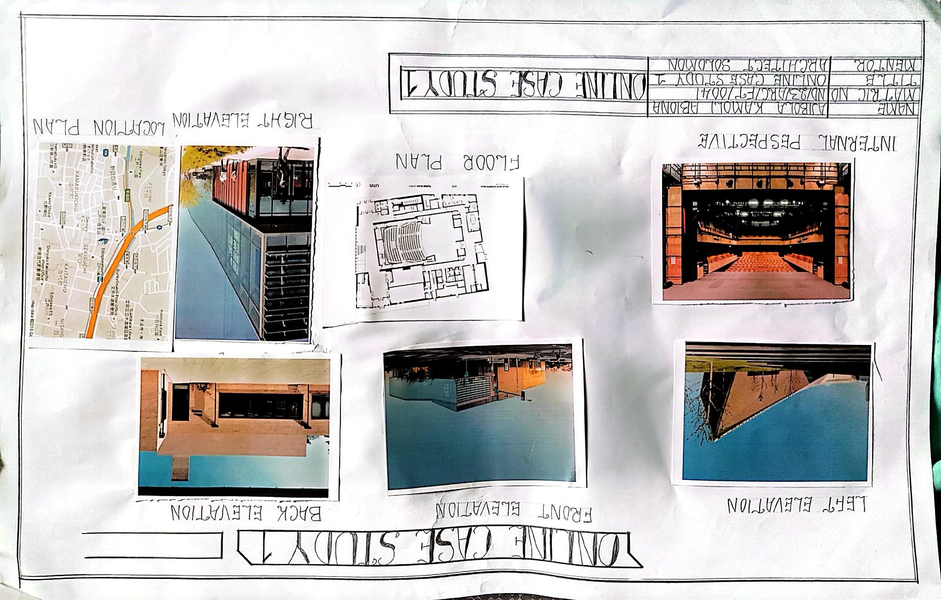

FIGURE 3.1.10: ONLINE CASE STUDY ONE
DESCRIPTION:
This event center features modern architectural design with clear functional zoning, spacious halls, and advanced aesthetic treatments that enhance its identity.
MERITS:
- The left elevation reveals dynamic roof forms, enhancing the building’s aesthetics and landmark identity.
- The front elevation features extensive glazing, allowing natural lighting and enhancing visual connection with the external environment.
- The internal perspective shows well-organized seating arrangements and stage layout for effective viewing and acoustics.
- The building incorporates clear circulation routes and functional planning as seen in the floor plan.
- Good site accessibility is indicated by the location plan and road connections.
DEMERITS:
- Limited landscaping within the immediate building frontage reduces environmental quality.
- Maintenance of expansive glazing may be cost-intensive if not planned adequately.
ONLINE CASE STUDY TWO
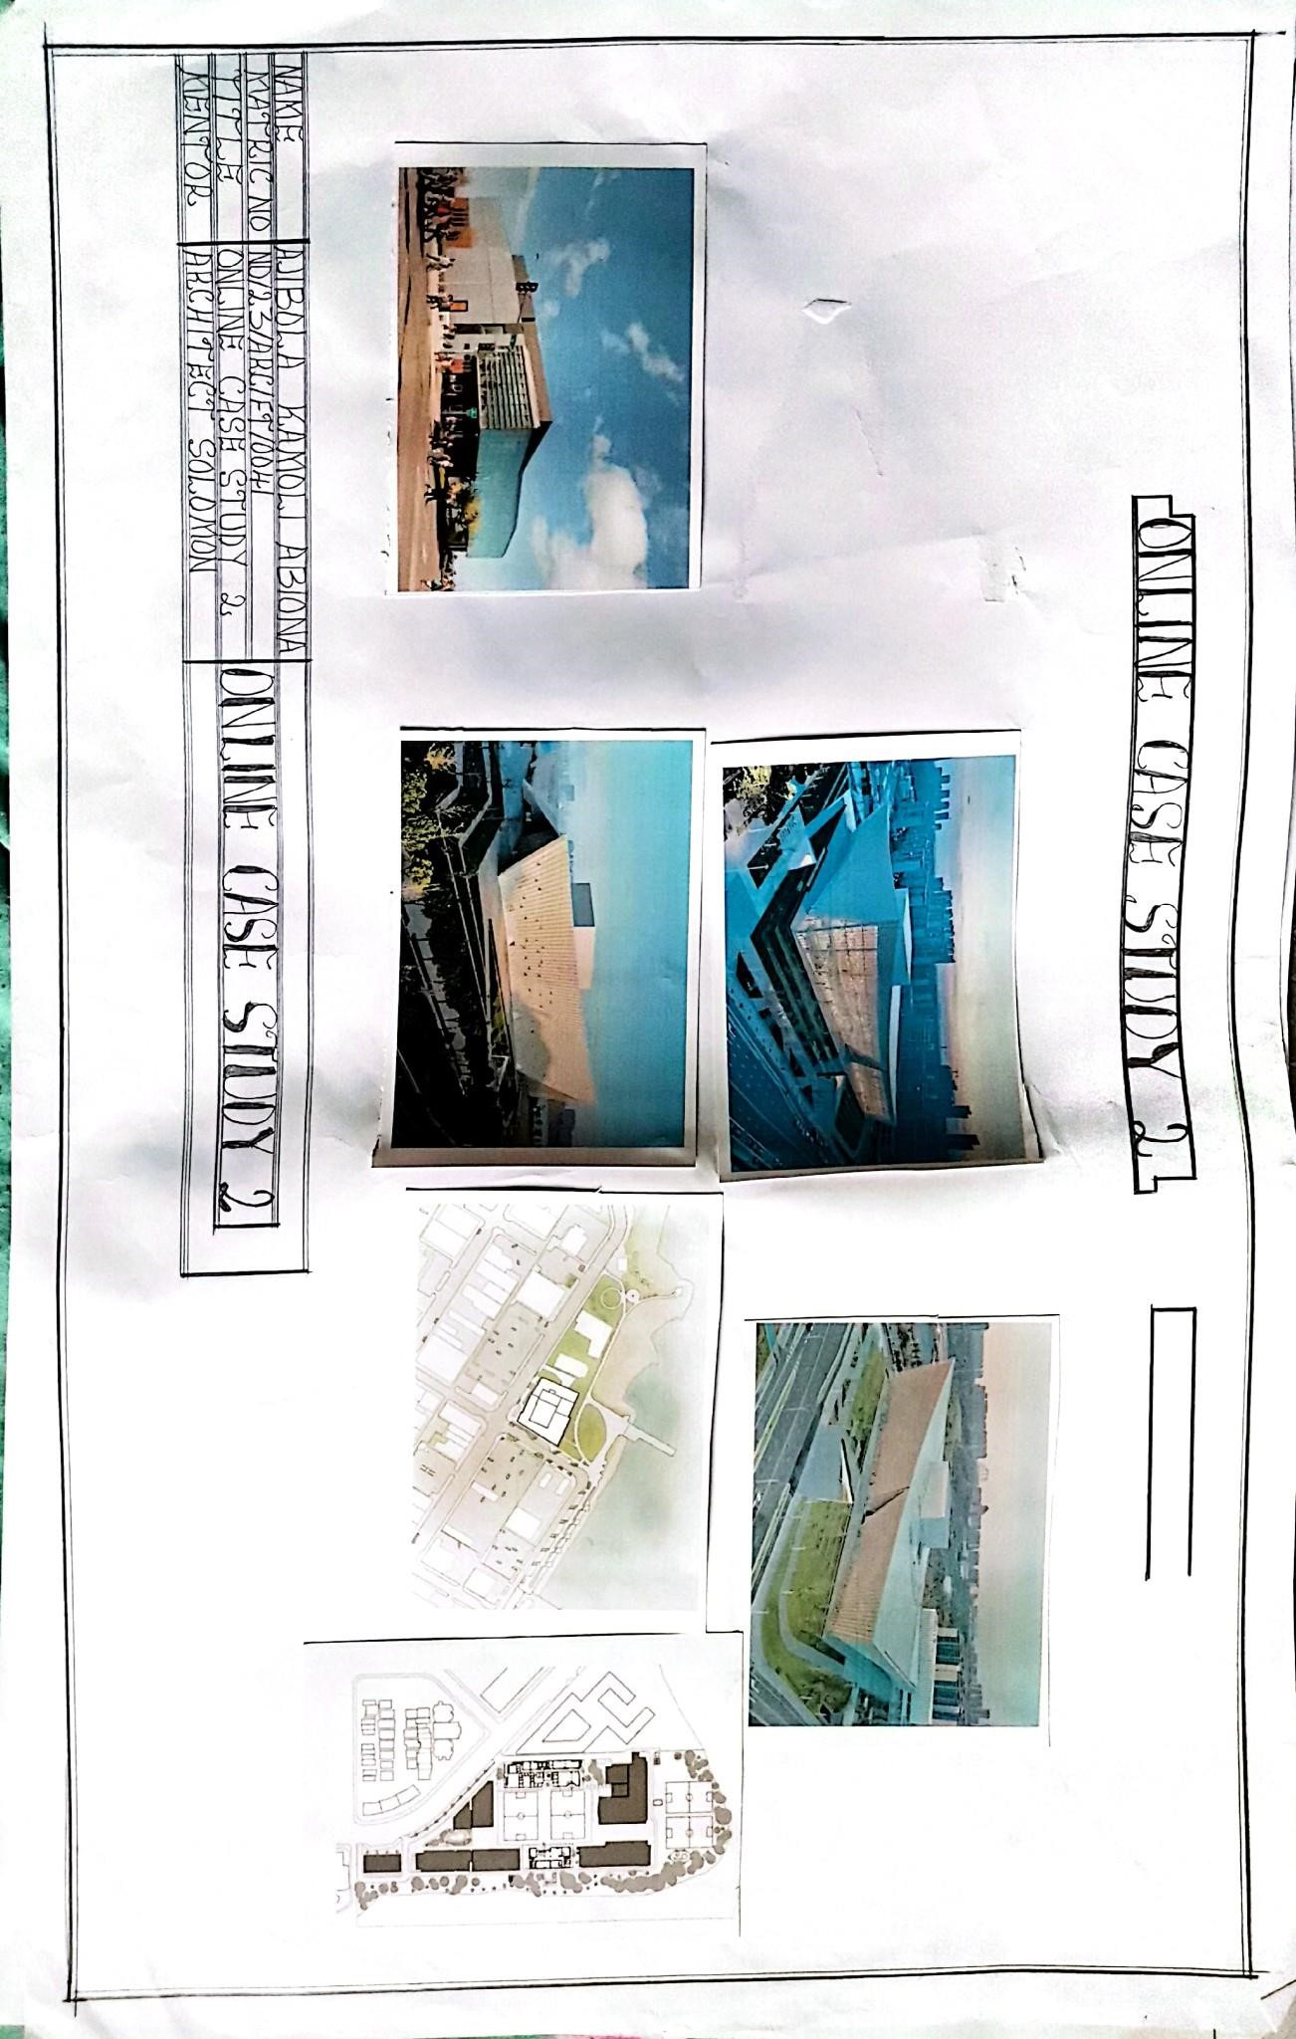
FIGURE 3.1.11: ONLINE CASE STUDY TWO
DESCRIPTION:
This case study showcases a high-capacity event center with innovative façade treatments and extensive site planning.
MERITS:
- Modern and attractive architectural form with unique angular projections that create iconic identity.
- Adequate site layout with provision for parking and circulation as seen in the site plan.
- Effective integration of indoor and outdoor spaces for user comfort.
- Use of durable materials and finishes for longevity.
- Spacious internal halls designed for flexibility in event layouts.
DEMERITS:
- Some sections lack green landscaping, affecting urban environmental quality.
- Large building footprint may increase energy demand if sustainable strategies are not incorporated.

CHAPTER FOUR

STUDY AREA / PROJECT SITE (ENVIRONMENTAL AND IMPACT ANALYSIS)

4.1 INTRODUCTION OF STUDY AREA / SITE SELECTION
This chapter presents an analysis of the selected project site for the proposed event center. Site analysis is essential in understanding the topographical, climatic, environmental, and socio-economic factors that influence the design, ensuring the proposed development responds efficiently to its context. The site was selected based on accessibility, availability of utilities, compatibility with surrounding land uses, and suitability for the proposed function. The goal is to locate the event center within an area that enhances user convenience, promotes social integration, and contributes positively to urban development.
Additionally, a thorough evaluation of the site’s opportunities and constraints was carried out to guide design decisions and optimize functionality. Factors such as ease of vehicular and pedestrian access, proximity to public transport routes, environmental safety, and potential for future expansion were considered to ensure that the chosen site will support the operational, spatial, and aesthetic goals of the project effectively.
The site selection process also involved examining existing zoning regulations, land ownership status, and infrastructural provisions to avoid future legal or operational challenges. By selecting a strategically located site with minimal environmental risks and maximum development potential, the design ensures long-term sustainability, cost-effectiveness, and successful integration within the urban fabric.

4.2 SITE LOCATION, DESCRIPTION, AND SELECTION CRITERIA

4.2.1 SITE LOCATION
- Location: Along Old Jebba Road, Oyun, Kwara State.
- Accessibility: The site is situated along Old Jebba Road with good access to public transportation. It is connected to surrounding commercial and residential areas via major roads like Barrack Road, Indian School Road, and Tippe Garage Road.
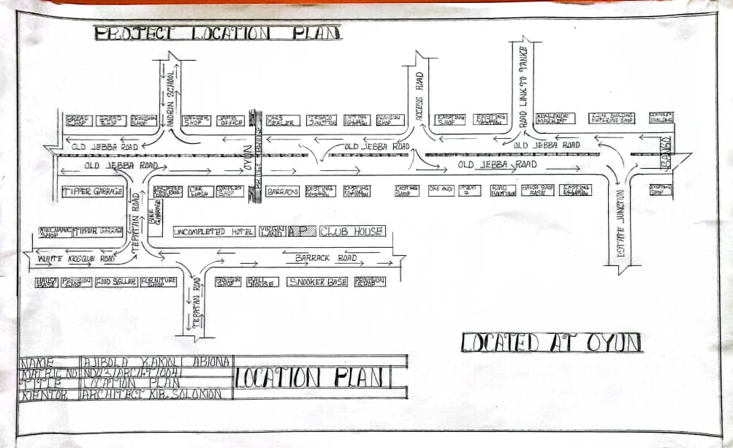
FIGURE 4.2.1.1: LOATIONAL PLAN

4.2.2 SITE DESCRIPTION
- Prime Area: Oyun is a developing area with a mix of residential, educational, and commercial facilities along Old Jebba Road.
- Accessibility: Located strategically with direct routes linking Tipper Garage, Barracks, Club House, and Oyun Junction, enhancing access for guests and service deliveries.
- Proximity to Institutions: Close to schools, shops, mosques, and local businesses, creating opportunities for hosting community events, educational programs, and social gatherings.
- Topography: The area has generally flat terrain with slight undulations, making it suitable for construction with minimal site leveling required.

4.2.3 SITE SELECTION CRITERIA
The site was chosen based on:
- Easy access to main roads and transport routes
- Availability of utilities (electricity, water, drainage)
- Suitable topography for stable and easy development
- Proximity to community facilities to encourage use
- Environmental safety, being free from flooding and erosion risks

4.3 SITE ANALYSIS
The site analysis examines the physical, environmental, and socio-economic characteristics of the proposed location to determine its suitability for the development of an event center.
The proposed site is located in a prime area of Kwara State with easy access to major transportation routes. The site analysis reveals that the area is conducive to event-related activities, with nearby entertainment venues, commercial centers, and supporting facilities that will enhance the functionality and economic viability of the proposed event center.
The topography of the site is relatively flat, which facilitates construction and minimizes extensive earthworks. The site is free from flooding risks due to its good drainage conditions. Vegetation on the site is moderate, comprising grasses and scattered shrubs, making it suitable for landscaping and site beautification.
In terms of utilities, the area is well served with electricity, water supply, and telecommunication networks, ensuring that the proposed event center will have access to essential services. The neighborhood is safe, with good road networks connecting it to other parts of the city, which will enhance accessibility for guests and service providers.
Environmental conditions such as sun path and wind direction indicate that the building design can incorporate natural lighting and ventilation to reduce energy costs while ensuring user comfort.
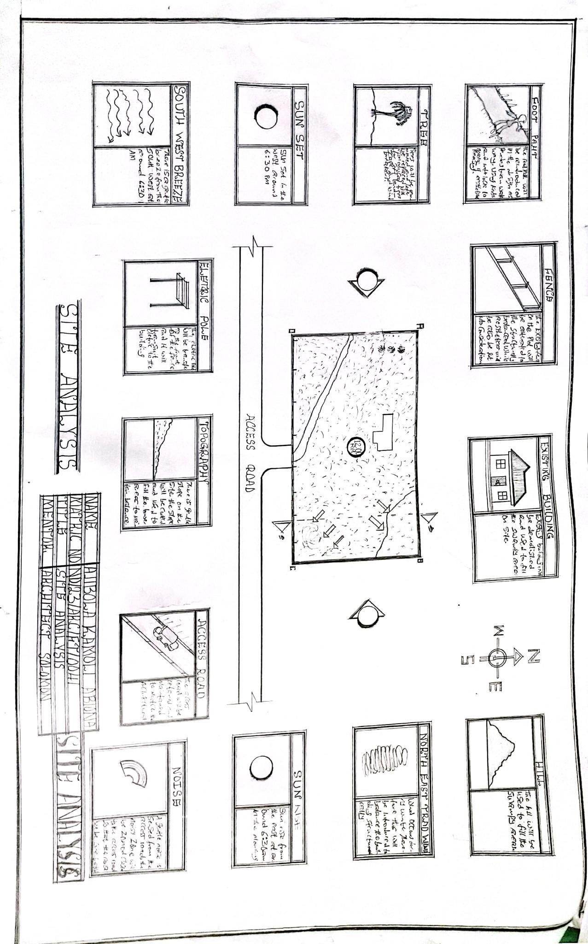
FIGURE 4.3.1: SITE ANALYSIS

4.4 GEOGRAPHICAL AND CLIMATIC DATA
The proposed site is in Ilorin, Kwara State (latitude 8°30'N, longitude 4°33'E), within Nigeria’s forest-savannah transition zone. The climate is tropical with a rainy season (April–October) and dry season (November–March). Annual rainfall is 1,000–1,500mm, peaking in August and September. Temperatures range 22°C–34°C, hottest from February to April, and cooler during Harmattan (December–January). Humidity is high (>70%) in the rainy season and drops in the dry season. The topography is flat with lateritic soil, suitable for construction. Prevailing winds are south-westerly in rainy season and north-easterly in dry season.
Design Implications:
Incorporate good ventilation, sun shading, effective drainage, and drought-resistant landscaping for year-round functionality.
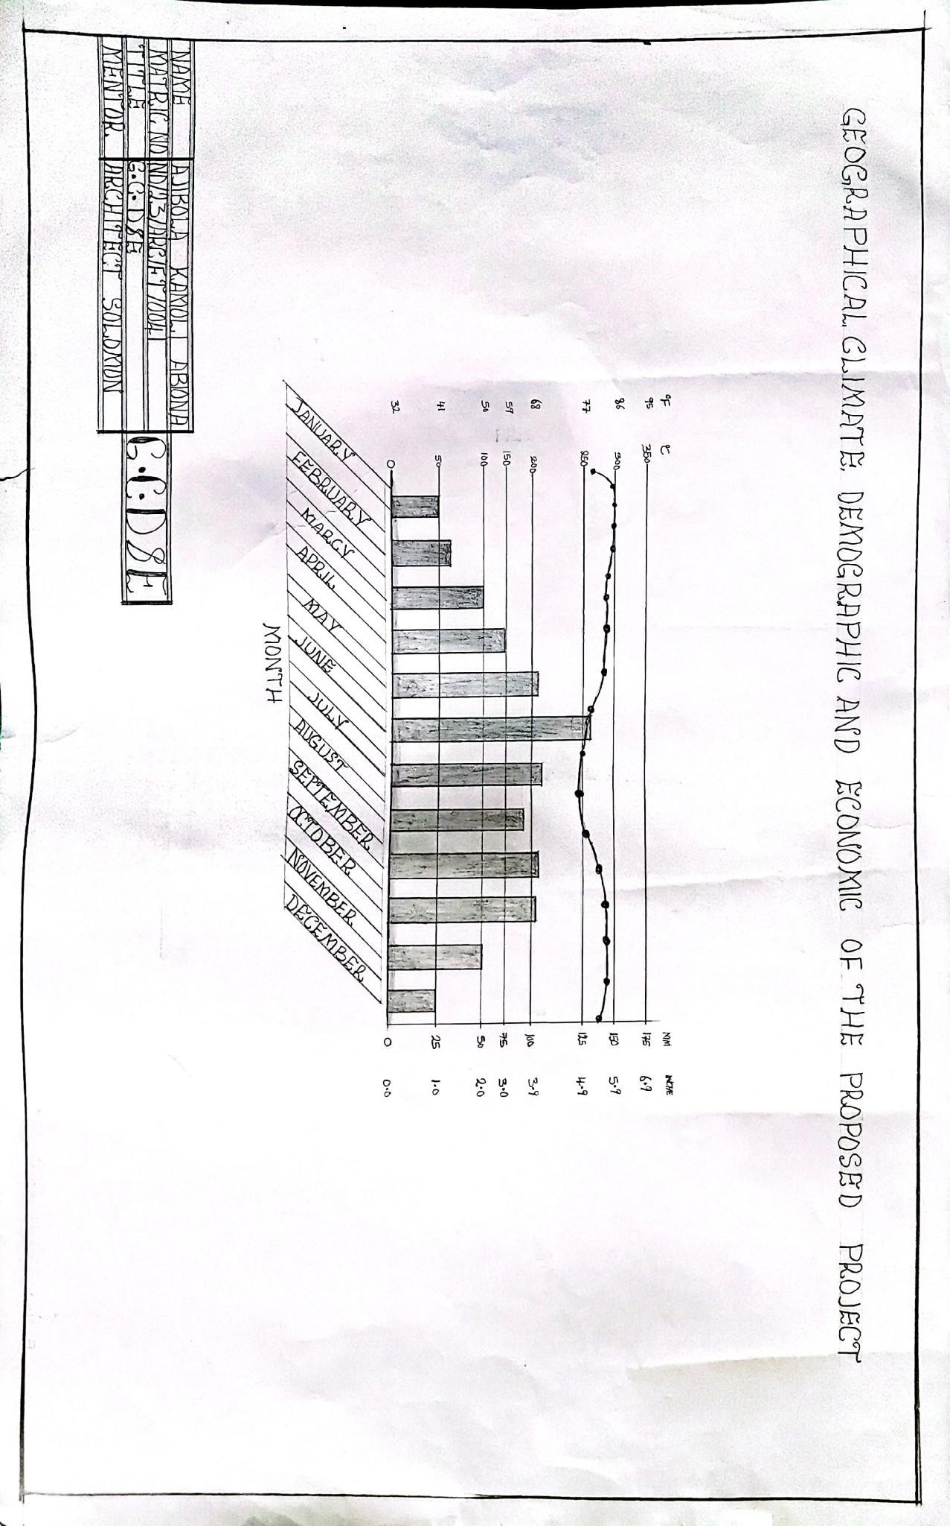
FIGURE 4.4.1: G.C.D.E

4.5 DESIGN PRELIMINARIES
Design preliminaries involve initial studies and schematic analyses carried out to guide the development of the proposed event center.

4.5.1 BUBBLE DIAGRAM
The bubble diagram is a schematic representation used during the design preliminary stage to illustrate spatial zoning and functional relationships between different areas of the proposed event center. It shows how spaces relate to one another before detailed planning and drafting are carried out.
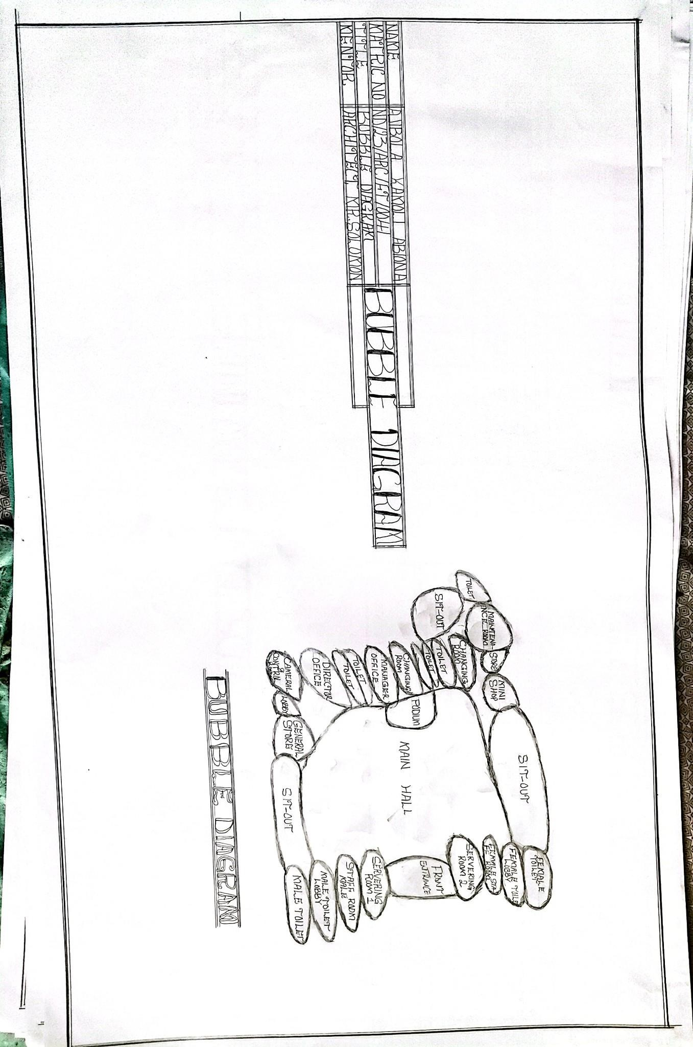
FIGURE 4.5.1.1: BUBBLE DIAGRAM

4.5.2 SCHEDULE
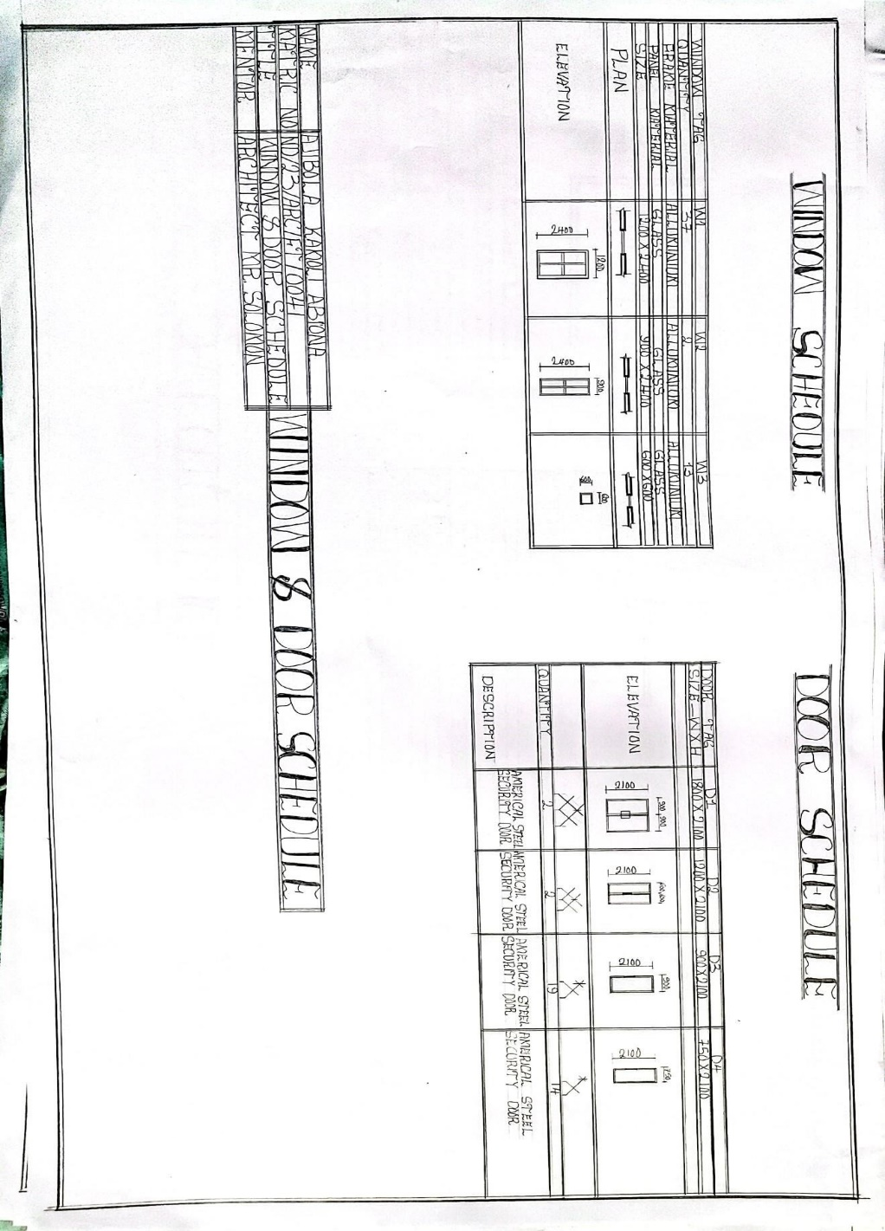
This is the appendix that is use to show the quantity, types, descriptions and size of doors and windows use in the construction of a design

FIGURE 4.5.2.1: WINDOW AND DOOR SCHEDULE

4.5.3 SPATIAL ALLOCATION
This deals with the dimensioning and measurement of the units provided in the design. The following are the various unites in the buildings and their dimensions.

S/N | Units | dimension (mm)
1  2  3  4  5  6  7  8  9  10  11  12  13  14  15  16  17  18  19  20  21  22  23  24 | Front Entrance  Serving Rooms  Staff Rooms  Toilet Lobbies  Toilets  Main Hall  Sit-outs  Podium  General Store  Lobby  Control and Camera Room  Director Office  Toilets  Manager Office  Changing Rooms  Store  Maintenance Room  Toilet Lobby  Toilet  Back Sit-out  Maintenance Lobby  Store  Mini Shop  Staff Room Lobby | 9050 x 8450  5475 x 3000  4250 x 2000  5475 x 1500  1200 x 2500  34500 x 22000  27300 x 3000  4500 x 6800  3000 x 3000  1500 x 1500  4000 x 3000  3000 x 3000  1875 x 1200  3000 x 3000  3000 x 3000  3000 x 2800  4000 x 3000  1200 x 2000  1700 x 1200  7600 x 1200  1500 x 900  1875 x 1500  3000 x 3000  1200 x 2000

4.5.4 DESIGN ZONING
Design zoning involves the systematic arrangement of spaces within the proposed event center to ensure functional efficiency, safety, and ease of navigation while enhancing user experience. The zoning strategy for this project is based on the identified spaces in the client’s brief and their functional relationships.
Public Zone  Main hall  Lobby  Sit-out area  Toilets  Mini shop | Semi Public Zone  Manager’s office  Director’s office  Changing room  Control room | Private Zone  General store  Maintenance room  Podium store  Serving/staff room

4.6 DESIGN CRITERIA

CLIENTS BRIEF
The client’s brief outlines the required spaces and functional expectations for the proposed modern event center. These requirements form the basis of the design criteria to ensure the facility meets operational, spatial, and user needs effectively.

Key Design Requirements:
- Entrance Serving / Staff Room
- Main Hall
- Male & Female Toilets
- Sit-Out Area
- General Store
- Lobby
- Camera & Control Room
- Director’s Office
- Manager’s Office.
- Changing Room
- Podium Store
- Maintenance Room
- Mini Shop

4.7 CONCEPTUAL DEVELOPMENT
The conceptual development for the proposed modern event center is based on the client’s brief, site analysis, climatic data, and design considerations aimed at creating a functional, aesthetically pleasing, and environmentally responsive facility.
The design concept emphasizes effective spatial organization, placing the main event hall at the center as the core space. Supporting facilities, including administrative offices, VIP rooms, toilets, storage, and changing rooms, are strategically arranged around it to ensure smooth circulation and accessibility. This arrangement promotes operational efficiency and user convenience.
Additionally, the design incorporates sustainable strategies by maximizing natural lighting and ventilation through the use of wide openings and cross-ventilated spaces, thereby reducing energy consumption and creating comfortable indoor environments. Landscaping elements and green spaces are incorporated to enhance aesthetics, promote relaxation, and improve environmental quality within the site.

CHAPTER FIVE

APPROACH TO THE DESIGN / DESIGN REALIZATION

5.1 DESIGN AND CONCEPTS
The design concept is based on simplicity, functionality, and modern aesthetics. The layout adopts clear zoning to separate public, semi-public, and service areas, ensuring ease of circulation and user comfort. The main hall is centrally located with direct access from the lobby, while supporting facilities such as toilets, changing rooms, and stores are positioned for convenience. Large windows and open spaces enhance natural lighting and ventilation, while the façade design incorporates clean lines and textured finishes to create a unique and welcoming identity for the event center.
To further illustrate the technical aspects of the design, detailed drawings, including structural and architectural components, are provided in Appendix A. These drawings support the design rationale and provide visual clarity for construction and implementation.

5.2 TECHNOLOGICAL AND ENVIRONMENTAL CRITERIA
The event center adopts a reinforced concrete frame with block infill for durability, finished with textured exterior paint and stone cladding for aesthetics. Long-span aluminium roofing sheets are used for easy maintenance, while floors feature non-slip ceramic tiles in the main hall and vitrified tiles in offices and toilets.
Natural cross ventilation is supported by ceiling fans and provisions for air conditioning, with energy-efficient LED lighting enhancing illumination. Standard concealed plumbing and electrical systems ensure safety and neat finishes. Acoustic panels in the main hall improve sound quality, while fire safety features such as extinguishers, exit signage, and emergency exits are integrated.
The design incorporates waste management facilities with recycling options, alongside landscaping and green spaces to enhance environmental sustainability, user comfort, and visual appeal.

5.3 LEGAL ISSUES AND PLANNING REGULATIONS
The design complies with Kwara State Urban and Regional Planning Authority regulations, including:
- Adequate setbacks from property boundaries.
- Provision of parking spaces sufficient for event capacities.
- Compliance with building codes for public assembly buildings.
- Accessibility features such as ramps and wide doorways for persons with disabilities.
- Fire safety requirements including exits, alarms, and firefighting equipment.

5.4 BEHAVIORAL PATTERNS AND CONSIDERATIONS
The design considers human behavior patterns such as:
- Easy navigation from entrance through lobby to the main hall and ancillary spaces.
- Clear separation of public and service circulation routes.
- Privacy for administrative offices and changing rooms.
- Comfortable interaction spaces such as the sit-out area and lobby.
- Flexible main hall layout adaptable for various event types and seating arrangements to enhance user experience and operational efficiency.
These considerations aim to support intuitive movement, social comfort, and functional adaptability within the event center. The spatial arrangement promotes seamless flow while reducing congestion during peak activities. Visual connectivity and appropriate zoning ensure that users, staff, and guests can move through the facility with minimal confusion or overlap.
Detailed architectural layouts and circulation patterns illustrating these behavioral considerations are provided in Appendix offering visual support for how user-centered design was implemented throughout the project.

5.5 CONCLUSION
The design of this modern event center has been developed based on extensive research, analysis, and case studies to create a functional, comfortable, and aesthetically pleasing facility. The project successfully addresses user needs by incorporating efficient spatial planning, modern construction materials, sustainable design strategies, and compliance with safety and planning regulations. It contributes to community development by providing a venue that supports social, cultural, and economic activities within a safe and welcoming environment.
Furthermore, the design reflects the integration of innovative solutions to overcome common challenges faced by existing event centers, such as poor circulation, lack of adequate parking, and insufficient environmental considerations. By applying best architectural practices and prioritizing user comfort and sustainability, this project sets a standard for future event center designs, ensuring it remains relevant, adaptable, and impactful within its community for years to come.

5.6 RECOMMENDATIONS
It is recommended that future designs and research on event centers focus on integrating advanced smart technologies to control lighting, sound, and security systems efficiently, thereby enhancing user experience and operational management. Greater emphasis should also be placed on the adoption of renewable energy solutions such as solar panels to promote energy self-sufficiency and reduce long-term operational costs. Additionally, innovative strategies for water recycling and effective waste management systems should be incorporated to improve environmental sustainability and minimize ecological impact. Designers should consider creating flexible interior layouts that can easily adapt to various event types and emerging trends, ensuring long-term relevance and usability of the facility. Finally, it is crucial to develop comprehensive maintenance and facility management plans to uphold the functionality, safety, and aesthetic quality of event centers throughout their lifespan.

REFERENCES
Adebayo, A. A. (2000). Principles and Practice of Architecture in Nigeria. Ibadan: Spectrum Books Limited.
Adedeji, Y. M. D., & Ogunsote, O. O. (2010). Sustainable building materials for low-income housing development in Nigeria. The Built & Human Environment Review, 3, 33-48.
Ajayi, O. M., & Aderonmu, P. A. (2015). Sustainable approaches to event centre design in Lagos State, Nigeria. Journal of Environmental Design and Management, 7(1), 15-23.
Akande, O. K., & Odeleye, D. A. (2013). Sustainable building design: Learning from traditional architecture. International Journal of Architecture, Engineering and Construction, 2(3), 214-222.
Aluko, O. (2011). The impact of urbanization on housing development: The Lagos experience, Nigeria. Ethiopian Journal of Environmental Studies and Management, 4(3), 64-74.
Babalola, B. (2016). Event management in Nigeria: Challenges and opportunities. African Journal of Hospitality, Tourism and Leisure, 5(4), 1-15.
Bamidele, J. (2021). Architectural design considerations for inclusive event centres in Nigeria. Journal of Contemporary Urban Studies, 3(2), 45-59.
Chudley, R., & Greeno, R. (2016). Building Construction Handbook (11th ed.). Routledge.
Emmitt, S., & Gorse, C. (2014). Barry’s Introduction to Construction of Buildings (3rd ed.). Wiley Blackwell.
Ghyka, M. (1977). The Geometry of Art and Life. New York: Dover Publications.
Neufert, E., & Neufert, P. (2012). Architects’ Data (4th ed.). Wiley-Blackwell.
National Population Commission (NPC). (2006). Population and Housing Census of the Federal Republic of Nigeria: National and State Population and Housing Tables. Abuja: NPC.
Njoku, C. & Ugochukwu, C. (2017). Event centre development and its impact on urban land use in Owerri, Nigeria. International Journal of Development and Sustainability, 6(10), 1327-1339.
Nwokoro, I., & Onukwube, H. N. (2011). Sustainable or green construction in Lagos, Nigeria: Principles, attributes and frameworks. West Africa Built Environment Research (WABER) Conference, 553-567.
Olajide, C. J. (2018). Design considerations for contemporary event centres in Nigeria. International Journal of Architecture and Urban Development, 8(4), 11-18.
Onibokun, A. G., & Faniran, A. (1995). Urban Research in Nigeria. Ibadan: French Institute for Research in Africa (IFRA).
Oyetola, O. O. (2019). Sustainable design strategies for public event centres. Nigerian Journal of Environmental Design and Management, 11(2), 45-53.
Smith, P. F. (2001). Architecture in a Climate of Change: A Guide to Sustainable Design. Architectural Press.
Uji, Z. A. (1994). Understanding Architecture: The Elements of Design. Jos: Mazlink Nigeria Limited.
United Nations Environment Programme (UNEP). (2009). Buildings and Climate Change: Summary for Decision-Makers. Paris: UNEP.
Yarwood, A. (2001). Introduction to AutoCAD 2000. Longman.
Zubairu, S. N., & Ismail, M. (2016). Green architecture in Nigeria: An overview. ATBU Journal of Environmental Technology, 9(1), 24-34.

APPENDIX

SITE PLAN
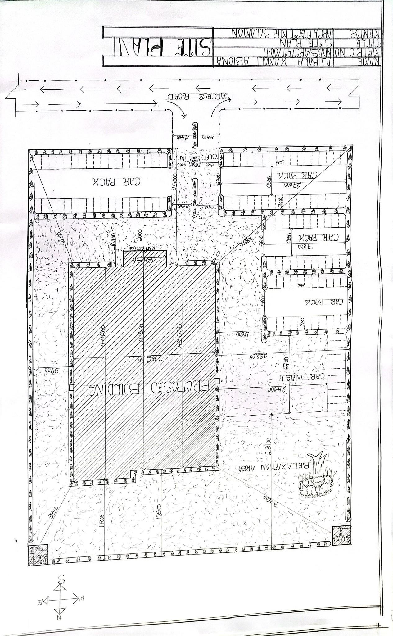
APPENDIX 1: SITE PLAN

FLOOR PLAN
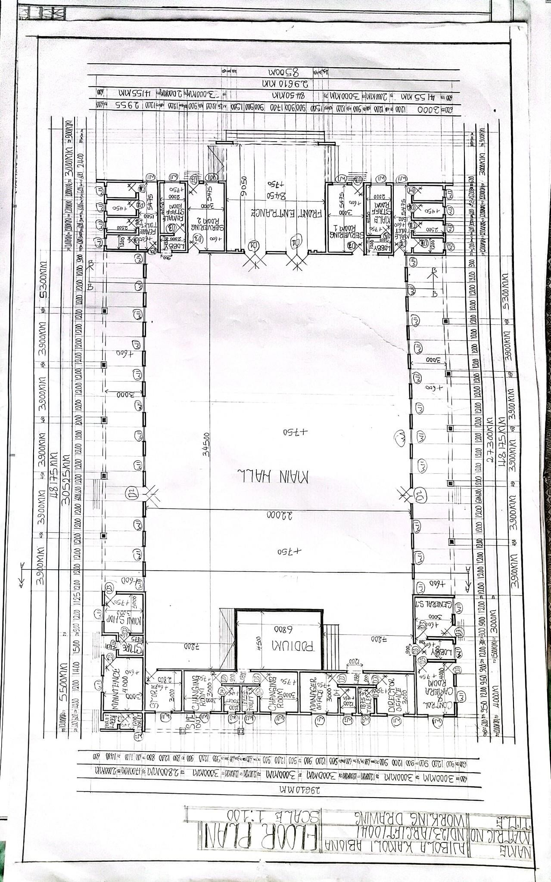
APPENDIX 2: FLOOR PLAN

ROOF PLAN
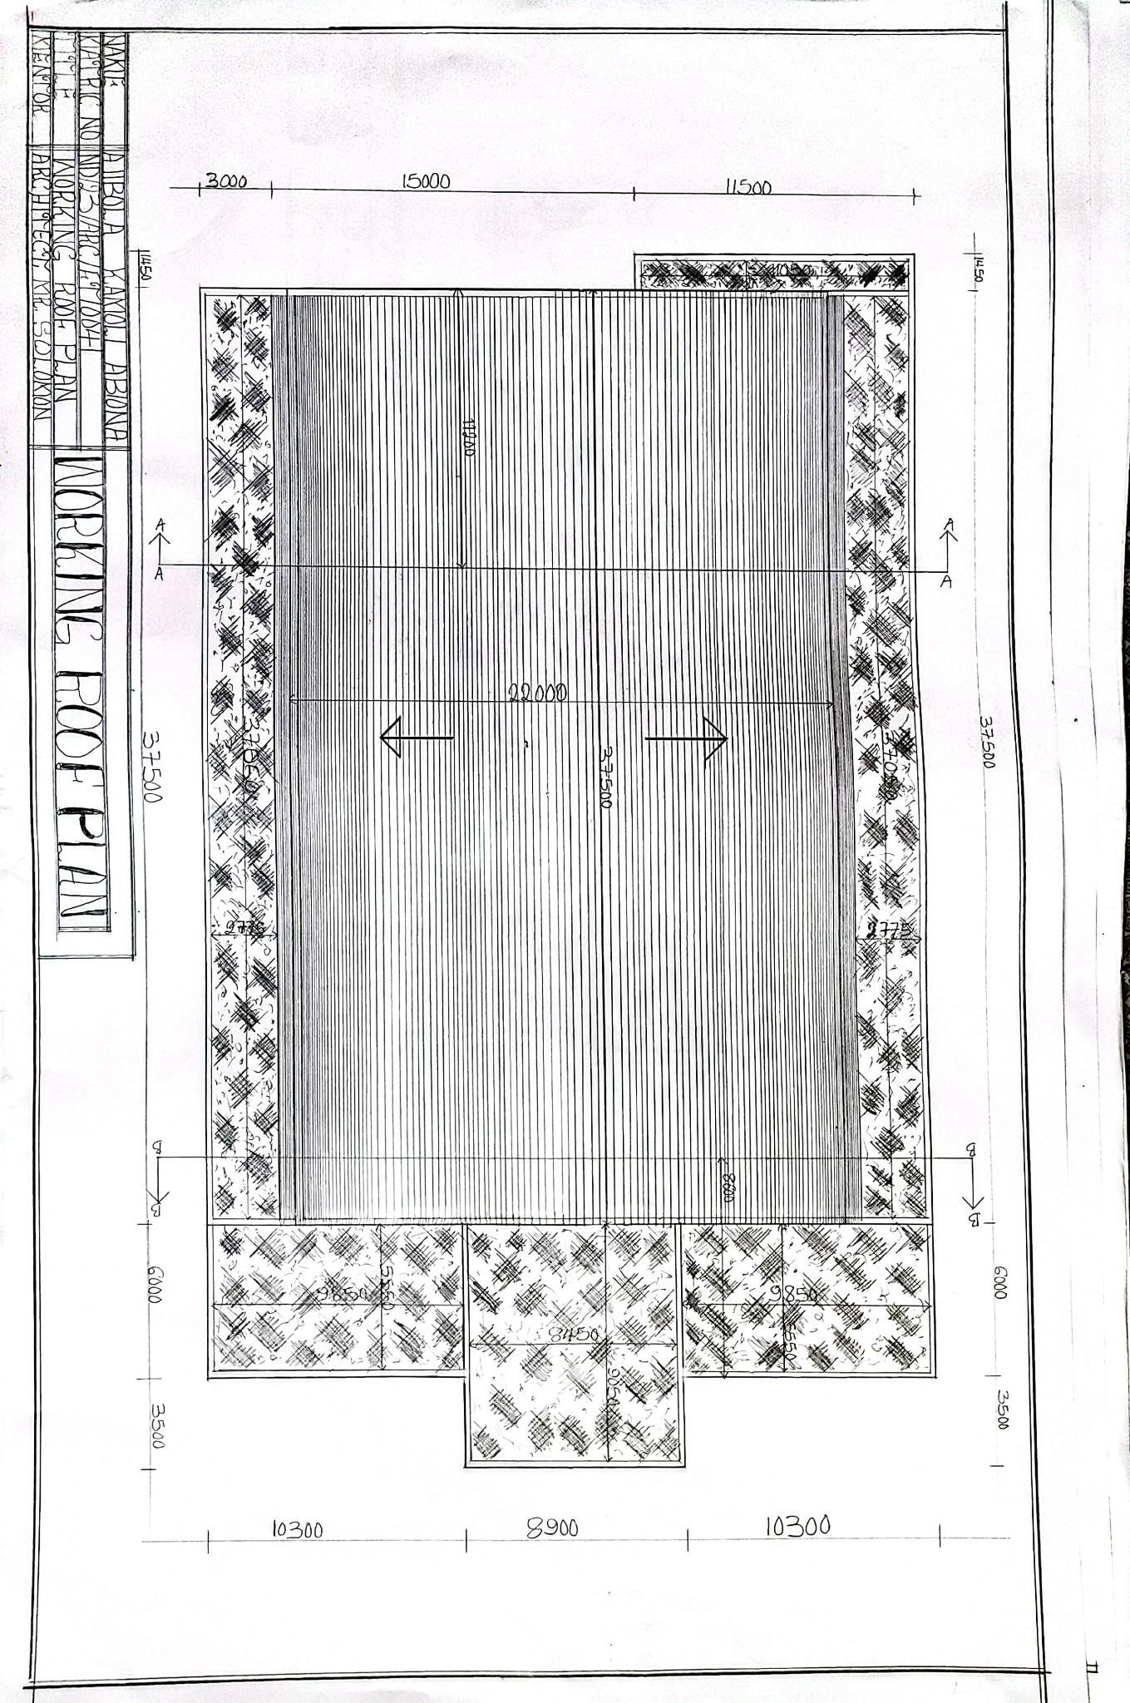
APPENDIX 3: ROOF PLAN

SECTIONS
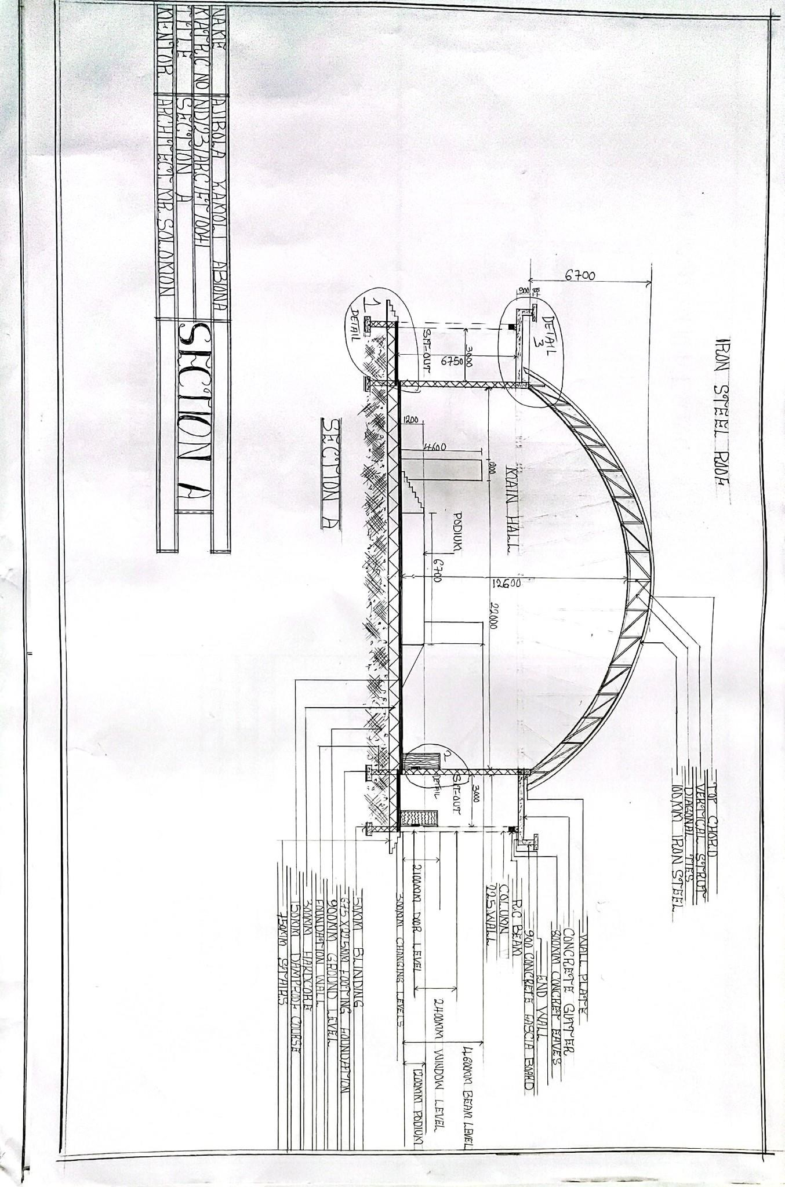
APPENDIX 4: SECTION A
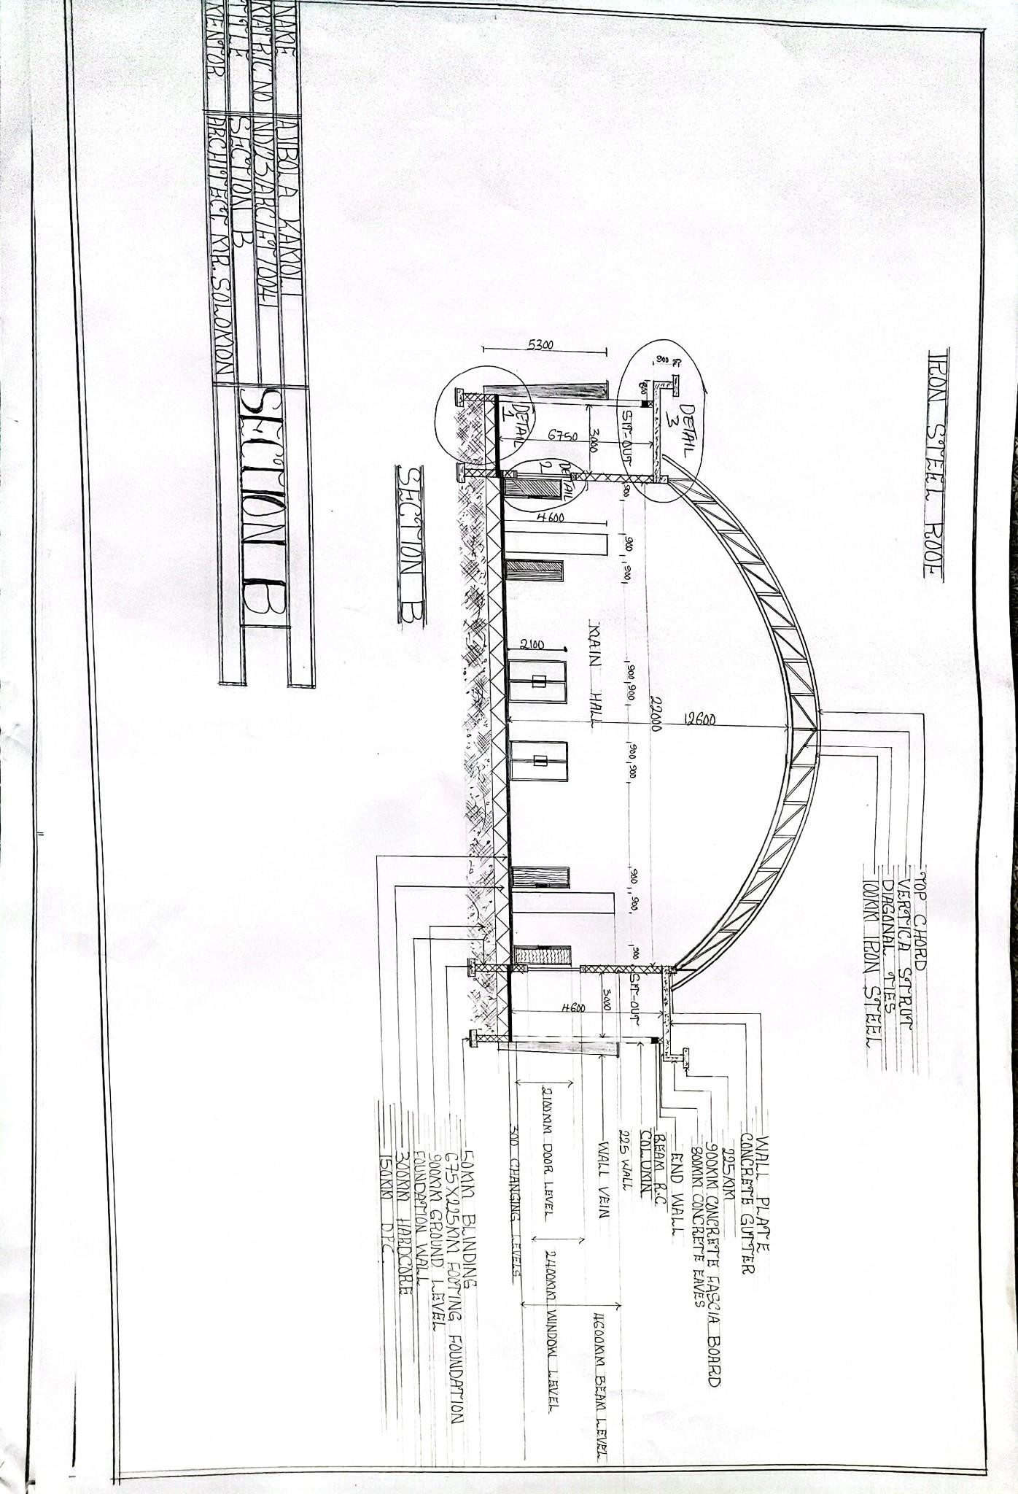
APPENDIX 5: SECTION B

ELEVATION
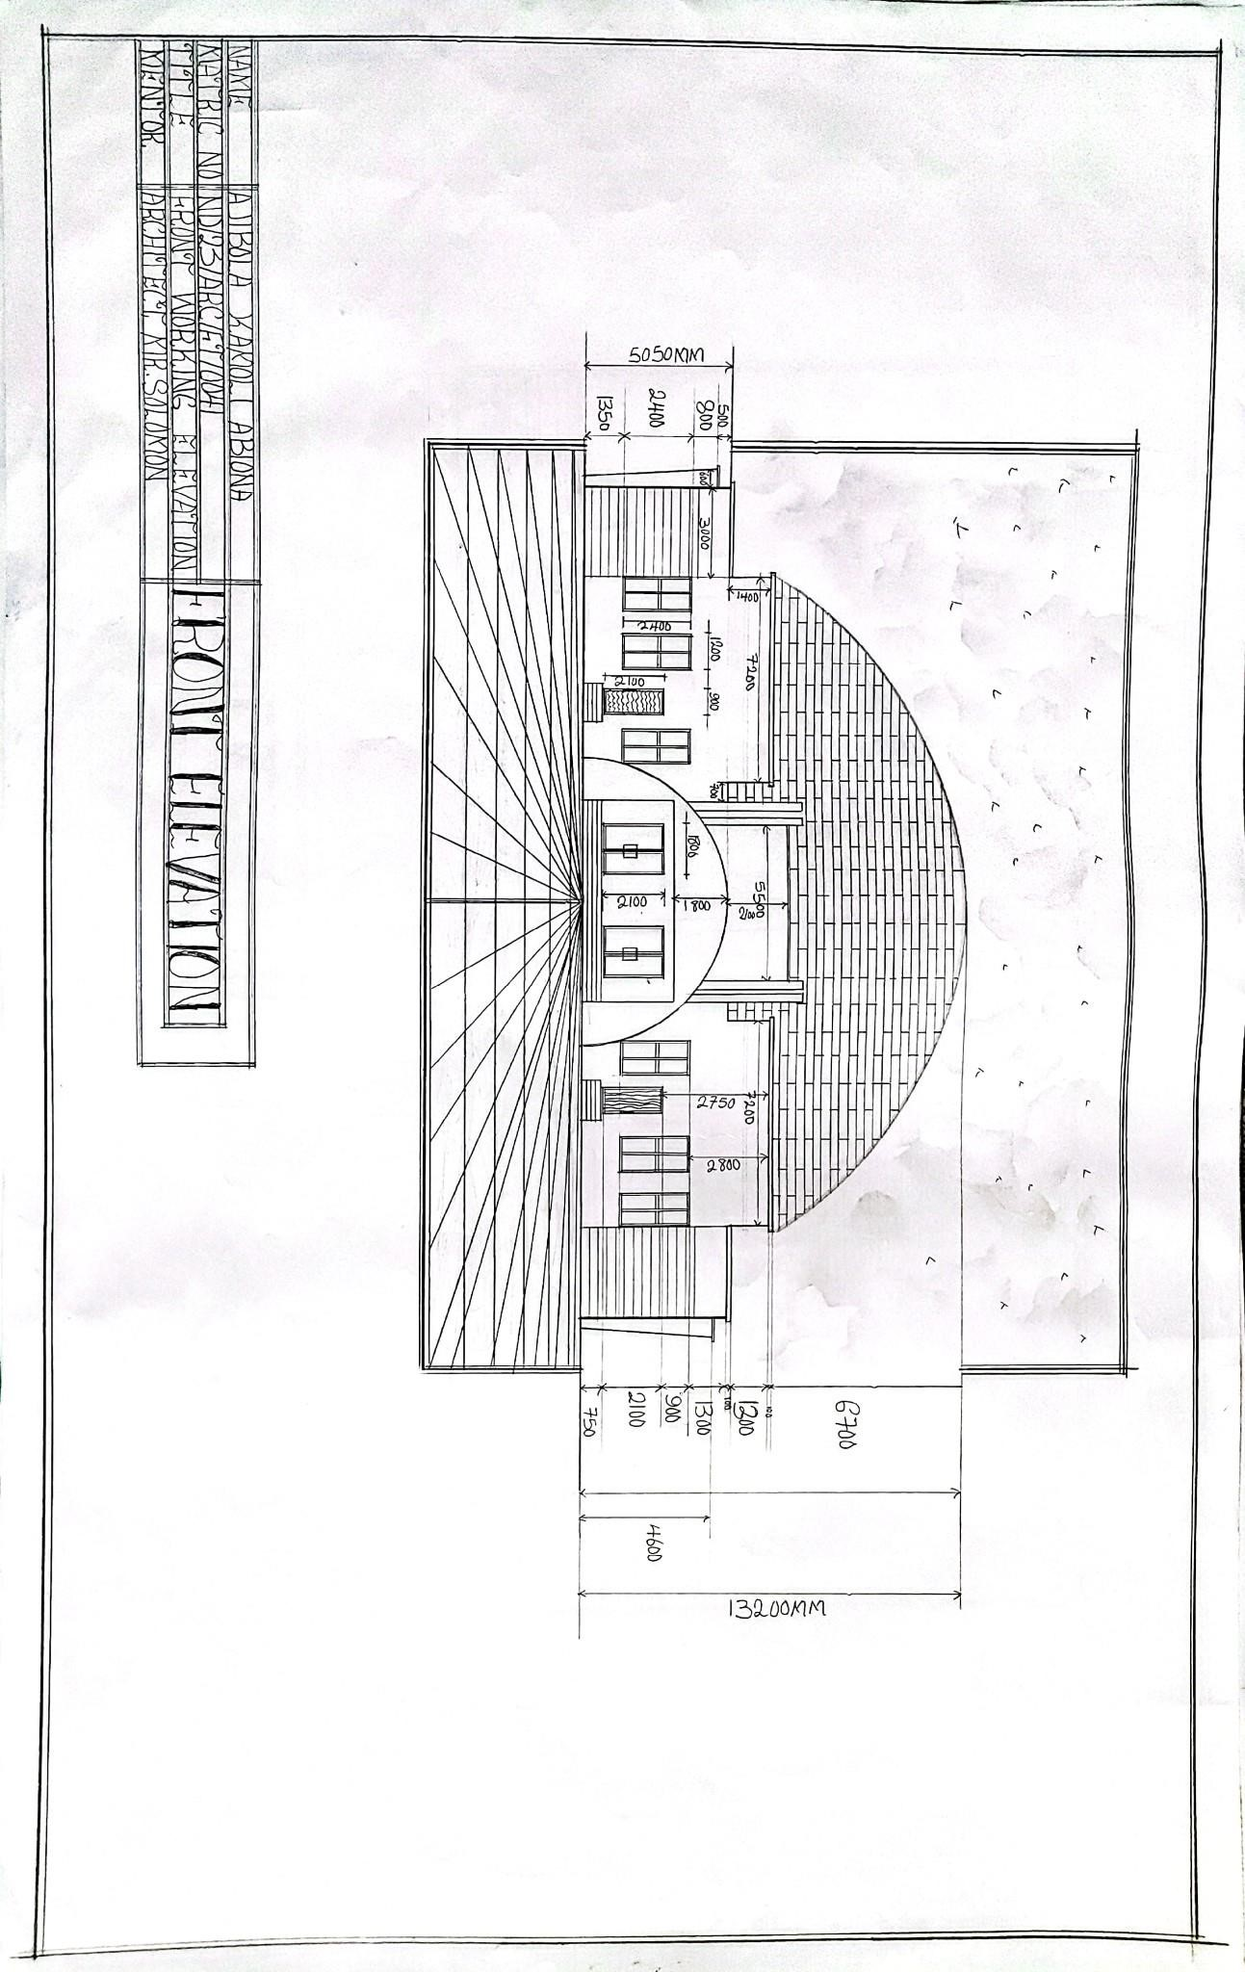
APPENDIX 6: FRONT ELEVATION
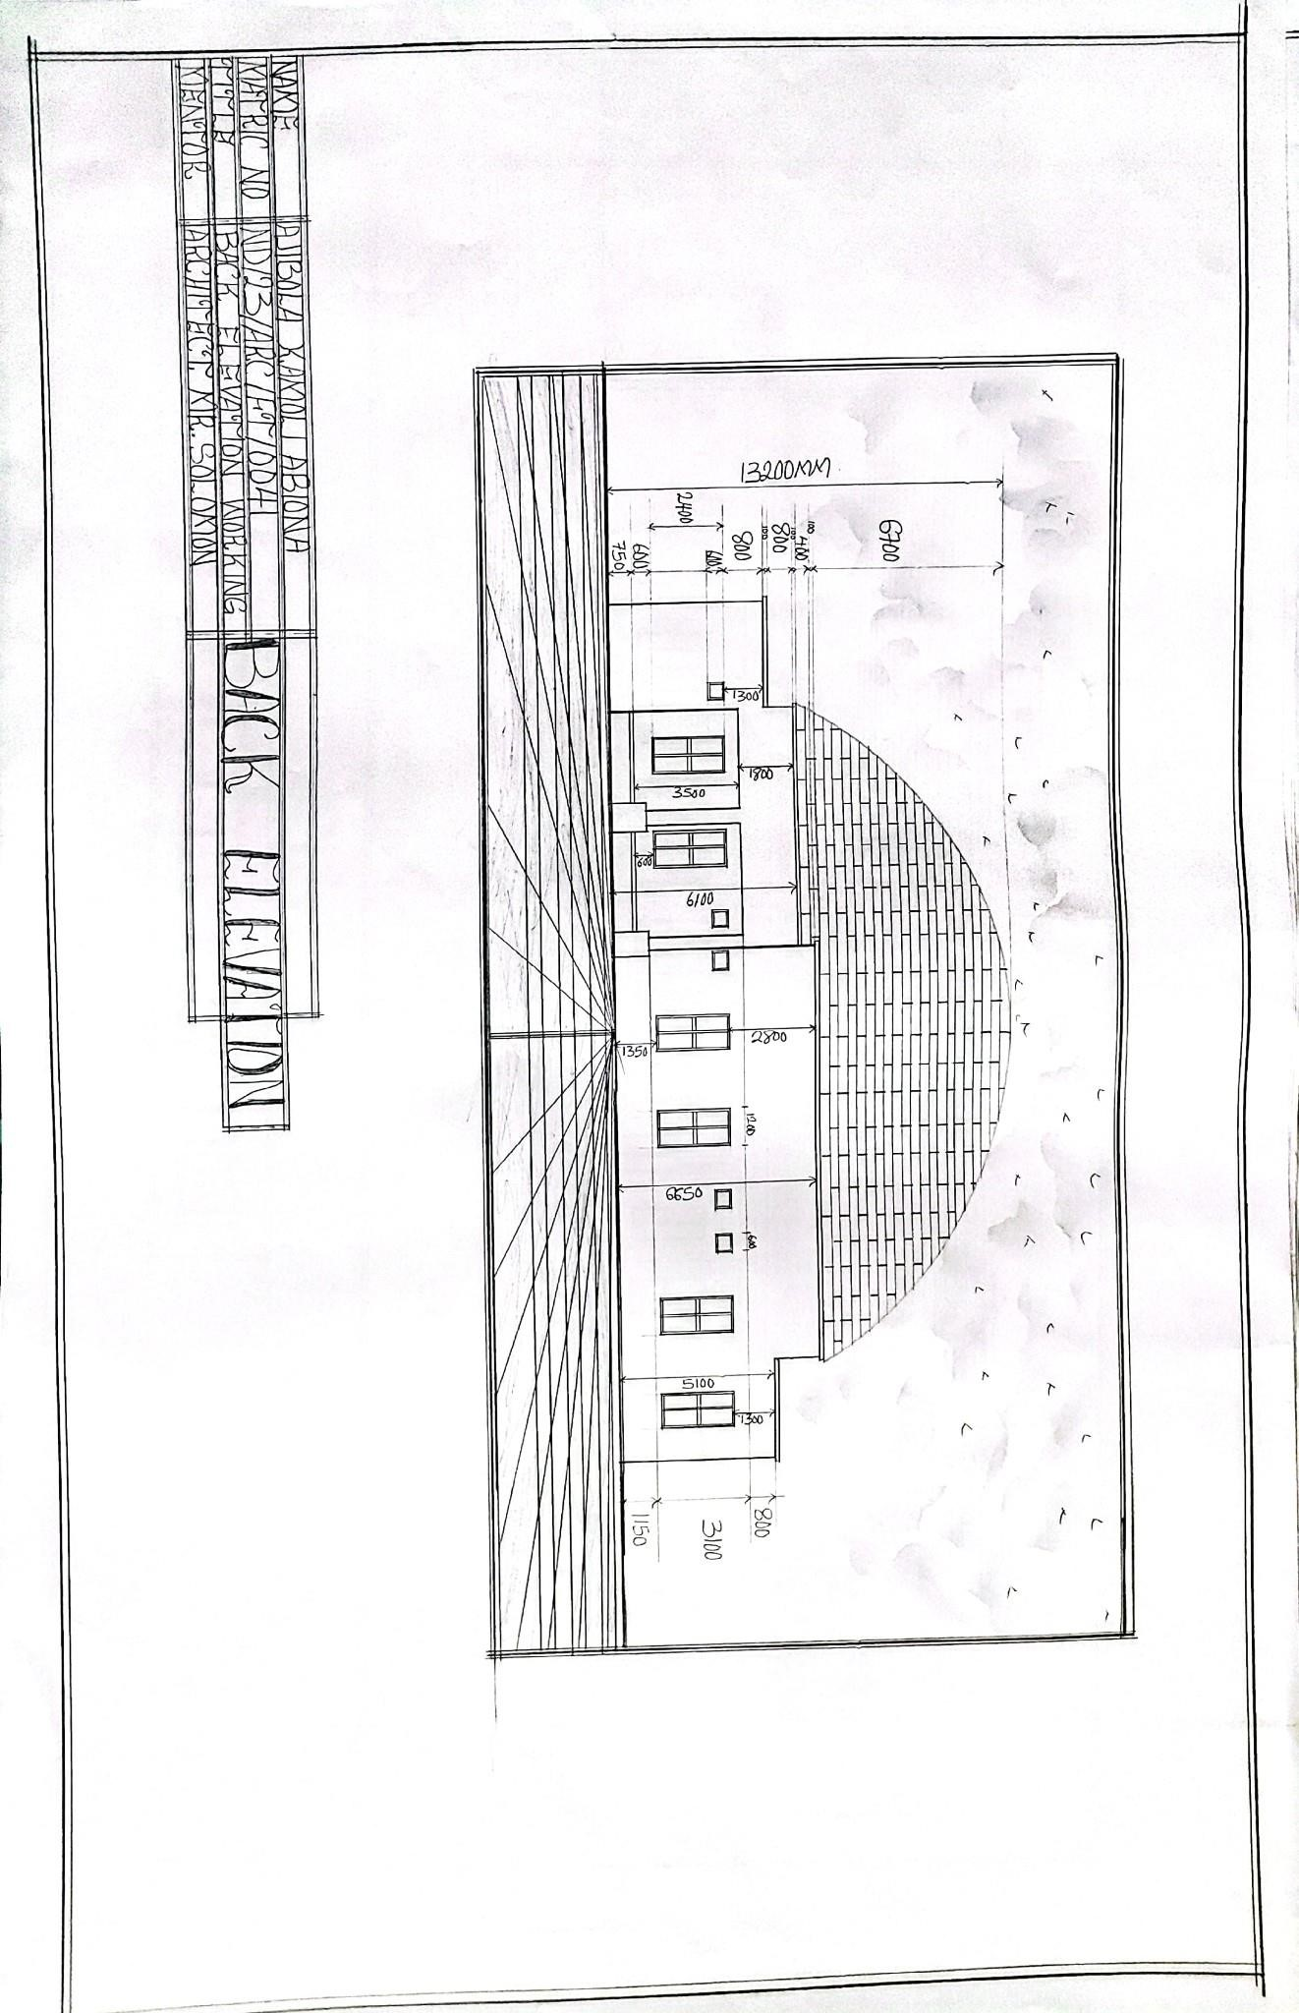
APPENDIX 7: BACK ELEVATION
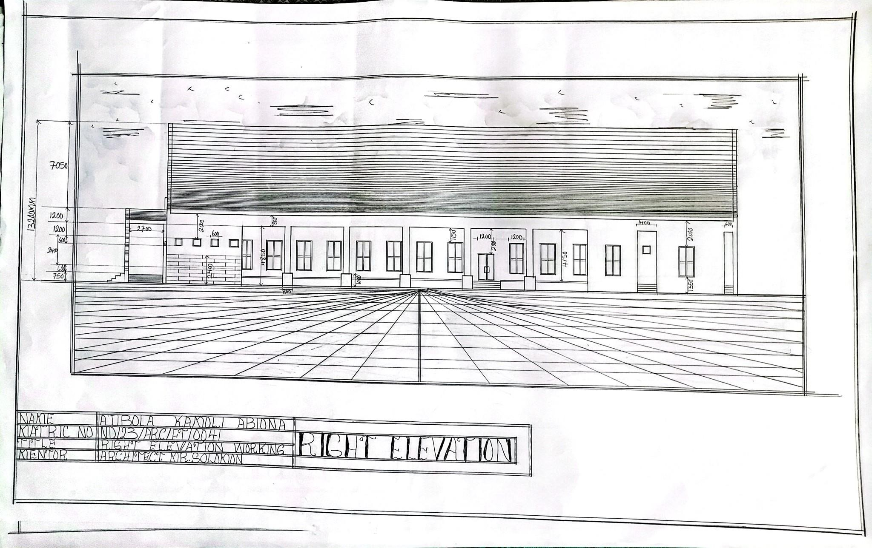
APPENDIX 8: RIGHT ELEVATION
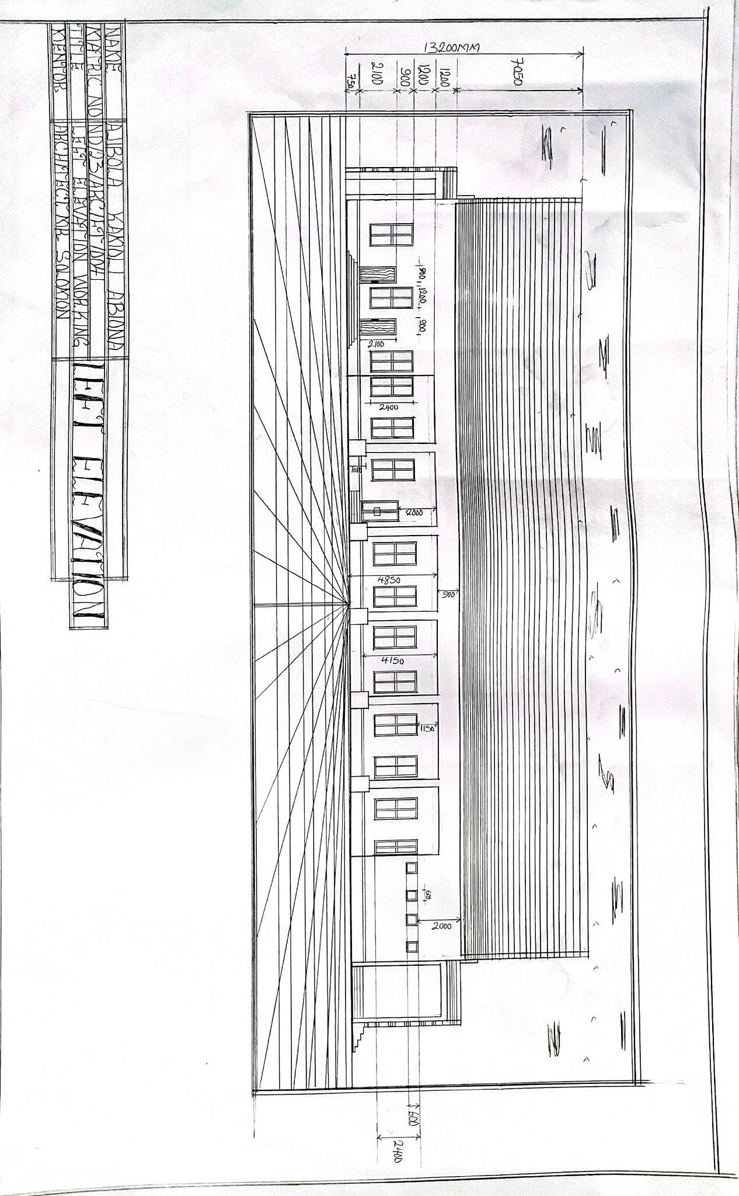
APPENDIX 9: LEFT ELEVATION
DETAILING
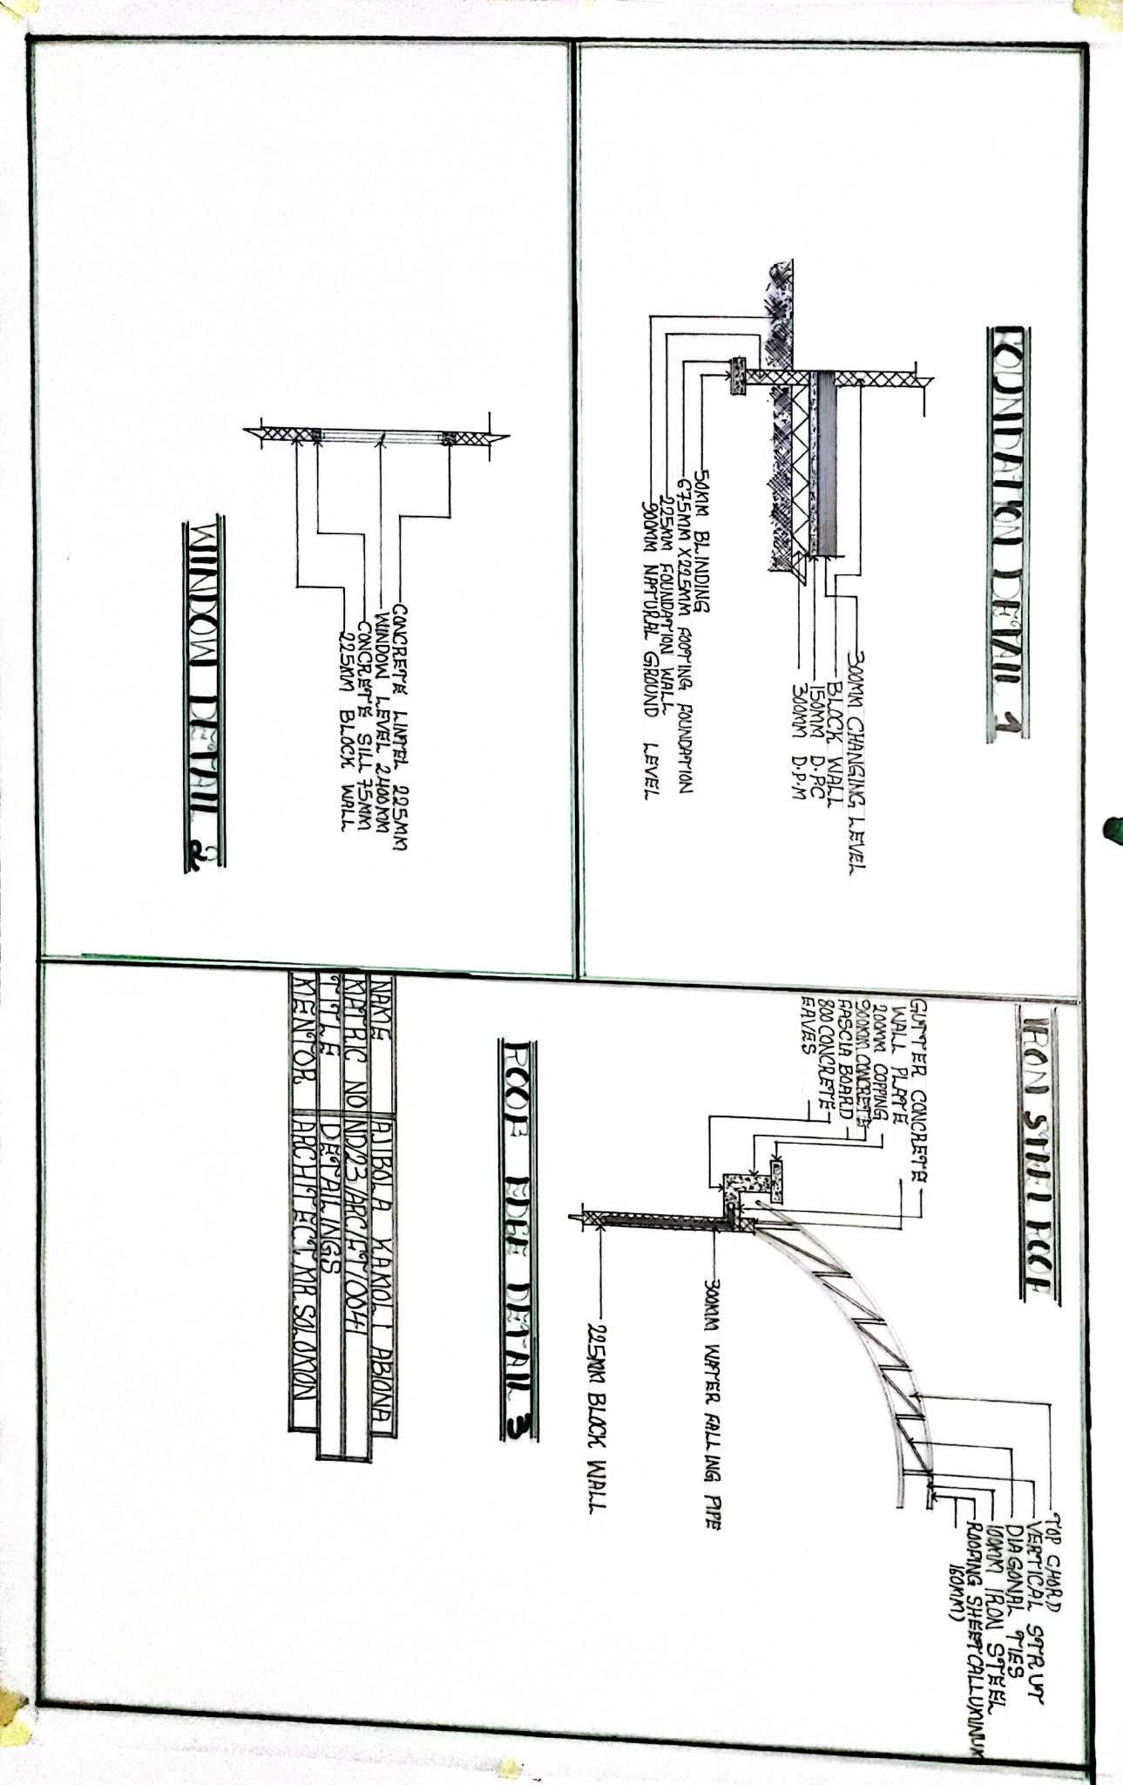
APPENDIX 10: DETAILING

INTERNAL PERSPECTIVE VIEE
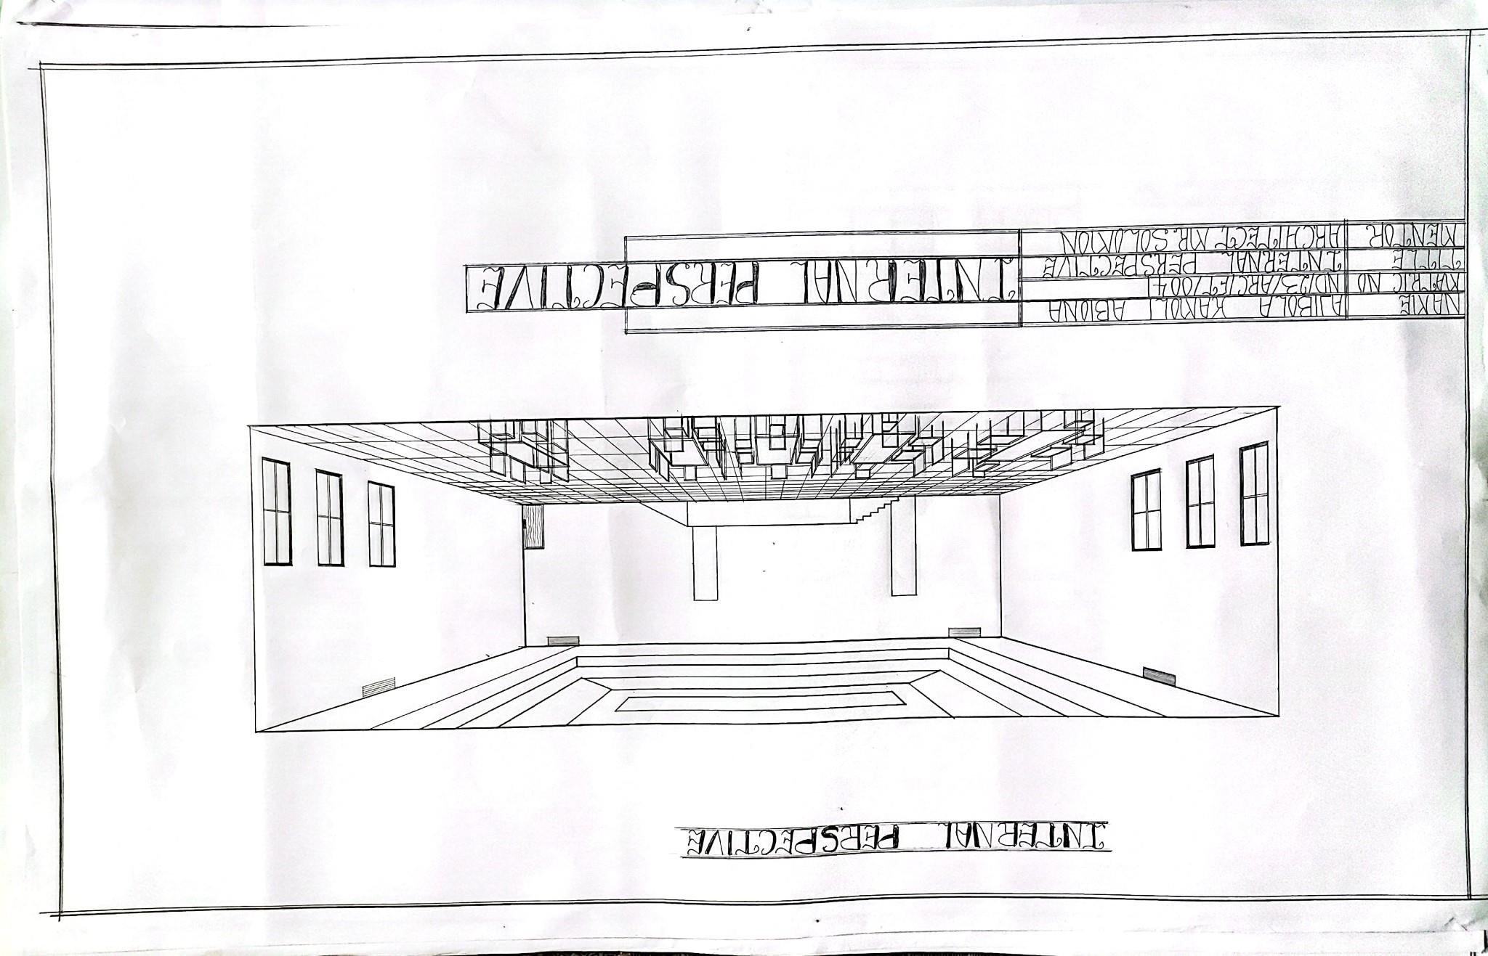
APPENDIX 11: INTERNAL PERSPECTIVE VIEW

EXTERNAL PERSPECTIVE VIEW

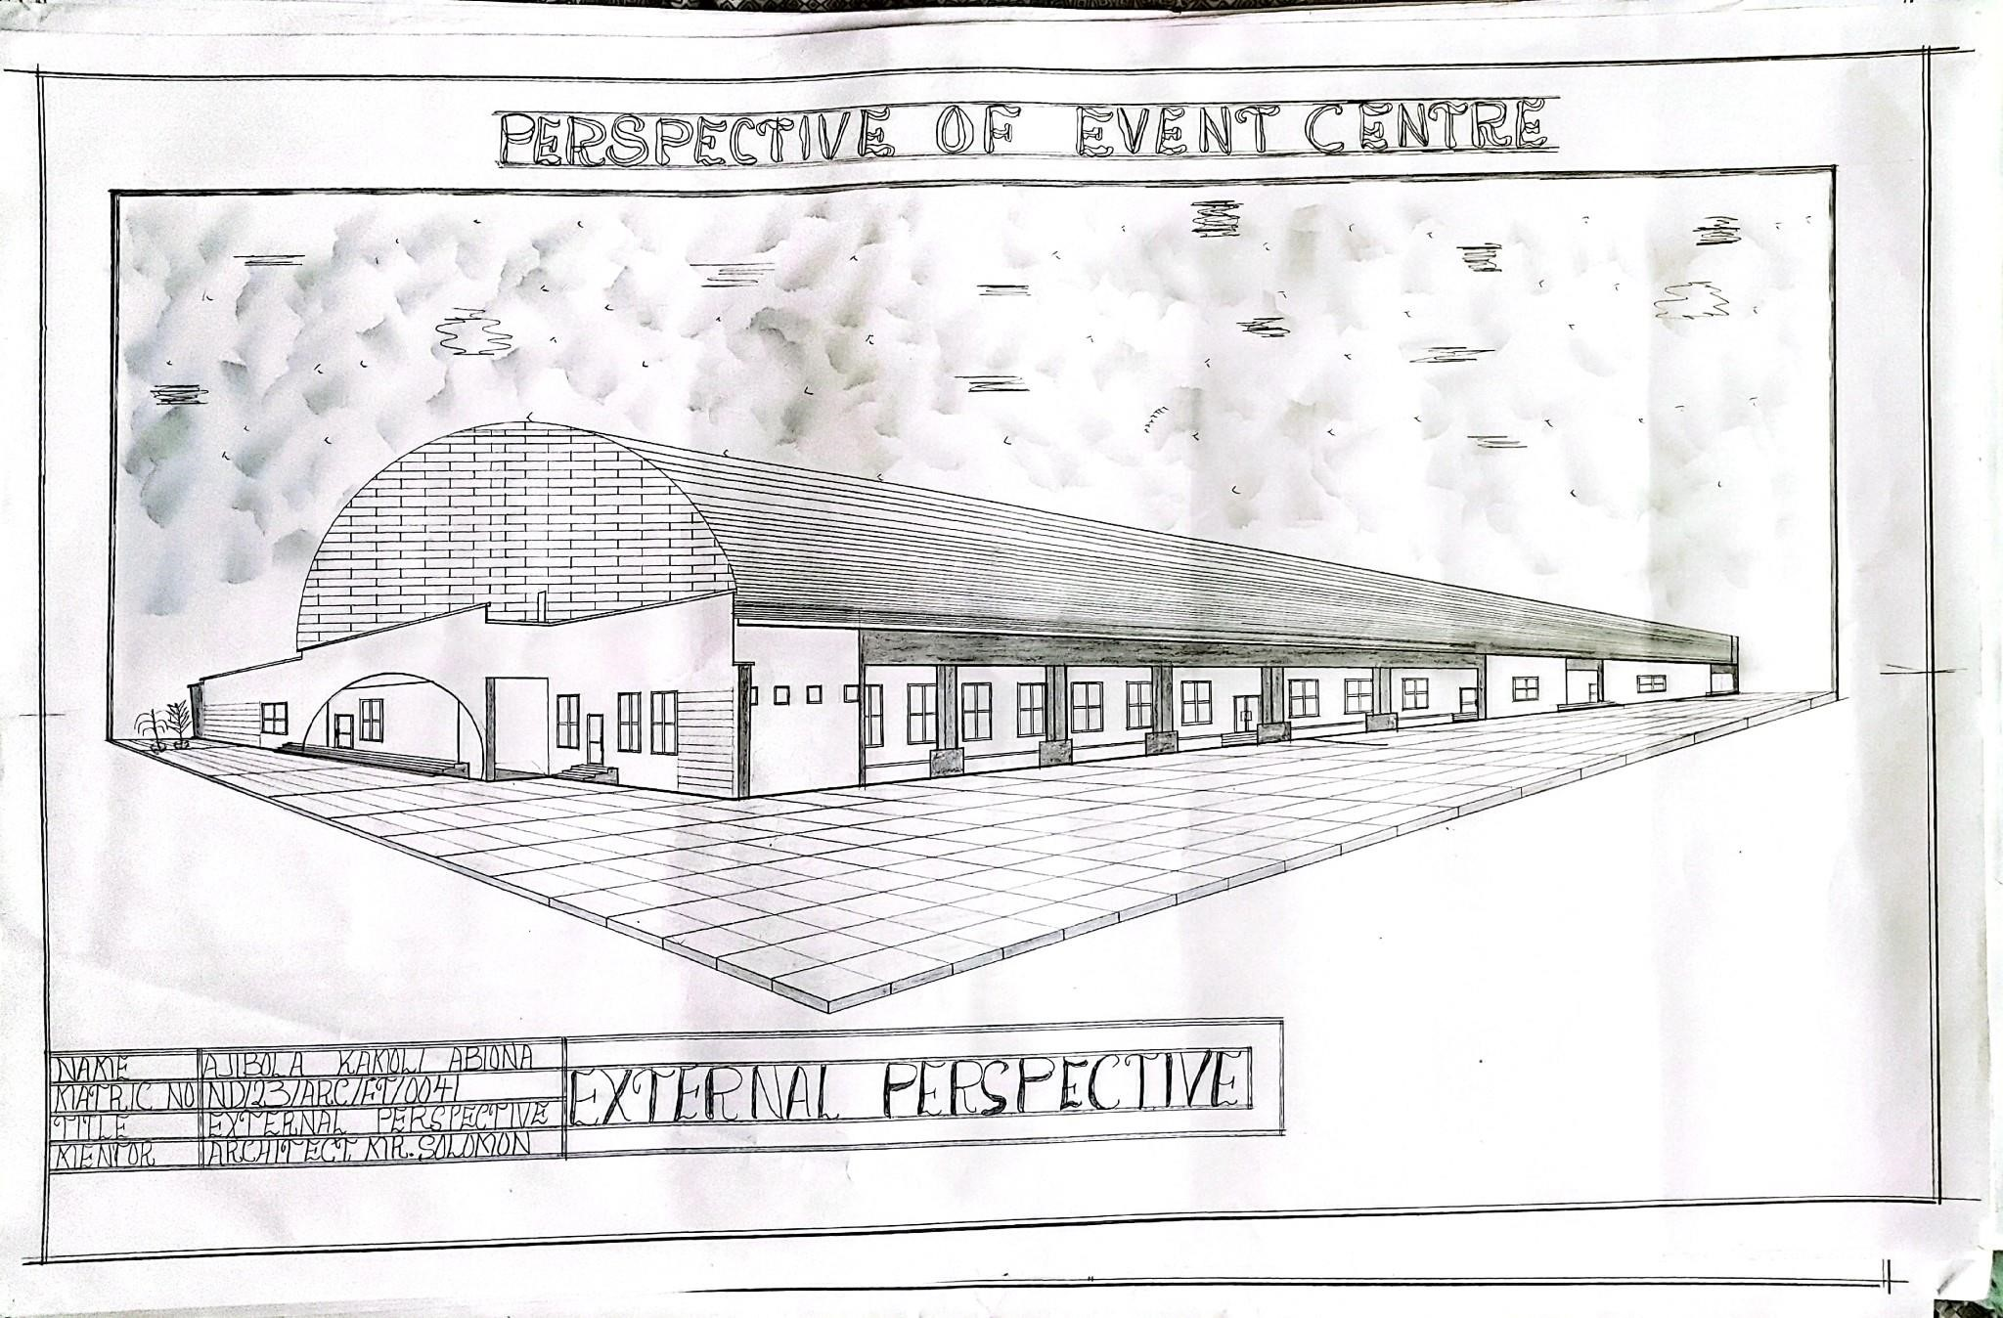
APPENDIX 12: EXTERNAL PERSPECTIVE VIEW

