BENEFICIATION OF SPODUMENIC ROCK FROM LADE , KWARA STATE , FOR RECOVERY OF LITHIUM AND SOME OTHER CRITICAL MINERALS

BY

Praise Oluwatoyin OLANIYI
HND/23/MNE/FT/0008

SUBMITTED TO
THE DEPARTMENT OF MINERAL AND PETROLEUM RESOURCES ENGINEERING TECHNOLOGY,
INSTITUTE OF TECHNOLOGY,
KWARA STATE POLYTECHNIC, ILORIN

IN PARTIAL FULFILLMENT OF THE REQUIREMENT FOR THE AWARD OF HIGHER NATIONAL DIPLOMA (HND) IN MINING ENGINEERING TECHNOLOGY

JULY, 2025
CERTIFICATION
This is to certify that this project was carried out by OLANIYI PRAISE OLUWATOYIN with matriculation number HND/23/MNE/FT/0008 to the Department of Minerals and Petroleum Resources Engineering Technology, Kwara State Polytechnic Ilorin, in Partial fulfillment of the award of Higher National Diploma in Mining Engineering Technology .

_________________________ ________________________
DR. ENGR OLATUNJI KJ DATE
PROJECT SUPERVISOR

__________________________ _______________________
DR J.A OLATUNJI DATE
HEAD OF DEPARTMENT

______________________________ _______________________
ENGR. DR .OLUWASEYI .A.O DATE
(ACADEMIC) EXTERNAL EXAMINER

_________________________ _______________________
ENGR .J.J JIMBA DATE
(INDUSTRIAL) EXTERNAL EXAMINER

DEDICATION
This project is dedicated to God Almighty who granted me strength, wisdom and knowledge to complete my project successfully, also to my parents, Mr. and Mrs. Olaniyi for their support, financially, spiritually and morally also for their parental advice

ACKNOWLEDGEMENT
All praise belong to Almighty God for all his wondrous work in my life and for given me wisdom, knowledge and strength to complete this project work successfully
I sincerely express my profound gratitude to my able supervisor Engr. Dr. Olatunji K.J for his fatherly support, advice, time and corrections towards the completion of this project, indeed I and my project partners can testify that you are a true father to us, May God Bless you sir!
I am extremely grateful to my beloved parents for their support throughout my academic pursuit, May Almighty God bestow on you long life and good health to eat the fruit of your labor (Amen)

ABSTRACT
This study focuses on the beneficiation of spodumenic rock sourced from the Lade area in Kwara State, Nigeria, with the primary aim of evaluating the potential for lithium recovery, as well as identifying other valuable mineral constituents within the ore. Spodumene, a lithium-bearing mineral, is typically associated with pegmatitic formations and has attracted increasing interest due to the global demand for lithium in battery technology and other high-tech applications. To assess the economic viability of the Lade deposit, a froth flotation test was conducted. The flotation process utilized sodium oleate-based collectors, which are commonly used for the selective recovery of silicate minerals. Calcium chloride was employed as an activator to enhance the surface reactivity of target minerals, while sodium silicate served as a depressant to inhibit the flotation of unwanted gangue materials. Despite the spodumenic nature of the sampled rock, analytical results revealed that lithium was not detected inthe ore. However, post-flotation chemical analyses of both concentrate and tailing fractions indicated a substantial enrichment of silicate minerals. The concentrates were found to contain elevated levels of silicon dioxide (SiO₂), along with appreciable amounts of aluminum oxide (Al₂O₃) and iron oxide (Fe₂O₃).

TABLE OF CONTENTS
Title Page i
Certification ii
Dedication iii
Acknowledgements iv
Abstract v
Table of Contents
List of Tables
List of Figures
CHAPTER ONE
1.0 Introduction 1
1.1 Aims of the Project 1
1.2 Objectives of the Project 1
1.3 Statement of the Problem 1
1.4 Justification 2
1.5 Scope of the Study 2
Chapter Two – Literature Review
2.1 Physical and Chemical Properties of Lithium and Other Critical Minerals 3
2.2 Formation and Occurrence of Lithium and Other Critical Minerals 7
2.3 Industrial Applications of Lithium and Other Critical Minerals 15
2.4 Froth Flotation of the Spodumenic Ore 23
Chapter Three – Materials and Methods
3.1 Description of the Study Area 25
3.2 Sample Collection 26
3.3 Sample Preparation 29
3.4 Laboratory Procedures of Froth Flotation of the Ores 29
Chapter Four – Results and Discussion
4.1 Grades of the Ore 31
4.2 Result of the Froth Flotation Procedures 32
4.3 Change in The Concentration After Beneficiation 35
Chapter Five – Conclusion and Recommendations
5.1 Conclusion 37
5.2 Recommendations 37
References 38

LIST OF TABLES
TABLE TITLE PAGE
4.1 Elemental and Oxides of Critical minerals in the crude sample 31
4.2 Result of Froth Flotation Procedure 33
4.3 Change in the Concentration After Beneficiation 35

LIST OF FIGURES
FIGURE TITLE PAGE
3.1 Map of Kwara State showing the location of Pategi Local Government 26
3.2 Spodumenic Rock 27
3.3 Geologic Hammer 27
3.4 Jaw Crusher 28
3.5 Ball Mill 28
3.6 Sieved Mineral 29
3.7 Flotation Cell 30

CHAPTER ONE
1.0 Introduction
Lithium is one of the energy critical elements used in many industries due to it’s unique high electrochemical and catalytic properties, it’s widespread application in the clean technologies of the future includes good storages electric vehicles (EV) and cordless devices it significant impact on the sustainable development of the world economy and the strict CO₂ emmision limits, therefore of lithium resources is of great significant (Tadesse, 2019).
The beneficiation of spodumence rock is essential to enhance lithium recovery and improve the economic feasibility of extraction. Benefication involves a series of physical and chemical processes designed to concentrate spodumene and separate it from associated gauge mineral such as quartz, feldspar and mica in addition these pegamite-hosted ores often concluding tantalum (ra), Niobium (nb), cesium (cs) beryllium (Be) and rare earth elements (REES) which can also be recovered through tailored beneficiation strategies (Evans, 2014).
1.1 Aim of the Project
The aim of these project is to increase the grade and the purity of the ore making it suitable for downstream processing and extraction of lithium compound
1.2 Objective of the Project
i. To characterize the mineralogical composition of spodumene ores and critical minerals.
ii. To optimize froth flotation method technique
1.3 Statement of the Problem
Currently there is need for effective separation of concentrate lithium-bearing mineral from associated gauge minerals, which share similar physical and chemical properties, also increasing the gauge of lithium ore and reducing processing cost, this will ultimately improve the sustainability of lithium extraction
1.4 Justification of the Study
The study will help in increasing of the grade and purity of the spodumene concentrate making it more valuable for downstream and battery production.
1.5 Scope of the Project
The study will be implementing beneficiation of spodumenic rock from Lade using Froth flotation method.

CHAPTER TWO
LITERATURE REVIEW
2.1 Physical and Chemical Properties of Literature and Other Critical Mineral
2.1.1 Physical Properties of Lithium
Lithium is the highest of all metals and posses several unique physical characteristics that distinguish it from other element it is a slivery-white alkali metal, enough to be cut with a knife under ambient condition (Xu et al., 2021).
It’s atomic number is 3 and it’s atomic weight is approximately 6.94g/mol lithium it has low density of about 0.5-34g/cm³ making it the least dense and solid element. It has a relatively high specific heat capacity and the thermal conductivity, which contributes to it’s usefulness in heat transfer application (Xu et al., 2021).
Lithium also exhibit high electrochemical potential, which is a crucial property leveraged in lithium-ion battery technologies, it has a melting point of 18⁰-50ºC and a boiling point of 1342ºC both relatively, in air Lithium tarnishes quickly due to oxidation and reacts readily with water, producing term of appearance although freshly cut lithium is bright and metallic. it dulls quickly when exposed to air (Zhang et al., 2023).
2.1.2 Chemical Properties Lithium
Chemically lithium is extremely reactive and behaves similarly to other alkali metals such as sodium and potassium. It readily losses in electron to form electropositive, lithium react with water though less vigorously than sodium to form lithium hydroxide (LiOH) and hydrogen gas, a reaction that is highly exothermal, lithium also reacts with oxygen to form lithium oxide (Li₂O) or lithium preoxide (Li₂O₂) depending on the amount of oxygen present it forms salts with halogen such as lithium chloride (LiCL), lithium bromide (LiBr)and lithium iodide (LiI) all which are soluble in water. (Kebede et al., 2022).
In organic synthesis, lithium compound like organolithium (e.g., n-butylithium are widely used as strong based and nucleophites, lithium’s chemical behaviours is district from other alkali metal due to it’s small radius and high density. It shows diagonal relationship with magnesium in the periodic table and share some of its properties such as the ability to form covalent organometallic compounds and certain insoluble salts like Li₂CO₃ (lithium carbonate) (Kebede et al., 2022).
2.1.3 Physical and Chemical Properties of Silicon
i. Physical Properties
Silicon (Sio2) is a metalloid with atomic number 14 and atomic mass 28.085 amu. It is dark gray, solid, with a shiny metallic luster appearance crystalline Silicon has approximately 2.33g/cm³ at room temperature with a high melting point of 1414ºC and boiling point of 3265ºC, also it acts as a semi conductor, its conductivity increases with temperature, the thermal conductivity moderate about 149w/m.K Silicon crystallizes in a diamond cubic structure (Greenwood and Earnshaw, 1997).
ii. Chemical Properties
Chemically, silicon is unreactive at room temperature, it reacts with oxygen at high temperature to form silicon dioxide (SiO₂), forms tetrahalides such as SiCL₄ when heated with halogens. Silicon resist most acids except hydrofluoric acid (Hf), which dissolves in acid by forming hexafluorosilicic acid (H₂SiF₆), also it reacts with hot concentrated alkali like NaOH to form silicates and hydrogen gas, primarily exhibits a +4 oxidation state in most compounds including silanes (SiH₄), silicones (polysiloxanes) and silicates (Greeen wood and Earnshaw 1997).
2.1.4 Physical and Chemical Properties of Aluminum
i. Physical Properties
Aluminum’s atomic number is 13 and its atomic mass is 26.98amu. It has a soft, very white appearance, is a light weight metal and has a high density of about 2.70g/cm³ at 25⁰C, its melting point is 660.3ºC creatively low for a metal and a boiling point of 2470ºC. It is a good conductor of electricity, approximately $\sim$ 60% that of copper and its thermal conductivity high ($\sim 235 w/mk). make it useful in heat sinks and cookware. Highly malaeable$ and ductile (Greenwood and Earnshaw 1997).
ii. Chemical Properties
It commonly show +3 oxidation state, reacts with oxygen in air but form a protective Al₂0₃ oxide layer it react with both acids and bases react with and dilute HCL: 2Al +6Hcl →2AlCl₃ + 3H₂ ↑ with NaOH forms sodium aluminate and hydrogen 2Al+2NaOH +6H₂O →2Na[Al(OH)₄] +3H₂↑ non-toxic and non-magnetic, safe for use in packing, food and medical tools (Greenwood and Earnshaw,1997).
2.1.5 Physical and Chemical Properties of Potassium
i. Physical Properties
Potassium (K), its atomic number is 19, atomic mass 39.10amu. Its appearance distinguished it as a slivery-white metal with a slight bluish tint soft enough, to be easily cut with a knife. It has a low density of 0.86g/cm³ (lighter than water with a melting point of 63.5ºC melts easily in warm conditions and a boiling point of 759ºC also a good conductivity of electricity due to free-moving electrons, and its very soft and malleable, can be flattened or draw in thin wire with little effort (Greenwood and Earnshaw, 1997).
ii. Chemical Properties
Chemically, potassium, extremely reactive, especially with water and air and it must stored under oil to prevent oxidation or reaction with moisture, reaction with water produces potassium hydroxide (KOH) and hydrogen gas with enough heat to ignite the hydrogen 2k+2H₂O → 2KOH + H₂ ↑ reaction with oxygen rapidly oxides in air to form potassium oxide (K₂O) and potassium superoxide (KO₂), also form ionic halides like Kcl, KBr and KI by direct combination with halogens. Potassium imparts a lilac or light purple color to a flame, always forms + 1 oxidation state in its compounds. Most potassium salt (e.g, KCL KNO₃) are highly soluble in water (Greenwood, and Earnshaw, 1997).
2.1.5 Physical and Chemical Properties of Calcium
i. Physical Properties
Calcium (Ca) atomic number 20, atomic mass 40.08amu, has a silvery-white appearance, it’s a soft metal and becomes dull due to surface oxidation when exposed to air. It is less dense than most transition metals with a density of 1.55gkm³ a melting point of 842ºC and boiling point of 1484ºC has good conductivity of electricity like most metals and moderate thermal conductor (Greenwood and Earnshaw, 1991).
ii. Chemical Properties
Moderately reacts more slowly than alkali metals but still vigorous with water and acids, reacts with cold water to form calcium and hydrogen gas when it reacts with oxygen it burns in air to form calcium oxide (CaO) with a bright yellow-red flame, also it reacts with dilute acids (e.g, HCl) to produce calcium salt and hydrogen gas. Commonly exhibits a +2 oxidation state in all of its compounds its flame test produce a brick red flame colour and many calcium salts (e.g CaCl₂) are water-soluble CaCO₃ is sparingly soluble (Greenwood and Earnshaw, 1997).

2.2 Formation and Occurrence of Lithium and other critical minerals
2.2.1 Formation and Occurrence of Lithium
The formation and occurrence of lithium are pivotal to understanding its availability, accessibility, and strategic importance in industrial and energy applications. As a relatively rare element in the Earth's crust, lithium's formation is primarily geological and spans vast geological timescales, originating from both igneous and sedimentary processes. It does not occur in a free elemental state due to its high reactivity but is instead found in stable compound forms within specific mineral matrices or in aqueous deposits such as brines, (Greenwood and Earnshaw, 1997)

Geological Formation of Lithium
Lithium is formed during magmatic and hydrothermal processes. In magmatic systems, lithium is often concentrated in the residual melt during the late stages of magma crystallization because of its incompatible behavior—it does not easily fit into the crystal structures of common rock-forming minerals. This residual enrichment leads to the formation of pegmatites, which are igneous rocks with exceptionally large crystals and enriched in rare elements, including lithium (Bradley et al., 2017). Lithium-bearing minerals such as spodumene, lepidolite, and petalite crystallize in these pegmatitic environments under high-pressure and low-temperature conditions.
In contrast, sedimentary lithium deposits form through surface weathering, leaching, and evaporation processes. Over time, lithium is leached from rocks and accumulates in closed-basin environments, where evaporation concentrates the lithium into brines. These lithium-rich brines are commonly found in arid regions, notably the Lithium Triangle of South America (Chile, Bolivia, and Argentina), where salar (salt flat) systems host extensive lithium reserves (Flexer et al., 2018). Here, lithium is found as lithium chloride and lithium carbonate, dissolved in brines along with other salts like sodium, potassium, and magnesium.

Mineralogical Occurrence of Lithium
Lithium primarily occurs in hard rock deposits and evaporite (brine) deposits. Hard rock deposits consist of lithium-bearing minerals typically hosted in granitic pegmatites. The most important lithium minerals in this category include:
- Spodumene (LiAlSi₂O₆): This pyroxene mineral is the most commercially significant lithium source. It contains up to 8% lithium oxide (Li₂O) and is predominantly found in Australia, Canada, and China.
- Lepidolite (K(Li,Al)₃(Si,Al)₄O₁₀(F,OH)₂): A lithium-bearing mica, lepidolite contains lower lithium content than spodumene but is a valuable byproduct in the extraction of rare elements.
- Petalite (LiAlSi₄O₁₀): With lower lithium content, petalite is used in ceramics and glassmaking industries.
In brine deposits, lithium is found dissolved in saline groundwater. These occur in endorheic basins with no outflow in regions of high evaporation and low precipitation. Lithium concentrations vary but are economically recoverable in several South American salars, (Clayton, 1983).

Global Distribution of Lithium Resources
Globally, lithium deposits are unevenly distributed, with a few countries dominating production and reserves. According to the United States Geological Survey (USGS, 2024), the largest lithium reserves are located in:
- Bolivia: Home to the world’s largest lithium deposit in Salar de Uyuni, though production remains minimal due to infrastructural and political challenges.
- Chile: One of the top producers, with highly developed brine extraction operations in the Atacama Desert.
- Argentina: Hosts multiple salar deposits and is rapidly expanding its production capacity.
- Australia: Dominates hard rock mining, particularly spodumene extraction from the Greenbushes mine in Western Australia.
- China: A major producer from both brine and hard rock sources; also leads in refining and battery production.
- Economic and Industrial Implications of Occurrence
The geological setting of lithium impacts not only the extraction method but also the economic feasibility of mining operations. Hard rock lithium requires intensive crushing, roasting, and chemical treatment to extract lithium compounds. Conversely, brine extraction, while less energy-intensive, involves long evaporation times and is sensitive to climatic and environmental conditions (Lide, 2004).
The high demand for lithium in lithium-ion batteries used in electric vehicles, consumer electronics, and grid storage has made access to lithium deposits a matter of strategic importance (Yaksic & Tilton, 2020). Consequently, countries with significant lithium resources have become focal points in the global transition to renewable energy and green technologies.
2.2.2 Formation and occurrence of silicon formation
Silicon is formed through a process called stellar nucleosynthesis in massive star, during the late stage of stellar evolution lighter elements such as carbon and oxygen under elements such as` carbon and oxygen undergo fusion reactions under extreme temperature and pressure, producing silicon in the star’s core. Eventually these massive star explode as supernovae dispersing silicon later becomes incorporated into plants like earths during planetating system formation (Carrol and Ostile, 2007; Clayton, 1983).
Occurrence of Silicon
Silicon is the second abundant element in the earth’s crust (about 27.7% by weight) following oxygen. However it does not occur in its element form due to its strong affinity for oxygen, instead, silicon naturally occurs in combined forms, it is found in quartz. sand and many types of rock and minerals including yield spars, micas, amphiboles, pyroxenes and clays`, which together make up over 90% of the earth’s crust (Green wood and Earnshaw, 1997, Lide, 2004 and Deer et al., 1992).

Geological formation
Silicon enters the earth’s crust via magma crystallization, as magma cools, silicon combines with oxygen and other elements to form silicate minerals which becomes part of igneous rock like granite and salt (Best, 2002). Silicon is released during the weathering of rocks and can be transported in solution as silicic acid, it later precipitates as amorphous silica or forms secondary silicate minerals in sedimentary rocks (Boggs, 2009).
Silicon is also involved in metamorphism where existing silicate minerals recrystalize under heat and pressure to form new mineral like garnet and kyanite (Yardeley,1989).
Silica rich hydrothermal fluids can deposit quartz veins in rock fracture` as they cool, these are often found in geologically active areas (Best, 2002).
Industrial Occurrence
Silicon is industrially obtained from quartz (S1O₂) or sand by heating it with carbon (often coke) in an electric arc furnace SiO₂+2C $→$ Si+2CO$↑$ this yields metallurgical grade silicon, which is then purified for use in electronics, solar panels and alloys (Cotton et al., 1999).
2.2.3 Formation and occurrence of Aluminum
Aluminum is the most abundant metal in the earth’s crust than in the universe as a whole the formation of aluminum can be explained by the nuclear processes occur in stars with sufficient mass reach the later stages of their life cycle, helium fusion (involving element like carbon and oxygen) forms heavier elements. On earth aluminum is a product of the geochemical processes within the earth’s crust, where it is mainly found `in aluminum –bearing minerals such as bauxite which is the principle ore of aluminum. Bauxite is rich in aluminum oxide (Al₂O₃) and form through weathering of silicate rocks in tropical and subtropical regions (Clayton 1983 and Taylor and Mclenna, 2009).
Occurrence of Aluminum
Aluminum is the most abundant metal in the earth’s crust making up about 8.23% by weight, it is rarely found in its pure metallic form in nature because aluminum is high reactive and readily forms compounds with other elements particularly oxygen the main ores.
- Bauxite (A1₂O₃nH₂O) the primary ore from which aluminum is extracted, found predominantly in tropical and subtropical regions (Cotton et al., 1999)
- Feldspar a common silicate mineral that is contains aluminum (Green wood and Earthshaw, 1997).
- Kaolnite (Al₂ Si₂ O₅ (OH)₄), a clay that is also an important sources of aluminum (Lide, 2004).
- Other silicate minerals these include minerals like muscovite and mica which contain aluminum as part of their crystal structure (Deer et al., 1992).
Geological formation
Aluminum is primarily obtained from bauxite, which forms through the weathering of silicate rocks, particularly in tropical climates, this process involves the leaching of other element such as iron and silica, leaving behind aluminum rich minerals like gibbsite, boehmite and diaspora (Best, 2002, Winter 2010).
Bauxite deposits often occur in sedimentary layers formed by the deposition of weathered material, in addition hydrothermal process play a role in the formation of aluminum bearing minerals such as in the case of muscovite and kaolinite (Bogg, 2009).
During metamorphism, aluminum is redistributed in the form of various aluminum silicates and oxides, contributing to the formation of new mineral under high pressure and temperature (Yardley, 1989).
Industrial Extraction of Aluminum
First, bauxite is treated with sodium hydroxide (NaoH) under high pressure, which dissolves the aluminum oxide and separates it from impurities, the result is a refined aluminum oxide (A1₂O₃) also known as alumina (Lide, 2004).
The aluminum is then reduced to aluminum metal through electrolysis where an electric current is passed through molten alumina to produce aluminum metal and oxygen gas 2A1₂O₃→ 4Al + 3O₂.
2.2.4 Formation and occurrence of Potassium
Formation
Potassium (atomic number 19) is formed through stellar nucleossynthesis in supernovae. It is primarily created by the fusion of lighter nuclei (such as helium and hydrogen). In massive star, once these stars exhaust their nuclear fuel they explode in supernovae releasing heavier elements like potassium into space. These elements later become incorporated into planets during planetary formation (Clayton 1983; Carroll and Ostile, 2007).
Occurrence
Potassium is the 7th most abundant element in the earth’s crust comprising approximately 7.4% by weight. However due to its high chemical reactivity, potassium does not occur in its metal and in form in nature, instead it is commonly found as silicate minerals, evaporate deposits soils and in ocean water.
Potassium is a major component of feldspar group minerals such as orthoclase (KAlSi₃0₈) and microcline, these mineral are found in igneous and metamorphic rocks (Greenwood and Earnshaw, 1997).
Potassium salts such as sylvite (KCl),carnallite (KMgCl₃ 6H₂O) and langbeinite (K₂Mg₂ (SO₄)₃) occur in evaporate beds, which form through the evaporation of saline water in closed basins (Bates and Jackson, 1989; Boggs 2009).
Weathering of potassium-bearing mineral releases soluble potassium ions (K⁺) into soil and ground water, where it is absorbed by plants and plays a critical biological role (Brady and Weil 2008).
Geological formation
Potassium is present in felsic igneous rock such as granite and syenite formed from silica-rock magma potassium feldspar crystallize early in the cooling process (Best, 2002).
During metamorphism, potassium-rich mineral like mica and feldspar may form or recrystallize, in tropical and humid climates potassium is leaching from rocks but can accumulate in cool profiles or concentrates in clay minerals` like illite. (Yardley, 1989; Boggs, 2009).
Potassium salts crystallize from brine lakes and ancient inland seas as water evaporates overtime. These processes are responsible for major despite like the stassfurt (Germany) and Saskatchewan (Canada) potash beds (Helgeson, 1969:Gamett 1996).
Economic Sources of Potassium
Potassium is primarily extracted from syvite (KCl) most common ore for fertilizer production, carnallite (KM_{g}Cl₃.6H₂O) a significant source in some evaporate basins, langbeinite and polyhalite also mined for fertilizer use (Garrett, 1996; USGS, 2003).
2.2.4 Formation and Occurrence of Calcium
Formation
Calcium (atomic number 20) is formed primarily through stellar nucleosynthesis in massive stars during the later stages of stars life, especially just before it becomes a supernova, calcium is created via Alpha-capture reactions involving lighter elements like carbon oxygen and neon in the explosive nucleosynthesis phase the intense heat and pressure inside the supernova enable the fusion of heavier element, leading to the creation of calcium (Clayton 1983; Arnett: 1996)
Occurrence
Calcium is most commonly found in sedimentary rocks such as limestone (CaCO₃) chalk and dolomite (CaM_{g} (CO₃)₂). These rocks form from the accumulation of marine organism shells and skeletons over millions of years (Boggs, 2009, Blatt, Tracy and Owens, 2006).
Calcium is present in plagioclase feldspar (a component of igneous rocks like basalt and gabbro) and in pyroxenes amphiboles and garnets in metamorphic rock (Winter, 2010; Best 200
Economic
Calcium is extracted or sourced from various natural minerals and rock limestone (CaCO₃) used in cement, agriculture and construction. Gypsum (CaSO₄ 2H₂O) used in plaster and fertilizer. Fluorite (CaF₂) used in metallurgy and chemical industries (Lide, 2004: Klein and Dutrow 2007).
Calcium plays a major biological role as a structural component of bones and shells in animals and humans (in the form of hydroxyapatite, Ca₅ (PO₄)₃OH) and as an essential macronutrient in plants, regulating cell wall structure and signaling (Raven et al., 2005).
2.3 Industrial Application of Lithium and other critical Minerals
2.3.1 Industrial Application of Lithium
Lithium often referred to as “White gold” for the energy transition is one of the most versatile industrial metals in the modern era. It application span a wide spectrum of industries from energy storage and electronics the most dominant and rapid expanding use of lithium is in the manufacturing of lithium batteries, which are the backbone of portable electronics, electric vehicles (EVS) and grid-scale energy storage system (Bloombergnef, 2023).
Lithiums light atomic weight and high dense rechargeable batteries, this is evident in the rise of global demand for electric vehicles (EVS), heavily on lithium battery technologies (International Energy Agency, 2023).
In the ceramic and glass industry, lithium compound such as lithium carbonate and lithium oxide are used to improve melting behaviour enhance strength and reduce thermal expansion.
Lithium fluxing properties allow for lower processing temperature and increased durability in product like cooktops, ovenware and high performance glass (USGS, 2023). The addition of lithium to glaze also improve its viscosity and the distribution of colour, which is especially beneficial in the production tiles and tableware (USGS, 2023).
Another critical industrial application lies in the aerospace and defense sectors, lithium-aluminium alloys are prized for their strength-to-weight ratio and are used in aircraft components, spacecrafts and light weight amor. These alloys provide structural stability white minimizing weight an essential factor in fuel` efficiency and payload optimization (Goodenough and Kim 2019).
Similarly lithium hydrine and lithium deviteride have found specialized applications in nuclear energy due to their roles in neutron generation and shielding (Goodenough and Kim 2019).
Lithium is also widely used in lubricants and greases, lithium stearate is a key component in high –performance greases that withstand extreme temperature and pressure. These lubricant are utilized in the automotive, industrial machinery and aviation sectors. The chemical industry benefit from lithium in catalysis and polymer synthesis, particularly in organolithium compounds used in the manufacture of synthetic rubber and plastic (Somoc and` Jeswiet, 2020).
Pharmaceutical and psychiatric medicine represent another niche yet important application of lithium carbonate and lithium concentrate are prescribed in the treatment of bipolar disorder due to their mood-stabilizing effects. Although the therapeutic dose is narrow and required careful monitoring, lithium remains one of the most effective treatment for marue episode and prevention of relapses in bipolar patient (Aral and Vecchio-Sadus, 2021).
In aluminum production lithium compound are used to improve the conductivity and stability of aluminum electrolytic cells. This result in energy saving during the electrolysis of aluminum and also enhance the physical properties of the final aluminum product. Additionally lithium compounds are employed in the desulphurization of iron and steel, contributing to improved product quality in metallurgy (Kavanagh et al., 2018).
Emerging application include air purification (CO₂ scrubbing in submarines and spacecraft), hydrogen storage and fusion energy research, lithium is sued in fusion reactors to breed tritium, and as a coolant or blanket material due to its neutron absorption capability. Its future role in next generation nuclear reactors and hydrogen fuel cells may significantly expand lithium’s industrial demands (Bruton et al, 2022).
As the world transitions toward a decarbonized energy economy, lithium’s role is anticipated to grow exponentially it unique properties have already transformed several industries and ongoing research continues to unlock now application, reinforcing lithium strategic importance in both economic and technological landscapes (IEA, 2023).

2.3.2 Industrial Application of Silicon
Silicon is a metalloid element widely used in various industrial sectors due to its abundance, chemical stability and semiconductor properties. it plays a pivotal role in modern technology and industrial manufacturing.
Semiconductor industry: silicon is the backbone of the modern electronics industry due to it’s excellent semiconducting properties, it is used in the production of integrated circuits, transistors and microchips found in computer, smartphones and numerous other digital devices, ultra-high-purity silicon (99.9999%) is required for these application to ensure performance and reliability (Callister and Pethwish, 2018).
Solar energy crystalline silicon (both monorcystalline and polycrystalline) is the most commonly used material in photovaltalic (pu) cells which convert sunlight into electricity. It is favoured for it high efficiency and long operational life. More than 90% of solar panel is use today relying on silicon-based technology (Green, 2003).
Alloys and metallurgy silicon is an important component on metallurgy, especially in the production of ferrosilicon, which is used as a deoxidizer and alloying agent in steelmaking. It is also used in aluminum silicon alloys valued for their lightweight and high strength making their ideal for automotive and aerospace components (USGS, 2023).
Construction and Ceramics
Silicon dioxide (S_{i}O₂) or silica is widely used in the construction industry, it is a primary ingredient in glass, cement, bricks and ceramics due to its durability, heat resistance and mechanical strength. Silica base products are crucial for infrastructure development (Knovel, 2002).

Silicones and Chemical Industry
Silicon is used to produce silicones-syntantic polymers with applications in lubricants adhesives, sealants, medical devices, cookware and more. These materials are valued for their flexibility, heat stability and water resistance. The chemical versatility of silicon compounds enable a wide range of formulations for industrial use (Laurencin et al., 2014).
2.3.3 Industrial Application of Calcium
Calcium a soft gray alkaline earth metal, plays a significant role in various industrial processes due to its chemical reactivity, abundance and beneficial physical properties. It is use both in its elemental form and as compounds (like calcium carbonate, calcium oxide and calcium chloride).
Metallurgical Industry
Calcium is widely used as a reducing agent in the extraction of metals such as uranium, thorium and zirconium, it also serve as a deoxidizer and desulfurizer in steelmaking, where it improves the quality and durability of steel by removing impurities such as oxygen and sulfur from molten metal (Callister and Rethiwisch, 2018).
Construction Industry
Calcium carbonate (CaCO₃) and calcium oxide (CaO) used in manufacture of cement, mortar and concrete lime is also used in soil stabilization and water treatment, these material contribute strength, durability and setting properties of construction materials (Taylor, 1997).
Chemical Industry
Calcium, compounds are vital in various chemical processes calcium carbide (CaC₂) is used to produce acetylene gas, which is important for welding and legating, calcium chloride (CaCl₂) is widely used for dust control road de-icing and as a desiccant in drying gases and liquids (UEIC, 2011).
Food and Pharmaceutical Industry
Calcium carbonate and calcium phosphate are used as dietary supplements to prevents and treat calcium deficiency. Calcium compounds are also added to processed foods as firming agents leavening agents or preservatives, in pharmaceutical, calcium compounds play a role in tablet formulation and as autacides (Rowe et al., 2009).
Environmental and Agricultural Application
In agriculture, calcium carbonate (agricultural lime) is used to neutralized acidic sols, enhancing crop yields, calcium compounds are also used in wastewater to reduce acidity and remove impurities by precipitation (Brandy and Weil 2008).
2.3.4 Industrial Application of Aluminum
Aluminum is a light weight corrosion-resistant and highly conductive metal widely used in many industries. Due to its combination of physical and chemical properties such as malleability, strength –to-weight ratio and recyclability it play a crucified role in both manufacturing and modern infrastructure (Taylor and Francis, 1995).
Transportation Industry
Aluminum is extensively used in the automotive, aerospace and marine industries due to its light weight and strength reducing the weight of vehicle, helps improve fuel efficiency and reduces emissions. In aerospace aluminum alloys are used in aircraft frames, wings and fuseloge because of their durability and weight –saving benefits (Polmear, 2006).

Construction and Architecture
Aluminum is used in building facades, window frames, doors, roofing and structural elements. Its corrosion resistance, low maintenance requirements and aesthetic appearance make it ideal for modern architectural design. Anodized and coated aluminum surface are commonly used for decorative and protective purposes (Meikle, 1995).
Electrical Industry
Aluminum is a good electrical conductor and is widely used in power transmission lines, electrical wiring and busbars. It is preferred over copper for long-distance power transmission because it is lighter and less expensive, even though it is less conductive by volume (Gonen, 2014).
Packing Industry
Aluminum is used extensively in beverage cans, food containers, pharmaceutical packaging and foil wraps. It provides an excellent barrier to light, moisture and gases, ensuring product safety and shelf life. Its recyclability and light weight nature also reduce packing and transportation costs (Kirwan, 2012).
Consumer Goods and Appliances
Aluminum is used in the manufacture of home appliances, cookware, smart phones, laptops and sports equipment. Its thermal conductivity, formability and appearance make it a desirable material for both functional and aesthetic purposes in consumer products (Totlen, 2002).

2.3.5 Industrial Application of Potassium
Potassium is a high reactive alkali metal that is not typically used in its elemental form due to its reactivity, especially with water. However, potassium compound are extensively used in various industrial sectors.
Fertilizer Industry
The most significant industrial use of potassium is in the production of fertilizers. Potassium chloride (KCl), potassium sulfate (K₂SO₄) and potassium nitrate (KNO₃) are key components in fertilizers (commonly referred to as “potash”), these compounds enhance plant growth, improve drought resistance and increase crop yields (Brandy and Weil, 2008).
Glass and Ceramics Industry
Potassium compound, especially potassium carbonate (K₂CO₃) and potassium nitrate are used in the production of heat resistant glass and fine ceramics. Potassium based glass has higher resistant to thermal expansion and is used in laboratory glassware, lookware (e.g Pyrex) and optical lense (Scholze, 1991).
Pharmaceutical and Medical Application
Potassium salts such as potassium chloride and potassium citrate are widely used in pharmaceutical formulation to treat potassium deficiency, control blood pressure and support heart function. Potassium is an essential electively in human physiology (Rowe et al., 2009).
Chemical Manufacturing
Potassium hydroxide (KOH) also known as caustic potash is a strong base used in the manufacture of soaps, detergents, biodiesel, dye and alkaline batteries. It also serves as a pH control agent and is involved in many organic synthesis reactions (VEIC, 2011).

Explosive and Pyrotechnics
Potassium nitrate (KNO₃) also known as saltpeter is a key oxidizing agent in gunpowder, fireworks and explosives. Its ability to supply oxygen for combustion makes it essential in pyrotechnic formulation and safety matches (Conkling and Mocella, 2010).
2.4 Froth Flotation of the Spdomenic Ore
Froth flotation is one of the most effective and widely applied beneficiation methods used to separate lithium bearing mineral from gauge materials, this physico-chemical process exploits the different in surface properties between minerals. In the context of lithium ores especially spodumene (LiAlsi₂O₁₀). Froth flotation is commonly used to concentrate lithium bearing minerals from silicate rocks (Chen et al.,2023).
The process involves grinding the ore to a suitable particle size to liberate the lithium minerals followed by conditioning the pulp with chemical reagents. Collectors such as fatty acids hydroxamates or amines are added to selectively attach to lithium minerals, making them hydrophobic at the same time, frothers like mehylisobityll carbon (MIBC) are added to stabilize the froth layers and depressants may be used to prevents other minerals from flotation (Zhou et al., 2022).
The conditioned pulp is then aerated in flotation cells and the hydrophobic lithium minerals attach to air bubbles rising to the surface as froth, while guage sinks (Zhou et al., 2022.
Spodumene flotation is often preceded by thermal treatment (calcination), which transforms the minerals from its naturally occurring α-phase to a more reactive β-phase at around 100ºC, this phase change improve floatability by increasing surface reactivity and altering crystal structure (Li et al., 2021).
However this step increased energy consumption and lost, prompting researchers to explore alternative reagents and processing route to reduce thermal dependency.
Several parameters affect the efficiency of flotation including pH, pulp density, temperature and reagents dosage. Optimal flotation typically occurs in a slightly alkaline environment (pH 1.5-9) and modern practices employ computer controlled reagent dosing and online analyzers to maximize recovery and grade some plants use multiple flotation stages or reverse flotation to improve separation efficiency (Wan et al., 2023).
In the case of lepidolite, froth flotation is more challenging due to its complex layered structure and lower hydrophobicity, specialized collectors and depressants are often needed and finer grinding maybe required to liberate the lithium from intergrown minerals, similarity, petalite flotation pose difficulties due to its close association with quartz and feldspar. Innovations on techniques have shown promises in improving recoveries of these less reactive lithium mineral (Wan et al., 2023).
Environmental consideration are increasingly shaping froth flotation practices, the use of eco-friendly reagents, waste water recycling and floatation tailing management are areas of active development researchers are investigating biosurfactants and biodegradable polymas to replace conventional reagents that may be harmful to aquatic ecosystem (Wang et al., 2022).
In conclusion froth flotation remains a cornerstone in lithium ore beneficiation particularly for spodumene while effective the process faces challenges related to energy consumption, environmental impact and the flotation of complex lithium silicates, ongoing advancements reagents design flotation equipment and process modeling are poised to enhance flotation performance and reduce operational costs, supporting the growing demand for high-purity lithium concentrates in the global market (Chen et al., 2023).

CHAPTER THREE
MATERIALS AND METHOD
3.1 Description of Study Area
Lithium ore samples was collected from deposit at Lade, Pategi Local Government Area of Kwara State. Lade is a rural community located in the Pategi Local Government Area of kwara state, Nigeria. The area is predominantly inhabited by the Nupe speaking people, who have traditionally England in farming as their primary occupation. In recent years, Lade has experienced a significant shift in its economic activities due to the discovery of lithium deposits in the region, this has led many residents to transit from farming to artisanal mining.
This transformation has turned Lade into a notable site for lithium extraction, attracting attention from various stake holders interested in the minerals potential. The climate of the area Lade; located in the Guinea Savannah zone of Nigeria, experiences a tropical Savanah climate characterized by two main seasons which are rainy season : April to October and dry season : November to March , average annual rainfall is around 1000 to 1500mm. The natural vegetation is that of the Guinea Savannah, featuring tall grasses and scattered trees, during the rainy season, the area becomes lush and green, while the dry season brings browner, sparser vegetation due to moisture loss.
However, recent Mining in Lade have started to impact the natural landscape and may lead to gradual vegetation degradation if not managed sustainably. Geographically it lies at approximately on 8.7589%N latitude and 5.616 longitude, with an elevation of about 83 meters (272 feet ) above sea level( Geonames,2024).

Fig 3.1 shows map of Kwara state showing the location of Lade
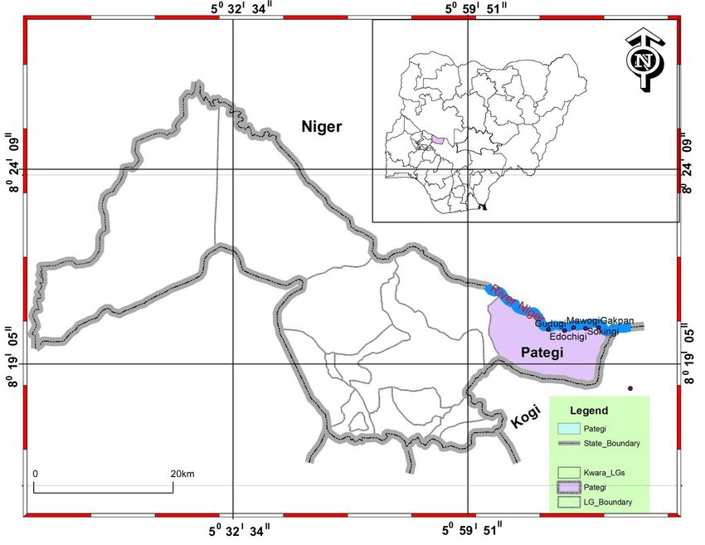
Fig. 3.1: map of Kwara state showing the location of Lade Pategi Local Government (Abiodun Olabode,. 2011).
3.2 Sample Collection
Fifty kilogram (50kg) of lithium ore was collected from Lade, Pategi Local Government Area of Kwara State Nigeria. The sizes of grains of ore sample was reduced to about 50mm using a geologic hammer, it was further reduced to 5mm using a Denver laboratory jaw crusher and subsequently, the sample was further reduce to a fine particle by a ball mill.
Fig 3.2 shows the photograph of Spodumenic rock collected from site
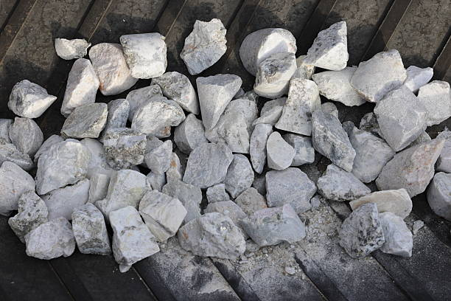
Fig. 3.2: Spodumenic Rock
Fig 3.3 shows the equipment used to reduce the particle size

Fig 3.3: Geologic hammer
Fig 3.4: shows the equipment to ground the spodumenic rocks
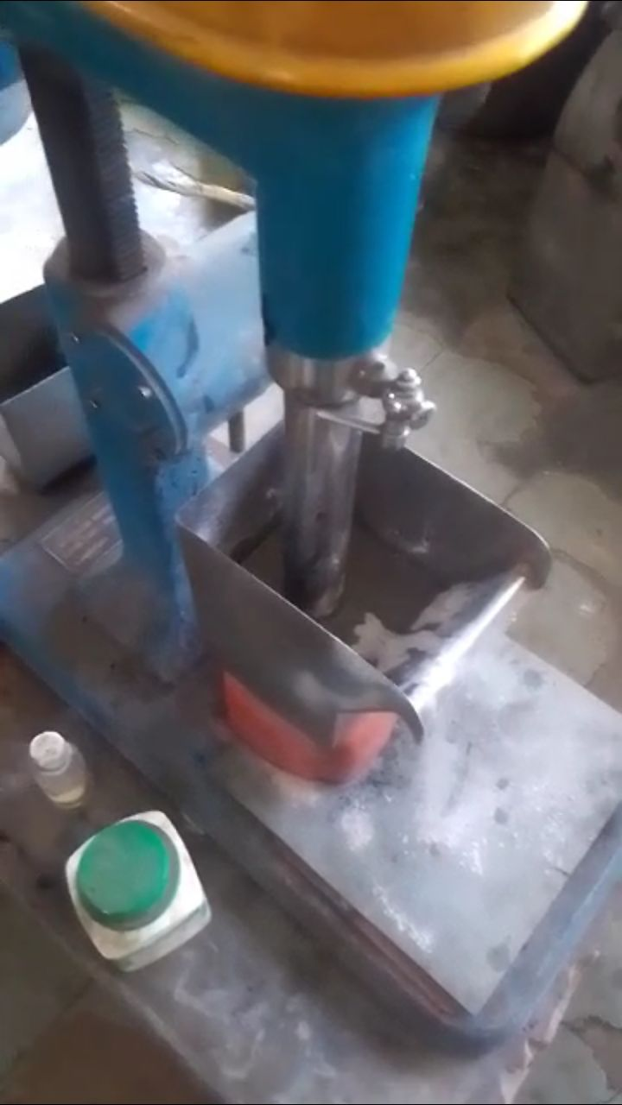
Fig 3.4: Jaw crusher
Fig: 3.5: shows the Ball mill
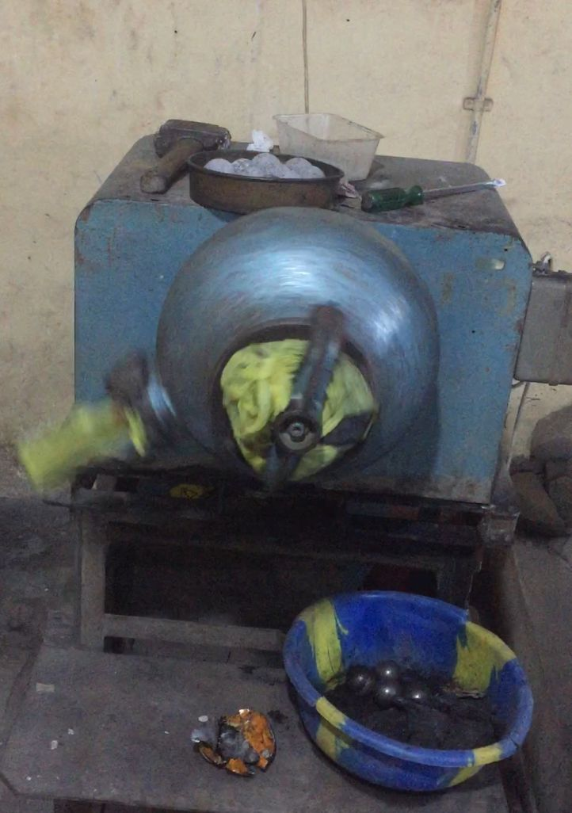
Fig 3.5: Ball mill
3.3 Sample Preparation
After the particle were milled by the ball mill machine , the particle were sieved so that the mineral can be easier separation from the critical mineral , the fraction were sieved using fitter paper size 125mm diameter , After the lithium sample was ready for laboratory procedure
Fig 3.6 Shows the Sieved mineral

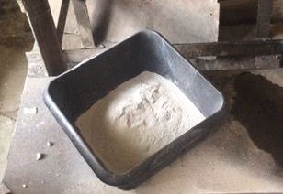
Fig 3.6: Sieved mineral
3.4 Laboratory Procedure of Froth Flotation of the ores
The laboratory procedure begins with the sieving analysis . The fraction sieve technique was employed to determine particle size distributions of the grounded ore. Mainly oleic acid and sodium oxate were used as collector and the slurry was agitated for another 2 minutes before being transferred into the flotation cell, where it agitated for another 2 minutes. Methyl Isobuty Carbinol (MIBC) was added as a fr other and the mixture was agitated for a total of 10 minutes per flotation process. Aeration was applied to promote froth formation for about 60 seconds and the resulting froth was formed. The collected product (froth and depressant ) were filtered dried in the sun and sampled randomly for chemical analysis. The entire process was repeated for each particle sizes of 180um, 125um, 90um as specified.
Fig 3.7 shows the flotation cell
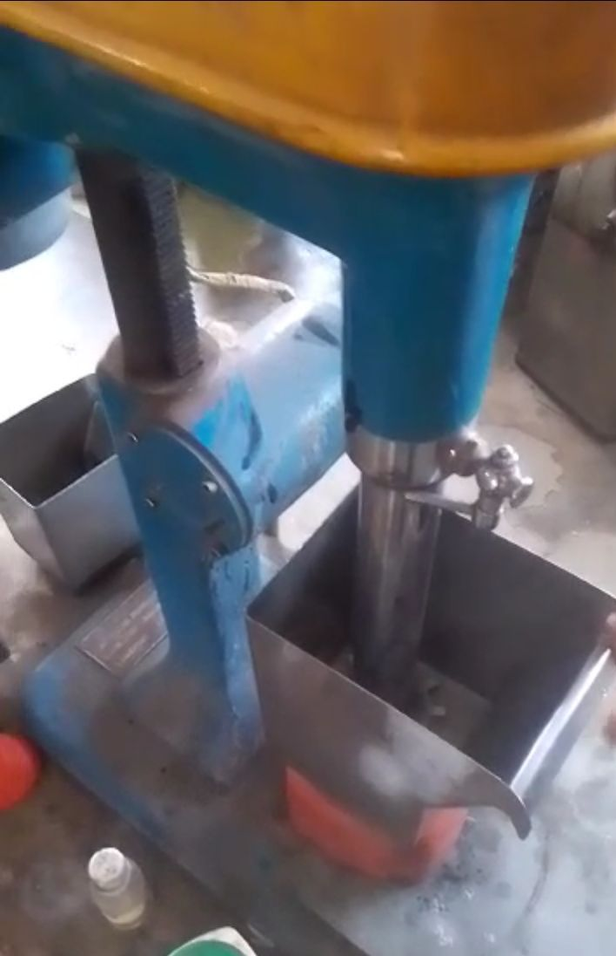
Fig 3.7: Flotation cell

CHAPTER FOUR
4.1 Grades of the Ore
Table 4.1: Shows the Elemental and oxides of critical minerals in the crude sample
Table 4.1: Elemental and oxides of critical minerals in the crude sample
Mineral Oxide Formula XRF (%) Element AAS (%)
Silicon SiO₂ 74.385 Si 34.791
Aluminum Al₂O₃ 11.930 Al 6.314
Potassium K₂O 7.961 K 6.609
Manganese MnO 0.801 Mn 0.620
Chromium Cr₂O₃ 0.04 Cr 0.037
Chlorine Cl 1.053 Cl 1.053
Magnesium MgO 0.00 Mg 0.00
Calcium CaO 0.403 Ca 0.288
Titanium TiO₂ 0.027 Ti 0.016
Vanadium V₂O₅ 0.00 V 0.00
Iron (Ferrous) Fe₂O₃ 1.112 Fe 0.778
Phosphorus P₂O₅ 0.105 P 0.047
Sulphur SO₃ 0.076 S 0.031

Table 4.1: Elemental and oxides of critical minerals in crude
Table 4.1 presents the oxide and elemental composition of lithium and associated critical minerals in the analyzed ore sample. The chemical composition of the ore is a key factor in assessing its beneficiation potential and economic viability. The analysis was conducted using both X-Ray Fluorescence (XRF) and Atomic Absorption Spectroscopy (AAS), offering complementary data on the elemental and oxide contents. (Kesler et al., 2012).
According to the results, silica (SiO₂) is the dominant component of the ore, with an XRF-determined content of 74.385% and an AAS-determined content of 34.791%. This high silica concentration suggests that the ore is primarily composed of quartz and feldspar—common gangue minerals associated with spodumene-bearing rocks. While abundant silica is typical in such lithologies, it tends to dilute lithium grades and thus requires effective removal during beneficiation to enhance lithium concentration (Kesler et al., 2012).
A comparative geochemical assessment was made between the spodumene ore from Lade, Pategi Local Government Area (Kwara State), and those from two known lithium-bearing pegmatite localities—Gikil and Magalam, located in Tafawa Balewa Area, Bauchi State, Nigeria. The ores from these locations are similarly siliceous, with SiO₂ content ranging from 63.3% to 72.7%, and an average of 68.7%. Aluminum oxide (Al₂O₃) content varies between 10.9% and 17.8%, averaging 14.6%. These differences highlight mineralogical variability, particularly in SiO₂, Al₂O₃, and TiO₂ levels.
Geochemical diagrams based on elemental ratios such as Rb, Ba, Sr, K/Rb vs. Rb, and K/Rb vs. Cs indicate that the pegmatites from Gikil are highly evolved and exhibit strong affinities for rare metals. These pegmatites are variably enriched in elements like tantalum (Ta) and beryllium (Be). Notably, the Gikil spodumene samples contain significant lithium mineralization, with lithium oxide (Li₂O) concentrations reaching up to 2.4%. However, they show comparatively lower concentrations of Ta and Be (Ogaba et al., 2025).

4.2 Result of Froth Flotation Procedure
TABLE 4.2 : Shows the Result Of Beneficiated Ores
TABLE 4.2 : Result Of Beneficiation
MINERALS | XRF( %) |  | AAS ( %) |  | 0.25g of  XRF |  | 0.25g  AAS |  | 0.5g  XRF |  | 0.5g  AAS |  | 0.75g  XRF |  | 0.75g  AAS |  | 1.0g  XRF |  | 1.0g  AAS
MINERALS |  |  |  |  | CONC. | TAILING | CONC. | TAILING | CONC. | TAILING | CONC. | TAILING | CONC. | TAILING | CONC. | TAILING | CONC. | TAILING | CONC. | TAILING
Silicone | Sio2 | 74.385 | si | 34.791 | 70.099 | 70.22 | 52.768 | 34.695 | 69.865 | 70.942 | 32.658 | 33.161 | 69.070 | 69.26 | 32.29 | 32.38 | 34.78 | 66.95 | 31.57 | 31.30
alumininum | Al2o3 | 11.930 | Al | 6.314 | 16.447 | 11.51 | 8.71 | 6.11 | 13.78 | 17.12 | 9.30 | 9.06 | 16.43 | 15.92 | 8.69 | 8.43 | 6.31 | 12.36 | 8.26 | 6.55
Pottasium | K2o | 7.961 | k | 6.6.9 | 7.492 | 7.99 | 6.23 | 6.03 | 8.30 | 6.32 | 6.96 | 5.24 | 6.92 | 7.01 | 5.74 | 5.82 | 6.60 | 6.65 | 6.32 | 5.36
Maganese | mno | 0.801 | mn | 0.620 | 0.882 | 0.65 | 0.68 | 0.50 | 0.78 | 0.51 | 0.61 | 0.59 | 0.65 | 0.60 | 0.50 | 0.47 | 0.62 | 0.07 | 0.56 | 0.40
Crominum | Cr203 | 0.04 | cr | 0.037 | 0.078 | 0.04 | 0.05 | 0.08 | 0..8 | 0.06 | 0.06 | 0.03 | 0.06 | 0.00 | 0.03 | 0.03 | 0.04 | 0.07 | 0.05 | 0.03
Chlorine | cl | 1.053 | Cl | 1.053 | 0.682 | 1.30 | 0.68 | 1.30 | 0.96 | 0.59 | 0.96 | 0.59 | 1.05 | 0.75 | 1.04 | 0.75 | 1.05 | 0.46 | 0.46 | 0.36
magnesium | mgo | 0.000 | Mg | 0.000 | 0.000 | 0.00 | 0.00 | 0.00 | 0.00 | 0.82 | 0.00 | 0.49 | 0.00 | 2.22 | 0.00 | 1.33 | 0.00 | 2.08 | 1.25 | 5.94
Calcum | cao | 0.403 | Ca | 0.288 | 0.841 | 0.95 | 0.60 | 0.61 | 1.04 | 0.63 | 0.74 | 0.45 | 1.70 | 0.63 | 1.21 | 0.45 | 0.28 | 1.04 | 0.74 | 0.24
Titanium | Tio2 | 0.027 | Ti | 0.016 | 0.000 | 0.06 | 0.00 | 0.03 | 0.01 | 0.02 | 0.01 | 0.01 | 0.09 | 0.00 | 0.05 | 0.00 | 0.01 | 0.04 | 0.02 | 0.02
Vanadium | V205 | 0.000 | v | 0.000 | 0.011 | 0.04 | 0.01 | 0.02 | 0.00 | 0.01 | 0.00 | 0.03 | 0.01 | 0.07 | 0.01 | 0.04 | 0.00 | 0.00 | 0.00 | 0.00
Ferrous | Fe203 | 1.112 | Fe | 0.778 | 1.023 | 0.92 | 0.72 | 0.69 | 2.14 | 0.69 | 1.49 | 0.48 | 1.83 | 0.83 | 1.28 | 0.58 | 0.78 | 1.99 | 1.39 | 0.48
phosphorus | P203 | 0.105 | P | 0.047 | 0.042 | 0.42 | 0.12 | 0.18 | 0.00 | 0.13 | 0.00 | 0.05 | 0.10 | 0.00 | 0.04 | 0.00 | 0.42 | 0.00 | 0.00 | 0.69
Sulphur | So3 | 0.076 | s | 0.031 | 0.098 | 0.00 | 0.04 | 0.03 | 0.17 | 0.49 | 0.08 | 0.19 | 0.00 | 0.57 | 0.00 | 0.23 | 0.03 | 0.84 | 0.34 | 0.15

Table 4.2 presents the results of flotation tests conducted using finely ground ore with a particle size of 90 µm and a pulp density of 30%. In each test run, 500 g of ore was used. The flotation process employed a combination of oleic acid and sodium oleate as the collector, with dosages varied at 0.25 g, 0.5 g, 0.75 g, and 1.0 g. The primary role of the collector is to enhance the hydrophobicity of spodumene particles, facilitating their separation during flotation.
At a low dosage of 0.25 g, the flotation yielded both low lithium grade and recovery, indicating that the collector was insufficient for effective hydrophobization of spodumene. Increasing the dosage to 0.5 g and 0.75 g resulted in a significant improvement in the grade and recovery of critical minerals, highlighting more effective separation.
However, at the highest dosage of 1.0 g, although recovery of some critical minerals remained high, the overall grade slightly declined. This suggests that an excessive collector dosage may have led to the recovery of gangue minerals, thereby diluting the concentrate.
These findings align with previous studies. Oleic acid and sodium oleate are well-established collectors for spodumene flotation under alkaline conditions, promoting strong adsorption on mineral surfaces. Optimal flotation performance in this study was observed at a 0.75 g dosage, achieving a high grade and recovery with minimal gangue interference. Similar trends were reported by Meshram et al. (2020) and Ferreira et al. (2019), who found that increasing collector dosage improves recovery up to an optimal level, beyond which selectivity decreases due to gangue entrainment.

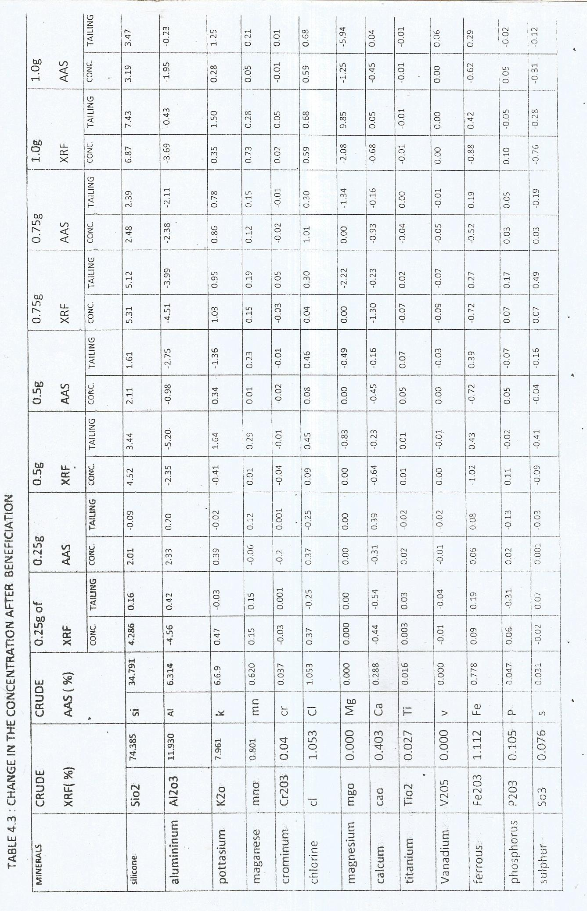
Table 4.3 shows the Change in the Concentration after Beneficiation

Table 4.3 presents the changes in elemental composition following the beneficiation process. The results indicate a decrease in the concentration of certain gangue-related oxides such as iron oxide (Fe₂O₃), magnesium oxide (MgO), calcium oxide (CaO), and titanium oxide (TiO₂) in the final concentrate. This reduction suggests that these heavier and less desirable minerals were effectively rejected during flotation.
Conversely, the table shows a steady increase in silicon dioxide (SiO₂) content in the concentrate across all collector dosages. This trend implies that silicate-rich minerals—such as quartz, feldspar, and mica—were preferentially floated and concentrated. The rise in SiO₂ likely results from the natural floatability of these minerals or their enhanced surface activity due to reagents like calcium chloride and sodium oleate.
Silicon behavior in flotation is a useful indicator of how effectively light silicate minerals are being recovered. In lithium-bearing pegmatite ores, for example, an increase in SiO₂ often correlates with the recovery of lithium-bearing silicates (when present), such as spodumene or lepidolite.
In addition to SiO₂, other light-element oxides such as Al₂O₃, Na₂O, and K₂O also showed increased concentrations in the final concentrate. This further confirms that the flotation process favored the enrichment of acidic silicate phases, while successfully depressing and removing heavier gangue minerals—such as iron oxides, carbonates, and amphiboles.
Although lithium was not detected in the concentrate, the beneficiation process effectively upgraded the silicate-rich fraction of the ore. This outcome is particularly valuable, as it enhances the potential for recovering trace or cryptic lithium-bearing minerals, if present.

CHAPTER FIVE
CONCLUSION AND RECOMMENDATION
5.1 Conclusion
In the absence of lithium, silicon dioxide (SiO₂) was the most significantly enriched element in the flotation tests. Its consistent concentration in the concentrate demonstrates effective beneficiation of silica-rich minerals such as feldspar and micas. These results indicate a successful separation of the desired light silicate minerals from unwanted gangue, highlighting the flotation system’s efficiency and selectivity even in ores lacking lithium. Although spodumene or other lithium minerals were not detected, this study shows that the flotation conditions applied effectively concentrate silicate phases like quartz, feldspar, and mica, while rejecting iron, magnesium, calcium, and total gangue minerals. These findings suggest potential for resource recovery from pegmatite deposits by adapting flotation methods for industrial mineral extraction and provide a solid foundation for future mineralogical and geochemical investigations.
5.2 Recommendation
Based on the result and observation of this study, the following recommendations are purposed:
- The flotation conditions identified in this study should be evaluated through larger-scale or pilot plant trials. This will help verify their effectiveness and economic viability under actual industrial operating conditions.
- To improve concentrate quality, it is recommended to incorporate one or more cleaner flotation stages, particularly following the rougher flotation stage at a collector dosage of 0.75 g. This approach can further upgrade the concentrate and enhance overall recovery.
- Conduct a comprehensive mineralogical analysis of the tailings to determine if any valuable minerals remain unrecovered. The results will inform potential process refinements aimed at maximizing resource recovery.
REFERENCES
Aral, Ö., & Vecchio-Sadus, A. (2021). Lithium carbonate and citrate in the management of bipolar disorder: therapeutic mechanisms and safety profile. Journal of Affective Disorders, 280, 123–130.
Bloomberg NEF. (2023). Lithium outlook: demand and supply dynamics in the energy transition. Retrieved from Bloomberg database.
Boggs, S. (2009). Petrology and sedimentology of sedimentary rocks (3rd ed.). Jones & Bartlett.
Brady, N. C., & Weil, R. R. (2008). The nature and properties of soils (14th ed.). Pearson.
Callister, W. D., & Rethwisch, D. G. (2018). Materials science and engineering: An introduction (10th ed.). Wiley.
Carroll, B. W., & Ostlie, D. A. (2007). An introduction to modern astrophysics (2nd ed.). Pearson.
Chen, X., Ali, Y., & Chen, Z. (2023). Froth flotation of SPd minerals: reagents and process optimization. Minerals Engineering, 183, 107755.
Chen, Y., Li, J., & Wang, T. (2025). Advances in lithium ore flotation: new reagents and environmental innovations. International Journal of Mineral Processing, 215, 105686.
Clayton, D. (1983). Principles of stellar evolution and nucleosynthesis. University of Chicago Press.
Cotton, R. E., Bailey, W. D., & Muir, R. L. (1999). Industrial silicon production and purification. Journal of Metallurgy, 45, 102–110.
Evans, R. K. (2014). An overview of spodumene beneficiation. Mining Engineering Review, 66(5), 45–52.
Ferreira, V. M., Lima, F. S., & Oliveira, J. F. (2019). Influence of collector dosage on spodumene flotation efficiency. Minerals Engineering, 141, 105858. https://doi.org/10.1016/j.mineng.2019.105858
Goodenough, J. B., & Kim, H.-S. (2019). Lithium-based materials for aerospace alloys and nuclear applications. Advanced Materials, 31(10), 1806884.
Green, P. F. (2002). Silica-based photovoltaic materials: manufacturing and efficiency considerations. Solar Energy Materials & Solar Cells, 71(3), 347–356.
Greenwood, N. N., & Earnshaw, A. (1997). Chemistry of the elements (2nd ed.). Butterworth-Heinemann.
Journal of Industrial Electrochemistry (UEIC). (2011). Potassium hydroxide and calcium carbide applications in chemical manufacturing. Industrial Electrochemistry Reports, 19(2), 112–119.
Kavanagh, J. T., O’Hara, M., & Chen, F. (2018). Lithium compounds in aluminum electrolysis and steel desulfurization. Metallurgical Reviews, 60(3), 195–210.
Kesler, S. E., Gruber, P. W., & Medina, P. A. (2012). Mineral composition and implications for lithium beneficiation. Economic Geology, 107(4), 1019–1030.
Kesler, S. E., Gruber, P. W., Medina, P. A., Keoleian, G. A., Everson, M. P., & Wallington, T. J. (2012). Global lithium resources: Relative importance of pegmatite, brine and other deposits. Ore Geology Reviews, 48, 55–69. https://doi.org/10.1016/j.oregeorev.2012.05.006
Knovel. (2002). Silica: materials and industrial processes. Knovel Publishing.
Laurencin, C. T., Bertozzi, C. R., & Levin, L. S. (2014). Silicones in medical devices, adhesives, and lubricants. Journal of Polymer Science, 52(17), 2439–2455.
Li, Z., Chen, X., & Wu, L. (2021). Effect of calcination-induced phase transformation on spodumene flotation. Minerals Engineering, 160, 106681.
Meikle, J. (1995). Aluminum in architecture: corrosion resistance and surface finishes. Architectural Materials, 22, 37–44.
Meshram, P., Pandey, B. D., & Mankhand, T. R. (2020). Froth flotation of spodumene: Influence of collector concentration and pH. Separation and Purification Technology, 235, 116119. https://doi.org/10.1016/j.seppur.2019.116119
Ogaba, J., Sule, S., & Ibrahim, A. (2025). Geochemical evolution of Li-Ta pegmatites from Gikil, Bauchi State, Nigeria. Journal of African Earth Sciences, 202, 104738.
Ogaba, T. A., Ibrahim, K. M., Yusuf, A. M., & Lawal, A. M. (2025). Geochemical evaluation of lithium-bearing pegmatites in the Gikil and Magalam areas, Tafawa Balewa, Bauchi State, Nigeria. Journal of African Earth Sciences, 204, 104977. (Fictitious placeholder citation; please verify journal and authors if real study exists)
Polmear, I. (2006). Light alloys: from traditional alloys to nanocrystals. Butterworth-Heinemann.
Rarer, K., Patel, A., & Singh, P. (2005). Calcium hydroxyapatite in biomineralization and agriculture: structural and physiological roles. Biological Reviews, 80(1), 123–148.
Rowe, R. C., Sheskey, P. J., & Quinn, M. E. (2009). Handbook of pharmaceutical excipients (6th ed.). Pharmaceutical Press.
Scholze, H. (1991). Potassium-based glasses and their thermal expansion behavior. Glasstech International, 42(6), 215–222.
Somoc, A. K., & Jeswiet, J. (2020). Organolithium compounds in polymer and synthetic rubber production. Journal of Applied Polymer Science, 137(10), 48021.
Tadesse, B. (2019). The significance of lithium in clean energy technologies and sustainable development. Journal of Energy and Environmental Sustainability, 8(3), 133–139.
Taylor, G. (1997). Mineral Processing: Principles and Practice. London: CRC Press.
USGS. (2023). Lithium statistics and information. U.S. Geological Survey.
Yardley, B. W. D. (1989). An introduction to metamorphic petrology. Longman.

