IMPACT OF CUSTOMERS’ REWARD PROGRAMS ON CUSTOMER LOYALTY IN SMALL SCALE SUPERMARKET
(A CASE STUDY OF DANCO SUPERMARKET, ILORIN KWARA STATE)

BY

DADA BOSEDE STELLA
HND/23/BAM/FT/0570

BEING A RESEARCH PROJECT SUBMITTED TO DEPARTMENT BUSINESS ADMINISTRATION AND MANAGEMENT, INSTITUTE OF FINANCE AND MANAGEMENT STUDIES (IFMS) KWARA STATE POLYTECHNIC ILORIN

IN PARTIAL FULFILMENT OF THE REQUIREMENT FOR THE AWARD OF HIGHER NATIONAL DIPLOMA (HND) IN BUSINESS ADMINISTRATION AND MANAGEMENT

AUGUST, 2025

CERTIFICATION
This is to certify that this research work has been read and approved as meeting the requirement for the Award of Higher National Diploma (HND) in Business Administration and Management, Institute of Finance and Management Studies, Kwara State Polytechnic, Ilorin, Kwara State.

______________________ _______________
MR. IMAM R. A DATE
Project Supervisor

______________________ _______________
MR. UMAR B. A DATE
Project Coordinator

______________________ _______________
MR. ALAKOSO I. K. DATE
Head of Department

______________________ _______________
External Examiner DATE

DEDICATION
This research work is dedicated to Almighty God.

ACKNOWLEDGEMENT
I give all glory, honor and adoration to Almighty God for his grace, mercy, favor, protection, provision and guidance throughout my program in the department of estate management and valuation in kwara state polytechnic. Have anxiously hope for this opportunity to express adequate profound gratitude to the people who have in one way or the other assisted my academic pursuit.
I am very grateful to my dearest and lovely parent Mr. and Mrs. DADA for how they nurtured me from infancy, prayer, encouragement and financial assistance. May your days be long to reap the fruit of your labor.
I also use this medium to thank my Supervisor IMAM R. A. For his patience and constant kindness which he shown to me throughout this program, and I pray both will eat the true work of his hands (Amen).
May God almighty bless u all
Amen

TABLE OF CONTENTS
Title page |  | i
Certification |  | ii
Dedication |  | iii
Acknowledgement |  | iv
Table of Contents |  | v
Abstract  CHAPTER ONE: INTRODUCTION |  | viii
1.0 Introduction |  | 1
1.1 Background to the Study |  | 1
1.2 Statement of the Problem |  | 3
1.3 Research Question |  | 5
1.4 Research Objectives |  | 5
1.5 Research Hypotheses |  | 5
1.6 Significance of the Study |  | 5
1.7 Scope of the Study |  | 6
1.8 Definition of Terms |  | 6
1.9 Plan of the Study  CHAPTER TWO: LITERATURE REVIEW |  | 6
2.0 Introduction |  | 8
2.1 Conceptual Clarification |  | 8
2.1.1 Concept of customer Reward Programs |  | 8
2.1.2 Types of Customer Reward Programs |  | 8
2.1.3 Types of Customer Reward Users |  | 11
2.1.4 Benefits of Customer Reward Programs |  | 12
2.1.5 Objectives of Customer Reward Programs |  | 13
2.1.6 Concept of Customer Loyalty |  | 14
2.1.7 Characteristics of Customer Reward Programs |  | 15
2.1.8 Dimension of Customer Reward Programs |  | 16
2.1.9 Stages of Customer Reward Programs |  | 17
2.1.10 Benefits of Customer Loyalty |  | 22
2.1.11 Bases of Customer Loyalty |  | 23
2.1.12 Factors Influencing Customer |  | 25
2.2 Theoretical Review |  | 28
2.2.1 Instant Gratification Theory |  | 28
2.2.2 Expectancy Theory |  | 29
2.3 Empirical Review  CHAPTER THREE: RESEARCH METHODOLOGY |  | 30
3.0 Introduction |  | 33
3.1 Research Design |  | 33
3.2 Population of the Study |  | 33
3.3 Sample Size and Sampling Technique |  | 33
 | 3.4 Method of Data Collection |  | 34
 | 3.5 Method of Data Analysis |  | 35
 | 3.6 Historical Background |  | 35
CHAPTER FOUR: DATA PRESENTATION, ANALYSIS AND INTERPRETATION
4.0 Introduction | 36
4.1 Data presentation | 36
4.2 Presentation of Statistical data | 41
4.3 Test of Hypotheses | 47
4.4 Discussion of Findings | 50
CHAPTER FIVE: SUMMARY, CONCLUSION AND RECOMMENDATIONS
5.0 Introduction | 51
5.1 Summary | 51
5.2 Conclusion | 51
5.3 Recommendations | 52
References | 53

ABSTRACT
The problem that prompt the conduct of this research is the need to examine the effectiveness of customer reward programs in enhancing customer loyalty. The goal of this study is to obtain a deep understanding of the impact of customer reward programs on customer loyalty. The study was applied to Danco supermarket in Ilorin, Kwara State. The study examines the impact of independent variable; point system, price discount and non-monetary program on the dependent variable; customer loyalty. 80 questionnaires were distributed randomly to Danco supermarket customers and regression and correlation statistical tools were used to analyze the gathered data. The findings reveal that there is a significant impact of all the customer reward programs in enhancing and maintaining customer loyalty except point system. Organizations are recommend to adopt customer reward programs that will reflect the customer’s shopping preferences
and values, in order to keep them loyal to the business and create a life time customer.

CHAPTER ONE
INTRODUCTION
1.1 Background to the Study
It is generally well known that customer reward programs often refer to as loyalty programs are valuable communication tools that promote positive behaviour of existing customers, and may later attract new ones. It is a way of businesses to gain a trust of customers and brand value. The reward programs collect and analyze customers’ preference and shopping priorities, identify and reward the best customers, along with choosing the appropriate communication methods (Clark, 2010).
Customer reward programs offer rewards, discounts and other special incentives, so it is a way to attract and retain customer. It encourage repeated purchase and brand loyalty (Clark, 2010). According to marketing literature, reward programs increase customer retention while increasing loyalty. Marketing literature has distinguished among many type of reward programs. Immediate rewards include financial benefit such as discount and promotional offers, while deferred benefits include non-cash reward such as vouchers and coupons (Mai, Nguyen & Nguyen, 2021).
The first usage of loyalty programs in business was many years ago originally in Germany, where price competition was disallowed by government. In 1981 was the first launched of loyalty programs by American Airlines and quickly used by other airlines and hotels, car rental companies, credit card organizations and retailers. As reported in the New York Times, Forrester Research found that across 12 industries, retailers are the most loyalty while others, like TV service providers and internet service providers proved more unsteady. Retail loyalty programs are offering points, rebates, discounts or combinations of them (Lewis, 2004).
Loyalty programs are considered part of a comprehensive customer relationship strategy. Loyalty programs are not only a tool to increase the organization’s loyal customers, but they are an opportunity to gather information about customer shopping habits and preferences. This information helps in customizing the organization’s services. Retailers recognized that without “customer database”, they were unable to identify the best customers and reward them for their preferable behaviour. The Loyalty Marketer's Association opined that due to the fact, that not all customers are potentially loyal customers, the ideal loyalty program would benefit only loyal and potential loyal customers. This means that the customers have first sorted into groups, and then to be approached in different ways. Customer loyalty programs should increase customer happiness and retention.
1.2 Statement of the Problem
In the rural business area, many retail outlets have overlooked the relevance of implementing customer reward programs as a tool to attract new customers and retain existing ones. On the other hand, in the developed cities where there is high competition between and among business firms, retailers offer several types of reward programs to increase sales of products, maintain standard market share and make reasonable profit necessary for the survival of the business firm.
Due to the rapid increase in competition in urban cities retail market, retailers offer several types of reward programs to increase sales of products through customer repurchase over a period of time. Jain and Singhal (2012) concluded that in spite of the predominant use of reward programs, there is inadequate affirmation on the long-standing effects of these programs and their efficiency is not well recognized.
1.3 Research Questions
This study is an attempt to investigate the impact of customer reward programs on customer loyalty. In the course of doing so, the following research questions will be addressed:
- Does point system have impact on customer retention?
- What is the impact of after sales service on customer loyalty? iii. What is the impact of discount price program on customer repurchase?
1.4 Research Objectives
The general objective of this study is to examine the impact of customer reward programs on customer loyalty. In order to attain this objective, the research will address the following sub-objectives:
i. To evaluate the impact of point system on customer retention. ii. To analyze the impact of after sales service on customer loyalty. iii. To assess the impact of discount price program on customer repurchase.
1.5 Research Hypotheses
In the course of this research effort, the following hypotheses will be tested:
H1₁: Point system have impact on customer retention.
H1₂: There is significant impact of after sales service on customer loyalty.
H1₃: There is significant impact of discount price program on customer repurchase.
1.6 Significance of the Study
This research is design to investigate the impact of customer reward programs on customer loyalty. The research will serve as a tool to clarify the role of customer reward programs and their impact on customer loyalty. It will also look into the most important impact of reward programs that affect customer loyalty and make recommendation about the most effective. This type of research will help to provide the proper recommendation for organizations and also serve as specialized scientific addition in the field of studying customer loyalty.
1.7 Scope of the Study
This research concentrates on the impact of customer reward programs on customer loyalty in small scale supermarket with emphasis on Danco supermarket in Ilorin, Kwara State as a case study. The research covers the period of 2020 to 2023.

1.8 Definition of Terms
The following terms and concepts are defined as used in this study:
Customer: A customer is an individual or business that purchase goods and services from business organization.
Reward Programs: These are programs designed to increase customer engagement and purchases in exchange for discounts and other benefits.
Customer Loyalty: Customer loyalty describes an ongoing relationship between a company and their customer in which the customer is willing to repeatedly return to the company to conduct business.
1.9 Plan of the Study
Chapter one: The chapter will cover the introduction section of the study which will provide a brief overview of the topic ‘impact of customer reward programs on customer loyalty’. It will addresses the problem of the research, research questions, objective of the research study, hypotheses of the research, significance of the study, definition of key terms and plan of the study.
Chapter two: The chapter will cover literature review section of the study. It will dwell on the relevant past and present work on customer reward programs and customer loyalty. It also include identification and description of conceptual framework, theoretical framework and empirical review(theories, principles, generalization and research findings that are close related to customer reward programs and customer loyalty).
Chapter three: The chapter focuses on the processes and procedures used in gathering and analyzing data. The areas to be covered include research design, population of the study, sample size and sampling technique, method of data collection, method of data analysis and historical background of the case study.
Chapter four: In this chapter, data collected in the previous section will be presented, analyzed and interpreted. Hypotheses of the study will be tested and discussion of the findings will be presented.
Chapter five: This section of the research work will centered on summary of the research work, conclusion of the findings and recommendation will be made on the impact of customer reward programs on customer loyalty in small scale enterprises.

CHAPTER TWO
LITERATURE REVIEW
2.0 Introduction
This chapter dwells on the relevant previous and present work on customer reward programs and customer loyalty. It involves the identification and description of theories, principles, generalizations and research findings that are closely related to the study.
2.1 Conceptual Framework
2.1.1 Concept of Customer Reward Program
A customer reward program, also known as customer loyalty program, is a strategy that helps retain customers and encourages them to continue purchasing from a company. Loyalty/reward programs are structured marketing efforts that reward, and therefore encourage, loyal buying behavior, which is potentially beneficial to the firm (Sharp & Sharp, 1997). The rewards programs are offered by a company to customers who frequently make purchases. A loyalty program may give a customer advanced access to new products, special sales coupons or free merchandise. Customers typically register their personal information with the company.
According to Wijaya (2008), customer reward program is a program offered to the customers to build an emotional bond to the company or the brand of company. Peiguss (2012), views loyalty programs as an incentive by providing benefits based on cumulative purchasing over time. Loyalty programs encourage consumers to shift from myopic or single-period decision making to dynamic or multiple-period decision making. These programs encourage repeat buying and improve retention rates by providing incentives for customers to purchase more frequently and in larger volumes.
Loyalty program is a technique of growing and maintaining the existing customers and supporting the rebuying through the incentive scheme (Doyle, 2013). Also, Rebecca (2019) assert that customer loyalty program is a marketing approach that recognizes and rewards customers who purchase or engage with the brand on a recurring basis. Customer reward program has been defined as a program run by a company that offers benefits to frequent customer. Those benefits may be in the form of discounts, rebates, free products, or other promotion. An effective customer reward program rewards customer who buy from the business on a regular basis, encouraging the customer to return frequently (Tara, 2022).
2.1.2 Types of Customer Reward Programs
Organizations have rewarded the loyalty of preferred customers by enhanced services or price discounts. Recently, loyalty rewards programs have become applicable in several sectors businesses. Loyalty programs are structured marketing efforts that reward, and encourage loyal buying behavior which is potentially beneficial to the company. Specifically in retailing marketing it includes: point-based reward programs, tiered reward programs, paid reward programs etc.
- Points system: This is the most common type of reward program. Frequent customers earn points, which translate into some type of reward: discount, gifts, or special customer treatment, customer purchases toward a certain amount of points to redeem their reward. Reward programs based on service usage levels (frequent buyer programs) have become common in the transportation and hospitality industries. This type of loyalty program is most appropriate for businesses that encourage frequent, short-term purchases. Sephora’s Beauty Insider rewards program is a widely popular example of point reward system where customers earn reward based on a traditional point system.
- Tier reward system: This type of reward programs offer small rewards as a base offering for being a part of the program, and encourage repeated customers by increasing the value of the rewards as the customer moves up the loyalty ladder. The difference between points and tiered systems is that customers extract shortterm versus long-term value from the loyalty program. Tiered programs may work better for high commitment, higher price-point businesses like airlines, hospitality businesses, or insurance companies.
- Charge an upfront fee for VIP benefits: Charge one-time (or annual) customers to start collecting points by their purchases. Clearly this system is most applicable to businesses that thrive on frequent, repeat purchases. For an upfront fee, the customers are relieved of inconveniences that could impede future purchases. Example of this type of reward program is Designer Shoe Warehouse. DSW has long run VIP loyalty program that rewards customers with points for each purchase.
- Non-monetary programs: This involve providing value to customers in other ways than discount and cash rewards.
2.1.3 Types of Customer Reward Programs Users
There are four types of customers regarding their attitudes to use loyalty programs.
- Never: Never consumers are those who are not affected by loyalty programs and their reward incentives in any way. These set of customers are not influence at all by loyalty reward programs.
- Light consumers are having reward program memberships and being influenced by their incentives, but only moderately. These users are relatively affected by loyalty programs and their reward incentives.
- Heavy consumers are highly influenced members of reward programs. The users in the group are influence by loyalty reward incentive to a great extent.
Extreme consumers are customers who are addicted to or obsessed with loyalty programs. They place an uttermost value to reward incentives and this influence their buying decision to a large extent.

2.1.4 Benefits of Customer Reward Programs
Researches from previous studies proved that, only 12% - 15% of customers are loyal to a single retailer. This small number of loyal customers generate between 55% - 70% of company sales. Some food retailers find that 65%-95% of their sales go to members of loyalty programs. 53% of food retailers offer loyalty programs, 75% of the loyalty programs members used their loyalty cards at least weekly and 25% at least used them once a month. The retail marketing literature demonstrates several benefits for loyalty programs for both businesses and consumers.
For businesses, loyalty programs are profitable because:
  - The costs of serving loyal customers are less.
  - Loyal customers are low price sensitive.
  - Loyal customers spend more with the company.
  - Loyal customers pass on positive recommendations about their favorite brands to their friends and relatives.
  - Loyalty programs provide the company with a wealth of consumer information. While companies can evaluate different purchases, the use of a loyalty program gives additional information about the type of products that may be purchased together, and whether certain coupons are more effective than others.
  - Retaining customers is less expensive than acquiring new ones, and customer experience management is the most cost-effective way to drive customer satisfaction, customer retention and customer loyalty.
  - Loyal customers are more likely to purchase more, with a high-margin of supplemental products and services.
  - Loyal customers reduce costs associated with consumer education and marketing.

2.1.5 Objectives Customer Reward Programs
Reinatz (2004) summarizes the objectives for using customer reward programs as the following:
- Building true attitudinal and behavioral loyalty.
- Efficiency profits.
- Effectiveness profits.
    - The Concept of Customer loyalty
In Oliver’s (1999) book, customer loyalty is defined as a deeply held commitment to rebuy or patronize a preferred product/service consistently in the future, thereby causing repetitive same-brand or same brand-set purchasing, despite situational influences and marketing efforts having the potential to cause switching behaviour. Also, Bose and Rao (2011) opined that in the business context, loyalty is the customer’s commitment to do business with a particular organization which effects in repeat purchases of goods and services of that organization.
According to Bobâlcă (2013), Loyalty can be analyzed both from the perspective of a company and a consumer. Customer relationship management and direct marketing research center on strategies and activities that a company must initiate in order to retain its customer’s portfolio. There are academic papers that present the loyalty concept as a result of marketing efforts. Bobalca opined that the two perspectives must be analyzed as a whole and not as distinct parts of the same process. The strategies developed by both national and international companies must be sustained by depth knowledge of the dimensions and factors affecting loyalty and also of the consequences of loyalty.
Customer loyalty has been perceived to be a behavioural concept entailing repeat buying of product or service measured as the series or share of purchases, referrals, magnitude of relationship or all of the above mingled together (Rai & Medha, 2013).

2.1.7 Characteristics of Loyal Customer
A loyal customer is a natural or legal person who purchases goods or services and is not inclined to buy from competitors (Dudonis, 2012). Pranulis and Pajuodis (2012), describe loyal customers as a constant preference for certain goods (brand loyalty) and stores (loyalty to the place of purchase). A customer can be refer to as a loyal customer if he or she:
  - for a long time remains loyal to the company
  - buys new products offered by the company
  - creates a positive image of the company, attracting your friends to buy the goods
  - is insensitive to the actions of competitors
  - less sensitive to price changes
  - tolerates errors made by the company
  - willingly provides information
  - willing to share his ideas on improving the products and services
The buyer does not have to meet all the criteria, it depends on the situation, but it is necessary to fit any number of criteria so that a buyer could be called loyal. Loyalty, a commitment, which can be both emotional and rational. Rational loyalty leads to loyalty programs, the gifts, coupons, prizes, which encourages the customer to buy the company's products. However, such loyalty lasts as much as loyalty program. Emotional loyalty forms the positive experience of the company. Thus, the positive experience of receiving customers remains loyal buyers.
    - Dimensions of Customer Loyalty
In Ball, Coelho and Machas (2004) article, there are two customer loyalty dimensions to be discussed, which are behavior loyalty and attitude loyalty. Behavior loyalty is defined as repeated transactions or percentage of total transactions and total expenditures. It can be simply measured with observation approach. In contrast, attitude loyalty is defined as positive affect for relationship and desire for retaining relationship continuance.
As mentioned above, behavior loyalty is repeated purchase. It can offer advantages for companies. First, research on behavior loyalty can show the customer preference for a brand or product. Second, behavior loyalty can reflect a customer’s purchase intention. Last, behavior loyalty can retain companies’ profit through increasing market shares (Chaudhuri and Holbrook, 2001). However, according to Ball and his partners (2004), the research that combine behavior loyalty and attitude loyalty is more useful for practical purposes. As Oliver (1999) states in his article, attitude loyalty reflects customer’s cognitive, affective, and co-native predispositions to continue relating to the brand or company. In this process often involve customer commitment. Therefore, according to Ball and his partners (2004), combining of behavior loyalty and attitude loyalty is powerful. It can influence first, customer’s intention to recommend the brand or company to others; second, the horizontal communication among customers and mouthto-mouth communication; third, customer’s resistance to competitors’ offerings and persuasive tactics to attract new customers and buzz marketing.
    - Stages of customer Loyalty
For a better implementation of a customer loyalty strategy, understanding the customer is also important. In the following part, the methods of customer classification will be introduced. Because customer classification can better help companies visualize, analyze, and improve the behavior and profitability of customers (Curry, 2000). According to Torres-Moraga, Vasquez-parraga and Zamora-gonzalez (2008), customer can be classified into three categories. The first is recent customers. They adopt the product that best fits their needs or best appeals to them emotionally and cognitively. The second is more experienced but not highly experience customers. They adopt a range of brands on the basis of both value and price. The last is some highly experienced customers. They become loyal to a brand.
2.2. Theoretical Review
    - Instant Gratification Theory
Instant (or immediate) gratification is a term that refers to the temptation, and resulting tendency, to forego a future benefit in order to obtain a less rewarding but more immediate benefit. It’s a natural human urge to want good things and to want them NOW. It has almost certainly provided an evolutionary advantage for humans and their ancestors, as life for pre-modern humans hinged on decisions made and actions taken in the immediate far more than those intended for long-term gain.
Today, we live in a society where only 4% of digital ads are viewed for more than two seconds and two-minute commercial break feels like a lifetime. Customers want everything now and will not hand around waiting. One study of 67 million online users even found that when left waiting for just ten seconds for a video to load, over half abandoned the video altogether. Conditioning customer to keep seeking instant rewards is the key to keeping loyalty program growing for long term. Rewarding customers for nontransactional activities through loyalty program is a great way to show them immediate value for engaging with a brand.
    - Expectancy theory
Expectancy theory of motivation was postulated by Vroom in 1964. Expectancy theory of motivation is an example of a loyalty psychology theory which proposes that people are motivated to behave because they believe their actions will lead to their desired outcome. The theory states that individuals will be motivated if they believe that there is a positive correlation between efforts and performance, and that favorable performance will result in a desirable reward. This makes the desire to satisfy the need strong enough to make the effort worthwhile.
Vroom outlined three core variables in his theory; expectancy, instrumentality and valence. Expectancy involves the belief that increases in effort leads to increases in performance.
Instrumentality involves the belief that an appropriate reward will be received for the right performance. Valence is the importance a person places on the outcome that is expected.
For the purpose of this research, expectancy theory of motivation will be adopted because the theory has a powerful part to play in the successful implementation of loyalty programs. It makes customers want to engage more if they know they will get something in return. Expectancy theory postulated that individual will behave or act in a specific way because they are motivated by a desirable result. A member will be motivated to engage with a loyalty program if they have the expectancy that their efforts will move them forward on a pathway towards accessing a reward (instrumentality) that satisfies an important need (valence). For loyalty program design, expectancy theory is a useful tool for empathizing with the members’ point of view. Focusing on the three core areas critical for motivation can help to clarify important and non-essential features, supporting the development of a simple yet sophisticated design. It is equally valuable when auditing existing programs, by directing the attention of the program operator to deficient aspects of the program which either blocks motivation, or doesn’t motivate sufficiently.
2.3 Empirical Review
East, Philip, Kathy and Wendy (2005), defined Consumer loyalty as a singular concept, usually as an attitude toward the loyalty object or as repeat patronage behavior. The definition may combine attitude and behavior in either an additive or an interactive expression. The authors argue that definitions of loyalty are useful if they predict phenomena such as recommendation, search and retention (loyalty outcomes). The findings of the study addressed that in there consumer fields, the combination measures of customer loyalty often perform poorly as predictors of loyalty outcomes compared with singular measures since recommendation is predicted by attitude but not by repeat patronage. Retention and search behavior are predicted better by repeat patronage than by attitude. The prediction of loyalty outcomes is not improved by the inclusion of an interaction term in the model.

CHAPTER THREE
METHODOLOGY
3.0 Introduction
This chapter dwells on the procedures and methods used in gathering and analysing data. The sphere to be covered include research design, population of the study, sample size and sample technique, method of data collection, method of data analysis and historical background of the case study.
3.1 Research Design
Research design is a master plan, structure and strategy specifying the methods and procedures for collection and analysing of the needed data.
For the purpose of this study, descriptive research design was used. Descriptive research design focuses is to obtain information concerning the current status of a phenomena and to describe ‘what exists’ with respect to variables or conditions in a situation. Under this design, the subject is being observed in a completely natural and unchanged natural environment. 3.2 Population of the Study
Population is the entire aggregation of people from which sample can be drawn. It can also be seen as any identifiable and well specified group of individual. As obtained from the sales record of the case study, the population of this study is 100 customers.
3.3 Sample Size and Sampling Technique
A sample is any number of persons selected to represent the population according to some rule of plan. Thus a sample is a smaller representation of the population. Sample size is the number of selected individual from whom to obtain the require information and is usually denoted by the letter (n). Sampling size determination is the technique of electing the number of observation to include in the sample. Sample size is an important feature of any investigation or study in which the aim is to make inferences about the population from a sample. Taro Yamane (1967) sample size determination technique will be adopted for the purpose of the study.
Thus: n= N/1+N (e) ²
Where: n= Sample size
N= Population if the study e= Level of significance
1= unit (a constant)
Note. e= 0.05
Therefore, sample size:
= 100/1+100(0.05)²
=100/1+100(0.0025)
=100/1+0.25
=100/1.25
=80
The sample size derived from the use of the technique is 80.
Sampling is the procedure for drawing the sample from the population or selecting a few from a whole and coming to conclusion based on the finding of the few. As it is practically impossible to reach every member of the population as a result of logical problems. Sampling is used to derive the desired information about the population at the minimum cost and with the maximum reliability. Simple random sampling technique will be used for this study because of the relatively small size of the population and homogeneous nature of the population.
3.4 Method of Data Collection
The two commonly used research instruments for data collection are qualitative and quantitative instrument. Qualitative method is often used to elicit non-numeric data while quantitative method is used to obtain numeric data.
In this study, journals and project review has been used to obtain secondary data while structured interview and closed ended questionnaire will be used in order to elicit primary data from the respondent that will meet the objective of the research.
3.5 Method of Data Analysis
The method of data analysis used in this research is inferential statistics because it is a field of statistics that uses analytical tools for drawing conclusions about a population by examining random samples. Regression and correlation analysis was adopted specifically for this study. Regression analysis is used to shows the relationship between independent variable and dependent variable.
3.6 Historical Background of Danco Supermarket
Danco supermarket was established as a sole proprietorship business by Daniel
Chukwudebelu Uchechukwu in 2008. The supermarket was situated at 272, Ibrahim Taiwo Road, Ilorin the capital of Kwara State. Danco supermarket has 1 manager, 6 sales representatives, 2 security officers, 3 stockiest, 1 customer-assistant all together making 13 employees. The supermarket is well stocked with varieties of home and kitchen items, foodstuff, biscuits and confectioneries, wine and beverages, beauty and fashion product etc. The supermarket is one of the most frequently patronise supermarket along Ibrahim Taiwo road.

CHAPTER FOUR
DATA PRESENTATION, ANALYSIS AND INTERPRETATION
4.0 Introduction
This chapter focused on the presentation, analysis and interpretation of the data collected from the field survey. It also covers hypothesis testing using statistical package for social science (SPSS) and discussion of findings discovered from the research work.
4.1 Data Presentation, Analysis and Interpretation
Data were analyzed in the write up through the use of statistical method. Tables were employed to represent the responses obtained from the survey and the interview and simple percentage was applied to make the analysis of data more meaningful for easy corrections.
The research questionnaire was administered to eighty (80) customers of danco Supermarket Ilorin which is the sample size obtained from the use of Tara Yamane sample size determination technique. Out of 80 questionnaires distributed, 60 were dully filled and returned.
Table 4.0 Analysis of Response Rate
Questionnaire | Frequency | Percentage%
Returned | 60 | 75
Not returned | 20 | 25
Total | 80 | 100
Source: Field Survey 2025
4.1.1. Demographic Representation of the Respondents Table 4.1.
Table 4.1.GENDER
 |  | Frequency | Percent | Valid Percent | Cumulative Percent
Valid | MALE | 34 | 56.2 | 56.2 | 56.2
Valid | FEMALE | 26 | 43.8 | 43.8 | 100.0
Valid | Total | 60 | 100.0 | 100.0
Source: Field survey, 2025
The table above shows the sex /gender proportion of the respondents. It could be seen that out of the 60 respondents, 34(56.2%) were males while 26 respondents (43.8%) were females. The Pie chart representing the results is therefore presented below.
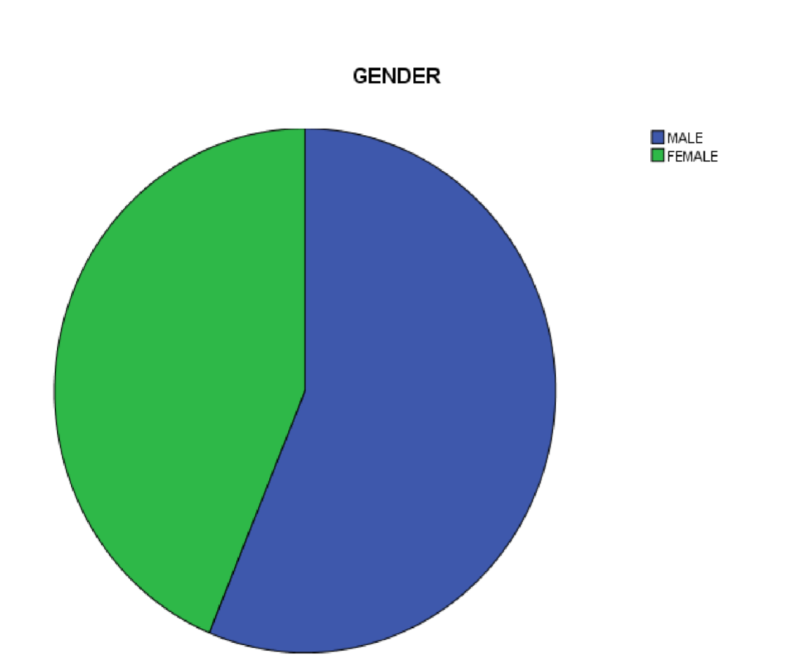
Source: SPSS data result, 2024
Table 4.2. MARITAL STATUS
 |  | Frequency | Percent | Valid Percent | Cumulative  Percent
Valid | SINGLE  MARRIED | 23 | 38 | 38  62 | 38
Valid | SINGLE  MARRIED | 37 | 62 | 38  62 | 100.0
Valid | Total | 60 | 100.0 | 100.0
Source: Field survey, 2025
Table 4.2. above shows the marital status of the respondents as 37 respondents were married representing 62.% while 23 respondents 38.% were single, nobody indicated to be widow or widower.
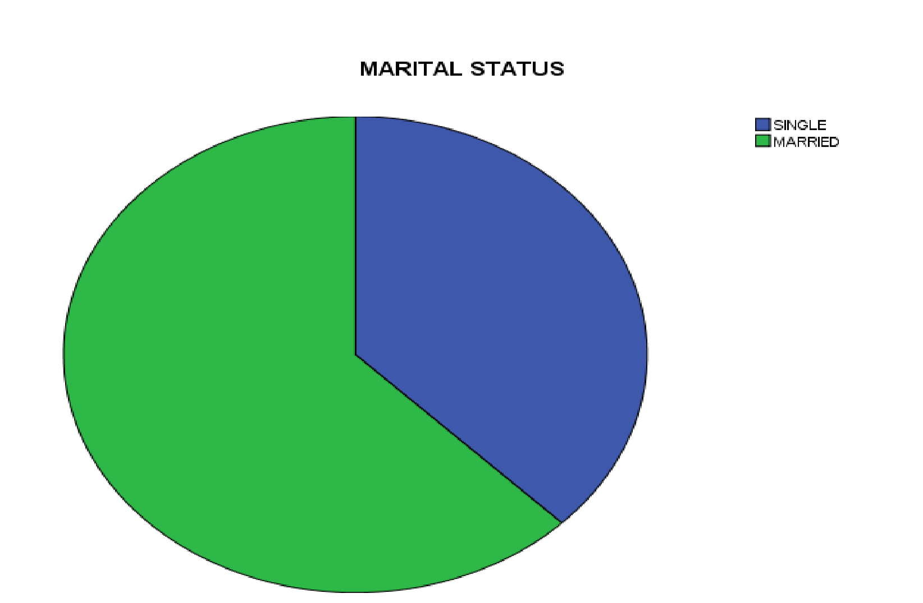
Source: SPSS data result, 2025
Table 4.3. Academic Qualification of the Respondents
 |  | Frequency | Percent | Valid Percent | Cumulative  Percent
Valid | OND/NCE  HND/BSC  POSTGRADUATE/PROFES | 9 | 15.6 | 15.6 | 15.6
Valid | OND/NCE  HND/BSC  POSTGRADUATE/PROFES | 28 | 46.9 | 46.9 | 62.5
 | SIONALS  Total | 23 | 37.5 | 37.5 | 100.0
 | SIONALS  Total | 60 | 100.0 | 100.0
Source: Field survey, 2025
Table 4.3 above shows that out of the total 60 respondents, 28 respondents representing 46.9% are the major dominant, 23 respondents (37.5%) has either postgraduate or professional qualifications while the remaining 9 respondents (15.6%) were national diploma certificate.
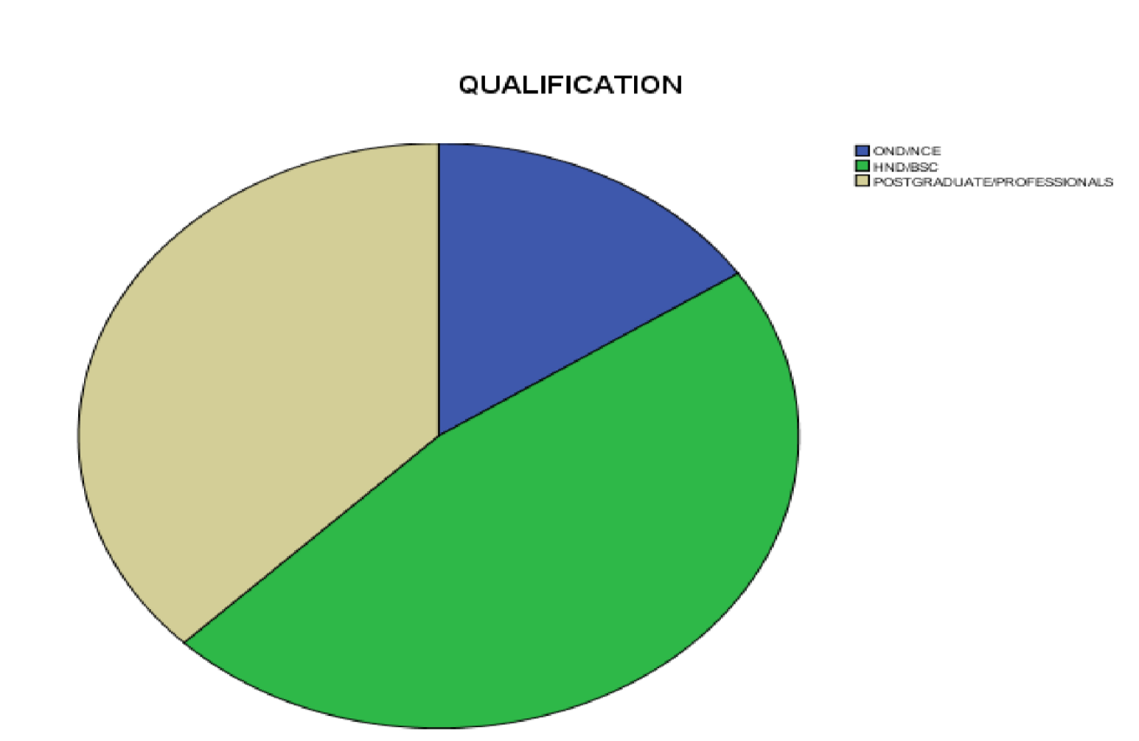
Source: SPSS data result, 2024
Table 4.5.AGE
 |  | Frequency | Percent | Valid Percent | Cumulative  Percent
Valid | 21-30 | 21 | 34.4 | 34.4 | 34.4
Valid | 31-40 41-ABOVE | 24 | 40.6 | 40.6  25.0 | 75.0
Valid | 31-40 41-ABOVE | 15 | 25.0 | 40.6  25.0 | 100.0
Valid | Total | 60 | 100.0 | 100.0
Source: Field survey, 2025
Table 4.5 shows that out of 60 respondents. 24 respondents were between the age of 31-
40yrs has 40.6% are the dominants, 21 respondents of 34.4% are between the age of 2130yrs, while, 15 respondent of 25.0% are between the age of 40 above.

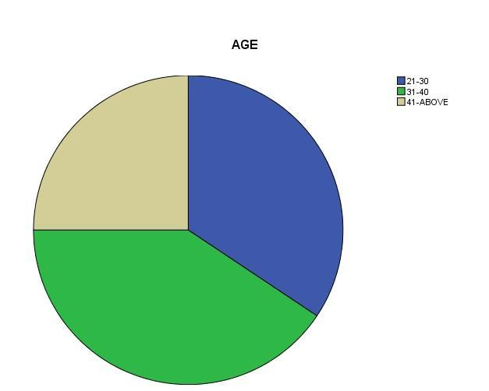

4.2. Presentation of statistical data
Table 4.2.1.
Question 1: Reward programmes adopted by Danco Supermarket influences you to re-visit the store
 |  | Frequency | Percent | Valid Percent | Cumulative Percent
Valid | SD | 4 | 6.7 | 6.7 | 6.7  23.3 30.0  56.7  100.0
Valid | D | 10 | 16.7 | 16.7 | 6.7  23.3 30.0  56.7  100.0
Valid | N | 4 | 6.7 | 6.7 | 6.7  23.3 30.0  56.7  100.0
Valid | A | 16 | 26.7 | 26.7 | 6.7  23.3 30.0  56.7  100.0
Valid | SA | 26 | 43.3 | 43.3 | 6.7  23.3 30.0  56.7  100.0
Valid | Total | 60 | 100.0 | 100.0 | 6.7  23.3 30.0  56.7  100.0
Source: Field survey, 2025
Table 4.2.1. Shows that majority of the respondents representing 43.3% of the respondent population strongly agree to the fact that reward programs influence them to revisit the store. 26.7% agree, 16.7% disagree, 6.7 strongly disagree and 6.7 maintain a neutral position.
Table 4.2.2.
Question 2: Reward Packages Offered by Danco Supermarket induce you to patronize them continuously
 | Frequency | Percent | Valid Percent | Cumulative Percent
Valid D | 8 | 13.3 | 13.3 | 13.3
U | 10 | 16.7 | 16.7 | 30.0
A | 16 | 26.7 | 26.7 | 56.7
SA | 26 | 43.3 | 43.3 | 100.0
Total | 60 | 100.0 | 100.0
Source: Field survey, 2025
Table 4.2.2 showcase that 43% of the respondent population strongly agree, 26.7% agree, 16.7% neutral and 13.3% disagree. This reveals that most of the respondents agree that reward packages offered by Danco supermarket induce them to patronize them continuously. Table 4.2.3.
Question 3: the value of the reward packages influences your buying decision
 |  | Frequency | Percent | Valid Percent | Cumulative Percent
Valid | SD | 2 | 3.3 | 3.3 | 3.3
Valid | U | 8 | 13.3 | 13.3 | 16.7
Valid | A | 30 | 50.0 | 50.0 | 66.7
Valid | SA | 20 | 33.3 | 33.3 | 100.0
Valid | Total | 60 | 100.0 | 100.0
Source: Field survey, 2025
Table 4.2.3 reveal that 50% of the respondents agree that the value of reward programs influence their buying decision, 33.3% strongly agree, 13.3% undecided and 3.3% strongly disagree.
Table 4.2.4.
Question 4 : Danco Supermarket adopt point system as as a means of rewarding their customers
 |  | Frequency | Percent | Valid Percent | Cumulative Percent
Valid | D | 32 | 53.3 | 53.3 | 53.3
Valid | U | 14 | 23.3 | 23.3 | 76.7
Valid | A | 10 | 16.7 | 16.7 | 93.3
Valid | SA | 4 | 6.7 | 6.7 | 100.0
Valid | Total | 60 | 100.0 | 100.0
Source: Field survey, 2025
Table 4.2.4 shows that 53.3% of the respondents’ population disagree that Danco supermarket adopt point system as a means of rewarding them. 23.3% undecided, 16.7 agree while 6.7 strongly agree. This shows that majority of the respondent disagree.
Table 4.2.5.
Question 5: The point system adopted by Danco supermarket glue you to make reparative purchase
 |  | Frequency | Percent | Valid Percent | Cumulative Percent
Valid | SD | 18 | 30.0 | 30.0 | 30.0
Valid | D | 18 | 30.0 | 30.0 | 60.0
Valid | U | 16 | 26.7 | 26.7 | 86.7
Valid | A | 6 | 10.0 | 10.0 | 96.7
Valid | SA | 2 | 3.3 | 3.3 | 100.0
Valid | Total | 60 | 100.0 | 100.0
Source: Field survey, 2025
Table 4.2.5 reveals that 30% of the respondent strongly disagree, 30% disagree, 36.7% undecided, 10% agree and 3.3% strongly disagree.
Table 4.2.6.
Question 6: The point rating used by Danco supermarket trigger you to make reparative purchase.
 |  | Frequency | Percent | Valid Percent | Cumulative Percent
Valid | SD | 16 | 26.7 | 26.7 | 26.7
Valid | D | 14 | 23.3 | 23.3 | 50.0
Valid | U | 16 | 26.7 | 26.7 | 76.7
Valid | A | 6 | 10.0 | 10.0 | 86.7
Valid | SA | 8 | 13.3 | 13.3 | 100.0
Valid | Total | 60 | 100.0 | 100.0
Source: Field survey, 2025
Table 4.2.6 show that most of the respondent representing 26.7% of the respondent population strongly disagree and the same percentage hold undecided position, 23.3% disagree, 10% agree and 13.3% strongly agree.
Table 4.2.7.
Question 7: You are satisfied service rendered by the organization after sales.
 |  | Frequency | Percent | Valid Percent | Cumulative Percent
Valid | D | 3 | 5.0 | 5.0 | 5.0.
Valid | U | 12 | 20.0 | 20.0 | 25.0
Valid | A | 29 | 48.3 | 48.3 | 73.3
Valid | SA | 16 | 26.7 | 26.7 | 100.0
Total |  | 60 | 100.0
Source: Field survey, 2025
Table 4.2.7 shows that 48.3% agree, 26.7% strongly agree, 20% undecided and 5% disagree. Majority of the respondent agree that they are satisfy with after sales service as a non-monetary reward program.
Table 4.2.8.
Question 8: After sales service of Danco supermarket is effective
 |  | Frequency | Percent | Valid Percent | Cumulative Percent
Valid | SD | 2 | 3.3 | 3.3 | 3.3  20.0  46.7  83.3  100.0
Valid | D | 10 | 16.7 | 16.7 | 3.3  20.0  46.7  83.3  100.0
Valid | U | 16 | 26.7 | 26.7 | 3.3  20.0  46.7  83.3  100.0
Valid | A | 22 | 36.7 | 36.7 | 3.3  20.0  46.7  83.3  100.0
Valid | SA | 10 | 16.7 | 16.7 | 3.3  20.0  46.7  83.3  100.0
Valid | Total | 60 | 100.0 | 100.0 | 3.3  20.0  46.7  83.3  100.0
Source: Field survey, 2025
Table 4.2.8 shows that 36.7% of the respondents agree, 26.7% undecided, 16.7% disagree, 16.7% strongly agree and 3.3% strongly disagree.
Table 4.2.9.
Question 9: The after sales service rendered motivate you to continue patronizing Danco Supermarket.
 |  | Frequency | Percent | Valid Percent | Cumulative Percent
Valid | SD | 6 | 10.0 | 10.0 | 10.0
Valid | D | 14 | 23.3 | 23.3 | 33.3
Valid | U | 6 | 10.0 | 10.0 | 43.3
Valid | A | 20 | 33.3 | 33.3 | 76.7
Valid | SA | 14 | 23.3 | 23.3 | 100.0
Valid | Total | 60 | 100.0 | 100.0
Source: Field survey, 2025
Table 4.2.9 showcase that 33.3% of respondent agree that the after sales service rendered by Danco supermarket motivate them to repurchase, 23.3% disagree, 23.3 strongly disagree, 10% strongly disagree and 10% undecided.
Table 4.2.10.
Question 10: Price discount offered by Danco supermarket influence bulk purchase by customers.
 | Frequency | Percent | Valid Percent | Cumulative Percent
Valid SD | 4 | 6.7 | 6.7 | 6.7
D | - | 0 | 0 | 6.7
U | 12 | 20.0 | 20.0 | 26.7
A | 32 | 53.3 | 53.3 | 80.0
SA | 12 | 20.0 | 20.0 | 100.0
Total | 60 | 100.0 | 100.0
Source: Field survey, 2025
Table 4.2.10 shows that 53.3% agree, 20% undecided, 20% strongly agree and 6.7% strongly disagree.
4.4 Discussion of Findings
From the analysis of the data gathered from this research work, it was discovered that there is significant impact of price discount program on customer re-purchase. The findings also revealed that non-monetary reward program (after sales service) has significant impact on customer loyalty as customer tend to glue to organization that offers effective and satisfying after sales service despite the fact that it does not involve any direct or indirect financial reward. The findings of this study therefore shows that there is significant impact of customer reward programs on customer loyalty.
CHAPTER FIVE
SUMMARY, CONCLUSION AND RECOMMENDATIONS
5.0 Introduction
This chapter dwells on the summary of the research work, conclusion of the findings and recommendation.
5.1 Summary
This research work centers on the impact of customer reward programs on customer loyalty, using Danco supermarket in Ilorin, Kwara State as case study and the research covers the period of 2020 to 2023.
To examine the impact of reward programs in enhancing customer loyalty, the research work divided the study into five chapter which focus on introduction to the study, literature review, methodology, data presentation, analysis and discussion of findings, and summary, conclusion and recommendation.
From the outcome of data gathered through questionnaire and interview and analyzed using regression and correlation (SPSS) analytical tools, it reveals that discount price and non-monetary reward (after sales service) have significant impact in enhancing customer loyalty.
5.2 Conclusion
The success of firms in today’s competitive market environment largely depends on their ability to attract and retain loyal customers, because it is generally well known that there is a positive relationship between customer loyalty and profitability.
In conclusion, the result of the study showed that all customer reward programs are significant in building and upholding customer loyalty. Non-monetary reward and price discount according to the findings are more effective in increasing customer patronage and customer loyalty. The study maintain a neutral position regarding the effectiveness of point system as a reward program because the adopted case study do not adopt point system as a reward tool.
5.3 Recommendations
Organizations that has adopted reward programs as a means to reward and enhance the loyalty of their existing customer and attract new ones should improve in doing so and for organizations that has not, they should plan to do so because it has been hypothetically proven that customer reward programs has significant impact in enhancing customer loyalty. And in today’s world of intensive competition with rapid growth in information and technology which poses threats and opportunities to organizations, organizations must ensure to gain and maintain the loyalty of their customers in order to survive and ensure continuous profit.
Organizations must know how to initiate reward programs that will reflect the customer’s shopping attitudes and value, in order to keep them loyal to the business and create a life time customer. Firms need to keep using all forms of customer reward programs as the findings has reveal a vivid impact on customer loyalty. Due to the fact that customers differ in their preferences and values, the distinctive reward programs should be segmented according the preferences and values of the target customers. Reward programs should focus on retaining customers due to their role in recommending the company to their friends and relatives through the positive word of mouth. And retaining customers is less expensive than acquiring new ones. Customers should be duly informed about all available reward programs and how to go about it. A transparent feedback system should be develop and listening to customer views and suggestions.

REFERENCES
Aaker, D.A. (1991), Brand equity, New York NY: The free press.
Ball, D., Coelho, P.S & Machás, A. (2004). The role of communication and trust in explaining customer loyalty, European Journal of Marketing, Vol. 38 No. 9/10 pp. 1272-1293
Bobâlcă, C. (2013). Study of customers’ loyalty: dimensions and facets. Management Marketing, volume XI, issue 1/2013, p.p.104-114. 6.
Bose, S., & Rao, V.G. (2011). Perceived benefits of customer loyalty programs: Validating the scale in the Indian context. Management & Marketing Challenges for the Knowledge Society Vol. 6, No. 4, pp. 543-560.
Bowen, J.T. and Chen, S. (2001). The relationship between customer loyalty and customer satisfaction, International Journal of Contemporary Hospitality
Management, Vol. 13 No. 5 pp. 213-217
Bowen, J. & Shoemaker, S. (1998). "Loyalty: a strategic commitment", Cornell Hotel and Restaurant Administration Quarterly, Vol. 2 No. February, pp.12-25
Chaudhuri, A. & Holbrook, M.B. (2001), "The chain of effects from brand trust and brand affect to brand performance: the role of brand loyalty", Journal of Marketing, Vol. 65 No.2, pp.81-94.
Clark P (2010). “The 15 Business Benefits of a Loyalty Initiative”, The Wise Marketer.
Curry, J. (2000). The customer marketing method: how to implement and profit from customer relationship management, New York: Free Press
Duffy, D. L. (1998). Customer loyalty strategies, journal of consumer marketing, vol. 15 no.5 pp. 435-448
Duffy, D. L. (2003), Internal and external factors which affect customer loyalty, Journal of Consumer Marketing, vol. 20 No. 5 pp. 480-485
Dwyer, F.R., Schurr, P.H & Oh, S. (1987). "Developing buyer-seller relationships", Journal of Marketing, Vol. 51 No.1, pp.11-27.
East R, Philip G, Kathy H & Wendy L, (2005). “Consumer Loyalty: Singular, Additive or Interactive?” Australasian Marketing Journal 13 (2), p 10-26.

