SOLAR INTEGRATED WIRELESS SENSOR NETWORKS FOR REMOTE ENVIRONMENTAL MONITORING

BY
OLADIPUPO ABDULGA OLAMILEKAN
HND/23/COM/FT/0339

A Project Submitted to the Department of Computer Science, Institute of Information and Communication Technology, Kwara State Polytechnic, Ilorin

In Partial Fulfillment of the Requirements for the Award of National Diploma (ND) in Computer Science

June, 2025
CERTIFICATION
This is to certify that this project was carried out by OLADIPUPO ABDULGAFAR OLAMILEKAN Matric Number HND/23/COM/FT/0339 as part of the requirements for the award of National Diploma (ND) in Computer Science.

………………………………. ……………………………….
Dr. (Mrs.) Dada, O. M. Date
(Project Supervisor)

………………………………. ……………………………….
Mr. Oyedepo, F. S. Date
(Head of Department)

………………………………. ……………………………….
External Examiner Date

DEDICATION
This project is dedicated to the creator of the earth and the universe, the Almighty God. It is also dedicated to my parents for their moral and financial support.

ACKNOWLEDGEMENTS
All praise is due to the Almighty God, the Lord of the universe. I praise Him and thank Him for giving me the strength and knowledge to complete my ND programme and also for my continued existence on earth.
I appreciate the utmost effort of my supervisor,( Dr. (Mrs.) Dada, O. M.,) whose patience support and encouragement were the driving force behind the success of this research work. She gave useful corrections, constructive criticisms, comments, recommendations, advice and always ensures that an excellent research is done. My sincere gratitude goes to the Head of the Department, (Mr. Oyedepo, F. S.) and other members of staff of the Department of Computer Science, Kwara State Polytechnic, Ilorin, for their constant cooperation, constructive criticisms and encouragements throughout the programme.
Special gratitude goes to my parents MR&MRS OLADIPUPO who exhibited immeasurable financial, patience, support, prayers and understanding during the periods in which I was busy tirelessly in my studies. Special thanks go to all my lovely siblings.
My sincere appreciation goes to my friends and classmates

TABLE OF CONTENTS
Title Page i
Certification ii
Dedication iii
Acknowledgements iv
Abstract v
Table of Contents vi
CHAPTER ONE: GENERAL INTRODUCTION
  - Background to the Study 1
  - Statement of the Problem 3
  - Aim and Objectives of the Study 3
  - Significance of the Study 4
  - Scope of the Study 4
  - Organization of the Report 5
CHAPTER TWO: LITERATURE REVIEW
2.1 Review of Related Works 6
2.2 Review of Related Concepts 10
CHAPTER THREE: RESEARCH METHODOLOGY AND ANALYSIS OF THE EXISTING SYSTEM
  - Research Methodology 14
  - Analysis of the Existing System 15
  - Problems of the Existing System 15
  - Description of the Proposed System 16
  - Advantages of the proposed system 16
CHAPTER FOUR: DESIGN, IMPLEMENTATION AND DOCUMENTATION OF THE SYSTEM
  - Design of the System 17
    - Output Design 17
    - Input Design 21
    - Database Design 23
4.1.4 Procedure Design 25
  - Implementation of the System 25
    - Choice of Programming Language 25
    - Hardware Support 26
    - Software Support 26
  - Documentation of the System 27
    - Program Documentation 27
    - Maintaining the System 27
CHAPTER FIVE: SUMMARY, CONCLUSION AND RECOMMENDATION
  - Summary 28
  - Conclusion 28
  - Recommendation 29
References
Appendices

ABSTRACT
Solar Integrated Wireless Sensor Networks (SIWSNs) are emerging as a transformative technology for remote environmental monitoring. These systems use solar energy to ensure continuous operation, overcoming the limitations of conventional battery-powered networks. This project explores the design, implementation, and evaluation of solar integrated wireless sensor networks, highlighting their effectiveness in monitoring environmental parameters in remote areas. The designed sensor node, equipped with a small PV panel to recharge the Li-Ion battery for feeding the entire system, by means of the different embedded sensors, is capable of detecting environmental parameters, the solar radiation level as well as soil temperature and moisture (i.e. water volume content) values. By addressing challenges such as energy efficiency, data reliability, and scalability, the proposed system demonstrates the potential for enhanced environmental awareness and decision-making.

Keywords: Environment monitoring, wireless sensor Networks, routing, energy conservation, solar power

CHAPTER ONE
GENERAL INTRODUCTION
1.1 BACKGROUND TO THE STUDY
Wireless Sensor Networks (WSNs) have revolutionized environmental monitoring by enabling real-time data collection and analysis. These networks consist of spatially distributed sensors that measure parameters such as temperature, humidity, and pollution levels. Despite their potential, traditional wireless sensor networks face significant challenges, particularly in energy management. Limited battery life often hinders their deployment in remote and inaccessible areas (Lanzolla & Spadavecchia, 2021).
The integration of solar energy into wireless sensor networks offers a viable solution to the energy constraint. Solar-powered wireless sensor networks harness renewable energy, ensuring uninterrupted operation and reducing environmental impact. Remote environmental monitoring plays a crucial role in addressing global challenges such as climate change, deforestation, and disaster management. Efficient monitoring systems provide critical data to researchers, policymakers, and stakeholders. However, implementing such systems in remote areas demands innovative solutions to overcome logistical and technical barriers (Bader, 2019).
El-Bendary (2023) claimed that the rapid advancements in wireless communication and sensor technology have enabled the development of wireless sensor networks for various applications, including agriculture, healthcare, and environmental monitoring. Traditional wireless sensor networks rely on batteries for power, limiting their deployment in remote areas where recharging or replacement is impractical. Solar energy, as a sustainable power source, has the potential to address these challenges. Wireless sensor networks leverage photovoltaic cells to convert sunlight into electricity, providing a renewable and reliable energy source for sensors.
Advances in wireless networking, micro-fabrication and integration (for examples, sensors and actuators manufactured using micro-electromechanical system technology, or MEMS), and embedded microprocessors have enabled a new generation of massive-scale sensor networks suitable for a range of commercial and military applications. The technology promises to revolutionize the way we live, work, and interact with the physical environment. In a typical sensor network, each sensor node operates untethered and has a microprocessor and a small amount of memory for signal processing and task scheduling. Each node is equipped with one or more sensing devices such as acoustic microphone arrays, video or still cameras, infrared (IR), seismic, or magnetic sensors. Each sensor node communicates wirelessly with a few other local nodes within its radio communication range (Vaish, 2020).
Sensor networks extend the existing Internet deep into the physical environment. The resulting new network in order of magnitude is more expansive and dynamic than the current TCP/IP networks and is creating entirely new types of traffic that are quite different from what one finds on the Internet now. Information collected by and transmitted on a sensor network describes conditions of physical environments for example, temperature, humidity, or vibration and requires advanced query interfaces and search engines to effectively support user-level functions. Sensor networks may inter-network with an IP core network via a number of gateways. A gateway routes user queries or commands to appropriate nodes in a sensor network. It also routes sensor data, at times aggregated and summarized, to users who have requested it or are expected to utilize the information. A data repository or storage service may be present at the gateway, in addition to data logging at each sensor. repository may serve as an intermediary between users and sensors, providing a persistent data storage. It is well known that communicating 1 bit over the wireless medium at short ranges consumes far more energy than processing that bit (Liu, 2020).
This project focuses on Solar Integrated Wireless Sensor Networks, which combine advanced energy harvesting technologies with intelligent networking protocols. It investigates the potential of wireless sensor networks in overcoming the barriers. By analyzing existing systems, identifying their limitations, and proposing a novel approach, this study aims to advance the state-of-the-art in environmental monitoring. The proposed system is designed to be robust, energy-efficient, and scalable, addressing the diverse needs of remote monitoring applications.
1.2 STATEMENT OF THE PROBLEM
Despite the promising potential of wireless sensor networks, their adoption in remote environmental monitoring remains constrained by energy limitations. Battery dependency leads to frequent maintenance, high costs, and reduced reliability. Existing systems also face challenges related to data transmission over long distances, environmental harshness, and scalability. There is a need for a sustainable, efficient, and scalable solution to address these challenges.
1.3 AIM AND OBJECTIVES OF THE STUDY
The of this project is to design and evaluate a solar integrated wireless sensor network for effective remote environmental monitoring. The objectives are to:
- develop a solar-powered wireless sensor network for continuous operation;
- implement energy-efficient data transmission protocols;
- evaluate the performance of the proposed system in real-world scenarios; and
- demonstrate the scalability and reliability of the system in diverse environmental conditions.

  - SIGNIFICANCE OF THE STUDY
This project contributes to advancing environmental monitoring technologies by addressing critical energy and operational challenges. The integration of solar energy enhances the sustainability and longevity of wireless sensor networks, reducing maintenance costs and environmental impact. The findings of this research will benefit stakeholders in academia, industry, and policy-making by providing a robust framework for deploying solar integrated wireless sensor network in remote areas.
1.5 SCOPE OF THE STUDY
The project focuses on the design, implementation, and evaluation of solar integrated wireless sensor network for remote environmental monitoring. It addresses energy management, data reliability, and system scalability. The scope includes the development of a prototype system, field testing in diverse environmental conditions, and comparative analysis with existing systems. While the study primarily targets remote monitoring, the findings are applicable to other domains requiring sustainable sensor networks.
1.6 ORGANIZATION OF THE REPORT
The project write-up is organized into five distinct chapters. Chapter one covers general introduction, which contains introduction to the research topic, statement of the problem, aim and objectives, significance of the study, scope of the study and organization of the report. Chapter two covers literature review, which contains review of related past works and the review of general texts. Chapter three explains the project methodology by giving the analysis of the existing system, problems of the existing system, the description of the proposed system, advantages of proposed system and design and implementation techniques used. Chapter four explains the design, implementation and documentation of the system which contain system design output design, input design, database design and procedure design, implementation of the system hardware and software support and documentation of the new system installation procedure, operating the system and system maintenance. Lastly, chapter five explains the summary of the research, recommendations and conclusion.

CHAPTER TWO
LITERATURE REVIEW
2.1 REVIEW OF RELATED WORKS
A lot of research has been conducted on wireless sensor networks. In this chapter, some past journals and articles relating to this topic of study will be reviewed.
Chaudhary and Waoo (2023) worked on wireless sensor network for environmental monitoring. The main objective of the system is to enable real-time data collection, monitoring, and control of physical phenomena and environments. These networks are highly versatile and have a wide range of applications, from monitoring environmental conditions in remote areas to tracking the movement of goods in a supply chain. Wireless sensor network have the potential to revolutionize various industries by providing valuable insights, increasing efficiency, and reducing operational costs.
Al-Dahoud and Belhouchet (2019) conducted a research on remote monitoring system using Wireless Sensor Network (WSN) for solar power panels. The researchers presented a simulation interface for PV Panels. The research problem has been presented by Centre for Development of renewable Energies (CDER)
technicians and operators in Algeria, in order to monitor and detect faults within solar panels, which affect considerably the energy produced by the solar panels. A new solution is proposed to this problem based on installing WSN nodes with appropriate sensors for more often occurred faults on the solar power panels in Algeria. A simulation has been done on nodes distribution and a study for the design of a node with appropriate sensors taking into account the priorities of the
processing faults. Finally, a graphic user interface is designed and adapted to tele-monitoring panels using WSN. The primary results of simulation are very encouraging. A friendly GUI using high level language Wincc was developed to carry out the monitoring tasks.
Roseline and Sumathi (2021) developed a solar power for wireless sensor networks in environment monitoring applications. The paper provided a review of Environment monitoring using Wireless Sensor Networks. The issues related to environment sensor networks is highlighted. The real time applications in environment monitoring are presented with emphasis on energy conservation. Furthermore, in this paper we address the problem of scavenging energy using solar powered devices.
Visconti (2019) implemented a solar powered wireless monitoring system of environmental conditions for early flood prediction or optimized irrigation in agriculture. The paper described the design and realization of a smart electronic system, based on a Wireless Sensor Network, for wide-area monitoring of availability level and rapid changes of the water presence in the monitored soil, in order to guarantee, depending on application, early flood prediction, water savings in the optimized farmland irrigation as well as waste reduction and optimal use of water resources where its availability is low. The designed sensor node, equipped with a small PV panel to recharge the Li-Ion battery for feeding the entire system, by means of the different embedded sensors, is capable of detecting environmental parameters, the solar radiation level and soil temperature and moisture (i.e. water volume content) values. The sensors communicate with a central processing unit located on board, the ESP8266 SoC module, used both as data processing unit and as Wi-Fi transceiver to receive/transmit sensors data; the user near a sensor node, by a tablet or smartphone with an appropriate app, can collect information provided from sensors and share them with all users who use the same app, through peer-to-peer Wi-Fi or other internet connection.
Lanzolla and Spadavecchia (2021) worked on wireless sensor networks for environmental monitoring. The aim of the special issue is to survey and discuss the state of the art, difficulties, innovations, and improvements on environmental data acquisition, monitoring, analysis, and risk assessment and management. Wireless sensor networks (WSNs) allow for innovative and attractive solutions, as well as for pervasive environmental monitoring by providing many important benefits such as real time access to data, coverage of wide areas, long-term monitoring, and system scalability. These networks consist of a large number distributed devices, each including sensing, processing, and wireless communications capabilities, and their uses have greatly improved remote environmental sensing, the monitoring of several physical systems, and risk assessment and management. A total of 11 papers were submitted to this special issue. After a careful peer review process, six of these were finally accepted for publication.
Vaish (2019) application of wireless sensor networks for environmental monitoring and development of an energy efficient hierarchical cluster-based routing. The system uses measurement of temperature and light by the use of Crossbow sensor kit in which there are different nodes/motes placed at different locations. These nodes are having different node identification & they will sense the temperature and light of their surrounding location and send it to the base station node which is connected through USB port to the computer by the use of MoteView and MoteConfig environment. The data acquisition board that we have
used is MDA100CB (Mote Data Acquisition). The programming of the sensor nodes is done by MoteConfig and live data is viewed through MoteView environment. The nodes that we have used are MicaZ, the MDA100CB board is fixed over these nodes by means of 51 Input/output pins.

2.2 REVIEW OF GENERAL TEXTS
2.2.1 Overview of Wireless Sensor Networks
A wireless sensor network (WSN) has important applications such as remote environmental monitoring and target tracking. This has been enabled by the availability, particularly in recent years, of sensors that are smaller, cheaper, and intelligent. These sensors are equipped with wireless interfaces with which they can communicate with one another to form a network. The design of a WSN depends significantly on the application, and it must consider factors such as the environment, the applications design objectives, cost, hardware, and system constraints. We give an overview of several new applications and then review the literature on various aspects of WSNs.
A sensor network system consisting of a large number of small sensors with low
power can be an effective tool for collection and integration of data by each sensor in a variety of environments. The collected data by each sensor node is communicated through the network to a single base station that uses all collected data to determine properties of the data. Clustering sensors into groups, yields that sensors communicate information only to cluster heads and then the cluster heads communicate the aggregated information to the base station (Ramadan & Hesham, 2018).
2.2.2 Overview of Environmental Monitoring
Currently, the world faces unprecedented challenges in environmental monitoring. Therefore, the target is to collect and analyze environmental data in order to avoid any potential risks. In fact, this is an essential aspect of decision makers; however, environmental data is scarce. At the same time, increasing population, urbanization, energy, transportation, and agricultural developments
are the main sources of environmental pollution. In addition, natural disasters, such as earthquakes, floods, tsunamis, and landslides, are sources of environmental phenomena that might affect a large number of people. Moreover, global warming, ocean acidification, and biodiversity loss can also lead to large-scale impacts on the environment.
Furthermore, air and water pollution are considered to be the most serious environmental problems. So, the more the relationship between air and water pollution and human health is understood, the more risk is mitigated. As an individual usually breathes once every three to four seconds, air pollution is considered to be one of the environmental parameters that most directly affects human health. In fact, toxic gases, such as sulfur dioxide (SO2), nitrogen oxides (NOx), zone, etc., are the pollutants produced by industrial activities and/or road transportation. In addition to atmospheric air pollution, indoor air pollution from burning traditional fuels in small spaces poses serious health risks. It has been discovered that the most effected humans are the women and girls involved in cooking over wood and charcoal. This problem appears especially in undeveloped countries where modern sources of energy are not available and the common fuels are wood, agricultural residues, animal dung, charcoal, and coal.
On the other hand, water is the main source of life for humans, plants, and all living creatures. Therefore, large agencies, including government agencies, industry, academic researchers, and a wide variety of private organizations, dedicate significant resources to monitoring, protecting, and restoring water resources and their watersheds. The main sources of water pollution involve untreated sewage, chemical discharge, petroleum leaks and spills, dumping in old mines and pits, and agricultural chemicals that are washed off or seep into the ground from farms. However, water-quality monitoring for large water surfaces is not an easy task. Each one of the important parameters reflecting water quality has a measuring sensitivity level, such as temperature, pH, conductivity, dissolved oxygen, nitrogen, and phosphorous. Water security is another challenge in environmental monitoring in which the increasing population and growth of urbanization, especially in developing countries, increases water demands. In fact, it is expected that by 2030 developing countries will suffer from a shortage of water resulting from the increasing number of the world’s population from one billion to 3.9 billion.
In addition to the water shortage problem, degradation of the land might be an environmental problem as well when soil erosion risk is increasing because of the use of soil to support food production. It is also projected that by the year 2030, the land affected by soil will increase from 20 million km2 to 30 million km2 (Ramadan, 2019).
2.2.3 Wireless Sensor Network vs. Ad hoc Network
A mobile ad hoc network (MANET), sometimes called a mobile mesh network, is a self-configuring network of mobile devices connected by wireless links. Each device in a MANET is free to move independently in any direction, and will therefore change its links to other devices frequently. The difference between wireless sensor networks and ad-hoc networks are outlined below:
  - The number of sensor nodes in a sensor network can be several orders of magnitude higher than the nodes in an ad hoc network.
  - Sensor nodes are densely deployed.
  - Sensor nodes are prone to failures.
  - The topology of a sensor network changes very frequently.
  - Sensor nodes mainly use broadcast communication paradigm whereas most ad hoc networks are based on point-to-point communication.
  - Sensor nodes are limited in power, computational capacities, and memory.
  - Sensor nodes may not have global identification (ID) because of the large amount of overheads and large number of sensors.
  - Sensor networks are deployed with a specific sensing application in mind whereas ad-hoc networks are mostly constructed for communication purpose.
To summarize, the challenges we face in designing sensor network systems and
applications include:-
- Limited hardware: Each node has limited processing, storage, and communication capabilities, and limited energy supply and bandwidth.
- Limited support for networking: The network is peer-to-peer, with a mesh topology and dynamic, mobile, and unreliable connectivity. There are no universal routing protocols or central registry services.
- Limited support for software development: The tasks are typically real-time and massively distributed, involve dynamic collaboration among nodes, and must handle multiple competing events. Global properties can be specified only via local instructions. Because of the coupling between applications and system layers, the software architecture must be codesigned with the information processing architecture (Lanzolla & Spadavecchia, 2021).
2.2.4 Smart Environmental Monitoring: An Overview
Several years ago, digital data loggers replaced the old mechanical mechanisms for environmental monitoring. The digital data loggers are easier to operate and maintain and cheaper than the old mechanisms used to record data at specific intervals and which required human intervention. However, digital data loggers usually provide monitoring at one point only, and in many cases, multiple points need to be monitored. So, several different solutions are used. Recent advances in low-power wireless network technology have created the technical conditions to build multifunctional tiny sensor devices with several types of sensors, such as chemical, optical, thermal, and biological, available to be attached to these wireless sensor devices. WSNs can be used to observe and react according to the physical phenomena of the surrounding environment without the need for human supervision or intervention. So widespread networks of inexpensive wireless sensor devices offer a substantial opportunity for smart environmental monitoring in which the surrounding physical phenomena in certain environments is being monitored more accurately compared to traditional sensing methods.
Accordingly, the word “smart” in “smart environmental monitoring” does not mean only automatic collection without supervision. It means involving ambient intelligence (AmI) in data analysis and decision making. Ambient intelligence (AmI) refers to electronic environments, which are sensitive and responsive to the presence of people, where devices work in concert to support people in carrying out their daily life activities and tasks easily and naturally using information and intelligence that is hidden in the network connecting these devices. As these devices grow smaller and more integrated into the environment, the technology disappears into the surroundings until only the user interface remains perceivable by users. The achievement of AmI largely depends on the technology deployed (e.g., sensors and devices interconnected through wireless networks) as well as on the intelligence of the software used for decision making. The science of AmI has been advanced to become the science covering different fields, such as robotics, WSNs, human–computer interfaces (HCIs), pervasive computing, and artificial intelligence (AI) as shown in Figure 2.1 below.
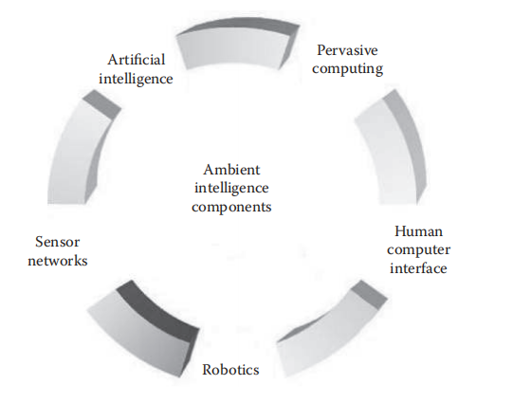
Figure 2.1: Ambient intelligence components.
We can say that ambient intelligence is an extension of AI, in which sensing is added as well as interactivity with the used system. In addition, AmI is closely related to what is called “service science”, in which smart services are introduced to the user. The science of robotics is no longer related to mechanical fields only. Different and smarter robots are designed and introduced to the world. Most current robots look like humans, and new embedded technology makes them walk and think like humans. Some of these robots are mobile, and they are able to move from one place to another. Such robots are usually responsible for searching areas and measuring different environmental parameters. An example of such robots are the ones that explored Mars and were designed to roam its surface. Another type of robots is the rolling robots that have wheels and usually look like cars (Lewis, 2020).
Sensor Network Applications
A sensor network is designed to perform a set of high-level information processing tasks such as detection, tracking, or classification. Measures of performance for these tasks are well defined, including detection of false alarms or misses, classification errors, and track quality. Applications of sensor networks are wide ranging and can vary significantly in application requirements, mode of deployment (e.g., ad hoc versus instrumented environment), sensing modality, or means of power supply (e.g. battery versus wall socket) (Augusto & McCullagh, 2017). Sample commercial and military applications include:
  - Environmental monitoring (e.g. traffic, habitat, security)
  - Industrial sensing and diagnostics (e.g. appliances, factory, supply chains)
  - Infrastructure protection (e.g. power grid, water distribution)
  - Battlefield awareness (e.g. muti-target tracking)
  - Context-aware computing (e.g. intelligent home, responsive environment)
2.2.5 WSN for Environmental Monitoring
Environmental Monitoring-applications are based on the development from data to information to knowledge. Hence, the more meaningful data is obtained, the more knowledge that can be derived. Because data that is gathered through measurement and observation, the measurement system capabilities of WSNs offer several advantages to the field of Environmental Monitoring. Probably the most fundamental is the autonomy of data aggregation. While traditional sampling methods demand increased labor input for larger amounts of samples (e.g., sampling at several locations in the same area), an ideal WSN observes the environment at multiple locations and automatically transmits the data to a gathering point via the networked infrastructure. Furthermore, the autonomous sampling allows for the unobtrusive observation of phenomena and for monitoring in harsh locations and under extreme conditions.
Because the sensing networks are usually directly connected to the operator via the Internet or some type of local connection, data is gathered in real-time or near-real-time. This enables problems to be detected at an earlier stage than in systems with local storage and manual downloading at the end of an acquisition period. In addition, the remote connection to the sensor network means removal of distance between scientist and the monitored site, as the researcher can directly observe what is happening at a particular area of interest. Nevertheless, Environmental Monitoring is an extensive area and different applications impose different requirements on the Wireless Sensor Network. A very useful classification of WSN-applications is made by Barrenetxea et al., who divide them into time-driven, event-driven and query-driven sensor networks. However, as sensing in most applications is time-driven (e.g., by continuous or periodically sampling of the attached sensing devices), the classification mainly describes the network activity in the system. Within these, time-driven applications usually transmit their sensor readings periodically, which is typically used in data gathering applications (Augusto & McCullagh, 2017).

CHAPTER THREE
RESEARCH METHODOLOGY AND ANALYSIS OF THE EXISTING SYSTEM
3.1 METHODOLOGY
The research employs a mixed-methods approach, combining theoretical analysis, system design, and empirical evaluation. The methodology includes:
System Architecture Design
The architecture of the system includes the following components:
a. Solar Power System:
- Solar panels and batteries are selected to meet the energy requirements of the sensors, communication modules, and processing units.
- Energy consumption is analyzed to ensure the system's sustainability over extended periods.
b. Sensor Nodes:
- DHT11 (for temperature/humidity) and MQ135 (for air quality) Sensors are chosen to measure specific environmental parameters.
- Low-power Arduino microcontrollers are integrated for data processing and transmission.
c. Communication Protocol:
- Wi-Fi communication technologies is evaluated for its range, power efficiency, and suitability for remote environments.
d. Data Processing and Transmission:
- A central gateway aggregates data from sensor nodes.
- Algorithms are implemented for preprocessing and transmitting data to cloud-based platforms or local servers. Below is the architecture of smart environmental monitoring system:

Figure 3.2 Basic components of smart environmental monitoring system.
Prototype Development
A prototype is built to validate the system design, comprising:
- A solar-powered energy subsystem with rechargeable batteries.
- Integrated sensors and microcontrollers functioning as sensor nodes.
- Communication modules for data transmission to the central gateway.
- Preliminary testing of power consumption and data transmission reliability.

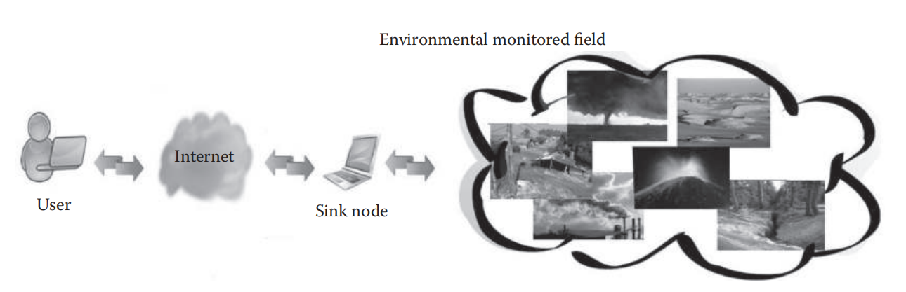
Figure 3.2: Monitoring environmental phenomena using WSNs.
3.2 ANALYSIS OF THE EXISTING SYSTEM
Analysis of the existing system traditional wireless sensor network relies heavily on batteries, leading to frequent maintenance and operational disruptions. Data transmission over long distances often results in signal degradation and energy loss. Additionally, existing systems lack scalability and adaptability to harsh environmental conditions.
3.3 PROBLEMS OF THE EXISTING SYSTEM
The existing wireless sensor network for environmental monitoring has the following problems:
- Limited battery life and high maintenance requirements.
- Inefficient data transmission over extended ranges.
- Inadequate resilience to environmental factors.
- Scalability issues in large-scale deployments.
With the help of solar powered batteries the problems can be overcome.
3.4 DESCRIPTION OF THE PROPOSED SYSTEM
The proposed solar integrated wireless sensor network incorporates solar panels for energy harvesting, advanced sensors for data collection, and optimized communication protocols for energy-efficient data transmission. The system is designed to operate autonomously in remote areas, with features such as real-time monitoring, data redundancy, and fault tolerance.
3.5 ADVANTAGES OF THE PROPOSED SYSTEM
The following are the advantages of the proposed solar integrated wireless sensor network:
- Continuous operation powered by renewable energy.
- Reduced maintenance and operational costs.
- Enhanced data reliability and transmission efficiency.
- Scalability and adaptability to diverse environmental conditions.
- Reduced environmental impact compared to battery-dependent systems.

CHAPTER FOUR
DESIGN, IMPLEMENTATION AND DOCUMENTATION OF THE SYSTEM
4.1 DESIGN OF THE SYSTEM
The design of the solar integrated wireless sensor networks for remote environmental monitoring involves integrating water quality sensors, weather sensors, a microcontroller (such as an Arduino or ESP32), solar panels, batteries, and communication modules (GSM or Wi-Fi) to monitor environments. The microcontroller processes real-time data from the sensors to determine the environments. A mobile app or web interface allows users to remotely monitor and control the system, providing notifications and data logging for analysis. This design ensures efficient and sustainable environment, monitoring weather conditions, air quality, water quality, and natural disasters.
4.1.1 OUTPUT DESIGN
The output design of the solar integrated wireless sensor networks for remote environmental monitoring includes automated control signals from the microcontroller to manage the connections and energy based on sensor data, user notifications for system status and monitoring via user interface, data visualization of real-time and historical trends in change in environment, weather, and water quality through a mobile app or web interface, and detailed system logs of environment data and sensor readings for review and analysis, ensuring efficient and sustainable environment. Things taken into consideration in determining the output are represented below:
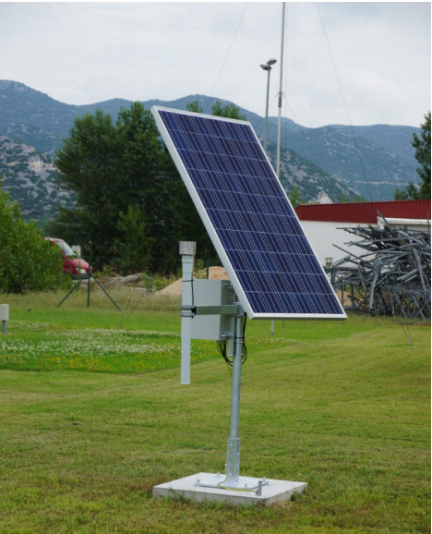
Figure 4.1: Solar integrated wireless sensor networks for remote environmental monitoring
This is the solar integrated wireless sensor networks for remote environmental monitoring with an Arduino Uno which will control the system automatically and data will be acquire by the sensors.
4.1.2 INPUT DESIGN
The input design of the solar integrated wireless sensor networks for remote environmental monitoring incorporates real-time data from water sensors, weather sensors (measuring temperature, humidity, and rainfall), and user-configurable parameters via a mobile app or web interface. This data is processed by a microcontroller, which uses it to determine the environmental condition, ensuring efficient and responsive environmental management.

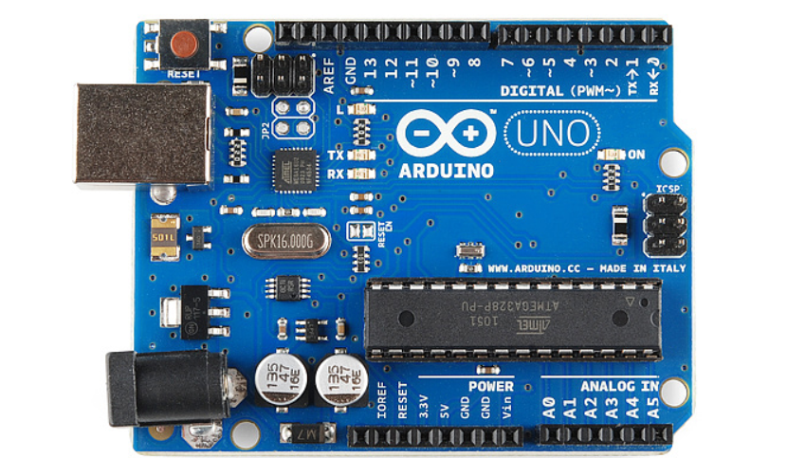
Figure 4.2: Arduino Uno
The microcontroller, such as an Arduino or ESP32, is the central processing unit of the solar integrated sensor system, responsible for collecting data from sensors, processing this data, and facilitating communication with remote user interfaces via built-in or external communication modules like GSM or Wi-Fi.
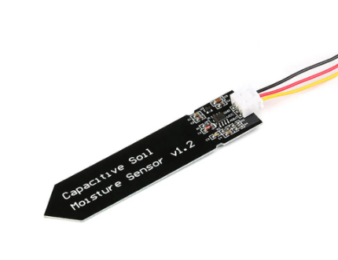
Figure 4.3: Time Domain Transmissometry (TDT) Sensor.
this Time Domain Transmissometry (TDT) sensor measures the time it takes for a pulse to travel through a looped or closed-circuit rod, providing information about the medium's dielectric properties.
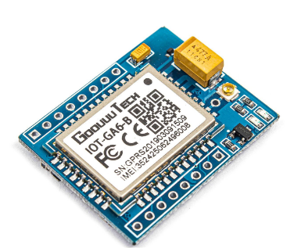
Figure 4.4: GSM or Wi-Fi Module
A GSM or Wi-Fi module enables the wireless sensor network system to communicate with remote user interfaces, allowing for real-time monitoring, control, and notifications via mobile apps or web interfaces, enhancing the system's accessibility and convenience.
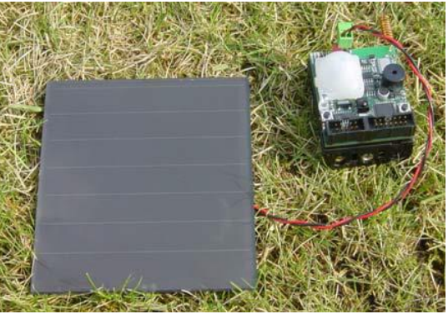
Figure 4.5: Solar panel connected to Sensor Board
4.1.3 PROCEDURE DESIGN
The procedure design of the wireless sensor network for environmental monitoring involves initializing the system components, continuously monitoring real-time data from the environments and weather sensors, processing this data through a microcontroller to assess user needs. The system also includes user interaction through a mobile app or web interface for remote monitoring, configuration, and manual override, ensuring efficient and adaptive environmental management.
4.2 IMPLEMENTATION OF THE SYSTEM
In the implementation phase, the wireless sensor network for environmental monitoring is constructed and deployed according to the designed specifications. This involves assembling hardware components, such as water sensors, weather sensors, microcontroller, solar panel, and batteries, and connecting them as per the system architecture. Software development entails writing code for the microcontroller to process sensor data, determine environmental condition, and interface with user applications. Thorough testing is conducted to verify system functionality and ensure reliable operation under various conditions. Once tested, the system is deployed in the field, with user interfaces configured for remote monitoring and control. Ongoing maintenance and updates are performed to sustain optimal performance and address any issues that arise, ensuring efficient and sustainable environmental management.
4.2.1 CHOICE OF PROGRAMMING LANGUAGE
For the wireless sensor network for environmental monitoring, the choice of programming language is pivotal to ensure efficient communication between hardware components, data processing, and user interface development. Therefore, the programming language selection plays a crucial role in the system's functionality and scalability. Commonly, a combination of languages is utilized:
In the implementation of the wireless sensor network for environmental monitoring, the primary programming language chosen is C/C++, renowned for its efficiency and suitability for embedded systems programming. C/C++ facilitates direct hardware interaction and memory management, crucial for microcontroller-based applications.
4.2.2 HARDWARE REQUIREMENT
The hardware requirements for the wireless sensor network for environmental monitoring encompass a range of components to facilitate sensor data acquisition, processing, and control of weather equipment. Here's an overview:
- Microcontroller: A central processing unit such as Arduino or ESP32, responsible for collecting sensor data, making irrigation decisions, and controlling water pumps and valves.
- Water Sensors: These sensors measure soil moisture levels to determine when irrigation is required. Multiple sensors may be deployed throughout the irrigation area for comprehensive coverage.
- Weather Sensors: Including temperature, humidity, and rainfall sensors to gather environmental data, enabling the system to adjust irrigation schedules based on weather conditions.
- Power Supply: Reliable power sources such as batteries, or mains power adapters to ensure continuous operation of the system.
- Communication Module: Optional GSM or Wi-Fi module for remote monitoring and control, allowing users to access the system from a mobile app or web interface.
- Enclosure: Protective housing to shield components from environmental factors such as moisture, dust, and temperature fluctuations.
- Mounting Hardware: Brackets, screws, and other fixtures to securely install sensors, microcontroller, and batteries in water area.
4.2.3 SOFTWARE REQUIREMENT
The software requirements for the wireless sensor network for environmental monitoring encompass various components for data processing, control logic, user interface development, and remote monitoring capabilities. Here's an overview:
- Microcontroller Programming: Code written in C/C++ to run on the microcontroller (e.g., Arduino or ESP32), responsible for collecting sensor data and implementing weather algorithms.
- User Interface Development: Development of a user interface for remote monitoring and control. This may include web applications or mobile apps developed using languages like HTML, CSS, JavaScript for web development, or Java/Kotlin for Android apps and Swift for iOS apps.
- Data Processing and Analysis: Algorithms to process sensor data and make decisions based on predefined thresholds and environmental conditions. This may involve statistical analysis, machine learning techniques, or rule-based logic.
- Communication Protocols: Implementation of communication protocols (e.g., Wi-Fi, GSM) to enable remote access to the system from a mobile app or web interface.
- Database Management: Database management system (DBMS) to store historical sensor data and user preferences. This facilitates data logging, analysis, and reporting.
- Error Handling and Logging: Mechanisms to handle errors, log system events, and generate alerts or notifications for users in case of abnormalities or malfunctions.
4.3 DOCUMENTATION OF THE SYSTEM
4.3.1 Program Documentation
Program documentation for the wireless sensor network for environmental monitoring encompasses detailed explanations and instructions to facilitate system understanding, maintenance, and further development. This documentation includes comprehensive comments within the source code, providing clarity on the purpose, functionality, and usage of each module, function, and variable. Additionally, documentation includes user manuals and guides detailing system installation, configuration, and operation, ensuring users can effectively utilize the system's features and functionalities. Technical documentation outlines system architecture, hardware specifications, software components, and communication protocols, aiding developers in troubleshooting, debugging, and extending system capabilities. Through meticulous program documentation, the wireless sensor network for environmental monitoring is equipped with the necessary resources to ensure smooth implementation, operation, and ongoing maintenance, fostering efficient environment management practices and sustainable environment.
4.3.2 Maintaining of the System
Maintaining the wireless sensor network for environmental monitoring involves ongoing efforts to ensure its reliability, efficiency, and effectiveness in managing environmental resources for human use. This includes regular inspection and calibration of sensors to ensure accurate data collection, monitoring system performance to detect and address any issues or malfunctions promptly, and updating software and firmware to incorporate new features, optimize algorithms, and address security vulnerabilities. Additionally, routine maintenance of hardware components such as the microcontroller, sensors, and communication modules is essential to prevent breakdowns and ensure continuous operation. User training and support are provided to ensure operators understand how to use the system effectively and troubleshoot common issues. By implementing proactive maintenance practices, the wireless sensor network for environmental monitoring can sustain optimal performance, conserve energy, and support sustainable environment over the long term.

CHAPTER FIVE
SUMMARY, CONCLUSION AND RECOMMENDATIONS
5.1 SUMMARY
This project proposes a novel approach to remote environmental monitoring by integrating solar energy into wireless sensor networks. The proposed solar integrated wireless sensor networks address critical challenges such as energy management, data reliability, and system scalability. Through a combination of theoretical analysis, system design, and empirical evaluation, the study demonstrates the feasibility and advantages of the proposed system. This developed system represents a promising solution for remote environmental monitoring. By leveraging renewable energy and advanced networking technologies, solar integrated wireless sensor networks offer a sustainable, efficient, and reliable approach to environmental data collection. The findings of this project contribute to the advancement of wireless sensor networks technologies and their applications in addressing global environmental challenges.

5.2 CONCLUSION
For smart environmental monitoring, integrating WSNs in the environment itself will considerably raise the degree of environmental protection, enabling a lot of new intelligent features for that environment, such as self-monitoring and self-protection and the possibility of both reactive and proactive reactions to different events. To implement these features, it is necessary to work not only on the development of new sensor units and communication between them, but also on the development of new procedures and algorithms for environmental data collection, analysis, and verification.
Smart environmental monitoring systems adapt to changing conditions and intelligently communicate with phenomena in order to obtain certain observations and take certain actions accordingly. Their design and implementation require multidisciplinary knowledge of human-machine interfaces, decision-making, databases, wireless sensor networking, multimedia, and pervasive computing.
Research on smart environmental monitoring has recently made great strides, and for the first time, data of different types and places can be merged together and accessed from anywhere. However, a number of ongoing challenges remain.
5.3 RECOMMENDATIONS
Based on the findings of this project, the following were recommended:
- Further research should be conducted on integrating advanced energy storage technologies to complement solar power.
- Development of adaptive communication protocols for enhanced performance in dynamic environments.
- Deployment of solar integrated wireless sensor networks in various applications beyond environmental monitoring, such as agriculture and disaster management.
- Collaboration between researchers, policymakers, and industry stakeholders to standardize and scale solar integrated wireless sensor networks technologies.

REFERENCES
Wireless Sensor Networks, Retrieved From: https://inlportal.inl.gov/portal/server.pt/community/robotics_and_intelligence_systems/455. On April, 22, 2015.
Al-Dahoud, A. & Belhouchet, M. F. (2019). Remote Monitoring System using WSN for Solar Power Panels, 2019 First International Conference on Systems Informatics, Modelling and Simulation. Pp. 14-16. DOI 10.1109/SIMS.2014.31
Cardell-Oliver, R., Kranz, M., Smettem, K. & Mayer, K. (2019), A Reactive Soil Moisture Sensor Network: Design and Field Evaluation, International Journal of Distributed Sensor Networks. Vol. 1. Pp. 149–162. VDM Verlag Publisher.
Chaudhary, P. & Waoo, A. (2023). Wireless Sensor Network for Environmental Monitoring, International Research Journal of Modernization in Engineering Technology and Science. Vol. 5. Issue: 11. Pp. 78-79. DOI: https://www.doi.org/10.56726/IRJMETS45853
El-Bendary, N., Fouad, M. M., Ramadan, R. A., Banerjee, S. & Hassanien, A. E. (2021). Smart Environmental Monitoring Using Wireless Sensor Networks, International Journal of Advanced Computer Science and Applications. Vol. 13. Issue: 8. Pp. 123-124. DOI: https://www.doi.org/10.56726/IJACSA45853
Lanzolla, A & Spadavecchia, M. (2021). Wireless Sensor Networks for Environmental Monitoring, In Proceedings of the 28th IEEE Conference on Military communications (MILCOM). Pp. 5-6. IEEE Press, Piscataway, NJ, USA
Lee, S. H., Lee, S., Song, H. & Lee, H. S. (2019), Wireless Sensor Network Design for Tactical Military Applications: Remote Large-scale environments, In Proceedings of the 28th IEEE Conference on Military
Lewis, F. L. (2020), Smart Environments: Technologies, Protocols, and Applications. Pp. 6-7. In Cook, D. J. Das.
Ramadan, R. A. (2019), Deployment of Mobile Heterogeneous Sensors on Critical Infrastructure: Sensor Deployment Problem and Its Solutions. Pp. 13-15. VDM Verlag Publisher.
Ramadan, R. A., Hagras, H., Nawito, M. & Eldesouky A. E. B. (2020), The Intelligent Classroom: towards an Educational Ambient Intelligence Testbed, In Proceedings of the 6th International Conference. Pp. 4-5.
Roseline, R. A. & Sumathi, P. (2021). Solar power for Wireless Sensor Networks in Environment Monitoring Applications, International Journal of Scientific and Research Publications. Vol. 4, Issue: 8. Pp. 102-103. Doi.org/10.1051/e3sconf/202126003010
Stipanicev, D., Bodrozic, L, Stula, M. (2017), Environmental Intelligence Based on Advanced Sensor Networks, In Proceedings of the 14th International Workshop on 2017 IWSSIP and ECSIPMCS, Maribor, Slovenia.
Streitz, N. A., Kameas A. & Mavrommati, I. (Eds.) (2017), The Disappearing Computer, In Lecture Notes in Computer Science. Vol. 4500, Pp. 7-8. Springer.
Visconti, P., Primiceri, P. & Orlando, C. (2021). Solar Powered Wireless Monitoring System of Environmental Conditions for early Flood Prediction or Optimized Irrigation in Agriculture, ARPN Journal of Engineering and Applied Sciences. Pp. 2-4. Philadelphia, PA.

