A PROJECT REPORT

ON

PROPOSED DAY PRIMARY SCHOOL FOR ELEMERE COMMUNITY MORO LOCAL GOVERNMENT, KWARA STATE

BY
IDRIS ABDULGANIYU ONAOLAPO
ND/23/ARC/PT/0059

BEING A RESEARCH PROJECT SUBMITTED TO THE DEPARTMENT OF ARCHITECTURAL TECHNOLOGY, INSTITUTE OF ENVIRONMENTAL STUDIES (IES), KWARA STATE POLYTECHNIC ILORIN, KWARA STATE

IN PARTIAL FULFILLMENT OF THE REQUIREMENTS FOR THE AWARD OF NATIONAL DIPLOMA (ND) IN ARCHITECTURAL TECHNOLOGY

JULY, 2025

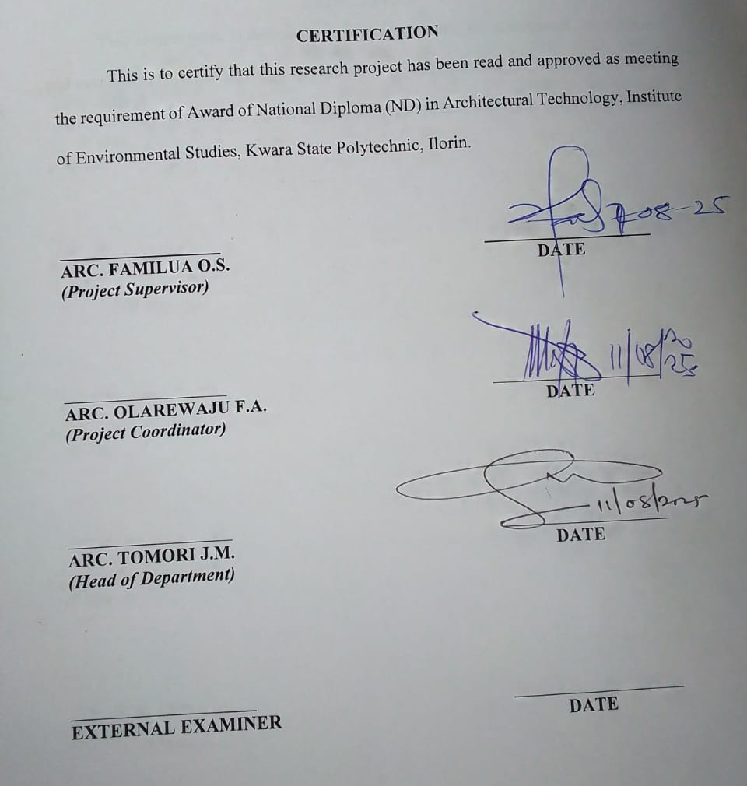

DEDICATION
This project work is dedication to Almighty Allah the omnipotent, omnipresent, and omniscience for his blessings, protection and guidance over me. Also this project is dedicated to my parents for their love and support financially and spiritually, we are indeed grateful.
ACKNOWLEDGEMENT
All praise and adoration is due to Almighty Allah for His unlimited blessings, grace, mercies, and who has also been my rock and source of inspiration throughout this project.
Am using this moment to acknowledged the support and guidance of my amiable project supervisor ARC. FAMILUA O.S. I pray May Almighty Allah reward him abundantly, bless him and his family endlessly and also grant him sufficient health AMEEN.
I must not fail to appreciate my lovely father MR. AND MRS. IDRIS for their guidance and support throughout my education, May Almighty Allah let you live long to reap the fruit of your Labour AMEEN.
My appreciation also goes to all my family and friends who have helped me grow and learn, May Allah bless them for their kindness, patience, and wisdom.
Once again am grateful to GOD for his mercies, loves, and care for the greatest opportunity he gave me to accomplish the task of being a graduate ALHAMDULILLAH

TABLE OF CONTENTS
Title Page i
Certification ii
Dedication iii
Acknowledgment iv
Table of Contents v

CHAPTER ONE

1.0 Introduction 1
1.1 Project Definition 1
1.2 Historical Background 2

1.3 Justification 3

1.4 Aims 3

1.5 Objectives 4

1.6 Client Background, Philosophy 5

1.7 Scope of Study 6

1.8 Limitations of Design 6

1.9 Research Methodology 7
CHAPTER TWO
2.1 Literature Review 8
2.2 Review of all Literature on the Sub-Topic 9
CHAPTER THREE
3.1 Case Study One 12
3.2 Case Study Two 13
3.3 Case Study Three 14
CHAPTER FOUR
4.1 Introduction of Study Area 15
4.2 Site Location /Description 16
4.3 Site Analysis/Inventory 17
4.4 Geographical /Climatic Conditions 18
4.5 Design Criteria 18
4.6 Brief Analysis 20
4.7 Spatial Programme (Requirement and Analysis) 21
4.8 Conceptual Development 23
4.9 Site Concept 25
4.10 Building Concept 33
CHAPTER FIVE
5.1 Project Appraisal 30
5.2 Construction Methodology and Materials 31
5.3 Building Service 34
5.4 Conclusion 36
5.5 Recommendations 37
References 38
Appendix 39

CHAPTER ONE
1.0 INTRODUCTION
Primary School Elemere Community is a vibrant educational institution dedicated to nurturing the academic, social, and emotional growth of young learners in the Elemere area. As a cornerstone of the community, the school provides a safe and inclusive environment where children are encouraged to explore, discover, and develop foundational skills essential for lifelong learning. The school emphasizes not only academic excellence but also the development of values such as respect, cooperation, and responsibility.
With a strong commitment to community involvement, Primary School Elemere fosters partnerships between teachers, parents, and local organizations to create a supportive network that enriches the students' educational experience. The school’s programs are designed to cater to diverse learning needs, ensuring that every child has the opportunity to thrive and reach their full potential.
By blending traditional teaching methods with innovative practices, Primary School Elemere Community aims to prepare its students for the challenges of the future while maintaining a nurturing and caring atmosphere.
1.1 PROJECT DEFINITION
The primary objective of this project is to design, construct, and establish a fully functional primary school that provides quality education to children aged 6 to 12 years. The school will serve as a safe, inclusive, and stimulating environment where students can develop essential academic, social, and emotional skills.
- Architectural and structural designs approved by relevant authorities.
- Completed construction of the school building and grounds.
- Furnished classrooms and facilities ready for student use.
- Safety certification and operational permits.
- Staff recruitment and training plans.
- Curriculum implementation plan aligned with educational standards.
1.2 HISTORICAL BACKGROUND
Elemere Community Primary School is situated in the rural town of Elemere, located in the Womi/Ayaki Ward of Moro Local Government Area (LGA) in Kwara State, Nigeria. Elemere is one of the older towns in Kwara, traditionally said to have been founded many years ago by two brothers, Odunbaku and Oyeyemi, who migrated from Oyo to Ilorin and were known as hunter warlords. The town is divided into two parts: Elemere Oke and Elemere Isale, and is led by two community leaders known as Mogaji.
The name "Elemere" is derived from a peculiar river located in the town, assumed to be "omi emere" (meaning "gene water") due to the scarcity of water and the hidden location where the water was found. The community is predominantly known for its cassava production, with cassava plantations occupying a significant portion of the land.
Elemere Community Primary School serves as an educational institution for the children of the town and surrounding areas. While specific historical details about the founding and development of the school are limited, it plays a crucial role in providing primary education to the local population.
In recent years, there have been efforts to enhance educational resources in the area. For instance, in February 2023, Kwara State University donated internet access and electronic information resources to Elemere Secondary School, located within the same community. This initiative aimed to improve access to educational content and train staff on utilizing the internet for educational purposes.
1.3 JUSTIFICATION
- Foundation of Education: Primary school education provides the essential building blocks for literacy, numeracy, and basic knowledge necessary for further learning.
- Child Development: It supports the holistic development of children—intellectual, social, emotional, and physical.
- Community Growth: A local primary school promotes community development by increasing literacy rates and empowering families.
- Accessibility: Establishing a primary school within the community ensures that children have easy access to education, reducing dropout rates due to distance or lack of facilities.
- Equity: It helps bridge educational gaps by providing opportunities for all children, including those from disadvantaged backgrounds.
- Long-term Impact: Early education is linked to better outcomes in secondary education, employment, and civic engagement.
1.4 AIMS
- To provide quality and inclusive basic education to children aged 6 to 12 years.
- To nurture the intellectual, social, emotional, and physical development of every child.
- To develop foundational skills in literacy, numeracy, critical thinking, and communication.
- To foster moral values, creativity, and a positive attitude towards lifelong learning.
- To create a safe, supportive, and stimulating learning environment.
- To promote community involvement and partnership in education.

1.5 OBJECTIVES
- To create a learning environment that supports academic excellence and personal growth.
- To ensure the safety and well-being of students and staff through appropriate infrastructure and policies.
- To foster a sense of community and collaboration among students, teachers, parents, and local stakeholders.
- To design flexible spaces adaptable to evolving educational needs and technologies.
1.6 CLIENT BACKGROUND, PHILOSOPHY
The client is the local education authority (such as a school board, government education department, or community education committee) responsible for providing accessible, quality primary education within the community. Their mission is to ensure that all children in the region have the opportunity to attend school in a safe and nurturing environment that fosters academic achievement and personal growth.
The client is committed to supporting educational initiatives that align with national curriculum standards and promote inclusive learning for children from diverse socio-economic backgrounds. They seek to collaborate with educators, parents, and community stakeholders to enhance educational infrastructure, improve teaching quality, and boost student outcomes. Through this project, the client aims to address gaps in educational access and quality within the community, contributing to broader social and economic development.

PHILOSOPHY
The primary school is founded on the philosophy that every child deserves a quality education that respects their unique potential and promotes holistic development. The school believes in nurturing not just academic excellence but also social skills, creativity, moral values, and physical well-being.
Education is viewed as a partnership between teachers, students, parents, and the community, where collaboration fosters an environment of mutual respect and encouragement. The school emphasizes child-centered learning approaches that engage students actively and cater to their diverse learning styles.
The philosophy embraces inclusivity, ensuring that children of all abilities and backgrounds have equal opportunities to learn and succeed. It promotes a safe, supportive atmosphere where curiosity is encouraged, critical thinking is developed, and lifelong learning habits are instilled.
1.7 SCOPE OF STUDY
- Design and construction of classrooms, administrative offices, playgrounds, and support facilities such as libraries, restrooms, and staff rooms.
- Incorporation of child-friendly and accessible design features to accommodate all students, including those with special needs.
- Provision of necessary educational resources and equipment to facilitate effective teaching and learning.
- Implementation of safety measures and compliance with local building codes and educational regulations.
- Establishment of recreational and outdoor spaces to promote physical activity and holistic development.
- Integration of community involvement and parent engagement areas.
1.8 LIMITATION OF DESIGN
- Budget Constraints: Limited funding can restrict the quality and quantity of materials, finishes, and facilities included in the design, affecting durability, aesthetics, and available resources.
- Site Restrictions: The physical size, shape, and topography of the site may limit the building layout, outdoor play areas, and future expansion possibilities.
- Regulatory Compliance: Strict building codes, safety regulations, and educational facility standards can impose design limitations, sometimes leading to compromises in space usage or aesthetics.
- Accessibility Challenges: Retrofitting older buildings or designing in constrained areas to fully comply with accessibility standards for children with disabilities can be difficult and costly.
- Environmental Factors: Local climate conditions (extreme heat, heavy rains, flooding) may limit certain architectural features or require additional design measures (like drainage systems or shading).
- Flexibility vs. Functionality: Designing spaces that are flexible for multiple uses may reduce their effectiveness for specific functions, such as specialized classrooms or quiet study areas.
- Technology Integration: Incorporating current technology infrastructure might be limited by budget or existing structural conditions, affecting the ability to support digital learning tools.
- Community and Cultural Expectations: Sometimes, cultural or community preferences can restrict innovative or modern design approaches, favoring traditional layouts that may not optimize learning.
- Time Constraints: Project timelines may limit thorough design development, testing, or the incorporation of sustainable and innovative features.
1.9 RESEARCH METHODOLOGY
The study will adopt a mixed-methods approach, combining both qualitative and quantitative research methods to obtain a comprehensive understanding of the educational environment, challenges, and outcomes at the primary school.

CHAPTER TWO
2.1 LITERATURE REVIEW
Primary education is widely recognized as the foundation of lifelong learning and personal development. It encompasses the first formal stage of schooling, typically for children aged 6 to 12, and aims to equip learners with essential skills in literacy, numeracy, social interaction, and critical thinking.
Primary education in rural Nigerian communities like Elemere plays a pivotal role in the socio-economic development of the area. The availability and quality of primary schools directly affect literacy rates, skill acquisition, and future opportunities for children in such communities.
Numerous studies highlight the critical role primary education plays in individual and societal progress. According to UNESCO (2020), access to quality primary education reduces poverty, promotes gender equality, and fosters sustainable development. Early education enhances cognitive development and sets the stage for higher educational attainment (Heckman, 2011).
Effective primary education relies on age-appropriate, inclusive curricula that balance academic content with social and emotional learning. Vygotsky’s social development theory emphasizes the importance of social interaction in learning, which has influenced many child-centered teaching approaches (Vygotsky, 1978). Active learning, cooperative learning, and the use of technology have been shown to improve student engagement and outcomes (Hattie, 2009).
Despite progress, challenges persist in many regions, especially in rural and low-income communities. Common issues include inadequate infrastructure, insufficient qualified teachers, large class sizes, and lack of teaching materials (World Bank, 2018). Gender disparities and socio-economic factors also affect enrollment and retention rates (Lewin, 2007).
Research shows that strong collaboration between schools, families, and communities enhances student achievement and well-being (Epstein, 2011). Parental involvement in homework, school governance, and learning activities positively correlates with improved academic performance and attendance (Fan & Chen, 2001).
Recent studies advocate for integrating technology, personalized learning, and inclusive education practices in primary schools to address diverse learning needs (UNICEF, 2022). The Sustainable Development Goals (SDGs) emphasize inclusive, equitable quality education to ensure no child is left behind.
2.2 REVIEW OF ALL LITERATURE ON THE SUB-TOPIC

1. Importance of Primary Education
Primary education is universally acknowledged as the foundation of formal education systems. Literature consistently emphasizes its role in literacy, numeracy, and the development of essential life skills. Heckman (2011) demonstrated that early educational investments yield high returns in human capital development, affecting social and economic outcomes later in life. UNESCO (2020) links universal primary education to reduced poverty, improved health, and enhanced gender equality.

2. Curriculum and Pedagogical Approaches
Research highlights the need for curricula that are age-appropriate, inclusive, and culturally relevant (UNICEF, 2019). Pedagogical strategies such as child-centered learning, cooperative learning, and active engagement are shown to improve academic outcomes (Hattie, 2009). Vygotsky’s social development theory (1978) underpins many approaches by emphasizing interaction and scaffolding in learning.

3. Challenges in Primary Education
Common challenges documented in the literature include inadequate infrastructure, insufficiently trained teachers, overcrowded classrooms, and lack of instructional materials (World Bank, 2018). Socio-economic factors such as poverty and gender disparities further exacerbate access and retention issues (Lewin, 2007). Rural areas, in particular, experience more pronounced challenges (Ajayi & Ojo, 2019).

4. Role of Community and Parental Involvement
Epstein (2011) and Fan & Chen (2001) highlight that parental engagement positively influences attendance, behavior, and achievement. Community involvement fosters ownership and resource mobilization, especially in rural primary schools where government support may be limited.

5. Infrastructure and Learning Environment
Studies show that adequate physical facilities—classrooms, sanitation, water supply, and play areas—are critical for effective learning (Adeniran, 2018). Poor infrastructure contributes to absenteeism and low academic performance. Sustainable school design is increasingly recognized as important for health and environmental reasons.

6. Integration of Technology
Recent literature explores the growing role of ICT in primary education, especially in bridging rural-urban educational gaps (UNICEF, 2022). Access to digital resources enhances learning opportunities, although infrastructural and training challenges remain significant barriers in low-resource settings.

7. Case Studies: Rural Primary Schools
Specific studies on rural schools, such as Elemere Community Primary School in Kwara State, Nigeria, illustrate the compounded effects of limited resources, socio-economic challenges, and infrastructural deficits (ResearchGate, 2022). However, community efforts and donor interventions can mitigate some of these challenges, highlighting the importance of multi-stakeholder collaboration.

CHAPTER THREE
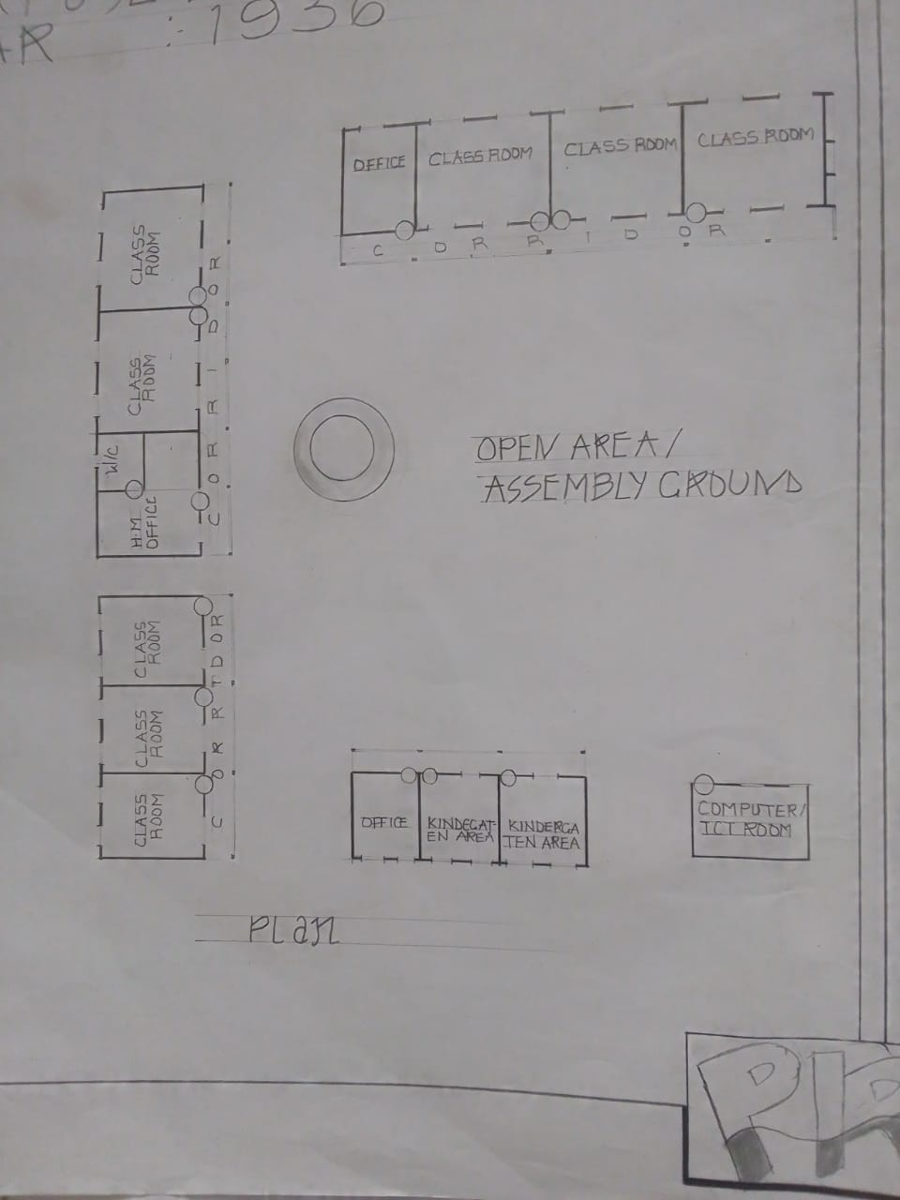
3.1 CASE STUDY ONE

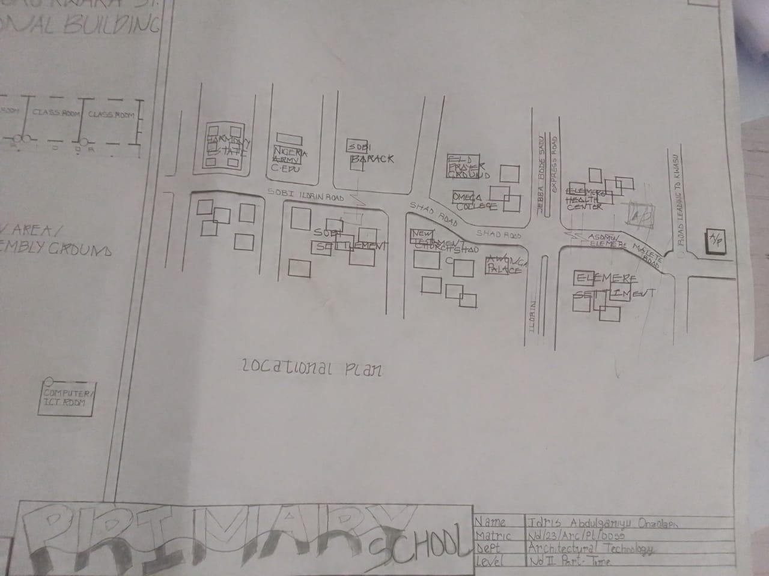

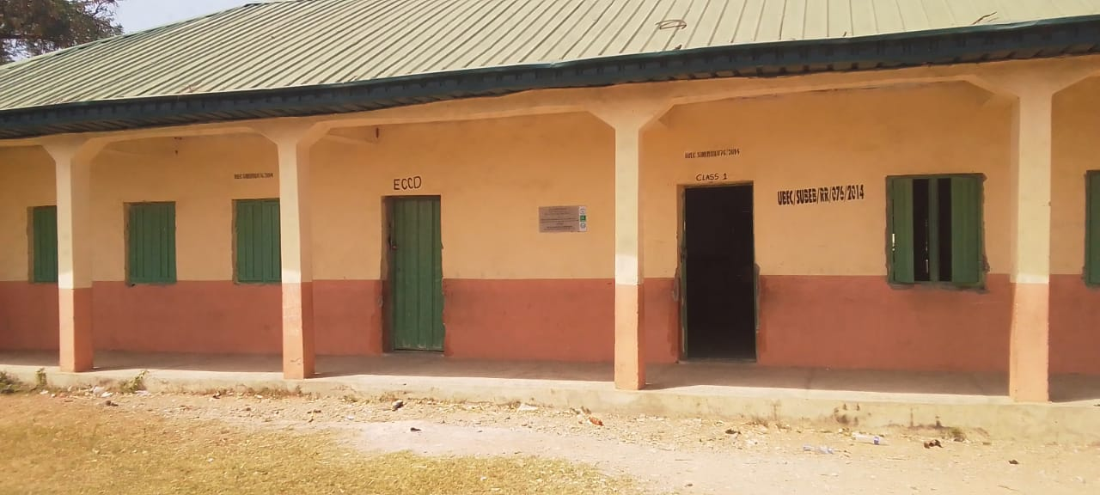

Case Study 1
Name: L.G.E.A PILOT SCHOOL
LOCATION: MALETE MORO LGA KWARA STATE.
PURPOSE: Educational Building
YEAR: 1936

MERITS
1. The school serves as community primary school preparing children for the future
2. Availability of land for future use
3. It is situated at the center of the community

DEMERITS
1. There is no hard and soft land scape
2. There is no provisions of toilet for the staff and the student
3. Classes are not in equal proportion

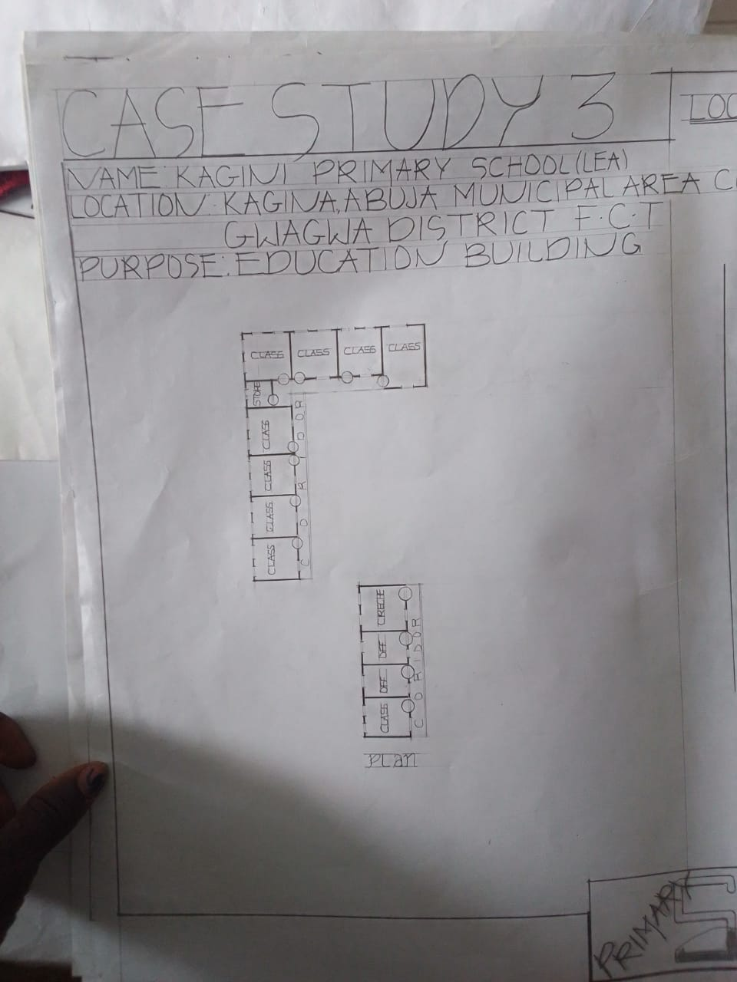
3.2 CASE STUDY TWO

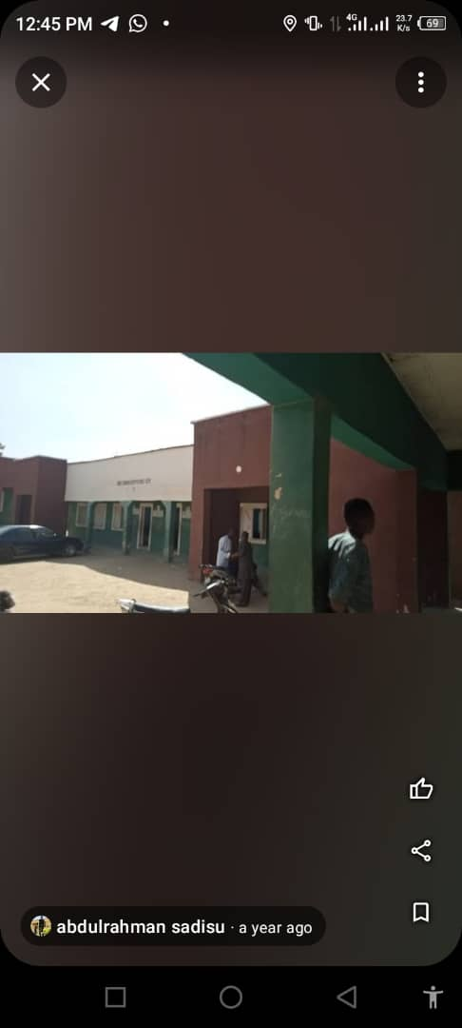

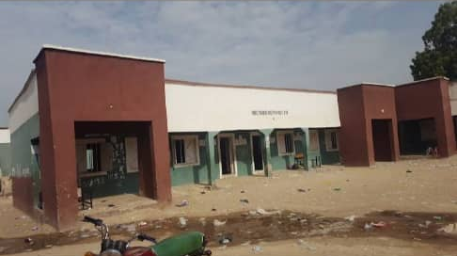
CASE STUDY 2
Shadawanka primary school
Location: Darazo road Bauchi L.G.A Bauchi
Purpose: Educational Building
Year: Unknown
MERITS
1. The school is in a serene environment which is conducive for learning.
2. Availability of land for future use.
3. Classes are in balance proportion to aid ventilation
DEMERITS
1. There is no provision for office for the staff
2. There is no availability of soft landscape
3. The classes are old

3.3 CASE STUDY THREE
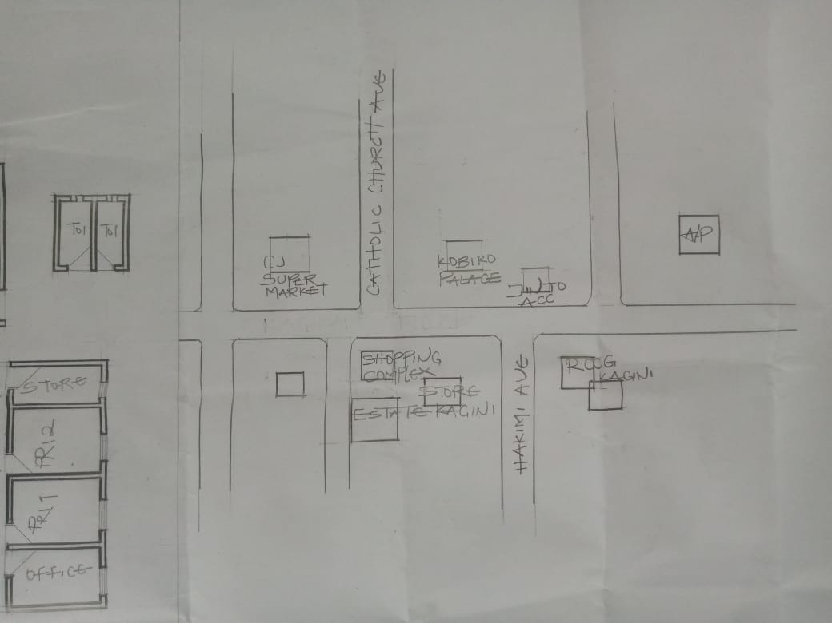

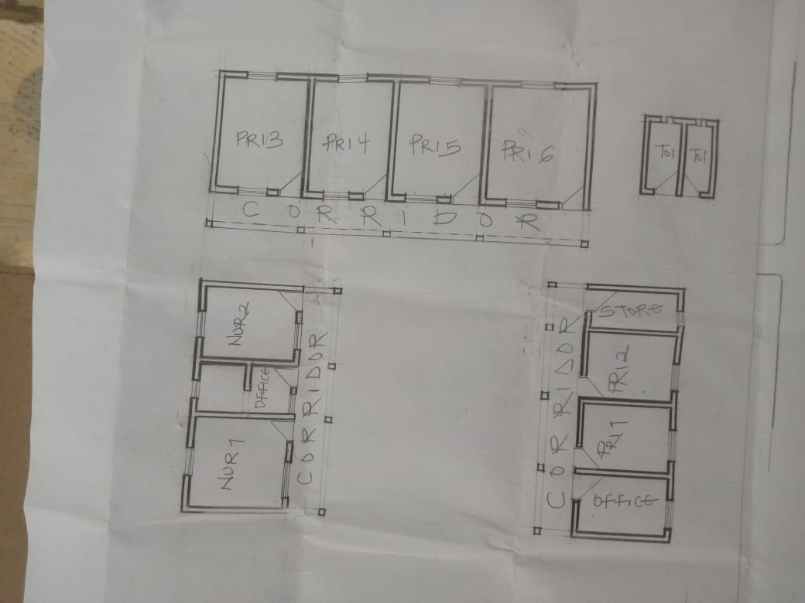

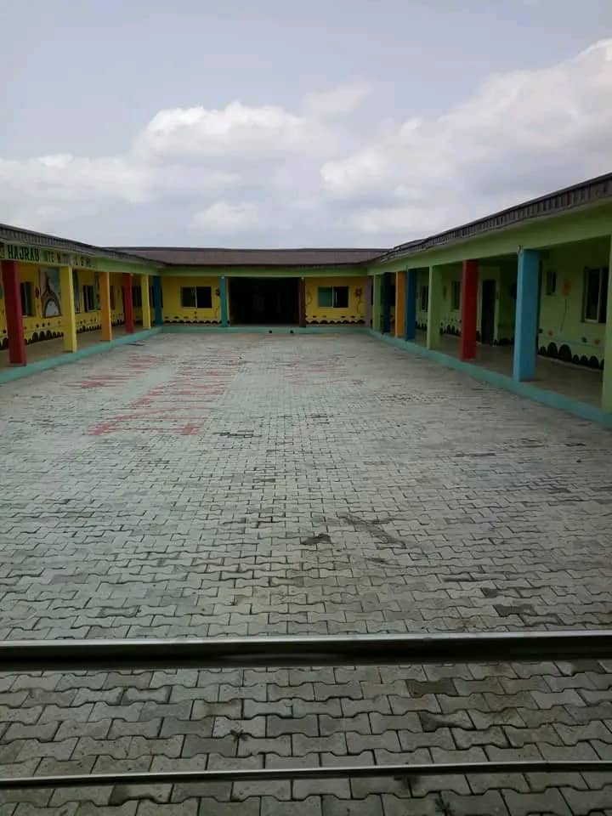
Case Study 3
Name: Kagini Primary School
Location: Kagini Abuja Municipal Area Gwagwa District Fct
Purpose: Educational Building
MERITS
1. It is in a conducive environment
2. Classes are in good condition
DEMERITS
1. They are not enough classes for pupils
2. They are not availability of toilet for staff and pupils
3. They are not availability of land for future use.

ONLINE CASE STUDY
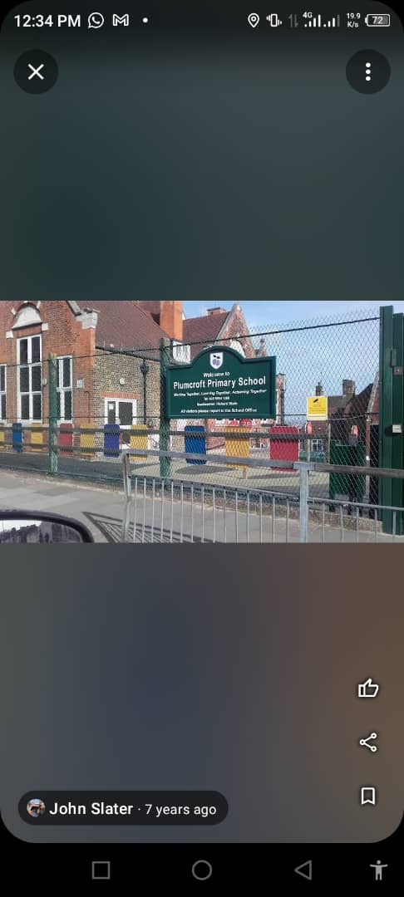
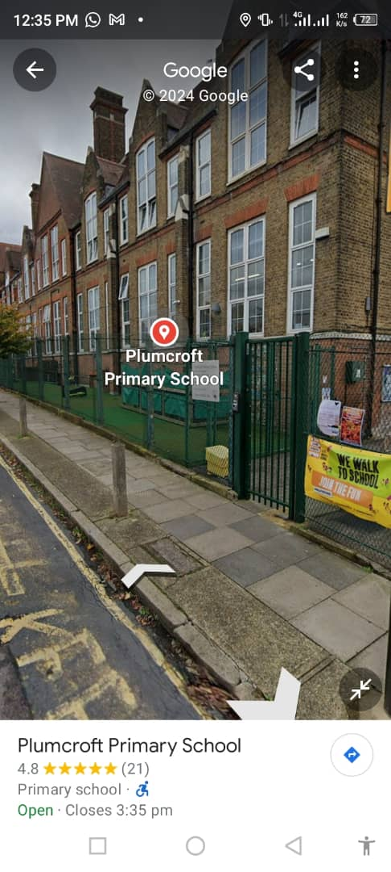

Case Study 4
Plumcroft Primary School
Location: London SE 183 HW United Kingdom
Merits
1. It is conducive for learning
2. It is easily accessible
Demerits.
1. No land for future use
2. There is no availability of hard landscape

ONLINE CASE STUDY


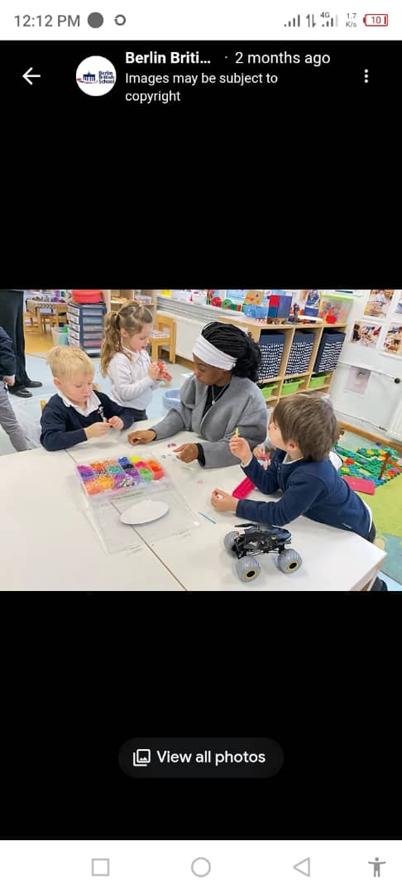

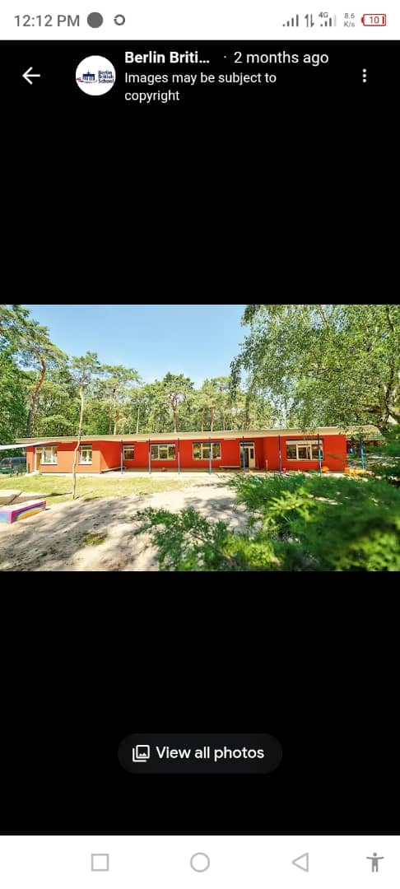
Case study 5
Name: Berlin British School
Location: Berlin City Germany.
Merits
1. Good environment for learning
2. Serene environment
Demerits
1. There is no availability of soft and hard landscape.

CHAPTER FOUR
4.1 INTRODUCTION ON STUDY AREA
The study area is centered around Elemere Community, located in Moro Local Government Area (LGA) of Kwara State, Nigeria. Elemere is a rural community characterized by a predominantly agrarian economy, with cassava farming as a major source of livelihood. The community is divided into two parts, Elemere Oke and Elemere Isale, and is governed by traditional leadership structures alongside local government administration.
Education in Elemere, as in many rural Nigerian communities, plays a vital role in social and economic development. However, access to quality education remains a challenge due to limited infrastructure, inadequate teaching materials, and socio-economic constraints. Elemere Community Primary School serves as the primary formal educational institution for children aged approximately 6 to 12 years within the community and neighboring areas.
This study focuses on the primary school in Elemere, aiming to assess its role, challenges, and opportunities in delivering foundational education. Understanding the context of Elemere is crucial because the socio-cultural and economic characteristics of the community significantly influence educational access, participation, and outcomes. Insights gained from this area will help identify key factors affecting primary education in rural settings and inform strategies for improvement.

4.2 SITE LOCATION/DESCRIPTION
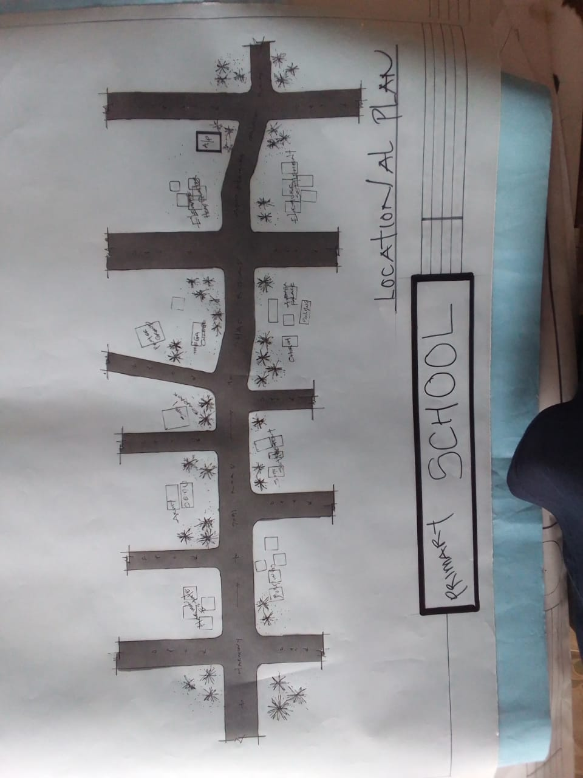

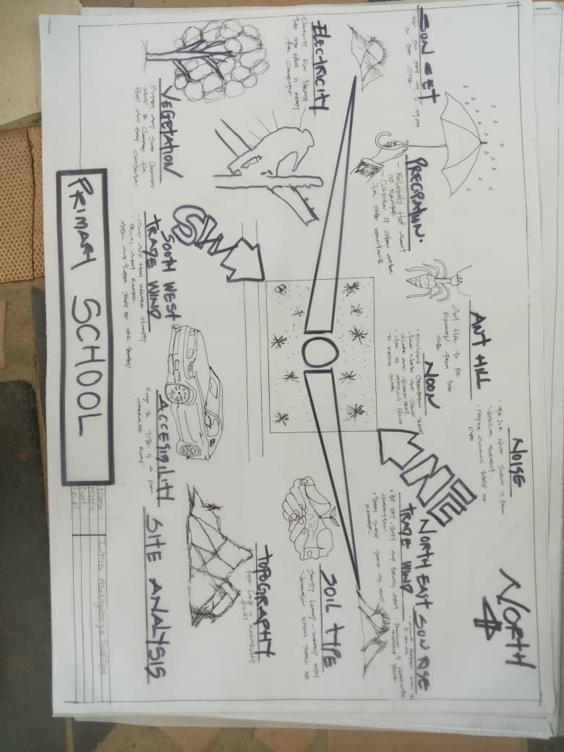
4.3 SITE ANALYSIS/INVENTORY

INVENTORY
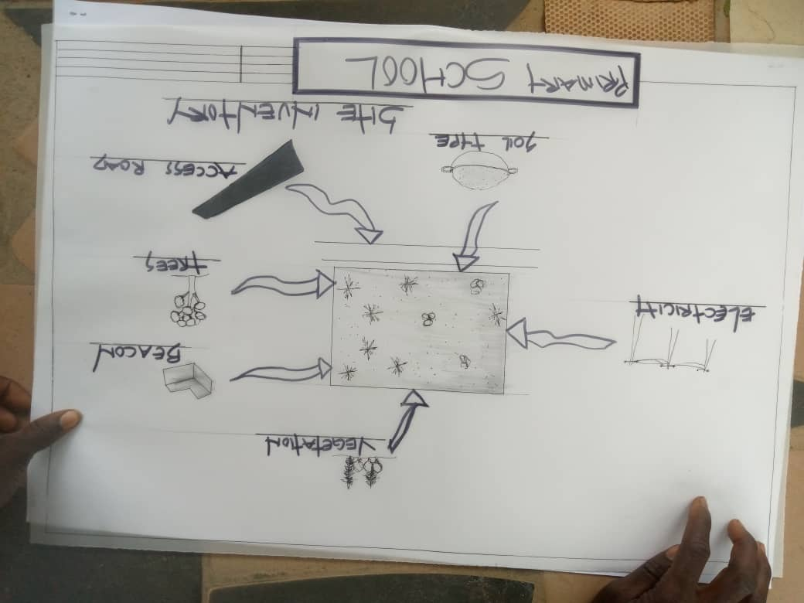
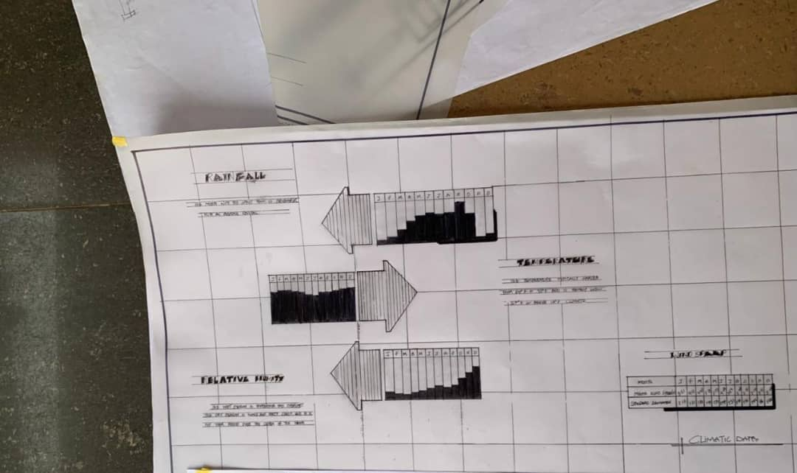
4.4 GEOGRPAHICAL /CLIMATIC CONDITION

4.5 DESIGN CRITERIA
• Safety and Security
- Ensure safe access and egress for children, with secure boundaries and controlled entry points.
- Use non-toxic, durable materials that are safe for children.
- Incorporate fire safety measures, emergency exits, and clear signage.
• Child-Centered Spaces
- Design classrooms and facilities to suit the physical size and developmental needs of children aged 6–12.
- Provide flexible learning spaces that can accommodate different teaching styles and group sizes.
- Include comfortable furniture scaled for children.
• Adequate Classroom Size and Layout
- Provide sufficient space to avoid overcrowding; generally, a minimum of 1.5 to 2 square meters per pupil.
- Classrooms should have good acoustics, lighting, and ventilation.
• Natural Lighting and Ventilation
- Maximize natural light through windows and skylights to enhance learning and reduce energy use.
- Ensure proper cross-ventilation to maintain fresh air and a comfortable environment.
• Inclusive Design
- Provide accessible facilities for children with disabilities (ramps, accessible toilets, tactile signage).
- Promote an inclusive learning environment respecting diverse needs.
• Sanitation and Hygiene
- Adequate toilets with separate facilities for boys and girls.
- Handwashing stations with clean water access.
- Proper waste disposal and drainage systems.
• Outdoor Learning and Play Areas
- Safe, shaded outdoor spaces for recreation and physical education.
- Incorporate playground equipment that encourages physical development and social interaction.
• Support Facilities
- Provision for administration offices, staff rooms, storage, and meeting spaces.
- Areas for library, ICT lab, and resource centers where feasible.
• Sustainability and Environmentally Friendly Design
- Use locally sourced materials where possible.
- Incorporate energy-efficient lighting and water-saving fixtures.
- Design for rainwater harvesting and solar energy use if possible.
• Community Use
- Spaces that can serve community activities outside school hours, fostering local engagement.
4.6 BRIEF ANALYSIS
Primary school education serves as the foundational stage of formal learning, typically catering to children aged 6 to 12 years. It is crucial for developing basic literacy, numeracy, and social skills that shape the learner’s future academic and personal growth. Across many communities, especially in rural areas, primary schools face challenges such as limited infrastructure, shortage of qualified teachers, and inadequate learning materials. These factors often impact the quality of education and student retention rates.
Despite these challenges, primary schools remain central to community development. They foster social cohesion, reduce illiteracy, and create pathways for higher education and employment. Innovations such as integrating technology and community involvement have shown positive effects on improving educational outcomes. However, sustained investment in facilities, teacher training, and inclusive curricula is necessary to ensure that primary schools fulfill their role effectively.
In summary, while primary schools face significant obstacles, they continue to be vital institutions for empowering children and supporting broader societal progress.
4.7 SPATIAL PROGRAMME (REQUIREMENT AND ANALYSIS)

1. Academic Areas
Space | Description | Approx. Size
Classrooms (6–12) | One per grade level or class stream. Should accommodate 25–40 pupils. | 48–60 m² each
Library/Reading Room | Quiet space with books, reading corners, and tables. | 40–60 m²
ICT/Computer Room | Equipped with computers and digital learning tools. | 40–50 m²
Resource Room (Special Needs) | For support programs, assessments, or therapy. | 20–30 m²

2. Administrative Spaces
Space | Description | Approx. Size
Head Teacher’s Office | Administrative center of the school. | 15–20 m²
Staff Room | Common workspace and rest area for teachers. | 30–40 m²
Reception/Waiting Area | For parents and visitors. | 15–20 m²
Records/Storage Room | For storing files, books, and supplies. | 10–15 m²

3. Support Facilities
Space | Description | Approx. Size
Toilets (Students) | Separate male/female blocks; 1 toilet per 20–25 pupils. | Variable
Toilets (Staff) | At least one each for male and female staff. | 6–8 m²
Sick Bay/First Aid Room | For health emergencies or resting sick pupils. | 10–15 m²
Kitchen/Canteen | For preparing or serving meals (optional based on school feeding policy). | 20–30 m²

4. Recreational and Outdoor Spaces
Space | Description | Approx. Size
Playground | Safe, open area with age-appropriate play equipment. | 300–500 m²
Sports Field (Optional) | For football, athletics, etc. | Variable
Assembly Area | For morning assembly and events (can be covered). | 100–200 m²

Notes:
- Circulation spaces (corridors, stairs) should be at least 20–25% of total built area.
- Accessibility features like ramps, handrails, and wide doorways should be included.
- Final space sizes may vary based on local guidelines, available land, and student population.

4.8 CONCEPTUAL DEVELOPMENT
1. Vision and Purpose
The conceptual development begins with a clear vision:
To create a safe, inclusive, and stimulating environment that supports the educational, emotional, and physical development of children aged 6–12. The school must not only provide knowledge but also promote values, creativity, and community involvement.
2. Design Philosophy
The core idea is "child-centered learning in a community-rooted space." The school should reflect the needs, culture, and future aspirations of the children and the wider community. This includes:
- Warm, welcoming architecture that feels accessible and non-institutional.
- Flexible spaces that encourage active learning, exploration, and collaboration.
- A blend of indoor and outdoor learning environments.
3. Spatial Planning Concepts
- Zoning: The school is divided into academic, administrative, recreational, and support zones for clear navigation and safety.
- Hierarchy of Spaces: From public (entry/reception), to semi-private (classrooms, library), to private (staff areas, sick bay).
- Flow and Circulation: Simple, child-friendly circulation with visual cues, natural light, and minimal obstacles.
- Central Courtyard or Assembly Area: A multifunctional open space for play, learning, and community gatherings.
4. Environmental Considerations
The school design will integrate passive environmental strategies for sustainability and comfort:
- Cross-ventilation in classrooms.
- Large windows and shaded verandas to maximize natural lighting.
- Rainwater harvesting and provision for solar panels.
- Use of locally available, eco-friendly materials.
5. Cultural and Contextual Sensitivity
The school’s layout, materials, and colors will reflect local cultural identity and traditions. Murals, indigenous art, and local language signage can enhance connection to the community and promote cultural pride among students.
6. Flexibility and Growth
Design allows for:
- Modular expansion as the student population grows.
- Spaces that can be adapted for multiple uses (e.g., a library used for storytelling events).
- Outdoor classrooms and shaded reading corners for creative teaching approaches.
7. Inclusivity and Accessibility
All areas will be accessible to students with physical challenges. Universal design principles guide the layout, ensuring all learners can move and participate freely.
4.9 SITE CONCEPT
1. Site Layout Philosophy
The primary school site is designed with a “central community and child-focused” concept, where buildings and open spaces are arranged to encourage interaction, safety, learning, and flexibility. The goal is to create a campus that feels welcoming, accessible, and functional for children, staff, and the surrounding community.

2. Zoning and Functional Areas
The site is organized into clearly defined zones:
Zone | Functions
Academic Zone | Classrooms, library, ICT room, and resource rooms (quiet, focused activities)
Administrative Zone | Head teacher’s office, staff room, records, reception
Recreational Zone | Playground, sports field, open-air assembly area
Support Zone | Toilets, kitchen/canteen, sick bay, maintenance/storage
Community Zone (Optional) | Multipurpose hall or community room for after-school or community use

3. Circulation Concept
- Pedestrian-friendly pathways: Covered walkways connect all key areas, ensuring ease of movement during rain or sun.
- Child-scaled design: Low steps, ramps, visual signage, and clear sightlines make the site navigable and safe.
- Vehicular access: A clearly separated drop-off/pick-up area at the front, with restricted vehicle access beyond entry.

4. Orientation and Climate Response
- Classroom Orientation: Oriented east-west to reduce heat gain and maximize cross ventilation.
- Natural Ventilation: Buildings are spaced adequately to allow airflow; large operable windows and ventilated roofs are integrated.
- Natural Lighting: Windows positioned to avoid glare while maximizing daylight, reducing reliance on artificial lighting.
- Shaded Outdoor Areas: Verandas, trees, and canopies provide shaded spaces for informal learning and play.

5. Landscaping and Open Spaces
- Green buffers at the perimeter for security and aesthetics.
- Learning gardens for agricultural or science-based activities.
- Child-friendly play surfaces (sand, grass, rubber mats).
- Rainwater channels and bioswales for effective drainage and environmental education.

6. Safety and Security
- Perimeter fencing with a gated entrance.
- Clear visibility across the site for supervision.
- Emergency access points for fire services and first aid.

7. Future Expansion
- Open spaces left around academic zones to allow for modular expansion (additional classrooms, labs).
- Provision for future solar panel installations or ICT upgrades.

4.10 BUILDING CONCEPT

1. Concept Philosophy
The building concept is centered on the theme:
“A Safe, Inspiring Space for Learning and Growth.”
The goal is to create an environment that supports both structured learning and informal exploration—an adaptable space that reflects the children’s identity, encourages community participation, and responds to the local climate and context.

2. Form and Massing
- Modular Layout: The school is composed of simple, repeated modular classroom blocks that can be expanded or reorganized as the school grows.
- Low-Rise Structures: All buildings are single-storey for safety, easy accessibility, and child-friendly scale.
- Clustered Arrangement: Classrooms are grouped by grade levels around shared spaces such as courtyards or gardens to encourage a sense of belonging.

3. Spatial Organization
Component | Design Consideration
Classrooms | Oriented for natural ventilation and lighting; allow flexible furniture arrangement.
Library/Resource Room | Centralized location, quiet, with daylight and reading nooks.
Administration Block | Near entrance for control and accessibility to visitors.
Multipurpose Hall | Open-plan for indoor activities, events, or dining.
Toilets and Sick Bay | Strategically located for quick access; separate units for boys, girls, and staff.

4. Climate-Responsive Design
- Cross Ventilation: Classrooms have operable windows on opposite walls and ventilated roofs to maximize airflow.
- Sun Shading: Roof overhangs, verandas, and sun-breakers are used to protect against direct sunlight.
- Thermal Comfort: Walls made of thermally stable local materials (e.g., mud bricks, hollow blocks) for passive cooling.
- Rain Protection: Pitched roofs with gutters for water collection and protection from heavy rainfall.

5. Materials and Construction
- Local and Sustainable Materials: Use of locally sourced bricks, timber, and stone to reduce cost and support the local economy.
- Simple Construction Techniques: Encouraging community participation and ease of maintenance.
- Durability: Finishes and materials selected for resistance to heavy use by children and low maintenance.

6. Child-Friendly Design Features
- Bright, natural colors and murals on walls to make spaces joyful and engaging.
- Low-height windows for outdoor views and ventilation.
- Safe edges, anti-slip floors, and barrier-free access for inclusivity.
- Designated quiet zones and interactive learning areas.

7. Cultural and Contextual Sensitivity
- Building forms, colors, and decorative elements reflect local identity and culture.
- Spaces for cultural events or parent meetings are integrated to reinforce the school's role as a community hub.

8. Sustainability Integration
- Solar Power: Roofs designed for future solar panel installation.
- Rainwater Harvesting: Roof catchment systems channel water into tanks for toilet flushing and gardening.
- Waste Management: Composting zones and litter separation bins in place.

CHAPTER FIVE
5.1 PROJECT APPRAISAL
The proposed project involves the design and development of a modern, inclusive, and climate-responsive primary school facility aimed at improving access to quality basic education for children aged 6–12 years in a target community (e.g., Elemere Community, Moro LGA, Kwara State). The project responds to the urgent need for improved learning environments, increased school capacity, and community development through education.

Need Assessment / Problem Statement
- Inadequate Infrastructure: Existing schools in the area suffer from dilapidated buildings, overcrowded classrooms, and poor sanitation.
- High Dropout and Low Enrollment Rates: Due to poor facilities, many children are either not enrolled or drop out early.
- Lack of Inclusive Design: Most schools do not cater to children with disabilities or special needs.
- Limited Access to Learning Resources: Absence of libraries, ICT, and teaching aids hampers educational outcomes.

Social and Educational Impact
- Improved literacy and numeracy skills in the community
- Greater access for marginalized groups (girls, children with disabilities)
- Employment opportunities during construction and operation
- A stronger sense of community ownership and pride

5.2 CONSTRUCTION METHODOLOGY AND MATERIALS

Construction Methodology
The construction process will follow a simple, cost-effective, and community-inclusive approach to ensure durability, speed, and sustainability.

A. Pre-Construction Phase
- Site Clearance & Surveying: Clear vegetation, debris, and level the site. Carry out soil tests and topographic survey.
- Setting Out: Use pegs and lines to mark building outlines and excavation boundaries based on architectural drawings.
- Foundation Design: Depending on soil type, strip foundations or reinforced pad foundations will be used. Foundation depth will consider local soil bearing capacity and water table.

B. Construction Phase
- Substructure Works:
  - Excavate trenches and pour concrete footings.
  - Apply damp-proof membrane or layer.
  - Construct blockwork foundation walls and fill with compacted laterite or hardcore.
- Superstructure Works:
  - Erect walls using solid concrete blocks or stabilized earth blocks.
  - Reinforced concrete columns and lintels added for structural strength.
  - Openings for doors and windows formed with block or timber frames.
- Roofing Works:
  - Pitched timber roof trusses or steel framing depending on budget.
  - Roofing covered with long-span aluminum or corrugated iron sheets.
  - Soffits, fascia boards, and rain gutters installed.
- Finishing Works:
  - Plastering of internal and external walls.
  - Painting using washable, non-toxic paint.
  - Screeded concrete floors with smooth finish or terrazzo (if affordable).
- Sanitary and Water Installations:
  - PVC piping for water supply and drainage.
  - Ventilated improved pit (VIP) latrines or water closet systems.
  - Handwashing stations with basins or tippy-taps.
- Electrical Works:
  - Conduits embedded during walling.
  - LED lights and basic outlets in classrooms and offices.
  - Provision for solar panel installation (optional but recommended).

C. Post-Construction Phase
- Final inspection and snag list corrections.
- Cleaning and landscaping (trees, grass, walkways).
- Handover to client and training of maintenance staff.

Construction Materials
Component | Recommended Materials
Walls | Hollow sandcrete blocks, stabilized earth blocks (alternative), cement mortar
Roof Structure | Treated timber trusses or galvanized steel
Roofing Sheets | Corrugated iron sheets, long-span aluminum, with insulation underneath (optional)
Windows | Aluminum or steel casement windows with mosquito netting
Doors | Hardwood panel doors (main) and flush doors (internal)
Flooring | Screeded concrete finish or terrazzo tiles
Paints | Emulsion (interior) and weather-resistant paints (exterior)
Ceiling | PVC panels, fiberboard, or exposed roof (with insulation in hot climates)
Sanitary Wares | Ceramic basins, WCs or VIP latrine slabs, plastic tanks for rainwater harvesting
External Works | Concrete paving, local stone paths, metal gates, security fencing

Sustainability & Local Adaptation
- Use of Local Materials: Where possible, use locally sourced sand, gravel, timber, and laterite to reduce cost and support local economy.
- Rainwater Harvesting: Gutter and tank system to provide water for sanitation or cleaning.
- Natural Ventilation: Wall openings, high ceilings, and cross-ventilation reduce need for fans or air conditioning.
- Low Maintenance Finishes: Cement plaster and paint selected to minimize recurring maintenance costs.

Labor Strategy
- Skilled and Unskilled Labor Mix: Engage local artisans for masonry, carpentry, and roofing to foster community ownership.
- Community Participation: Labor-based construction approach (e.g., sand supply, material handling) can reduce costs and increase local support.
5.3 BUILDING SERVICE

1. Concept Philosophy
The building concept is rooted in the idea of “Learning Through Space” — creating a school that is not just a place of instruction but a nurturing environment that supports creativity, curiosity, safety, and community identity.
The design places the child at the center, using architecture as a tool to stimulate learning, social interaction, and emotional well-being, while being practical, inclusive, and contextually appropriate for the local climate and culture.

2. Design Approach and Spatial Strategy
- Clustered Layout: Classrooms and key learning spaces are arranged in clusters around shared courtyards, promoting interaction, visibility, and ease of supervision.
- Zoning: Spaces are grouped by function — academic, administrative, recreational, sanitary, and community — to enhance flow, safety, and organization.
- Hierarchy of Spaces: The school transitions from public (entrance, reception) to semi-public (classrooms, library) and private (staff rooms, storage, sick bay) spaces.

3. Climatic and Environmental Response
- Orientation: Buildings are oriented east–west to reduce solar heat gain, with large shaded verandas facing north/south.
- Ventilation & Lighting: Cross-ventilation is achieved using opposing operable windows, high ceilings, and ventilated roofs. Generous windows and clerestories provide abundant natural light.
- Roofing: Pitched or butterfly roof designs allow rainwater harvesting and promote air circulation.

4. Material Expression
- Local Materials: Use of earth blocks, laterite, or sandcrete block walls, timber, and bamboo for a vernacular aesthetic and reduced cost.
- Finishes: Durable, low-maintenance finishes like cement render, emulsion paint, and terrazzo or polished concrete floors.
- Roofing: Lightweight metal sheeting with timber or steel trusses, detailed to minimize noise and heat transfer.

5. Child-Friendly Design Features
- Color and Playfulness: Use of bright colors, murals, and child-scale elements to create a stimulating and inviting learning atmosphere.
- Interactive Spaces: Inclusion of learning gardens, outdoor classrooms, and informal reading corners for varied learning experiences.
- Accessibility: Ramps, wide doorways, and accessible toilets ensure universal access for children with disabilities.

6. Community Integration
- Shared Facilities: Spaces like the multipurpose hall, library, and playground can be used by the wider community for events and programs.
- Cultural Relevance: Local motifs, symbols, and language are incorporated in the design to reflect community identity and pride.
- Flexible Use: Classrooms and open spaces are designed for reconfiguration or extension, ensuring adaptability over time.

7. Sustainability Features
- Rainwater Harvesting: Gutters and tanks provide water for toilets, cleaning, or gardening.
- Solar Energy Provision: Roof structure is solar-ready for lighting and ICT support.
- Shaded Outdoor Areas: Use of pergolas, trees, and covered walkways to enhance comfort and usability of open spaces.
5.4 CONCLUSION
The development of a well-designed, inclusive, and sustainable primary school is critical to achieving universal access to quality education, especially in underserved rural communities. This project addresses key challenges faced by many public schools, including poor infrastructure, limited accessibility, and lack of child-centered design. By integrating local materials, climate-responsive architecture, and flexible learning spaces, the proposed school model aims to foster an environment where children can learn, play, and grow safely and effectively.
The architectural and planning decisions made in this proposal are rooted in educational research, local context, and community engagement, ensuring that the school will not only serve as a place of learning but also as a cultural and social hub for the wider community.
Primary school education plays a fundamental role in laying the foundation for lifelong learning and development. It shapes children's cognitive, emotional, and social skills during the most formative years of their lives. Despite progress in access to primary education in many parts of the world, challenges such as inadequate resources, poorly trained teachers, overcrowded classrooms, and limited parental involvement continue to impact the quality of education. Addressing these issues is essential for improving learning outcomes and ensuring that every child has the opportunity to reach their full potential.
5.5 RECOMMENDATIONS
- Improve Teacher Training and Support: Governments and educational institutions should invest in ongoing professional development for teachers to enhance their pedagogical skills and subject knowledge.
- Strengthen Infrastructure: Schools should be provided with adequate facilities, such as classrooms, sanitation, libraries, and digital tools, to create a safe and stimulating learning environment.
- Promote Inclusive Education: Ensure that all children, including those with disabilities or from marginalized communities, have equal access to quality primary education.
- Engage Parents and Communities: Strengthen collaboration between schools and families to support children's learning both at school and at home.
- Enhance Curriculum Relevance: The curriculum should be regularly updated to reflect the needs of the modern world and to promote critical thinking, creativity, and problem-solving skills.
- Monitor and Evaluate Learning Outcomes: Regular assessments should be implemented to track student progress and inform teaching strategies.

REFERENCES
Darling-Hammond, L. (2017). Effective Teacher Professional Development. Palo Alto, CA: Learning Policy Institute.
Eleme LGA and Eleme Language Center stakeholder meeting reports (2017).
Eneji & Attah (2020). Social Challenges to the Education of Orphaned and Vulnerable Children in Eleme, Nigeria, International Journal of Scientific & Engineering Research.
Nigerian Federal Ministry of Education; National Policy on Education (latest edition), and Rivers State Education (Teaching of Indigenous Languages) Law 2003.
Ollorwi, Osaro (Chairman, Eleme Language Center). Nsã Eloi Rã, Ekã Eleme, Eleme counting system book.
UNESCO. (2023). Global Education Monitoring Report. Paris: UNESCO Publishing.
UNICEF. (2022). The State of the World's Children 2022: Education. New York: UNICEF.
United Nations. (2015). Sustainable Development Goals. Goal 4: Quality Education.
Wikipedia entries on Eleme LGA and Eleme people for socioeconomic and cultural context.
World Bank. (2021). Improving Learning Outcomes in Primary Education. Washington, DC: World Bank.

APPENDIX
