PROJECT REPORT
ON
PRIMARY SCHOOL
FOR
APATA YAKUBA COMFORT STREET, ILORIN.

By:
AJINE MOSES ADOGA
ND/23/ARC/FT/0008

Submitted to:
THE DEPARTMENT OF ARCHITECTURAL TECHNOLOGY INSTITUTE OF ENVIRONMENTAL STUDIES (IES) KWARA STATE POLYTECHNIC, ILORIN

IN PARTIAL FULFILMENT OF THE REQUIREMENTS FOR THE AWARD OF NATIONAL DIPLOMA (ND) IN ARCHITECTURAL TECHNOLOGY

JULY, 2025.
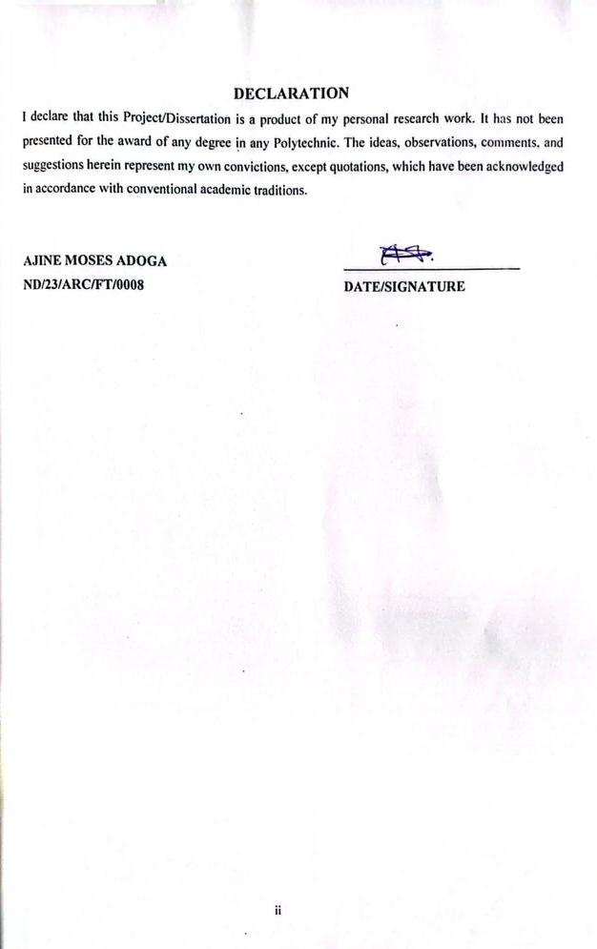
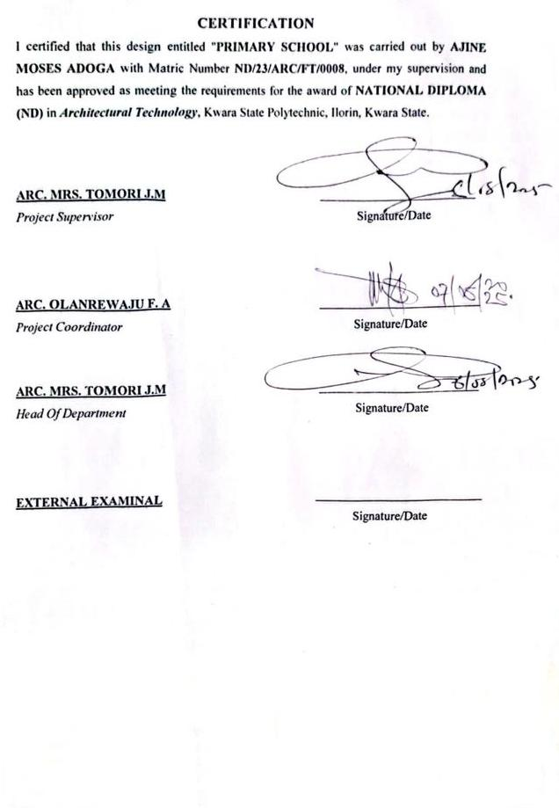

ACKNOWLEDGEMENTS
As this project culminates, I offer my deepest gratitude to the Almighty, whose strength, wisdom, and perseverance have been my constant companions. His guidance has been my bedrock throughout this endeavor.

My heartfelt appreciation also goes to my parents, MR AJINE CLETUS ATE and MRS AJINE ABIGAIL EJEME for their unwavering love, encouragement, and sacrifices. Their belief in me has been a constant source of motivation.

I am especially grateful to my supervisor ARC. MRS. J.M TOMORI, for the crucial guidance, patience, and insightful feedback. Her expertise has been instrumental in shaping this project, and I am deeply thankful for the mentorship

I extend my thanks to my lecturers and mentors, whose guidance, constructive feedback, and knowledge have significantly contributed to my growth in architecture.

Finally, I want to express my sincere appreciation to my friends and colleagues, whose encouragement, advice, and companionship have enriched this experience.
DEDICATION
I humbly dedicate this project to the Almighty, the wellspring of my knowledge, fortitude, and drive. His grace has been my constant guide, and His blessings have brought this accomplishment to fruition. I also dedicate it to my cherished parents, MR AJINE CLETUS ATE and MRS AJINE ABIGAIL EJEME, whose boundless love, sacrifices, and support have been my greatest motivation. Their prayers, encouragement, and guidance have molded me into the person I am today. This project stands as a tribute to their unwavering efforts and faith in my aspirations.

ABSTRACT
The design of primary schools in Nigeria often lacks consideration for modern educational needs, climatic response, and child-friendly environments. This project addresses the challenge of inadequate and poorly planned primary school buildings by proposing a functional and inclusive architectural design that caters to the developmental, psychological, and educational needs of young learners. The aim is to design a sustainable, safe, and inspiring primary school environment that supports learning, play, and social interaction in a conducive atmosphere.

The methodology adopted for the project includes literature review, analysis of existing case studies, site analysis, interviews with users (teachers, pupils, and administrators), and conceptual design development. The design process involved understanding user needs, site conditions, and environmental factors to create an architectural solution that aligns with local context and educational standards.

The findings revealed that most primary schools suffer from spatial inadequacy, poor ventilation, and lack of recreational and sanitary facilities. The proposed design responds to these issues by providing well-ventilated classrooms, clear functional zoning, shaded play areas, accessible toilets, and administrative support spaces. The use of passive design strategies and locally available materials was prioritized for environmental and economic sustainability.

The study concludes that a well-designed primary school significantly improves the learning process and overall development of children. It recommends that future school projects should prioritize environmental responsiveness, safety, and flexible learning spaces. Furthermore, government and private stakeholders should invest in scalable and replicable models of school architecture to improve basic education infrastructure nationwide.

TABLE OF CONTENTS
TITLE PAGE…………………………………………………………………..........i
DECLERATION………………………………………………………………...…. ii
CERTIFICATION………………………………………………………………….. iii
ACKNOLEDGMENT……………………………………………………………… iv
DEDICATION……………………………………………………………………… v
ABSTRACT……………………………………………………………………...…. vi
TABLE OF CONTENTS…………………………………………………………… vii
LIST OF PLATES……………………………………………………………….…. x
LIST OF FIGURES………………………………………………………………… xi
LIST OF TABLES………………………………………………………………… xii
LIST OF APPENDICES…………………………………………………………….xiii
CHAPTER ONE
1.0 INTRODUCTION………………………………….………….………………………1
1.1 HISTORICAL BACKGROUND…………………………….………………..………2
1.2 DEFINITION…………………………….…………………….…...…………………3
1.3 STATEMENT O F THE RESEARCH PROBLEM. ………………………………….3
1.4 AIM AND OBJECTIVES………………………………………..………………..…..3
1.5 JUSTIFICATION………………………………………………………………….…..4
1.6 SCOPE OF STUDY………………………………………………………………..…4
1.7 LIMITATIONS OF STUDY………………………………………………………..…4
1.8 RESEARCH METHODOLOGY…………………………………………………...…5

CHAPTER TWO

2.1 LITERATURE REVIEW …………………………….…………………………………. 6
2.1.1 INTRODUCTION………………………………………………………………………...6
2.1.2 IMPORTANT ISSUES AND PROBLEMS PECULIAR TO PRIMARY SCHOOL TYPOLOGY………………………………………………………………………....7
2.1.3 TECHNOLOGICAL AND ENVIRONMENTAL APPROACHES FOR DESIGNING A PRIMARY SCHOOL……………………………...……………………………….………..8
2.2 MERIT OF STUDYING……………………………………………………….…10
2.3 CONCLUSION ………………………………………………………………….10

CHAPTER THREE
3.0 CASE STUDY………………………………………………………….…..…. 11
3.1 OUTLINES OF THE CASE STUDIES……………………………...…….….. 11
3.1.1 CASE STUDY ONE (1): Community Primary School…………………..…….11
3.1.2 CASE STUDY TWO (2): Fountain Success Nur & Pry School................…….16
3.1.3 CASE STUDY ONE (3): Christ Liberty Nur & Pry School…………………....19
3.1.4 CASE STUDY FOUR (4): Online Case Study ………………..……………….23

CHAPTER FOUR
4.1 ANALYTICAL STUDY OF THE PROJECT LOCATION…………………………24
4.1.1 INTRODUCTION…………………………………………………………………….24
4.1.2 SITE LOCATION…………………………………………………………………….24
4.1.3 SITE INVENTORY…………..…...…………………………………………………26
4.1.4 SITE ANALYSIS………………...…………………………………………………..26
4.1.5 GENERAL GEOGRAPHICAL CONDITION…………………….……………..….27
4.1.6 CLIMATE …………………………………………………………………………………...27
4.1.7 VEGETATION………………...………………………………………………..…..29
4.1.8 TOPOGRAPHY………………...……………………………………………… …..29
4.1.9 NATURAL RESOURCES………………...…………………………………….… 29
4.1.10 ENVIRONMENTAL CHALLENGES…………………………………………… ..29
4.1.11 SITE SERVICES………………………………………………………………… …30
4.1.12 SITE UNIQUENESS AND BENEFIT………………………………………………30
4.1.13 SITE SUITABILITY……………………………………………………………….30
4.2. DESIGN CRITERIA……………………………………………………………….30
4.2.1 SITE SELECTION………………………………………………………...……….30
4.2.2 BUILDING ARRANGEMENT…………………………………………………….31
4.2.3 DESIGN SCOPE…………………………………………...……………………….31
4.2.4 DESIGN BRIEF 9ANALYSIS…………………………………………………….31
4.2.5 SPACES DERIVATION ANALYSIS/SCHEDULE FOR ADMINBLOCK………32
4.2.6 FUCTIONAL ANALYSIS AND RELATIONSHIP………………………………32

CHAPTER FIVE
5.1 APPRAISAL OF PROPOSED SCHEME………………………………………….34
5.2 CONSTRUCTION METHODOLOGY AND MATERIALS. …………………….34
5.21 MATERIALS FOR CONSTRUCTION……………………………………………34
5.2.2 CONSTRUCTION METHODOLOGIES………………………………………….34
5.2.1 SERVICE……………………………………………………………………….….36
5.2.2 CIRCULATION……………………………….……………………………….….36
5.2.3 VENTILATION……………………………………….……………………….….36
5.2.4 LIGHTING……………………………………….……………………………….37
5.2.5 PLUMBING ……………………………………….……………….…………….37
5.2.6 ELECTRICAL INSTALLATION……………………………..………………….37
5.2.7 WASTE DISPOSAL……………………………………….…….……………….37
5.2.8 FIRE PROTECTION……………………………………………………………..38
5.2.9 EXTERNAL WORKS……………………………………………..……………..38
5.3 CONCLUSION AND RECOMMENDATION………………………………….38
REFERENCES………………………………………………………………………….39

LIST OF PLATES
CASE STUDY 1
PLATE 3:1.1 LOCATION MAP………………………………………………………….13
PLATE 3.1.2 ELEVATION ……………………………………………..……………….14
PLATE 3.1.3 ELEVATION……………… ……………………………………………….15
PLATE 3.1.4 ELEVATION……………..……………………………………...………….15
CASE STUDY 2
PLATE 3.2.1 ELEVATION………………………………………………………………18
PLATE 3.2.2 STAFF OFFICE. ………………………………………………………….18
CASE STUDY 3
PLATE 3.3.1 LOCATION MAP………………………………………………………….20
PLATE 3.3.2 ELEVATION……………………………………………………………….21
PLATE 3.3.3 ELEVATION…..…………...……………………………………...……….22
PLATE 3.3.4 ELEVATION…...…………...……………………………………….……...22

LIST OF FIGURES
FIGURE 3:1:1 LOCATION PLAN CASE STUDY 1…………………………..………12
FIGURE 3.1.2 FLOOR PLANS CASE STUDY 1…….………………………….…..…13
FIGURE 3:1.3 SITE PLAN CASE STUDY 1 ……………………...……………………14
FIGURE 3.2.1 LOCATION PLAN CASE STUDY 2……………………………………15
FIGURE 3.2.2 FLOOR PLANS CASE STUDY 2……………………………….…….…15
FIGURE 3.3.1 LOCATION PLAN CASE STUDY 3……………………………….……20
FIGURE 3.3.2 FLOOR PLAN. CASE STUDY 3…………………..…………………..…21
FIGURE 4.1.11.1 MAP OF NIGERIA, 36 STATES AND FCT. ……………..………….24
FIGURE 4.1.11.2 OYO STATE MAP………..……………………………..……………...25
FIGURE 4.1.11.1 LOCATION PLAN …………………………………..………….……...25
FIGURE 4.1.12.1 SITE INVENTORY …………………………………….……….………26
FIGURE 4.1.12.2 SITE ANALYSIS ……………………………..………..……….………27
FIGURE 4.1.3.1 AVERAGE MONTHLY RAINFALL IN ILORIN. …….….…………….28
FIGURE 4.1.3.2 SUNSHINE DURATION IN ILORIN. ………………………..………….28
FIGURE 4.1.3.3 RELATIVE HUMIDITY IN ILORIN. ………………………..…………..29
FIGURE 4.2.6.1: FUNCTIONAL ANALYSIS 1 ……………………………………………32
FIGURE 4.2.6.2: FUNCTIONAL ANALYSIS 2 ……………………………………………32
FIGURE 4.2.6.3: FUNCTIONAL RELATIONSHIP 1 …………………………….………..33
FIGURE 4.2.6.4: FUNCTIONAL RELATIONSHIP 2 ………………………………………33

LIST OF TABLES

TABLE 4.2.5: SPACE ALLOCATION………………………………………………32

LIST OF APPENDICES
APPENDICES 5.1: GROUND FLOOR PLAN…………………………………………..40
APPENDICES 5.2: FIRST FLOOR PLAN. ……………………………………………..40
APPENDICES 5.3: SECON FLOOR……………………………………………………..41
APPENDICES 5.4: ROOF PLAN ………………………………………………………..41
APPENDICES 5.5: SITE PLAN……………………………………………………..…..42
APPENDICES 5.6: SECTIONS……………………………………………………..…..42
APPENDICES 5.7: ELEVATION……………………………………………….…..…..43
APPENDICES 5.8: EXTERNAL PERSPECTIVE. …………………………………….43

CHAPTER ONE

INTRODUCTION

Primary education is the foundation of any nation's educational system and plays a crucial role in shaping the intellectual and social development of children. It is during this stage that children learn fundamental skills in literacy, numeracy, communication, and social behavior. As such, the environment in which this education takes place must be safe, comfortable, and conducive to learning.

However, in many parts of Nigeria, the architectural design of primary schools remains substandard. Most public schools are overcrowded, poorly ventilated, inadequately lit, and lack essential facilities such as libraries, ICT rooms, and proper sanitation. These deficiencies negatively impact the performance and development of pupils.

Architecture, therefore, must be seen as a vital tool in creating environments that nurture young learners. A well-designed school encourages concentration, creativity, interaction, and safety. This project focuses on designing a modern, functional, and climate-responsive primary school that meets educational, psychological, and health needs of children while also reflecting contemporary design practices.

1.1 HISTORICAL BACKGROUND OF THE PROJECT
The history of primary education in Nigeria dates back to the early 19th century during the missionary era. The first formal primary school, St. Thomas Anglican Primary School, was established in Badagry in 1843 by Christian missionaries. These early schools were built to serve religious and moral instruction purposes rather than structured academic development. Most of them operated under makeshift structures such as church halls or sheds with minimal facilities.
By the early 20th century, the colonial government began to take interest in education and established formal policies that guided the curriculum and funding of primary schools. During this period, the architecture of school buildings began to evolve slightly from temporary wooden sheds to more permanent structures made of brick and corrugated roofing, but still with minimal regard for child psychology, classroom ventilation, or spatial planning.
After independence in 1960, Nigeria witnessed a surge in educational reforms, especially with the introduction of the Universal Primary Education (UPE) scheme in 1976, which aimed to make primary education free and compulsory. This led to a rapid increase in the number of schools and enrolments, but unfortunately, many of these schools were constructed hastily without proper architectural input. Most were standardized concrete block structures, overcrowded, and poorly ventilated.
In 1999, the Universal Basic Education (UBE) programme was launched to further improve access to and quality of basic education. This brought renewed attention to school infrastructure, but many of the design problems still persist — including lack of proper lighting, poor sanitation, and insufficient play spaces.
Today, the challenge remains to design primary school environments that are responsive to modern educational standards, child development psychology, climate, and safety. There is a growing call for architects to create learning spaces that go beyond just walls and roofs spaces that are inclusive, interactive, and environmentally sustainable.
1.2 DEFINITION
This project is defined as the architectural design of a standard, modern primary school, aimed at providing a safe, functional, and inspiring learning environment for children between the ages of 5 and 12. The design incorporates educational, social, recreational, and administrative spaces that support both the academic and developmental needs of pupils.
A primary school, in this context, refers to a formal institution where children receive foundational education in subjects such as mathematics, literacy, science, arts, and civic studies. It marks the first stage of compulsory education and plays a critical role in shaping future learning abilities and character.
The project design involves the creative and technical process of organizing land, structures, and spaces to ensure the effective functioning of all components of a primary school classrooms, offices, library, sick bay, ICT room, playground, and sanitary facilities. The architectural approach taken emphasizes:
- Child-centered design (spaces scaled to child size and needs)
- Sustainability (using passive cooling, local materials, and natural lighting)
- Accessibility (easy movement for all users, including children with disabilities)
- Safety and security (fencing, controlled access, and visible circulation)
1.3 STATEMENT O F THE RESEARCH PROBLEM.
Many existing public and private primary schools in Nigeria were not originally designed for educational purposes. They are typically adapted residential buildings or poorly planned structures that do not meet spatial, safety, or functional standards. Classrooms are often overcrowded, poorly ventilated, and inadequately lit. Inadequate sanitation, lack of recreational spaces, and absence of technology integration further reduce the quality of education offered.
The architectural challenge is to design a modern primary school that addresses these issues creating flexible, inclusive, and safe spaces that support both formal and informal learning, encourage play, and respond to the local climate and culture.
1.4 AIM AND OBJECTIVES
1.4.1 AIM OF THE STUDY
To design a conducive and child-friendly primary school.
To provide learning spaces that stimulates creativity and concentration.
To integrate natural ventilation, daylight, and sustainability principles.
1.4.2 OBJECTIVES
- To design a functional and flexible learning environment that supports effective teaching and accommodates modern educational methods.
- To create a child-friendly architectural design that promotes comfort, safety, and psychological development for young learners.
- To provide adequate academic and non-academic facilities, including classrooms, administrative offices, library, ICT room, toilets, playgrounds, and a multipurpose hall.
- To ensure proper spatial planning for efficient circulation, security, and accessibility within the school premises.
- To incorporate sustainable and locally available materials and adopt passive design strategies such as natural lighting and ventilation

1.5 JUSTIFICATION.

The project addresses the need for standard, inclusive, and modern learning environments in response to population growth and educational reform.

Client’s Background (Can be fictional or real)

E.g. Ministry of Education or Private Educational Foundation – goal is to provide quality education through functional infrastructure.

1.6 SCOPE OF THE STUDY
This study covers the architectural design of a model primary school. The scope includes:
- Classrooms for Primary 1 to 6
- Administrative offices including Head Teacher’s office, Staff Room, Reception
- Library and ICT Room
- Sick Bay and Toilets
- Assembly and multi-purpose space
- Recreational playground and open green areas
- Parking spaces for staff and visitors
- Site planning, landscaping, and circulation design
- 2D architectural drawings and 3D concept visuals
This scope focuses on architectural design and spatial relationships, excluding detailed structural and service designs.

1.7 LIMITATIONS OF STUDY
The project is limited by time, data access, and financial constraints. Specifically:
- Detailed structural, mechanical, and electrical drawings are not included.
- Construction documentation and costing are beyond the current scope.
- Some case study visits were limited due to access restrictions.

1.8 RESEARCH METHODOLOGY
- To achieve the stated objectives, the following research methods were used:
- Literature Review: Study of academic journals, architectural texts, and educational facility design guides.
- Case Studies: Visits and analysis of selected primary schools to evaluate design strategies, space use, and user satisfaction.
- Site Analysis: Evaluation of the proposed site’s physical characteristics, including topography, climate, vegetation, and access routes.
- User Needs Assessment: Informal interviews with teachers, pupils, and school administrators to understand user expectations.
- Design Process: Development of sketches, concept diagrams, spatial programming, zoning, and detailed drawings based on site conditions and client brief.
Literature Review
Analysis of existing academic works, journals, and design guidelines related to school architecture, child-centered learning environments, and educational space planning.
- Case Study Analysis
Examination of selected local and international primary school projects to understand spatial arrangements, materials used, environmental strategies, and functional zoning.
Focus was placed on identifying best practices in design, sustainability, and child safety.
- Site Analysis
Observation and assessment of the proposed site (if available), including location, orientation, access, topography, climate, and surrounding land use
Environmental factors such as sun path, wind direction, and rainfall patterns were also considered for passive design strategies.

CHAPTER TWO
2.1LITERATURE REVIEW
2.1.1 Introduction
The literature review explores previous studies, architectural standards, and educational policies relevant to the design of primary schools. It provides insight into the principles and practices that guide the creation of effective learning environments for children.
- Educational Space Design Principles
Scholars like Neufert (Architects' Data) and sources such as the UNICEF School Infrastructure Guidelines emphasize that primary schools should be designed to promote safety, comfort, flexibility, and learning stimulation. Classrooms must be well-lit, well-ventilated, and spacious enough to support various teaching styles and group sizes. Ergonomic furniture and age-appropriate materials are crucial for early childhood learning.
- Child-Centered Architecture
Research by Maria Montessori and later architectural theorists highlights the need for environments that support independent exploration, creativity, and inclusiveness. Classrooms should allow for mobility, interaction, and accessibility for all children—including those with disabilities.
2.1.2 IMPORTANT ISSUES AND PROBLEMS PECULIAR TO PRIMARY SCHOOL TYPOLOGY
The typology of primary school buildings presents specific challenges and design issues that are unique due to the nature of the users (young children), the learning objectives, and the educational structure. Below are key issues:
- User Scale and Ergonomics
Children between the ages of 5 and 12 are physically smaller and more sensitive to their environments. Many existing school buildings do not reflect this; furniture, circulation spaces, doors, and windows are often adult-sized, leading to discomfort and inefficiency.
- Natural Lighting and Ventilation
Many schools are constructed with little or no consideration for natural ventilation and daylighting. Poor air circulation and dark classrooms negatively affect concentration and health, especially in hot tropical climates like Nigeria’s.
- Safety and Security
Children are vulnerable to hazards such as open drains, sharp edges, slippery floors, or poorly fenced school premises. The absence of clear sightlines and access control can expose students to both internal and external threats.
- Functional Zoning and Circulation
Improper planning of classroom blocks, toilets, admin areas, and play spaces can cause congestion, noise distraction, or confusion. Primary schools must have clear zoning to separate learning from play and administration, while allowing fluid movement.
- Sanitation and Hygiene
Many primary schools lack sufficient toilet facilities or clean water. This contributes to disease spread and absenteeism, especially for girl children. Toilets should be age-appropriate, separated by gender, and easily accessible from classrooms.

2.1.3 TECHNOLOGICAL AND ENVIRONMENTAL APPROACHES FOR DESIGNING A PRIMARY SCHOOL.
Designing a primary school requires more than just creating classrooms and offices — it involves integrating technology and environmental strategies that enhance learning, promote sustainability, and improve user experience. The following are key technological and environmental design approaches applicable to the primary school typology:

- Passive Cooling and Ventilation Strategies
Primary schools in tropical regions like Nigeria must be designed to reduce indoor heat without depending solely on mechanical cooling systems. Effective passive strategies include:
- Cross ventilation: Arranging windows and doors opposite each other to allow free air movement.
- High ceilings and ventilated roofs: Hot air rises and exits through clerestory openings or louvered vents.
- Shading devices: Use of overhangs, canopies, and trees to block direct sunlight from windows and play areas.
- Orientation: Placing classrooms along the east-west axis to reduce sun glare and heat gain.

- Use of Sustainable and Local Materials
Utilizing locally sourced, low-cost, and environmentally friendly materials helps reduce cost and promote community ownership. Examples include:
- Stabilized earth blocks or compressed bricks.
- Bamboo and timber for shading or cladding.
- Corrugated aluminum roofing with insulation beneath. These materials reduce carbon footprint and support thermal comfort.
- Daylighting Techniques
Natural light boosts attention and reduces energy consumption. Approaches include:
- Large windows with high-level glazing for diffuse daylight.
- Light shelves and reflective surfaces to bounce light deeper into rooms.
- Roof monitors or skylights in multipurpose halls. All openings should include louvered windows or adjustable blinds to control glare.

- Rainwater Harvesting and Drainage Systems
Due to the long rainy season in most parts of Nigeria, school roofs can be designed with:
- Gutters and downpipes for collecting rainwater.
- Storage tanks for reusing water in toilets or for cleaning.
- Permeable paving and drains to prevent waterlogging during rainfall.

- Renewable Energy Integration
To overcome unstable power supply and reduce long-term costs, the school can be equipped with:
- Solar panels to power fans, lights, and ICT rooms.
- Solar lanterns or daylight tubes in rural locations. This promotes energy independence and aligns with green building principles.

CHAPTER THREE

3.0 CASE STUDY
A case study involves an up-close, in-depth, and detailed examination of a particular case or cases, within a real-world context. Case study research is to establish a firm research focus to which the research can refer over the course of a complex phenomenon or object.
Case study can be view as the study of an existing project for a reference purpose in order to determine adjustment point of that particular building. Case study research is to establish a firm research focus to which the research can refer over the course of a complex phenomenon or object.
According to researcher Robert K. Yin, defined case study method as an empirical inquiry that investigate a contemporary phenomenon within its real-life context,

3.1 OUTLINES OF THE CASE STUDIES
- Community Primary School Igbusi Ogun State
- Fountain Success Nur & Pry School Apata Yakuba, Kwara State
- Christ Liberty Nur & Pry School Ogbomoso.

3.1.1CASE STUDY ONE (1): NUD 1 PRIMARY SCHOOL
Date of Establishment:
Architect: Unknown
Location: Igbusi Ogun State
Brief Description:

Community Primary School, Igbusi is a government-owned public primary school located in Igbusi Village, within Ifo Local Government Area of Ogun State, Nigeria. It serves children from surrounding rural and peri-urban communities, offering education from Primary 1 to Primary 6. The school follows the Universal Basic Education (UBE) curriculum set by the Ogun State Universal Basic Education Board (SUBEB).
Climate: Tropical wet and dry climate
Topography: The Landscape is Gently
Vegetation: Guinea Savanna

Merits:
- Free or Low-Cost Education
- Makes schooling accessible to children from low-income families.

- Community Access & Inclusion
- Located within the village, reducing the need for transportation and encouraging enrollment.

- Government Curriculum & Oversight
- Follows standardized curriculum under UBE guidelines, ensuring minimum quality.

Demerits:
- Inadequate Infrastructure
- May lack sufficient classrooms, furniture, toilets, water supply, and electricity.

- Overcrowding
- Limited classrooms with a high number of students can affect learning quality.

- Shortage of Teaching Materials
- Textbooks, chalkboards, and learning aids may be insufficient or outdated.

LOCATION PLAN
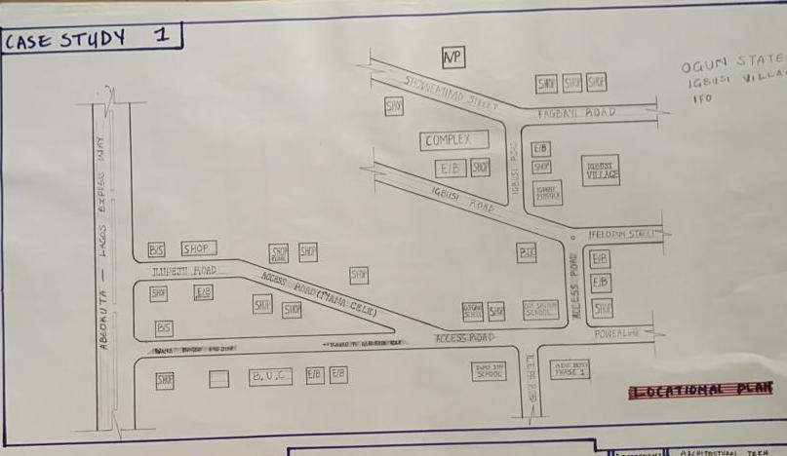

Figure 3:1:1 Location Plan
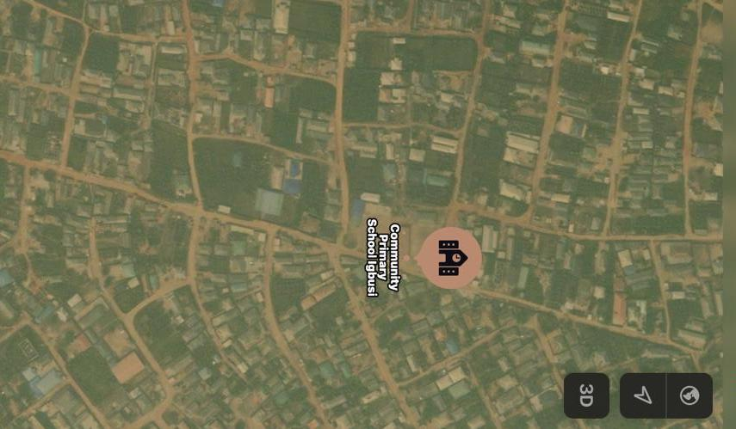
Plate 3:1.1Geographical Layout

SITE PLAN
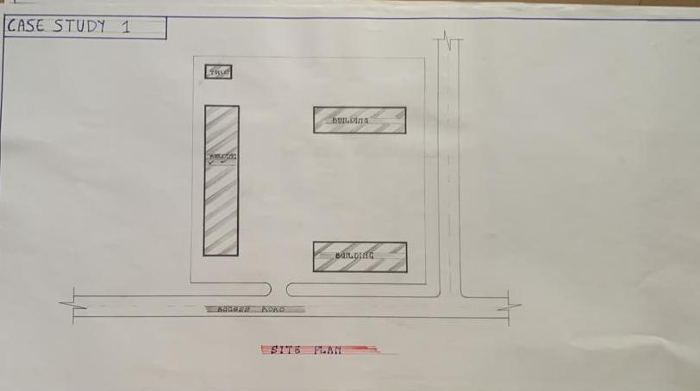
Figure 3.1.2Site Plan

FLOOR PLAN
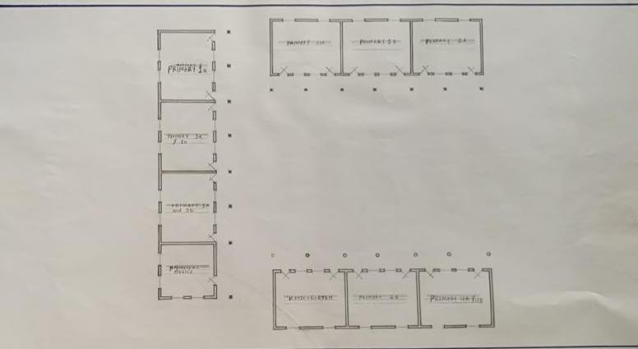
Figure 3:1.3Floor Plans

PICTURES
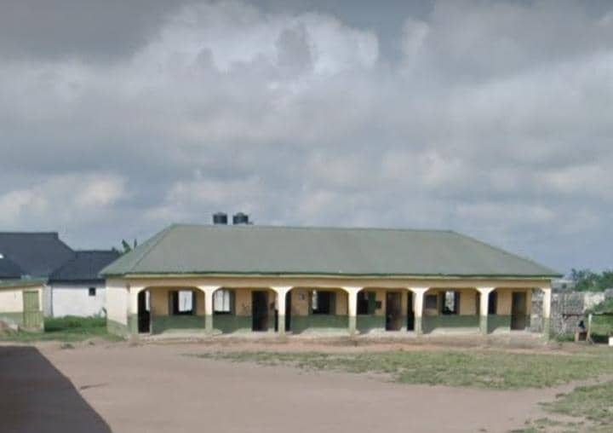Plate 3.1.2Elevation
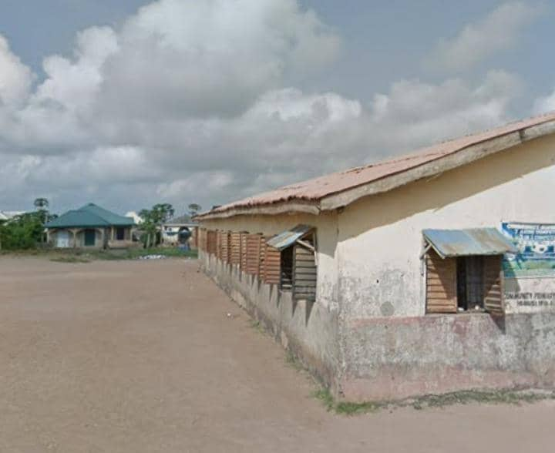

Plate 3.1.3School

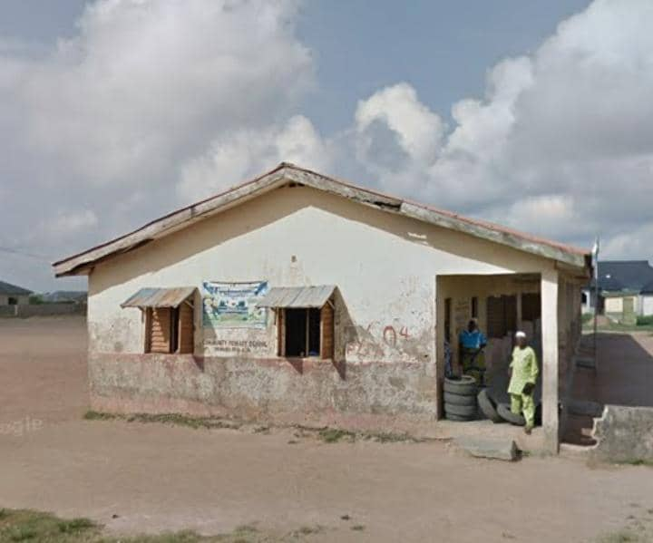
Plate 3.1.4 Elevation
3.1.2 CASE STUDY TWO (2): Fountain Success Nur & Pry School Apata Yakuba, Kwara State
Date of Establishment: Unknown
Architect: Unknown
Location: Apata Yakuba, Kwara State

Brief Description:
As no direct listing is available, this outline assumes that it is a private nursery and primary school located in the Apata Yakuba area, likely within Ilorin West or nearby in Kwara State
Climate: Tropical wet and dry climate.
Topography: Asa River and small streams
Vegetation: Guinea Savanna

Merits
- Structured Learning Environment
- Private schools often provide organized routines and dedicated teaching staff.

- Relatively Small Class Sizes
- Compared with overcrowded public schools, private schools tend to allow more individualized attention.

- Supplementary Facilities
- May offer play areas, reading corners, creative teaching aids (e.g., art, drama), depending on resources.

Demerits
- Tuition or Fees Required
- Even if modest, fees may be a barrier for low-income families.

- Regulatory Oversight May Vary
- Some private schools operate without proper accreditation or approval from state education authorities.
In Kwara, unapproved schools have been closed down due to unsanitary or unsafe conditions

- Facilities Quality Uncertain
- If small scale, they may lack libraries, ICT labs, reliable water or sanitary facilities.

LOCATION PLAN
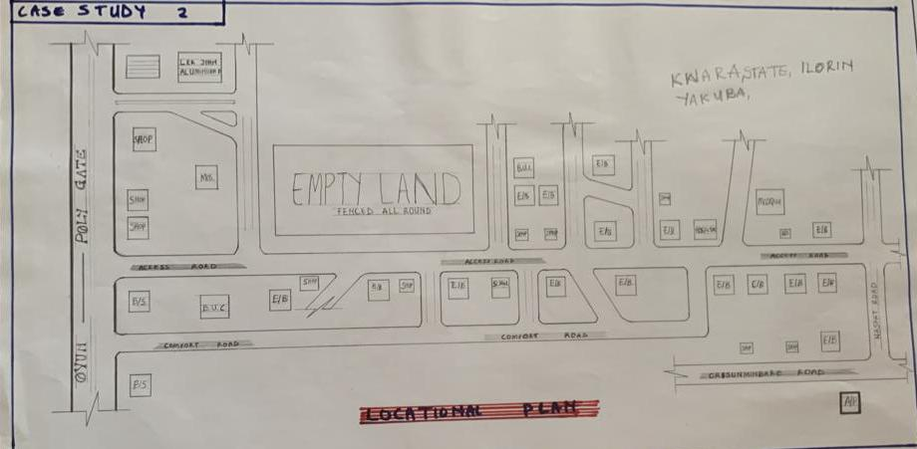
Figure 3.2.1Location Plan

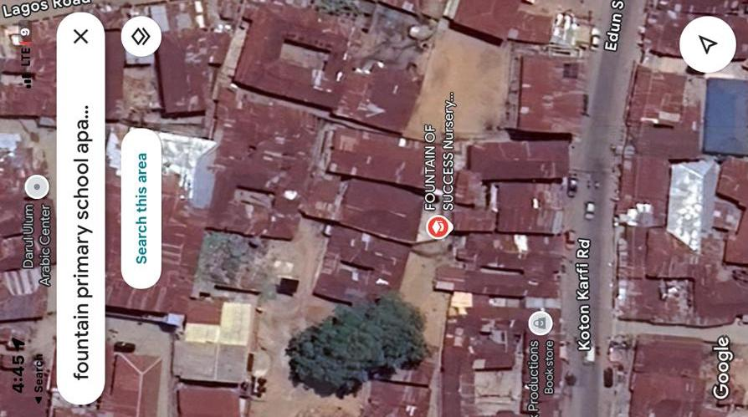
Plate 3.2.1 Geographical Layout
FLOOR PLAN
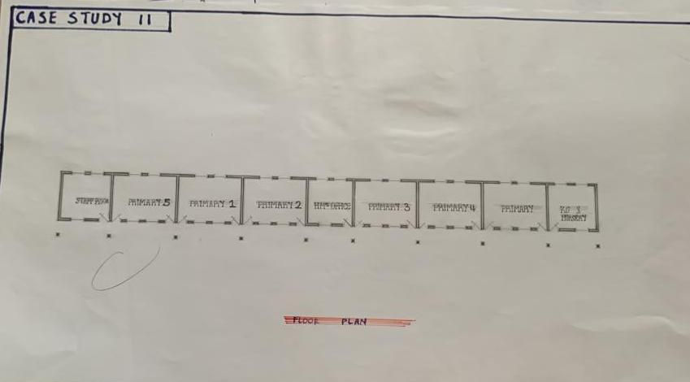
Figure 3.2.2 Floor Plans
PICTURES
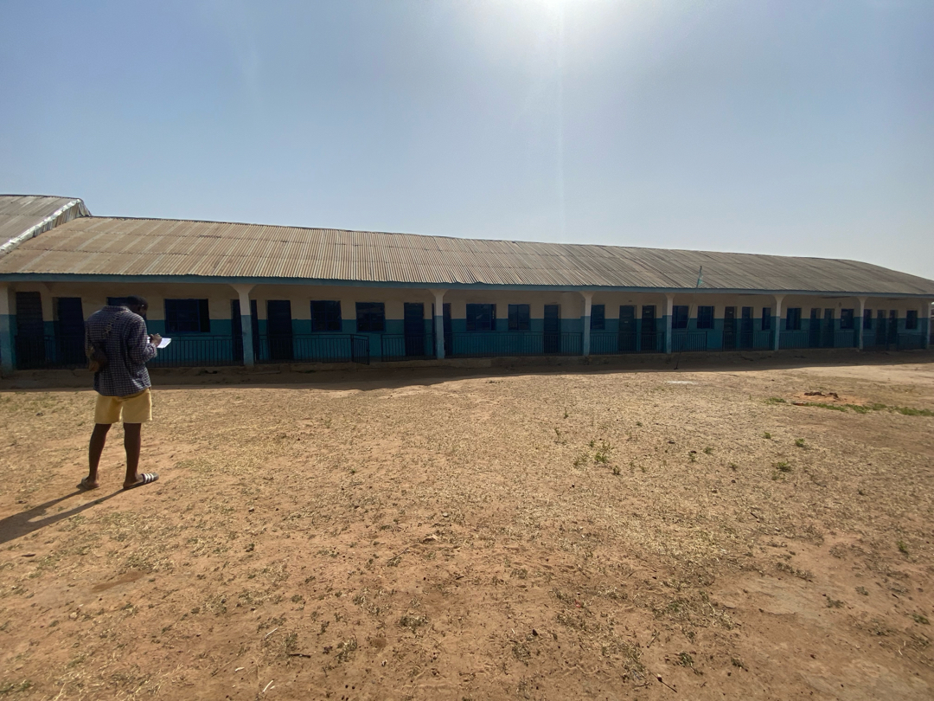

Plate 3.2.2 Back Elevation

Plate 3.2.3 Front Elevation

3.1.3 CASE STUDY ONE (3): Christ Liberty Nursery and Primary School Ogbomoso
Date of Establishment: 2003
Architect: Unknown
Location: Ogbomoso

Brief Description:
Christ Liberty Nursery & Primary School is a private, state-approved nursery and primary institution located in the Odo Aamo (Sabo) area of Ogbomoso, Oyo State, Nigeria . The school is officially recognized by the state Ministry of Education and aims to offer “solid elementary education and adequate child care” for pre‑school and primary-age kids Topography: The Landscape is Gently
Vegetation: Guinea Savanna

Merits:
- State-Approved Status
- Listed as approved by the Oyo State Ministry of Education, which suggests compliance with minimum education and safety standards.

- Structured Elementary & Pre-School Provision
- Offers both nursery and primary education, making it a viable one-stop option for early childhood through foundational education under one roof.

- Private School Environment
- Typically, private schools maintain more structured operations, focused attention, and possibly better hygiene and discipline compared to public alternatives.

Demerits:
- Lack of Public Feedback or Reviews
- No available reviews or ratings, making it hard to assess reputation, quality of instruction, or parent satisfaction.

- Unknown Infrastructure Quality
- Public listings do not mention facilities—e.g. classrooms, playgrounds, toilets, laboratories—leading to uncertainty about the learning environment.

- Limited Academic Information
- There is no published data regarding results, teacher qualifications, extra-curricular activities, or distinctive learning programs.

LOCATION PLAN

Figure 3.3.1 Location Plan

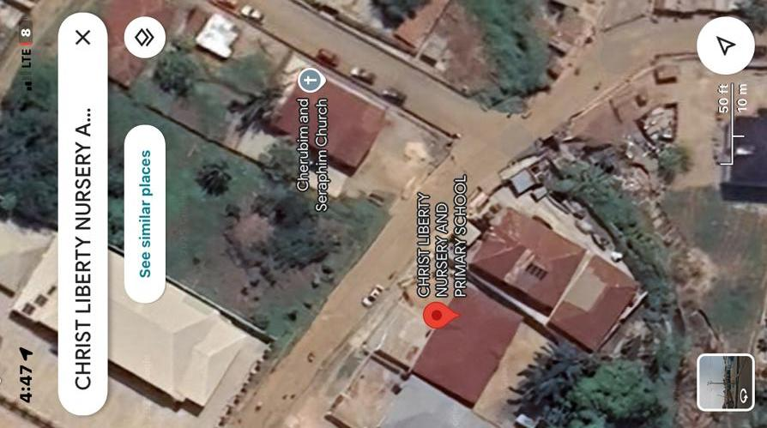
Plate 3.3.1Geographical Layout

FLOOR PLAN
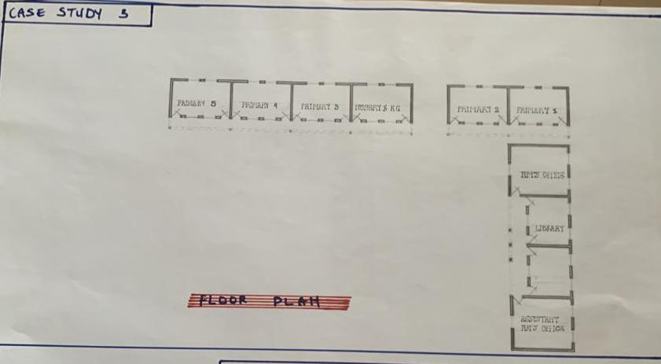
Figure 3.3.2 Floor Plan.

3.1.4 CASE STUDY FOUR (4): ONLINE CASE STUDY
Location:
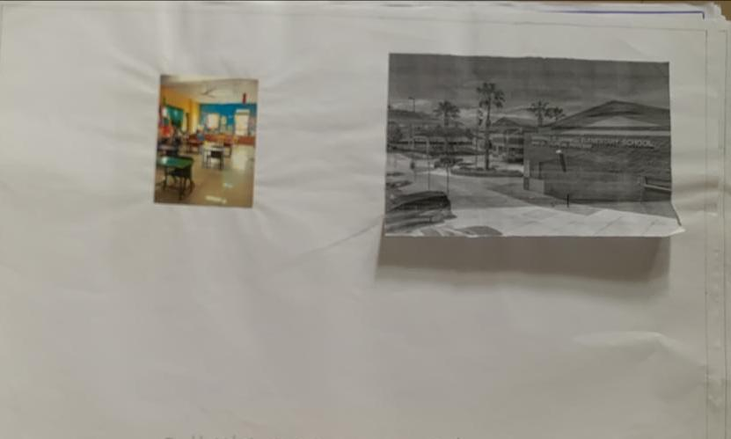

SHOWING FLOOR PLAN OF CASE STUDY FOUR
3.1.5 CASE STUDY FIVE (5): ONLINE CASE STUDY
Location:
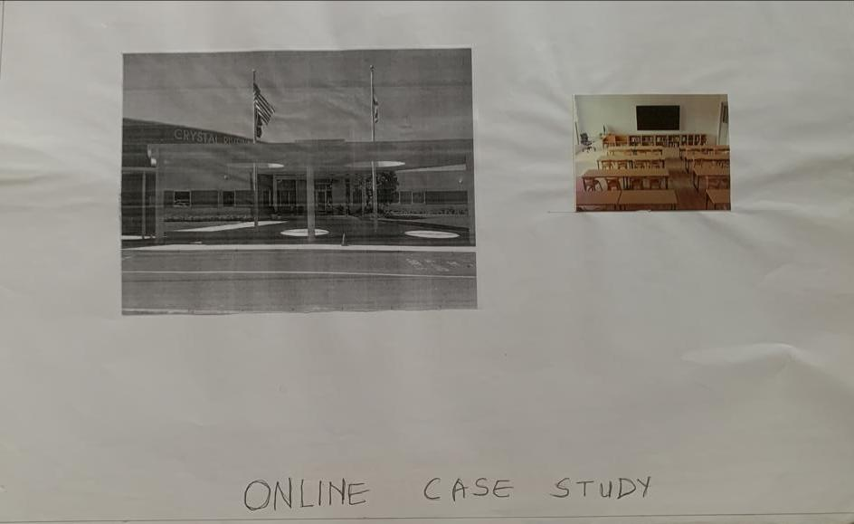
SHOWING FLOOR PLAN

CHAPTER FOUR
4.1 ANALYTICAL STUDY OF THE PROJECT LOCATION
4.1.1 INTRODUCTION
Ilorin is one of 36 states of federal of republic of Nigeria. Ilorin, the capital city of Kwara State, Nigeria, is a city with a rich historical, cultural, and economic background. Ilorin was founded in 1450 and has a significant historical legacy as a prominent center in the Yoruba and Fulani empires. Ilorin is a city with a rich historical heritage and cultural diversity, serving as an economic and educational hub in Kwara State. Its strategic location, coupled with ongoing development efforts, positions it as a key city in Nigeria’s socio-economic landscape.
4.1.2 SITE LOCATION
This is very important point to be considered before establishing the setting of houses, should take advantage of topographical features speeds and directions should be studied to ensure the best orientation to take advantage of the prevailing wind. Avoiding site prone to water logging and rain and draught which depends on wind direction and speed in the raining season placement of a building so that the length extends along the East and West direction. The proposed project is sited at Adewole, Atiku Abubakar Road Ilorin, Kwara State. It is surrounded with built up environment with various commercial activities being taken up in the area.
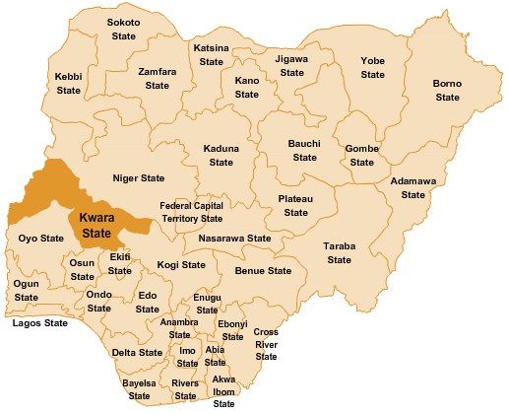

Figure 4.1.11.1 Map of Nigeria, 36 States and FCT.
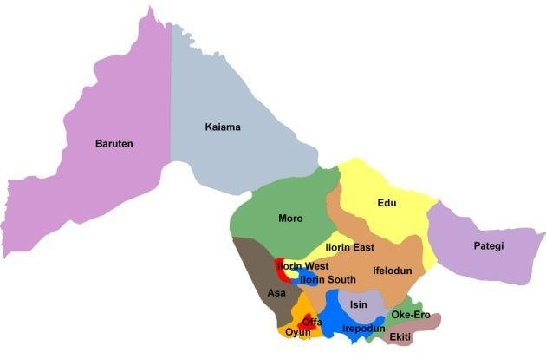
Figure 4.1.11.2 Kwara State Map

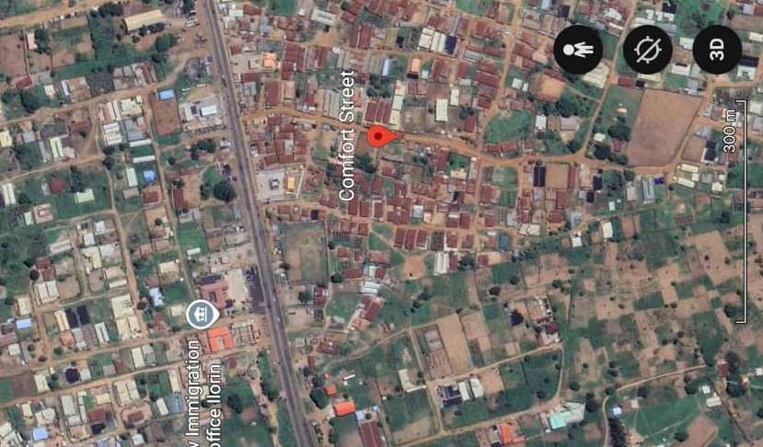

Figure 4.1.11.1 Location Plan

4.1.3 SITE INVENTORY
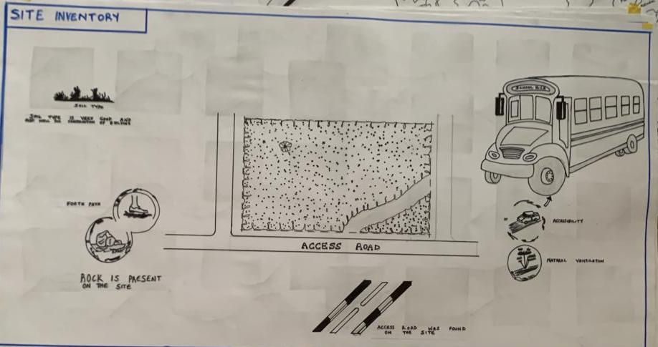
Figure 4.1.12.1 Site Inventory

Site analysis is the synthesis of the physical feature and facilities that are present on the site and over the site such as trees, footpath, soil, topography, vegetation, stream and shrubs etc.

4.1.4 SITE ANALYSIS
Site Analysis is the process of evaluating how a proposed site system will integrate with the existing site infrastructure by assessing physical obstructions, electrical interference, and noise to identify suitable interrogation zones for coexistence with the infrastructure.

The site selected for the project is a very gentle slope, it is a site that has never been used for any form of building construction i.e. it has not been developed in the past which make it an abode for several trees and shrubs, it is also observed during the course of inventory that some of the trees are to be removed as it could obstruct the construction process during the project, while some are to be retained to help control the adverse of the wind storm.

The soil is well compacted Soil in nature with good soil texture. The sun rises from the eastern part of the site and sets on the western part. The Construction does not need a special type of foundation due to the fact that the site is having a good bearing capacity and strength.

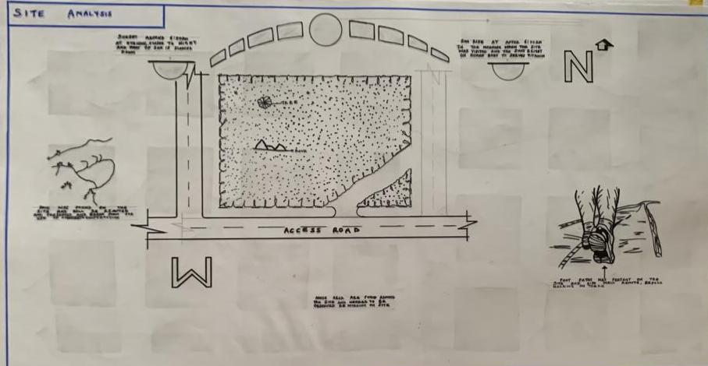
Figure 4.1.12.2 Site Analysis

4.1.5 GENERAL GEOGRAPHICAL CONDITION
Kwara State is located in the North-Central region of Nigeria. It shares boundaries with Kogi State to the east, Ekiti and Osun States to the south, Oyo State to the southwest, Niger State to the north, and an international border with Benin Republic to the west.

- Terrain: The state has a generally flat to gently undulating terrain, with some scattered hills especially in areas like Baruten and Kaiama. The land is a mix of savanna grasslands and wooded areas.

- Soil and Vegetation: The soils are mostly loamy and lateritic, suitable for farming. Vegetation varies from Guinea Savannah in the north to forest-savannah in the south.

Natural Features:
- Rivers like River Niger, Asa River, and Awon River are notable.
- There are also rock formations like Owu Falls and Imoleboja Rock Shelter.

4.1.6 CLIMATE:
Tropical savanna climate (Aw) according to the Köppen classification.
Temperature:
- Average annual temperature ranges between 25°C and 35°C.
- Hottest months: March to April (can reach up to 38°C).
- Coolest months: December to January (due to Harmattan winds).

Rainy Season:
- Starts around April and ends in October.
- Peak rainfall is usually in June and September.
- Annual rainfall ranges from 1,000 mm to 1,500 mm.

Dry Season:
- Runs from November to March.
- Influenced by Harmattan, a dry and dusty wind from the Sahara.
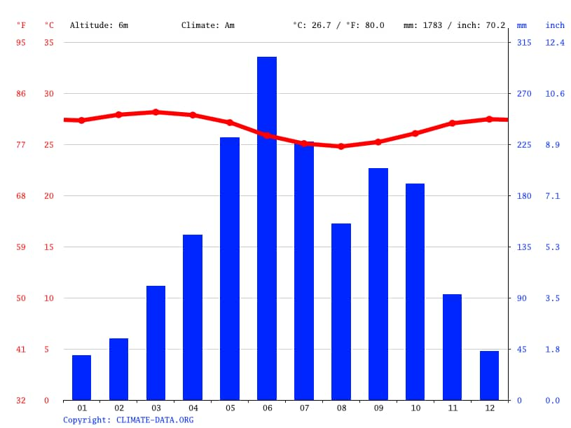
Figure 4.1.3.1 Average Monthly Rainfall in Kwara State.

Dry Season: The dry season in Kwara State usually spans from November to March. This period is marked by little to no rainfall, high daytime temperatures, and significantly lower humidity compared to the rainy season. A key feature of the dry season is the Harmattan, a dry and dusty wind that blows from the northeast, usually between December and February.

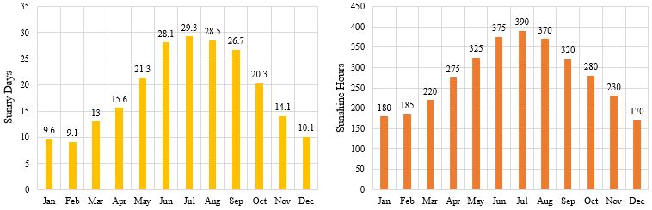

Figure 4.1.3.2 Sunshine Duration in Kwara State.
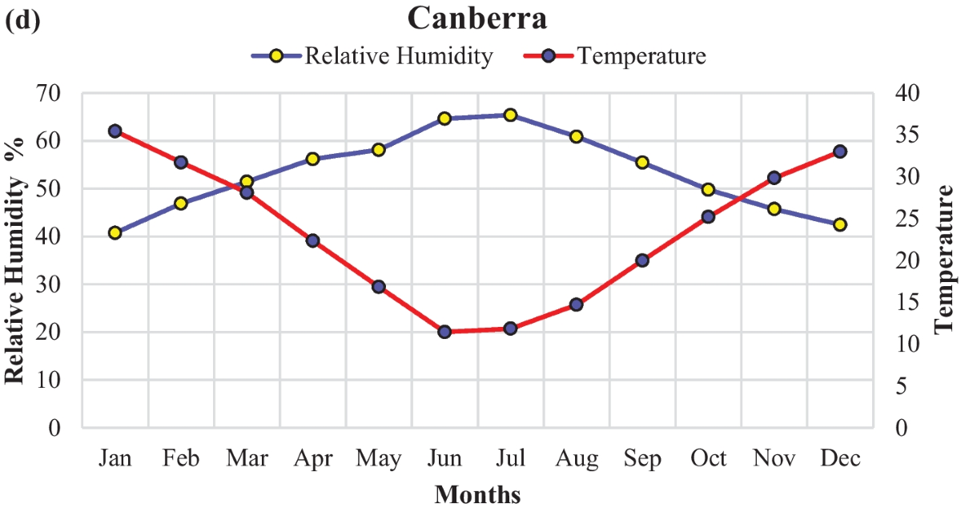

Figure 4.1.3.3 Relative Humidity in Kwara State.

4.1.7 VEGETATION
Guinea Savanna: The predominant vegetation type in Kwara State is the Guinea Savanna, characterized by a mix of grassland and scattered trees. This vegetation type is typical of the transitional zone between the forest regions in the south and the Sahel in the north.
Flora: Common plant species include acacia, baobab, shea butter trees, and various grasses and shrubs adapted to the savanna climate.

4.1.8 TOPOGRAPHY
Gently Undulating Plains: Kwara State. topography consists mainly of gently undulating plains, with occasional hills and low-lying areas.

4.1.9 NATURAL RESOURCES
Kwara State is rich in both metallic and non-metallic mineral resources, which support small- to medium-scale mining and industrial activities.
- Limestone
- Location: Found in large deposits in areas like Ogunreke, Patigi, and Share.
- Uses: Cement production, construction, and road building.
- Granite
- Location: Common in Ilorin, Asa, and Moro local government areas.
- Uses: Building and construction (used as crushed stone).
- Kaolin
- Location: Found in Edu, Ifelodun, and Offa.

4.1.10 ENVIRONMENTAL CHALLENGES
Urbanization: Rapid urbanization in Kwara State has led to challenges such as deforestation, waste management issues, and pressure on infrastructure and services.
Climate Change: Like many regions, Kwara State faces the impacts of climate change, including variability in rainfall patterns and increased frequency of extreme weather even.

4.1.11 SITE SERVICES
There are good services around the site, which include good access road, for students coming to school, availability of electricity very close to the site which will be useful before and after construction. Also, availability of pipe born water at the chosen site.

4.1.12 SITE UNIQUENESS AND BENEFIT
- The site is accessible
- Natural factor like, is very useful
- Utility services such as water, electricity, telephone, etc. cause no problem to the inhabitants.

4.1.13 SITE SUITABILITY
The appropriateness or suitability of the site for the construction and planning of the proposed project is based on the fact that is possesses and meets the entire requirements. All the existing features were strictly considered with the intension of making advantage of them to maximum level most especially the geographical, topographical features of the site.
Types of Forest Region
- Mangrove (Salt Quarter) Swamp Forest
- Fresh water swamp forest
- High forest

4.2. DESIGN CRITERIA
The design of a primary school must create a safe, functional, and stimulating learning environment for children between the ages of 4 and 12. The following criteria have been considered to guide the planning, layout, and development of the proposed primary school in Kwara State.
4.2.1 SITE SELECTION
A number of factors necessary for site selection for a farmstead are outlined below:
  - ﻿﻿﻿Access Road
  - ﻿﻿﻿Water
  - ﻿﻿﻿Utilizes and services (electricity, telephone, access drives etc.)
  - ﻿﻿﻿Orientation (air drainage and maximum sunshine may require orientation on a gentle Southerly slope).
  - ﻿﻿﻿Expansion.

4.2.2 BUILDING ARRANGEMENT
The arrangement of facilities for maximum efficiency of operation should be a prime concern. Proper arrangement increase efficiency by reducing walking distance to a minimum and providing adequate drive ways and turn around. It is important to note that five protections, safely and security and all influenced by the design planning.

4.2.3 DESIGN SCOPE
These are scope of designing a Muslim Secondary School which includesthe followings;
Security House, Cafeteria/Canteen, Main Building, Examination Hall, Mosque, School Field, Students Hostel, Staff Quarters, Park Lots, School Clinic and Assembly Ground.

4.2.4 DESIGN BRIEF9ANALYSIS
- The following are the brief analysis of the Administrative Units;
Entrance, Reception and Waiting Area, Secretary Office, Principal Office, Vice Principal Administrative, Vice Principal Academic, H.O.D’S Office, Staff Office, Counselling Office, Bursar’s Office and C.C.T.V Room.

- The following are the brief analysis of the Academic Units;
Classrooms, Laboratories, I.C.T Room, Computer Maintenance Room (Hardware), Art and Craft Room, Lecture Hall and Examination Hall.

- The following are the brief analysis of the Supporting Units;
Assembly Ground, Storage Facilities, Connivences and School Medical.

- The following are the brief analysis of the Residential Units;
Students Hostel and Staff Quarters.

4.2.5 SPACES DERIVATION ANALYSIS/SCHEDULE FOR ADMINBLOCK
S/N | UNITS | NO REQ. | LENGHT | BREADTH | LENGTH x BREADTH (mm) | AREA (m²)
 | Entrance |  | 5000 | 2000 | 5000x2000 | 18-0m²
 | Reception |  | 4100 | 3200 | 4100x3200 | 13-12m²
 | Nursery 1-2 |  | 5000 | 3500 | 5000x3500 | 17.5m²
 | Kindergarten 1-2 |  | 5000 | 4500 | 5000x4500 | 22.5m²
 | Primary 1 |  | 5000 | 4000 | 5000x4000 | 20m²
 | Primary 2 |  | 4000 | 3100 | 4000x3100 | 13.25m²
 | Primary 3 |  | 5000 | 3100 | 5000x3100 | 15.3m²
 | Primary 4 |  | 5500 | 5300 | 5500x5300 | 19.25m²
 | Primary 5 |  | 5500 | 5300 | 5500x5300 | 19.25m²
 | Primary 6 |  | 5500 | 5300 | 5500x5300 | 19.25m²
 | Headmaster Office |  | 5500 | 4500 | 5500x4500 | 24.45m²
 | Assembly Area |  | 16500 | 1100 | 16500x1100 | 181.3m²
 | Staff Room |  | 5800 | 3000 | 5800x3000 | 20
 | Secretary Office |  | 5500 | 3500 | 5500x3500 | 19.25m²
 | Exit |  | 2800 | 1500 | 2800x1500 | 2m²
 | Libraries |  | 7000 | 4500 | 7000x4500 | 24.5m²
 | Sick Bay |  | 3500 | 3000 | 3500x3000 | 10.5m²
 | ICT |  | 7000 | 4500 | 7000X4500 | 24.5m²
 | Admin Office |  | 5000 | 4000 | 5000x4000 | 20
 | Storage |  | 2000 | 1200 | 2000x1200 | 2.8m²
 | Toilets |  | 1200 | 2000 | 1200x2000 | 3.0m²

Table 4.2.5: Space Allocation

4.2.6 BUBBLE DIAGRAM
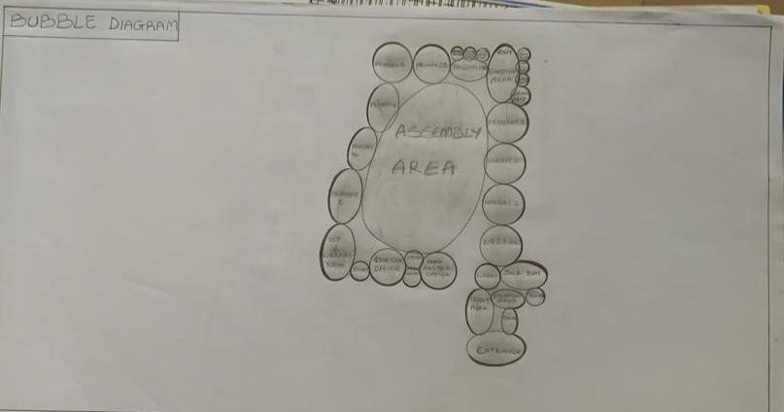

CHAPTER FIVE
5.1 APPRAISAL OF PROPOSED SCHEME
The proposed Project is to satisfy the appropriate building regulations. The design is to confirm the aid intended use of building taking into consideration with both natural factors and human factors that earn us a threat on the validity and stability of the building.

5.2 CONSTRUCTION METHODOLOGY AND MATERIALS.
The construction is to be carried out following the due process of construction ranging from:
- Preliminary: This involves the clearing of the site, setting out and excavation of foundation trench and foundation works.
- Sub-Structure: This process also entails the positioning and erection of Columns and beans, masonry works etc.
- Post Structure Stage: Is the stage which has to do with the application and installation of the paints, tiles, other finishes and construction of external works etc.

5.21 MATERIALS FOR CONSTRUCTION
1. Sustainable and Eco-Friendly Materials
- Bamboo and Timber: These materials are renewable, have a low carbon footprint, and can be sourced sustainably. Bamboo, in particular, grows quickly and has strong tensile properties.
- Recycled Materials: Using recycled steel, concrete, and glass can reduce the environmental impact of the construction process.
- Insulating Materials: Materials like sheep wool, cellulose, and hemp provide excellent thermal insulation and are environmentally friendly.

2. Traditional and Cultural Materials
- Clay and Adobe: Traditional building materials that offer good thermal mass, keeping buildings cool in hot climates. These materials can be locally sourced and are culturally significant in many regions.
- Stone: Using locally available stone can provide durability and cultural relevance, reflecting traditional architecture.
- Tiles and Ceramics: Decorative tiles and ceramics are often used in architecture for aesthetic purposes, featuring intricate geometric patterns and calligraphy.

3. Modern Materials
- Concrete: Widely used for its strength and versatility. It can be enhanced with additives to improve its sustainability.
- Steel: Provides structural strength and flexibility. Recycled steel can be a more sustainable option.
- Glass: Used for windows and facades to allow natural light. Double or triple-glazed glass can improve energy efficiency.

5.2.2 CONSTRUCTION METHODOLOGIES
1. Green Building Practices
- Passive Solar Design: Orienting the building to maximize natural light and heat from the sun, reducing the need for artificial lighting and heating.
- Green Roofs and Walls: Planting vegetation on roofs and walls to improve insulation, reduce heat island effects, and provide green spaces.
- Rainwater Harvesting Systems: Collecting and using rainwater for irrigation and non-potable uses within the school.

2. Energy-Efficient Construction
- Insulation: Using high-quality insulation materials to reduce energy consumption for heating and cooling.
- LED Lighting: Implementing energy-efficient LED lighting throughout the school.
- Solar Panels: Installing solar panels to generate renewable energy, reducing dependence on non-renewable energy sources.

3. Cultural and Religious Considerations
- Orientation: Provision of natural, quiet spaces that can be used for individual or group prayer during break periods.
- Architectural Elements: In the design of a functional and child-centered primary school, several architectural elements must be thoughtfully considered to ensure safety, comfort, and effective learning.
- Community Involvement: Engaging local communities in the design and construction process to ensure that the school meets cultural and social needs.

5.2.1 SERVICE
A building can be said to be good when it performs the service required by it. In order to have well-functioning building. There calls for an installation of underground water pipes in other to provide water to all the restrooms and other necessary units in the building. A borehole system of water supply is to be adopted alongside the government supplied services and a storage facility is to be provided for effective management of water supply.

5.2.2 CIRCULATION
In my primary school project, circulation is carefully planned to make movement around the school safe, easy, and comfortable for both pupils and staff. Since children are the main users, all circulation paths are designed to be wide, open, and easy to understand.

5.2.3 VENTILATION
As it relates to architecture, is the intentional introduction of outside air into a space. It is mainly used to control indoor air quality by diluting and displacing indoor pollutants. It can also be used for purpose of thermal comfort of dehumidification when the introduction of outside air will help to achieve desired indoor psychometric condition.

This could be either mechanical or natural ventilation. As a regard the proposed project design, there is an introduction of a very spacious courtyard in other to make cross ventilation in most of the building units. There should also a provision of wide passage to allow free movement of air, students and materials. Artificial ventilation is also provided through the installation of air conditioning system and fans.

5.2.4 LIGHTING
Lighting is one of the most important elements in my primary school project because it affects how well pupils can see, learn, and stay alert in class. In my design, I considered both natural and artificial lighting to create a bright, healthy, and energy-efficient learning environment.

5.2.5 PLUMBING
The plumbing system in this proposed building is made easy since the building has a courtyard. Water drained pipes are to be installed underground right from the courtyard to the soak away in other to discharge rainwater.

All water or sewage from the toilets are also channeled into their various inspection chambers using good and appropriate diameter PVC pipes, and taken from the inspection chamber to septic tanka and soak away pit.

Rain water is also collected from gutter if the roof using 100mm diameter PVC rain water pipes and channeled into various drainage or soak away pits. There shall be no ponding; the size of any channel shall effectively discharge rain and water without causing any over lowing stagnation and mosquito breeding. All rain water channeled shall be laid to fall and shall not cause any pounding or splashing unto the committers neighboring area.

5.2.6 ELECTRICAL INSTALLATION
The type of wiring system chosen should be full conduit system of wiring. Classrooms and other students’ technical areas should be wired with strong, durable and light current resistance cable because of the careless operate by the students. Also, electrical installation is to be done to allow for the use of quality electrical fittings and fixtures in the whole building.

5.2.7 WASTE DISPOSAL
Waste disposal bins are to put every office of the building and also in some specific necessary area. These water bins should dispose in the incinerator which will be provided within the compound of the station. The waste should therefore be burnt in the incinerator.

5.2.8 FIRE PROTECTION
Electrically, fire alarms and sensors are to be installed in the school building. This should be done in case of fire occurrence; fire extinguisher is to be placed at certain distances in the cobbles and some other necessary area. It is also serving as protector in case of fire.

5.2.9 EXTERNAL WORKS
The external works are to be carned out uncrate Krebs laid and shrubs, flowers grasses and trees planted.
Concrete interlocking tiles to be adopted of hard landscape and parking spaces both for visitors and staffs have been provided on the site.

5.3 CONCLUSION AND RECOMMENDATION
Conclusion
This project has explored the design of a functional, inclusive, and sustainable primary school that meets the educational and developmental needs of young learners. Based on the study of site conditions, cultural context, environmental factors, and case studies, the design integrates key features such as proper circulation, effective lighting, safe classrooms, and outdoor play areas.

The goal is to create a school environment that encourages learning, comfort, creativity, and security for pupils and staff. Special consideration was given to community involvement, accessibility, and the use of local materials to make the project practical and culturally relevant, especially for a location like Kwara State.

Recommendation
- Government and private bodies should invest more in early education infrastructure, especially in rural communities like those in Kwara State.
- Architects and planners should always consider child safety, local climate, and cultural background when designing for schools.
- School authorities should involve the community during planning and decision-making to ensure the school meets local expectations and is well maintained.
- Use of sustainable design (e.g., natural lighting, cross-ventilation, rainwater harvesting) should be encouraged to reduce operational costs.
- Future expansion should be considered in the design, with room for adding more classrooms or facilities as the population grows.

REFERENCES
- National Policy on Education (NPE)
- Federal Republic of Nigeria, 2014 Edition
- Gives educational guidelines for primary school levels.

- UNESCO (2009). “Designing Effective Learning Spaces.”
- Source: United Nations Educational, Scientific and Cultural Organization.
- Provides international standards for school planning and classroom design.

- Ministry of Education Guidelines – Kwara State
- Local government design and spatial planning regulations.

- Neufert, E. (Architects' Data)
- A classic architectural reference for space standards, room sizes, and furniture layout.

- Time-Saver Standards for Building Types
- Joseph De Chiara & Michael Crosbie.
- Offers detailed architectural data on school buildings.

- Nigerian Building Code (2006)
- For construction standards, safety, and accessibility in Nigeria.

- Olusanya, S. O. (2011). "Architectural Design Criteria for Nigerian Schools."
- Journal of Environmental Design and Management.

- Arayela, O. (2003). “Designing for Nigerian Schools: A Climatic Approach.”
- Focuses on using local materials and adapting to the tropical climate.

- World Bank (2010). “Safe and Inclusive Schools.”
- A guideline for planning schools with emphasis on safety and inclusion.

- Interview with Local School Teachers or Headmasters
- Real-world insights for user needs and functionality.

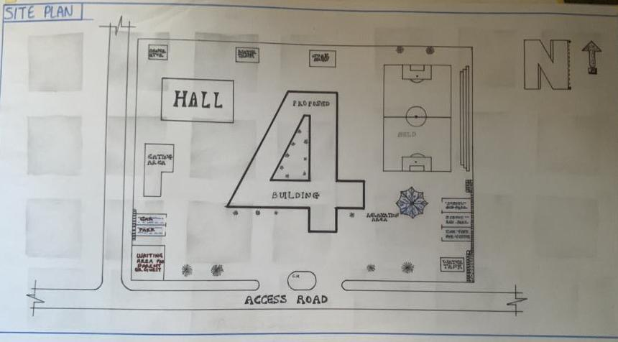

Appendix 5.1: Site Plan
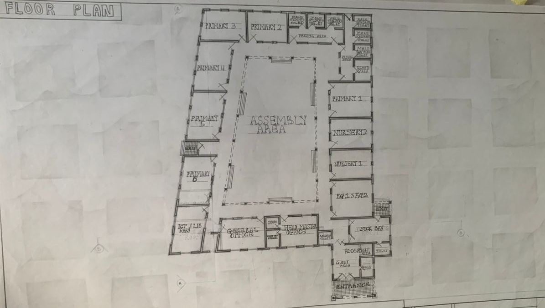

Appendix5.2: Floor Plan.

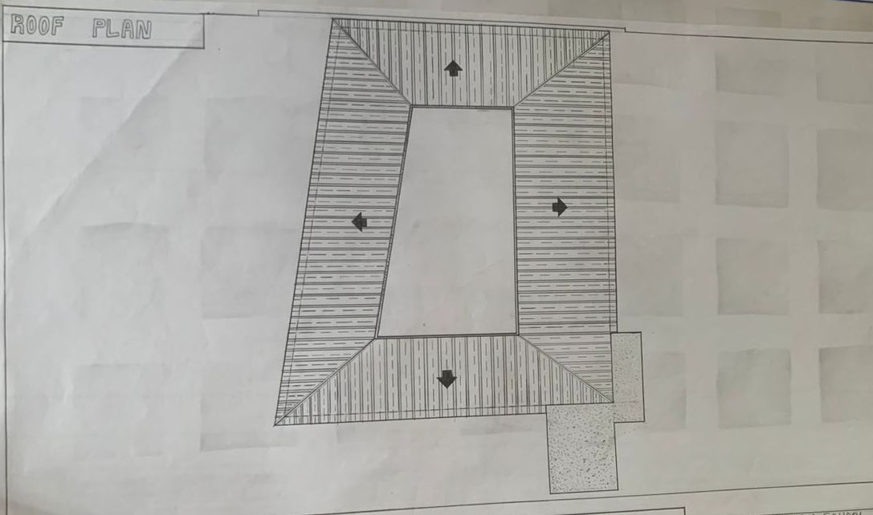

Appendix 5.5: Roof Plan

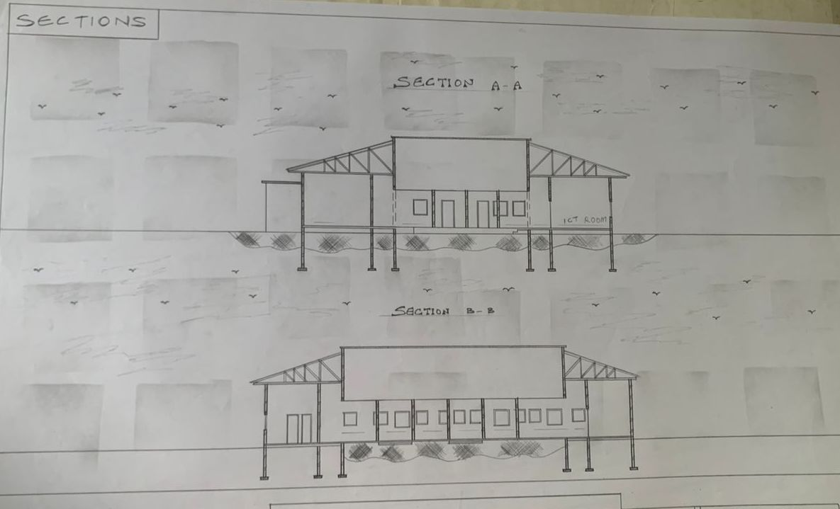

Appendix5.6: Section

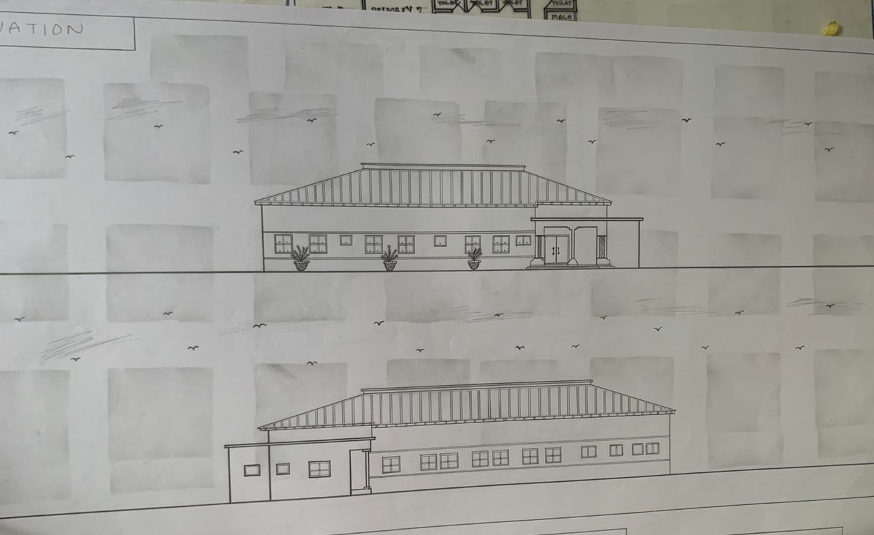

Appendix5.7: Elevation

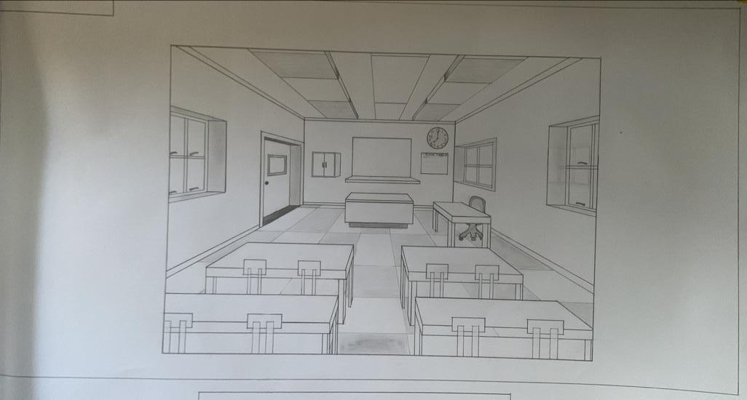

Appendix5.8: Internal Perspective.

