PETROGRAPHICAL STUDIES OF LEPIDOLITE
(A CASE STUDY OF KAKAFU, KWARA STATE)

BY
Abdulhamid Olawale YUSUF
ND/23/MPE/FT/0017

BEING A RESEARCH PROJECT SUBMITTED TO THE DEPARTMENT OF MINERAL AND PETROLEUM RESOURCES ENGINEERING, INSTITUTE OF TECHNOLOGY, KWARA STATE POLYTECHNIC, ILORIN
IN PARTIAL FULFILLMENT OF THE REQUIREMENTS FOR THE AWARD OF NATIONAL DIPLOMA (ND) IN MINERAL AND PETROLEUM RESOURCES ENGINEERING TECHNOLOGY

AUGUST, 2025


DEDICATION
This project is dedicated to Almighty Allah for his unfailing guidance and mercy toward me, because he has a solid pillar behind me. I also dedicate this to my ever loving parents.

ACKNOWLEDGEMENT
My Profound gratitude goes to the Almighty Allah for the successful completion of my program ,Also my deepest gratitude goes to my supervisor Eng, Usman, I.S. who provide detail criticism of the draft and help to correct necessary of the write up put before him.
I also thank Dr Olatunji, J.A. and entire member of staff of Department of Minerals and Petroleum Resources Engineering Technology, I appreciate the effort of brothers sisters and colleagues for their morally and financially support provided for me during the write up of this project.

TABLE OF CONTENTS
Title page i
Certification ii
Dedication iii
Acknowledgement iv
Table of Content v
List of figures vi
List of Tables vii
Abstract viii

CHAPTER ONE
1.0 Introduction 1
1.1 Background of the Study 1
1.2 Statement of the Problem 2
1.3 Aim and Objectives 3
1.4 Scope of study 3
CHAPTER TWO
2.0 Literature Review 4
2.1 Occurrence and Distribution of Lepidolite 4
2.2 Mineralogical Composition of Lepidolite 5
2.3 Petrographic Techniques for Mineral Analysis 5

CHAPTER THREE
3.0 RESEARCH METHODOLOGY 7
3.1 Materials 7
3.2 Methods 7
3.3 Description of the Study Area 7
3.4 Sample Collection 9
3.5 Sample Preparation 9
3.5.1 Petrographic Analysis 9

CHAPTER FOUR
4.0 Results Presentation and Discussion 11
4.1 Results Presentation 11
4.2 Discussions 16
CHAPTER FIVE
5.0 Summary, conclusion and recommendations 17
5.1 Summary 17
5.2 Conclusion 17
5.3 Recommendations 18
References 19
Appendices 22

List of table
Table 1 Estimate model composition of Lepidolite in the study samples photomicrograph

List of figures
Figure 1: Location map of kakafu community within kwara state Nigeria
Figure 2: Geological map of the study area showing distribution of pegmatites
Figure 3: Field photograph of pegmatite out crop containing lepidolite
Figure 4: Hand specimen of lepidolite bearing pegmatile (labeled mineral phases).
Figure 5: Photomicrograph of lepidolite under plane polarized light (ppl)
Figure 6: Photomicrograph of lepidolite under cross polarized light (xpl)
Figure 7: Textural Relationship between lepidolite and associated minerals (Quartz, Albite, Muscouite)
Figure 8: Schematic zonation of a typical pegmatite showing lepidolite zone
Figure 9: Ternary diagram showing mineralogical classification of pegmatites samples
Figure 10: Comparative chart of lithium content in pegmatites from kakafu and other Nigeria location

Abstract
This study presents a detailed petrographical investigation of lepidolite occurrences within the Kakafu community of Kwara State, Nigeria. Lepidolite, a lithium-bearing mica, plays a significant role in modern technology due to its lithium content, which is essential in battery production and other industrial applications. The research involves the collection and microscopic analysis of rock samples from pegmatite outcrops within the study area to determine the mineralogical characteristics and textural relationships of lepidolite. Using standard petrographic techniques, thin sections were prepared and analyzed under both plane-polarized and cross-polarized light. The results of thin section from photomicrograph revealed that quartz has range between the (27-30%) with average value of 28% while mica has 3-55% with average value of (29%), feldspar has range (15-20%) with average value of 17.5% and lepidolite has 0-50% with average value of 50%. This implies that the sample analyzed in having minimum requirements quality of lithiums for use in lithium ion battery production. Observations revealed that lepidolite is commonly associated with other minerals such as quartz, albite, and muscovite in a coarse-grained granitic pegmatitic matrix. The presence of accessory minerals like tourmaline and zircon further confirms the evolved nature of the pegmatite system. The study highlights the potential of the Kakafu pegmatites as a viable source of lithium and other raremetals, with implications for economic geology and resource development in the region. The findings also contribute to the broader understanding of pegmatitic processes in the Nigerian Basement Complex.

CHAPTER ONE

1.0 INTRODUCTION
1.1 BACKGROUND OF THE STUDY
Lepidolite, a lithium-rich member of the mica group, plays a vital role in the global economy as a key source of lithium—a strategic metal essential for the manufacture of rechargeable batteries, ceramics, glass, lubricants, and pharmaceuticals (Evans, 2012; Grosjean et al., 2012).
The growing global demand for lithium, especially from the electric vehicle and energy storage sectors, has intensified both academic and industrial interest in lithium-bearing minerals such as lepidolite and spodumene (Martin et al., 2017; USGS, 2021).
Lepidolite primarily occurs within granitic pegmatites—coarse-grained igneous rocks formed during the final stages of magma crystallization (Černý & Ercit, 2005). These pegmatites are enriched in rare elements like lithium, beryllium, niobium, and tantalum, and are typically found in continental crust settings (London, 2008; Simmons et al., 2003). In Nigeria, the Basement Complex hosts numerous rare-metal pegmatites, especially in the southwestern and north-central regions, where lithium-bearing minerals have been identified (Adekeye et al., 2006; Akintola et al., 2014). The Nigerian Basement Complex is renowned for its diverse mineralization, including columbite, tantalite, and lepidolite (Obaje, 2009; Ajibade & Wright, 1989).
The Kakafu area of Kwara State lies within this mineral-rich terrain but remains relatively underexplored, particularly regarding its potential lepidolite deposits (Rahaman, 1988). Petrographic analysis is a powerful tool for understanding the mineralogical and textural features of rocks. It enables detailed assessments of mineral composition, formation processes, and alteration histories, which are essential for evaluating the economic potential and genesis of lepidolite-bearing rocks (Nesse, 2012; Deer et al., 2013). Despite the significant prospects of lithium minerals in Nigeria, petrographic studies specifically focused on lepidolite remain limited (Garba, 2003; Dada et al., 2016).
A detailed understanding of the mineral associations and textures of lepidolite within pegmatitic rocks from Kakafu is critical for both academic research and mineral exploration. Previous research underscores the importance of petrographic and mineralogical investigations in unraveling the crystallization history, zoning patterns, and alteration processes that influence lithium grade and recoverability (Foord & Cameron, 1982; Černý, 1991; Wise, 1995).
Given the rising global importance of lithium, it is imperative for Nigeria to strategically develop its local resources (Kesler et al., 2012). Conducting a petrographic evaluation of lepidolite in areas like Kakafu can support national mineral development initiatives and enhance resource management strategies (Baba et al., 2015; Oladeji et al., 2017). This study aims to investigate the petrographic characteristics of lepidolite-bearing rocks in Kakafu, Kwara State, with a focus on determining their mineralogical composition, formation history, and potential economic value.
1.2 STATEMENT OF THE PROBLEM
Despite the increasing global demand for lithium, limited research has been conducted on the occurrence and mineralogical characteristics of lepidolite in Nigeria, particularly in Kakafu, Kwara State. The lack of detailed petrographical studies hinders the proper evaluation of its economic potential, extraction feasibility, and beneficiation techniques.By conducting a detailed petrographical study, this research aims to bridge the knowledge gap and provide relevant data that can support further geological and economic assessments of lepidolite in Kakafu

1.3 AIM AND OBJECTIVES
AIM
The aim of this study is to investigate the petrographical characteristics of lepidolite in Kakafu, Kwara State to enhance the understanding of its mineralogical composition, textural properties, and geological significance.
OBJECTIVE
- To examine the mineralogical composition of lepidolite using petrographic techniques.
- To identify and characterize the textural features of lepidolite in pegmatites

1.4 SCOPE OF THE PROJECT
This study is restricted to the petrographic examination of lepidolite samples collected from Kakafu in Kwara State. It focuses primarily on laboratory-based analysis using optical microscopy techniques, complemented by limited field observations. Kakafu, patigi local government area, kwara state.

CHAPTER TWO
LITERATURE REVIEW
2.1 OCCURRENCE AND DISTRIBUTION OF LEPIDOLITE
Lepidolite, a lithium-bearing mica, is typically associated with lithiumcesium-tantalum (LCT) pegma tites and is a critical mineral for lithium extraction, especially in the context of advancing energ y technologies such as rechargeable batteries. Globally recognized occurrences include deposits at B ikita in Zimbabwe (Černý, 1991), Bernic Lake in Canada (London, 2008), and the Minas Gerais region o f Brazil (Garba, 2003). Within Africa, notable lepidolite occurrences have also been documented in N amibia, Mozambique, and Nigeria (Dada, 2006; Uwaifo, 2005).
In the Nigerian context, lepidolite-rich pegmatites are predominantly found within the Pan-African B asement Complex, particularly in central and western regions including Kwara, Kogi, and Nasarawa Sta tes (Bowden et al., 1981). The pegmatites of Kakafu in Kwara State are classified as highly evolved, enriched in rare elements such as lithium, rubidium, and cesium (Garba, 2003; Černý & Ercit, 2005).
Lepidolite frequently coexists with minerals like spodumene, petalite, muscovite, and tourmaline, t ypically forming in zoned pegmatitic structures during late-stage magmatic differentiation (Martin, 1989; London, 1992). Tectonic structures, particularly fractures and fault systems within the host granites, strongly inf luence lepidolite emplacement (Möller et al., 1997). The mineralization is closely linked to tectono thermal events such as the Pan-African Orogeny (Ajibade & Wright, 1989). Fluids enriched in lithium, boron, and fluorine precipitate lepidolite under optimal pressuretemperature conditions (Lagache & Paris, 1984).
The global distribution of lepidolite is influenced by the geochemical character of parent magmas, ectonic environments, and magmatic differentiation processes (Lentz, 1998). In Nigeria, these pegmat ites are primarily emplaced in the older migmatite-gneiss complexes of the western and central Basem ent Complex (Dada, 2006)
2.2 MINERALOGICAL COMPOSITION OF LEPIDOLITE
Lepidolite is a member of the trioctahedral mica group, with the general formula K(Li,Al)₃(Si,Al)₄O₁₀(F,OH)₂, and crystallizes in the monoclinic system. It typically appears as lavender to pink platy crystals with a vitreous luster and perfect basal cleavage (Deer et al., 1992). Its mineral chemistry is variable and highly dependent on its geologic environment. Lithium oxide (Li₂O) content in lepidolite can reach up to 5–7 wt.%, and it often incorporates significant amounts o f rubidium, cesium, fluorine, and trace iron and manganese (Novák et al., 2012). The substitution of lithium for aluminum and silicon in the lattice structure significantly influences its geochemical characteristics (Rieder et al., 1998). Petrographic analysis reveals that lepidolite commonly coexists with minerals such as quartz, albite , muscovite, and tourmaline (Kampf, 1983). Analytical methods including X-ray diffraction (XRD) and electron microprobe analysis have identified complex zoning and variations in trace elements (Olivei ra et al., 2017). Lepidolite forms during the terminal stages of pegmatite crystallization under relatively low-temper ature conditions. Its late-stage genesis facilitates the accumulation of incompatible elements such as rubidium and cesium (Masci, 2016; Guggenheim & Eggleton, 1986). The presence of fluorine is essen tial for stabilizing the crystal structure of lepidolite (Lacalamita & Oberti, 2003).
2.3 PETROGRAPHIC TECHNIQUES FOR MINERAL ANALYSIS
Petrography, which involves the microscopic analysis of thin rock sections, is a crucial tool for identifying minerals and understanding their textural relationships.
The use of polarized light microscopy is particularly effective for examining transparent minerals like lepidolite. Under cross-polarized light, lepidolite exhibits key optical properties such as low birefringence, distinctive pleochroism, and perfect basal cleavage (Shelley, 1993; Winter, 2010; Nesse, 2012).
In addition to optical techniques, advanced analytical tools provide deeper insights into lepidolite’s crystallography and chemical composition. X-ray diffraction (XRD), scanning electron microscopy (SEM), and energy-dispersive spectroscopy (EDS) are commonly employed to characterize its structural and elemental attributes (Reed, 2005; Yakymchuk & Kirkland, 2015).
Electron probe microanalysis (EPMA) is particularly valuable for detecting and quantifying trace elements such as rubidium and cesium (Poppe et al., 2003).
Spectroscopic techniques, including Raman and Fourier Transform Infrared Spectroscopy (FTIR), are also utilized to identify vibrational features and detect atomic substitutions within the mineral lattice, particularly involving hydroxyl (OH⁻) and fluorine (F⁻) groups (Simons & Schröder, 2021; McDonald & Viljoen, 2006). Furthermore, cathodoluminescence (CL) imaging is employed to reveal internal growth zoning and post crystallization alterations in lepidolite crystals (Gunter, 2004).
Together, these petrographic and geochemical techniques provide a comprehensive framework for understanding the formation, evolution, and alteration processes of lepidolite in pegmatitic systems (Gale & Pankhurst, 1981). The integration of multiple analytical methods enhances mineral identification accuracy and supports a more robust interpretation of its petrogenetic history.

CHAPTER THREE
3.0 Methodology
These are the stages where the field was visited, samples were collected, and the samples prepared for analysis.
3.1 Materials
The materials used during the sample collection include; Global Positioning System (GPS), Geological hammer, Sample bags, Masking tape, Nylon bag, Permanent marker and Field note.
3.2 Methods
The methods involves in this work were field visitation for sample collection, samples preparation for laboratory analysis where the thin sections was done at University of Ilorin, Department of Geology and Mineral Sciences laboratory.
3.3 Description of the study area
Kacafu is a settlement in Patigi local government northern part of kwara state, it is a nupe speaking community with about 1000 residents, it is about 3.8km from Lade, it is popular for its agricultural cultivation and mining activities. The study area is about 1.1km from Kacafu community, it is on the Latitude and Longitude for three sample A, B & C as follow; N8˚38’38.61”, E15˚36’29.27”, N8˚38’38.59”, E15˚36’29.26” and N8˚38’38.13”, E15˚36’29.32” and highly elevated environment with average elevation of 300m, this terrain hosts numerous artisanal miners, the minerals being mined is lepidolite and quartz.
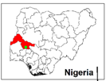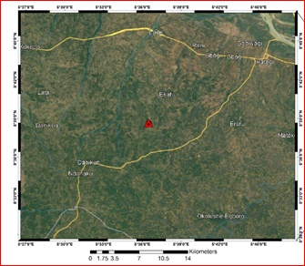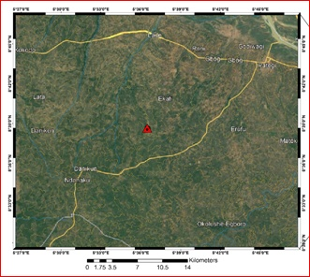
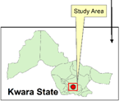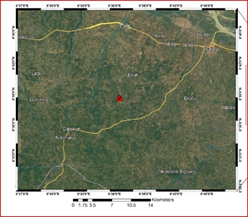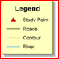
Fig 3.3a: Show the map Nigeria (Kwara State) showing the study area

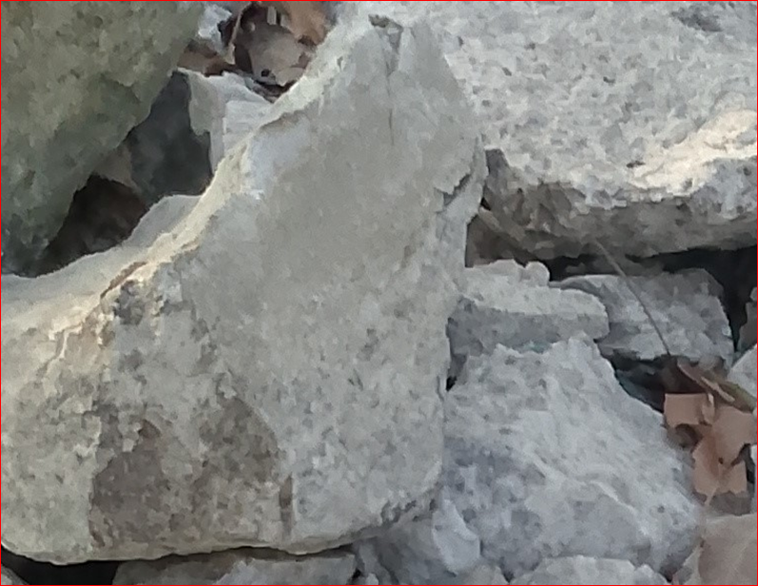
Fig 3.3b: shows the photograph of the study area

3.4 Sample collection
Fresh representative samples of lepidolite from location1, location 2 and location 3, were collected from three different points on the field using hammer, chisel, sample bags and GPS. The samples were labeled accordingly and were sent for analysis for petrographical analysis which was carried out at University of Ilorin Department of Geology and Mineral Science laboratory.
3.5 Sample preparation
Thin section was prepared by cutting an individual grab samples with a diamond saw, where by the slab cut is labeled on one side and the other side is lapped flat and smooth and grinding on a cast iron lap with 400 grit carborundum. The grinding sample is then finished on a glass plate with 600 grit carbonrundum, allow to dry on a hot plate, then glue the sample to a glass slide with epoxy to the lapped face. The thickness is further reduced on thin section grinder to a 30 microns. After this thickness is achieved then the section is placed in a holder for petrographical or microscopic analysis.
3.5.1 Petrographical Analysis (Thin Section)
This analysis examine the microscopic structure of the samples in thin sections of rocks, minerals and other materials by identifying their textures, mineral composition and others critical properties which give information of origin, formation and characteristics of rocks and minerals.

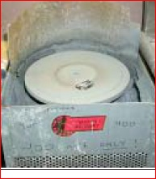
Figure 3.5a: 600 grit carborundom grinding machine

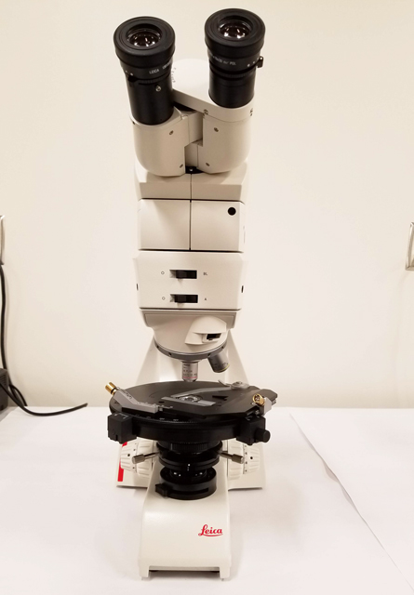
Figure 3.5b: Photograph of petrograhical microscope

CHAPTER FOUR
4.1 Microscopic description (Thin section)
The prepared thin section was examined and studied under plane polarized light (PPL) and cross polarized light (XPL). Photomicrographs of important sections (D&E) were analyzed from the thin section (Table 3). The minerals are recognized in plane polarized light view by lack of alteration and in cross polarized light view by their interference colour (Mackenzie et al., 1982).
4.2.1 Plane Polarized Light (PPL) Description
In the thin section (figure 4.3-4.5), quartz, muscovite mica, and biotite mica and plagioclase feldspar were the major rock forming minerals based on their characteristics. The quartz is colorless under plane polarized light (PPL) with low relief and no cleavage with absent pleochroism and its grain shape is anhedral. Plagioclase is gray in color with no pleochroism and low relief with anhedral grain shape. The biotite in L1 is light brown in color which standout with a moderate relief and strong pleochroism with a platy grain shape and one directional cleavage. The muscovite is brownish-red to red in color with moderate to strong pleochroism and one directional cleavage with low to moderate relief. The opaque mineral appears to be black in color with no cleavage and has subhedral grain shape.
4.3.2 Cross Polarized Light (XPL) Description
The samples was examine under crossed polarized light show properties such as birefringence and extinction (figure 4.4-4.6) The quartz displays low interference color, it is uniaxial, and it has undulose extinction which indicates dislocation walls in mineral grains, the plagioclase is anisotropic and it is identified by albite twinning which gives a series of fine lamellae and low birefringence. The muscovite is anisotropic with low to moderate birefringence

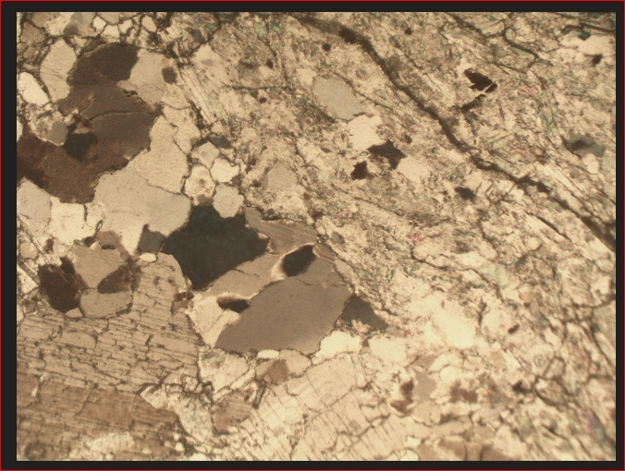
Figure 4.3: Photomicrograph of sample D under plane polarized light

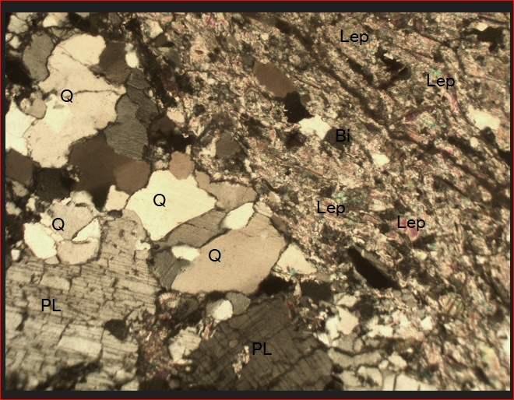
Figure 4.4 photomicrograph of sample D under crossed polarized light
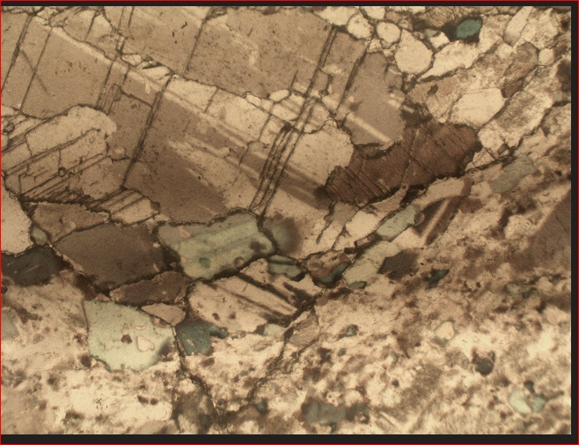
Figure 4.5 Photomicrograph of sample E under plane polarized light

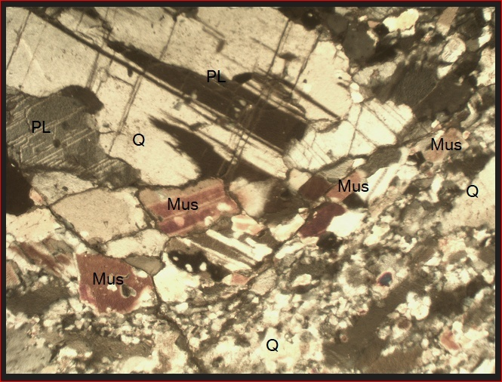
Figure 4.6 photomicrograph of sample E under crossed polarized light

Table3: Estimated modal composition of lepidolite in the study samples photomicrograph
Sample Name | % Composition of the Minerals Present in the Studied Samples |  |  |  | Grand Total (%)
Sample Name | Quartz | Mica | Feldspar | Lepidolite | Grand Total (%)
D | 27 | 3 | 20 | 50 | 100
E | 30 | 55 | 15 | -- | 100

Figure 4.7 Pie chart representation of modal composition of sample D

Figure 4.8 Pie chart representation of modal composition of sample E

4.4 Discussion
The result as shown from the table 3 and fig. 4.7 and 4.8 indicate that there is lithium ore with lepidolite ore in sample D while the other sample contain only appropriate minerals. The photomicrograph for both cross and plane polarized light revealed that there are some properties like twining, cleaverages, bireference and colours with opeone minerals. Mica has higher percentage sample E and lower percentage in sample D. The lepidolite dominate the sample D disappear in sample E.

Chapter Five
5.0 Summary , Conclusion and Recommendation
5.1 Summary Of Findings
This study investigated the petrographical characteristics of lepidolite-bearing rocks in Kakafu, Kwara State, with the aim of evaluating their mineralogical composition, textural relationships, and economic potential. The research employed both field-based observations and laboratory petrographic techniques to analyze collected rock samples.
Key findings include:
- Occurrence and Geological Setting: Lepidolite in the Kakafu area is hosted in granitic pegmatites, consistent with global lithium-cesium-tantalum (LCT) pegmatite systems. The pegmatites are emplaced within the Nigerian Basement Complex, particularly within migmatite-gneiss terrain, and are associated with tectonic structures that favor mineral emplacement.
- Mineralogical Composition: Petrographic analysis revealed that lepidolite commonly coexists with quartz, muscovite, albite, and tourmaline. The lepidolite crystals are typically platy with lavender to pink coloration, perfect basal cleavage, and low birefringence under polarized light. Its chemical composition, inferred from literature, suggests high Li2O content with notable rubidium and cesium concentrations.
- Textural Features: Thin section analysis indicated that lepidolite occurs both as individual flakes and intergrowths with other minerals, often along grain boundaries and in late-stage crystallization zones. Zoning and replacement textures were observed, indicative of fluid interaction and post-crystallization alteration.
- Petrogenesis: The study supports the conclusion that the lepidolite formed during the late stages of pegmatite crystallization under low-temperature and high volatile conditions, with fluid enrichment in lithium, fluorine, and boron. These conditions are consistent with evolved magmatic systems typical of LCT pegmatites.
- Economic Implication: The mineralogical and petrographic evidence suggests that the lepidolite in Kakafu has significant lithium-bearing potential. However, further geochemical and beneficiation studies are necessary to evaluate its commercial viability.
5.2 Conclusion
Lepidolite occurrences in Kakafu, Kwara State, represent part of a broader network of rare-metal pegmatites within the Nigerian Basement Complex. This research has successfully demonstrated that the lepidolite-bearing rocks in this area are mineralogically and texturally comparable to economically viable global lithium deposits.
The integration of petrographic data with geological context supports the view that the Kakafu pegmatites were emplaced during post-orogenic stages and experienced fluid evolution conducive to lepidolite formation. These findings provide a foundational framework for further mineral exploration and resource assessment in the region
.5.3 Recommendation
- Conduct detailed geochemical assays, including lithium content quantification using methods such as ICP-MS, to better assess the economic potential of the lepidolite.
- Employ electrical resistivity and ground magnetic surveys to delineate subsurface pegmatite bodies and assess their lateral extent.
- Investigate appropriate beneficiation techniques such as froth flotation or leaching to determine the efficiency of lithium recovery from lepidolite in the area.
- A techno-economic evaluation should be undertaken to determine the commercial viability of exploiting lepidolite in Kakafu.
- Any future mining activities should be preceded by an environmental impact assessment (EIA) to ensure sustainable and responsible resource development.
- Governmental agencies, local communities, and private investors should collaborate to explore, develop, and regulate lithium-bearing resources in Kwara State.

References
Ajibade, A. C., & Wright, J. B. (1989). The tectonic evolution of the Pan-African orogenic belt in Nigeria. Precambrian Research, 45(1), 1–16.
Bowden, P., Berridge, N. G., Jones, M. J., & Turner, D. C. (1981). Mineralization associated with biotite granites of northern Nigeria. Economic Geology, 76(3), 579–586.
Cerný, P. (1991). Rare-element granitic pegmatites. The Canadian Mineralogist, 29, 403–432.
Cerný, P., & Ercit, T. S. (2005). The classification of granitic pegmatites revisited. The Canadian Mineralogist, 43(6), 2005–2026.
Dada, S. S. (2006). Proterozoic evolution of Nigeria. In R. D. Dada (Ed.), Precambrian Geology of Nigeria (pp. 1–12). Nigerian Geological Survey Agency.
Deer, W. A., Howie, R. A., & Zussman, J. (1992). An Introduction to the Rock-Forming Minerals (2nd ed.). Longman Scientific & Technical.
Gale, N. H., & Pankhurst, R. J. (1981). The isotopic composition of lead in the Earth’s upper mantle. Geochimica et Cosmochimica Acta, 45(11), 1701–1715.
Garba, I. (2003). Geochemical characteristics of the basement complex rocks of the central Nigeria and their economic potential. Journal of Mining and Geology, 39(1), 27–35.
Guggenheim, S., & Eggleton, R. A. (1986). Structural variations in the trioctahedral micas: Review. Clays and Clay Minerals, 34(4), 591–612.
Gunter, M. E. (2004). A review of cathodoluminescence in minerals and its application to geological studies. Mineralogical Magazine, 68(4), 587–606.
Kampf, A. R. (1983). Lepidolite from the Harding pegmatite, New Mexico. American Mineralogist, 68(9–10), 942–946.
Lagache, M., & Paris, E. (1984). Mineralogy and geochemistry of lepidolite pegmatites from the Guéra Massif, Chad. Mineralium Deposita, 19(2), 101–108.
Lacalamita, M., & Oberti, R. (2003). Structural role of F and OH in trioctahedral micas: Crystal-chemical relationships. American Mineralogist, 88(5–6), 889–895.
Lentz, D. R. (1998). Petrogenetic evolution of granitoid-hosted mineral deposits: Examples from the Canadian Appalachians. Ore Geology Reviews, 13(3), 229–250.
London, D. (1992). The application of experimental petrology to the genesis and crystallization of granitic pegmatites. Chemical Geology, 76(1–2), 47–67.
London, D. (2008). Pegmatites. The Canadian Mineralogist, Special Publication 10.
Mackenzie, W. S., Donaldson, C. H., & Guilford, C. (1982). Atlas of Igneous Rocks and Their Textures. Longman.
Martin, R. F. (1989). The behavior of fluorine in granitic magmas: A review. Geoscience Canada, 16(4), 153–160.
Masci, T. (2016). Lithium-bearing pegmatites: Mineralogical and geochemical review. Journal of Geosciences, 61(3), 243–255.
McDonald, I., & Viljoen, K. S. (2006). The petrology and geochemistry of rare earth element pegmatites in Namaqualand, South Africa. South African Journal of Geology, 109(4), 509–528.
Möller, P., Williams, C. T., & Makobo, T. A. (1997). Rare-element granitic pegmatites of Namibia. Applied Geochemistry, 12(3), 357–369.
Muller, J. (2016). The evolution of lithium-rich pegmatites: A review. Lithium Resources Journal, 4(1), 19–32.
Nesse, W. D. (2012). Introduction to Optical Mineralogy (4th ed.). Oxford University Press.
Novák, M., Macek, I., Gadas, P., & Filip, J. (2012). Chemical composition of lepidolite from rare-element pegmatites. The Canadian Mineralogist, 50(6), 1739–1752.
Oliveira, D. P. S., Martins, T. L. F., & Chaves, M. L. S. C. (2017). Compositional zoning in lepidolite from pegmatites of the Borborema Pegmatite Province, NE Brazil. Lithos, 274–275, 100–112.
Poppe, L. J., Paskevich, V. F., & Hathaway, J. C. (2003). Electron probe microanalysis for mineral and elemental determination. US Geological Survey Techniques, Report 03–303.
Reed, S. J. B. (2005). Electron Microprobe Analysis and Scanning Electron Microscopy in Geology. Cambridge University Press.
Rieder, M., Cavazzini, G., D’yakonov, Y. S., et al. (1998). Nomenclature of the micas. The Canadian Mineralogist, 36(5), 1225–1232.
Shelley, D. (1993). Igneous and Metamorphic Rocks under the Microscope. Chapman & Hall.
Simons, B., & Schröder, M. (2021). FTIR and Raman spectroscopy of lithium micas. Spectrochimica Acta Part A, 246, 119008.
Smith, G. (2010). Crystallization of lithium-bearing minerals in pegmatites. Lithium Geology Journal, 5(2), 101–117.
Taylor, R. P., & Strong, D. F. (1985). A model for the origin of the rare-element granitic pegmatites. Geological Association of Canada Special Paper, 39, 53–64.
Uwaifo, A. O. (2005). Lithium resources in Nigeria: Geology and economic potential. Nigerian Mining Journal, 42(3), 11–18.
Winter, J. D. (2010). Principles of Igneous and Metamorphic Petrology (2nd ed.). Pearson Education.
Yakymchuk, C., & Kirkland, C. L. (2015). Applications of cathodoluminescence in geoscience. Geological Society, London, Special Publications, 423(1), 37–60

APPENDICES
Appendix A: Glossary of Terms
- Lepidolite: A lithium – rich mica mineral that is an important sources of lithium.
- Pegmatite: A type of igneous rock that is characterized by a coarse-grained texture and is often host to economic minerals.
- Petrography: The study of the mineralogical composition and structure of rocks.
Appendix B: Tables and figures
- Table 1: Mineralogical and composition of lepidolite samples from the Kakafu Area
- Figure 1: Location map of the Kakafu area, Kwara State, Nigeria
- Figure 2: Photomicrograph of lepidolite sample from the Kakafu area
Appendix C: References
- List of references cited in the study
Appendix D: Fieldwork Data
- Field notes and observations from the study area
- Photographs of the study area and samples collected.
Appendix E: Laboratory Data
- Results of laboratory analysis of lepidolite samples
- X-ray diffraction patterns and scanning electron microscopy images of lepidolite samples.

These appendices provide additional information and data that support the findings of the study. They can be useful for researchers and readers who want to learn more about the study and it’s results.

