A PROJECT REPORT

ON

PROPOSED DAY CARE FOR MR MUHAMMED BALOGUN AT HARMONY ESTATE, ILORIN EAST,
KWARA STATE

BY

ABDULMUMEEN ABDULSOMAD APALANDO
ND/23/ARC/PT/0028

BEING A RESEARCH PROJECT SUBMITTED TO THE DEPARTMENT OF ARCHITECTURAL TECHNOLOGY, INSTITUTE OF ENVIRONMENTAL STUDIES (IES), KWARA STATE POLYTECHNIC ILORIN, KWARA STATE

IN PARTIAL FULFILLMENT OF THE REQUIREMENTS FOR THE AWARD OF NATIONAL DIPLOMA (ND) IN ARCHITECTURAL TECHNOLOGY

JULY, 2025


DEDICATION
This project work is dedication to Almighty Allah the omnipotent, omnipresent, and omniscience for his blessings, protection and guidance over me. Also this project is dedicated to my parents for their love and support financially and spiritually, we are indeed grateful.
ACKNOWLEDGEMENT
All praise and adoration is due to Almighty Allah for His unlimited blessings, grace, mercies, and who has also been my rock and source of inspiration throughout this project.
Am using this moment to acknowledged the support and guidance of my amiable project supervisor ARC. FAMILUA O.S. I pray May Almighty Allah reward him abundantly, bless him and his family endlessly and also grant him sufficient health AMEEN.
I must not fail to appreciate my lovely father MR. APALANDO for his guidance and support throughout my education, May Almighty Allah let you live long to reap the fruit of your Labour AMEEN.
My appreciation also goes to all my family and friends who have helped me grow and learn, May Allah bless them for their kindness, patience, and wisdom.
Once again am grateful to GOD for his mercies, loves, and care for the greatest opportunity he gave me to accomplish the task of being a graduate ALHAMDULILLAH

TABLE OF CONTENTS
Title Page i
Certification ii
Dedication iii
Acknowledgment iv
Table of Contents v

CHAPTER ONE

1.0 Introduction 1
1.1 Project Definition 2
1.2 Historical Background 2

1.3 Justification 3

1.4 Aims 4

1.5 Objectives 5

1.6 Client Background, Philosophy 6

1.7 Scope of Study 8

1.8 Limitations of Design 10

1.9 Research Methodology 11
CHAPTER TWO
2.1 Literature Review 12
2.2 Review of all Literature on the Sub-Topic 13
CHAPTER THREE
3.1 Case Study One 18
3.2 Case Study Two 19
3.3 Case Study Three 20
CHAPTER FOUR
4.1 Introduction of Study Area 21
4.2 Site Location /Description 22
4.3 Site Analysis/Inventory 23
4.4 Geographical /Climatic Conditions 24
4.5 Design Criteria 24
4.6 Brief Analysis 26
4.7 Spatial Programme (Requirement and Analysis) 28
4.8 Conceptual Development 31
4.9 Site Concept 32
4.10 Building Concept 33
CHAPTER FIVE
5.1 Project Appraisal 35
5.2 Construction Methodology and Materials 35
5.3 Building Service 40
5.4 Conclusion 43
5.5 Recommendations 44
References 46
Appendix 47

CHAPTER ONE

1.0 INTRODUCTION
Day care, also known as child care, is a service that provides supervised care and early education for young children, typically from infancy to preschool age, during the day while their parents or guardians are at work, school, or engaged in other responsibilities. It serves as a supportive environment where children are not only looked after but also encouraged to develop socially, emotionally, cognitively, and physically.
A well-organized day care center offers more than just babysitting—it provides structured activities, educational play, early learning programs, and opportunities for interaction with peers. These early experiences contribute significantly to a child’s development and prepare them for formal schooling.
Day care facilities are especially valuable for working parents, as they offer a reliable solution for child supervision and early learning in a safe and nurturing setting. With trained caregivers, appropriate learning materials, and age-appropriate activities, day care centers play a crucial role in fostering a child’s overall growth during their formative years.
In today’s fast-paced world, day care services are not only a necessity for many families but also a vital part of community and educational systems, supporting both economic productivity and early childhood development.
Day Care operates with a clear mission to support learning and productivity among the Polytechnic community while ensuring the welfare and development of children during their early years. As such, it remains an essential facility within the institution, contributing not only to the well-being of families but also to the broader goals of educational excellence and gender inclusion.
1.1 PROJECT DEFINITION
Day care is a service that provides supervised care, protection, and early education for young children—typically from infancy to school age—during the day while their parents or guardians are at work, school, or otherwise unavailable.
It is usually offered in a dedicated facility, home setting, or institutional environment where trained caregivers or educators attend to the children's physical, emotional, social, and cognitive needs through structured activities and free play.
1.2 HISTORICAL BACKGROUND
The concept of day care has evolved over centuries, shaped by changing societal roles, economic demands, and educational priorities. The roots of organized child care can be traced back to the early 19th century, particularly in Europe, where the industrial revolution led to a significant increase in working-class women entering the labor force. This shift created a growing need for child supervision during working hours.
One of the earliest recorded day care institutions was established in France in 1844, known as “crèches,” which provided care for the children of factory workers. The idea quickly spread across Europe and into the United States, where similar facilities began to emerge in urban areas, especially to support poor and immigrant families.

1.3 JUSTIFICATION
The establishment and operation of a day care center is essential in today’s society, where the demands of work, education, and other responsibilities often require parents and guardians to be away from their young children for extended periods. A day care facility provides a practical solution by ensuring that children are cared for in a safe, nurturing, and stimulating environment during these times.
One of the key justifications for a day care center is its role in supporting working parents and students, particularly mothers, who might otherwise be forced to choose between their careers or education and the care of their children. By providing reliable and professional child care services, day care centers enable parents to remain productive, pursue academic goals, and contribute meaningfully to the economy or institutional community.
Moreover, day care centers contribute significantly to a child’s early development. The early years of life are crucial for emotional, cognitive, and social growth. In a well-managed day care setting, children are exposed to structured routines, age-appropriate learning activities, social interactions, and foundational educational experiences that prepare them for formal schooling.
In institutional settings such as kwarapoly (Kwara State Polytechnic), a day care center is particularly justified as it serves both staff and students who have young children. It helps maintain a healthy work-life and study-life balance, reduces absenteeism, and increases concentration and productivity by removing the stress and distraction of child care concerns.
In summary, the presence of a day care facility is not merely a convenience—it is a vital support system that promotes educational attainment, professional development, gender inclusivity, and the holistic well-being of children during their formative years.

1.4 AIMS
The primary aims of a day care center are centered around the well-being, development, and support of both children and their families. A well-structured day care facility seeks to achieve the following objectives:
- To provide a safe and secure environment for children while their parents or guardians are at work, school, or engaged in other responsibilities.
- To support the early development of children by offering age-appropriate learning activities that promote cognitive, emotional, social, and physical growth.
- To assist working parents and students by reducing the burden of child care, allowing them to focus on their jobs, academic pursuits, or other obligations.
- To promote social interaction among children through group activities, encouraging the development of communication skills, empathy, and cooperation.
- To prepare children for formal education by instilling basic academic skills, discipline, and routines necessary for school readiness.
- To create an inclusive environment that supports the needs of children from diverse backgrounds and encourages equality and respect.
- To contribute to community and institutional productivity by enabling parents, especially mothers, to participate more fully in educational and professional activities.

1.5 OBJECTIVES
The day care center operates with the following key objectives:
- To provide consistent and reliable care for children during the day in a safe, clean, and child-friendly environment.
- To support early childhood education by engaging children in structured learning activities that enhance their language, numeracy, motor, and social skills.
- To ensure the health, safety, and well-being of every child through proper nutrition, hygiene practices, and routine health checks.
- To foster emotional and social development by encouraging positive relationships with peers and caregivers.
- To aid parents and guardians, particularly working parents and student-mothers, by reducing the stress and challenges associated with balancing child care and professional or academic responsibilities.
- To promote independence and self-confidence in children by encouraging self-help skills and decision-making at an early age.
- To offer inclusive care that respects and values diversity, ensuring that children from different backgrounds feel welcome and supported.
- To collaborate with parents and guardians by maintaining open communication and involving them in the growth and development of their children.

1.6 CLIENT BACKGROUND, PHILOSOPHY
The primary clients of a day care center are children, typically ranging from infants to preschool-aged, who require daytime supervision and care while their parents or guardians are engaged in work, studies, or other responsibilities. In the context of an institutional setting like Kwara State Polytechnic (KWARAPOLY), the day care serves:
- Staff members' children, providing a supportive environment that enables staff to perform their duties without worrying about child care.
- Students' children, particularly those of student-mothers, helping them continue their education without interruption due to parenting responsibilities.
These clients come from diverse social, cultural, and educational backgrounds. They rely on the day care for safety, early learning, emotional support, and social development of their children. Understanding the needs of these families is crucial in delivering personalized and high-quality child care services.

Philosophy
The philosophy of a day care center is grounded in the belief that every child deserves a safe, nurturing, and stimulating environment in which to grow, learn, and develop to their full potential. The core principles guiding this philosophy include:
- Child-Centered Care: Every child is unique and should be treated with respect, love, and understanding. Care and learning activities are designed to meet each child’s individual needs and developmental stage.
- Holistic Development: Day care should support all areas of a child's development—cognitive, physical, emotional, and social—through play-based and experiential learning.
- Safe and Supportive Environment: Children thrive in spaces where they feel secure, valued, and free to express themselves. The day care prioritizes child safety, cleanliness, and emotional well-being.
- Partnership with Parents: Strong collaboration with parents or guardians is essential. Open communication, mutual respect, and shared goals for each child’s development form the foundation of effective care.
- Inclusivity and Respect for Diversity: The day care embraces children of all backgrounds and ensures a welcoming, non-discriminatory environment that promotes mutual respect and understanding.
- Lifelong Learning Foundation: Early childhood is a critical time for building the foundations of lifelong learning. The day care aims to instill curiosity, confidence, and positive attitudes toward learning.

1.7 SCOPE OF STUDY
This study focuses on the operation, effectiveness, and impact of day care services, with particular attention to how such centers support early childhood development and assist parents—especially working-class individuals and students—in balancing their responsibilities.
The scope of the study covers the following key areas:
- Target Population: The study examines children between the ages of 3 months to 5 years, who are enrolled in day care centers. It also includes the parents or guardians (especially staff and students in an institutional setting) and caregivers or staff of the day care facility.
- Location and Institutional Context: While general principles of child care are considered, the study specifically focuses on day care services within educational institutions, such as Kwarapoly Day Care, exploring how these centers function in a school or polytechnic setting.
- Service Delivery and Management: The study investigates the organizational structure, staffing, caregiver-to-child ratio, facilities, and policies that govern the day care’s operation.
- Child Developmental Impact: Emphasis is placed on how day care services influence children's social, emotional, physical, and cognitive development, including early learning readiness.
- Parental and Institutional Benefits: The study explores how the availability of day care contributes to academic performance, job productivity, and emotional well-being of parents, particularly student-mothers and working staff.
- Challenges and Limitations: Common challenges faced by day care centers—such as funding, caregiver training, child-to-caregiver ratios, and facility maintenance—are also analyzed.
- Time Frame: The study reflects on current practices and trends over the last 5 to 10 years, with room for future recommendations.

1.8 LIMITATIONS OF DESIGN
While designing a day care center, several limitations and challenges may affect the overall effectiveness, functionality, and accessibility of the facility. These limitations often stem from practical, financial, and environmental constraints and can impact both the caregivers’ ability to provide quality care and the children’s experience. Common limitations of design in day care include:
- Space Constraints: Limited physical space can restrict the number of children accommodated, reduce play areas, and limit the variety of activities available. Insufficient indoor and outdoor space may hinder children’s freedom to explore and engage in physical play.
- Budget and Funding: Financial constraints often influence design choices, leading to compromises in materials, furniture quality, and safety features. Limited budgets can prevent the incorporation of modern educational and safety equipment.
- Safety and Accessibility Issues: Designing a facility that fully meets safety standards for young children—such as secure fencing, childproof fixtures, and emergency exits—can be challenging, especially in older buildings or temporary structures. Accessibility for children with disabilities may also be limited if not adequately planned for.
- Environmental Factors: Location-related challenges like noise pollution, poor ventilation, inadequate natural lighting, or exposure to harsh weather can negatively affect the day care environment and children’s comfort.
- Flexibility and Adaptability: Fixed or rigid designs may not allow easy modification of spaces to accommodate changing numbers of children or evolving educational practices.
- Staffing and Supervision Challenges: A design that does not facilitate clear sightlines for caregivers or lacks designated staff areas can affect supervision quality and staff efficiency.
- Compliance with Regulations: Adhering to building codes, health, and safety regulations may restrict certain design elements or increase costs, limiting innovative or customized design solutions.

1.9 RESEARCH METHODOLOGY
This section outlines the approach and methods used to investigate the operation, impact, and challenges of day care centers, with particular focus on their role in early childhood development and parental support.

CHAPTER TWO
2.1 LITERATURE REVIEW
Day care services have become an essential component of modern societies, particularly in urban and institutional settings. The literature on day care spans a wide range of disciplines including early childhood education, developmental psychology, sociology, and public policy. This review summarizes key themes and findings from previous studies on the role, impact, and challenges of day care systems.
According to the World Health Organization (WHO, 2012), day care refers to organized care provided for children, particularly during working hours, in a facility outside their home. Day care centers are designed to support both supervision and early education, ensuring children’s basic needs are met while encouraging developmental growth.
The reviewed literature confirms that day care is a vital service that supports both child development and family stability. While the benefits are widely acknowledged, the effectiveness of day care centers depends heavily on quality, accessibility, funding, and policy support. More localized research is needed in Nigeria to evaluate how institutional day care services, like those in tertiary institutions, can be improved and sustained for long-term impact.
2.2 REVIEW OF ALL LITERATURE ON THE SUB-TOPIC

1. Concept and Evolution of Day Care
The term day care refers to the organized care and supervision of infants and young children during the day, typically while their parents are at work or engaged in other activities. Historically, the concept of day care gained traction during the Industrial Revolution, particularly in Europe, when women began to enter the workforce in large numbers (Michel, 1990).

2. Importance of Day Care in Early Childhood Development
Research has consistently shown that high-quality day care contributes significantly to early childhood development. The National Institute of Child Health and Human Development (NICHD) conducted a longitudinal study revealing that children who received quality early child care demonstrated better cognitive, language, and social skills by the time they entered school (NICHD, 2006).
Similarly, Pianta et al. (2009) observed that structured day care environments promote school readiness, encourage routine, and support emotional regulation. These settings expose children to peer interaction and foundational learning experiences that stimulate both brain development and emotional intelligence.

3. Day Care as a Support System for Working and Studying Parents
Day care services are not only beneficial to children—they also serve as a support system for parents, particularly mothers. Kossek and Nichol (1992) found that access to child care increased employee productivity, reduced absenteeism, and improved job satisfaction. In an academic setting, Ogunnaike and Adepoju (2017) concluded that the availability of day care on Nigerian campuses led to higher retention and academic success for student-mothers.
This support allows both staff and students to maintain focus and reduce stress, thereby balancing family life with professional or academic responsibilities.

4. Quality Indicators in Day Care Services
According to Harms, Clifford, and Cryer (2005), the quality of a day care center is determined by several factors, including:
- Trained and responsive caregivers
- Child-to-caregiver ratio
- Age-appropriate educational materials
- A safe and stimulating physical environment
- Health and hygiene practices
The Early Childhood Environment Rating Scale (ECERS) is a standard tool used globally to assess the quality of child care settings. Environments lacking in these areas often contribute to poor developmental outcomes (Vandell & Wolfe, 2000).

5. Challenges Facing Day Care Centers
Despite their importance, day care centers—especially in developing countries—face several challenges:
- Inadequate funding
- Lack of trained personnel
- Overcrowding
- Poor infrastructure
- Limited government regulation
Ejuvbekpokpo (2020) observed that in Nigeria, many institutional day care centers are under-resourced and considered secondary priorities. This affects service delivery, staff morale, and child outcomes. Additionally, in rural areas, the gap between demand and availability of quality care services remains wide.

6. Parental Perception and Community Involvement
Parental involvement and perception significantly influence the success of day care programs. Studies (e.g., Epstein, 2001) suggest that regular communication and trust between parents and caregivers create a stronger support network for the child. However, in some communities, cultural skepticism about non-family care or fear of abuse can limit participation (Adeyemi, 2018).
Community-based day care models, supported by local leadership and NGOs, have shown success in improving both access and acceptance of child care services.

7. Policy Framework and Government Role
Globally, frameworks such as the UN Convention on the Rights of the Child (UNCRC) and UNESCO's Early Childhood Care and Education (ECCE) promote access to quality early childhood programs. In Nigeria, the National Policy on Education (2013) recognizes Early Childhood Care and Development Education (ECCDE) as a critical foundation for lifelong learning.
However, policy implementation remains inconsistent due to inadequate funding, poor monitoring, and limited inter-sectoral collaboration (Ige, 2011).

8. The Role of Institutional Day Care (e.g., KWARAPOLY Day Care)
Institutions like polytechnics and universities increasingly provide in-house day care services for their staff and students. These facilities aim to reduce absenteeism, support female empowerment, and promote child development. However, their success depends on administrative commitment, infrastructure, and stakeholder involvement.
KWARAPOLY Day Care, for example, plays a significant role in bridging the gap between education and parenting for student-mothers and staff with young children, though like many others, it may face operational limitations that warrant further study.

CHAPTER THREE
3.1 CASE STUDY ONE
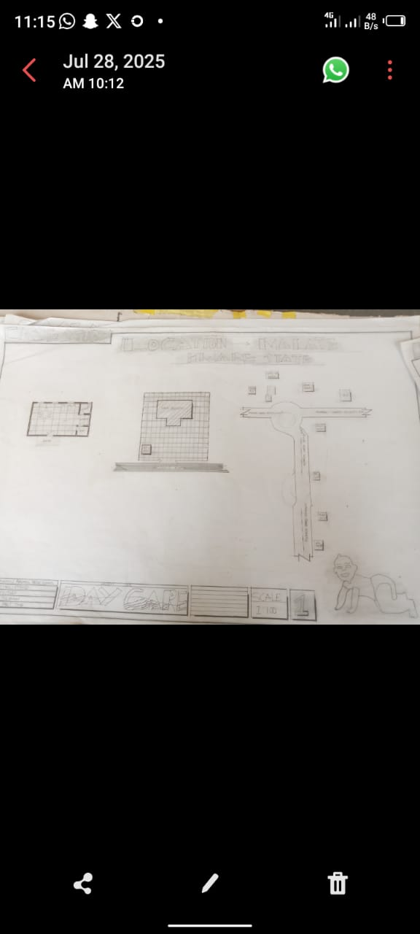
Location: Kwara State University Malete Day Care
Merit
- Good aesthetic of the interior
- Good location area for the day care building
Demerit
- Lack of facility
- Inadequate of packing space

3.2 CASE STUDY TWO
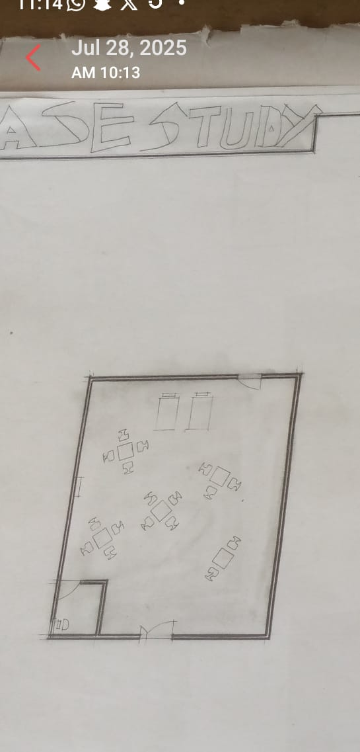
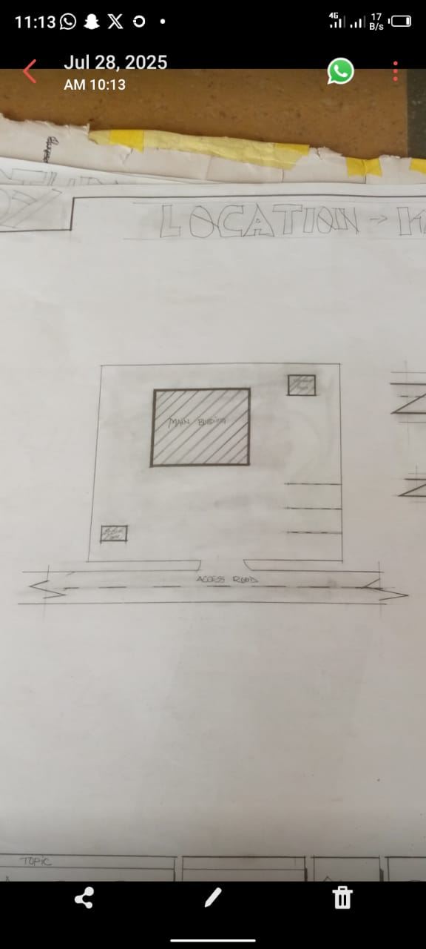
Location: Dayo Day Care, Ogbomosho
Merit
- Good landscaping
- Easily accessible
- There is space for future expansion
Demerit
- Noisy area
- No playing ground
- Lack of cross ventilation

3.3 CASE STUDY THREE
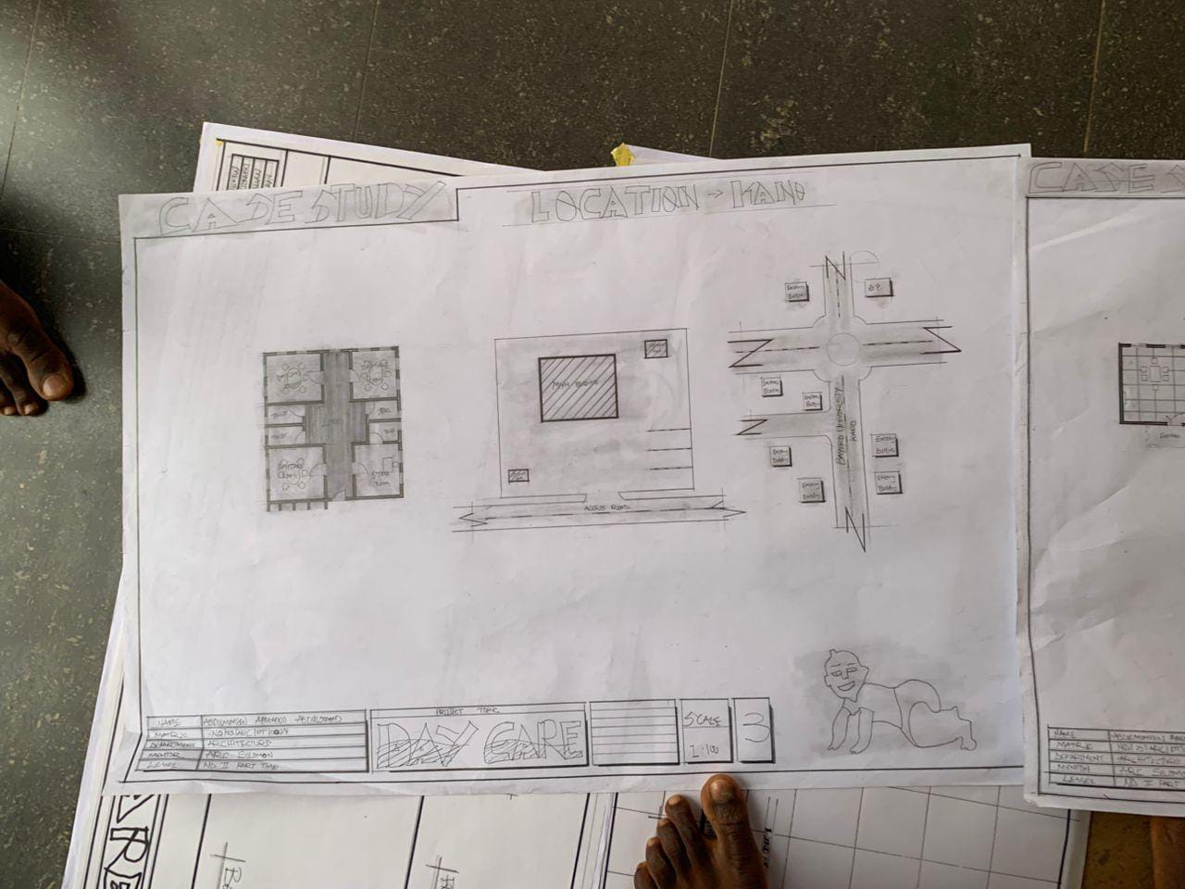
Location: Bayero University Day Care Kano State
Merit
- Adequate facility
- Cross ventilation
Demerit
- Lack of staff
- Bad landscaping

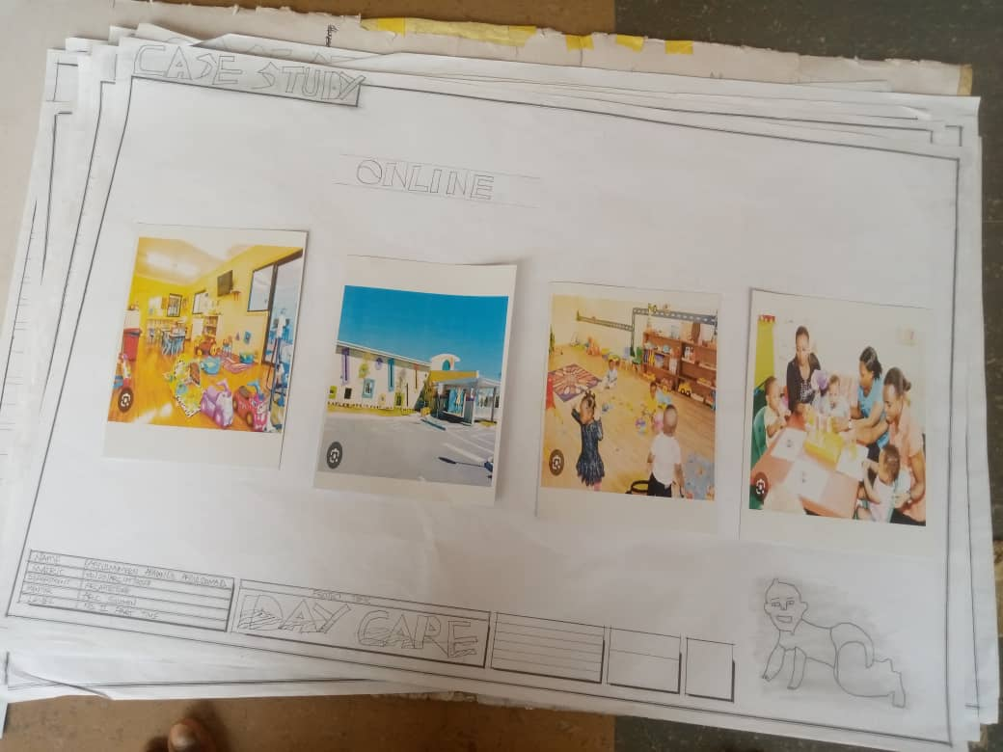
ONLINE CASE STUDY

Online Case Study
Merit
- Learning and exploration
- Physical health and wellness being
- Socialization
Demerit
- High staff turnover
- Noise activity
- Policies
CHAPTER FOUR
4.1 INTRODUCTION OF STUDY AREA
The study is situated within the context of Kwara State Polytechnic (Kwarapoly), located in Ilorin, Kwara State, Nigeria. As a prominent institution of higher learning, Kwarapoly serves a diverse population of staff and students, many of whom are parents with young children. In response to the growing need for accessible child care services, the institution established the Kwarapoly Day Care Centre to support the academic and professional commitments of these individuals.
The day care center is strategically located within the school premises, offering care and supervision for children ranging from infancy to pre-school age. It is designed to provide a safe, nurturing, and educational environment where children can thrive during the day while their parents attend lectures, conduct research, or fulfill administrative duties.
The day care operates under the institution’s welfare department and is staffed by trained caregivers and early childhood educators. Services typically include feeding, napping, hygiene assistance, play-based learning, and emotional support. The center also plays a significant role in promoting gender equity and work-life balance, especially for female staff and students.
Given the increasing number of young parents in higher education and the importance of early childhood development, the KWARAPOLY Day Care Centre represents a critical social service within the academic community. This study seeks to examine its operations, benefits, challenges, and overall impact on both children and their parents within the Polytechnic environment.
4.2 SITE LOCATION /DESCRIPTION
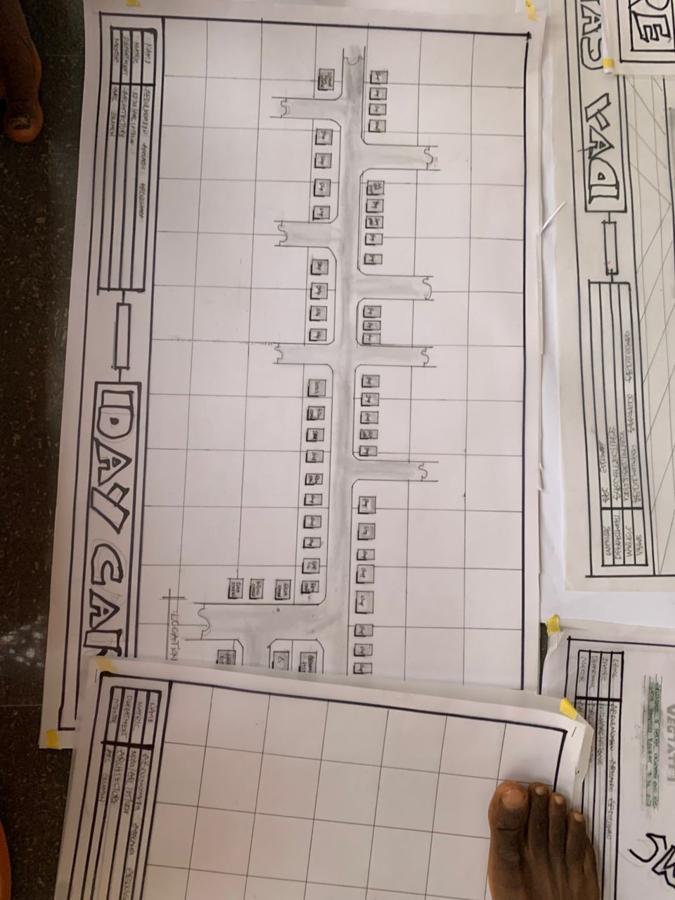

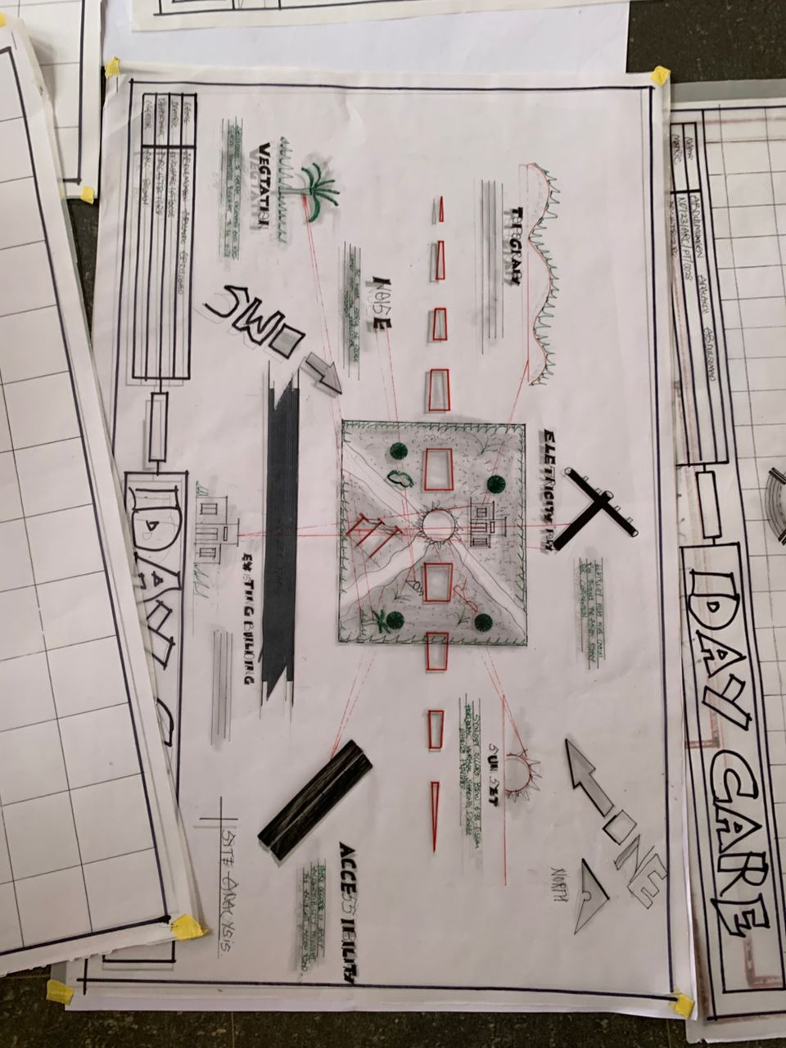
4.3 SITE ANALYSIS/INVENTORY

INVENTORY
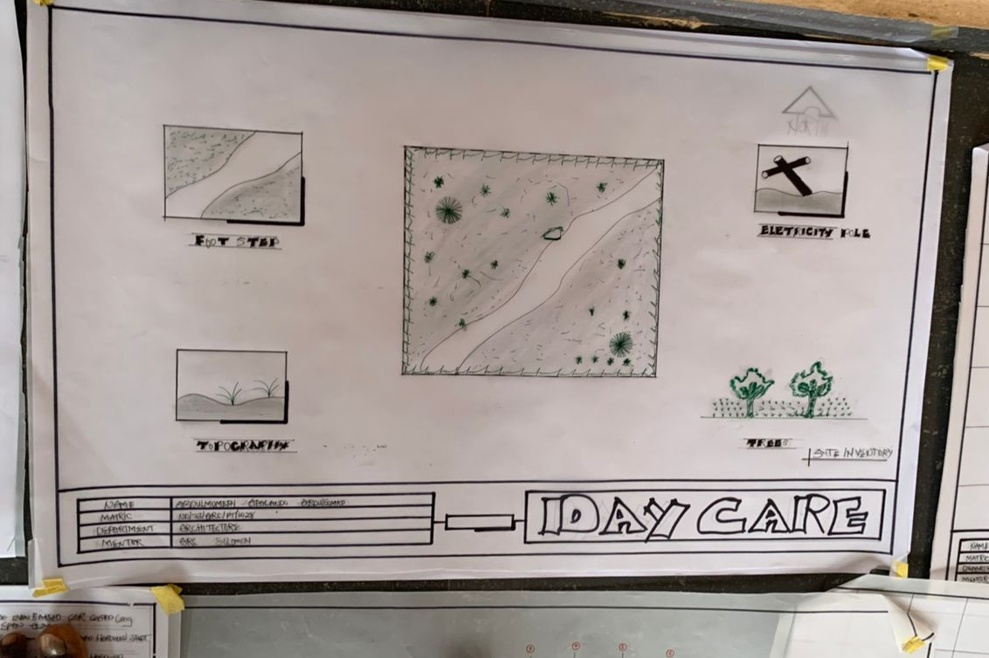

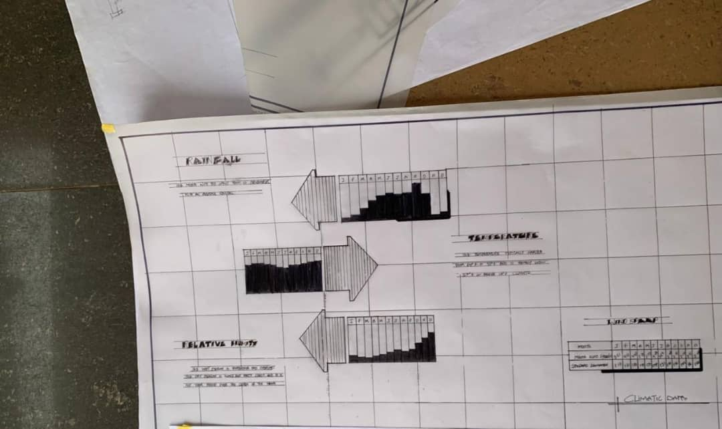
4.4 GEOGRAPHICAL /CLIMATIC CONDITIONS

4.5 DESIGN CRITERIA

1. Safety & Security
- Secure entrances and exits with controlled access.
- Child-proof locks on cabinets and doors.
- Safe electrical outlets and no sharp edges.
- Non-slip flooring.
- Clear emergency exits and visible signage.
- Adequate fire alarms, sprinklers, and safety equipment.
- Outdoor play area fenced and secure.

2. Space Planning
- Separate areas for different age groups.
- Ample indoor play space for physical activities.
- Quiet zones for rest and naps.
- Dedicated areas for meals, arts & crafts, and learning.
- Sufficient storage for toys, equipment, and personal items.
- Wide corridors and open layouts for easy supervision.

3. Accessibility
- Wheelchair accessible entrances, ramps, and restrooms.
- Child-friendly furniture scaled to different age groups.
- Easy access to bathrooms and diaper changing stations.

4. Lighting and Ventilation
- Plenty of natural light for a healthy, uplifting environment.
- Well-ventilated rooms with good airflow.
- Use of soft, non-glare artificial lighting for indoor areas.

5. Materials & Finishes
- Non-toxic, easy-to-clean, and durable materials.
- Surfaces resistant to spills, scratches, and wear.
- Use of bright, stimulating, but calming colors.

6. Outdoor Play Area
- Safe, age-appropriate play equipment.
- Shaded areas to protect children from sun.
- Soft ground materials like rubber mulch or grass.
- Separate zones for different activities (running, climbing, sand play).

7. Acoustics
- Noise control measures to minimize echo and loud sounds.
- Use of soft materials to absorb sound and create a calm atmosphere.

8. Facilities
- Child-sized toilets and sinks.
- Adequate diaper changing stations.
- Kitchen or food preparation area meeting hygiene standards.
- Staff lounge and office space.
- Parent waiting area with comfortable seating.

9. Flexibility & Future Growth
- Modular furniture and movable partitions.
- Spaces adaptable for different uses and changing needs.
- Room for future expansion or increase in enrollment.
4.6 BRIEF ANALYSIS
Day care centers play a vital role in modern society by providing structured care and early childhood education to young children while their parents are at work or school. These centers serve as a bridge between home and formal schooling, offering a safe, nurturing environment where children can develop socially, emotionally, cognitively, and physically.
A well-managed day care center typically offers services such as supervised play, early learning activities, feeding, rest, and hygiene support. Studies have shown that children who attend quality day care settings demonstrate improved language skills, better social interaction, and increased readiness for primary education.
From a socio-economic perspective, day care services also provide critical support for working parents, especially women, by enabling them to pursue careers or complete their education. In institutional settings—such as universities or polytechnics—on-campus day care facilities reduce absenteeism among staff and students with young children, while also promoting gender equity and academic retention.
However, the effectiveness of day care depends heavily on factors such as caregiver qualifications, staff-to-child ratios, facility safety, and learning resources. In many developing contexts, including Nigeria, challenges such as underfunding, limited space, untrained staff, and inadequate oversight can hinder service delivery and limit the developmental benefits for children.
Overall, day care centers are not just custodial spaces—they are developmental hubs that, when properly run, contribute to child well-being, parental productivity, and broader educational and economic outcomes.
4.7 SPATIAL PROGRAMME (REQUIREMENT AND ANALYSIS)
A well-planned spatial program is essential to create a safe, functional, and nurturing environment in a day care center. The spatial layout must support children’s developmental needs, caregiver efficiency, and safety regulations.

KEY SPATIAL REQUIREMENTS
Space/Area | Function | Design Considerations
Reception/Entrance Area | Welcoming parents and visitors, check-in/out point | Secure access control, seating, information display
Activity/Play Rooms | Main area for learning and play activities | Age-appropriate, bright, flexible layout, safe flooring, storage for toys and materials
Nap/Rest Rooms | Quiet, dim environment for children’s rest and naps | Comfortable cots/mats, soft lighting, soundproofing
Toilets and Washrooms | Sanitary facilities designed for young children | Child-sized fixtures, easy access, good ventilation, hygiene standards
Feeding Area | Space for snack and meal times | Easy to clean surfaces, child-sized tables and chairs, proximity to kitchen or food prep area
Kitchen/Food Preparation | Prepare and store food safely | Complies with health regulations, storage, hygiene
Staff Room/Office | Space for caregivers to rest, plan activities, and administrative tasks | Comfortable seating, workstations, secure storage for records
Storage Areas | Storage for toys, learning materials, cleaning supplies | Organized shelving, easy access but child-safe
Outdoor Play Area | Space for physical activities and fresh air | Safe, enclosed, age-appropriate equipment, shaded areas
Isolation/Medical Room | Quiet space for children who are unwell | Close to staff room, equipped with basic first aid supplies
Security and Safety Features | Surveillance, fire exits, emergency access | Complies with local safety codes

Analysis of Spatial Requirements
- Child-Centric Design: All spaces must be scaled to suit young children’s physical dimensions and developmental needs. For example, toilets and sinks should be child height, and furniture should allow ease of movement.
- Flow and Accessibility: The layout should ensure smooth movement between spaces, minimizing cross-contamination between play, eating, and toileting areas. It should allow caregivers to supervise easily.
- Safety and Hygiene: Materials and finishes should be non-toxic, durable, and easy to clean. Outdoor play areas must be securely fenced and regularly maintained.
- Flexibility: Spaces should accommodate varying group sizes and activities, allowing rearrangement of furniture and equipment as needed.
- Natural Light and Ventilation: Ample daylight and good air circulation enhance children’s comfort and health.
- Security: Controlled entry/exit points prevent unauthorized access; surveillance and alarms enhance child safety.
A carefully planned spatial program ensures that a day care center meets the functional, safety, and developmental needs of children while supporting caregivers in their duties. The design must balance efficiency, flexibility, and child-friendliness to create an environment conducive to learning, play, and growth.
4.8 CONCEPTUAL DEVELOPMENT
The conceptual development of a day care center is grounded in the understanding that early childhood is a critical period for holistic development—cognitive, emotional, social, and physical. A day care facility must therefore be more than a safe holding space; it should be a nurturing environment that stimulates growth, learning, and well-being.

Core Concept
The core concept of a day care center revolves around providing a secure, stimulating, and supportive environment for children while enabling parents or guardians to engage in work or study without worry. The design and operation emphasize:
- Child-centeredness: The environment is tailored to children’s needs, interests, and safety.
- Developmental Support: Activities and spaces encourage exploration, creativity, socialization, and learning.
- Inclusivity: Services are accessible to children of diverse backgrounds and abilities.
- Parental Partnership: The center acts as a bridge between home and early education, involving parents in their child’s growth.
- Community Engagement: The center connects with local resources and culture, promoting social cohesion.
4.9 SITE CONCEPT
- Location and Accessibility The site for the day care center should be centrally located within the institution or community it serves to ensure easy access for parents, staff, and children. It should be close to main pedestrian routes, classrooms, or staff offices to reduce transit time and enhance convenience.
- Safety and Security The site must be secure and enclosed, ideally with controlled entry and exit points to prevent unauthorized access. Buffer zones such as landscaped gardens or fences separate the center from busy roads or hazardous areas.
- Environmental Quality A site with ample natural light and ventilation supports a healthy environment. Green spaces and outdoor play areas are integrated to provide children with fresh air, exposure to nature, and opportunities for physical activity.
- Noise and Disturbance Management The site should be away from loud or disruptive areas such as workshops, heavy traffic, or noisy machinery to maintain a calm atmosphere conducive to learning and rest.
- Future Expansion The site layout should consider potential future expansion to accommodate more children or additional facilities, with flexible open spaces or adjacent plots reserved for growth.
4.10 BUILDING CONCEPT
- Child-Centered Design The building design prioritizes the scale, safety, and comfort of young children. Low-height fixtures, non-toxic materials, rounded corners, and slip-resistant floors ensure physical safety and ease of use.
- Zoning and Layout The interior is organized into distinct zones: play/activity areas, rest rooms, eating spaces, sanitation facilities, and administrative offices. The layout encourages smooth circulation, minimizes cross-contamination, and supports supervision with clear sightlines.
- Natural Lighting and Ventilation Large windows, skylights, and operable openings maximize natural daylight and airflow, reducing energy consumption and creating a cheerful, healthy environment.
- Indoor-Outdoor Connection The building is designed with easy access to outdoor play areas via wide doors or covered verandas, promoting a seamless flow between indoor learning and outdoor physical activity.
- Flexibility and Adaptability Modular furniture and movable partitions allow spaces to be reconfigured for different age groups or activities, accommodating changing needs without structural modifications.
- Sustainability and Comfort Incorporation of sustainable features such as rainwater harvesting, natural shading, and energy-efficient lighting supports environmental responsibility while maintaining comfort.
- Security and Supervision Secure entrances, CCTV monitoring, and staff-only access areas are integrated to ensure child safety. Open-plan spaces and transparent partitions help caregivers maintain visual supervision.

CHAPTER FIVE
5.1 PROJECT APPRAISAL
The proposed day care center aims to provide quality childcare services within [Institution/Community Name] to support working parents and students. The facility will cater to children aged 6 months to 5 years, offering a safe, nurturing, and educational environment.
- To provide reliable and affordable child care for parents and students.
- To promote early childhood development through structured learning and play.
- To enhance productivity and academic success by reducing absenteeism among staff and students with young children.
- To contribute to gender equity by supporting female participation in education and employment.
5.2 CONSTRUCTION METHODOLOGY AND MATERIALS
The construction of a day care center involves creating a safe, durable, and child-friendly environment that supports early childhood development. The methodology must ensure quality, efficiency, and adherence to safety standards, while the choice of materials should reflect durability, non-toxicity, and ease of maintenance.
a. Site Preparation
- Clearing the site of vegetation, debris, and leveling the ground.
- Marking out the building footprint according to architectural plans.
- Excavation for foundation works, ensuring proper depth based on soil tests.
b. Foundation Construction
- Laying a stable foundation using concrete footings or raft foundation, depending on soil bearing capacity.
- Ensuring foundations are moisture-resistant and structurally sound to support the building load.
c. Structural Works
- Erection of load-bearing walls using concrete blocks or bricks.
- Construction of reinforced concrete columns and beams for structural support.
- Installation of lintels above doors and windows for stability.
d. Roofing
- Installation of roof trusses or reinforced concrete slab roof depending on design.
- Application of roofing materials such as metal sheets, tiles, or shingles to ensure weather protection.
- Incorporating proper drainage systems (gutters and downpipes) to prevent water accumulation.
e. Flooring
- Laying sub-floor base and screeding for a smooth, level surface.
- Final flooring materials selected for safety and durability, such as vinyl, rubber flooring, or ceramic tiles with non-slip finishes.
f. Walls and Finishes
- Plastering walls internally and externally for smooth finish.
- Painting with non-toxic, washable, and child-safe paints.
- Installation of child-height windows with safety grills or tempered glass for ventilation and security.
g. Doors and Windows
- Use of wooden or metal doors with secure locking systems.
- Windows designed for maximum natural light and ventilation, with child safety features.
h. Utilities Installation
- Electrical wiring installed according to safety codes, with protected outlets and switches.
- Plumbing works for toilets, sinks, and kitchen areas, ensuring hygienic water supply and drainage.
- Installation of fire safety systems, including alarms, extinguishers, and emergency exits.
i. External Works
- Landscaping for outdoor play areas, including soft surfaces like grass or rubber mats.
- Construction of perimeter fencing to ensure child safety and controlled access.
- Paving pathways for easy and safe movement around the site.

MATERIALS
Component | Preferred Materials | Justification
Foundation | Concrete mix (cement, sand, gravel, water), steel reinforcements | Strong, durable, moisture-resistant
Walls | Concrete blocks, bricks, or stabilized earth blocks | Fire-resistant, durable, soundproof
Roofing | Corrugated metal sheets, clay tiles, or reinforced concrete slabs | Weatherproof, long-lasting
Flooring | Non-slip vinyl flooring, rubber mats, ceramic tiles | Safety, easy maintenance, durability
Paint | Non-toxic, low VOC, washable paint | Safe for children, easy to clean
Doors & Windows | Timber or aluminum frames, tempered glass, safety grills | Security, ventilation, natural light
Plumbing | PVC pipes, stainless steel fittings | Durable, corrosion-resistant
Electrical | Conduits, circuit breakers, child-safe sockets | Safety, compliance with standards
Fencing | Metal mesh or timber panels with secure gates | Security, durability

Sustainability Considerations
- Use of locally sourced materials to reduce cost and environmental impact.
- Incorporation of energy-efficient lighting and ventilation systems to reduce operational costs.
- Rainwater harvesting systems integrated into plumbing for outdoor irrigation.
- Use of non-toxic, eco-friendly finishes and paints to ensure healthy indoor air quality.

Quality Control and Safety
- Regular site inspections to ensure compliance with design specifications and safety standards.
- Ensuring all materials meet relevant building codes and certifications.
- Safety protocols for construction workers and early childhood considerations during and after construction.
5.3 BUILDING SERVICE

1. Electrical Services
- Power Supply: Reliable electrical wiring with adequate outlets to support lighting, fans, computers, and other equipment.
- Lighting: Use of natural and artificial lighting designed for comfort—bright but not harsh, with dimmable options in nap/rest areas.
- Safety Features: Child-safe electrical sockets with covers, circuit breakers, and emergency lighting.
- Communication Systems: Intercom or public address systems for easy communication across the center.
- Security Systems: CCTV cameras, alarm systems, and secure access controls at entry points.

2. Plumbing and Sanitary Services
- Water Supply: Clean, potable water for drinking, cooking, cleaning, and sanitation.
- Sanitary Facilities: Child-friendly toilets and wash basins with easy-to-use taps (e.g., lever taps or sensor-activated).
- Drainage System: Efficient waste water drainage to prevent flooding and ensure hygiene.
- Handwashing Stations: Strategically located sinks to encourage good hygiene habits.
- Kitchen Plumbing: Water supply and drainage for food preparation and cleaning.

3. Heating, Ventilation, and Air Conditioning (HVAC)
- Ventilation: Adequate natural ventilation through windows and mechanical ventilation to maintain air quality.
- Temperature Control: Fans, heaters, or air conditioning to ensure a comfortable indoor climate regardless of weather.
- Air Filtration: Systems to reduce dust, allergens, and pollutants, contributing to a healthy environment.

4. Fire Safety and Protection Systems
- Fire Detection: Smoke detectors and fire alarms installed throughout the building.
- Fire Fighting: Fire extinguishers, hose reels, and sprinkler systems as required by local codes.
- Emergency Exits: Clearly marked, unobstructed exit routes and emergency lighting.
- Evacuation Plans: Displayed evacuation procedures and regular drills for staff and children.

5. Waste Management
- Waste Segregation: Separate bins for recyclable, organic, and general waste to promote hygiene and environmental responsibility.
- Safe Disposal: Regular collection and disposal of waste, including hazardous waste like used medical supplies.

6. Lighting and Acoustics
- Acoustic Control: Use of sound-absorbing materials to reduce noise levels, creating a calm environment for children.
- Daylighting: Large windows and skylights to maximize natural light, enhancing mood and reducing electricity use.

7. Information Technology (IT) Infrastructure
- Internet Access: Reliable Wi-Fi or wired connections for administrative use and educational tools.
- Security Systems: Integration of digital monitoring and access control systems.
5.4 CONCLUSION
The establishment of a day care center is a vital investment in the well-being and development of young children, as well as a support system for parents and the broader community. Through careful planning, design, and operation, day care centers provide a safe, nurturing, and stimulating environment that promotes early childhood development across physical, cognitive, emotional, and social domains. The positive impact extends beyond the children to improve parental productivity, community cohesion, and institutional reputation. Challenges such as funding, staffing, and safety can be effectively managed with proper strategies, ensuring the sustainability and success of the center.
The day care center project is a viable and necessary intervention that addresses the childcare needs of the institution's community. It promises significant social, economic, and educational benefits, justifying the investment. With proper planning, funding, and management, the project will enhance child development outcomes and support parents in achieving their academic and professional goals.
The construction of a day care center requires a carefully planned methodology using safe, durable, and child-friendly materials. This ensures the creation of a secure and stimulating environment conducive to early childhood development, while maintaining structural integrity and sustainability.
5.5 RECOMMENDATIONS
- Adequate Funding and Resource Allocation: Ensure sufficient financial support for construction, equipment, staffing, and ongoing operations to maintain high-quality services.
- Qualified and Trained StaffRecruit and retain well-trained caregivers and educators who understand child development and can provide responsive, nurturing care.
- Safe and Child-Friendly Environment: Design and maintain facilities with child safety and comfort as paramount concerns, including secure access, appropriate materials, and hygienic conditions.
- Parental Engagement and Communication: Foster strong partnerships with parents through regular communication, involvement opportunities, and feedback mechanisms.
- Continuous Monitoring and Improvement: Implement systems for regular evaluation of programs, safety, and facilities, adapting to the evolving needs of children and families.
- Community and Institutional Support Encourage collaboration with local authorities, NGOs, and the institution to provide additional resources, training, and outreach.
- Awareness and Enrollment Campaigns: Promote the day care center within the community and institution to ensure optimal utilization and support.

REFERENCES
Bredekamp, S., & Copple, C. (Eds.). (1997). Developmentally Appropriate Practice in Early Childhood Programs. National Association for the Education of Young Children (NAEYC).
Guralnick, M. J. (2011). Early Intervention for Children with Intellectual Disabilities: An Update. Journal of Applied Research in Intellectual Disabilities, 24(4), 331–349.
National Association for the Education of Young Children. (2020). Early Childhood Program Standards and Accreditation Criteria. NAEYC. Science of Early Childhood Development. National Academy Press.
National Resource Center for Health and Safety in Child Care and Early Education. (2019). Caring for Our Children: National Health and Safety Performance Standards. American Academy of Pediatrics.
Philips, D. A., & Meloy, M. E. (2018). Family, Friend, and Neighbor Care: A Review of the Research Literature. The Urban Institute.
UNICEF. (2019). Early Childhood Development: The Promise of Child-Friendly Day Care. Retrieved from https://www.unicef.org/early-childhood-development
Whitebook, M., Phillips, D., & Howes, C. (2014). Worthy Work, STILL Unlivable Wages: The Early Childhood Workforce 25 Years After the National Child Care Staffing Study. Center for the Study of Child Care Employment, University of California, Berkeley.

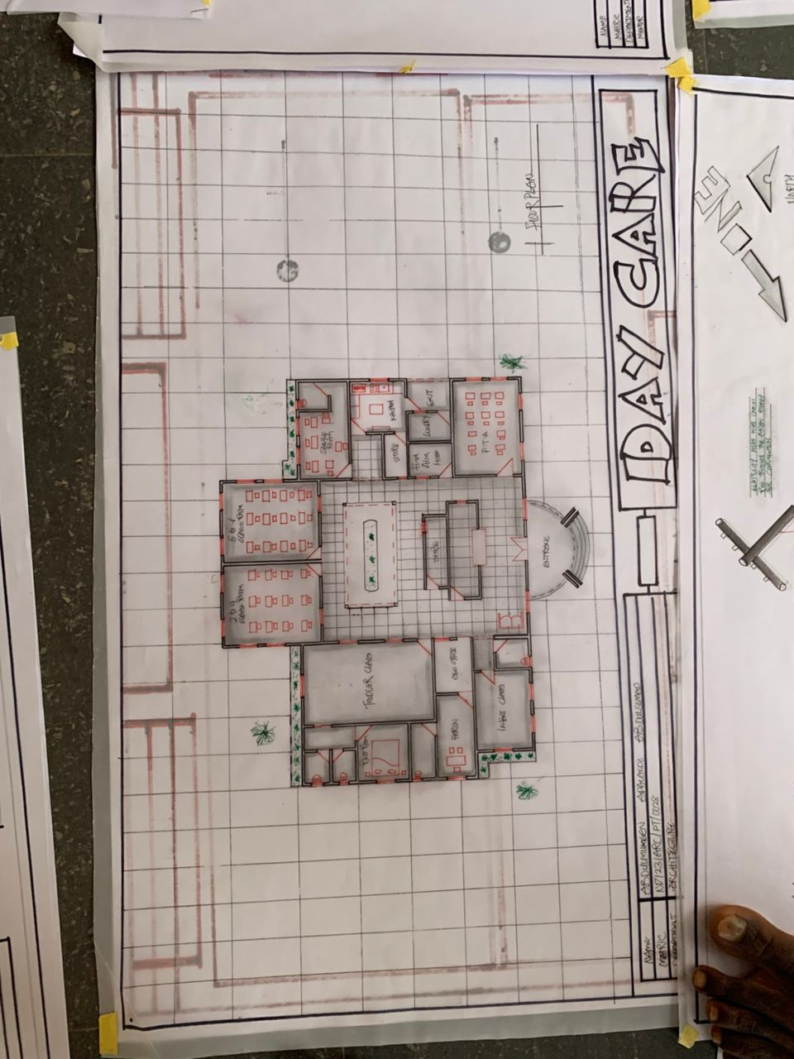
APPENDIX

