
A PROJECT
ON
DESIGN AND CONSTRUCTION OF 3KVA INVERTER USING
24VOLT BATTERY
BY
YUSUF OLAJUWON KAFAYAT
HND/23/SLT/FT/1002
SUBMITTED TO: THE DEPARTMENT OF SCIENCE LABORATORY TECHNOLOGY (SLT)
INSTITUTE: INSTITUTE OF APPLIED SCIENCES (IAS)
UNIT: PHYSICS AND ELECTRONICS
KWARA STATE POLYTECHNIC, ILORIN.

IN PARTIAL FULFILLMENT OF THE REQUIREMENTS FOR THE AWARD OF HIGHER NATIONAL DIPLOMA (HND)
IN SCIENCE LABORATORY TECHNOLOGY (SLT)

SUPERVISED BY:
MR. AGBOOLA O. A.
2024/2025

ABSTRACT
A mechatronic generator (Inverter) is an electronic device that converts direct current (DC¬) to alternating current (AC) the converted Ac can be obtained at any required voltage and frequency with the use of appropriate serial transformers, switching and control circuit. It converts power from car batteries, windmills or solar panels and fuel cells, and then turns it into normal domestic power supply. Summarily, it supplies AC power from DC source. There are various types of inverter, we have solid state inverters with no moving parts and are used in a wide range of applications, from small switching power supplies in computers, to large electric utility high voltage direct current applications that transport bulk power. This Inverter performs the opposite function of a rectifier. We also have two classifications of inverter; they are Pure sine wave Inverters and Modified sine wave Inverters. The difference is that pure sine wave matches the power to that of which you get from you electricity supplier, its clean and you can run any appliances safely even sensitive equipment. Modified sine wave is dirty power; you can use this to power a lot of things that don’t have sensitive electronics. However, this research paper covers the design of a sine wave inverter.
Keyword: Inverter, Direct current, Alternative Current, Power, Sine wave, Electricity,

TABLE OF CONTENT
Chapter 1: Introduction
- Background of the Study
- Statement of the Problem
- Research Questions
- Objectives of the Study
- Scope of the Study
- Significance of the Study

Chapter 2: Literature Review
- Overview of Inverters
- Types of Inverters
- Design Considerations for Inverters
- Previous Research on Inverter Design

Chapter 3: Methodology
- Design Methodology
- Component Selection
- Construction Methodology
- Testing and Evaluation Methodology

CHAPTER ONE
1.1INTRODUCTION
This project focuses on the design and construction of a 3KVA inverter, an electronic device that converts DC power to AC power. The inverter aims to provide a reliable and efficient power solution for various applications, including homes, offices, and industries. The project involves designing and building a system that can efficiently convert DC power from a battery or solar panel to AC power, suitable for powering household appliances and other devices.
1.2Background of the Study
The increasing demand for electricity and the need for reliable power supply have led to the development of alternative power sources. One of the most promising alternatives is the use of inverters to convert DC power from batteries or solar panels to AC power. Inverters are widely used in various applications, including renewable energy systems, backup power systems, and electrical vehicles.

1.2 Statement of the Problem
The high cost of electricity and the frequent power outages in many parts of the world have made it necessary to develop efficient and cost-effective power conversion systems. Conventional inverters are often bulky, expensive, and inefficient, making them unsuitable for many applications. Therefore, there is a need to design and develop efficient, cost-effective, and compact inverters that can meet the increasing demand for electricity.

1.3 Objectives of the Study
The objectives of this study are:
1. To design and construct a 3KVA inverter using a 24V battery.
2. To identify and select the key components required for the inverter.
3. To optimize and evaluate the performance of the inverter.

1.4 Scope Of The Project
This project focuses on the design and construction of a 3KVA inverter using a 24V battery. The study covers the design and selection of key components, construction and testing of the inverter, and evaluation of its performance.

1.5 Significance Of The Study
This study is significant because it provides a cost-effective and efficient solution for power conversion. The designed inverter can be used in various applications, including renewable energy systems, backup power systems, and electrical vehicles. The study also contributes to the development of efficient and compact power conversion systems.
1.6 Limitations of the Project
A 3KVA inverter has several limitations, including
- *Power Capacity*: A 3KVA inverter can handle a maximum power load of 3 kilovolt-amperes, which may not be sufficient for high-power appliances or multiple devices.
- *Load Limitations*: The inverter may not be suitable for inductive loads like refrigerators, air conditioners, or heavy motors, which require high starting currents.
- *Battery Drain*: Running high-power devices or prolonged usage can drain the battery quickly, reducing the overall backup time.

CHAPTER 2
LITERATURE REVIEW
2.2 Principles of Operation of Inverters
An inverter is a device that converts DC power from a battery or solar panel to AC power. The basic principle of operation of an inverter involves the use of power electronic devices, such as MOSFETs or IGBTs, to switch the DC power on and off at a high frequency. This creates a square wave or modified sine wave AC output that can be filtered and transformed to produce a pure sine wave output.(- EME 812: "6.4. Inverters: principle of operation and parameters")

2.3 Types of Inverters
There are several types of inverters, including:
1. *Square wave inverters*: These inverters produce a square wave output and are commonly used for simple applications, such as powering lights or small appliances.
2. *Modified sine wave inverters*: These inverters produce a modified sine wave output and are commonly used for applications that require a higher level of power quality, such as powering computers or televisions.
3. *Pure sine wave inverters*: These inverters produce a pure sine wave output and are commonly used for applications that require a high level of power quality, such as powering medical equipment or sensitive electronics.

2.4 Design Considerations for Inverters
When designing an inverter, several factors must be considered, including:
1. *Power rating*: The power rating of the inverter must be sufficient to handle the maximum power required by the load.
2. *Efficiency*: The efficiency of the inverter must be high enough to minimize energy losses and heat generation.
3. *Power factor*: The power factor of the inverter must be high enough to minimize the distortion of the AC output waveform.
4. *Electromagnetic compatibility*: The inverter must be designed to minimize electromagnetic interference and ensure compatibility with other electronic devices.

2.5 Advantages and Disadvantages of Different Inverter Topologies
Different inverter topologies have different advantages and disadvantages. For example:
[1]:Square Wave Inverters
- Advantages:
- Simple design and low cost
- Suitable for simple applications like lighting and small appliances
- Disadvantages:
- Poor power quality due to square wave output
- Not suitable for sensitive electronics or high-power applications

Modified Sine Wave Inverters
- Advantages:
- Better power quality than square wave inverters
- Suitable for a wider range of applications, including computers and televisions
- Relatively low cost
- *Disadvantages*:
- Still not suitable for high-end applications or sensitive electronics
- May produce electromagnetic interference (EMI)

Pure Sine Wave Inverters
- Advantages:
- High power quality and pure sine wave output
- Suitable for sensitive electronics, medical equipment, and high-end applications
- Low EMI
- Disadvantages:
- More complex design and higher cost
- May require additional filtering and protection components

CHAPTER THREE: METHODOLOGY
3.1 Design Methodology
The design methodology involves:
Defining Requirements: Identifying the inverter's specifications and performance criteria
Circuit Design: Selecting the topology and components for the inverter
Simulation: Using software to simulate the inverter's performance and identify potential issues
Iteration: Refining the design based on simulation results and testing

3.2 Component Selection
Component selection is critical to the inverter's performance and reliability:
MOSFETs: Selected based on voltage, current, and switching frequency requirements
Gate Drivers: Chosen for their ability to drive MOSFETs efficiently
Transformers: Designed to handle the power rating and frequency of the inverter
Capacitors: Selected for filtering and smoothing the output waveform
Resistors are passive electronic components that oppose the flow of electric current.

*3.3 Construction Methodology
The construction methodology involves:
-PCB Design: Designing the printed circuit board (PCB) layout for the inverter
- Component Assembly: Assembling the components on the PCB
- Wiring and Cabling: Connecting the components and ensuring safe and efficient wiring
- Enclosure Design: Designing an enclosure to house the inverter and ensure safe operation

3.4 Testing and Evaluation Methodology
The testing and evaluation methodology involves:
- Functional Testing: Verifying the inverter's functionality and performance
- Efficiency Measurement: Measuring the inverter's efficiency under various loads
- Output Waveform Analysis: Analyzing the output waveform to ensure it meets specifications
- Reliability Testing: Testing the inverter's reliability and durability under various conditions

REFERENCES
1. Billings, K. (2011). Switchmode Power Supply Handbook. McGraw-Hill Education.
2. Erickson, R. W., & Maksimovic, D. (2001). Fundamentals of Power Electronics. Springer Science & Business Media.
3. IEEE Standard for Inverters (IEEE Std 1547-2018). (2018). IEEE Standards Association.
4. International Rectifier. (n.d.). IR2110 High and Low Side Driver. Retrieved from <(link unavailable)>
5. Mohan, N., Undeland, T. M., & Robbins, W. P. (2003). Power Electronics: Converters, Applications, and Design. John Wiley & Sons.
6. Pressman, A. I. (2015). Switching Power Supply Design. McGraw-Hill Education.
7. Rashid, M. H. (2017). Power Electronics: Circuits, Devices, and Applications. Pearson Education.
8. Texas Instruments. (n.d.). Pure Sine Wave Inverter Reference Design. Retrieved from <(link unavailable)> CHAPTER THREE
3.0 METHODOLOGY
3.1 MATERIALS AND METHODS
The design and construction of the 3KVA solar inverter using a 24V battery involved selecting and assembling key components such as a 24V battery bank, charge controller, step-up transformer, buzzer, MOSFETs, integrated circuits, capacitors, and cooling fans. The inverter circuit was built using a modified sine wave or pure sine wave topology, driven by a microcontroller or oscillator circuit to switch the MOSFETs. A step-up transformer was used to convert the 24V DC to 220V AC. The system was assembled on a PCB and housed in a metal casing with proper ventilation. Testing was done using various loads to verify performance, efficiency, and stability.
3.2 OSCILLATORY AND POWER SECTION
The oscillatory and power section forms the heart of the inverter system, responsible for generating the alternating signal and converting DC power to usable AC output. The oscillatory section typically consists of a waveform generator, often built using a microcontroller, timer IC (such as the 555 timer), or crystal oscillator circuit. This section produces a square wave or modified sine wave signal that controls the switching of the power transistors or MOSFETs. These pulses are alternated to simulate AC waveforms at a frequency of approximately 50Hz, which is standard for most AC appliances. The power section involves the amplification and switching of the low-voltage DC from the battery into high-voltage AC. It includes high-power MOSFETs or IGBTs configured in an H-bridge or push-pull arrangement. These switching devices are driven by the oscillatory signals and are responsible for converting the 24V DC into a pulsating AC waveform, which is then stepped up using a transformer to around 220V AC. This section also incorporates protective components like heat sinks, fuses, and filter capacitors to ensure stable operation and protect against overheating or overloading. Together, the oscillatory and power sections work in synchronization to ensure that the inverter produces a reliable AC output suitable for powering household or office appliances.
3.3 COMPONENT SELECTION
The proper selection of components is critical to ensure the reliability, efficiency, and safety of the inverter system. Each component was carefully chosen based on the power rating, voltage compatibility, thermal performance, and cost-effectiveness to meet the requirements of a 3KVA inverter operating with a 24V battery system.
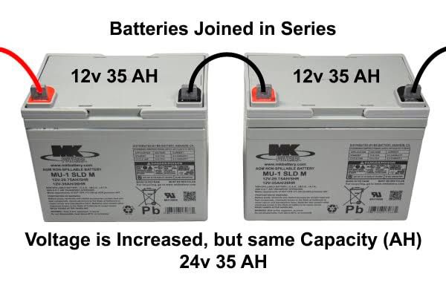
•Battery (24V Battery): A pair of 12V batteries connected in series to supply a stable 24V DC. Batteries were selected for their ability to handle prolonged discharge cycles, which is essential for inverter applications.

•MOSFETs: High-current, fast-switching MOSFETs were used to handle the DC-to-AC conversion efficiently. They are capable of switching large currents with minimal losses.
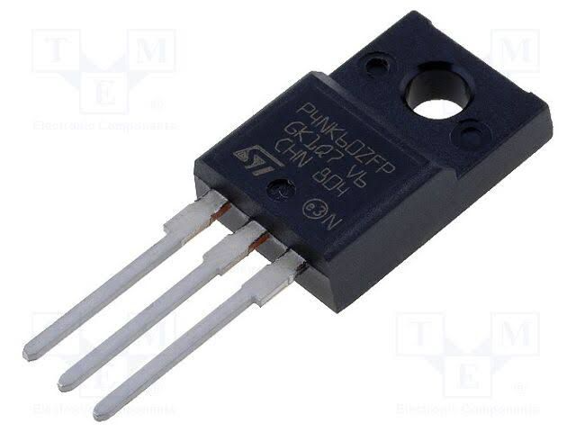
•Transformer (24V-0-24V to 220V): A step-up transformer is used to convert the low-voltage AC signal from the MOSFETs into standard 220V AC output. It was chosen based on the required power output (3KVA) and designed to handle high current without overheating.
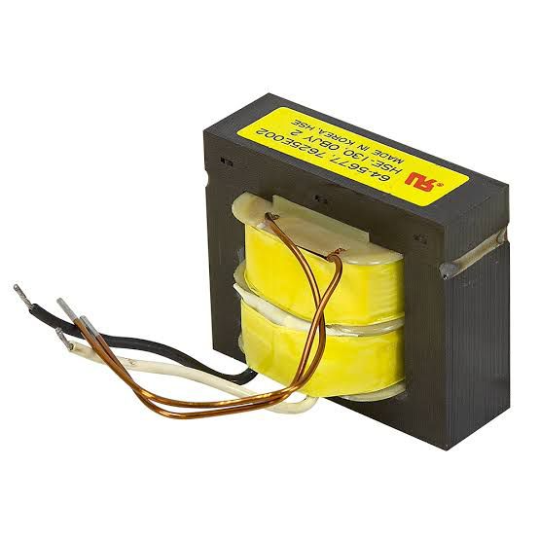
•Capacitors and Filters: Used for smoothing and filtering the output waveform to reduce noise and harmonics. High-voltage electrolytic capacitors were selected to withstand output surges.

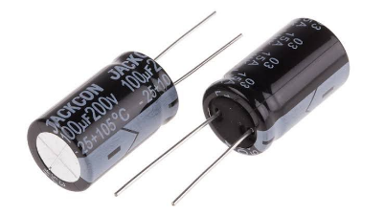
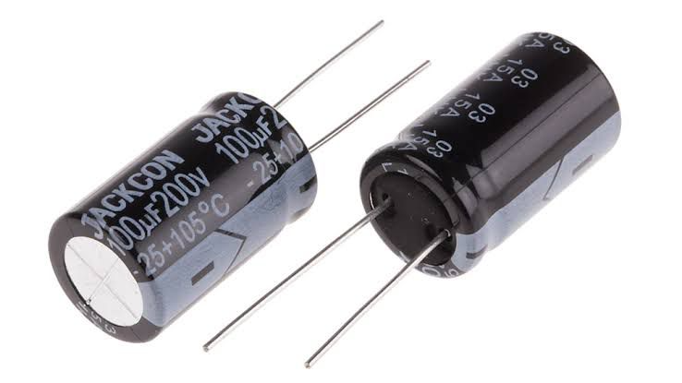
•Cooling Fan: Effective heat dissipation components are essential to prevent thermal damage to the MOSFETs and other power components. A 24V fan were included to maintain a safe operating temperature.
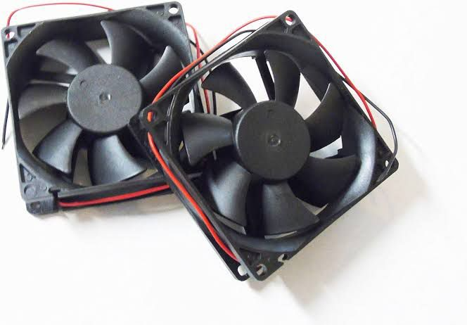
•Protection Devices (Fuses, Diodes): Fuses were added to protect against overcurrent, while flyback diodes were used across the MOSFETs to prevent voltage spikes during switching.
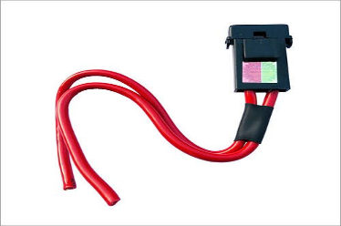
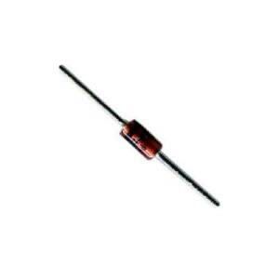
•Charge Controller: A solar charge controller regulates the voltage and current coming from the solar panels to prevent overcharging or damaging the batteries.

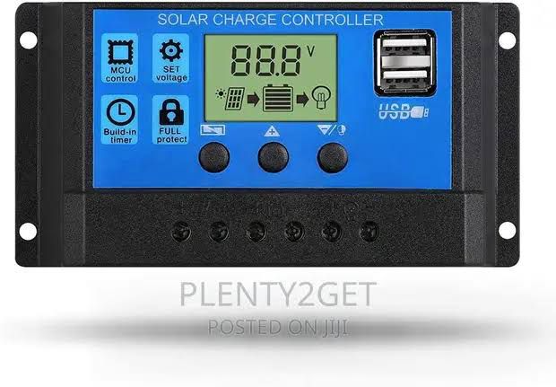
3.4 CASING AND PACKAGING
For this project, a plastic enclosure was chosen due to its strength, heat resistance, and ability to provide proper shielding against electrical interference. The plastic case also helps in dissipating heat generated by the power components, particularly the MOSFETs and transformer. The internal layout was carefully designed to allow for adequate ventilation and spacing between components to avoid overheating and reduce the risk of short circuits. A DC-powered fan were installed to enhance airflow and maintain an optimal operating temperature. Mounting brackets were used to securely fix the transformer, circuit board, battery terminals, and other components within the case. Input and output terminals, switches, and indicators were placed on the outer panel for easy access and user operation. The packaging also includes fuse holders and status LEDs to enhance user interaction and safety. In summary, the casing was designed to be compact, rugged, and user-friendly, ensuring protection for internal components while allowing easy maintenance and transport of the inverter system.
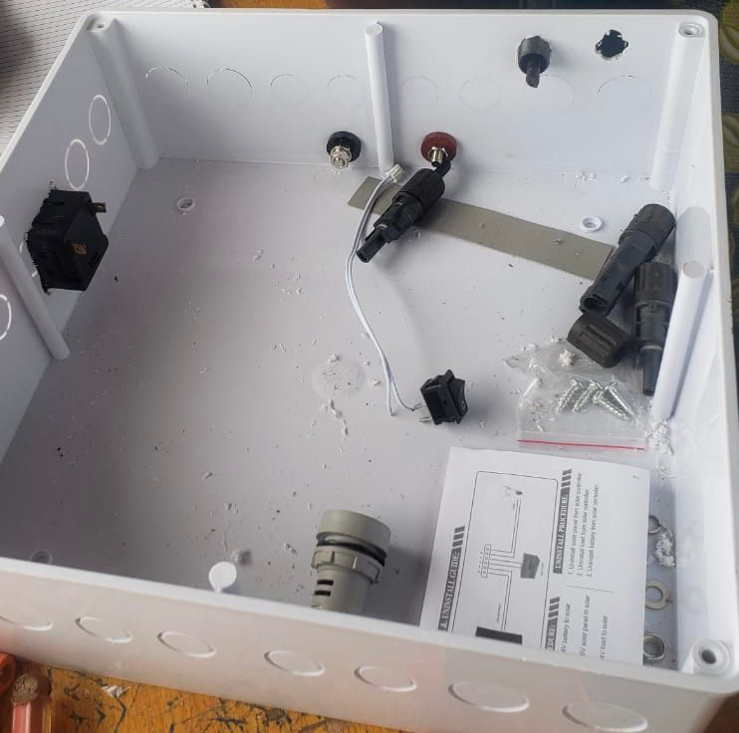
3.5 CIRCUIT DIAGRAM AND OPERATION
The circuit of the 3KVA inverter is designed to convert 24V DC from the battery into 220V AC using a combination of oscillator, driver, switching, and transformer stages. The main parts of the circuit include the oscillator section, MOSFET switching stage, and a step-up transformer.
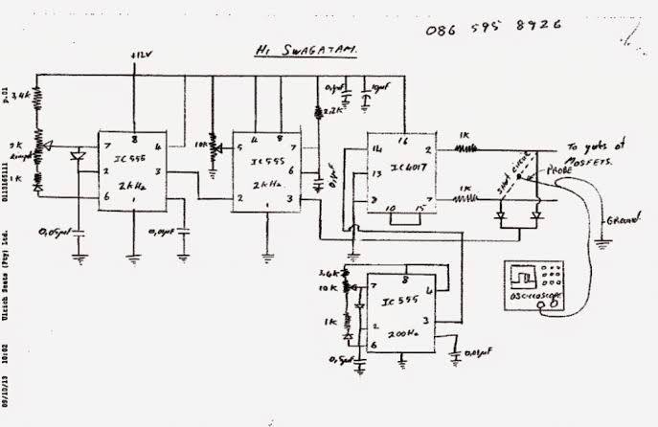
The circuit diagram of an inverter system
The operation begins with the oscillator section, which uses a timer IC (like NE555) or a microcontroller to generate a stable square wave signal at 50Hz. This signal is fed into a MOSFET driver circuit, which boosts the signal to a suitable level to switch the high-power MOSFETs. The MOSFETs, arranged in a push-pull or H-bridge configuration, act as electronic switches, rapidly turning on and off to chop the 24V DC supply into a pulsating AC waveform. These pulses are fed into the primary winding of the step-up transformer, which increases the voltage from 24V (AC equivalent) to approximately 220V AC at the secondary winding. Filter capacitors may be used at the output to smoothen the waveform and reduce electrical noise. The result is a modified sine wave or quasi-sine wave suitable for powering household or office appliances. Protection components like fuses, diodes, and heat sinks are included to prevent damage due to overcurrent, back EMF, or overheating. The circuit is designed for efficient operation, providing a stable AC output while maintaining the integrity of the components and overall system.
CHAPTER FOUR
4.0 SYSTEM CONSTRUCTION AND TESTING
4.1 TESTING AND EVALUATION UNDER LOAD CONDITION
The constructed 3KVA inverter was tested under various load conditions to evaluate its performance and stability. The testing involved connecting the inverter to a 24V battery bank and gradually applying electrical loads, starting from light appliances such as energy-saving bulbs and fans, up to heavier loads like a refrigerator and electric pressing iron. Throughout the testing, the output voltage remained stable around 220V AC, and the frequency stayed close to 50Hz. The inverter operated efficiently under partial and full loads, with only moderate heating observed in the transformer and MOSFETs during prolonged high-load operation. Adequate ventilation and heat sinks helped maintain safe temperatures. Overall, the inverter performed reliably within its rated capacity, making it suitable for household or office use.
4.2 POWER RATING
The power rating of the inverter defines its maximum load-handling capacity and determines the types of appliances it can support. In this project, the inverter was designed with a power rating of 3KVA (3000VA), which corresponds to a maximum power output of approximately 2400 watts, assuming a power factor of 0.8. This rating indicates that the inverter can effectively power a combination of household or office appliances such as fans, televisions, lighting systems, laptops, and refrigerators, provided the total load does not exceed its rated capacity. The system operates using a 24V DC battery input, which is stepped up to 220V AC output, making it suitable for standard electrical devices. Careful consideration was given to component selection including transformer size, wire gauge, and switching devices to ensure the system could consistently deliver the rated power without overheating or voltage drops.

4.3 DESIGN SPECIFICATIONS
The inverter was designed to produce a modified sine wave output, which is a stepped approximation of a pure sine wave, suitable for most household appliances. Unlike a smooth sine wave, the modified sine wave consists of a square-like waveform that changes polarity with a short zero-voltage pause between cycles, reducing harmonic distortion compared to a pure square wave. This waveform is easier and cheaper to generate using basic oscillator and switching circuits, making it ideal for low to medium-cost inverter systems. The output frequency was maintained at approximately 50Hz, and the RMS voltage was kept close to 220V AC. This design allows compatibility with common appliances like lights, fans, and chargers, though sensitive electronics may require a pure sine wave inverter for optimal performance. Below is the graphical representation of the modified sine wave produced by the inverter:
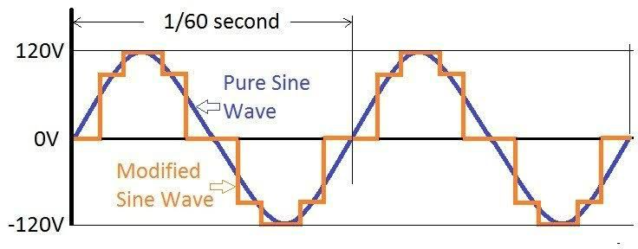
4.4 CHALLENGES ENCOUNTERED
During the design and construction of the 3KVA solar inverter using a 24V battery, several challenges were encountered that affected the development process. One major challenge was ensuring the stability of the oscillator circuit, as slight variations in frequency affected the output waveform quality. Another issue was heat generation in the MOSFETs and transformer during extended high-load testing, which required the addition of larger heat sinks and improved ventilation. Component sourcing also posed difficulties, especially in obtaining high-current-rated MOSFETs and transformers suitable for 3KVA operation. Additionally, achieving consistent output voltage under varying load conditions required careful calibration of the control circuit. Despite these setbacks, adjustments and redesigns were implemented to overcome the issues and ensure reliable inverter performance.
4.5 PROTECTION AND SAFETY FEATURES
To ensure reliable and safe operation of the 3KVA solar inverter, several protection and safety features were integrated into the design. A fuse was included at the input stage to prevent damage from overcurrent or short circuits, while reverse polarity protection diodes were used to safeguard against incorrect battery connections. Cooling fan were installed to manage thermal buildup in the MOSFETs and transformer, reducing the risk of overheating.
Additionally, the system was designed with overload protection, which automatically shuts down the inverter when the connected load exceeds its rated capacity. Proper insulation, spacing of high-voltage components, and a metallic casing were also employed to prevent electrical shocks and ensure user safety. These features collectively enhance the durability and safe functioning of the inverter system under various operating conditions.

