A PROJECT REPORT
ON
PROPORSED PRIMARY SCHOOL
FOR ADELEXE SANNI
AT
AYOBO, LAGOS STATE.
BY
AGBAJE OLATUNDE KOREDE
ND/23/ARC/PT/0058

BEING A PROJECT REPORT SUBMITTED TO
THE DEPARTMENT OF ARCHITECTURAL TECHOLOGY, INSTITUTE OF
ENVIRONMENTAL STUDIES,
KWARA STATE POLYTECHIC, ILORIN.

IN PARTIAL FULFILMENT OF THE REQUIREMENT FOR
THE AWARD OF NATIONAL DIPLOMA (ND)
IN ARCHITECTURAL TECHNOLOGY.

JULY, 2025

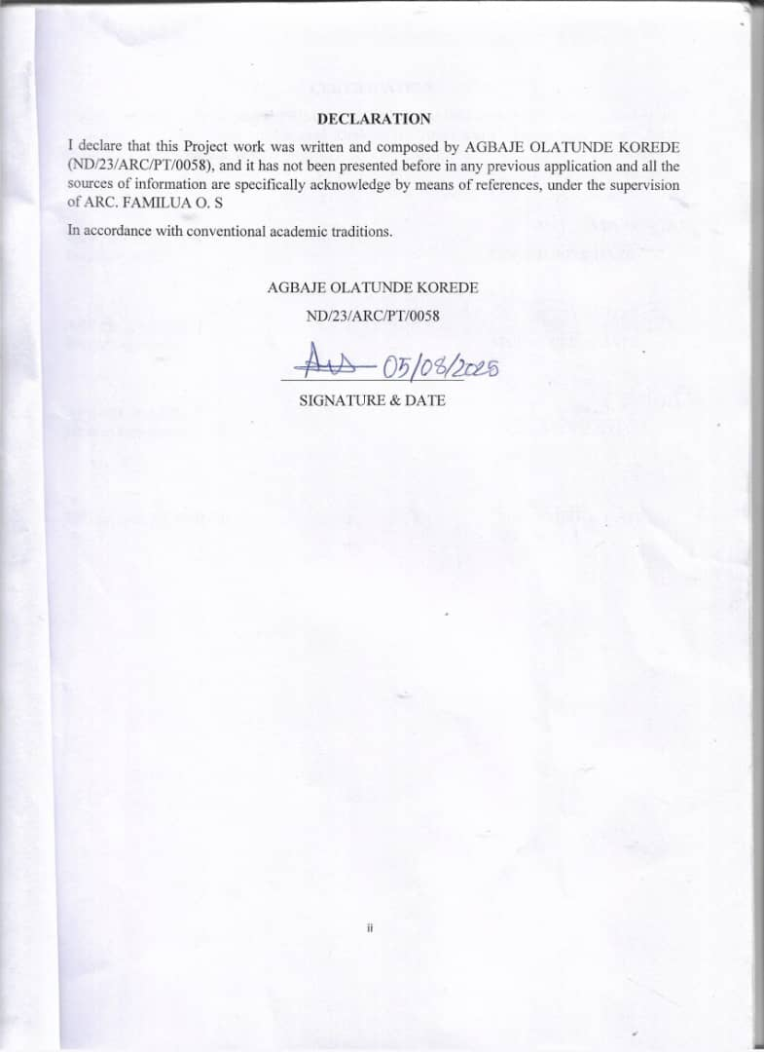

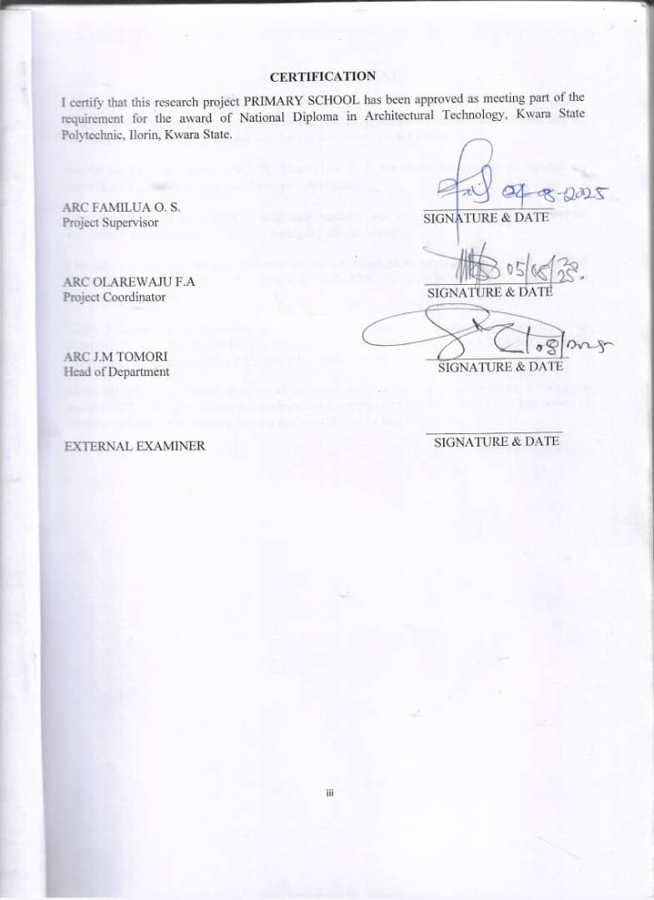

ACKNOWLEDGEMENT
Everything that has beginning must have an end, therefore, all praises and adoration is unto God for the strength and courage He has accorded me in the process of this project.
I wish to express my profound gratitude to my supervisor ARC FAMILUA O.S. For his commitment, concern and support from initial stage of my project, the constructive concern and support from the initial stage to the final stage of completion of this project work, may Almighty Allah continue to enrich you more in knowledge for his thorough supervision for this successful project. I must also be grateful to my H. O. D, ARC. J. M. TOMORI and the whole host of lectures. ARC. MOH. SHERO, ARC. OLAREWAJU F.A, ARC. CHUCKWUMA NMOM, I pray Almighty Allah will continue to bless you all.
I say thanks to the management, staff both teaching and non-teaching staff of Architectural Technology for their impact in my life during my course of study.
I would also show my deepest appreciation for the effort of an unforgettable of MR AGBAJE KAYODE AND MRS AGBAJE TENIOLA ABOSEDE, for their moral and financial support towards my education
Lastly ,I would like to appreciate the effort of my colleagues in department, school, my sister SUMISOLA, ABIODUN and brother OKIKIOLA, I whole heartedly say a VERY BIG THANK YOU, I appreciate you all, May Almighty Allah bless you all.
Above all, my utmost thanks go to the all sufficient God, the fountain of my wisdom, for his great and protection over my life, for his undying love, support and guidance throughout my period of learning and also for in sighting writing this project without him am nothing.

DEDICATION
I dedicate this project to God Almighty the creator of the universe for the grace bestow upon my life, for He has strengthen me to this present time, and also to my beloved parent MR & MRS AGBAJE for their prayer and support.

TABLE OF CONTENT
TITLE PAGE i
DECLARATION… ii
CERTIFICATION… iii
ACKNOWLEDGEMENT… ..iv
DEDICATION… v
TABLE OF CONTENTS… vi
LIST OF TABLES… x
LIST OF FIGURES… xi
LIST OF PLATES… xii
LIST OF APPENDICES… xiii
ABSRTACT… xiv
CHAPTER ONE
  - INTRODUCTION……………………………………………………………………...1
1.2 DEFINITION… 3
1.3 HISTORICAL BACKGROUND 3
1.4 AIM AND OBJECTIVES … … 4
1.5 PROJECT JUSTIFICATION … .. 4
1.6 CLIENT BACKGROUND 4
1.7 SCOPE OF THE PROJECT 5
1.8 RESEARCH METHODOLOGY… 5
CHAPTER TWO
2.1 LITERATURE REVIEW…………………………………………………………….....6
2.2 HISTORICAL BACKGROUND 6

CHAPTER THREE
3.1 CASE STUDIES…………………………………....……………………………………6
3.2 SELECTED CASE STUDIES 6
3.3 CASE STUDY ONE 7
3.3 CASE STUDY TWO… 11
3.4 CASE STUDY THREE………………………………………………………………13
3.5 ONLINE CASE STUDY.……………………………………………………………..15
3.6 DEDUCTION…... …………………………………………………………………...17
CHAPTER FOUR
BRIEF HISTORICAL BACKGROUND…………... …………………………………...18
LOCATION AND SETTING OUT…………….…………………………………...…....19
POPULATION……………………………………………………………………..…….19
SITE INVENTORY……..………………………………………………………………...21
SITE ANALYSIS…….…………………………………………………………………...21
SITE SELECTION AND JUSTIFICATION………………………………………….......22
LOCATION ….. ………………………………………………………………………..22
ACCESSIBILITY………….………………………………………………………………..22
INFRASTRUCTURE FACILITIES……………………………………………………….. 23
TOPOGRAPHY……………………………………………………………………………... 23
SOIL STRUCTURE……………………………………………………………………….. 23
GENERAL CLIMATE CONDITION…………….………………………………………. 23
RELATIVE HUMIDITY…………………………………………………………………... 23
WIND…................................................................................................................................. 23
TEMPERATURE……………………………………………………………………………24
VEGETATION……………………………………………………………………………...24
ROAD………………………………………………………………………………………24
WATER AND ELECTRICITY……………………………………………………………...24
DESIGN CRITERIA………………………………………………………………………….25
DESIGN BRIEF 25
DESIGN ANALYSIS 25
SPACIAL ALLOCATION 26
PLANNING PRINCIPLE… 28
CHAPTER FIVE
APPRAISAL OF PROPOSED SCHEME…………………………………………………. 29
CONSTRUCTION METHODOLOGY…………………………………………………… 29
SERVICES…………………………………………………………………………………. 29
VENTILATION 30
LIGHTING..… 30
PLUMBING 30
ELECTRICAL INSTALLATION… 30
WASTE DISPOSAL 31
FIRE PROTECTION… 31
RAIN PROTECTION… 31
EXTERNALWORK… 31
SUMMARY… 31
CONCLUSION… 32
RECOMMENDATION… 32
REFERENCES 33
APPENDICES 34

LIST OF TABLES

TABLE1;SHOWING THE POPULATION OF THE GENDER 25

TABLE2;SHOWING SPACIAL ALLOCATION OF FLOOR PLAN… 3

LIST OF FIGURES
FIG1;SHOWING LOCATION PLAN OF CASE STUDY ONE… 10
FIG2;SHOWING FLOOR PLAN OF CASE STUDY ONE… 10
FIG3;SHOWING LOCATION PLAN OF CASE STUDY TWO… 13
FIG4;SHOWING FLOOR PLAN OF CASE STUDY TWO… 14
FIG5;SHOWING LOCATION PLAN OF CASE STUDY THRE… 16
FIG6;SHOWING FLOOR PLAN OF CASE STUDY THREE… 17
FIG7;SHOWING LOCATIONAL PLAN OF THE PROPOSED SITE… 24
FIG8;SHOWING SITE INVENTORY OF THE PROPOSED SITE… 26
FIG9;SHOWING SITE ANALYSIS OF THE PROPOSED SITE… 27

LIST OF PLATES

PLATE1;SHOWING FRONT VIEW OF CASE STUDY ONE… 11

PLATE2;SHOWING LEFT VIEW OF CASE STUDY ONE… 11

PLATE3;SHOWING BACK VIEW OF CASE STUDY ONE 12

PLATE4;SHOWING RIGHT VIEW OF CASE STUDY ONE… 12

PLATE5;SHOWING FRONT VIEW OF CASE STUDY TWO… 14

PLATE6; SHOWING BACK VIEW OF CASE STUDY TWO… 15

PLATE7;SHOWING LEFT VIEW OF CASE STUDY TWO… 15

PLATE8;SHOWING FRONT VIEW OF CASE STUDY THREE 16

PLATE9;SHOWING LEFT VIEW OF CASE STUDY THREE 18

PLATE10;SHOWING FLOOR PLAN OF ONLINE CASE STUDY 19

PLATE11;SHOWING FRONT VIEW OF ONLINE CASE STUDY 19

PLATE12;SHOWING LEFT VIEW OF ONLINE CASE STUDY 20
PLATE13;SHOWING FLOOR PLAN OF ONLINE CASE STUDY 20
PLATE14;SHOWING FRONT VIEW OF ONLINE CASE STUDY 21

LIST OF APPENDICES
APP1;SHOWING SITE PLAN OF THE PROPOSED PROJECT 38
APP2; SHOWING FLOOR PLAN OF THE PROPOSED PROJECT 39
APP4;SHOWING ROOF PLAN OF THE PROPOSED PROJECT 40
APP5;SHOWING CROSS SECTION OF THE PROPOSED PROJECT 41
APP6;SHOWING FRONT VIEW OF THE PROPOSED PROJECT 42
APP7;SHOWING SIDE VIEW OF THE PROPOSED PROJECT 43

ABSTRACT
Proposed based learning (PBL) is increasingly being adapted as the effective approach to learning in primary school as teachers realize how authentic and challenging learning experience enable higher level of engagement and self-directed learning. Supporting learning through PBL approaches in school requires rethinking a number of aspects which includes the type of experiences students are exposed to, the process of learning and the output of such learning. The role of assessment as well as student feedback and self-assessment are important features of PBL. This approach further draws on the input of ‘experts’ who supports students to explore real life problems or challenges. Enveloping those experiences is the use of educational technology and how this can enhance the learning process. This chapter explores how PBL can be successfully incorporated into primary school classroom drawing on existing literature and from researchundertaken by authors.

CHAPTER ONE
1.1 INTRODUCTION
The establishment of a primary school serves as a foundational cornerstone in the educational journey of young learners, providing a structured and nurturing environment where children between the ages of five and eleven are introduced to formal education for the first time in their lives. This crucial phase not only focuses on the development of basic literacy and numeracy skills but also fosters the social, emotional, and physical growth necessary for a child's holistic development. A well-organized primary school is typically equipped with age-appropriate learning materials, professionally trained teachers, and a curriculum designed to meet national educational standards while accommodating the unique needs of individual learners. By creating a supportive atmosphere that encourages curiosity, discipline, creativity, and collaboration, primary schools play a pivotal role in laying the groundwork for future academic success and responsible citizenship. The school also serves as a safe space where children can interact with their peers, learn the importance of respect and responsibility, and begin to form the values and habits that will guide them throughout their lives.
Education is widely recognized as the cornerstone of individual and societal development, and at the heart of every nation’s educational structure lies the primary school. Primary education represents the first formal stage of learning, providing the essential foundation upon which all subsequent academic and personal growth is built. In most countries, including the United Kingdom and Nigeria, primary schools serve children between the ages of 4 or 5 and 11, shaping their early experiences in reading, writing, numeracy, communication, and social interaction.
The primary school environment plays a crucial role in the cognitive, emotional, physical, and moral development of children. It is during these formative years that learners are introduced to basic literacy and numeracy skills, as well as the concepts of responsibility, cooperation, and self-discipline. More than just a place for academic instruction, the primary school serves as a nurturing space where children begin to understand their role within a community, explore their individual potential, and develop the confidence needed to navigate future academic challenges.
This project focuses on the design, purpose, and operation of a modern primary school from an architectural and educational perspective. It examines how the physical environment—including classroom layout, lighting, ventilation, play areas, safety features, and accessibility—directly influences the learning process and child development. As the demand for inclusive and adaptive education grows, so too must the quality and functionality of the built environment in which it is delivered.
Furthermore, this report explores the historical background of primary education, the objectives guiding the establishment of primary schools, and the educational policies that shape their operation. It also highlights how modern primary schools are designed not only to meet academic needs but also to promote mental well-being, creativity, and environmental awareness among pupils.
By understanding the comprehensive role of primary schools in society and the architectural considerations that support effective learning, this project aims to contribute valuable insight into the planning and development of future-oriented educational facilities that are both child-friendly and sustainable.

1.2 DEFINITIONOF PRIMARY SCHOOL
A primary school is an educational institution specifically designed to provide the first stage of formal education to young children, typically between the ages of five and eleven, during which they are introduced to foundational subjects such as reading, writing, mathematics, science, and social studies in a structured and supportive environment. This level of schooling is aimed at equipping pupils with essential academic skills, moral values, and basic life competencies that prepare them for the next phase of learning, usually at the secondary school level. A primary school not only imparts knowledge through a carefully designed curriculum that aligns with national education policies and standards, but also focuses on the social and emotional development of each child, ensuring that learners grow intellectually, socially, and emotionally within a safe and inclusive learning atmosphere. Through a combination of classroom teaching, extracurricular activities, and community involvement, primary schools help to build a strong educational foundation, cultivate positive attitudes toward learning, and foster a sense of responsibility, discipline, and teamwork among pupils at an early and impressionable stage of life.
1.3 HISTORICALBACKGROUND
The concept of primary education dates back to ancient civilizations such as Egypt, Mesopotamia, Greece, and Rome, where basic education was provided to young boys, often focusing on reading, writing, and arithmetic, though it was largely reserved for the wealthy or privileged classes. During the Middle Ages, education was primarily conducted by religious institutions such as churches and monasteries, and while literacy began to spread, there were still very limited opportunities for the general population, especially the poor and girls. The idea of universal primary education began to take shape during the Enlightenment period in Europe, particularly in the 17th and 18th centuries, when philosophers and reformers like John Locke and Jean-Jacques Rousseau emphasized the importance of childhood development and learning. In the 19th century, many countries began establishing formal systems of primary education, with governments introducing compulsory schooling laws to ensure that all children, regardless of social background, had access to basic education; for example, England passed the Elementary Education Act in 1870, while other countries like Germany and France developed similar frameworks. In Africa, the development of primary schools was significantly influenced by colonial powers, where missionary and colonial schools introduced Western-style education, though it was often limited in scope and unevenly distributed. Over time, primary education has evolved into a globally recognized stage of learning, becoming a fundamental human right as declared by international bodies such as the United Nations and UNESCO, with modern primary schools now serving as essential institutions that aim to provide equitable, inclusive, and quality education for all children at the foundation of lifelong learning.
1.4 AIM AND OBJECTIVES OF THE PROJECT
AIM OF THE PROJECT
The primary aim of a primary school is to lay a strong and balanced educational foundation for young children by equipping them with essential literacy, numeracy, and communication skills that will support their academic progress and lifelong learning. It seeks to nurture the intellectual, emotional, physical, moral, and social development of pupils in a safe, inclusive, and stimulating environment that promotes curiosity, creativity, and a love for learning. Primary education also aims to help children develop positive attitudes, critical thinking abilities, and problem-solving skills that will enable them to adapt to future educational challenges and societal demands. Furthermore, it is designed to instill in pupils the core values of discipline, responsibility, cooperation, and respect for others, while fostering a sense of national identity, cultural awareness, and civic responsibility from an early age
OBJECTIVES OF THE PROJECT
To provide basic literacy and numeracy skills essential for further education.
To develop children's thinking, problem-solving, and communication abilities.
To promote moral, emotional, and social development.
To instill discipline, responsibility, and respect for others.
To encourage creativity and physical development through arts and sports.
To prepare children for lifelong learning and active citizenship.
1.5 PROJECT JUSTIFICATION OF THE PROJECT
The establishment of a primary school is justified by the vital role it plays in laying the foundation for a child’s lifelong learning and overall development, as it is at this early stage that children acquire the basic literacy, numeracy, and communication skills needed to function effectively in society. Primary education is essential because it not only equips young learners with the knowledge required for academic success in later stages, but also fosters cognitive, emotional, and social growth during the most formative years of their lives. It provides a structured environment where children learn discipline, cooperation, and respect for others, which are fundamental qualities for good citizenship and personal development.
1.6 CLIENT BACKGROUND
The name of my client is MUHAMMED AZEEZ ALAANU.
CEO of ALAANU OIL AND GAS.
MuhammedAzezAlaanu is a Nigerian businessman who is the CEO of ALAANU OIL AND GAS Lagos state. He was first into car dealer business then handover it to his first male child 2017, now managing his Oil and Gas business. Born: 18November 1967[age 58 years],
1.7 SCOPE OF THE STUDY
- Proposed Building
- Hall\Auditorium
- Playing Ground
- Security House
- Generator House
- Car Park
- Soak-away
1.8 RESEACH METHOLODY
Various avenues were expressed as regards the method of research on order to arrive at a functional and appealing design concepts. The following research methods were employed.
CASE STUDY: This is the method that carried out in which to gain more detailed experience in my project topic primary school.
ORAL INTERVIEW: An oral interview in the method I carried out to collect more information by directly engaging with individuale.g manager the workers, the citizens and other to gain more experience on my project
LITERATURE REVIEW: This is the process by which I carried out in the process of reach, articles, and others materials on my project.

CHAPTER TWO
2.0 LITERATURE REVIEW
2.1 HISTORICAL BACKGROUND OF A PRIMARY SCHOOL
PRIMARY SCHOOL
The origin of primary schools can be traced back to ancient civilizations such as Egypt, China, Greece, and Rome, where education was initially reserved for the elite and mainly focused on training boys in reading, writing, arithmetic, and religious or philosophical teachings. Over time, as societies became more organized and the need for educated citizens grew, especially during the Enlightenment period in Europe, thinkers and reformers began to emphasize the importance of universal education for all children, regardless of social class or background. This led to the gradual development of formal systems of primary education, with countries like Prussia (now Germany) pioneering state-sponsored, compulsory primary schooling in the 18th century, followed by England’s Elementary Education Act of 1870 which marked the beginning of publicly funded primary schools. In many parts of the world, including Africa and Asia, the introduction of primary schools was significantly influenced by colonial administrations and Christian missionary efforts, who saw education as a tool for spreading religion and administering colonial governance. In Nigeria, for example, the earliest forms of primary education were introduced by Christian missionaries in the 19th century, beginning in the southern region and later expanding with the involvement of colonial authorities who began to take more active control in the 20th century. Today, the primary school system is a globally recognized institution that provides structured education to children typically between the ages of 5 and 11, focusing on foundational skills in literacy, numeracy, moral values, and basic science and social knowledge, while also promoting social development, discipline, and citizenship.
2.2 PRIMARY SCHOOL IN U. S. A
The historical development of primary schools in the United States dates back to the early colonial period, when education was largely informal and heavily influenced by religious beliefs, particularly in New England, where Puritans emphasized the importance of reading the Bible and thus established some of the first schools, such as the Boston Latin School in 1635. In these early years, education was often delivered in one-room schoolhouses, where a single teacher taught multiple age groups, focusing mainly on reading, writing, arithmetic, and moral instruction, often using religious texts like the New England Primer. As the colonies grew and became more diverse, so did their educational practices, with the Mid-Atlantic and Southern colonies placing less emphasis on universal education and more on private tutoring for the wealthy, which resulted in a lack of consistent schooling for many children. The movement toward free, universal primary education gained significant momentum in the 19th century through the efforts of educational reformers like Horace Mann, often called the "Father of American Public Education," who championed the idea of tax-funded public schools that would be free, non-sectarian, and accessible to all children. This led to the gradual establishment of compulsory education laws, beginning with Massachusetts in 1852, which required children to attend school, thereby institutionalizing the idea of primary education as a right and responsibility in American society.
With the rapid industrialization and urbanization of the late 19th and early 20th centuries, the American primary school system expanded significantly to accommodate a growing and diverse population, including large numbers of immigrants, and adopted more standardized curricula, trained teachers, and graded classrooms. The 20th century brought further reforms, including the introduction of kindergarten, the implementation of school lunch programs, and the federal government’s increasing involvement in education policy, particularly through landmark legislation such as the Elementary and Secondary Education Act (ESEA) of 1965, which aimed to address educational inequality. Over time, American primary schools evolved from small, community-based institutions into a nationwide system of structured public education, shaped by changing social values, technological advancements, and ongoing debates about curriculum, funding, inclusion, and educational standards.
Primary education in the United States, commonly referred to as elementary school, forms the foundational stage of formal education for young children. It typically serves children between the ages of 5 and 11, although in some districts, this range may extend to include younger children through pre-kindergarten programs or older students in Grade 6, depending on the school system's structure. The American primary school system is designed to promote intellectual, emotional, and social development during these formative years, preparing children for the more specialized and advanced learning they will encounter in secondary school.
Children in the U.S. generally begin their educational journey with Pre-Kindergarten (Pre-K), which is offered in many states for children aged 3 to 4 years old. Though Pre-K is not mandatory, it plays an increasingly important role in early childhood development by introducing basic concepts of language, numbers, social skills, and classroom routines. Following this stage, children typically enter Kindergarten at the age of 5, which marks the official start of primary education. In Kindergarten, students learn foundational skills such as reading readiness, basic mathematics, communication, and cooperative play. This year serves as a transitional phase between informal early learning and more structured academic instruction.
After Kindergarten, student progress to Grade 1, usually at the age of 6, where they begin formal instruction in core subjects such as reading, writing, mathematics, science, and social studies. This is followed by Grade 2 at age 7, where these skills are further reinforced and expanded upon. In Grade 3, typically for 8-year-olds, children begin to read more independently, explore complex arithmetic operations, and gain a broader understanding of history and the natural world.
By Grade 4 (age 9) and Grade 5 (age 10), students are expected to apply their basic knowledge to problem-solving tasks, group projects, writing assignments, and standardized assessments. These years are particularly important in building analytical thinking, independence, and responsibility. In some U.S. school districts, Grade 6 (age 11 to 12) is still considered part of the elementary or primary school, although it is more commonly included in middle school. When it is part of primary school, it often involves departmentalized teaching where students may begin switching classes for different subjects, similar to middle school settings.
Across all grades, the U.S. primary school system places emphasis on nurturing a child’s development not only in academic areas but also in social skills, creativity, and physical health. The school day typically includes time for music, physical education, art, and sometimes foreign language learning. In addition, classroom environments and teaching strategies are increasingly designed to accommodate diverse learning needs, cultural backgrounds, and developmental stages.
In summary, primary or elementary education in the United States spans from Kindergarten (age 5–6) to typically Grade 5 (age 10–11), with many students beginning earlier in Pre-K (ages 3–4) and some continuing through Grade 6 (age 11–12). These early years are considered the most crucial in shaping a child’s academic trajectory, social skills, and attitudes toward learning. The U.S. educational system has progressively expanded access to early education and standardized curricula to ensure that all children, regardless of background, are given a strong and equal start to their academic lives.

CHAPTER THREE
3.1 CASE STUDIES
This is are search or an exercise that is carried out on existing building which is similar to the one researcher is writing on. The objective of a case study is to take a critical appraisal of existing related project with a view to identify the positive and negative aspect of such projects. It is only with time that a project can be adjusted so that it can be successful. The information obtained from the appraisal will guide the designer of new and similar project, the positive aspect of it shall be incorporated in the view proposal while attempts will be made to solve the problem of negative aspects. It is only through this that a designer can better enhance the quality and efficiency of building in the society. For a comprehensive analysis their case studies have been conducted.
3.2 SELETED CASE STUDIES
Case studies are of paramount important. It is an experimental research or analysis carried out on existing building or group of building functionally similar to the one which there search is working.
For any technical design to be meaningful there is always the need for preliminary research effort to be made on this proposal as a very necessary ground work.
The following are case studies of some primary school.
    - Kenirah International School, lagos island ayobo, Lagos State
    - African Church Central School, OttaOgun State
    - Silver Line Montessori School, Ilorin, Kwara State

3.3 CASE STUDY ONE
    - Location:Kenirah International School, lagos island ayobo, Lagos State

OBSEVERATION
MERITS
- Adequate parking space
- It is well landscape
- Easily accessible from the gate
- Provision of drainage facilities
- Good security arrangement

DEMERIT
- Noisy area
- There is no lab unit in the building

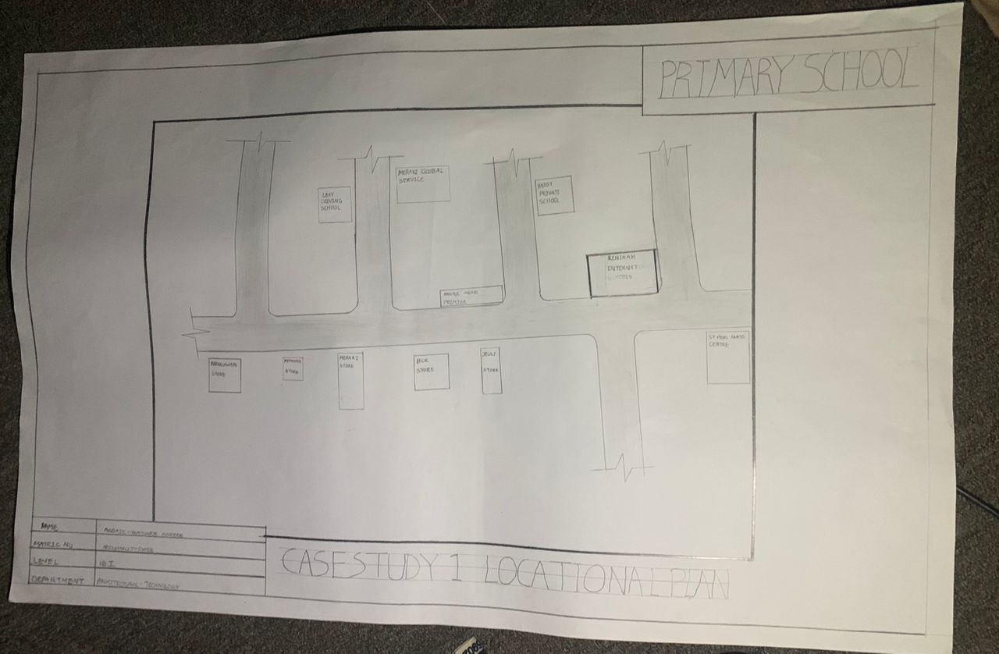

FIG1;SHOWING LOCATION PLAN OFCASE STUDY ONE

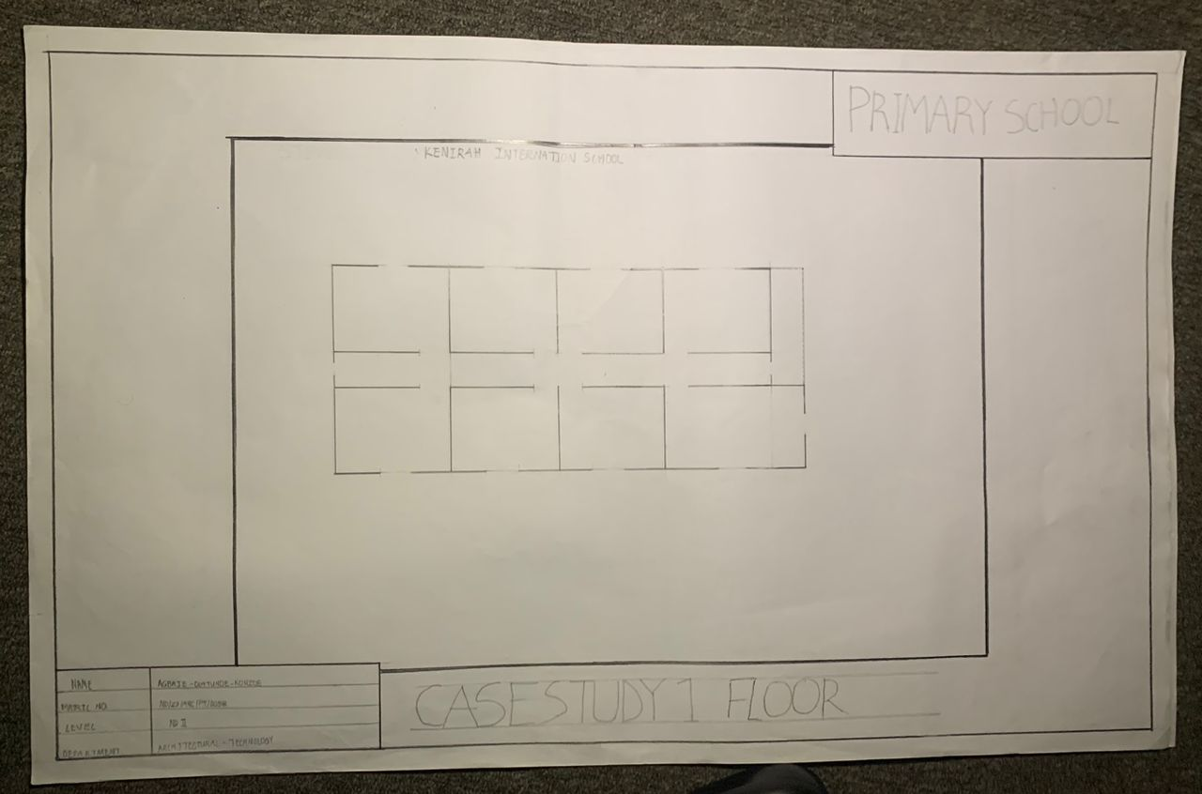

FIG2; SHOWING FLOOR PLAN OF CASE STUDY ONE
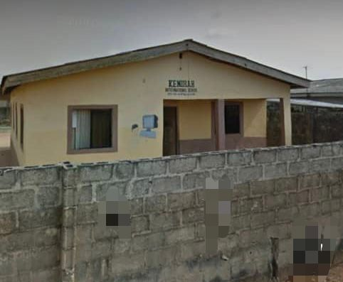

PLATE1; SHOWING FRONT VIEW OF CASE STUDY ONE

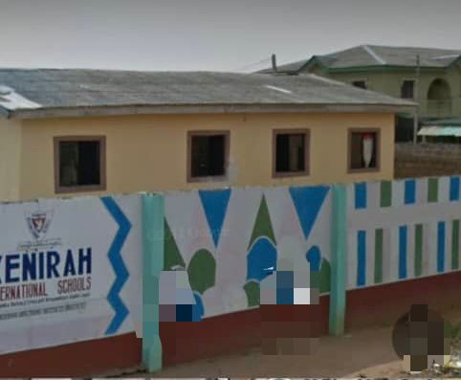

PLATE2; SHOWING LEFT VIEW OF CASE STUDY ONE

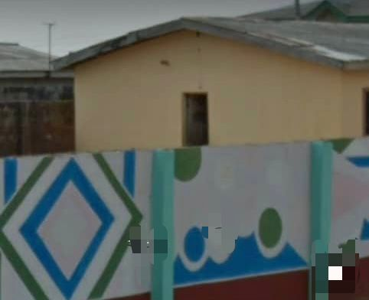

PLATE3; SHOWING BACK VIEW OF CASE STUDY ONE

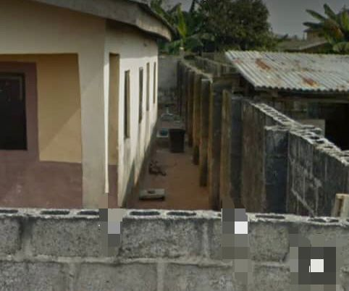
PLATE4; SHOWING RIGHT VIEW OF CASE STUDY ONE

3.4 CASE STUDY TWO (2)

    - LOCATION: African Church Central School, OttaOgun State
MERITS
- Eazy to locate
- Provision of drainage facilities
- There is a room provide secured storage for medical records

DEMERITS
- Noisy area
- It is not well landscape
- Not in a conducive environment

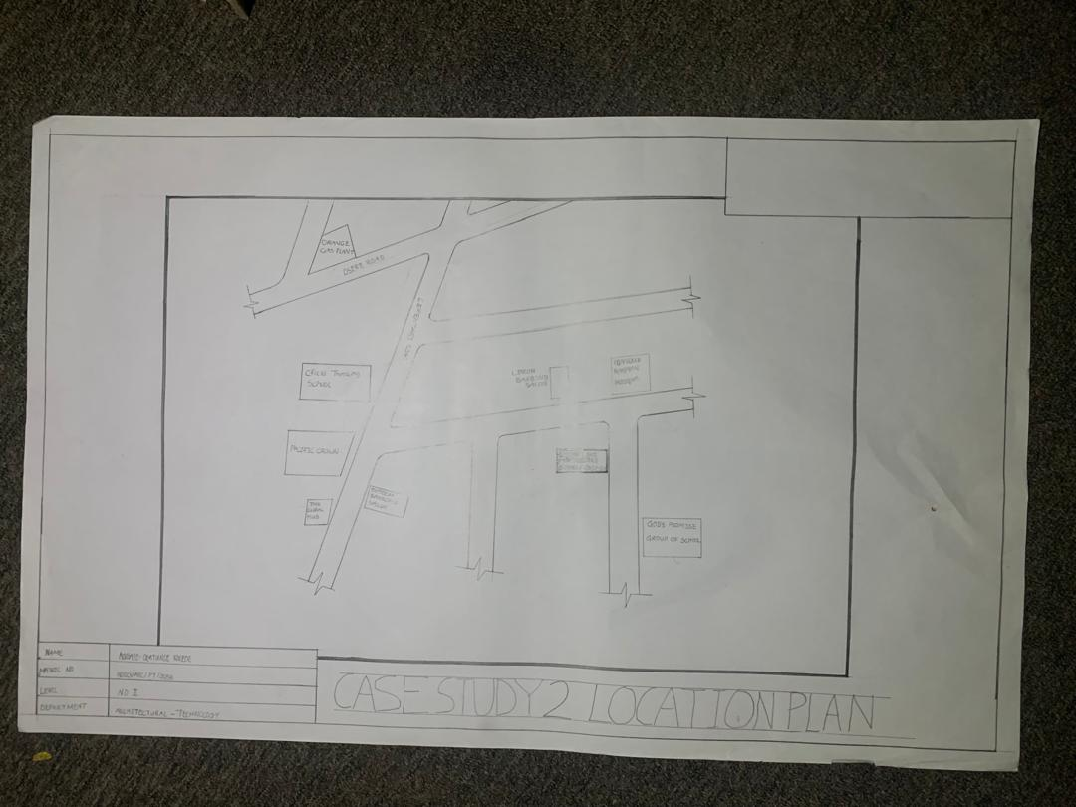

FIG3; SHOWING LOCATION PLAN OF CASE STURDY TWO
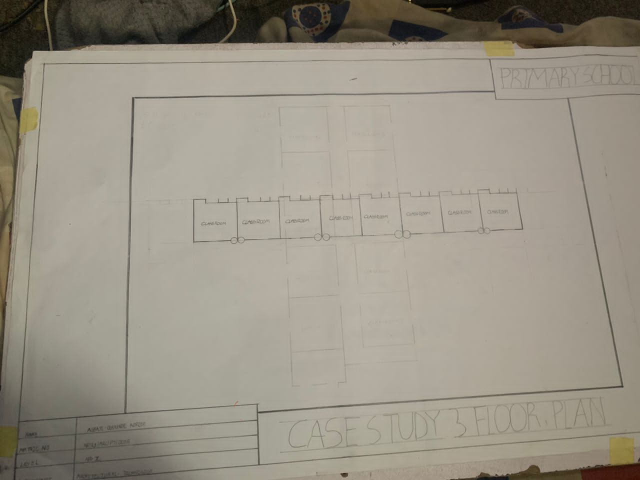
FIG 4; SHOWING THE FLOOR PLAN OF CASE STUDY TWO

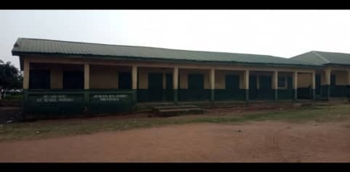

PLATE 5; SHOWING THE FRONT VIEW OF CASE STUDY TWO

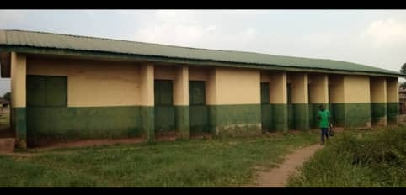

PLATE 6;SHOWING BACK VIEW OF CASE STUDY

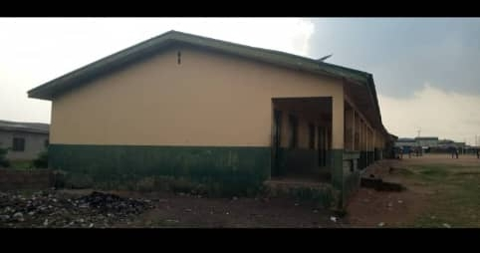

PLATE 7; SHOWINGLEFT OF CASE STUDY TWO

3.5 CASE STUDY THREE (3)
    - LOCATION: Silver Line Montessori School, Ilorin, Kwara State

MERITS
- Easy to locate
- Good security
- Well landscaping

DEMERIT
- In adequate parking space
- Noisy area
- Poor building structure

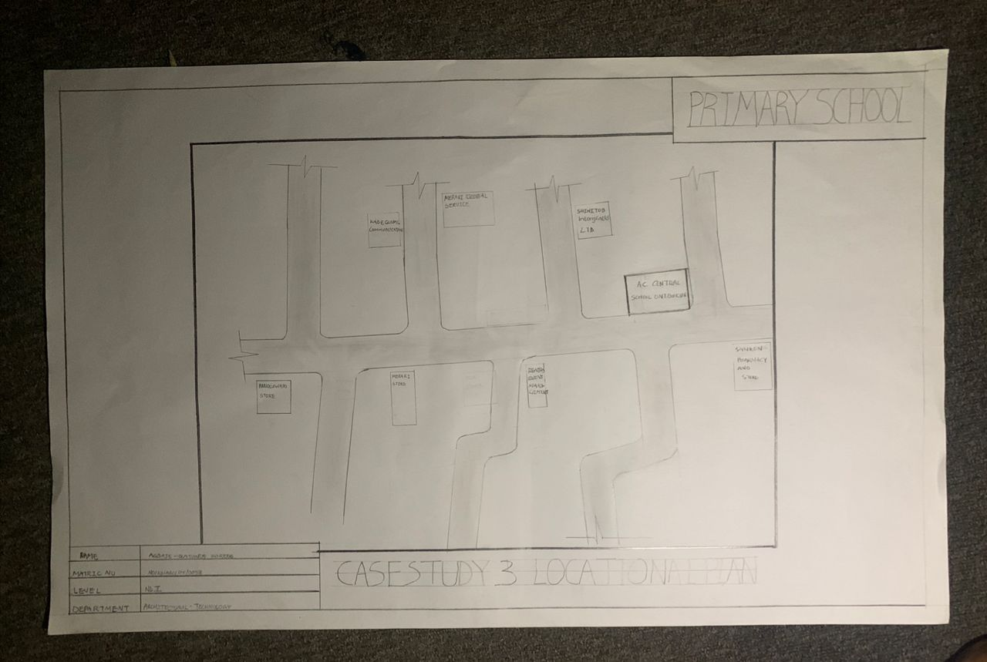

FIG 5; SHOWING LOCATION PLAN OF CASE STUDY THREE

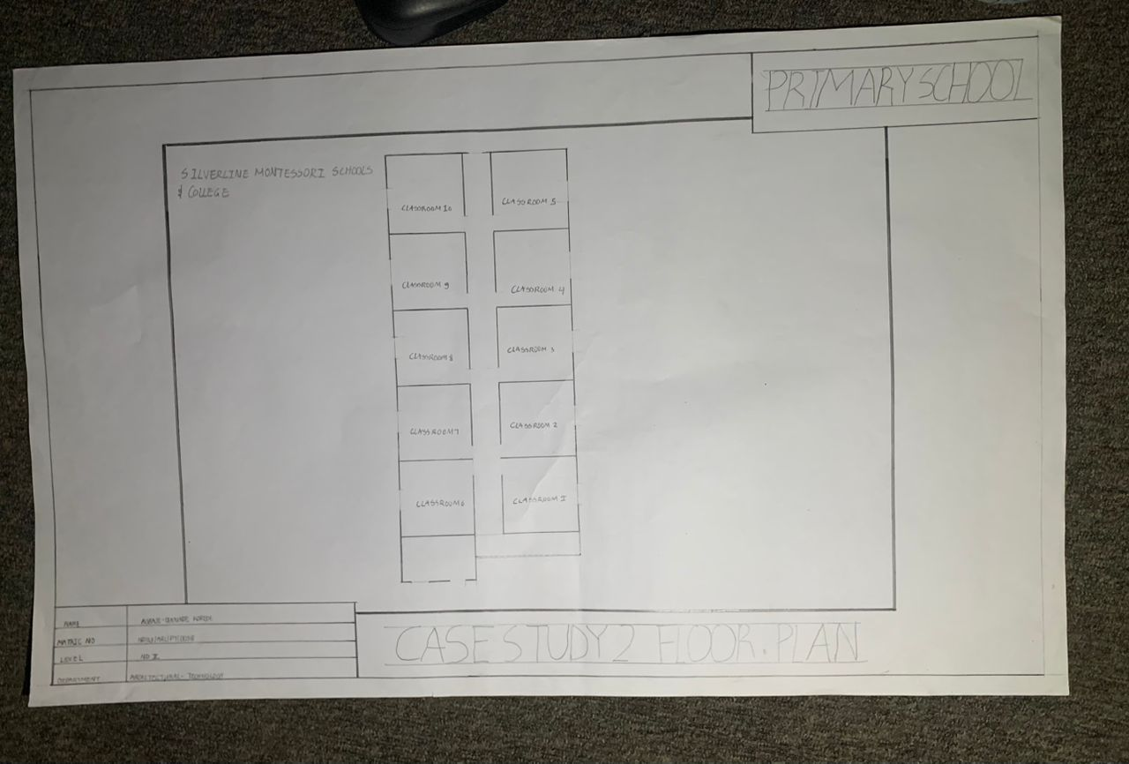
FIG 6; SHOWING FLOOR PLAN OF CASE STUDY THREE

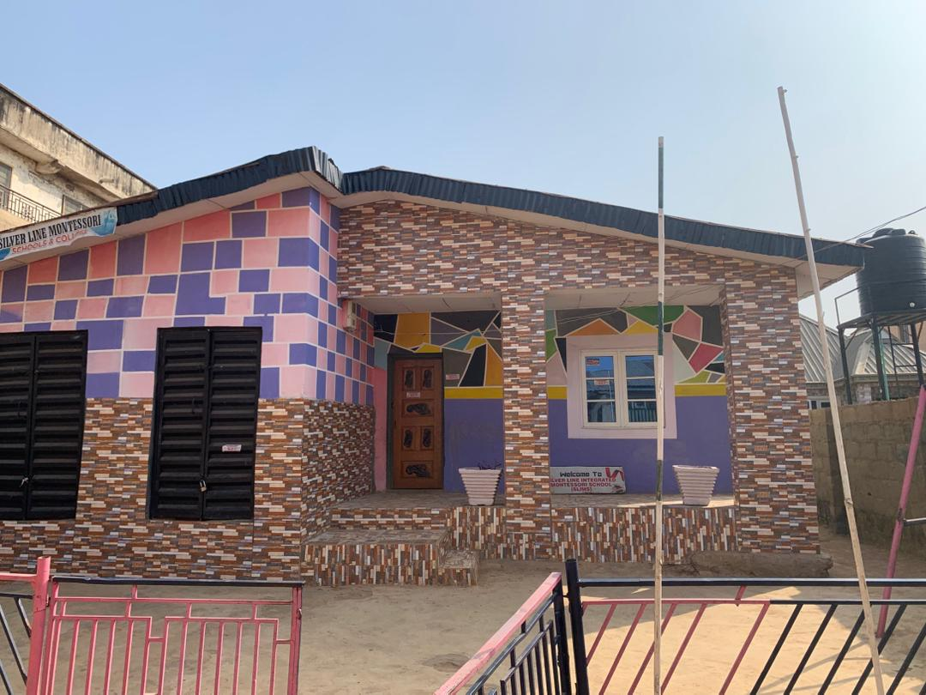

PLATE 8;SHOWING FRONT VIEW OF CASE STUDY THREE

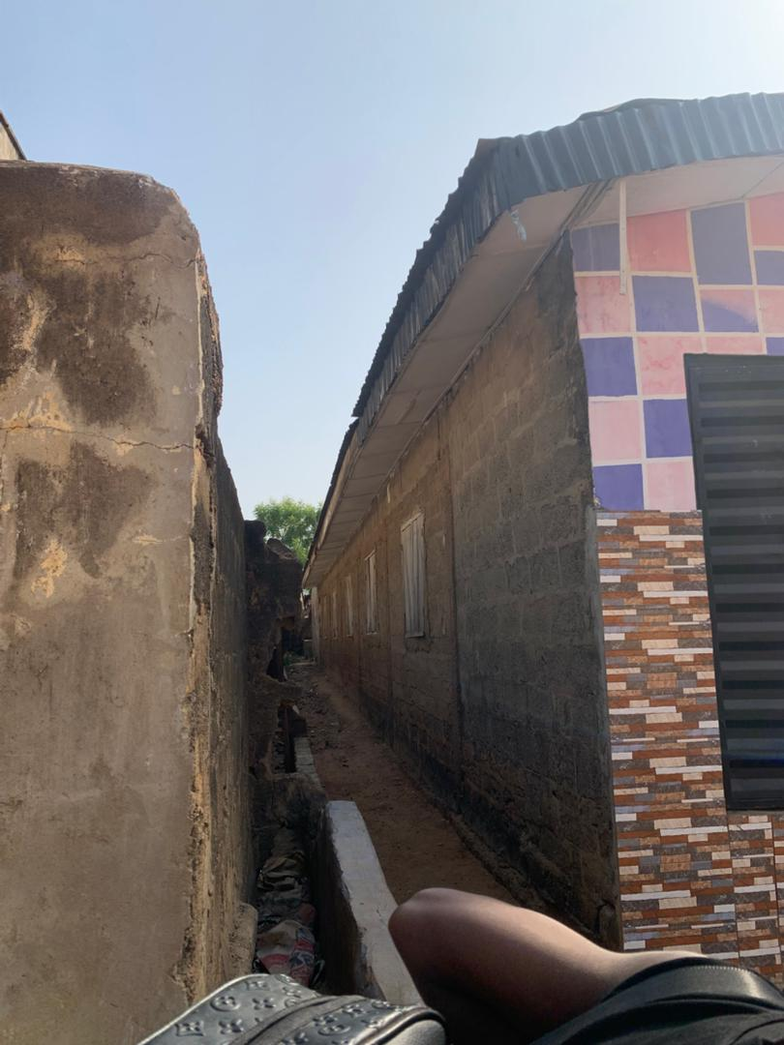

PLATE 9; SHOWING LEFT VIEW OF CASE STUDY THREE

3.6 ONLINE CASE STUDY
ONLINE CASE STUDY ONE
PROJECT NAME: ELPTON HILL PRIMARY SCHOOL
LOCATION: USA

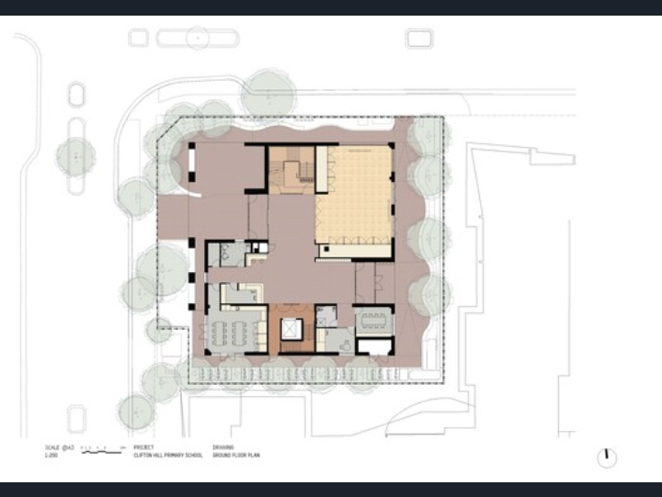
PLATE 10; SHOWING FLOOR PLAN OF ONLINE CASE STUDY

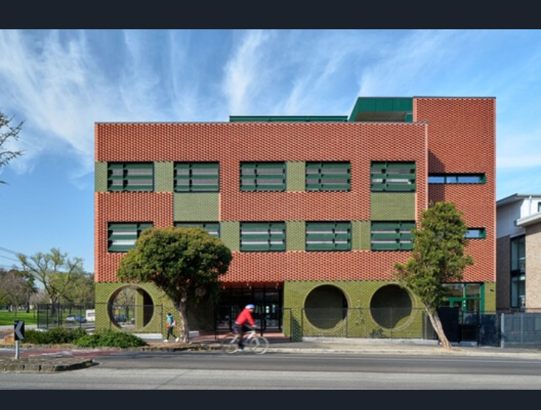
PLATE 11; SHOWING FRONT VIEW OF ONLINE CASE STUDY
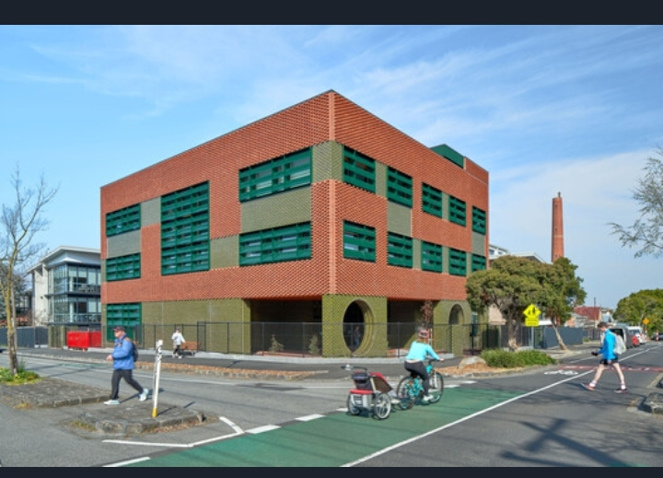
PLATE 12; SHOWING LEFT VIEW OF ONLINE CASE STUDY

ONLINE CASE STUDY TWO
PROJECT NAME: SHARED FACULTY PRIMARY SCHOOL
LOCATION: F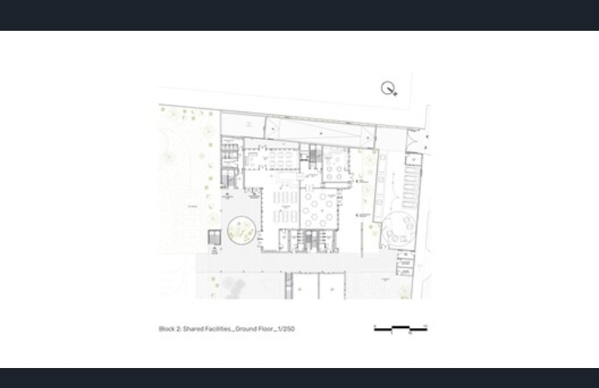
PLATE 13; SHOWING FLOOR PLAN OF ONLINE CASE STUDY

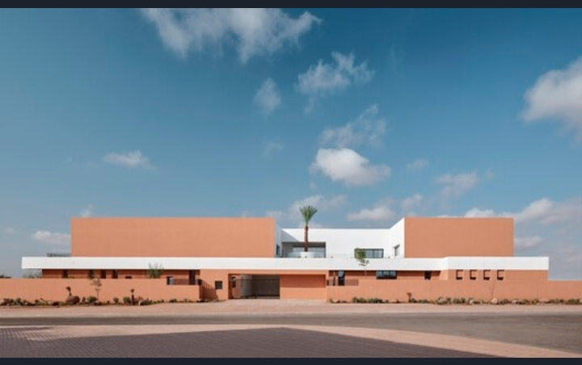PLATE 15; SHOWING FRONT VIEW OF ONLINE CASE STUDY

DEDUCTION FROM CASE STUDIES
During my visit to the primary school. I was opportunities to see what was obtain in the school, I made a proper studies of their related function and analysis were made to their present situation with the aim of incorporation with their merit in my own final proposal.
The following were deduce from my case study
- Adequate natural ventilation and lighting.
- Good architectural landscaping.
- The units in the school should be properly and well linked.
- Parking spaces should be well defined.
- Good drainage system.

CHAPTER FOUR
4.0 PROJECT LOCATION
4.1 BRIEF HISTORICAL BACKGROUND OF LAGOS STATE
Lagos State, located in the southwestern part of Nigeria, was created on May 27, 1967 by the Federal Military Government under General Yakubu Gowon, as part of the restructuring of Nigeria into twelve states. Before its creation as a state, Lagos had served as the capital of Nigeria from 1914 (when the Northern and Southern Protectorates were amalgamated) until 1991, when the capital was officially moved to Abuja.
Historically, Lagos was originally a small Yoruba fishing and farming settlement called "Eko", founded by the Awori people. It later came under the rule of the Benin Empire in the 15th century and was renamed Lagos by Portuguese explorers in the 15th century, meaning "lakes" in Portuguese. During the colonial period, Lagos became a major center for trade, especially during the transatlantic slave trade and later for palm oil and other commodities.
Over the years, Lagos developed into Nigeria’s commercial and industrial hub, attracting people from all parts of the country and beyond. Today, Lagos State is the most populous and economically significant state in Nigeria, with Lagos city being the largest urban center in West Africa.
GEOGRAPHY OF LAGOS STATE
Lagos State, located in the southwestern geopolitical zone of Nigeria, is the smallest state in terms of land area, yet it is the most populous and economically active. It shares boundaries with Ogun State to the north and east, the Republic of Benin to the west, and is bordered to the south by the Atlantic Ocean.
ECONOMY OF LAGOS STATE
Lagos State is the economic center of Nigeria and one of the largest economies in Africa. Despite being the smallest state by land area, it generates the highest Internally Generated Revenue (IGR) in the country and contributes over 30% of Nigeria’s GDP. The economy is driven by commerce, finance, manufacturing, oil and gas services, technology, transportation, and entertainment.
It is home to the Nigerian Stock Exchange, major banks, seaports (Apapa and Tin Can), and the MurtalaMuhammed International Airport, making it a vital gateway for trade and investment. Lagos also leads in technology and innovation, with a growing number of startups, especially in Yaba. Additionally, it is the heart of Nollywood, Africa’s largest film industry, and a key player in music, fashion, and tourism.
In summary, Lagos has a diverse and fast-growing economy that supports millions of businesses and jobs, making it the commercial heartbeat of Nigeria and West Africa.
ORGANIZATION STRUCTRE
Lagos State operates under a three-tier system of government, similar to the federal structure of Nigeria, consisting of:
- Executive Arm:
Headed by the Governor, assisted by the Deputy Governor, Commissioners, and Special Advisers who oversee various ministries and agencies. This arm implements laws and manages daily administration.
- Legislative Arm:
Made up of the Lagos State House of Assembly, led by the Speaker. Members are elected to make laws, approve budgets, and perform oversight on the executive.
- Judiciary Arm:
Headed by the Chief Judge of Lagos State, this arm interprets laws and ensures justice through various courts, including the High Court, Magistrate Courts, and Customary Courts.
- Local Government Structure:
The state has 20 Local Government Areas (LGAs) and 37 Local Council Development Areas (LCDAs), each led by an elected Chairman and Councillors who oversee grassroots development and services.
4.2 LOCATION AND SETTING OF LAGOS STATE
Lagos State is located in the Southwestern part of Nigeria, along the Atlantic Ocean coast. It shares boundaries with Ogun State to the north and east, the Republic of Benin to the west, and the Atlantic Ocean to the south.
It is the smallest state in Nigeria by land area (about 3,577 km²), but the most populous and economically significant. The state features a coastal setting with low-lying terrain, lagoons, and creeks, making it both a commercial hub and a center for maritime activities.
Lagos consists of Mainland and Island areas, with major urban centers like Ikeja, Lagos Island, Victoria Island, and Lekki, contributing to its status as the commercial capital of Nigeria.

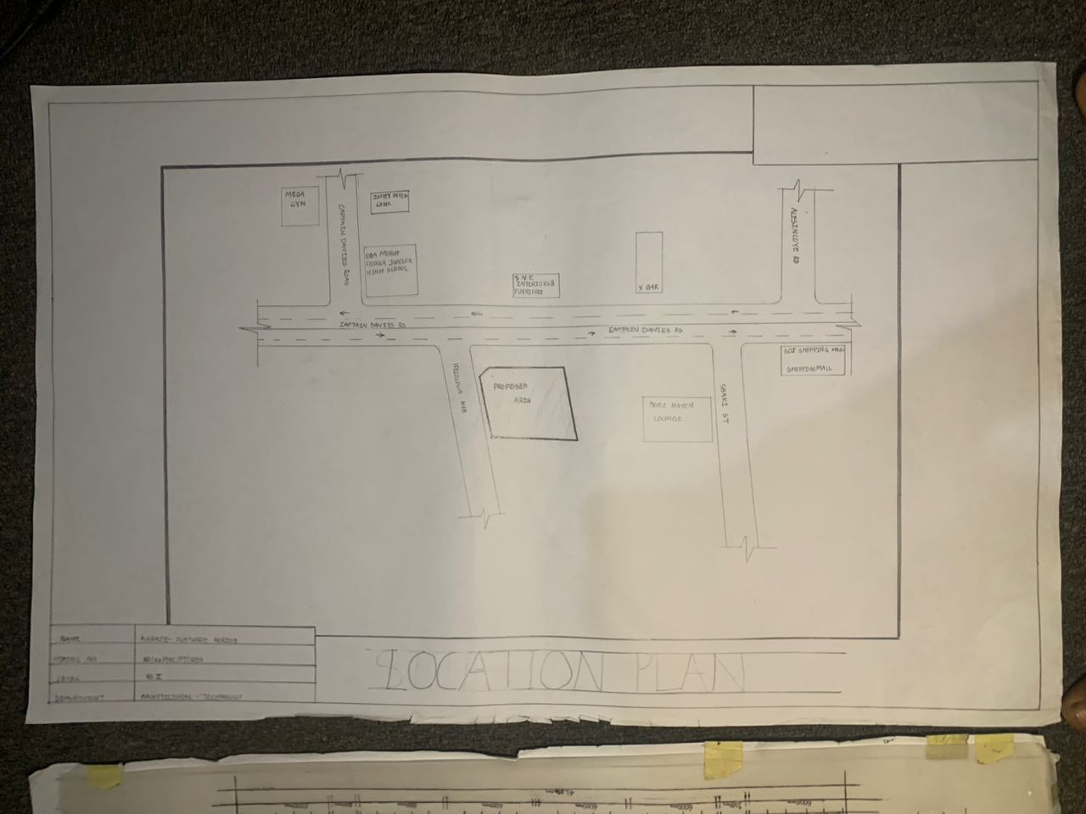
FIG 7; SHOWING LOCATION OF THE PROPOSE SITE

4.3 POPULATION
Lagos State is the most populous state in Nigeria. According to recent estimates by the National Population Commission and other sources, the population of Lagos is over 20 million people, making it not only the largest in Nigeria but also one of the most densely populated urban areas in Africa.
This high population is due to its status as the economic, commercial, and cultural hub of Nigeria, which attracts people from all parts of the country and beyond. The rapid urbanization and migration into the state contribute significantly to its population growth.
4.4 SITE INVENTORY
In the proposed site, some shrubs will be retained on site. It used to reduce sky glare and also serve as soft landscape and wind breaker.
Presence of road network which would serve as a means of accessibility to the site. Presence of electricity pole which serve as source of electricity to the site. Some trees would be retained while some will be removed if they disrupt the construction of building.

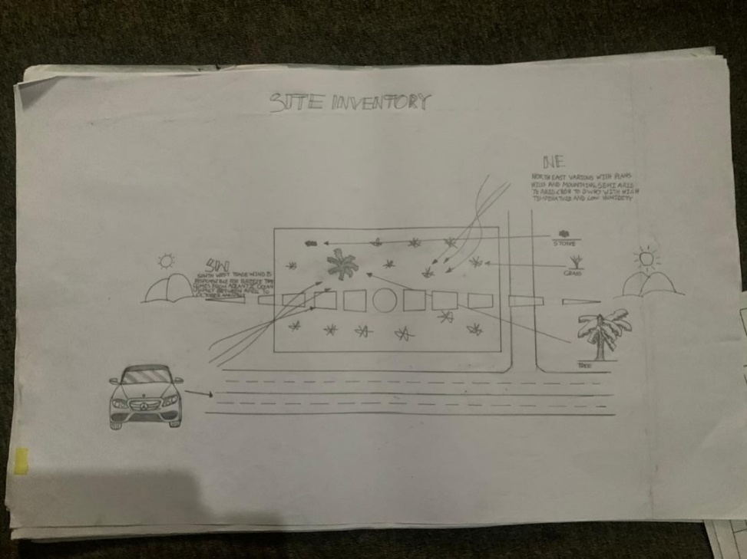
FIG 8; SHOWING SITE INVENTORY OF THE PROPOSED SITE

4.5 SITE ANALYSIS
After visiting the site, a detail analysis have been done, to reveal to analyse both natural and artificial features of the site, some of the analysis noted during the investigation are stated.
Certainly, steps are considered to obtain vital information of the site, this information is the analysed in details. For design purpose, the information include soil condition, geology, topography, vegetation etc. It also involves carrying out a preliminary survey of the site.

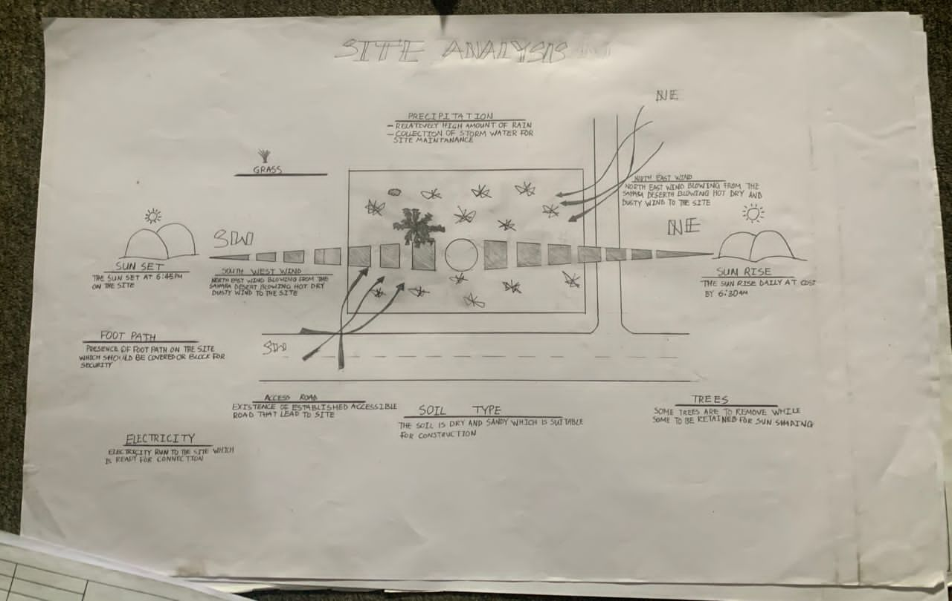
FIG 9; SHOWING SITE ANALYSIS OF THE PROPOSED SITE

4.5.1 SITE SELECTION/JUSTIFICATION
This site was chosen as a key location due to its strategic coastal position along the Atlantic Ocean, providing natural harbors for trade and easy access to international shipping routes. Its flat terrain, lagoon system, and early colonial interest made it ideal for port development and urban settlement. As Nigeria’s former capital and commercial hub, Lagos grew rapidly due to economic opportunities, migration, and infrastructure, justifying its continued prominence as the nation's economic center.
4.5.2 LOCATION
AdelexeSanni is located in Ayobo, a semi-urban area within the Alimosho Local Government Area of Lagos State, Nigeria. Specifically, it is situated along AdelexeSanni Street, a residential axis that forms part of the growing neighborhoods in the Ayobo-Ipaja district, known for its developing infrastructure and increasing population. The area is positioned in the northeastern part of Lagos, close to the boundary with Ogun State, and is accessible via major roads linking Ayobo to other parts of Lagos, such as Ipaja, Igando, and Iyana-Ipaja. Over the years, the location has evolved from a quiet suburban settlement into a bustling residential zone, supported by schools, churches, small businesses, and local markets. Its proximity to both urban Lagos and neighboring Ogun communities makes AdelexeSanni Street an important residential corridor within the expanding Lagos metropolis.

4.5.3 ACCESSIBILITY
AdelexeSanni in Ayobo is accessible via major roads such as Ayobo Road, which connects to the Lagos-Abeokuta Expressway.
The area can be reached through Command Road, Megida Road, and adjoining streets.
Public buses (danfo), commercial motorcycles (okada), and tricycles (kekenapep) operate actively in the area.
Recent road projects, including the Ayobo–Igando link bridge, have improved travel time and access.
Some roads still experience traffic congestion and poor drainage, especially during rainy seasons.
Water transport remains limited, but there is potential for development through nearby creeks.
4.5.4 INFRASTRUCTURAL FACILITIES
Facilities such as water electricity, telephone network and road network are all in Lagos, hence it can easily be tapped to the proposed site.
4.5.5 TOPOGRAPHY
The topography explain the analysis of land structure in term of the slope, and the site shape orientation. Meanwhile the topography of the proposed site is relatively uniform.
4.5.6 SOIL STRUCTURE
It is made up of clayish laterite soil, which is good for building construction.
4.6 GENERAL CLIMATIC CONDITION
Lagos State, located in the southwestern coastal region of Nigeria, experiences a tropical wet and dry climate, also known as the tropical savanna climate, which is significantly influenced by its proximity to the Atlantic Ocean. The climate is characterized by two distinct seasons: the rainy season, which typically begins in April and lasts until October, and the dry season, which spans from November to March, often accompanied by the harmattan winds blowing from the Sahara Desert.
During the rainy season, Lagos receives a high amount of rainfall, averaging between 1,500 mm and 2,000 mm annually, with peak rainfall months usually occurring in June and July, followed by a brief dry spell in August, and then a secondary rainfall peak in September. These rains are often heavy and sustained, contributing to high humidity levels, which can range between 80% and 100%, making the weather feel warmer than it actually is.
The dry season is generally marked by lower humidity, clear skies, and the occasional presence of dust-laden harmattan winds, which reduce visibility and cause a slight drop in temperature, especially during early mornings and nights. Average temperatures in Lagos range between 25°C and 33°C throughout the year, with March and April often being the hottest months, sometimes exceeding 35°C, while July and August tend to be the coolest due to persistent rainfall and cloud cover.
Because of its low-lying coastal terrain and intense urban development, Lagos is prone to flooding during the rainy season, particularly in areas with poor drainage. Additionally, the climate supports lush vegetation and a variety of ecosystems, including mangroves, swamps, and tropical forests, all of which are influenced by the state’s consistently warm and moist weather conditions.

4.6.1 RELATIVE HUMIDITY
Lagos experiences high relative humidity throughout the year due to its coastal location.
Humidity levels typically range between 80% and 100% during the rainy season (April to October), and 60% to 80% during the dry season (November to March).
The highest humidity is often recorded in June, July, and September, while lower humidity occurs during the harmattan period in December and January.
4.6.2 WIND
Lagos experiences moderate wind speeds throughout the year, influenced by seasonal wind patterns.
During the dry season (November to March), the northeast trade winds (harmattan) bring dry, dusty air from the Sahara.
In the rainy season (April to October), southwest monsoon winds from the Atlantic Ocean bring moist, rain-laden air.
Average wind speeds range from 5 to 15 km/h, with stronger gusts during storms or coastal weather events.
4.6.3 TEMPERATURE
Lagos has a warm tropical climate with temperatures ranging between 25°C and 33°C throughout the year.
The hottest months are typically March and April, when temperatures can exceed 35°C.
The coolest months are July and August, due to cloud cover and rainfall, with temperatures around 25°C to 27°C.
Overall, Lagos experiences consistently warm weather year-round.
4.6.4 VEGETATION
The proposed site is covered with grasses and trees, 60% of grasses and 40% of tress. The trees and grasses to be removed
4.7 SOCIAL SERVICES
4.7.1 ROAD
The main access route is Ayobo Road, connecting Ayobo to the Lagos–Abeokuta Expressway, providing direct vehicular access to the broader Lagos metropolis
4.7.2 WATER AND ELECTRICITY
Electricity:
Ayobo now benefits from a 24-hour mini-grid power supply in some areas (e.g., Ishokan Phase 1 and Mercyland), thanks to a 2022 project by Ikeja Electric and Enaro Energy.
However, other parts still face irregular electricity, frequent blackouts, and reliance on generators and solar power.
Water:
Many residents rely on boreholes and water vendors, as public tap water is limited.
The local government has installed some community boreholes, but access and water quality still vary across the area.
4.8 DESIGN CRITERIA
Design criteria is the essential requirements, guidelines, and standards that must be followed during the planning, development, and construction of a project to ensure it meets functionality, safety, aesthetic, and performance expectations. These criteria serve as a foundation for architects, engineers, planners, and designers to create structures or systems that are both effective and efficient.
4.9 DESIGN BRIEF
- The project is to design and build a modern primary school.
- It will be located in Ayobo, Lagos State.
- The school will serve children between ages 5 and 12.
- It will have 6 to 12 classrooms with good lighting and ventilation.
- Offices for the head teacher and staff will be included.
- There will be a library and a small ICT room for learning.
- Toilets will be provided separately for boys, girls, and staff.
- A playground and an assembly area will be created for outdoor activities.
- The school will have clean water from a borehole and stable electricity.
- Solar panels and rainwater harvesting may be added for sustainability.
- Security fencing and ramps for disabled access will be included.
- The design will be safe, simple, and child-friendly.
4.10 DESIGN ANALYSIS
This is the process of itemizing units within the component of the entire design with a view to establishing a solid understanding and appreciation of the space relationships.
The units of the design are in three division, the unit of the project division are as follows:
GROUND FLOOR PLAN; Headmaster Office, Bursar Office, Sick Bay, Economics Lab, Laboratory, Music and Art, Library, Toilet, Staff Room, Computer Lab, Creche, Kindergaten, Nursery 1, Basic 1-6, Entrance, Exit.

4.11 SPACE REQUIREMENT
Units Area (m2)
Headmaster Office 5400m2
Bursar Office 5400m2
Sick Bay 9500m2
Economics Lab 11000m2
Laboratory 11000m2
Music and Art 11000m2
Library 11000m2
Toilet 2700m2
Staff Room 10500m2
Computer Lab 10500m2
Creche 13000m2
Kindergaten 13000m2
Nursery 1 13000m2
Basic 1-6 13000m2
Entrance 7000m2
Exit 4500m2

TABLE 2; SHOWING SPACIAL ALLOCATION OF FLOOR PLAN
Necessary units in the building. A borehole system of water supply is to be adopted alongside the government supplied services and a storage facility is to be provided for effective management of water supply.

4.12 PLANNING PRINCIPLE
The planning principle is one of the most important aspects of any design. The planning of various units taking into consideration the activities performed in each unit, how they are related to one another and the users of the various units in the design. In respect to the above factors.

CHAPTER FIVE
5.0 APPRAISAL OF PROPOSED SCHEME
A primary school serves as the foundational educational institution where children between the ages of 5 and 11 are introduced to basic literacy, numeracy, and social skills. The appraisal of a primary school involves evaluating its architectural layout, learning environment, accessibility, infrastructure, and services. The school should be safe, child-friendly, and designed to promote active learning. Classrooms must be well-ventilated and naturally lit, with adequate space for movement and interaction. Supporting facilities such as toilets, staff offices, library, and play areas are essential. Accessibility, security, water supply, electricity, and sanitation are critical components that ensure effective learning and child well-being.
5.1 CONSTRUCTION METHODOLOGY
The construction of a primary school begins with site clearance and setting out, followed by excavation for foundations. Reinforced concrete is used for footings and columns. The walls are built using blocks or bricks, with appropriate insulation and damp-proofing. Concrete slabs or suspended floors are laid, depending on the design. Roofing is constructed with timber or steel trusses covered by long-span roofing sheets. Windows and doors are fixed, followed by electrical and plumbing installations. Internal and external wall finishes are applied (e.g., plastering and painting). The process concludes with flooring, ceiling installation, external works like drainage and landscaping, and final inspections for quality assurance.
5.2 SERVICES
A primary school requires clean water supply for drinking, washing, and sanitation. Electricity is essential for lighting, powering fans, and using educational equipment. Proper ventilation ensures a healthy and comfortable learning environment. Sanitation services, including functional toilets and waste disposal systems, are necessary for hygiene. Fire safety measures such as extinguishers and clear escape routes are important for emergency response. ICT services support learning through internet access and digital tools. Security features like fencing and gates help protect pupils and staff. Efficient drainage systems prevent flooding and maintain a safe environment.
5.3 VENTILATION
Ventilation in a primary school is important to provide fresh air and remove stale air from classrooms. Good ventilation helps maintain a healthy indoor environment and prevents the buildup of heat, humidity, and odors. It can be achieved through windows, vents, and ceiling fans or mechanical systems. Proper airflow improves students’ concentration, comfort, and overall well-being during learning activities.
5.4 LIGHTING
Lighting in a primary school should be bright, natural, and evenly distributed to support reading, writing, and other learning activities. Natural lighting through large windows is preferred during the day, while artificial lighting using energy-efficient bulbs ensures visibility in all areas. Proper lighting reduces eye strain, enhances focus, and creates a comfortable learning environment for pupils and teachers.
5.5 PLUMBING
Plumbing in a primary school provides clean water supply and efficient wastewater removal for toilets, sinks, and drinking points. It includes the installation of pipes, taps, water tanks, and drainage systems. Proper plumbing ensures hygiene, supports sanitation facilities, and helps maintain a safe and healthy school environment for pupils and staff.
5.6 WATER DISPOSAL
Water disposal in a primary school involves the proper drainage of wastewater from toilets, sinks, and rainwater runoff. It includes the use of underground drainage pipes, soakaway, and septic tanks or connection to a public sewage system. Efficient water disposal prevents waterlogging, reduces health risks, and maintains a clean and safe school environment.
5.7 FIRE PROTECTION
Fire protection in a primary school includes the installation of fire extinguishers, smoke detectors, and alarm systems to detect and respond to fire emergencies. Clear evacuation routes and emergency exits must be provided for safe escape. Fire drills should be conducted regularly to train staff and pupils on emergency response. Proper fire protection ensures the safety of all occupants in case of fire outbreaks.
5.8 EXTERNAL WORK
External work in a primary school includes landscaping, walkways, playgrounds, perimeter fencing, drainage systems, and access roads. It also involves the installation of outdoor lighting, signage, and parking spaces. These works enhance safety, accessibility, and the overall appearance of the school environment.
5.9SUMMARY
A primary school is an essential educational institution designed to provide foundational knowledge and skills to children typically between the ages of five and twelve, focusing on basic subjects such as literacy, numeracy, science, and social studies, while also nurturing their emotional, physical, and social development in a structured and child-centered learning environment. It serves as the first formal step in a child’s academic journey, where young learners are introduced to classroom discipline, interactive learning, and early social integration, which helps prepare them for higher levels of education and responsible citizenship.
The design and operation of a primary school usually emphasize the safety, comfort, and holistic development of the pupils, providing age-appropriate classrooms, recreational spaces, and sanitation facilities, all guided by national educational standards and curriculum frameworks. In many communities, a primary school also acts as a central hub for community development, contributing to literacy improvement, social awareness, and long-term national progress through the early education of its youngest citizens.

5.10CONCLUSION
In conclusion, a primary school plays a vital and irreplaceable role in shaping the intellectual, moral, emotional, and social foundation of children, serving as the cornerstone of formal education and a critical phase in the lifelong learning process. It is within the nurturing environment of a primary school that young learners acquire essential skills such as reading, writing, counting, critical thinking, and social interaction, which collectively prepare them not only for higher academic pursuits but also for active participation in society.
The importance of establishing well-planned, inclusive, and adequately equipped primary schools cannot be overemphasized, as these institutions lay the groundwork for national development by producing informed, disciplined, and responsible future leaders. Therefore, continued investment in the infrastructure, curriculum, and overall management of primary education is essential to ensure that every child, regardless of background or location, has access to quality education in a safe and supportive environment.

5.11RECOMMENDATION
It is strongly recommended that every community, especially in developing and densely populated areas, prioritizes the establishment and proper maintenance of well-structured primary schools that are not only safe and conducive to learning but also accessible to all children regardless of their socio-economic background. To achieve this, government agencies, private stakeholders, and educational planners should collaborate to ensure that these schools are adequately staffed with trained teachers, equipped with modern learning materials, and supported by reliable infrastructure such as clean water, electricity, sanitation, and spacious classrooms.
Furthermore, it is advisable that primary schools incorporate child-friendly designs that promote inclusiveness, creativity, physical activity, and emotional well-being, while also embracing the use of technology and innovative teaching methods that align with global educational standards. Regular monitoring, evaluation, and community involvement should also be encouraged to ensure the continuous improvement and sustainability of the school’s operations, thereby guaranteeing that every child receives a strong and balanced foundation for lifelong success.

REFERENCE
The foundational role and structure of primary schools have been widely discussed in educational literature and development policy documents. According to the Universal Basic Education Commission (UBEC, 2010), primary education in Nigeria serves as the first stage of formal education aimed at providing a sound foundation for literacy, numeracy, and social development, forming the base for further learning and personal growth. Additionally, UNESCO (2005) emphasizes that primary education is not only a fundamental human right but also a powerful tool for breaking the cycle of poverty and promoting sustainable development, especially when it is accessible, inclusive, and of high quality. In line with this, National Policy on Education (FRN, 2014) outlines the objectives of primary education in Nigeria, stating that it should instill permanent literacy and numeracy, as well as the ability to communicate effectively and function in society. These references collectively highlight the importance of primary schools in national educational systems and reinforce the need for continuous investment in their development, accessibility, and effectiveness
References:
- Federal Republic of Nigeria (FRN), (2014). National Policy on Education, 6th Edition. Nigerian Educational Research and Development Council (NERDC), Lagos.
- Universal Basic Education Commission (UBEC), (2010). Guidelines for Primary Education in Nigeria. Abuja: UBEC Publications.
- UNESCO, (2005). Education for All: Global Monitoring Report – The Quality Imperative. Paris: United Nations Educational, Scientific and Cultural Organization.

APPENDICES
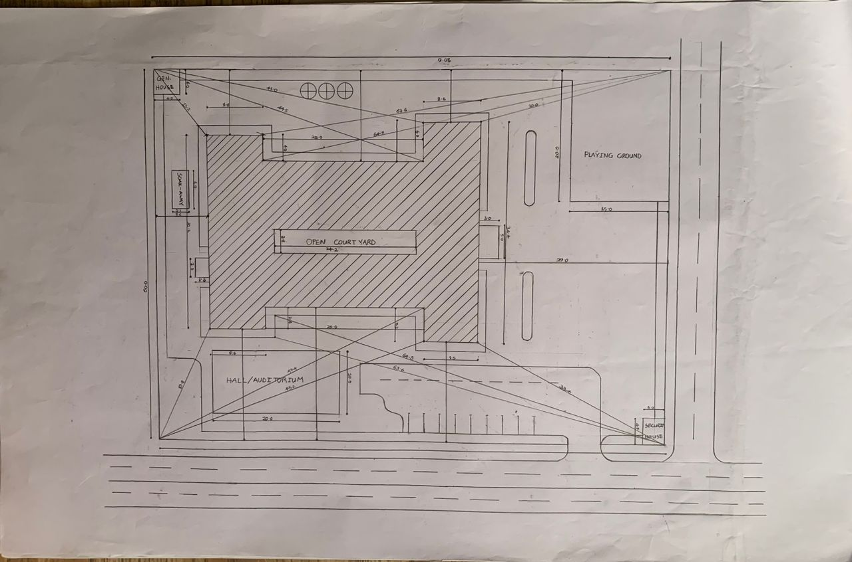
APP1; SHOWING SITE PLAN OF THE PROPOSED PROJECT
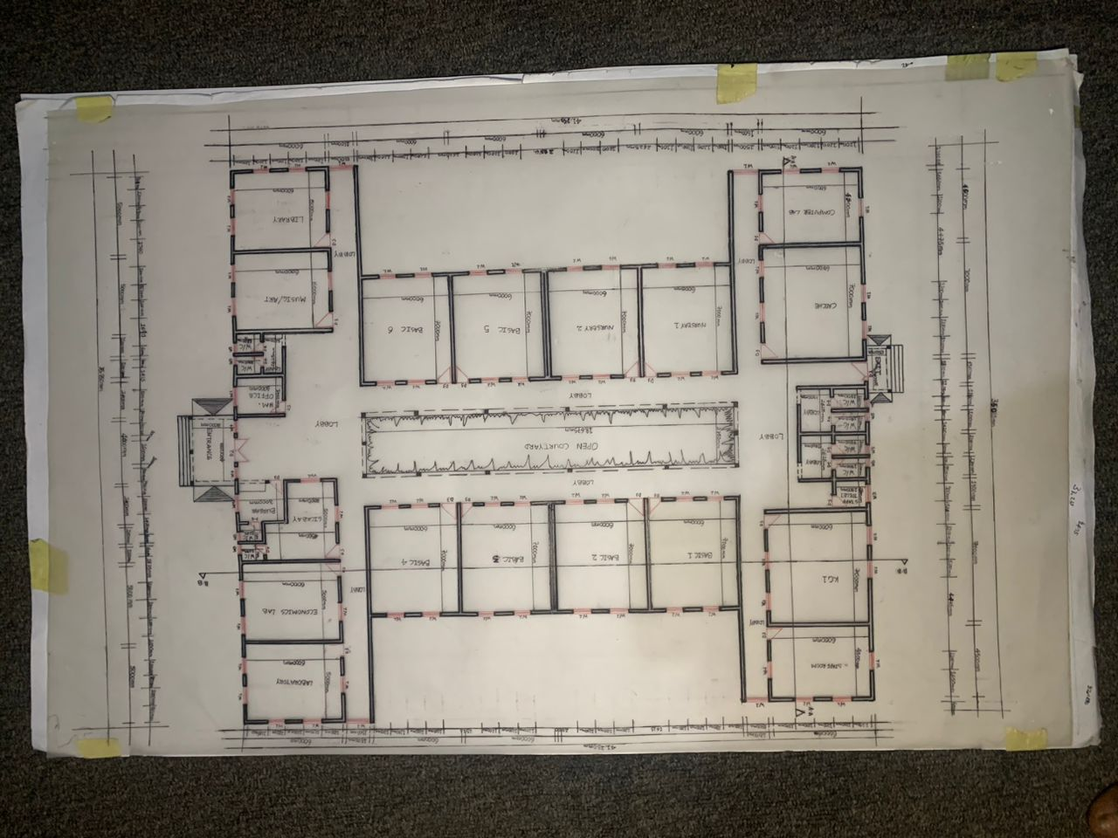
APP2; SHOWING FLOOR PLAN OF THE PROPOSED PROJECT
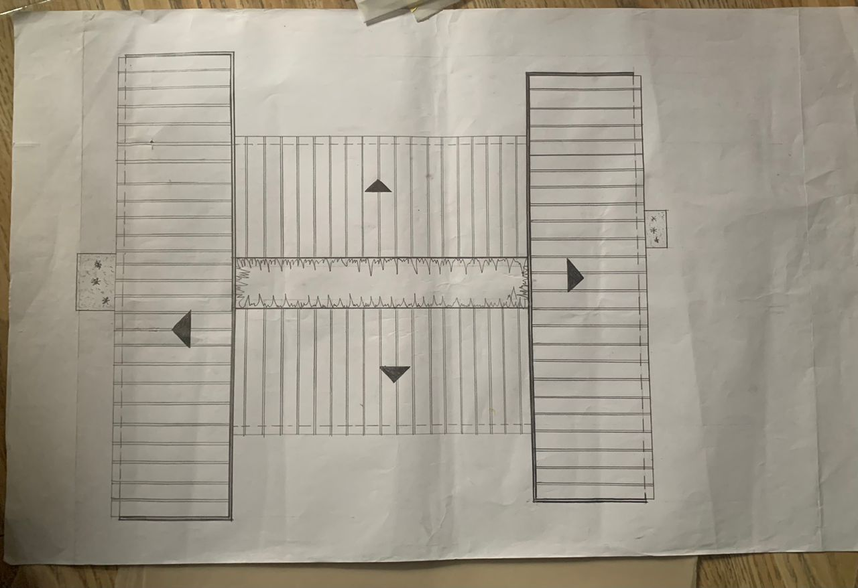
APP3; SHOWING ROOF PLAN OF THE PROPOSED PROJECT
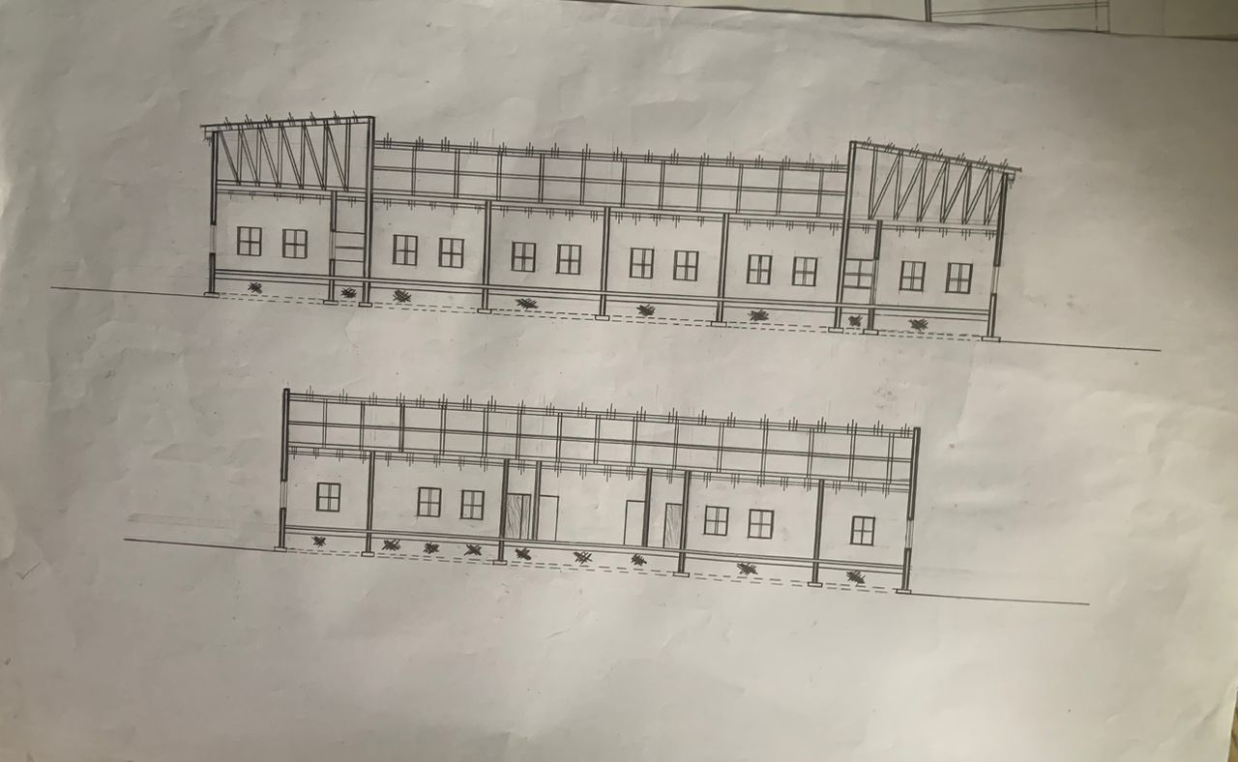
APP4; SHOWING CROSS SECTION OF THE PROPOSED PROJECT

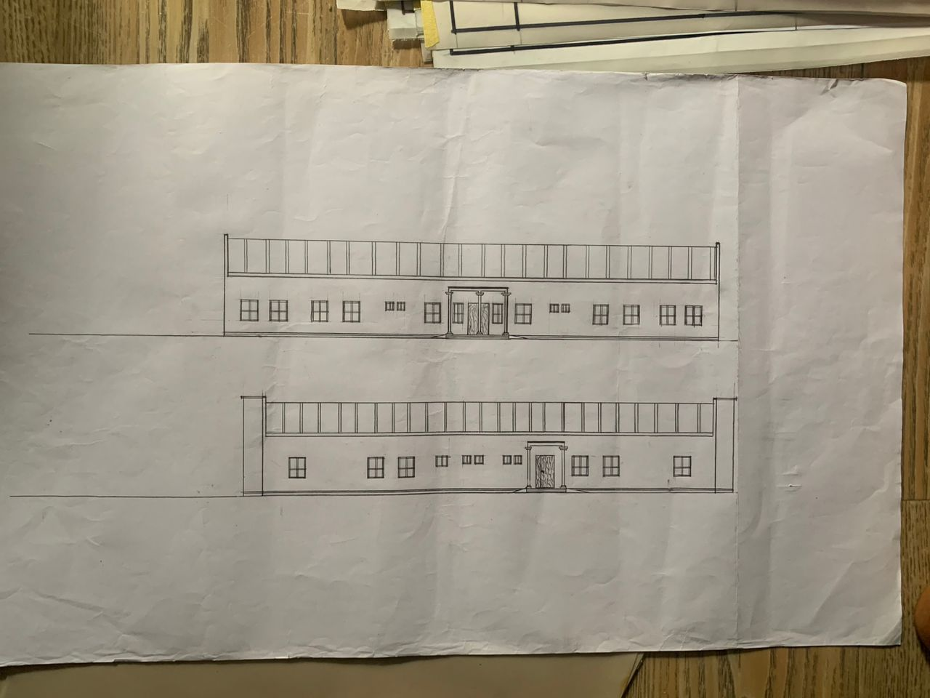
APP5; SHOWING FRONT&BACK VIEW OF THE PROPOSED PROJECT
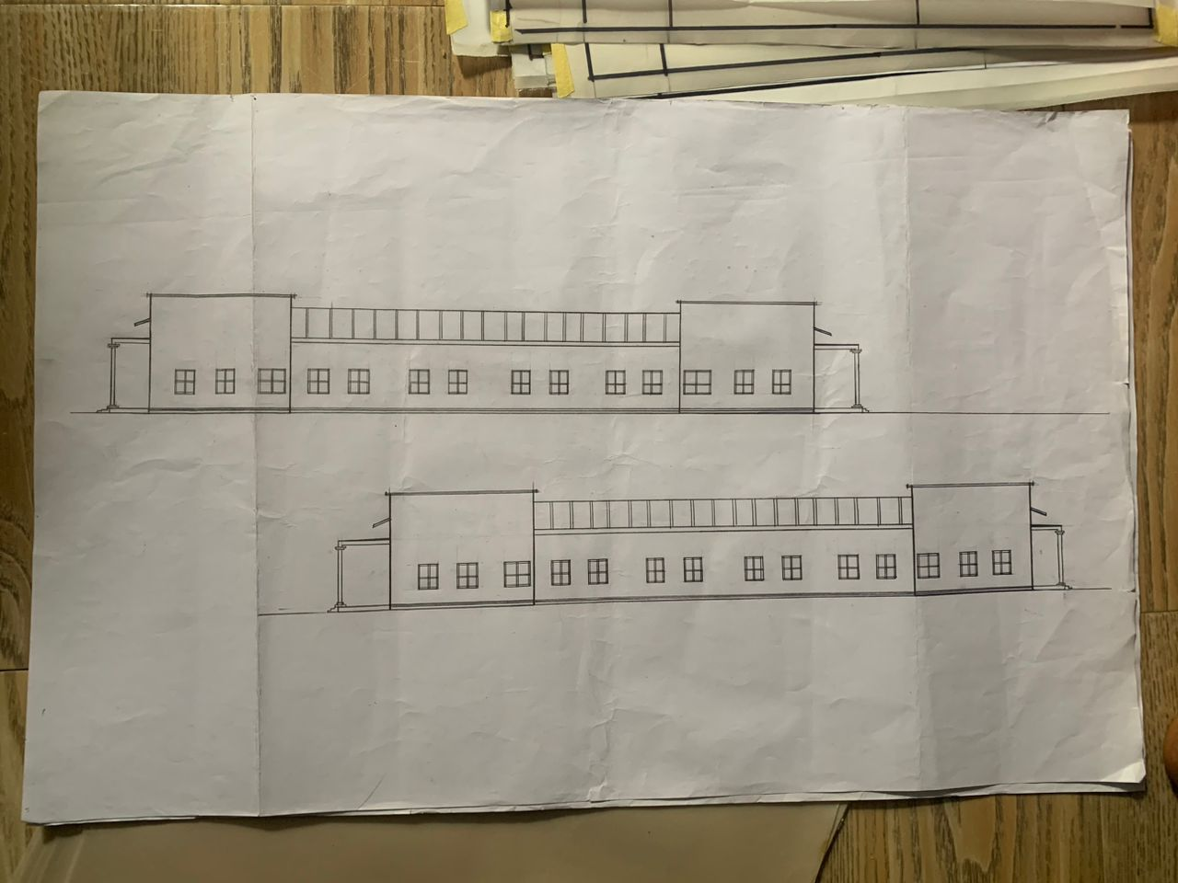
APP6; SHOWING SIDES VIEW OF THE PROPOSED PROJECT

