A PROJECT REPORT
ON
PROPOSED FIRST BANK (Commercial bank)
For
FIRST BANK PLC
BY
AWOYEMI EMMANUEL OLUWASOGO
HND/23/ARC/FT/0065

SUBMITTED TO
DEPARTMENT OF ARCHITECTURAL TECHNOLOGY, INSTITUTE OF ENVIRONMENT STUDIES, KWARA STATE POLYTECHNIC, ILORIN

IN PARTIAL FULFILMENT OF THE REQUIREMENTS FOR THE AWARD OF HIGHER NATIONAL DIPLOMA IN ARCHITECTURAL TECHNOLOGY KWARA STATE POLYTECHNIC, ILORIN, KWARA STATE.

JULY, 2025
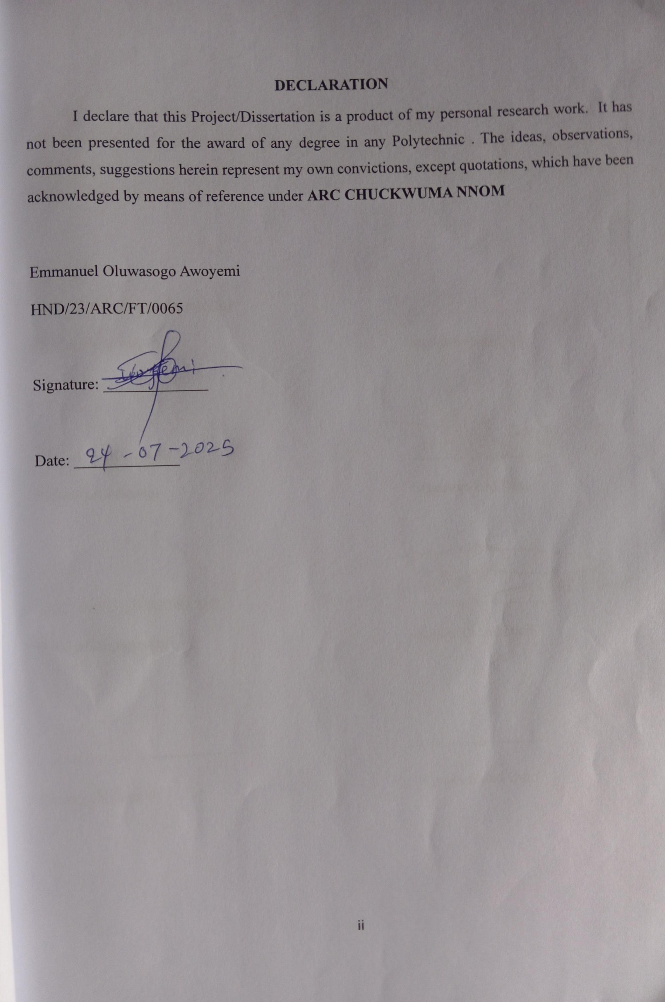
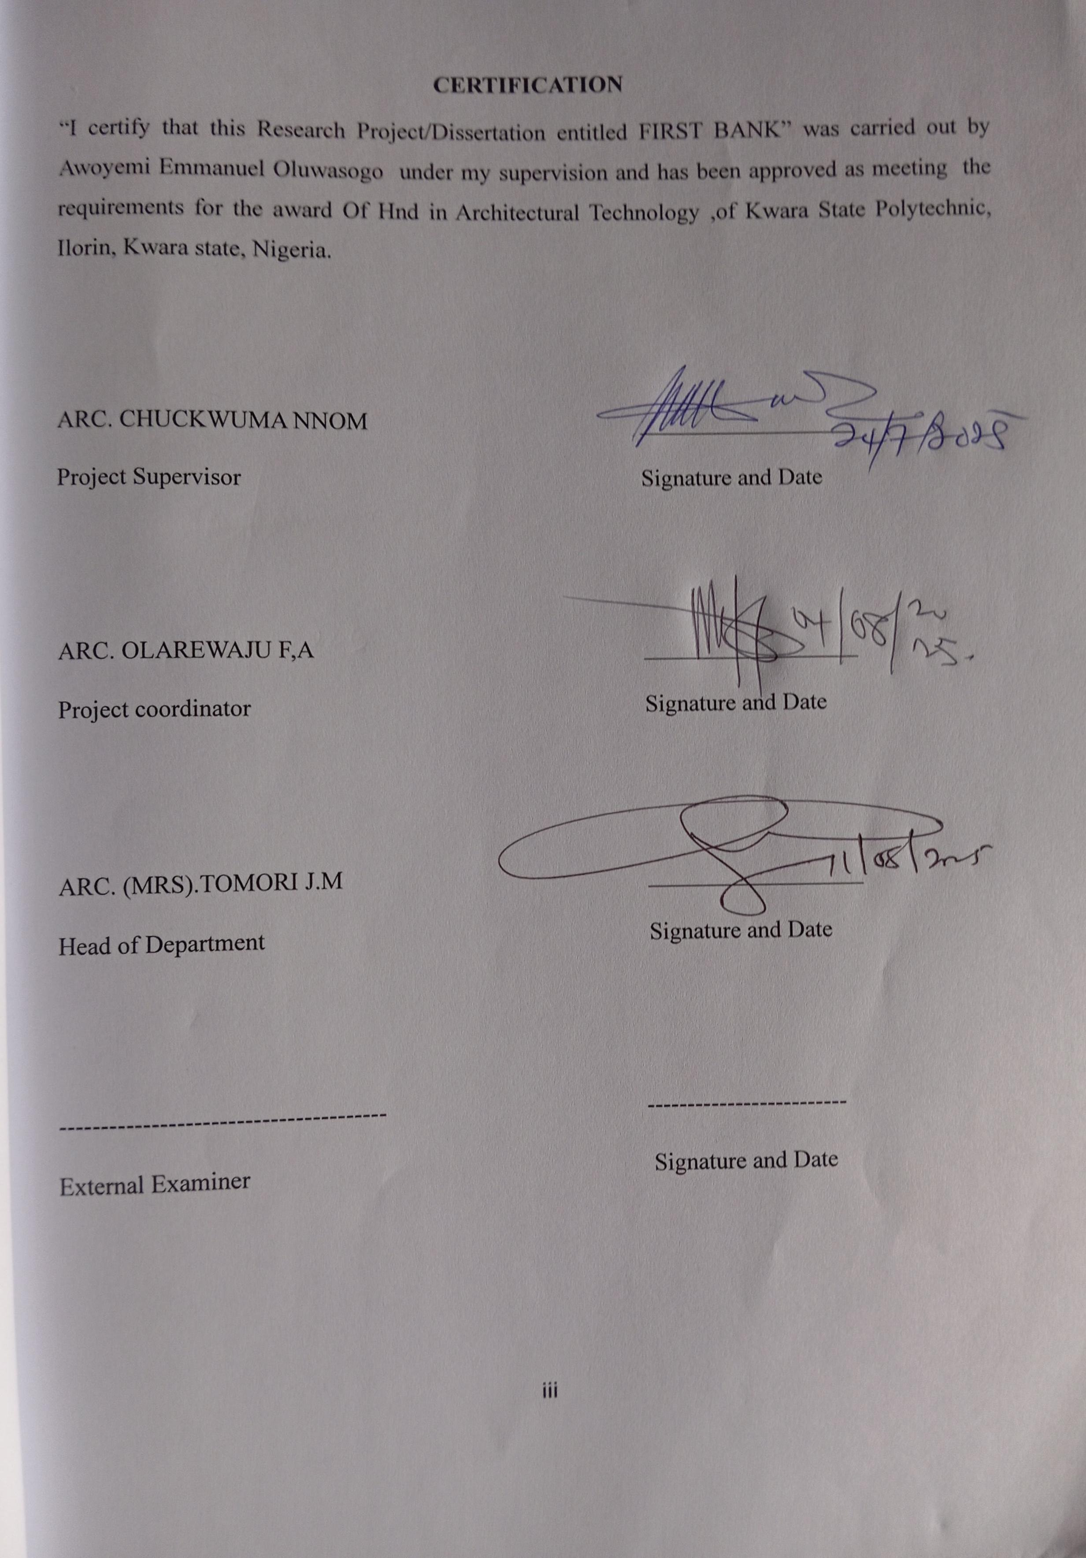
DEDICATION
I dedicate this project to my family, teachers, and friends, whose support and encouragement have helped me throughout this journey. Their guidance, inspiration, and belief in me made this work possible.

ACKNOWLEDGEMENTS
All glory, adoration, and honour to Almighty God, the creation of the universe may His names be praised forever. It is a genuine pleasure to express my deep sense of thanks and gratitude to the Almighty God for His sustenance and love throughout the course of this study.

I wish to express my profound gratitude to my mentor, guide, relentless, and untiring supervisor ARC. CHUCKWUMA NNOM, his keen interest and dedication above all his overwhelming attitude to help his student had been mainly and solely responsible for completing my project. His timely advice, scholarly and scientific, and meticulous scrutiny approach have helped me to a very great extent to accomplish this great task. May God keep blessing and sustaining you. I equally commend the effort of the Head of Department ARC TOMORI J.M, the project co-ordinator ARC. ADEYEMI O.F and the entire teaching and non-teaching staffs of Architectural Technology Department for their supports during the course of study. I say a BIG THANK YOU to you all.

I also extend my appreciation to my school and its staff for providing the resources and environment necessary for completing this project successfully.
A special thanks to my parents and friends for their continuous support, motivation, and understanding throughout this journey.
Lastly, I am thankful to everyone who directly or indirectly helped me in the completion of this project.

ABSTRACT
This project addresses the design challenge of creating a modern commercial bank that balances functionality, security, and customer experience within a sustainable built environment. The specific objectives include integrating advanced financial technologies, ensuring physical and digital security, enhancing spatial efficiency, and promoting user-centered design that caters to both staff and clients. The methodology involved a mixed-method approach, including site analysis, case studies of contemporary banking institutions, user behavior observation, and digital modeling using Revit and SketchUp. Environmental impact assessments and passive design strategies were also incorporated to guide sustainable decision-making throughout the design process. The design solution resulted in a multi-level banking facility featuring open-plan customer service areas, secure transactional zones, flexible staff offices, and a green roof system. Key findings indicate that spatial transparency, natural lighting, and intuitive wayfinding significantly improve customer satisfaction and staff productivity, while the incorporation of modular design elements supports future scalability. In conclusion, the project demonstrates that thoughtful integration of technology, spatial efficiency, and biophilic design principles can redefine the user experience in commercial banking. It is recommended that future designs continue to explore adaptive reuse, community integration, and enhanced security features to meet evolving banking trends and sustainability goals.

TABLE OF CONTENT
TITLE PAGE…………………………………………………………………………………… i
DECLARATION……………………………………………………….…………………………ii
CERTIFICATION……………………………………………………….………………………..ii
ACKNOWLEDGEMENT………………………………………………………………………..iv
DEDICATION……………………………………………………….……………………………v
LIST OF TABLES………………………………………………..………………………………vi
LIST OF FIGURES……………………..……………………….……………………….……..vii
LIST OF PLATES………………………………………………………………….……...……viii
ABSTRACT………………………………………………………………………..…………….ix
CHAPTER ONE
1.1 INTRODUCTION………………………………….………….……………….…………1
1.2 History of First Bank of Nigeria………...………………….……………………………3
1.3 STATEMENT OF DESIGN PROBLEM……….…………..……………………….……2
1.4 AIM AND OBJECTIVES………………………………………..……………………..…2
1.5 JUSTIFICATION………………………………………………………………..…..……3

1.6 CLIENT’S BACKGROUND, PHILOSOPHY, OPERATIONAL STRUCTURE, AND GOAL OF THE PROPOSAL ………………………………………………………………….…3
1.7 SCOPE OF STUDY…………………………………………………………………….…3
1.8 LIMITATIONS OF STUDY ………………………..…....……………..…….…4
1.9 RESEARCH METHODOLOGY…………………………………………………………4

CHAPTER TWO
2.1 REVIEW OF LITERATURE ON BUILDING TYPE ………………………………. 15
2.1.1. Evolution of Bank Building Typology……………………………………………………
2.1.2. Variants and Classification of the Building Type………………………………………
2.1.3. Functional Relationships Between Spaces…………………………………………
2.1.5. Conclusion………………………………………………………………………………
2.2 REVIEW LITERATURE ON SUBTOPIC OF THESIS ……………….……..……..16
CHAPTER THREE(CASE STUDY)
3.1 CASE STUDY 1 ONE (FIRST BANK OGBOMOSHO)……………………………….18
3.2 CASE STUDY TWO (FIRST BANK IWO)……………………………………………. 21
3.3 CASE STUDY THREE (FIRST BANK OGBOMOSHO)……………………… 24
3.4. ONLINE CASESTUDY 1 (HEAD OFFICE)………………………………………..28
3.5. ONLINE CASESTUDY 2 (FIRST BANK BRANCH, JOS)…….....32
CHAPTER FOUR(STUDY AREA / PROJECT SITE)
4.1 ANALYSIS OF TROPICAL ENVIRONMENTAL CONDITIONS OF SITE………..38
4.2 PROJECT ANALYSIS AND DESIGN CRITERIA….…………….........……………38
CHAPTER FIVE(APPROACH TO THE DESIGN / DESIGN REALIZATION)
5.4 DESIGN CONCEPT AND DIFFERENT LEVEL OF DESIGN PROCESS…………56
5.5 TECHNOLOGICAL AND ENVIRONMENTAL CRITERIA….……………………..56
5.6 CONSTRUCTION METHODOLOGY AND MATERIAL…………………………57
5.8 SERVICE REQUIRED………….…………………………………………………...58
5.7 ENVIRONMENTAL CONDITION TO BE ACHIEVED……………………………57
5.9 PERFORMANCE STANDARDS……………….…………………………………….58
6.0 LEGAL ISSUES AND PLANNING REGULATIONS…………………….……….59

6.1 BEHAVIORAL CONSIDERATION………………………………………………..60
CONCLUSION………………………………………………………………………….
RECOMMENDATIONS…………………………………………………………………..
REFERENCES………………………………………………………………………………
APPENDICES………………………………………………………………………………….

CHAPTER ONE – INTRODUCTION

1.1 INTRODUCTION TO COMMERCIAL BANK (FIRST BANK OF NIGERIA)
Introduction to Commercial Bank: First Bank of Nigeria
- Overview
First Bank of Nigeria Limited (FBN) is one of the oldest and most prominent commercial banks in Nigeria and West Africa. Established in 1894 as the Bank of British West Africa (BBWA), it was renamed First Bank of Nigeria in 1979. With a long history of leadership and innovation in the Nigerian banking sector, First Bank plays a vital role in financial services, economic development, and banking reform.
- Key Facts
Founded: 1894
Headquarters: Lagos, Nigeria
Type: Commercial Bank
Parent Company: FBN Holdings Plc
Regulator: Central Bank of Nigeria (CBN)
- Core Functions of First Bank (as a Commercial Bank)
- Deposit Mobilization: Accepts savings, current, and fixed deposits from individuals, businesses, and institutions.
- Loan and Credit Services: Offers personal loans, corporate loans, overdrafts, and other forms of credit.
- Payment and Settlement Services: Provides facilities like mobile banking, POS terminals, ATM services, internet banking, and electronic fund transfers.
- Trade Finance: Facilitates import/export financing, letters of credit, and international banking services.
- Wealth and Asset Management: Offers investment, advisory, and trust services through subsidiaries.

- Vision and Mission
- Vision: “To be Africa’s bank of first choice.”
- Mission: “To remain true to our name by providing the best financial services possible.”
- Products and Services
- Retail Banking: Savings and current accounts, debit/credit cards, consumer loans
- Corporate Banking: Business accounts, working capital financing, project finance
- Digital Banking: FirstMobile App, FirstOnline, USSD banking (*894#)
- SME Banking: Loans and advisory services tailored to small and medium enterprises
- Agency Banking: Through the Firstmonie platform, bringing financial services to rural areas
- Role in Economic Development
- Financial Inclusion: Expanding banking access to unbanked populations
- Support for SMEs: Providing funding and capacity-building support to entrepreneurs
- Job Creation: Employing thousands across Nigeria and Africa
Infrastructure Financing: Funding key sectors like power, transport, and agriculture
- Global Presence
First Bank has operations and subsidiaries across various countries including:
United Kingdom (FBN Bank UK)
Ghana
DR Congo
Sierra Leone
The Gambia
Senegal
China (Representative Office)
United Arab Emirates (Representative Office)
- Conclusion
First Bank of Nigeria stands as a pillar of trust, stability, and innovation in Nigeria’s financial ecosystem. Through its commitment to customer service, technological advancement, and corporate responsibility, it continues to shape the future of banking in Africa.

1.2 HISTORY OF FIRST BANK OF NIGERIA
First Bank of Nigeria Limited is Nigeria’s oldest and one of the most prominent financial institutions. Here's a concise history tracing its development:
Foundation and Early Years (1894 – 1960s)
Founded: In 1894 as Bank of British West Africa (BBWA) by Sir Alfred Jones, a shipping magnate from Liverpool.
It was the first bank to be established in Nigeria. Initial office: Located in Lagos, and it began operations to serve the British colonial government and European businesses.
Expansion and Transformation (1950s – 1970s)
The bank opened branches across West Africa: in Accra (Ghana), Freetown (Sierra Leone), and other major Nigerian cities.
In 1957, the bank changed its name to Bank of West Africa (BWA).
In 1965, it became part of Standard Bank, a British group, and was renamed Standard Bank of West Africa.
Nigerian Indigenization (1971 – 1979)
In 1971, the bank was incorporated as a Nigerian entity and listed on the Nigerian Stock Exchange. During the Nigerian Enterprises Promotion Decree (Indigenization Policy), Nigerians acquired majority shareholding.
The bank was renamed First Bank of Nigeria Limited in 1979, reflecting its Nigerian ownership.

Modernization and Growth (1980s – 2000s)
First Bank expanded rapidly and modernized its operations, becoming a leader in Nigeria’s banking sector.
In 1991, it became First Bank of Nigeria Plc following a regulatory requirement.
It launched electronic banking services and increased its investment in digital transformation
Rebranding and Holding Structure (2010 – Present)
In 2012, the bank adopted a holding company structure: FBN Holdings Plc became the parent group.
First Bank remains the commercial banking arm of the group.
Under this structure, FBN Holdings also oversees other subsidiaries such as insurance, asset management, and microfinance.
Key Achievements
Over 130 years of uninterrupted banking operations.
Serves millions of customers through over 750 branches and tens of thousands of agent banking locations.
Winner of several awards for innovation, financial inclusion, and customer service.
Motto and Vision
Motto: "You First"
Vision: "To be Africa’s bank of first choice"

1.3 STATEMENT OF DESIGN PROBLEM
The architectural design of many First Bank branches across Nigeria faces significant challenges in adapting to the evolving needs of modern banking, technological advancement, and customer expectations. Originally developed to serve a limited, formal clientele in a rigid banking environment, many of the existing structures lack the spatial flexibility, technological integration, and aesthetic appeal required for today’s dynamic financial services landscape.
Key issues include inefficient space utilization, outdated layouts that hinder customer flow, inadequate natural lighting and ventilation, limited accessibility for persons with disabilities, and insufficient integration of green building practices. Additionally, the security-focused designs often create an intimidating atmosphere rather than a welcoming environment for diverse users.
As digital banking services reduce foot traffic for routine transactions, the physical branch must be reimagined as a multifunctional space that supports personalized service, financial literacy, and community engagement. The design problem, therefore, lies in transforming the conventional First Bank branch model into a modern, inclusive, technologically-enabled, and environmentally responsible architectural solution that aligns with the bank’s legacy while meeting contemporary standards and future scalability.

1.4 AIM AND OBJECTIVES OF THE PROJECT
Aim:
To design a modern, functional, and sustainable First Bank branch in Nigeria that enhances user experience, supports evolving banking technologies, ensures security, and reflects the brand’s legacy and commitment to innovation.
Objectives:
- To create a flexible and customer-centric spatial layout that improves service delivery and operational efficiency.
- To integrate smart banking technologies and digital infrastructure within the physical environment.
- To incorporate sustainable architectural practices, including energy efficiency, natural lighting, and environmentally friendly materials.
- To ensure the design meets accessibility standards for all users, including persons with disabilities.
- To develop a secure yet welcoming atmosphere that balances physical and digital safety with user comfort.
- To reflect the identity and heritage of First Bank through thoughtful architectural expression and branding.
- To future-proof the design for adaptability to emerging banking trends and community engagement needs.

1.5 JUSTIFICATION FOR THE PROJECT
The design of a new First Bank branch in Nigeria is justified by the urgent need to align the bank’s physical infrastructure with the evolving demands of the financial industry, customer’s behavior, and sustainable development goals. As one of the oldest and most influential financial institutions in Nigeria, First Bank has a responsibility to set a benchmark in modern banking architecture that reflects innovation, inclusivity, and environmental responsibility.
The current design of many existing branches does not adequately support digital banking integration, energy efficiency, or the user-centred experience required in today’s competitive financial market. Redesigning a First Bank branch offers an opportunity to introduce flexible layouts, smart technologies, improved accessibility, and eco-friendly materials that enhance operational efficiency while creating a welcoming atmosphere for clients and staff.

1.6 CLIENT’S BACKGROUND, PHILOSOPHY, OPERATIONAL STRUCTURE, AND GOAL OF THE PROPOSAL
Client’s Background:
First Bank of Nigeria Limited is Nigeria’s oldest financial institution, established in 1894. As a pioneer in West African banking, it has grown into one of the largest and most trusted banks in the country, with an extensive branch network and a strong presence across Africa and internationally. The bank serves a diverse customer base, including individuals, SMEs, large corporations, and government institutions.
Philosophy:
First Bank operates on a foundation of integrity, innovation, and excellence. Its core philosophy revolves around building enduring relationships with customers through reliable financial services and a commitment to socio-economic development. The bank values trust, professionalism, and a customer-first approach, continuously seeking ways to modernize its services while preserving its heritage.
Operational Structure:
The bank is structured to operate through a centralized administrative system, supported by regional branches nationwide. It has various departments handling retail, corporate, and digital banking, risk management, compliance, and customer service. The operations are governed by modern banking regulations and supported by advanced digital platforms to enhance service delivery, reduce manual processes, and improve customer engagement.
Goal of the Proposal:
The proposed architectural design aims to reimagine a First Bank branch as a modern, sustainable, and technologically advanced banking environment. The goal is to reflect the bank’s legacy and brand identity while addressing present-day operational needs and future scalability. The design will prioritize user experience, accessibility, environmental performance, and spatial efficiency—creating a physical space that complements the bank’s digital transformation strategy and reinforces its role as a financial industry leader.

1.7 SCOPE OF STUDY
The scope of this study focuses on the architectural design and planning of a prototype First Bank of Nigeria branch that meets contemporary banking needs while reflecting the institution’s legacy and corporate identity. The project will address key aspects of spatial planning, environmental sustainability, technology integration, accessibility, and user experience.
Specifically, the design will include functional zoning for banking operations such as customer service areas, secure transaction zones (e.g., vaults and teller spaces), private consultation rooms, staff offices, waiting areas, restrooms, and ATMs. External features such as parking areas, landscape design, signage, and security installations will also be considered.
The study will emphasize the integration of passive design strategies, natural lighting, ventilation, and energy-efficient systems. It will incorporate smart banking technologies and address compliance with Nigerian building codes, Central Bank of Nigeria guidelines, and global best practices in commercial architecture.
The project will not include the structural or engineering detailing of banking equipment or internal IT infrastructure. Instead, the focus will remain on spatial layout, functionality, aesthetics, and environmental performance as essential components of a modern First Bank architectural model.

1.8 LIMITATION OF STUDY
This study on designing a First Bank of Nigeria branch is subject to several limitations that may affect the scope and depth of the design outcomes. Firstly, access to proprietary or classified information regarding the bank’s internal operations, security protocols, and spatial planning standards was restricted, limiting the ability to fully incorporate real-world operational requirements into the design.
Secondly, the study is constrained by time and academic resources, which restrict extensive field research, user testing, or collaboration with actual banking professionals. As such, the design solutions are based on general banking principles, case studies, and assumed user needs rather than firsthand data from First Bank clients and staff.
Additionally, budgetary and regulatory constraints typical of real-world banking projects, such as Central Bank of Nigeria (CBN) compliance standards, zoning laws, and construction costs, were only considered theoretically and not validated against actual project implementation processes.
Lastly, the design is conceptual and intended primarily for academic purposes. While it proposes practical and innovative ideas, it may not address all technical complexities and real-life constraints involved in the construction and operation of a functioning commercial bank in Nigeria.

1.9 RESEARCH METHODOLOGY (APPROACH TO TACKLING THE DESIGN PROBLEM)
The approach to tackling the design problem of a modern First Bank of Nigeria branch involved a comprehensive, multi-phase research methodology combining both qualitative and quantitative strategies to ensure a functional, sustainable, and contextually responsive architectural solution.
- Site Analysis: A detailed study of the proposed site location was conducted, including environmental conditions, sun path, wind patterns, vehicular and pedestrian access, topography, and surrounding land use. This helped in determining orientation, massing, and spatial zoning.
- Case Studies: Comparative analysis of existing First Bank branches and other leading commercial banks—both locally and internationally—was carried out to identify best practices and common shortcomings in banking architecture, particularly regarding layout efficiency, security, customer flow, and technological integration.
- User Needs Assessment: Interviews and surveys were conducted with customers, bank staff, and facility managers to understand functional requirements, common issues, and expectations from a modern bank space. This data informed the spatial programming and prioritized customer-centric design.
- Design Concept Development: The gathered data was synthesized into design criteria, guiding the conceptual development through sketches, bubble diagrams, and zoning studies. Emphasis was placed on open-plan customer service areas, secure transaction zones, digital service hubs, and staff efficiency.
- Digital Modelling and Simulation: 3D modeling tools like Revit and SketchUp were used to visualize the design, while software such as AutoCAD supported technical drafting. Environmental simulation tools (e.g., ClimateStudio or Insight) were used to test daylighting, ventilation, and energy performance.
- Sustainability Integration: Passive design strategies, use of local materials, and provisions for renewable energy (e.g., solar panels) and water management systems were embedded in the design to meet green building standards.

CHAPTER TWO

LITERATURE REVIEW

2.1 REVIEW OF LITERATURE ON THE BUILDING TYPE

2.1.1 Evolution of Bank Building Typology
Bank architecture has evolved from monumental, fortress-like structures designed to symbolize stability and trust to transparent, customer-centric spaces reflecting efficiency, openness, and technological advancement. Early banks, especially in colonial-era Nigeria, were characterized by rigid symmetry, heavy masonry, and limited public access, reflecting the exclusivity of banking services. As banking expanded to a broader demographic, architectural expressions shifted towards open-plan layouts, automated service areas, and inclusive design to accommodate digital and physical banking needs.
The First Bank of Nigeria, established in 1894, has mirrored this transformation. From its early colonial structures modeled after British prototypes, the bank has moved toward more modern architectural expressions incorporating automation, branding, and customer experience as integral elements of design.

2.1.2 Variants and Classification of the Building Type
Commercial banks can be classified into several types based on function, scale, and service delivery models:
Retail Bank Branches: These are the most common types, offering walk-in services such as deposits, withdrawals, account inquiries, and customer service. They vary in size depending on location and foot traffic.
Corporate/Headquarters: Larger and more complex, these facilities house executive offices, large meeting spaces, data centers, and administrative departments.
Microfinance Units/Community Banks: Smaller structures intended for local or rural outreach, designed for low-cost operation and high accessibility.
Digital/Smart Branches: Modern, tech-focused branches that emphasize digital interfaces, self-service kiosks, and minimal human interaction.
The design classification is often based on factors such as transaction volume, staffing levels, site constraints, security considerations, and the extent of automation.

2.1.3 Functional Relationships Between Spaces
Bank buildings share a set of core spatial functions and interrelationships that are vital to their operation:
- Customer Service Areas (Banking Hall): Usually located at the front or center of the building for ease of access. Includes teller counters, self-service machines, and information desks.
- Security and Control Zones: Vaults, strong rooms, and secure transaction counters must be physically and technologically separated from public zones.
- Administrative and Staff Offices: Often semi-private zones, including managerial offices, meeting rooms, and staff lounges.
- ATM and Digital Service Areas: Either integrated within the main building or housed externally but connected architecturally.
- Waiting Areas and Circulation Spaces: Must be well-lit, clearly zoned, and comfortable to enhance user experience and customer flow.
- Efficient layout planning is critical to balance accessibility, security, and operational functionality.

2.1.4 Technological and Environmental Approaches
- Modern commercial bank design increasingly incorporates advanced technological and environmental solutions:
- Structural Systems: Reinforced concrete frames are common for their durability and adaptability. Steel may be used in high-tech or modular bank designs. Load-bearing masonry is still seen in rural branches.
- Materials: Finishes must convey professionalism and durability. Common materials include polished stone, aluminum cladding, glass curtain walls, and composite panels. Anti-vandal glazing is frequently used in teller zones and ATMs.
- Lighting: Natural lighting is prioritized for public areas using skylights, large glazed façades, and light wells. Task lighting and energy-efficient LED systems are integrated for operational efficiency.
- Ventilation and HVAC: Mixed-mode ventilation is common, combining natural airflow with mechanical cooling systems. In some branches, passive design strategies such as cross-ventilation, shading devices, and thermal mass are employed to reduce energy costs.
- ICT and Security Systems: Modern branches require integrated ICT systems for banking operations, CCTV monitoring, alarm systems, and secure network facilities. Vault and ATM rooms demand specialized environmental controls and reinforced security protocols.
- Sustainability Features: Green building considerations include rainwater harvesting, solar energy integration, low-flow plumbing fixtures, and use of recycled materials. LEED or EDGE compliance is gradually being adopted in new flagship branches.

2.1.5 Conclusion
The design of a commercial bank, particularly one as established as First Bank of Nigeria, involves reconciling tradition with innovation. Literature shows a clear trend toward adaptability, efficiency, and customer-centered environments supported by robust security and smart technologies. The building typology continues to evolve to accommodate digital transformation, sustainability demands, and changing user behavior—making this project a relevant and timely exploration of architectural strategy in the banking sector.

2.2 REVIEW OF LITERATURE ON THE SUB-TOPIC OF THE THESIS
The design of commercial bank buildings, particularly in developing countries like Nigeria, has evolved in response to changing economic structures, customer expectations, and technological innovations. This review of literature explores key themes and issues relevant to the sub-topic of redesigning a First Bank of Nigeria branch, focusing on spatial functionality, user experience, digital integration, security, and sustainability—elements crucial to redefining the physical identity of banking institutions in the 21st century.
In the general context, several scholars emphasize the importance of adaptive spatial planning in commercial banking architecture. According to Olajide (2019), bank buildings in Nigeria have historically followed rigid, security-dominated layouts that prioritize staff safety over customer experience. However, with the digital transformation of banking services, there is an increasing need to transition to open-plan, flexible layouts that support interaction, self-service, and privacy simultaneously. This aligns with the global shift noted by Fenwick and Carrel (2018), who argue that modern bank branches should serve more as community-focused financial hubs than transactional spaces.
Another important issue is the integration of technology in banking architecture. Research by Ukoha and Nwankwo (2020) on Nigerian financial institutions points to a lack of physical infrastructure to support digital services such as self-service kiosks, interactive ATMs, and virtual consultation booths. This is particularly relevant to First Bank, which, despite its leading role in financial innovation, often operates out of buildings that were not originally designed to accommodate these emerging technologies.
Security remains a dual concern—physical and cyber. Akinyemi (2017) notes that most Nigerian bank buildings adopt fortress-like designs that compromise user comfort and accessibility. Literature suggests that security can now be achieved through smarter architectural solutions such as layered access, passive surveillance, and controlled zoning rather than high barriers and intimidating checkpoints.
Environmental sustainability is another underexplored area in Nigerian bank design. Literature from Akande and Odusami (2021) emphasizes the role of passive design strategies in reducing operational costs and enhancing customer comfort. Despite Nigeria’s tropical climate, many existing bank buildings—including some First Bank branches—still rely heavily on mechanical ventilation and artificial lighting due to poor orientation and lack of green features.
Specifically, First Bank of Nigeria’s long history and vast physical presence present unique challenges. A study by Balogun (2016) on heritage institutions notes that legacy buildings often struggle to balance modern function with brand heritage. For First Bank, there is a need to preserve its reputation for stability and trust while embracing contemporary design practices that reflect innovation, accessibility, and community relevance.
In conclusion, the literature reveals a growing consensus on the need to rethink commercial bank architecture in Nigeria, particularly for legacy institutions like First Bank. The shift from transactional spaces to experiential environments, the demand for digital infrastructure, the redefinition of security, and the imperative of sustainability are all crucial issues that inform the design approach. These findings support the candidate’s decision to focus on transforming a First Bank branch into a forward-thinking, inclusive, and environmentally responsible architectural solution.

CHAPTER THREE

CASE STUDIES

3.1 CASE STUDY 1 (FIRST BANK OGBOMOSHO BRANCH)
Address: Akinwale Street, Tackie Square, Ilorin Road, Ogbomosho North, Oyo State, Nigeria
The First Bank branch at Tackie Square is strategically placed to serve a robust customer base, especially during weekday peak times. Its strong infrastructure and reliable services are tempered by spatial constraints common in urban banking nodes. With targeted adjustments in parking, queue handling, and layout, the site’s efficiency and user satisfaction can be significantly elevated.
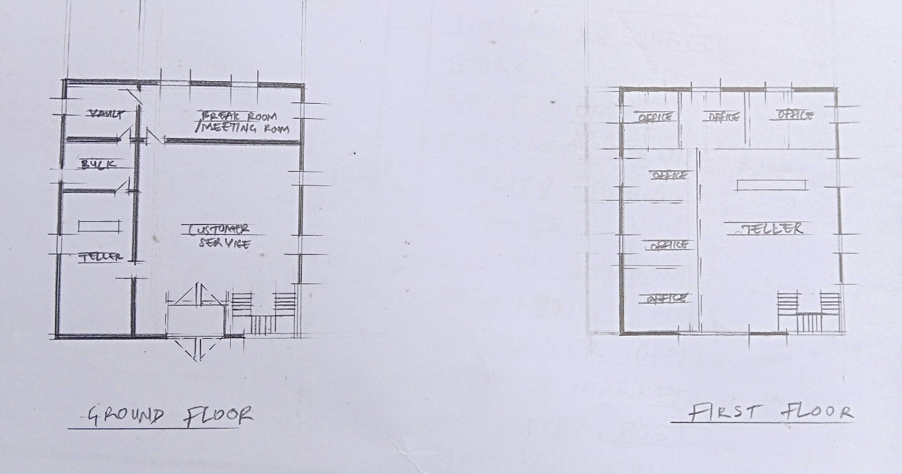
FLOOR PLANS
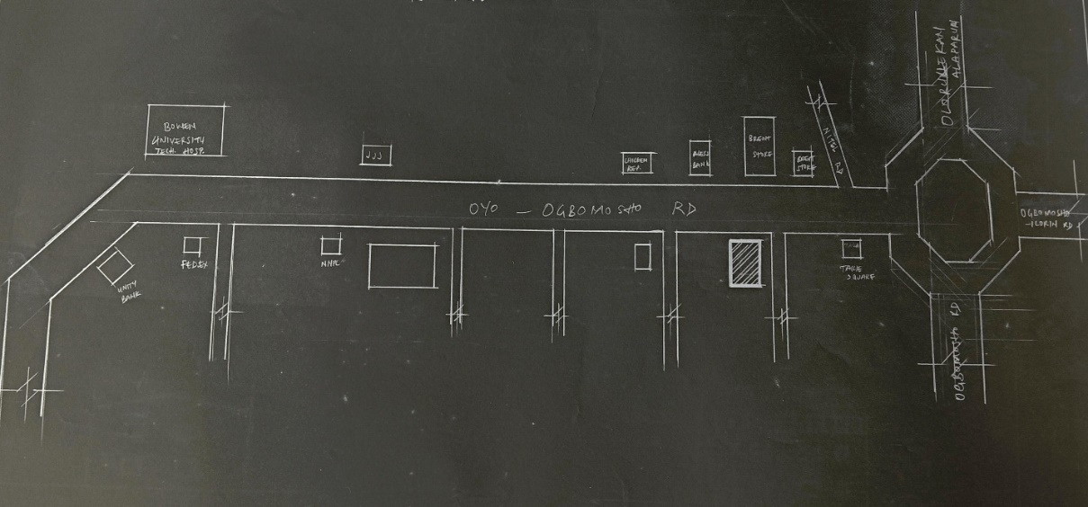
LOCATION PLAN
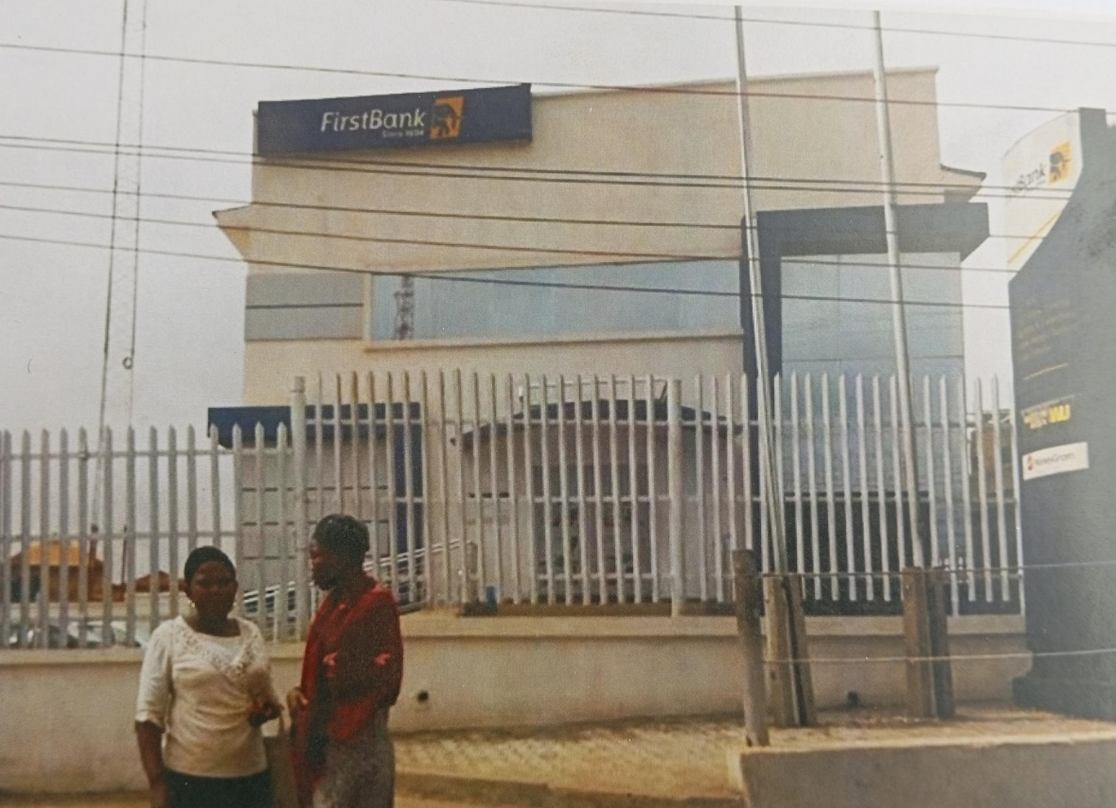
APPROACH VIEW

ARCHITECTURAL MERITS OF FIRST BANK OGBOMOSHO BRANCH
- Strategic Location
Merit: Positioned along Ilorin–Ogbomosho road, a high-traffic commercial corridor, the site benefits from maximum visibility, easy accessibility for customers, and proximity to other service-oriented businesses.
- Urban Integration
Merit: Located in a commercially dense area, the bank contributes to the urban fabric and activates street-level interactions.
- Functional Layout (Typical Branch)
Merit: Most First Bank branches—including this one—tend to use a straightforward, compact floor plan, separating public zones (ATM, lobby, banking hall) from restricted areas (vaults, staff rooms, etc.).
- Security-Oriented Design
Merit: The use of high perimeter walls, controlled entry points, surveillance equipment, and security booths demonstrates intentional architectural responses to safety—a major priority in Nigerian urban bank design.
- Consistent Branding & Identity
Merit: The building reflects First Bank’s corporate architectural language, using familiar materials, signage, and color palette—establishing a recognizable institutional identity across branches.
- Structural Durability
Merit: Most Nigerian First Bank branches are constructed with reinforced concrete and masonry walls, ensuring durability against weather conditions and vandalism.

ARCHITECTURAL DEMERITS OF FIRST BANK OGBOMOSHO BRANCH
- Limited Parking & Circulation
Demerit: The site lacks adequate on-site parking, leading to congestion along the main road and unsafe conditions for pedestrians. This is a critical site planning flaw affecting usability and traffic flow.
- Poor Spatial Efficiency
Demerit: The branch appears cramped during peak periods, indicating that internal space may not be well-scaled for its user load. The banking hall, ATM queue area, and customer service zones may lack sufficient buffer zones.
- Minimal Passive Design Features
Demerit: There’s little evidence of passive cooling strategies (like shading devices, cross ventilation, or overhangs), which could improve energy efficiency and thermal comfort in the hot Ogbomosho climate.
- Lack of Landscape Integration
Demerit: The building is predominantly surrounded by hardscape (pavement, concrete), with minimal green buffers, shading trees, or aesthetic landscaping—leading to heat retention and a harsh visual environment.
- Urban Disconnection
Demerit: Though centrally located, the site shows weak urban connectivity in terms of pedestrian walkways, integration with public transit stops, and accessible design for people with disabilities (e.g., lack of ramps, tactile surfaces).
- No Sustainable or Smart Systems Visible
Demerit: The branch appears to lack solar panels, rainwater harvesting systems, or smart lighting/ventilation, which are becoming standard in environmentally responsible bank designs.

3.2 CASE STUDY 2 (FIRST BANK IWO)
Address: Opposite Bowen University, Station Road (Oke‑Odo), Iwo, Osun State, NigeriaLocated directly opposite a major tertiary institution—Bowen University—ensuring a steady footfall of students, staff, and visitors. It sits on one of Iwo’s main thoroughfares .
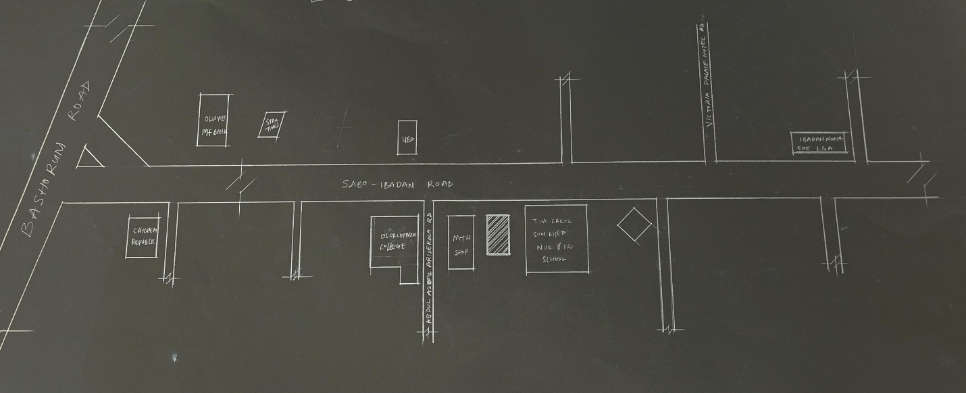
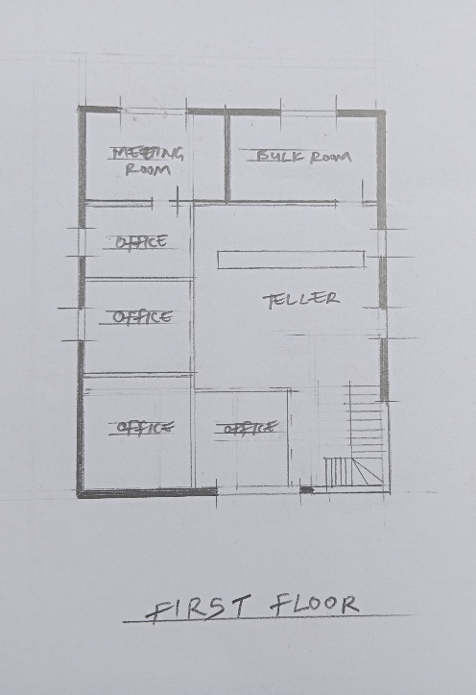
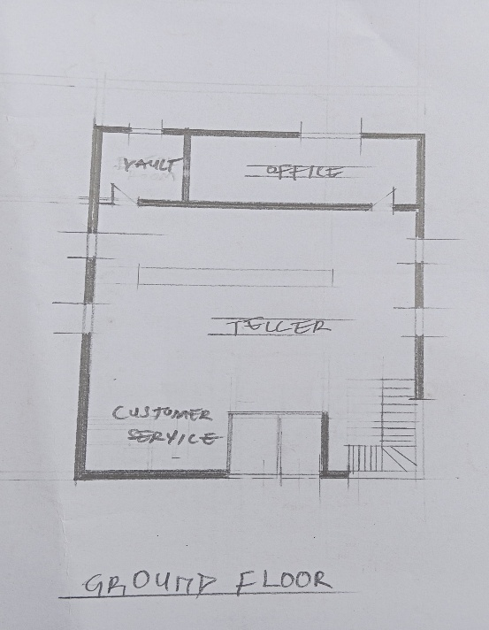
LOCATION PLAN
FLOOR PLAN
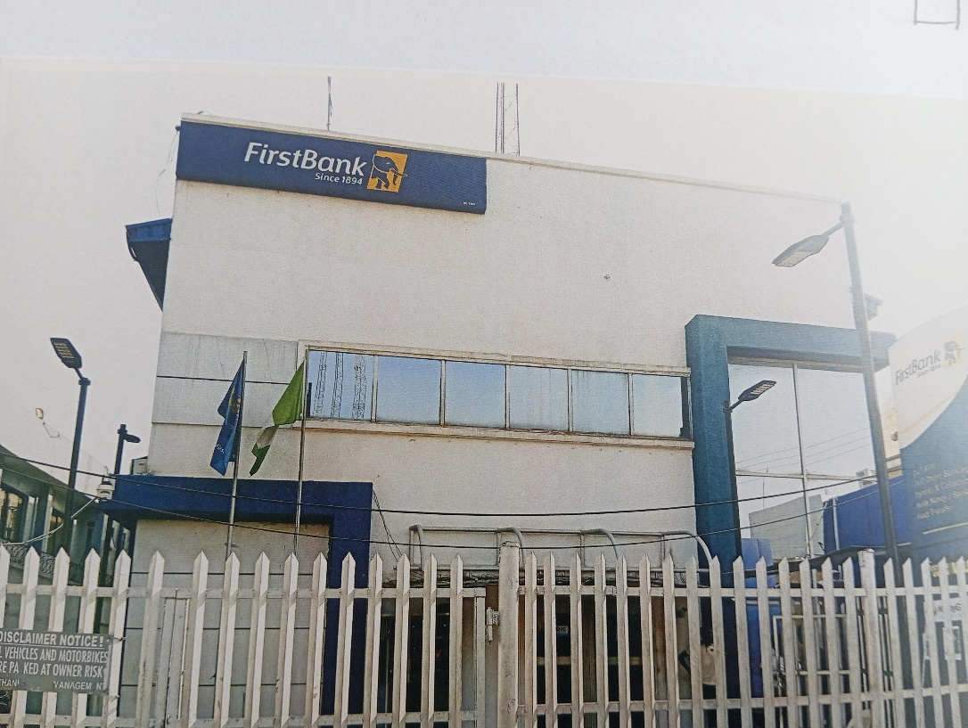
APPROACH VIEW

ARCHITECTURAL MERITS
- Strategic Siting
Positioned for maximum visibility and reach, serving university and local community patrons efficiently.
- Institutional Identity
The branch uses a recognizable First Bank façade, branding, and signage, reinforcing trust and user familiarity.
- Security Features
Attention to physical security with perimeter fencing, CCTV coverage, controlled access—aligning with banking safety standards.
- Functional Zoning
Separation of public banking areas (ATM bay, lobby) from staff/vault zones, enhancing workflow and operational clarity.
- Barrier-Free Access
The presence of a wheelchair-friendly entrance improves accessibility for people with disabilities
- Reinforced Construction
Common use of concrete and masonry construction ensures structural stability and resilience.

ARCHITECTURAL DEMERITS
- Space Constraints & Congestion
The ATM bay area is often cramped and queues spill onto the sidewalk, posing safety issues .
Road expansion and high traffic have squeezed parking zones, making vehicular access challenging .
- Insufficient Parking
Lack of organized parking leads to congestion and hinders smooth drive-in banking experiences .
- Limited Passive Design
The branch appears to lack climate-responsive design elements (like sun shading, cross-ventilation), increasing reliance on active systems and operational cost.
- Minimal Landscaping
The exterior is predominantly paved, lacking greenery that could enhance aesthetics and reduce heat island effects.
- Weak Pedestrian Interface
Absence of defined walkways, seating, or waiting zones; ATM queues often interfere with pedestrian flow.
- Urban Pressure
Expansion of surrounding roads and dense campus activity leave little room for future branch extension or adaptive addition.

3.3 CASE STUDY 3(FIRST BANK GARAGE OFFA GARRAGE)
Address & Access
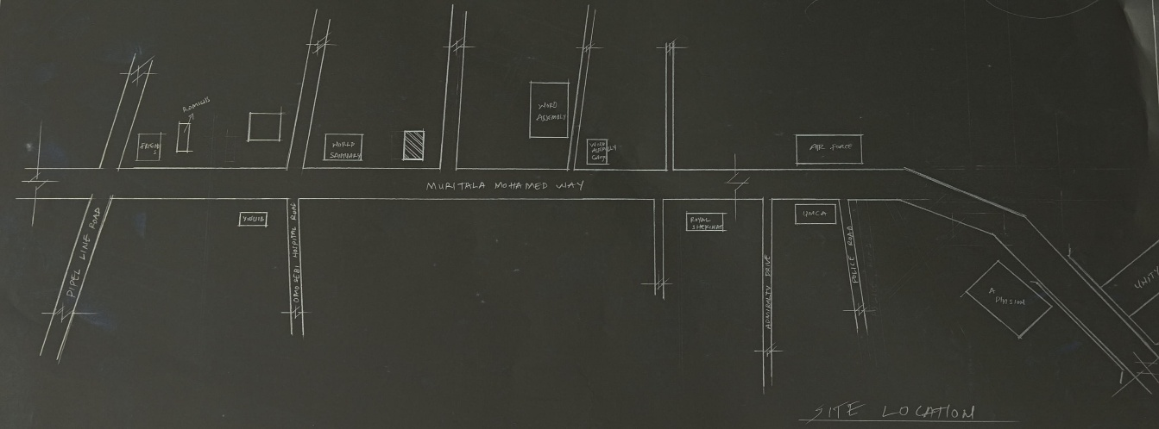
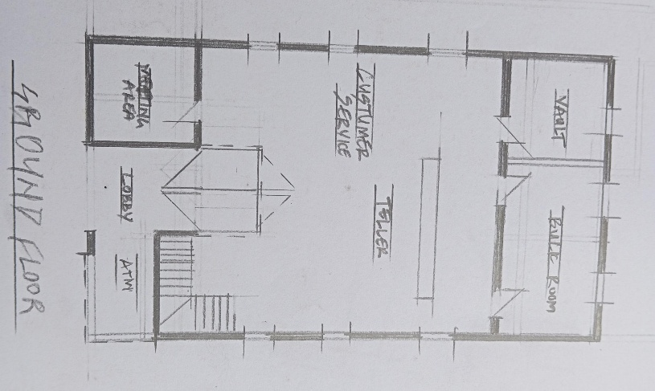
Situated at Ajase‑Ipo Road, beside Winners Chapel, Offa Garage, Ilorin, Kwara State, the branch occupies a strategic position within a busy transport hub
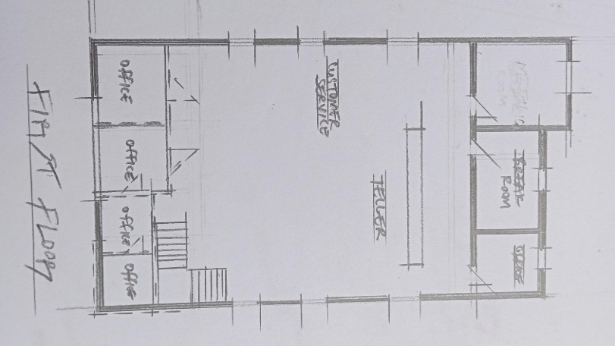
.LOCATION PLAN
FLOOR PLAN
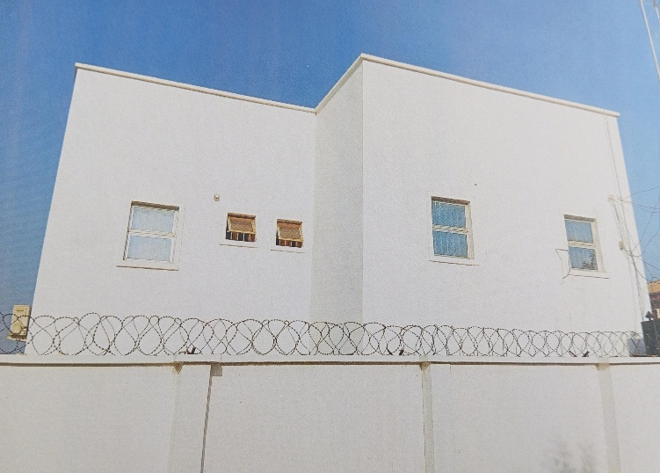
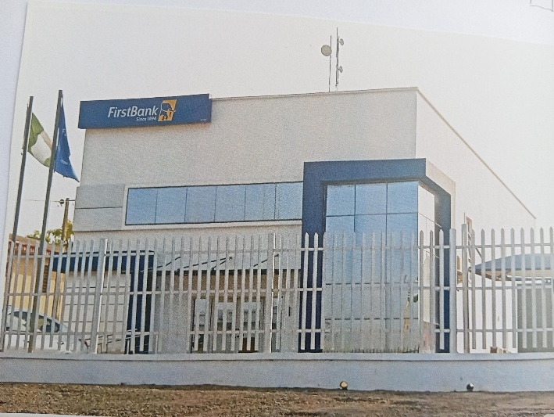
APPROACH VIEW SIDE VIEW

ARCHITECTURAL MERITS
- High Visibility & Engagement
Located within a vibrant transport center ensures constant exposure, enhancing both banking convenience and brand recognition.
- Integration with Transport Infrastructure
The convenient proximity to the garage makes it easy to address the banking needs of travelers, like cash injection, withdrawals, and remittances.
- Corporate Branding & Identity
Presumably adheres to First Bank’s standardized design—prominent signage, branded façade, and consistent corporate aesthetic that fosters institutional cohesion.
- Essential Security Elements
Likely includes standard features: secure perimeter, restricted entry points, ATM bay, and surveillance systems—crucial in high-foot-traffic urban contexts.

ARCHITECTURAL DEMERITS
- Congestion & Limited Parking
Embedded in a transport hub, the branch likely suffers blocked driveways and constrained vehicle access, complicating entry and curbside pickup/drop-off.
- Spatial Deficiencies
Urban site constraints might lead to cramped interiors, insufficient ATM queuing areas, and minimal buffer zones for customer waiting.
- Lack of Passive Comfort Strategies
Observed designs often omit passive cooling (shading, natural ventilation), critical in hot tropical climates like Ilorin. This could result in higher energy costs and reduced comfort.
- Poor Pedestrian Integration
With surroundings dominated by vendors and vehicles, the branch may lack dedicated paths, ramps, and universal access features, impacting inclusive design.
- Minimal Landscaping
The urban-heavy site and paved surroundings offer little to no green features, contributing to heat buildup and a sterile environment.
- Missed Enhancement Opportunities
Being in a high-traffic node, the branch could leverage smart systems—like solar lighting, modular canopies, and rainwater systems—but there’s no visible evidence of these elements.

3.4 ONLINE CASE STUDY 4 (HEAD OFFICE)
First Bank Head Office
Building Name: Samuel Asabia House
Address: 35 Marina, Lagos Island, Lagos
Year Built: Completed in the 1970s
Architectural Style: Modernist / Brutalist
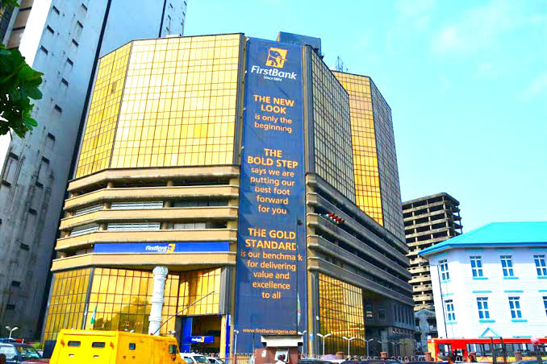
Use: Commercial – Banking Headquarters

FIRST BANK HEAD OFFICE, LAGOS, NIGERIA

ARCHITECTURAL MERITS
- Strategic Urban Placement
Located at the heart of Lagos Island (Marina), which is Nigeria’s traditional financial district.
High visibility and accessibility for business and administrative functions.
- Structural Integrity
The building has stood the test of time for over 40 years, showcasing durable engineering and materials.
Designed for longevity and functionality.

- Modernist Design Language
Embraces clean lines, concrete cladding, vertical rhythm, and minimal ornamentation typical of Brutalist/Modernist architecture.
It reflects the stability and reliability the bank aims to portray.
- Symbolic Importance
It is one of the iconic high-rise buildings that shaped post-independence commercial Lagos.
A representation of banking evolution in Nigeria and FirstBank’s long heritage.
- Internal Functionality
The plan supports vertical circulation with elevators and fire escape stairwells.
Offices and banking halls are spatially distributed to maximize efficiency.

ARCHITECTURAL DEMERITS
- Outdated Design Aesthetics
The modernist style lacks contemporary appeal by today’s architectural and sustainability standards.
Façade materials and appearance appear aged without a significant facelift.
- Limited Environmental Sustainability
The building was constructed before sustainable building practices became standard (e.g., no green roofing, solar integration, or water recycling).
Likely to have high energy consumption due to outdated HVAC and lighting systems.
- Restricted Expansion Potential
Being in a tightly packed commercial district limits spatial expansion or redesign flexibility.
Surrounding congestion may impact future physical or landscape upgrades.
- Inadequate Parking & Public Space
The location on Marina restricts large-scale parking areas or landscape features.
Pedestrian flow and open public areas are minimal or confined.
- Accessibility Issues
Older buildings often do not meet modern accessibility standards (e.g., ramps, tactile indicators, smart elevators).
Retrofitting for universal access may be limited or challenging.

3.5 ONLINE CASE STUDY 2 (FIRST BANK BRANCH, JOS)
Location: Bank Street, Jos (opposite CBN), with other branches at Main Market, Farin Gada Road, and Katako .
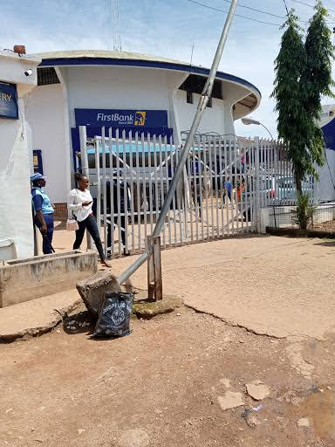
FIRST BANK BRANCH, JOS
Typology: Medium-rise, modern commercial building designed for retail banking—a branch rather than a corporate headquarters.
Context: Situated in the busy commercial core near the main market, blending institutional presence with high street surroundings.

ARCHITECTURAL MERITS
- Strategic Urban Placement
The branch occupies prime commercial real estate on Bank Street, enhancing visibility and pedestrian accessibility for customers and local businesses .
- Functional Layout
Common branch design likely incorporates efficient teller counters, teller queue areas, vaults, offices, ATM facilities, and meeting rooms—optimized for customer flow and transaction speed.
- Institutional Branding
The structure reinforces First Bank’s presence in Jos—a major financial center—projecting trust and familiarity through recognizable brand identity.
- Efficient Use of Space
Compact footprint well-suited to dense urban environment, delivering banking services without large land requirements.

ARCHITECTURAL DEMERITS
- Lack of Architectural Distinction
The building is modest in scale and form, without notable stylistic features or local design influences. It largely reflects a standardized commercial branch model, adapted across many towns and cities in Nigeria.
- Aging Infrastructure and Construction
Given the likely 1990–2000 era of construction, many materials and systems may now appear dated—e.g., façade finishes, glazing, and potential need for modernization.
- Limited Sustainability Features
There’s no visible evidence of eco‑design aspects such as solar shading, daylighting optimization, water harvesting, or energy-efficient HVAC systems.
- Accessibility Constraints
While some sources suggest wheelchair access exists at certain branches (e.g. Farin Gada), it’s unclear whether all customer flows, entrances, and facilities meet modern accessibility standards .
- Urban Congestion Constraints
Located in a dense market area, the building has constrained setbacks, limited parking, and no open landscaped zones—which limits future expansion or redesign flexibility.

CHAPTER FOUR

STUDY AREA/PROJECT SITE (ENVIRONMENTAL AND IMPACT ANALYSIS)
4.1 ANALYSIS OF THE TOPOGRAPHICAL AND ENVIRONMENTAL CONDITIONS OF THE SITE
1. Introduction of Study Area / Site Selection
The proposed site for the new First Bank branch is strategically located opposite the Ilorin International Airport, in the Eastern axis of Ilorin, Kwara State, Nigeria. This location offers proximity to a growing transportation hub, enhancing accessibility and supporting commercial activity.
The selection of this site is driven by the anticipated growth in aviation-related business, increasing demand for financial services from travelers, airport staff, logistics companies, and local residents. Its location along a major arterial road makes it a prime node for financial infrastructure.
2. Site Location, Description, and Selection Criteria
Site Location
- Located directly opposite the main entrance to Ilorin International Airport.
- Approximately 8.4348154° N, 4.974292°E. Connected to Airport Road, which links to major roads like Asa Dam Road and University Road.
Site Description
- Size: Approximately 8,000–10, 000 sqm .Mostly undeveloped; covered with natural grass and sparse vegetation.
- Topography ;Relatively flat terrain, minimal grading required.
- Surroundings: residential structures, and government buffer zones.
Selection Criteria
- Proximity to Ilorin Airport = High customer volume.
- Flat topography = Cost-effective construction.
- Visibility & branding opportunity.
- Future development potential in the airport area.
- Availability of utility infrastructure in expanding area.
3. Site Analysis / Inventory
Parameter | Observation
Landform | Flat and firm ground with minimal slope.
Soil Type | Sandy-loamy mix; supports good drainage and moderate load-bearing capacity.
Vegetation | Sparse vegetation, mostly grass and bushes. Few trees, reducing site clearance cost.
Drainage | Naturally drained with no visible waterlogging; roadside drains nearby.
Utilities Nearby | Electricity poles, water lines, and telecom masts visible nearby.
Surrounding Uses | Residential homes, schools, business enterprises, airport and military zone nearby.
Noise Source | Aircraft movement and vehicular traffic, though intermittent.

4. Geographical / Climatic Data
Data Point | Information
Climate Zone | Tropical wet and dry (Savanna).
Annual Rainfall | ~1,200 mm – 1,500 mm.
Temperature Range | 21°C – 35°C (avg.).
Humidity | Ranges between 45% – 80%.
Prevailing Winds | Mostly from the Southwest, especially during the rainy season.
Sun Path | East–West orientation; long periods of solar exposure ideal for passive solar design or PV systems.

Design Implication: Use of shading devices, reflective roofing, and cross ventilation systems is advised to combat solar gain and ensure comfort.
- Analysis of Immediate Environmental Conditions
Opportunities
Visibility: Opposite the airport’s entrance, perfect for branding and first impressions.
Access: Good road infrastructure; anticipated increase in pedestrian and vehicular traffic.
Security: Proximity to airport security enhances site safety.
Growth Potential: Area is transitioning to a mixed-use urban node; ripe for business expansion.
Constraints
Noise: Aircraft operations may require sound insulation in design.
Development Controls: Airport zoning and setback requirements must be strictly observed.
Utility Extensions: Full connection to water and sewer lines may still require site-specific engineering input.
Summary
The proposed site opposite Ilorin International Airport offers a strategic, secure, and highly visible location for the development of a First Bank branch. The flat topography, solid soils, and expanding infrastructure make it architecturally favorable, while climatic data suggests the need for passive cooling strategies and weather-responsive materials.
  - Project Analysis/ design criteria
- Project Goals / Design Brief
The proposed First Bank branch is a response to the need for an accessible, secure, and technologically equipped financial institution near Ilorin International Airport. The design aims to reflect First Bank’s brand identity, enhance customer experience, and support future banking innovation.
Objectives:
- To provide efficient, customer-friendly banking services to airport users, travelers, nearby businesses, and residents.
- To ensure secure, accessible, and flexible banking operations in a high-traffic environment.
- To integrate modern banking technologies (ATMs, digital kiosks, CCTV, etc.) within a functional architectural space.
- To project a contemporary, eco-conscious image consistent with First Bank’s national presence.
- Functional / Spatial Criteria
The design must:
- Support clear circulation between customer zones, staff work areas, and secure zones.
- Allow easy expansion or modular adaptation.
- Incorporate adequate natural lighting, ventilation, and thermal comfort.
Include zoning for:
- Public access (ATM lobby, main banking hall)
- Semi-public zones (customer service and waiting)
- Restricted areas (vault, manager’s office, server room)
- Support areas (toilets, storage, janitorial, security).

- Appraisal of Proposed Scheme – Space, Size, and Relationship
Zone Approx. Size (m²) Functional Role Relationship
ATM Lobby 12–15 m² 24/7 access point External, accessible from main road
Banking Hall 80–100 m² Customer transactions Central public space
Customer Waiting Area 25–30 m² Queue/comfort zone Adjacent to service desks
Teller Counters (3–4) 20–25 m² Daily cash operations Interface between banking hall and vault
Manager’s Office 15–20 m² Private supervision/consultation Discrete, near staff zone
Vault / Cash Room 15–18 m² Secure storage Accessible from teller zone only
Server / IT Room 8–10 m² Network & security system base Isolated, secure room
Security Post 6–8 m² Entry control Near building entrance
Staff Lounge / Toilets 10–15 m² Staff welfare Separated from public zones
Janitor / Store Room 5–7 m² Utility support Discreet location, rear access
Total estimated built-up area: ~250–300 m² on a plot of ~1,000–1,500 m², allowing space for parking, landscaping, security fencing, and service access.
- Equipment, Operational and Performance Requirements
- ATM machines (2–3 units): 24-hour public interface; shaded & secure.
- CCTV Surveillance System: Full coverage of external/internal spaces.
- ICT Infrastructure: Networking, biometric terminals, digital displays.
- Vault Security Doors and Fire Protection: UL-rated vault doors and passive fire protection.
- Power Systems: Backup generator, inverter/solar hybrid system.
- Mechanical Systems: HVAC systems for customer hall and server room.
- Lighting: Energy-efficient LED + natural lighting from clerestory or skylights.
- Accessibility Features: Ramps, wide doors, tactile paths, signage.

- Spatial Allocation / Schedule of Accommodation
Space No. Of Units Area / Unit (m²) Total Area (m²)
ATM Lobby 1 15 15
Banking Hall 1 100 100
Waiting Area 1 25 25
Teller Counters 5 8 30
Manager’s Office 1 18 18
Vault 1 15 15
Server Room 1 10 10
Staff Lounge / Toilets 1 15 15
Janitor/Store 1 7 7
Security Post 1 8 8
Total ~233 m² + external works
- Functional Relationship (Bubble/Zoning Logic)
- Entry Sequence: Parking → ATM zone (open) → Main entrance → Security check → Banking hall
- Internal Circulation:
Customers: Public → Waiting → Teller/Customer Service
Staff: Rear/staff entrance → Lounge → Offices → Vault/Server
Secure Circulation: Vault accessible only from teller counter & manager zones.
- Operational Flow: Clean segregation of public, semi-public, and private/staff-only zones to optimize safety and efficiency.
- Conceptual Development
- Design Concept: “Gateway Finance Hub”
Inspired by its proximity to the airport (a gateway to the city), the branch is envisioned as a gateway-style financial landmark—both symbolically and functionally.
Design Drivers:
- Transparency: Use of glass, openness for customer trust.
- Security: Controlled access and zoning.
- Modern Identity: Bold forms, signage tower, and First Bank’s brand colors.
- Sustainability: Incorporate shading devices, solar PV panels, and drought-resistant landscape.
- Modularity: Expandable layout for future tellers, office spaces, or fintech kiosks.
The proposed First Bank opposite Ilorin Airport is designed as a functional, scalable, and iconic branch with strong public interface and high operational security. It integrates customer-friendly spaces, brand identity, and responsive architecture suited to Ilorin’s climate and airport-growth corridor.

CHAPTER FIVE

APPROACH TO THE DESIGN / DESIGN REALIZATION
5.1 DESIGN CONCEPTS AT DIFFERENT LEVELS OF THE DESIGN PROCESS
- Site-Level Conceptualization
The site, positioned opposite Ilorin International Airport, offers an ideal location for visibility, accessibility, and prominence. The design concept is centered around “Gateway Identity”—emphasizing the role of First Bank as a secure, modern, and accessible financial institution. The landscape and building form reflect institutional strength, cultural sensitivity, and modern innovation.
Key Site Design Features:
- Strategic building orientation to minimize solar heat gain.
- Designated zones: parking, ATM area, banking hall, staff areas.
- Landscape buffer zones using low-maintenance native plants.
- Defined vehicular and pedestrian circulation for safety and flow.
- Building-Level Conceptualization
The bank is designed as a two-story modular structure with distinct spatial hierarchy: public, semi-public, and restricted zones. A central atrium concept is used for natural lighting and spatial organization.
- Architectural Ideals:
- Transparency: Use of glass to project openness and trust.
- Security: Reinforced structural core and restricted access zones.
- Sustainability: Integrated passive cooling strategies.
5.2 TECHNOLOGICAL AND ENVIRONMENTAL CRITERIA
- Use of smart systems for security, lighting, and HVAC.
- Energy-efficient fixtures (e.g., motion sensor lighting).
- Rainwater harvesting and solar power integration.
- Cross ventilation and shading elements to reduce energy demand.
- Building envelope designed to withstand local climatic extremes.
5.3 CONSTRUCTION METHODOLOGY AND MATERIALS / FINISHES DESIRED BY CLIENTS
Construction Methodology
- Reinforced concrete frame system with infill block walls.
- Strip foundation suitable for Ilorin’s soil type.
- Modular wall systems to allow future expansion.
Material & Finishes
- External walls: Cement-rendered finish with granite stone cladding.
- Roof: Long-span aluminum roofing sheets.
- Floors: Porcelain tiles in public spaces; anti-slip vinyl tiles in wet areas.
- Walls: Emulsion-painted walls; executive offices with wood panel accents.
- Ceilings: Acoustic panel ceilings in offices and customer areas.
- Security Features: Bullet-resistant teller counters, steel vault doors.
5.4 SERVICES REQUIRED
- Circulation
Vertical circulation: Staircase and accessible ramp; provision for elevator.
Horizontal circulation: Clear corridors with directional signage.
- Ventilation
Natural cross-ventilation via operable windows and clerestories.
Mechanical ventilation in enclosed areas (vault, toilets, server room).
- Lighting
Daylighting through clerestories and large glazed areas.
LED lights with smart occupancy sensors in all rooms.
- Plumbing and Electrical Installation
Dual water system (fresh water + harvested rainwater).
Backup generator and solar inverter system.
Embedded cable trays and conduits for easy maintenance.
- Acoustics
Sound-insulated partitions in conference rooms and executive offices.
Acoustic ceiling tiles in the banking hall.
- Waste Disposal
Waste sorting area behind the building.
Septic tank and soak-away system with grease traps for staff kitchen.
- Fire Protection
Fire alarms, extinguishers, smoke detectors, and sprinkler points.
Clearly marked emergency exits and escape route lighting.
- External Works
Paved driveway and parking for up to 15 cars.
Security post and gatehouse.
ATM gallery with independent access and CCTV surveillance.
Generator house, borehole station, and landscaped garden.
5.5 ENVIRONMENTAL CONDITIONS TO BE ACHIEVED
Target Condition Performance Goal
Indoor Temperature 22–26°C
Lighting Levels 300–500 lux (offices and teller zones)
Acoustic Control 35–45 dB for customer comfort
Indoor Air Quality Natural + mechanical ventilation
Water Use Reduction 30% below conventional baseline
5.6 PERFORMANCE STANDARDS
Thermal Comfort: ASHRAE Standard 55
Lighting: Nigerian Building Code + LEED daylighting targets
Fire Safety: NFPA 101 & Local Fire Code Compliance
Accessibility: Nigerian Disability Act standards
Security: CBN Banking Premises Standards
Energy Use: Targeting 20% reduction in operational energy
5.7 LEGAL ISSUES AND PLANNING REGULATIONS
- Land Use Compliance: Conforms to Government Land Use zoning for commercial/institutional purpose.
- Development Permit: All designs comply with Ilorin Municipal Planning Authority (IMPA) regulations.
- Building Code Compliance: Design aligns with the National Building Code of Nigeria (NBC) and Central Bank of Nigeria (CBN) security standards for financial institutions.
- Fire Service Approval and Environmental Impact Assessment (EIA) obtained prior to construction.
- Setback Regulations: 9m front, 3m side and rear setbacks observed.
5.8 BEHAVIORAL CONSIDERATIONS
- The design is sensitive to user psychology and customer behavior:
- Queuing efficiency: Clear signage and layout reduce confusion.
- Privacy zones: Semi-private waiting areas for customer comfort.
- Security perception: Use of visible surveillance and uniformed personnel to reduce tension.
- Comfort and dignity: Consideration for PWDs and elderly clients with ramps and priority service areas.

CONCLUSION
The design of the proposed First Bank branch opposite Ilorin International Airport has been approached with a focus on functionality, security, sustainability, and contextual relevance. Through detailed site analysis, concept development, spatial planning, and integration of modern construction technologies, the project aims to meet both the operational requirements of a financial institution and the expectations of users in terms of comfort, accessibility, and service efficiency.
The location—strategically positioned near a major transportation hub—offers increased visibility and customer flow. Environmental and technological considerations have been incorporated to ensure energy efficiency, user comfort, and long-term viability of the building. The integration of passive cooling strategies, effective spatial organization, and modern materials supports a design solution that is both responsive and responsible.
The research and design process justify the proposed solution as an effective architectural response to the client’s brief, regulatory requirements, and contextual challenges.

RECOMMENDATIONS
- Post-Occupancy Evaluation:
It is recommended that a post-occupancy study be conducted within 6–12 months after the facility becomes operational to assess user satisfaction, energy performance, and functional effectiveness of the spaces.
- Digital Banking Integration:
Further design consideration should be given to future expansion or adaptation for fully automated banking systems, including digital kiosks and smart queue systems.
- Research on Security Design Trends:
Future research should explore evolving trends in bank security architecture, especially concerning cyber-physical integration (e.g., biometric access, surveillance AI, and cashless transaction design layouts).

- Sustainable Building Certification:
Research into aligning future bank branches with green certification standards (like EDGE or LEED) should be encouraged to ensure broader environmental responsibility.
- Behavioral Studies:
Continued research on how user behavior in financial spaces changes with technological advancements (e.g., mobile banking vs. In-person visits) will inform the adaptability of future banking hall designs.

REFERENCES
Abdullahi, Y. (2015). Modern architectural design for tropical climates. Lagos: Akin Publishers.
Ameh, J. E., & Odusami, K. T. (2010). Professionals' ambivalence toward ethics in the Nigerian construction industry. Journal of Professional Issues in Engineering Education and Practice, 136(1), 9–16.
Central Bank of Nigeria. (2012). Guidelines for the design and security of bank branches in Nigeria. Abuja: CBN Publications.
National Building Code of Nigeria. (2006). Building regulations and safety standards. Abuja: Federal Ministry of Housing and Urban Development.
United Nations Environment Programme. (2011). Towards a green economy: Pathways to sustainable development and poverty eradication. Geneva: UNEP.
(The sixth edition of the APA Format is posted on the Class WhatsApp Platform)

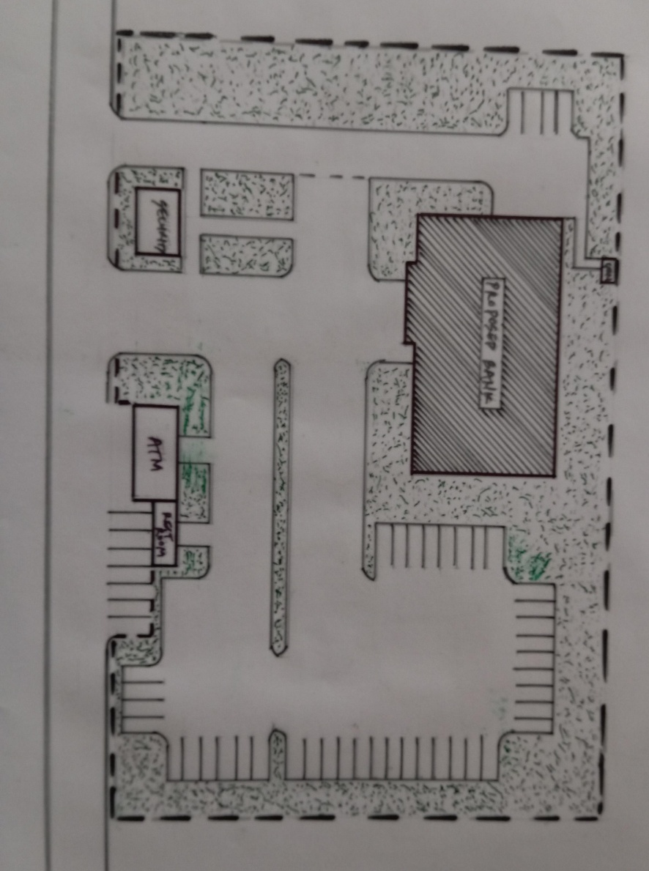
APPENDICES
Supportive sketches and graphic illustrations include:
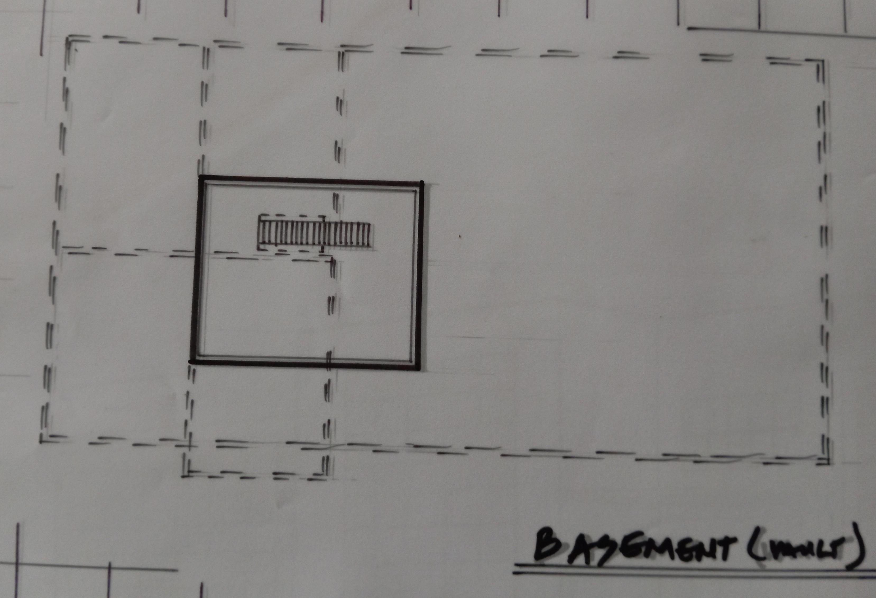
SITE LAYOUT PLAN
FLOOR PLANS CIRCULATION DIAGRAMS
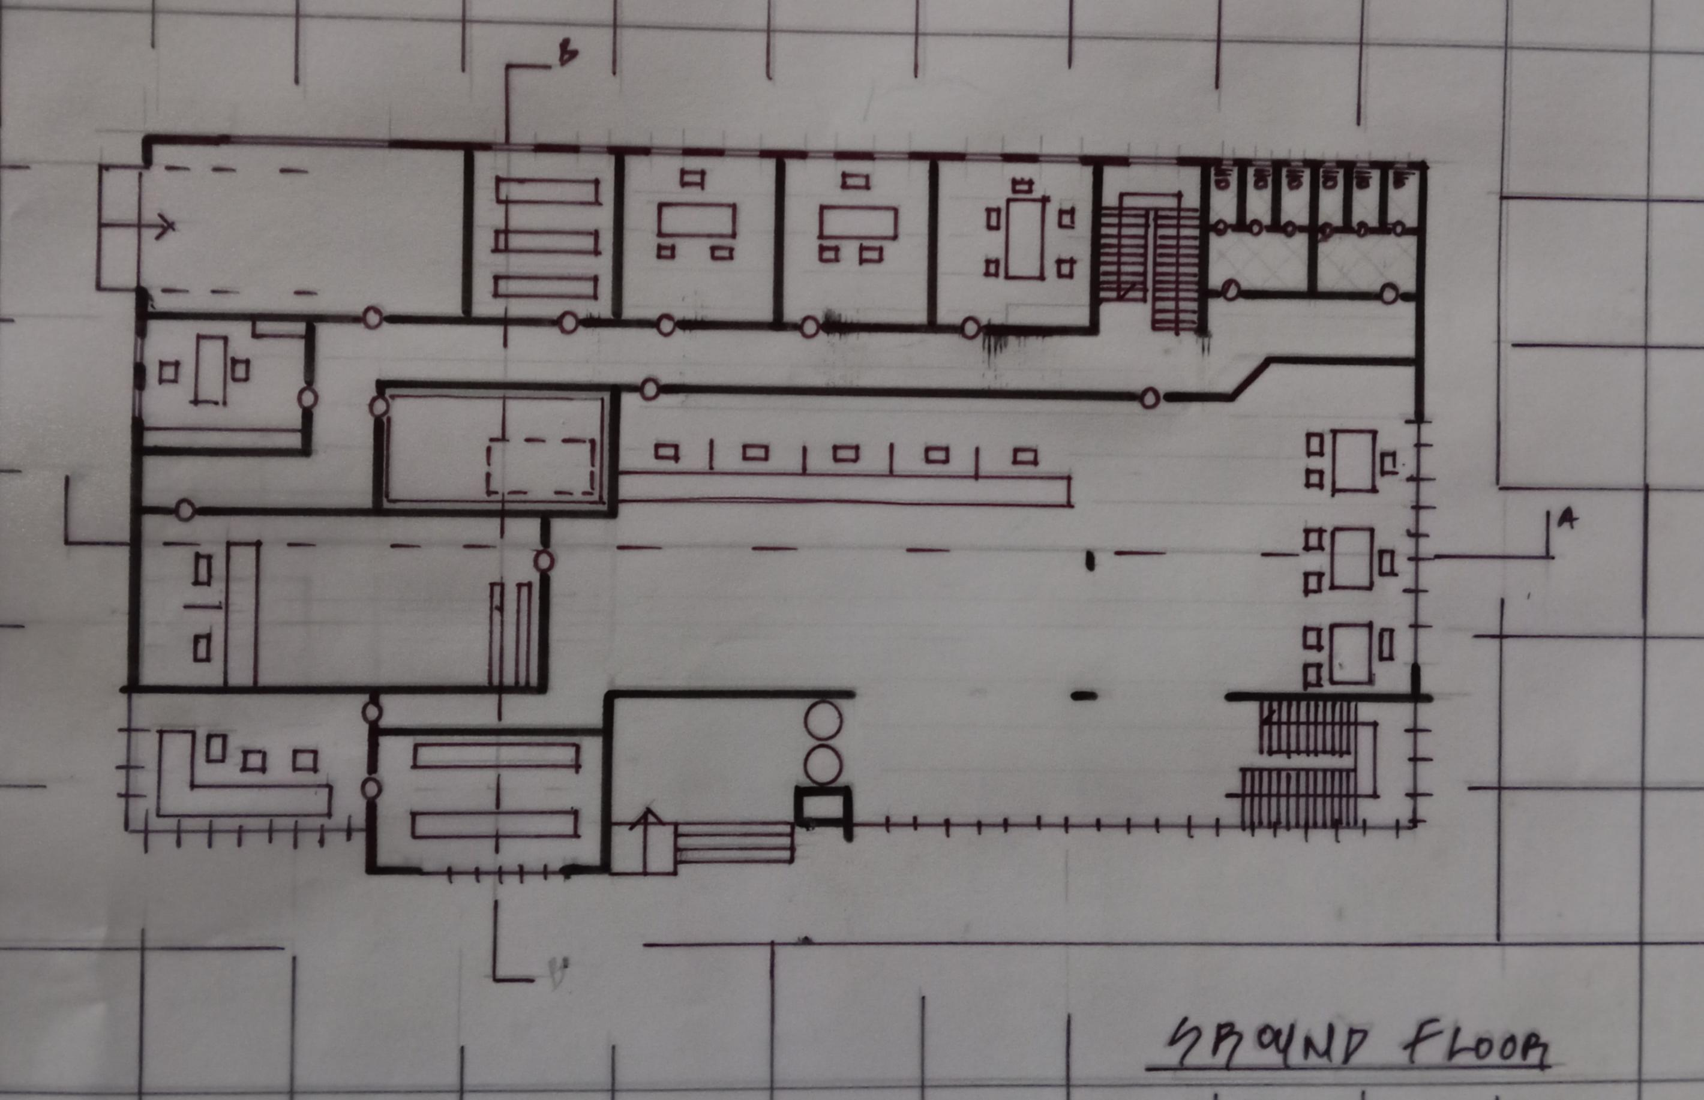

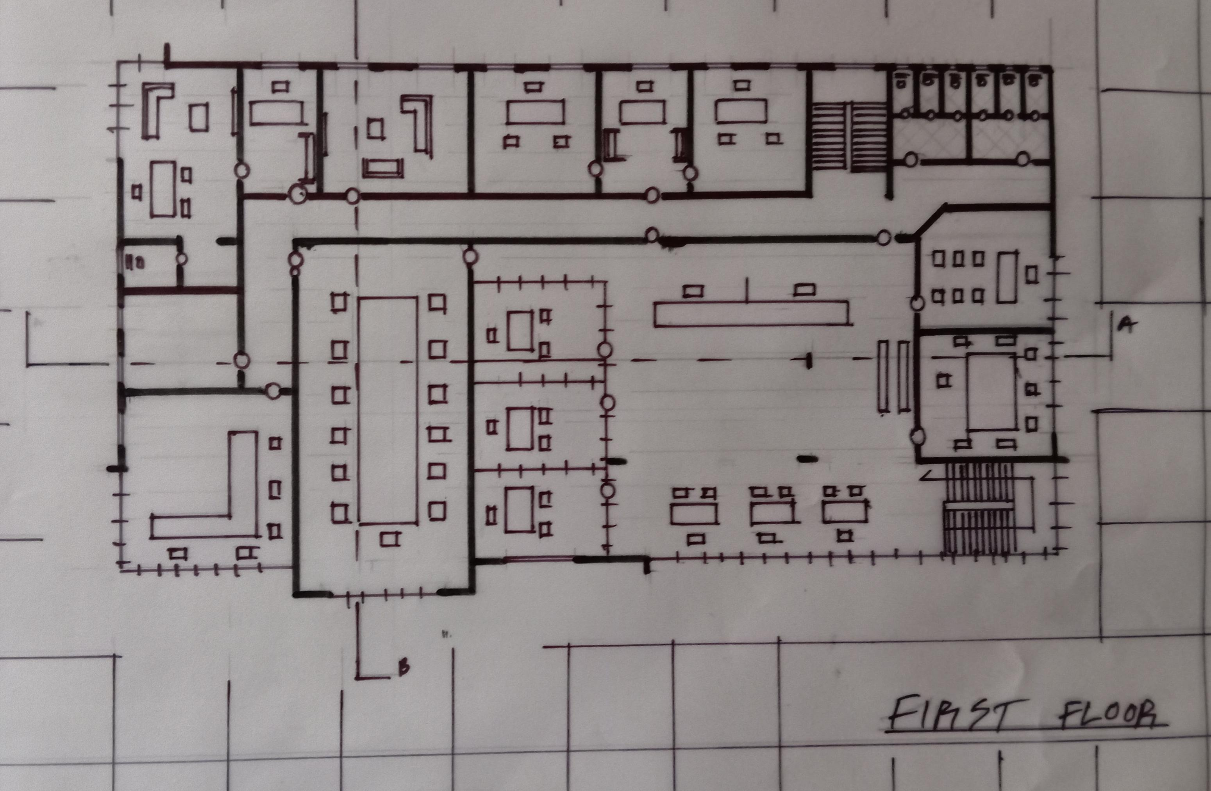
FLOOR PLANS CIRCULATION DIAGRAMS
FIRST FLOOR PLANS CIRCULATION DIAGRAMS

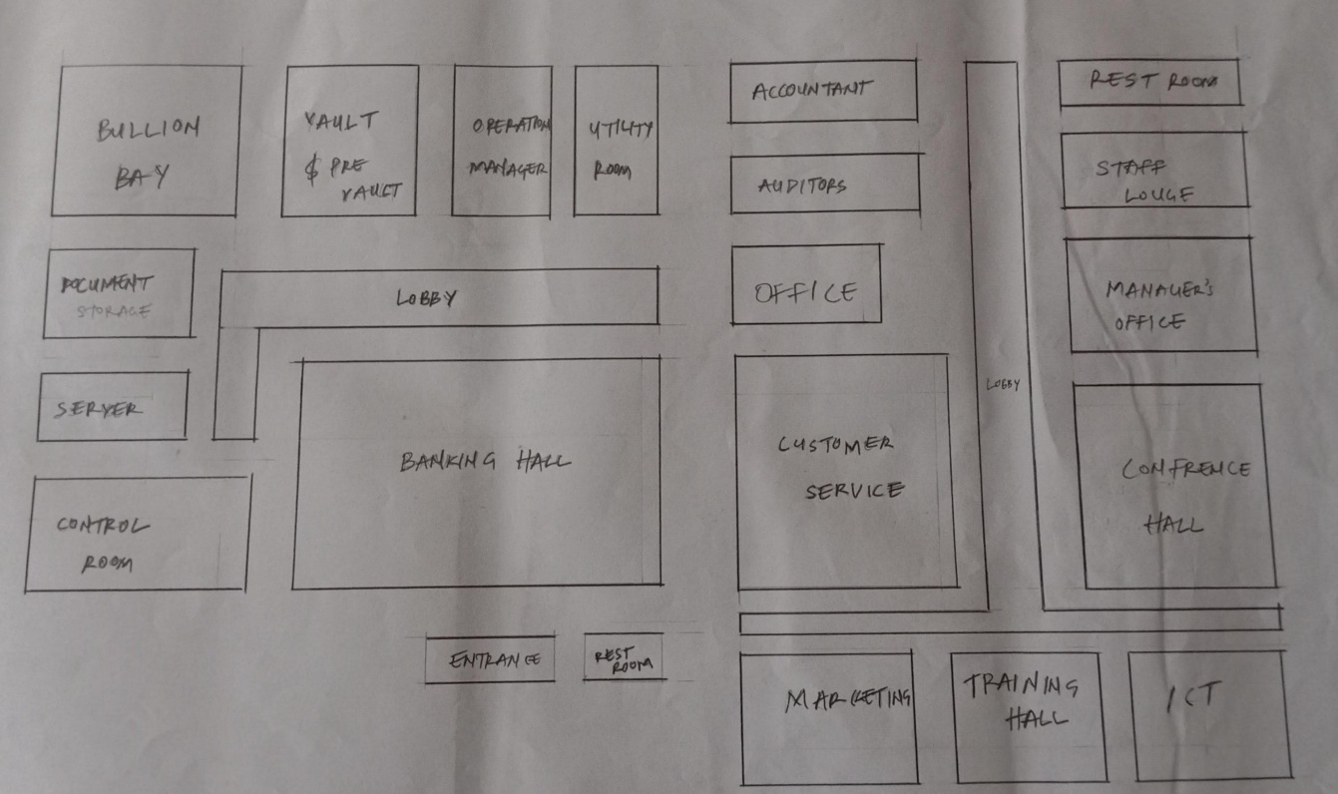
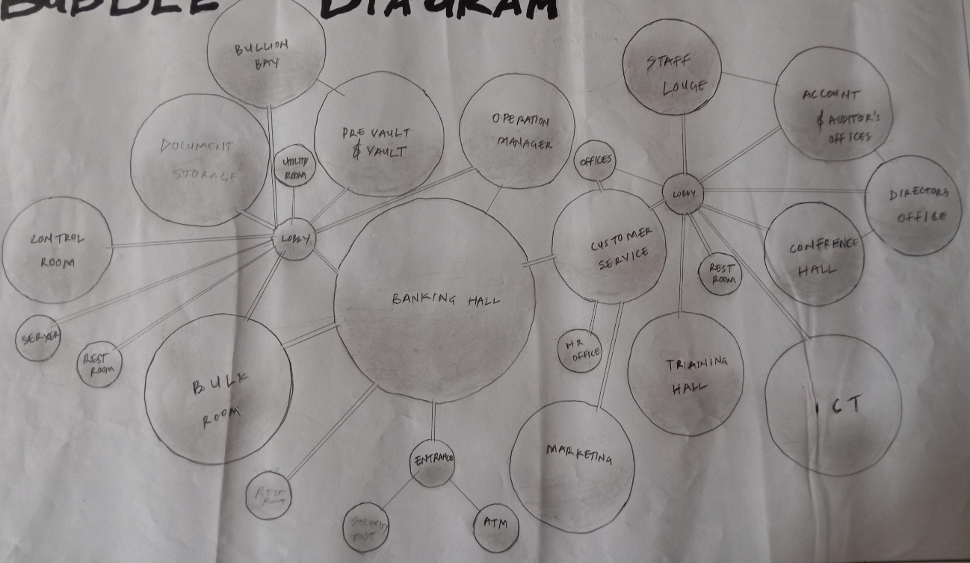
FUNCTIONAL FLOW CHAT
FUNCTIONAL FLOW CHAT

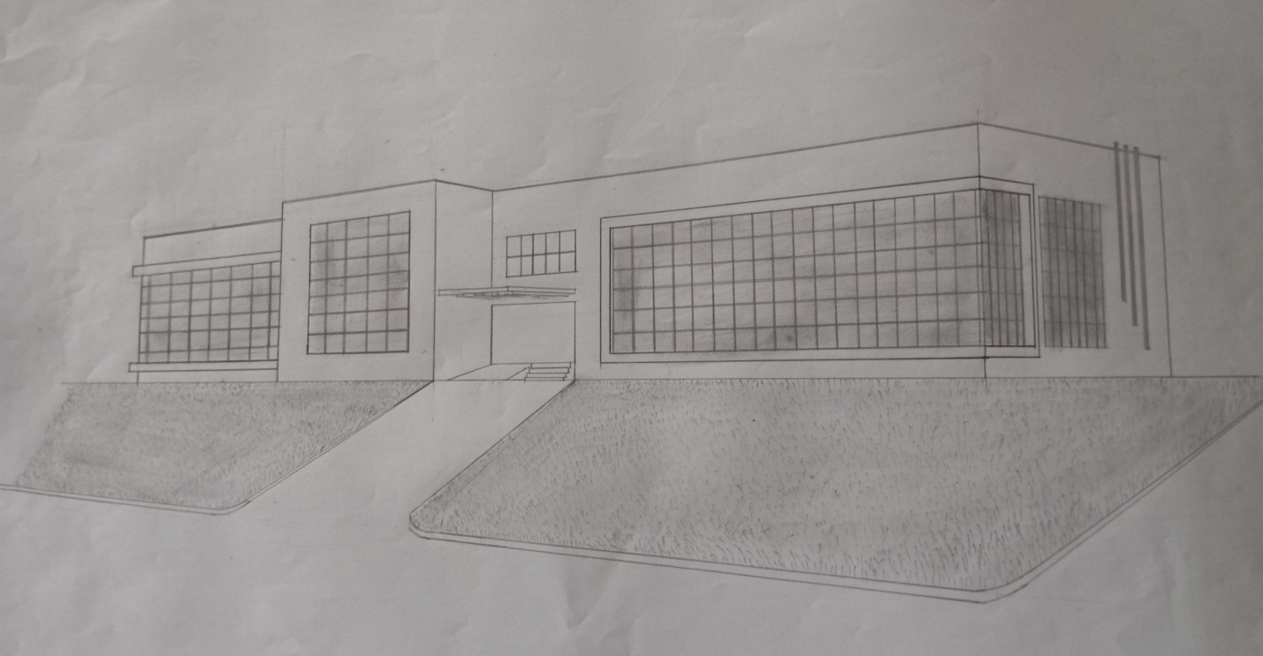
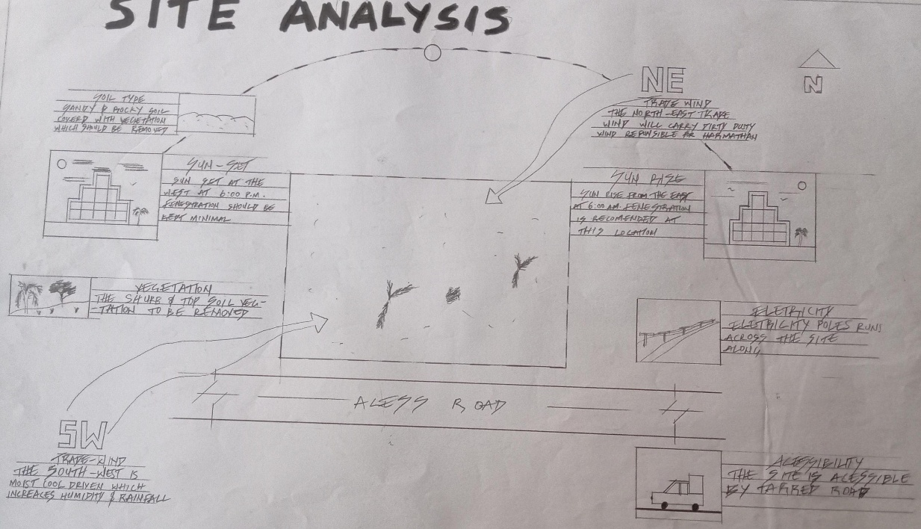
SITE ANALYSIS
3D PERSPECTIVE

