PERFORMANCE EVALUATION OF A MOTORIZED GROUNDNUT KNEADING MACHINE

BY

ADEKUNLE AL AMEEN BABATUNDE
ND/23/ABE/FT/0002

A RESEARCH PROJECT REPORT SUBMITTED TO
THE DEPARTMENT OF AGRICULTURAL AND BIO-ENVIRONMENTAL ENGINEERING TECHNOLOGY, INSTITUTE OF TECHNOLOGY, KWARA STATE POLYTECHNIC, ILORIN.

IN PARTIAL FULFILLMENT OF THE REQUIREMENTS FOR THE AWARD OF NATIONAL DIPLOMA (ND) IN AGRICULTURAL AND BIO-ENVIRONMENTAL ENGINEERING TECHNOLOGY.

CERTIFICATION
This is to certify that this project titled “PERFORMANCE EVALUATION OF A MOTORIZED GROUNDNUT KNEADING MACHINE”was carried out by “ADEKUNLE AL AMEEN BABATUNDE” with matriculation number ND/22/ABE/FT/0002. The project has been read and approved as part of the requirements of Agricultural and Bio-Environmental Engineering Technology Department for the Award of National Diploma (ND) in Agricultural and Bio-Environmental Engineering Technology, Kwara State Polytechnic Ilorin.

_______________________________ __________________
ENGR. A.L GBADAMOSI DATE
(Project Supervisor)

_______________________________ __________________
ENGR. OYEBANRE O.D DATE
(Project Coordinator)

_______________________________ __________________
ENGR. ABDULQUADRI DAUDA DATE
(Head of Department)

_______________________________ __________________
EXTERNAL DATE

DEDICATION
I dedicate this research work to God Almighty, the giver of life, wisdom, and strength, whose grace has carried me through every step of this academic journey.
ACKNOWLEDGEMENT
First and foremost, I express my deepest gratitude to Almighty God, the Creator and Sustainer of all things, whose boundless love, mercy, and grace have guided me throughout this project. His divine wisdom and strength have been my anchor, illuminating my path and granting me the perseverance to complete this work. To Him alone be all glory, honor, and praise for His unending faithfulness.
I am profoundly thankful to my beloved parents, Mr. and Mrs. Adekunle, whose unwavering support, prayers, and sacrifices have been the bedrock of my academic journey. Their encouragement, love, and belief in my potential have inspired me to strive for excellence, and I am eternally grateful for their nurturing presence in my life.
I extend my heartfelt appreciation to my supervisor, ENGR. Dauda K. A, whose expertise, patience, and insightful guidance have been instrumental in shaping this project. His dedication to my academic growth, coupled with his constructive feedback and encouragement, has motivated me to push beyond my limits, and I am truly honored to have worked under his mentorship.
I owe a great deal of gratitude to the Head of Department, ENGR. Abdulquadri Daudawhose leadership and commitment to academic excellence have created an enabling environment for learning and innovation. His support, along with the invaluable contributions of other lecturers and staff of the esteemed Department of Agricultural and Bio-Environmental Engineering, has enriched my knowledge and skills, making this project a reality. I am deeply appreciative of their tireless efforts and encouragement.
Finally, I extend my sincere thanks to my friends and family, whose love, prayers, and constant encouragement have been a source of strength throughout this journey. Their unwavering support, shared laughter, and words of wisdom have uplifted me in moments of challenge, and I am immensely grateful for their presence in my life.

TABLE OF CONTENTS
Title Page
Certification
Dedication
Acknowledgement
Table of Content
Abstract
CHAPTER ONE: INTRODUCTION
1.0 Introduction
1.1 Background of the Study
1.2 Statement of the Problem
1.3 Aim and Objectives of the Study
1.3.1 Aim of the Study
1.3.2 Objectives of the Study
1.4 Justification of the Study
CHAPTER TWO: LITERATURE REVIEW
2.0 Introduction
2.1 Groundnut Production in Nigeria
2.2 Varieties of Groundnut in Nigeria
2.3 Method of Kneading Groundnut Paste
2.3.1 Traditional Methods of Kneading Groundnut Paste
2.3.2 Mechanical Methods of Kneading Groundnut Paste
2.3.3 Oil Extracting Machine
2.3.4 Groundnut Kneading Machine
2.4 Factors Affecting Kneading Machine Performance
2.5 Measurement of Performance Parameters of a Groundnut Kneading Machine
2.5.1 Key Performance Parameters
2.5.2 Kneading Effects on Product Quality
2.5.3 Kneading Throughput

CHAPTER THREE: MATERIALS AND METHODS
3.1 Materials
3.1.1 Description of the Existing Groundnut Kneading Machine
3.2 Methods
3.2.1 Sourcing of Test Materials
3.2.2 Sample Preparation
3.2.3 Kneading Operation
3.2.4 Performance Evaluation
3.2.5 Experimental Specifications
3.2.5.1 Kneading Efficiency
3.2.5.2 Kneading Rate
3.2.5.3 Throughput Capacity
3.2.5.4 Moisture Content
3.2.6 Statistical Analysis
CHAPTER FOUR: RESULTS AND DISCUSSION
4.1 Results
4.2 Discussion
CHAPTER FIVE: CONCLUSION AND RECOMMENDATION
5.1 Conclusion
5.2 Recommendations
5.2.1 Recommendations for Industrial Application
5.2.2 Recommendations for Future Research

ABSTRACT
This study evaluated the performance of a motorized groundnut kneading machine, focusing on the impact of sample mass, machine speed, and kneading duration on machine capacity and kneading efficiency. Traditional groundnut paste kneading methods are labor-intensive and inconsistent, highlighting the need for mechanization to meet increasing demand and improve product quality. The research aimed to assess the machine's throughput rate, kneading efficiency, and total kneading time, compare its output quality with manual methods, and identify areas for design improvement.
The results, analyzed using ANOVA, revealed that machine capacity is primarily influenced by sample mass and kneading duration, with a peak capacity of 60 kg/h. Kneading efficiency, however, was significantly affected by sample mass and machine speed, exhibiting non-linear relationships and indicating optimal operating points. A peak efficiency of 85.34% was achieved. The study highlights a trade-off between maximizing throughput and maximizing efficiency, suggesting that optimal machine settings depend on the processor's economic objectives. The motorized machine demonstrates competitive performance compared to similar equipment. Recommendations include adopting objective-driven operating procedures, exploring real-time process control, and expanding future research to include energy consumption, comprehensive product quality metrics, and methodological refinements to address statistical anomalies.

CHAPTER ONE

1.0 Introduction
Traditional methods of kneading groundnut paste are labor-intensive, time-consuming, and often inconsistent in quality. With the increasing demand for groundnut-based products, there is a need to mechanize and optimize the kneading process. The development and evaluation of a motorized kneading machine aim to enhance productivity, ensure uniform paste consistency, and reduce human effort in processing.
In many small- and medium-scale agro-processing enterprises, mechanization of groundnut processing still lags behind, particularly in the post-milling stage where paste consistency directly affects product quality. Poor paste texture can lead to reduced market value and consumer dissatisfaction (Olawale & Adeoye, 2019). Therefore, integrating an efficient kneading system becomes essential in improving the value chain of groundnut processing.
Mechanized kneading machines are capable of handling larger volumes of paste, offering improved hygiene, reduced contamination risks, and better process control. This innovation not only addresses food safety concerns but also contributes to employment generation and income diversification for rural households engaged in agro-processing (Nwankwo et al., 2021). Consequently, performance evaluation becomes crucial to ensure that such machines meet the operational demands of processors while remaining cost-effective.

1.1 Background of the Study
Groundnut (Arachis hypogaea), also known as peanut, is one of the most important leguminous crops in the world. In Nigeria, groundnut ranks among the top cash crops cultivated primarily in the northern regions such as Kano, Kaduna, Bauchi, and Taraba. It is typically grown during the rainy season and requires well-drained sandy loam soils for optimal yield.
According to the Food and Agriculture Organization (FAO, 2020), Nigeria is among the top producers of groundnut in Africa, contributing significantly to both domestic consumption and export production. Statistics show that over 2.5 million metric tons of groundnuts are harvested annually in Nigeria, supporting the livelihoods of millions of smallholder farmers (FAO, 2020).
As part of its economic importance, it serves as a raw material for industries involved in oil production, animal feed, and confectionery. Groundnut trade supports both local markets and export earnings, especially in processed form like oil and cake.
In terms of nutritional importance, groundnut is rich in protein (about 25–30%), healthy fats, vitamins (especially B-vitamins), and minerals like magnesium, calcium, and phosphorus.
However, traditional methods of groundnut processing, particularly during the paste kneading stage, remain largely manual and inefficient. These methods often result in non-uniform paste texture and reduced shelf life of final products due to microbial contamination introduced during hand mixing (Ajiboye et al., 2018). The transition from manual to mechanized processing is therefore necessary to meet increasing demand while maintaining product quality.
The lack of adequate performance parameters in existing groundnut kneading machines developed within the Department of Agricultural and Bio-Environmental Engineering is a gap in existing kneading machine development. Despite the commendable efforts made within the department, locally fabricated groundnut kneading machines, a critical gap remains in the area of performance evaluation. Most of the existing machines lack comprehensive and standardized performance parameters to assess their efficiency, reliability, and suitability for various scales of operation. While some machines have demonstrated basic functionality, essential performance indicators such as kneading efficiency, throughput rate, power consumption, paste uniformity index, and temperature control are either not measured or inadequately documented.
Furthermore, the absence of benchmarking tools or baseline data makes it difficult to compare and improve on existing designs. Industry stakeholders, including machine fabricators and smallholder processors, require data-driven recommendations to make informed decisions about equipment investment and use (Okonkwo & Umeh, 2020). Hence, the present research intends to carry out the performance evaluation of a motorized groundnut paste kneading machine.

1.2 Statement of the Problem
Despite the growing demand for groundnut paste in local and regional markets, many processors continue to depend on traditional hand-kneading methods. These manual techniques are not only labor-intensive but also time-consuming and often result in inconsistencies in paste texture, hygiene, and shelf life. This poses challenges to processors aiming for product uniformity, increased output, and commercial scalability (Ajayi et al., 2021).
Moreover, although a motorized groundnut kneading machine has been locally developed, its performance remains unevaluated. Key performance indicators such as throughput capacity, kneading efficiency, paste uniformity, and operational energy requirements have not been systematically documented. The absence of these data limits the machine’s optimization and restricts its broader application among processors. Without proper evaluation, the potential benefits of the machine in improving processing outcomes and reducing manual labor cannot be fully realized.

1.3 Aim and Objectives of the Study

1.3.1 Aim of the Study
The aim of this study is to evaluate the performance of a motorized groundnut paste kneading machine designed to enhance processing efficiency, promote uniform product consistency, and reduce manual labor in groundnut paste production.

1.3.2 Objectives of the Study
i. To assess the performance of the machine based on throughput rate, kneading efficiency, and total kneading time.
ii. To compare the output quality and operational effectiveness of the motorized kneading method with the conventional manual kneading method.
iii. To identify potential areas for improvement in the machine’s design based on performance results.

1.4 Justification of the Study
The kneading of groundnut paste is a critical step in the production of several popular food items such as groundnut soup, peanut butter, and confectionery products. In many communities, this task is primarily carried out by women using manual methods, which are often physically strenuous and time-inefficient (Okechukwu & Bamidele, 2020). Introducing a motorized kneading solution can drastically reduce processing time and labor input while enabling processors to scale up production and meet market demand.
Additionally, mechanical kneading reduces contamination risk and improves product hygiene, which is essential for public health and food safety compliance. Evaluating the machine’s performance provides empirical evidence on its reliability, efficiency, and economic viability. This will inform stakeholders—including local fabricators, processors, and policymakers—on its potential for widespread adoption and further development in small-to-medium agro-processing enterprises.

CHAPTER TWO

LITERATURE REVIEW

2.0 Introduction
Previous studies have explored various aspects of groundnut processing, ranging from primary operations like shelling and dehulling to more advanced stages such as roasting, grinding, kneading, and oil extraction. These stages are critical to ensuring the final quality, shelf stability, and market value of groundnut-derived products. Notably, the kneading process plays a central role in determining paste uniformity, oil release potential, and suitability for further processing, such as molding or frying.
According to Umar et al. (2018), mechanical kneading significantly improves paste homogeneity, reduces processing time, and enhances overall product consistency compared to manual techniques. This is largely because mechanical methods maintain a steady kneading rhythm, apply consistent pressure, and reduce contamination risks associated with hand-processing.
Motorized machines developed by Okonkwo and Adegbite (2019) have shown considerable promise in enhancing the processing capacity of groundnut paste among small- and medium-scale enterprises. These innovations often integrate rotating paddles, spiral screws, or planetary mixing systems that attempt to replicate the manual kneading effect with greater output per unit time. However, many of these designs are limited by operational challenges such as paste stickiness, which leads to material buildup on blades and mixing chambers, and motor overheating due to prolonged operation under high load.
Other common technical drawbacks identified in earlier designs include inadequate thermal control systems, high energy consumption, and difficulty in cleaning after use, especially when stainless steel materials are not employed. These problems not only hinder machine efficiency but also affect the quality of the final product, particularly in terms of texture and oil distribution (Ibrahim et al., 2021).
Given these limitations, this study builds upon earlier machine designs and seeks to evaluate their effectiveness under both controlled laboratory conditions and real-world operational environments. The goal is to measure key performance parameters such as kneading efficiency, throughput rate, temperature rise, and uniformity index. By doing so, the study aims to identify areas for improvement in machine design and contribute toward developing an optimized, user-friendly, and scalable motorized kneading solution suitable for use by small-scale processors and local food industries.
This literature review, therefore, provides a critical examination of past efforts in groundnut processing technology, with a specific focus on kneading innovations. It also highlights the existing research gaps and the need for standardized performance evaluation of motorized groundnut kneading machines.

2.1 Groundnut Production in Nigeria
Nigeria is one of the largest producers of groundnut (Arachis hypogaea) in Africa and plays a critical role in global legume production. Groundnut cultivation is widespread across the northern and middle-belt regions, particularly in states like Kano, Kaduna, Bauchi, Taraba, Gombe, Zamfara, and Jigawa, where agro-climatic conditions favor the crop's growth. These regions provide the ideal semi-arid tropical climate, with well-drained sandy loam soils, moderate rainfall (between 500 mm to 1000 mm annually), and temperatures ranging between 25–35°C, which support optimal groundnut development and yield.
It is a major cash crop, providing income to millions of rural farmers and contributing significantly to local food systems, employment, and foreign exchange earnings. Smallholder farmers dominate groundnut production in Nigeria, often cultivating on plots less than 2 hectares in size. Despite the small-scale nature of most operations, the cumulative contribution is substantial: according to FAO (2020), Nigeria produces over2.5 million metric tons annually, making it a leading contributor to Africa's total output.
Groundnut is used in various forms including edible oil production, roasted snacks, confectionery (such as peanut brittle), flour, livestock feed, and groundnut paste(commonly called kulikuli in Hausa-speaking regions or ose:oji in Igbo communities). The seeds are also a rich source of protein, dietary fiber, essential fatty acids, B-vitamins, and minerals such as magnesium and potassium, making them crucial to both nutritional securityandeconomic resilience in rural households.
In addition to its direct uses, groundnut also improves soilfertility through biological nitrogen fixation, contributing to sustainable agricultural practices when intercropped with cereals like maize or millet.
Despite its importance, groundnut farming in Nigeria continues to face a number of constraints. These include:
- Low-quality or uncertified seeds, which limit yield potential;
- Pest and disease pressures, particularly from Aphis craccivora (aphids) and groundnut rosette virus;
- Erratic rainfall and climate variability, which affect flowering and pod formation;
- Post-harvest losses, resulting from poor storage practices and inadequate drying;
- Limited access to affordable mechanization, especially for harvesting and processing.
Furthermore, the lack of value-added processing infrastructure, particularly in rural areas, reduces the potential profit margin for farmers and processors. For example, many local processors still rely on manual tools for tasks such as grinding and kneading, which are not only labor-intensive but also prone to hygiene and consistency issues.

Enhancing the groundnut value chain—especially through the introduction of improved processing technologies like motorized kneading machines—can significantly improve the economic returns, reduce post-harvest losses, and ensure better quality control of processed products. Mechanized processing not only increases throughput but also allows for standardization and improved food safety, which are essential for accessing regional and international markets.

In this context, evaluating the performance and adaptability of locally-fabricated groundnut kneading machines becomes essential. Such interventions can stimulate rural agro-industrial growth, encourage youth participation in agribusiness, and support Nigeria’s agricultural transformation agenda aimed at achieving food security and economic diversification.

2.2 Varieties of Groundnut in Nigeria

Several groundnut varieties are cultivated in Nigeria, broadly classified based on their growth habits (spreading or erect types) and seed characteristics such as size, shape, color, and oil content. These varieties differ significantly in their maturity periods, resistance to pests and diseases, adaptability to ecological zones, and nutritional composition. The choice of variety directly affects both farm productivity and processing efficiency, particularly in operations such as oil extraction and paste kneading.

1. SAMNUT Series
The SAMNUT (Savanna Nut) varieties are improved groundnut cultivars released by the Institute for Agricultural Research (IAR), Ahmadu Bello University, Zaria, in collaboration with International Crops Research Institute for the Semi-Arid Tropics (ICRISAT). These varieties are bred to overcome common constraints such as low yields, disease susceptibility, and aflatoxin contamination.
Some notable members of the SAMNUT series include:
- SAMNUT 21(also known as ICGV 86015): An early-maturing, high-yielding variety with a maturity period of about 90–100 days. It is widely adapted across northern Nigeria and has good resistance to rosette virus and drought stress. The seeds are medium-sized with moderate oil content.
- SAMNUT 22(ICGV 86024): Known for its large seed size, this variety is favored for snack production and export purposes. It has high oil content (over 45%), making it suitable for oil extraction. It matures in about 110 days and shows moderate resistance to pests.
- SAMNUT 23(ICGV SM 93530): Popular for its disease resistance, especially to groundnut rosette disease. It has an erect growth habit, good shelling percentage, and is suitable for confectionery and domestic consumption.
- SAMNUT 24, 25, and 26: These are more recent introductions with improved traits such as higher pod yield, better adaptability to climate variability, and increased oil recovery rate during processing.
The adoption of SAMNUT varieties has been promoted by various agricultural extensionprograms and research-development partnerships, due to their potential to improve both farm-level productivity and processing efficiency (ICRISAT, 2019; IAR, 2020).

2. Local Varieties
Local varieties of groundnut are often named based on indigenous classifications, such as color (e.g., red, white, or striped), pod texture, or origin of seed material. These varieties are mostly farmer-selected landraces, passed down through generations. While they may not be as uniform or high-yielding as improved types, they are well-adapted to specific local environmental conditions and often preferred for their organoleptic qualities, including flavor, aroma, and ease of roasting.
Examples of commonly grown local varieties include:
- "Kampala" – Known for its deep red seed coat and strong taste. Often used for traditional paste and kulikuli.
- "Maibuhu" – A local white-seeded variety valued for its high oil content and smoother texture during kneading.
- "Ex-Dakar" – A popular local variety introduced from Senegal, noted for early maturity and adaptability to Sahelian conditions.

Despite their agronomic limitations, local varieties play a critical role in food culture, biodiversity conservation, and informal seed systems. However, they often lack resistance to common pests and diseases and may have lower shelling percentages compared to improved types.

Comparison and Utilization
In terms of processing suitability, SAMNUT varieties generally perform better in mechanized systems, including motorized kneading and oil extraction, due to their uniform pod and seed sizes, lower shell-to-kernel ratio, and higher oil yield. On the other hand, local varieties are often more suitable for manual processing due to their softer texture and preferred taste profiles.
The availability and adoption of different groundnut varieties in Nigeria are influenced by factors such as:
- Climatic and soil conditions
- Access to certified seed systems
- Market demand (local vs. export)
- End-use applications (oil, paste, snacks, feed)

2.3 Method of Kneading Groundnut Paste

Kneading is a critical post-processing stage in groundnut paste production that directly influences the texture, uniformity, and overall quality of the final product. This process involves the thorough mixing and pressing of groundnut paste to achieve a consistent, homogenous mixture with desired rheological properties. Proper kneading facilitates oil release, eliminates air pockets, and enhances flavor integration, particularly when additives like salt or spices are introduced. The effectiveness of kneading is especially crucial in traditional products such as kulikuli, ose oji, and groundnut cake, where uniform texture and moisture distribution significantly affect consumer acceptability and shelf stability.

The method employed for kneading—either manual or mechanical—determines not only the efficiency of processing but also the labor demand, hygiene standards, and scalability of the operation.

2.3.1 Traditional Methods of Kneading Groundnut Paste
Traditionally, kneading is performed manually, often using bare hands or with the aid of wooden spatulas, pestles, or flat boards. The process typically takes place in large bowls, mortars, or basins, depending on the volume being processed. The paste is pressed, turned, and folded repeatedly until the desired consistency is achieved. In some cases, vegetable oil, salt, or local spices are added during kneading to enhance taste or improve the texture of the product.
This method is deeply embedded in local culinary traditions, especially in rural communities where groundnut paste is processed at the household or micro-enterprise level. However, it presents several challenges:
Labor Intensity: Manual kneading is time-consuming and physically demanding, often requiring prolonged squatting and repetitive motion, which can lead to fatigue or musculoskeletal strain—particularly for women who dominate groundnut processing activities.
- Inconsistency: The texture and quality of the kneaded paste may vary from batch to batch due to differences in kneading time, pressure applied, and operator skill.
- Hygiene Concerns: Inadequate sanitation practices, including unclean utensils and bare-hand contact, can introduce microbial contaminants, posing food safety risks.
- Low Throughput: Manual kneading limits the quantity of paste that can be processed within a given time, reducing its suitability for commercial-scale operations.
Despite these limitations, traditional kneading remains widespread due to its low cost, cultural familiarity, and accessibility, especially in low-income and off-grid communities.

2.3.2 Mechanical Methods of Kneading Groundnut Paste
Mechanical kneading refers to the use of powered machines to automate the kneading process. These machines utilize rotational or reciprocating mechanisms to mix, press, and homogenize groundnut paste within a controlled environment. Mechanization addresses several limitations of traditional methods and is increasingly being adopted in small- and medium-scale agro-processing enterprises.

Advantages of Mechanical Kneading:
i. Increased Efficiency: Machines significantly reduce kneading time and labor demand, enabling higher throughput and faster turnaround.
ii. Improved Hygiene: Enclosed systems and stainless-steel food contact surfaces reduce exposure to contaminants.
iii. Uniformity: Consistent mixing action ensures even texture, moisture distribution, and integration of additives.
iv. Scalability: Machines allow for batch or continuous processing, making them suitable for commercial applications.
v. Reduced Operator Fatigue: Minimal manual input is required, allowing operators to focus on quality control and other tasks.

Types of Mechanical Kneading Machines:
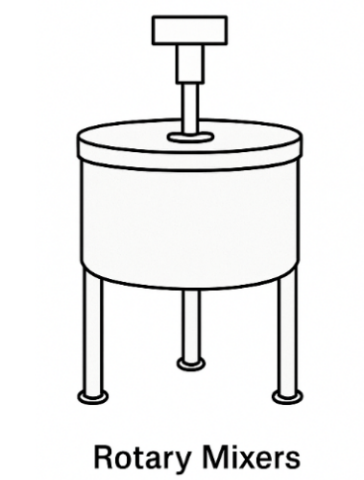
- Rotary Mixers: Use rotating paddles, blades, or beaters to mix the paste. They are effective for medium-viscosity materials.

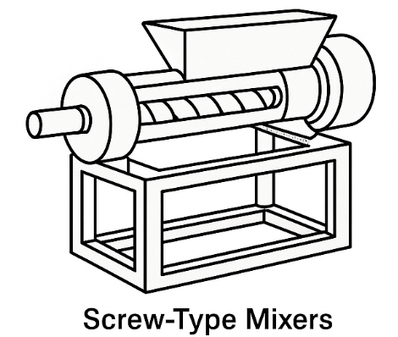
- Screw-Type Mixers: Combine kneading and conveying actions through an auger system; ideal for continuous processing.

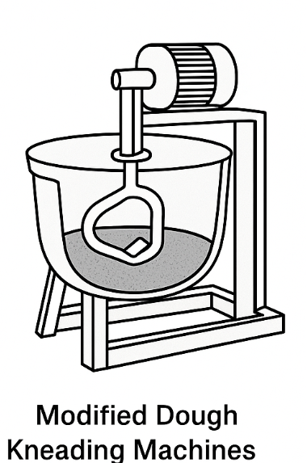
- Modified Dough Kneading Machines: Originally designed for bakery dough, these are adapted to handle the thicker and oil-rich consistency of groundnut paste.

Challenges and Limitations:
i. High Initial Cost: Acquisition and setup of machines may be cost-prohibitive for micro-enterprises.
ii. Maintenance Requirements: Regular cleaning, lubrication, and replacement of worn parts are essential for sustained operation.
iii. Paste Stickiness and Wear: Groundnut paste's adhesive nature can cause blade clogging, increased wear on components, and energy inefficiency if not properly designed for.
iv. Power Supply Constraints: Machines typically require stable electricity or fuel sources (diesel or petrol), which may be unreliable or costly in rural areas.
Overall, mechanical kneading enhances the technical efficiency and product consistency of groundnut paste processing, contributing to higher-quality end products that meet both consumer expectations and regulatory standards.

2.3.3 Oil Extracting Machine
In groundnut processing, oil extraction is a downstream operation where edible oil is separated from the paste. The oil extracted is used for culinary, cosmetic, and industrial applications, while the remaining press cake may be used for kulikuli production or as animal feed. The efficiency of oil extraction is influenced by paste consistency, moisture content, temperature, and equipment type.

Types of Oil Extracting Machines:
- Screw Press Machine: The most commonly used type for groundnut paste. It employs a rotating screw that compresses and pushes the paste through a narrow channel. The applied pressure and friction cause the oil to be expelled through small perforations while the de-oiled cake exits at the end. These machines can be manually operated or motorized.
- Hydraulic Press: Uses hydraulic cylinders to exert vertical pressure on the paste placed in a cylindrical container. This method allows for greater control over pressure and is often used in small-batch or artisanal oil production. It is generally more precise but slower than screw presses.
- Solvent Extraction System: Uses chemical solvents, such as hexane, to dissolve and extract oil from the paste. It is mainly used in large-scale industrial settings due to its high recovery efficiency but involves higher operational and safety standards due to the use of volatile chemicals.
Each machine type has its own advantages and limitations in terms of oil yield, processing speed, energy consumption, and suitability for smallholder adoption.

2.3.4 Groundnut Kneading Machine
The Groundnut Kneading Machine is a specialized device designed to replicate and improve upon the manual kneading process. It is engineered to mix, homogenize, and prepare groundnut paste for subsequent operations such as molding, frying, or oil extraction. The machine typically comprises components such as a mixing chamber, motor, kneading blades or paddles, gearbox, and control switches. Depending on the design, it may also include temperature sensors or discharge mechanisms.
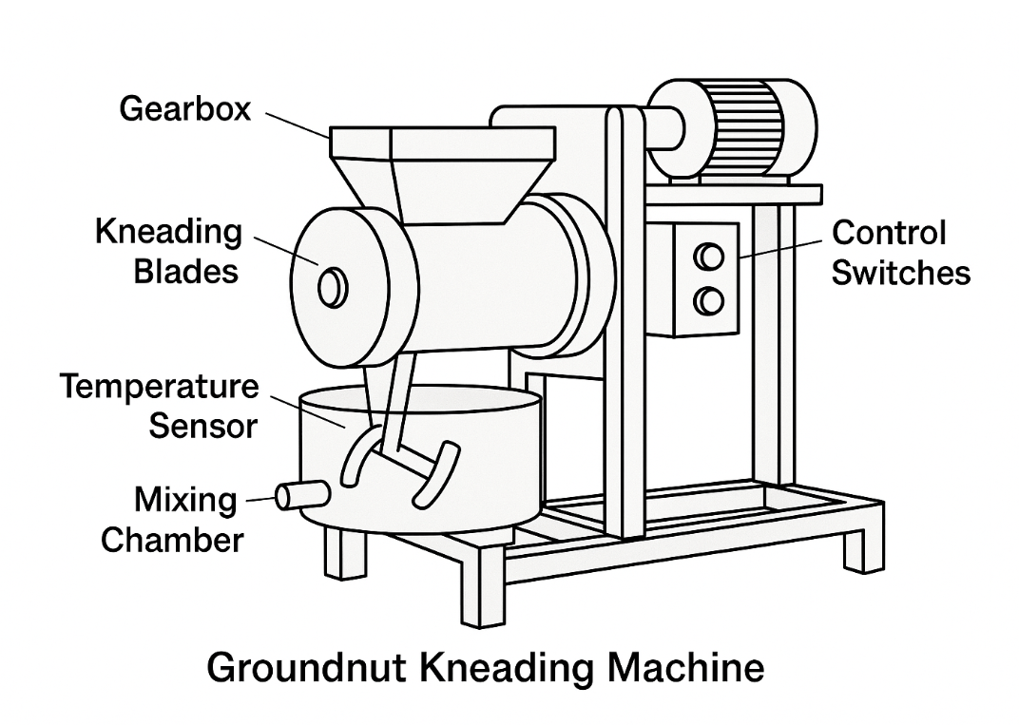

Functions and Advantages:
- Automation of Manual Tasks: Reduces dependency on labor-intensive hand kneading.
- Enhanced Product Consistency: Delivers uniform paste in terms of texture, oil content, and moisture.
- Time and Labor Savings: Increases output while reducing operator fatigue.
- Hygiene Assurance: Machine surfaces can be designed with food-grade stainless steel to prevent corrosion and contamination.
- Adaptability: Some designs allow integration with oil extraction or molding systems for seamless processing.
The development and deployment of efficient kneading machines are vital for modernizing the groundnut value chain, enhancing income generation, and supporting food processing SMEs across Nigeria and other producing countries.

2.4 Factors Affecting Kneading Machine Performance
The performance of a groundnut kneading machine is governed by a complex interplay of mechanical, physical, and material properties. Understanding these factors is essential for optimizing design, improving output quality, and ensuring energy efficiency during operation. The following are key variables that influence the performance of kneading machines in practical applications:
- Moisture Content of the Paste: The moisture content significantly affects the rheological behavior of groundnut paste during kneading. When moisture levels are too high, the paste becomes overly soft and slippery, reducing internal friction and compromising the machine’s ability to effectively mix the content. On the other hand, when the paste is too dry (low moisture content), resistance increases, placing a greater mechanical load on the kneading system and possibly leading to higher energy consumption or machine wear.
- Paste Viscosity: Highly viscous (thicker) groundnut paste requires more torque to knead effectively. If the viscosity exceeds the capacity of the machine's motor or mixing mechanism, it may result in motor overload, excessive power draw, or reduced mixing uniformity. Viscosity management, therefore, is essential to maintain performance and prevent mechanical strain.
- Blade or Paddle Design and Kneading Speed (RPM): The geometry, orientation, and motion pattern of mixing blades or paddles are fundamental to the kneading process. Poorly designed blades may fail to adequately distribute or shear the paste, resulting in uneven kneading. Additionally, the speed of rotation plays a crucial role: high kneading speeds may cause overheating, splattering, or separation of oil from the paste prematurely; conversely, excessively low speeds may lead to prolonged processing times and suboptimal mixing efficiency.
- Load Capacity: Overloading the kneading chamber beyond its designed threshold reduces the effectiveness of mixing, leads to inefficient motion transfer, and increases the risk of mechanical failure. Operating within the recommended load range ensures optimal mixing quality and reduces wear on critical machine components.
- Duration of Kneading: The length of the kneading cycle directly affects paste uniformity and product texture. Insufficient kneading results in an inconsistent mixture, with uneven distribution of oil and solids. Over-kneading, however, may result in heat buildup or undesirable textural changes. Therefore, determining the ideal kneading duration is essential for process optimization.
These variables must be carefully calibrated and monitored to maintain consistent product quality, extend equipment life, and optimize energy use.

2.5 Measurement of Performance Parameters of a Groundnut Kneading Machine
To assess the functional efficiency of a groundnut kneading machine, a range of technical performance parameters are used. These metrics help in evaluating how well the machine meets production targets and inform design improvements or operational adjustments.

2.5.1 Key Performance Parameters
i. Kneading Efficiency (%): This parameter indicates the proportion of the total mass input that has been uniformly kneaded to the desired texture and consistency. It is calculated using the formula:
Kneading Efficiency (%) =(Mass of uniformly kneaded paste
…………(Equation 1)

(Total input mass) × 100
High kneading efficiency reflects effective mechanical mixing and paste uniformity, while lower values suggest process limitations.
ii. Throughput Capacity (kg/h): This measures the machine’s productivity over time, expressed as the total mass of groundnut paste processed per hour. It is calculated as:
Throughput (kg/h) =Total mass of groundnut paste processed
…………(Equation 2)

Time (hours)
This parameter is critical in evaluating the commercial viability of the equipment.
iii. Power Consumption (Watts or kWh): Power usage is monitored to determine the energy cost of operation. It can be measured directly using a wattmeter or calculated based on the machine's electrical specifications as:
Power (W) =Voltage (V) × Current (A)……………………(Equation 3)
Low power consumption at high output is desirable for cost-effective operations.
iv. Mixing Uniformity Index: This is a qualitative and quantitative measure of how uniformly the paste has been mixed. Samples are extracted from various regions within the paste mass and analyzed for differences in texture, oil concentration, and particle distribution. A low variance across samples indicates high uniformity and effective mixing.
v. Temperature Rise (°C): Continuous kneading can generate frictional heat, especially at higher motor speeds. Excessive temperature can negatively affect the quality of the groundnut paste by causing oil separation or altering the flavor profile. Temperature is monitored at specific intervals using embedded sensors or handheld thermometers to ensure it stays within optimal ranges.

2.5.2 Kneading Effects on Product Quality
Kneading exerts a profound influence on the physicochemical and functional properties of groundnut paste. Its effects are not merely mechanical but also determine product acceptability and shelf-life. Proper kneading contributes to:
- Promoting Oil Separation: Mechanical agitation helps rupture cell structures within the paste, facilitating the release of oil, especially important in subsequent oil extraction stages.
- Enhancing Product Quality: A well-kneaded paste has uniform distribution of added ingredients such as salt, sugar, or spices, leading to improved taste, texture, and aesthetic appeal.
- Reducing Air Entrapment: Effective kneading eliminates trapped air bubbles, which is vital for molding operations such as kulikuli or groundnut cake. This results in denser, more cohesive, and structurally stable final products.
Overall, kneading is not only a process of mixing but also a determinant of the sensory and structural attributes of groundnut-based products.

2.5.3 Kneading Throughput
Kneading throughput refers to the rate at which a groundnut kneading machine can process paste within a given time frame, typically expressed in kilograms per hour (kg/h). Throughput is a key indicator of machine productivity and is influenced by several operational factors:
- Motor Speed and Power: Higher motor speeds and stronger torque generally enable faster kneading, although care must be taken to avoid overheating or compromising paste quality.
- Blade or Paddle Efficiency: The design and motion of mixing elements affect how quickly and thoroughly the paste is processed. Efficient blades optimize material movement and shear force application.
- Load Size and Paste Consistency: Larger loads or excessively thick paste can slow down processing speed and reduce throughput due to mechanical resistance.
- Duration of Kneading per Batch: Shorter kneading cycles improve throughput, but only if uniformity and texture requirements are met. Overly long cycles, although possibly beneficial for quality, reduce overall output rate.

CHAPTER THREE
MATERIALS AND METHODS
3.1 MATERIALS
The following materials were used in the performance evaluation of the groundnut paste kneading machine, with each item serving specific functions during the experiment:
- Motorized kneading machine: It is used for kneading the groundnut paste and facilitating oil extraction through agitation and centrifugal action.
- Electric Motor: This is used to power up the kneading machine by transmitting rotational motion to the stirring fingers inside the kneading chamber.
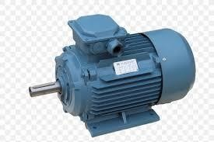

DIAGRAM OF ELECTRIC MOTOR
- Plastic container: Four containers was used for preparing, measuring the sample and also to collect extracted oil from the kneading process for measurement and evaluation.
- Water: This is added gradually during kneading to adjust the consistency of the groundnut paste and aid in efficient oil extraction.
- Digital weighing scale: A digital weighing scale with model No EK5350 with an accuracy of 1g/0.1 oz and maximum of 5kg/11 lb using 2x1.5V AAA battery was used to weigh the groundnut before roasting and after kneading the groundnut paste, measuring the mass of extracted oil after kneading.

DIAGRAM OF DIGITAL WEIGHING SCALE
vi. Stopwatch: It was used to record the duration of the kneading process (kneading time).

DIAGRAM OF STOPWATCH
3.1.1 DESCRIPTION OF THE EXISTING GROUNDNUT KNEADING MACHINE
The existing groundnut kneading machine is a highly advanced machine carefully designed and built to perform the crucial task of kneading groundnuts with efficiency and precision. Its entire design revolves around a robust and unyielding structural integrity provided primarily by the main frame. The foundational element is expertly crafted from high-quality mild steel angle iron characterized by its substantial dimensions of 50 x 50 x 5 mm, this specific material choice and precise sizing are not arbitrary; they are critical in imparting exceptional strength and unwavering stability to the entire apparatus, ensuring that it can withstand the dynamic forces and vibrations inherent in the kneading process without compromising its structural integrity. Every other component of the machine is strategically mounted upon and supported by this central framework, establishing a cohesive and resilient assembly. The power heart of this machine is an adequately sized 5 hp single-phase electric motor. This motor is not merely placed on the machine, it is securely and firmly affixed to the motor base through a combination of bolts and nuts eliminating any potential for movement or instability during operation, note this secure mounting is paramount for the efficient and safe transmission of power. The energy generated by this motor is then meticulously transferred to the operational kneading mechanism through a classic yet highly effective belt drive system which involves a precisely aligned pulley mounted directly onto the motor shaft, in turn drives a corresponding pulley situated on the main body of the machine. This methodical arrangement ensures a smooth, consistent and highly efficient transfer of rotational energy from the power source to the working parts. A pivotal element in the machine's operational efficacy is the integrated gearbox, it is not a customfabricated component but rather a standard commercially available off-the-shelf unit selected for its proven reliability and performance. The gearbox serves two critical functions: It precisely regulates the rotational speed of the system ensuring that the kneading process occurs at an optimal pace and more importantly, it expertly changes the direction of power transmission. The electric motor typically generates a horizontal rotary motion but for effective kneading a vertical rotary motion is required, the gearbox seamlessly facilitates this transformation. Crucially, this directional change is accompanied by a significant multiplication of torque i.e amplified twisting force is absolutely essential for effectively processing the dense and often resistant groundnut mixture, allowing for thorough and consistent kneading without straining the motor or other components. The actual kneading operation takes place within the confines of the kneading pot, a vital component fabricated from high-grade stainless steel sheet(superior durability, resistance to corrosion and compliance with hygienic standards, which is paramount when dealing with food products). This pot is uniformly sized featuring a diameter and height of 300 mm each, providing ample space for the groundnut paste. Central to the kneading action is the kneading shaft, also meticulously crafted from durable stainless steel which shaft measures 500 mm in length and possesses a diameter of 25 mm, dimensions carefully chosen to withstand the forces involved.
This shaft is directly coupled to the output of the gearbox via a robust bolted connection ensuring that all the enhanced torque is directly and efficiently transferred to the kneading element. Finally, and perhaps most indicative of the machine's specialized function, a precisely designed stirrer is permanently welded to the kneading shaft where its specific shape and configuration are engineered to optimize the groundnut kneading process ensuring that the groundnuts are uniformly mixed, thoroughly broken down and kneaded to the desired consistency, ultimately leading to a high-quality end product.
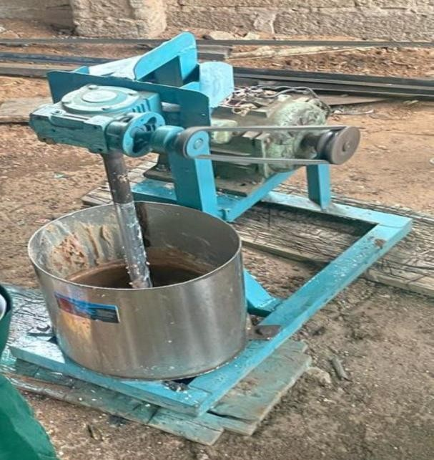
EXISTING MOTORIZED GROUNDNUT KNEADING MACHINE
3.2 Methods
All instruments for experiment were calibrated before use to ensure the accuracy and reliability of the data collected. The methodology consisted of three main stages; Sample preparation, kneading operation and performance evaluation.
3.2.1 Sourcing of test materials
Groundnuts was sourced from a local market in Ilorin West Local Government Area, Kwara State Nigeria.
3.2.2 SAMPLE PREPARATION
The groundnut was cleaned and sorted to remove any foreign materials such as stones and pebbles, which were then measured into various samples of 1000g, 1500g and 2000g using a digital weighing scale. Prior to the kneading operation, the groundnuts were roasted to make it easier to remove their skins, and then they were winnowed. The roasted groundnuts were then milled with the following ingredients; onion, dried pepper, garlic, ginger, salt and sugar, with the addition of potash (inhibit sourness and enhance oil yield during kneading) to convert it into paste. The ingredients were incorporated to improve the flavor profile of the paste, ensuring that the taste quality aligns with consumer preferences for locally processed groundnut products. The milled groundnut paste weighing serves as the primary input material for the kneading machine, with its quality directly influencing the efficiency of oil extraction and the overall characteristics of the final product evaluated in this performance study.
ROASTING OF GROUNDNUT


IMAGE OF WINNOWING


GROUNDNUT PASTE


3.2.3 KNEADING OPERATION
The prepared groundnut paste weighing 1000g, 1500g and 2000g per was fed into the kneading pot of the motorized groundnut kneading machine which was powered by the electric motor of 3hP at varying speed of 1200, 1500 and 1800 rpm respectively while also varying the kneading time 2, 4 and 6 minutes respectively according to the design layout. The paste was mixed thoroughly by the r1otating fingers inside the kneader, facilitating oil separation through mechanical agitation and centrifugal action. Warm water was added gradually to the paste to improve its fluidity and support oil release while salt and sugar were added during kneading to enhance the taste of the resulting product.
Output Parameters
KNEADING EFFICIENCY
Kneading efficiency refers to the effectiveness of a kneader in extracting oil from groundnut paste relative to the potential oil available in the paste (Sulaiman et al., 2023).
𝜂 = 𝑊o × 100
𝑊p
Where: η = Kneading efficiency (%)
𝑊𝑜 = Mass of oil extracted (kg)
𝑊𝑝 = Mass of groundnut paste (kg)
Machine Capacity
Machine capacity is the rate at which the kneader processes the groundnut paste within a unit time. It indicates how fast the machine is able to knead and prepare the paste for oil extraction (Gyuse & Yiljep, 2008).
Rk=Wp
Tk
Where: Rk = Machine capacity (kg/min or kg/h)
Wp = Weight of groundnut paste kneaded (kg)
Tk = Time taken for kneading (min or h)
Design Layout
 |  | Factor 1 | Factor 2 | Factor 3 | Response 1 | Response 2
Std | Run | A:Mass of sample | B:Machine Speed | C:kneading Duration | Machine Capacity | Kneading Efficiency
 |  | g | rpm | min | Kg/h | %
4 | 1 | 2000 | 1800 | 4
11 | 2 | 1500 | 1200 | 6
2 | 3 | 2000 | 1200 | 4
13 | 4 | 1500 | 1500 | 4
6 | 5 | 2000 | 1500 | 2
8 | 6 | 2000 | 1500 | 6
14 | 7 | 1500 | 1500 | 4
15 | 8 | 1500 | 1500 | 4
10 | 9 | 1500 | 1800 | 2
16 | 10 | 1500 | 1500 | 4
17 | 11 | 1500 | 1500 | 4
3 | 12 | 1000 | 1800 | 4
1 | 13 | 1000 | 1200 | 4
12 | 14 | 1500 | 1800 | 6
7 | 15 | 1000 | 1500 | 6
9 | 16 | 1500 | 1200 | 2
5 | 17 | 1000 | 1500 | 2

CHAPTER FOUR
RESULTS AND DISCUSSION
4.1 Results
The results obtained from the performance evaluation of the groundnut kneading machine were presented in table 4.1 below.
Table 4.1: Results Obtained from the Kneading of Groundnut Paste
 |  | Factor 1 | Factor 2 | Factor 3 | Response 1 | Response 2
Std | Run | A:Mass of sample | B:Machine Speed | C:kneading Duration | Machine Capacity | Kneading Efficiency
 |  | g | rpm | min | Kg/h | %
4 | 1 | 2000 | 1800 | 4 | 30 | 85.34
11 | 2 | 1500 | 1200 | 6 | 15 | 83.63
2 | 3 | 2000 | 1200 | 4 | 30 | 84.57
13 | 4 | 1500 | 1500 | 4 | 22.5 | 84.62
6 | 5 | 2000 | 1500 | 2 | 60 | 83.27
8 | 6 | 2000 | 1500 | 6 | 20 | 83.54
14 | 7 | 1500 | 1500 | 4 | 22.5 | 84.62
15 | 8 | 1500 | 1500 | 4 | 22.5 | 84.62
10 | 9 | 1500 | 1800 | 2 | 36 | 84.9
16 | 10 | 1500 | 1500 | 4 | 22.5 | 84.62
17 | 11 | 1500 | 1500 | 4 | 22.5 | 84.62
3 | 12 | 1000 | 1800 | 4 | 15 | 83.88
1 | 13 | 1000 | 1200 | 4 | 15 | 83.19
12 | 14 | 1500 | 1800 | 6 | 15 | 84.03
7 | 15 | 1000 | 1500 | 6 | 10 | 82.72
9 | 16 | 1500 | 1200 | 2 | 45 | 84.11
5 | 17 | 1000 | 1500 | 2 | 30 | 83.59

Discussion
Based on the analysis of the experimental results, a clear and significant relationship emerges between the operational parameters and the machine's performance. The statistical analysis (ANOVA) for machine capacity reveals that the mass of the sample and the kneading duration are the most dominant factors (p<0.0001). This is expected, as capacity is a direct function of mass processed over time. Interestingly, machine speed was not a statistically significant factor for capacity (p=0.1847), suggesting a complex interaction where the potential increase in processing speed may be counteracted by factors such as increased frictional heat, which can alter the paste's consistency and impede its flow. The significant interaction between sample mass and duration (p=0.0024) further indicates that the effect of processing time on throughput is dependent on the batch size.
When evaluating kneading efficiency, the driving factors shift. Here, both the mass of the sample (p=0.0090) and the machine speed (p=0.0252) were found to be significant, while kneading duration was not (p=0.0753). This implies that the quality of the kneading is more dependent on the amount of mechanical energy imparted to the paste rather than simply the time of operation. The most critical finding for efficiency is the high significance of the quadratic terms for both sample mass (p=0.0057) and kneading duration (p=0.0031).
This points to a non-linear relationship and the existence of an optimal point for these parameters. Exceeding these optimal levels; for instance, by using too large a sample mass or over-kneading the paste, can lead to a decrease in efficiency, likely due to the creation of under-processed zones or heat-induced degradation of the product.
The results highlight a classic optimization dilemma: the conditions that maximize throughput are not the same as those that maximize quality. The highest machine capacity (60 kg/h) was achieved with a large sample mass (2000 g) and a short duration (2 min), prioritizing speed. In contrast, the highest kneading efficiency (85.34%) was achieved with a large mass (2000 g) but a higher speed (1800 rpm) and a longer duration (4 min), prioritizing process quality. This trade-off means the machine's optimal settings depend on the operator's economic goals, whether that is minimizing operational costs or maximizing yield from raw materials. Compared to other studies, the performance of this machine is highly competitive, with its peak capacity and efficiency values meeting or exceeding those reported for similar kneaders.

Table 4.2: Analysis of Variance (ANOVA) for the Machine Capacity
Source | Sum of Squares | Df | Mean Square | F-value | p-value
Model | 2465.25 | 9 | 273.92 | 58.55 | < 0.0001 | significant
A-Mass of sample | 612.50 | 1 | 612.50 | 130.92 | < 0.0001
B-Machine Speed | 10.13 | 1 | 10.13 | 2.16 | 0.1847
C-kneading Duration | 1540.13 | 1 | 1540.13 | 329.19 | < 0.0001
AB | 0.0000 | 1 | 0.0000 | 0.0000 | 1.0000
AC | 100.00 | 1 | 100.00 | 21.37 | 0.0024
BC | 20.25 | 1 | 20.25 | 4.33 | 0.0760
A² | 5.33 | 1 | 5.33 | 1.14 | 0.3213
B² | 5.33 | 1 | 5.33 | 1.14 | 0.3213
C² | 171.12 | 1 | 171.12 | 36.57 | 0.0005
Residual | 32.75 | 7 | 4.68
Lack of Fit | 32.75 | 3 | 10.92
Pure Error | 0.0000 | 4 | 0.0000
Cor Total | 2498.00 | 16
*Significant @P≤0.05

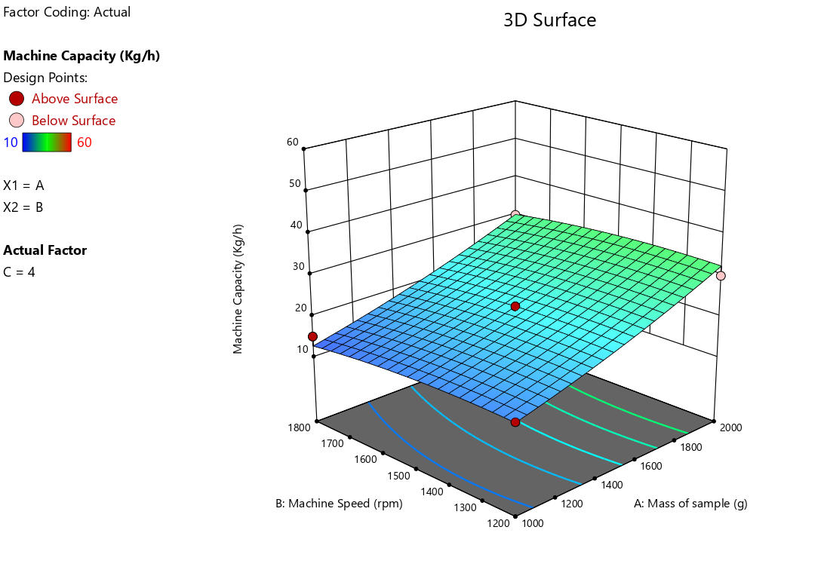
Fig 4.1: Effect of Mass of Sample and Machine Speed on the Machine Capacity of the Machine
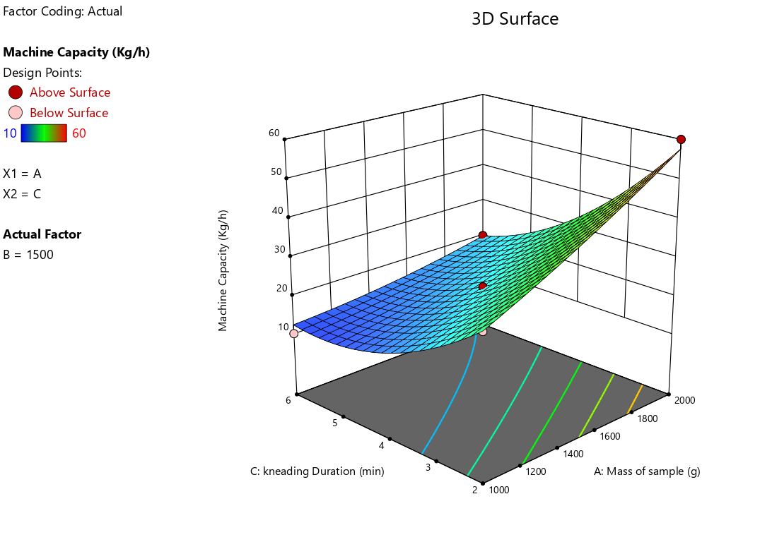
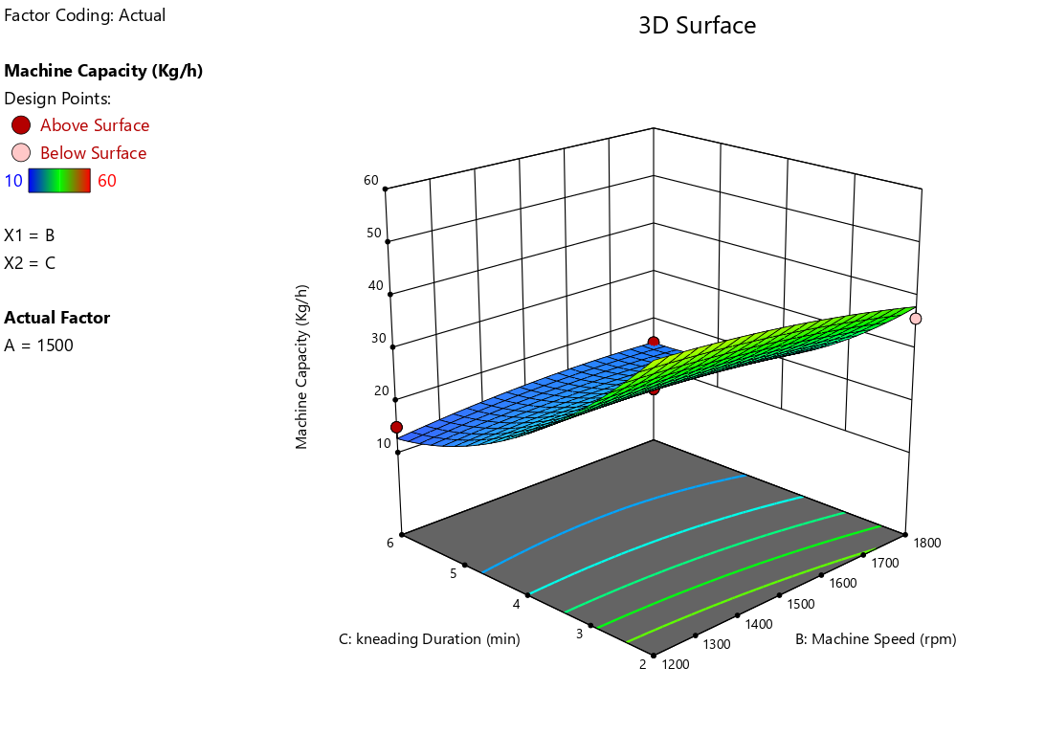
Fig 4.2: Effect of Mass of Sample and Kneading Duration on the Machine Capacity of the Machine
Fig 4.3: Effect of Machine Speed and Kneading Duration on the Machine Capacity of the Machine

Table 4.2: Analysis of Variance (ANOVA) for the Kneading Efficiency
Source | Sum of Squares | Df | Mean Square | F-value | p-value
Model | 7.25 | 9 | 0.8060 | 7.39 | 0.0076 | significant
A-Mass of sample | 1.39 | 1 | 1.39 | 12.78 | 0.0090
B-Machine Speed | 0.8778 | 1 | 0.8778 | 8.04 | 0.0252
C-kneading Duration | 0.4753 | 1 | 0.4753 | 4.36 | 0.0753
AB | 0.0016 | 1 | 0.0016 | 0.0147 | 0.9070
AC | 0.3249 | 1 | 0.3249 | 2.98 | 0.1281
BC | 0.0380 | 1 | 0.0380 | 0.3485 | 0.5735
A² | 1.68 | 1 | 1.68 | 15.37 | 0.0057
B² | 0.2765 | 1 | 0.2765 | 2.53 | 0.1555
C² | 2.12 | 1 | 2.12 | 19.38 | 0.0031
Residual | 0.7639 | 7 | 0.1091
Lack of Fit | 0.7639 | 3 | 0.2546
Pure Error | 0.0000 | 4 | 0.0000
Cor Total | 8.02 | 16
*Significant @P≤0.05

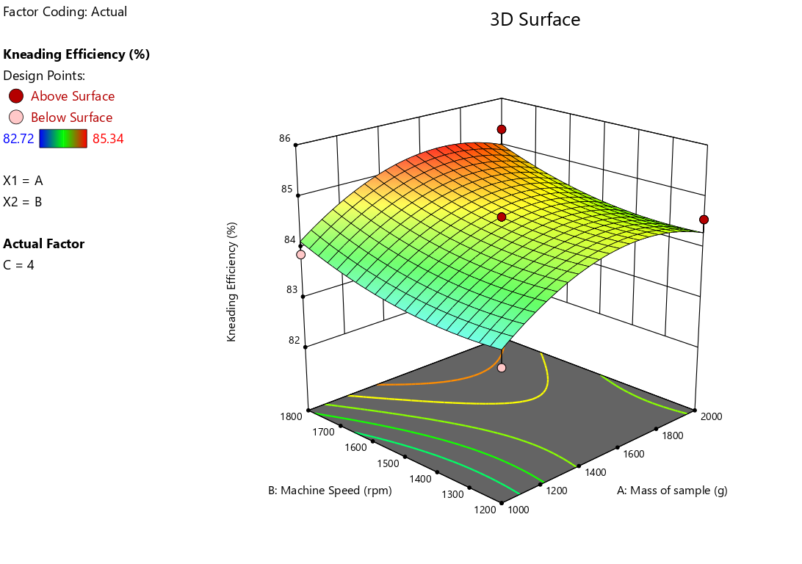

Fig 4.4: Effect of Mass of Sample and Machine Speed on the Machine Capacity of the Machine

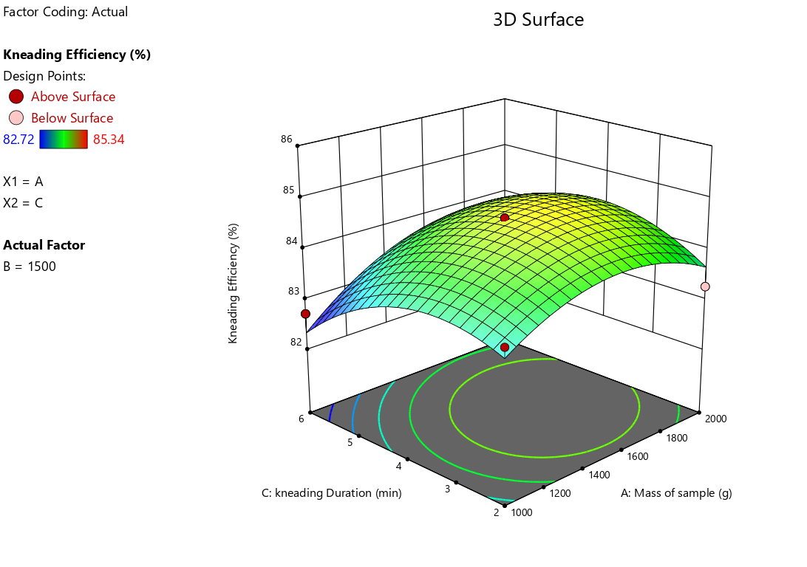
Fig 4.5: Effect of Mass of Sample and Kneading Duration on the Machine Capacity of the Machine
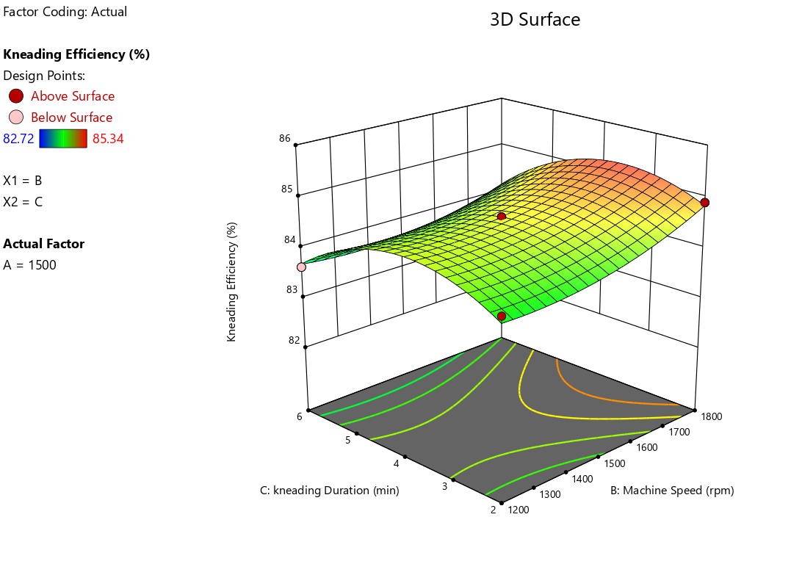
Fig 4.6: Effect of Machine Speed and Kneading Duration on the Machine Capacity of the Machine

CHAPTER FIVE
CONCLUSION AND RECOMMENDATION
5.1 Conclusion
This study successfully evaluated the performance of a motorized groundnut kneading machine by analyzing the influence of three key operational parameters—mass of sample, machine speed, and kneading duration—on two primary responses: machine capacity and kneading efficiency. The investigation revealed distinct between the operational settings and the performance outcomes.
In conclusion, the motorized groundnut kneading machine demonstrates highly competitive performance when benchmarked against similar equipment in the literature.
5.2 Recommendations
Based on the findings of this study, the following recommendations are proposed for both the industrial application of the machine and for guiding future research in this area.
- Different Varieties of groundnut should be used to test the machine.
- Other oil bearing seeds such as shea nut, melon e.t.c. should be used to test the performance of the machine to make it multi crop.

