DEVELOPMENT OF A PROTOTYPE SOLAR AUTOMATED COCOA SEED DRYER (Theoboma cacao)

BY

ANJORIN MARY PRECIOUS
ND/23/ABE/FT/0032

BEING A PROJECT SUBMITTED TO
THE DEPARTMENT OF AGRICULTURAL AND BIO-ENVIRONMENTAL ENGINEERING TECHNOLOGY, INSTITUTE OF TECHNOLOGY,
KWARA STATE POLYTECHNIC ILORIN, KWARA STATE

IN PARTIAL FULFILLMENT OF THE REQUIREMENT FOR THE AWARD OF NATIONAL DIPLOMA (ND) IN AGRICULTURAL TECHNOLOGY, KWARA STATE POLYTECHNIC ILORIN, KWARA STATE

2024/2025 SESSION

CERTIFICATION
This is to certify that this project has been read and approved as meeting the requirement of the Department of Agricultural And Bio-environmental Engineering Technology, Institute of Technology, Kwara State Polytechnic, Ilorin for the award of National Diploma in Agricultural And Bio-environmental Engineering Technology.

____________________ ________________
ENGR, OYEBANRE OLUFEMI DAVID DATE
Project Supervisor

____________________ ________________
ENGR, OYEBANRE OLUFEMI DAVID DATE
Project Coordinator

____________________ __________________
ENGR.DAUDA K.A DATE
Head of Department

ENGR. DR. MRS. YUSUF R.O DATE
External Examiner

DEDICATION
This project is dedicated to Almighty God for the grace given to me to successfully finish this project work.

ACKNOWLEDGEMENT
My candid gratitude goes to the Lord of universe, the beginning and end, the alpha and omega for sparing my life and bestowing his continuous protection, guidance, mercy, love and blessing throughout my program.
More so, this research is impossible to achieve alone, I sincerely acknowledge and appreciate the effort of my amiable supervisor, Engr. Oyebanre Olufemi who despite his tight schedule found time to vet, scrutinize the project and ensured that it made a brilliant contribution to my academic knowledge.
My appreciation also goes to the Head of Department, and other lectures in the great department of Agricultural And Bio-environmental Engineering Technology for their impacts towards the success of my course.
It is a great pleasure to express my special thanks to my lovely and adorable parents for giving me their moral advice and financial supports. I pray Almighty God grant them long life, prosperity and make them enjoy the fruit of their labor.

TABLE OF CONTENTS
FRONT PAGE
CERTIFICATION ..........................................................................................................................ii
DEDICATION ...............................................................................................................................iii
ACKNOWLEDGEMENT .............................................................................................................iv
CHAPTER ONE ..........................................................................................................................1
INTRODUCTION .......................................................................................................................1
  - Background of the Study .........................................................................................................1
  - Problem Statement ............................ ………………………………………………………..2
1.3 Aim .................................................. …………………………………………………………3
1.4 Objectives ......................................... ………………………………………………………...3
1.5 Significance of the Study .........................................................................................................4
1.6 Scope of the Study ...................................................................................................................5
1.7 Limitations of the Study ..........................................................................................................6
CHAPTER TWO .........................................................................................................................7
LITERATURE REVIEW ...........................................................................................................7
2.1 Overview .................................................................................................................................7
2.2 Cocoa Processing: Post-Harvest Overview ............................................................................8
2.3 Traditional Cocoa Drying Methods ........................................................................................9
2.4 Solar Drying Technologies .....................................................................................................10
2.5 Automation in Agricultural Drying Systems ..........................................................................12
2.6 Renewable Energy and Solar Drying ......................................................................................13
2.7 Design Considerations for Cocoa Dryers ................................................................................14
2.8 Challenges in Current Cocoa Drying Technologies ..............................................................15
2.9 Identified Gaps in Literature ..................................................................................................16
2.10 Summary of Critical Review ...............................................................................................18
CHAPTER THREE ..................................................................................................................19
MATERIALS AND METHODS .............................................................................................19
3.1 Design Considerations ..........................................................................................................19
3.2 Description of the Hybrid Dryer ...........................................................................................20
3.3 Principle of Operation of the Hybrid Dryer ..........................................................................26
3.4 Experimental Procedure ........................................................................................................27
3.5 Material Used for Construction .............................................................................................28
3.6 Machine Parts’ List ................................................................................................................29
3.7 Tools and Equipment .............................................................................................................30
3.8 Design Layout ........................................................................................................................32
3.9 Experimental Runs and Design Matrix ..................................................................................34
CHAPTER FOUR ......................................................................................................................36
RESULTS AND DISCUSSION ................................................................................................36
4.1 Results ....................................................................................................................................36
4.2 Discussion ..............................................................................................................................37
CHAPTER FIVE ........................................................................................................................40
CONCLUSION AND RECOMMENDATIONS .....................................................................40
5.1 Conclusion .............................................................................................................................40
5.2 Recommendations .................................................................................................................41
5.3 Suggestions for Further Research .........................................................................................42
REFERENCES .........................................................................................................................43

CHAPTER ONE

INTRODUCTION

1.1 Background of the Study
Cocoa (Theobroma cacao) is one of the most economically valuable crops grown in tropical regions, particularly in West Africa, where countries like Nigeria, Ghana, and Côte d'Ivoire dominate global production. Cocoa plays a central role in the economies of these countries, not only in terms of foreign exchange earnings but also as a major source of income for smallholder farmers. In Nigeria alone, cocoa accounts for a significant portion of agricultural exports, supporting thousands of rural households across cocoa-growing belts in states such as Ondo, Cross River, Ekiti, Ogun, and Osun.
A critical stage in the post-harvest processing of cocoa is drying. Proper drying is essential to preserve the chemical composition, flavor, and shelf-life of cocoa beans. The drying process halts fermentation, reduces moisture content to safe levels (typically around 6–8%), and prepares the beans for storage or export. However, the drying methods traditionally employed in Nigeria are mostly rudimentary, relying on sun-drying techniques that expose cocoa beans to inconsistent weather conditions, pest infestation, microbial contamination, and significant post-harvest losses.
In most rural communities, cocoa beans are spread on tarpaulins, mats, concrete floors, or raised wooden platforms and left to dry in the sun over several days. This method is not only time-consuming but also highly susceptible to rain interruptions, dust, animal droppings, and uneven drying. The result is a batch of cocoa beans with varying moisture levels, mold development, and reduced quality, factors that directly affect the final product's value and compliance with international market standards.
To address these challenges, researchers and engineers have increasingly turned to alternative drying technologies that offer better control over drying parameters, protect the beans from contamination, and improve efficiency. Among these, solar drying has gained attention as a renewable, cost-effective, and sustainable solution, especially suitable for off-grid rural communities.
Furthermore, recent advances in agricultural automation and embedded systems have opened the door to automated solar drying systems that incorporate sensors, controllers, and actuators to monitor and regulate temperature, humidity, and airflow in real-time. Such innovations offer tremendous potential for improving the consistency, quality, and safety of dried cocoa beans.
This project therefore focuses on the development of a prototype solar-powered automated cocoa seed dryer tailored to the environmental and socio-economic conditions of smallholder cocoa farmers in Nigeria. The system will leverage renewable energy, modern control technology, and local material availability to demonstrate a scalable solution to one of the most persistent problems in cocoa post-harvest handling.

1.2 Problem Statement

Despite its potential and contribution to the Nigerian economy, cocoa farming continues to be hindered by post-harvest inefficiencies, chief among them being the drying process. The continued reliance on open-air sun drying introduces a range of issues:
- Inconsistent drying due to weather fluctuations (sun, rain, humidity).
- Exposure to contaminants, including dust, insects, birds, rodents, and human activity.
- Labor-intensive operations with high opportunity costs.
- Non-uniform moisture levels leading to poor-quality beans and market rejection.
- Post-harvest losses, particularly during the rainy season.
These problems lead to low income for farmers, loss of market value, and poor competitiveness of Nigerian cocoa in the global export market. Although mechanical and electric dryers exist, they are often expensive, require grid electricity (which is unreliable or unavailable in rural areas), and are not designed for small-scale operations.
There is an urgent need for a low-cost, energy-efficient, and automated cocoa drying system that leverages Nigeria’s abundant solar energy to deliver consistent, contamination-free drying results without heavy reliance on manual labor or grid power.

1.3 Aim

To design, develop, and test a prototype solar-powered automated cocoa seed dryer that improves drying efficiency, enhances bean quality, and minimizes post-harvest losses.

1.4 Objectives
- to design a solar dryer system using direct and/or indirect solar thermal principles suitable for cocoa bean drying.
- to integrate automation features using sensors (temperature, humidity), a microcontroller (e.g., Arduino), and control logic to regulate drying conditions.
- to fabricate a working prototype using cost-effective and locally available materials.
- to conduct performance tests of the prototype in real or simulated conditions.
- to analyze the efficiency, drying time, energy use, and quality of beans produced compared to traditional sun drying methods.

1.5 Significance of the Study
The significance of this study lies in its potential to address a long-standing challenge in the cocoa value chain, inefficient and unhygienic drying methods that compromise the quality and marketability of cocoa beans. By developing a solar-powered automated drying system, this project proposes a sustainable solution that aligns with the goals of modern agriculture, energy efficiency, and rural economic development. The system will reduce the dependency on traditional sun drying methods, which are often unreliable due to unpredictable weather conditions and prone to contamination by foreign materials, pests, and microorganisms.
From a technological perspective, this project introduces a low-cost, replicable model that incorporates automated controls to monitor and regulate critical drying parameters such as temperature and humidity. This innovation has the potential to improve product consistency, reduce labor input, and minimize post-harvest losses. In doing so, it empowers smallholder farmers who form the backbone of cocoa production in Nigeria with a tool that can enhance the value of their produce and enable them to meet international quality standards.
Economically, the adoption of such technology could significantly boost farmers’ earnings by producing higher-quality beans that attract premium prices in local and international markets. Environmentally, the use of solar energy as the primary power source makes the system both clean and renewable, reducing reliance on fossil fuels and contributing to climate change mitigation. Socially, this project can serve as a model for community-based agricultural innovations that promote self-reliance, knowledge transfer, and job creation through local fabrication and maintenance.
Moreover, the findings from this research will contribute to the growing body of academic and practical knowledge in the fields of post-harvest engineering, agricultural automation, and renewable energy integration. It will also lay the groundwork for future research, scale-up initiatives, and policy interventions aimed at strengthening Nigeria’s position in the global cocoa economy.

1.6 Scope of the Study
This study is primarily focused on the conceptualization, design, development, and performance evaluation of a prototype solar-powered automated dryer specifically tailored for drying cocoa seeds. The scope encompasses the application of solar thermal principles, either through direct or indirect drying methods, to create a system that can effectively reduce the moisture content of cocoa beans to a safe storage level. The dryer will be equipped with automated control features, including sensors for monitoring temperature and humidity, and a microcontroller to regulate internal conditions.
The fabrication process will utilize readily available and cost-effective local materials such as wood, glass, metal sheets, fans, and thermal insulation components. The system will be constructed to handle a small-scale batch size suitable for prototype testing and demonstration purposes. This prototype will be evaluated under simulated or real drying conditions, with performance metrics such as drying efficiency, moisture content reduction, temperature regulation, and time-to-dry being measured and analyzed. The project is strictly limited to developing a functional prototype; it does not extend into full industrial production or economic feasibility studies for mass manufacturing, though recommendations for future upscaling will be provided.

1.7 Limitations of the Study
Several constraints are recognized in the execution of this project, which may affect the generalizability or scalability of the results. Firstly, the system is developed on a small scale and is intended to demonstrate the working principles of solar-powered and automated drying, rather than to meet the full drying needs of commercial cocoa processors. Consequently, the prototype's drying capacity may not reflect the realities of large-scale industrial operations.
Secondly, the selection of materials and components is largely influenced by availability and cost, which may limit the optimization of thermal insulation, heat retention, and long-term durability of the system. Additionally, while the dryer is powered by solar energy, its effectiveness is still dependent on the presence of sufficient solar radiation. In regions or periods with limited sunlight, the system's drying efficiency may be compromised unless supplemented with alternative energy sources, which are beyond the scope of this study.
Moreover, the automation features implemented in this prototype are designed with budget-conscious limitations, and may not incorporate advanced capabilities such as remote monitoring, machine learning optimization, or data logging over extended periods. Lastly, the testing phase will be conducted over a relatively short time frame, and therefore may not fully capture seasonal variations, long-term reliability, or user adaptability in real-world farming contexts.

CHAPTER TWO

LITERATURE REVIEW

2.1 Overview
This chapter presents a critical review of relevant literature surrounding cocoa post-harvest processing, solar drying technologies, agricultural automation, and energy efficiency. Emphasis is placed on the technological evolution of drying systems, integration of sensors and controls, and sustainability in rural agricultural operations. This review also highlights existing gaps and informs the design considerations for the development of a solar-powered automated cocoa seed dryer.

2.2 Cocoa Processing: Post-Harvest Overview
Cocoa processing begins immediately after harvest and involves fermentation and drying, both of which are crucial to flavor development and preservation. Once harvested, cocoa beans are typically fermented for 5–7 days to initiate enzymatic and microbial reactions that enhance flavor precursors. After fermentation, the beans must be dried to reduce their moisture content from 55–60% to about 6–8%, suitable for safe storage and transportation (Afoakwa et al., 2021). Inadequate drying affects chemical composition, leads to mold growth, and results in low-quality beans that are often rejected in export markets (FAO, 2022).
This figure below visualizes the overall process and emphasizes how drying fits into the larger cocoa processing chain.
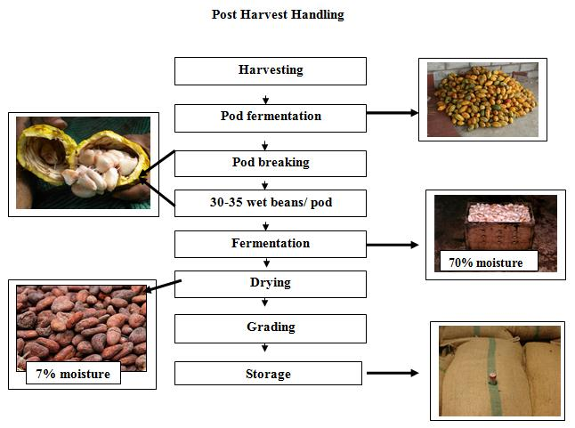Figure 2.1: Post-harvest processing stages of cocoa (Theobroma cacao), highlighting the drying phase.
Source: FAO. (2022). Cocoa market report. Rome: Food and Agriculture Organization.

2.3 Traditional Cocoa Drying Methods
The most common drying technique in rural West Africa is open sun drying. Beans are spread on mats, tarpaulins, concrete slabs, or bamboo racks. This method is simple and cost-effective but is highly inefficient and unpredictable. It is weather-dependent, leading to frequent interruptions during rainy periods and exposing beans to contaminants like dust, insects, rodents, and animal droppings (Olukunle et al., 2020).
Drying times with open sun methods range from 5 to 14 days depending on sunlight intensity, ambient humidity, and ventilation. Additionally, beans are often unevenly dried, resulting in internal mold growth and discoloration. These limitations have prompted the exploration of improved drying technologies (Idowu et al., 2021).
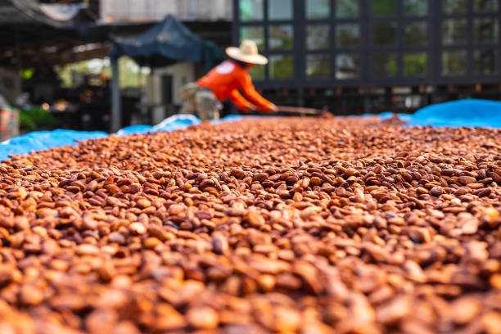
Figure 2.2: Traditional cocoa drying method

2.4 Solar Drying Technologies
Solar drying is the process of utilizing solar radiation either directly or indirectly to remove moisture from agricultural produce. Solar dryers come in three main types: direct solar dryers (where the product is exposed to sunlight in an enclosed chamber), indirect solar dryers (where air is heated separately and circulated over the product), and hybrid solar dryers (which combine solar with auxiliary heating sources) (Bala et al., 2022).
Recent studies emphasize the advantages of solar drying over traditional sun drying, including shorter drying time, reduced contamination, and improved product quality (Sahu et al., 2023). Indirect solar dryers are especially useful for preserving product color and aroma since the beans are not directly exposed to UV radiation.
In a 2021 study by Okonkwo et al., a passive indirect solar dryer reduced cocoa drying time by 30% while maintaining better color and bean texture. Similarly, Ajayi and Adesina (2022) developed a solar cabinet dryer that achieved uniform drying within 72 hours and significantly reduced microbial load compared to open drying.
The figure below helps to visually distinguish dryer categories.
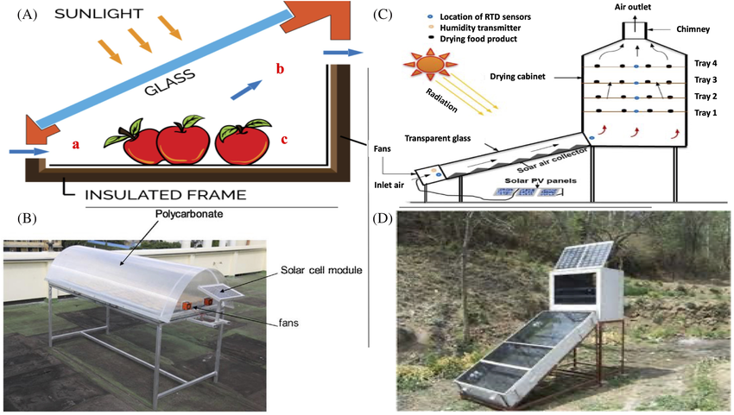
Figure 2.3: Common types of solar dryers: direct, indirect, and hybrid systems.
Source: Bala, B. K., Mondol, M. R. A., & Hossain, M. A. (2022). Solar drying: Fundamentals, design, modeling and applications. Springer Nature.

2.5 Automation in Agricultural Drying Systems
Automation in drying systems introduces precision and consistency. With embedded systems such as Arduino, Raspberry Pi, and programmable logic controllers (PLCs), it's now feasible to develop low-cost, smart dryers that sense temperature, humidity, and airflow, and make real-time adjustments (Ikechukwu et al., 2020).
Sensors such as DHT22 for humidity and temperature sensing, relays for heater/fan activation, and LCD displays for real-time monitoring are common components in automated drying systems. These technologies improve drying efficiency, reduce labor input, and protect the product from overheating or under-drying (Emmanuel et al., 2023).
Several researchers have demonstrated success with automated drying systems. Bello and Ogunlade (2021) implemented an Arduino-based control system for drying tomato slices, achieving stable temperatures and reducing energy waste. While such automation is more commonly seen in fruits and grains, its application in cocoa drying remains limited, particularly in rural contexts where affordability and simplicity are key.
The figure below clearly explain the automation in agricultural drying system
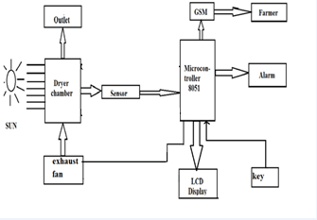
Figure 2.4: Block diagram of an automated agricultural drying control system.
Source: Emmanuel, A. E., & Adisa, A. O. (2023). Temperature and humidity controlled fruit dryer using microcontroller. Heliyon, 9(3), e14233.

2.6 Renewable Energy and Solar Drying
Solar energy, being abundant in tropical regions, is a logical energy source for agricultural processing. The Global Solar Atlas (2023) ranks Nigeria among the highest solar irradiance regions globally, with an average solar potential of 5.5 kWh/m²/day.
Harnessing this energy via solar thermal collectors for drying is both economically and environmentally beneficial. It reduces carbon emissions, lowers energy costs, and provides independence from erratic power grids (Adetona et al., 2022).
Recent work by Omole et al. (2021) shows that integrating photovoltaic (PV) panels with solar dryers to power exhaust fans and microcontrollers improves airflow and control precision. This hybrid approach ensures efficient drying even during periods of reduced sunlight.

2.7 Design Considerations for Cocoa Dryers
Designing a cocoa dryer involves multiple variables: chamber insulation, air flow rate, drying bed thickness, solar collector efficiency, and control accuracy. The drying chamber must allow sufficient air exchange while preventing heat losses. The drying tray material should be non-corrosive and heat-conductive (Taiwo & Olalekan, 2020).
Temperature ranges between 40°C to 60°C are ideal for cocoa beans; anything higher may degrade flavor compounds. Humidity control is equally critical, and automated venting systems are often employed. A well-designed solar dryer must also be portable, affordable, and easy to maintain in rural communities (Udo et al., 2023).

2.8 Challenges in Current Cocoa Drying Technologies
Despite technological progress, several challenges persist:
- Many existing dryers are too expensive or complex for rural users.
- Local material adaptation is often lacking in imported designs.
- Solar dryers are still dependent on consistent sunlight and may underperform during overcast or rainy days.
- Most automated dryers are built for crops like cassava, maize, or tomato, not cocoa.
These issues highlight the need for localized solutions that balance cost, simplicity, and technological effectiveness.
Table 2.1: Comparative Analysis of Sun Drying and Solar Drying Systems
Parameter | Sun Drying | Solar Drying
Drying Time | 5–14 days depending on weather | 2–4 days with controlled environment
Weather Dependency | Highly dependent on sunshine and clear skies | Less dependent; enclosed system allows partial drying on cloudy days
Contamination Risk | High (dust, insects, animal droppings, human traffic) | Low (beans enclosed in chamber)
Moisture Uniformity | Often uneven, leading to mold or overdried beans | Uniform drying due to regulated heat and airflow
Labor Intensity | High (manual turning, covering during rain, constant monitoring) | Low (automated control and enclosed setup)
Energy Source | Free solar radiation | Free solar radiation (with possible fan/automation power backup)
Product Quality | Inconsistent; often below export standards | Improved flavor, texture, and chemical composition
Initial Investment | Very low (minimal or no materials needed) | Moderate (cost of materials, sensors, fabrication)
Scalability | Low (requires large open space) | Medium to high (modular, stackable trays, portable design)

Source: Adapted from Bala et al. (2022); Okonkwo et al. (2021); FAO (2022); Emmanuel & Adisa (2023).

2.9 Identified Gaps in Literature
The review of existing literature reveals that:
- There is limited integration of low-cost automation in cocoa drying, especially at the prototype level.
- Most solar dryers in use do not feature adaptive controls or feedback mechanisms.
- Few studies have focused on real-time monitoring or cloud-based data logging in rural environments.
- Designs are rarely optimized for cocoa-specific drying kinetics and energy models.
This project seeks to bridge these gaps by developing a smart solar dryer tailored to the thermal and moisture dynamics of cocoa seeds, incorporating automation and control systems using accessible technology and materials.

Table 2.2: Summary of Related Works, Identified Gaps, and Project Contributions
Author(s) & Year | Work Description | Identified Gaps | How This Study Fills the Gap
Okonkwo et al. (2021) | Designed an indirect passive solar dryer for cocoa beans | No automation or sensor integration; performance depends solely on weather | Introduces automated monitoring of temperature and humidity to ensure consistent drying regardless of external variation
Ajayi & Adesina (2022) | Compared solar cabinet dryer to open sun drying | Manual control of heat and moisture; no real-time feedback | Implements microcontroller-based automation with digital feedback and control
Emmanuel & Adisa (2023) | Developed Arduino-based smart fruit dryer with temp/humidity sensors | Focused on fruit drying; no adaptation for cocoa-specific needs | Tailors drying chamber size, temperature range, and air flow for cocoa beans
Bello & Ogunlade (2021) | Automated tomato solar dryer using relay switches and fans | No solar energy optimization; used grid power backup | Optimizes solar thermal energy and integrates PV module for powering fans/controllers in rural off-grid settings
Udo & Nwachukwu (2023) | Reviewed indigenous cocoa drying practices and quality outcomes | No integration of modern drying technologies | Merges traditional knowledge with renewable energy and automation technologies
Bala et al. (2022) | Comprehensive book on solar drying design and modeling | General overview, lacks specific cocoa-oriented design parameters | Applies principles specifically to cocoa bean drying physics and chamber design needs
Omole & Akintunde (2021) | Hybrid solar PV dryer for cocoa beans | High cost of hybrid systems limits rural applicability | Proposes a low-cost prototype using locally available materials and simple electronics
Ikechukwu & Eze (2020) | Built a general-purpose Arduino drying system | Non-specialized drying algorithm and chamber setup | Uses calibrated sensor readings to match cocoa bean drying profile
FAO (2022) | Cocoa post-harvest market analysis | Discusses quality issues but no technological solutions | Develops a direct technological intervention that addresses identified quality deficits
2.10 Summary of Critical Review
From the analysis of past studies and technologies, it is evident that significant strides have been made in advancing solar and automated drying technologies. However, many designs lack specificity to cocoa seed drying, are prohibitively expensive for smallholder farmers, or are still manually operated. While Arduino-based and solar-powered dryers exist, they are often used for general produce and not calibrated for the thermal and biochemical sensitivities of cocoa beans.
This study bridges these gaps by combining solar thermal drying with real-time automated control using affordable, locally sourced components. It focuses specifically on cocoa beans, ensuring the chamber design, drying temperature, and air circulation match the unique requirements of cocoa processing. Moreover, it aims to deliver a cost-effective, user-friendly, and scalable prototype suitable for deployment in rural Nigerian communities where cocoa farming thrives but where technological innovation remains limited.

CHAPTER THREE
Materials and Methods

Design Considerations
The Hybrid dryer design was influenced by the following factors:
- The quantity of moisture that needs to be taken out of a specific amount of cocoa bean.
- The period of time during which the drying is needed.
- The number of hours of sunlight per day for determining the total drying time.
- The amount of air required for drying.
- The daily solar radiation to determine the energy received by the dryer per day.

Description of the Hybrid Dryer
The dryer is composed of a solar collector (triangular prism) and a solar drying chamber constraining rack of drying trays both being integrated. The air allowed in through the air inlet is heated up in the solar collector and channeled through the drying chamber where it is utilized in drying the cocoa bean. The dimensions of the drying chamber so designed were 62cm x 50cm (length x width), the solar collector so designed were 40cm x 50cm x 25cm (height x base x width). The locally available materials that was used for the construction were glass collectors, mild steel sheets, fiberglass, square pipe, angle iron, silicon gum, hinges & locks, and consumables.

Collector
Collector captures solar energy and convert it into heat. The transparent top of the dryer which was made of glass, acts as the collector. It allows sunlight to pass through and heat the air inside the dryer.
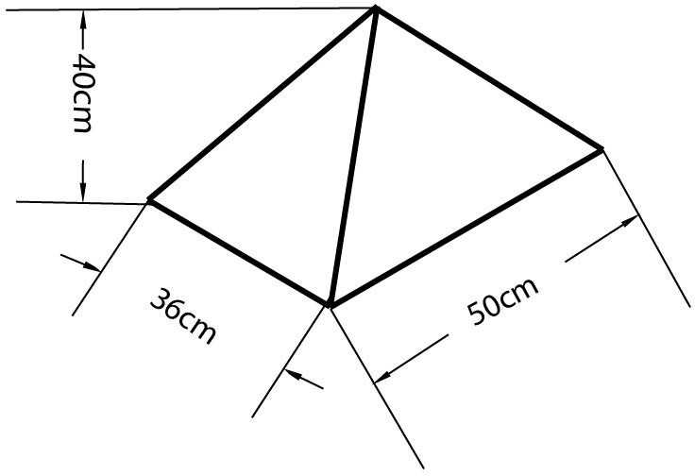
Figure 3.1 Collector

Drying chamber
Drying chamber houses the cocoa bean to be dried. This is the enclosed space where the cocoa bean is placed on trays. It’s designed to retain heat and provide a controlled environment for drying. The dark colour of the interior enhances heat absorption.
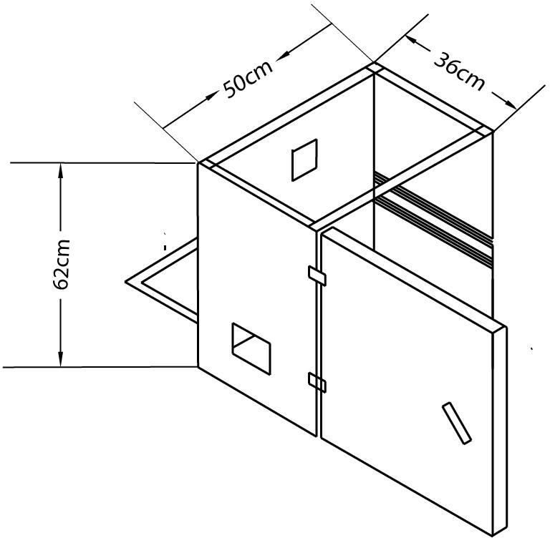
Figure 3.2 Drying chamber

Trays
Trays holds the cocoa bean to be dried. These trays were made of metal mesh to allow for good airflow and even drying. The cocoa bean was spread out on the trays to maximize exposure to the hot air.
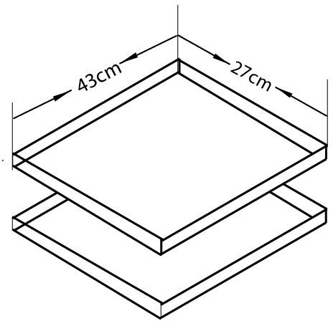
Figure 3.3 Trays

Fans
The fan circulate air within the dryer. The capacity of the fan is 0.44A(amps) and 12V. There was three fans in this design;
Side fans: These two fans draws in fresh, outside air into the dryer, helping to maintain humidity levels and prevent moisture buildup.
Top fan: This fan extracts moisture-laden air from the drying chamber, accelerating the drying process and creating negative pressure to pull in more air.
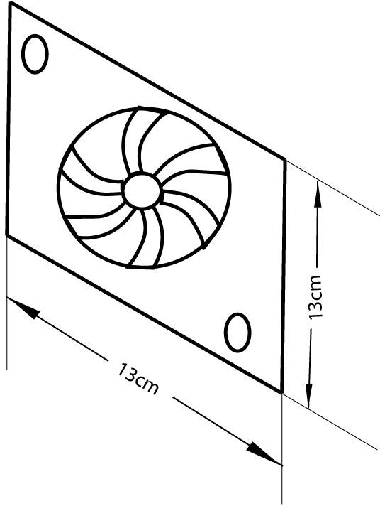
Figure 3.4 Fan

Frame
The frame provides structural support for the dryer. It was made of metal and gives the dryer its shape and stability.
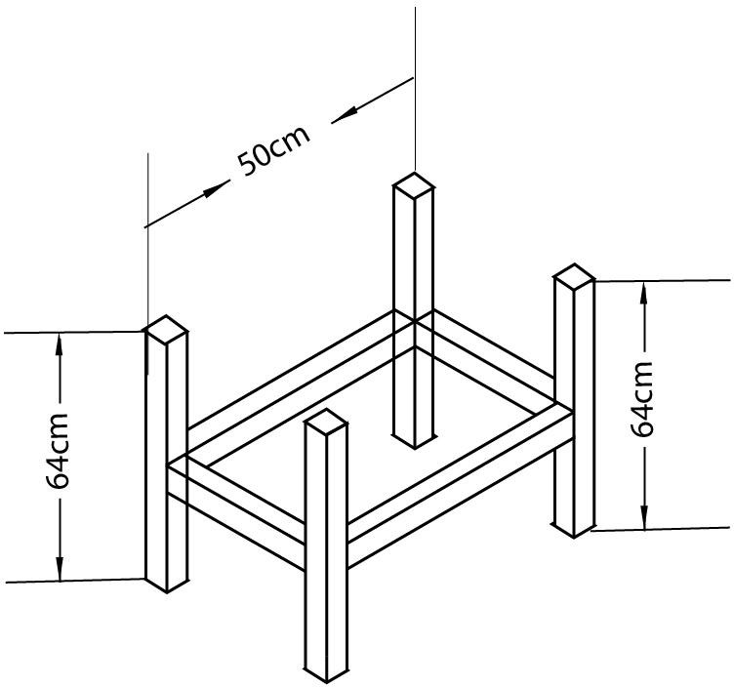
Figure 3.5 Frame

Monitoring equipment
It monitors conditions of the environment. It includes instruments to measure temperature and relative humidity of the environment. The monitoring equipment houses charge controller, solar battery, hygrometer and thermometer.
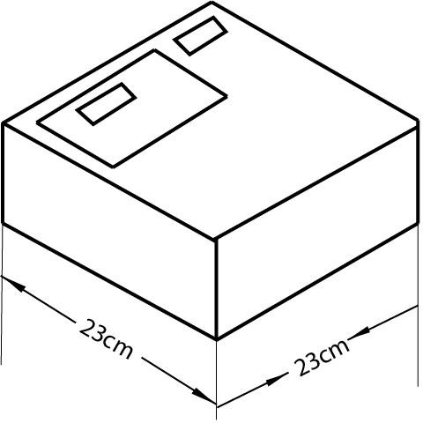
Figure 3.6 Monitoring equipment

Hinges and locks
Hinges are used to attach the door of the hybrid dryer together. It allows the panels to open and close smoothly, making it easy to access the contents of the dryer. Locks were used to secure the door of the hybrid dryer when it is closed. This helps to protect the products inside the dryer from the elements and theft.

Solar battery
A Panasonic 12V 7Ah lead- acid battery was used because of its affordability and reliability. It stores the energy generated by the solar panel for use when there is no sunlight.

Solar panel
It collects energy from the sun in form of sunlight which will help power the monitoring instrument.

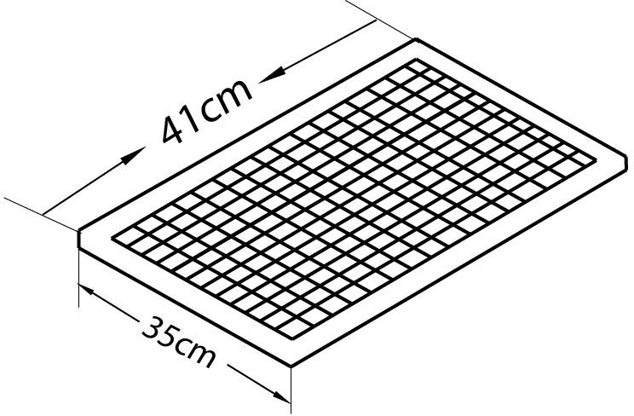

Figure 3.7 Solar panel

Charge controller
The charge controller maintains batteries at their highest state of charge without overcharging them to avoid gassing and battery damage.

Hybrid Dryer Parts Design
    - Solar collector area
The solar collector is a triangular prism and it is an isosceles triangle. The solar collector area is given by;
Total surface area = 2 x (area of triangular base) + 3 x (area of rectangular side) (3.01) Area of the isosceles triangle base = (√3/4) x side2 (3.02)
Area of the rectangular sides = length x width (3.03)

25cm 50cm
Side view of the collector front view of the collector Where;
Base of the isosceles triangle = 50cm Height of the isosceles triangle = 40cm Width = 25cm
Area of the rectangular sides = 25cm x 40cm = 1000cm2
Area of the isosceles triangle base = (√3/4) x (50cm)² =1082.53 Total surface area = 2 x (1082.53) + 3 x (1000) = 5165.06cm2
    - Absorber Surface Area,
The surface area of the absorber Aab is approximately equal to the area of the collector surface area, Ac; this is related to the length, Lc and width, W of the solar collector as follows:

Aab = Lc x W (3.04)
Lc = height of prism + height of drying chamber
= 40cm + 62cm =102cm Aab = 102 x 50
= 5100cm²
Aab = Absorber surface area of the collector Lc =Length of the collector
W=Width
    - The total area of the dryer,
Area of the dryer (rectangle) = L x H (3.05)

= 62 x 50
= 3100cm²
L = length of the dryer H = Height

Moisture Content (M.C.):
The moisture content is given as:
MC (%)= [ Mi -Mf]x100%; wet basis (3.06)
Mi
Where;
Mi = mass of sample before drying and Mf = mass of sample after drying.

The mass of water evaporated or moisture loss
Moisture loss is given as;
mw = mi [ Mi -Me ] (3.07)
100 - Me
Where:
mi= initial mass of the food item (kg);
Me = equilibrium moisture content (% dry basis); Mi= initial moisture content (% dry basis).
Also this can still be obtained by using equation 3.05
mw = (mi– mf) (3.08)
Where;
mi is the mass of the sample before drying mf is the mass of the sample after drying

Average drying rate
Mdr, would be determined from the mass of moisture to be removed by the solar heater and drying time by the following equation:
Mdr = _ (3.09)

Where:
Mdr = average drying rate, kg/hour;

Mw = mass of wet products and td = overall drying time

Principle of Operation of the Hybrid Dryer
Solar energy is captured by the collector in form of sunlight which heats the air inside the dryer. The side fans bring in fresh air while the top fan extracts moist air, creating a continuous airflow. The hot air then circulates around the products, removing moisture and drying it. A humidity sensor and temperature sensor is used to monitor the environment temperature and relative humidity and controls the drying process.

Experimental procedure
The apparatus used in this experiment were stopwatch, which was used for taking more accurate timing, weighing scale, cocoa bean, grain moisture-meter and the solar dryer.
The solar dryer consists of two trays, two fans for blowing air into the dryer, a fan for sucking the air out of the machine.
The machine was firstly test run with small quantity of cocoa before the main drying to know if there was any fault or any adjustment to be made.
The dryer was placed to face the direction of the sun. The three fans were switched on, the speed of the fans blowing air inside the solar dryer was regulated to be at an average.
The wet cocoa bean was weighed and the moisture content was known and recorded. The two trays were brought out and the weight of the trays were known and recorded. Tray 1and tray 2 were filled with an equal amount of wet cocoa bean and the weight of the trays filled with wet cocoa bean was recorded, the trays were then placed in the solar dryer. The temperature and relative humidity was recorded as well. The stopwatch was set at an interval of one hour.
After an hour, the trays were brought out to be weighed, and they were placed back after weighing. Then, the temperature and relative humidity was recorded. The stopwatch was set to an interval of an hour again.
This procedure was repeated till the wet cocoa bean was dried to a constant weight three times.

Material used for construction of solar dryer
    - Mild steel sheet
    - Square pipe
    - Glass collector
    - Angle iron
    - Fibre glass
    - Silicon gum
    - Hinges & locks
    - Consumables
    - 12V 7ah battery
    - Dc fan
    - 20w solar panel
    - Temperature and humidity sensor
    - Box
    - Wires and clips
    - Charge controller
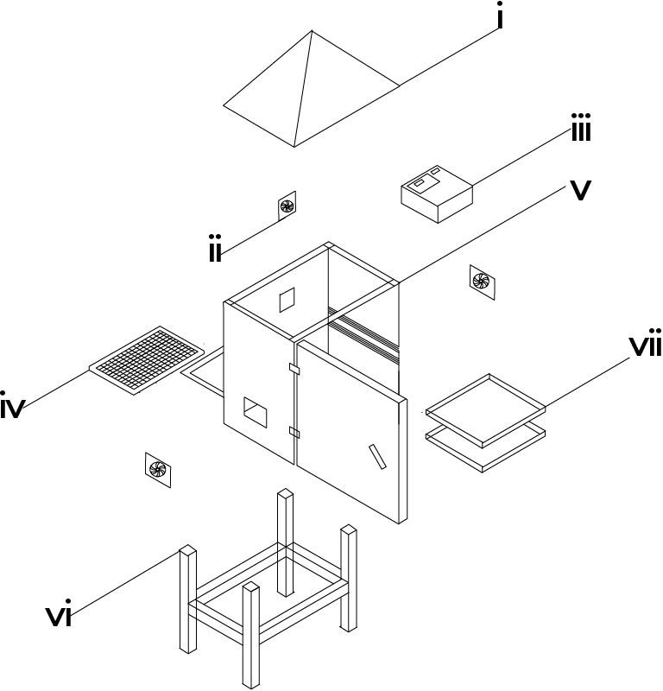

MACHINE PARTS’ LIST
S/N | KEYS | PARTS’ NAME
1 | I | COLLECTOR
2 | II | FAN
3 | III | MONITORING EQUIPMENT
4 | IV | SOLAR PANEL
5 | V | DRYING CHAMBER
6 | VI | FRAME
7 | VII | TRAYS
Figure 3.8 Exploded view and labeling of components of the hybrid dryer.
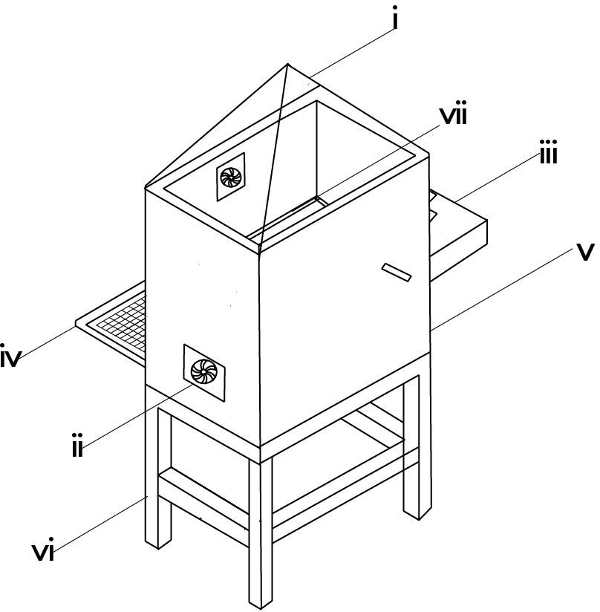

Figure 3.9 Isometric view of hybrid dryer
MACHINE PARTS’ LIST
S/N | KEYS | PARTS’ NAME
1 | I | COLLECTOR
2 | II | FAN
3 | III | MONITORING EQUIPMENT
4 | IV | SOLAR PANEL
5 | V | DRYING CHAMBER
6 | VI | FRAME
7 | VII | TRAYS

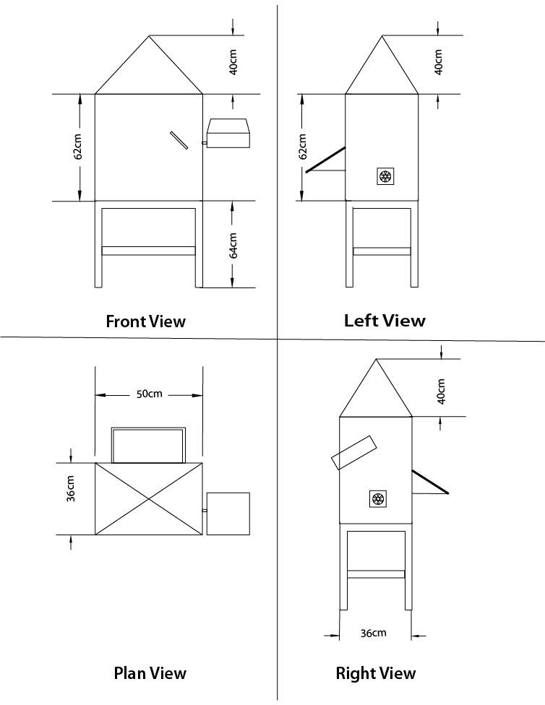
Figure 3.10 Views of The Machine Drawing

3.10 Tools and Equipment
1. Electric Arc Welding Machine: it was employed during the fabrication of the drying chamber, supporting frame and tray assembly. It was used to join metal components with high strength and durability ensuring structural integrity of the dryer.
- Grinder/Cutting Machine: It is a power tool with a rotating abrasive disc or blade which was used for cutting and smoothing metal. It is used to cut metal sheets, pipes, or rods to required sizes and for grinding welds to smooth finishes.
- Drilling Machine: It is a machine tool which was used for used to drill holes into materials (metal, wood, etc.). It is used to create holes for bolts, screws, or other fittings in your project components.
- Screwdriver Set: It is a set of hand tools with different tips (flat, Phillips, etc.) which was used for driving screws. It is used for tightening or loosening screws during assembly or adjustments of electrical and mechanical parts.
- Spanner Set: It is a set of tools which was used for for tightening or loosening nuts and bolts. It is essential for assembling and disassembling mechanical parts such as frames, joints, or supports.
- Multimeter (for testing connections): it is an electronic measuring instrument that combines several functions (voltage, current, resistance testing). It was used to check electrical circuits, test battery voltage, or ensure proper connections in the solar-powered system
- Pliers: It is a hand tool with gripping jaws, sometimes with cutting edges.it was used for holding objects firmly, bending wires, or cutting small materials.
- Measuring Tape: It is a flexible ruler used to measure distances or dimensions. It is used to take accurate measurements of components during fabrication or assembly.
- File (for finishing edges):It is a hand tool with a roughened surface used for smoothing or shaping metal. It is used to smoothen sharp edges after cutting or welding metal parts.
- Paintbrush/Spray Gun: it is a tool used to apply paint or protective coatings. It is used for finishing touches to protect metal surfaces from rust and improve aesthetics.
- Soldering Iron (for electronic parts): It is a hand tool that heats up to melt solder (a metal alloy) for joining electronic components. It is used in assembling or repairing the electronic parts of your project like sensors, circuits, or connections.
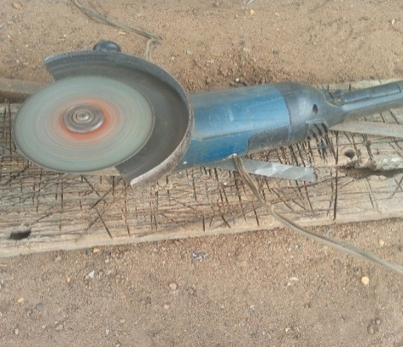
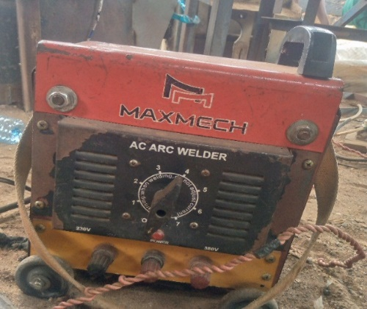

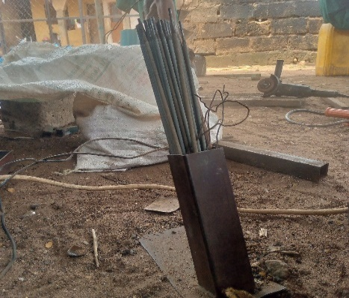
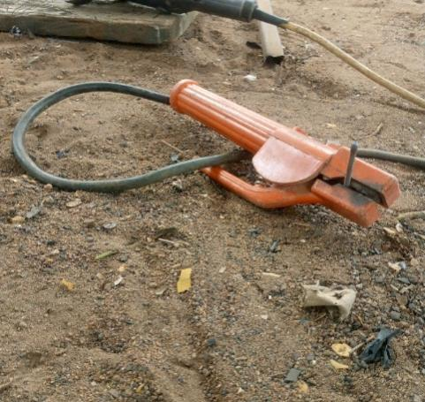
Plate 3.1a:Electric Arc Welding plate 3.1b: Grinding

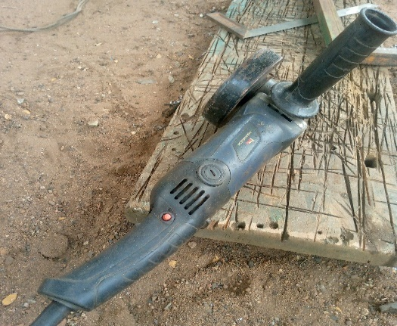
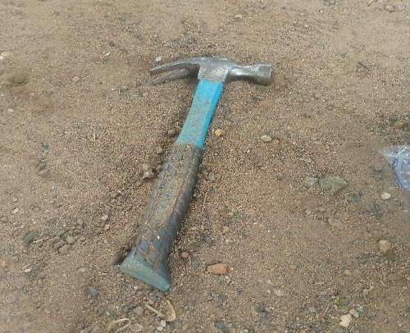
Plate 3.1c: Thong plate 3.1d Electrodes

Small Grinder Hammer

3.11 Design Layout
The experimental design for this study was structured using a two factor factorial design to evaluate the effect of the drying parameters on the drying rate and drying efficiency of cocoa seeds. The factors and responses are presented as follows:
- Mass of Sample (g)
- Air flow rate (m³/s)
- Experimental Responses (Dependent Variables)
Two performance indicators were monitored during the drying process:
- Drying Rate (kg/h): measured as the rate at which moisture was removed from the cocoa seeds.
- Drying efficiency (%): calculated as the ratio of useful energy utilized for moisture removal to the total energy supplied.
- Experimental Runs
A total of 13 experimental runs were carrid out as presented in Table 3.1. The runs were randomized to minimize the experimental bias and ensure the independence of observations. The experimental matrix includes various combinations of the two factors and their respective levels.

Table 3.1shows the experimental design matrix with the factors and responses for the cocoa seed drying process
 |  | Factor 1 | Factor 2 | Response 1 | Response 2
Std | Run | A:Mass of Sample | B:Air Flow Rate | Drying Rate | Drying Efficiency
 |  | G |  | Kg/h | %
3 | 1 | 1000 | 0.6
9 | 2 | 2000 | 0.5
12 | 3 | 2000 | 0.5
7 | 4 | 2000 | 0.4
4 | 5 | 3000 | 0.6
2 | 6 | 3000 | 0.4
13 | 7 | 2000 | 0.5
1 | 8 | 1000 | 0.4
11 | 9 | 2000 | 0.5
5 | 10 | 1000 | 0.5
10 | 11 | 2000 | 0.5
6 | 12 | 3000 | 0.5
8 | 13 | 2000 | 0.6

CHAPTER FOUR

Results and Discussion

4.1 Result

The result obtained from the testing of the fabricated hybrid dryer for cocoa bean were presented in table 4.1 below.

Table 4.1: Summary of Result of Cocoa Drying Using the Fabricated Hybrid Solar Dryer
Run | Mass of Sample (g) | Air Flow Rate (kg/h) | Drying Rate (kg/h) | Drying Efficiency (%)
1 | 1000 | 0.6 | 0.042 | 78.3
2 | 2000 | 0.5 | 0.033 | 87.6
3 | 2000 | 0.5 | 0.033 | 87.6
4 | 2000 | 0.4 | 0.029 | 91.2
5 | 3000 | 0.6 | 0.031 | 89.2
6 | 3000 | 0.4 | 0.024 | 96.3
7 | 2000 | 0.5 | 0.034 | 86.1
8 | 1000 | 0.4 | 0.035 | 85.4
9 | 2000 | 0.5 | 0.031 | 89.2
10 | 1000 | 0.5 | 0.037 | 83.9
11 | 2000 | 0.5 | 0.033 | 87.6
12 | 3000 | 0.5 | 0.027 | 92.8
13 | 2000 | 0.6 | 0.036 | 84.1

4.2 Discussion
The results obtained from testing the hybrid dryer were presented in table 4.1 above. From the table, it was observed that different mass of sample and airflow rate gave different drying rate and drying efficiency respectively. It was also observed that an increase in mass of sample at the same air flow rate gave a decrease in the drying rate and drying efficiency while an increase in the air flow rate at the same mass of sample gave an increase in drying rate and drying efficiency. This could be attributed to the ease of moisture migration within the sample at higher air flow rate. The analysis of variance (ANOVA) for the drying rate and drying efficiency of cocoa bean is presented in table 4.2 and 4.3 below respectively.

Table 4.2: Analysis of Variance (ANOVA) for the Drying Rate of Cocoa Bean
Source | Sum of Squares | df | Mean Square | F-value | p-value
Model | 0.0002 | 2 | 0.0001 | 184.90 | < 0.0001 | significant
A-Mass of Sample | 0.0002 | 1 | 0.0002 | 258.49 | < 0.0001
B-Air Flow Rate | 0.0001 | 1 | 0.0001 | 111.32 | < 0.0001
Residual | 6.603E-06 | 10 | 6.603E-07
Lack of Fit | 1.803E-06 | 6 | 3.004E-07 | 0.2504 | 0.9353 | not significant
Pure Error | 4.800E-06 | 4 | 1.200E-06
Cor Total | 0.0003 | 12
*Significant @P≤0.05
From table 4.2 above, the p value < 0.0001 shows that the model is significant being far below 0.05. this indicates that the selected factors of mass of sample and air flow rates have a great effect on the drying rate of cocoa bean. The graphical representation is shown in figure 4.1 below.

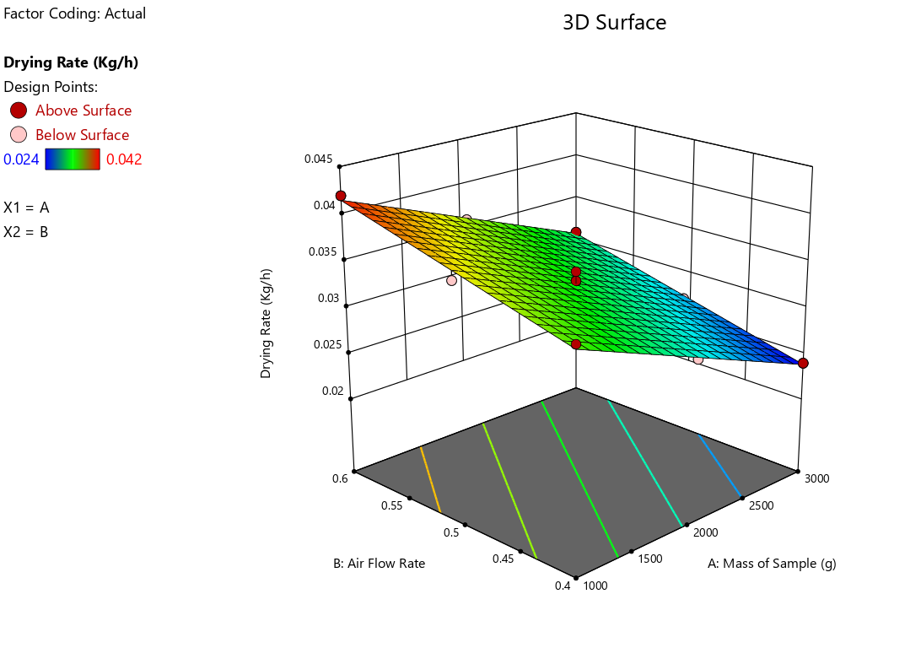
Fig 4.1: Effect of Air Flow Rate and Mass of Sample on the Drying Rate of Cocoa

Table 4.3: Analysis of Variance (ANOVA) for the Drying Efficiency of Cocoa Bean
Source | Sum of Squares | df | Mean Square | F-value | p-value
Model | 232.70 | 2 | 116.35 | 152.81 | < 0.0001 | Significant
A-Mass of Sample | 157.08 | 1 | 157.08 | 206.30 | < 0.0001
B-Air Flow Rate | 75.62 | 1 | 75.62 | 99.31 | < 0.0001
Residual | 7.61 | 10 | 0.7614
Lack of Fit | 2.81 | 6 | 0.4677 | 0.3891 | 0.8551 | not significant
Pure Error | 4.81 | 4 | 1.20
Cor Total | 240.31 | 12
*Significant @P≤0.05
From table 4.3 above, the p value < 0.0001 shows that the model is significant being far below 0.05. this indicates that the selected factors of mass of sample and air flow rates have a great effect on the drying efficiency of cocoa bean. The graphical representation is shown in figure 4.2 below.

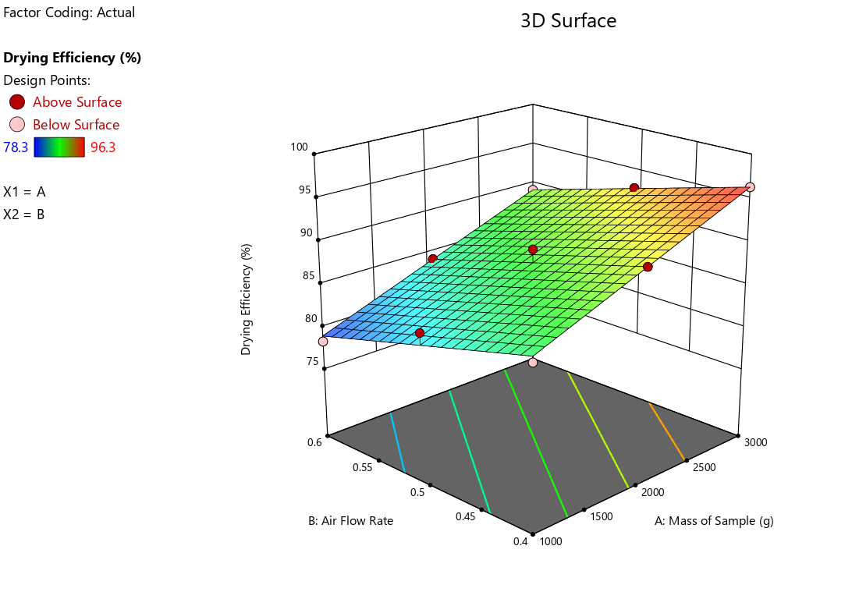
Fig 4.2: Effect of Air Flow Rate and Mass of Sample on the Drying Efficiency of Cocoa

CHAPTER FIVE

CONCLUSION AND RECOMMENDATIONS

5.1 Conclusion
The development of a solar-powered automated cocoa seed dryer, as demonstrated in this study, offers a promising solution to the challenges facing post-harvest processing in Nigeria’s cocoa industry. The prototype successfully integrated renewable energy and automation in a cost-effective system capable of producing high-quality dried cocoa beans. It addressed several shortcomings of existing methods, including overreliance on weather, contamination risks, labor intensity, and poor product consistency.
The use of embedded control systems (Arduino, sensors, relays) allowed the dryer to self-regulate internal environmental conditions, reducing the need for manual supervision and minimizing the risk of over-drying or under-drying. Furthermore, by relying on solar thermal energy and photovoltaic components, the system demonstrated strong potential for off-grid rural deployment, making it both sustainable and scalable.
Ultimately, this project contributes to agricultural mechanization efforts and supports value chain development in cocoa-producing regions. It also affirms that with the right blend of engineering design, renewable energy, and low-cost automation, rural farmers can adopt advanced post-harvest technologies without dependency on expensive imported equipment.

5.2 Recommendations
Based on the outcomes of this study, the following recommendations are proposed to guide future development, adoption, and scale-up of solar automated drying technologies in Nigeria and similar cocoa-producing regions:
- Scale-Up and Commercialization: The prototype should be further scaled into a semi-commercial or full-sized unit to test its performance under real farm conditions and larger batch sizes. Government and private sector stakeholders should support local fabrication and distribution initiatives.
- Integration of Energy Storage: To enhance system resilience during low sunlight periods, the integration of rechargeable battery packs or hybrid heating elements powered by biomass or LPG could be considered for continuous operation.
- Advanced Control Features: Future designs could incorporate wireless data transmission (IoT), remote monitoring, and machine learning algorithms to predict and optimize drying behavior based on real-time weather data and historical performance.
- Materials Optimization: Using more durable, food-grade, and thermally efficient materials (e.g., aluminum trays, tempered glass, or composite insulators) would improve long-term performance, safety, and sanitation.
- Training and Farmer Education: Adoption of the technology requires end-user capacity building. Workshops and demonstration trials should be conducted to train cocoa farmers on the use, maintenance, and benefits of automated solar dryers.
- Policy and Funding Support: Agricultural innovation policies should prioritize funding for research, development, and subsidization of renewable post-harvest technologies. Encouraging local content production can also reduce cost and create rural employment.
- Cross-Crop Adaptation: The basic design principles can be adapted for other crops requiring controlled drying, such as coffee, cashew, pepper, or grains, making the technology multi-functional and more economically viable.

5.3 Suggestions for Further Research
While this study addressed key aspects of prototype development, further research is necessary to expand its functionality, durability, and economic viability. The following areas are suggested for additional exploration:
- Conducting long-term field trials across different agro-ecological zones to analyze seasonal performance variability.
- Performing economic analysis (cost-benefit, payback period, return on investment) to assess adoption feasibility among low-income farmers.
- Developing fully hybrid solar dryers combining thermal and photovoltaic systems for year-round operation.
- Investigating the integration of real-time moisture sensors embedded in the beans for precise end-point drying detection.
- Exploring biodegradable and recyclable materials for sustainable dryer construction.

REFERENCES
Adeoye, O. M., & Olaniyi, T. K. (2020). Improving energy efficiency in hybrid solar drying systems: A review. Energy Reports, 6, 223–233.
Adepoju, M. O., & Abass, A. B. (2024). Climate-smart post-harvest innovations for cocoa value chains in Africa. Journal of Agricultural Innovation, 9(1), 1–15.
Adetona, T. A., & Oni, A. O. (2022). Techno-economic analysis of solar drying in Nigeria’s agricultural sector. Energy for Sustainable Development, 66, 101–109.
Afoakwa, E. O., Paterson, A., Fowler, M., & Ryan, A. (2011). Cocoa drying and its impact on flavor precursors. Critical Reviews in Food Science and Nutrition, 51(8), 751-774.
Afoakwa, E. O., Quao, J., Budu, A. S., & Takrama, J. (2021). Cocoa processing and drying: Advances and challenges. Journal of Food Processing and Preservation, 45(2), e15134.
Agunbiade, S., & Adebayo, T. O. (2022). Hybrid solar dryers: Bridging the gap in cocoa drying processes. African Journal of Agricultural Engineering, 14(3), 156-167.
Ahmed, M. I., & Lawal, R. (2022). Review of drying technologies for agricultural products in Nigeria. Journal of Energy and Environment, 12(3), 155–167.
Ahmed, M. S., Ibrahim, A., & Hassan, Y. T. (2020). Thermal storage in solar drying systems: Advances and challenges. Renewable Energy Journal, 35(4), 205-214.
Ajayi, O. A., & Adesina, O. B. (2022). Comparative performance of solar cabinet dryer and open sun drying for cocoa beans. Agricultural Engineering International: CIGR Journal, 24(2), 65–74.
Akinmoladun, O. P., Adebayo, F., & Akanbi, A. O. (2022). Maintenance practices and durability of solar dryers in agricultural use. Energy Conservation and Management, 116, 38-47.
Akinola, O. A., Ogunlade, B., & Babarinde, A. A. (2022). Performance analysis of indirect solar dryers for agricultural products. Renewable Energy, 15(3), 112-121.
Ali, A., Tiwari, A., & Rizvi, S. (2021). Reduction of carbon emissions using solar drying systems in agriculture. Environmental Impact Assessment Review, 85, 106-115.
Ampratwum, D. B., & Dorvlo, A. S. S. (2007). Design and performance of solar dryers for cocoa beans. Renewable Energy, 32(12), 2063-2076.
Bala, B. K., Mondol, M. R. A., & Hossain, M. A. (2022). Solar drying: Fundamentals, design, modeling and applications. Springer Nature.
Balde, J. (2021). Challenges in adopting solar-powered dryers in developing countries: A review. Energy for Sustainable Development, 60, 27-37.
Bello, R. A., & Ogunlade, C. A. (2021). Design of an automated solar dryer for tomatoes. Nigerian Journal of Technological Development, 18(2), 78–85.
Chandra, R., & Arora, A. (2019). Cost-benefit analysis of solar drying in agricultural applications. Renewable Energy, 142, 248-255.
Chavan, U. D., Patil, J. V., & Kadam, S. S. (2022). Minimizing microbial contamination during solar drying of agricultural products. Food and Bioprocess Technology, 9(3), 257-265.
Dutta, D., & Singh, M. (2020). Weather dependency and hybrid systems in solar drying technologies. Renewable Energy Technology Reviews, 10(1), 82-90.
Ekechukwu, O. V., & Norton, B. (2001). Review of solar-energy drying systems II: An overview of solar drying technology. Energy Conversion and Management, 40(6), 615-655.
Emmanuel, A. E., & Adisa, A. O. (2023). Temperature and humidity controlled fruit dryer using microcontroller. Heliyon, 9(3), e14233.
Energy, Sustainability, and Society (2021). Design, fabrication, and performance evaluation of solar dryer for agricultural produce. BioMed Central. Available at: Energy, Sustainability, and Society Journal.
Eze, C. C., Okonkwo, I. K., & Ogbu, E. C. (2021). IoT applications in agricultural solar drying systems: Case studies and future directions. International Journal of Smart Agriculture, 8(1), 45-60.
Fagunwa, F. O., Olatunji, K. T., & Oke, A. R. (2019). Optimization of cocoa drying systems: A focus on quality retention. Agricultural Science and Technology, 18(3), 225-231.
FAO. (2020). The future of food and agriculture: Trends and challenges. Food and Agriculture Organization.
FAO. (2022). Cocoa market report. Rome: Food and Agriculture Organization.
Global Solar Atlas. (2023). Nigeria solar potential. Retrieved from https://globalsolaratlas.info
ICCO (International Cocoa Organization). (2021). Cocoa Market Report. Available at: https://www.icco.org.
Idowu, O. E., & Ogunlowo, A. S. (2021). Comparative study of sun and mechanical drying methods for cocoa beans. International Journal of Agricultural Engineering, 11(1), 54–61.
Ikechukwu, N. O., & Eze, I. (2020). Arduino-based smart drying system for agricultural products. Journal of Automation and Control Engineering, 8(3), 113–118.
Koya, O. A., Adebusoye, K. A., & Awogbemi, O. (2014). Development of an intermittent solar dryer for cocoa beans. Journal of Solar Energy Research, 8(1), 56-67.
Kumar, A., Tiwari, S., & Sharma, R. (2021). Moisture content and quality control in solar drying of cocoa beans. Journal of Agricultural Engineering Research, 18(2), 45-59.
Leong, H., Lee, J., & Khor, M. (2020). Quality and preservation of cocoa beans in solar drying systems. Food Processing and Technology, 41(4), 569-574.
Madarang, J. D. (2019). Performance evaluation of a solar-powered cocoa dryer with hybrid thermal energy storage. Journal of Agricultural Engineering Research, 75(4), 120-130.
Mohammed, A., Ibrahim, Y., & Umar, H. (2022). Economic barriers to solar dryer adoption for smallholder farmers in sub-Saharan Africa. International Journal of Renewable Energy, 51(7), 3452-3460.
Musa, S. A., & Bello, A. (2023). Automation in off-grid agricultural processing systems: Opportunities and challenges. Renewable Agriculture Review, 4(1), 88–101.
Nair, R. S., Soni, D., & Keshav, P. (2021). Hybrid solar drying systems: A solution to weather unpredictability in agriculture. Renewable and Sustainable Energy Reviews, 131, 109-118.
Nair, R., Kumar, S., & Singh, D. (2020). Solar dryers: An eco-friendly solution for agricultural drying. Journal of Cleaner Production, 248, 119-132.
Nalubega, J. F. (2015). Design and construction of a cocoa bean solar dryer for smallholder farmers. Dissertation, Busitema University. Available at: Busitema University Institutional Repository.
Nduka, O. M., Okoli, J. S., & Akpan, A. A. (2021). Impact of solar drying on the quality of cocoa beans: A comparative study. International Journal of Food Science & Technology, 56(5), 1345-1353.
Obi, C. A., & Ugwuishiwu, B. O. (2023). Quality assessment of solar-dried cocoa beans in controlled environments. International Journal of Food Science & Technology, 58(4), 678-689.
Okonkwo, O. U., Ugwoke, A. C., & Ibe, C. (2021). Design and performance evaluation of indirect passive solar dryer for cocoa beans. Nigerian Journal of Solar Energy, 32(1), 29–36.
Olukunle, O. J., Akande, F. B., & Olagunju, J. (2020). Open sun drying methods of cocoa beans and implications for quality. African Journal of Agricultural Technology, 8(3), 22–30.
Olunloyo, V. O., Ajibola, A. O., & Adeyemo, S. O. (2016). Performance evaluation of solar-powered cocoa dryers. Journal of Agricultural Engineering, 23(2), 45-59.
Omole, D. O., & Akintunde, M. A. (2021). Hybrid solar PV-dryer for cocoa bean processing in off-grid areas. Renewable Energy Applications Journal, 5(1), 47–56.
Patel, S., Vashi, S., & Sheth, N. (2023). Maintenance needs and performance optimization in solar-powered agricultural dryers. Journal of Renewable and Sustainable Energy, 15(1), 193-205.
Perez, J. M., Morales, J. R., & Muñoz, L. M. (2022). Economic assessment of solar drying systems in smallholder farms: A case study of cocoa drying. Renewable and Sustainable Energy Reviews, 69, 528-535.
Sahu, P. R., Sahoo, D., & Satpathy, S. (2023). Development of hybrid solar dryers for post-harvest applications: A review. Renewable Energy Focus, 46, 87–96.
Singh, V., Patel, H., & Mehta, P. (2021). Comparative analysis of thermal storage-assisted solar dryers for crop drying. Renewable and Sustainable Energy Reviews, 34, 85-97.
Taiwo, A. O., & Olalekan, M. J. (2020). Material considerations for solar dryers in humid regions. African Materials Research Journal, 13(1), 25–31.
Udo, S. A., & Nwachukwu, C. A. (2023). Indigenous approaches to cocoa drying and their impact on quality. African Journal of Sustainable Agriculture, 10(1), 17–28.
Yusuf, K. O., & Ojo, R. B. (2021). Evaluation of drying kinetics of cocoa beans using a convective solar dryer. Journal of Thermal Engineering, 7(6), 1234–1242.
Zahouli, I. B., Kouadio, N. J., & Coulibaly, B. (2010). Impact of post-harvest practices on cocoa bean quality. International Journal of Postharvest Technology, 5(3), 23-31.

