

THE CAUSES AND EFFECTS OF ABANDONED RESIDENTIAL PROPERTIES ON HOUSING SUPPLY IN ILORIN METROPOLIS (A Case Study of Budo Osho/Magida Estate Tanke Ilorin)

(GROUP 11)

BY

ND/23/ETM/PT/0017
OLAPADE MUJEEB ABIODUN

A RESEARCH PROJECT REPORT SUBMITTED TO THE

DEPARTMENT OF ESTATE MANAGEMENT AND VALUATION,

INSTITUTE OF ENVIRONMENAL STUDIES (IES), KWARA STATE POLYTECHNIC, ILORIN.
IN PARTIAL FULFILLMENT OF THE REQUIREMENTS FOR THE
AWARD OF NATIONAL DIPLOMA (ND) IN ESTATE MANAGEMENT

AND VALUATION, ILORIN, NIGERIA

PROJECT SUPERVISOR

ESV. YAKUB GANIYU BOLAJI 08038135646

JULY, 2025

CERTIFICATION
This is to certify that the project work was carried out by this matriculation number: ND/23/ETM/PT/0017

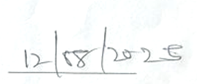
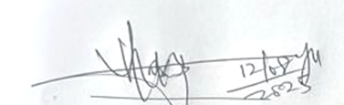

______________________ | ___________________
ESV. YAKUB GANIYU BOLAJI (ANIVS/RSV) | DATE
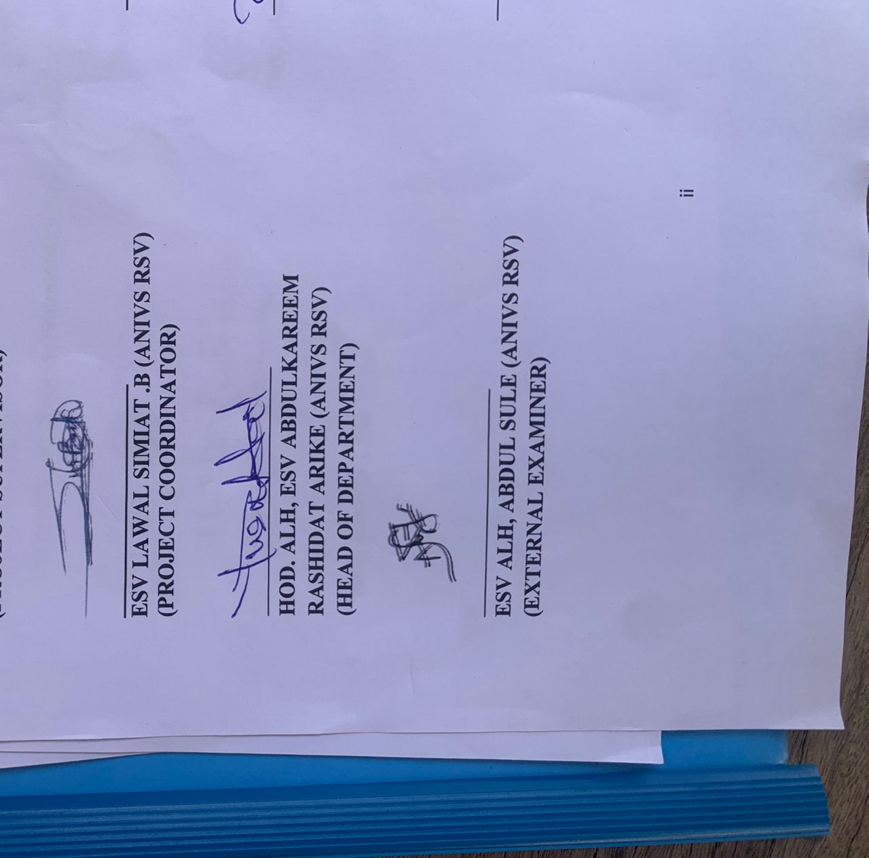  (PROJECT SUPERVISOR) | 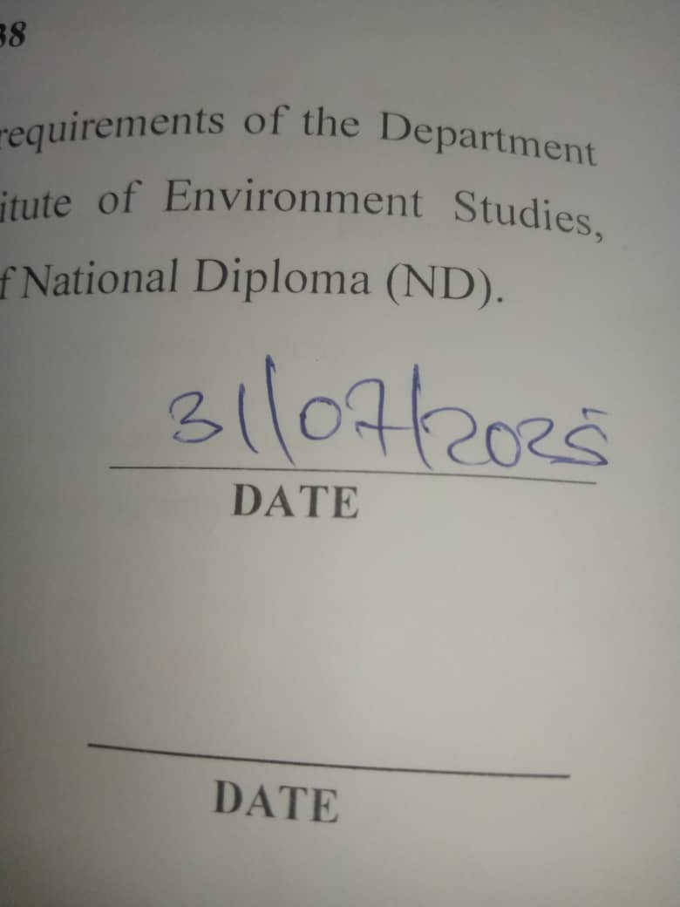
_______________________ | ___________________
ESV.MRS.SIMIAT .B ANIVS (RSV) | DATE
(PROJECT COORDINATOR)

 | ___________________
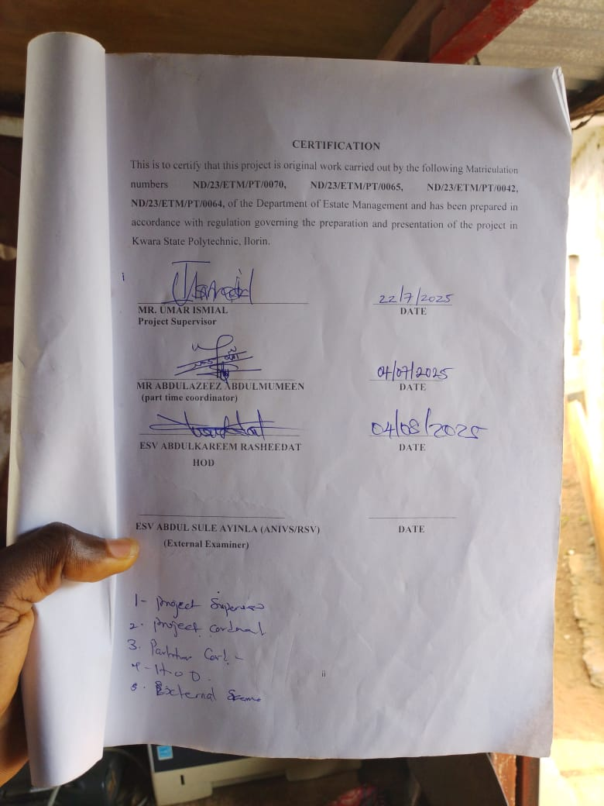 | DATE
 | ___________________
DATE

DEDICATION
This research is dedicated to Almighty God, the owner of Universe for His special grace on us, right from Birth to this Moment and also to our Lovely and caring parent.

ACKNOWLEDGEMENT
All special thanks to God Almighty for His immeasurable blessing he has showered on us throughout this project and with his continuous countless mercies and grace.
We so much acknowledge the moral support of our supervisor in person of ESV. YAKUB GANIYU BOLAJI (ANIVS/RSV) who really stood by us throughout this project work at ensuring a standard and successful project completion. May God reward her abundantly. My gratitude is incomplete without acknowledging our coordinator in person of MR ABDULAZEEZ ABDULMUMEEN and all the lecturers of the department of Estate Management and Valuation, Kwara State Polytechnic for their advice and moral support.
ABSTRACT
Abandoned residential properties pose significant challenges to housing markets, affecting supply, demand, and community stability. Causes of abandonment include economic downturns, foreclosure crises, neglect, and urban decay. Effects on housing supply include reduced availability, increased vacancy rates, and decreased property values. This, in turn, exacerbates housing shortages, limits affordable options, and perpetuates urban blight. Understanding the root causes and consequences of abandoned properties is crucial for developing effective strategies to revitalize neighborhoods, increase housing supply, and promote sustainable community development.

TABLE OF CONTENTS
Title page i
Certification ii
Dedication iii
Acknowledgement iv
Abstraction v
Table of Contents vi
CHAPTER ONE
1.0 Introduction 1
1.1 Background to the study 1
1.2 Statement of the Problem 2
1.3 Research Questions 2
1.4 Aims and Objectives 2
1.5 Justification of the Study 3
1.6 Scope of Study 3
CHAPTER TWO
2.0 Introduction 4
2.1 Literature Review 4
2.1.1 Causes of Abandoned Residential Properties in Ilorin 5
2.1.2 Effects of Abandoned Residential Properties Ilorin 6
2.1.3 Conceptual Framework 7
2.1.4 Theoretical Frame Works 8
2.2 Summary of Literature Review 10
CHAPTER THREE
3.0 Research Methodology 11
3.1 Introduction 11
3.2 Research Design 11
3.3 Data Types and Sources 11
3.4 Instrument for Data Collection 12
3.5 Target Population 12
3.6 Sample Frame 12
3.7 Sample Size 12
3.8 Sampling Procedure 13
3.9 Method of Data Analysis 13
3.10 Summary of Data Analysis for Each Objective 14
CHAPTER FOUR
Data Presentation Analysis and Interpretation 15
4.0 Introduction 15
4.1 Data Presentation Analysis and Interpretation of Result 15
4.1.1 Socio-demographic Characteristics of Respondent 15
4.1.2 Causes of abandoned Residential Properties. 16
4.1.3 Main Reasons for abandoned residential properties. 17
4.1.4 Notice of Abandoned properties residential properties. 17
4.1.5 Measure to Prevent Properties from Being Abandoned. 17
4.1.6 Community and Governmental Response 18
4.1.7 Effects of Abandoned Residential Properties 18
Discussion of Findings 20
CHAPTER FIVE
SUMMARY OF FINDINGS, CONCLUSIONS AND RECOMMENDATIONS
5.0 Introductions 21
5.1 Summary of Findings. 21
5.2 Conclusion 22
5.3 Recommendations 22
RETERENCES
QUESTIONNAIRE

CHAPTER ONE

INTRODUCTION
BACKGROUAD TO THE STUDY
The unceasing abandonment of residential buildings and development project is so shocking in the developing Countries such that Nigerian has remained one of the counties such difficulty (Ayodele and Alabi, 2011, Kontangora, 1993, Osemenan, 1987). Therefore, the significance that the incessant abandonment of residential buildings and project would bring several effects on real properties and It's values and the economy cannot beaver emphasized Since some of the abandoned buildings and development project provide the basic services that should enhance the real properties developed.
Longman Dictionary 2005) define abandon as "to stop doing something because there are too many problems and it is Impossible to Continue. The phenomenon of abandoned residential properties has become a Significant Issues In Urban areas, with far - reaching Consequences for both local Communities and the broader Urban landscape.
Abandoned residential building is a building whose occupy and has moved out basically due to poor maintenance and Infrastructure, Security, dilapidation, natural disaster which has made the building not to be habitable. The abandonment of residential properties and development project is the act of Isolate the building or discontinuing any activates a maintenance Works on such development project within a time frame of the Contract agreement and with no Intention of returning back to the development projects "suggest that it is when an owner or developer is ceasing to provide the required maintenance management to a developed property.
However, real property development and maintenance being a Capital Intensive undertaking should be Critically analyzed to as creation It's feasibility and viability before embarking on it-But on severed occasions and as it has been Observed governments, Contactors and agencies have abandoned Old buildings and development projects mid-way Into Construction Completion.
The causes and effects of those residential buildings abandonments are

not just peculiar to a particular reason neither Cut across Several reason (Ayodele and Alabi, 2011), and as well as Creating a total dwindling effects the value of developed properties located close and with the vicinity, Most of this abandoned residential building usually turned Into hideout for Criminal.
1.2 STATEMENT OF THE PROBLEM
The causes and effects of abandonment of residential property has been a subject of concern fur experts In real estate Therefore, the Study purpose is to Investigate the Causes and effects of abandoned residential property on real property and Its value- the cogent of this Study is in the premise that the expected real, properties and its value In Nigeria are suspected to be dwindling as a result of Incessant abandonment of residential properties. These abandoned Structures not only Signify Wasted Investment but also Contribute to urban decay, reduce the quality of life for residents, and provide hideout for criminal activities.
13 RESEARCH QUESTIONS
- What are the Causes of abandonment of residential properties in Magida estate tanke?
- What are the effects of abandonment of residential properties in Magida estate.
- What are the solution to the Issues of abandoned residential properties in the Study area?
- How do socio economic and legal factor. Influence property abandonment in these areas?
1.4 AIMS AND OBJECTIVES
AIM
To critically examine the causes and effect of abandoned residential properties In budo osho magida estate tanke Ilorin and to propose strategies for mitigating occurrences.
OBJECTIVES
    - To Identify the underlying factors responsible for the abandonment of residential properties in the study areas.
    - To examine the effects of abandonment of residential properties in Magida estate tanke Kwara State.
    - To assess current government and Community responses to the issues of abandoned properties.
    - To recommend workable strategies to Improve the Issues of abandoned wit residential properties in the Study area.
1.5 JUSTIFICATION OF THE STUDY
The growing Issues Of abandoned residential properties is a critical Urban Challenges that has far-reaching Implications for both physical environment and the Socio-economic fabric of cities particularly in rapidly urbanizing regions like magida estate tanke Ilorin Kwara state, have witness an Increasing number Of residential properties left unoccupied or in a state Of neglect. This study on the causes and effects of abandoned presidential properties in this are is not only timely but also essential for several key reasons are:: Addressing a growth urban crisis, Socio-economic Impact on local Communities, environmental and aesthetic Degradation, rising Security risk and Safety Concerns, policy Gaps and urban Planning Deficiencies, Contribution is Sustainable Urban development, Relevance to broader Niger an urban Context: we arms to provide evidence-based recommendation that Can guide local authorizes, Urban Planners In Ilorin and other Nigeria Cities.
16 SCOPE OF STUDY
This study is geographically limited
Thematically, it focuses on abandoned residential properties excluding
Commercial or Industrial buildings the Scope Include Identifying Causes (e.g legal - economic, migration related) assessing effects (e.g Crime, Urban decay economic loss) and evaluating Current responses and future Interventions. The temporal scope will cover development over the last 5 years to understand historical and recent trends within the study area with Special focus on Budo Osho magida estate tanke road; llorin Kwara State.

CHAPTER TWO
2.0 INTRODUCTION
The Phenomenon Of abandoned residential properties is an increasingly prevalent issue in both urban and suburban areas, particularly within rapidly growing cities in developing Countries like Nigeria. In Cities such as Ilorin, the Capital of Kwara State, abandoned residential properties have become a persistent problems commuting to urban blight, economic challenges, and Social disintegration. This issue has garnered significant attentions from urban development, community wellbeing, and the real estate sector. The Case Study of budo osho magida estate tanke, located in Kwara state, provides a microasm of the wider Issues affecting urban centers across Nigeria, where the causes and effects of abandoned residential properties are deeply inter tome with socio-economic political, and environmental factors.
Understanding the dynamics behind property reaves an in depth exploration of various contributing factors, ranging from Socio-economic Instability legal disputes, to the Challenges posed by in advocate urban Planning and poor governance. The effects of property abandonment are multifaceted, touching upon a wide range of Issues that affects local Communities and the urban environment. These effects include negative Impact on property values, an increase in crime, deterioration of public health and environmental degradation.
2.1 LITERATURE REVIEW
The prevalence of abandoned residential properties presents a significant Urban Challenges in many rapidly growing cities, particularly in developing Countries such as Nigeria. In urban Centers like Ilorin Kwara State, abandoned residential properties have become a ubiquities sight, contributing to the overall degradation of urban environments.

2.1.1 CAUSES OF ABANDONED RESIDENTIAL PROPERTIES IN ILORIN
The causes of abandoned residential Properties are multifaceted and can be categorised into economic, social legal and political factors. Understanding these causes is crucial for addressing the issues effectively. In Ilorin, like many Other Nigerian cities, property abandonment is a complex problem Influenced by Several Interrelated Variables.
- Economic factors: A significant numbers Of residential properties in Ilorin remain abandoned due to economic challenges faced by property owners and potential buyers the economic instability in Nigeria, Characterized by fluctuating real estate prices Inflation and un feasible investment. According to Studies by Obakin et al (2024) and Adedokun (2018), many properties owners purchase properties with speculative intents hoping to sell or rent at higher prices in the failure. However, due to the volatility of the property market and the absence of buyers on tenant these properties remains unoccupied for extended periods, ultimately leading to abandonment.
- Legal and Regulatory factors: Legal issues and property rights are also significant causes of property abandonment in Ilorin. A major factor contributing to the abandonment of residential properties is (Land disputes and unclear property title). According to Adeniran et al (2018), land ownership disputer are common, with families or individuals involved in protracted legal battles over ownership rights. This uncertainty prevents property owners from selling or developing their properties leading to long term abandonment.
- Social and Demographic factors: Population growth and urban migration, have significantly contributed to property abandonment. As rural to urban migration Increases, new residential area late developed rapidly and Older properties in areas fall into neglect. According to Oyedele (2021) many residents of Ilorin abandon then properties in search of

better Job opportunities a safer environments in other parts of the city or outside the state. This leads to entire neighborhood or specific properties being left vacant for long periods.
- Environmental factors: Environmental factors such as "climate change, natural disasters and urban decay”, also contribute to property abandonment. In Ilorin flooding is a common occurrence, particularly poorly planned or unregulated urban zones. Flooding often damage Infrastructure, and when properties are repeatedly affected by environmental disasters, owners may abandon them rather than investing in repairs or relocations.
2.1.2 EFFECTS OF ABANDONED RESIDENTIAL PROPERTIES ILORIN
The abandonment of residential properties in Ilorin has far reaching effects that are felt by residents, property owners, the local government and the environments the effects can be grouped into social economic environmental and psychological Categories.
- Socio-Economic effects:- Abandoned residential properties have a negative Impact on property value in neighborhoods. The proliferation of abandoned buildings makes the area less attractive to potential buyers and investors thus lowering the overall market Value of properties Adeniran et al (2018) found that the presence of abandon a properties can decrease the desirability Of an area, which in turns deters Investment, leading to further economic stagnation.
- Psychological and Social Impacts:- Abandoned residential properties Often Create a sense of Social Isolation and Insecurity among residents. The fear of crime is particularly prevalent in areas with abandoned properties as these buildings can serve as havens for criminal actvities such as robbery, drug abuse and Vandalism: Aremu 2024 argues that the psychological effects of abandoned properties on residents are profound leading to anxiety fear, and a sense of insecurity among Individuals living nearby.

- Environmental Effects:- Abandoned Properties Contribute to environmental degradation, Including poor sanitation, the accumulation of garbage, and growth of pests such as rodents and Mosoulities Oyedele (2021) highlights that these environmental hazards not only pose risks to public heath but also contribute to the spread of diseases like malaria and cholera. Abandoned buildings often suffer from structural degradation which can lead to dangerous Situations such as the Collapse of buildings, particularly in areas with inadequate buildings Inspection or maintenance Systems.
2.1.3 CONCEPTUAL FRAMEWORK
The Conceptual frame wink for this Study is built upon several cored concepts and theories that help explain the causes and effects of residential properties within the Contest of Magida estate tanke Road Ilorin, Nigeria. These Concepts provide the foundation for understanding the various dimensions of the issues from the Socio-economic and legal factors to the psychological and environmental properties.
- Urban decay and Blight Theory:- Urban decay refers to the gradual deterioration of a once-vibrant urban area due to a variety of factors, including economic decline, poor Infrastructure, and Social neglect. Abandoned properties are often seen as a visible manifestation of urban decay, leading to a cycle of disinvestment and decline. The theory posits that the abandonments of properties can lead to further disinvestment and the gradual erosion of the neighborhood’s physical and social Infrastructure.
- Theory of Economic Instability:- Economic instability is one of the key drivers behind the abandonment of residential properties in many urban Centers. In the Nigerian Contest, fluctuating real estate prices, economic recessions, and limited access to credit and financial resources for property owners have led to the abandonment of residential properties. This theory
suggests that economic fluctuations significantly impact property Investment decisions, with abandoned properties serving as a reflection of broader financial Instability with the urban economy.
- Social Disorganization Theory:- Social disorganization theory focuses on the breakdown of social and community ties, often due to factors such as poverty Crime and the absence of collective efficacy. the presence of such abandoned properties Can under-mine the Community ability to work together to address issues lice crime and public Safety leading to a decline in the overall duality of life for local residents this theory emphasized the rile of community social structure in either mitigating or exacerbating urban problems like property abandonment.
- Environmental Degradation and public Health theory:- Abandoned
residential properties often become hotspots for environmental degradation, Contributing to Issues like poor Sanitation, waste accumulation and the Spread of diseases. In urban areas like (Ilorin, the neglect of property results in unsanitary Conditions, attracting pests, rodents, and other surrounding neighbartonds, particularly in high-density residential areas where the populating density and Inadequate waste management system Increase the potential for health Crises.
- Legal and Regulatory frameworks: the legal and regulating framework governing property Ownership, real estate development, and land use. Plays a crucial role in both the causes and potential Solutions to the Issues of abandoned residential properties. This framework emphasizes the Importance of legal reforms to address Ownership disputes, ensure effective Urban planning and encourage responsible property development practices. It also highlights the role of government agencies in regulating land use and enforcing policies to prevent property abandonment.
2.1.4 THORETICAL FRAME WORKS
This Study draws on several theoretical frameworks to explain the causes and effects of abandoned residential properties in Ilorin, Nigeria
- Urban Diary and Blight they the urban decay theory explains the relationship between property abandonment and the gradual deterioration of urban areas. The theory posits that the accumulation of abandoned properties in a particular area leads to a decline in the quality of life for residents, as the urban landscape becomes less functional and mare hazardous.
- Economic Instability theory:- The economic instability theory explains how macro-economic factor such as Inflation, rescission, and the volatility of the real estate market can discourage property investment and maintenance. Property owners abandon their Investments When they are unable to generate Sufficient Income from their properties due to fluctuating property Values or lack of demand.
- Social Disorganization Theory:- The social disorganization theory, proposed by Shaw and Mckay (1942), explain how communities breakdown, often due to factors like poverty, migration, and a lack of social, cohesion, leads to higher levels of crime and property abandonments. Abandoned properties in neighborhoods exacerbate this problem, Contributing to the erosion of community networks and increasing social disorder.
- Environmental Degradation Theory:- This theory Suggests that abandoned properties Contribute Significantly to urban decay and the deterioration of the environment: As the properties fall into disrepair, they create visual and physical pollution, Increase waste accumulation and attract pests, all of which negatively affect the quality of life in Surrounding neighborhoods.
The causes and effects of abandoned residential properties In. llorin are complex and multifaceted, Influenced by a combination of economic legal, social, and environmental factors. The literature reviewed underscores the need for effective Urban planning policy Intervention, and community engagement to address the Issue of property abandonment
2.2 SUMMARY OF LITERATURE REVIEW
The following table encapsulates key findings from the renewed literature.
Study | Focus Area | Key Findings | Relevance to Current Study
Obakin et-at,  2024 | Causes of abandoned housing project | Identified economic constrains, legal disputes and design flaws as primary causes; highlighted urban decay and increase crime as effects. | Provide Empirical Data On Factors Leading To Property Abandonment In Magida estate tanke Road Ilorin Kwara State.
Adeniran et al 2018. | Impact of waste management on property values. | Demonstrate the poor waste management contributes to environmental degradation and lower property values. | Highlight environmental factors affecting property abandonment.
Aremu, 2014 | Security implication of abandoned house | Emphasized that vacant properties serves as hideouts for criminals, posing security threats. | Underlines the social consequences of property abandonments.
Oyedele, 2021. | Adaptive reuse of abandoned public  buildings in Nigeria | Advocated for repurposing abandoned buildings to harness their potential and mitigate Urban decay. | Suggests potential interventions for addressing property abandonment.
The literature reviews reveals that the causes of abandoned residential properties in Magida estate tanke Ilorin are rooted in a combination of economic instability, legal challenges, social changes and environmental factors. These causes manifest in the form of poor property market conditions, legal disputes, migration and infrastructure neglect. The study emphasized the importance of addressing these issues through effective urban planning, policy reforms, and community engagement to mitigate the negative consequences of abandoned residential properties and foster sustainable urban development in the affected areas of kwara state, Nigeria.

CHAPTER THREE

Research Methodology
3.1 INTRODUCTION
This chapter presents the methodological approach adopted for investigating the causes and effects of abandoned residential properties in Magida estate tanke Ilorin. It outlines the research design, data types and sources (instruments) used for data collecting, target population, sampling procedures and the techniques employed in data analysis. The methodology ensures the research is systematic, replicable and empirically grounded, enabling reliable conclusions and recommendations.
3.2 RESEARCH DESIGN
The study employs a descriptive survey design, which is suitable for collecting data that reflect current conditions and perceptions within a defined population. This design allows for the identification, analysis, and interpretation of the various causes and effects associated with abandoned residential properties in the study areas. The combination of both qualitative and quantitative methods ensures a comprehensive understanding of the phenomenon.
3.3 DATA TYPES AND SOURCES
Two major types of data will be used:
- PRIMARY DATA:
These include responses from structured questionnaires, in-depth interviews with residents, landlords, estate agents, and officials of town planning authorities.
- SECONDARY DATA:
These are obtained from published journals, government records, planning documents, satellite images, maps, and academic literature related to urban decay, housing abandonment, and property management in Nigeria.
3.4 INSTRUMENT FOR DATA COLLECTION
The instrument used for data collection include:
- Structured Questionnaires: Designed to gather quantitative data from residents and landlords.
- Interview Guides: Used to collect qualitative data from selected stakeholders such as urban planners and estate developers.
- Observation Checklists: Used to assess the physical condition and environmental impact of abandoned properties in the field.
3.5 Target Population
The target population comprises:
- Landlords and property owners in magida estate Ilorin.
- Residents living in proximity to abandoned properties.
- Real estate professionals (agents, developers).
- Officials from the ministry of physical planning and urban development.
  - Sample Frame
The sample frame consists of all registered residential properties (both occupied and abandoned) in magida estate Ilorin. This frame is derived from property tax records, local government land registries, and physical surveys conducted in the areas.
  - Sample Size
Based on the populations density and distribution of properties in the study areas, a sample size of 90 respondents will be selected.
60 respondents from magida estate (including 10 estate agents and 5 planning officials).
30 general stakeholders (including researchers, government officials, and residents in adjacent communities).
This sample size is considered sufficient for meaningful statistical analysis and generalization within the study context.
3.8 SAMPLING PROCEDURE
A multi- stage Sampling technique will be Employed:
- Purpose Sampling:- To Select magida estate due to their high prevalence of abandoned residential properties.
- Stratified Sampling:- To ensure Inclusion of different Categories
(landlords, tenants, professionals, officials).
- Sample Random Sampling:- To Select respondents within each Stratum for unbiased representation.
3.9 METHOD OF DATA ANALYSIS
Data analysis will be Conducted using both quantitative and qualitative methods:
Descriptive Statistics (percentages, frequencies, mean scores) to summarize responses.
Inferential Statistics (Chi-square tests, Correlation analysis) to test hypothesis and assess relationships between variable.
Thematic Analysis for qualitative responses to (identify key brands and narratives.
Geospatial Mapping using GIS tools to visualize the distribution and Clustering of abandoned properties.

3.10 SUMMARY OF DATA ANALYSIS FOR EACH OBJECTIVE
S/N | RESEARCH OBJECTIVE | DATA  COLLECTION TOOLS | DATA ANALYSIS METHOD
1. | To Identify and analysis the underlying factors responsible for the abandonment of residential properties. | Structured questionnaires,  Interviews | Descriptive Statistics (frequency, percentage)  Cross-tabulation Chi-square test.
2. | To examine the socio-economic and environmental impacts of abandoned properties on the local abandonment. | Questionnaire, filed observation | Descriptive statistics mean ranking, thematic Analysis of observational data.
3. | To evaluate the role of legal, institutional, and market forces in influencing property abandonment. | Interviews with official and  Agents. | Thematic analysis, content analysis and Chi-square test for correlation.
4. | To assess current government and community responses to the issues of abandoned properties. | Interviews  Questionnaire | Thematic analysis, descriptive statistics, SWOT matrix  (strengths weaknesses etc)
5. | To recommend policy and planning interventions for reducing property abandonment. | Synthesized from all data sources. | Policy implication mapping, cross comparative analysis,  Expert opinion coding

CHAPTER FOUR
DATA PRESENTATION ANALYSIS AND INTERPRETATION
4.0 INTRODUCTION
This chapter presents, analyzes and interpret the data collected during field works. It reflects the view and experiences of respondent across Budo Osho Magida estate Ilorin in and align with the objective outlined in chapter one. The data are presented in table forms and descriptive summaries followed by analytical interpretations. The aims is to empirically validate the research hypothesis and provide insight into the causes and effects of abandoned residential properties. The chapter also includes a discussion of findings in comparison with existing literature.
4.1 Data Presentation Analysis and Interpretation of Result
4.1.1 Socio-demographic Characteristics of Respondent
Table 4.1
Variable | Category | Frequency | Percentage %
Gender | Female | 87 | 58%
 | Male | 63 | 42%
Total |  | 150 | 100
From table 1: the above 70 female respondents representing 58% are the female that responds very well while 63 respondent representing 42% of male responds. Table 4.2
Variable | Category |  | Frequency | Percentage %
Age | 16- 20 Years |  | 30 | 20%
 | 21- 30 Years |  | 50 | 33.3%
 | 31- 40 Years |  | 50 | 33.3%
 | 41 Years above | and | 20 | 13.5%
Total |  |  | 150 | 100
From Table 2: Action of age group making them idea source for reliable insights into prefer related issues from age 21- 40 Years is the most respondents of the ages.
Table 4.3
Variable | Category | Frequency | Percentage%
Occupation | Landlords | 39 | 26
 | Tenants | 51 | 34
 | Estate agents | 25 | 16.7
 | Government  Officials | 15 | 10
 | Others | 20 | 13.3
Total |  | 150 | 100%
From Table 3: Above 51 respondents representing 34% is the most significant number directly affected by property abandonments.
4.1.2 Causes of abandoned Residential Properties. Table 4.4
Cause Identified | Frequency | Percentage %
Legal Inheritance  Disputes | 49 | 31.3%
Economic Constraints | 35 | 23.3%
Poor Building Design &  Structural failure | 28 | 18.7%
High maintenance cost | 22 | 14.7%
Migration (Relocation) | 18 | 12%
Total | 150 | 100%
From the above table 4:- 47 respondents representing 31.3% is the people that support the issue of legal and inheritance dispute emerge as the leading cause of abandonment followed by economic & constraints.

4.1.3 Main Reasons for abandoned residential properties.
Table 4.1.5
Reasons Identified | Frequency | Percentage %
Lack of maintenance | 30 | 20
Financial Constraints | 70 | 46.6
Dispute over Ownership | 23 | 15.3
Insecurity | 27 | 18
Total | 150 | 100

4.1.4 Notice of Abandoned properties residential properties.
Table 6
Variable | Frequency | Percentage
Yes | 100 | 66.6
No | 50 | 33.3
Total | 150 | 100
From the table 6 above, 100 respondents representing 66.6% said yes to the notice of abandoned properties within the study area, while 50 respondents representing 33.3% said no. to the notice of abandoned properties within the study areas.
4.1.5 Table 4.7: Measure to Prevent Properties from Being Abandoned.
Variable | Frequency | Percentage (%)
Community Engagement | 60 | 40%
Regulatory Measure | 10 | 6.6
Economic Incentives | 70 | 46.6
Other Strategies | 10 | 6.6
Total | 150 | 100
From Table 7 above, 70 respondents representing 46.6% said that to prevent abandoned properties is economic incentives, followed by Community engagement.
4.1.6 Community and Governmental Response Table 4.8
Types of Intervention | Frequency | Percentage (%)
Community-led Clean Up | 19 | 12.7
Local Government Task Force (Monitoring) | 31 | 20.7
No Organized Intervention | 100 | 66.6
Total | 150 | 100
From the table above, Government and Community response is overwhelmingly weak, with most respondents indicating no meaningful intervention. This highlights the need for Structured Policy frameworks and Inter-agency Collaboration.
4.1.7 Table 4.9: Effects of Abandoned Residential Properties*
Observed Effects | Frequency | Percentage %
Increased Crime/Insecurity | 52 | 34.7
Urban Decay | 39 | 26
Devaluation of Nearby properties | 33 | 22
Environmental Hazard | 26 | 17.3
Total | 150 | 100

From table 8 above 52 respondents representing 34.7% is the people the people that support increased Insecurity as abandoned Structures often serve hideouts for criminal
4.10 How abandoned properties affect the housing Supply.
Variable | Frequency | Percentage (%)
Reduced available of housing | 10 | 6.6
Increased Crime and Insecurity. | 20 | 13-3
Decreased property Values. | 70 | 46-6
Negative impact on neighborhood aesthetics | 50 | 33.3
Total | 150 | 100

From table 9 above 70 respondent represent 46.6 is the respond to the support of decreased property value Affected followed by Negative impact on neighborhood aesthetics can affect the housing supply.
4.11. Table 10 measure of the problem of abandoned properties.
Variable problems Identified | Frequency | Percentage (%)
Economic Issues | 50 | 33.3
Environmental Issues | 25 | 16.6
Community development Issues | 60 | 40
Social issues. | 15 | 10
Total | 150 | 100
From table 10 above 60 respondents representing 40 is the respond to the problem of abandoned properties i.e Community development issues is one of the Critical problems followed by economic issues. 4.12 Table 11: How to revitalize abandoned properties
Variable | Frequency | Percentage (%)
Housing Supply Strategies | 40 | 26.6
Community Engagement | 20 | 13.3
Revitalization Strategies | 30 | 20
Incentives and Financing | 60 | 40
Total | 150 | 100
From table 11 above 60 respondents representing 40% is the people that followed by 40 respondents representing 26.6 which is housing supply strategies.

Discussion of Findings
The findings corroborate earlier studies (Crayobakin 2015; Adeyemi 2018) which affirm that economic hardship, legal dispute and poor urban governance contribute significantly to property abandonment. Moreover, the effects ranging from rising time to environmental degradation mirror global trends in urban decline particularly in under-managed African Cities. The lack of structured government response further compounds the issues calling for urgent reforms in property law housing policy and municipal governance.

CHAPTER FIVE

SUMMARY OF FINDINGS, CONCLUSIONS AND

RECOMMENDATIONS
5.0 INTRODUCTIONS
This Chapter provides a synthesis of the research by summarizing the major findings, drawing conclusions, and offering practical and policy-oriented recommendations. It reflects on how the study objectives were addressed through empirical investigation and analysis, and proposed actions to tackle the growing issues of abandoned residential properties in the study area. The chapter also emphasized the broader implications for urban planning, housing policy and sustainable development in Nigeria Cities.
5.1 SUMMARY OF FINDINGS.
Based on field investigations, statistical analysis, and theoretical reviews, the following key findings were made:
- Predominants Causes of Abandonment: the study revealed that legal and inheritance disputes (31.3%) were the most significant contributors to property abandonment. This was closely followed by economic hardship (23.34%) and poor building design & structural failure (18.70%).
- Socio-Economic And Environmental Effects: Abandoned residential properties were found to facilitate crime (34.47%) and urban decay (26%). They also contributed to property devaluation (72%) and environmental hazards such as waste dumping and flooding (12-39%).
- Institutional and Market Factors: The inefficiency of planning authorities, unresolved litigations, poor enforcement of property laws, and real estate market over-saturation were all seen as contributing to the abandonment trend.
- Community and Government Response: Government and community response were largely ineffective, with over two-thirds (66.6%) of respondents reporting no visible or structured intervention. This suggests a failure of proactive planning and policy implementations.

- Significant Correlation Identified: The Chi-square test conducted revealed a statistically significant relationship between socio-economic/legal factors and property abandonment, thereby validating the study's alternate hypothesis (H1).
  - CONCLUSION
The problem of abandoned residential properties in Magida Estate Tanke Ilorin, is both structural and symptomatic of deeper issues in land administration/urban governance, and socio-economic stability. The findings confirm that abandonment is largely driven by legal disputes, economic strain, and weak urban institutions. The consequences of this phenomenon are legal, economic, and social; they threaten security, reduce the quality of life, and deter investment in urban infrastructure.
The research highlights the urgent need for institutional reform, public-private collaboration, and stronger policy frameworks to reverse the trend. Only through integrated urban planning, legal clarity, and stakeholder engagement can the menace of abandoned properties be mitigated and turned into opportunities for urban renewal.
  - RECOMMENDATIONS
To address the challenges identified in this study, the following recommendations are proposed:
- Strengthen legal and land dispute resolution mechanisms: the governments should prioritize the digitization of land records and support specialized property tribunals to speed up the resolution of inheritance and ownership disputes.
- Introduce preventive urban management policies: local governments should implement regular inspections of lying or vacant buildings/landscapes by urban planning law that penalize neglect or abandonment.
- Encourage public-private Redevelopment Initiatives: Government Should provide Incentives for private developers to acquire and renovate abandoned properties through tax rebates or redevelopment credits.
- Community Engagement and Urban Surveillance: Community-based organizations should be empowered to monitor abandoned properties and report suspicious activities. This can be facilitated through resident associations and local task forces.
- Capacity building for Urban planning Institutions: Planning agencies should receive training and legislative support to enforce building regulations, monitor real estate trends, and respond to early signs of urban decay.

RETERENCES
Ayodele, E.O and Alabi On (2011,) Abandonment of construction project In Nigeria: Causes and effects, Journal emerging trend Sin economics and Management Sciences (JETEMS)
Kontangra, O.O. (1993), Project Abandonment, Nigeria tribune.
O’ flaherty, B (1993) Abandonment buildings: A stochastic Analysis.
Osemenan, I. (1987), Project abandonment New Watch Magazine.
Schram, J. F. JR (2012), Real estate Apprasial
Spelman, W (1998) Abandemed buildings, magrets for crime, Journal Of crime Justice.

QESTIONNAIRE
Department of estate management and valuation,
Institute of environmental studies,
Kwara state polytechnic institute of technology, Ilorin,kwara state, Nigeria.
July,2025
Dear respondent
I am an undergraduate student of the name institution; I am presently carrying out research work titled’’. The causes and effects of abandoned residential properties in Ilorin metropolis. A questionnaire has been developed essentially for the research purpose. Hence, your participation and invaluable contribution to the success of this study will be greatly appreciated. Since it is purely for academic purposes, your responses will be treated with strict confidentially. -Thanks, in anticipation for your kind assistance and cooperation.
Section A: PART A BIO DATA OF RESPONDENT
Please tick( ) in the appropriate option from the list of the options that followed each question.
- Please indicate your gender: Male ( ),female ( ), option 3 ( )
- Please indicate your age group: 16-20years( ), 21-30years ( ), 31-40 years ( ),41 above ( )
- Please indicate your occupation: Landlord ( ), Tenants ( ), Estate agents ( ), Government Officials ( ), Others ( ).

Section B: MAIN STUDY ITEMS
Please tick in the most appropriate option by answering the following questions,

- What do you think are the main reasons for abandoned residential properties in Budo Osho/Magida Estate? (Select all that apply)
Lack of maintenance Financial constraints Disputes over ownership
Insecurity
- Have you noticed any abandoned properties in the area? Yes No
- What do you think could be done to prevent properties from being abandoned? Economic incentive Community engagement Regulatory Measure Other strategies
- How do you think abandoned residential properties affect the housing supply in Budo Osho/Magida Estate? (Select all that apply)
Reduced availability of housing increased crime and insecurity
- Decreased property values Negative impact on neighborhood aesthetics
9.what could be the problem in abandoned residential properties in the area? Economic issues social issues environmental issues community development issues
10. What do you think could be done to revitalize abandoned properties and improve the housing supply? Incentives and financing community engagement housing supply strategies revitalization strategies 11. Do you have any additional comments or suggestions about abandoned residential properties in Budo Osho/Magida Estate? Additional root causes Innovation Solutions Collaboration & Partnerships
12.what did you think is the causes of abandonment in Budo Osho? High maintenance cost Economic Constraint Migration/ Relocation
Legal / inheritance dispute
- how do you think abandoned properties could affect in Budo Osho/Magida
Estate? Increased crime Urban decay Environmental hazard devaluation of nearby property

- How did government response to community abandon property in Budo
Osho/Magida Estate? Community led cleanup Local government task force
No organized intervention

