A PROJECT REPORT
ON
PROPOSED FASHION HOME
FOR
ILORIN EAST KWARA STATE.

By:
SAKA FARUK AKOREDE
ND/23/ARC/FT/0037

Submitted to:
THE DEPARTMENT OF ARCHITECTURAL TECHNOLOGY INSTITUTE OF ENVIRONMENTAL STUDIES (IES) KWARA STATE POLYTECHNIC, ILORIN

IN PARTIAL FULFILMENT OF THE REQUIREMENTS FOR THE AWARD OF NATIONAL DIPLOMA (ND) IN ARCHITECTURAL TECHNOLOGY

JULY, 2025.
DECLARATION
I declare that this Project/Dissertation is a product of my personal research work. It has not been presented for the award of any degree in any Polytechnic. The ideas, observations, comments, and suggestions herein represent my own convictions, except quotations, which have been acknowledged in accordance with conventional academic traditions.

SAKA FARUK AKOREDE __________________________
ND/23/ARC/FT/0037 DATE/SIGNATURE

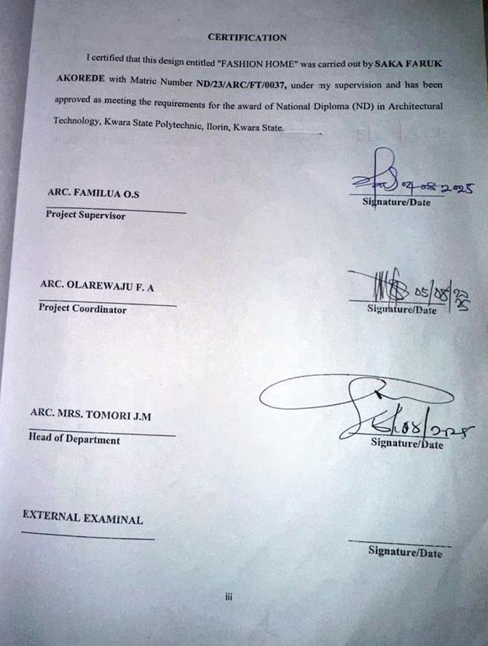

DEDICATION
Dedicate this project to Almighty God, the source of my wisdom, strength, and inspiration. His grace has guided me through every challenge, and His blessings have made this achievement possible. and also to my beloved parents, MR. and Mrs. SAKA whose unwavering love, sacrifices, and support have been my greatest motivation. Their prayers, encouragement, and guidance have shaped me into the person l am today. This project is a testament to their endless efforts and belief in my dreams.

ACKNOWLEDGEMENTS
All thanks, praise, glory and adoration belong to Almighty God the first without
predecessor and the last without successor for he is good and his mercy endures forever.
I also give profound gratitude and appreciation to my Project Supervisor Arc Familua O.S, for his time in supervising my research work. May Almighty God bless you and your family (Amen).
Respectfully, I appreciate the effort of my Head of Department in person of Arc Tomori J.M for her contribution towards the success of the student, I really appreciate all your effort ma. May Almighty God bless you ma (amen), I also appreciate the effort of the Project Coordinator Arc. OLAREWAJU F.A for over-seeing this project.
I really appreciate everything you have done may Almighty God bless you and reward you sir (Amen)
My profound gratitude goes to all entire lecturers in noble Department and non-
academic staff of Architectural Department for their dedicated service throughout the programme. May God bless you all abundantly.
My profound gratitude and appreciation also goes to a special, dynamic, courageous and irreplaceable best parent in the world my lovely, caring and wonderful parents Mr. & Mrs. SAKA for their love and care towards the completion of my academic success. I really love you and thanks so much for the maximum support and care.
I thank almighty God for the success on my project and i thank my parents but i pray may God keep them alive longer, thanks to all those that supported me.
To my siblings, and all in the family, I love you all, thanks to everyone for their support, you remain the best ever in my life.
I express my sincere gratitude and love to my friends and colleagues may God bless you all Amen

ABSTRACT
The report write up comprises of the following location fashion home. Brief History on fashion home, aim and objectives of the project , case studies drawing and pictures of each case study. This Proposed project is located in Ilorin East Ilorin Kwara state in order to play a catalyst role in
establishing more suitable place. The important construction consideration in term of aesthetics and luxury as a factor considered in design of multi purpose hall and conclusion.

That, this project will be of great benefit to whoever that read it. Particularly those who want to embark on the project of the type.

TABLE OF CONTENTS
TITLE PAGE…………………………………………………………………..........i
DECLERATION………………………………………………………………...…. ii
CERTIFICATION………………………………………………………………….. iii
DEDICATION……………………………………………………………………… iv
ACKNOLEDGMENT ………………………………………………………...…… v
TABLE OF CONTENTS…………………………………………………………… vi
LIST OF TABLES……………………………………………………………….…. vii
LIST OF FIGURES………………………………………………………………… viii
LIST OF PLATES………………………………………………………………… ix
LIST OF APPENDICES…………………………………………………………….x
ABSTRACT……………………………………………………………………...…. xi

CHAPTER ONE
1.0 INTRODUCTION………………………………….………….………………………1
1.1 HISTORICAL BACKGROUND…………………………….………………..………2
1.2 DEFINITION…………………………….…………………….…...…………………3
1.3 STATEMENT O F THE RESEARCH PROBLEM. ………………………………….3
1.4 AIM AND OBJECTIVES………………………………………..………………..…..3
1.5 JUSTIFICATION………………………………………………………………….…..4
1.6 SCOPE OF STUDY………………………………………………………………..…4
1.7 LIMITATIONS OF STUDY………………………………………………………..…4
1.8 RESEARCH METHODOLOGY…………………………………………………...…5

CHAPTER TWO

2.1 LITERATURE REVIEW …………………………….…………………………………. 6
2.1.1 INTRODUCTION………………………………………………………………………...6
2.1.2 IMPORTANT ISSUES AND PROBLEMS PECULIAR TO FASHION HOME TYPOLOGY………………………………………………………………………....7
2.1.3 TECHNOLOGICAL AND ENVIRONMENTAL APPROACHES FOR DESIGNING A FASHION HOME……………………………...……………………………….………..8
2.2 MERIT OF STUDYING……………………………………………………….…10
2.3 CONCLUSION ………………………………………………………………….10

CHAPTER THREE
3.0 CASE STUDY………………………………………………………….…..…. 11
3.1 OUTLINES OF THE CASE STUDIES……………………………...…….….. 11
3.1.1 CASE STUDY ONE (1): Yomi Casual Fashion House …………………..…….11
3.1.2 CASE STUDY TWO (2): Tymans Fashion………….………….................…….16

CHAPTER FOUR
4.1 ANALYTICAL STUDY OF THE PROJECT LOCATION…………………………24
4.1.1 INTRODUCTION…………………………………………………………………….24
4.1.2 SITE LOCATION…………………………………………………………………….24
4.1.3 SITE INVENTORY…………..…...…………………………………………………26
4.1.4 SITE ANALYSIS………………...…………………………………………………..26
4.1.5 GENERAL GEOGRAPHICAL CONDITION…………………….……………..….27
4.1.6 CLIMATE …………………………………………………………………………………...27
4.1.7 VEGETATION………………...………………………………………………..…..29
4.1.8 TOPOGRAPHY………………...……………………………………………… …..29
4.1.9 NATURAL RESOURCES………………...…………………………………….… 29
4.1.10 ENVIRONMENTAL CHALLENGES…………………………………………… ..29
4.1.11 SITE SERVICES………………………………………………………………… …30
4.1.12 SITE UNIQUENESS AND BENEFIT………………………………………………30
4.1.13 SITE SUITABILITY……………………………………………………………….30
4.2. DESIGN CRITERIA……………………………………………………………….30
4.2.1 SITE SELECTION………………………………………………………...……….30
4.2.2 BUILDING ARRANGEMENT…………………………………………………….31
4.2.3 DESIGN SCOPE…………………………………………...……………………….31
4.2.4 DESIGN BRIEF 9ANALYSIS…………………………………………………….31
4.2.5 SPACES DERIVATION ANALYSIS/SCHEDULE FOR ADMINBLOCK………32
4.2.6 FUCTIONAL ANALYSIS AND RELATIONSHIP………………………………32

CHAPTER FIVE
5.1 APPRAISAL OF PROPOSED SCHEME………………………………………….34
5.2 CONSTRUCTION METHODOLOGY AND MATERIALS. …………………….34
5.21 MATERIALS FOR CONSTRUCTION……………………………………………34
5.2.2 CONSTRUCTION METHODOLOGIES………………………………………….34
5.2.1 SERVICE……………………………………………………………………….….36
5.2.2 CIRCULATION……………………………….……………………………….….36
5.2.3 VENTILATION……………………………………….……………………….….36
5.2.4 LIGHTING……………………………………….……………………………….37
5.2.5 PLUMBING ……………………………………….……………….…………….37
5.2.6 ELECTRICAL INSTALLATION……………………………..………………….37
5.2.7 WASTE DISPOSAL……………………………………….…….……………….37
5.2.8 FIRE PROTECTION……………………………………………………………..38
5.2.9 EXTERNAL WORKS……………………………………………..……………..38
5.3 CONCLUSION AND RECOMMENDATION………………………………….38
REFERENCES………………………………………………………………………….39

LIST OF PLATES
CASE STUDY 1
PLATE 3:1.1 LOCATION MAP………………………………………………………….13
PLATE 3.1.2 ELEVATION ……………………………………………..……………….14
PLATE 3.1.3 ELEVATION……………… ……………………………………………….15
PLATE 3.1.4 ELEVATION……………..……………………………………...………….15
CASE STUDY 2
PLATE 3.2.1 ELEVATION………………………………………………………………18
PLATE 3.2.2 STAFF OFFICE. ………………………………………………………….18
CASE STUDY 3
PLATE 3.3.1 LOCATION MAP………………………………………………………….20
PLATE 3.3.2 ELEVATION……………………………………………………………….21
PLATE 3.3.3 ELEVATION…..…………...……………………………………...……….22
PLATE 3.3.4 ELEVATION…...…………...……………………………………….……...22

LIST OF FIGURES
FIGURE 3:1:1 LOCATION PLAN CASE STUDY 1…………………………..………12
FIGURE 3.1.2 FLOOR PLANS CASE STUDY 1…….………………………….…..…13
FIGURE 3:1.3 SITE PLAN CASE STUDY 1 ……………………...……………………14
FIGURE 3.2.1 LOCATION PLAN CASE STUDY 2……………………………………15
FIGURE 3.2.2 FLOOR PLANS CASE STUDY 2……………………………….…….…15
FIGURE 3.3.1 LOCATION PLAN CASE STUDY 3……………………………….……20
FIGURE 3.3.2 FLOOR PLAN. CASE STUDY 3…………………..…………………..…21
FIGURE 4.1.11.1 MAP OF NIGERIA, 36 STATES AND FCT. ……………..………….24
FIGURE 4.1.11.2 KWARA STATE MAP………..……………………………..……………...25
FIGURE 4.1.11.1 LOCATION PLAN …………………………………..………….……...25
FIGURE 4.1.12.1 SITE INVENTORY …………………………………….……….………26
FIGURE 4.1.12.2 SITE ANALYSIS ……………………………..………..……….………27
FIGURE 4.1.3.1 AVERAGE MONTHLY RAINFALL IN ILORIN. …….….…………….28
FIGURE 4.1.3.2 SUNSHINE DURATION IN ILORIN. ………………………..………….28
FIGURE 4.1.3.3 RELATIVE HUMIDITY IN ILORIN. ………………………..…………..29
FIGURE 4.2.6.1: FUNCTIONAL ANALYSIS 1 ……………………………………………32
FIGURE 4.2.6.2: FUNCTIONAL ANALYSIS 2 ……………………………………………32
FIGURE 4.2.6.3: FUNCTIONAL RELATIONSHIP 1 …………………………….………..33
FIGURE 4.2.6.4: FUNCTIONAL RELATIONSHIP 2 ………………………………………33

LIST OF TABLES

TABLE 4.1.1: SPACE ALLOCATION………………………………………………32

LIST OF APPENDICES
APPENDICES 5.1: GROUND FLOOR PLAN…………………………………………..40
APPENDICES 5.2: FIRST FLOOR PLAN. ……………………………………………..40
APPENDICES 5.3: SECON FLOOR……………………………………………………..41
APPENDICES 5.4: ROOF PLAN ………………………………………………………..41
APPENDICES 5.5: SITE PLAN……………………………………………………..…..42
APPENDICES 5.6: SECTIONS……………………………………………………..…..42
APPENDICES 5.7: ELEVATION……………………………………………….…..…..43

CHAPTER ONE

INTRODUCTION

Fashion is more than just clothing—it is a reflection of identity, creativity, culture, and time. A fashion home serves as a central hub for designing, producing, and sometimes retailing clothing and accessories. In recent times, fashion homes have evolved into creative laboratories where traditional styles meet contemporary innovations. This project explores the design and functionality of a modern fashion home, focusing on how architectural design can influence creativity, productivity, and customer experience in the fashion industry.

1.1 HISTORICAL BACKGROUND OF THE PROJECT
The concept of a fashion home dates back to the early 20th century, with the rise of haute couture in Europe, particularly in France and Italy. Over time, African countries, including Nigeria, began to develop their own fashion industries with local designers gaining recognition. The Nigerian fashion industry has seen significant growth, driven by cultural pride, the rise of Afrocentric designs, and global interest in African textiles. The fashion home evolved from simple tailor shops to modern establishments equipped with design studios, fitting rooms, offices, showrooms, and training centers. This project reflects the changing needs of today's fashion businesses and the architecture that supports them.
In Nigeria, fashion has always been a vibrant part of culture and identity, with traditional garments such as agbada, aso-oke, ankara, and lace materials serving not just as clothing but as symbols of heritage and pride. Over the decades, the growth of local fashion designers and increased global exposure have fueled a boom in the fashion sector, particularly in urban centers like Lagos, Abuja, and Ibadan.
As the industry matured, the limitations of traditional tailoring shops became more apparent—lack of space for design and production, poor lighting, inadequate customer service areas, and unappealing aesthetics. This led to the idea of a “Fashion Home” — a modern, well-planned facility that blends functionality with beauty. It typically includes

sections for design, production, storage, fittings, photography, display/showroom, and sometimes even training.
This project aims to reflect the evolution of fashion spaces by designing a Fashion Home that is not only a center for creativity and commerce but also a landmark that uplifts the aesthetics and functionality of fashion architecture in Nigeria.
1.2 DEFINITION
A Fashion Home is a dedicated facility where clothing and accessories are designed, produced, displayed, and often sold. It typically houses various functional spaces including workrooms, design studios, cutting areas, storage, offices, and sometimes training classrooms for aspiring designers or tailors. It combines business and creativity under one roof.
1.3 STATEMENT O F THE RESEARCH PROBLEM.
In many parts of Nigeria, especially urban and semi-urban areas, fashion designers often operate in poorly planned environments. They struggle with space limitations, lack of ventilation, inadequate lighting, and inefficient layouts that hinder productivity and creativity. There is a need to develop a well-organized, functional fashion home that meets modern design standards while being culturally relevant and economically viable.
This situation results in several challenges, including inefficient workflow, overcrowding, poor customer experience, low aesthetic appeal, and limited capacity for training or expansion. As the Nigerian fashion industry continues to grow both locally and internationally, there is a rising demand for professionally designed spaces that can support not just tailoring but the full spectrum of fashion-related activities such as creative design, branding, production, modeling, and client interaction.

Despite this demand, there is limited architectural attention given to the design of Fashion Homes—facilities that blend creativity, functionality, and branding in one environment. The lack of a well-thought-out architectural solution limits the growth potential and professional image of many fashion businesses.
1.4 AIM AND OBJECTIVES
1.4.1 AIM OF THE STUDY
To design a modern, functional, and sustainable fashion home that promotes productivity, creativity, and business growth in the Nigerian fashion industry.
OBJECTIVES:
- To study the spatial needs of a fashion home.
- To design a flexible layout that supports different activities like cutting, sewing, fitting, and showcasing.
- To integrate natural lighting and ventilation for better working conditions.
- To consider aesthetics that reflects African identity.
- To accommodate spaces for training and customer interaction.

1.5 JUSTIFICATION.
The fashion industry in Nigeria is rapidly growing, with increasing demand for creative, high-quality, and culturally expressive clothing. However, many designers and tailors still operate in cramped, poorly designed environments that limit both productivity and professionalism. A well-planned fashion home is not just a workspace—it is a reflection of brand identity, innovation, and business ambition.
Most existing fashion designers operate in cramped, poorly ventilated shops or home-based spaces that are not conducive to professional work, customer service, or brand development. These limitations often affect productivity, organization, comfort, creativity, and the ability to scale operations or train apprentices effectively.

3

Designing a Fashion Home provides a sustainable architectural solution that brings together all key functions—design, production, training, showcasing, and customer service—under one roof. It supports better workflow, enhances the working environment, improves client experience, and promotes the identity of fashion brands

1.6 SCOPE OF THE STUDY
This study focuses on the architectural design of a fashion home suitable for a small to medium-scale fashion business in Nigeria. It includes the analysis and design of the following spaces:

- Cutting and sewing rooms
- Fitting rooms
- Showroom/display area
- Admin/management offices
- Staff restrooms
- Reception/waiting area
- Storage for fabrics and materials
- Outdoor signage and branding
It does not cover large-scale industrial fashion factories or international fashion runways.

1.7 LIMITATIONS OF STUDY
- Limited access to professional fashion homes for physical study and measurement.
- Budget constraints affecting material selection in the design.
- Availability of standard data on space requirements for fashion operations in Nigeria.
- Time constraints that restricted wider field research.
- Technological and environmental limitations in some proposed locations.

1.8 RESEARCH METHODOLOGY

The research approach for this project involved both primary and secondary methods:
- Primary Data: Site visits to existing fashion homes, interviews with fashion designers and tailors, and sketches of functional spaces.
4
- Secondary Data: Review of books, journals, internet articles, and architectural case studies on fashion-related buildings.

- Case Studies: Detailed analysis of selected fashion homes in Nigeria to understand their layout, materials, advantages, and weaknesses.

- Design Tools: Use of architectural design software (e.g., AutoCAD, Revit, SketchUp) to develop and present the project drawings.

5

CHAPTER TWO
2.1LITERATURE REVIEW
2.1.1 Introduction
A fashion home is more than just a tailoring shop—it is a multifunctional space where creativity, business, and culture intersect. The structure and layout of a fashion home significantly influence how effectively designers and tailors work, how clients experience the brand, and how fashion products are produced and displayed. In architectural terms, it must serve multiple functions: design studio, sewing/cutting room, administrative office, retail/showroom, storage, and sometimes training space.

Oladipo (2019) argues that natural lighting is a key component in fashion spaces. Designers rely heavily on accurate color perception, which can be affected by poor lighting. Incorporating wide windows, skylights, and cross-ventilation strategies not only reduces energy costs but also enhances worker comfort and productivity.

2.1.2 IMPORTANT ISSUES AND PROBLEMS PECULIAR TO FASHION HOME TYPOLOGY
Designing a Fashion Home comes with unique challenges that are different from other commercial or residential building types. These issues must be identified and addressed in order to create a space that is functional, comfortable, and supportive of creative work. The major problems peculiar to fashion home design include:

- Space Management and Functional Zoning
Fashion involves multiple activities like designing, cutting, sewing, fitting, ironing, and displaying finished products. Poor zoning can lead to disorganization, noise interference, and workflow disruption. A Fashion Home must clearly separate public areas (e.g., reception, showroom) from semi-public (e.g., fitting rooms) and private zones (e.g., production area).

- Lighting and Ventilation
Fashion work is detailed and requires good visibility. Inadequate natural lighting and poor ventilation can affect productivity and comfort, especially for tailors and designers who spend long hours indoors.

- Noise and Distraction
Sewing machines, generators, and human activity generate noise. Without proper acoustic planning, noise can disturb concentration and customer experience.
- Material Storage and Organization
Fashion requires storage for fabrics, tools, threads, accessories, and finished clothes. Without dedicated and well-designed storage, materials can become scattered, causing clutter and reducing workspace efficiency.

2.1.3 TECHNOLOGICAL AND ENVIRONMENTAL APPROACHES FOR DESIGNING A FASHION HOME.
Technological and Environmental Approaches for Designing a Fashion Home

Modern architecture demands not just functionality, but also sustainability and the integration of technology. A well-designed Fashion Home should adopt smart technological solutions and environmentally responsive strategies to create a comfortable, efficient, and future-ready space. Below are key approaches to consider:

- TECHNOLOGICAL APPROACHES
- Energy-efficient Lighting and Equipment
Use of LED lights and energy-saving sewing equipment can reduce power consumption. Task lighting should be integrated into workstations to provide adequate brightness for cutting, stitching, and detailing.

- Smart Power Management Systems
Installation of inverters, solar panels, or hybrid systems ensures uninterrupted power supply for lighting, sewing machines, and ironing tools in areas with unstable electricity.

- Digital Design Tools
Provision for computer-aided design (CAD) stations where designers can use fashion software to create patterns, visualize styles, and speed up workflow.

- Security Systems
Use of surveillance cameras (CCTV), access control for production areas, and fire alarm systems ensures safety for people, equipment, and stored materials.

- E-commerce Integration Points
Provision of media corners with internet access for photography, content creation, and online marketing to support the digital aspect of modern fashion businesses.

- ENVIRONMENTAL APPROACHES

- Natural Lighting and Ventilation
Large windows, skylights, and cross-ventilation designs reduce the need for artificial lighting and cooling. This enhances indoor comfort and reduces energy costs.

- Climate-responsive Design
Orienting the building to take advantage of prevailing winds and minimizing direct sunlight on heat-prone surfaces reduces thermal discomfort. Shading devices, overhangs, and ventilation blocks can help.

- Use of Local and Sustainable Materials
Incorporating locally available, eco-friendly materials such as compressed earth blocks, bamboo, or recycled wood reduces environmental impact and supports local economies.

- Water Management
Rainwater harvesting systems can provide water for cleaning and toilet use. Low-flow taps and water-efficient toilets reduce water wastage.

- Green Landscaping
Planting trees and using green cover around the site not only beautifies the surroundings but also cools the environment and improves air quality.

CHAPTER THREE

3.0 CASE STUDY
A case study involves an up-close, in-depth, and detailed examination of a particular case or cases, within a real-world context. Case study research is to establish a firm research focus to which the research can refer over the course of a complex phenomenon or object.
Case study can be view as the study of an existing project for a reference purpose in order to determine adjustment point of that particular building. Case study research is to establish a firm research focus to which the research can refer over the course of a complex phenomenon or object.
According to researcher Robert K. Yin, defined case study method as an empirical inquiry that investigate a contemporary phenomenon within its real-life context,

3.1 OUTLINES OF THE CASE STUDIES
- CASE STUDY 1: Yomi Casual Fashion House
- CASE STUDY 2: Tymans Fashion

3.1.1 CASE STUDY ONE (1): Yomi Casual Fashion House Lagos State
Location: Lekki, Lagos
Function: Fashion design, tailoring, celebrity styling, branding, and showroom
Business Type: High-end custom menswear fashion brand

Overview:
Yomi Casual, founded by Olorunyomi Makun, is a prominent Nigerian fashion brand known for its bold, elegant, and creative menswear. Based in Lagos, the fashion house has become a symbol of modern African fashion excellence, serving celebrities, entertainers, and high-profile clients.

The Yomi Casual Fashion House operates in a bespoke-designed facility that reflects the brand’s identity — classy, bold, and professional. It’s a strong example of how architecture and interior design can communicate brand values.

Merits:
- The building reflects the luxury and class of the fashion brand.
- Interior design enhances client perception and brand image.
- Spatial planning separates customer space from production zones, improving professionalism.
- Offers privacy and comfort for celebrity clients.
- Reinforces the idea that architecture and fashion branding go hand-in-hand.

Demerits:
- High cost of setup and maintenance, due to the luxury design and location
- As a high-end facility, it is less accessible to the general public or smaller fashion startups
- Noise control is important, but might still be a challenge if production isn't isolated acoustically
- Power backup is necessary to keep operations running smoothly — a common Lagos issue.

LOCATION PLAN

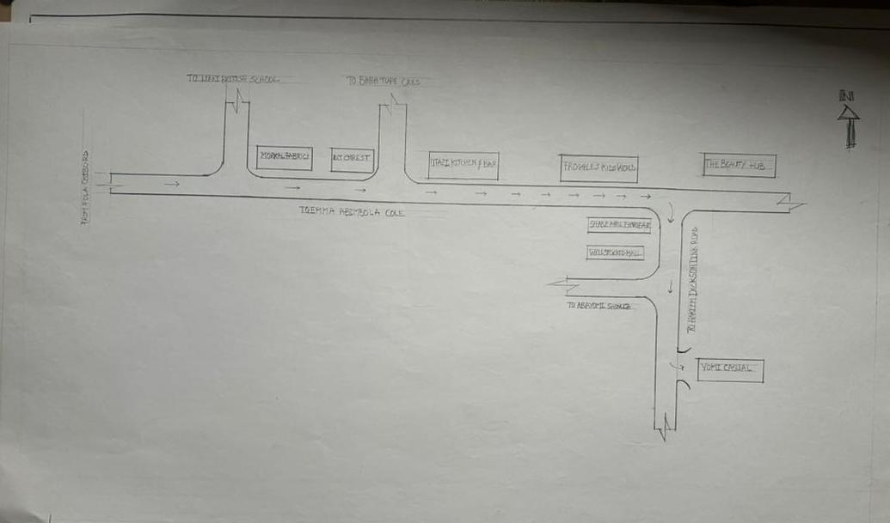
Figure 3:1:1 Location Plan

SITE PLAN
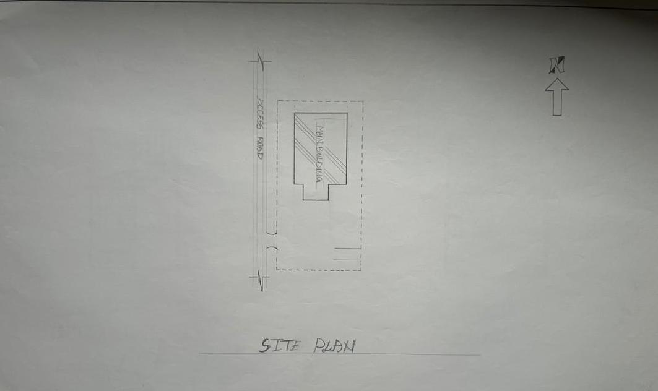
Figure 3.1.2Site Plan
FLOOR PLAN
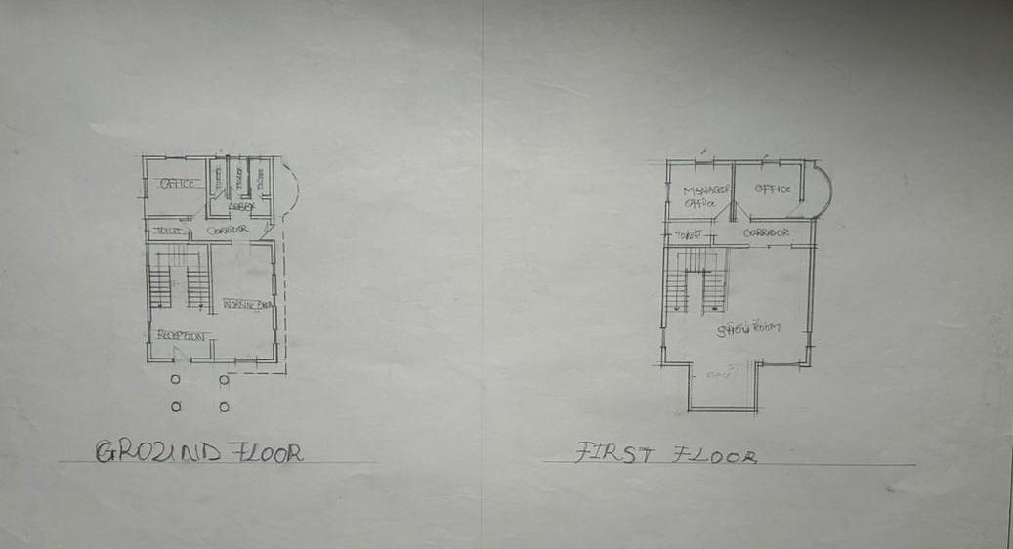
Figure 3:1.3Floor Plans

PICTURES
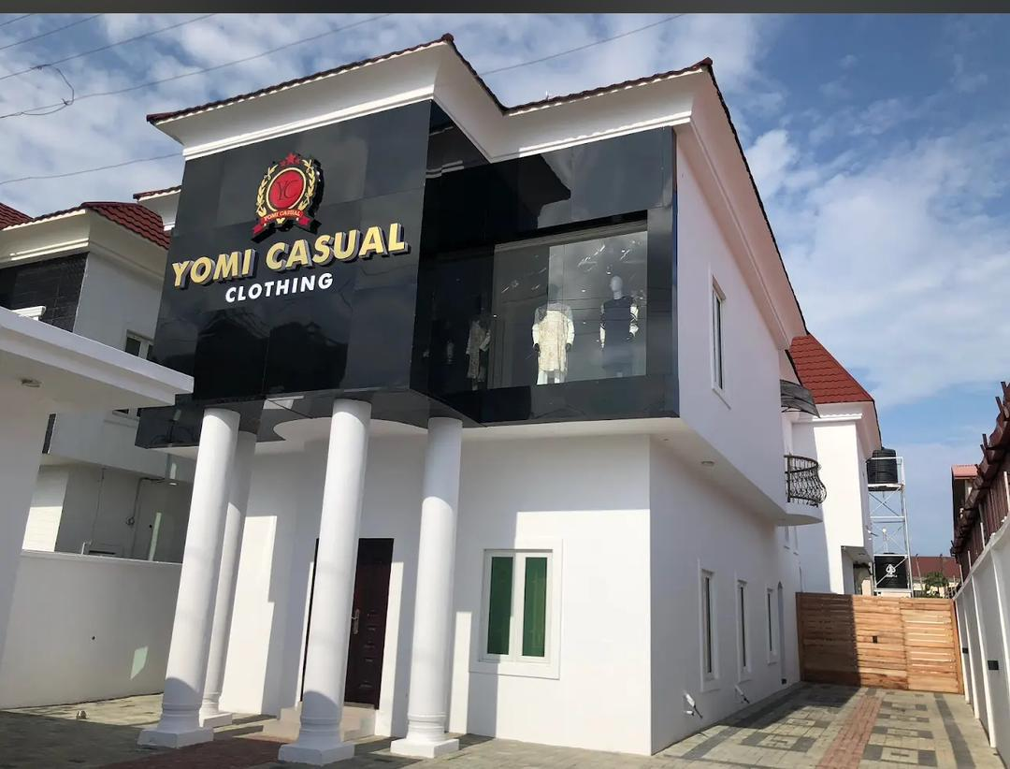
Plate 3.1.2Elevation
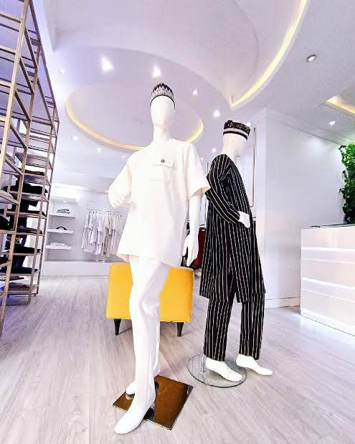

Plate 3.1.3 Inside
    - CASE STUDY TWO (2): Tymans Fashion Ilorin Kwara State
Location: Ilorin, Kwara State (or specify the exact city if different)
Function: Fashion design, tailoring, styling, and brand promotion
Business Type: Medium-scale bespoke fashion brand for men and women

Overview:
Tymans Fashion is a growing Nigerian fashion brand recognized for its clean, stylish, and modern designs, especially in native wear and custom formal outfits. Tymans combines creative tailoring with branding and social media marketing to serve a wide range of clients across Nigeria.

Merits
- Blends creativity and business with a clean, youthful aesthetic.
- Functional use of limited space for production, fittings, and display.
- Excellent social media branding, making up for limited physical space.
- Supports youth training and skill development through apprenticeships.
- Operates in a flexible setup that allows daily tailoring business to run smoothly.
Demerits
- Operates in a non-purpose-built space, which limits organization and expansion.
- Lighting and ventilation may be inadequate in production zones.
- Power supply issues affect productivity without consistent backup solutions.
- Storage space is limited, sometimes leading to clutter and inefficiency.
- Limited client lounge or waiting area affects customer comfort during fittings.

LOCATION PLAN
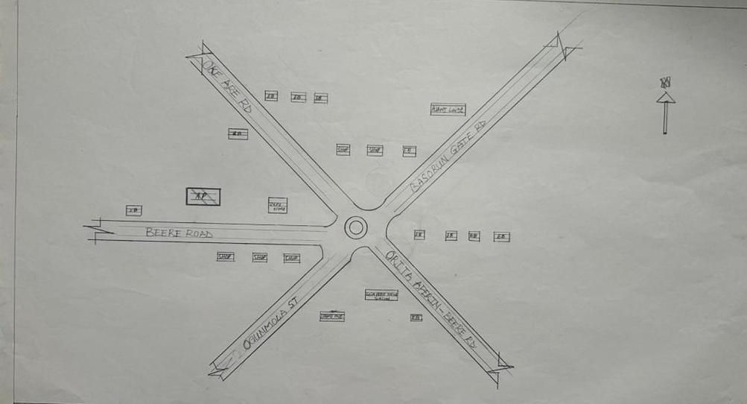
Figure 3.2.1Location Plan
FLOOR PLAN
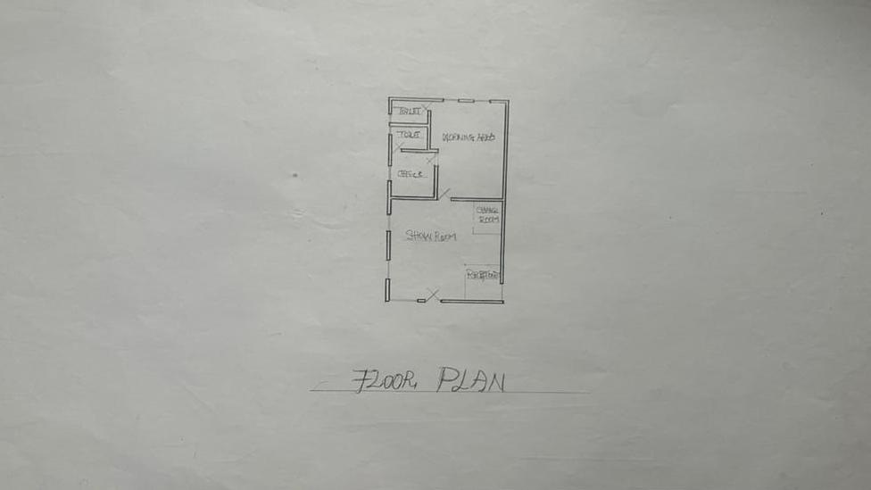
Figure 3.2.2 Floor Plans

PICTURES
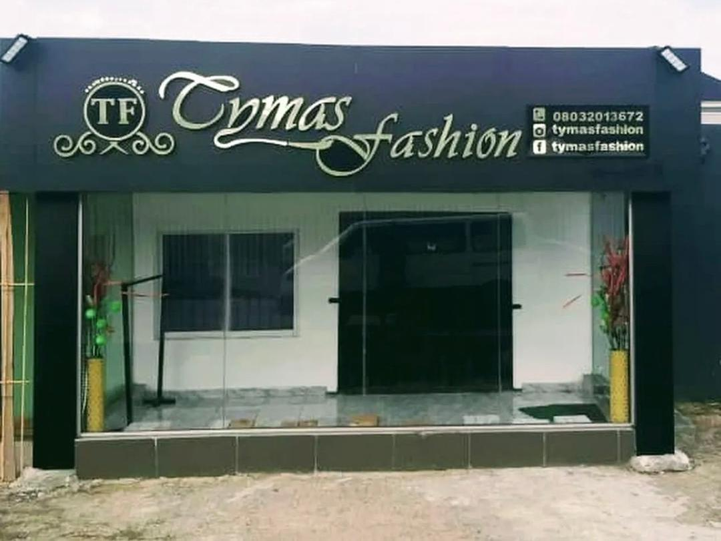
Plate 3.2.2 Front Elevation

CHAPTER FOUR
4.1 ANALYTICAL STUDY OF THE PROJECT LOCATION
4.1.1 INTRODUCTION
Ilorin is one of 36 states of federal of republic of Nigeria. Ilorin, the capital city of Kwara State, Nigeria, is a city with a rich historical, cultural, and economic background. Ilorin was founded in 1450 and has a significant historical legacy as a prominent center in the Yoruba and Fulani empires. Ilorin is a city with a rich historical heritage and cultural diversity, serving as an economic and educational hub in Kwara State. Its strategic location, coupled with ongoing development efforts, positions it as a key city in Nigeria’s socio-economic landscape.
4.1.2 SITE LOCATION
This is very important point to be considered before establishing the setting of houses, should take advantage of topographical features speeds and directions should be studied to ensure the best orientation to take advantage of the prevailing wind. Avoiding site prone to water logging and rain and draught which depends on wind direction and speed in the raining season placement of a building so that the length extends along the East and West direction. The proposed project is sited at Adewole, Atiku Abubakar Road Ilorin, Kwara State. It is surrounded with built up environment with various commercial activities being taken up in the area.
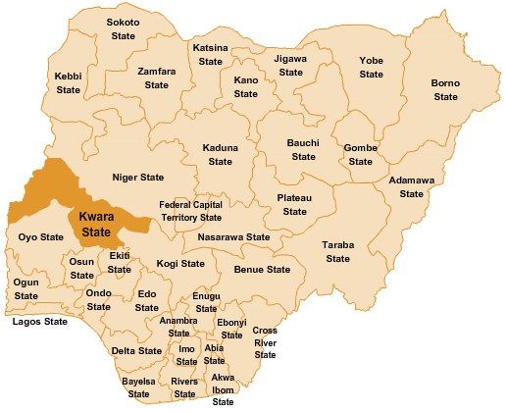

Figure 4.1.11.1 Map of Nigeria, 36 States and FCT.
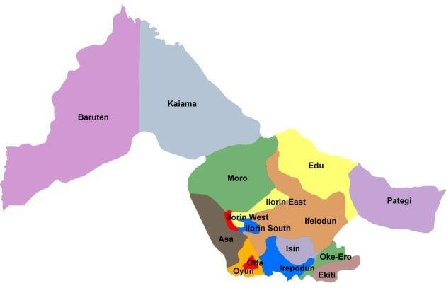
Figure 4.1.11.2 Kwara State Map
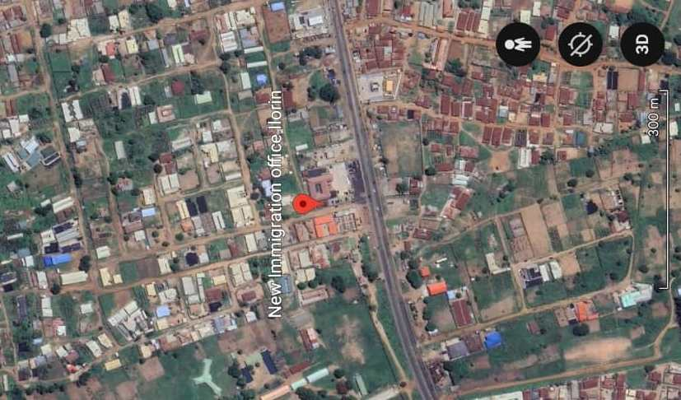
Figure 4.1.11.1 Location Plan

4.1.3 SITE INVENTORY

Site inventory is the synthesis of the physical feature and facilities that are present on the site and over the site such as trees, footpath, soil, topography, vegetation, stream and shrubs etc.

4.1.4 SITE ANALYSIS
Site Analysis is the process of evaluating how a proposed site system will integrate with the existing site infrastructure by assessing physical obstructions, electrical interference, and noise to identify suitable interrogation zones for coexistence with the infrastructure.

The site selected for the project is a very gentle slope, it is a site that has never been used for any form of building construction i.e. it has not been developed in the past which make it an abode for several trees and shrubs, it is also observed during the course of inventory that some of the trees are to be removed as it could obstruct the construction process during the project, while some are to be retained to help control the adverse of the wind storm.

The soil is well compacted Soil in nature with good soil texture. The sun rises from the eastern part of the site and sets on the western part. The Construction does not need a special type of foundation due to the fact that the site is having a good bearing capacity and strength.

4.1.5 GENERAL GEOGRAPHICAL CONDITION
Kwara State is located in the North-Central region of Nigeria. It shares boundaries with Kogi State to the east, Ekiti and Osun States to the south, Oyo State to the southwest, Niger State to the north, and an international border with Benin Republic to the west.

- Terrain: The state has a generally flat to gently undulating terrain, with some scattered hills especially in areas like Baruten and Kaiama. The land is a mix of savanna grasslands and wooded areas.

- Soil and Vegetation: The soils are mostly loamy and lateritic, suitable for farming. Vegetation varies from Guinea Savannah in the north to forest-savannah in the south.

Natural Features:
- Rivers like River Niger, Asa River, and Awon River are notable.
- There are also rock formations like Owu Falls and Imoleboja Rock Shelter.

4.1.6 CLIMATE:
Tropical savanna climate (Aw) according to the Köppen classification.
Temperature:
- Average annual temperature ranges between 25°C and 35°C.
- Hottest months: March to April (can reach up to 38°C).
- Coolest months: December to January (due to Harmattan winds).

Rainy Season:
- Starts around April and ends in October.
- Peak rainfall is usually in June and September.
- Annual rainfall ranges from 1,000 mm to 1,500 mm.

Dry Season:
- Runs from November to March.
- Influenced by Harmattan, a dry and dusty wind from the Sahara.
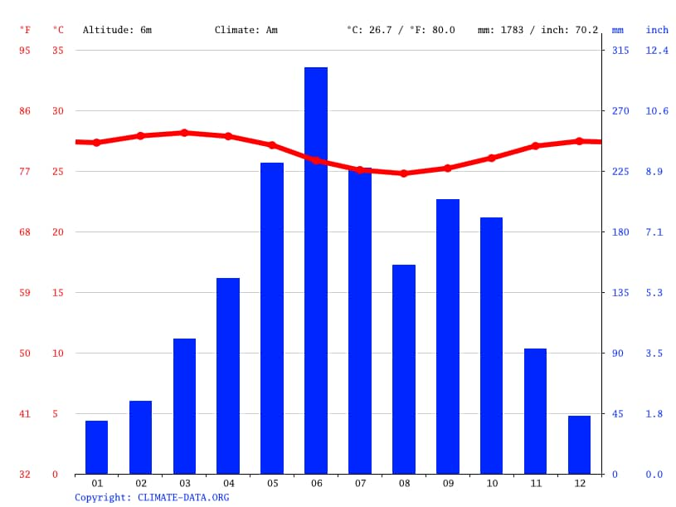
Figure 4.1.3.1 Average Monthly Rainfall in Kwara State.

Dry Season: The dry season in Kwara State usually spans from November to March. This period is marked by little to no rainfall, high daytime temperatures, and significantly lower humidity compared to the rainy season. A key feature of the dry season is the Harmattan, a dry and dusty wind that blows from the northeast, usually between December and February.

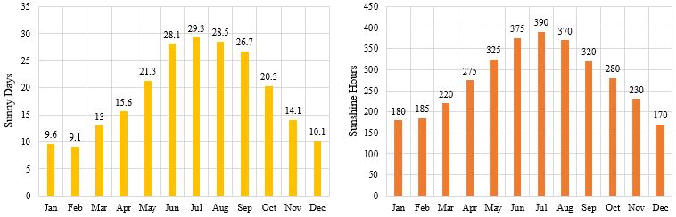

Figure 4.1.3.2 Sunshine Duration in Kwara State.
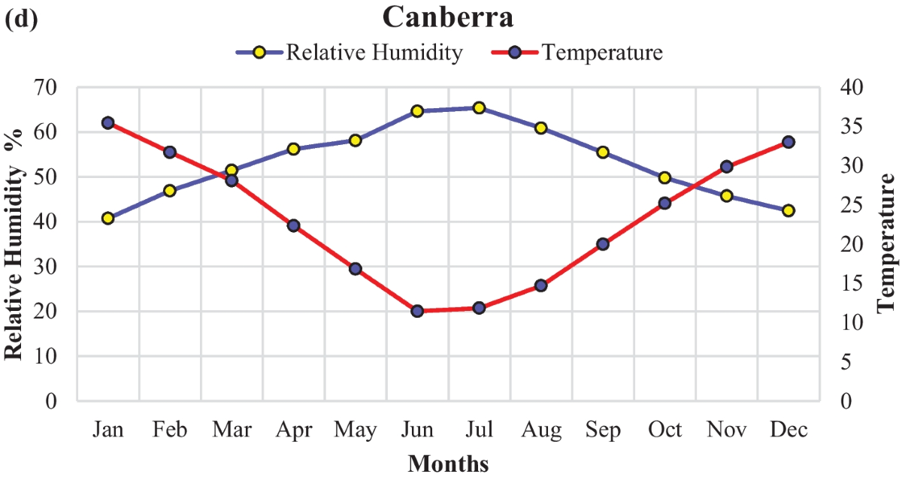

Figure 4.1.3.3 Relative Humidity in Kwara State.

4.1.7 VEGETATION
Guinea Savanna: The predominant vegetation type in Kwara State is the Guinea Savanna, characterized by a mix of grassland and scattered trees. This vegetation type is typical of the transitional zone between the forest regions in the south and the Sahel in the north.
Flora: Common plant species include acacia, baobab, shea butter trees, and various grasses and shrubs adapted to the savanna climate.

4.1.8 TOPOGRAPHY
Gently Undulating Plains: Kwara State. topography consists mainly of gently undulating plains, with occasional hills and low-lying areas.

4.1.9 NATURAL RESOURCES
Kwara State is rich in both metallic and non-metallic mineral resources, which support small- to medium-scale mining and industrial activities.
- Limestone
- Location: Found in large deposits in areas like Ogunreke, Patigi, and Share.
- Uses: Cement production, construction, and road building.
- Granite
- Location: Common in Ilorin, Asa, and Moro local government areas.
- Uses: Building and construction (used as crushed stone).
- Kaolin
- Location: Found in Edu, Ifelodun, and Offa.

4.1.10 ENVIRONMENTAL CHALLENGES
Urbanization: Rapid urbanization in Kwara State has led to challenges such as deforestation, waste management issues, and pressure on infrastructure and services.
Climate Change: Like many regions, Kwara State faces the impacts of climate change, including variability in rainfall patterns and increased frequency of extreme weather even.

4.1.11 SITE SERVICES
There are good services around the site, which include good access road, for students coming to school, availability of electricity very close to the site which will be useful before and after construction. Also, availability of pipe born water at the chosen site.

4.1.12 SITE UNIQUENESS AND BENEFIT
- The site is accessible
- Natural factor like, is very useful
- Utility services such as water, electricity, telephone, etc. cause no problem to the inhabitants.

4.1.13 SITE SUITABILITY
The appropriateness or suitability of the site for the construction and planning of the proposed project is based on the fact that is possesses and meets the entire requirements. All the existing features were strictly considered with the intension of making advantage of them to maximum level most especially the geographical, topographical features of the site.
Types of Forest Region
- Mangrove (Salt Quarter) Swamp Forest
- Fresh water swamp forest
- High forest

4.2. DESIGN CRITERIA
The design of a fashion home must support creativity, comfort, and efficient workflow. It should be divided into zones—public (showroom, reception), semi-private (workroom, training), and private (office, store). Natural lighting and ventilation are key to improving productivity and health. Spaces should be flexible for future changes and reflect local culture through materials and decoration. Good circulation, accessibility, and safety must also be ensured. The building should be environmentally friendly and give both workers and customers a pleasant experience.

4.2.1 SITE SELECTION
A number of factors necessary for site selection for a farmstead are outlined below:
  - ﻿﻿﻿Access Road
  - ﻿﻿﻿Water
  - ﻿﻿﻿Utilizes and services (electricity, telephone, access drives etc.)
  - ﻿﻿﻿Orientation (air drainage and maximum sunshine may require orientation on a gentle Southerly slope).
  - ﻿﻿﻿Expansion.

4.2.2 BUILDING ARRANGEMENT
The arrangement of facilities for maximum efficiency of operation should be a prime concern. Proper arrangement increase efficiency by reducing walking distance to a minimum and providing adequate drive ways and turn around. It is important to note that five protections, safely and security and all influenced by the design planning.

4.2.3 DESIGN SCOPE
The design scope of this project covers the planning and architectural design of a functional fashion home suitable for a small to medium-scale fashion business. It includes essential spaces such as the reception, showroom, cutting/sewing room, design studio, fitting room, admin office, store, toilets, and staff rest area. The project focuses on space efficiency, aesthetic appeal, cultural expression, natural ventilation, and lighting. The design also considers customer experience, staff comfort, and future expansion possibilities.

4.2.4 DESIGN BRIEF9ANALYSIS
The proposed fashion home is intended to serve as a creative and functional space for fashion design, tailoring, display, and administration. The design must accommodate the workflow from fabric cutting to garment finishing, while also providing space for customer service and staff operations. Key requirements include a welcoming reception, spacious sewing and cutting areas, a design studio, a stylish showroom, private offices, store rooms, fitting areas, and restrooms

4.2.5 SPACES DERIVATION ANALYSIS/SCHEDULE FOR ADMINBLOCK
S/N | UNITS | NO REQ. | LENGTH | BREADTH | METER CM²
 | Main Entrance |  | 2100mm | 1940mm
 | Reception Area |  | 7200mm | 7500mm
 | Exhibition Area |  | 14400mm | 10000mm
 | Sewing Room |  | 9600mm | 7500mm
 | Cutting Room |  | 9100mm | 8300mm
 | Weaving Room |  | 4000mm | 7800mm
 | Medical & Pedicure Room |  | 7200mm | 10000mm
 | Hair Style Room |  | 9600mm | 8500mm
 | Class Room |  | 7300mm | 7500mm
 | Design Studio |  | 7500mm | 5100mm
 | Finishing Room |  | 4900mm | 4900mm
 | Over locking Room (x2) |  | 4000mm | 2100mm
 | Raw Store |  | 4700mm | 4500mm
 | Manager’s Office |  | 6200mm | 3900mm
 | Supervisor’s Office |  | 5800mm | 3600mm
 | Massage Room |  | 9000mm | 4800mm
 | Measure Room |  | 4700mm | 4200mm
 | First Aid Room |  | 1800mm | 4200mm
 | Store |  | 2700mm | 1800mm
 | Convenience (13 units) |  | 2100mm | 1800mm

Table 4.2.5: Space Allocation

CHAPTER FIVE
5.1 APPRAISAL OF PROPOSED SCHEME
The proposed Project is to satisfy the appropriate building regulations. The design is to confirm the aid intended use of building taking into consideration with both natural factors and human factors that earn us a threat on the validity and stability of the building.

5.2 CONSTRUCTION METHODOLOGY AND MATERIALS.
The construction is to be carried out following the due process of construction ranging from:
- Preliminary: This involves the clearing of the site, setting out and excavation of foundation trench and foundation works.
- Sub-Structure: This process also entails the positioning and erection of Columns and beans, masonry works etc.
- Post Structure Stage: Is the stage which has to do with the application and installation of the paints, tiles, other finishes and construction of external works etc.

5.21 MATERIALS FOR CONSTRUCTION
1. Sustainable and Eco-Friendly Materials
- Bamboo and Timber: These materials are renewable, have a low carbon footprint, and can be sourced sustainably. Bamboo, in particular, grows quickly and has strong tensile properties.
- Recycled Materials: Using recycled steel, concrete, and glass can reduce the environmental impact of the construction process.
- Insulating Materials: Materials like sheep wool, cellulose, and hemp provide excellent thermal insulation and are environmentally friendly.

2. Traditional and Cultural Materials
- Clay and Adobe: Traditional building materials that offer good thermal mass, keeping buildings cool in hot climates. These materials can be locally sourced and are culturally significant in many regions.
- Stone: Using locally available stone can provide durability and cultural relevance, reflecting traditional architecture.
- Tiles and Ceramics: Decorative tiles and ceramics are often used in architecture for aesthetic purposes, featuring intricate geometric patterns and calligraphy.

3. Modern Materials
- Concrete: Widely used for its strength and versatility. It can be enhanced with additives to improve its sustainability.
- Steel: Provides structural strength and flexibility. Recycled steel can be a more sustainable option.
- Glass: Used for windows and facades to allow natural light. Double or triple-glazed glass can improve energy efficiency.

5.2.2 CONSTRUCTION METHODOLOGIES
1. Green Building Practices
- Passive Solar Design: Orienting the building to maximize natural light and heat from the sun, reducing the need for artificial lighting and heating.
- Green Roofs and Walls: Planting vegetation on roofs and walls to improve insulation, reduce heat island effects, and provide green spaces.
- Rainwater Harvesting Systems: Collecting and using rainwater for irrigation and non-potable uses within the school.

2. Energy-Efficient Construction
- Insulation: Using high-quality insulation materials to reduce energy consumption for heating and cooling.
- LED Lighting: Implementing energy-efficient LED lighting throughout the school.
- Solar Panels: Installing solar panels to generate renewable energy, reducing dependence on non-renewable energy sources.

3. Cultural and Religious Considerations
- Orientation: Provision of natural, quiet spaces that can be used for individual or group prayer during break periods.
- Architectural Elements: In the design of a functional and child-centered primary school, several architectural elements must be thoughtfully considered to ensure safety, comfort, and effective learning.
- Community Involvement: Engaging local communities in the design and construction process to ensure that the school meets cultural and social needs.

5.2.1 SERVICE
A building can be said to be good when it performs the service required by it. In order to have well-functioning building. There calls for an installation of underground water pipes in other to provide water to all the restrooms and other necessary units in the building. A borehole system of water supply is to be adopted alongside the government supplied services and a storage facility is to be provided for effective management of water supply.

5.2.2 CIRCULATION
In my primary school project, circulation is carefully planned to make movement around the school safe, easy, and comfortable for both pupils and staff. Since children are the main users, all circulation paths are designed to be wide, open, and easy to understand.

5.2.3 VENTILATION
As it relates to architecture, is the intentional introduction of outside air into a space. It is mainly used to control indoor air quality by diluting and displacing indoor pollutants. It can also be used for purpose of thermal comfort of dehumidification when the introduction of outside air will help to achieve desired indoor psychometric condition.

This could be either mechanical or natural ventilation. As a regard the proposed project design, there is an introduction of a very spacious courtyard in other to make cross ventilation in most of the building units. There should also a provision of wide passage to allow free movement of air, students and materials. Artificial ventilation is also provided through the installation of air conditioning system and fans.

5.2.4 LIGHTING
Lighting is one of the most important elements in my primary school project because it affects how well pupils can see, learn, and stay alert in class. In my design, I considered both natural and artificial lighting to create a bright, healthy, and energy-efficient learning environment.

5.2.5 PLUMBING
The plumbing system in this proposed building is made easy since the building has a courtyard. Water drained pipes are to be installed underground right from the courtyard to the soak away in other to discharge rainwater.

All water or sewage from the toilets are also channeled into their various inspection chambers using good and appropriate diameter PVC pipes, and taken from the inspection chamber to septic tanka and soak away pit.

Rain water is also collected from gutter if the roof using 100mm diameter PVC rain water pipes and channeled into various drainage or soak away pits. There shall be no ponding; the size of any channel shall effectively discharge rain and water without causing any over lowing stagnation and mosquito breeding. All rain water channeled shall be laid to fall and shall not cause any pounding or splashing unto the committers neighboring area.

5.2.6 ELECTRICAL INSTALLATION
The type of wiring system chosen should be full conduit system of wiring. Classrooms and other students’ technical areas should be wired with strong, durable and light current resistance cable because of the careless operate by the students. Also, electrical installation is to be done to allow for the use of quality electrical fittings and fixtures in the whole building.

5.2.7 WASTE DISPOSAL
Waste disposal bins are to put every office of the building and also in some specific necessary area. These water bins should dispose in the incinerator which will be provided within the compound of the station. The waste should therefore be burnt in the incinerator.

5.2.8 FIRE PROTECTION
Electrically, fire alarms and sensors are to be installed in the school building. This should be done in case of fire occurrence; fire extinguisher is to be placed at certain distances in the cobbles and some other necessary area. It is also serving as protector in case of fire.

5.2.9 EXTERNAL WORKS
The external works are to be carned out uncrate Krebs laid and shrubs, flowers grasses and trees planted.
Concrete interlocking tiles to be adopted of hard landscape and parking spaces both for visitors and staffs have been provided on the site.

5.3 CONCLUSION AND RECOMMENDATION
Conclusion
This project has explored the design of a functional, inclusive, and sustainable primary school that meets the educational and developmental needs of young learners. Based on the study of site conditions, cultural context, environmental factors, and case studies, the design integrates key features such as proper circulation, effective lighting, safe classrooms, and outdoor play areas.

The goal is to create a school environment that encourages learning, comfort, creativity, and security for pupils and staff. Special consideration was given to community involvement, accessibility, and the use of local materials to make the project practical and culturally relevant, especially for a location like Kwara State.

Recommendation
- Government and private bodies should invest more in early education infrastructure, especially in rural communities like those in Kwara State.
- Architects and planners should always consider child safety, local climate, and cultural background when designing for schools.
- School authorities should involve the community during planning and decision-making to ensure the school meets local expectations and is well maintained.
- Use of sustainable design (e.g., natural lighting, cross-ventilation, rainwater harvesting) should be encouraged to reduce operational costs.
- Future expansion should be considered in the design, with room for adding more classrooms or facilities as the population grows.

REFERENCES
Adeyemi, M. (2016). The Role of Architecture in Creative Workspaces: A Case of Fashion Studios in Lagos. Journal of African Design, 5(2), 44–52.
Afolabi, T. (2018). Cultural Identity in Contemporary African Fashion Architecture. Nigerian Journal of Built Environment, 3(1), 33–47.
Oladipo, K. (2019). Design Considerations for Tailoring Shops and Fashion Houses in Urban Nigeria. West African Architectural Review, 7(4), 58–65.
Idowu, S. (2021). Space Planning in Small-Scale Fashion Industries: A Case Study of Abuja Tailoring Hubs. Journal of Design and Technology, 6(3), 22–31.
Mohammed, A. (2017). Functionality and Aesthetics in Commercial Architecture: Fashion Studios in Focus. African Journal of Environmental Design, 4(2), 66–75.
Nwankwo, C. (2020). Ventilation and Lighting in Garment Production Spaces: A Study of Nigerian Fashion Homes. International Journal of Sustainable Architecture, 8(1), 15–27.
Bello, R. (2022). Fashion Design Education and Studio Layout Efficiency in Nigerian Polytechnics. Journal of Vocational Studies and Design, 10(2), 89–97.
Eze, P. (2015). Small Business Architecture: Enhancing Creativity in Nigerian Fashion Houses. Design Theory and Practice, 2(1), 17–29.
Usman, F. (2023). Blending Tradition and Modernity in African Fashion Spaces. Contemporary Design Review, 11(1), 40–53
Ajayi, B. (2021). Adaptive Reuse in Fashion Architecture: Turning Residential Spaces into Fashion Studios. Journal of African Creative Spaces, 9(3), 61–70

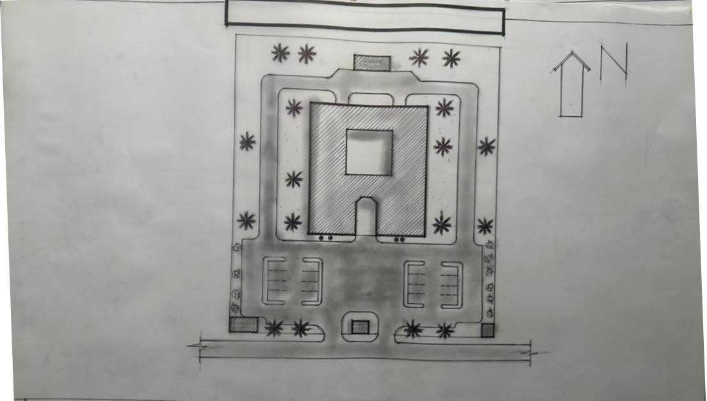

Appendix5.1: Site Plan.

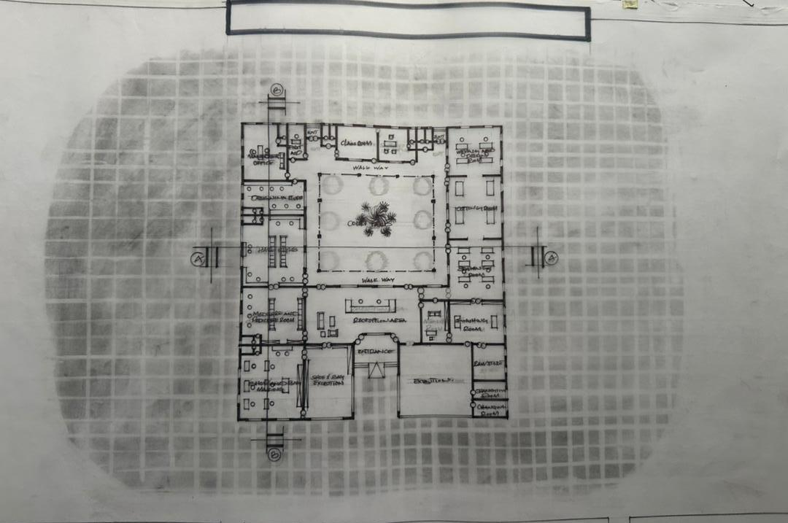

Appendix5.2: Floor Plan.

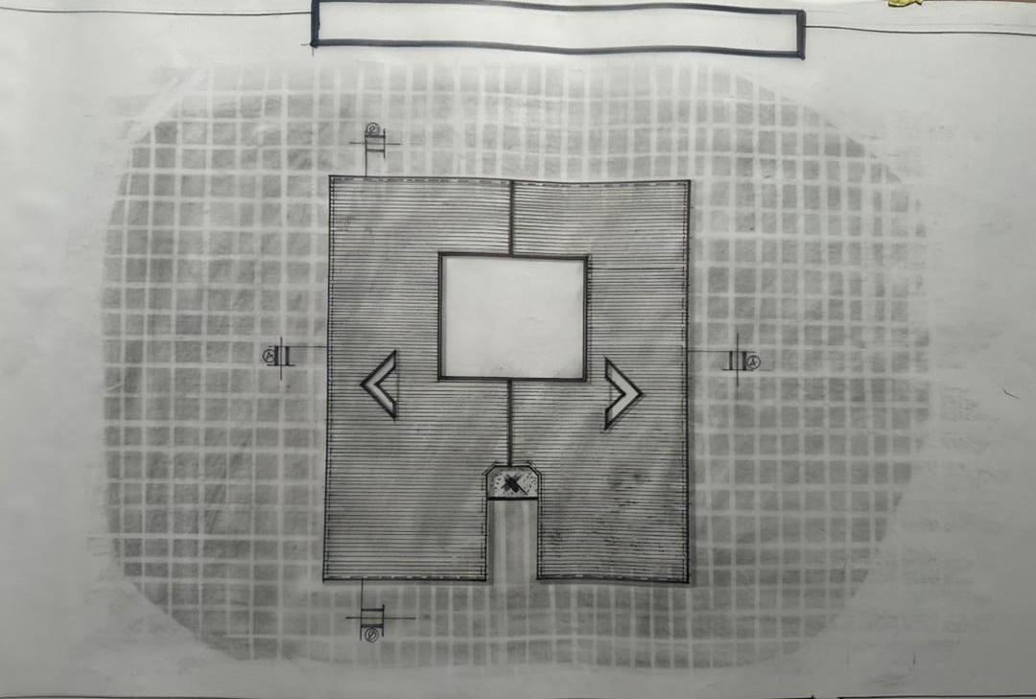

Appendix 5.5: Roof Plan

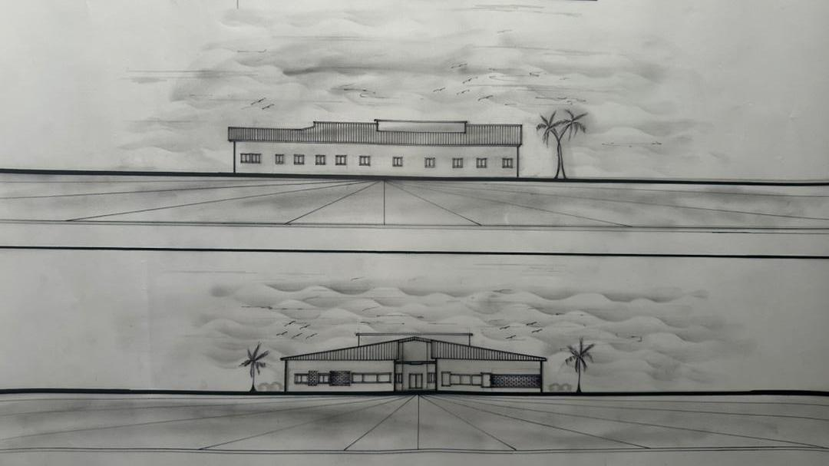
Appendix5.7: Elevation
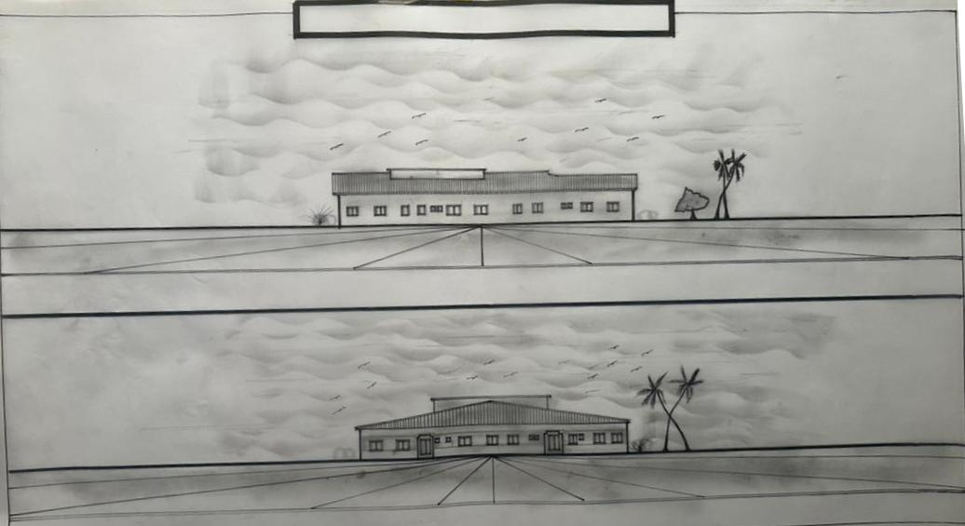

Appendix5.8: Elevation.

