A PROJECT REPORT

ON

PROPOSED MUSIC STUDIO FOR VINE TUNES STUDIO

PRESENTED BY

OLAITAN OLAWALE ISREAL

HND/23/ARC/FT/0013

SUBMITTED TO

THE DEPARTMENT OF ARCHITECTURAL TECHNOLOGY

INSTITUTE OF ENVIRONMENTAL STUDIES

KWARA STATE POLYTECHNIC, ILORIN

IN PARTIAL FULFILLMENT OF PART OF THE REQUIREMENT FOR THE AWARD OF HIGHER NATIONAL DIPLOMA (HND) IN ARCHITECTURAL TECHNOLOGY.

JULY, 2025

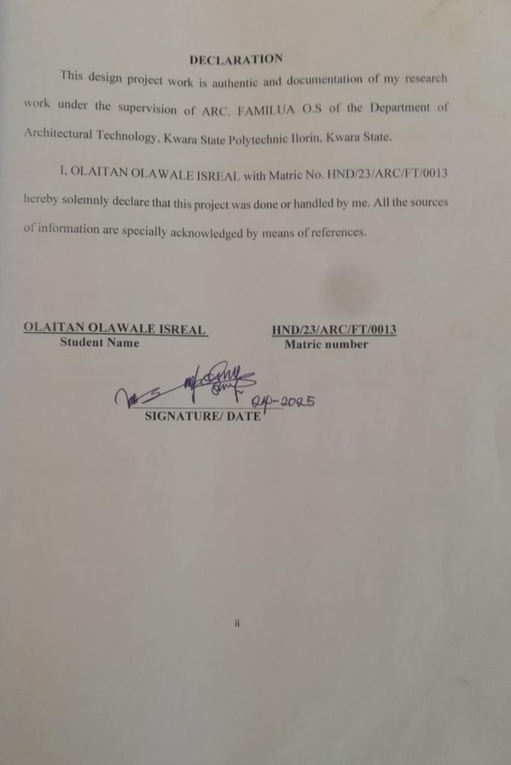

DEDICATION
The project is being thought-fully dedication to Almighty God, the creator of all for guiding me through the duration of the course.
I also dedicate this project to my fantastic and paramount families specially my parents Mr and Mrs OLAITAN for their moral, love and care, provision and financial support toward this great achievement.

ACKNOWLEDGEMENT
All glory, adoration, and honour to Almighty God, the creation of the universe may His names be praised forever. It is a genuine pleasure to express my deep sense of thanks and gratitude to the Almighty God for His sustenance and love throughout the course of this study.
I wish to express my profound gratitude to my mentor, guide, relentless, and untiring supervisor ARC. FAMILUA O.S, his keen interest and dedication above all his overwhelming attitude to help his student had been mainly and solely responsible for completing my project. His timely advice, scholarly and scientific, and meticulous scrutiny approach have helped me to a very great extent to accomplish this great task. May God keep blessing and sustaining you. I equally commend the effort of the Head of Department ARC TOMORI J.M, the project co-ordinator ARC. ADEYEMI O.F and the entire teaching and non-teaching staffs of Architectural Technology Department for their supports during the course of study. I say a BIG THANK YOU to you all.
I owe a deep sense of Gratitude to my parent Mr and Mrs OLAITAN and my siblings; All the OLAITAN’s family who gave their solemn support to the successful attainment of this worthy and rare degree and have to stopped at nothing to give the best of their support since I was born. I pray for you all will eat the fruit of your labour and may God keep sustaining and blessing you all. (AMEN).
On the whole, I, Olaitan Isreal hereby wish to acknowledge and thank all others whose names or title may not have mentioned but have in one or the other contributed to the success of my studies, I appreciate you all and I ask God’s blessing upon your endeavours. GOD BLESS YOU ALL.
TABLE OF CONTENT
Title page ……………………………………………………………. i
Declaration ………………………………………………………….. ii
Certification …………………………………………………...…….. iii
Dedication …………………………………………………………... iv
Acknowledgement ……………………………………………..……. v
Table of content …………………………………………….…..…… vi
Abstract …………………………………………………………...…. vii
List of tables ……………………………………………………….. viii
List of plates ………………………………………………………… ix
List of figures ………………………………………………………. x
CHAPTER ONE
- Introduction ………………………………….………………….. 1
  - Project Definition ……………………………………………… 6
  - Aim and Objectives ……………………………………………. 6
  - Design Scopes of the Projects ………………………………….. 7
  - Statement of Problem of the Projects …………………..………. 7
  - Research Methodology of the Projects …………………………. 8
  - Limits and Constraints of the Project ………………………….... 8
  - Justification of the Projects ……………………………..………. 9
CHAPTER TWO
- Literature Review and Case Study……………………………… 10
  - Studio Revolution & Nigeria Context …………………...……… 10
  - Historical Background of Music Studio …………………………12
  - Review of Relevant Literature ……………………………………13
  - Important of the Project ………………………….……………… 16
CHAPTER THREE
  - Selected Case Studies ……………………………………...… 17
3.1.1 Case Study One ……………………………………………… 17
3.1.2 Case Study Two ……………………………………………… 20
    - Case Study Three ……………………………………………. 23
3.2 Deduction………………………………………………...…… 26
3.3 Conclusion …………………………………………………… 26
CHAPTER FOUR
- Site and Environmental Analysis ……………………………. 27
4.1 Brief History and Introduction of Study ………………..…… 27
4.2 Site Location/Description …………………………………… 28
4.3 Site Selection/Location Criteria ……………………………. 28
4.4 Site Inventory/Analysis ……………………………………… 28
4.5 Climatic Data/Geographical Consideration …………………. 29
4.6 Site Planning …………………………………………………. 30
4.7 Brief Analysis ………………………………………………... 31
4.8 Analysis of the Scopes ………………………………………. 32
4.9 Space Allocation ……………………………………………... 33
4.10 Conceptual Development ……………………………………. 34
CHAPTER FIVE
- Design Approach ……………………………………………. 35
  - Appraisal of Proposed Scheme …………………………….. 35
  - Design and Construction ……………………………………. 35
  - General Design Consideration ………………………………. 36
  - Construction Method and Materials ………………………… 37
  - Landscape Element use in the Design……………………...… 38
  - General Maintenance ……………………………………….. 39
  - Summary and Recommendation …………………………….. 41
References

ABSTRACT
This work is focusing on rhythm activities. Apart from the fact that this project cannot be underestimated the design is also considering some structure as it is of great significance to lyric, mod, and others. Adequate car parks are considered for spectators ranging from the V.I. P’s to the popular ones. As a music studio which will accommodate several people, there is a need for proper security measures which was duly approached through the introduction of security post where necessary. Other facilities like, lounge, sit out etc. has also been duly considered to the minimum level.

LIST OF PLATES
Plate 1: Showing Case Study One Location Plans ……………………………7
Plate 2: Showing Case Study One Floor Plans ………………………………..8
Plate 3: Showing Case Study One Pictures ……………………………………8
Plate 4: Showing Case Study Two Location and Floor Plans …………………9
Plate 5: Showing Case Study Two Pictures …………………………………..10
Plate 6: Showing Case Study Three Location and Floor Plans ………………11
Plate 7: Showing Case Study Three Pictures ………………………………...12
Plate 8: Showing Climatic Chart …………………………………………….16

LIST OF FIGURES
Figure 1: Location Map and Plan ………………………………………….25
Figure 2: Site Inventory and Site Analysis…………………………………26
Figure 3: Site Consideration and Site Zoning ……………………………...27
Figure 4: Concept Derivation and Site Plan ……………………………….28
Figure 5: Floor Plan and Roof Plan ………………………………………..29
Figure 6: Cross and Longitude Sections …………………………………..30
Figure 7: Approach and Right-Side View …………………………………31
Figure 8: Detailing and Schedule ………………………………………….32

CHAPTER ONE
1.0 INTRODUCTION
Music is a universal language that transcends borders, cultures, and generations. It has the power to inspire, heal, and bring people together. In today’s rapidly evolving entertainment and creative industries, the demand for professional music has significantly increased. This evolution has given rise to the need for advanced, well-designed music studio that support both creative inspiration and technical excellence.
A music studio is a specialized space designed for recording, mixing, editing, and producing audio contents. It serves as the heart of the music production process, offering a controlled environment where sound can be manipulated with precision and creativity. Whether for solo artists, bands, voice-over artists, or podcasters, the functionality of a studio can greatly influence the quality of the output.
The music studio project is envisioned as a dynamic and creative hub designed to nurture musical talent, enable high-quality audio production, and support a wide range of musical activities. This studio will offer a professional-grade environment equipped with modern technology and expert resources.
The design of a music studio must address both acoustic performance and aesthetic appeal. Factors such as soundproofing, room geometry, reverberation control, and isolation are critical to prevent unwanted noise and ensure clarity in recording and monitoring. Furthermore, the spatial layout should allow for smooth communication between the control room and the recording booths, while maintaining comfort for long hours of work.
Beyond the technical aspects, the atmosphere of a music studio should be inspiring and motivating. Lighting, interior finishes, ventilation, and furniture arrangement must all work together to create a space where artists feel comfortable and creatively charged. As such, a music studio becomes more than just a place of work, it becomes a sanctuary for artistic expression.
A music studio, also known as a recording studio, is a purpose‑built space physical or digital optimized for capturing, processing, mixing, and producing musical and audio content. Whether for a solo artist, a band, or orchestral sessions, its core aim is to deliver the best possible sonic quality and creative workflow.
Simply put, a music studio also known as a recording studio is a purpose-built facility, physical or digital, designed to capture, process, mix, and produce musical and audio content with professional clarity and control. Its structure and ecosystem serve anyone from solo artists to full orchestras, aiming to elevate recordings beyond what any untreated space might deliver.
A music studio is more than just a place with microphones it’s a finely tuned instrument itself. The interplay of acoustic engineering, expert staff, premium gear, and focused creative space transforms raw musical ideas into polished, impactful recordings. Whether you’re an independent artist, filmmaker, podcaster, or composer, the studio’s purpose is to deliver sound that truly resonates.
1.3 PROJECT DEFINITION
A music studio is a space designed for the recording, mixing, and production of music. It typically includes various equipment such as microphones, mixing consoles, audio interfaces, and software for music production.
1.4 AIM AND OBJECTIVES OF THE PROJECT
AIM
The primary aim of a music studio design is to create an acoustic space that supports the production of high-quality music.

OBJECTIVES
- To design the studio to facilitate a smooth and efficient workflow.
- To provide a comfortable and ergonomic working environment, with adequate seating, lighting, and ventilation.
- To design a studio that will accommodate different types of music production.
1.5 DESIGN SCOPES OF THE PROJECT
DESIGN SCOPES
- Design and Plan the Music Studio.
- Accessibility Features.
- Sustainability Features.
- Procure Necessary Equipment.
- Establish Operational Policy.
1.7 STATEMENT OF PROBLEM OF THE PROJECT
The lack of affordable well-maintained and accessible music studio hinders the upcoming talent and physical well-being of residents, particularly low-income families and youth.

1.8 RESEARCH MENTHODOLOGY OF THE PROJECT
- INTERNET EXPLORING
This refers to the act of browsing, searching, and navigating the internet for information, resources. E.g. Being, Google, Wikipedia etc.
- CASE STUDY
This is the process of data collection through visitation of an existing project/work with the help of study and photograph.
- ORAL INTERVIEW
This is the process of interviewing the staffs of the visited existing recreational project/work.
- LITERATURE REVIEW
This refers to the act and process of gathering information through Textbooks, and other relevance PDF.
1.9 LIMITS AND CONSTRAINTS OF THE PROJECT
- Physical Limits and Constraints
- Regulatory Constraints
- Operational Limits and Constraints
- Financial Limits and Constraints

1.10 JUSTIFICATION OF THE PROJECT
The need for this project is to build a standard, functional, convenient, and aesthetically pleasing and ultra-modern music studio for the society and around the state.
CHAPTER TWO
2.0 LITERATURE REVIEW AND CASE STUDY
2.1 Studio Evolution & Nigerian Context
Emergence of recording studios in Nigeria traces back to the 1920s, with early recordings by Nigerian musicians in London studios using Zonophone and other labels.
In Lagos, studios were established by multinational labels: Philips (1957), PolyGram (1960), Premier Records (1963), EMI (1970), followed by indigenous studios like Music Matter, Kay-Jay Studio, Sam Soft, and Y2K Studio through the late 1990s
These studios enabled the flourishing of genres such as juju, highlife, afrobeat and launched icons like Fela Kuti, The Lijadu Sisters, and Chief Ebenezer Obey
Studio Design Principles & Acoustic Performance
Classical architectural acoustic theory underlines that studio performance strongly depends on room geometry, surface materials, ambient noise levels, and reverberation time (T₆₀) tailored to intended use
White (2020) (hypothetical) and Bartlett & Bartlett (2009) frameworks distinguish between “live” (e.g. drums, ensemble) and “dead” (e.g. vocal booths) rooms levels of absorbency, diffusion, and isolation vary by use. This approach remains foundational
Acoustic Treatment & Technology
Soundproofing in Nigeria, by firms like MMT Acoustix and Acoutech, promotes layered approaches (sound isolator blankets, bass absorption, foam panels) to combat reverberation and noise intrusion in an urban context
Emerging academic research examines acoustic metamaterials—collections of subwavelength resonators tuned for broadband absorption—as a cutting-edge option for small music rooms and studios
Social & Technological Integration
Technological adaptation by Nigerian youth and producers is reshaping music creation—even in absence of high-end resources. Scholars like Faniyi et al. (2016) discuss how portable digital tools empower creativity and sustainability among local musicians
Gender dynamics remain a concern: a 2022 survey of street studios in Anambra State finds audio engineering is male‑dominated, urging more skill training and equity for women in Nigeria’s studio workforce

2.2 HISTORICAL BACKGROUND OF MUSIC STUDIO
A music studio is a specialized workspace for producing high-quality music recordings. It’s equipment and rooms designed for different purposes, such as Live Room, Control Room, and Recording Booth.
A music studio or recording can be traced back to the late 19th century with the invention of the photograph by Thomas Edison in 1877. This ground-breaking device allowed sound to be recorded and played back, marking the beginning of recorded music.
Early recording studio were often simple setups that utilized acoustic methods to capture sound, with musicians performing live in front of a recording device. In the 1920s, the introduction of electrical recording technology revolutionized the music industry. This advancement allowed for better sound quality and more nuanced recordings.
The 1950s and 1960s are often referred to as the “Golden Age” of recording studios. Iconic studios such as Abbey Road in London and Motown in Detroit became legendary for their contribution to music. This era saw the emergence of multi-track recording, which allowed for individual instruments and vocals to be recorded separately and mixed together, giving producers greater control over the final sound.
The late 20th century brought about the digital revolution, profoundly impacting music production. The introduction of Digitals Audio Workstations (DAWs) in the 1980s and 1990s allowed for unprecedented flexibility and creativity in music recording and editing.
Today, music studio varies widely in size and scope, from professional commercial studios to small home setups. Home studios became more accessible, enabling aspiring musicians to produce high-quality recordings without the need for expensive studio time. The rise of the internet has also transformed the industry, allowing for remote collaboration and distribution of music across global platforms.

2.3 REVIEW OF RELEVANT LITERATURE
The design of a music studio is a unique architectural challenge that balances acoustic performance, functional zoning, user comfort, and aesthetic appeal. This chapter explores relevant literature on the evolution of music studios, design principles, acoustic treatment, spatial requirements, and modern technological integrations.
Music studio evolved from large open halls to sophisticated soundproof rooms tailored for sound recording, mixing, and production. The 20th century saw innovations driven by advancements in sound technology, especially in Europe and the U.S., with notable pioneers like EMI’s Abbey Road Studios. In Nigeria, the development of music studios gained traction from 1970s alongside the growth of the music industry.
Research emphasizes that studio architecture and acoustic treatment are central to sound quality. According to White (2020), factors such as soundproofing, room dimensions, and surface materials significantly affect the acoustic response of a studio. The concept of “live” versus “dead” rooms, first popularized by Bartlett & Bartlett (2009), still guides how different rooms are used for various recording purposes (e.g., drums in live rooms, vocals in dead booths).
Significant archaeological research has been done in an attempt to illuminate the structure and function of the recording, through archaeological finds, as well as much historical research and speculation on the societal value of the mixing, and mastering, through the few primary sources that speak of them. However, this paper will finally unite the tripartite scholarship of origins, functions, and value of the studio into a review about what is known regarding these vital structures.
The London music studio, were the “single most characteristic feature of British Culture,” and this review will give an inclusive overview of just why this is the case. The British music, recording, are recognizable by several different names.
The economics of studio operation have shifted dramatically in the digital age. Studies by Hracs et al. (2011) note a rise in DIY studios and bedroom producers, facilitated by affordable equipment and online distribution platforms. However, major commercial studios still hold value for high-end productions, especially in genres like pop, film scoring, and orchestral music, where large space and expert personnel are essential.
From a sociocultural standpoint, music studios are also viewed as creative hubs. According to Prior (2008), studios serve as spaces for cultural exchange, collaboration, and experimentation. There is also increasing interest in diversity and inclusivity within studio spaces, particularly regarding the underrepresentation of women and minority groups in technical roles.
  - IMPORTANCE OF THE PROJECT
- Creative Refining and Career Advancement
- Enhanced Sound Quality and Distraction-Free Environment
- Preserving Music History
- Expertise and Guidance

CHAPTER THREE
3.1 SELECTED CASE STUDY
The objective of a case study is to appraisal of existing project/work with a view to identify positive aspect of such project. The positive aspect shall be incorporated in the view proposal while attempt made to solve the problems of negative aspects.
    - CASE STUDY ONE
NAME: ACI ENTERTAINMENT
LOCATION: Kayode Otitoju St, Lekki Phase 1, Lagos
Merits
- It is well facilitated.
- Effective soundproofing.
- It is aesthetically appealing.
Demerits
- It is not spacious enough.
- Lack proper landscape.
- The environment is not conducive for outdoor activities.
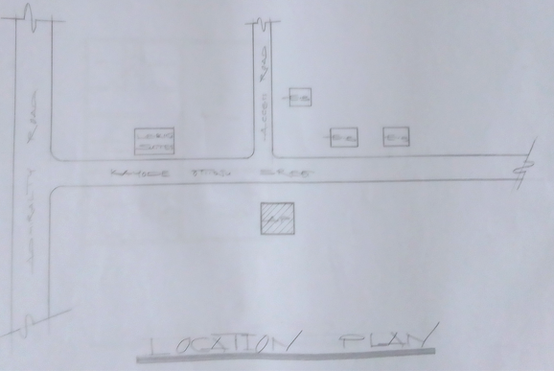
FIGURE 1: SHOWING CASE STUDY ONE LOCATION PLAN

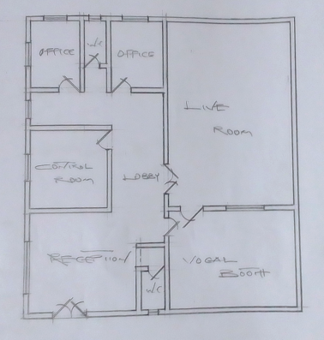
FIGURE 2: FLOOR PLAN
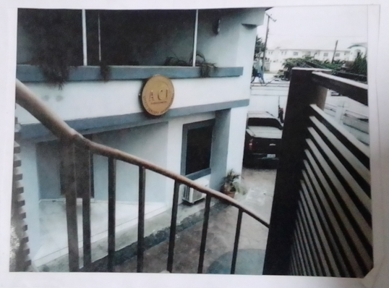
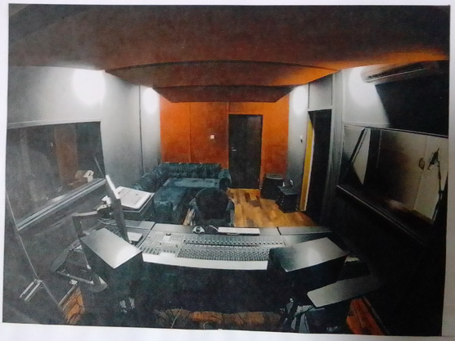
PLATE 1: SHOWING THE EXTERIOR OF THE BUILDING

PLATE 2: SHOWING THE INTERIOR OF THE BUILDING
    - CASE STUDY TWO
NAME: AZUSA PRODUCTION
LOCATION: Adeniyi Jones, Ikeja, Lagos
Merits
- It is well facilitated.
- It has good ambience.
- Good soundproofing system
Demerits
      - It is not spacious enough
      - It lacks proper landscaping
      - The environment is not conducive enough for outdoor activities

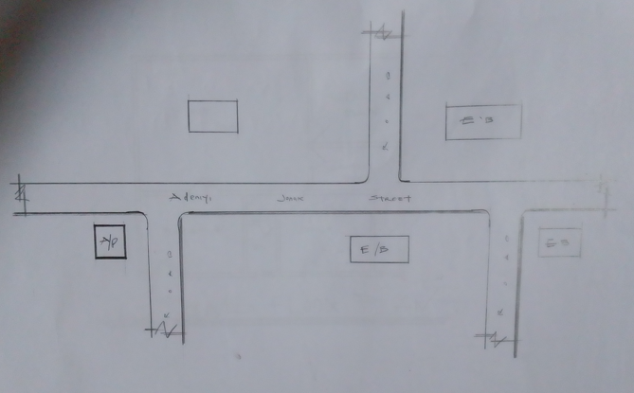
FIGURE 3: LOCATION PLAN
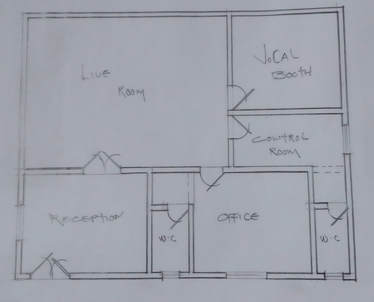
FIGURE 4: FLOOR PLAN

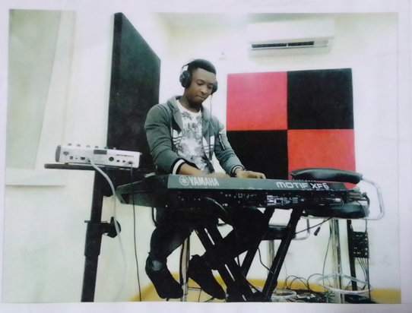
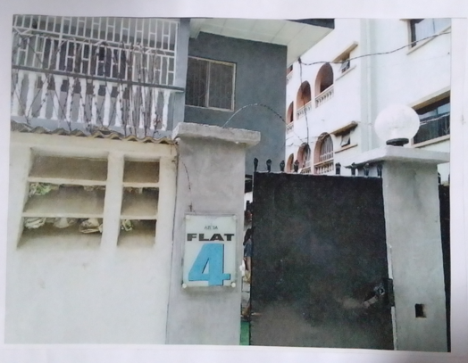

PLATE 3: SHOWING THE INTERIOR VIEW OF THE BUILDING

Plate 4: SHOWING THE INTERIOR VIEW OF THE BUILDING

3.1.3 CASE STUDY THREE
NAME: UNIQ MUSIC WORLD
LOCATION: Quad Plaza Suite, Ameh Ebute St, Abuja
Merits
- Good ambience.
- It is well facilitated.
Demerits
- No proper landscape
- Its not spacious enough

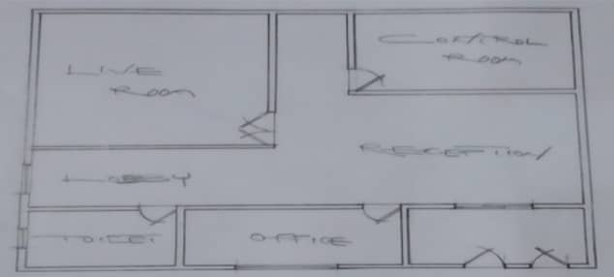
FIGURE 5: FLOOR PLAN
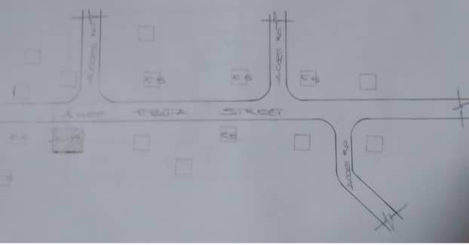


FIGURE 6: LOCATION PLAN
PLATE 5: EXTERIOR VIEW OF THE BUILDING
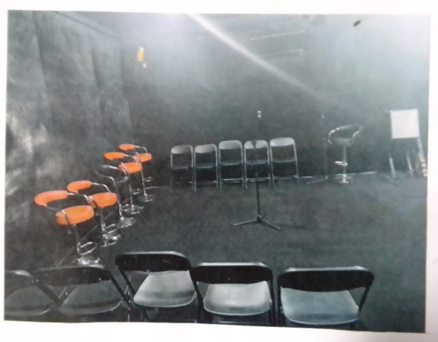

PLATE 6: INTERIOR VIEW OF THE BUILDING

  - DEDUCTION
Based on the case studies of the recreational centre, I was able to deduce that;
- Difficulty Attracting Talent: Professional artists and producers may be deterred from working in a studio with a reputation for substandard quality.
- Limited Business Opportunities: A studio’s poor reputation can limit its ability to attract clients and secure lucrative upgrades.
- Inefficient Workflow: Poorly designed studios or inadequate equipment can lead to inefficiencies in the recording process, wasting time and resources.
- Negative Impact on Artist Performance: A studio environment can affect artist morale and performance, potentially leading to subpar recordings
  - CONCLUSION
Case studies are of a greater significant in a project of this magnitude and the essence is to study existing music studio, and digital audio workstations (DAWs) facilities/structures, in the process a student get acquainted with fact and norms, functionality and spaces, and merit and demerit of an existing structures/facilities. At the end of exercise, the study will allow students to take necessary precaution against the failure of the proposed project

CHAPTER FOUR
4.0 SITE AND ENVIRONMENTAL ANALYSIS
4.1 BRIEF HISTORY OF THE STUDY AREA
Ilorin city, traditional emirate and capital of Kwara State in Western region of Nigeria. It is located on the Awun River, a minor tribulatory of the Niger founded in the late 18th Century by Yoruba people. It became the capital of a kingdom that was a vessel state of the Oyo empire, Oyo’s commander at Ilorin, Kakanfo (field marshal). Afonja, led a rebellion in 1817 that destroyed the unity of the empire. He was aided by Shehu Alimi (a Fulani from Sokoto) by his warriors, slaves and Hausa slaves. Afonja was increasingly dominated by the Muslim Fulani and upon his assassination, Alimi and son, Abdul-Salam (Abdul-Salami) became the Emir of Ilorin and pledged allegiance to the Sokoto caliphate (C-1829). As a Muslim emirate, 110 in subjugated several towns in Yoruba land and destroyed the Oyo capital, Oyo-Ile (Old Oyo or Katun) 40 miles (641m) North-West in 1837. Abdul-Salam conducted a fired toward the seal and was only stopped by the Tradan victory over his cavalry mon at Osogbo in 1840.
LOCATION OF ILORIN: Located at Latitude 8.533° North and Longitude 4.583° East, it covers one third of South-West of Nigeria which lies on the Northern Nigeria of Yoruba plater it’s about 278 metres above guinea Savanah, a position that commonly refer to as the middle belt. (Denice Savon an)
  - SITE LOCATION / DESCRIPTION
The site selected for the proposed project is located at Tanke, Ilorin, Kwara State.
  - SITE SELECTION / LOCATION CRITERIA
The selection is the consideration of certain factors which influence the development of the site and spatial activities.
Site selection criteria is based on screening, factors affecting site selection includes: ventilation and solar control, thermal control, comfort etc. and availability of services.
Moreover, due to the nature of the project, the site selection should meet the requirement for the efficiency and functionality of the proposed design. The size of the site available for development should be adequate reasonable to accommodate such functions/structure.
  - SITE INVENTORY / ANALYSIS
This is done on the basis of the purpose for which the site is to serve. Certain steps are considered to obtain vital information of or from the site. This information is then analysed after site survey in details. For design purpose, the information includes; vegetation, geology, topography, wind trade, longer and shorter sides, soil condition, and so on.
- VEGETATION: The site is covered with trees, shrubs, and ground cover most of it, would be retained for landscaping.
- GEOLOGY: This soil has a good location bearing capacity and hence raft foundation will be used for the structure to be erected on the site.
- The site longer side facing East and West while the shorter side facing North and South.
- SOIL CONDITION: The type of soil is loamy soil and hence aids goods vegetation’s of shrubs, trees, and grasses
- Sunrise and Sunset will be considered for building orientation.
Orientation of the building will give due consideration for effective ventilation and solar radiation control for total comfort of occupants.
  - CLIMATIC DATA CONSIDERATION
Ilorin has an area of 1,188square kilometres and a population of 777,667 as at the 2006 census and 908,490 estimated as at 2011.
- LATITUDE: 8°30ꞌ NORTH
- LONGITUDE: 4°33ꞌ EAST
- ATMOSPHERIC PRESSURE: 1007.1 pa
- AVERAGE RAINFALL: 250 mm/annum
- TEMPERATURE: 34.5ꞌꞌ C
- RELATIVE HUMIDITY: 31.5 %
- WIND SPREAD: 2.1 m/s N.E
- CLOUDINESS: 1.6 %
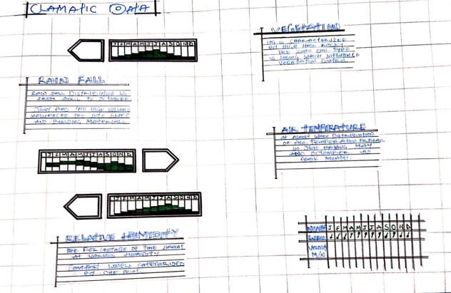
Plate 7: Showing Climatic Chart
  - SITE PLANNING OF THE PROJECT
The site is planned to give it a defined shape and also to reflect the activities taking place. The location of the music studio within the site follow these main principles;
- The zoning principle (noisy, semi-noisy, and quite zone) is observed which enhance placement of each structure.
- For easy accessibility to various units, parking spaces are planned.
The site is properly defined with a perfect blend of both natural and artificial attraction as well as soft and hard landscaping to give a quality taste of a desired comfort to all guests.
  - BRIEF ANALYSIS OF THE PROJECT
PROJECT SCOPE
- Main Building
- Parking Lot
- Gate House/Security
- Generator House

  - ANALYSIS OF THE SCOPE
DESIGN BRIEF
  - Reception Live Room
  - Recording Room Mastering Room
  - Mixing Room Vocal Room
  - Drum Room Record Store
  - Equipment Store Control Room
  - Bedroom Office
  - Manager Office Green Room
  - Kitchen Convenience
  - Store Exit

S/N | UNITS |  | LENGTH | BREADTH | AREA(LxB)m²
1 | RECEPTION |  | 6.8m | 7.5m | 51.0m²
1 | LIVE ROOM |  | 11.5m | 10.0m | 115.0m²
1 | RECORDING ROOM |  | 5.0m | 10.0m | 50.0m²
1 | MASTERING ROOM |  | 7.0m | 5.0m | 35.0m²
1 | MIXING ROOM |  | 4.0m | 4.0m | 16.0m²
1 | VOCAL ROOM |  | 4.5m | 3.0m | 13.5m²
1 | OFFICE |  | 5.0m | 3.6m | 18.0m²
1 | DRUM ROOM |  | 4.5m | 3.0m | 13.5m²
1 | RECORD STORE |  | 4.0m | 5.0m | 20.0m²
2 | KITCHEN |  | 5.0m | 3.0m | 15.0m²
1 | EQUIPMENT STORE |  | 4.0m | 3.8m | 15.2m²
1 | CONTROL ROOM |  | 4.8m | 4.0m | 19.2m²
2 | BEDROOM |  | 5.0m | 5.0m | 25.0m²
1 | GREEN ROOM |  | 7.0m | 8.0m | 56.0m²
1 | MANAGER OFFICE |  | 5.0m | 4.0m | 20.0m²
1 | CONVENIENCE |  | 2.7m | 0.9m | 2.43m²
1 | STORE |  | 5.0m | 3.0m | 15.0m²
1 | EXIT |  | 1.8m | 1.5m | 2.7m²
TOTAL |  | 1,297.53m²

TABLE 1: SPACE ALLOCATION

  - CONCEPTUAL DEVELOPMENT
The site concept was formed based on THREE values;
- VIEW: The building and facilities are located facing the road as the site is characterized with see through fence so that the road users can easily view the facility from the highway.
- ACCESSIBILITY: The parking lot provided are located in the most accessible area with good road network linking them together.
- CIRCULATION and PLANNING: The turning radius of vehicles was considered for adequate circulation and the building is located at a close proximity to aid easy access.

CHAPTER FIVE
5.0 DESIGN APPROACH
5.1 APPRAISAL OF PROPOSED SCHEME
In any project design, there are two basic factors that should be taken into consideration, these factors are; Forms, Aesthetics, and Functionality of a design of building. The above listed factors were thoroughly taken care of to satisfy the highly demanded functional requirement of the proposed project and also to create aesthetically and proportionally balanced design.
Furthermore, zoning of area with related functions, circulation pattern, security, and safety were highly considered in this project design. The design was carefully zoned into major area such as Noisy, Semi-noisy, and Quite zones.
5.2 DESIGN AND CONSTRUCTION
The studios themselves would have been richly decorated with plastered and painted walls, coloured-marble cladding, and some mosaic and opus sectile floors. Supplied by a water cistern, with water drained via ditches into a main sewer, the building would have provided hot rooms, plunge pools, and other recreation area. The cistern was massive, and water would have been hand-pumped up into the tank before a network of water pipes, drains, and sewers would have ensured a continual flow of clean water. The degree of workmanship seen within the remain during the original excavations was compared with that seen at Fish Bourne Roman Palace, and the kind of sophisticated and strategic planning involved in the construction of both the Palace and the Recreations is also comparable.
5.3 GENERAL DESIGN CONSIDERATION
To achieve a functional design, the following factors are essentially needed to give the structure a considerable aesthetic value, some of these things are:
- SERVICES: - These include Electrical services, Filtration, Mechanical services, Sewage disposal, Drainage, Waste disposal etc. the electrical services will be of high quality and cables in concealed conduct wiring will be used. There is a power house to generate constant electricity supply in case of power failure. For effective drainage of both surface and soil waste, appropriate size of pipes is used. All pipes used are run into duct system with leaf net provided on drain pipe to prevent blockage from soil waste.
Also, incinerator will be used to burn waste on site. The element that controls the effect of solar radiation such as roof wall, sun breaker, greenies, and other materials are used.
- VENTILATION: - A primary factor in determining human comfort. They have direct effect on human body through the physiological effect on air purity and motion and indirect erect through their influence on the temperature, humidity of the indoor air and surfaces. To achieve optimum ventilation condition, the use of mechanical means of ventilation and proper orientation of building is ensured and automated windows, adequate sizes, and good positioning within sub-division of internal spaces are provided and also with the provision of dehumidifiers to maintain room humidity level of the hall so as to prevent condensation and deterioration of the building structure.
Also, a proper technique to control humidity will be adopted i.e. fresh air pool dehumidification system, air to air heat exchangers are typically used to recover energy from the pool exhaust air and transfer it to the incoming outdoor air. Because the outdoor air humidity level changes with the temperature, the colder it is the lower the humidity level is of the outside air.
- LIGHTING: - Lighting inside a building must fulfil two functions to illuminate interior and its content, and to illuminate the activities within the building appropriately so that visual mechanism can function at high level of efficiency.
All windows are of adequate sizes and height within and outside the structure. Also, the use of a transparent material “ETFE” which is glazed into the roof materials is employed to throw light into the areas of the structure so as to compliment and reduce the cost of maintaining the artificial light source in the building.
- ACOUSTICS: - Acoustics design controls intrusive noise by the choice or material dimension and shape of building. High level of noise can cause damage to the ear and so careful selection of doors, windows seals, ceiling type, and material will play an effective role in providing acoustic for the building.
- FIRE PROTECTUON: - Modern building require not only means of escape, access for fire brigade and structure protection but also first aid equipment like hydrant plant, fire extinguisher to combat any fire outbreak before the intervention of fire brigade. The proposed design, there will be provision for fire alarms and detectors.
Also, fire extinguisher such as hose reels, sprinklers, and drenches are provided at strategies position for easy access.
- EXTERNAL WORKS: - The following specifications are applicable
- The floor surface to be of interlocking materials and asphalt to allow effective drainage.
- The drainage to be conveyed away through suitable sealed gully fitted with strong grating. It should be drained into existing gutter.
- The floor to withstand expected impact and high load bearing capacity.
- The enclosure to be secured against unauthorized entry.
- Surrounding walls to be rendered and painted.
- Tarred and grasses surface should be separated with kerbs.
- Soak-way pits must be avoided with the nature of the soil generally both foul and soil waste must be properly drained.
5.4 CONTRUCTION METHOD AND MATERIAL
The proposed design of a recreational will be based completely on the use of quality materials and modern technology equipment. Highly qualified professional in the building industry will engage from the inception to the completion of the project work. This is done to ensure efficiency and durability of the design after which the design completed and ready for use.
Appropriate foundation type shall be used and such foundation shall be able to withstand the vibration caused by people while walking, standing, and dancing during competitive activities as well as to be able to carry successful both live and dead load that is to be imposed on posing any threat to the comfort of the users of the complex.
    - LANDSCAPE DESIGN
Landscape design is the determination of the character of different landscaping element and their arrangement on the site to enhance the building works. Landscape design maybe two (2) types, aesthetic design and economic design. Both types are considered in the landscape design of the leisure centre.
It has been known to us that throughout the world people use mainly two (2) types of landscape namely; Soft and Hard Landscape
5.5 LANDSCAPE ELEMENT USED IN THE DESIGN
In choosing an appropriate landscape element, the following are considered:
- Easy Cleaning
- Durability
- Resistance to Footwear
- Acoustic Properties
The following landscaping elements are employed;
SOFT LANDSCAPE ELEMENTS
- TREES (VEGETATION): - To reduce solar rays in both paving and structures, reduce radiated heat, and improve comfort. Used as shading device and also used to beautify the environment.
- GRASSES AND LAWN (MATERIALS): - To reduce the reflective effect of the ground and also to control erosion and landslide in case of flooding. Used to reduce the intensity of sole radiation. It absorbs up to 45% of solar rays and disperses the rest of the environment thereby creating comfort for the occupant.
- DECORATIVE FLOWERS: - Different species of flowers are used to enhance the aesthetic appearance of the site.
- HARD LANDSCAPE ELEMENTS
- ASPHALT: - Used for drive ways and parking lots. It is economical and durable both for pedestrian and vehicular traffics.
- CONCRETE KERBS: - Uses to separate tarred surfaces from lawn covered areas.
- INTERLOCKING PAVING: - Used for walkways and outdoor paving to blend with the natural texture of the environment.
Other elements used include fountains, man-made hills, and waterfalls, flower ponds etc. to create visual interest and beautify the environment in a harmoniously blended aesthetical grandeur.
5.6 GENERAL MAINTENANCE
Maintenance cannot be isolated from the initial planning and design of any architectural edifice, most especially a project of this calibre which involves leisure and entertainment.
Timely maintenance of the structure and facilities to put them in proper working condition to enhance functionality and habitability of both structure and facilities for maximum satisfaction of visiting leisure and intending guest must be ensured.
Maintenance work in real technology is defined as work undertaken to keep or restore every facility of a building or site to an acceptable record i.e. planned maintenance or carried out on an emergency basis when the need arises. Due to the lack of the maintenance culture in this part of the globe, adequate provisions are made for security, sanitation, and maintenance department to centre for the facilities and endure high level of hygiene.
The maintenance of the building and facilities will be duly attended to with regular servicing of equipment’s and other facilities. The external works consist of so many factors that are of greater significant and these factors are as follow;
- Parking Space (Administrative and Staff parking, Players parking, and General parking): - This has to be technically considered by investigating the existing parking spaces in some bath house and gym. This has given me a detailed experience and I have been able to deduce to some facts that has assisted me in my own planning principle.
Effective parking space must be sectioned in order to have a proper security survey and manage space to the maximum level.
- Access Road: - This has been professionally achieved by creating or designing a ring road that has been properly linked by the minor road for easy accessibility to each basis unit with this and also case movement and transportation has been achieve affectively.
5.7 SUMMARY AND RECOMMENDATION
Conclusively the project has seriously broaden my view and observation beyond expectation and by this I have been able to deduce that project work of any form must not be taking lightly as it determines how far one can go to get facts and precise information towards assisting one’s self taking of experience and solving societal problems through academic works.
As a student I am recommending this project work to the entire public of Ilorin as a whole as it bring development and civilization to its locality as researched, it also creates healthy fitness, spa fitness, and general body well-being. Above it all it unites the youth and family-friendly.

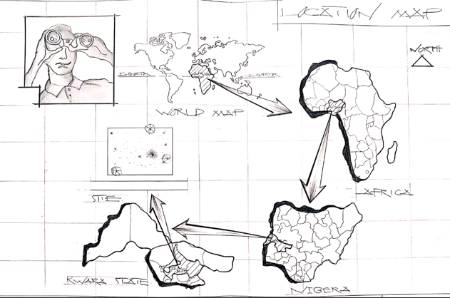
Figure 1: Location Map
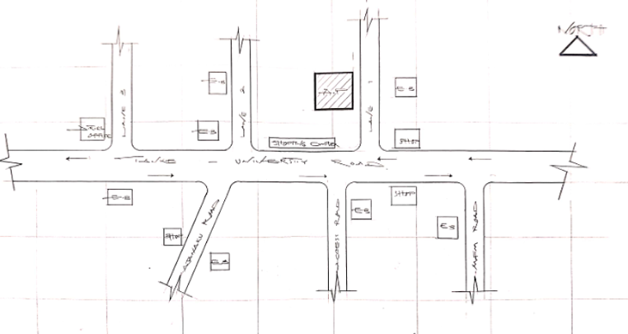

Figure 1: Location Plan

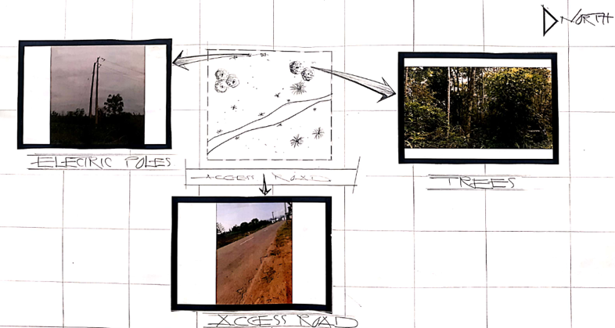
Figure 2: Site Inventory
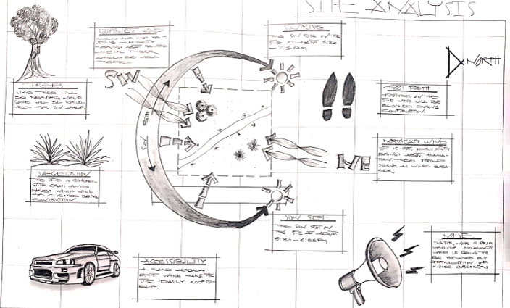

Figure 2: Site Analysis

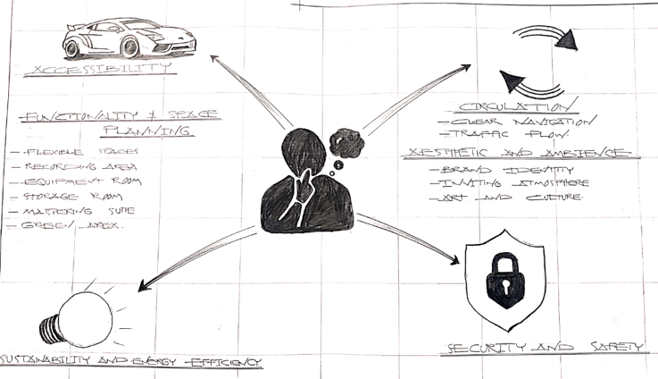
Figure 3: Site Consideration
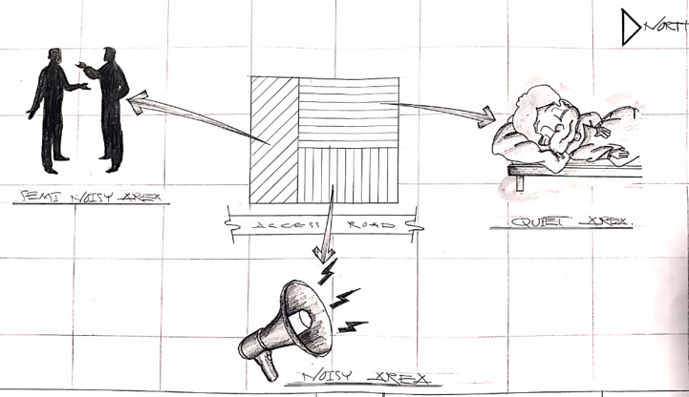
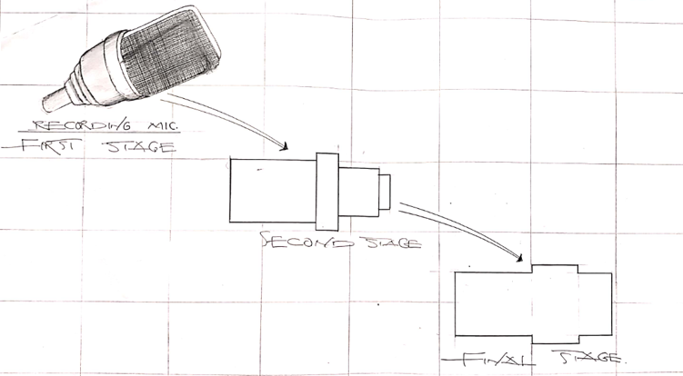

Figure 4: Concept Derivation

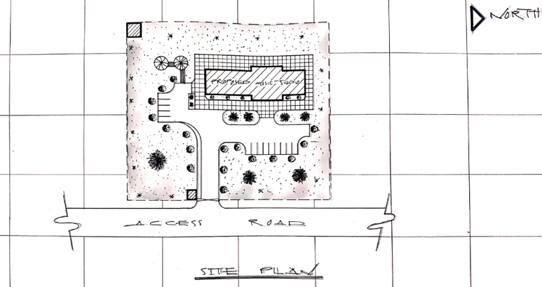
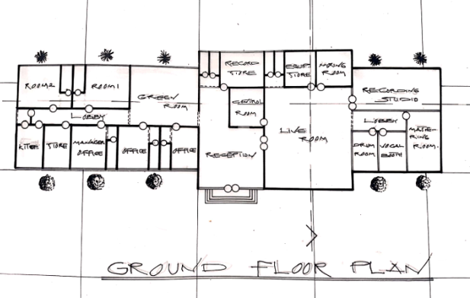
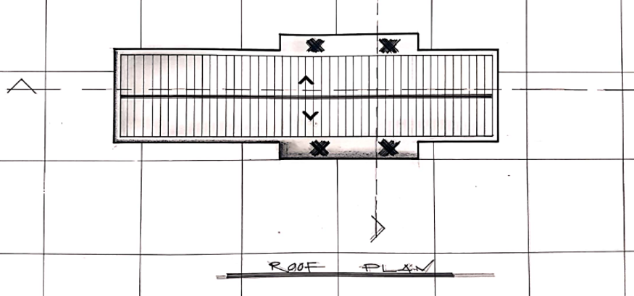
Figure 5: Floor Plan

Figure 5: Roof Plan

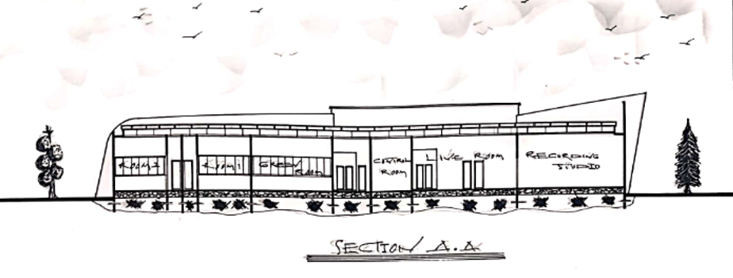
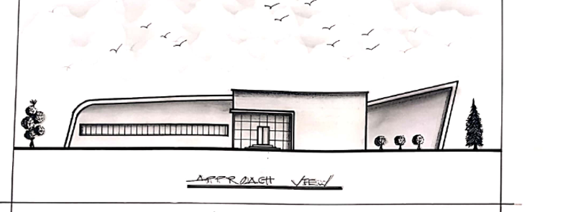

Figure 6: Longitude Section

Figure 6: Cross Section

Figure 7: Approach View

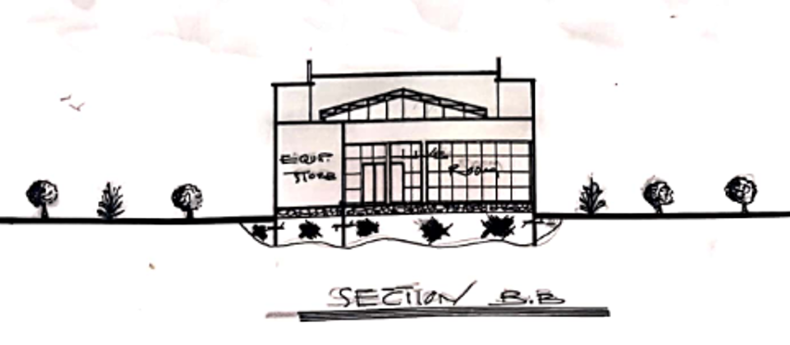
Figure 7: Right Side View
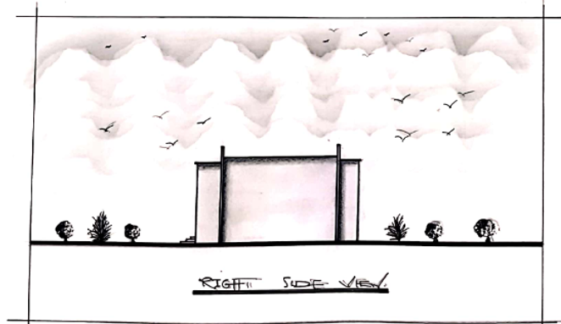
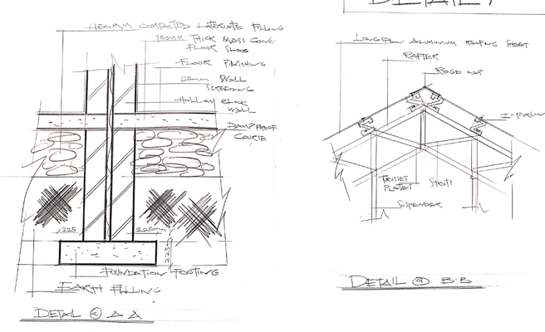

Figure 8: Detailing

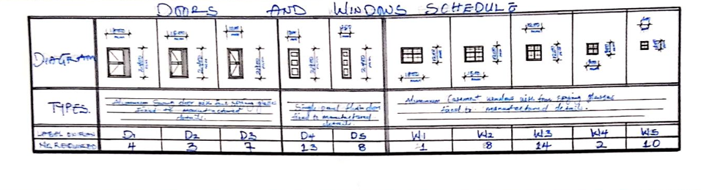

Figure 8: Door and Window Schedule

REFERENCES
Anita Lawrence (1989): Acoustic and Building Environmental Elsevier Science Publisher Ltd.
Barry R. (2018): Construction Building Vol. 1-5 Collins, English Language Dictionary.
David A. (1999): Metric Hand Planning and Design Data (New Edition); Architectural Press, United Kingdom.
De-Chiara (1983): Architectural Site Planning Macmillan Press Ltd.
Freezer Rekier (1979): Draughtsmanship Architectural and Building Graphics, Granada Publishers Ltd.
George K. Stedman (1996): Architectural Drafting, Functional Planning and Creative Design Granada Publishers Ltd.
Macmullan R. (1986): Environmental Service Building, The Macmillan Press Ltd.
Neufert E. (1980): Architects Data (New National Edition), Granada Ltd, Great Britain.
R. Chudley and R. Greeno (1999): Building Construction Handbook New Edition,
Smith N.A. (2000): Lighting for Health and Safety, A Division of Reed Education and Professional Publishing Ltd.
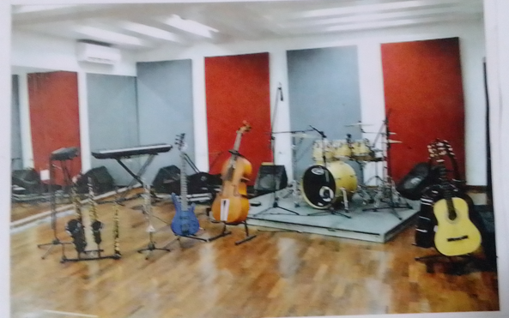
Stadia 4th Edition a Design and Development Guide. Final Guide to Quality Bathhouse Design (Fina Facility Rules and Infrastructure Regulations, Edition 2010), Natatoriums Technical Recommendations and Requirement.
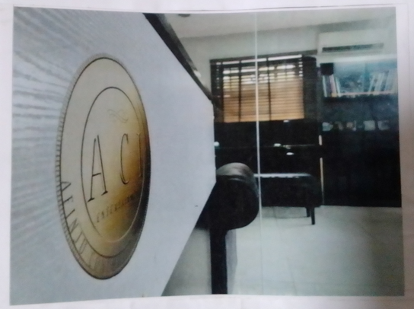

Showing Case Study One Pictures

