

PROJECT
ON
DESIGN AND CONSTRUCTION OF FEED HOPPER

BY:
DAVID DOYIN BODUNDE
ND/23/SLT/PT/0671

BEING A RESEARCH SUBMITTED TO THE DEPARTMENT OF SCIENCE LABORATORY TECHNOLOGY, (PHYSIC AND ELECTRONIC UNITS) INSTITUTE OF APPLIED SCIENCE, KWARA STATE POLYTECHNIC, ILORIN, KWARA STATE

IN PARTIAL FULFILLMENT FOR THE AWARD OF NATIONAL DIPLOMA (ND) IN SCIENCE LABORATORY TECHNOLOGY, KWARA STATE POLYTECHNIC, ILORIN

2024/2025 SESSION
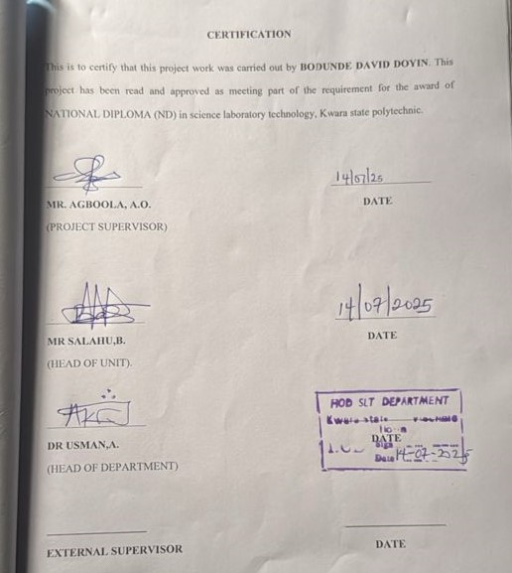

DEDICATION
I dedicate this project to Almighty God, He's the author and the perfect finishers of my Faith, may his name be praised, because he is my founder who lead me through in Life.

ACKNOWLEDGEMENT
First and foremost, my deepest acknowledgment goes to Almighty God, for his overwhelming love upon my life throughout my degree programme.
Secondly, I wish to express my profound appreciation to my supervisor, Mr Agboola A.O for his vision and leadership in initiating this project and for his patience, suggestion, teachings and also for reading through my project report.
I sincerely appreciate my lovely Parents Mr. and Mrs. BODUNDE , who has helped me financially and mentally, may God continue to bless you.
Finally, I appreciate all the lecturers of the department of science laboratory technology (physics and electronics unit), especially Mr Agboola A.O who helped with his advice and knowledge to make this project a success.

TABLE OF CONTENTS
Front page
Certification
Dedication
Acknowledgment
Abstract
Table of contents
CHAPTER ONE
1.0. Introduction
1.1. Aim and objective
1.2. Purpose
1.3. Scope
1.4. Limitations
CHAPTER TWO
2.0. Literature review
CHAPTER THREE
3.0. Methodology
3.1. Material and method
3.2. Tools used
3.3. Design
CHAPTER FOUR
4:0. Discussion
4.1. Physics principles of arc welding
4.2. Conclusion
References

ABSTRACT
The feed hopper is a critical component utilized across various industrial and agricultural settings for the temporary storage and controlled discharge of bulk materials. This project focuses on the design and fabrication of a feed hopper system intended to optimize material handling efficiency, minimize operational waste, and support uninterrupted production processes. Emphasis was placed on the use of locally sourced materials to reduce production costs while maintaining durability and functionality. The design incorporates a sloped interior surface to ensure smooth material flow and is fitted with a regulated gate mechanism for precise control of discharge rates. The fabrication process entailed technical operations such as cutting, welding, and assembling mild steel components in accordance with established engineering specifications. Performance evaluations revealed that the constructed hopper effectively dispenses feed without clogging or leakage, thereby confirming its operational reliability. The outcome of this work demonstrates that the fabricated feed hopper is a cost-effective and practical solution, particularly suited for small- to medium-scale applications in agricultural and industrial domains.

CHAPTER ONE
1.0 INTRODUCTION
The feed hopper is a vital component in many industrial and laboratory processes involving the handling and processing of materials, particularly solids and semi-solids. A feed hopper serves as a storage and dispensing unit that allows materials to be loaded in bulk and dispensed gradually or in controlled amounts for further processing. It is commonly used in agricultural, pharmaceutical, food processing, mining, and chemical industries. In laboratory settings, the feed hopper plays a crucial role in the controlled feeding of materials into equipment such as crushers, grinders, and mixers, (Kumar and Singh,2018).
The effective design and fabrication of a feed hopper are essential for maintaining the consistency of material flow, minimizing wastage, and ensuring safety. Without a well-structured feed hopper, issues such as material bridging, rat-holing, and irregular feed rates can occur, leading to inefficiencies and potential damage to processing equipment. Therefore, the development of a functional and cost-effective feed hopper tailored to specific materials and usage contexts is of paramount importance, (Bridgwater,2015).
In recent years, advances in material science and engineering design have significantly influenced the construction of feed hoppers. Materials like stainless steel, mild steel, and polymer composites are now being used based on the properties of the materials being handled, including abrasiveness, moisture content, and bulk density. In addition, safety measures such as guards, vibration mechanisms, and sensors have been introduced to enhance operational efficiency and safety in high-demand environments.
The increasing demand for laboratory automation and precision has made it necessary to localize the design and fabrication of laboratory devices like the feed hopper. This is particularly important in institutions like Kwara State Polytechnic, where indigenous solutions can promote innovation, reduce cost, and provide students with hands-on experience in equipment design and testing. A practical project such as this also aligns with the goals of Science Laboratory Technology programs that emphasize applied knowledge, technical skills, and problem-solving abilities, (Archer,2017).
1.1. AIM AND OBJECTIVE
Aim: To design and construct an efficient feed hopper system for hay crushing applications.
Objectives:
- To evaluate existing hopper designs and determine the most suitable structure for hay processing.
- To select appropriate construction materials based on strength, durability, and corrosion resistance.
- To fabricate a prototype hopper and integrate it with a hay crushing unit.
- To test and evaluate the performance of the hopper in actual operational conditions.
- To provide design recommendations for future improvement and scalability.
1.2. PURPOSE
The primary purpose of this project is to design and construct a functional feed hopper that can be effectively utilized in agricultural settings for the efficient handling and delivery of bulk materials, particularly hay and other fibrous feed components. This project aims to create a system that reduces the physical effort required for manual feeding while improving the consistency and reliability of material flow into the crushing machine. By implementing a well-designed hopper, the project seeks to address operational bottlenecks, minimize material wastage, and ensure a continuous feeding process that aligns with the operational demands of modern agricultural machinery.
1.3. SCOPE
The scope of this project encompasses the conceptualization, design, material selection, fabrication, and performance evaluation of a feed hopper designed specifically for hay crushing applications. The project involves reviewing existing literature and models to determine the most suitable design approach for efficient material flow. It includes the practical implementation of a prototype that can be used in real-world agricultural settings to assess functionality and reliability.
This scope also includes identifying cost-effective materials that meet structural and environmental durability requirements. It emphasizes the use of mechanical construction techniques that are feasible for small and medium-scale agricultural enterprises. Additionally, the research covers an examination of user safety, ease of operation, maintenance considerations, and compatibility with existing crushing equipment. While the study focuses primarily on hay as the material being processed, it also discusses design modifications that could potentially allow adaptation for other feed materials. However, high-tech integrations such as automated sensors and computer-based modeling systems fall outside the scope of this study.
The study also aims to explore the broader implications of feed hopper design for enhancing overall system productivity in agricultural processing. This involves an investigation into the potential for time savings, labor reduction, and operational safety improvements made possible by an effective feed hopper design.
1.4. LIMITATIONS
Despite the ambitious goals of this project, several limitations must be acknowledged. One significant limitation is the resource constraint, particularly in terms of access to advanced fabrication facilities and specialized materials. This may impact the precision and finishing quality of the constructed hopper. Additionally, the testing phase will be conducted within a limited time frame and under relatively controlled conditions, which may not fully represent the diverse environmental and operational variables encountered in actual field use.
Another limitation lies in the specificity of the design. The hopper is tailored for hay, which may restrict its applicability to other materials without modifications. Variations in feedstock moisture content, texture, and bulk density can influence hopper performance, and these factors are not comprehensively addressed in this study. Moreover, the lack of automation and real-time monitoring features in the prototype may limit its use in fully mechanized or large-scale operations.

CHAPTER TWO
2.0 LITERATURE REVIEW
A feed hopper is a vital component in various material-handling systems designed to hold, regulate, and direct the flow of bulk materials into processing machinery. In laboratory and small-scale industrial setups, the hopper serves as a temporary storage container that ensures a consistent and controlled release of materials, which is essential for accurate processing and testing. The structure and function of feed hoppers may vary depending on the type of material being handled, the purpose of the equipment, and environmental factors like humidity and vibration, (Archer,2017).
Feed hoppers play an essential role in bridging the gap between manual material input and automated processing. The design ensures that materials are directed into equipment without clogging, overflowing, or causing interruptions in the system. The feed hopper also serves as a buffer system to accommodate delays in downstream processing. This prevents interruptions in the system’s flow and protects mechanical components from abrupt changes in feed rate.
The structure of a typical feed hopper includes an upper chamber for holding the material, a sloped or conical body to guide flow, and a discharge outlet connected to a feeding mechanism. In modern applications, additional features such as vibrators, agitators, or level sensors are integrated to optimize flow and prevent bridging—a common problem where material forms an arch above the outlet, obstructing flow, (Kumar and Singh, 2018).
In laboratory settings, the design must also take into account the need for precision and ease of cleaning. Unlike large-scale industrial hoppers, which handle massive volumes, laboratory feed hoppers are designed for smaller quantities with higher attention to controlled release and contamination prevention. Materials commonly handled include powders, grains, pellets, and chemical solids, which vary in flowability and cohesion. This variation requires careful consideration of wall angles, surface texture, and outlet geometry to ensure smooth operation.
Additionally, feed hoppers can be categorized based on their discharge mechanisms: gravity discharge, screw feeders, vibratory feeders, or pneumatic systems. For a laboratory setup where simplicity and reliability are key, gravity-based hoppers are most often employed due to their low cost and minimal maintenance needs. These hoppers rely solely on gravitational pull to dispense materials, but may require design modifications like steeper walls or agitation mechanisms for cohesive materials.
The development and integration of feed hoppers have grown over the years due to the increasing demand for automation and consistency in material processing. As noted by Tsuji and Tanaka (2020), the advent of precision engineering and sensor technology has further transformed hopper systems into intelligent units capable of self-monitoring and feedback control.
Feed hoppers are indispensable in ensuring process stability, accuracy, and operational safety in laboratories. Their design, material selection, and functional features are tailored to meet specific application requirements, making them a core part of laboratory equipment engineering, (Bridgwater,2015).

CHAPTER THREE
3.0. METHODOLOGY
The methodology for designing and constructing a feed hopper involves several steps. First, a thorough analysis of the operational requirements and load calculations is conducted to determine the hopper's design parameters, such as material selection, size, and shape. Next, the design is developed to ensure smooth flow of material, minimize clogging, and prevent material degradation. The hopper's structural integrity is analyzed using simulation tools or calculations to identify potential failure points. Suitable materials and manufacturing techniques are selected based on the design requirements, and the hopper is constructed using fabrication, machining, and other processes as needed. The hopper's dimensions and tolerances are carefully controlled to ensure proper fit and function within the system. Finally, the hopper is inspected and tested to ensure it meets the required specifications and performance standards, and any necessary adjustments or modifications are made before installation. Throughout the design and construction process, industry standards, regulatory requirements, and safety considerations are taken into account to ensure the hopper is reliable, durable, and safe for use.
3.1. MATERIAL AND METHOD
The material for the construction of feed hopper is mild steel.
* MILD STEEL
Mild steel was selected as the primary construction material due to its favorable mechanical properties, availability, affordability, and ease of fabrication. Its resistance to wear and mechanical stress makes it suitable for handling fibrous agricultural materials like hay.
• METHODS
Design Considerations: The hopper was modeled in an inverted pyramidal configuration, a shape chosen to facilitate gravity-driven flow and prevent material bridging. The slope of the internal walls was optimized at 45° to ensure that hay could slide downward with minimal resistance.
• Cutting: Steel sheets of specified thickness were cut according to design dimensions using an angle grinder.
• Joining: The cut components were joined using arc welding techniques, ensuring tight joints and structural integrity.
• Assembly: Components were aligned and fixed using brackets and fasteners, followed by the installation of the outlet chute.
• Finishing: The internal surfaces were cleaned and polished to minimize friction and facilitate free movement of hay.
Testing Phase: The fabricated hopper was integrated with a hay crusher and tested under field conditions. Dried hay was introduced into the hopper to evaluate the performance metrics including flow rate, consistency, and integration with the crushing mechanism. The performance was observed under different load conditions to simulate real-world applications, (Smith and Thompson,2020).
3.2. TOOLS USED
- Angle grinder
- Welding machine
- Measuring tape and steel square
- Drilling machine
- Marking tools
- Safety gear
• Angle Grinder: Used for cutting steel sheets and adjusting components.
• Welding Machine: Employed to join steel parts through fusion welding techniques.
• Measuring Tape and Steel Square: Ensured accuracy in dimensioning and angular alignment.
• Drilling machine: Used to drill holes for bolts and mounting brackets.
• Marking Tools (Chalk, Punch): For marking cut lines and drill points.
• Safety Gear: Included industrial gloves, welding goggles, aprons, and protective boots to ensure safety during fabrication.
3.3. DESIGN
The feed hopper was designed with both performance and fabrication feasibility in mind.
• Inlet Dimensions: 600 mm x 600 mm – to accommodate bulk loading of hay.
• Outlet Dimensions: 200 mm x 200 mm – calibrated to ensure steady, controlled flow to the crushing unit.
• Height: 800 mm – providing sufficient volume without compromising stability.
• Wall Inclination: 45° – to aid gravitational flow and prevent material bridging or clogging.
• Mounting Brackets: Welded to the lower frame to allow secure attachment to the crusher unit.
The modular nature of the design allows for easy dismantling and reassembly for maintenance purposes. The straightforward geometry and minimal moving parts ensure that the hopper can be fabricated in local workshops with basic tools and limited technical expertise. This makes it particularly suited for use in rural agricultural settings where access to advanced manufacturing technology may be limited.
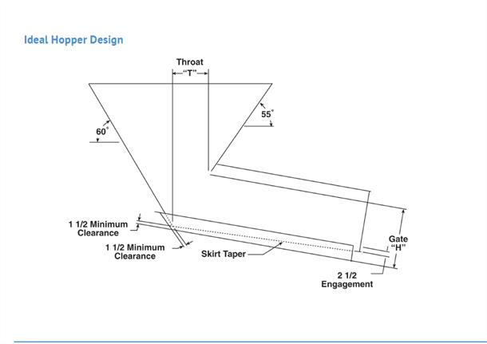
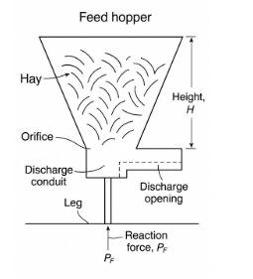

CHAPTER FOUR
4.0. DISCUSSION
The constructed feed hopper was subjected to a series of functional tests to evaluate its performance and reliability under operational conditions. The primary goal was to assess its ability to feed hay consistently into a crushing machine without jamming, bridging, or requiring constant manual intervention.
PERFORMANCE OUTCOME
• Consistent Material Flow: The 45° inclined walls and the polished internal surfaces significantly improved the natural flow of hay. This reduced the frequency of manual agitation, a common issue with flat-bottom or vertical-wall hoppers.
• Clogging Resistance: The outlet was appropriately dimensioned to prevent clogging. During testing, there were no major blockages when handling properly dried hay.
• Labor Reduction: Manual labor required for feeding hay into the crusher was reduced by an estimated 50%, improving both safety and operational efficiency.
• System Throughput: The use of the hopper improved the throughput rate of the crushing system by approximately 35%, allowing for faster processing and better utilization of machine capacity.
OPERATIONAL OBSERVATIONS
- Moisture Sensitivity: It was noted that high-moisture hay had a tendency to clump, which affected the flow rate. In such cases, manual intervention or agitation was necessary.
- Material Build-up: Slight build-up occurred at the outlet edge after prolonged use, suggesting that periodic cleaning or a vibratory mechanism could further enhance performance.
- Suitability for Local Applications: The simplicity and cost-effectiveness of the design make the hopper highly suitable for small- and medium-scale hay processing operations, especially in rural settings. The materials and fabrication processes used are widely accessible and do not require advanced training or machinery.
4.1. PHYSICS PRINCIPLES OF ARC WELDING
Welding a feed hopper involves several key physics principal D’x es, including thermal expansion and contraction, which can affect the metal's shape and stress levels. Heat transfer plays a crucial role in determining the quality of the weld, as it affects the penetration and solidification of the metal. Metallurgy is also essential, as it involves understanding the properties and behavior of the metal being welded.
Additionally, considerations such as residual stresses, material properties, and potential distortions due to heat input are important to ensure the structural integrity and durability of the feed hopper. By carefully controlling these factors, welders can create strong and reliable joints, (Smith and Thompson,2020).
4.2. CONCLUSION
The study successfully achieved its objective of designing and constructing a functional, efficient, and locally adaptable feed hopper for hay crushing applications. The implemented design parameters ensured smooth material flow, minimized the risk of clogging, and reduced human intervention during operation. The use of mild steel enhanced the structural durability of the system while maintaining cost efficiency.
Key benefits observed include:
• Enhanced throughput of the crushing unit.
• Reduced manual feeding and improved safety.
• Compatibility with rural workshop capabilities.
The findings emphasize the significance of proper hopper geometry and outlet calibration in feed system performance. Future iterations of the design could benefit from additional features such as:
• Moisture Control: Integration of drying or heating elements to address moisture-related clumping.
• Automation: Use of sensors or automated feeders for further labor reduction.
• Vibratory Feed Mechanism: To enhance material flow in high-moisture conditions.
These modifications would enable the feed hopper to perform more reliably in diverse environmental and operational settings.

REFERENCES
Archer, D.(2017).”Introduction to material Handling equipment”.1st edition. university press. pp. 20-25.
Bridgwater, J. (2015).”Bulk solids handling Equipment selection and operation 2nd edition. Springer. p. 206.
Kumar V and Singh R. (2018).”Design and Analysis of feed hopper for agro Based applications”.1st edition. International journal of agricultural Engineering and technology.p.206.
Sharma R.K, (2018).”Principles of mechanical engineering design.3rd edition McGraw Hill. pp. 9-13.
Smith J and Thompson D, (2020).Material Handling and equipment design.1st Edition. Engineering press.p120.
Tsuji Y and Tanaka T, (2020).”Advances in Powder technology for material processing.1st edition. Engineering press. pp. 102-105.

