APROJECTREPORT ON
PROPOSEDDENTALCLINIC FOR
OLOJECOMMUNITYILORIN,KWARA STATE.

By:

YAKUBWASIUMOBOLAJI ND/23/ARC/FT/0018

Submittedto:

THEDEPARTMENTOFARCHITECTURAL TECHNOLOGY INSTITUTE OFENVIRONMENTAL STUDIES (IES)KWARA STATE POLYTECHNIC, ILORIN

INPARTIALFULFILMENTOFTHEREQUIREMENTSFOR THE AWARD OF NATIONAL DIPLOMA (ND) IN ARCHITECTURAL TECHNOLOGY

JULY,2025.

i

DECLARATION
I declare thatthis designproject/Dissertation is a project of mypersonalwork. It has been presented for the award of any National Diploma in any Polytechnic. The ideas, observation, comment, suggestions herein represent my own convictions, except quotations, which have beenacknowledged in accordance with conventional academic traditions.

YAKUBWASIU MOBOLAJI

ND/23/ARC/FT/0018 DATE/SIGNATURE

ii

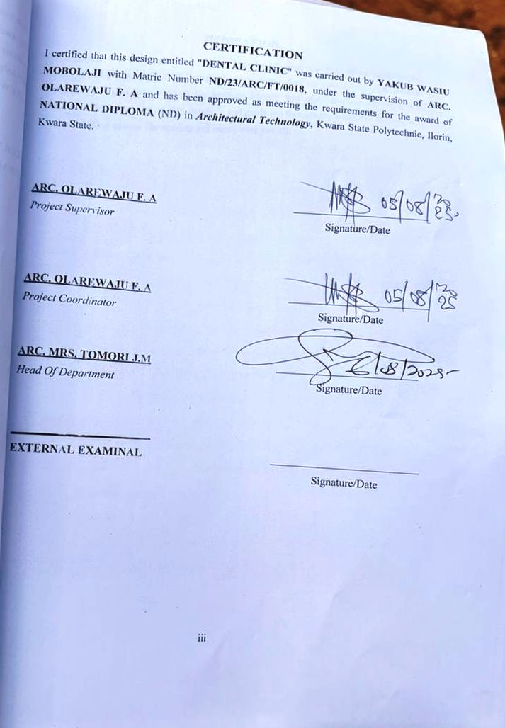

ACKNOWLEDGEMENTS
I will also like to appreciate my project supervisor in person of ARC. OLAREWAJUwhose contribution prepares me forthe challenges in the field and for his immense contribution in all ramifications towards the completion of this research work. He encouraged me and opened the door of interaction with him. I pray Almighty God will shower his blessing and mercyover him, your family and may you live to reap the fruit of your labour.
I also thank and appreciate the effort of my project coordinator in person of ARC. OLAREWAJU for is guidance and his immense contribution towards my project, I pray Almighty God will shower his blessing and mercy over him.
And a VERY BIG THANK YOU to my Head of Department in person of ARC J.M TOMORI for her work in the department, may the Lord reward her abundantly.
I also thank and appreciate the effort of all the Lecturers in Architectural Technology Department, who taught and gave lasting advice's that led tothe success of myprogramme, Almighty God will meet everyone at the point of their needs.
Iwould alsoshowmy profound gratitude tomy parents,MR.ABDULRAHMAN YAKUB and MRS. ABDULRAHMAN YAKUB for their immeasurable Motivation, advices, efforts, and prayerson me, for the completionofthisprogram. I’mreallygratefula lot for the time and efforts spent on seeing me through this programme and may Almighty God grant crown their efforts gracefully. My Sisters: My Lovely Brothers:Abbas oluwadamilareand AbdulrahmanYakub, MayAlmightyGodshowerhis Endless Blessing, Mercy, Unlimited Grace, Joy, Happiness without Sorrow, Sound Health over you all and May Almighty God meet everyone at the point of your needs.
Precious Friends: Olayinka, Omokayode, Almighty God shower his Blessing, Grace, Happiness with Sound Health over you all and answer all our prayer. (AMEN)

DEDICATION
Thisproject workisdedicatedtoAlmightyGodwho has beenprovidingallmyneeds forHis blessing and mercyover me all through the programme. And my parents, Mr. Abdulrahman Yakub and Abdulrahman Yakub, my brothers, friends, love one’s and my supervisor who assist me financially, spiritually, mentally and guide me through my academic pursuit. May Almighty God shower his blessing and mercy over you all.

ABSTRACT
This project focuses on the design of a modern dental clinic that meets thefunctional, hygienic, and psychological needs of patients and staff. The aim is to create a well-planned and aesthetically pleasing facility equipped to provide high- quality dental services. Key considerations include zoning for privacy, infection control, daylight access, ventilation, andspace optimization. Theproject is based on contemporary healthcare design principles, adapting to current challenges in Nigerian healthcare infrastructure.

TABLEOFCONTENTS

TITLEPAGE… i
DECLERATION… ii
CERTIFICATION… iii
ACKNOLEDGMENT iv
DEDICATION… v
ABSTRACT… vi
TABLEOFCONTENTS… vii
LISTOFPLATES x
LISTOFFIGURES xi
LISTOFTABLES xii
LISTOF APPENDICES xiii
CHAPTERONE
INTRODUCTION 1
HISTORICALBACKGROUND 2
DEFINITION 3
STATEMENTOFTHERESEARCH PROBLEM 3
AIMANDOBJECTIVES 3
JUSTIFICATION 4
SCOPE OFSTUDY… 4
LIMITATIONSOFSTUDY… 4
RESEARCHMETHODOLOGY… 5
CHAPTERTWO
LITERATUREREVIEW 6
INTRODUCTION 6
IMPORTANTISSUESANDPROBLEMSPECULIARTODENTALCLINIC
TYPOLOGY 7
TECHNOLOGICAL AND ENVIRONMENTALAPPROACHESFORDESIGNING
ADENTALCLINIC 8
MERITOFSTUDYING 10
CONCLUSION 10
CHAPTERTHREE
CASESTUDY… 11
OUTLINESOFTHE CASESTUDIES 11
CASESTUDYONE(1):OptimistDentalClinicLagosState 11
CASESTUDYTWO(2):BozidDentalClinicOyo State 16
CASE STUDYONE(3):EmitateDentalClinicIlorin 19
CHAPTERFOUR
ANALYTICALSTUDY OFTHEPROJECTLOCATION 24
INTRODUCTION 24
SITELOCATION 24
SITEINVENTORY… 26
SITEANALYSIS 26
GENERALGEOGRAPHICALCONDITION 27
CLIMATE 27
VEGETATION 29
TOPOGRAPHY 29
NATURALRESOURCES 29
ENVIRONMENTALCHALLENGES…………………………………………… 29
SITESERVICES 30
SITEUNIQUENESSANDBENEFIT 30
SITESUITABILITY… 30
DESIGNCRITERIA 30
SITESELECTION 30
BUILDINGARRANGEMENT 31
DESIGN SCOPE 31
DESIGN BRIEF 9ANALYSIS 31
SPACESDERIVATIONANALYSIS/SCHEDULEFORADMINBLOCK 32
FUCTIONALANALYSISANDRELATIONSHIP 32
CHAPTERFIVE
APPRAISALOFPROPOSEDSCHEME 34
CONSTRUCTIONMETHODOLOGYANDMATERIALS 34
5.21 MATERIALSFORCONSTRUCTION 34
CONSTRUCTIONMETHODOLOGIES 34
SERVICE 36
CIRCULATION 36
VENTILATION 36
LIGHTING 37
PLUMBING 37
ELECTRICALINSTALLATION 37
WASTE DISPOSAL 37
FIREPROTECTION 38
EXTERNALWORKS 38
CONCLUSIONAND RECOMMENDATION 38
REFERENCES 39

LISTOF PLATES

CASESTUDY1
PLATE3:1.1LOCATIONMAP 13
PLATE3.1.2ELEVATION 14
PLATE3.1.3 ELEVATION 15
PLATE3.1.4 ELEVATION 15

CASESTUDY2
PLATE3.2.1ELEVATION 18
PLATE3.2.2ELEVATION 18

CASESTUDY3
PLATE 3.3.1LOCATIONMAP 20
PLATE3.3.2 ELEVATION 21
PLATE3.3.3 ELEVATION 22
PLATE3.3.4 ELEVATION 22

LISTOF FIGURES
FIGURE3:1:1LOCATIONPLANCASESTUDY1… 12
FIGURE3.1.2FLOORPLANSCASESTUDY1 13
FIGURE3:1.3SITEPLANCASESTUDY1 14
FIGURE3.2.1LOCATIONPLANCASESTUDY2… 15
FIGURE3.2.2FLOORPLANSCASESTUDY2 15
FIGURE3.3.1LOCATIONPLANCASE STUDY3… 20
FIGURE3.3.2FLOORPLAN.CASE STUDY3 21
FIGURE 4.1.11.1MAPOFNIGERIA, 36STATESANDFCT 24
FIGURE4.1.11.2KWARASTATEMAP 25
FIGURE 4.1.11.1LOCATIONPLAN 25
FIGURE4.1.12.1SITEINVENTORY 26
FIGURE4.1.12.2SITEANALYSIS 27
FIGURE4.1.3.1AVERAGEMONTHLYRAINFALLIN ILORIN. 28
FIGURE4.1.3.2SUNSHINEDURATIONINILORIN. 28
FIGURE4.1.3.3RELATIVEHUMIDITYINILORIN. 29
FIGURE4.2.6.1:FUNCTIONALANALYSIS 32
FIGURE4.2.6.2:FUNCTIONALRELATIONSHIP 33

LISTOF TABLES
TABLE4.2.5:SPACEALLOCATION 32

LISTOF APPENDICES
APPENDICES5.1:FLOOR PLAN… 40
APPENDICES5.2:ROOFPLAN 41
APPENDICES 5.3:SITEPLAN… 42
APPENDICES 5.4:SECTIONS 42
APPENDICES 5.5:ELEVATION 43
APPENDICES5.6:INTERNALPERSPECTIVE 43
APPENDICES5.7:EXTERNALPERSPECTIVE 43

CHAPTERONE INTRODUCTION TO DENTAL CLINIC
A dental clinic is a healthcare facility where people receive professional care for their teeth and gums. This project focuses on designing a functional and modern dental clinic that can handle various dentalservices such as consultations, tooth extractions, cleaning, fillings, and X-rays. The aim is to create a space that is clean, comfortable, and welcoming to patients, while also being easy for staff to work in.
Dental care plays an important role in overall human health, yet in many communities,access to standard dental facilities remains limited. This project involves the design of a dental clinic that combines functionality, hygiene, and modern aesthetics to improve oral healthcare delivery. The clinic willaccommodate essentialspaces suchas treatment rooms, a waiting area, a pharmacy, and staff offices. The goal is to create a safe, clean, and comfortable environment for both patients and healthcare professionals.

HISTORICALBACKGROUNDOFTHEPROJECT

The history of dental practice can be traced back to ancient civilizations such as Egypt, Mesopotamia, and Greece, where basic dental procedures were performed. However, the concept of the modern dental clinic emerged in the 18th and 19th centuries with the advancement ofmedicalknowledge and tools. InNigeria, dentalcare begangaining attention in the colonial period, mainly within teaching hospitals. As awareness of oral health increased, private dental clinics began to develop across urban areas. These clinics were established to provide dedicated spaces for dental care, equipped with tools and technology for diagnosis and treatment. Today, dental clinics continue to evolve, combining modern architecture with healthcare requirements to deliver effective services in clean and efficient environments.
Dental care has been practiced for thousands of years, but the idea of a modern dental clinicis more recent. In the past, people often treated tooth problems at home or with traditional methods. As science improved, trained professionals began to handle dental treatment, leading to the development of dental hospitals and clinics. In Nigeria, dental services started

in major hospitals but have now expanded into private and public dental clinics. Today, dentalclinics are an important part ofthe healthcare system, providing clean and safe spaces for oral treatment.

DEFINITION

Adentalclinic isaplacewherepeoplegoto gettreatment fortheirteeth, gums, and mouth. It is run by trained professionals like dentists and dental nurses who help with tooth pain, cleaning, filling, removal, and other dental problems.
A dental clinic is a specialized medical facility designed for the diagnosis, prevention, and treatment of oral health issues. It provides dental services such as check-ups, cleaning, tooth extraction, fillings, and minor surgeries, in a clean and hygienic environment by licensed dental professionals.

STATEMENTOFTHERESEARCH PROBLEM.

Despite the growing need for oral healthcare, many existing dental clinics in Nigeria face challengessuchas inadequate facilities, poorventilation, inefficient spatialarrangement, and limited accessibility. These issues affect the quality of dentalservices provided. This project seeks to address these problems by researching and designing a modern dental clinic that meets both functional and architectural standards for effective oral healthcare delivery.
In many parts of Nigeria, dental clinics are poorly designed, lacking proper space planning, hygiene control, and patient comfort. This has made it difficult for people to receive quality oral care. The problem this project addresses is how to design a dental clinic that provides a clean, functional, and welcoming environment for bothpatientsand staff, while also meeting healthcare standards.

AIMANDOBJECTIVES

AIMOFTHESTUDY

The aim of this project is to design a functional, hygienic, and patient-friendly dental clinic that meets modern healthcare standards and provides quality oral care services in a safe and comfortable environment.

OBJECTIVES

      - Tocreateawell-planneddentalclinicwithclearlydefinedzonesfortreatment,waiting, and staff areas.
      - Toensuregoodhygieneandinfectioncontrolthroughproperspacelayoutand material selection.

      - Toprovideacomfortableandwelcomingenvironmentforpatientsofallages.
      - Todesignforaccessibility, allowingeaseofuseforphysicallychallenged persons.
      - Toincorporatenaturallightingandventilationintothebuilding design.

JUSTIFICATION.
The need for a well-designed dentalclinic is very important because manyexisting clinics in Nigeria do not meet modern health and design standards. Some clinics lack proper ventilation, enough space, and a clean environment, which can affect the quality of service and patient comfort. This project is justified because it will help provide a better space for dental care, where patients feel safe and relaxed, and staff can work effectively.
The justification forthis project arises fromthe increasing demand for qualityoralhealthcare services and the lack of standard dental clinic facilities in many urban and semi-urban areas. Poorly designed clinics often result in overcrowding, lack of privacy, and inefficient patient flow. By designing a functional and well-organized dental clinic, this project addresses criticalissuessuchashygiene, accessibility, anduser comfort.It willcontributeto improving healthcare delivery and setting a model for future dental facility design.

SCOPEOFTHESTUDY
Thisproject coversthearchitecturaldesignofadentalclinic. It includestheplanning of all necessary spaces such as the reception, waiting area, consultation rooms, treatment rooms, X-ray room, pharmacy, toilets, and staff areas. The project also covers the site planning, circulation, lighting, ventilation, and landscape design to ensure a safe and comfortable environment for both patients and staff.
The scope of this study includes the complete architectural design of a standard dental clinic facility. It involves the spatial planning and arrangement of core functional areas such as the reception and waiting areas, consultation rooms, treatment rooms, X-raysection, sterilizationroom, pharmacy, administrative offices, and sanitary facilities. It also includes the design of external elements such as entrancepoints,parkingspaces,greenareas,andserviceaccess.Theprojecttakes

into account environmental factors, building orientation, ventilation, lighting, circulation flow, accessibility, and patient comfort.

LIMITATIONSOFSTUDY
Thelimitationsexperienced during thiscourseofstudyinclude:
    - Timeconstraints limitedthenumberofphysicalcasestudiesthatcouldbe visited.
    - Accesstodetailedhealthfacilityregulationswaspartiallyrestricted.
    - Budgetaryconcernsforfulldigitalsystemimplementationwereassumed,not actualized.

RESEARCHMETHODOLOGY
In order to archive a well-functioning and organization farmstead and to know what the farmer need; the research was done.
- Case Studies: Existing dental clinics were visited to evaluate their spatial organization, design merits, and operational challenges.
- Literature Review: Relevant architectural texts and healthcare design manuals were consulted to understand the spatial, technical, and functional requirements of dental facilities.
- Internet Research: Online platforms were used to explore modern dental clinic designs globally, with emphasis on digital integration and user-centered layouts.
- Personal Observation: Direct site visits and informal interviews were conducted to observe real-life clinic operations, document activities, and gather user feedback for informed design decisions.

CHAPTERTWO

LITERATUREREVIEW

Introduction
This literature review explores the architectural design principles, functional requirements, and modern innovations relevant to the development of a dental clinic. As oral healthcare facilities require both clinical precision and patient comfort, the review draws on established architectural standards, case studies, and technological trends to guide the proposed design.

The review aims to understand how dental clinics have evolved in terms of spatial planning, digitalintegration, infectioncontrol, and environmentaldesign. It also considers how current practices inNigeria compare with internationalstandards, withthe goalofdesigning a dental clinic that is efficient, user-friendly, and adaptable to local needs.

IMPORTANTISSUESANDPROBLEMSPECULIARTODENTALCLINIC TYPOLOGY

VariantsoftheBuildingType

Dental clinic designs can vary significantly depending on their scale, function, ownership, and location. These differences directly affect the design approach, spatial planning, and technological integration.

PRIVATEVS.PUBLICDENTALCLINICS

PrivateClinics
    - DesignFocus:Emphasisonpatientcomfort,aesthetics,andpersonalizedservices.
    - Scale: Typicallysmaller, with2–4treatmentrooms.
    - Flexibility:Greaterfreedominspatiallayout,designstyle,anddigitalsystem integration.
    - Limitations:Maylackadvancedsurgicalfacilitiesduetospaceorbudgetconstraints.

PublicorTeaching Clinics
    - DesignFocus: Efficiency,highcapacity,andcompliancewithgovernmentstandards.

    - Scale:Larger,withmultipleconsultingrooms,teachingspaces,anddiagnosticunits.
    - ZoningNeeds: Clearseparationofclinical,academic, andadministrativefunctions.
    - Challenges:Overcrowding,complexcirculation,andhighmaintenancedemand.

STAND-ALONEVS. HOSPITAL-BASEDCLINICS

Stand-Alone Clinics
    - Operateindependently, typicallylocatedinresidentialor commercialareas.
    - Requirefulladministrative,sterilization,andemergencysystemswithinthesame facility.
    - Greateremphasisonoutpatientflowand street-levelaccessibility.

Hospital-BasedDentalClinics
    - Functionasadepartmentwithinageneralhospital.
    - Sharecentralfacilitiessuchaslaboratories,records,andemergencyservices.
    - Designmustaccommodatemultidisciplinaryinteractionandcompliancewithhospital-wide standards.

- EnvironmentalandContextualIssues

URBANCLINICS
    - SpaceLimitations:Clinics locatedinurbancentersoftenstrugglewithcompactsites.
    - ExternalNoise: Proximitytobusyroadsaffectspatientcomfort.
    - ParkingandAccess:Limitedspaceforvehicleaccessanddrop-off.

RuralorSemi-UrbanClinics
    - InfrastructureGaps:Pooraccesstoelectricity,water,or wastedisposalservices.
    - MaterialAvailability:Limitedoptionsforhygienic,durablebuildingmaterials.

TECHNOLOGICAL AND ENVIRONMENTAL APPROACHES FOR DESIGNING A DENTAL CLINIC.
Designing a modern dental clinic requires an integrated approach that leverages both technological innovations and environmentally sustainable strategies. These approaches not only enhance the efficiency and functionality of the clinic but also improve patient experience, reduce operational costs, and promote environmental stewardship.

TECHNOLOGICALAPPROACHES

DigitalIntegrationandHealthManagement Systems
- ElectronicMedicalRecords(EMR):Acentralized,securesystemforstoringand retrieving patient data, improving record accuracy and minimizing paperwork.
- AutomatedAppointmentSystems:Useofdigitalschedulingsoftwaretomanage bookings, send reminders, and reduce patient wait times.
- Patient Self-Check-In Kiosks: Touchscreen kiosks can streamline patient registration and reduce front desk congestion.
- DentalImagingSystems:IntegrationofdigitalX-rays,intraoralcameras,and3D imaging (CBCT) improves diagnostic accuracy and patient communication.

ITandCommunication Infrastructure
- High-SpeedInternet:Essentialforcloud-basedrecordsystems,real-timeconsultation, and digital imaging.
- Intranet Systems: For internalcommunication betweendepartments(e.g.,receptionto lab or sterilization room).
- SecureNetworkandBackupSystems:Ensuringdatasecurity,confidentiality,and recovery in case of system failure.

SmartClinicFeatures
- AutomatedLightingandHVACControls:Motionorschedule-basedsystemsto reduce energy waste.
- Voice-ActivatedAssistantsandTouchlessControls:Forimprovedhygieneandworkflow in treatment areas.
- Central Display Monitors: Used in consulting rooms for treatment planning, patient education, and real-time imaging display.

ENVIRONMENTALAPPROACHES

SustainableBuildingDesign
- Passive Cooling and Cross Ventilation: Oriented window openings, openable clerestory windows, and ventilated roofing help reduce reliance on mechanical cooling systems.
- Natural Daylighting: Maximize use of daylight through skylights and wide glazed surfaces, particularly in waiting and circulation areas.
- Thermal Insulation: Use of insulated roofing materials and cavity walls to reduce indoor temperature fluctuation and cooling load.

RenewableEnergyIntegration
- SolarPowerSystems:Rooftopsolarpanelscansupplyenergyforlighting,computers, and low-power devices, reducing utility costs and environmental impact.
- SolarWaterHeaters:Usedforhandwashingstationsandsterilizationrooms.

WaterConservationStrategies
- RainwaterHarvesting:Capturedrainwatercanbereusedforlandscaping,flushing toilets, and exterior cleaning.
- Low-FlowFixtures:Faucets,toilets,anddentalunitwaterlinesfittedwithflow restrictors to reduce consumption.
- GreywaterRecycling:Wherefeasible,wastewaterfromhandwashsinkscanbefiltered and reused for toilet flushing.

WasteManagement
- Segregated Waste Bins: For proper sorting ofgeneral, infectious, and sharp wastes in compliance with medical regulations.
- SharpsDisposalUnitsandIncineratorAccess:Essentialforhygienicandlegaldisposal of contaminated waste.
- Digital Communication: Reduces reliance on paper through electronic prescriptions, digital referrals, and online reporting.

LandscapeAndEnvironmentalEnhancement
- Healing Gardens and Outdoor Waiting Spaces: Landscaped zones with shade trees,benches, and greenery provide a calming atmosphere for patients.
- Green Roof or Wall Options: Improve insulation andpromote biodiversity in dense urban areas.
- PermeablePavingandDrainageDesign:Enhancesstormwatermanagementandreduces surface runoff around the site.

CulturalandCommunityConsiderations
- Accessible and Inclusive Design: Ramps, wide corridors, and signage to accommodate all users, including the elderly and physically challenged.
- LocallySourcedMaterials:Useofindigenousmaterialsforwalls,ceilings,andfinishes to promote local economy and reduce environmental impact.

- Community Engagement: Involving staff and community health workers during planning helps tailor design to real user needs, ensuring the clinic serves the population effectively.

CHAPTERTHREE

CASESTUDY

Acase studyinvolves anup-close, in-depth, and detailed examinationofa particular caseor cases, withinareal-worldcontext. Casestudyresearchisto establisha firmresearch focus to which the research can refer over the course of a complex phenomenon or object.
Case study can be view as the study of an existing project for a reference purpose in order to determine adjustment point of that particular building. Case study research is to establish a firm research focus to which the research can refer over the course of a complex phenomenon or object.
According to researcher Robert K. Yin, defined case study method as an empirical inquiry that investigate a contemporary phenomenon within its real-life context,

OUTLINESOFTHECASESTUDIES
- OptimistDentalClinicLagos State
- BozidDentalClinicIbadanOyoState.
- EmirateDentalClinicAsa-DamIlorin Kwara

CASESTUDYONE(1):OptimistDentalClinicLagosState
DateofEstablishment:1966 Architect: Unknown Location: Lagos State.

BriefDescription:
Optimist Dental Clinic is a modern private dental facility located in Lagos State. It provides comprehensive dental services such as tooth extraction, cleaning, orthodontics, and X-rays. The clinic operates ina well-structured building that emphasizes hygiene and patient comfort.

Merits:
      - Well-ventilatedandair-conditionedrooms
      - Moderndentalequipmentandtechnology
      - Cleanandwelcomingreceptionarea
      - Well-zonedspaces(separatewaiting,treatment,andsterilizationareas)

Demerits:
      - Limitedparkingspaceforpatient
      - Highservicecos
      - Smallwaiting areaduring peak hours
LOCATIONPLAN
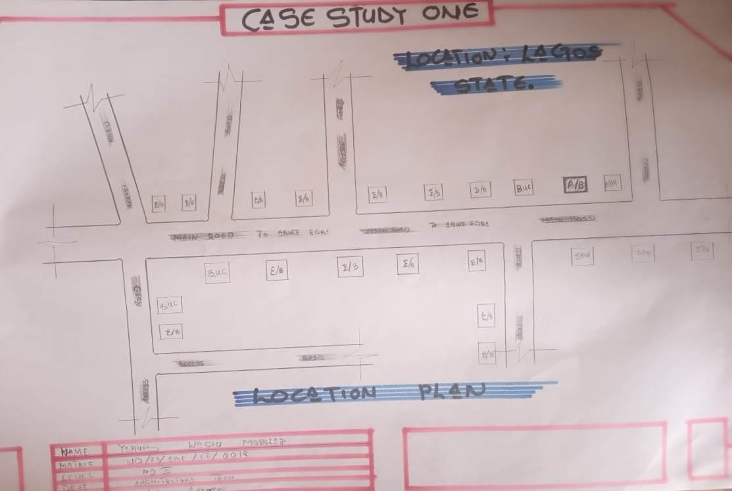
Figure3:1:1LocationPlan
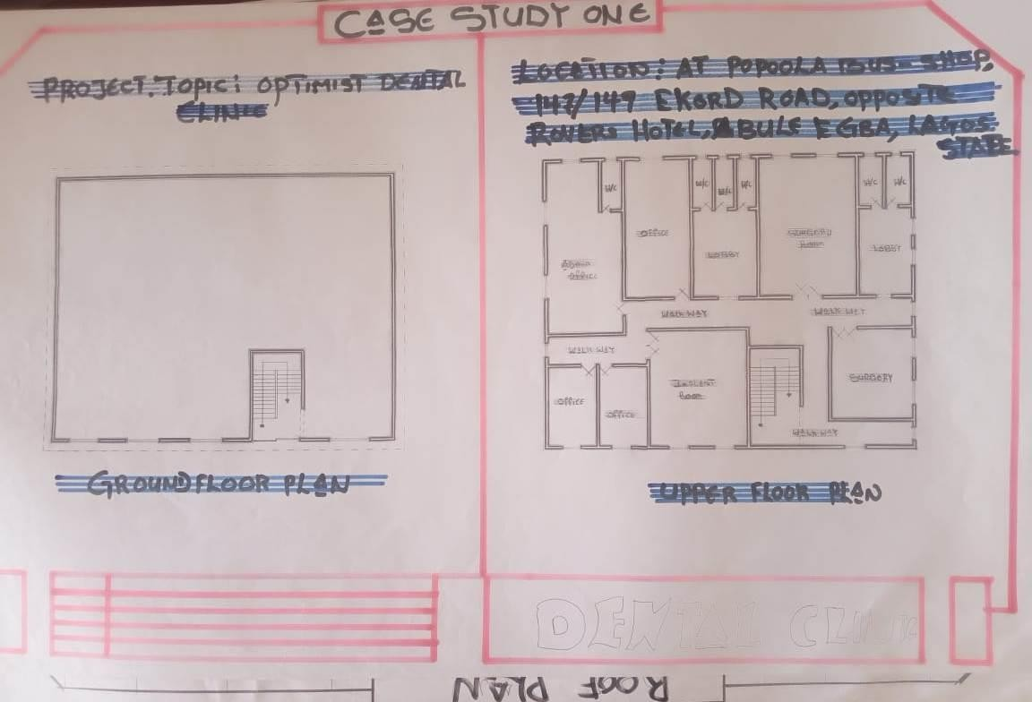ROOF&FLOORPLAN

Figure3:1.3Roof &FloorPlan

PICTURES
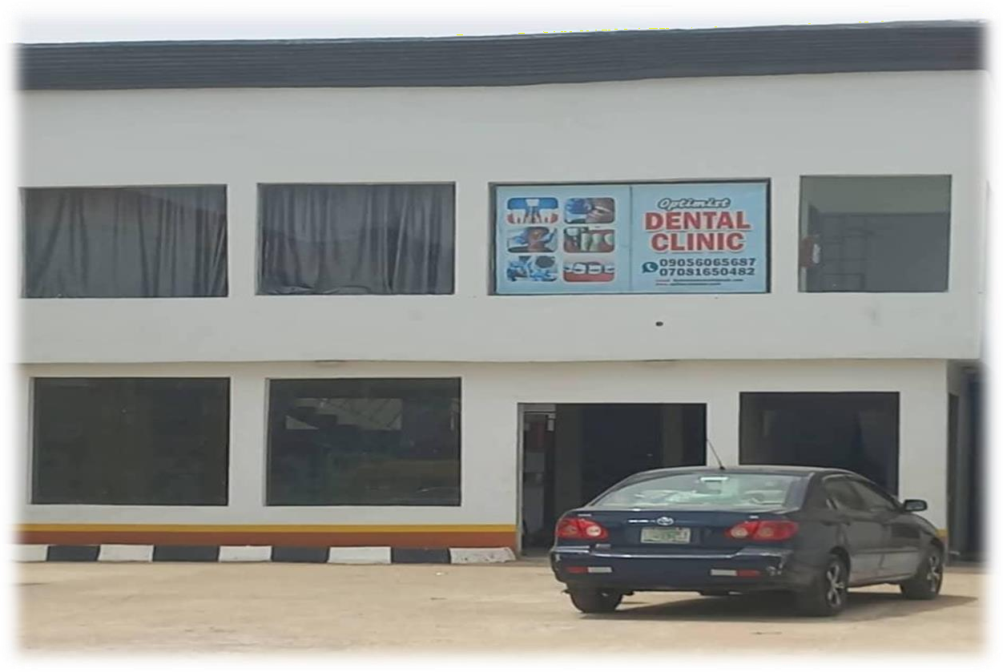
Plate3.1.2Elevation
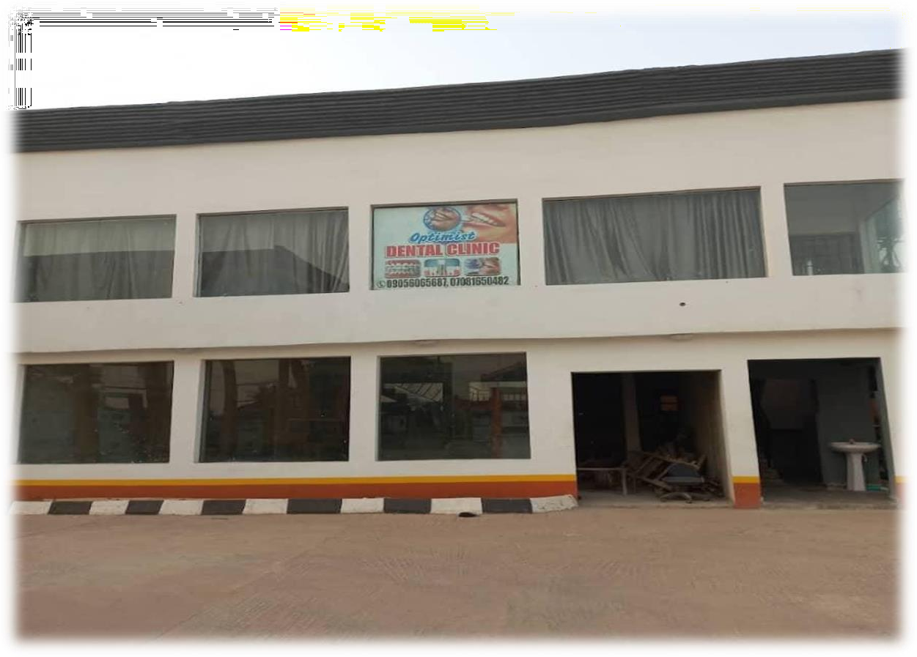
Plate3.1.3Elevation

CASESTUDYTWO(2):BozidDentalClinicIbadanOyoState.

DateofEstablishment:
Architect:Unknown
Location:IbadanLagos State.

BriefDescription:
BozidDentalClinic is located inIbadanandservesbothprivatepatientsandreferrals. The clinic offers general dental treatment and some specialized services. It operates from a converted residential building adapted for clinical use.

Merits
- Affordabletreatmentoptions
- Accessiblelocationwithpublictransport
- Friendlyandprofessionalstaff

Demerits
- Poorinternallayoutduetoconversionofresidentialstructure
- Inadequateventilationinsomerooms
- Limitedspaceforfuture expansion

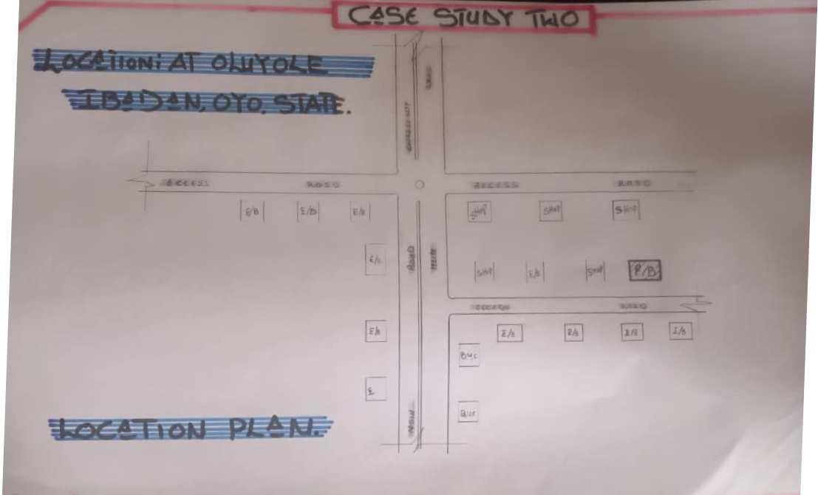LOCATIONPLAN

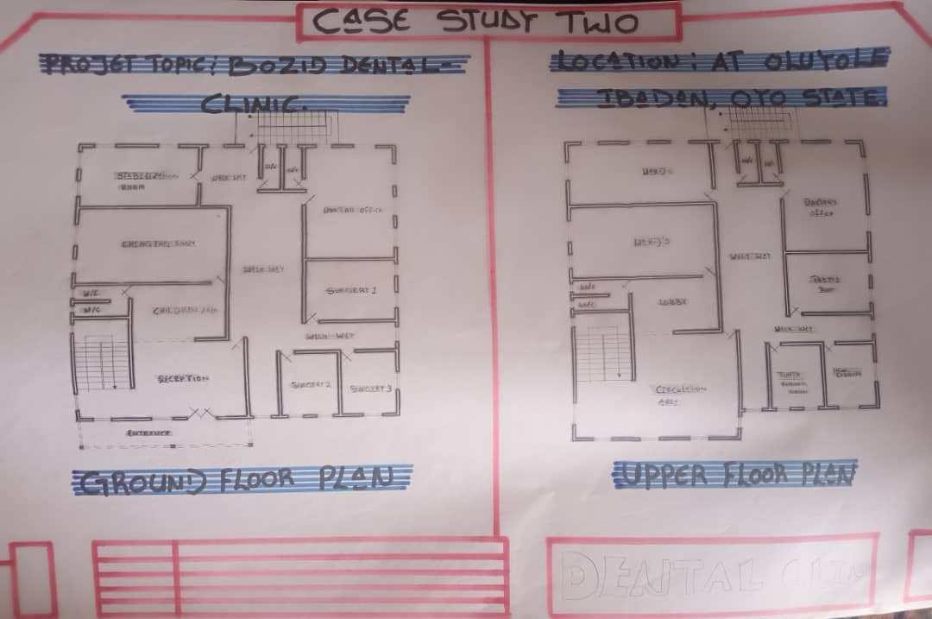Figure3.2.1LocationPlan

ROOF&FLOORPLAN

Figure3.2.2Roof&Floor Plans

PICTURES
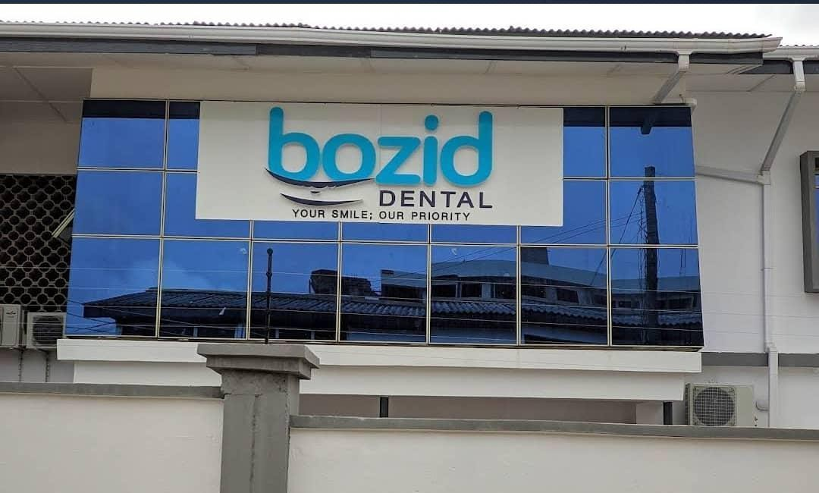

Plate3.2.2Elevation
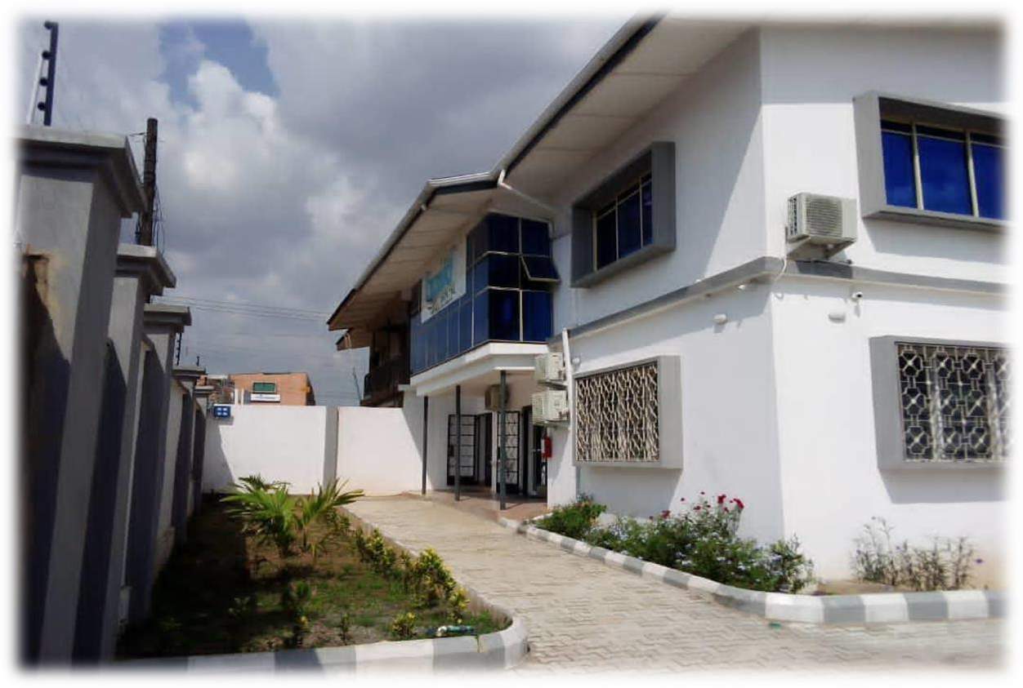
Plate3.2.3Elevation

CASESTUDYONE(3):EmirateDentalClinic–Ilorin,KwaraState

DateofEstablishment:
Architect: Unknown Location:Ilorin,KwaraState. Brief Description:
Emirate Dental Clinic is a private dental center located in Ilorin. It provides basic dentalcare services such as scaling, filling, and extractions. It is popular for its affordability and its proximity to residential areas.

Merits:
      - Affordableandcommunity-friendlyservices
      - Cleanandwell-maintainedenvironment
      - Easyaccessfromsurroundingneighborhoods

Demerits:
      - Smalltreatmentroomswithlimitedspace
      - Lackofadvanceddentaltechnology
      - Nodedicatedstaffloungeorsterilizationzone

LOCATIONPLAN
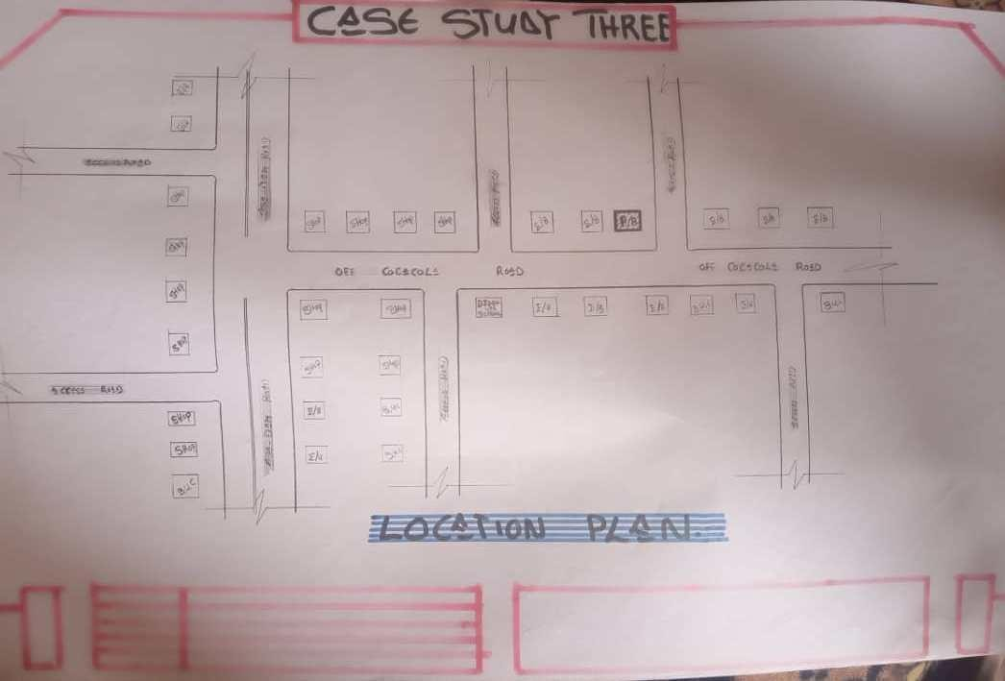
Figure3.3.1LocationPlan

ROOF&FLOORPLAN
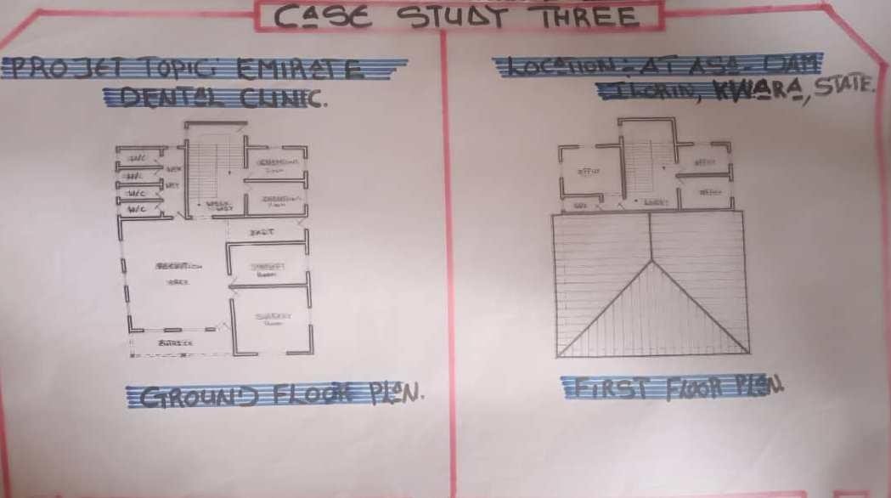
Figure3.3.2Roof&Floor Plan.

PICTURES
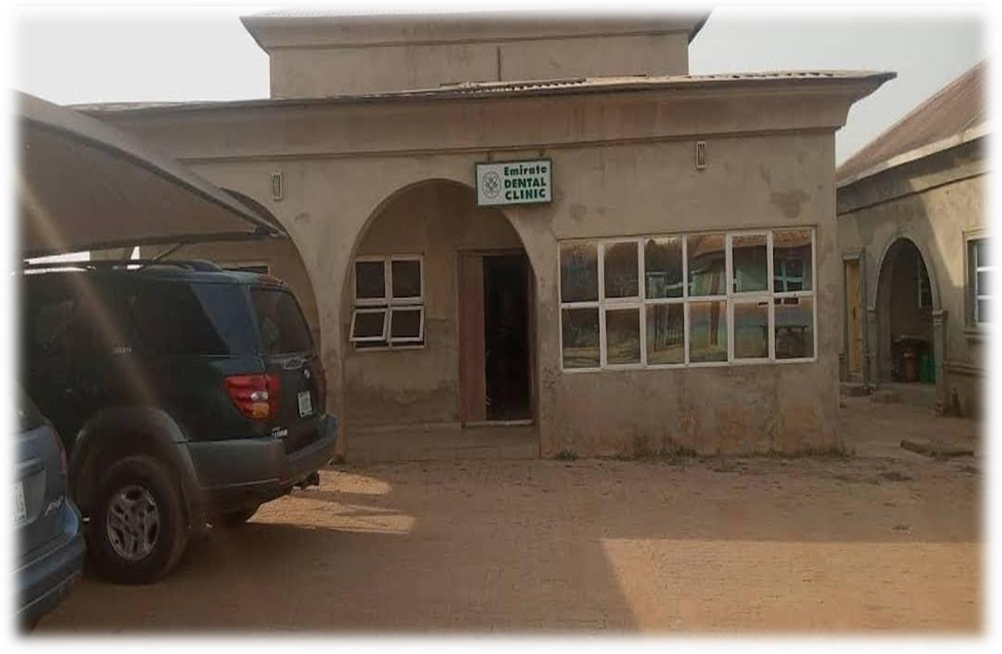
Plate3.3.2Elevation

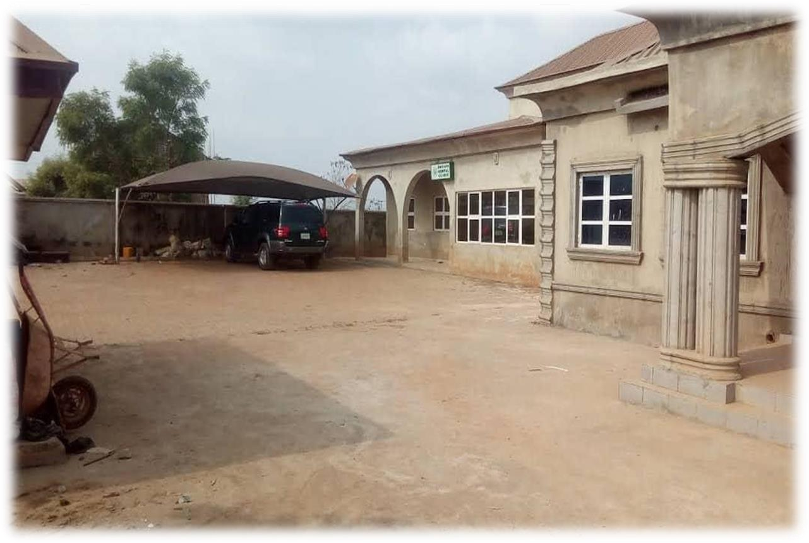

Plate3.3.3Elevation

CHAPTERFOUR

ANALYTICALSTUDYOFTHEPROJECTLOCATION

INTRODUCTION
Ilorin is one of 36 states of federal of republic of Nigeria. Ilorin, the capital city of Kwara State, Nigeria, is a city with a rich historical, cultural, and economic background. Ilorin was founded in 1450 and has a significant historical legacy as a prominent center in the Yoruba and Fulani empires.
Ilorin is a city with a rich historical heritage and cultural diversity, serving as an economic and educational hub in Kwara State. Its strategic location, coupled with ongoingdevelopment efforts, positions it as a key city in Nigeria’s socio-economic landscape.

SITELOCATION
Thisisveryimportant pointtobeconsideredbeforeestablishing thesettingofhouses,should take advantage of topographical features speeds and directions should be studied to ensurethe best orientation to take advantage of the prevailing wind.
Avoiding site prone to water logging and rain and draught which depends on wind direction and speed in the raining season placement of a building so that the length extends along the East and West direction.
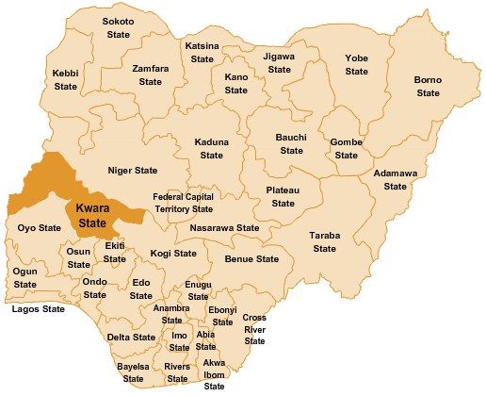
The proposed project is sited at Sobi Road Akerebiata Ilorin, Kwara State. It is surrounded with built up environment with various commercial activities being taken up in the area.

Figure 4.1.11.1MapofNigeria,36StatesandFCT.

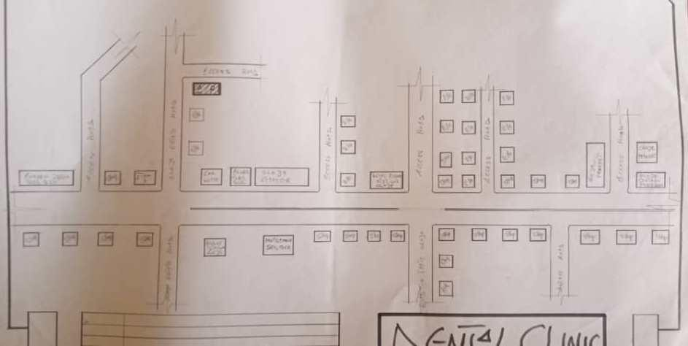
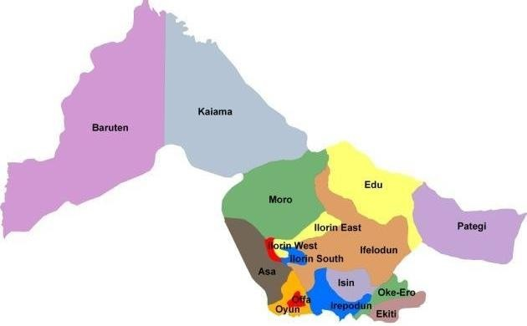

Figure4.1.11.2KwaraStateMap

Figure4.1.11.1LocationPlan

SITEINVENTORY
Site analysis is the synthesis of the physical feature and facilities that are present on the site and over the site such as trees, footpath, soil, topography, vegetation, streamand shrubs etc.

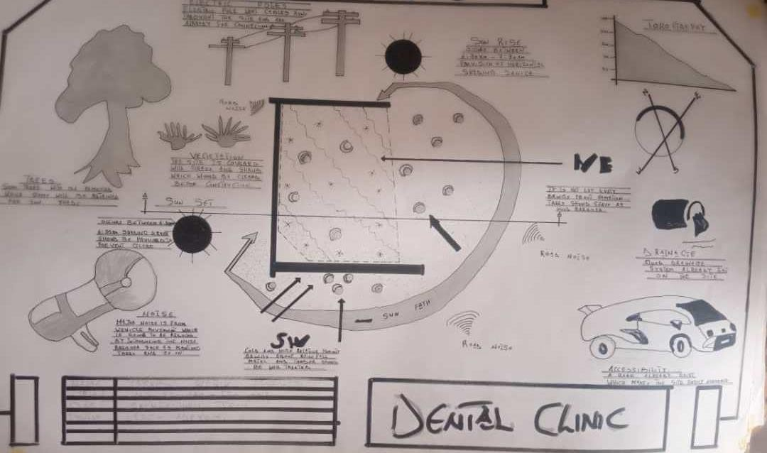

Figure4.1.12.1Site Inventory

SITEANALYSIS
Site Analysis is the process of evaluating how a proposed site system will integrate with the existing site infrastructure by assessing physical obstructions, electrical interference, and noise to identify suitable interrogation zones for coexistence with the infrastructure.

The site selected for the project is a verygentle slope, it is a site that has never beenused for any formof building construction i.e. it has not been developed in the past which make it an abode for several trees and shrubs, it is also observed during the course of inventory that some of the trees are to be removed as it could obstruct the construction process during the project, while some are to be retained to help controlthe adverse of the wind storm.

The soil is well compacted Soil in nature with good soil texture. The sun rises from the eastern part ofthe site and sets onthe western part. The Construction does not need a special type offoundationdue to the fact thatthe site is having a good bearing capacityand strength.

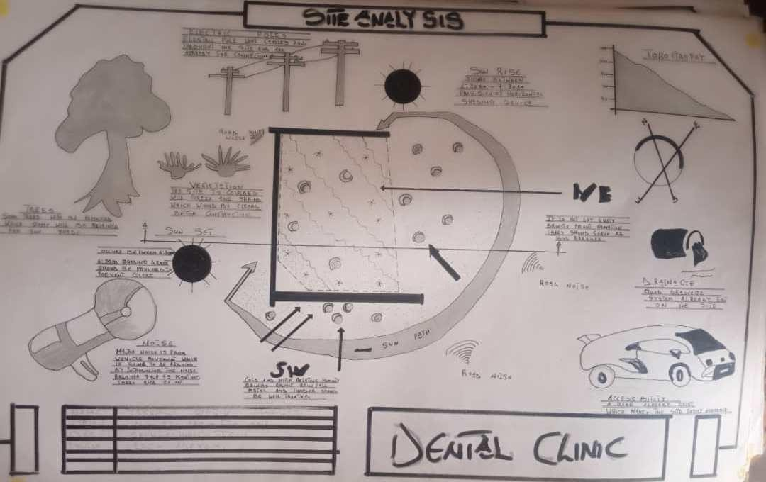

Figure4.1.12.2Site Analysis

GENERALGEOGRAPHICALCONDITION
Ilorin, the capital city of Kwara State, Nigeria, is characterized by specific geographical conditions that influence its climate, vegetation, and overall environmental features. Here'san overview of the general geographical conditions of Ilorin.
Ilorin issituated approximatelyat latitude 8.5°N and longitude 4.55°E. The cityispositioned at an elevation of about 290 meters (951 feet) above sea level. Ilorin is centrally located in Nigeria, serving as a significant connection between the northern and southern parts of the country.

CLIMATE:
Tropical Savanna Climate: Ilorin experiences a tropical savanna climate (Aw according to the Köppen climate classification), characterized by distinct wet and dry seasons.
Temperature: Average temperatures in Ilorin range from 22°C (72°F) to 33°C (91°F). During the dry season, daytime temperatures can rise significantly, while nights are cooler, especially during Harmattan.

Rain Season: The wet season typically spans from April to October, with the heaviest rainfall occurring between June and September. Annual rainfall averages around 1,200 mm (47 inches).

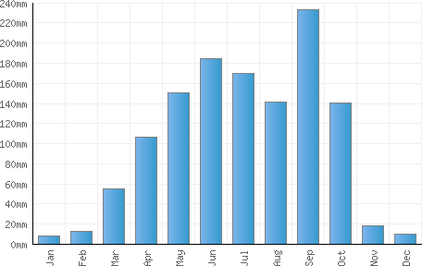

Figure 4.1.3.1AverageMonthlyRainfallin Ilorin.

Dry Season: The dry season lasts from November to March, marked by significantly lower humidity and occasional dust-laden winds from the Sahara Desert, known as Harmattan.

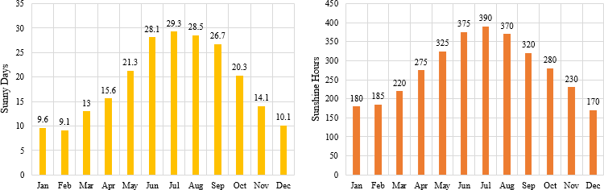

Figure4.1.3.2Sunshine Durationin Ilorin.

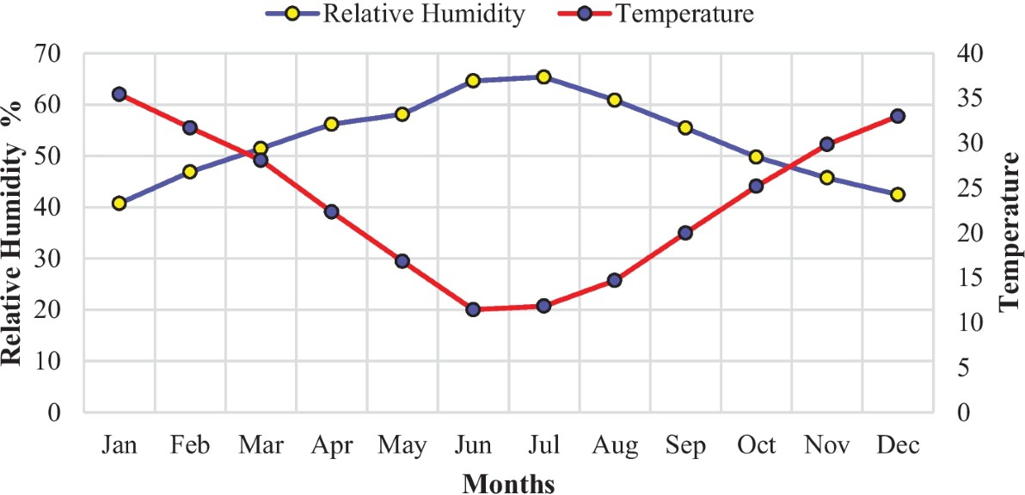

Figure4.1.3.3Relative Humidityin Ilorin.

VEGETATION
Guinea Savanna: The predominant vegetation type in Ilorin is the Guinea Savanna, characterized bya mix of grassland and scatteredtrees. This vegetation type is typicalof the transitional zone between the forest regions in the south and the Sahel in the north.
Flora: Common plant species include acacia, baobab, shea butter trees, and various grasses and shrubs adapted to the savanna climate.

TOPOGRAPHY
Gently Undulating Plains: Ilorin's topography consists mainly of gently undulating plains, with occasional hills and low-lying areas.

NATURALRESOURCES
Mineral Resources: Kwara State, including Ilorin, is endowed with various mineral resources suchas limestone, gold, and kaolin. These resources offer potential for mining and related industries.

ENVIRONMENTALCHALLENGES
Urbanization: RapidurbanizationinIlorinhas ledto challengessuchasdeforestation, waste management issues, and pressure on infrastructure and services.

Climate Change: Like many regions, Ilorin faces the impacts of climate change, including variability in rainfall patterns and increased frequency of extreme weather even.

SITESERVICES
There are good services around the site, which include good access road, for people coming to Dental Clinic, availability of electricity very close to the site which will be useful before and after construction. Also, availability of pipe born water at the chosen site.

SITEUNIQUENESSANDBENEFIT
      - Thesite isaccessible
      - Naturalfactorlike,isveryuseful
      - Utilityservicessuchaswater,electricity,telephone,etc.causenoproblemtothe inhabitants.

SITESUITABILITY
The appropriateness or suitability of the site for the construction and planning of theproposed project is based on the fact that is possesses and meets the entire requirements. All the existing features were strictlyconsidered with the intensionof making advantage ofthem to maximum level most especially the geographical, topographical features of the site.

TypesOfForestRegion
      - Mangrove(SaltQuarter)SwampForest
      - Freshwater swampforest
      - High forest

DESIGNCRITERIA
Planning is an important activity which determines the success of any endeavor. It is often said that without plans, purposesare frustrated,planning isthe first and most important steps in designing a DentalClinic, so as to achieve aims ofdesigning and the criteria’s and should be take into consideration.

SITESELECTION
Anumber offactorsnecessaryfor siteselectionfor afarmsteadareoutlined below:
      - AccessRoad
      - Water
      - Utilizesandservices(electricity,telephone,accessdrivesetc.)

      - Orientation (air drainage and maximum sunshine may require orientation on a gentle Southerly slope).
      - Expansion.

BUILDINGARRANGEMENT
The arrangement of facilities for maximum efficiency of operation should be a prime concern. Proper arrangement increase efficiency byreducing walking distance to a minimum and providing adequate drive ways and turn around. It is important to note that five protections, safely and security and all influenced by the design planning.

DESIGNSCOPE
Thesearescopeofdesigning aDentalClinicwhichincludesthe followings; Security House, Main Building, Mosque, Generator House, Park Lots.

DESIGNBRIEF9ANALYSIS
Entrance, Reception and Card Room, Waiting Area, Pharmacy, Therapy, Nurse Station, Dentist Office, Laboratory, Surgery Room, Recovery Room, Cosmetic, X-ray, Sterilization, Conference Room, Changing Room, Storage, Toilet, Exit.

SPACESDERIVATIONANALYSIS/SCHEDULEFORADMINBLOCK

S/N | SPACE | UNIT | LENGTH(M) | BREADTH(M) | AREA(M²)
1. | MainEntrance | 1 | 2.700mm | 6.000mm | 16,200,000m²
2. | ReceptionArea | 1 | 5.500mm | 6.000mm | 33,000,000m²
3. | CardRoom | 1 | 2.600mm | 3.000mm | 7,900,000m²
4. | CasherArea | 2 | 2.600mm | 2.200mm | 5,720,000m²
5. | ConsultationRoom | 1 | 4.200mm | 3.000mm | 15,120,000m²
6. | Pharmacy | 2 | 2.900mm | 3.600mm | 21,240,000m²
7. | Drug Room | 2 | 3.000mm | 5.200mm | 15,600,000m²
8. | LaboratoryRoom | 1 | 4.200mm | 3.600mm | 15,120,000m²
9. | SterilizationArea | 1 | 4.200mm | 3.600mm | 15,120,000m²
10. | SurgeryRoom | 2 | 4.200mm | 3.600mm | 15,120,000m²
11. | RecoveryRoom | 2 | 4.200mm | 3.600mm | 15,120,000m²
12. | RecoverRoom | 1 | 5.200mm | 3.000mm | 15,120,000m²
13. | Office | 1 | 4.200mm | 3.300mm | 13,860,000m²
14. | Office | 3 | 3.000mm | 3.900mm | 11,700,000m²
15. | Nurse Desk | 3 | 4.200mm | 4.000mm | 16,800,000m²
16. | X-Ray | 2 | 5.800mm | 3.00mm | 17,400,000m²
17. | LaundryJanitor | 2 | 4.200mm | 5.000mm | 21,000,000m²
18. | StaffRoom | 1 | 4.200mm | 5.300mm | 28,260,000m²
19. | Toilet | 1 | 2.900mm | 1.200mm | 3,360,000m²
20. | Exit | 1 | 900mm | 1.200mm | 1,080,000m²
Table 4.2.5:SpaceAllocation

FUCTIONALANALYSISAND RELATIONSHIP
TheMainBuildingplaniswellfunction,theunitaresowellrelatedtoeachother,
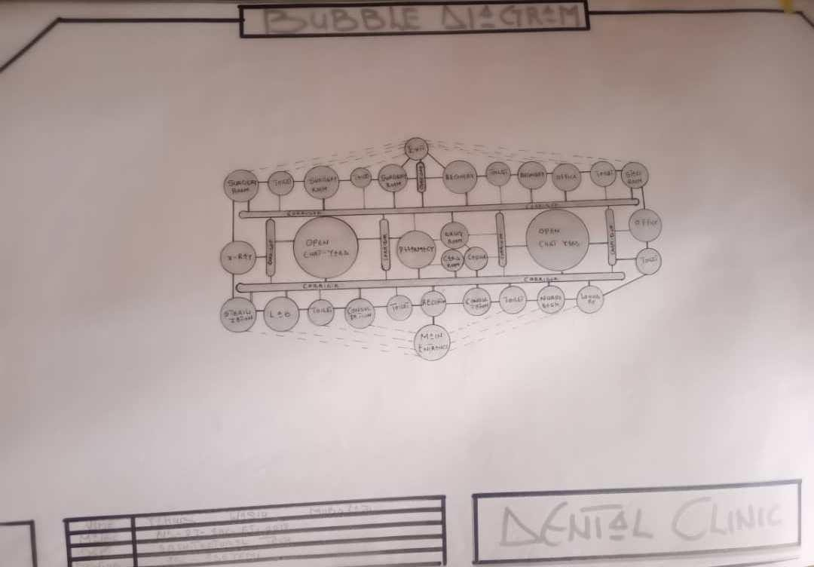
Figure4.2.6.1:BubbleDiagram

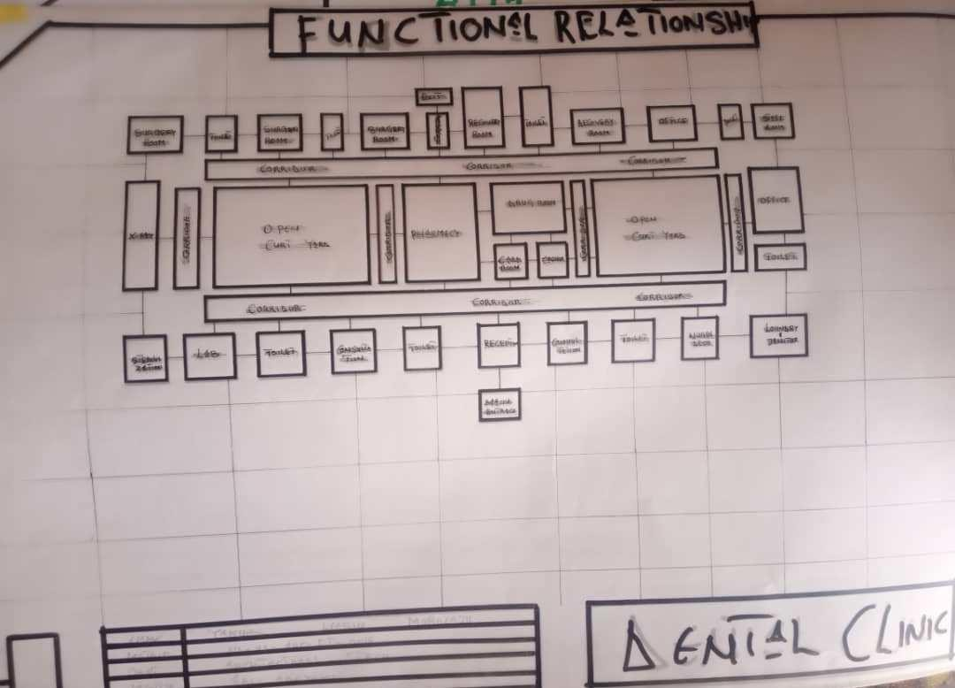

Figure4.2.6.3:FunctionalRelationship

CHAPTERFIVE

APPRAISALOFPROPOSEDSCHEME
The proposed Project is to satisfy the appropriate building regulations. The design is to confirm the aid intended use of building taking into consideration with both natural factors and human factors that earn us a threat on the validity and stability of the building.

CONSTRUCTIONMETHODOLOGYANDMATERIALS.
Theconstructionistobecarriedoutfollowingthedueprocessofconstructionrangingfrom:
- Preliminary:Thisinvolvestheclearingofthesite,settingoutandexcavationof foundation trench and foundation works.
- Sub-Structure:ThisprocessalsoentailsthepositioninganderectionofColumnsand beans, masonry works etc.
- Post Structure Stage: Is the stage which has to do with the application and installation of the paints, tiles, other finishes and construction of external works etc.

5.21MATERIALSFOR CONSTRUCTION
- SustainableandEco-FriendlyMaterials
  - BambooandTimber:Renewableandlow-carbonmaterials,suitablefornon- structural interior elements like ceiling finishes and decorative wall panels.

  - Recycled Materials: Recycled steel, glass, and concrete will be considered to minimize environmental impact.
  - Insulating Materials: Eco-friendly insulation such as cellulose or sheep wool may be used in walls and ceilings to enhance indoor thermal comfort.
- TraditionalandCulturalMaterials
  - Clay and Adobe: Where applicable, these can be used in landscaping features or accent walls, reflecting cultural identity and promoting thermal comfort in hot climates.
  - Stone: Locally sourced stone may be used for external cladding, boundary walls, or pathways to reflect cultural relevance and add durability.
  - Tiles and Ceramics: Geometric ceramic tiles with Islamic patterns can be applied in interior decor, particularly in waiting areas, ablution spaces, and reception zones, for both aesthetic and cultural expression.
- Modern Materials
  - Concrete: Reinforced concrete will be used for the main structural framework— foundations, slabs, beams, and columns—for strength and longevity.
  - Steel: Steel will be used for reinforcement and roof framing, offering structural reliability and adaptability.
  - Glass: Aluminum-framed windows with glazed panels will allow natural lighting while maintaining privacyand energyefficiency. Double-glazed options may be used in specific zones to enhance insulation and sound control.

CONSTRUCTIONMETHODOLOGIES
- GreenBuilding Practices
  - Passive Solar Design: The clinic is oriented to take advantage of naturalsunlight and ventilation, reducing reliance on artificial lighting and cooling systems.
  - GreenElements:Landscapingaroundthebuildingandpotentialuseofgreenwall features will enhance the environment, support insulation, and promote healing.
  - Rainwater Harvesting: A system will be integrated to collect and reuse rainwater for landscaping and cleaning purposes, minimizing water waste.
- Energy-EfficientConstruction
  - Thermal Insulation: High-performance insulation materials will be used in walls and roofing to reduce indoor temperature fluctuations and improve energy efficiency.
  - LED Lighting: The building will utilize LED lighting for all spaces, ensuring long-term energy savings and low maintenance.

  - Solar Energy: Solar panels may be installed to power essential services like lighting and ventilation, reducing dependency on grid electricity.
- CulturalandFunctionalConsiderations
  - Building Orientation: The layout ensures proper orientation of designated prayer spaces towards Mecca, respecting religious needs.
  - Islamic Architectural Features: The design may incorporate subtle Islamic elements such as arches, patterned screens, and courtyards, enhancing both identity and aesthetics.
  - Community Engagement: Input from local stakeholders, healthcare workers, and community members will be considered to ensure the facility reflects cultural expectations and serves practical healthcare needs

SERVICE
A building can be said to be good when itperforms the service required by it. In order to have well-functioning building. There calls for an installation of underground water pipes in other to provide water to all the restrooms and other necessary units in the building. A borehole systemofwater supplyis to be adopted alongside the government supplied services and a storage facility is to be provided for effective management of water supply.

CIRCULATION
As a healthcare facility designed to serve a significant number of patients and staff daily, effective circulation within the proposed dental clinic is essential. The layout has been carefully planned to ensure smooth movement, reduce congestion, and maintain privacy where necessary.
The building is a single-storystructure, making navigation easier and more accessible for all users, including the elderly and physically challenged. Public areas such as the reception, waiting area, and consultation rooms are positioned near the main entrance for easy access, while more private zones like treatment rooms, sterilization units, and staff offices are strategically placed to limit unnecessary traffic.
Clear separation between public, semi-public, and private spaces ensures a logical flow and enhances both functionality and hygiene control within the clinic.

VENTILATION

As it relates to architecture, is the intentional introduction of outside air into a space. It is mainly used to control indoor air quality by diluting and displacing indoor pollutants. It can also be used for purpose of thermal comfort of dehumidification when the introduction of outside air will help to achieve desired indoor psychometric condition.

This could be either mechanical or natural ventilation. As a regard the proposed project design, there is an introduction of a very spacious courtyard in other to make crossventilation in most of the building units. There should also a provision of wide passage to allow free movement of air, patient and materials. Artificial ventilation is also provided through the installation of air conditioning system and fans.

LIGHTING
The dental clinic is designed to make use of both natural and artificial lighting. Large windows allow natural light into waiting and consultation areas, creating a calm and energy- efficient environment. Artificial lighting, using LED fixtures, is provided in all spaces— especiallytreatment rooms—ensuring clear visibility, safety, and compliance with healthcare standards.

PLUMBING
The plumbing system in this proposed building is made easy since the building has a courtyard.Waterdrainedpipesaretobe installedundergroundright fromthecourtyardtothe soak away in other to discharge rainwater.

All water or sewage from the toilets are also channeled into their various inspectionchambers using good and appropriate diameter PVC pipes, and taken from the inspection chamber to septic tank and soak away pit.

Rain water is also collected from gutter if the roof using 100mm diameter PVC rain water pipes and channeled into various drainage or soak away pits. There shall be no ponding; the size of any channel shall effectively discharge rain and water without causing any over lowing stagnation and mosquito breeding. All rain water channeled shall be laid to fall and shall not cause any pounding or splashing unto the committers neighboring area.

ELECTRICALINSTALLATION
The type of wiring system chosen should be full conduit system of wiring. Office and other operationareasshouldbewiredwithstrong,durableandlightcurrentresistancecable

because of the careless operate by the students. Also, electrical installation is to be done to allow for the use of quality electrical fittings and fixtures in the whole building.

WASTE DISPOSAL
Waste disposal bins are to put every office of the building and also in some specificnecessary area. These water bins should dispose in the incinerator which will be provided within the compound of the station. The waste should therefore be burnt in the incinerator.

FIREPROTECTION
Electrically, fire alarms and sensors areto be installed inthe DentalBuilding. This should be done in case of fire occurrence; fire extinguisher is to be placed at certain distances in the cobbles and some other necessaryarea. It is also serving as protector in case of fire.

EXTERNALWORKS
The external works are to be carned out uncrate Krebs laid and shrubs, flowers grasses and trees planted.
Concrete interlocking tiles to be adopted of hard landscape and parking spaces both for visitors and staffs have been provided on the site.

CONCLUSIONANDRECOMMENDATION

Conclusion
Thisproject wasundertakento designa modern, functional, and sustainable dentalclinic that meets the needs of patients and dental professionals alike. Through critical literature review, siteanalysis, and casestudyexploration, thedesignaddressed challengessuchaspoor spatial organization, lack of comfort, infection control, and operational inefficiencies common in existing clinics.
The proposed clinic achieves clear spatial zoning, ease of movement, natural lighting, and integration of technology to enhance service delivery and patient experience. Environmental considerations such as passive ventilation, daylighting, and noise control were embedded in the design. In addition, attention was given to hygiene, accessibility, and regulatory compliance—core requirements for any healthcare facility.
Ultimately, this design proposal represents an academic contribution toward improving healthcare architecture in Nigeria, especially in the area of dental care delivery.

Recommendation
Based on the findings and experiences throughout this project, the following recommendations are made:

- Future dentalclinics should be purpose-built with architecturalinput fromthe earliest planning stage, rather than converting residential spaces.
- Architectsandhealthprofessionalsshouldcollaboratecloselytoensurefunctional efficiency and regulatory compliance in design.
- Universal accessibility features (e.g., ramps, handrails, signage) must be included as standard in all healthcare facilities.
- Sustainabledesignstrategiesshouldbeappliedtoreduceenergy consumptionand long-term maintenance costs.
- Furtherresearchshouldbedoneonthepsychologicaleffectofspatialdesignon dental patients, especially children and people with dental anxiety.
- Governmentandprivatedevelopersshouldinvestmoreinthemodernizationand expansion of oral healthcare infrastructure across Nigeria.

REFERENCES
- Akintunde,F.(2019).ModernHealthFacilityPlanningandDesign.Ibadan: Hope Publications.

- WorldHealthOrganization(2020).GuidelinesonOralHealthCareDelivery Systems. Geneva: WHO Press.

- Ayodele,A.O.(2018).ArchitectureandHealthcare:AStudyofClinicDesignin Nigeria. Lagos: Fola Academic Press.

- Nwachukwu, T. C.(2021).Design Principlesin DentalandMedicalFacilities. Enugu: Greyfield Publishers.

- Sitevisitandobservation: OptimistDentalClinic,Lagos (2025).

- Interviewanddocumentation:BozidDentalClinic,Ibadan (2025).

- Personalfieldstudy:EmirateDentalClinic,Ilorin (2025).

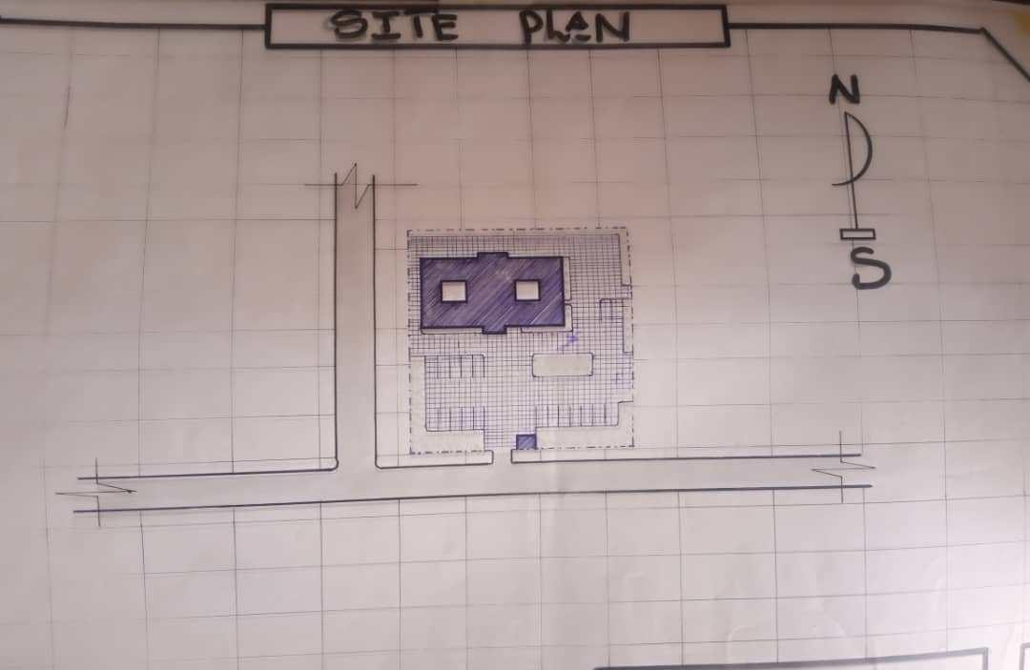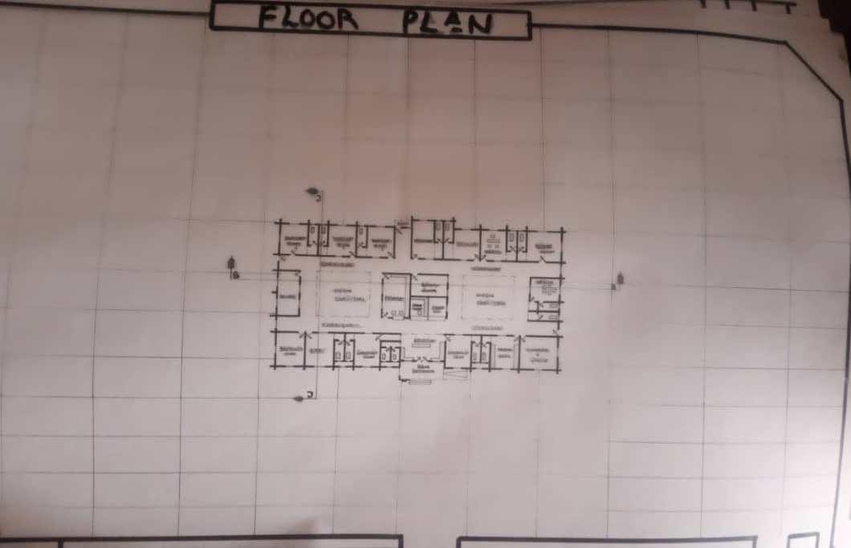

Appendix5.1:Site Plan

Appendix5.2:Floor Plan.

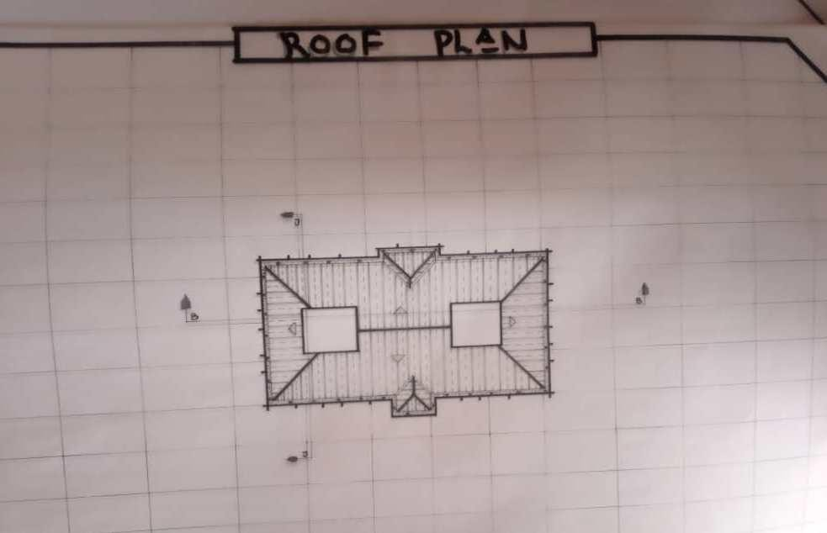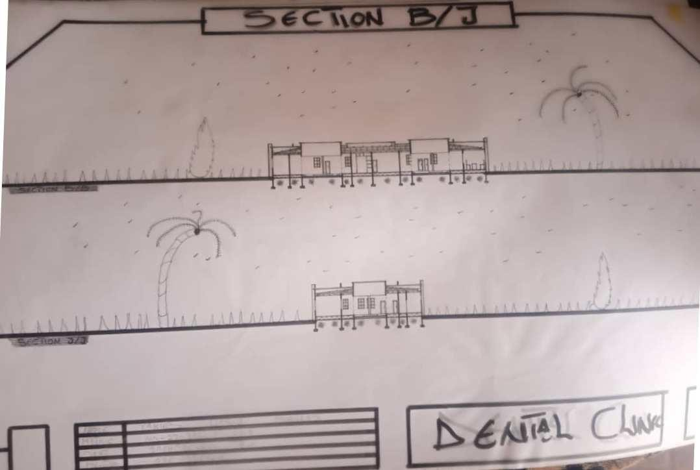

Appendix5.5:RoofPlan

Appendix5.6: Sections

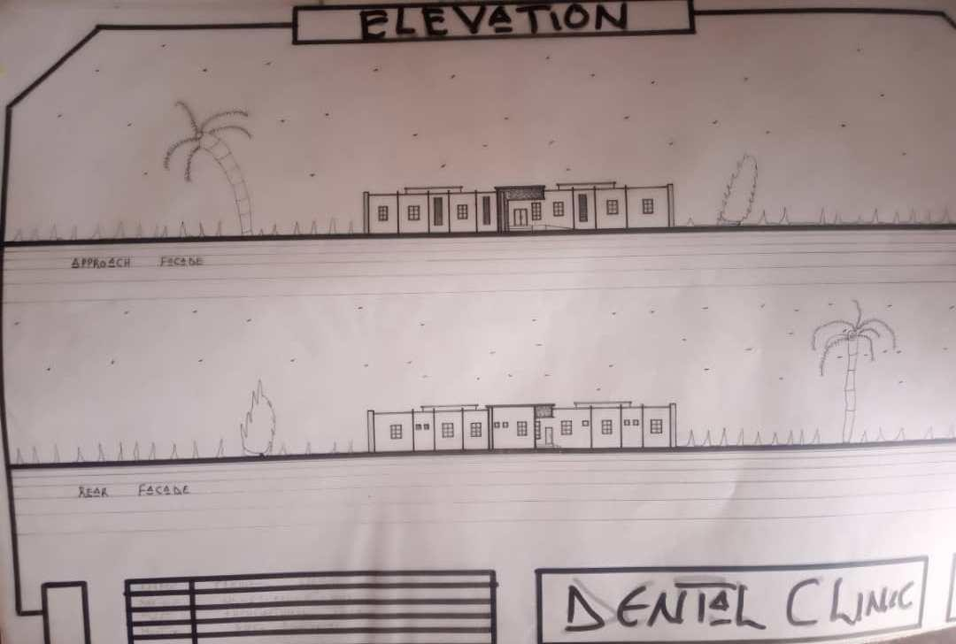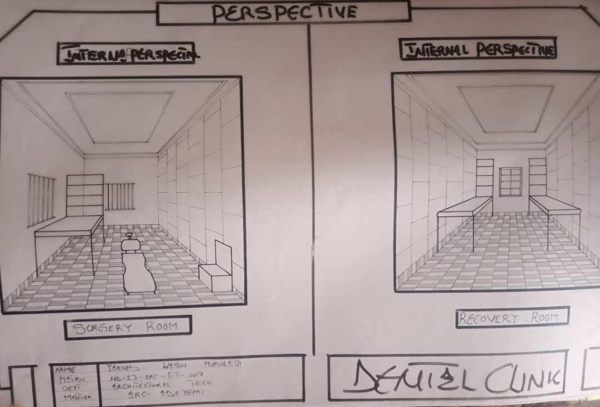

Appendix5.7: Elevation

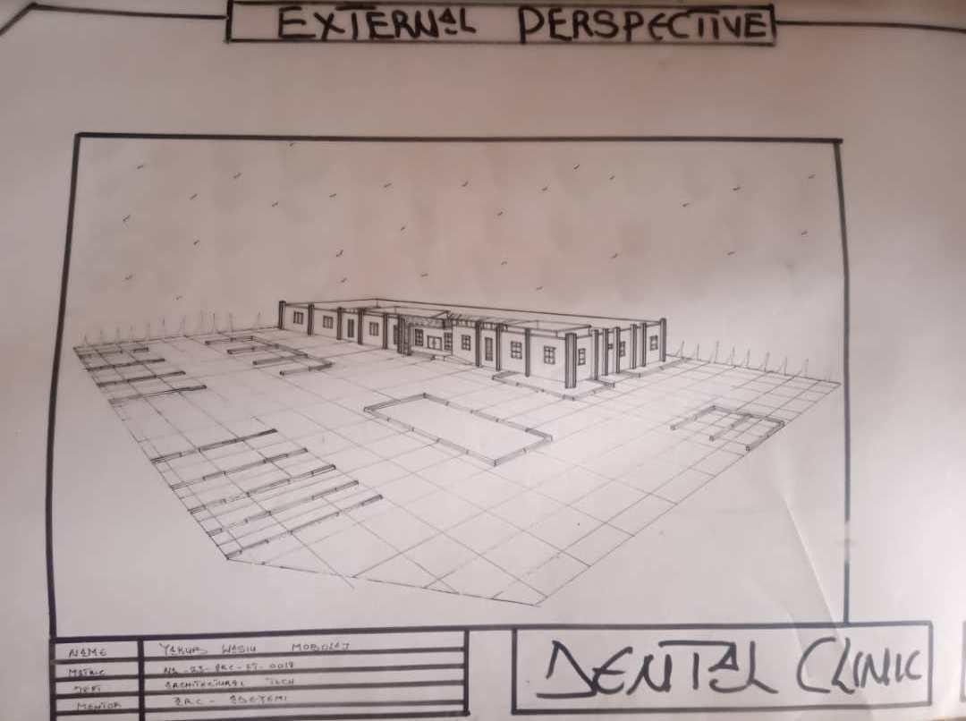Appendix5.8:InternalPerspective.

Appendix5.8:ExternalPerspective.

