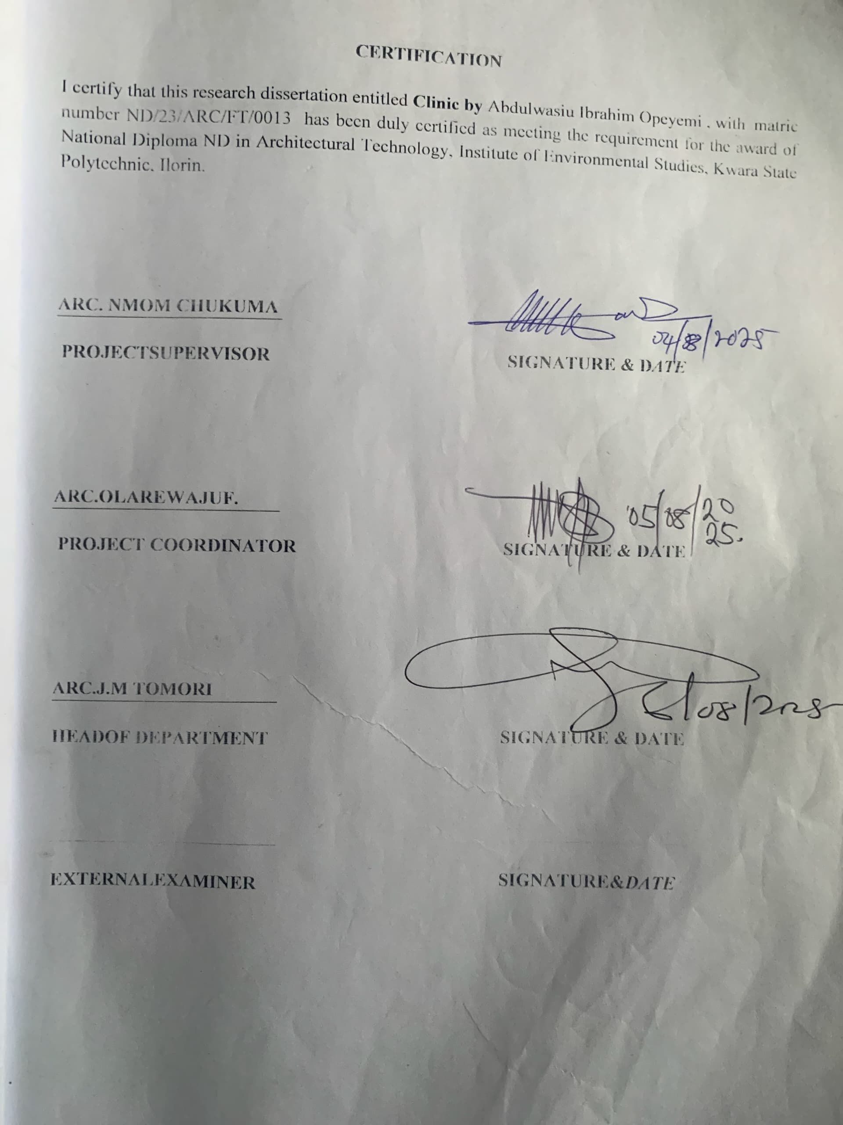

ATECHNICAL REPORT ON CLINIC
FOR
OWODE COMMUNITY, OSOGBO OSUN STATE

PRESENTEDBY

ABDULWASIU IBRAHIM OPEYEMI ND/23/ARC/FT/0013
SUBMITTED TO

THE DEPARTMENT OF ARCHITECTURAL TECHNOLOGY, INSTITUTE OF ENVIRONMENTALSTUDIES (IES), KWARA STATE POLYTECHNIC, ILORIN

INPARTIAL FULFILLMENT OF THE REQUIREMENT FOR THE AWARD OF NATIONAL DIPLOMA (ND) IN ARCHITECTURAL TECHNOLOGY,

JULY,2025

DECLARATION

I declare that this report is a product of my personal research work It has not been presented for the award of any degree in any Polytechnic . The ideas, observations, comments, suggestions herein represent my own convictions, except quotations, which have been acknowledged in accordance with conventional academic traditions.
ABDULWASIUIBRAHIMOPEYEMI, ND/23/ARC/FT/0013

Student name Matric number

Signature & Date.

CERTIFICATION

I certify that this research dissertation entitled Clinic by ABDULWASIU IBRAHIM OPEYEMI , with matric number ND/23/ARC/FT/0013 has been duly certified as meeting the requirement for the award of National Diploma ND in Architectural Technology, Institute of Environmental Studies, Kwara State Polytechnic, Ilorin.

ARC. NMOM CHUKUMA

PROJECTSUPERVISOR SIGNATURE & DATE

ARC.OLAREWAJUF.

PROJECT COORDINATOR SIGNATURE & DATE

ARC.J.M TOMORI

HEADOF DEPARTMENT SIGNATURE & DATE

EXTERNALEXAMINER SIGNATURE&DATE

DEDICATION

This report is dedicated to Almighty Allah for making it possible and also to my Parent and all Architects in the world.
ACKNOWLEDGEMENT

I return all the glory, honor, praise and adoration to the master of the universe that have given me the privilege of seeing the end of this program of him alone be the glory.
My immediate gratitude goes to my supervisor who has been supportive responsive throughout this project, may God continue to reward you and your family.
My appreciation goes to my Amiable Head Of Department in person of ARC. J. M TOMORI and other academic staffs for their immense contribution toward the success of my program may the Lord Honor and do you all good.
My sincere gratitude goes to my parent, MR & MRS ABDULWASIU who brought me to this world, may you eat the fruit of your labour.
However, my gratitude also goes to all my colleague, friends, brothers, sisters and well wishers. May your life experience joy.

TABLE OF CONTENTS
TITTLE PAGE ………………….………….…………..………………… i
DECLARATION ……...………………….………………..….……………. ii
CERTIFICATION ………………….………….……………….…………….iii
DEDICATION………………….………….……………….………………...iv
ACKNOWLEDGMENT ………………….………….……………….……... v
TABLE OF CONTENTS ………………….………….……………….……. vi
ABSTRACT………………….………….……………….…………………….vii
LIST OF FIGURES………………….………….……………….………….. ix

CHAPTER ONE
1.0 INTRODUCTION………………….………….……………….……… 1
1.1 BACKGROUND OF THE STUDY…………………………………… 1
1.2 STATEMENT OF DESIGN …………………………………….…… 1
1.3 AIM AND OBJECTIVE……………….……………………..…..……. 1
1.4 JUSTIFICATION OF THE ECONIMIC JUSTIFICATION…………... 1
1.6 SCOPE OF STUDY……………………………………………………. 2
1.7 RESEARCH METHODOLOGY………………………………………. 2

CHAPTER TWO
2.0 LITERATURE REVIEW …………..…………….…………..…………3
2.1 HISTORICAL OVERVIEW …………………………………………....3
2.2 DEFINATION OF DENTAL CLINIC …………..…………….………..3
2.3 DESIGN CONSIDRATION IN DENTAL CLINIC ……...………..……4
2.4 FUNTIONA SPACE RELATIONSHIP …………..…………………….4
2.5 TECHNOLOGICAL AND ENVIRONMENTAL DESIGN ……………4

CHAPTER THREE
3.1 CASE STUDY………………………………………………..………….5
3.2 CASE STUDY TYPICALLY INVOLVE …………..…………………..5
3.3 OUTLINE OF CASE STUDY …………..………………………..……..5
3.4 CASE STUDY ONE ……………..………………….…………..………6
3.5 CASE STUDY TWO …………..………………………..………………9
3.6 CASE STUDY THREE …………………………………………………12
3.7 ONLINE CASE THREE …………..………………………..…………...16
3.8 ONLINE CASE STUDY …………..………………………..…………..18

CHAPTER FOUR
4.0 STUDY AREA/SITE ANALYSIS …………..……………………..…..20
4.1 SITE DESCRIPTION AND ANALTYSIS .……………..……………..20
4.2 SITE SELECTION CRITARIA .…………..…………………………...20
4.3 SITE INVENTRY …………..………………………………………….21
4.4 CLIMATIC DATA ……………………………………………...….…..21
4.5 SPACIAL CRITERIAL …………………………………………..……22
4.6 SPATIAL AND FUNCTIONAL REQUIREMENTS ………………….22

CHAPTER FIVE
5.0 DESIGN APPROCH/REALIZATION …………..……………………..23
5.1 CONCEPT DEVELOPMENT …………..…………………………..….23
5.2 SKETCHES AND GRAPHIC …………..………………..…………….23
5.3 ENVIROMENTAL AND TECHNOLOGICAL DESIGN ……………..24
5.4 CONSTRUCTION AND MATERIAL ……..………………..…………24
5.5 BUILDING SERVICE …………………………………..……………..24
5.6 LEGAL/PLANNING CONSTRUCTION …………..…………………..24
5.7 CONCLUSION AND RECOMMENDATION …………..……………..25

LISTOFTABLES
TABLE4.1ADMINISTRATIVEBLOCK………………………………44 TABLE4.2SPACESCHEDULE……………..…………………………44 TABLE4.3DEMOGRAPHICDATAOFRESPONDAN 47
TABLE4.4RESPONDANTONQUESTION1 48
TABLE4.5RESPONDANTONQUESTION2 48
TABLE4.6RESPONDANTONQUESTION4 48
LISTOFFIGURES
FIGURE1.1:CASESTUDY1SITEPLAN 39
FIGURE1.2CASESTUDY2SITE PLANVIEW 39
FIGURE3.1SITELOCATION 42
FIGURE3.2SELECTIONCRITERIA 42
FIGURE3.3SITEANALYSIS 43
FIGURE4.1FUNCTIONAL RELATIONSHIP 45
FIGURE4.4CONCEPTDERIVATION 46

LISTOFFIGURES
PLATE2.1:ENTRANCECEVIEWOFCASESTUDYONE 37
PLATE2.2:RELAXATIONAREAOFCASESTUDYONE 37
PLATE2.3:RELAXATIONVIEWOFCASESTUDYONE 37
PLATE2.4:CHILDRENPLAYGROUNDOFCASESTUDYTHREE 37
PLATE2.5:WALKWAYVIEWOFCASESTUDY THREE 37
LISTOFFIGURES
APPENDICES1:SITEPLAN 60
APPENDICES2:FLOORPLAN 60
APPENDICES3:SECTIONX-X 61
APPENDICES4:SECTIONY-Y 61
APPENDICES5:SOUTHVIEW 62
APPENDICES6:NORTH VIEW 62
APPENDICES7:EASTVIEW 64
APPENDICES8:WESTVIEW 64

ABSTRACT
The architectural design of a dental clinic is a critical component that significantly impacts the functionality, comfort, and overall patient experience. Effective design strategies must prioritize patient well-being, operational efficiency, and infection control while integrating modern dental technology. The layout should optimize workflows, ensuring smooth transitions between waiting areas, consultation rooms, treatment zones, and staff spaces. Key elements such as lighting, acoustics, and air quality contribute to creating a calming atmosphere, reducing patient anxiety and enhancing comfort. Aesthetic considerations, like the use of soothing color sand materials, promote a positive environment conducive to healing. Additionally, incorporating sustainable design practices, such as energy-efficient systems and eco-friendly materials, is becoming increasingly important in modern dental clinic architecture. The goal is to create a space that not only meets the technical needs of dental professionals but also fosters trust and comfort for patients, ultimately improving both the clinical and emotional outcomes of dental care.

CHAPTER ONE
1.0 INTRODUCTION

Tooth decay was low in pre-agricultural societies, the growth in farming society about 10,000 years ago correlated with an increase with the rate of cavities. An infected tooth from Italy partially cleaned with flint tools, aged between 13,820 and 14,160 years old, represents the oldest known dentistry. The Indus Valley Civilization (IVC) has yielded evidence of dentistry being practiced as far back as 7000 BC. An IVC site in indicates that this form of dentistry involved curing tooth related disorders with bow drills operated, perhaps, by skilled bead crafters. The reconstruction of this ancient form of dentistry showed that the methods used were reliable and effective. The earliest dental filling, made of beeswax, was discovered in Slovenia and dates from 6500 years ago.
A well-designed dental clinic enhances the overall patient experience, providing a calming atmosphere that reduces stress and promotes trust in dental care providers. The design also ensures that dental procedures are conducted with high efficiency, while making use of the latest technologies and equipment to ensure the best possible care. From the reception area to the treatment rooms, every aspect of the clinic’s design contributes to creating a space that is both functional and welcoming, Ultimately, dental clinic architectural design merges aesthetics with practicality to support the delivery of high-quality dental services in a safe and efficient environment.

HISTORICALBACKGROUND

Historical Background on Dental Clinic Architectural Design

The architectural design of dental clinics has evolved significantly over the centuries, shaped by advancements in dentistry, changes in public health practices, and the increasing demand for specialized healthcare facilities. While dentistry as a practice dates back to ancient civilizations, the concept of dedicated spaces for dental care emerged more distinctly in the 19th and 20th centuries, aligning with the professionalization of dental practices and innovations in medical architecture.

Ancient and Medieval Times

In ancient civilizations such as Egypt, Greece, and Rome, dental care was often practiced by individuals with specialized knowledge, though they did not have dedicated clinics or specific architectural designs for dental care. Treatments were often performed in the homes or workshops of these practitioners, where basic tools, such as rudimentary drills and forceps, we reused. There was no formal architectural space for dental care—medical and dental practices were typically conducted in general medical spaces or even in informal settings.

17th and 18th Centuries: Early Developments

As dentistry began to emerge as a more recognized profession in the 17th and 18th centuries, dental procedures started to move away from general medicine and were performed by specialists. However, the idea of dedicated dental clinics was still largely absent. Dental practitioners typically operated from their homes or small private offices, often sharing spaces with other healthcare professionals. These spaces were rudimentary, with little to no emphasis on design or patient comfort.

19th Century: Professionalization of Dentistry

The19thcentury marked a turning point in dental care. As dental science progressed with the invention of new tools and techniques, including the first dental chair by Dr. Samuel Stockton in 1790, dentistry began to separate from general medicine. During this time, the first dedicated dental practices were established. These early dental offices were often simple, functional spaces that focused primarily on the technical aspects of dental procedures.
With the growing understanding of hygiene and sterilization in medical practice, dental clinics began to incorporate more specialized spaces, such as operating rooms and sterilization areas. The layout started to reflect the importance of maintaining a clean and organized environment to prevent the spread of infections. However, the architectural design remained relatively basic, with an emphasis on utility rather than patient experience.

Early 20th Century: Modernization of Dental Clinics

The early 20th century saw the first real attempts at designing dental clinics with a more comprehensive and patient-focused approach. With the rise of the dental profession, many dental offices started to implement modern conveniences, such as comfortable waiting areas, well-designed treatment rooms, and even decorative elements to make patients feel more at ease. During this period, there was also an increased focus on privacy, as dental practitioners sought to create individual treatment rooms for patients, which offered greater confidentiality and comfort.
Innovations in dental equipment and a growing understanding of ergonomics also influenced dental clinic design. The dental chair became a central element of the treatment room, and considerations were made to ensure that it was positioned to allow the dentist to work efficiently and comfortably. Lighting, ventilation, and acoustics were also considered for the first time as essential elements in dental clinic design.

Post-World War II: Growth and Technological Advancements

Following World War II, there was significant growth in the number of dental clinics, especially as modern technologies began to shape the field of dentistry. Dental imaging, X-ray machines, and sterilization equipment required specific spaces and infrastructure within clinics. The introduction of these advanced tools led to the redesign of treatment areas, as dental offices needed to accommodate new technologies while maintaining a focus on comfort and patient care. During this period, the design of dental clinics began to incorporate more aesthetics, combining functionality with architectural elements that aimed to reduce patient anxiety. For example, the waiting areas became more inviting, with comfortable furniture and soothing colors, reflecting the growing importance of the patient's emotional experience in addition to their physical treatment.

Late 20th Century to Present: Comprehensive Design and Patient-Centered Approach
In the late 20th century and into the 21st century, dental clinic architecture became increasingly sophisticated. The design of dental clinics evolved to meet the growing demand for specialized care, as well as the desire to create a welcoming and patient- friendly environment. The rise of cosmetic dentistry, orthodontics, and specialized treatment centers led to more diverse architectural designs, tailored to the specific needs of different types of dental care. Today, dental clinic design emphasizes patient comfort, operational efficiency, and hygiene. The integration of advanced technology—such as digital X-rays, computer-aided design (CAD), and virtual simulations—has further influenced the layout and design of treatment rooms. Modern dental clinics often feature open-concept waiting areas, ergonomic workspaces for staff, and efficient layouts that facilitate smooth patient flow. There is also a strong emphasis on sustainable design, with the use of energy-efficient materials and systems.

Architectural design now considers the holistic experience of patients, with many clinics incorporating calming aesthetics, natural light, and soundproofing elements to create an atmosphere of tranquility. The focus on creating a seamless connection between function and patient experience reflects a broader understanding of how the physical environment can positively affect mental well-being and health outcomes. The evolution of dental clinic architectural design reflects the development of the dental profession itself, from rudimentary and utilitarian spaces to modern, patient-centered environments. Advances in technology, changes in healthcare needs, and a growing understanding of patient psychology have all contributed to the design of dental clinics that not only meet the functional needs of dental practitioners but also enhance the comfort and experience of patients. The modern dental clinic has become a place where both the science of dentistry and the art of design converge to create spaces that support health, well-being, and trust.

DEFINITIONOFTHETERMS

Architectural Definition

A dental clinic building is a specialized healthcare structure designed and constructed to provide a dedicated space for dental care services. It is equipped with treatment rooms, sterilization areas, waiting rooms, and administrative offices to support the operational needs of a dental practice. The design of the building considers factors such as hygiene, patient comfort, safety, and workflow efficiency for both staff and patients.

Functional Definition

A dental clinic building is a facility where dental practitioners diagnose, treat, and manage oral health conditions. It is designed to accommodate various dental treatments such as routine checkups, surgeries, orthodontics, and cosmetic dentistry. The building includes specialized spaces like dental operatories, sterilization zones, and diagnostic areas, each tailored for specific procedures and patient care needs.

Operational Definition
A dental clinic building is a healthcare facility specifically dedicated to the delivery of oral health services, including preventive, therapeutic, and corrective dental treatments. This facility supports the day-to-day operations of a dental practice, including patient intake, treatment, consultation, and post-treatment care. It includes areas for both clinical procedures and administrative tasks, ensuring the smooth functioning of a dental practice.

Patient-Centric Definition

A dental clinic building is a patient-focused environment designed to provide comfortable, safe, and accessible care. The building is constructed with the aim of reducing patient anxiety and promoting well-being through welcoming aesthetics, effective use of space, and the incorporation of modern dental technology for high- quality care.

Health care Infrastructure Definition

A dental clinic building is an integral part of healthcare infrastructure, providing a specialized environment for the delivery of dental services to the community. It is a well- planned facility that ensures proper infection control, accessibility for people with disabilities, and compliance with healthcare regulations while offering efficient and comprehensive dental care.
AIMS & OBJECTIVES

Aim

The aim is to design a functional and befitting modern dental clinic that will meet up with acceptable architectural and structural standards which can receive national acclaim.

OBJECTIVES

    - Todesignafacilitythatwillfunctionallyandaestheticallyfulfilltheneedfora standard modern dental clinic in Enugu State.

    - Todesignamoderndentalclinicthatnaturallymeetsupwithbotharchitectural and structural standards.

    - To provide spaces that are large enough to accommodate the workers and equipment/machinery and encourage a seamless overlap between the two.

    - Tocontributetothearchitecturalbeautyoftheareaandtheappreciationofthe built environment.

    - Provision of adequate spaces for various dental treatments.

JUSTIFICATION

Designing a dental clinic building is an essential process that requires careful consideration of various factors to ensure the facility meets the needs of both patients and healthcare providers. The justification for investing in and designing a dedicated dental clinic building lies in several key areas, each contributing to the overall success and functionality of the space.
The patient experience plays a vital role in the success of a dental practice. Many individuals experience anxiety and discomfort at dental clinics, and a well-designed building can help alleviate these feelings. A thoughtful layout with welcoming features such as soothing colors, natural lighting, and comfortable waiting areas creates a calming atmosphere. The design of individual treatment rooms, with modern equipment and aesthetic features, further reduces patient stress. The overall comfort of the patient directly influences their willingness to return for follow-up visits and can contribute to better dental health outcomes.
A dental clinic building must be designed to optimize the workflow between patients, staff, and equipment. The layout should ensure that different areas (e.g., reception, waiting area, treatment rooms, sterilization rooms) are efficiently connected to minimize unnecessary movement and time spent by both patients and dental professionals. Streamlined patient flow, from check-in to consultation and treatment, enhances operation al efficiency. Efficient design ultimately leads to improved patient care, reduced waiting times, and increased productivity for the dental staff.

LIMITATION

financial resources available for the design and construction of a dental clinic often impose significant limitations. A limited budget may restrict the use of high-end materials, modern technologies, or the inclusion of desirable design features such as spacious waiting areas or advanced medical equipment. The need to balance quality with cost can sometimes lead to compromises in design, materials, or equipment that might affect the clinic's functionality or aesthetics, The available space for constructing a dental clinic may limit the design options, particularly in urban areas where property sizes are smaller or more expensive. The need to fit various functional areas (e.g., reception, waiting area, treatment rooms, sterilization areas, staff rooms, storage) into a limited footprint can be challenging.
Incorporating modern dental technologies such as digital X-rays, CAD/CAM systems, and advanced dental chairs requires specific infrastructure, including electrical systems, data management, and space requirements. The availability of space and resources to accommodate these technologies can pose a limitation, especially in smaller or older buildings.
RESEARCHMETHODOLOGY

Designing a dental clinic building involves a comprehensive research methodology that takes into account the specific needs of the healthcare professionals, the patients, and the functional requirements of the clinic. The research methodology will typically include a combination of qualitative and quantitative approaches, data collection, analysis, and design application. The first step in the research methodology is to identify the specific problems or requirements of the dental clinic building design. This involves understanding the unique needs of the dental practice, its staff, and the patients.

Review existing literature on dental clinic designs, conduct interviews with dentists, architects, and other stakeholders, and examine current trends in healthcare design. Identify the challenges faced by existing dental clinics in terms of space utilization, patient comfort, workflow efficiency, and technology integration.
To arrive at a financial and standard design concept, the following research methods were carried out.
- Oral review
- Online interview
- Case study review
- Literature review

Literature Review

To gather existing knowledge on the design of healthcare facilities, particularly dental clinics, to understand best practices, guidelines, and technological advancements.
Conduct a thorough review of academic articles, books, case studies, and reports from architectural firms that specialize in healthcare buildings. Look at successful examples of dental clinic designs and architectural solutions that improve patient care and optimize operational efficiency.

CHAPTERTWO

2.0 LITERATUREREVIEW

Dental clinics, like other healthcare facilities, have unique requirements for architectural design due to their specialized nature. A well-designed dental clinic not only addresses functional needs but also creates a therapeutic environment conducive to patient comfort, staff efficiency, and safety. This literature review discusses various factors that influence the architectural design of dental clinics, including space planning, aesthetics, patient experience, infection control, and sustainability.
Space Planning and Functionality

The spatial organization of a dental clinic is crucial for ensuring smooth workflows, patient comfort, and staff efficiency. According to Simmons (2014), the layout of a dental clinic should be carefully designed to separate clinical functions from administrative areas. A typical dental clinic includes treatment rooms, a sterilization area, waiting areas, and staff rooms, all of which must be logically interconnected to ensure ease of movement for both staff and patients.
Treatment Rooms: Treatment rooms are central to the design of dental clinics, and the arrangement of dental chairs, equipment, and storage is essential for operational efficiency. Frey (2016) emphasizes that treatment rooms should have sufficient space for dental equipment, while ensuring ease of accessibility for both the dental team and patients.
Waiting Areas: Waiting areas should be comfortable and calming to help reduce patient anxiety. According to Ulrich (2006), the use of natural light, greenery, and calming colors in waiting areas can reduce stress and improve patient experience.

Administrative Spaces: The design of the administrative office and reception area must also be considered. Perry et al. (2019) suggest that clear sightlines and patient privacy in these areas are critical for ensuring both security and confidentiality.
Aesthetics and Patient Experience

The aesthetic elements of dental clinic design are pivotal in shaping the patient experience. Geisinger et al. (2017) found that the physical environment of a dental clinic significantly impacts the emotional and psychological well-being of patients. The use of colors, materials, and lighting in dental clinics can enhance the overall ambiance and alleviate patient anxiety.
Colors and Materials: Light, neutral colors are generally favored in dental clinics as they contribute to a calm and hygienic environment. Materials like natural wood or stone are sometimes incorporated into the design to introduce warmth and organic textures into otherwise sterile environments (Frey, 2016).
Lighting: Both natural and artificial lighting play important roles in creating a welcoming and functional environment. Ulrich (2006) notes that exposure to natural light can positively influence the mood and comfort of patients and staff alike. Furthermore, lighting in treatment areas should be bright enough to allow for detailed procedures without causing glare or discomfort for the patient.
Patient Comfort: Comfort measures such as ergonomic furniture, noise control, and climate control are crucial in enhancing the overall patient experience. Simmons (2014) emphasizes the importance of providing an environment that minimizes discomfort and promotes a sense of calm, which in turn can improve patient outcomes and compliance.

Infection Control and Hygiene

Given the clinical nature of dental practices, infection control is a central concern in the design of dental clinics. Frey (2016) highlights that a well-designed clinic must have dedicated spaces for sterilization and cleaning, with equipment such as autoclaves and sterilization sinks integrated into the layout. The arrangement of these areas must also minimize the risk of cross-contamination.
Materials and Finishes: The selection of materials for finishes, such as walls, floors, and countertops, is critical in maintaining hygiene standards. Non-porous, easy-to-clean materials such as ceramic tiles, stainless steel, and epoxy resins are commonly used in dental clinic designs to ensure a high level of sanitation (Perry et al., 2019).
Airflow and Ventilation: Proper ventilation systems must be in place to prevent the accumulation of harmful particles and to ensure adequate air flow. Geisingeretal. (2017) highlight the importance of incorporating high-efficiency particulate air (HEPA) filters and exhaust systems that comply with healthcare facility standards to promote a clean and safe environment.
Sustainability and Energy Efficiency

Sustainability is an increasingly important consideration in healthcare architecture, including dental clinic design. Perry et al. (2019) argue that green design strategies not only contribute to environmental protection but also result in long-term cost savings for clinic owners.
Energy Efficiency: Incorporating energy-efficient systems, such as LED lighting, energy-saving HVAC systems, and passive solar heating, can reduce energy consumption in dental clinics. Geisinger et al. (2017) recommend that dental clinic designs integrate energy-efficient technologies to improve both sustainability and operational efficiency.
Water Efficiency: Dental clinics use significant amounts of water, especially in sterilization and patient care areas. According to Frey (2016), adopting water-efficient plumbing fixtures and water recycling systems can contribute to more sustainable dental clinic operations.

Technological Integration

With advances in dental technology, modern clinics must integrate cutting-edge equipment into their design. Digital dental radiography, 3D imaging systems, and intraoral cameras require specific spatial considerations for installation and use. Simmons (2014) notes that the integration of such technologies should not only focus on equipment functionality but also consider ergonomics and patient privacy.
Data Security: As dental practices increasingly move toward digital recordkeeping and telemedicine, incorporating secure storage spaces for sensitive patient data is essential (Perry et al., 2019).

CHAPTER THREE
CASE STUDIES

The purpose of case study in any architectural research project is to enable the designer to familiarize him/herself with terms, mode of operation, standard required any other factor that may help the designers in achieving his or her desire objectives through the study of the existing similar structure.
CASE STUDY ONE

LOCATION: UNIVERSITY COLLEGE OF HOSPITAL IBADAN OYO STATE BRIEIF HISTORY
University College Hospital (UCH) Ibadan, located in Oyo State, Nigeria, is one of the premier teaching hospitals in the country. It was established in 1948, as a teaching hospital for the University of Ibadan (UI), which was the first university in Nigeria, foundedin1948 as well. UCH was set up to provide clinical training for medical students and support medical research.
Establishment and Early Years (1948): UCH was established to cater to the medical needs of the population in Ibadan and its surrounding areas. It began as part of the University of Ibadan, which had originally been a college under the University of London. The hospital was intended to enhance the quality of medical education in the country and also provide high-quality healthcare.
Growth and Development: Over the years, UCH has expanded its services to accommodate a wide range of specialties, from general medicine to advanced surgical procedures. It became a key institution for both medical students at the University of Ibadan and the broader Nigerian healthcare system.

Role in Medical Education: As the teaching hospital for UI, UCH plays a significant role in training medical professionals, including doctors, nurses, and other healthcare providers. It also engages in extensive medical research aimed at addressing local health challenges.
Modernization: Over time, UCH has seen improvements in infrastructure, medical equipment, and patient care, becoming a referral center for complex medical cases in Nigeria. Its services extend beyond just teaching to include comprehensive healthcare for people in the region.
MERITS

- Their unit are well accessible
DEMERITS

- Poor landscaping

- There is no provision for disable to access the clinic such as, ramp
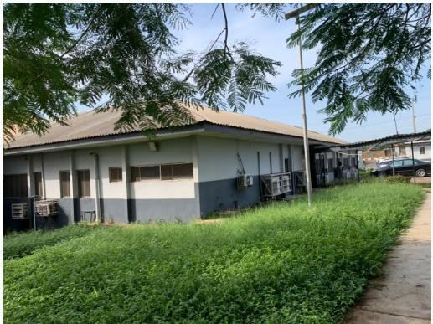
- Poor aesthetics

Plate 3.1.1: Side View Showing Of Case Study One University College Of Hospital Ibadan Oyo State

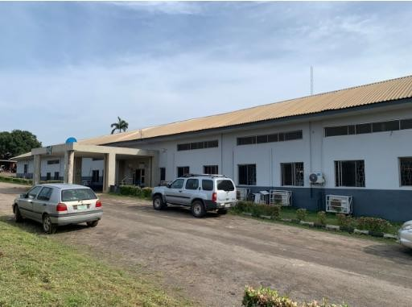
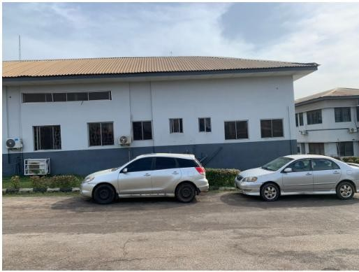
Plate 3.1.1: Showing the front View Of Case Study One University College Of Hospital Ibadan Oyo State
Plate 3.1.1: Showing the side View Of Case Study One University College Of Hospital Ibadan Oyo State

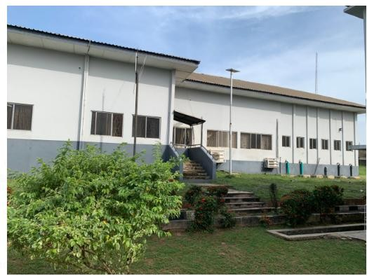
Plate 3.1.1: Showing the back View Of Case Study One University College Of Hospital Ibadan Oyo State

CASE STUDY TWO

LOCATION: ASUBIARO HOSPITAL OSOGBO OSUN STATE
BRIEIF HISTORY
Asubiaro Hospital is a prominent healthcare institution located in Osogbo, the capital of Osun State, Nigeria. The hospital was established to provide essential healthcare services to the residents of Osogbo and the surrounding areas. While detailed historical records about the hospital’s founding are not readily available, it is known to be one of the major government-owned hospitals in the state.
The hospital plays a key role in the state's healthcare system, offering a wide range of medical services, including general health services, emergency care, maternal and child health, surgery, and specialized treatments. Over the years, Asubiaro Hospital has grown in both infrastructure and capacity, becoming a critical part of the local healthcare landscape.
As part of the state government’s efforts to improve healthcare access, Asubiaro Hospital has benefited from various infrastructural upgrades and staff training programs. It continues to serve as a primary healthcare provider for the people of Osogbo and beyond, making significant contributions to improving public health outcomes in the region.
MERIT

    - It is well zoning and located at the centre of the community in the area
    - It is well modernized structure and aesthetically build

DEMERIT

- There offices and spaces are not well defined
- There’s no provision for future expansion

- There is not enough space to carried out other activities

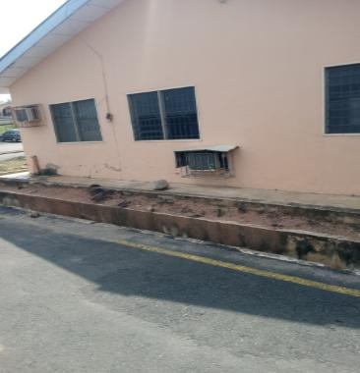
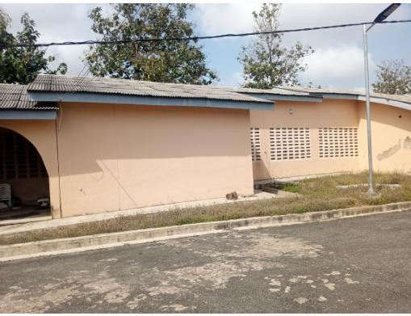
Plate 3.2.1: Showing the back View Of Case Study two Asubiaro Hospital Osogbo Osun State

Plate 3.2.2: Showing the side View Of Case Study two Asubiaro Hospital Osogbo Osun State

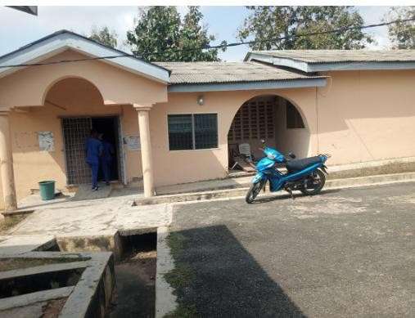
Plate 3.2.3: Showing the front View Of Case Study two Asubiaro Hospital Osogbo Osun State

CASE STUDY THREE

LOCATION: LAUTECH TEACHING HOSPITAL OSOGBO OSUN STATE
BRIEIF HISTORY

LAUTECH Teaching Hospital (LTH), Osogbo, is a prominent healthcare institution in OsunState, Nigeria.Itserves asbothateaching hospital formedical students andamajor healthcare provider in the region. Here's a brief history of the hospital:
Establishment and early years:
LAUTECH Teaching Hospital was established in 2010, after the transformation of the former Osogbo General Hospital into a teaching hospital. It is affiliated with Ladoke Akintola University of Technology (LAUTECH) in Ogbomoso, which had earlier established a Faculty of Health Sciences. The conversion of the Osogbo General Hospital into LAUTECH Teaching Hospital was part of an effort to enhance medical education, research, and healthcare services in the state.
.MERIT

- Easy accessibility
DEMERIT

- Poor landscaping

- The building itself is in need of renovation
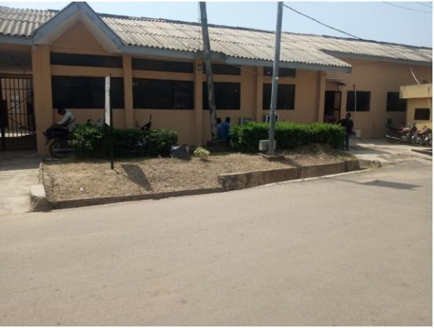
Plate 3.3.1: showing the front view of case study Three Lautech Teaching Hospital Osogbo Osun State

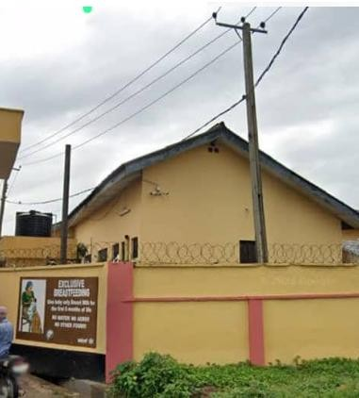

Plate3.3.2: showing the side view of case study Three Lautech Teaching Hospital Osogbo Osun State

CHAPTER FOUR
- HISTORY OF STUDY AREA
History of Osun State
Pre-Colonial Era
The area now known as Osun State was originally inhabited by various Yoruba sub-groups, most notably the Ife, Ijesa, Oyo, Ibolo, and Igbomina people. The city of Ile-Ife, located within Osun State, is traditionally regarded by the Yoruba as the cradle of creation—the ancestral home of the Yoruba people. According to Yoruba mythology, it is where Oduduwa, the progenitor of the Yoruba race, first descended to create the earth.
Ife and other parts of Osun were flourishing city-states with advanced systems of governance, religion, and trade long before European contact. They were part of the Oyo Empire, one of the most powerful and organized pre-colonial empires in West Africa.
History of Osogbo
Origins and Founding
Osogbo (also spelled Oshogbo) has a rich history rooted in Yoruba traditions. It is believed to have been founded over 400 years ago by Larooye, a hunter and one of the early leaders of the town. According to oral tradition, Larooye and his followers settled near the Osun River, where they encountered the goddess Osun, a revered female deity in Yoruba spirituality.
This encounter led to a spiritual pact between the goddess and the people. In return for their respect and annual worship, Osun promised to protect and bless the settlement. This event is commemorated annually in the Osun-Osogbo Festival, one of the most prominent traditional festivals in Nigeria.
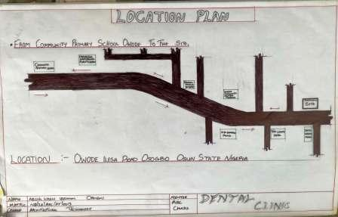
4.1 SITE LOCATION CRITERIA
The proposed site is located at Owode a town in Osogbo local government area of Osun State. The site is accessible it is a border town located very close to Osun State
Accessibility: The site is easily accessible by both vehicles and pedestrians from all parts of the state, towns, and villages surrounding.
Topography: The landform is corner pieces and relatively leveled and flat, which does not need grading and leveling of the site. This site is a gentle slope towards the West side, which tells the direction of the slope of the drainage to be constructed. Some natural features like trees and shrubs on site can be retained to form part of the landscaping of the Shopping mall.
EXISTING SERVICES:
The existing services present on the site are;
➢ Electric power line.
➢ Municipal drainage beside the access roads.
➢ Pipe: borne water supply along the closed.
h ➢ State constructed road.

4.2 SITE ANALYSIS/INVENTORY
Site analysis is a crucial phase in architectural design, providing the foundational understanding needed to inform and shape a project's development.
SITE INVENTORYs
Site inventory provides the foundation for informed design and planning decisions. By documenting physical characteristics, legal and regulatory information, environmental considerations, and social factors, designers and planners can address site-specific challenges and opportunities effectively. This comprehensive understanding helps in creating designs that are functional, sustainable, and well integrated with the surrounding context.
4.3 GEOGRAPHICAL/CLIMATIC DATA
Location & Urban Context
Road Type: Major arterial road connecting Osogbo to Ilesa (toward Ondo State)
Area Type: Semi-urban transitioning to peri-urban
Proximity to landmarks:
- Close to Osogbo city center
Near Owode Market, commercial buildings, and residential estates
Developing infrastructure — good road access and utility links
2. Site Geography
Topography:
Generally flat to gently sloping, ideal for foundation work and water runoff
Minor undulations — natural stormwater flow from northeast to southwest
Soil Type:
Lateritic red soil (typical in Osun), stable but needs compaction and testing for bearing capacity
Good for shallow foundations if not waterlogged
3. Climatic Conditions
Köppen Classification: Tropical wet and dry (Aw)
Parameter Data
Rainfall ~1,300–1,500 mm/year (mostly April–October)
Temperature 22°C – 34°C
Humidity 60%–95% (high during rainy season)
Sun path Overhead most of the year
Wind SW wind (rain season), NE wind (harmattan)
4. Design Implications
Site Planning & Orientation
Main Building Axis: East–West for reduced solar gain
Courtyards: Recommended for airflow and natural lighting
Vegetation Buffer: Use landscape buffer from dusty road; plant fast-growing trees (like neem or acacia)
Ventilation & Openings
Use opposite-facing windows for cross ventilation (SW ↔ NE)
Avoid large west-facing windows; use shading devices
Rain Management
Sloped roofs with overhangs (35–45° pitch)
Gutters + Rainwater harvesting tanks
Drainage channels must slope toward SW or SE corners of site
5. Utilities & Access
Electricity: Access to grid, but plan for solar backup
Water: Boreholes are common; plan for water treatment
Access: Main road is tarred, but internal access roads may be earth-surfaced

6. Local Materials
Available: Laterite, stone, sand, clay
Construction materials: Burnt bricks, compressed earth blocks, reinforced concrete
Labor: Readily available, with mix of skilled and semi-skilled workers
GEOGRAPHICAL DATA LOCATION
Owode Ilesa Road, Osogbo is located in the western section of Osogbo, close to the Fed Housing Estate neighborhood .
Approximate GPS Coordinates:
Latitude: 7.7413° N
Longitude: 4.5853° E
TOPOGRAPHY
Terrain
The terrain of the project site is gently undulating, typical of the Osogbo landscape. It features mild slopes with natural surface water drainage directed from the northeast to the southwest. The landform is generally stable and suitable for development, with minimal need for heavy land reshaping or contour modification. The undulations present opportunities for integrating terraced landscaping, site zoning, and natural stormwater control.

Elevation
The site lies within an elevation range of approximately 310 to 330 meters above sea level, with the average ground level being around 320 meters. These elevations are well above flood risk zones commonly found in lower valley regions. The moderate height of the land contributes to good air movement, visibility, and natural drainage—essential for climate-adaptive architecture and infrastructure planning.

Soil Composition
The predominant soil type in the area is lateritic soil, which is reddish-brown, well-drained, and rich in iron and aluminum oxides. It overlies the crystalline basement complex geology made up of granite, schist, and quartzite. The soil exhibits good shear strength and is generally suitable for shallow foundations, especially when compacted properly. However, site-specific geotechnical testing is recommended to determine exact bearing capacity and moisture content before construction.
Water Bodies
Although there is no major water body directly on the site, the wider region is influenced by the Osun River system, with tributaries such as Erinle and Oba Rivers running through Osogbo. Seasonal runoff from rainfall naturally drains toward these rivers. The site’s topography facilitates surface water flow and can accommodate stormwater management systems, such as drainage channels, infiltration trenches, or rain gardens, to avoid waterlogging during peak rainfall periods.
Climate Data
The climate of the project site falls under the tropical wet and dry (Aw) category in the Köppen-Geiger climate classification, which is typical of southwestern Nigeria. The climate is a key determinant in shaping design strategies for ventilation, shading, water management, and energy efficiency.
Temperature
Osogbo experiences moderate to high temperatures throughout the year.
Average annual temperature: 26°C – 28°C
Hottest months: February to April (up to 34°C)
Coolest months: December to January (as low as 22°C due to harmattan influence)
The relatively high temperatures necessitate the use of passive cooling strategies, such as cross ventilation, thermal mass, and shading devices.

Rainfall
The region has a distinct wet and dry season.
Annual Rainfall: 1,200 – 1,500 mm
Rainy Season: March to October
Peak Rainfall: May – July and September
Dry Season: November to February
Rainfall is often heavy and seasonal, making stormwater management (such as gutters, sloped roofs, and drainage channels) a crucial consideration in design.
Humidity
Humidity levels vary with the seasons.
Wet season humidity: 80% – 95%
Dry season humidity: Drops to around 20% – 40% (especially during harmattan)
High humidity during the rainy season increases the need for ventilation and mould-resistant materials, while the dry season supports construction work due to reduced moisture levels.
Wind Pattern
Dominant wind directions:
Southwest winds during the rainy season (moist, oceanic air)
Northeast harmattan winds during the dry season (cool, dry air from the Sahara)
Average Wind Speed: 6 – 12 km/h
Design implication: Building orientation should harness natural cross-ventilation, ideally aligning openings in SW ↔ NE direction.
Sunlight
Sunlight availability: High throughout the year
Average daily sunshine: 6 – 8 hours
Sun path: Overhead most of the year, with highest solar angles in March and September
Environmental Consideration: Vegetation
The project site along Owode–Ilesa Road lies within the tropical rainforest zone transitioning into derived savannah vegetation, typical of central Osun State. The natural vegetation is largely influenced by the climate, soil type, and human activity, including farming and urban development.

Existing Vegetation
The area features a mix of natural and disturbed vegetation, including:
Scattered trees: e.g., oil palm, mango, neem, guava, and tropical hardwoods
Shrubs and grasses: Especially in open areas or previously cleared land
Bush fallow: In semi-developed plots, where natural vegetation is re growing
Cultivated plants: In nearby residential plots and home gardens
This mix indicates a semi-urban landscape with pockets of native vegetation and cultivated greenery, providing some ecological value and microclimatic benefits.
4.4 ANALYSIS OF THE IMMEDIATE ENVIRONMENTAL CONDITIONS OF THE SITE
The project site, located along Owode–Ilesa Road, Osogbo, presents a unique blend of semi-urban and natural environmental elements. The analysis of the immediate environmental conditions is critical to informing sustainable and context-sensitive architectural design.

1. Physical Environment
The site is situated on gently undulating terrain, which provides natural surface water drainage and reduces the risk of flooding.
The elevation ranges from 310–330 meters above sea level, contributing to good airflow and limiting stagnant water accumulation.
The soil is lateritic, offering good bearing capacity for shallow foundations, although it may become compacted and dusty during the dry season.

2. Vegetation
The surrounding environment features scattered indigenous and cultivated trees, including neem, guava, mango, and oil palm.
Vegetation is moderately dense on undeveloped plots, while partially cleared in areas undergoing development.
This vegetation helps moderate the microclimate, provides shade, filters dust, and supports biodiversity.
3. Climate Influence
The site experiences a tropical wet and dry climate, with a long rainy season and a dry season influenced by harmattan winds.
Sunlight exposure is high, with an average of 6–8 hours of sunshine daily. This encourages the use of passive solar design and solar energy systems.
Prevailing winds are from the southwest during rainy months and northeast during dry season, supporting natural cross-ventilation when the building is oriented correctly.
4. Surrounding Land Use
The immediate surroundings include residential housing, low-rise commercial buildings, market areas, and open land.
There is ongoing development, with a mix of built-up plots and vacant lands.
Noise levels are moderate, mostly from vehicular traffic on the main road and periodic market activities.
5. Accessibility and Infrastructure
The site is directly accessible from the Owode–Ilesa tarred road, which links it to central Osogbo and surrounding towns.
Power supply, telecommunication, and basic water infrastructure are available, though often supplemented with boreholes and generators.
6. Environmental Concerns
Dust during the dry season, especially from surrounding undeveloped land and roadside activities.
Surface runoff and erosion in areas without proper drainage, particularly during intense rainfall.
Waste disposal practices are informal in parts of the area, necessitating a plan for on-site waste management.
4.5 SCOPE ANALYSIS
The project is located along Owode–Ilesa Road, Osogbo, Osun State, within a growing semi-urban environment. The scope includes the design and development of a functional architectural facility that responds to the site’s topography, climate, vegetation, and surrounding context.
Scope Includes:
Site planning to accommodate terrain and natural drainage
Climate-responsive design using passive cooling, shading, and ventilation
Integration of existing vegetation and landscaping
Efficient space planning for the proposed building type
Basic infrastructure connections (road access, water, electricity)
4.6 DESIGN APPRAISAL
The proposed dental clinic design responds directly to the site conditions, climate, and functional needs of a healthcare facility.
Site Response
Building is oriented along the east–west axis to reduce heat gain.
Natural slope of the site supports effective drainage and wastewater flow.
Existing vegetation is preserved where possible for shading and microclimate control.
Climate Adaptation
Use of large windows on opposite walls for cross ventilation.
Roof overhangs and vertical fins reduce direct sunlight.
Openings and waiting areas are shaded to improve comfort.
Functional Layout
Clear zoning of public, semi-private, and staff-only areas.
Reception placed near entrance for easy access and visibility.
Treatment rooms are well-lit and ventilated, with privacy considered.
Efficient circulation ensures clean workflow and infection control.
Sustainability
Provision for rainwater harvesting.
Use of local materials and natural lighting to reduce energy use.
4.7 EQUIPMENT AND OPERATIONAL & PERFORMANCE REQUIREMENTS
Essential Equipment
The clinic will be equipped with standard dental and support equipment to ensure efficient service delivery:
Dental Chairs with overhead lights and delivery systems
Sterilization Unit (autoclave, ultrasonic cleaner)
Dental Cabinetry for instruments and storage
Suction Systems and compressors
Wash basins, sinks, and medical waste bins
Reception desk, computers, and patient file storage

Operational Requirements
Uninterrupted power supply (NEPA + inverter/solar backup)
Clean water supply (borehole + overhead tank)
Proper ventilation and cooling (natural and/or mechanical)
Accessible layout for patients, including elderly and disabled
Infection control: smooth, washable finishes and zoning separation
Performance Requirements
Quiet and calm environment for patient comfort
Good lighting: natural and artificial, especially in treatment rooms
Efficient spatial flow: from reception to treatment to exit
Hygiene compliance: easy-to-clean surfaces and waste handling
Privacy in consultation and treatment rooms
4.8 SPATIAL ALLOCATION TABLE
4.1: SPATIAL ALLOCATION

S/N | UNIT | LENGTH | BREAHT | LXB | M²
1 | WAITING AREA | 5.1m | 9.0m | 5.1x9.0 | 45.9
2 | RECEPTION AND CASHIER | 4.2m | 3.6m | 4.2x3.6 | 15.12
3 | RECORDING | 1.8m | 3.6m | 1.8x3.6 | 6.48
4 | PHARMACY AND STORE | 6.2m | 3.9m | 6.2x3.9 | 24.19
5 | CONSULTANT (2) | 6.3m | 4.2m | 6.3x4.2 | 26.46
6 | DIRECTOR OFFICE | 6.2m | 6.825m | 6.2x6.825 | 42.315
7 | STAFF ROOM (2) | 6.3m | 5.4m | 6.3x5.4 | 34.02
8 | STORAGE | 4.2m | 3.6m | 4.2x3.6 | 15.12
9 | PEDIATRIC AND LAB | 3.9m | 5.4m | 3.9x5.4 | 21.06
10 | ORTHODONTICS AND LAB | 4.2m | 3.6m | 4.2x3.6 | 15.12
11 | ENDODONTIC AND LAB | 3.9m | 4.2m | 3.9x4.2 | 16.38
12 | PERODONTICS & GUM CARE AND LAB | 3.6m | 4.2m | 3.6x4.2 | 15.12
13 | STERILIZATION ROOM | 4.2m | 3.0m | 4.2x3.0 | 12.6
14 | SURGERY ROOM (2) | 4.2m | 3.9m | 4.2x3.9 | 16.38
15 | DENTAL HYGIENE | 4.2m | 3.9m | 4.2x3.9 | 16.38
16 | WARD (2) | 3.9m | 5.3m | 3.9x5.3 | 2067

4.9 FUNCTIONAL RELATIONSHIPS
The dental clinic is organized to ensure smooth workflow, patient comfort, and infection control through proper zoning and spatial connection.

Zoning
Public Zone: Reception, waiting area, toilet
Semi-Private Zone: Consultation, record/filing, corridors
Private/Clinical Zone: Treatment rooms, sterilization, X-ray, staff room

Key Relationships
Reception → Waiting → Consultation: Easy and direct access
Consultation → Treatment Rooms: Close and private
Treatment → Sterilization: Quick and hygienic access
Staff Room connected to clinical area but separated from patient flow
Toilets easily accessible from both waiting and staff areas
Design Focus
Linear or radial circulation to reduce cross-traffic
Clear separation of clean and potentially contaminated areas
Privacy and acoustic control in treatment zones
4.10 CONCEPTUAL DEVELOPMENT
The form development of the dental clinic is inspired by the shape of a molar tooth, symbolizing the function and identity of the building.
Design Evolution
First Stage:
The initial form mimics the organic shape of a molar, referencing the clinic’s purpose.
Second Stage:
The form is refined for functionality, creating straight edges and cleaner geometry suitable for spatial planning and construction.
Final Stage:
The shape is further modified by cutting and adjusting edges to allow for better space flow, zoning, and site fit. The result is a form that retains the essence of a tooth, while being practical for architectural use.
Concept Strength
This symbolic approach blends identity and function, creating a space that is both memorable and efficient, reflecting the core purpose of the building — oral health care
CHAPTER FIVE
5.0 CONSTRUCTION METHODOLOGY AND MATERIALS
Construction Methodology
The project adopts a conventional frame structure using reinforced concrete for stability, durability, and ease of sourcing materials locally.
Foundation: Strip or pad foundation (based on soil test)
Structural System: Reinforced concrete columns and beams
Walls: Sandcrete block walls (150 mm–225 mm thick)
Roofing: Pitched roof with timber trusses and long-span aluminum sheets
Finishes: Cement screed floor, tiled wet areas, emulsion-painted walls
Windows: Powder-coated aluminum with louvre and sliding glass
Doors: Flush doors (internal), steel security doors (main access)
5.1 BUILDING SERVICES
The clinic is designed to incorporate essential building services that support healthcare operations efficiently and hygienically.
1. Electrical Services
Power supply from the national grid (NEPA) with solar/inverter backup
Adequate lighting: general, task (in treatment areas), and emergency lighting
Sockets provided in all rooms; extra points for dental chairs and equipment
External lighting for security and visibility

2. Water Supply
Clean water from borehole, stored in an overhead tank
Water points in treatment rooms, sterilization, toilets, and utility areas
Provision for rainwater harvesting for landscaping or backup
3. Waste Disposal
Medical waste separated from general waste
Covered bins in key areas
Waste collected regularly and disposed of according to health regulations
4. Plumbing and Drainage
Plumbing system includes clean water and wastewater pipes
Soak-away and septic tank system for sewage
Floor drains in wet areas for hygiene
5. Mechanical Services
Ceiling/wall fans and provision for split-unit ACs in treatment rooms
Natural ventilation supported by building orientation and window design
5.2 CONCLUSION AND RECOMMENDATION
CONCLUSION
This project demonstrates a functional and climate-responsive approach to designing a dental clinic in Owode–Ilesa Road, Osogbo. The design balances aesthetic identity, efficiency, and comfort, while considering the environmental conditions, site constraints, and user needs.
Spaces are clearly zoned for public, clinical, and staff use, ensuring smooth workflow and infection control. The use of a tooth-inspired form reinforces the building’s purpose while maintaining practicality in planning and construction.
RECOMMENDATION
It is recommended that:
The design be further developed with structural and MEP details
Soil and water analysis be completed to finalize foundation and drainage systems
Sustainable materials and systems (solar, rainwater harvesting) be prioritized
Future expansion zones be planned for anticipated growth in services

REFERENCES

Simmons, R. (2014). The Impact of Architectural Design on Healthcare Outcomes: Case Studies in Dental Clinics. Journal of Healthcare Design, 10(3), 45-57.

This study examines the relationship between architectural design and healthcare outcomes in dental clinics, exploring how spatial layouts can influence both patient experience and staff efficiency.

Frey, A. (2016). Designing the Ideal Dental Office: Best Practices and Layout Considerations. Healthcare Design, 18(5), 34-39.

This article provides a comprehensive overview of best practices in designing dental clinics, discussing key layout considerations, ergonomics, and patient comfort.

Ulrich, R. (2006). The Role of the Physical Environment in theHospital of the 21st Century: A Once-in-a-Lifetime Opportunity. The Center for Health Design.

Ulrich’s work focuses on how physical spaces influence healthcare outcomes, including the importance of design in reducing stress and enhancing patient satisfaction, which is also applicable to dental clinic environments.

Perry, S., Wills, D., & Wysocki, M. (2019). Dental Office Design: A Guide to Space Planning and Workflow. Wiley.

This book serves as a guide to designing dental offices with a focus on optimizing space planning, workflow, and ensuring a positive experience for both patients and dental staff.

Geisinger, M., Braddock, A., & Larson, K. (2017). Design and Healing: Using Design to mprove Patient Experience. Journal of Health Design, 8(1), 15-30.

This paper examines the psychological impact of design elements on patients' health outcomes, including how dental clinics can incorporate healing and calming environments.

Kincaid,D. (2015). Healthcare Architecture: TheInfluence of Design onPatient Health and Wellbeing. The American Journal of Health Promotion, 29(4), 267-274.

This article explores how architectural design in healthcare settings, including dental clinics, can contribute to improved patient outcomes and overall wellbeing.

Sundararajan, V., & Gupta, N. (2018). Sustainability in Healthcare Architecture: Challenges and Opportunities in Dental Clinic Design. Journal of Sustainable Design, 4(2), 10-20.
Focuseson sustainablearchitectural practices and theintegration of green technologies in dental clinics to reduce environmental impact while improving operational efficiency.

Fisher, M., & Griffin, L. (2012). Creating the Optimal Dental Office: Space Planning for Patient Comfort and Operational Efficiency. Journal of Dental Practice Management, 23(4), 43-51.

This reference provides insight into the relationship between spatial planning and patient comfort, offering practical tips for dental office design.

Gensler, M. (2015). Designing Healthcare Spaces: A Guide to Creating EffectiveHealthcare Environments. Gensler Insights.

This bookexploresthe holistic approachtohealthcaredesign,including dentalclinics, and highlights strategies for creating functional and aesthetically pleasing environments.

Patterson, J. (2013). Architectural Strategies for Effective Healthcare Design: A Guide for the Design of Dental Clinics. Architectural Review, 56(2), 67-76.

Providesspecificarchitecturalstrategiestailoredtodentalclinics,emphasizingpatient flow, infection control, and design aesthetics.

APPENDICES
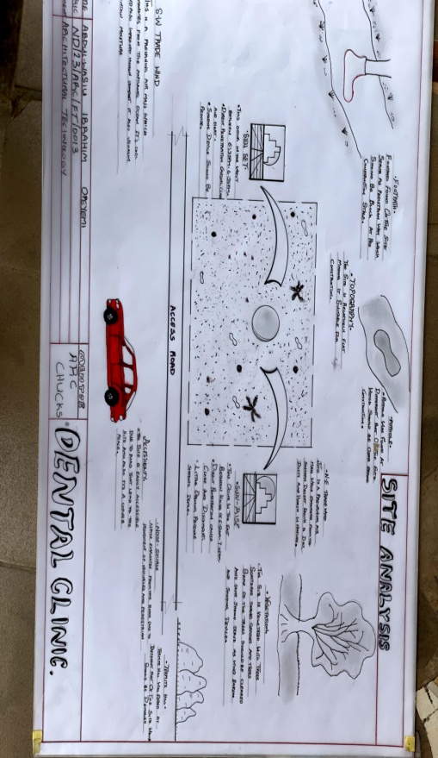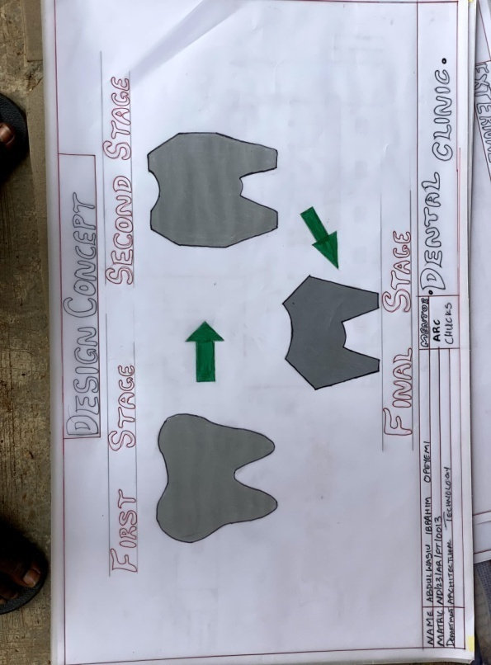
Site Analysis
Design Concept

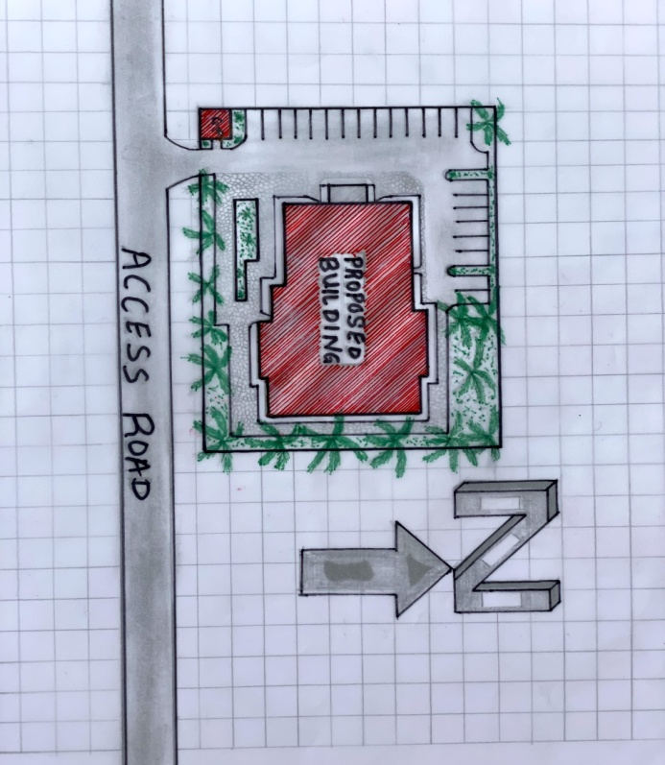
Site plan

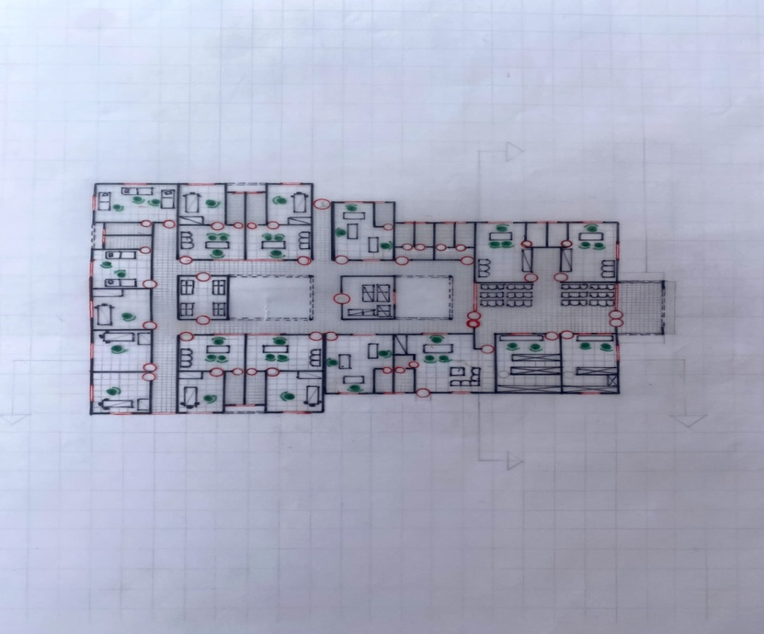

Flour plan

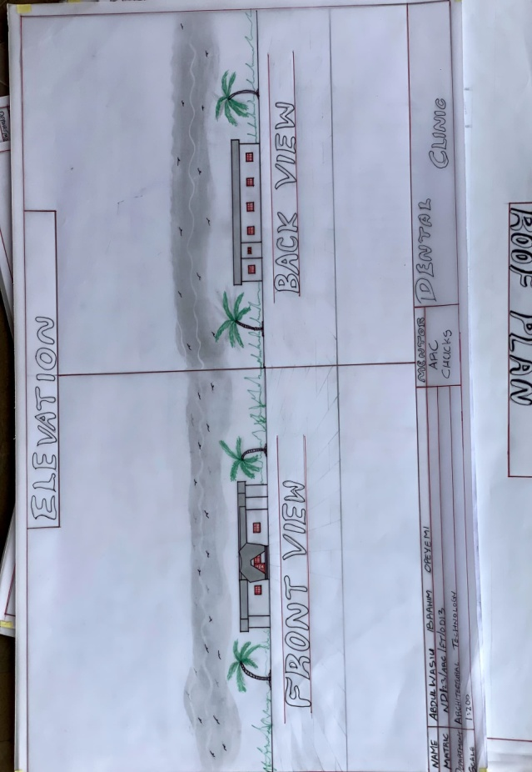
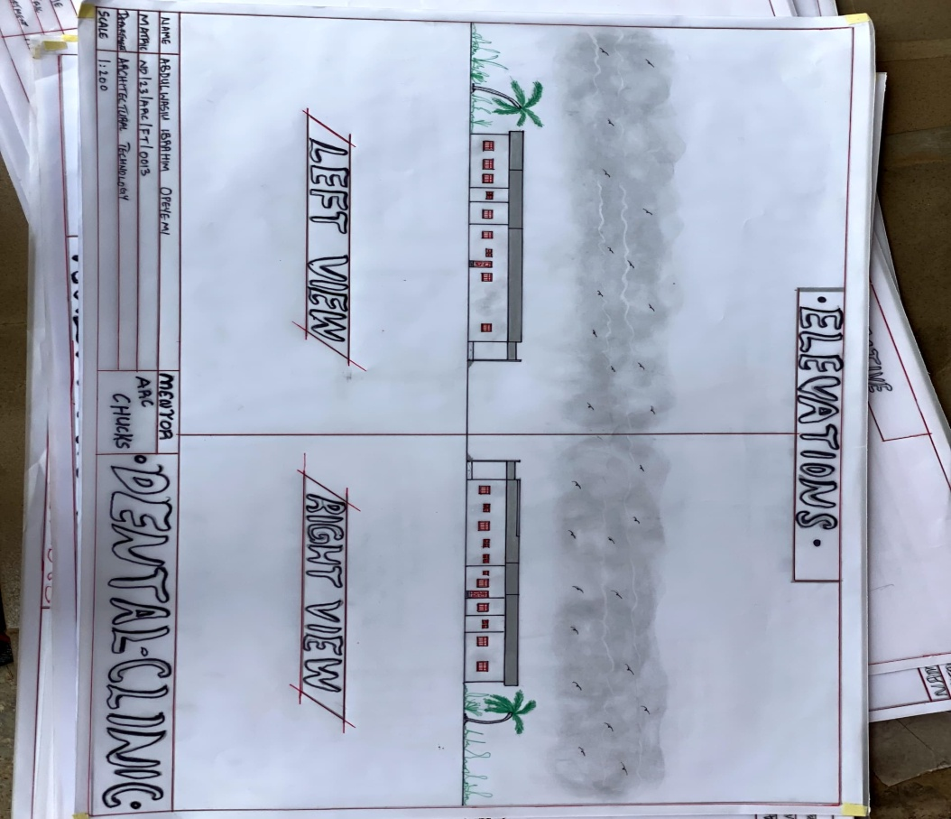
ELEVATIONS

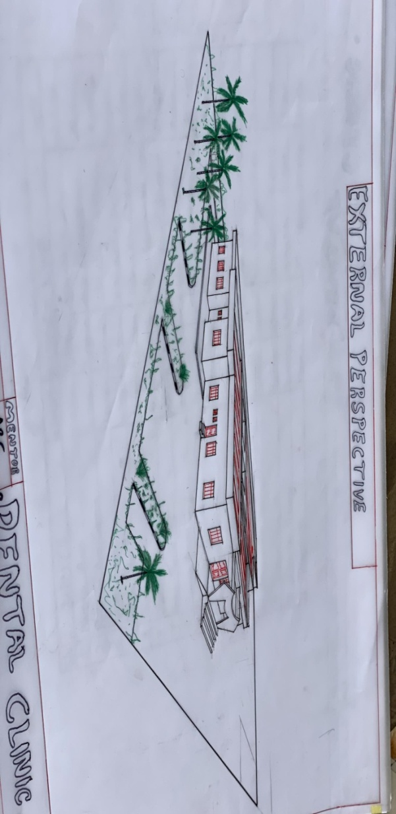
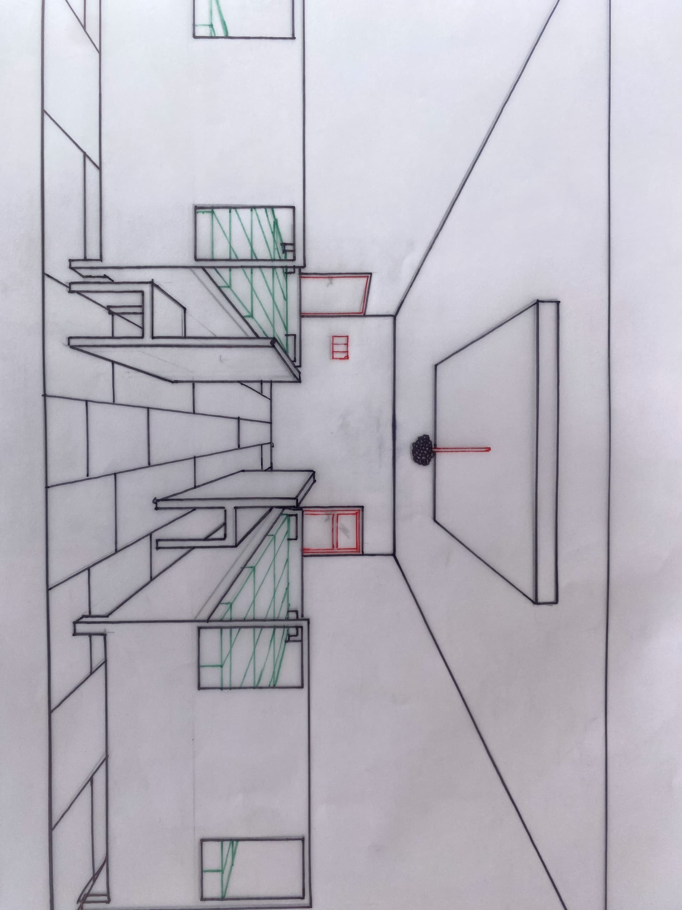
PERSPECTIVES

