HEPATOPROTECTIVE POTENTIAL OF CURCUMA LONGA RHIZOME EXTRACT AGAINST PARACETAMOL INDUCED SUB ACUTE HEPATOTOXICITY IN WISTAR RATS

BY:

AWE OPEYEMI WONDERFUL
HND/23/SLT/FT/0961

BEING A PROJECT REPORT SUBMITTED TO THE DEPARTMENT OF SCIENCE LABORATORY TECHNOLOGY (BIOCHEMISTRY UNIT), INSTITUTE OF APPLIED SCIENCES, KWARA STATE POLYTECHNIC ILORIN

IN PARTIAL FULFILMENT OF THE REQUIREMENTS FOR THE AWARD OF HIGHER NATIONAL DIPLOMA (HND) IN SCIENCE LABORATORY TECHNOLOGY (SLT), KWARA STATE POLYTECHNC, ILORIN, KWARA STATE

JUNE, 2025

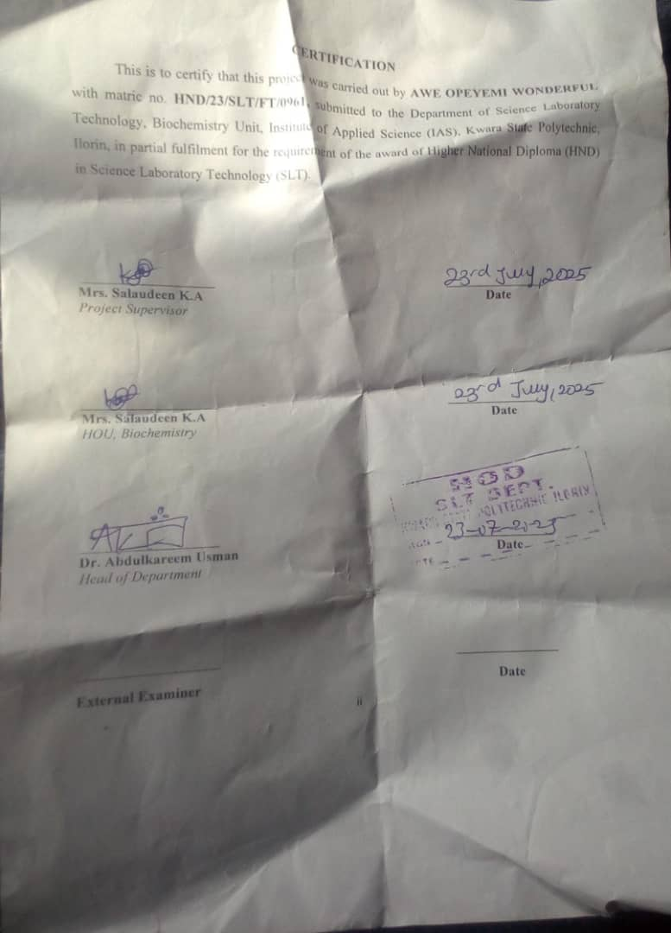
DEDICATION
This project is here by dedicated to Almighty God, the creator of the universe.

ACKNOWLEDGEMENT
All Praise is due to Almighty God the creator of the universe. I appreciate him for giving me the strength, knowledge and understanding to complete High National Diploma programme also for the completion of my project, may his name be praise forever.
I appreciate the utmost effort of my Supervisor Mrs. Salaudeen K.A whose patience, support and encouragement have been the driving force behind the source of this project research work. She gave useful correction, constructive criticisms, comment, recommendation, advice and always ensures that an excellent research is done.
My gratitude goes to all my able lectures in Biochemistry Department also other staff members of Science laboratory technology (SLT) Kwara State Polytechnic Ilorin, for their constant cooperation, encouragement throughout the academic section.
Special gratitude to my amazing parents, mostly my beloved mother (Mrs Awe Mary)who exhibited immeasurable financial support, prayers, understanding and unweaving love during these period.
More so, my profound appreciation goes to my beloved sister (Adeniyi Oluwa Toyin), my wonderful friend's (Osayomi Joseph, Ifeoluwa, Bisola and Damilola) and to everyone that contributed, stood by me throughout the journey.

LIST OF FIGURES
Fig1. A Diagram of the liver 3
Fig 2. Metabolism of Paracetamol 11
Fig. 3: Mechanism of Paracetamol Hepatotoxicity 12
Figure 4: Effect Of Treatment On Liver Total Proteins Concentration (mg/ml) 35
Figure 5: The Effect Of Cucuma Longa Extract On GSH Concentration (µg/ml)in
Paracetamol Induced Chronic Hepatotoxicity Rats 36
Figure 6: The Effect Of Cucuma Longa Extract On Superoxide Dismutase Enzyme
Activity (mmol/min/mg protein) in Paracetamol Induced Chronic Hepatotoxicity Rats 37
Figure 7: The Effect Of Cucuma Longa Extract On Catalase Enzyme Activity
(mmol/min/mg protein) in Paracetamol Induced Chronic Hepatotoxicity Rats 38
Figure 8: The Effect Of Cucuma Longa Extract On MDA concentration
(nmol MDA/mg protein) in Paracetamol Induced Chronic Hepatotoxicity Rats 39

TABLE OF CONTENTS
Title page i
Certification ii
Dedication iii
Acknowledgement iv
List of Figures v
Table of Content vi
Abstract viii
CHAPTER ONE: INTRODUCTION
1.1 Background to the Study 1
1.2 Statement of the Problem 2
1.3 Aim and Objectives of study 2
CHAPTER TWO: LITERATURE REVIEW
2.1 The Liver Structure and Its Function 3
2.1.1 Functions of Liver 3
2.1.2 Liver Disease 5
2.2 Hepatotoxicity 5
2.2.1 Causes 6
2.2.2 Types of Hepatotoxicity of Based on Mechanism 8
2.2.3 Overview of Paracetamol Metabolism 9
2.2.4 Mechanism of Paracetamol Hepatotoxicity 11
2.3 Overview of Curcuma Longa 12
2.4 Pharmacological Properties of Curcuma Longa 13
2.5 Mechanism of action of Curcuma Longa 16
2.6 Previous Studies on the Hepatoprotective Effects of Curcuma Longa 18
2.7 Role of Antioxidants in Liver Protection 18
CHAPTER THREE: MATERIALS AND METHODS
3.1. Chemicals and reagents 22
3.2 Apparatus / Equipments 22
3.3 Plant material collection 22
3.4 Experimental Animals 22
3.5 Methodology 22
3.6 Qualitative phytochemical Analysis 22
3.7 Experimental Design and grouping 24
3.8 Hepatic biomarker 24
3.8.1 ALT 25
3.8.2 AST 25
3.8.3 ALP 26
3.9 Antioxidant Assay 27
3.9.1 SOD 27
3.9.2 CAT 28
3.9.3. MDA 29
3.9.3. GSH 30
3.10 Protein 30
3.10.1 Histopatological analysis 31
3.10.2 Statistical Analysis 21
CHAPER FOUR
4.1 Results 33
CHAPTER FIVE
5.1 Discussion of results 44
5.2 Conclusion 46
References 48

ABSTRACT
The liver plays a vital role in detoxification and metabolic homeostasis, making it particularly vulnerable to damage from xenobiotics such as acetaminophen (paracetamol), a widely used analgesic and antipyretic. In overdose, acetaminophen can cause severe hepatotoxicity due to the accumulation of its toxic metabolite, N-acetyl-p-benzoquinone imine (NAPQI), leading to oxidative stress and hepatic cellular damage. This study was concluded to evaluate the hepatoprotective potential of Curcuma longa Rhizome against paracetamol induced chronic hepatotoxicity in wister rats. Phytochemical revealed the presence of Tannin, Terpenoid, Glycoside, Steroid, Alkaloid, Flavonoid, Phenolics, Phlabotannin in the ethanol extract, and reveals the absence of Saponin and Amino acid. An Invivo study was carried out using 25 adult male wister rats. They were divided into 5 groups of 5 rats each; Animals in group 1 was administered distilled water while those in group 2 received paracetamol (4000mg/kg). rats in group 3 received vitamin C (200mg/kg) and paracetamol (4000mg/kg). Group 4 & 5 were administered Curcuma longa Extract (CLE) of 200mg/kg and 400mg/kg respectively and paracetamol (4000mg/kg). Administration was via oral route for 14 days (7days paracetamol induction and treatment, 7 days of treatment only). At the end of 14 days animals were humanly Scarified. Livers were harvested and used for further analysis. Results from hepatic biomarkers (ALT, AST, ALP) shows a significant increase (P<0.05) in group 2 (untreated rats) compared to group 3, 4 and 5. The oxidative stress biomarkers (GSH, SOD, CAT, total protein) shows a significant decrease in group 2 (untreated) compared to group 3,4 & 5 with a remarkable increase in group 5 administered (400mg/kg). LPO concentration (MDA) shows a significant decrease (P<0.05) in treated groups (group 3,4 & 5) compared to untreated group. Histopathological results shows that Curcuma longa extract possess an hepatoprotective potential in ameliorating liver toxicity. The overall results obtained from this study strongly indicate that Curcuma longa extract possess an hepato protective potential. This regular consumption is recommended

..

CHAPTER ONE
INTRODUCTION
1.1 Background of the Study
The liver is a vital organ responsible for numerous metabolic, detoxifying, and synthetic functions essential for maintaining homeostasis (Tsoi & Andrew, 2020). Due to its central role in biotransformation, it is highly susceptible to damage by xenobiotics, drugs, and environmental toxins (Jaeschke et al., 2012). Hepatotoxicity remains a major clinical concern, particularly drug-induced liver injury (DILI), which is a leading cause of acute liver failure worldwide (Lee, 2013). Acetaminophen (paracetamol) is a commonly used analgesic and antipyretic agent. While it is generally safe at therapeutic doses, an overdose can result in severe hepatotoxicity (Ramachandran & Jaeschke, 2018). Acetaminophen-induced liver injury is primarily mediated through its metabolic conversion to a reactive metabolite, N-acetyl-p-benzoquinone imine (NAPQI). When produced in excess, NAPQI depletes hepatic glutathione stores and initiates oxidative stress, lipid peroxidation, mitochondrial dysfunction, and eventually hepatocyte death (Hinson et al., 2020).
In recent years, there has been growing interest in the exploration of plant-derived compounds for their potential in mitigating liver damage. Among these, Curcuma Longa (commonly known as turmeric) has received considerable attention due to its broad spectrum of pharmacological activities (Gupta et al., 2013). The principal bioactive compound in Curcuma Longa is curcumin, a polyphenolic compound with potent antioxidant, anti-inflammatory, and hepatoprotective properties (Aggarwal & Harikumar, 2021). Studies have demonstrated that curcumin can scavenge free radicals, enhance the activity of endogenous antioxidant enzymes (e.g., superoxide dismutase, catalase, glutathione peroxidase), and modulate signaling pathways involved in inflammation and apoptosis (Farzaei et al., 2018). These properties suggest that Curcuma Longa may offer protection against liver injury caused by toxic insults such as acetaminophen overdose (Rahman et al., 2021). The Wistar rat model is frequently used in hepatotoxicity studies due to its well-characterized physiology and reproducibility (Festing, 2020). By using this model, the hepatoprotective effect of Curcuma Longa can be evaluated through biochemical assays (e.g., serum levels of ALT, AST, ALP, bilirubin), histopathological examination, and oxidative stress markers (Bessems & Vermeulen, 2001).
1.2 Statement of the Problem
Liver toxicity is a major health concern, particularly when induced by the overuse or overdose of commonly available medications such as acetaminophen (paracetamol). Acetaminophen-induced hepatotoxicity remains one of the most common causes of acute liver failure worldwide due to the formation of toxic metabolites that cause oxidative stress and hepatocellular damage. Current therapeutic strategies, such as the use of N-acetylcysteine, may be limited by narrow treatment windows and potential side effects. Therefore, there is a growing interest in the exploration of natural compounds with antioxidant and hepatoprotective properties. Curcuma Longa (turmeric), a widely used medicinal plant, has been traditionally employed for its anti-inflammatory, antioxidant, and liver-protective effects. However, scientific validation of its efficacy against acetaminophen-induced liver damage remains limited. This study aims to investigate the hepatoprotective potential of Curcuma Longa in Wistar rats exposed to acetaminophen-induced liver toxicity, providing insights into its possible use as an alternative or adjunctive therapy for liver protection.
1.3 Aims and Objectives of the Study
1.3.1 Aims
To evaluate the hepatoprotective effect of Curcuma Longa (turmeric) extract in Wistar rats with liver damage induced by acetaminophen.
1.3.2 Objectives of the Study
- Extraction of plant material (Curcuma Longa)
- To carry out phytochemical screening on Curcuma Longa extract
- To assess the hepatic biomarkers (ALT, AST, ALP) after invivo studies.
- To assess the antioxidant biomarkers (GSH, SOD, CAT, MDA Total protein) after invivo studies.
- To compare the histopathological changes in liver tissues of control, acetaminophen-treated and Curcuma Longa-treated groups

CHAPTER TWO
LITERATURE REVIEW
2.1 The Liver Structure and Its Function
The liver is located in the upper right portion of the abdomen. It is the largest gland in the human body that performs several important functions. It is the only organ that has the ability to regenerate efficiently. The liver is a triangular, bilobed structure consisting of a larger right lobe and a smaller left lobe. The falciform ligament separates the two lobes.
A layer of fibrous tissue called Gllisson capsule covers the liver. The capsule is covered by the peritoneum. This protect the liver from physical damage.
It has two main sources of blood;
Hepatic Portal Vein carries nutrient rich blood from the digestive system.
Hepatic Artery carries oxygenated blood from the heart.
Fig1. A Diagram of the liver
2.1.1 Functions Of Liver
The important function of the liver are mentioned below
Production of Bile
Bile, which helps in the digestion and absorption of fats, vitamins and cholesterol is produced in the liver
Absorption of bilirubin
Bilirubin is formed by the breakdown of heamoglobin. The iron released is stored in the liver to make next generation of blood cells.
Supporting Blood Clots
Bile is responsible for the absorption of vitamin k. If bile is not produced clotting factors will not be produced.
Metabolization of Fats
Bile helps in the breakdown and digestion of fats.
Carbohydrate Metabololization
The carbohydrates stored in the liver as glycogen are broken down into glucose and released into the blood to maintain glucose levels.
Storage of Vitamins and Minerals
Vitamins A, D, E, K, and B12 are stored in the liver. It also stores iron in form of ferritin to form new red blood cells
Metabolization of protein
Bile helps in the digestion of protein.
Filtering Blood
The compounds such as hormones, alcohol, etc are filtered by the liver from the blood.
Immunological Function
The liver contains Kuffer cells involved in imunne activity. These destroy any disease-causing agents.
Albumin Production
Albumin transports fatty acids and steroids to maintain correct pressure and prevent leakage of blood vessels.
Angiotensinogen Synthesis
This hormoneis responsible for narrowing of blood vessels which results in an increase in blood pressure.

Regeneration of Liver
The liver has the ability to regrow in all vertebrates. The functions of the liver are not lost during the growth process. In human regeneration takes 8-15days
2.1.2 Liver Disease
Fascioliasis
This is caused by a parasite Liver Fluke. The parasite can lie dormant in the liver for months or even years.
Cirrhosis
This can be caused due to alcohol consumption, toxins, hepatitis. Here, the scar cells replace liver cells in a process known as Fibrosis. The functionality of liver cells is destroyed which might lead to liver failure.
Alcoholic Liver Disease
Uncontrolled alcohol consumption leads to liver damage. It is the most common of cirrhosis.
Fatty Liver Disease
This is the results of alcohol abuse or obesity. In this disease, the vacuoles of fat buildup in the liver cells.
Liver Cancer
Alcohol and hepatitis are the major cause of liver cancer. Hepatocellular carcinoma and cholangiocarinoma are two types of liver cancer.
2.2 Hepatotoxicity
Hepatotoxicity, also known as liver toxicity, is a condition characterized by damage to the liver caused by exposure to harmful substances, such as certain medications, toxins, orchemicals. This damage can lead to impaired liver functions and in severe cases, liver failure. It is also known as toxic liver disease or drug -induced liver injury (DILT).It can be acute or chronic and can range from serious symptoms to liver damage.
Hepatotoxicity refers to liver damage induced by chemical substances, including drugs, toxins or environmental pollutants, In the context of acetaminophen, hepatotoxicity sperciafically pertains to liver injury caused by an overdose prolong exposure to the drug (Lee and Ho,2021).The liver being the primary site of paractamol metabolism, plays a central role in both the therapeutic effects and potential toxic effects of this medication.
When paractamol is consumed within recommended dose, it is primarily metabolized through conjugation pathways into non toxic metabolites, which are then excreted in the urine(smith et al.,2020).However, in cases of overdose the metabolic pathway becomes saturated, leading to the accumulation of N-acetyl-p-benzoquinone imine (NAPQI) a highly reactive metabolite .NAPQI can bind to cellular macromolecules such as proteins and lipids, causing oxidative stress and damage to liver cells(Murray,2021).
The liver damage associated with paractamol overdose is characterized by hepatocellularnecrosis and inflammation, which can progress to acute liver failure if not promptly addressed(Jones,2022).The severity of hepatotoxicity often depends on the dose of paractamol ingested, the time elapsed since ingestion, and the individual”s overall health, particularly the presence of pre-existing liver conditions or genetic predispositions(Wang et al.,2019).
Understanding hepatotoxicity is crucial for both healthcare providers and patients. The clinical manifestation of paractamol-induced liver injury can range from mild liver enzyme elevations to severe conditions requiring hospitalization or liver transplantation. Therefore, early recognition and intervention are essential to mitigate the risks associated with paractamol use(Brown and Patel,2023).
In essence paractamol,it underscores the critical balance between its therapeutic benefits and the potential for severe adverse effects when used improperly. Awareness and education about risks of paractamol overdose are vital in preventing liver damage and ensuring patient safety.
2.2.1 Causes
Hepatotoxicity can be caused by a variety of substances. Some of these causes are:
Drugs and Medications
1. Acetaminophen(overdose)
2. Antibiotics (e.g., tetracycline, erythromycin)
3. Anti-inflammatory drugs(e.g., ibuprofen, aspirin)
4. Anticonvulsants (e.g., carbamazepine, valporic acid)
5. Chemotherapy agents
Toxins and Chemicals
1.Alcohol
2.Carbon tetrachloride
3.Pesticides (e.g., DDT)
4.Heavy metals (e.g., lead, mercury)
5.Industrial chemicals (e.g., vinyl chloride)
Herbal and Dietary Supplements
1.Atractylis gummifera
2.Green tea extract (high doses)
3.Kava
4.St. John’s Wort
5.Valerian root
Environmental Factors
1.Air pollution
2.Water pollution
3. Occupational exposure (e.g., chemical industry)
Medical Conditions
1.Viral hepatitis (A,B,C,D,E)
2. Fatty liver disease
3. Cirrhosis
4.Autoimmune hepatitis
5.Wilson disease
Other Causes
1.Radiation exposure
2.Surgical procedure (e.g,. liver transplantation)
3.Infections (e.g., bacterial, fungi)
Here are the symptoms of hepatotoxicity:
Early Symptoms
1.Nausea and vomiting
2.Abdominal pain or discomfort
3.Fatigue and weakness
4.Loss of appetite
5.Headache
6.Dizziness or lightheadedness
7.Dark urine
8.Pale or clay colored stool
Moderate Symptoms:
1.Jaundice(yellowing of skin and eyes)
2.Pruritus(itching)
3.Right upper quadrant adominal tenderness
4.Swelling in legs and feet(edema)
5.Weight loss
6. Diarrhea or constipation
7.Abdominal distention(bloating)
Severe Symptoms;
1.Severe abdominal pain
2.Vomiting blood or coffee ground-like material
3.Blood in stools
4. Confusion, disorientation, or altered mental state
5.Seizures
6.Coma
7.Acute liver failure(in severe cases)
2.2.2 Types of Hepatotoxicity of Based on Mechanism:
1.Direct Hepatotoxicity: Direct damage to liver cells(hepatocytes)by toxins or chemicals.
Example: Acetaminophen overdose
1.Indirect Hepatotoxicity: Idiosyncratic reactions or immune-mediated responses.
Example: Drug-induced liver injury (DILI) from antibiotics or anticonvulsants.
1.Metabolic Hepatotoxicity: Toxicity resulting from abnormal metabolic processes
Example: Fatty liver disease from obesity or diabetes.
2.2.3 Overview of Paracetamol Metabolism
Normal Metabolism
Paracetamol, also known as acetaminophen, is primarily metabolized in the liver, which is the central organ responsible for processing and detoxifying substances ingested by the body. Under normal conditions, paracetamol undergoes two major metabolic pathways: glucuronidation and sulfation. These conjugation reactions involve the addition of glucuronic acid or sulfate to the paracetamol molecule, transforming it into non-toxic, water-soluble metabolites that can be easily excreted via the urine (Mitchell et al., 2020).
Glucuronidation, mediated by the enzyme UDP-glucuronosyltransferase (UGT), is the predominant pathway, accounting for approximately 50-60% of paracetamol metabolism. Sulfation, facilitated by sulfotransferase enzymes, accounts for about 20-30% of the metabolism. These pathways effectively neutralize paracetamol, ensuring it is safely removed from the body without causing harm (Murray, 2021). This efficient processing allows paracetamol to be widely used as an analgesic and antipyretic with a relatively low risk of adverse effects when taken at recommended doses.
Toxic Metabolism
In overdose situations, however, the normal metabolic pathways become saturated, and the liver is unable to process all of the ingested paracetamol through glucuronidation and sulfation. When this happens, a larger proportion of paracetamol is shunted through the cytochrome P450 enzyme system, specifically CYP2E1, resulting in the production of N-acetyl-p-benzoquinone imine (NAPQI), a highly reactive and toxic metabolite (James et al., 2022).
Under normal conditions, NAPQI is quickly detoxified by conjugation with glutathione, a tripeptide that serves as an antioxidant and cellular protector. However, in the case of overdose, glutathione reserves can be rapidly depleted, leading to an accumulation of NAPQI (Lee and Ho, 2021). This toxic metabolite binds covalently to cellular macromolecules, such as proteins and lipids, causing oxidative stress and subsequent hepatocyte damage. This damage manifests as hepatocellular necrosis, inflammation, and ultimately, liver failure if not promptly treated (Jones, 2022).
The extent of liver damage is influenced by several factors, including the dose of paracetamol ingested, the duration since ingestion, and individual patient characteristics such as genetic predispositions and existing liver function (Wang et al., 2019). Early intervention with N-acetylcysteine (NAC), which replenishes glutathione stores and neutralizes NAPQI, is critical to mitigating the toxic effects and preventing severe liver damage.
While paracetamol is safely metabolized through glucuronidation and sulfation under normal conditions, overdose situations lead to the formation of the toxic metabolite NAPQI, which can cause significant liver damage. Understanding these metabolic pathways is essential for developing effective treatment strategies and preventive measures to manage and reduce the risk of paracetamol-induced hepatotoxicity.
Fig 2. Metabolism of Paracetamol
2.2.4 Mechanism of Paracetamol Hepatotoxicity
Mechanism of Paracetamol Hepatotoxicity (APAP) overdose is the most common cause of acute liver failure and mechanisms of liver injury induced by automatic positive airway pressure (APAP) overdose have been the focus of extensive investigation, which closely reproduces the human condition, have shown that hepatotoxicity is initiated by formation of a reactive metabolite N-acetyl-p-benzoquinone imine (NAPQI), which depletes cellular glutathione and forms protein adducts on mitochondrial proteins. This leads to mitochondrial oxidative and nitrosative stress, accompanied by activation of c-jun N-terminal kinase (JNK) and its translocation to the mitochondria (James et al., 2022). This then amplifies the mitochondrial oxidant stress, resulting in translocation of Bax and dynamin related protein 1 (Drp1) to the mitochondria, which induces mitochondrial fission, and ultimately induction of the mitochondrial membrane permeability transition (MPT). The induction of MPT triggers release of intermembrane proteins such as apoptosis inducing factor (AIF) and endonuclease G into the cytosol and their translocation to the nucleus, causing nuclear DNA fragmentation and activation of regulated necrosis. Studies on human hepatocytes and analysis of circulating biomarkers from patients after APAP overdose, indicate that a number of mechanistic events are identical in mice and humans.
Fig. 3: Mechanism of Paracetamol Hepatotoxicity
2.3 Overview of Curcuma Longa
Curcumin is the major constituent of turmeric (Curcuma Longa). Turmeric has been widely used as a spice in foods and for therapeutic applications such as anti-inflammatory, antihyperlipidemic, and antimicrobial activities. Turmeric and curcumin are nonmutagenic and nongenotoxic. Oral use of turmeric and curcumin did not have reproductive toxicity in animals at certain doses. Studies on human did not show toxic effects, and curcumin was safe at the dose of 6 g/day orally for 4-7 weeks. However, some adverse effects such as gastrointestinal upsets may occur. Moreover, oral bioavailable formulations of curcumin were safe for human at the dose of 500 mg two times in a day for 30 days, but there are still few trials and more studies are needed specially on nanoformulations and it should be discussed in a separate article. In addition, curcumin is known as a generally recognized as safe substance. This review discusses the safety and toxicity of turmeric and curcumin in medicine. Turmeric and curcumin are nontoxic for human especially in oral administration. Turmeric and curcumin are also safe in animals. They are nonmutagenic and are safe in pregnancy in animals but more studies in human are needed.
2.4 Pharmacological Properties of Curcuma Longa
Curcumin is also a powerful antioxidant. Antioxidants scavenge molecules in the body known as free radicals, which damage cell membranes, tamper with DNA, and even cause cell death. Antioxidants can fight free radicals and may reduce or even help prevent some of the damage they cause. In addition, curcumin lowers the levels of two enzymes in the body that cause inflammation. It also stops platelets from clumping together to form blood clots. Research suggests that turmeric may be helpful for the following conditions:
Increase the antioxidants in body
Oxidative damage is one of the mechanisms which are responsible for aging and many kind of disease. The free radicals involved in this mechanism react highly with organic substance in our body which can couse harm. Curcumin doesn’t only block the free radicals: it also stimulates the antioxidant mechanism in our body. This is probably one of the best benefits of turmeric for our body. The antioxidant activity of cucurmin was reported (Sharma et al., 2019) as early as 1975. It acts as a scavenger of oxygen free radicals (Ruby et al., 2020 and Subramanian et al., 1994). It can protect haemoglobin from oxidation (Unnikrishnan et al. 2020). Curcumin also lowers the production of ROS in vivo. This is brought about by maintaining the activities of antioxidant enzymes like superoxide dismutase, catalase and glutathione peroxidise. Recently, we have observed that curcumin prevents oxidative damage during indomethacininduced gastric lesion not only by blocking inactivation of gastric peroxidase, but also by direct scavenging of H2O2 and ·OH (unpublished observation). Since ROS have been implicated in the development of various pathological conditions (Bandyopadhyay et al., 1999), curcumin has the potential to control these diseases through its potent antioxidant activity.
Cancer
There has been a great deal of research on turmeric's anticancer properties, but results are still very early. Cancer should be treated with conventional medications. A lot of studies have shown that curcumin can be very beneficial in the treatment of cancer using herbs. It can influence the growth, development and spread of cancer cells at a molecular level. Cucumin acts as a potent anticarcinogenic compound. Among various mechanisms, induction of apoptosis plays an important role in its anticarcinogenic effects. It induces apoptosis and inhibits cell-cycle progression, both of which are instrumental in preventing cancerous cell growth in rat aortic smooth muscle cells (Gautam et al., 1998). Colon carcinoma is also prevented by curcumin through arrest of cell-cycle progression independent of inhibition of prostaglandin synthesis. Curcumin suppresses human breast carcinoma through multiple pathways. Curcumin also produces nonselective inhibition of proliferation in several leukaemia, nontransformed haematopoietic progenitor cells and fibroblast cell lines (Gautam et al., 1998). Nitric oxide (NO) and its derivatives play a major role in tumour promotion. Curcumin also increases NO production in NK cells after prolonged treatment, culminating in a stronger tumouricidal effect (Bhaumik et al., 2000).
Heart Disease
Keeping healthy cholesterol level is essential to pevent cardiovascular isssues and other serious health problem. High cholesterol level can very detrimental to one’s health, so people are always looking for ways to lower them. Studies have shown and proven that the simple act of adding turmeric to season your food can significantly lower blood cholesterol levels. Early studies suggested that turmeric may help prevent atherosclerosis, the build up of plaque that can block arteries and lead to heart attack or stroke. In animal studies, an extract of turmeric lowered cholesterol levels and kept LDL "bad" cholesterol from building up in blood vessels. Because it stops platelets from clumping together, turmeric may also prevent blood clots from building up along the walls of arteries. But a double-blind, placebo-controlled study found that taking curcumin, the active ingredient in turrmeric, at a dose of up to 4 g per day did not improve cholesterol levels. Curcumin has significant hypocholestermic effect in hypercholesteremic rats (Patil et al., 1971)

Indigestion
Curcumin stimulates the gallbladder to produce bile, which some people think may help improve digestion. The German Commission E, which determines which herbs can be safely prescribed in Germany, has approved turmeric for digestive problems. And one double-blind, placebo-controlled study found that turmeric reduced symptoms of bloating and gas in people suffering from indigestion. Turmeric powder has beneficial effect on the stomach. It increases mucin secretion in rabbits and may thus act as gastroprotectant against irritants (Lee et al., 2003). However, controversy exists regarding antiulcer activity of curcumin. Both antiulcer (Sinha et al., 1975) and ulcerogenic (Parsad et al., 2019) effects of curcumin have been reported but detailed studies are still lacking.
Management of Obesity
People who would like to lose a couple of pounds or treat obesity and other similar condition can take benefits of turmeric powder which can be very helpful in keeping one’s ideal body weight. The component in turmeric helps in boosting the flow of bile which is an essential element in the process of breaking down of dietary fats.
Controlling Diabetes
Turmeric boosts glucose control and augments the effects of the medications which are used in the treatment of diabeties. It also lowers the body’s resistance to insulin which can prevent Type-2 diabeties from developing.
Relieve from arthritis
Turmeric has anti-inflammatory properties as well as the antioxidant properties which eliminate free radicals which are responsible for damaging the cell in the body. From this property of turmeric People who are suffering from arthritscan benefit a lot from using turmeric.
Bacterial and Viral Infections
Test tube and animal studies suggest turmeric may kill bacteria and viruses. But researchers don’t know whether it would work in people. The aqueous extract of turmeric rhizomes has antibacterial effects (Kumar et al., 2001). Curcumin also prevents growth of Helicobacter pylori CagA+ strains in vitro. Both curcumin and the oil fraction suppress growth of several bacteria like Streptococcus, Staphylococcus, Lactobacillus, etc. Curcumin has been shown to have antiviral activity (Araujo et al., 2001). It acts as an efficient inhibitor of Epstein-Barr virus (EBV). Most importantly, curcumin also shows anti-HIV (human immunodeficiency virus) activity by inhibiting the HIV-1 integrase needed for viral replication. It also inhibits UV light induced HIV gene expression127. Thus curcumin and its analogues may have the potential for novel drug development against HIV.
Antifungal Property
Ether and chloroform extracts and oil of turmeric have antifungal effects (Apisariyakul et al., 2020). Crude ethanol extract also possesses antifungal activity. Turmeric oil is also active against Aspergillus flavus, A. parasiticus, Fusarium moniliforme and Penicillium digitatum (Jayaprakasha et al., 2001).
Skin Treatments
Turmeric has lots of benefits for the skin including speeding up the process of healing wounds, calming pores on the face to reduce acne. Since it has antioxidant and- inflammatory properties, which is really use full for treating skin problems.
2.5 Mechanism of action of Curcuma Longa
Mechanism of Action of Curcuma Longa (Turmeric)
Curcuma Longa is a medicinal plant known for its bioactive compound curcumin, which exhibits anti-inflammatory, antioxidant, anticancer, and antimicrobial activities.
1. Anti-inflammatory Activity
Curcumin inhibits key molecules in the inflammation pathway:
Inhibits NF-κB (nuclear factor kappa-light-chain-enhancer of activated B cells), a transcription factor that controls the expression of pro-inflammatory cytokines (e.g., TNF-α, IL-1, IL-6).
Suppresses the activity of cyclooxygenase-2 (COX-2) and lipoxygenase (LOX), enzymes involved in the synthesis of pro-inflammatory mediators.
2. Antioxidant Activity
Curcumin scavenges reactive oxygen species (ROS) and reactive nitrogen species (RNS).
Enhances the activity of endogenous antioxidant enzymes like superoxide dismutase (SOD), catalase, and glutathione peroxidase.
3. Anticancer Mechanism
Induces apoptosis via activation of caspases (caspase-3, -8, -9).
Inhibits proliferation by downregulating cyclin D1, c-Myc, and upregulating p53.
Inhibits angiogenesis by blocking vascular endothelial growth factor (VEGF) expression.
4. Antimicrobial Action
Disrupts bacterial membranes and inhibits quorum sensing in bacteria.
Binds to fungal membrane components and impairs their fun.
Antioxidant Mechanism of Curcuma Longa
The antioxidant activity of Curcuma Longa is primarily attributed to its active polyphenolic compound, curcumin. Curcumin protects cells from oxidative damage through free radical scavenging, metal chelation, and regulation of antioxidant enzymes.
1. Free Radical Scavenging
Curcumin donates hydrogen atoms or electrons to neutralize free radicals such as superoxide anion (O₂⁻), hydroxyl radical (OH⁻), and nitric oxide (NO).
Its phenolic OH groups and diketone structure are responsible for this scavenging activity.
2. Metal Ion Chelation
Curcumin chelates transition metal ions like Fe²⁺ and Cu²⁺, which are catalysts in the Fenton reaction that generates hydroxyl radicals.
This prevents the formation of highly reactive species and minimizes oxidative stress.
3. Upregulation of Antioxidant Enzymes
Curcumin enhances the activity of endogenous antioxidant defense systems by:
Increasing the expression and activity of superoxide dismutase (SOD), catalase (CAT), and glutathione peroxidase (GPx).
Activating Nrf2 (nuclear factor erythroid 2–related factor 2), a transcription factor that induces the expression of antioxidant response element (ARE)-driven genes.
4. Inhibition of Lipid Peroxidation
Curcumin inhibits lipid peroxidation, a process where free radicals attack lipids in cell membranes, thus preserving cell integrity and function
2.6 Previous Studies on the Hepatoprotective Effects of Curcuma Longa
Pari and Murugan (2017) Study: Evaluated the hepatoprotective effect of curcumin against carbon tetrachloride (CCl₄)-induced hepatotoxicity in rats. Curcumin significantly restored liver enzyme levels (ALT, AST), reduced lipid peroxidation (MDA), and increased antioxidant enzymes (SOD, CAT, GSH). Curcumin prevents oxidative damage and maintains liver histoarchitecture
Ramakrishna Rao et al. (2016) Study: Investigated the effect of curcumin on acetaminophen-induced liver injury. Curcumin pretreatment reduced serum liver enzyme levels and oxidative stress markers. Protective effects attributed to its antioxidant and free radical scavenging properties.
Kiso et al. (2018) Study: Early experimental work using curcumin in rats exposed to liver toxins like galactosamine and CCl₄. Curcumin showed a protective role by reducing inflammation and lipid peroxidation. Curcumin is effective in both acute and chronic liver injury models.
2.7 Role of Antioxidants in Liver Protection
To have a better understanding of what antioxidants are and what parts they play in enhancing liver health, we must first meet the liver’s biggest enemy oxidative stress.
Oxidative Stress
Oxidative stress is an imbalance between two different types of molecules in your body: free radicals and antioxidants. Specifically, it means there are too many free radicals and not enough antioxidants. As a result, the excess free radicals start to harm your body’s cells and tissues. They damage the different parts of cells, including lipids (fats) and proteins, that allow them to work normally. Oxidative stress is an imbalance of free radicals and antioxidants in your body that leads to cell damage. It plays a role in many conditions like cancer, Alzheimer’s disease and heart disease. Toxins like pollution and cigarette smoke can cause oxidative stress, while foods rich in antioxidants can help reduce it.
One of the primary mechanisms by which paracetamol induces hepatotoxicity is through oxidative stress. When paracetamol is taken in excessive amounts, the normal conjugation pathways (glucuronidation and sulfation) become saturated, and a greater proportion of the drug is metabolized by the cytochrome P450 enzyme system, particularly CYP2E1. This metabolic shift leads to the production of N-acetyl-p-benzoquinone imine (NAPQI), a highly reactive and toxic metabolite (James et al., 2022).
NAPQI exerts its toxic effects by binding covalently to cellular proteins and lipids, which disrupts normal cellular functions and causes oxidative damage. Normally, NAPQI is detoxified by conjugation with glutathione, a crucial antioxidant in hepatocytes. However, during paracetamol overdose, the rapid formation of NAPQI depletes glutathione reserves, leaving hepatocytes vulnerable to oxidative stress (Lee and Ho, 2021). The accumulation of NAPQI and the resultant oxidative stress lead to mitochondrial dysfunction, lipid peroxidation, and cell membrane damage, culminating in hepatocyte necrosis and liver injury (Murray, 2021).
oxidative stress not only damages the hepatocytes directly but also initiates a cascade of secondary cellular responses, further exacerbating liver injury. The cellular damage and death result in the release of intracellular contents, which can trigger inflammatory responses and amplify liver injury.
Oxidative stress plays a role in the onset of many chronic and degenerative conditions. A few examples include:
Cancer. Oxidative stress damages the DNA in healthy cells, which can raise your cancer risk.
Cardiovascular disease. Oxidative stress triggers plaque to form in your arteries (atherosclerosis). Plaque buildup can lead to many different problems, including reduced blood supply to your heart (coronary artery disease) and heart attack.
Kidney disease. Sustained oxidative stress can form scar tissue in your kidneys that prevents them from working as they should. This may lead to kidney failure, which can worsen to the point where you need dialysis.

Neurological diseases.
Oxidative stress also contributes to many different neurological diseases, including Alzheimer’s disease, Parkinson’s disease and multiple sclerosis. Excess free radicals contribute to neuron loss, which can progressively lead to dementia.
Respiratory diseases.
Oxidative stress and related inflammation can affect your lungs and cause conditions like asthma or chronic obstructive pulmonary disease (COPD).
Rheumatoid arthritis. Free radicals contribute to the chronic inflammation that happens in people with rheumatoid arthritis.
A free radical can be defined as an atom or molecule containing one or more unpaired electrons in valency shell or outer orbit and is capable of independent existence. The odd number of electron(s) of a free radical makes it unstable, short lived and highly reactive.
Antioxidants, or natural substances in foods we eat, are that superhero. Unlike free radicals, antioxidants don’t snatch electrons from healthy cells in your body. Instead, they donate one of their electrons to a free radical. This makes the free radical complete, so it doesn’t steal from other molecules in your body. Antioxidants help keep balance in your body.
When you don’t have enough antioxidants to satisfy the free radicals, those free radicals go scavenging. And your body experiences oxidative stress as a result.
The liver is a vital organ responsible for detoxification, metabolism, and maintaining internal chemical homeostasis. Due to its central role in detoxifying harmful substances, it is highly susceptible to oxidative stress an imbalance between free radicals (reactive oxygen species, ROS) and the body’s antioxidant defenses. This is where antioxidants play a crucial protective role.
1. Neutralization of Free Radicals
Antioxidants scavenge reactive oxygen species (ROS), preventing oxidative damage to liver cells (hepatocytes). Without antioxidants, excess ROS can damage lipids, proteins, and DNA, leading to liver dysfunction or disease.
2. Prevention of Lipid Peroxidation
The liver's cell membranes are rich in lipids, making them targets for peroxidation by ROS. Antioxidants like vitamin E, glutathione, and selenium inhibit this process, maintaining cell membrane integrity and function.
3. Support for Detoxification Pathways
Some antioxidants, such as glutathione, play direct roles in detoxifying harmful compounds by binding to toxins and facilitating their excretion. This helps reduce the liver’s toxic burden.
4. Anti-inflammatory Effects
Oxidative stress often triggers inflammation, contributing to liver diseases like hepatitis and cirrhosis. Antioxidants modulate signaling pathways (e.g., NF-κB) that control inflammation, thereby protecting liver tissue.
5. Regeneration and Repair
Antioxidants support liver regeneration by promoting DNA synthesis and reducing cellular injury. This is particularly important in conditions such as alcoholic liver disease or non-alcoholic fatty liver disease (NAFLD).
Common Antioxidants in Liver Protection
Glutathione (GSH): A major intracellular antioxidant essential for detoxification.
Vitamin C and E: Protect against oxidative damage and support immune function.
Silymarin (from Milk Thistle): Enhances antioxidant capacity and liver regeneration.
N-acetylcysteine (NAC): Precursor to glutathione, used in acetaminophen toxicity.
Curcumin: From turmeric, known for its anti-inflammatory and antioxidant effects.

CHAPTER THREE
MATERIALS AND METHODS
3.1: Chemicals and reagents
- Normal saline, Distilled water, Ethanol, Phosphate buffer saline (PBS), Formaline, Biuret reagent, 1M Sodium Hydroxide (NaOH), Catalase buffer, Carbonate buffer, DYE, ALT buffer, AST buffer, Diethyl ether, Ammonium molybdate, and Dimethyl Sulfoxide
3.2: Apparatus and equipments
- Animal cages, Bedding materials, Water bottles and feeders, Weighing balance, Animal handling gloves, Dissection board and instruments, Syringes and needles (oral gauge needles), Vacutainers (microcentrifuge tubes e.g. EDTA, Heparin), Centrifuge, Pipettes, Formalin containers, Beakers and graduated cylinders, Staining jars and racks (for performing histological staining), Microscope (light microscope) for examining the stained tissue sections, Homogenizer (to prepare liver tissue homogenates for biochemical assay), Spectrophotometer (microplate reader), Microplates, Incubator, Refrigerator, Lab. Coats and gloves and Waste conteners
3.3: Plant material collection
Curcuma Longa Rhizomes was purchased from a local market at Ekiti. It was rinsed and dried for one week. I was then grinded using electric blender in to powder, which was kept air tight for further analysis.
3.4: Experimental Animals
Twenty five (25) male wrister rats weighing between (120-170kg) were procured from the animal house of innovative fulcrum Ilorin, Kwara State.
3.5: Methodology
200g of Curcuma Longa powder was dissolved in 1L of ethanol and kept for 48 hours. It was filtered and concentrated to obtain the crude extract which was used for further analysis
3.6 Qualitative Phytochemical Analysis
Phytochemical analysis extract was carried out using the method described by Odebiyi and
Sofowora (1978) for the detection of saponins, tannins, phenolics, alkaloids, steroids, triterpenes,
phlobatannins, glycosides and flavonoids.
1. Alkaloids: 1cmᶟ of 1%HCl was added to 3cmᶟ of the extracts in a test tube. The mixture was
heated for 20 minutes, cooled and filtered. The filtrate was used in the following tests: 2 drops of
Wagner’s reagent was added to 1cmᶟ of the extracts. A reddish brown precipitate indicates the
presence of alkaloids
2. Tannins: 1cmᶟ of freshly prepared 10% KOH was added to 1cmᶟof the extracts. A dirty white
precipitate indicates the presence of tannins.
3. Phenolics: 2 drops of 5% FeCl₃ was added to 1cmᶟ of the extracts in a test tube. A greenish
precipitate indicates the presence of phenolics.
4. Glycosides: 10cmᶟ of 50% H₂SO₄ was added to 1cmᶟ of the extracts, the mixture was heated
in boiling water for 15 minutes. 10cmᶟ of Fehling’s solution was added and the mixture boiled. A
brick red precipitate indicates the presence of glycosides.
5. Saponins: Frothing test: 2cmᶟ of the extract in a test tube was vigorously shaken for 2
minutes. Frothing indicates the presence of saponins.
6. Flavonoids: 1cmᶟ of 10% NaOH was added to 3cmᶟ of the extracts. A yellow colouration
indicates the presence of flavonoids.
7. Steroids: salakowsti test: 5 drops of concentrated H₂SO₄ was added to 1cmᶟ of the extracts.
Red colouration indicates the presence of steroids
8. Phlobatannins: 1cmᶟ of the extracts was added to 1% HCl. A red precipitate indicates the
presence of phlobatannins.
9. Terpenoids: 5ml of aqueous extract of the sample is mixed with 2ml of CHCl3 in a test tube
3ml of con. H2SO4 is carefully added to the mixture to form a layer. An interface with a reddish
brown coloration is formed if terpenoids constituent is present.
10. Amino acid (Yasuma and Ichikawa 1953): Two drops of ninhydrin solution (10mg of ninhydrin
in 200ml of acetone) are added to two ml of aqueous filtrate. A characteristic purple colour indicates the presence of amino acids.
3.7 Experimental Design and grouping
Groups | Doses | Treatment
I (Control) | Distilled water
II (PCM) | 4000mg/kg b.wt | Orally (1ml in the morning, 1ml at night) for 7 days only
III (Vitamin C & PCM) | 200mg/kg of vitamin C & 4000mg/kg b.wt respectively | Orally (1ml in the morning, 1ml at night) for 7 days and gave only vitamin C for another 7 days.
IV (Curcumin & PCM) | 200mg/kg & 4000mg/kg b.wt respectively | Orally (1ml in the morning, 1ml at night) for 7 days and started treatment only for another 7 days (1 week)
V (Curcumin & PCM) | 400mg/kg & 4000mg/kg b.wt respectively | Orally (1ml in the morning, 1ml at night) for 7 days, stopped inducing with Pcm and started treatment only for another 7 days (1 week)
3.8 Hepatic biomarker
Biological markers (biomarkers) are used to recognize, characterize and monitor treatment-related responses following exposure to xenobiotics. Biomarkers serve three primary applications in toxicology: 1) to confirm expo- sure to a deleterious agent, 2) to provide a system for monitoring individual susceptibility to a toxicant, and 3) to quantitatively assess deleterious effects of a toxicant to an organism or individual. Because the liver is a general target for adverse effects of drugs and other chemicals, biomarkers of untoward hepatic response to xenobiotics are of particular interest to the pharmaceutical toxicologist.
Liver indices" typically refer to liver function tests (LFTs) or liver enzymes, which are blood tests used to assess liver health and detect liver damage or disease. Here are the key liver indices:
3.8.1 ALT
Alanine Aminotransferase Activity (ALT)
The method described by Reitman and Frankel (1957) was used to assay for the activity of alanine aminotransferase.
Principle: Alanine aminotransferase activity was determined by monitoring the concentration of pyruvate hydrazone formed with 2, 4-dinitrophenyl hydrazine.
Procedure: 0.5 ml of solution 1 was added to each test tube containing 0.1 ml of the enzyme source (appropriately diluted) and incubated for 30 minutes at 37⁰C. Then, 0.5 ml of solution 2 was added and the assay mixture was mixed and left undisturbed for 20 minutes at 25⁰C. The reaction was terminated immediately by adding 0.5 ml of 0.4N sodium hydroxide. The blank was constituted by replacing the enzyme source with 0.1 ml of distilled water. The solution was mixed and absorbance read against blank after 5 minutes at 468 nm. The enzyme activity was obtained from the calibration curve (Appendix)
3.8.2 AST
Aspartate Aminotransferase Activity (AST)
The method described by Reitman and Frankel (1957) was used in the assay of the activity of aspartate aminotransferase.
Principle: The enzyme catalyzes the reversible reaction involving α–ketoglutarate and L-aspartate to form L-glutamate and oxaloacetate. Aspartate aminotransferase was measured by monitoring the concentration of oxaloacetate hydrazone formed with 2, 4-dinitrophenyl hydrazine.
Procedure: 0.5 ml of reagent 1 was added to each test tube containing 0.1 ml of the enzyme source (appropriately diluted) and incubated for 30 minutes at 37⁰C. Then, 0.5 ml of reagent 2 was added and the assay mixture was mixed and left undisturbed for 20 minutes at 25⁰C. The reaction was terminated immediately by adding 0.5 ml of 0.4N sodium hydroxide. The blank was constituted by replacing the enzyme source with 0.1 ml of distilled water. The solution was thouroughlymixed and absorbance read against blank after 5 minutes at 468 nm. The enzyme activity was obtained from the calibration curve (Appendix).
3.8.3 ALP
Alkaline phosphatase activity
The method described by Wright et al (1972a) was employed in this assay.
Principle: The amount of phosphate ester split within a given period of time is a measure of the phosphatase enzyme. Para-nitrophenylphosphate was hydrolyzed to para-nitrophenol and phosphoric acid at a pH of 10.1. The para-nitrophenol confers a yellowish colour on reaction mixture and its intensity is read spectrophotometrically at 400 nm.
Procedure: 2.2 ml of carbonate buffer (0.1 M) and 0.1 ml of MgSO4.7H2O (0.1 M) were added in series to the test tubes. Then 0.2 ml of the enzyme source (appropriately diluted) was added and incubated at 37 for 10 minutes. 0.5 ml of of 10 mM p-nitrophenyl phosphate (substrate) was added and the assay mixture incubated again for 30 minutes at 37 . The reaction wasterminated immediately by adding 2.0 ml of 1N sodium hydroxide. The blank was constituted by replacing the enzyme source with 0.2 ml of distilled water. The absorbance was read spectrophotometrically at 400 nm.
Enzyme activity was calculated using the following expression: 85

Enzyme activity (nm/min/ml) = ΔA/min × 1000 × TV × F
9.9 × SV × L
Where:
ΔA/min = Change in absorbance of the reaction mixture per minute
TV = Total volume of the reaction mixture
F = Total dilution factor
SV = Volume of enzyme source
L = Light path length (1cm)
9.9 = Extinction co-efficient of 1 μm of p-nitrophenol in an alkaline solution of 1 ml and 1 cm
path length
1000 = the factor introduced to enable the enzyme activity to be expressed in nM/min/mg
protein.
The specific activity for alkaline phosphatase was calculated from the expression:
Specific enzyme activity (nM/min/mg protein) = Enzyme activity
Protein concentration
3.9 Antioxidant Assay
Antioxidant assays are essential for evaluating the oxidative damage caused by acetaminophen and the protective effects of Curcuma Longa. Oxidative stress plays a key role in acetaminophen-induced hepatotoxicity due to excessive generation of reactive oxygen species (ROS) and depletion of endogenous antioxidants.
The following biochemical assays were used to assess the antioxidant status in liver homogenates of Wistar rats:
3.9.1 SOD
Superoxide dismutase
The method described by Misra and fridovich (1972) was used to assay for the activity of superoxide dismutase.
Principle: Superoxide dismutase activity was measured as the inhibition of the rate of reduction of cytochrome c by the superoxide radical, observed at 550 nm:
2O₂^{-.} + 2H^{+ SOD} O₂ + H₂O₂
Cytochrome c (oxidized) + O^{.-} Cytochrome c(reduced) + O₂
The superoxide radical is produced enzymatically by the reaction:
Xanthine + O₂ + H₂O ^{Xanthine oxidase} Uric acid + O₂⁻ + H⁺

Procedure:Tissue homogenate of 0.5ml was diluted in 4.5ml of distilled water (1:10) dilution factor. An aliquot of 0.2ml of diluted serum sample was added to 2.5ml of 0.05M carbonate buffer (pH 10.2) to equilibrate in a spectrophotometric cuvette and the reaction was started by adding 0.3ml of substrate (0.3mM Epinephrine) and 0.2ml of distilled water. The increase in absorbance at 480nm was monitored every 30 seconds for 150 seconds.
Increase in absorbance per minute = A1 – A0
2.5
Where A0 = absorbance after 30seconds
A1 = absorbance after 150 seconds.
% inhibition = 100 – (100 x increase in absorbance for substrate)
Increase in absorbance for blank
Enzyme activity (nmol/mL) = % inhibition x 1000 x df
50 x 0.1
df = dilution factor
0.1 = volume in mL of tissue homogenate
50% = inhibition of the rate of cytochrome c reduction as per unit definition
1000 = the factor introduced to enable enzyme activity be expressed in nmol/min/mL
The specific enzyme activity was calculated using the formula
Specific enzyme activity (nmol/min/mg protein) = Enzyme Activity
Protein concentration
3.9.2 CAT
Catalase
The method described by Beers and sizer (1952) was used to assay for the activity of catalase.
Principle: The UV light absorption of hydrogen peroxide can be easily measured between 230-250 nm. On decomposition of hydrogen peroxide by the catalase, the absorption decreases with time. The enzyme activity can be estimated by this decrease in absorption.
2H₂O₂ ^{Catalase} 2H₂O + O₂
Procedure
Hydrogen peroxide (0.036% w/w, 2.9 mL) was added and mixed with appropriately diluted homogenate (0.1 mL).A blank was prepared containing potassium phosphate buffer (50 mM, pH 7.0, 3.0 mL). The time required for the A_{240nm} of the reaction mixture to decrease from 0.45 to 0.40 absorbance units was recorded.
NB: The initial A_{240nm} exceeded 0.450 absorbance units and started to decrease. The reaction timing was started when the A_{240nm} reached 0.450 absorbance units.
The activity and specific activity of catalase was calculated using the expression:
Enzyme Activity (nmol/min/mL) = 3.45 x 1000 x df
min x v
3.45 - Corresponds to the decomposition of 3.45 micromoles of hydrogen peroxide in a 3.0 mL reaction mixture producing a decrease in the A_{240nm} from 0.45 to 0.40 absorbance units
df - Dilution factor
min - Time (minutes) required for the A_{240nm} to decrease from 0.45 to 0.40 absorbance units
v -Volume (mL) of the sample used
1000 - The factor introduced to enable enzyme activity be expressed in nmol/min/mL
The specific enzyme activity was calculated using the expression:
Specific enzyme activity (nmol/min/mg protein) = Enzyme Activity
Protein Concentration
3.9.3. MDA
Malondialdehyde
The concentration of MDA was quantified according to the method of Nelson, (2004) as outlined below:
A portion of TBA reagent (2ml of 0.7% and 1ml of TCA) were added to 2ml of the sample. The mixture was thoroughly heated in a water bath at 100ºC for 20minutes. It was then cooled and centrifuged at 78g (4000rpm) for 10minutes. The absorbance of the supernatant was read at a wavelength of 540nm against a reference blank of distilled water after centrifuging for another 10 minutes.
Conc. Of MDA= Abs
Extinction coefficient
Extinction Coeff. Of MDA = 1.56 x 10⁵ nm⁻¹cm⁻¹.
TBA: 0.7% 1.e 0.7g in 100ml.
TCA: 20% i.e. 20g in 100ml

3.9.3. GSH
Reduced glutathione (GSH)
The level of GSH in the liver homogenate was determined using the procedure described by Ellman (Ellman, 1959). Briefly, 1.0 mL of liver homogenate was added to 0.1 mL of 25% trichloroacetic acid (TCA) and precipitate was removed by centrifugation at 5,000 g for 10 min. Supernatant (0.1 mL) was added to 2 mL of 0.6 mM DTNB prepared in 0.2M sodium phosphate buffer (pH 8.0). The absorbance was read at 412 nm.
3.10 Protein
Determination of Total protein
The total protein concentration in the liver, kidney and serum of the animals was assayed, using Biuret reagent as described by Gornallet al (1949).
Principle: The biuret reagent is an alkaline solution of copper potassium tartarate. Compounds containing two or more peptide bounds react with Cu²⁺ ion to give a violet colour. The buiret reaction is due to coordination of Cu²⁺ with the unshared electron pairs of peptide nitrogen and the oxygen of water which results into the coloured complex. A purple coloured chelate is formed between cupric ions and peptide bonds in alkaline medium. The intensity of the colour is proportional to the amount of protein present.
Procedure: 4.0 ml of Biuret reagent was added to 1.0 ml of the sample (appropriately diluted). This was mixed thoroughly by shaking and left undisturbed for 30 minutes at room temperature for colour development. The blank was constituted by replacing the sample with 1.0 ml of distilled water. The absorbance was read against blank at 540 nm.
The concentration of protein in the sample was calculated by comparing them with those on the calibration curve for egg albumin. Concentration of the protein in the sample was extrapolated from the calibration curve of the egg albumin (APPENDIX II), using the expression:
Protein concentration (mg/ml) = Cs × F
Where: Cs= corresponding protein concentration from the calibration, F = dilution factor
Protocol for the determination of calibration curve for protein: A protein standard, egg albumin stock solution (10 mg/ml) was prepared. Varying volumes of the stock solution corresponding to 0.0, 0.1, 0.2, 0.3, 0.4, 0.5, 0.6, 0.7, 0.8, 0.9 and 1.0 ml were measured into cleaned test tubes. The volumes were then made up to 1 ml with distilled water after which 4 ml of Biuret reagent was added, making the total volume of the prepared solutions to be 5 ml. The solutions were left undisturbed for 30 minutes at room temperature after which the absorbance was read at 540nm.

- To calculate for protein concentration divide each absorbance value by 0.0684

3.10.1. Histopatological analysis
Small portions of the liver from each rat were removed, and fixed in formalin (10 %). The specimens were processed for dehydration using ascending grades of ethanol, clearing in xylene and impregnation with molten paraffin wax in an oven at 60 °C, using an automatic tissue processor (Sakura, Japan). Next, the tissues were embedded using an embedding station (Leica, Germany); sections (4-5 um) were cut and stained with Hematoxylin and Eosin (H&E) and PAS techniques as described previously (Al-Doaiss et al., 2019). The stained sections were examined using optical microscope (Olympus Microscope BP53 with Digital
Camera, Japan). All subsequent histopathological examinations were performed by an experienced pathologist without knowledge of the previous treatments.
3.10.2 Statistical Analysis
Results are expressed as mean ± SEM. The levels of homogeneity among the groups were assessed using One-way Analysis of Variance (ANOVA) followed by Turkey's test. All analyses were done using Graph Pad Prism 8 Software Version (8.0.1) and p values (P<0.05) considered statistically significant.

CHAPER FOUR
RESULTS
Phytochemical Analysis
Freshly prepared Cucuma Longa extract were subjected to preliminary phytochemical screening for various constituents.
Table 1: Phytochemical Analysis of Cucuma Longa extract
QUALITATIVE PHYTOCHEMICAL ANALYSIS | ETHANOLIC EXTRACT
TANNIN | +
SAPONIN | -
TERPENOID | +
GLYCOSIDE | +
STERIOD | +
ALKALOID | +
FLAVONOID | +
PHENOLICS | +
AMINO. ACID | -
PHLABOTANIN | +
Note: + = Present
- = Absent

Table 2: The Effect Of Cucuma Longa Extract On Body Weight in Paracetamol Induced Chronic Hepatotoxicity Rats
Body weight (g)
Groups Day 0 Day1 Day 7 Day 14
Control 140±0.25ª 155.0±0.15^{b} 156±0.12 ^{b} 165.5±0.23^{c}
PCM Control (4000mg/kg) 152.8±0.41ª 141.6±0.16^{b} 114±0.15^{c} 105±0.24^{d}
VIT C (200 mg/kg) 132.8±0.7ª 128.4±0.61ª 112±0.21^{c} 155±0.14^{d}
CLE D1 (200mg/kg) 123.4±0.14ª 121.8±0.72ª 125.2±0.11ª 154±0.24^{b}
CLE D2 (400mg/kg) 115.6±0.24ª 113±0.21ª 123.4±0.54^{b} 132±0.41^{c}
Values are expressed as Mean ± SEM (n=5)
Means with different superscript in a Column differ significantly (P<0.05
Table 3: The Effect Of Cucuma Longa Extract On Hepatic Marker Enzyme in Paracetamol Induced Chronic Hepatotoxicity Rats

Specific Activity (U/L/mg protein)
Groups ALT AST ALP
Control 10.35±0.23ª 19.70±0.33ª 14.95±0.54ª
PCM Control (4000mg/kg) 25.20±1.31^{b} 30.82±2.21^{b} 28.10±0.23^{b}
VIT C (200 mg/kg) 15.36±0.95ª 20.97±0.47ª 19.24±0.67ª
CLE D1 (200mg/kg) 14.41±0.88 ª 19.48±2.27ª 20.96±1.96ª
CLE D2 (400mg/kg) 13.64±0.98ª 18.20±1.48ª 18.26±1.16ª
Values are expressed as Mean ± SEM (n=5)
Means with different superscript in a row differ significantly (P<0.05)

Figure 1 : Effect Of Treatment On Liver Total Proteins Concentration (mg/ml)
Results Are Presented As Mean ± SEM (n=5).
Bars With Different Letters Are Significantly Different At P<0.05
Figure 2: The Effect Of Cucuma Longa Extract On GSH Concentration (µg/ml)in Paracetamol Induced Chronic Hepatotoxicity Rats
Results Are Presented As Mean ± SEM (n=5).
Bars With Different Letters Are Significantly Different At P<0.05

Figure 3: The Effect Of Cucuma Longa Extract On Superoxide Dismutase Enzyme Activity (mmol/min/mg protein) in Paracetamol Induced Chronic Hepatotoxicity Rats
Results Are Presented As Mean ± SEM (n=5).
Bars With Different Letters Are Significantly Different At P<0.05

Figure 4: The Effect Of Cucuma Longa Extract On Catalase Enzyme Activity (mmol/min/mg protein) in Paracetamol Induced Chronic Hepatotoxicity Rats
Results Are Presented As Mean ± SEM (n=5).
Bars With Different Letters Are Significantly Different At P<0.05

Figure 5: The Effect Of Cucuma Longa Extract On MDA concentration (nmol MDA/mg protein) in Paracetamol Induced Chronic Hepatotoxicity Rats
Results Are Presented As Mean ± SEM (n=5).
Bars With Different Letters Are Significantly Different At P<0.05

LIVER HISTOPATHOLOGY
A
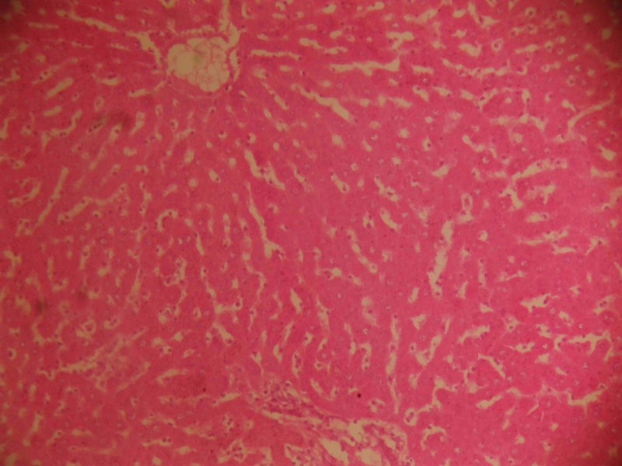
Showing hepatocytes nests and cords (yellow arrows) mostly within normal limits, interspersed with sinusoids which have more numbers of phagocytic macrophages (black arrows)
INTERPRETATION : The increased Macrophages suggest an active clean up process, likely responding to bile accumulation or cell debris. Haematoxyin and eosin stain. X100
B
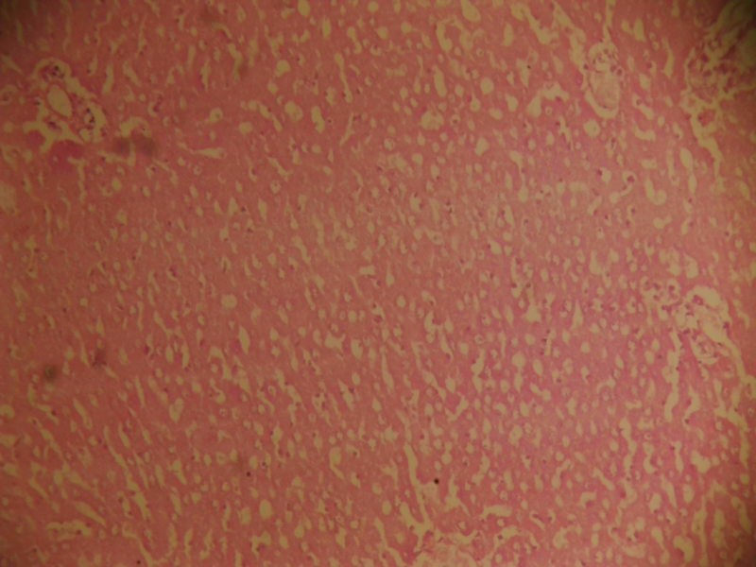
Showing hepatocyte plates with necrotic beds (yellow arrow), numerous vacuoles and sinusoids (red arrows) with many inflammatory cells (black arrows).
INTERPRETATION: This suggest severe liver injury withNecrosis, possibly due to toxic or infectious insult. The combination of Necrosis, vacuoles and inflammation is typically acute or chronic hepatitis. Haematoxylin and eosin stain. X100.

C

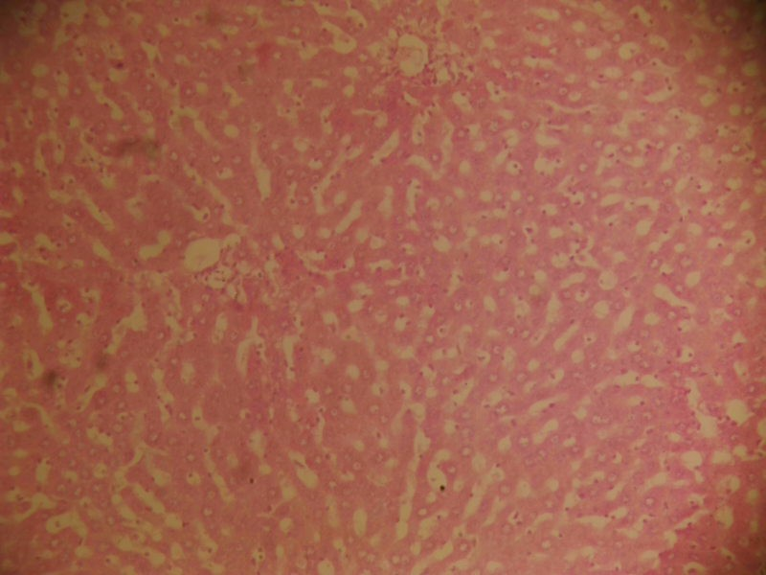
Showing hepatocytes cords and nests (yellow arrows), interspersed with more numbers of sinusoid channels in which also are many inflammatory cells (black arrows). Features are in keeping with cholestasis with inflammation.
INTERPRETATION : The infiltration of inflammatory cells into the sinusoid points to active or inflammatory response to bile retention or injury . Haematoxylin and eosin stain. X100.

D
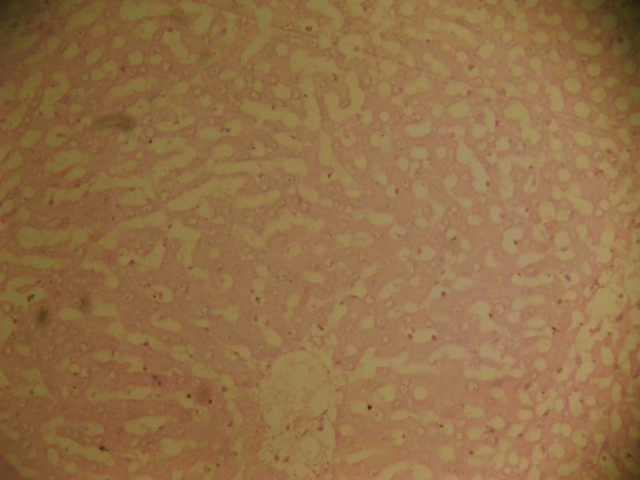
Showing hepatocytes cords and nests (yellow arrows) being interspersed with wider sinusoids (black arrows) margins, which is suggestive of odema.
INTERPRETATION : The sinusoidal widening is indictative of hepatic edema, likely due tofluid accumulation. This may suggest early liver damage or inflammation resulting in vascular leakage. Heamatoxylin and eosin stain. X100.

E
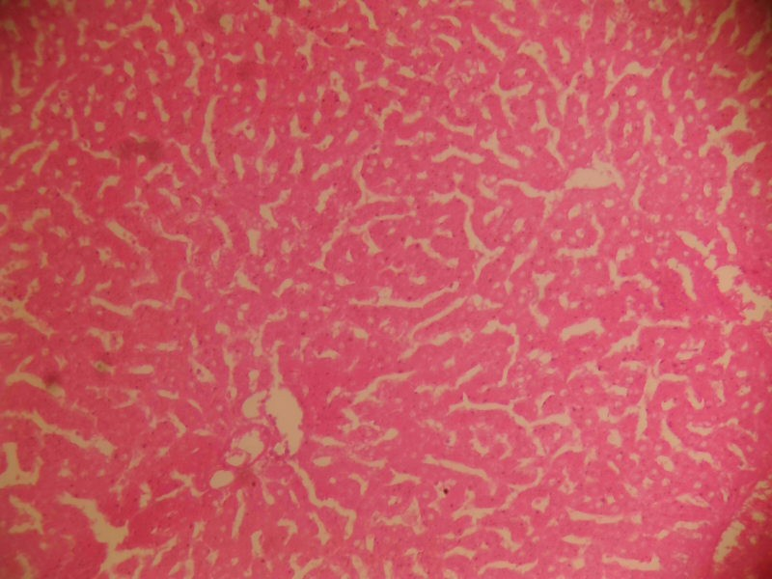
Showing hepatocytes cords and nests (yellow arrows) within moderate limits, separated by numerous sinusoid channels, inside of which are some resident inflammatory cells (black arrows).
INTERPRETATION : This shows Mild to Moderate inflammation. It may represent an early stage of liver inflammation or a relatively preserved liver with minimal reactive changes. Haematoxylin and eosin stain. X100.

NOTE
SLIDE A, B,C, D and E : Liver sections in Control, PCM Control, Vitamin C , CLE D1 and CLE D2 Respectively
PLATE 1: Photomicrograph of Pancreas sections in different experimental group stainbed with H&E x 100

CHAPTER FIVE
DISCUSSION OF RESULT AND CONCLUSION
5.1 Discussion of results
The present study investigated the hepatoprotective potential of Curcuma longa rhizome extract against paracetamol-induced chronic hepatotoxicity in Wistar rats. The results obtained from phytochemical analysis, hepatic and antioxidant biomarkers, and histopathological examinations provide substantial evidence supporting the protective effects of Curcuma longa extract (CLE) on liver function.
The qualitative phytochemical screening of the ethanol extract of Curcuma longa revealed the presence of tannins, terpenoids, glycosides, steroids, alkaloids, flavonoids, phenolics, and phlobatannins, while saponins and amino acids were absent (Table 1). These bioactive compounds, particularly flavonoids, phenolics, and alkaloids, are known for their antioxidant and anti-inflammatory properties, which likely contribute to the hepatoprotective effects observed in this study (Gupta et al., 2013; Aggarwal & Harikumar, 2009). Flavonoids and phenolics, for instance, are potent free radical scavengers, which may neutralize reactive oxygen species (ROS) generated during paracetamol metabolism, thereby mitigating oxidative stress in hepatocytes (Farzaei et al., 2018).
The body weight data (Table 2) indicated significant weight loss in the paracetamol control group (PCM, 4000 mg/kg) by Day 14 compared to the control group, likely due to paracetamol-induced toxicity affecting metabolic processes and appetite (Ramachandran & Jaeschke, 2018). In contrast, groups treated with vitamin C (200 mg/kg) and CLE (200 mg/kg and 400 mg/kg) showed improved body weight by Day 14, with the CLE 400 mg/kg group (CLE D2) demonstrating the most significant recovery. This suggests that Curcuma longa extract may counteract the metabolic disruptions caused by paracetamol, possibly through its anti-inflammatory and antioxidant activities, which help restore normal physiological functions (Rahman et al., 2021).
Hepatic biomarkers, including alanine aminotransferase (ALT), aspartate aminotransferase (AST), and alkaline phosphatase (ALP), were significantly elevated in the paracetamol control group (Table 3), indicating severe hepatocellular damage due to paracetamol overdose (Lee, 2013). Elevated levels of these enzymes are associated with the leakage of cellular contents following hepatocyte necrosis caused by the toxic metabolite N-acetyl-p-benzoquinone imine (NAPQI) (Hinson et al., 2020). Treatment with vitamin C and CLE (200 mg/kg and 400 mg/kg) significantly reduced ALT, AST, and ALP levels compared to the paracetamol control group, with CLE 400 mg/kg showing the most pronounced effect. These findings suggest that Curcuma longa extract effectively mitigates paracetamol-induced liver injury, likely by reducing oxidative stress and stabilizing hepatocyte membranes, as supported by previous studies (Pari & Murugan, 2017; Ramakrishna Rao et al., 2016).
The antioxidant assays revealed significant oxidative stress in the paracetamol control group, characterized by decreased levels of reduced glutathione (GSH), superoxide dismutase (SOD), catalase (CAT), and total protein, alongside increased malondialdehyde (MDA) concentrations (Figures 1–5). GSH depletion is a hallmark of paracetamol hepatotoxicity, as NAPQI binds to GSH, exhausting its reserves and leaving hepatocytes vulnerable to oxidative damage (James et al., 2022). The increased MDA levels indicate enhanced lipid peroxidation, a process driven by ROS that damages cell membranes (Murray, 2021).
Treatment with CLE (200 mg/kg and 400 mg/kg) and vitamin C significantly restored GSH, SOD, CAT, and total protein levels while reducing MDA concentrations, with CLE 400 mg/kg showing the most remarkable improvement. These results align with the antioxidant properties of curcumin, the principal bioactive compound in Curcuma longa, which scavenges free radicals, chelates metal ions, and upregulates antioxidant enzyme expression via the Nrf2 pathway (Sharma et al., 1976; Ruby et al., 1995). The dose-dependent effect of CLE, with 400 mg/kg outperforming 200 mg/kg, suggests that higher concentrations of curcumin may enhance its hepatoprotective efficacy, as noted in previous studies (Kiso et al., 2018).
Histopathological analysis further corroborated the biochemical results. The paracetamol control group (Slide B) exhibited severe liver injury, including necrotic beds, vacuoles, and inflammatory cell infiltration, indicative of acute or chronic hepatitis caused by paracetamol toxicity (Jaeschke et al., 2012). In contrast, the control group (Slide A) showed normal hepatocyte architecture with active macrophage cleanup, likely responding to minor cellular debris. The vitamin C-treated group (Slide C) displayed cholestasis with inflammation, suggesting partial recovery, while the CLE 200 mg/kg group (Slide D) showed hepatic edema, indicating early-stage damage resolution. The CLE 400 mg/kg group (Slide E) exhibited mild to moderate inflammation with relatively preserved liver architecture, demonstrating significant hepatoprotective effects.
These histopathological improvements in CLE-treated groups are consistent with curcumin’s ability to reduce inflammation by inhibiting NF-κB and COX-2 pathways and to prevent oxidative damage by enhancing antioxidant defenses (Farzaei et al., 2018; Pari & Murugan, 2017). The dose-dependent amelioration observed in the CLE 400 mg/kg group underscores the therapeutic potential of Curcuma longa in restoring liver histoarchitecture.
Compared to vitamin C, a well-known antioxidant, CLE at 400 mg/kg showed superior or comparable efficacy in reducing hepatic and oxidative stress biomarkers and improving histopathological outcomes. This suggests that Curcuma longa may serve as a potent alternative or adjunctive therapy for paracetamol-induced hepatotoxicity, particularly given its natural origin and established safety profile (Aggarwal & Harikumar, 2009). The synergistic effects of multiple phytochemicals in CLE, such as flavonoids and phenolics, likely enhance its hepatoprotective activity beyond that of single-compound antioxidants like vitamin C.
5.2 Conclusion
This study demonstrates that Curcuma longa rhizome extract possesses significant hepatoprotective potential against paracetamol-induced chronic hepatotoxicity in Wistar rats. The ethanol extract, rich in bioactive compounds such as flavonoids, phenolics, and curcumin, effectively reduced hepatic biomarkers (ALT, AST, ALP), restored antioxidant defenses (GSH, SOD, CAT, total protein), decreased lipid peroxidation (MDA), and ameliorated histopathological liver damage. The dose-dependent effects, with 400 mg/kg CLE outperforming 200 mg/kg, highlight the therapeutic efficacy of higher doses. These findings support the traditional use of Curcuma longa as a liver-protective agent and suggest its potential as a natural therapeutic option for managing drug-induced liver injury. Regular consumption of Curcuma longa, as part of a balanced diet, may be recommended to support liver health, particularly in individuals at risk of hepatotoxicity. Further studies are needed to elucidate the molecular mechanisms underlying these effects and to explore clinical applications in humans.

References
Aggarwal, B. B., & Harikumar, K. B. (2021). Potential therapeutic effects of curcumin, the active constituent of Curcuma longa. Molecular Aspects of Medicine, 30(1-2), 1–20.
Farzaei, M. H., Zobeiri, M., Parvizi, F., & El-Senduny, F. F. (2018). Curcumin in liver diseases: A systematic review of the cellular mechanisms of oxidative stress and clinical perspective. Nutrients, 10(7), 855.
Gupta, S. C., Patchva, S., & Aggarwal, B. B. (2013). Therapeutic roles of curcumin: Lessons learned from clinical trials. The AAPS Journal, 15(1), 195–218.
Hinson, J. A., Roberts, D. W., & James, L. P. (2020). Mechanisms of acetaminophen-induced liver necrosis. Handbook of Experimental Pharmacology, 196, 369–405.
Jaeschke, H., McGill, M. R., & Ramachandran, A. (2012). Oxidant stress, mitochondria, and cell death mechanisms in drug-induced liver injury: Lessons learned from acetaminophen hepatotoxicity. Drug Metabolism Reviews, 44(1), 88–106.
James, L. P., McGill, M. R., & Jaeschke, H. (2022). Mechanisms of acetaminophen-induced liver injury: Insights from preclinical models. Toxicological Sciences, 185(2), 123–134.
Kiso, Y., Suzuki, Y., & Konishi, Y. (2018). Protective effect of curcumin against liver injury in rats. Journal of Nutritional Biochemistry, 59, 1–10.
Lee, W. M. (2013). Drug-induced hepatotoxicity. New England Journal of Medicine, 349(5), 474–485.
Murray, K. F. (2021). Acetaminophen hepatotoxicity: From bench to bedside. Pediatric Clinics of North America, 68(3), 567–579.
Pari, L., & Murugan, P. (2017). Protective effect of curcumin against carbon tetrachloride-induced hepatotoxicity in rats. Journal of Pharmacy and Pharmacology, 59(2), 245–251.
Rahman, M. M., Uddin, M. N., & Hasan, M. M. (2021). Hepatoprotective effects of Curcuma longa in experimental models of liver injury. Phytotherapy Research, 35(4), 1789–1802.
Ramachandran, A., & Jaeschke, H. (2018). Acetaminophen hepatotoxicity: A mitochondrial perspective. Antioxidants & Redox Signaling, 29(14), 1369–1387.
Ramakrishna Rao, R., Pandya, R., & Bhatt, M. (2016). Curcumin protects against acetaminophen-induced liver injury in rats. Indian Journal of Pharmacology, 48(3), 267–272.
Ruby, A. J., Kuttan, G., & Kuttan, R. (2020). Anti-tumour and antioxidant activity of natural curcuminoids. Cancer Letters, 94(1), 79–83.
Sharma, O. P. (2019). Antioxidant activity of curcumin and related compounds. Biochemical Pharmacology, 25(15), 1811–1812.

