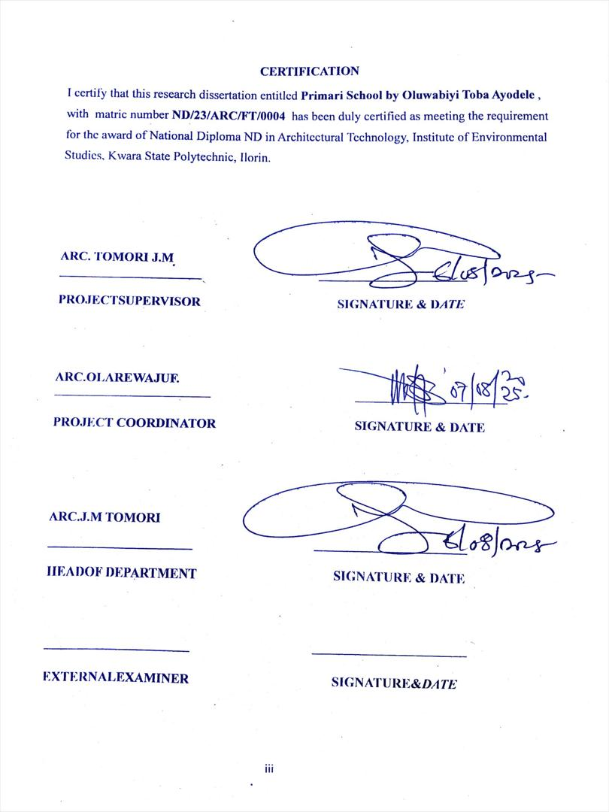

A PROJECT REPORT
ON
PROPOSED PRIMARY SCHOOL
FOR
MERCY LAND COMMUNITY, OTUN EKITI, EKITI STATE
BY
OLUWABIYI TOBA AYODELE
ND/23/ARC/FT/0004
SUBMITTED TO: THE DEPARTMENT OF ARCHITECTURAL TECHNOLOGY, INSTITUTE OF ENVIROMENTAL STUDIES (I.E.S), KWARA STATE POLYTECHNIC, ILORIN

IN PARTIAL FULFILLMENT OF THE REQUIREMENT FOR THE AWARD OF NATIONAL DIPLOMA (ND) IN ARCHITECTURAL TECHNOLOGY.

JULY, 2025
DECLARATION
I declare that this report is a product of my personal research work. It has not been presented for the award of any degree in any Polytechnic. The ideas, observations, comments, suggestions herein represent my own convictions, except quotations, which have been acknowledged in accordance with conventional academic traditions.
OLUWABIYI TOBA AYODELE,
ND/23/ARC/FT/0004

Signature: __________________ Date: ____________________

Project Title:
PRIMARY SCHOOL

ACKNOWLEDGMENT
I return all the glory, honor, praise and adoration to the master of the universe that have given me the privilege of seeing the end of this program of him alone be the glory. My immediate gratitude goes to my supervisor who has been supportive responsive throughout this project, may God continue to reward you and your family.
My appreciation goes to my Amiable Head Of Department in person of ARC. J. M TOMORI. My sincere gratitude goes to my parent, MR & MRS OLAWABIVI who brought me to this world, may you eat the fruit of your labor.
However, my gratitude also goes to all my colleague, friends, brothers, sisters and well wishers. May your life experience joy.
My heartfelt gratitude goes to all my lecturers and the entire faculty for their dedication and knowledge shared over the years, which laid the foundation for this project.
Lastly I acknowledge everyone who directly or indirectly contributed to the successful completion of this project. Your support is deeply appreciated.

ABSTRACT
The architectural design of a dental clinic is a critical component that significantly impacts the functionality, comfort, and overall patient experience. liffective design strategies must prioritize patient well-being, operational efficiency, and infection control while integrating modern dental technology. The layout should optimize workflows, ensuring smooth transitions between waiting areas, consultation rooms, treatment zones, and staff spaces.
Key elements such as lighting, acoustics, and air quality contribute to creating a calming atmosphere, patient enhancing comfort.
Aesthetic considerations, liker house of soothing colors and materials. Promote a positive environment conducive 10 healing. Additionally, incorporating sustainable design practices, such as energy-efficient systems and eco-friendly materials, is becoming increasingly important in modern dental clinic architecture. The goal is to create a space that not only meets the technical needs of dental professionals but also fosters trust and comfort for patients, ultimately improving both the clinical and emotional outcomes of dental care. This study presents the design of a sustainable and functional primary school tailored to the unique needs of the Mercy Land Community in Otun Ekiti. Nigeria. The design is based on a detailed case study approach, assessing existing educational infrastructure, climatic conditions, cultural context, and community needs. Key considerations include spatial organization, natural ventilation, lighting, accessibility, and the use of locally sourced, cost-effective materials. Emphasis is placed on creating a child-friendly environment that supports interactive learning, safety, and community integration.
The findings from the case study informed design strategies that enhance durability, adaptability, and inclusivity. This project aims to serve as a model for future rural educational developments that align with both pedagogical goals and local identity.

TABLE OF CONTENT
Title Page…………………………………………………………………………………… I
Declaration ………………………………………………………………………………… II
Certification ………………………………………………………………………………. III
Acknowledgement . ……………………………………………………………………… IV
Abstract ………………………………………………………………………………….., V
Table Of Content ………………………………………………………………………… VI
List Of Figure.. ………………………………………………………………………….. VII
List Of Plate. ……………………………………………………………………………. VIII
List Of Table. …………………………………………………………………………… IX
List Of Appendices ……………………………………………………………………… X

CHAPTER ONE
1.0 Introduction. …………………………………………………………………………1
1.1 Historical Background ………………………………………………………………2
1.2 Definition Of Terms …………………………………………………………….…..2
1.3 Aims and Objective …………………………………………………………….…..3
1.3.1 Aims . ………………………………………………………………………..……3
1.3.2 Objective. …………………………………………………………………………3
1.4 Justification. …………………………………………………………………………4
1.5 Limitation Of The Study …………………………………………………………….4
1.6 Research Methodology ………………………………………………………………5
CHAPTER TWO
2.1 Literature Review ……………………………………………………………………..8
2.1.1 Introduction . ………………………………………………………………………. 8
2.1.2 Important Issues And Problems Peculiar To Primary School Typology ……………8
2.1.3 Technological And Environmental Approaches For Designing A Primary School .....8

CHAPTER THREE
3.0 Case Studies .. …………………………………………………………………….. 10
3.1 Case Study One. …………………………………………………………………..12
3.2 Case Study Two . …………………………………………………………………15
3.3 Case Study Three.. ………………………………………………………………...18
3.4 Online Case Study Four ……………………………………………………………21
3.5 Online Case Study Five . …………………………………………………………..23
CHAPTER FOUR
4.1 Site Location Criteria. …………………………………………………………… 24
4.2 Site Analysis /Inventory …………………………………………………………..25
4.3 Geographical / Climatic Data ……………………………………………………..25
4.4 Analysis Of The Immediate Environmental Condition Site ………………………28
4.5 Scope Analysis .. …………………………………………………………………..31
4.6 Design Appraisal. ……………………………………………………………….....32
4.7 Equipment and operational performance requirements. …………………………..34
4.8 Spatial Allocation table ……………………………………………………………37
4.9 Functional relationship ……………………………………………………………38
4.10 conceptual development …………………………………………………………38
CHAPTER FIVE
5.1 Appraisal Of Proposed Scheme . …………………………………………………40
5.2 Construction Methodology And Material.. ……………………………………….40
5.3 Building service …………………………………………………………………...41
5.4 Conclusion and Recommendation ………………………………………………...43
References …………………………………………………………………………….44
LIST OF FIGURE
Figure 1.1 locational plan …………………………………………………………… 13
Figure 1.2 floor plan.. ………………………………………………………………... 1 3
Figure 2.1 locational plan ……………………………………………………………. 1 6
Figure 2.2 floor plan ………………………………………………………………….. 16
Figure 3.1 locational plan.. ……………………………………………………………. 19
Figure 3.2 Floor plan ………………………………………………………………….. 19
Figure 4.1 floor plan …………………………………………………………………… 21
Figure 5.1 floor plan …………………………………………………………………… 23

LIST OF PLATE
Plate 1.1 Elevation ……………………………………………………………………… 14
Plate 1.2 Elevation . …………………………………………………………………….. 14
Plate 1 .3 Elevation……………………………………………………………………… 14
Plate 2.1 Elevation ……………………………………………………………………… 17
Plate 2.2 Elevation ……………………………………………………………………… 14
Plate 2.3 Elevation ……………………………………………………………………… 14
Plate 3.1 Elevation ……………………………………………………………………… 20
Plate 3.2 Elevation ……………………………………………………………………… 20
Plate 3.3 Elevation ……………………………………………………………………… 20
Plate 4.1 Elevation ……………………………………………………………………… 22
Plate 5.1 Elevation ……………………………………………………………………… 23

LIST OF TABLES
4.8 Spatial allocation table . ……………………………………………………………. 37

LIST OF APPENDIX

Appendix 5.1 floor plan.. ……………………………………………………………… 45
Appendix 5.2 Roof plan ……………………………………………………………….. 45
Appendix 5.3 section xx and yy ………………………………………………………. 46
Appendix 5.4 locational plan …………………………………………………………. 47
Appendix 5.5 internal perspectives …………………………………………………… 48

CHAPTER ONE

1.0 INTRODUCTION
Primary School is an essential part of our lives. It would be difficult to imagine not having our teachers and school friends, but when the British Government passed something called the Elementary Education Act in 187(), almost half of the 4.3 million children of primary school age in England and Wales did not have access to school education. This was the first of a number of acts of Parliament passed to create compulsory education for children aged between5and13. Thousands of state funded schools had to be built to meet the new demand. Parents had to pay for children's places, but the government would fund children from the poorest families. During the reign of Queen Victoria (1837-1901), Britain's cities became increasingly overcrowded and polluted. The Industrial Revolution started in the 1700s, but 1870-1914 is often called the Second Industrial Revolution because there were so many new inventions. Adults and children left the countryside in huge numbers to find work in urban factories. Children could work long hours, with dangerous machinery, for very low wages. The government wanted to educate children so that they would make well informed voting decisions as adults and contribute to a more skilled work force. They believed this would help Britain to keep ahead as an industrial power. Bunt, L., & Howard, C. (2018)
The architectural design of primary schools plays a crucial role in shaping the educational experience of young children. It encompasses not only the aesthetic and functional aspects of a building but also considers how the design can support pedagogical goals, enhance student well-being, and create an environment conducive to learning. The architecture of primary schools must address diverse requirements such as safety, accessibility, sustainability, and flexibility while reflecting the cultural context and educational values of the community. Cowan, R., & Turner, J. (2014). A sense of ownership and pride in the school is often fostered when the design integrates elements of the local context and community values. UNESCO (2012).
By focusing on the various design elements, architects can create educational environments that are not only functional and sustainable but also promote the well-being and development of children, fostering a generation of learners who are both inspired and equipped to succeed.

1.1 HISTORICALBACKGROUND
The design of primary schools has evolved significantly over the centuries, influenced by changes in educational philosophy, societal needs, and advancements in architectural technology. From the early informal educational settings to the modern, purpose-built schools, the architectural design of primary schools has been shaped by both cultural values and practical considerations.
Before formal schools were established, education was often conducted in private homes, churches, or other informal spaces. In ancient civilizations, such as in Greece and Rome, education took place in open areas or modest buildings, sometimes under the guidance of private tutors. The curriculum focused on basic literacy, numeracy, and moral teachings.
In medieval Europe, education was mainly controlled by religious institutions, and schools were typically located within monasteries or churches. These early schools were small and not designed specifically for young children. The focus was on reading religious texts, with little consideration for the architectural or environmental needs of students.
1.2 DEFINITION OF THE TERMS
General Definition
A primary school is an educational institution that provides the first stage of formal Education for children, typically between the ages of 4 to 11 or 6 to 12, depending on the country. It is designed to teach foundational skills such as literacy, numeracy, and basic social studies, as well as to foster cognitive, emotional, and physical development.

In the Context of the United States (Elementary School) In the U.S., the term primary school is some times used interchangeably with elementary school, although elementary schools typically include kindergarten through grade 5 or 6, depending on the district. Primary schools here are the first years of schooling where children learn the basics of reading, writing, arithmetic, and social behavior.
International Definition (United Kingdom) In the United Kingdom, primary school refers to the first phase of education for children, usually aged 5 to 11 years, covering Key Stages 1 and 2 of the National Curriculum. Primary education in the UK focuses on developing literacy, numeracy, and social skills, along with an introduction to a broad range of subjects such as science, history, and art.
1.3 AIMS & OBJECTIVES
1.3.1 AIM
Crafting an environment that supports the developmental needs of young children, promotes effective learning, and fosters a positive and safe atmosphere.
As the architect, my aim is to design a sustainable, functional, and inclusive primary school for the Mercy Land Community in Otun Ekiti. This project seeks to provide a safe, stimulating, and culturally responsive learning environment that meets the educational needs of the community. My goal is to create a design that not only enhances the quality of basic education but also reflects the identity and values of the people, using appropriate materials, passive design strategies, and community-driven planning principles.

1.3.2 OBJECTIVES
- To design adaptable, flexible classrooms and learning areas that can accommodate different teaching methods, activities, and group sizes. Classrooms should be easily configurable for both individual study and group activities.
- To design with inclusivity in mind by incorporating ramps, wide door ways, elevators, and other accessibility features that allow children with physical disabilities to fully participate in school life.
- To incorporate large windows, skylights, and ventilation systems that allow for natural light and fresh air, which arc essential for creating a healthy learning environment. Natural light has been shown to improve concentration and mood.
- To design safe, well-equipped outdoor play areas that encourage physical activity, creativity, and social interaction. Play is an essential aspect of childhood development, and these areas should be integrated into the overall school layout.
1.4 JUSTIFICATION
Designing a primary school is a significant undertaking that requires careful consideration of multiple factors to ensure the creation of a space that supports the educational, developmental, and social needs of young children. The justification for designing a primary school is based on several key reasons, which stem from the physical, psychological, educational, and social needs of children, as well as the role that the school plays in the community. Primary school design should be centered on the developmental needs of children. During the primary school years, children experience rapid growth and development, both cognitively and physically.
The design of the school must create an environment that supports this growth by offering spaces that promote learning, play, and social interaction.
1.5 LIMITATION OF THE STUDY
Designing a primary school is a complex process that involves numerous factors. While the aim is to create an optimal environment for learning, development, and community, there are several limitations that architects, educators, and planners must consider. These limitations can arise from financial constraints, regulatory requirements, physical space restrictions, and other practical challenges.
1.6 RESEARCIIMETIIODOLOGY
The design of a primary school is a multi-faceted process that requires thorough research to ensure that the built environment supports the educational, social, emotional, and physical needs of children. A well-structured research methodology is essential to gather the necessary data, assess needs, and make informed decisions throughout the design process. Below is an out line of a comprehensive research methodology for designing a primary school.
Identifying Research Objectives and Goals
The first step in the research methodology is to define the specific objectives and goals for the design of the primary school. These goals will guide the entire research process and help ensure that the design meets the intended educational, social, and community needs.
Literature Review
A literature review is conducted to gain insights into existing research and best practices in primary school design. This step allows for the collection of secondary data related to design trends, space planning strategies, and successful school projects from various geographical regions and educational systems.

Key focus areas:
Educational Theories and Pedagogies: Exploring theories like Montessori, Reggio Emilia, or child-centered learning to understand how space impacts teaching and learning.
Previous Case Studies: Reviewing case studies of well-designed primary schools to understand what works well and what doesn't in terms of spatial organization, layout, and facility design.
Sustainability in Design: Researching eco-friendly materials, energy-efficient solutions, and green building standards (e.g., LEED or BREEAM certifications).
Inclusive design: Studying universal design principles to ensure accessibility for all children, including those with physical and learning disabilities.
Health and Safety Standards: Understanding health and safety regulations relevant to school design, including fire codes, safety standards for playgrounds, and sanitary facilities.
Data Collection
The next step is to collect primary data through a variety of methods to better understand the specific needs of the school community. This data will be instrumental in shaping the design process.
Stakeholder Interviews and Surveys
Teachers and Educators: Interviews or surveys with educators to understand their spatial needs for teaching, their vision for the school's learning environment, and the kinds of spaces they require for collaborative and individual work.
Students and Parents: Gathering input from students and parents through surveys or focus groups to understand their expectations for the school's layout, facilities, and overall design.
Community Leaders: Engaging with local community leaders or officials to ensure that the school design reflects the community's values, traditions, and aspirations.
Facilities Management: Discussions with facilities management teams to understand practical concerns about maintenance, accessibility, and the long-term viability of the school infrastructure.
SITE ANALYSIS
Location Study: Analyzing the site's location, environmental conditions, climate, and surrounding infrastructure (e.g., transportati01 5 al amenities, safety concerns).
Physical Site Features: Identifying any challenges or opportunities presented by the topography, soil quality, and existing structures on the site.
Space Constraints: Understanding the site's limitations in terms of space, shape, and accessibility. For example, in urban areas, space might be limited, influencing the decision to design a multi-story school.

CHAPTER TWO
2.1 LITERATUREREVIEW
2.1.1 Introduction
As an architect tasked with designing a primary school for the Mercy Land Community in Otun Ekiti, it is essential to ground the project in existing literature that explores the relationship between educational architecture and learning outcomes, particularly in rural and developing contexts.
Educational Space Design Principles
As an architect designing a primary school for the Mercy Land Community in Otun Ekiti, I have adopted a set of educational space design principles aimed at fostering an engaging, inclusive, and supportive learning environment.
Examples
1: child-centered design
2: Flexibility and adaptability
3: Natural lighting and Ventilation.
2.1.2 Important Issues and Problems Peculiar to Primary School Typology
As an architect working on the design of a primary school in the Mercy Land Community, Otun Ekiti, it is important to recognize the unique challenges and issues that are commonly associated with the primary school typology. These issues influence both the design approach and the functionality of the school environment.
2.1.3 "Technological and Environmental Approaches for Designing a Primary School
As the architect responsible for designing a primary school in the Mercy Land Community, Otun Ekiti, my approach integrates both technological innovations and environmental strategies to create a sustainable, functional, and climate-responsive learning environment. These approaches are especially vital in rural settings where resource limitations demand efficiency, durability, and simplicity in design.
Technology approaches
1. Modular and Prefabricated Construction: To reduce construction time, improve quality control, and allow for future expansion.
2.solar energy integration: Solar streetlights or courtyard lights ensure safety during early morning or evening school activities.
3. Water Management Technology: Rainwater harvesting systems designed with gutters and elevated storage tanks to collect water for toilets and cleaning.
Environmental Approaches for Designing a Primary School
1. Climate-Responsive Orientation
- Positioning buildings to reduce heat gain and take advantage of prevailing winds.
2. Natural Ventilation
- Use of cross-ventilation through windows, louvres, and ventilation blocks.
3. Day lighting
- Maximizing natural light with large, shaded openings to reduce artificial lighting
needs.
4. Shading Devices
- Incorporation of overhangs, verandahs, sunshades, and pergolas to minimize direct sunlight.
5. Use of Local and Sustainable Materials
- Using locally sourced materials like laterite, mud blocks, or bamboo to reduce embodied energy and transportation costs.
Benefits of Technological and Environmental Approaches
1. Improved indoor thermal comfort
2. Enhanced natural lighting and ventilation
3. Reduced energy consumption and utility costs
4. Lower construction and maintenance costs
5. Promotion of better student concentration and health

CHAPTER THREE
3.1 CASE STUDYS
A case study is an in-depth study of one person, group, or event. In a case study, nearly every aspect of the subject's life and history is analyzed to seek patterns and causes of behavior. Case studies can be used in many different fields, including psychology, medicine, education, anthropology, political science, and social work.
The point of a case study is to learn as much as possible about an individual or group so that the information can be generalized to many others. Unfortunately, case studies tend to be highly subjective, and it is sometimes difficult to generalize results to a larger population.
While case studies focus on a single individual or group, they follow a format similar to other types of psychology writing. If you are writing a case study, we got you—here are some rules of APA format to reference.
A case study, or an in-depth study of a person, group, or event, can be a useful research tool when used wisely. In many cases, case studies are best used in situations where it would be difficult or impossible for you to conduct an experiment. They are helpful for looking at unique situations and allow researchers to gather a lot or information about a specific individual or group of people. However, it's important to be cautious of any bias we draw from them as they are highly subjective.

What Arc the Benefits and Limitations of Case Studies
A case study can have its strengths and weaknesses. Researchers must consider these pros and cons before deciding if this type of study is appropriate for their needs.
One of the greatest advantages of a case study is that it allows researchers to investigate things that are often difficult or impossible to replicate in a lab.
Some other benefits of a case study: I
- Allows researchers to capture information on the 'how, "what,' and 'why,' of something that's implemented
- Givesresearchersthechancetocollectinformationonwhyonestrategymightbechosen over another
- Permits researchers to develop hypotheses that can be explored in experimental research.
Cons
On the other hand, a case study can have some draw backs:
- It can not necessarily be generalized to the larger population
- Cannot demonstrate cause and effect
- It may not be scientifically rigorous
- It can lead to bias
Researchers may choose to perform a case study if they want to explore a unique or recently discovered phenomenon. Through their insights, researchers develop additional ideas and study questions that might be explored in future studies.
It's important to remember that the insights from case studies cannot be used to determine cause-and- effect relationships between variables. However, case studies may be used to develop hypotheses that can then be addressed in experimental research.

CASE STUDY EXAMPLES
There have been a number of notable case studies in the history of psychology. Much of Freud's work and theories were developed through individual case studies. Some great examples of case studies in psychology include:
Anna O: Anna O. was a pseudonym of a woman named Bertha Pappenheim, a patient of a physician named Josef Breuer. While she was never a patient of Freud's, Freud and Breuer discussed her case extensively. The woman was experiencing symptoms of a condition that was then known as hysteria and found that talking about her problems helped relieve her symptoms. Her case played an important part in the development of talk therapy as an approach to mental health treatment.
Phineas Gage: Phineas Gage was a railroad employee who experienced a terrible accident in which an explosion sent a metal rod through his skull, damaging important portions of his brain. Gage recovered from his accident but was left with serious changes in both personality and behavior.
Genie: Genie was a young girl subjected to horrific abuse and isolation. The case study of Genie allowed researchers to study whether language learning was possible, even after missing critical periods for language development. Her case also served as an example of how scientific research may interfere with treatment and lead to further abuse of vulnerable individuals.
Such cases demonstrate how case research can be used to study things that researchers could not replicate in experimental settings. In Genie's case, her horrific abuse denied her the opportunity to learn a language at critical points in her development.
CASE STUDY ONE
OS IN PRIMARY SCHOOL ILORIN, KWARA STATE
CASE STUDY TWO
METHODIST SCHOOL, OGBOMOSO OYO STATE
CASE STUDY THREE
SAINT PETTER'SANGLICAN PRIMARY SCHOOL, OTUN EKITI, EKITI STATE
CASE STUDYONE
OS IN PRIMARY SCHOOL ILORIN, KWARA STATE
Osin Primary School in Ilorin, Kwara State, Nigeria, has a history that reflects the broader educational developments in the region. Established in the early 20th century, the school was part of the Nigerian government's efforts to expand access to education, particularly in rural areas.
Initially, the school served as a community-based initiative aimed at providing basic education to children. Over the decades, it has evolved, adapting to changes in educational policies and societal needs. The school has focused on improving literacy rates and providing a foundation for further education.
Throughout its history, Osin Primary School has faced challenges, including infrastructural deficits and funding issues. However, it has remained a vital institution in the community, contributing to the education of many generations of students.
In recent years, there has been an emphasis on improving facilities and teaching quality, often supported by local government initiatives and community involvement. The school continues to play a crucial role in the educational landscape of Ilorin, shaping the futures of its students.

LOCATION
OSIN PRIMARY SCHOOL, ILORIN KWARA STATE
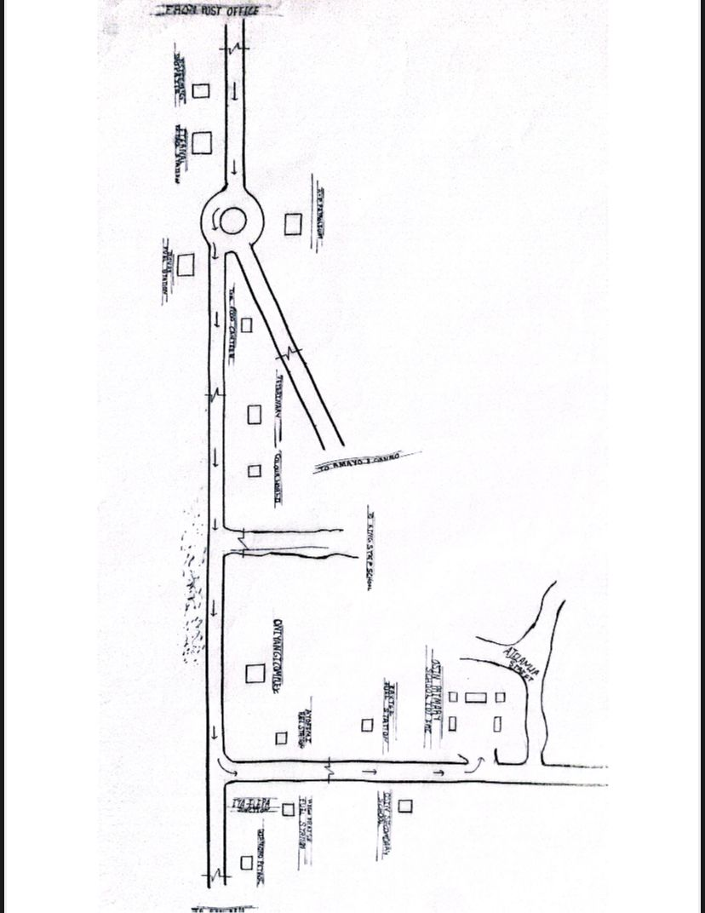
Figure 1.1 : Locational Plan
Figure 1 Floor Plan of Case Study One, Osin Primary School, Ilorin Kwara State
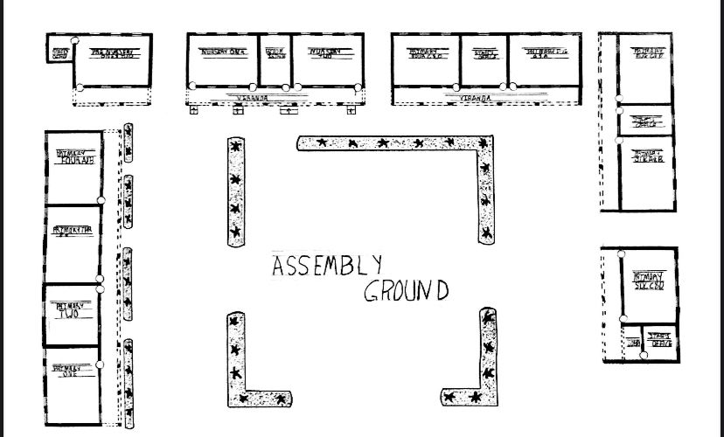
Figure 1.2 : Floor Plan
Plate 1.1 Elevation of Case Study One, Osin Primary School, Ilorin Kwara State

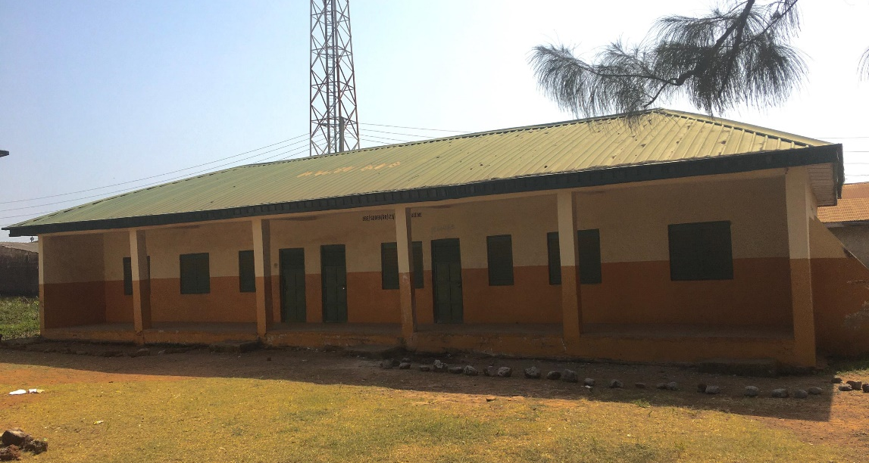
Plate 1. 2 Front View of Case Study One, Osin Primary School, Ilorin Kwara State
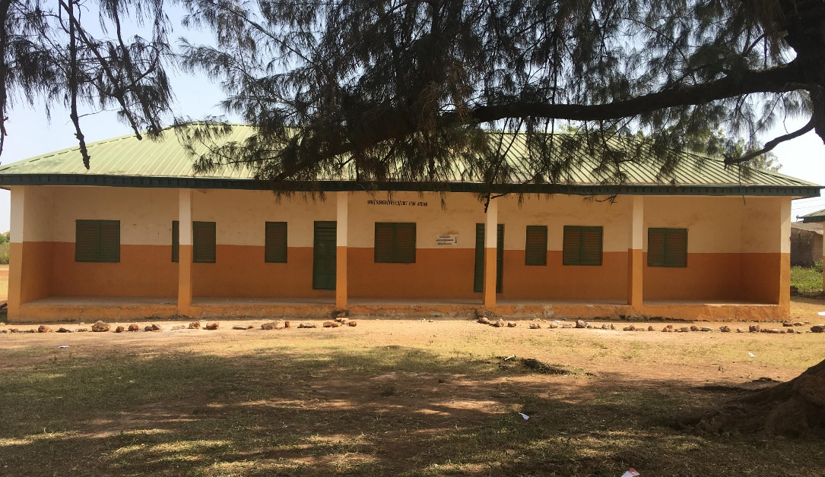

MERIT
Lighten and ventilation
Community accessibility: Schools are centrally located, allowing easy walking access for children.
DEMERIT
Lack of security o Lack of parking space
CASE STUDY TWO
METHODIST SCHOOL, OGBOMOSO OYO STATE
Methodist School, Ogbomosho, located in Oyo State, Nigeria, has a rich history rooted in the establishment of missionary education in the region. The school was founded in the late 19th century, specifically in 1878, by the Methodist Church, which sought to provide quality education along side its religious mission.
Initially, the school aimed to serve the children of Methodist congregants and the wider community, emphasizing moral and academic instruction. Over they ears, it became known for its commitment to academic excellence and character development.
In the early 20th century, the school expanded its curriculum and facilities, adapting to the educational needs of the growing population. It played a significant role in the education of many prominent Nigerian leaders and professionals.
Today, Methodist School, Ogbomosho, continues to uphold its founding principles, focusing on holistic education while fostering a strong sense of community and faith among its students. The school remains an important institution in Ogbomosho, contributing to the educational landscape of Oyo State.

LOCATION
METHODIST SCI 10010, OGBOMOSHO OYO SIATE
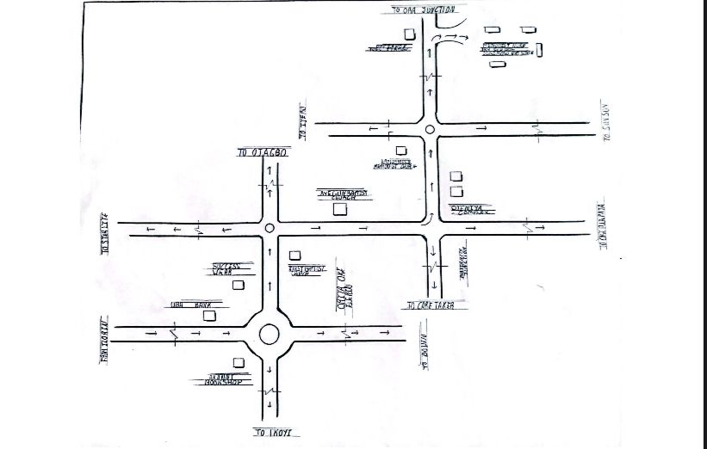
Figure 2.1 Locational plan
FLOOR PLAN
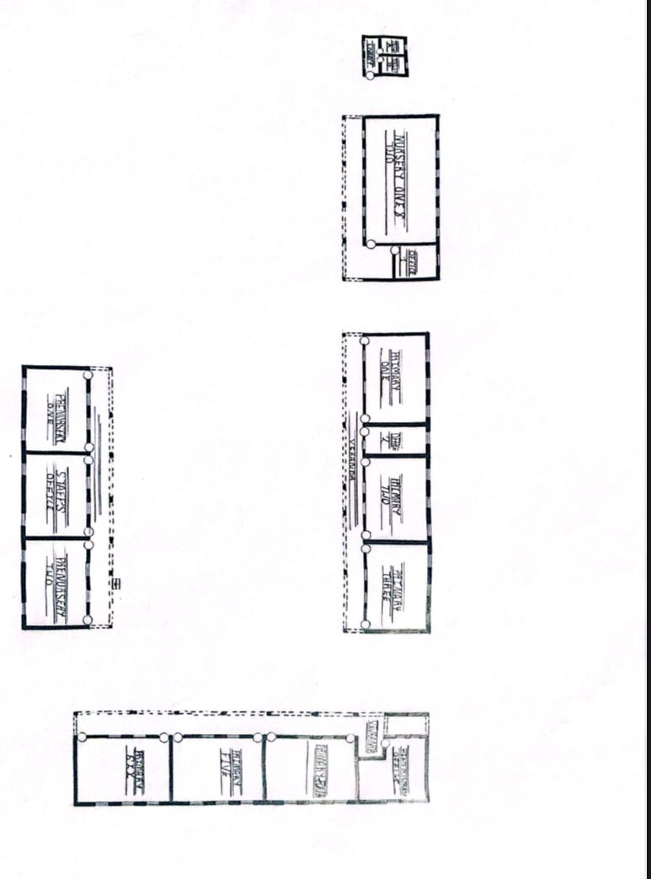
Figure 2.2 Floor Plan

Plate 2.1 Showing The Back View of The Class Room
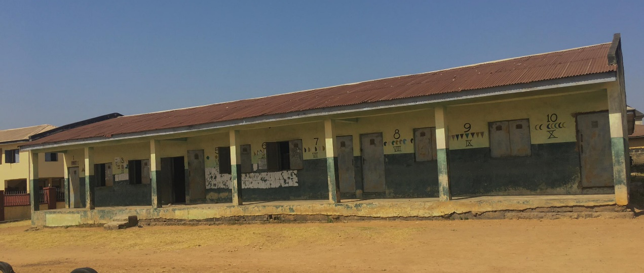
Plate 2.2 Showing The Front View of The Class Room
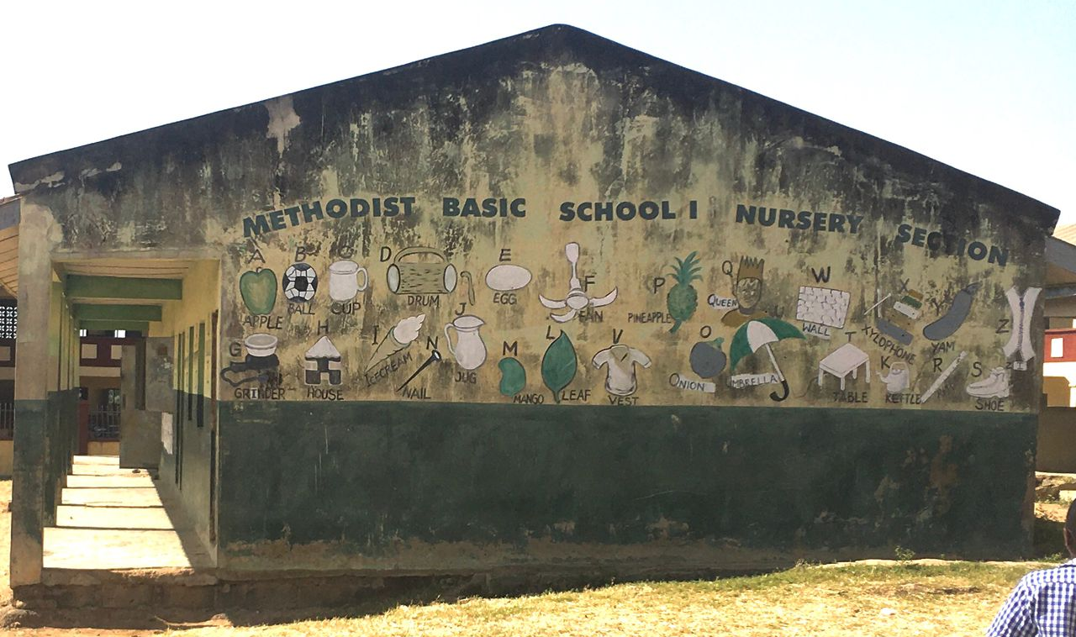
MERITS
Well Ventilated
Enough space for future expansion
e security
DEMERIT
Not well landscape Not well arrange
CASE STUDY THREE
Brief History Of Saint Peters' Anglican Primary School, Otun Ekiti, Ekiti State
Saint Peter's Anglican Primary School, Otun Ekiti, was established in 1914 as part of the Church Missionary Society's efforts to provide education in the region. Founded under the auspices of the Anglican Church, the school aimed to offer quality education that integrated moral and spiritual development with academic learning.
The school began with a small number of students and gradually expanded its enrollment and curriculum to meet the educational needs of the local community. Over the years, it has played a significant role in the education of children in Otun Ekiti and the surrounding areas, emphasizing values such as discipline, integrity, and service.
In the latter half of the 20th century, the school faced challenges such as infrastructural needs and changes in educational policy, but it continued to adapt and grow. Today, Saint Peter's Anglican Primary School remains a vital educational institution in Otun Ekiti, known for its commitment to academic excellence and character formation, contributing to the development of future leaders in the community.

LOCATION
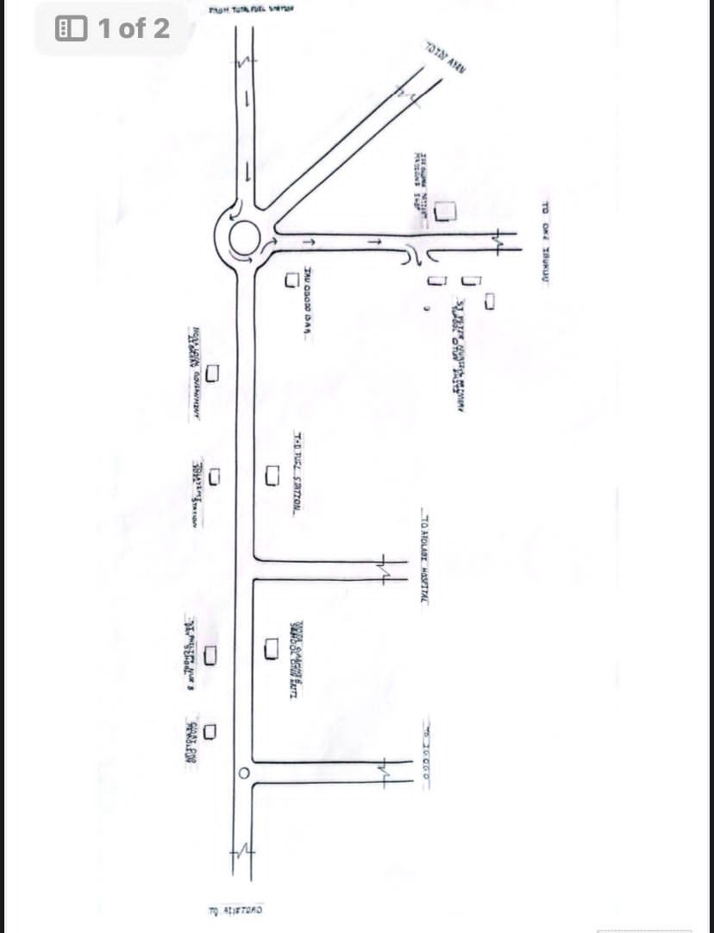
Figure 3.1 Locational plan for ST's peter's Anglican school Otun Ekiti
FOOR PLAN
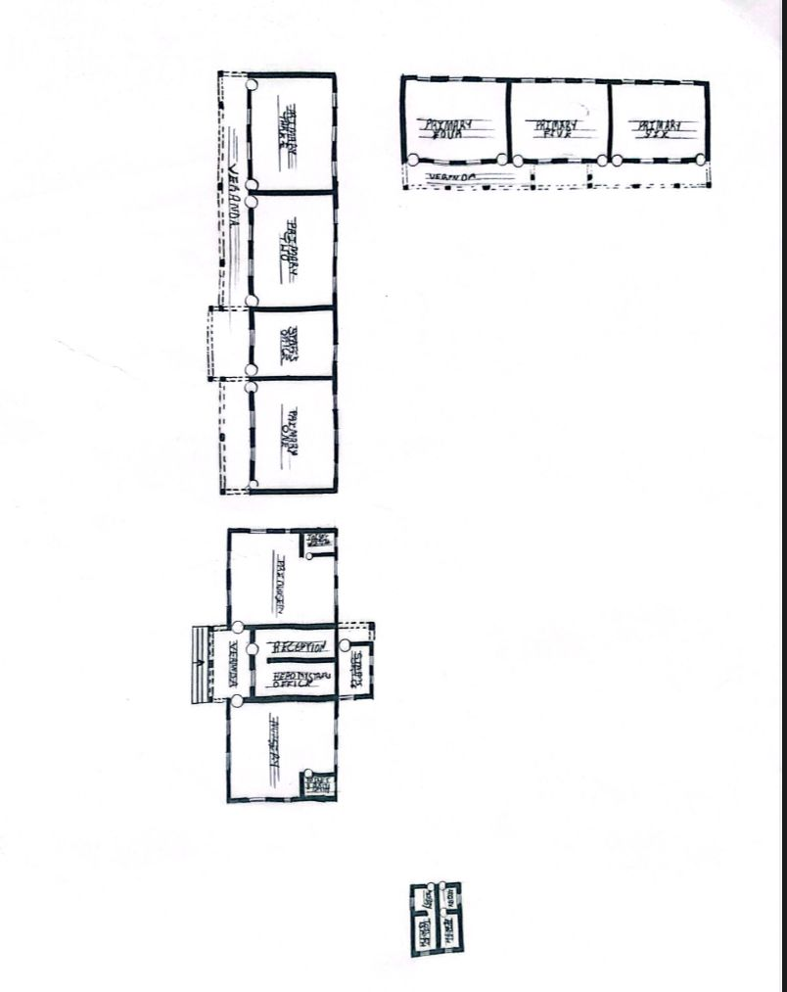
Figure 3.2 Floor Plan

Plate 3.1 Showing Elevation View
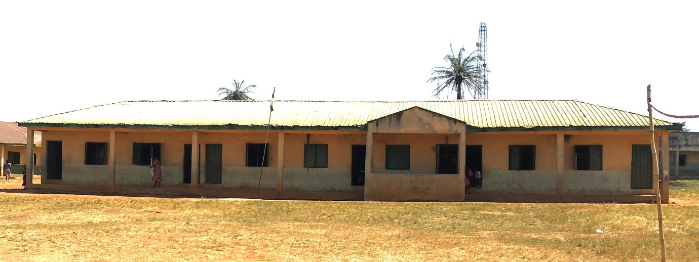
Plate 3.2 Showing Elevation View
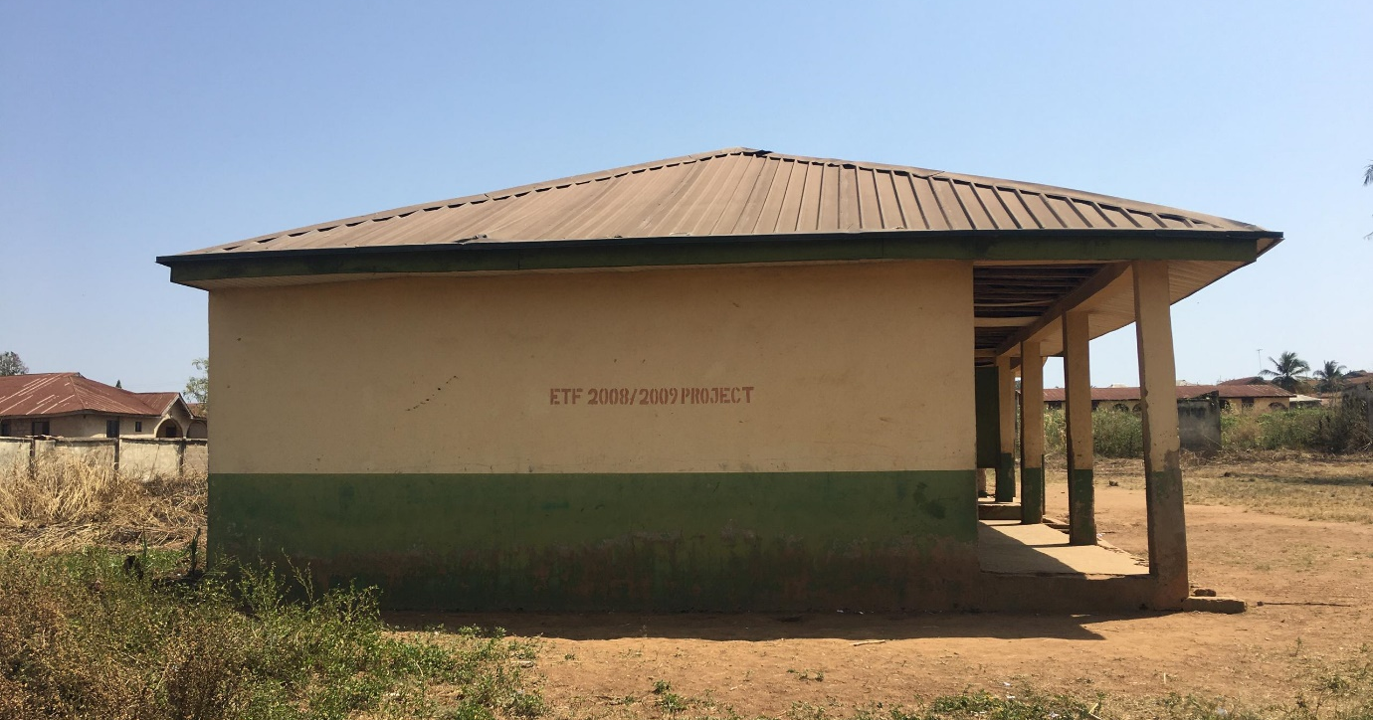
MERIT
Well painted
Natural Ventilated
DEMERIT
Is not easily accessible
The structure was a little bit old
ONLINE CASE STUDY FOUR
Benton elementary school united state of America
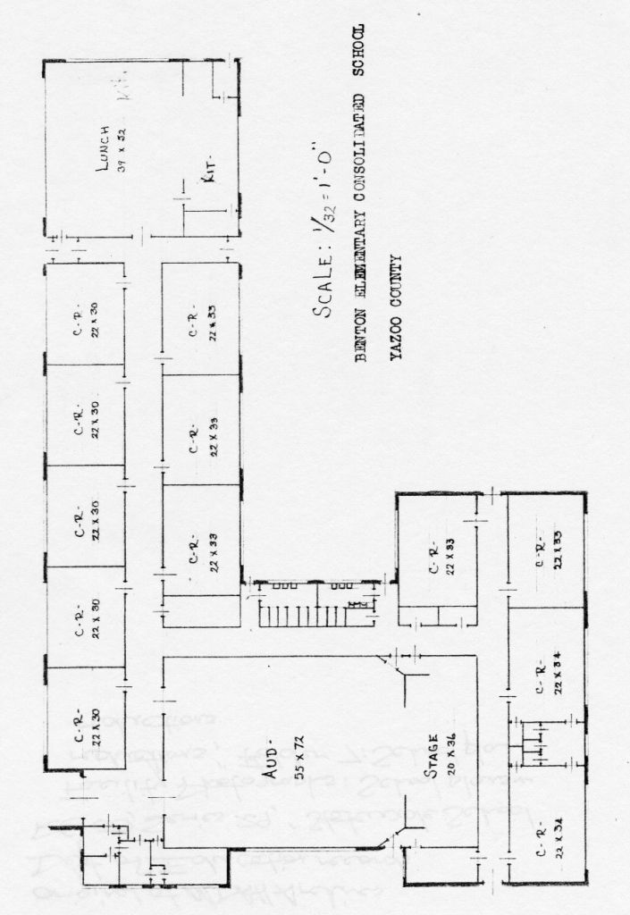
Figure 4.1 Floor Plan
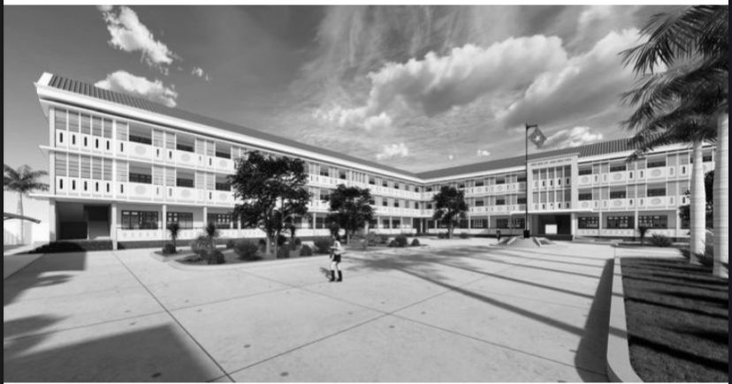
Figure 4.2 Elevation
ONLINE CASE STUDY FIVE
Elementary and middle school Japan
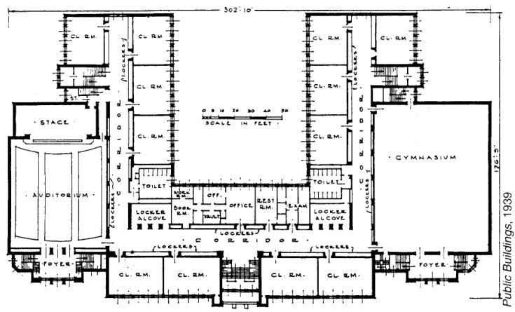
Figure 5.1 floor plan
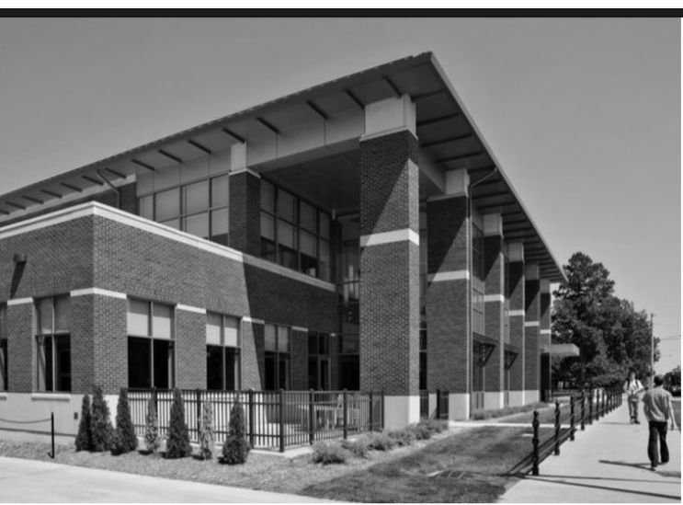
Figure 5.2 Elevation

CHAPTER FOUR
4.1 SITE LOCATION AND CRITERIA
The proposed site is located at Otun Ekiti a town in moba local government area of Ekiti state.
1. Accessibility
- Proximity to residential areas — close to the communities it will serve.
- Safe routes for children — Walkable paths, pedestrian crossings, and low-traffic zones.
- Public transportation access — Especially in urban areas.
2. Safety and Security
- Distance from hazards — Avoids siting near highways, factories, power stations, flood prone zones, or open water bodies.
- Noise pollution Away from markets, airports, or busy roads.
- Visibility and lighting — Well-lit and visible area to enhance safety.
3. Topography and Soil Condition
- Flat & gently sloping land — For ease of construction and movement.
- Stable soil — Suitable for building foundations (avoid waterlogged or swampy areas).
4. Space Availability
- Adequate land area — To accommodate buildings, play areas, sports fields, parking, and future expansion.
- Conformity to planning standards —As per local education or urban planning regulations.

5. Utilities and Infrastructure
- Water supply — Clean, reliable source for drinking, sanitation, and cleaning.
- Electricity — For lighting, fans, ICT tools, etc.
- Drainage system — Proper stormwater drainage to avoid flooding.
- Sanitation facilities — Suitable location for toilets and waste management.
6. Environmental Quality
- Air quality — Should be good, especially for younger children.
- Green space — Presence of trees and natural ventilation is a plus.
- Climate considerations — The site should allow good orientation to sun and wind for energy efficiency.
7. Legal and Regulatory Compliance
- Zoning laws — Ensure the area is zoned for educational use.
- Land ownership — Clear title with no disputes.
- Approval from relevant authorities — Ministry of Education, local government, etc.
8. Community Acceptance
- Cultural compatibility — Should align with the social norms and values of the community.
- Community support — Engaging the local people helps long-term sustainability.

4.2 SITE ANALYSIS/INVENTORY
Site analysis is a crucial phase in architectural design, providing the foundational understanding needed to inform and shape a project's development.
SITE INVENTORY
Site inventory provides the foundation for informed design and planning decisions. By documenting physical characteristics, legal and regulatory information, environmental considerations, and social factors, designers and planners can address site-specific challenges and opportunities effectively. This comprehensive understanding helps in creating designs that are functional, sustainable, and well integrated with the surrounding context.
4.3 GEOGRAPHICAL/CLIMATIC DATA
Otun-Ekiti is located at approximately 7.989 0 N, 5.123 0 E, with an elevation of about 1,755 ft (535 m) above sea level
• Within a 2-mile radius, land cover comprises about 39% shrubs, 34% cropland, and 22% trees, reflecting a mixed agricultural - residential setting
GEOGRAPHICAL DATA LOCATION
Otun Ekiti is situated in southwestern Nigeria, on a gently undulating plateau region.
The terrain is mostly hilly, typical of Ekiti State's upland geography, with areas of farmland, low shrubland, and sparse forest cover.
The area is not coastal and has no major rivers passing through, but several streams and springs (e.g., Eleti, Orere) are found nearby.
The elevation makes it relatively cooler than lowland tropical zones, with good air flow and moderate humidity during dry months.

TOPOGRAPHY
1. Terrain / Topography
- General Terrain:
Otun Ekiti lies on the Yoruba Uplands—a region characterized by gently undulating terrain with a mix of low hills, plateaus, and scattered rock outcrops. Slope: Slopes are mostly gentle (0—5%), favorable for construction and drainage.
- Land Cover:
Dominated by farmland (—34%), shrubland (—39%), and tree cover (—22%) within a 2-mile radius of the town.
2. Elevation
- Average Elevation:
Approximately 535 meters (1,755 feet) above sea level.
- Topographic Advantage:
This elevation gives Otun Ekiti relatively cooler temperatures and good natural drainage compared to lowland regions.
3. Soil Composition
- Soil Type:
Soils are predominantly ferruginous tropical soils derived from crystalline basement rocks.
- Texture:
Generally sandy loam to clayey loam.
- Drainage:
Soils are well-drained in most parts but may become temporarily waterlogged in poorly managed areas during heavy rains.
- Fertility:
Moderate to good, supporting mixed farming.
- Concerns:
Some parts near workshops have reported heavy metal contamination— especially from iron and lead due to informal fabrication industries.

4. Water Bodies
- Otun Ekiti is not adjacent to major rivers, but has:
- Eleti stream
- Orere
- Ogburummiesin lwesu springs
- These provide local water supply for farming, domestic use, and possibly for school water systems (with treatment).
5. Climatic Data
A. Climate Type
- Tropical Savanna (Köppen Aw):
- Wet Season: April to October
- Dry Season: November to March (with Harmattan winds)
Temperature
- Period
- Average Temperature
- Annual Avg
- 24 0C -
- Coolest Months
- July — September (—23 oc — 24 0C)
- Hottest Months
- February - April (-28 0C - 29 0C)

ENVIRONMENTAL
An analysis of the immediate environmental conditions of a proposed primary school site in Otun Ekiti (Mercy Land Community)—structured to support site planning, assessment, or reporting:
1. Land Use and Surrounding Features
- Immediate Surroundings:
- Mercy Land in Otun Ekiti is primarily residential with interspersed agricultural plots, small-scale trading stalls, churches, and community centers.
- Nearby Land Uses:
- North/East: Residential buildings and footpaths.
- South: Open farmland or fallow plots, possibly reserved.
- West: Local access road; minor commercial activities (welding, shops).
- Noise Levels:
- Generally moderate to low, except occasional spikes from roadside vendors or generators.
2. Vegetation and Natural Features
- Vegetation Cover:
- Scattered trees (mango, neem, cashew) providing shade.
- Grasses and shrubs in undeveloped plots.
- Some bush encroachment in unused lots, needing clearing.
- Soil Cover:
- Mostly exposed topsoil, particularly after rainfall.
- Evidence of surface erosion in footpaths.

3. Drainage and Water Flow
- Natural Drainage:
- The site has gentle slope toward low-lying areas, allowing surface runoff, but no structured drainage observed.
- Drainage Problems:
- During heavy rains, water pools in footpaths and low points.
- Risk of erosion in unpaved areas.
- No nearby stream or river crossing the site, but seasonal surface runoff is common.
4. Soil and Ground Conditions
- Soil Type:
- Likely sandy loam to lateritic clay.
- Compaction:
- Moderate. Vehicular paths are compacted; other parts are soft, especially after rainfall.
- Foundation Suitability:
- Soil appears suitable for shallow foundations (with proper geotechnical testing).
5. Wind and Air Quality
- Air Quality:
- Clean and free of industrial pollutants. Occasional dust in dry season (Harmattan winds).
- Wind Flow:
- Natural breezes from southwest (wet season) and northeast (dry/Harmattan season).

- Implication:
- Proper building orientation can take advantage of natural cross-ventilation.

6. Sunlight and Shade
- Sunlight:
- Ample daylight all year.
- Long hours of direct exposure during dry months (Dec—March).
- Less sunlight during rainy season due to cloud cover.
- Shade Areas:
- Existing trees provide partial shade but may not cover full site—supplemental planting recommended.
7. Environmental Risks and Hazards
- Flooding:
- Not near a water body, but poor surface grading could lead to localized flooding without proper drainage.
- Pollution:
- No major industrial pollution sources. However:
- Nearby metal workshops could pose soil contamination risks (heavy metals).
- Open refuse dumping possible in unused corners.
- Fire Risk:
- Low, but dry grasses and bushy areas may present bushfire risk in dry season if unmanaged.

4.5 SCOPE ANALYSIS
Scope Analysis tailored for a Primary School Development Project in Otun Ekiti (Mercy Land Community). This analysis defines what the project will include (inscope) and what it will not include (out-of-scope), which is vital for proper planning, resource allocation, and stakeholder alignment.
1. Project Objective
To plan, design, and construct a functional, safe, and accessible primary school in the Mercy Land community of Otun Ekiti, addressing local educational demand and aligning with national and state standards for basic education infrastructure.
2. In-Scope Activities (What the Project WILL Cover) Planning & Design
- Site surveys and analysis (topography, soil test, environmental impact).
- Architectural drawings: classrooms, offices, toilets, staff rooms, etc.
- Structural, electrical, plumbing, and landscape design.
- Building orientation for natural lighting and ventilation.
Construction
- Clearing and preparation of site.
- Foundations, walls, roofing, plastering, and finishes.
- Construction of:
- 6—12 Classes

3. Key Constraints
- Budget limits (may restrict number of classrooms or extras).
- Weather patterns — must consider rainy season delays.
- Land ownership/title — must be secured before building.
- Material availability — dependent on local suppliers.
6. Success Criteria
- School is completed on time and within budget.
- Buildings comply with Ekiti SUBEB standards.
- Classrooms are safe, accessible, and well-ventilated.
- Community accepts and supports the project.
- Enrollment capacity meets current and future demand
4.6 DESIGN APPRAISAL
Here's a narrative-style design appraisal of the proposed primary school in Otun Ekiti (Mercy Land community).
1. Functional Suitability
The design demonstrates strong functional logic. The placement of classrooms in rows or blocks allows clear circulation paths for pupils and staff. Entry and exit points are clearly defined, with adequate separation between learning, administration, toilet, and play areas. This separation ensures minimal interference between active zones like playfields and quiet zones like classrooms.
The spatial arrangement supports the needs of young children—providing sufficient room for movement, supervised outdoor activity, and teacher visibility. All proposed buildings are single-story, which is ideal for accessibility, safety, and cost in a primary school context.

2. Structural and Material Considerations
The structural design appears contextually appropriate. Given the relatively stable, well-drained lateritic soils in Otun Ekiti, shallow strip foundations are suitable and cost-effective. Load-bearing walls using sandcrete or laterite blocks provide thermal mass and durability, and these materials are readily available locally, supporting affordability and ease of maintenance.
The roofing design uses pitched (gable or hipped) roofs, which are well-suited for this tropical savannah climate. The slope allows for effective rainwater runoff during the wet season, and metal sheets, if treated with anti-rust coating, are durable for this environment. Ceiling installations, if included, would help mitigate indoor heat during the dry season.
3. Climatic Responsiveness
The design is responsive to local climate conditions. Classrooms are naturally ventilated through opposing window openings, which support cross-ventilation— a critical factor in a humid, tropical environment. The window-to-wall ratio seems generous, ensuring good daylighting, which reduces dependency on artificial lighting during school hours. Building orientation aligns with the east-west axis where possible, reducing harsh solar gain on wide faqades and minimizing glare. Overhangs or verandas provide shading, especially during the dry season when sunlight is intense. Landscaping with trees or grass around the school will also help cool the surroundings and prevent dust.
4. Environmental and Safety Considerations
Environmental impact appears minimal, as the proposed site is within a mixed-use community zone and does not disturb any major ecological or water body. Proper drainage should be integrated into the design to manage the heavy rainfall from June to September. The inclusion of soakaways or connected surface drains will be essential to avoid erosion or waterlogging. Safety features are moderately addressed. The open site will require perimeter fencing to control access and protect pupils from external risks. Clear sightlines within the school compound are a positive feature, allowing staff to supervise children at all times.

5 Aesthetic and Cultural Appropriateness
The proposed design is simple but effective, reflecting the practical needs of a rural or semi-urban Nigerian primary school. While it is not heavily ornamented, the form and finish are culturally and socially acceptable. Use of earthy tones, local materials, and shaded open areas will give the school a welcoming, community-based identity.
4.7 EQUIPMENT AND OPERATIONAL & PERFORMANCE REQUIREMENTS
Equipment, Operational, and Performance Requirements for a proposed primary school in Otun Ekiti (Mercy Land community)
1. Equipment Requirements
These are the physical and instructional tools needed for school functionality and quality learning:
Furniture & Fittings
- Pupil desks and chairs (durable, age-appropriate)
- Teacher tables and chairs
- Whiteboards or chalkboards
- Shelving and cupboards (for books and teaching materials)
- Fans or natural ventilation systems
- Noticeboards and timetables
- Window louvers or nets (for ventilation and insect control)

Learning Materials
- Textbooks (approved by SUBEB/Nigeria Educational Research and Development Council)
- Exercise books, writing materials
- Visual aids (charts, posters, maps)
- Teaching kits (math sets, science experiment tools)
ICT (Basic, Optional for Rural Schools)
- Laptops or tablets (1—3 per class or for admin)
- Projector and screen (if budget permits)
- Charging stations with surge protectors
Administrative Tools
- Attendance registers
- Filing cabinets or lockable drawers
- Record books, assessment forms
- School bell or PA system
Sanitation & Utilities
- Toilets (flush or pour-flush type)
- Wash hand basins or tippy taps
- Water storage tanks or overhead plastic tanks Borehole or rainwater harvesting system
- Solar panel kits (optional in low-power zones)

2. Operational Requirements
These are systems and routines that must be in place to run the school effectively:
Daily Operations
- School hours: Typically 8:00 AM - 2:00 PM
- Standard pupil-teacher ratio: 30: I (recommended max: 40: l)
- Supervised break time and lunch routines
- Daily cleaning schedules for classrooms and toilets
- Secure morning assembly space (covered or open)
Staffing
- Qualified teachers for Basic I to 6 (minimum NCE qualification)
- Head teacher/administrator
- Non-teaching staff:
- Cleaner/caretaker
- Security personnel (at least l)
- Clerical assistant (optional)
- Regular in-service teacher training
Health & Safety
- First aid box
- Fire extinguishers or sand buckets
- Emergency evacuation plan
- Perimeter fencing and locked gate
- School rules posted and enforced
Maintenance
- Periodic checks on: Roofs and windows Desks and furniture
- Water system
- Drainage channels
- Waste disposal plan (burn pit or pickup if local council permits)
Performance Requirements
These are standards and indicators for assessing how well the school functions after opening:
Infrastructure Performance
- Buildings must remain structurally sound under local weather (wind, rain)
- Drainage must handle heavy rainfall without flooding
- Classrooms must maintain natural ventilation and lighting year-round
- Water and toilets must remain functional >90% of the time
Learning Performance
- Student attendance > 80% per term
- Teacher punctuality and coverage of syllabus > 90%
- Pupil progression rate from class to class > 95%
- Literacy and numeracy benchmarks set by LGEA or SUBEB met by at least 70% of pupils

4.8 SPACE ALLOCATION TABLE
4.1 SPATIAL ALLOCATION
S/N | SPACES | LENGTH | BRIGHT | DRED | UNIT
1 | PRINCIPALS OFFICE | 3.4mm | 3.0mm | 1.2m | 1
2 | STAFF ROOM | 6.0mm | 5.0mm | 30.9m | 1
3 | BURDENS OFFICE & RECEPTION | 3.0mm | 2.625mm | 7.8m | 1
4 | CONFERENCE HALL | 6.5mm | 5.0mm | 32.5m | 1
5 | I.C.T | 5.0mm | 5.0mm | 25.0m | 1
6 | LIBERARY | 6.0mm | 5.0 | 30.0m | 1
7 | MEDICAL ROOM | 5.0mm | 2.9mm | 14.5m | 1
8 | MUSIC ROOM | 5.0mm | 5.0mm | 25.0mm | 1
9 | STORAGE ROOM | 3.9mm | 2.4mm | 9.36m | 1
10 | REST ROOM 1X | 2.3 mm | 1.3mm | 2.76m | 1
11 | CLASS ROOMS | 6.0mm | 5.0mm | 30.0m | 10
12 | REST ROOMS 2X | 2.215mm | 1.2mm | 2.73m | 3
13 | REST ROOMS 3X | 1.7mm | 1.2mm | 2.04m | 2

4.9 FUNCTIONAL RELATIONSHIPS
Functional Relationships for a primary school design—focused on how different school spaces, facilities, and functions should relate to one another for efficiency, safety, supervision, and learning flow. This applies directly to the proposed school in Otun Ekiti (Mercy Land community).
4.10 CONCEPTUAL DEVELOPMENT
Conceptual development is the process of shaping ideas, principles, and priorities into a design strategy. For a primary school in a semi-urban, growing area like Mercy Land, the concept must balance functionality, cost-efficiency, climate adaptability, and child-centered learning.
1. Core Concept (Big Idea)
"A child-friendly, climate-responsive, and expandable learning environment rooted in community values and environmental harmony."
The school is imagined as a safe, vibrant place where learning happens indoors and outdoors. Buildings are low-rise, naturally ventilated, and arranged around open courtyards to promote supervision, interaction, and safety.
2. Form Development
- Clustered block layout: Classrooms are grouped in blocks based on age level (lower, middle, upper primary).
- Courtyard concept: Classrooms and facilities are arranged around an open space used for assembly, play, or informal learning.
- Low horizontal forms: All buildings are single-storey with gable or hipped roofs to blend with the surrounding skyline and ease access.
3. Spatial Organization Concept
- Zoning: Separation of public (entrance/admin), semi-public (classrooms), and private (toilets/staff areas) spaces.
- Flow: Logical circulation paths that separate pupils, staff, and visitors.
- Visibility: Open corridors and passive surveillance from classrooms/admin allow for child safety and easy supervision.
4. Climate and Environment Concept
- Orientation: Buildings placed along the east-west axis to reduce solar gain.
- Ventilation: Cross-ventilation via opposing windows; high ceilings or vent blocks to release heat.
- Sun shading: Use of roof overhangs, verandas, and trees to reduce direct sunlight into classrooms.
- Rain protection: Gutter systems and raised plinths protect against erosion and flooding.
5. Material and Construction Concept
- Local materials: Use of sandcrete blocks, locally sourced timber, or stabilized laterite bricks to reduce cost and support the local economy.
- Modular design: Buildings designed in repeatable units for easy expansion in future.
- Simple finishes: Durable and easy-to-maintain floors, walls, and fittings that are child-safe.

CHAPTER FIVE
5.1 APPRAISAL OF PROPOSED SCHEME
As the architect of the proposed primary school for the Mercy Land Community in Otun Ekiti, this appraisal evaluates the strengths and potential areas for improvement in the current design scheme.
5.2 CONSTRUCTION METHODOLOGY AND MATERIALS
Construction Methodology and Materials for the proposed primary school project in Otun Ekiti (Mercy Land community).
I. Site Preparation
- Clearing and leveling of site (remove vegetation, debris).
- Soil test (if required) to confirm load-bearing capacity.
- Setting out using pegs, lines, and a site layout plan.
- Temporary fencing or demarcation for safety and control.
2. Foundation Construction
- Shallow strip foundations are most suitable due to:
- Relatively stable, well-drained lateritic soil in Otun Ekiti.
- Single-storey, lightweight school buildings.
- Excavation to about 600—900 mm depth.
- Blinding with 50—75 mm lean concrete.
- Concrete strip footing: Mix ratio (l with adequate reinforcement.
- DPC (Damp Proof Course) with polythene sheet or DPC membrane after blockwork reaches floor level.
3. Wall Construction
- Blockwork using sandcrete or stabilized laterite blocks:
- Size: 225 mm for external walls, 150 mm for internal partitions.
- Mortar mix: 1:6 (cement:sand).
- Plastering on both sides for durability and smooth finish.
- Lintels cast in-situ above door and window openings using reinforced concrete.
4. Floor Construction
- Hardcore filling (granite, broken bricks) compacted in layers.
- Concrete slab: 1:2:4 mix, thickness 100—125 mm.
- Finish with cement screed or terrazzo (optional).
5. Roof Construction
- Timber or mild steel truss framework (timber is more cost-effective and available locally).
- Covered with long-span aluminum or corrugated galvanized iron sheets.
- Roof pitch: Steep enough to allow for effective rainwater drainage.
- Include soffit vents or ridge vents for heat escape.

5.3 BUILDING SERVICES
Building services are the mechanical, electrical, water, and safety systems integrated into a structure to support daily operations. In a school setting, they must be reliable, child-friendly, low-maintenance, and cost-effective.
1. Water Supply System
- Source:
- Borehole (preferred in rural/semi-urban areas)
- Rainwater harvesting system (optional backup)
- Storage:
- Overhead plastic tank (1,000—2,000 liters)
- Ground reservoir (optional)
- Distribution:
- PVC piping network to taps, toilets, wash basins, kitchen
- Outlets:
- Hand washing stations near toilets and playground
- Tap points for cleaning and janitorial use
2. Electrical/Lighting System Power Source:
- PHCN (if available)
- Solar backup (small system for lights, admin, ICT)
- Generator (optional or for emergencies)
- Lighting Fixtures:
- LED bulbs or energy-saving fluorescent tubes
- Indoor lighting for classrooms, library, admin Outdoor security lighting
- Power Points:
- Limited sockets in classrooms (for fans/projectors)
- More outlets in admin block and ICT room

3. Ventilation and Thermal Comfort
- Natural ventilation:
- Cross-ventilation through opposite-facing windows
- High ceilings and openable louver blades
- Vent blocks or air bricks at roof level
- Mechanical ventilation:
- Ceiling or wall fans in classrooms and staff areas (if power is stable).
5.4 CONCLUSION AND RECOMMENDATION
Conclusion
The proposed design and development of the Primary School in Mercy Land, Otun Ekiti presents a thoughtful, context-sensitive solution that aligns with both educational needs and local realities. Through careful planning, functional zoning, and sustainable construction methods, the project addresses the core principles of safety, accessibility, environmental responsiveness, and expandability.
Recommendation
Based on the findings, design development, and environmental analysis of the proposed primary school project in Mercy Land, Otun Ekiti, the following recommendations are made to ensure the successful implementation, long-term sustainability, and positive community impact of the project:

REFERENCES
Adeyemi, A. M Ojo, T A. (2019). Sustainable design principles in primary school buildings in Nigeria: A case study approach. Journal ofBuilding Performance, 10(1), 65—73.
Bunt, L. , & Howard, C. (2018). Primary School Design: A Guide for Architects and Designers.
Rou//edge. This book offers practical guidance on creating learning environments for young children, focusing on pedagogy, function, and environmental factors in the design ofprimary schools.
Cowan, R. , & Turner, J. (2014). Designing Schools: Architecture as a Tool for Teaching and Learning. Routledge. This text emphasizes the connection between the built environment and learning outcomes, providing case studies of primary school architecture from around the world.
Eze, Chinedu M, & Okonkwo, Grace N. (2023). Environmentally responsive design in subSaharan African primary schools: A framework for sustainable development. Sustainable Architecture and Design Journal, 15(1), 57—69.
Gruzen, R., & Selin, H (2016). School Architecture and Sustainability. McGraw-Hill. A comprehensive guide on sustainable school design, this reference explores eco-friendly materials, energy efficiency, and the relationship between the environment and the classroom experience.
UNESCO (2012). Education for Sustainable Development: Learning and Living Sustainability.
UNESCO. This report outlines global standards for sustainable educational facilities, with insights on how primary school designs can promote sustainable development in both design and practice.
APPENDIX
Appendix 5.1: Floor Plan
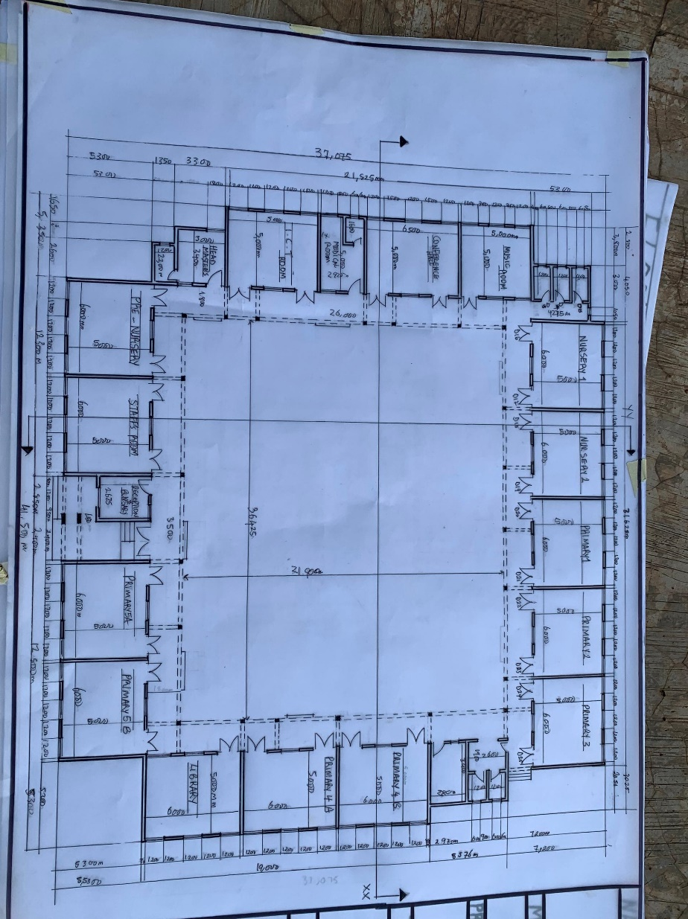
Appendix 5.2: Roof Plan
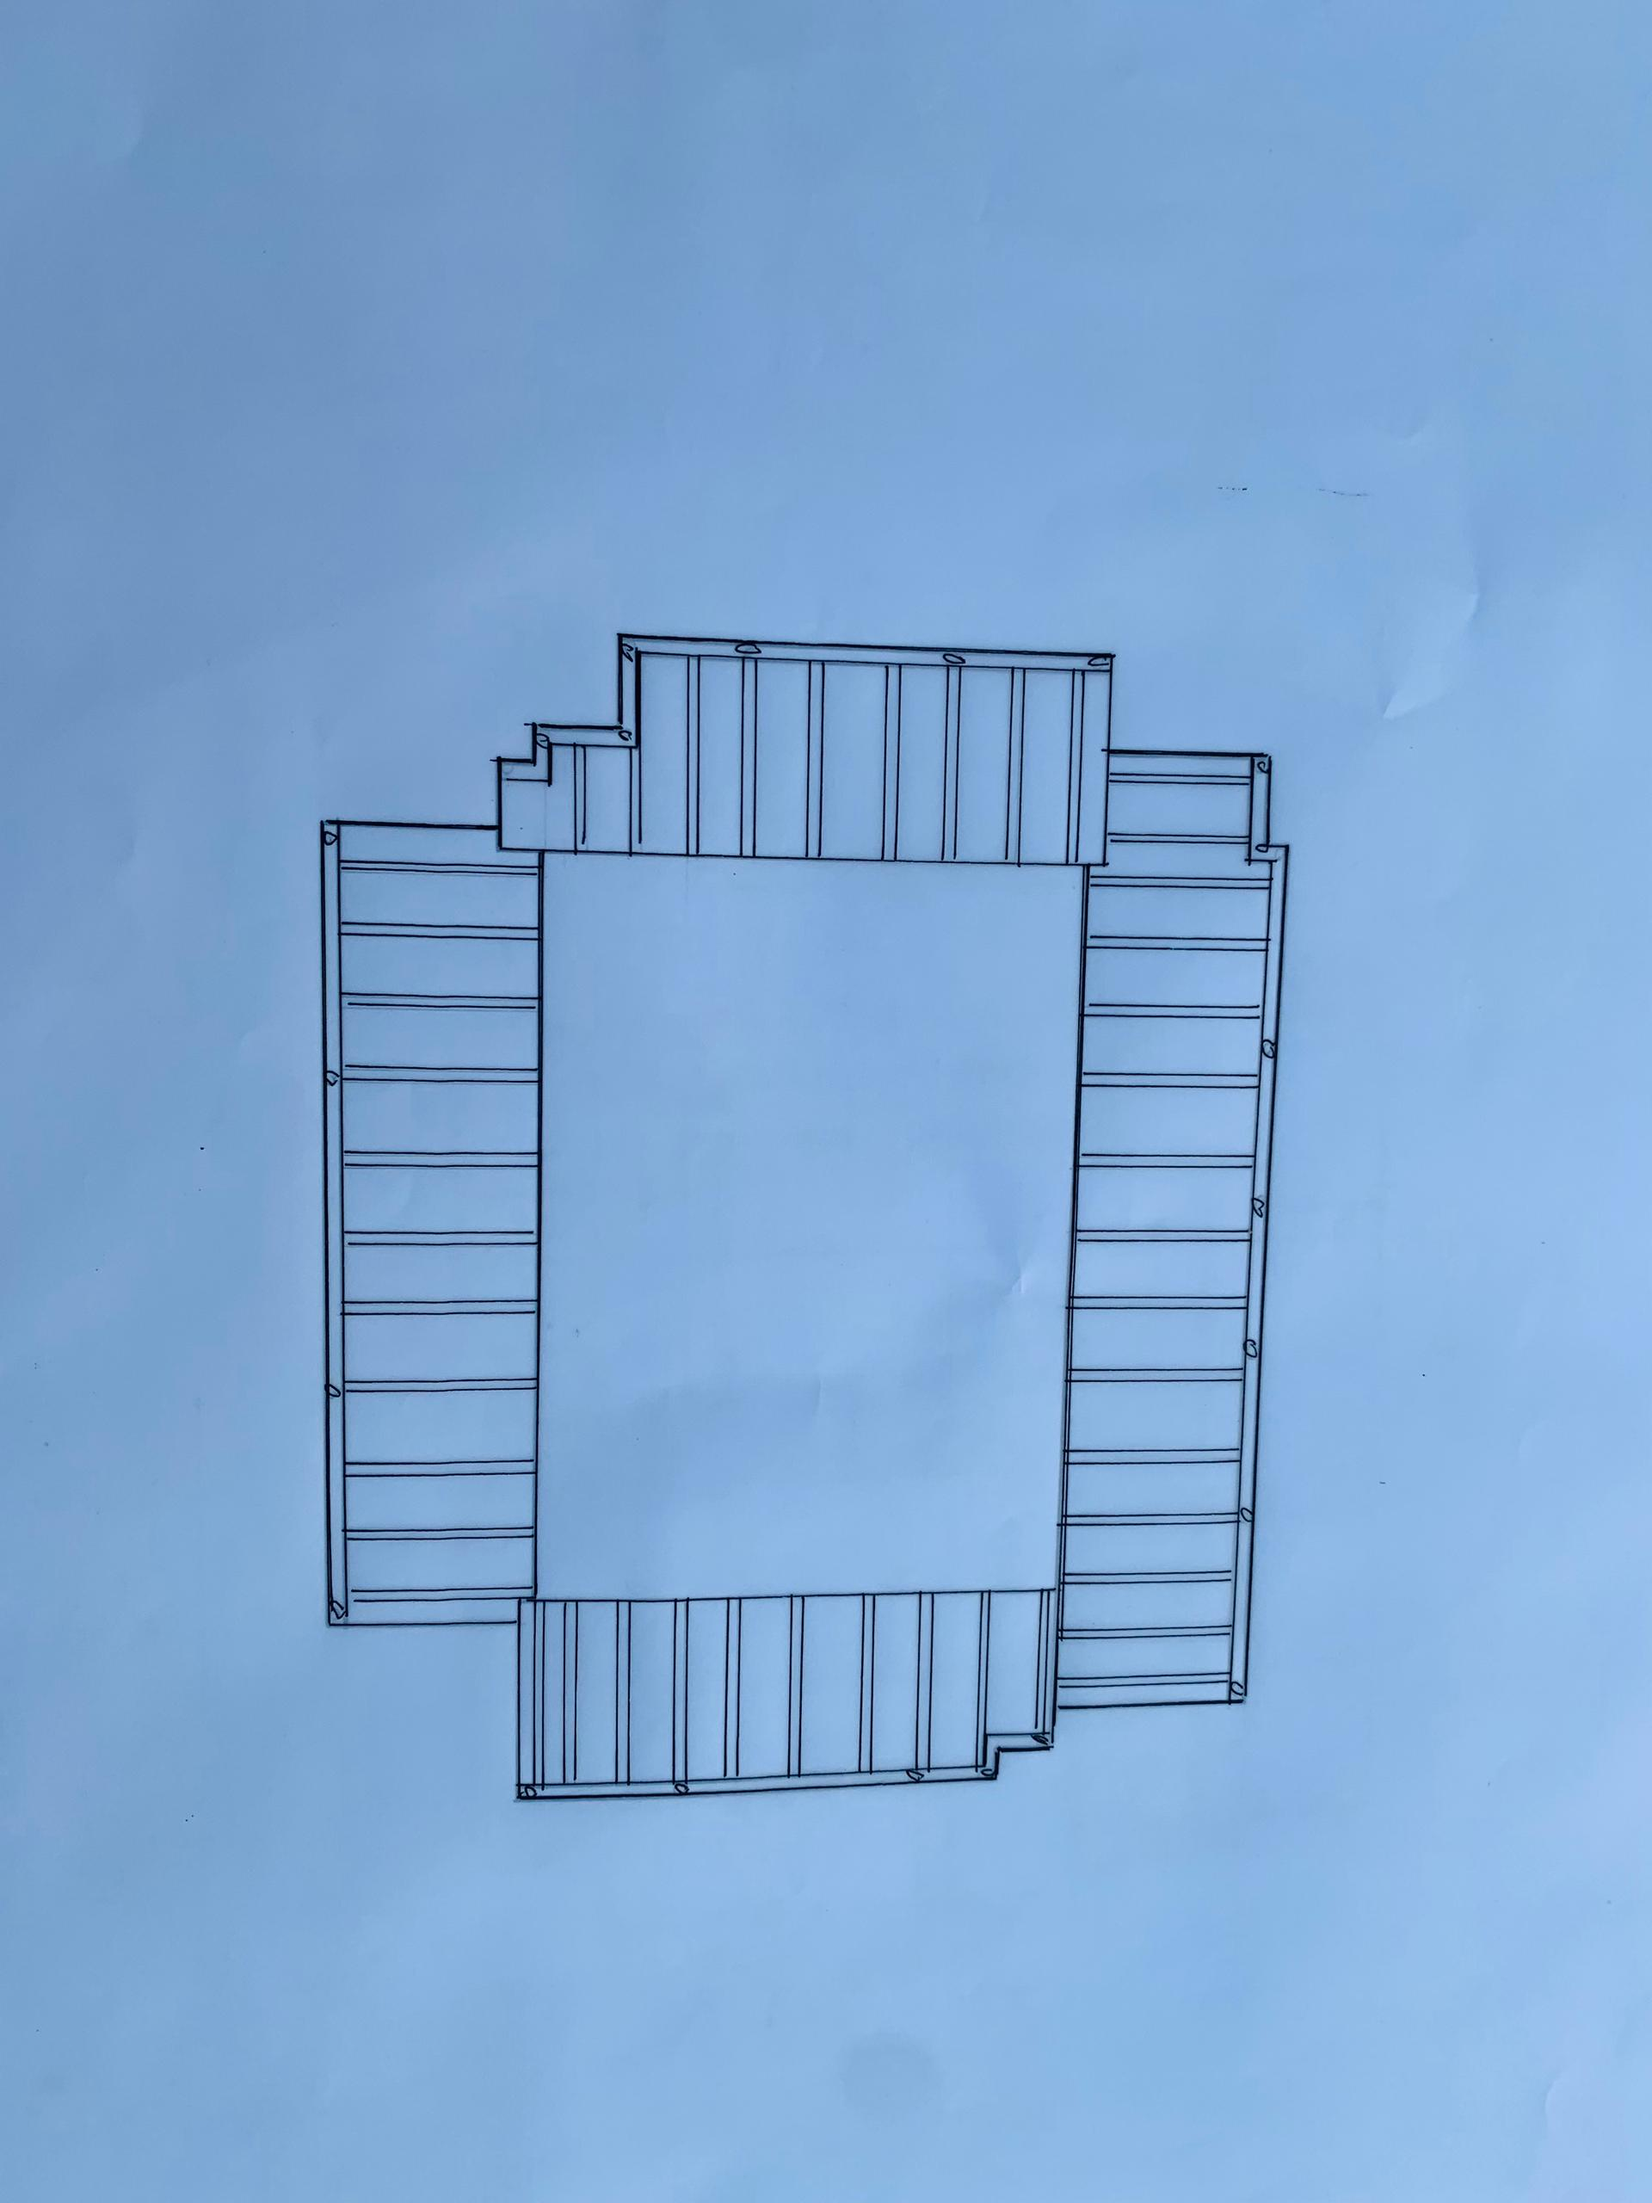

Appendix 5.3 Section XX
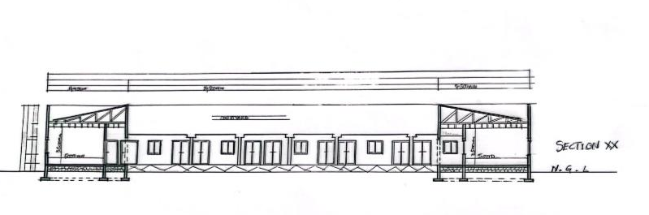
Section YY
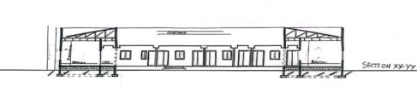
Appendix 5.4 Locational plan
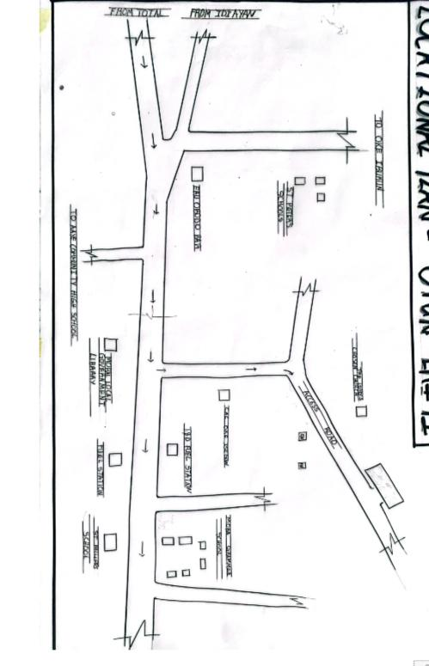

Appendix 5.5: External Perspective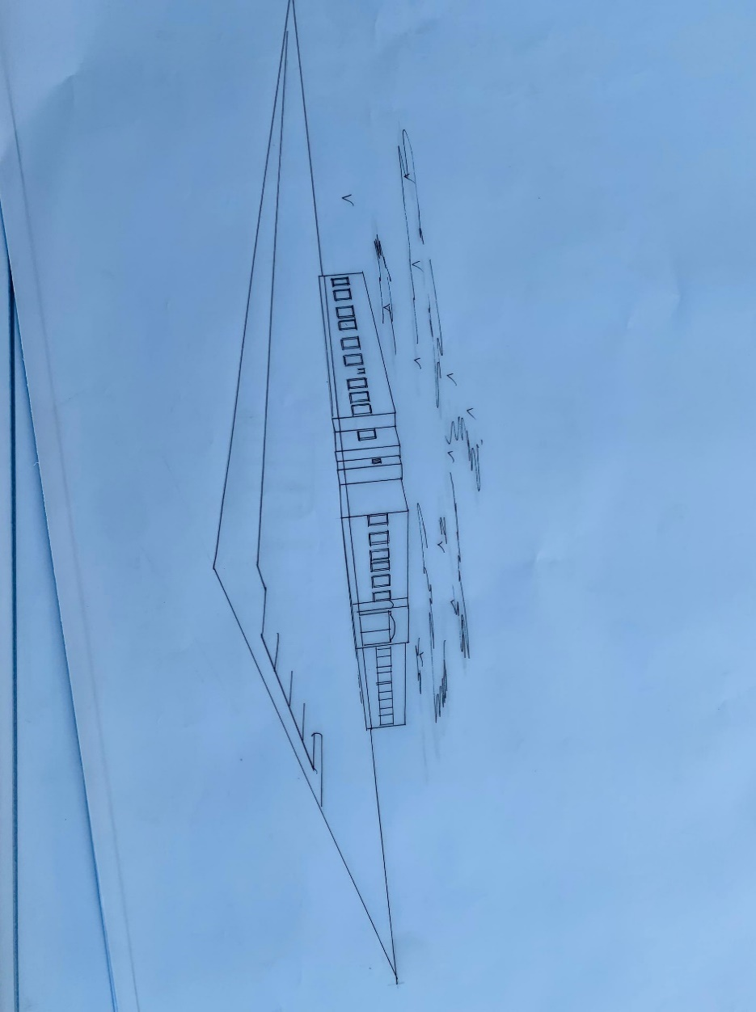

Appendix 5.6: Internal Perspective
