A PROJECT REPORT
ON
PROPOSED CAC AREA HEADQUARTER

FOR
PASTOR E.O. ODEJOBI GENERAL SUPERINTENDENT CAC

BY
OLORUNLAIYE DEMILADE
HND/23/ARC/FT/0014

SUBMITTED TO
DEPARTMENT OF ARCHITECTURAL TECHNOLOGY, INSTITUTE OF ENVIRONMENT STUDIES, KWARA STATE POLYTECHNIC, ILORIN

BEING A DISSERTATION SUBMITTED TO THE DEPARTMENT OF
ARCHITECTURAL TECHNOLOGY, INSTITUTE OF ENVIRONMENTAL STUDIES
(IES), KWARA STATE POLYECHNIC, ILORIN

IN PARTIAL FULFILMENT OF THE REQUIREMENTS FOR THE AWARD OF
HIGHER NATIONAL DIPLOMA IN ARCHITECTURAL TECHNOLOGY KWARA STATE POLYTECHNIC, ILORIN, KWARA STATE.

JULY, 2025

DECLARATION
I declare that this project/dissertation are a product of my personal research work. It has not been presented for the award of any degree in any polytechnic. The ideas, observations, comments, suggestions herein represent my own convictions, except quotations, which has been acknowledged in accordance with conventional academic traditions.
Name: OLORUNLAIYE DEMILADE
Matric NO.: HND/22/ARC/FT/0014
___________________________ ______________________
Signature Date

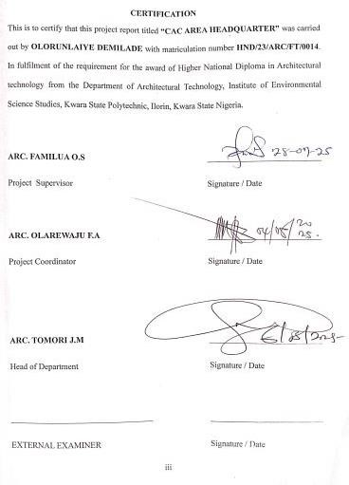

DEDICATION
I would like to dedicate this project to my family, who have been my constant source of love, support, and inspiration throughout my academic journey. Your unwavering encouragement and belief in me has been my greatest motivation your love and support have been the driving force behind my success.
To my lecturers and mentors, whose guidance and wisdom have shaped me into the person I am today. Your patience and dedication have been a great support and I can proudly say it is invaluable to me.
To my friends and classmates, who has been my rock throughout the ups and downs of school life, your camaraderie and support have made this journey enjoyable and memorable.

ACKNOWLEDGEMENTS
All glory honor and adoration to God Almighty, the way maker, my helper unto him be all the glory forever. Amen!!!
My sincere gratitude goes to my supervisor in person of ARC. FAMILUA O.S for his constructive ideas, counsel, corrections and mentorship during struggle time in the process of accomplishing my project.
Also, my sincere appreciation goes to my Head of Department (HOD) in person of ARC. MRS. J. M. TOMORI for her motherly counsel, advice and effort for me to successfully accomplish my project in Architectural Technology Department.
Likewise, my sincere appreciation also goes to the project coordinator in person of ARC. OLAREWAJU, F. A. For his advice, support and fatherly counsel for me to successfully accomplish my project in Architectural Technology Department. And, my appreciation goes to all my lecturers and Non-teaching staffs in the department, I pray God Almighty will shower His blessing abundantly upon you and your entire families. May you always know peace. AMEN!!!
My sincere gratitude to my parent in person of Mr. and Mrs. OLORUNLAIYE, I can’t thank you enough, thank you so much for your support, love and care. I pray you will live long to eat the fruit of your labour in good health and sound wealth. AMEN.
My appreciation also goes to my Sister, my Brother and Mr. TOSIN IBITOYE, Pas MOSES OLAREWAJU, Mr. KOLA OWONIMI, Mr. SAMUEL OLAJIDE, MR JOHNSON OLAJIDE and Mr. SEUN OLAJIDE for their financial and material supports during the actualization of my project, I really appreciate it. I pray God will continue to bless you people more and more. AMEN!!!

ABSTRACT
CAC Area Headquarter Building: A purpose-built facility that houses the administrative, executive, and spiritual leadership of Christ Apostolic Church in the regional axis. It serves as the central hub for decision-making, policy development, and communication with local churches, members, and the wider community. Chapter one of the project covers the historical background, introduction, definition, scope of the study, justification etc. while Chapter two covers the relevant/ related literature & the case study. Chapter three on the hand covers the fact about the proposed site for the project, which involves; brief history of Ilorin, the climatic consideration of the site, site location, Site description, site analysis, existing infrastructures, site selection criteria and site planning. Chapter four covers the project concept, analysis of scopes and brief, details of the drainage, expansion joint, steel roof details & space allocation etc. Chapter Five covers the design solution e.g. Acoustic, Ventilation, lighting, orientation, fine protection and control, services, landscape design, construction specification of materials finishes and maintenance. Chapter six covers project summary, conclusion and reference.

TABLE OF CONTENTS
Declaration ………………………………………………………………………..……ii
Certification ……………………………………………………………………...…….iii
Dedication…………………………………………………………………….…….…..iv
Acknowledgements………………………………………………………………….….v
Abstract………………………………………………………………………………....vi
Table of Content……………..……………………………………………………….…vii
CHAPTER ONE
1.0 Introduction……………………………………………………………………………1
1.1 Background of the Study…………………………………………………………...….2
1.2 Statements of Design Problem……………………………………………………..….3
1.3 Aim and Objective of the Study………………………………………………………..5
1.4 Justification of the Study………………………………………………..……………..5
1.5 Background of the Client……………………………………….……………………...8
1.5.1 Client’s Background………………………………………………………………....8
1.5.2 Client’s Philosophy…………………………………..…………………………….10
1.5.3 Operational Structure………………………………………..……………………..11
1.5.4 Client’s Goal………………………………………………..…………………..….12
1.6 Scope of the Project……………………………………………..…………………...13
1.7 Limitation of the Project………………………………………………..……………14
1.8 Research Methodology………………………………………...……………………..15
CHAPTER TWO
2.0 Literature Review……………………………………………………………………18
2.1 Introduction………………………………………………………………………….19
2.2 Definition…………………………………………………………………………….21
2.3 Historical Development of CAC Area Headquarter……………………………....22
2.4 CAC Area Headquarters in Nigeria……………………………………………….23
CHAPTER THREE
3.0 Case Study………………………………………………………...………………….25
3.1 Case Study One…………………………………………………………………...….25
3.2 Case Study Two……………………………………………………………………….29
3.3 Case Study Three…………………………………………………………………..…33
3.4 Case Study Four………………………………………………………………...…….37
3.5 Case Study Five………………………………………………………………...…….38
CHAPTER FOUR
4.0 Design Proposal…………………………………………………………….………..39
4.1 Introduction…………………………………………………………………..………39
4.2 Site Location, Description and Criteria………………………………..…………….40
4.2. Site Location Map………..……………….…….…………………………………...40
4.2.2 Site Selection Criteria…………………………………………………………..….41
4.3 Site Characteristics………………………………………………….…………….…41
4.3.1 Soil Type…………………………………………………………………...………41
4.3.2 Vegetation………………………………………………………..………….....…..41
4.3.3 Topography………………………………………………………………...………42
4.3.4 Drainage……………………………………………………………………........…43
4.3.5 Accessibility………………………………………………………………..………45
4.4 Geographical and Climatic Data………………………………………………..……45
4.5 Analysis of Immediate Environmental Conditions..…………………………………47
4.6 Project analysis and Design Criteria………..……………………………………..…48
4.6.1 Project Goals…………………………………………………………………….…48
4.6.2 Functional and Spatial Criteria……………………………………………………..49
4.6.3 Appraisal of Proposed Schemes in Space, Size and Relationship………….………50
4.6.4 Equipment and Operational Performance Requirement…………………………....52
4.6.5 Functional Relationships…..………………………………………………………54
4.6.6 Conceptual Development………………..…………………………………...……54
4.7 Space Allocation………………………………………………..……………………57
CHAPTER FIVE
5.0 Design Ideas and Concept at Different Levels of the Design Process…………...…58
5.1 Technological and Environmental Criteria………………………………………....59
5.2 Services Required……………………………………………………………...……61
5.3 Performance Standard………………………………………………………………62
5.3.1 Illegal Issues and Planning Regulations……………………………………….....62
5.4 Conclusion and Recommendation………………………………………………..64
5.4.1 Conclusion ………………………………………………………………………64
5.4.2 Justification by Research Result…………………………………………………65
5.4.3 Recommendations for Future Research…………………………….……………67
References……………………………………………………………………….…69
Appendix…………………………………………………………………………...71

CHAPTER ONE
- INTRODUCTION
The Christ Apostolic Church (CAC) Area Headquarters is a significant establishment that embodies the spiritual aspirations and communal unity of its members. Founded in 1918 in Ijebu-Ode, Nigeria. Adeyemo (2006), the CAC has grown to become a prominent Pentecostal church with a strong presence in Nigeria and beyond. The church’s history is linked to its founders, including Joseph Ayo Babalola, who played a pivotal role in shaping its mission and values. Ojo (2006).

The CAC's organizational structure Is designed to facilitate effective governance and spiritual growth, with Assemblies forming the lowest unit of church organization. CAC Constitution(2020). These Assemblies are grouped into Districts, which in turn form District Councils (DCCs). The church is led by Principal Officers, including the President, General Superintendent, General Evangelist, General Secretary, and Finance Director. CAC Leadership Handbook(2019).

The CAC Area Headquarters will serve as a central hub for various church activities, including worship services, Bible studies, fellowship meetings, and community outreach programs. This facility will cater to the spiritual needs of members while providing opportunities for social welfare, education, and moral development initiatives. Afolayan(2018). By creating a dedicated space for worship and community activities, the project aims to strengthen bonds among church members and enhance their ability to positively impact their communities.

Vision and Mission
The vision behind the CAC Area Headquarters project is to create a vibrant and dynamic center of worship and community service that reflects the core values of the Christ Apostolic Church. The mission is to provide a welcoming and inclusive environment where members can deepen their relationship with God and with one another. Through this project, the church aims to empower its members to live out their faith in practical ways, making a positive impact in their communities and beyond.

The Christ Apostolic Church Area Headquarters project is more than just a physical structure; it represents a commitment to spiritual growth, community service, and the propagation of the gospel. As the project comes to fruition, it is expected to become a beacon of hope and a source of strength for the members of the CAC and the wider community. With its focus on worship, fellowship, and service, the CAC Area Headquarters will undoubtedly play a significant role in advancing the mission of the church and touching lives for the better.
  - BACKGROUND OF THE STUDY
The Christ Apostolic Church (CAC) has a rich history that dates back to the early 20th century. Founded in 1918 by Joseph Ayo Babalola, the church has grown exponentially, spreading its roots across Nigeria and beyond. As a prominent Pentecostal denomination, the CAC is known for its vibrant worship services, fervent prayers, and commitment to spreading the gospel. The establishment of an Area Headquarters is a significant milestone in the church’s journey, marking a new chapter in its growth and development.

History of the Christ Apostolic Church
The Christ Apostolic Church was born out of a revival movement that swept through Nigeria in the early 20th century. Joseph Ayo Babalola, a young and zealous prophet, was instrumental in the church’s founding. Through his ministry, many people were saved, healed, and delivered, leading to a rapid expansion of the church. Over the years, the CAC has continued to grow, with new branches and districts being established across Nigeria and beyond.
The Need for an Area Headquarters
As the CAC continues to grow, the need for a centralized hub for its operations becomes increasingly evident. An Area Headquarters will provide a focal point for the church’s activities, enabling it to better coordinate its efforts and serve its members more effectively. The headquarters will also serve as a symbol of the church’s presence and influence in the community, providing a visible representation of its values and mission.
1.2. STATEMENT OF PROBLEM
The Christ Apostolic Church (CAC) has experienced rapid growth over the years, with an increasing number of members and branches across Nigeria and beyond. As the church continues to expand, it faces various challenges that hinder its ability to effectively serve its members and the community. The establishment of an Area Headquarters is a strategic initiative aimed at addressing some of these challenges and enhancing the church’s overall operations.
Challenges Facing the Church
The CAC faces several challenges that impact its ability to fulfill its mission and serve its members. Some of the key challenges include:

-Limited Infrastructure: The church’s current infrastructure is inadequate to support its growing membership and activities. This limitation hinders the church’s ability to provide quality services and accommodate its members comfortably.
- Inefficient Coordination: The lack of a centralized hub for church operations leads to inefficient coordination of activities, resulting in duplication of efforts, wasted resources, and reduced productivity.
-Inadequate Administrative Support: The church’s administrative capacity is overstretched, leading to delays in decision-making, poor record-keeping, and inadequate support for its various departments and ministries.
- Limited Community Engagement: The church’s ability to engage with the local community is limited by its current infrastructure and operational capacity. This limitation hinders the church’s ability to promote its mission and values, serve the community, and build meaningful relationships with local stakeholders.
- Financial Constraints: The church faces financial constraints that limit its ability to invest in infrastructure, personnel, and programs. This constraint hinders the church’s ability to achieve its goals and fulfill its mission.
Impact of Challenges on Church Operations
The challenges facing the CAC have a significant impact on its operations, including:
- Reduced Effectiveness: The church’s ability to effectively serve its members and the community is reduced due to inadequate infrastructure, inefficient coordination, and limited administrative support.
- Decreased Productivity: The church’s productivity is decreased due to duplication of efforts, wasted resources, and inadequate support for its various departments and ministries.
-Poor Member Experience: The church’s members experience poor service delivery, inadequate support, and limited opportunities for spiritual growth and development.
- Limited Community Impact: The church’s ability to make a positive impact on the community is limited by its current infrastructure and operational capacity.
1.3. AIM AND OBJECTIVES OF THE STUDY
AIM
-My aim is to design a well oriented church building, where worshippers and
Spiritual leaders can worship in a convenient and conducive environment,
Suitable for carrying out spiritual activities.
OBJECTIVE
-Provide a modern functional and well equipped facility for the church’s
Administrative operations
- Create a conducive environment for prayer, worship , and spiritual growth,
Enabling church lead members to deepen their relationship with God.
-Provide facilities for leadership training conference and workshops
Equipping church leaders and members for effective ministry and service.
1.4. JUSTIFICATION OF THE STUDY
The Christ Apostolic Church (CAC) has been a prominent spiritual institution in Nigeria for over a century, with a rich history of spreading the gospel and serving communities across the country. The establishment of an Area Headquarters in Ilorin West Local Government is a strategic initiative that aligns with the church’s mission to promote spiritual growth, community development, and unity among its members. This justification outlines the rationale behind this initiative and highlights the benefits that the Area Headquarters will bring to the church and the community.
Strategic Location
Ilorin West Local Government is a strategic location for the CAC Area Headquarters due to its central position in Kwara State and its accessibility to surrounding communities. The area is home to a diverse population, with a mix of urban and rural settlements, making it an ideal location for the church to reach out to a broader audience. The proximity to major roads and transportation hubs also facilitates easy access for members and visitors, enhancing the church’s ability to serve its constituents.
Growing Membership
The CAC has experienced significant growth in membership in Ilorin West Local Government, with an increasing number of people attending worship services, Bible studies, and other church activities. The establishment of an Area Headquarters will provide a centralized hub for church operations, enabling the church to better serve its growing membership and cater to their spiritual needs. This will also create opportunities for members to participate in various ministries and outreach programs, fostering a sense of community and belonging.
Community Development
The CAC Area Headquarters will play a vital role in promoting community development in Ilorin West Local Government. The church will organize outreach programs and initiatives that cater to the needs of the community, including education, healthcare, and social welfare. This will not only benefit the community but also provide opportunities for church members to engage in meaningful service, promoting a sense of purpose and fulfillment.
Enhanced Coordination
The Area Headquarters will enhance coordination of church activities, reducing duplication of efforts and improving productivity. The centralized hub will enable the church to better manage its resources, streamline its operations, and respond more effectively to the needs of its members and the community. This will also facilitate communication and collaboration among church members, promoting unity and cooperation.
Administrative Support
The Area Headquarters will provide administrative support to the church’s various departments and ministries, ensuring efficient management and coordination of its activities. This will enable the church to better serve its members, manage its resources, and achieve its goals. The administrative support will also facilitate decision-making, reduce bureaucracy, and promote accountability.
Financial Sustainability
The establishment of the Area Headquarters will also promote financial sustainability for the church. The centralized hub will enable the church to better manage its finances, reduce costs, and increase revenue generation. This will ensure that the church has the resources it needs to fulfill its mission and serve its members and the community.
Spiritual Growth
The CAC Area Headquarters will provide a conducive environment for spiritual growth, with opportunities for members to deepen their relationship with God through worship, Bible study, and fellowship. The church will also organize spiritual retreats, conferences, and workshops, providing members with opportunities for spiritual renewal and growth. This will enable members to live out their faith in practical ways, making a positive impact in their communities.
Community Engagement
The Area Headquarters will promote community engagement, with opportunities for church members to participate in outreach programs and initiatives that cater to the needs of the community. This will foster a sense of community and belonging among members, while also promoting the church’s mission and values. The church will also engage with local stakeholders, including community leaders, government officials, and other organizations, to promote collaboration and partnership.
The establishment of a Christ Apostolic Church Area Headquarters in Ilorin West Local Government is a strategic initiative that aligns with the church’s mission to promote spiritual growth, community development, and unity among its members. The Area Headquarters will provide a centralized hub for church operations, enhancing coordination, administrative support, and financial sustainability. It will also promote community engagement, spiritual growth, and community development, making a positive impact in the lives of church members and the broader community. With its strategic location, growing membership, and commitment to community development, the CAC Area Headquarters in Ilorin West Local Government is poised to make a lasting impact in the region.
1.5. BACKGROUND OF THE CLIENT
1.5.1. CLIENT’S BACKGROUND
CLIENT: PASTOR E.O.ODEJOBI
Pastor Emmanuel Olatoro Odejobi, the General Superintendent of Christ Apostolic Church, was born on July 31, 1952, to Pa Abraham Odejobi, a pioneer member of the church, and Mama Maria Omitunde Odejobi, a deaconess. His parents played a significant role in shaping his values and faith.
Early Life and Education
Pastor Odejobi’s educational journey began at Christ Church (Anglican) School 1, Ipetumodu, and later St. John’s Primary School at Omidi Onipetesi, where he completed his primary school education. He then attended CAC Commercial Modern School but couldn’t start due to financial constraints. He eventually gained admission to Government Technical College, Owo, in 1974, where he studied Electrical Engineering.
Career and Ministry
Pastor Odejobi’s career path took a significant turn when he joined Christ Apostolic Church Printing Press, Shiaba, Agege, Lagos, under Late Pastor Benjamin Okpaise. He worked as an Assistant Engineer with WESTEX and later became a renowned evangelist, leading various evangelical groups and fellowships. His ministry has taken him to numerous countries, including Nigeria, Ghana, Benin Republic, Europe, and the USA.
Leadership Roles
Pastor Odejobi has held several leadership positions within the Christ Apostolic Church, including :
- General Superintendent: Appointed on October 15, 2020
-Member, Management Board: A member of the church’s management board and one of the trustees
-Vice Chairman, Mission Board: Serving under the current General Superintendent, Pastor S.O. Oladele
- Chairman, Evangelical Committee: Under revered General Evangelist, Prophet S.K. Abiara (Rtd.)
Personal Life
Pastor Odejobi is married to Folashade Mariam Odejobi, and they have children, some of whom reside overseas. His wedding ceremony was conducted at Go Yee Evangelical Church in 1982. He is known for his humility and commitment to his faith, often attributing his success to God’s grace.
1.5.2. CLIENT’S PHILOSOPHY
- Christ-Centred Leadership: He emphasizes the importance of Christ-centered leadership, focusing on equipping pastors for effective ministry through structured training and spiritual development.
-Human Development and Training: Pastor Odejobi prioritizes human development, recognizing the need for ministers to acquire specific skills and competencies to address contemporary church needs.
- Evangelism and Church Growth: He believes in the importance of evangelism and church growth, citing Jesus’ instruction to pray for laborers in the harvest field (Luke 10:2).
- Reconciliation and Unity: As evident from his statement after inauguration, Pastor Odejobi aims to promote unity within the church, acknowledging that misunderstandings are not unique to the CAC and expressing his commitment to resolving the crisis.
- Discipleship and Discipline: He stresses the importance of discipline in enhancing networking and church growth, ensuring that the church remains true to its mission.
- Teamwork: Pastor Odejobi values teamwork, recognizing that God works through teams and that each member has a vital role to play in achieving the church’s objectives.

1.5.3. OPERATIONAL STRUCTURE
Pastor E.O. Odejobi’s operational structure as the General Superintendent of Christ Apostolic Church is centered around several key areas:
- Leadership Role: As the General Superintendent, Pastor Odejobi serves as a key leader in the church, working closely with the President, Pastor S.O. Oladele, to guide the church’s activities and operations.
- Teamwork: He emphasizes the importance of teamwork, recognizing that God works through teams and that each member has a vital role to play in achieving the church’s objectives.
- Discipleship and Discipline: Pastor Odejobi stresses the importance of discipline in enhancing networking and church growth, ensuring that the church remains true to its mission.
- Reconciliation and Unity: He aims to promote unity within the church, acknowledging that misunderstandings are not unique to the CAC and expressing his commitment to resolving the crisis.
- Training and Development: Pastor Odejobi prioritizes human development, recognizing the need for ministers to acquire specific skills and competencies to address contemporary church needs.
- Evangelism and Church Growth: He believes in the importance of evangelism and church growth, citing Jesus’ instruction to pray for laborers in the harvest field (Luke 10:2).
In his role, Pastor Odejobi works within the church’s hierarchical structure, which includes;
- General Executive Council (GEC): The highest decision-making body in the church, responsible for formulating policy directives.
- President: The highest executive officer of the church, responsible for administering the church and carrying out policies formulated by the GEC.
- General Superintendent: Responsible for overseeing the church’s activities and operations, working closely with the President and other principal officers.
1.5.4. CLIENT’S GOALS
Spiritual Growth and Development
- Enhance Unity: Foster a sense of unity and cooperation among church members, promoting a spirit of love and harmony.
- Deepen Discipleship: Develop a structured discipleship program to help members grow in their faith and become effective witnesses for Christ.
- Increase Evangelism: Organize regular evangelism outreaches and programs to reach the community with the gospel.
Church Planting and Expansion
- Plant New Churches: Establish new churches in Ilorin West Local Government, aiming to reach more people with the gospel.
- Develop Church Infrastructure: Build or renovate church facilities to provide a conducive environment for worship, fellowship, and community service.
Leadership Development and Training
- Train Ministers: Provide ongoing training and development for ministers, focusing on leadership skills, biblical studies, and pastoral care.
- Empower Leaders: Identify and empower leaders within the church to take on key roles and responsibilities.
Community Engagement and Service
- Community Outreach: Organize community outreach programs, providing support and services to those in need.
- Partner with Local Organizations: Collaborate with local organizations and stakeholders to promote community development and social welfare.
Reconciliation and Conflict Resolution
- Promote Reconciliation: Work towards resolving conflicts and promoting reconciliation within the church and the community.
- Foster Peaceful Coexistence: Encourage peaceful coexistence among church members and the broader community.
1.6. SCOPE OF STUDY
- CHURCH AUDITORIUM
- CHURCH LIBRARY
- YOUTH CHAPEL
- CHILDREN CHAPEL
- CHURCH SECRETARIAT
- FAITH HOME
- RETREAT GROUND
- CHAIRMAN RESIDENTIAL BUILDING
- MINISTERS RESIDENTIAL BUILDING
- WATER TANK
- GENERATOR HOUSE
- SECURITY POST
1.7. LIMITATIONS OF STUDY
The study on the Christ Apostolic Church (CAC) Area Headquarters has several limitations that need to be acknowledged. These limitations may impact the generalizability and validity of the findings, and it is essential to consider them when interpreting the results.
Limited Sample Size
One limitation of this study is the limited sample size. The study focuses on the CAC Area Headquarters and its members, which may not be representative of the entire church or other similar organizations. The sample size may not be large enough to generalize the findings to other contexts.
Time Constraints
The study is also limited by time constraints. The data collection process may be limited to a specific period, which may not capture the full range of activities and events that occur within the church. This may impact the study’s ability to provide a comprehensive understanding of the church’s operations and impact.
Limited Access to Information
Another limitation is limited access to information. The study may rely on self-reported data from church members and leaders, which may be subject to bias or incomplete information. Additionally, some information may not be publicly available or accessible due to confidentiality or other concerns.

Potential Bias
The study may also be subject to potential bias. The researcher’s own biases or perspectives may influence the data collection and analysis, which may impact the validity of the findings. Additionally, the study may be conducted from a particular perspective or framework, which may not capture the full complexity of the issue.
Limited Generalizability
The study’s findings may not be generalizable to other contexts or organizations. The CAC Area Headquarters has its unique characteristics, history, and context, which may not be applicable to other similar organizations.
Methodological Limitations
The study’s methodology may also have limitations. The use of surveys, interviews, or observations may not capture the full range of data or perspectives. Additionally, the study may rely on quantitative or qualitative methods, which may not provide a comprehensive understanding of the issue.
In conclusion, the study on the CAC Area Headquarters has several limitations that need to be considered when interpreting the findings. These limitations highlight the importance of cautious interpretation and the need for further research to validate the findings. Despite these limitations, the study provides valuable insights into the church’s operations and impact, which can inform decision-making and strategic planning.
1.8. RESEARCH METHODOLOGY
The research methodology for the Christ Apostolic Church (CAC) Area Headquarters study is designed to provide a comprehensive understanding of the church’s operations, activities, and impact. This study employs a mixed-methods approach, combining qualitative and quantitative research methods to gather data.
Research Design
The research design for this study is a case study approach, focusing on the CAC Area Headquarters as a single case. This approach allows for an in-depth examination of the church’s operations, activities, and impact within its specific context.
Data Collection Methods
The study will employ several data collection methods, including:
- Surveys: Distributed to church members to gather quantitative data on their perceptions and experiences.
- Interviews: Conducted with church leaders and members to gather qualitative data on their perspectives and experiences.
- Observations: Conducted at church services and events to observe the church’s activities and interactions.
- Document analysis: Analysis of church documents, reports, and other relevant materials to gather data on the church’s history, policies, and practices.
Sampling Strategy
The sampling strategy for this study will involve selecting a representative sample of church members and leaders. This will include:
- Random sampling: A random sample of church members will be selected to participate in surveys.
- Purposive sampling: Church leaders and members with specific roles or experiences will be selected to participate in interviews.
Data Analysis
The data analysis for this study will involve both quantitative and qualitative methods. Quantitative data will be analyzed using statistical software, while qualitative data will be analyzed using thematic analysis.
Ethical Considerations
The study will adhere to ethical principles, including:
- Informed consent: Participants will be informed about the purpose and procedures of the study and will provide their consent before participating.
- Confidentiality: Participants’ identities and responses will be kept confidential.
- Respect for participants: Participants will be treated with respect and dignity throughout the study.

CHAPTER TWO
2.0. LITERATURE REVIEW
The Christ Apostolic Church (CAC) has a rich history and a significant presence in Nigeria and beyond. The church’s Area Headquarters plays a crucial role in coordinating its activities, promoting spiritual growth, and serving the community. This literature review aims to examine existing research on the CAC Area Headquarters, highlighting its significance, challenges, and opportunities.
Historical Context
The CAC was founded in 1918 by Joseph Ayo Babalola, and since then, it has grown to become one of the largest and most influential churches in Nigeria. Omoyajowo (2008). The church’s history is marked by a strong emphasis on prayer, evangelism, and community service. Adeyemi (2015). The CAC Area Headquarters is a key part of this history, serving as a hub for church activities and operations.
Church Growth and Development
Research has shown that the CAC has experienced significant growth and development over the years, with an increasing number of members and branches. Ojo (2017). The church’s Area Headquarters plays a crucial role in facilitating this growth, providing support and guidance to local churches and members. Studies have highlighted the importance of effective leadership, strategic planning, and community engagement in promoting church growth and development. Adeboye (2012).
Community Service and Outreach
The CAC is known for its commitment to community service and outreach, with a range of programs and initiatives aimed at serving the needs of the community. Fatokun (2016). The church’s Area Headquarters is involved in various community development projects, including education, healthcare, and social welfare. Research has highlighted the importance of community engagement and partnership in promoting effective community service and outreach. Olowola (2018).
Challenges and Opportunities
Despite its successes, the CAC Area Headquarters faces several challenges, including limited resources, infrastructure, and personnel. Adebayo (2019). The church also faces opportunities for growth and development, including the need to engage with new technologies and innovative approaches to ministry. Research has highlighted the importance of strategic planning, leadership development, and collaboration in addressing these challenges and opportunities. Adeyemi (2020).
2.1. INTRODUCTION
The Christ Apostolic Church (CAC) Area Headquarters project is a momentous endeavor that embodies the spiritual aspirations and communal unity of the Christ Apostolic Church members. As a beacon of faith and spirituality, the CAC has been a cornerstone for countless individuals, providing a nurturing environment for spiritual growth, fellowship, and service. The establishment of an Area Headquarters is a testament to the church’s commitment to spreading the gospel and serving as a lighthouse of hope and guidance for its members and the wider community.
Project Overview
The CAC Area Headquarters project is designed to serve as a central hub for various church activities, including worship services, Bible studies, fellowship meetings, and community outreach programs. This facility will not only cater to the spiritual needs of the members but also provide a platform for organizing initiatives that promote social welfare, education, and moral development. By creating a dedicated space for worship and community activities, the project aims to strengthen the bonds among church members and enhance their ability to serve and impact their communities positively.
Community Impact
The CAC Area Headquarters will play a pivotal role in fostering a sense of community and belonging among its members. It will serve as a place where individuals can come together to worship, learn, and grow in their faith. The project will also provide opportunities for members to engage in various ministries and outreach programs, thereby contributing to the holistic development of the community. By promoting values such as love, compassion, and service, the CAC Area Headquarters will be a source of inspiration and hope for all who are part of it.
Vision and Mission
The vision behind the CAC Area Headquarters project is to create a vibrant and dynamic center of worship and community service that reflects the core values of the Christ Apostolic Church. The mission is to provide a welcoming and inclusive environment where members can deepen their relationship with God and with one another. Through this project, the church aims to empower its members to live out their faith in practical ways, making a positive impact in their communities and beyond.
The Christ Apostolic Church Area Headquarters project is more than just a physical structure; it represents a commitment to spiritual growth, community service, and the propagation of the gospel. As the project comes to fruition, it is expected to become a beacon of hope and a source of strength for the members of the CAC and the wider community. With its focus on worship, fellowship, and service, the CAC Area Headquarters will undoubtedly play a significant role in advancing the mission of the church and touching lives for the better.

2.2. DEFINITION
The Christ Apostolic Church (CAC) Area Headquarters is a centralized hub that serves as the administrative and spiritual center for the church’s activities and operations within a designated area. It is a strategic location that provides a focal point for the church’s worship, fellowship, and community service initiatives.
The CAC Area Headquarters is designed to meet the needs of the church and its members, providing a comprehensive framework for spiritual growth, community development, and social welfare. It serves as a place of worship, a center for Bible study and discipleship, and a hub for community outreach and service.
The Area Headquarters is typically responsible for overseeing the activities of local churches and branches within its designated area, providing support and guidance to church leaders and members. It also serves as a resource center, providing access to training, mentorship, and other forms of support.
The CAC Area Headquarters plays a critical role in promoting the church’s mission and values, which emphasize the importance of prayer, evangelism, and community. It is a symbol of the church’s commitment to serving its members and the community, and it serves as a beacon of hope and inspiration for those seeking spiritual guidance and support.
Overall, the CAC Area Headquarters is a vital component of the church’s structure and operations, providing a centralized hub for its activities and initiatives. It serves as a catalyst for spiritual growth, community development, and social welfare, and it plays a critical role in promoting the church’s mission and values.

2.3. HISTORICAL DEVELOPMENT OF CAC AREA HEADQUARTER
The Christ Apostolic Church (CAC) has a rich history that dates back to the early 20th century. The church was founded by Joseph Ayo Babalola, a Nigerian evangelist, in 1943. The CAC has since grown to become one of the largest Christian denominations in Nigeria.
Early Years
The CAC’s early years were marked by rapid growth and expansion, driven by the evangelistic efforts of Joseph Babalola and other pioneers. The church’s message of salvation, healing, and deliverance resonated with many Nigerians, and it quickly gained a large following.
Establishment of the Area Headquarters
The establishment of the CAC Area Headquarters in Kingstep area, Ilorin West Local Government, marked a significant milestone in the church’s history. The headquarters serves as a hub for the church’s activities in the area, providing a central location for worship, fellowship, and service.
Growth and Development
Over the years, the CAC Area Headquarters has experienced significant growth and development. The church has expanded its facilities, increased its membership, and diversified its activities to meet the needs of the community. Today, the church is a vibrant and dynamic community of believers, committed to spreading the gospel and serving the needs of others.
Impact on the Community
The CAC Area Headquarters has had a profound impact on the community, providing spiritual guidance, social support, and economic empowerment to its members and the wider community. The church’s commitment to community service and development has earned it a reputation as a caring and compassionate institution
2.4. CAC AREA HEADQUARTER IN NIGERIA
Here’s a list of Christ Apostolic Church area headquarters in Nigeria:
- Adelaja Region: Located at CAC Kano DCC, 81 Atiken Road, Sabongari, Kano, serving Kano, Sokoto, Yobe, Zamfara, Taraba, Adamawa, Borno, and Kebbi States.
- Akilling Region: Located at CAC Agege DCC, 5 Shiaba Street, Agege, Lagos, serving former Lagos 3.
- Akinyele Region: Located at CAC Lagos DCC, 28 Olowu Street, Ebute Elefun, Lagos, serving former Lagos 1.
- Anosike Region: Located at Nehemiah Generation DCC, 123-125 Stanstead Road, Forest Hill London, serving UK, France, Italy, and Europe.
- Babajide Region: Located at CAC Kabba DCC, Oke Isegun, Odi Olowo Street, Kabba, serving Kwara and Kogi States.
- Babalola Region: Located at CAC Eleta DCC, Idi Aro, Elete Road, Near Odinjo Junction, Eleta, Mapo, Ibadan, serving Oyo State.
- Essien Region: Located at CAC Egba DCC, 6 Lisabi Avenue, Isale Ake, Abeokuta, serving Ogun State and Benin Republic.
- Hanson Region: Located at CAC Warri DCC, 18A Sido Street, Off Cemetary Road, Warri, serving Edo and Delta States.
- Latunde Region: Located at CAC Village, Baltimore, United States Of America, serving North America
- Medaiyese Region: Located at CAC FCC DCC, CAC Garki Along Old V.I.O Road, Stadium Roundabout, Durumi Area, Garki, Abuja, serving FCT, Kaduna, and Niger States.
- Odubanjo Region: Located at CAC Akure DCC, Oke Iga Eringbo Street, Akure, serving Ondo State.
- Odusona Region: Located at CAC Abia DCC, Behind Golden Guinea Breweries Railway Quarters, Afaraujwu, Umuahia, Abia State, serving Abia, Anambra, Enugu, Ebonyi, and Imo States.
- Olutimehin Region: Located at CAC Yenagoa DCC, Azikoro Road, Yenagoa, Bayelsa State, serving Rivers, Bayelsa, Cross River, and Akwa Ibom States
- Orekoya Region: Located at CAC Bauchi DCC, Hospital Road, Bauchi
- Orogun Region: Located at CAC Osogbo DCC, 20 Latona Street, Osogbo, serving Osun State.
- Pearce Region: Located at CAC Mushin DCC, 1 CAC Street, Olorunsogo, Mushin, Lagos, serving former Lagos 2.
- Sophia Ajayi Region: Located at CAC Sophia Ajayi Regional Headquarters, Ogba Alafia, Ijigbo Street, Ado-Ekiti, serving Ekiti State.
Some notable headquarters include:
- Agbala-itura International Headquarters: Located in Ibadan
- Lokoja DCC Headquarters: Located at RP3X+W97, Ajara Road, Lokoja, Kogi State

CHAPTER THREE
3.0. CASE STUDY
Case Study are of paramount important. It is an experimental research or analysis carried out on existing building or group of building functionally similar to the one which the researcher is working.
For any technical design to meaningful there is always need for preliminary research effort to be made on this proposal as a very necessary groundwork.
3.1. CASE STUDY ONE
NAME: CAC OKE ISEGUN ZONAL HEADQUARTER
LOCATION: Taiwo Isale, Ilorin Kwara state
BACKGROUND OF CASE STUDY ONE
Christ Apostolic Church Oke Isegun, located in Taiwo Isale, Ilorin, Kwara State, has a rich history dating back to 1946.
- Founding: The church started as a small congregation and has since grown into a prominent district coordinating council (DCC) headquarters.
- Early Years: In the 1950s, the church introduced Sunday school as an educative arm, which was taught by catechists. The Sunday school classes were held at 3:30 pm before the evening service.
- Growth and Development: Over the years, the church has experienced significant growth, with the construction of new facilities, including a 1,200-seater ultramodern English Assembly Auditorium and a proposed 1,500-seater Joseph Ayo Babalola Events Hall.
- 75th Anniversary: In 2022, the church celebrated its 75th anniversary, marking seven decades of spreading the gospel and serving the community. During this celebration, the church dedicated its newly built auditorium and public address system, and laid the foundation for the events hall.
- Attack in 2018: Unfortunately, the church was attacked by miscreants on New Year’s Day in 2018, resulting in damage to property and harm to worshippers. The Christian Association of Nigeria (CAN) condemned the attack and appealed to the state government to take measures to prevent future incidents.
Today, Christ Apostolic Church Oke Isegun continues to thrive, with a strong focus on evangelism, discipleship, and community service. The church has become a beacon of hope and spiritual guidance for its members and the broader community in Ilorin.
MERIT:
- There’s enough sitting capacity to accommodate members
- There’s enough ministers quarters to accommodate the ministers at large.
- There is church Secretariat where the affairs of all district headquarters and assemblies are carried out.
DEMERIT:
- The parking space is not enough to accommodate vehicles.
- The media room is situated at a wrong direction.
- The site is not well landscape

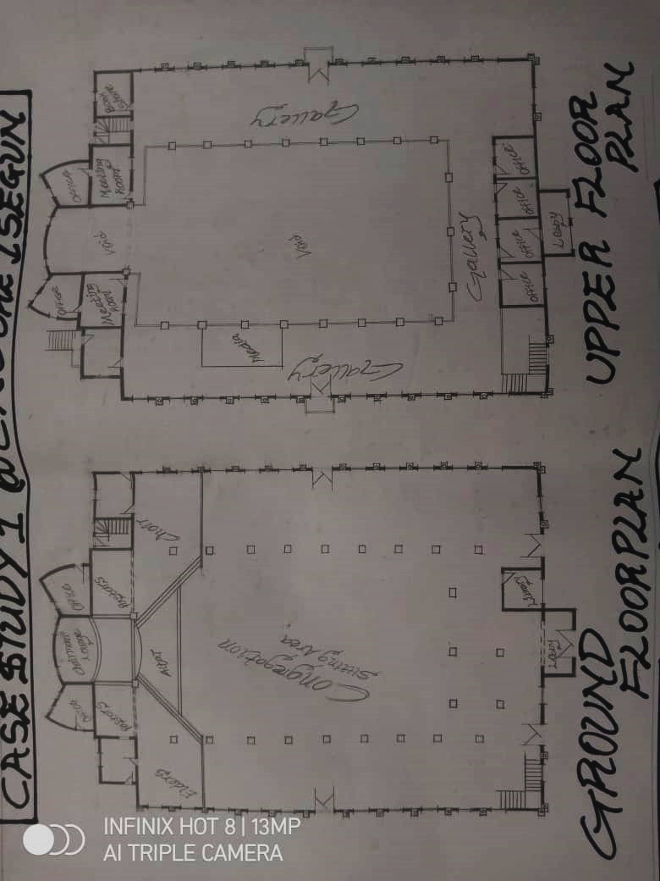
FLOOR PLAN

LOCATIONAL PLAN
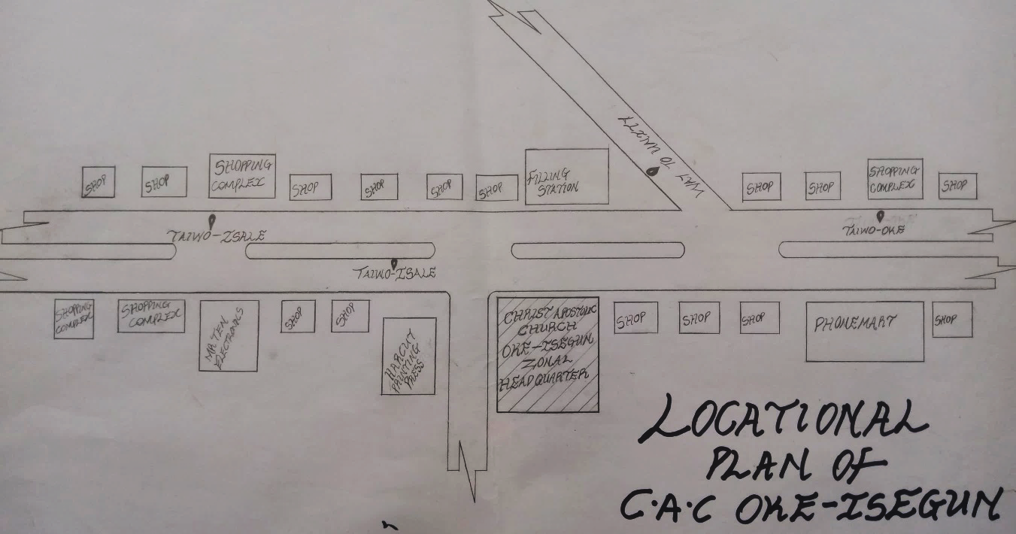

FRONT OF CAC OKE ISEGUN ZONAL HEADQUARTER

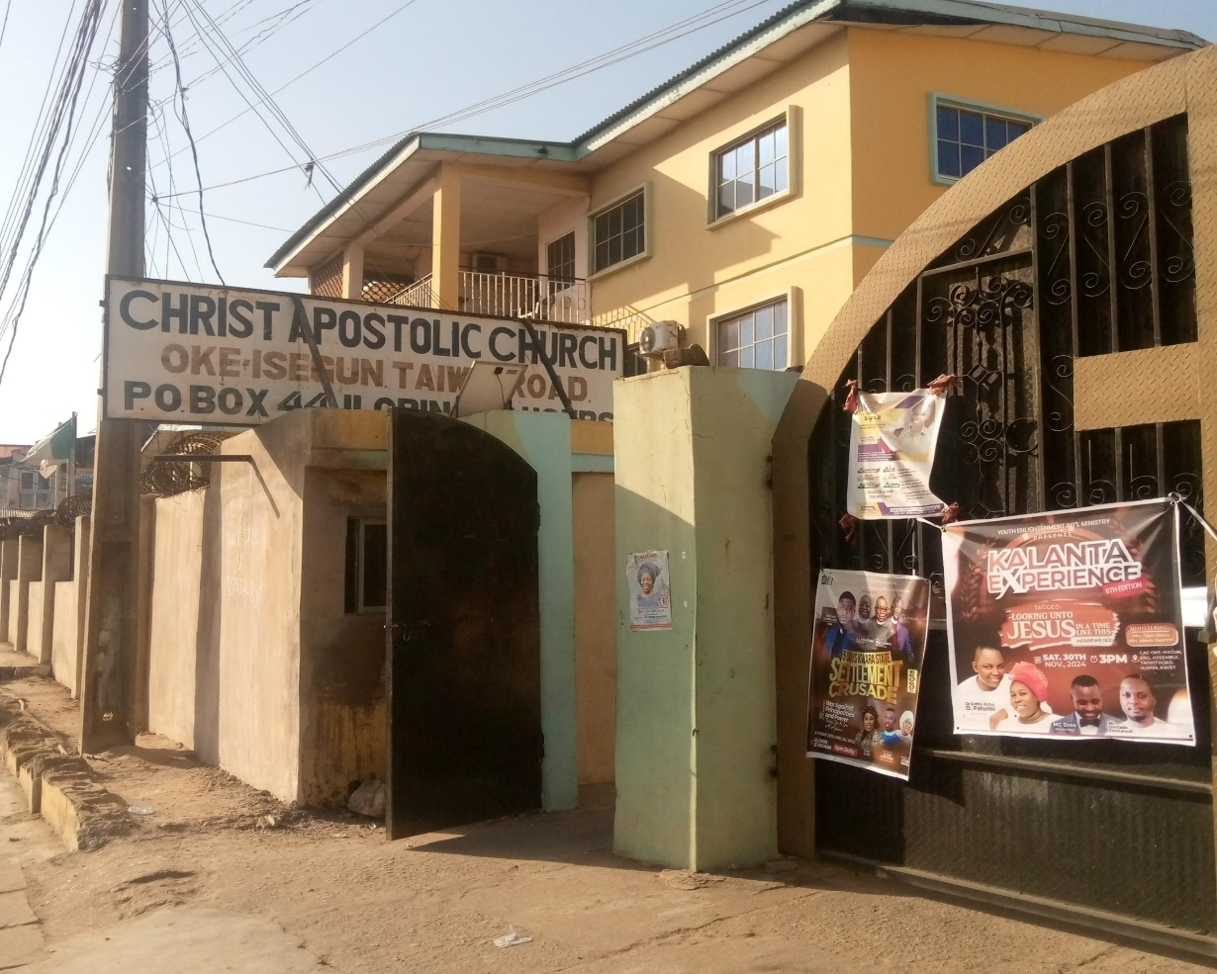

INSIDE THE CHURCH AUDITORIUM OF CAC OKE ISEGUN

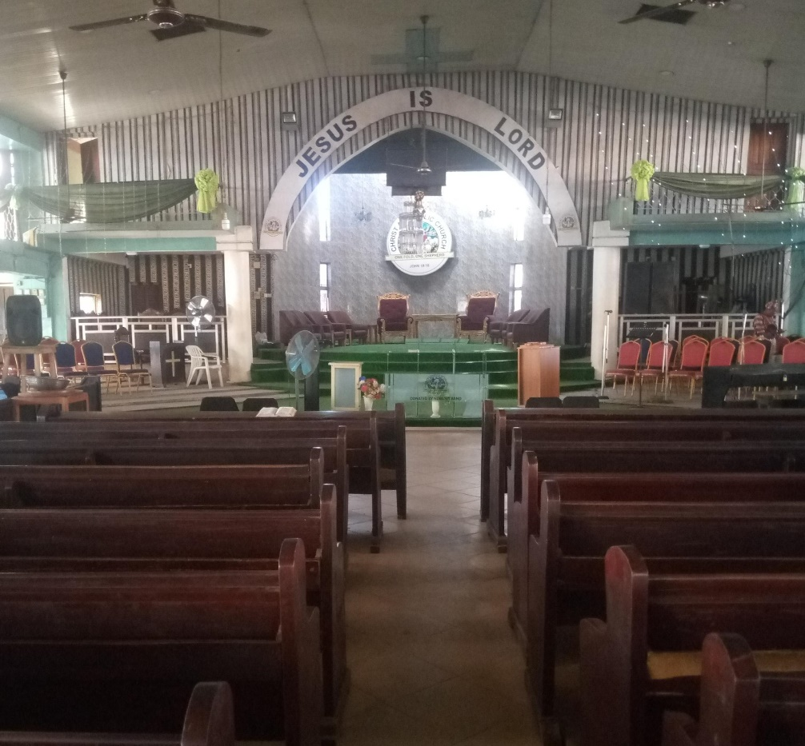
FRONT VIEW OF CAC OKE ISEGUN ZONAL HEADQUARTER

INTERIOR VIEW OF CAC OKE ISEGUN ZONAL HEADQUARTER
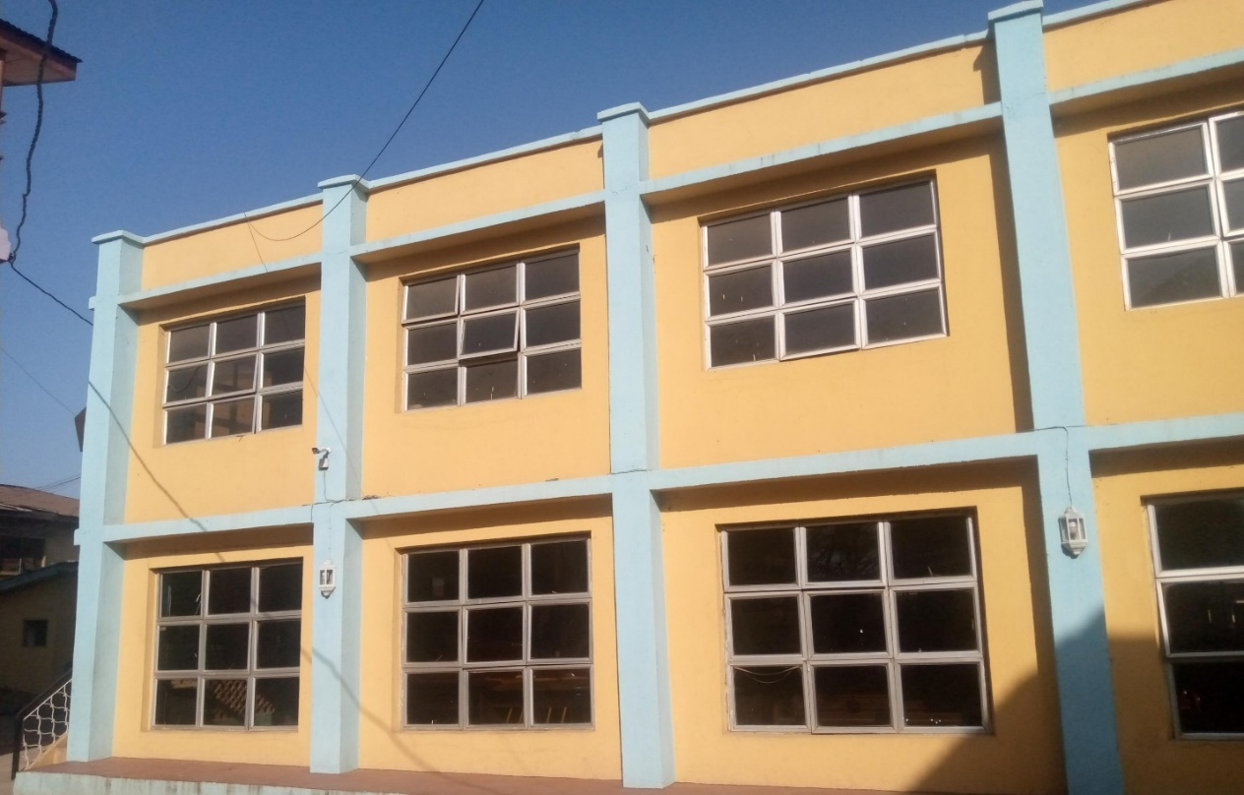

SIDE VIEW OF CAC OKE ISEGUN ZONAL HEADQUARTER

3.2. CASE STUDY TWO
NAME: CAC ALABUKUN ZONAL HEADQUARTER
LOCATION: ITA ALAMU, ILORIN KWARA STATE
BACKGROUND OF CASE STUDY TWO
The Christ Apostolic Church Alabukun Zonal Headquarters in Ita Alamu, Ilorin, has a rich history that dates back to its founding by Prophet M.O. Adio in the late 1980s. Initially, the church started as a small congregation but has since grown to become one of the leading CAC churches in Nigeria, with Prophet Adio at the helm.
MERIT:
- There is provision of access road to the church.
- There is enough sitting capacity to accommodate members.
- The building is sound proof for good sound production
- Provision of faith home for safe delivery of pregnant women
- Gallery stairs are spacious to allow the free movement of crowd.
DEMERIT:
- Parking space is not enough to accommodate vehicles.
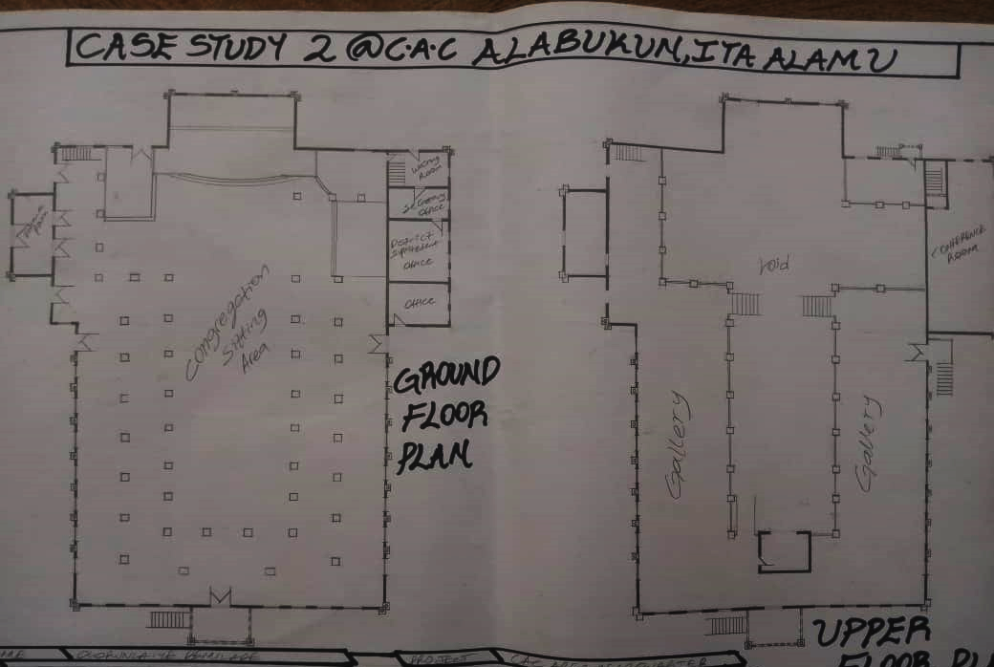
- Access road is usually clumsy, and probably leads to hold-up on the main road during program days.

FLOOR PLAN OF CAC ALABUKUN ZONAL HEADQUATERS ILORIN

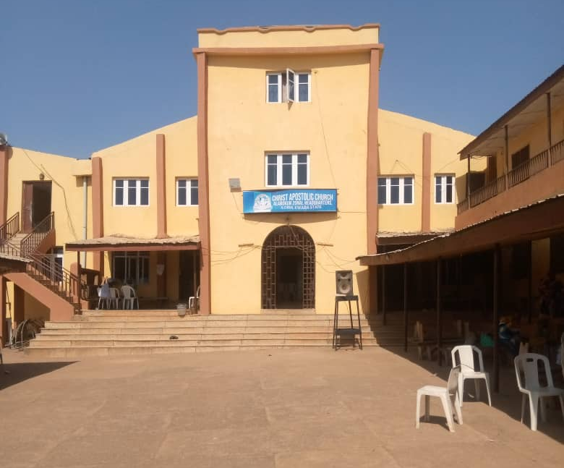

FRONT VIEW OF CAC ALABUKUN ZONAL HEADQUATERS ILORIN
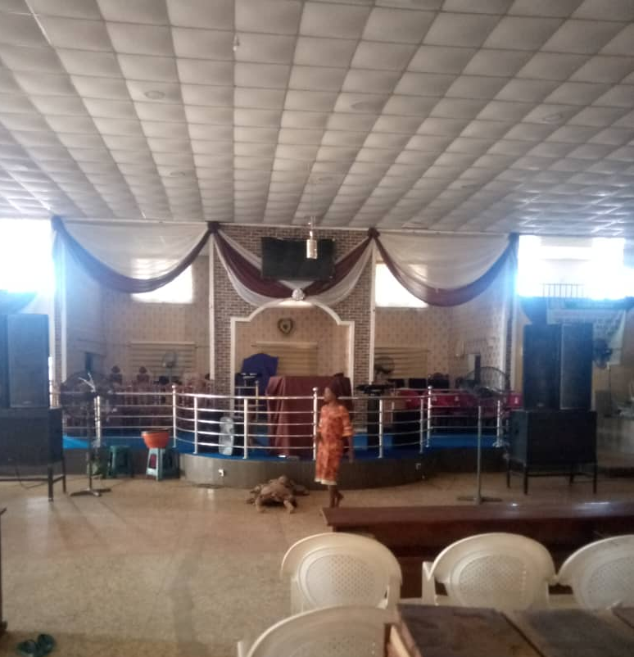

INTERIOR VIEW OF CAC ALABUKUN ZONAL HEADQUATERS ILORIN

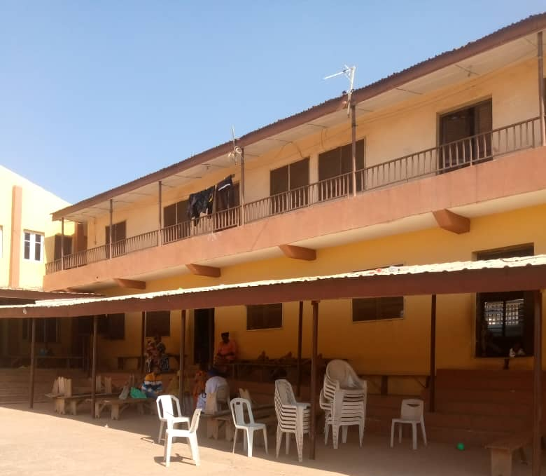

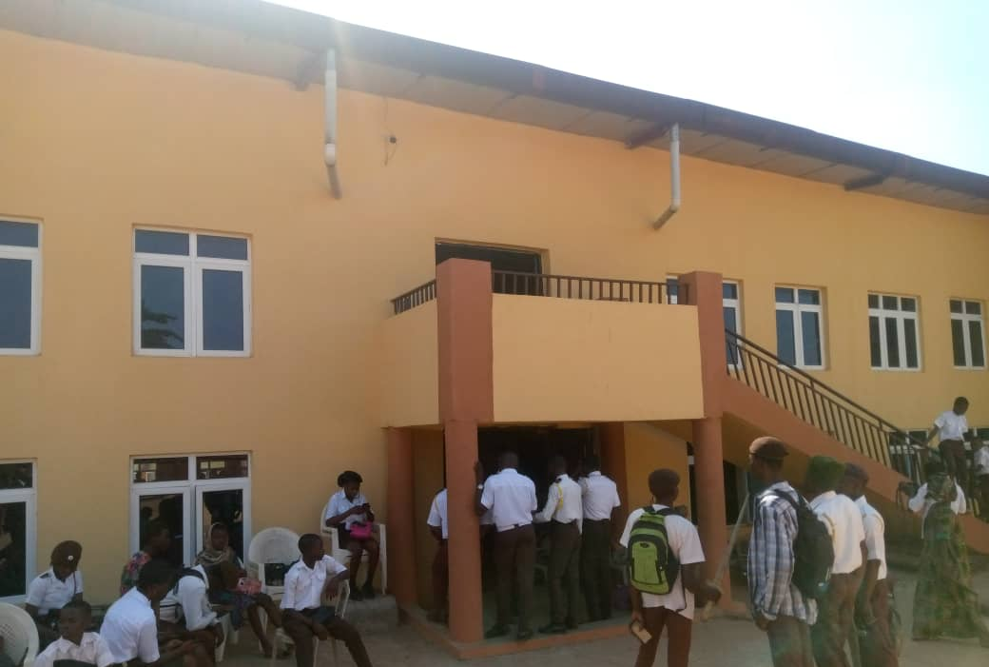
SIDE VIEW OF CAC ALABUKUN ZONAL HEADQUATERS ILORIN

REAR VIEW OF CAC ALABUKUN ZONAL HEADQUATERS ILORIN
3.3. CASE STUDY THREE:
NAME: CAC LATONA ZONAL HEADQUARTER
LOCATION: LATONA STREET, OSOGBO OSUN STATE
BACKGROUND OF CASE STUDY THREE
Christ Apostolic Church Latona, located at Latona Street in Osogbo, Osun State, has a rich history dating back to the Great Revival of 1930, which spread to Osogbo and its environs in 1933. The church’s establishment in Osogbo is attributed to the efforts of B.A. Jonah, a Post and Telegraph official, who played a significant role in introducing Christianity to the area.
Early History and Development
- The church’s growth in Osogbo was fueled by the revival, which led to the establishment of branches in various towns and villages.
- Notable figures such as Late Pastor A.O. Ade Olutimehin, Late Pastor J.O. Yerokun, and Late Pastor E.A. Faniyan contributed to the church’s development in Osogbo.
Leadership and Governance
- Christ Apostolic Church Latona is currently part of the Orogun Region, which was inaugurated in August 2022 by the church’s authorities.
- The region comprises 70 DCCs and Zones, with Pastor Emmanuel S. Famuyide serving as the pioneer Regional Superintendent.
MERIT
- Enough sitting capacity to accommodate members.
- There is church library for convenient reading, with lots of spirit-filled books written by excellent authors.
- There is school where knowledge is been impacted with moral teaching standard.
- There is faith home, for save delivery of pregnant women.

DEMERIT
- Due to the width of the window, there is too much lightening inside the church, so it affects the production of good quality video, during the media session
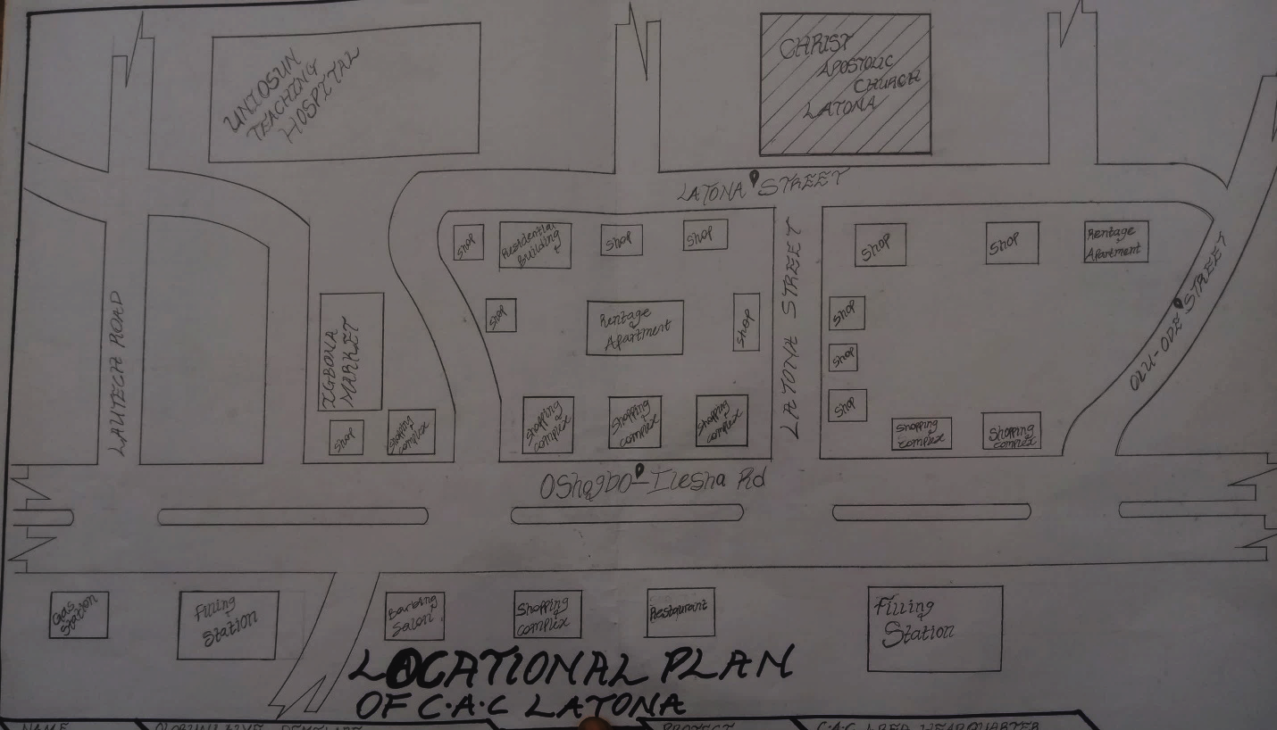
- The church technology infrastructure is outdated, which leads to hindrance in communication collaboration and productivity.

LOCATION PLAN OF CAC LATONA ZONAL HEADQUARTER

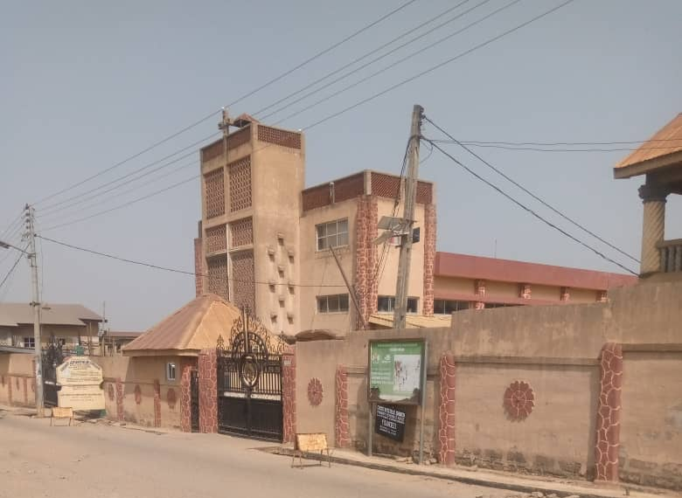

FRONT VIEW OF CAC LATONA ZONAL HEADQUATERS OSOGBO
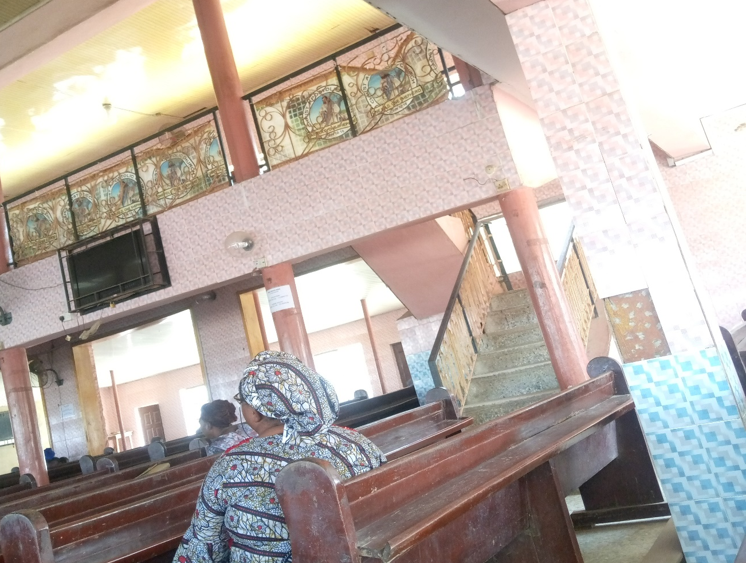
INTERIOR VIEW OF CAC LATONA ZONAL HEADQUATERS OSOGBO
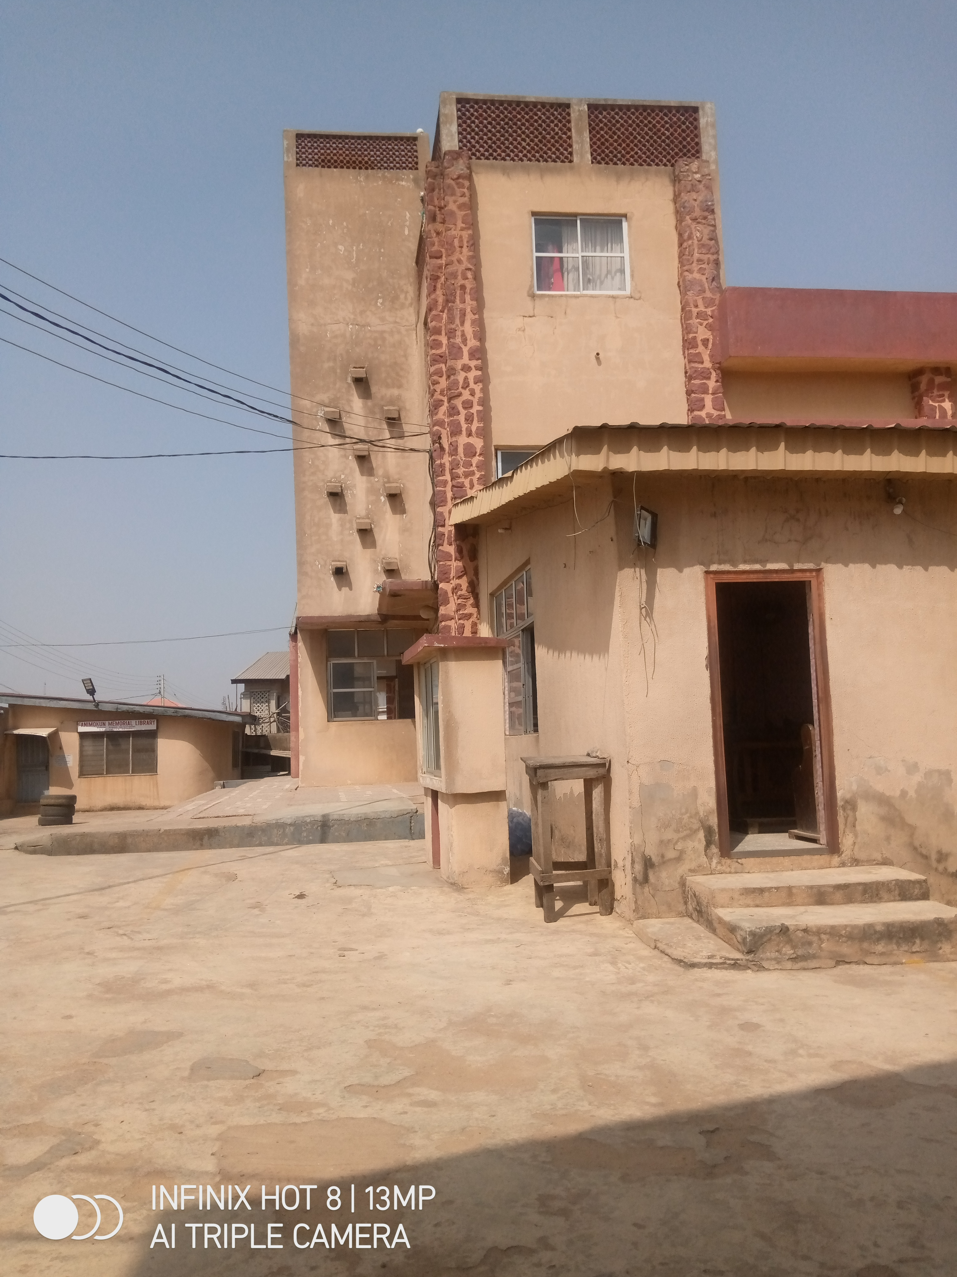
SIDE VIEW OF CAC LATONA ZONAL HEADQUATERS OSOGBO
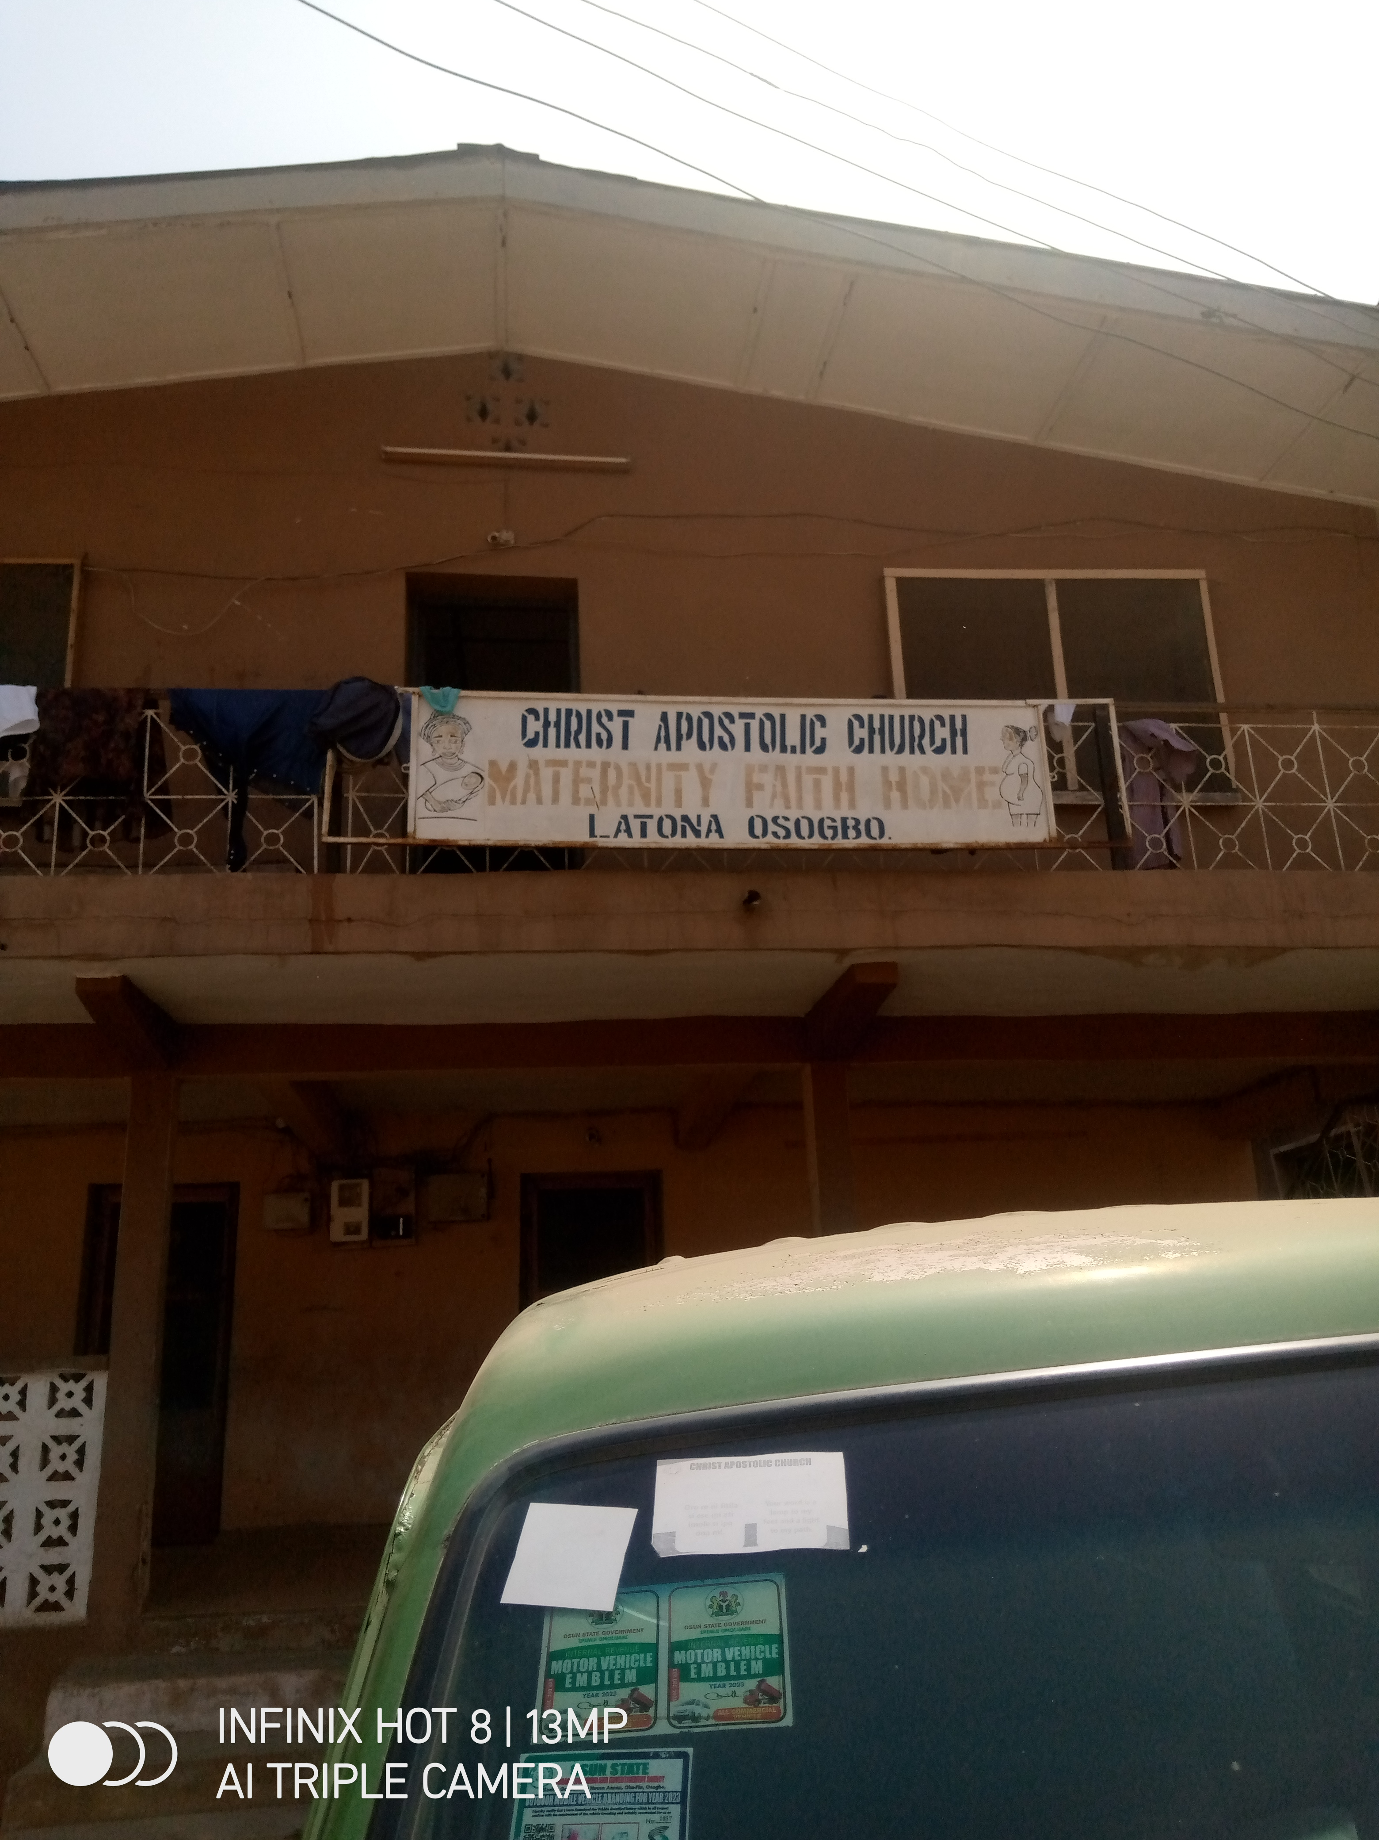
FAITH HOME OF CAC LATONA ZONAL HEADQUATERS OSOGBO
3.4. CASE STUDY FOUR
NAME: CAC ABUJA NIGERIA (ONLINE)
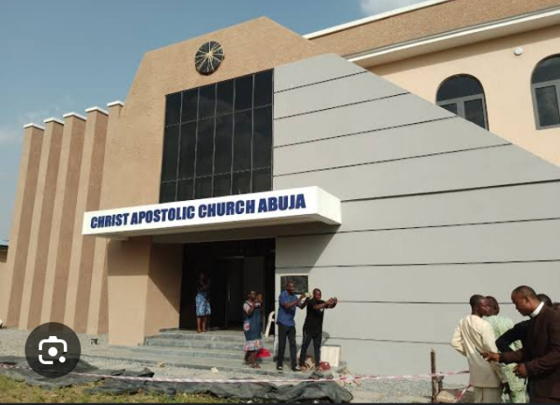
LOCATION: OFF GALADIMA ROAD ,ABUJA NIGERIA.

3.5. CASE STYDY FIVE
NAME: CAC ACCRA GHANA (ONLINE)
LOCATION: OFF AMASAMAN ROAD, ACCRA GHANA


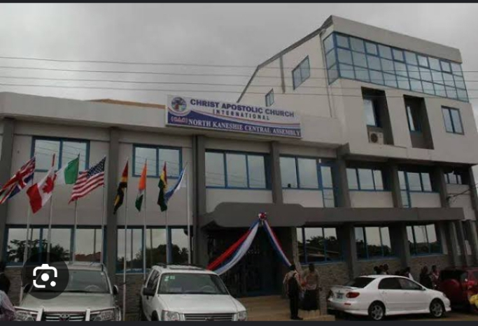

CHAPTER FOUR
4.0. DESIGN PROPOSAL
4.1. INTRODUCTION
The proposed Christ Apostolic Church Area Headquarters in Ilorin West Local Government is designed to serve as a vibrant hub for worship, fellowship, and community service. The project aims to create a functional, sustainable, and spiritually uplifting environment that reflects the church’s values and mission.
The design concept revolves around the themes of light, community, and growth, incorporating modern architectural elements while minimizing environmental impact. The building’s layout will maximize natural light and ventilation, fostering a sense of community through open spaces and gathering areas. Symbolic elements will be incorporated to reflect the church’s values and mission.
The worship center will be a spacious and well-lit auditorium with seating capacity for 1,000 people, featuring a stage for worship and performances. The administration block will house offices for church administrators, meeting rooms, and storage facilities. The education block will comprise classrooms, libraries, and resource centers for Sunday school, Bible study, and other educational programs. Fellowship areas will include designated spaces for socialization, recreation, and community activities.
Sustainability features will be integrated into the design, including energy-efficient lighting and HVAC systems, rainwater harvesting and greywater reuse, solar panels for electricity generation, and landscaping with native plants and trees. Ample parking spaces and accessible pathways will be provided for members and visitors.
The project will be implemented in phases, with the construction of the worship center and administration block as the first phase. The development of the education block and fellowship areas will follow, with the installation of sustainability features and landscaping as the final phase. The estimated budget for the project is ₦500 million, with a projected timeline of 24 months for completion.
The proposed design for the Christ Apostolic Church Area Headquarters In Ilorin West Local Government will create a vibrant and sustainable community hub that reflects the church’s values and mission. With careful planning, execution, and community engagement, this project will become a beacon of hope and spiritual growth for the community.
4.2 SITE LOCATION, DESCRIPTION, AND CRITERIA
4.2.1 SITE LOCATION MAP
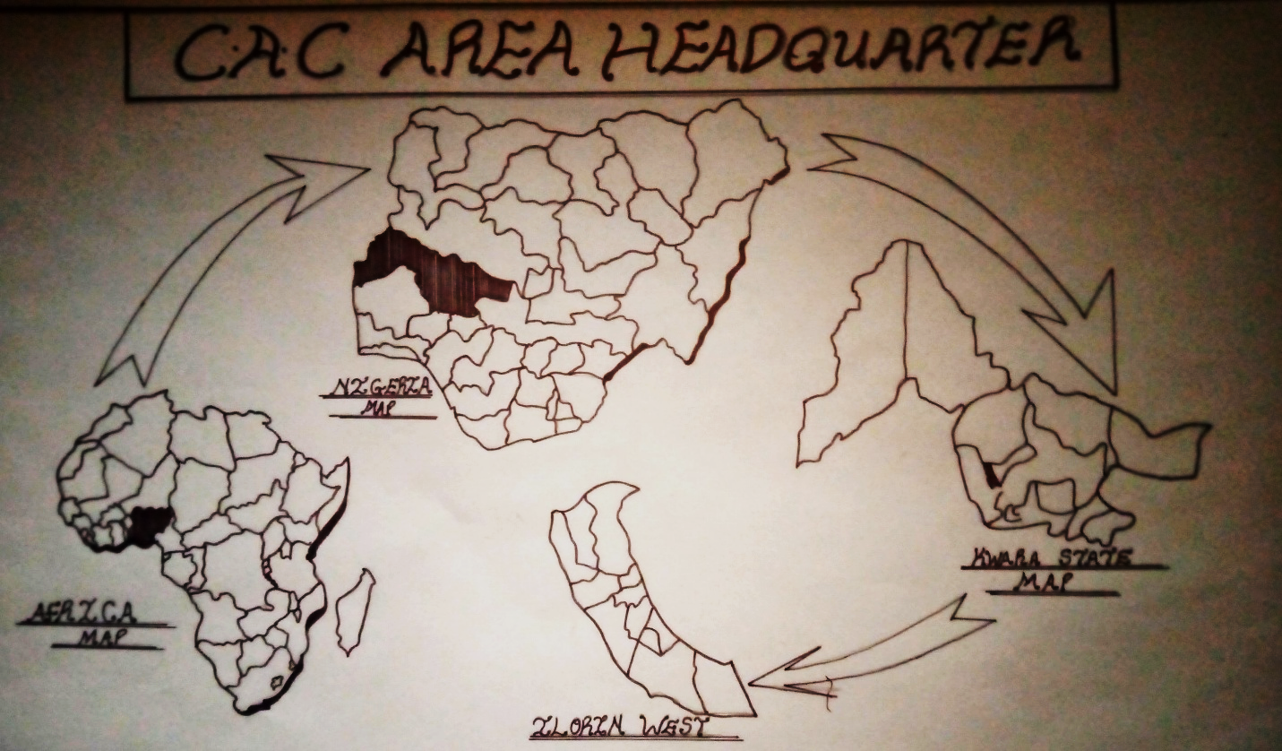

4.2.2. SITE SELECTION CRITERIA
- LOCATION
- EASE OF ACCESS
- NATURE OF SITE AND VEGETATION
- SECURITY
- VEGETATION
4.3. SITE CHARACTERISTICS
4.3 1. SOIL TYPE
The soil type in Ilorin West Local Government, Kingstep Area, plays a significant role in informing architectural design. By understanding the soil conditions, architects can create buildings that are tailored to the site’s specific needs. One of the primary benefits of knowing the soil type is that it allows architects to design foundations that are suitable for the soil conditions, ensuring the stability and safety of the building.
4.3.2. VEGETATION
The vegetation in Ilorin West Local Government, Kingstep Area, provides numerous benefits to the environment, wildlife, and human populations. One of the primary benefits is that it helps to maintain soil quality and prevent erosion. The roots of plants hold the soil in place, reducing the risk of landslides and soil degradation.
Climate Regulation
The vegetation in Kingstep Area also plays a crucial role in regulating the local climate. Trees and other plants provide shade, cool the air through evapotranspiration, and block winds, reducing the impact of extreme weather conditions. This can help to mitigate the effects of climate change and create a more comfortable living environment for residents.
Aesthetic and Recreational Value
The vegetation in Kingstep Area also has aesthetic and recreational value. Green spaces and parks can provide opportunities for recreation, relaxation, and socialization, improving the overall quality of life for residents. Additionally, the natural beauty of the vegetation can attract tourists and support local economic development.
Air and Water Quality
Finally, the vegetation in Kingstep Area helps to maintain good air and water quality. Plants absorb pollutants and particulate matter, improving air quality and reducing the negative impacts of air pollution on human health. Vegetation also helps to filter rainwater, reducing the amount of pollutants that enter waterways and improving water quality.
4.3.3 TOPOGRAPHY
The topography of Ilorin West Local Government, Kingstep Area, plays a significant role in architectural construction. One of the primary benefits is that it allows architects to design buildings that are tailored to the site’s unique characteristics. By understanding the topography, architects can create buildings that work with the natural landscape, reducing the need for extensive excavation or grading.
Natural Drainage
The topography of Kingstep Area can also inform the design of natural drainage systems. By understanding the slope and elevation of the land, architects can design buildings and landscapes that direct water flow in a way that reduces the risk of flooding and erosion. This can help to protect the building and surrounding environment from water damage.
Building Orientation
The topography of the area can also influence the orientation of buildings. By understanding the slope and aspect of the land, architects can design buildings that maximize natural light and ventilation, reducing the need for artificial lighting and heating. This can help to create more energy-efficient and sustainable buildings.
Site Planning
The topography of Kingstep Area can also inform site planning decisions. By understanding the natural features of the land, architects can design buildings and landscapes that work with the existing topography, rather than trying to alter it. This can help to reduce construction costs and minimize the environmental impact of the building.
Aesthetic Appeal
Finally, the topography of Kingstep Area can also contribute to the aesthetic appeal of buildings and landscapes. By incorporating natural features into the design, architects can create buildings that are visually striking and responsive to the surrounding environment. This can help to create a sense of place and connection to the natural world.
4.3.4. DRAINAGE
The drainage system in Ilorin West Local Government, Kingstep Area, plays a crucial role in informing architectural design. One of the primary benefits is that it helps to prevent water accumulation and flooding, which can damage buildings and pose health risks to occupants. By understanding the drainage patterns in the area, architects can design buildings and landscapes that direct water flow in a way that reduces the risk of flooding and erosion.

Site Planning
The drainage system in Kingstep Area can also inform site planning decisions. By understanding the natural drainage patterns, architects can design buildings and landscapes that work with the existing drainage system, rather than trying to alter it. This can help to reduce construction costs and minimize the environmental impact of the building.
Building Design
The drainage system can also influence building design. For example, architects can design buildings with sloping roofs or surfaces that direct water flow towards drainage channels, reducing the risk of water accumulation. Additionally, buildings can be designed with waterproofing measures to prevent water damage.
Stormwater Management
The drainage system in Kingstep Area can also inform stormwater management strategies. By understanding the drainage patterns, architects can design buildings and landscapes that incorporate stormwater management features, such as rain gardens or green roofs, which can help to reduce stormwater runoff and alleviate pressure on drainage systems.
Sustainability
Finally, understanding the drainage system in Kingstep Area can also contribute to sustainable design. By designing buildings and landscapes that work with natural drainage patterns, architects can reduce the need for artificial drainage systems, which can be energy-intensive and contribute to environmental degradation. This can help to create more sustainable and environmentally friendly buildings.

4.3.5. ACCESSIBILITY
The Christ Apostolic Church Area Headquarters situated in Ilorin West Local Government, Kingstep Area, offers several benefits in terms of accessibility. One of the primary advantages is that it provides easy access to church members and visitors, facilitating attendance at worship services, meetings, and other events.
Convenience for Members
The accessibility of the church headquarters is particularly beneficial for members who live in or near Kingstep Area. The proximity of the church to residential areas makes it convenient for members to attend services and participate in church activities without having to travel long distances.
Community Outreach
The accessibility of the church headquarters also facilitates community outreach and evangelism. The church’s location in a residential area makes it easily accessible to potential visitors, allowing the church to reach out to the community and share its message with a wider audience.
Economic Benefits
The accessibility of the church headquarters can also have economic benefits for the local community. By attracting visitors and members to the area, the church can contribute to the local economy through increased foot traffic and spending at local businesses.
4.4. GEOGRAPHICAL AND CLIMATIC DATA
Geographical and Climatic Data of Ilorin West Local Government, Kingstep Area Ilorin West Local Government, Kingstep Area, is located in Kwara State, Nigeria. Geographically, the area is characterized by a tropical savanna climate, with distinct wet and dry seasons. The region’s topography is generally flat, with some areas featuring gentle slopes.
Climate
The climate in Kingstep Area is marked by high temperatures throughout the year, with average temperatures ranging from 25°C to 35°C. The wet season typically lasts from May to October, with the most significant rainfall occurring in July and August. The dry season, which lasts from November to April, is characterized by low humidity and minimal rainfall.
Rainfall
The rainfall pattern in Kingstep Area is typical of the tropical savanna climate, with most of the rainfall occurring during the wet season. The area receives an average annual rainfall of around 1,000 mm, with the rainfall being essential for agriculture and other water-dependent activities.
Vegetation
The vegetation in Kingstep Area is characterized by a mix of grasses, shrubs, and trees, with the dominant vegetation type being the Guinea savanna. The area’s vegetation is influenced by the climate and soil type, with many plant species adapting to the region’s distinct wet and dry seasons.
Geographical Features
The geographical features of Kingstep Area include its proximity to the River Niger, which provides opportunities for water-based activities and supports the local ecosystem. The area’s flat topography and fertile soil make it suitable for agriculture, with many residents engaging in farming and other agricultural activities.

4.5. ANALYSIS OF IMMEDIATE ENVIRONMENTAL CONDITIONS
The immediate environmental conditions of Ilorin West Local Government in Kingstep Area are shaped by its geographical location and human activities. The area experiences a tropical savanna climate with distinct wet and dry seasons, which influences the vegetation and land use patterns. The region’s topography is generally flat, with some areas featuring gentle slopes, making it suitable for agriculture and urban development.
Environmental Features:
- Vegetation: The area’s vegetation is characterized by a mix of grasses, shrubs, and trees, with the dominant vegetation type being the Guinea savanna.
- Water Resources: The proximity to River Niger provides opportunities for water-based activities and supports the local ecosystem.
- Land Use: The area’s flat topography and fertile soil make it suitable for agriculture, with many residents engaging in farming and other agricultural activities.
Environmental Challenges:
- Urbanization and Waste Management: The area faces challenges related to urbanization, including inadequate waste management and environmental degradation.
- Water Scarcity: Access to public pipe-borne water is a significant issue in the area, with many residents relying on alternative sources of water.
- Crime and Safety: Some areas in Ilorin West experience high crime rates, with certain neighborhoods being considered crime hotspots.

Sustainable Development:
- Urban Planning: Effective urban planning is crucial to address the environmental challenges facing the area, including waste management and crime prevention.
- Sustainable Agriculture: Promoting sustainable agricultural practices can help maintain soil fertility and reduce environmental degradation.
4.6. PROJECT ANALYSIS AND DESIGN CRITERIA
4.6.1. PROJECT GOALS
The proposed Christ Apostolic Church Area Headquarters in Kingstep Area, Ilorin West Local Government, aims to provide a central hub for worship, fellowship, and community service. The project goals are multifaceted and include:
Spiritual Growth and Development
The primary goal of the project is to provide a sacred space for spiritual growth and development. The church headquarters will serve as a hub for worship, prayer, and Bible study, providing opportunities for members to deepen their faith and relationship with God.
Community Building and Fellowship
Another key goal of the project is to foster community building and fellowship among church members. The church headquarters will provide a welcoming space for members to gather, and its programs will promote unity, cooperation, and mutual support.
Education and Training
The project also aims to provide education and training programs for church members and the wider community. These programs will focus on spiritual development, leadership training, and community service.
Community Outreach and Service
The Christ Apostolic Church Area Headquarters will also prioritize community outreach and service. The church will engage in various outreach programs, including evangelism, community development, and social service, to serve the needs of the local community.
Sustainable and Functional Design
The project will prioritize sustainable and functional design, incorporating energy-efficient systems, natural light, and ventilation. The building’s design will also reflect the values and mission of the church, providing a welcoming and inclusive space for all users.
4.6.2. FUNCTIONAL AND SPATIAL CRITERIA
The Christ Apostolic Church Area Headquarters requires a functional and spatial design that meets the needs of its users. The functional criteria will prioritize spaces that facilitate worship, fellowship, and service, while the spatial criteria will consider the site’s unique characteristics and the church’s values.
Worship Spaces
The worship spaces should be designed to accommodate large congregations, with adequate seating, lighting, and sound systems. The design should also prioritize acoustics, ensuring that the spoken word and music are clearly audible to all. The worship spaces should be flexible and adaptable to accommodate different types of services and events.
Administrative Offices
The administrative offices should be designed to provide a functional and efficient workspace for church staff. The offices should be equipped with necessary amenities, including meeting rooms, storage spaces, and technology infrastructure. The design should prioritize privacy and confidentiality, ensuring that sensitive information is protected.
Community Facilities
The community facilities should be designed to promote fellowship and socialization among church members. The facilities should include spaces for social gatherings, meetings, and events, as well as amenities such as kitchens and restrooms. The design should prioritize accessibility and flexibility, ensuring that the facilities can be used for a variety of purposes.
Sustainable Design
The design of the Christ Apostolic Church Area Headquarters should prioritize sustainability, incorporating energy-efficient systems, natural light, and ventilation. The building’s design should also consider the use of sustainable materials and minimize waste during construction. By prioritizing sustainability, the church can reduce its environmental impact and promote eco-friendly practices.
Accessibility and Safety
The design of the Christ Apostolic Church Area Headquarters should also prioritize accessibility and safety. The building should be designed to be accessible to all users, including those with disabilities, and should incorporate safety features such as emergency exits and fire suppression systems. By prioritizing accessibility and safety, the church can ensure that all users feel welcome and secure.
4.6.3. APPRAISAL OF PROPOSED SCHEMES IN SPACE, SIZE AND RELATIONSHIP
The proposed Christ Apostolic Church Area Headquarters requires a thorough appraisal of its space, size, and relationship to ensure that it meets the needs of its users. Here are some key considerations:

Space Requirements
- Worship Spaces: The worship spaces should be designed to accommodate large congregations, with adequate seating, standing room, and circulation space. A minimum of 1,000 square meters of floor space may be required to accommodate a large congregation.
- Administrative Offices: The administrative offices should be designed to provide a functional and efficient workspace for church staff. A minimum of 200-300 square meters of floor space may be required to accommodate the administrative offices.
- Community Facilities: The community facilities should be designed to promote fellowship and socialization among church members. A minimum of 500-700 square meters of floor space may be required to accommodate community facilities such as meeting rooms, kitchens, and restrooms.
Size and Scale
- Building Size: The building size will depend on the specific needs of the church and the site constraints. A building size of 2,000-3,000 square meters may be suitable for the Christ Apostolic Church Area Headquarters.
- Height and Massing: The height and massing of the building should be designed to be compatible with the surrounding context. A building height of 2-3 stories may be suitable for the church headquarters.
Relationship between Spaces
- Proximity: The worship spaces, administrative offices, and community facilities should be designed to be in close proximity to each other to promote efficiency and convenience.
- Circulation: The circulation paths should be designed to be clear and efficient, with adequate signage and wayfinding.
- Visual Connections: The design should incorporate visual connections between spaces to promote a sense of community and connection.
Site Planning
- Site Size: The site size will depend on the specific needs of the church and the building design. A site size of 1-2 acres may be suitable for the Christ Apostolic Church Area Headquarters.
- Parking and Access: The site should be designed to provide adequate parking and access for church members and staff.
- Landscaping: The site should be landscaped to promote a sense of serenity and community.
4.6.4. EQUIPMENT AND OPERATIONAL PERFORMANCE REQUIREMENTS
The Christ Apostolic Church Area Headquarters will require various equipment and operational systems to ensure its effective functioning. Here are some of the key equipment and operational performance requirements:
Audio-Visual Equipment
- Sound System: A high-quality sound system will be required to ensure that the spoken word and music are clearly audible to the congregation.
- Projectors and Screens: Projectors and screens will be required for presentations, videos, and other visual aids during services and events.
- Microphones: Microphones will be required for the worship leaders, speakers, and other users.
Lighting and Electrical Systems
- Lighting: A well-designed lighting system will be required to create a welcoming and comfortable atmosphere for worship and other activities.
- Electrical Systems: The electrical systems should be designed to meet the needs of the church, including powering audio-visual equipment, lighting, and other essential systems.
HVAC and Ventilation Systems
- Heating, Ventilation, and Air Conditioning (HVAC): A reliable HVAC system will be required to maintain a comfortable temperature and air quality in the church.
- Ventilation: The ventilation system should be designed to provide adequate airflow and ventilation to prevent the buildup of stale air.
Security and Safety Systems
- Security Cameras: Security cameras will be required to monitor the church premises and ensure the safety of users.
- Alarm Systems: Alarm systems will be required to detect and respond to potential security threats.
- Fire Safety Systems: Fire safety systems, including fire alarms and suppression systems, will be required to ensure the safety of users in the event of a fire.
IT and Communication Systems
- Computer Systems: Computer systems will be required to manage church operations, including administration, finance, and communication.
- Communication Systems: Communication systems, including phones and email, will be required to facilitate communication between church leaders, members, and the wider community.

Operational Performance Requirements
- Maintenance: Regular maintenance will be required to ensure that the equipment and systems are functioning properly.

4.6.5. FUNCTIONAL RELATIONSHIPS
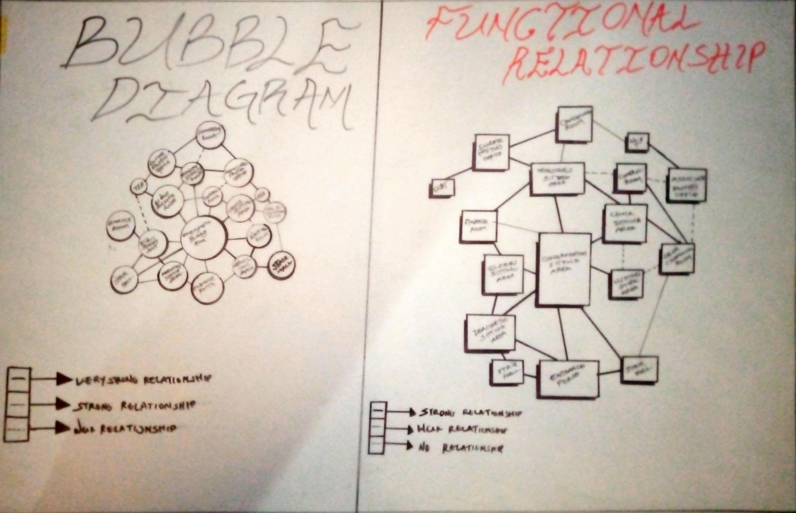

4.6.6. CONCEPTUAL DEVELOPMENT
The Christ Apostolic Church is a vibrant and dynamic community of believers that seeks to spread the message of Jesus Christ to all corners of the world. The bell and Bible are two significant symbols that represent the church’s core values and mission.
The Bell: A Call to Worship
The bell is a powerful symbol that represents the call to worship and the gathering of believers. In the Christ Apostolic Church, the bell is a reminder of the importance of coming together as a community to worship, pray, and seek guidance from God. The sound of the bell is a call to attention, a reminder that we are in the presence of God, and that we should be mindful of our actions and words.
The Bible: A Source of Guidance
The Bible is the sacred scripture that contains the teachings of Jesus Christ and the history of God’s relationship with humanity. In the Christ Apostolic Church, the Bible is revered as a source of guidance, wisdom, and inspiration. The Bible teaches us about God’s love, mercy, and justice, and provides us with a framework for living a meaningful and purposeful life.
Integration of Bell and Bible
The integration of the bell and Bible in the Christ Apostolic Church represents the importance of combining worship and scripture in our lives. The sound of the bell calls us to worship, while the Bible provides us with the guidance and wisdom we need to live a life that is pleasing to God. Together, the bell and Bible remind us of the importance of seeking God’s guidance and wisdom in all aspects of our lives.
Conceptual Development
The conceptual development of the Christ Apostolic Church using the bell and Bible as symbols can be seen in the church’s architecture, worship services, and community outreach programs. The church’s design may incorporate elements that reflect the significance of the bell and Bible, such as a prominent bell tower or a Bible-inspired mural. The worship services may include the use of bells and scripture readings, while the community outreach programs may be guided by the principles of compassion, love, and service that are found in the Bible.
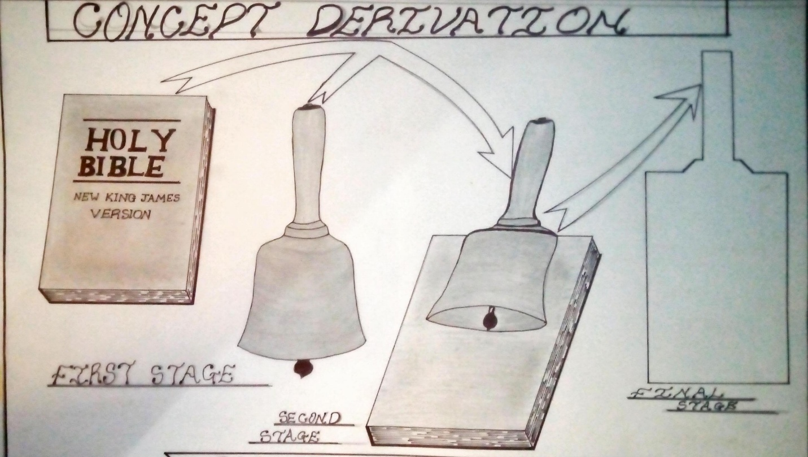
CONCEPTUAL DERIVATION

4.7. SPATIAL ALLOCATION
CHURCH BUILDING SPATIAL ALLOCATION
S/N | UNITS | S/N | LENGTH (M) | BREADTH (M) | AREA (LxB) M²
1. | Entrance Porch | 1 | 6600 | 3000 | 19.8
2. | Media Room | 1 | 4700 | 3000 | 14.1
3. | Usher’s Store Area | 2 | 6000 | 3300 | 19.8
4. | Control Room | 1 | 4000 | 3800 | 15.2
5. | Deaconess Sitting Area | 1 | 16200 | 5900 | 95.59
6. | Elder’s Sitting Area | 1 | 8200 | 6000 | 49.2
7. | Congregation | 1 | 18000 | 25000 | 450
8. | Choir Changing Room | 1 | 4000 | 4000 | 16
9. | Finance Room | 1 | 8000 | 4000 | 32
10. | Elder’s Meeting Room | 1 | 8000 | 4000 | 32
11. | Good Women Meeting Room | 1 | 8000 | 4000 | 32
12. | Stair Hall 1 | 2 | 5400 | 3400 | 18.36
13. | Stair Hall 2 | 1 | 8000 | 1200 | 9.6
14. | Stair Hall 3 | 1 | 5400 | 3000 | 16.2
15. | Counselling Room | 1 | 4000 | 3000 | 12
16. | Curate Pastor Office | 1 | 5400 | 3600 | 19.49
17. | District Superintendent’s Office | 1 | 5000 | 4000 | 20
18. | Associate Pastor’s Office | 1 | 5000 | 3000 | 15
19. | Conference Room | 1 | 6000 | 5400 | 32.4
20. | Toilet and Bathroom | 5 | 2100 | 1200 | 2.52
21. | Lobby | 1 | 8300 | 1200 | 9.96

CHAPTER FIVE
5.0. DESIGN IDEAS AND CONCEPT AT DIFFERENT LEVELS OF THE DESIGN PROCESS
The design of the Christ Apostolic Church Area Headquarters in Kingstep Area, Ilorin West Local Government, will be guided by a deep understanding of the church’s mission, values, and community. The design process will involve several levels, each with its unique ideas and concepts.
Site Planning
At the site planning level, the design will focus on creating a functional and accessible layout that meets the needs of the church community. The site will be designed to accommodate the church building, parking, landscaping, and other essential facilities. The design will also consider the site’s topography, climate, and environmental conditions to ensure sustainability and energy efficiency.
Building Design
The building design will be guided by a modern and functional aesthetic that reflects the church’s values and mission. The design will incorporate elements such as natural light, ventilation, and materials that promote sustainability and energy efficiency. The building’s façade will be designed to be visually appealing, with a prominent entrance that welcomes visitors and members.
Worship Spaces
The worship spaces will be designed to create a sense of community and spiritual connection. The design will incorporate elements such as flexible seating arrangements, good acoustics, and natural light. The worship spaces will also be equipped with modern audio-visual equipment to enhance the worship experience.
Community Facilities
The community facilities will be designed to promote fellowship and socialization among church members. The design will incorporate elements such as meeting rooms, kitchens, and restrooms. The facilities will be designed to be flexible and adaptable to meet the changing needs of the community.
Sustainability Features
The design will incorporate sustainability features such as rainwater harvesting, solar panels, and energy-efficient systems. These features will help to reduce the church’s environmental impact and promote sustainability.
Cultural and Contextual Considerations
The design will also consider the cultural and contextual factors of the Kingstep Area, Ilorin West Local Government. The design will be sensitive to the local culture and traditions, and will incorporate elements that reflect the community’s values and identity.
5.1 TECHNOLOGY AND ENVIRONMENTAL CRITERIA
The Christ Apostolic Church Area Headquarters will incorporate various technological and environmental criteria to ensure sustainability, efficiency, and effectiveness. The technological criteria will focus on utilizing modern technology to enhance the church’s operations, communication, and community engagement.

Technological Criteria
The church will utilize modern technology such as audio-visual equipment, sound systems, and digital displays to enhance worship services and community events. The church will also have a robust IT infrastructure, including computers, software, and internet connectivity, to support administrative tasks, communication, and online engagement. Additionally, the church may consider incorporating digital platforms for online worship services, community engagement, and outreach programs.
Environmental Criteria
The environmental criteria will focus on reducing the church’s environmental impact and promoting sustainability. The church will incorporate energy-efficient systems, such as solar panels and LED lighting, to reduce energy consumption. The church will also implement rainwater harvesting and greywater reuse systems to conserve water. Furthermore, the church will prioritize waste reduction and recycling, and will strive to minimize its carbon footprint through sustainable practices.
Sustainable Design
The church’s design will incorporate sustainable design principles, such as natural light and ventilation, to reduce the need for artificial lighting and heating and cooling systems. The design will also prioritize the use of sustainable materials, such as locally sourced wood and low-VOC paints, to minimize the church’s environmental impact.
Energy Efficiency
The church will prioritize energy efficiency through the use of energy-efficient systems and appliances. The church will also consider incorporating renewable energy sources, such as solar or wind power, to reduce its reliance on non-renewable energy sources.
5.2 SEVICES REQUIRED
The Christ Apostolic Church Area Headquarters will require a range of services to ensure its effective operation and management. These services will include electrical, plumbing, HVAC, IT, and security systems.
Electrical Services
The electrical services will provide power to the building, including lighting, heating, and cooling systems. The electrical system will be designed to be safe, efficient, and reliable, with backup power systems in place to ensure continuity of operations.
Plumbing Services
The plumbing services will provide clean water and sanitation facilities for the building, including sinks, toilets, and showers. The plumbing system will be designed to be efficient and safe, with adequate drainage and waste management systems.
HVAC Services
The HVAC (heating, ventilation, and air conditioning) services will provide a comfortable and healthy indoor environment for occupants. The HVAC system will be designed to be efficient, reliable, and quiet, with adequate ventilation and air filtration systems.
IT Services
The IT services will provide the church with the technology and infrastructure needed to support its operations, including computer systems, internet connectivity, and audio-visual equipment. The IT system will be designed to be secure, reliable, and efficient, with adequate backup systems in place.

Security Services
The security services will provide a safe and secure environment for occupants and assets. The security system will include features such as CCTV cameras, alarms, and access control systems.
Other Services
Other services that may be required for the Christ Apostolic Church Area Headquarters include fire protection systems, audio-visual systems, and communication systems. These services will be designed to support the church’s operations and ensure a safe and healthy environment for occupants.
5.3. PERFORMANCE STANDARD
5.3.1 LEGAL ISSUES AND PLANNING RELATIONS
The Christ Apostolic Church Area Headquarters in Kingstep Area, Ilorin West Local Government, must comply with local regulations and laws governing church establishments and land use. Here’s an overview of the key considerations:
Land Use and Zoning Regulations
The church must ensure that the land is zoned for religious or community use. Ilorin West Local Government Area has specific regulations regarding land use, and the church should obtain the necessary permits and approvals from the local authorities.
Building Codes and Permits
The church’s construction plans must meet the building codes and standards set by the Kwara State government. The church should obtain building permits and approvals from the relevant authorities, including the Ilorin West Local Government Area.
Registration and Incorporation
The Christ Apostolic Church Area Headquarters should register with the Corporate Affairs Commission (CAC) and obtain a certificate of incorporation. This will enable the church to own property, enter into contracts, and conduct financial transactions.
Tax Exemptions
As a religious organization, the church may be eligible for tax exemptions. The church should apply for tax-exempt status with the Federal Inland Revenue Service (FIRS) and provide necessary documentation.
Planning Relations
The church should maintain good relations with the local community, including neighboring residents, businesses, and other stakeholders. This can be achieved through community outreach programs, noise management, and other initiatives that promote peaceful coexistence.
Compliance with Local Laws
The church should comply with local laws and regulations, including those related to noise pollution, waste management, and environmental protection. The church should also ensure that its activities do not disturb the peace and tranquility of the surrounding community.
Relevant Authorities
The church should liaise with relevant authorities, including ¹:
- Ilorin West Local Government Area
- Kwara State Ministry of Lands and Housing
- Corporate Affairs Commission (CAC)
- Federal Inland Revenue Service (FIRS)

By complying with these regulations and maintaining good relations with the local community, the Christ Apostolic Church Area Headquarters can operate smoothly and effectively in the Kingstep Area of Ilorin West Local Government.
5.4. CONCLUSION AND RECOMMENDATIONS
5.4.1. CONCLUSION
The proposed Christ Apostolic Church Area Headquarters in Kingstep Area, Ilorin West Local Government, will be a vibrant and dynamic community hub that reflects the church’s values and mission. The project will provide a sacred space for worship, fellowship, and community engagement, while also promoting sustainability and environmental responsibility.
Community Impact
The Christ Apostolic Church Area Headquarters will have a positive impact on the local community, providing a welcoming and inclusive space for people of all ages and backgrounds. The church’s programs and activities will promote spiritual growth, community engagement, and social responsibility, while also providing support and resources for those in need.
Sustainable Development
The project will prioritize sustainable development, incorporating energy-efficient systems, rainwater harvesting, and sustainable materials into the design and construction of the building. This will not only reduce the church’s environmental impact but also promote sustainability and environmental responsibility.

Conclusion
In conclusion, the proposed Christ Apostolic Church Area Headquarters in Kingstep Area, Ilorin West Local Government, will be a valuable addition to the local community, providing a sacred space for worship, fellowship, and community engagement. The project’s focus on sustainability, community impact, and spiritual growth will make it a model for other churches and community organizations in the area. With careful planning, execution, and community engagement, the Christ Apostolic Church Area Headquarters will be a thriving hub of spiritual activity and community service.
5.4.2. JUSTIFICATION BY RESEARCH RESULTS
Research has shown that community-based initiatives, such as the proposed Christ Apostolic Church Area Headquarters, can have a positive impact on the social and spiritual well-being of individuals and communities. Studies have found that churches and other faith-based organizations play a critical role in promoting community engagement, social cohesion, and spiritual growth.
Community Engagement and Social Cohesion
Research has shown that community engagement and social cohesion are essential for building strong, resilient communities. The proposed Christ Apostolic Church Area Headquarters will provide a welcoming and inclusive space for community members to come together, build relationships, and engage in activities that promote social cohesion and community development.
Spiritual Growth and Development
The church will also provide opportunities for spiritual growth and development, including worship services, Bible studies, and other spiritual programs. Research has shown that spiritual growth and development are essential for individual well-being and can have a positive impact on mental and physical health.
Community Impact
The proposed Christ Apostolic Church Area Headquarters will have a positive impact on the local community, providing a range of benefits, including:
- Increased community engagement and social cohesion
- Opportunities for spiritual growth and development
- Support for vulnerable populations, such as the poor and the elderly
- Promotion of moral values and principles
Research-Based Design
The design of the church will be informed by research on sustainable design, community engagement, and spiritual growth. The building will be designed to be energy-efficient, sustainable, and accessible, with features such as natural light, ventilation, and sustainable materials.
In conclusion, the proposed Christ Apostolic Church Area Headquarters is justified by research results that demonstrate the positive impact of community-based initiatives on social and spiritual well-being. The church will provide a welcoming and inclusive space for community members to come together, engage in activities that promote social cohesion and community development, and pursue spiritual growth and development.

5.4.3. RECOMMENDATION FOR FUTURE RESEARCH
Future research on the Christ Apostolic Church Area Headquarters could explore various aspects of the church’s impact on the community, its sustainability, and its role in promoting spiritual growth and development. Here are some potential areas of research:
Community Impact
Research could investigate the impact of the church on the local community, including its role in promoting social cohesion, community engagement, and support for vulnerable populations. Studies could examine the church’s outreach programs, community services, and partnerships with other organizations.
Sustainability
Future research could explore the church’s sustainability practices, including its energy efficiency, waste management, and environmental stewardship. Studies could investigate the effectiveness of the church’s sustainability initiatives and identify opportunities for improvement.
Spiritual Growth and Development
Research could investigate the impact of the church’s spiritual programs and activities on the spiritual growth and development of its members. Studies could examine the effectiveness of the church’s discipleship programs, worship services, and other spiritual initiatives.
Leadership and Governance
Future research could explore the leadership and governance structures of the church, including its decision-making processes, leadership development, and accountability mechanisms. Studies could investigate the effectiveness of the church’s leadership and governance structures in promoting the church’s mission and values.
Comparative Studies
Comparative studies could be conducted to compare the Christ Apostolic Church Area Headquarters with other churches or community organizations in terms of its impact, sustainability, and spiritual growth and development. This could provide valuable insights into best practices and areas for improvement.
By exploring these areas of research, future studies could provide valuable insights into the impact and effectiveness of the Christ Apostolic Church Area Headquarters and inform strategies for improvement and growth.

REFERENCES
Adeboye, O. (2012). The Pentecostal Revolution in Nigeria. Journal of African Christian Thought.
Adebayo, A. (2019). Challenges facing the Christ Apostolic Church in Nigeria. Journal of Church and State.
Adeyemi, S. (2015). The history of the Christ Apostolic Church. Lagos: CAC Publishing House.
Adeyemi, S. (2020). Strategic planning for church growth and development. Journal of Church Administration.
Adeyemo.T. (2006). African Christianity: The Story of the Christ Apostolic Church. African Books Collective.
Afolayan, M. (2018). The Role of the Church in Community Development. Journal of Community Development.
CAC Constitution. (2020). Christ Apostolic Church Constitution.
CAC Leadership Handbook. (2019). Christ Apostolic Church Leadership Handbook.
Fatokun, S. (2016). The Christ Apostolic Church and community development in Nigeria. Journal of Community Development.
Ojo, M. (2017). The growth and development of the Christ Apostolic Church. Journal of Church and Society.
Ojo, M. A. (2006). The End-Time Army: Christ Apostolic Church Prophetic Ministry. African Journals Online.
Olowola, C. (2018). Community engagement and partnership in church ministry. Journal of Church and Community.
Omoyajowo, A. (2008). The Cherubim and Seraphim: The History of an African Independent Church. Lagos: Atlantic Books.

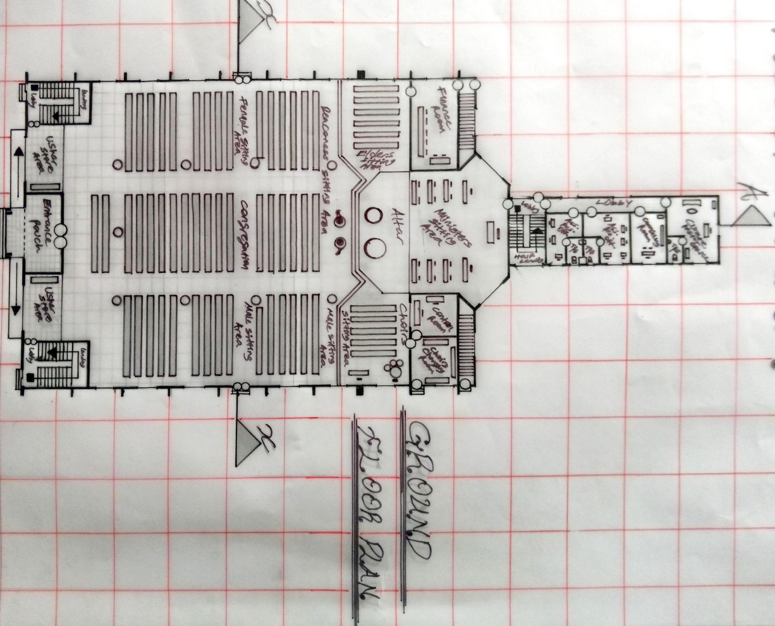
APPENDIX

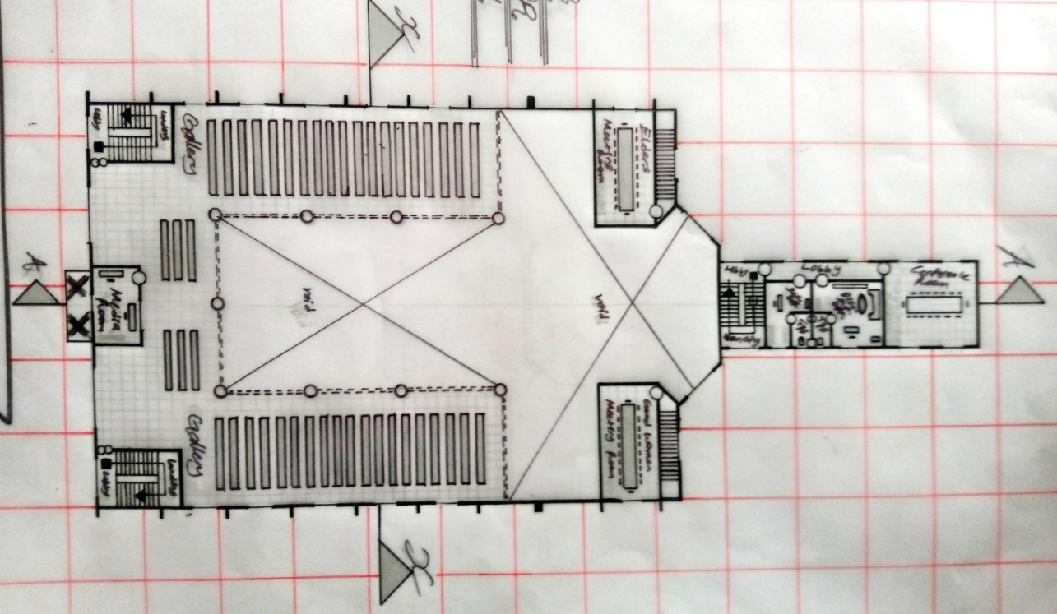
GROUND FLOOR PLAN
UPPER FLOOR PLAN

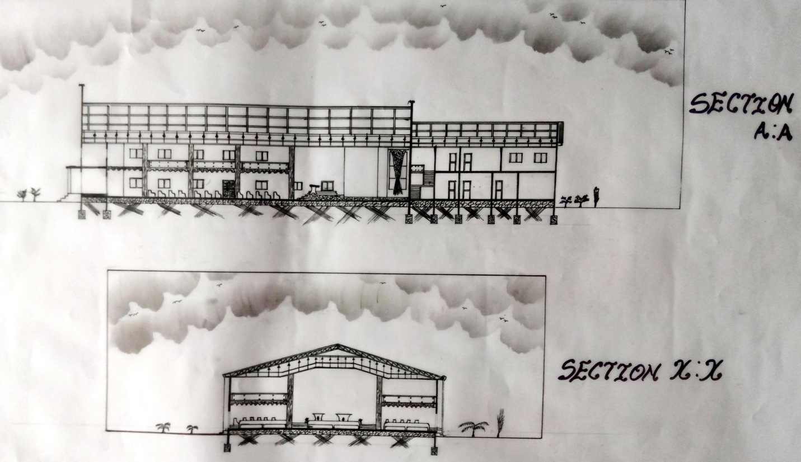
SECTIONAL DRAWINGS

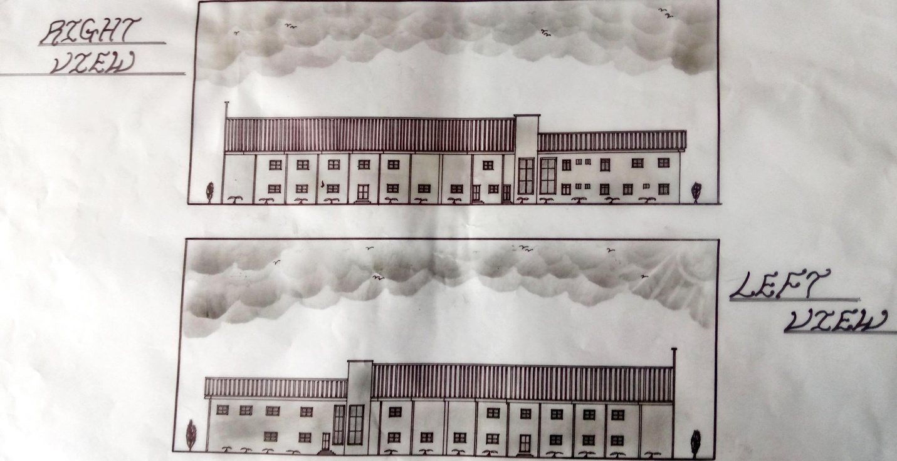
ELEVATION

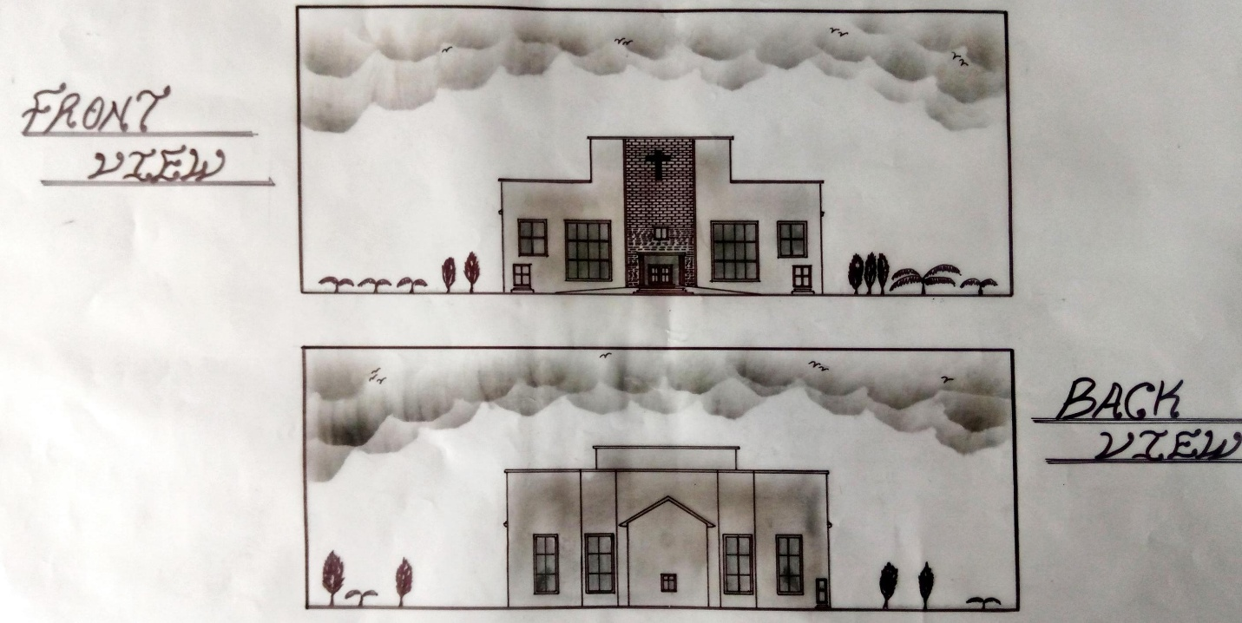
ELEVATION

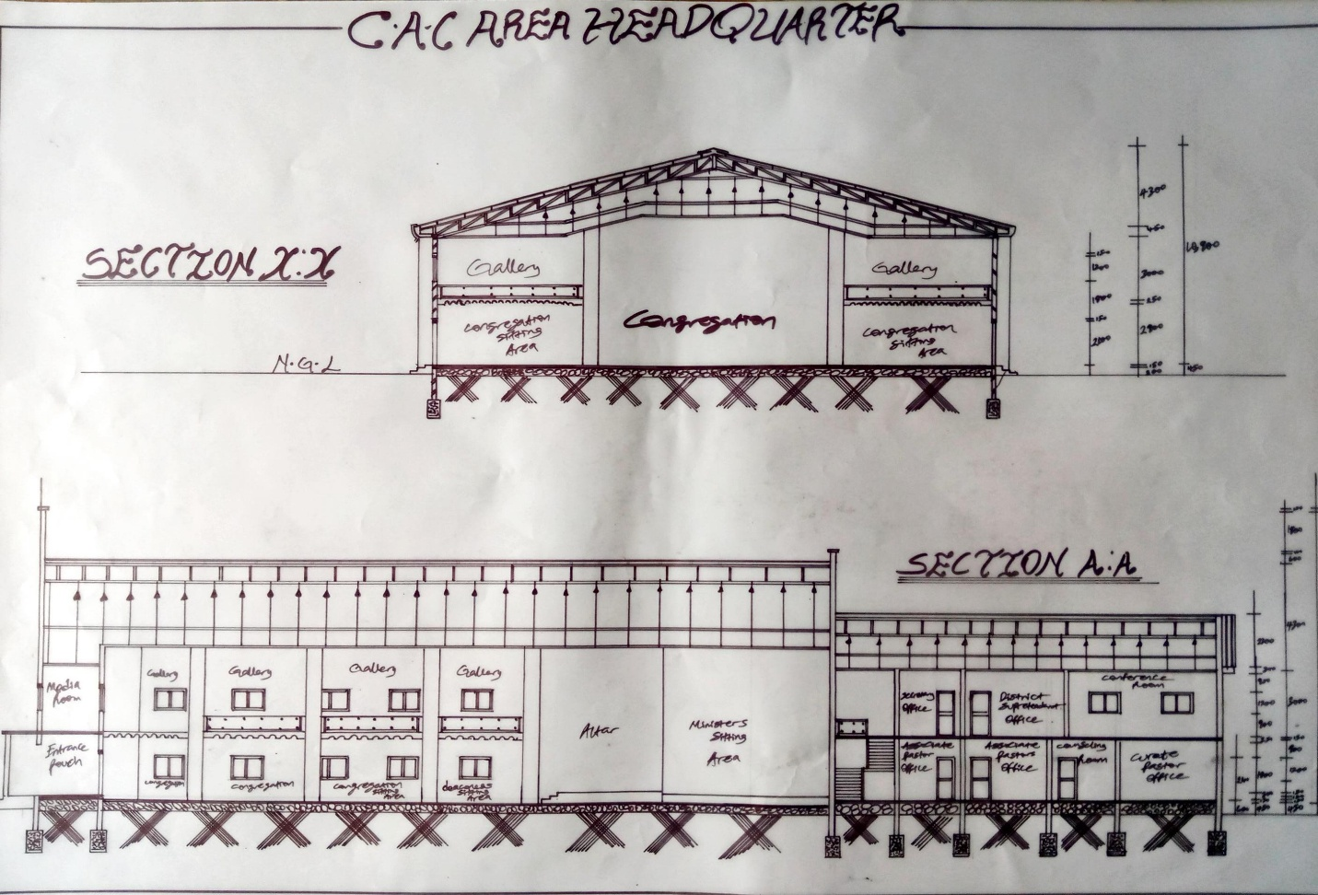
WORKING DRAWING SECTION

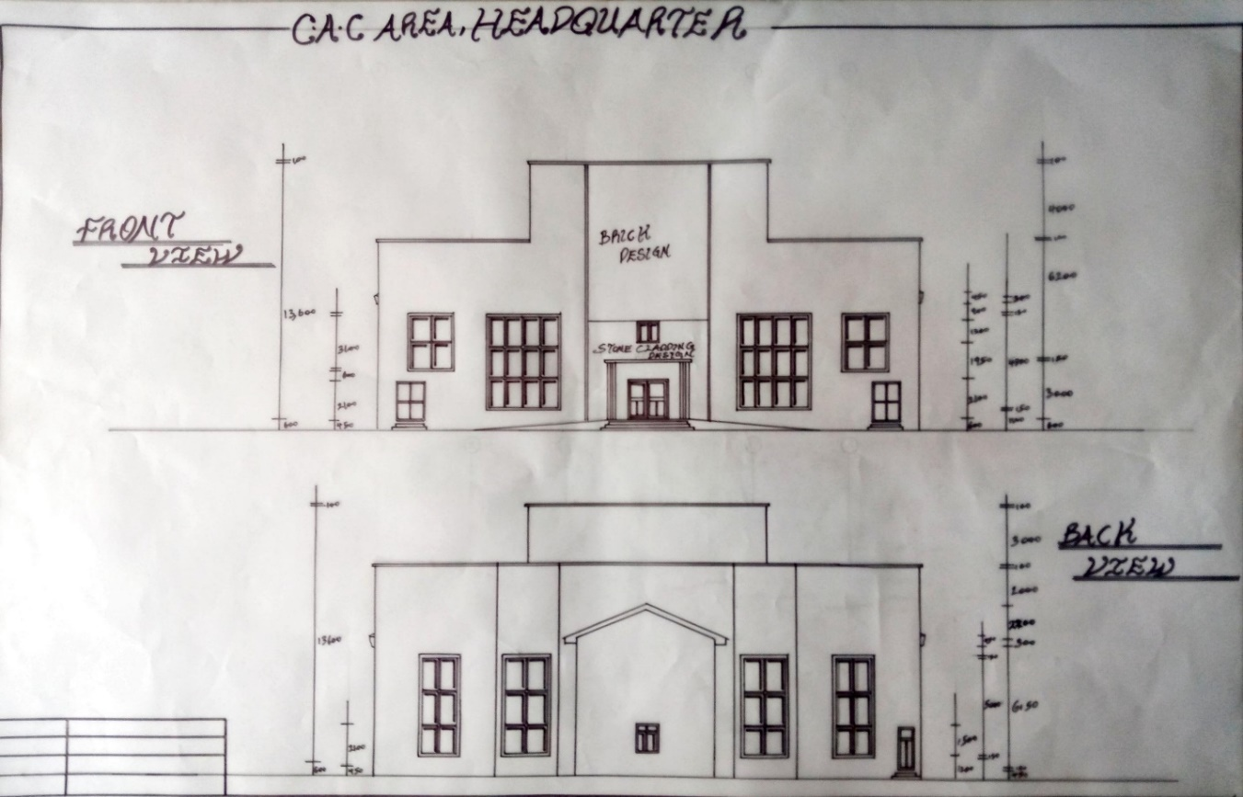
WORKING DRAWING ELEVATION

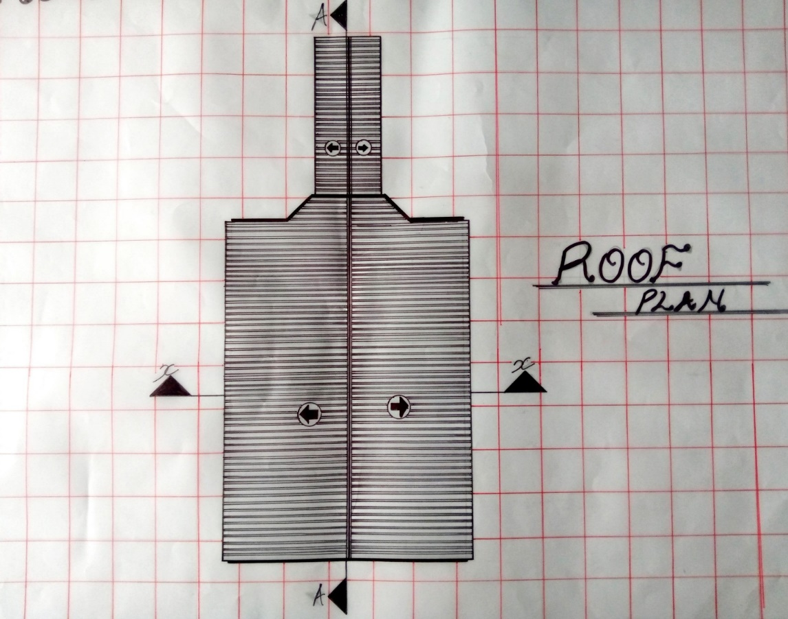
ROOF PLAN

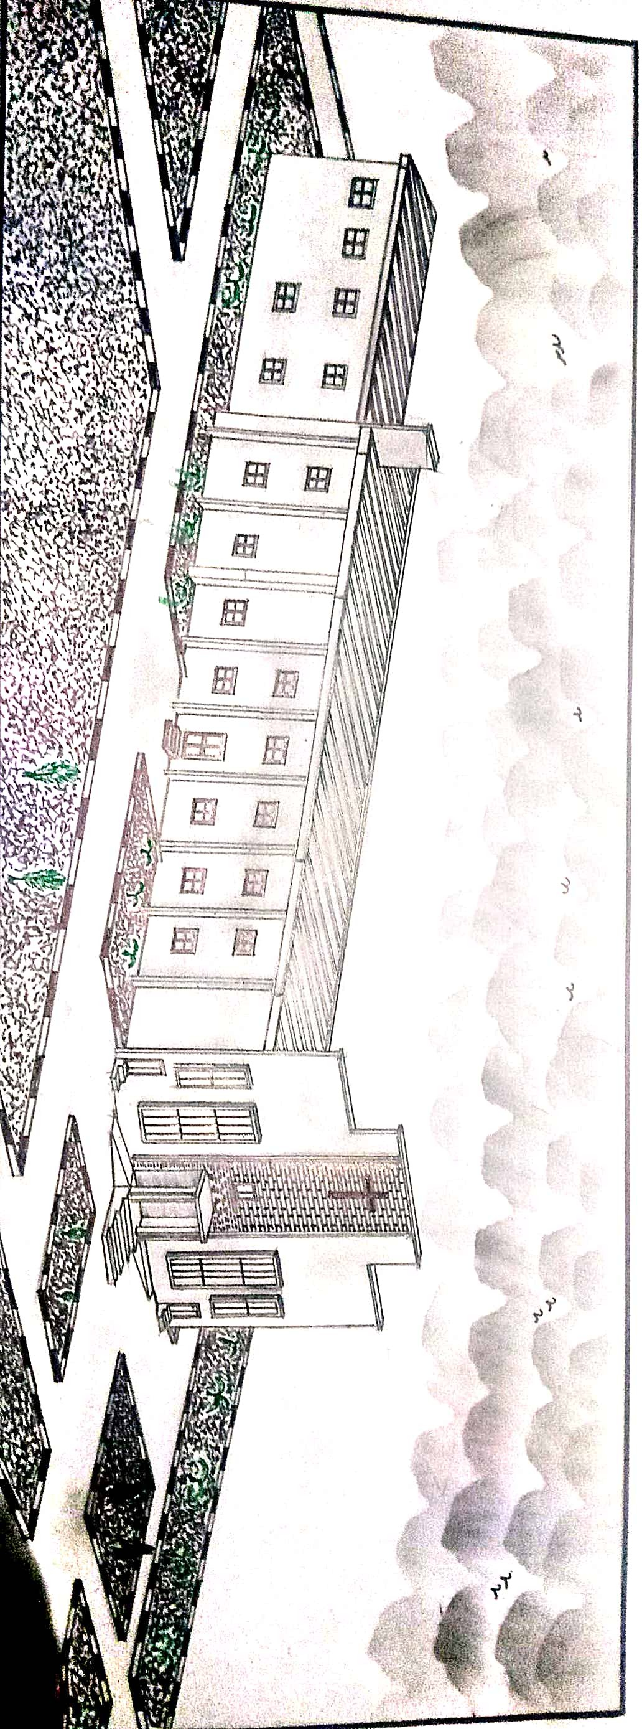
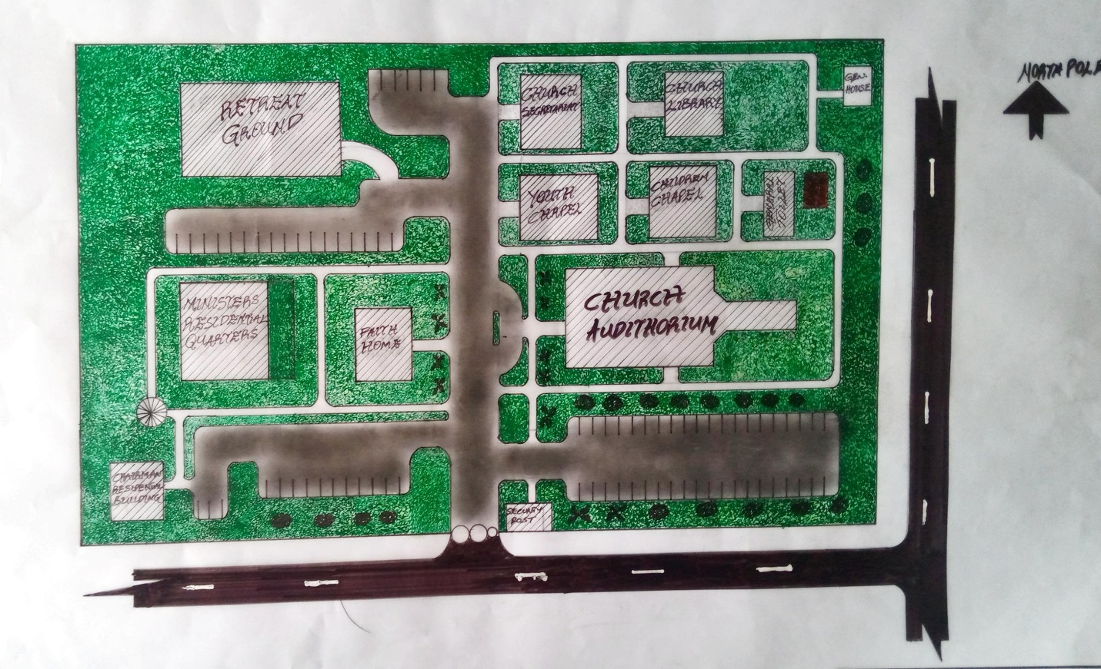
SITE PLAN

EXTERNAL PERSPECTIVE

