A PROJECT REPORT
ON
PROPOSED ICT CENTER
FOR
EGBE YAGBA WEST L.G.A. KOGI STATE

BY

ABOLADE OLUWATIMILEHIN PRECIOUS
ND/23/ARC/FT/0028

SUBMITTED TO:
THE DEPARTMENT OF ARCHITECTURAL TECHNOLOGY
INSTITUTE OF ENVIRONMENTAL STUDIES (I.E.S)
KWARA STATE POLYTECHNIC, ILORIN.

IN PARTIAL FULFILMENT OF THE REQUIREMENTS FOR THE AWARD OF NATIONAL DEPLOMA (ND) IN ARCHITECTURAL TECHNOLOGY

SUPERVISOR
ARC. MOHAMMED SHERO A.

JULY, 2025.

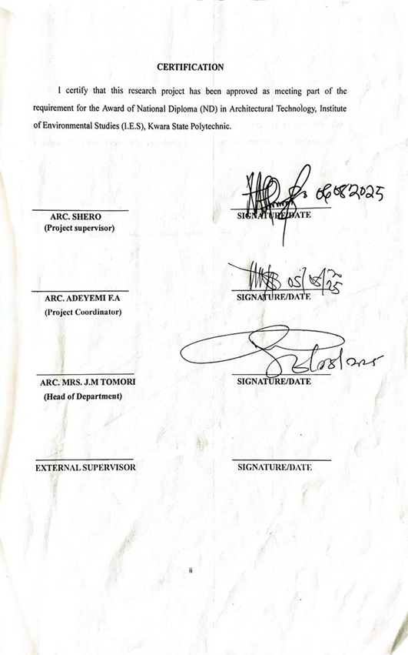

DECLARATION
I declare that this Project/Dissertation is a product of my personal research work. It has not been presented for the award of any degree in any Polytechnic. The ideas, observations, comments, and suggestions herein represent my own convictions, except quotations, which have been acknowledges in accordance with conventional academic traditions.

ABOLADE OLUWATIMILEHIN PRECIOUS __________________________
ND/23/ARC/FT/0028 DATE/SIGNATURE

DEDICATION
I dedicate this project to God Almighty the creator of the universe for the grace bestow upon my life, for he has strengthen me to this present time, and also to my beloved parent MR. ABOLADE and MRS. ABOLADE for their prayer and support. May God Almighty bless and reward them abundantly and every other supporter to my academic life.

ACKNOWLEDGEMENT
Everything that has beginning must have an end, therefore, all praises and adoration is unto God for the strength and courage he has accorded me in the process of this project.
Special thanks to my supervisor ARC. MOHAMMED SHERO A. for taking his time to go through my research work, may Almighty God bless you abundantly. Also I appreciate my H.O.D ARC. MRS. TOMORI J.M. my project coordinator ARC. OLAREWAJU.
I say thanks to the management, staff both teaching and non-teaching staff of Architectural Technology for their impact in my life during my course of study.
My deepest appreciation goes to my parents MR. ABOLADE and MRS. ABOLADE for their moral and financial support towards my education.

TABLE OF CONTENT
TITLE PAGE …………………………………………………………………………….i
CERTIFICATION………………………………………………………………………...ii
DECLARATION…………………………………………………………………………iii
DEDICATION……………………………………………………………………………iv
ACKNOWLEDGEMENT………………………………………………………………..v
TABLE OF CONTENT…………………………………………………………………..vi
ABSTRACT……………………………………………………………………………... ix
CHAPTER ONE: INTRODUCTION
1.1 HISTORICAL BACKGROUND…………………………………………………….1
1.2 AIM AND OBJECTIVES……………………………………………………………2
1.3 SCOPE OF STUDY………………………………………………………………….3
1.4 RESEARCH METHODOLOGY……………………………………………………4
CHAPTER TWO
2.0 LITERATURE REVIEW…………………………………………………………….5
2.1DEFINITION OF ICT CENTER……………………………………………………..5
2.2 TYPES OF ICT CENTER……………………………………………………………6
CHAPTER THREE
3.0 CASE STUDY……………………………………………………………………8
3.1 BRIEF HISTORY OF PROJECT LOCATION…………………………………..14
3.2 SITE LOCATION DESCRIPTION………………………………………………15
3.3 SITE SELECTION CRITERIA …………………………………………………..15
3.4 SITE ANALYSIS………………………………………………………………….16
3.4.1 SOIL TYPE……………………………………………………………………......16
3.4.2 TOPOGRAPHY…………………………………………………………………...16
3.4.3 ORIENTATION……………………………………………………………………17
3.4.4 VEGETATION…………………………………………………………………......17
3.5 GEOGRAPHICAL CLIMATE DATA……………………………………………..17
3.5.1 GEOGRAPHICAL OF KWARA STATE…………………………………………..17
3.5.2 CLIMATIC DATA………………………………………………………………….18
3.5.3 TEMPERATURE…………………………………………………………………...19
3.5.4 RAINFALL…………………………………………………………………………19
3.5.5 HUMIDITY………………………………………………………………………...19
3.5.6 WIND………………………………………………………………………………19
3.5.7 THE NORTHERN-EAST TRADE WIND………………………………………...19
3.5.8 THE SOUTHERN-EAST TRADE WIND…………………………………………20
3.6 CONCLUSION……………………………………………………………………..20
CHAPTER FOUR
4.0 DESIGN AIM……………………………………………………………………….21
4.1 DESIGN CONCEPT………………………………………………………………...21
4.2 DESIGN FORM……………………………………………………………………..21
4.2.1 DESIGN CRITERIA………………………………………………………………...22
4.2.2 DESIGN SCOPE…………………………………………………………………….22
4.2.3 DESIGN BRIEFS……………………………………………………………………22
4.3 TRAFFIC ANALYSIS ……………………………………………………………..23
4.4 DESIGN CONSIDERATION……………………………………………………...23
CHAPTER FIVE: SUMMARY, CONCLUSION AND RECOMMENDATIONS
5.0 APPRAISAL OF PROPOSED DESIGN ………………………………………......25
5.1 CONSTRUCTION TECHNIQES AND CHOICE MATERIAL…………………...25
5.2 SERVICE REQUIRED…………………………………………………………......25
5.2.1 VENTILATION…………………………………………………………………….26
5.2.2 LIGHTNING…………………………………………………………………….....26
5.2.3 CIRCULATION………………………………………………………………….....26
5.2.4 PLUMBING………………………………………………………………………...26
5.2.5 ACOUSTIC…………………………………………………………………………26
5.2.6 WATER DISPOSAL………………………………………………………………...26
5.2.7 FIRE PROTECTION……………………………………………………………......27
5.2.8 EXTERNAL…………………………………………………………………………27
5.3 CONSTRUCTION METHODOLOGY…………………………………………......28
5.4 RECOMMENTATION AND CONCLUSION………………………………………28
REFERENCES……………………………………………………………………………..29
APPENDIX…………………………………………………………………………………30
LIST OF FIGURES:
FIG 1.1 – FIG 1.8

ABSTRACT
An Information and Communication Technology (ICT) Center serves as a hub for digital learning, innovation, and technological advancement. This study explores the design, implementation, and impact of an ICT center in educational and professional settings. The research examines key aspects such as infrastructure, accessibility, digital literacy programs, and sustainability. Findings indicate that well-equipped ICT centers enhance learning outcomes, bridge the digital divide, and support economic growth by providing access to essential digital resources. However, challenges such as high maintenance costs, inadequate funding, and limited technical expertise hinder their effectiveness. The study concludes that for ICT centers to achieve their full potential, government policies, public-private partnerships, and community engagement must be prioritized.

CHAPTER ONE: INTRODUCTION
  - BACKGROUND TO THE STUDY
The history of ICT (Information and Communications Technology) centers is deeply intertwined with the evolution of computing and telecommunications. There's no single, definitive starting point, as the development happened gradually across different locations and institutions.
However, we can trace key phases:
Early Stages (Pre-1960s): The precursors to ICT centers were primarily found in universities and research institutions. These early centers often focused on specific technologies like mainframe computers, which were large, expensive, and required specialized facilities. Access was typically restricted to researchers and students involved in specific projects. These early "computing centers" were the forerunners of what would later become much more accessible ICT centers. The focus was primarily on computation, rather than the broader communication aspects that became central later on.
The Rise of Networking (1960s-1980s): The development of networks, like ARPANET (a precursor to the internet), dramatically changed the landscape. These networks enabled the sharing of computing resources and information across geographically dispersed locations. ICT centers began to evolve, incorporating networking technologies and expanding their services beyond simple computation to include data storage, network administration, and support for emerging applications.
The Personal Computer Revolution (1980s-1990s): The widespread adoption of personal computers (PCs) and the continued development of the internet led to a significant shift. ICT centers became more user-focused, providing access to a wider range of computing resources and applications for a larger community. The focus shifted from primarily computational tasks to supporting a diverse range of activities, including research, education, and administration.

This era also saw the growth of local area networks (LANs) within institutions, connecting various departments and facilitating data exchange.
The Internet Era (1990s-Present): The explosive growth of the internet and the World Wide Web fundamentally transformed ICT centers. They became essential hubs for connecting individuals and institutions to global networks, offering services like internet access, email, web hosting, and specialized software applications. The role of ICT centers expanded to include network security, data management, and support for increasingly complex software systems. Many centers also began offering training and support to users, helping individuals navigate the ever-evolving digital landscape.
Modern ICT Centers: Today, ICT centers vary considerably in their size, scope, and services. Some are large, centralized facilities supporting entire universities or organizations, while others are smaller, departmental units focused on specific needs. Common services include:
- Network infrastructure: Providing reliable internet access, network security, and management.
- Computing resources: Offering high-performance computing clusters, server farms, and storage solutions.
- Software applications: Providing access to a wide range of software, including specialized applications for research and education.
- Technical support: Assisting users with hardware, software, and network issues.
- Training and education: Offering courses and workshops on various ICT topics.
  - AIM AND OBJECTIVES OF THE STUDY
AIM
The aim of an Information and Communication Technology (ICT) Center is to enhance digital access, promote technological literacy, and facilitate innovation in various sectors. Specifically, an ICT center.

Objectives of ICT center:
The objectives of an ICT (Information and Communication Technology) Center can vary based on the specific needs of the community it serves, but typically include the following:
- Enhancing Digital Literacy: To provide training programs that improve individuals' ability to use digital technology effectively and confidently.
- Promoting Economic Development: To assist local businesses and entrepreneurs by offering technological resources and training, helping them to grow and compete in a digital economy.
- Supporting Education and Skill Development: To offer courses and workshops aimed at broadening the knowledge and skills of participants in various ICT disciplines, including programming, graphic design, networking, and cybersecurity.
- Increasing Access to Technology: To ensure that community members have access to computers, the internet, and other digital tools that are essential for education, employment, and communication.
  - SCOPE OF THE PROJECT
The scope of an ICT Center project defines the extent, objectives, components, and limitations of the project. It outlines the services provided, target users, infrastructure, and expected outcomes.
• Reception area
• Workstation area
• Training and digital literacy room
• Server and networking room
• Office
• Conference room
• Storage and maintenance room
• Multimedia unit
• Innovation hub
• Toilet
• Exit
  - RESEARCH METHODOLOGY
• Case study
• Oral interview
• Literature review

CHAPTER TWO
2.0 LITERATURE REVIEW
An Information and Communication Technology (ICT) Center is a facility designed to provide access to digital technology, internet services, and ICT training for individuals, businesses, and communities. It serves as a hub for learning, innovation, e-governance, and business development by offering resources such as computers, networking equipment, software, and digital literacy programs.
2.1 DEFINITION OF ICT CENTER
An ICT Center is a facility that provides computer access, internet services, and digital skills training to individuals and organizations. It serves as a hub for technology education, business support, online services, and innovation, helping people enhance their digital literacy and utilize modern communication tools effectively.
An ICT Center is a dedicated space equipped with computers, internet access, and digital resources, designed to support technology learning, communication, business activities, and e-governance services. It enables individuals and organizations to develop digital skills, access online information, and utilize modern technological tools for various purposes.
Architectural considerations for ICT center include:
- Size & Layout: Design an open-plan layout for efficient workspace utilization while ensuring privacy for specialized units.
- Ventilation & Cooling: Install air conditioning, proper airflow systems, and server cooling units to prevent overheating.
- Lighting: Provide natural lighting where possible, supplemented by LED lights to reduce eye strain and save energy.
- Server & Networking Room- Houses servers, routers, switches, and data storage units with high-security access.
- Power Supply & Backup: Use solar power, generators, and UPS systems to ensure continuous operation.
2.2 TYPES OF ICT CENTER
ICT centers vary based on their purpose, target users, and services offered. Below are the main types of ICT centers:
- Educational ICT Centers
School ICT Centers - Found in primary and secondary schools, providing students and teachers access to digital learning tools.
University ICT Labs - Equipped with advanced computing resources, research tools, and e-learning platforms for students and faculty.
Technical & Vocational ICT Centers - Offer IT training, coding boot camps, and digital skills development for career advancement.
- Community ICT Centers
Public Digital Access Centers - Provide free or low-cost internet and computer access to the public, especially in rural areas.
NGO & Non-Profit ICT Hubs - Focus on digital literacy, women empowerment, and youth technology training.
Tele centers - Government-supported centers that offer e-learning, e-government services, and technology workshops.
- Business & Innovation ICT Centers
Business Incubation & Tech Hubs - Support startups, software developers, and tech entrepreneurs with workspaces, mentorship, and funding.
Corporate ICT Training Centers - Provide IT skill development, cybersecurity training, and digital transformation programs for businesses.
E-Commerce & Digital Marketing Centers - Assist businesses with online store management, digital advertising, and website development.

- Government & E-Governance ICT Centers
E-Governance & Public Service ICT Centers - Enable citizens to access government portals, tax filing, and digital documentation services.
Cybersecurity & Data Protection Centers - Focus on IT security research, cybercrime prevention, and data privacy enforcement.
Smart City ICT Centers - Support urban development by integrating traffic control, surveillance, and digital communication networks.
- Healthcare & Research ICT Centers.
Medical ICT Centers - Found in hospitals and clinics for telemedicine, digital patient records, and healthcare research.
Biotechnology & Scientific Research ICT Labs - Provide high-performance computing resources for genetic analysis, data modeling, and Al research.
- Specialized & Emerging ICT Centers
Multimedia & Creative ICT-Labs - Focus on graphic design, video editing, animation, and digital content creation.
Al & Robotics Research Centers - Explore machine learning, robotics development, and automation technology.
Green ICT Centers - Promote environmentally friendly IT solutions, e-waste recycling, and solar-powered digital hubs

CHAPTER THREE
3.0 CASE STUDY
According to JSTOR (January 2019), a case study is about a person, group, or situation that has been studied over time. It can be defined as an intensive, systematic investigation about a person, stoup of people, or a unit in which the researcher examines in depth data relating to several variables case studies can be produced by following a formal research method. These case studies are likely to appear in formal research venues, as journals and professional conferences, rather than popular works. The resulting body of case study research has long had a prominent place in many disciplines and professions, ranging from psychology, anthropology, sociology, and political science to education, clinical science, social work, and administrative science. In doing case study research, the "case" being studied may be an individual, organization, event, or action, existing in a specific time and place.
Outline of Cases Studied
- OGBOMOSHO OYO STATE
ICT/DIGITAL CENTER BOWEN UNIVERSITY, OGBOMOSHO
MERIT
- Improve patient care
- Improve training and development
DEMERIT
- Inefficiency equipment
- Lack of adequate power

Fig 1: The Case Study One Images
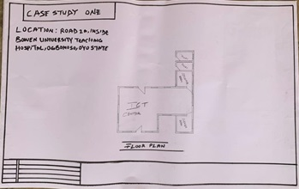

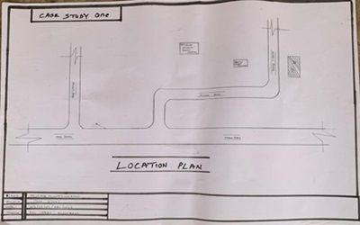

FIG 2: ICT/Digital Center inside Bowen University Teaching Hospital, Ogbomosho Oyo state

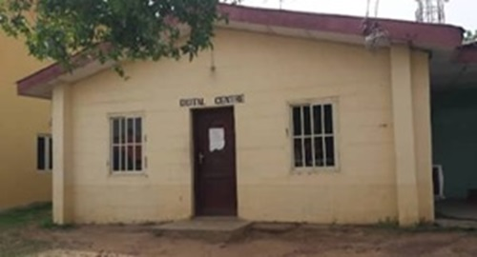

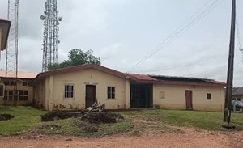

- TASUED ICT IJEBU ODE OGUN STATE
MERIT
- Adequate parking space
- Operational efficiency
DEMERIT
- Limited computer
- No waiting area
Fig 1: The Case Study Two Images
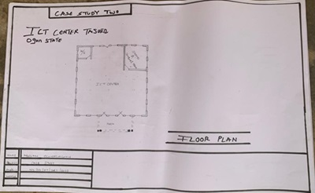

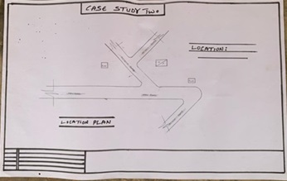

FIG 2: TASUED ICT, Ijebu Ode Ogun State.
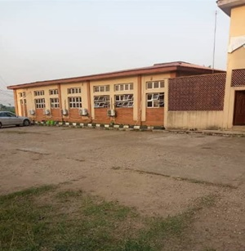
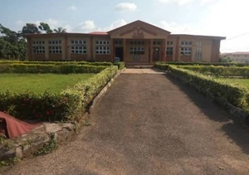

- PARROT CYBERWORLD TANKE ILORIN KWARA STATE
MERIT
- Reliable security
- Experienced staff
DEMERIT
- Inadequate power supply
- Technical issues
Fig 1: The Case Study Three Images
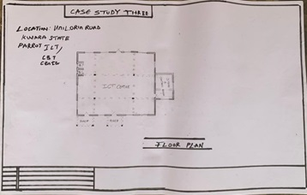
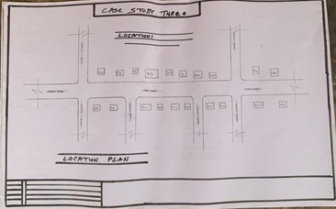

Fig 2: Parrot Cyber world Tanke, Ilorin Kwara State.
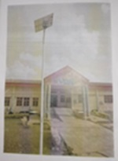
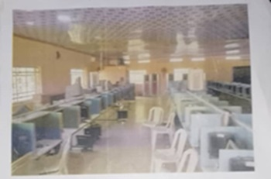

3.1 BRIEF HISTORY OF PROJECT LOCATION
Egbe is an ancient town located in Yagba West Local Government Area of Kogi State, Nigeria. The town has a rich and diverse history that dates back to the 15th century.
According to oral tradition, Egbe was founded by a hunter named Oba Egbe, who migrated from the ancient kingdom of Ile-Ife in present-day Osun State. Oba Egbe settled in the area and established a small settlement, which eventually grew into the town of Egbe.
During the colonial era, Egbe was an important center for the production of cotton, which was a major cash crop in the region. The town was also a major hub for trade and commerce, with merchants coming from all over the region to buy and sell goods.
After Nigeria gained independence in 1960, Egbe continued to grow and develop. The town became an important center for education, with the establishment of several schools and colleges. Today, Egbe is a thriving town with a rich cultural heritage and a strong sense of community.
Egbe is known for its rich cultural heritage, including its traditional music, dance, and art. The town is also home to several important cultural festivals, including the Egbe Festival, which is celebrated annually to commemorate the founding of the town.
Egbe is an important center for agriculture, with crops such as cotton, maize, and cassava being major sources of income for the local population. The town is also home to several small-scale industries, including textile manufacturing and food processing.
3.2 SITE LOCATION DESCRIPTION
The proposed “ICT CENTER” located in Egbe, Kogi state.
Fig 3.1: The site location description
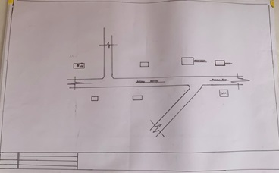
3.3 SITE SELECTION CRITERIA
Site selection is the consideration of factors which influenced the development of the site and the special activities. Conversely a site selection criteria is based on the screening factors affecting site selection including comfort, thermal control, orientation, ventilation and solar radiation control among others including the activities taking place in the sites.
Due to nature of the project, the site selected, should meet the basic the requirement of standard "ICT CENTER" which include the quality of the environment.

3.4 SITE ANALYSIS
After visiting the site a detail analysis have been done, to reveal to analyses both natural and artificial features if the site, some of the analysis noted during the investigation are stated.
Fig 3.4: Site Analysis
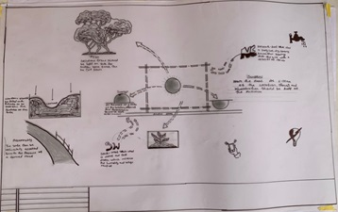
3.4.1 SOIL TYPE
This is very important to consider in planning of any project ad at the greatly to the structure stability. To avoid any collapse the texture of the soil of the site must be tested to determine it type. According to analysis done on the proposed site, the soil present on the site is loamy, underneath which is clay soil.
3.4.2 TOPOGRAPHY
Topography explain the analysis of land structure in term of the slope, and the site shape orientation. Meanwhile the topography of the proposed site is relatively uniform.

3.4.3 ORIENTATION
The orientation of the site is considered, the sunrise and sun set for the wellbeing of the building occupant. This analyze where the building will face and how to control the light rays.
3.4.4 VEGETATION
The site is cover trees and grasses, 60% of grasses and 40% of trees. The trees and grasses to be removed.
3.5 GEOGRAPHICAL CLIMATE DATA
3.5.1 GEOGRAPHICAL OF KOGI STATE
Kogi State is located in the north-central region of Nigeria and is popularly referred to as the “Confluence State” due to the meeting point of the River Niger and River Benue within its territory. This unique geographical feature not only gives the state its name but also contributes significantly to its agricultural and economic potential. The state shares boundaries with ten other states, making it one of the most strategically positioned states in Nigeria.
The topography of Kogi State is varied, consisting of undulating hills, flat plains, and fertile river valleys. Hilly terrains dominate the eastern and western parts of the state, while lowlands stretch along the riverbanks. These geographical features make the land suitable for a variety of agricultural activities. The confluence area is particularly rich in alluvial soils, supporting the cultivation of rice and other crops.
Kogi experiences a tropical savannah climate, with distinct wet and dry seasons. The rainy season typically spans from April to October, while the dry season lasts from November to March. Average annual rainfall ranges between 1,100 mm and 1,300 mm, and temperatures generally range from 25°C to 35°C. During the dry season, Harmattan winds from the Sahara often bring cooler temperatures and dusty air, especially between December and February.

Vegetation in the state falls within the Guinea Savannah zone, characterized by tall grasses, scattered trees, and occasional shrubs. The riverine areas, especially around the Niger and Benue, support lush vegetation and wetlands, making them suitable for rice farming, sugarcane cultivation, and fishing. The state’s natural vegetation has been altered in some areas due to human activities such as farming, logging, and settlement expansion.
Kogi State is abundantly endowed with natural resources. It possesses a wide range of solid minerals including coal, limestone, iron ore, gypsum, marble, and kaolin. These resources support various industries in the state, such as the large Dangote Cement factory in Obajana and the Ajaokuta Steel Complex, which, though underutilized, remains a significant industrial asset. In addition to minerals, the state also has rich agricultural land that supports the cultivation of yam, cassava, maize, rice, cashew, and other food and cash crops.
Major towns and cities in Kogi State include Lokoja, the state capital, which lies at the Niger-Benue confluence and serves as an administrative and historical center. Okene is another major town, known for its industrious population and cultural heritage. Idah, located in the eastern part of the state, is a significant Igala town with a deep cultural history. Ajaokuta is notable for its steel industry, while Kabba is a prominent Yoruba-speaking town and regional commercial hub. Anyigba is a growing urban center, home to Kogi State University and a key educational town in the state.
In summary, Kogi State’s geography is rich and diverse, with a landscape shaped by rivers, hills, and fertile lands. Its natural resources, favorable climate, and strategic location contribute to its importance in Nigeria’s economic and cultural landscape.
3.5.2 CLIMATIC DATA
Kogi State experiences a tropical savannah climate characterized by two main seasons: the rainy season (April to October) and the dry season (November to March). Annual rainfall ranges from 1,100 mm to 1,300 mm, with peak rainfall in July and September. Temperatures are generally high throughout the year, averaging between 25°C and 35°C, with the hottest months being February to April and the coolest during the Harmattan period in December and January, when temperatures can drop to around 18°C at night. Humidity levels are high during the rainy season, often exceeding 80%, but drop significantly during the dry season due to the Harmattan winds, which also bring dusty and hazy conditions. Sunshine is more abundant during the dry season, averaging 7 to 9 hours per day, while cloud cover during the rainy season reduces it to 4 to 6 hours. These climatic conditions support diverse agricultural activities and shape the state’s ecological and economic patterns.
3.5.3 TEMPERATURE
Kogi State experiences generally high temperatures throughout the year due to its location within the tropical savannah climate zone. Average daily temperatures range between 25°C and 35°C, with the hottest period occurring from February to April, when temperatures can rise above 38°C in some areas. The coolest period is during the Harmattan season, between December and January, when dry, dusty winds from the Sahara reduce humidity and cause temperatures to drop, especially at night, sometimes falling below 20°C. Despite these seasonal variations, the overall temperature remains warm year-round, supporting a wide range of agricultural activities but also requiring adaptations to heat and seasonal dryness.
3.5.4 RAINFALL
Kogi State receives annual rainfall between 1,100 mm and 1,300 mm, mainly from April to October during the rainy season.
3.5.5 HUMIDITY
Humidity is high in the wet season (up to 85%) and drops significantly during the dry Harmattan period.
3.5.6 WIND
The climatic condition of Kogi is affected by two main air current predominant in the West Africa region which are as follow.
3.5.7 THE NORTHERN-EAST TRADE WIND
The North-East Trade Wind (Harmattan) brings dry, dusty air from the Sahara during the dry season.
3.5.8 THE SOUTHERN-EAST TRADE WIND
This wind is responsible for the South-West Trade Wind (not South-East) brings moist, rain-bearing winds from the Atlantic during the rainy season.
3.6 CONCLUSION
Conclusively, this chapter has emphasized critically on the site and environmental analysis of the proposed location for the project.

CHAPTER FOUR
4.0 DESIGN AIM
My statement and purpose is to bring and provide a standard acceptable architectural in ICT center in terms of facilities, securities and construction and planning and also to improve efficacy of ICT center and take good care of the convenience of the staff and learners.
4.1 DESIGN CONCEPT
The proposed ICT center is expected to serve as a building where knowledge is impacted within Egbe. This design can be varied to any extent, therefore to achieve a standard ICT center that would be aesthetic and call the interest of the people itself, planning of structure, functionally and circulation should be put into consideration in order to achieve a well comfortable design.
Fig 4.1: Design concept
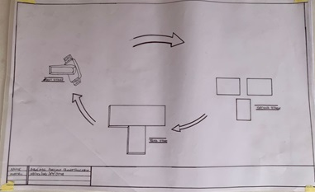
4.2 DESIGN FORM
There are various design for, for the type of project depending on the type of arrangement, layout and designs. In my own design project, the design form is in flash drive. In elevation, the structure will show hierarchy as we have in some ICT center.
4.2.1 DESIGN CRITERIA
- Size of the site
- Site topography
- Availability of services
- Government policy
- Adjourning feature
4.2.2 DESIGN SCOPE
- Gate House
- Main Building
- Car Park
- Passing Area
- Cafe Area
4.2.3 DESIGN BRIEFS
- Examination Hall
- Reception Office
- Toilet
- Control Room
- Storage Room
- Meeting Room
- Training Room
- File Room
- Equipment Room
- Server Room

4.3 TRAFFIC ANALYSIS
This traffic involve vehicle such as car, lorries, buses etc. and this include.
1. Through traffic
2. Direct access traffic
3. Occasional traffic
• THROUGH TRAFFIC
This is the private and the public vehicular traffic playing major roads carriage way that may block the ICT center.
• DIRECT ACCESS TRAFFIC
This class of traffic is associated with the vehicular traffic with the park for staff and other coming for different activities.
• OCCASIONAL TRAFFIC
This are traffic associated with park, services or utility vehicles which includes fire fighting vehicles, Ambulance, delivery trucks and refuse disposal truck.
4.4 DESIGN CONSIDERATION
The general consideration of the design of an ICT center include Planning concept, layout and designs, functionality, circulation system in the ICT center, vehicle, pedestrian circulation and circulation in the truck section.
PLANNING CONCEPT: Location of the lorry park has to confirm with land use zoning so that it will planned to serve the prospective ICT center and staffs adequately.
LAYOUT AND DESIGN: The layout plan of an ICT center should properly zone to enhance the segregation of various circulation network in order to minimize conflict.
FUNCTIONALITY: This is a characteristics of functionality to support the user and gives adequate service. Here are some key functionality:
VEHICULAR CIRCULATION: Vehicular circulation space are provided space mainly for vehicle traffic maneuvering and parking roadways, junction, parking and turning space.
PEDESTRAIN CIRCULATION: This includes the paved footpath walkways and others spaces like ramp, walkway which are exclusively used by pedestrian with little or no vehicle interfere.
CIRCULATION SYSTEM IN THE CAR PARK: Circulation network is lorry the park encompasses all movement all movement of cars, lorries, truck and people around various space. This analysis deal s with categories of movements and their design consideration so as to serve as a guide in the design of circulation system in the proposed ICT center.

CHAPTER FIVE
5.0 APPRAISAL OF PROPOSED DESIGN
As it has already been discussed, a functionality, aesthetic, sustainability, and secure ICT center will bring a good result in economy of the area and increasing the popularity of the area and bring more civilized world to them as the era goes on. The overall increases in population in Egbe over the past years with the attending of increases in business activities in the state, basically areas which there have many ICT center that are more popular in names and been in a centralized area that.
5.1 CONSTRUCTION TECHNIQES AND CHOICE MATERIAL
The prevalent architecture in the location of the site is the international style in architecture. The international style in architecture was the principle architecture trend of the 1920 and 1930, which began in Europe. The style consists of geometric and asymmetrical forms expressed in modern materials as concrete, steel and glass and arose the usage of steel trusses in the workshops with long span aluminum roofing sheet, the walkways and footpath are mainly of flat stones finishes, solar rays are avoided in the buildings by the use of tinted glasses.
In designing this building form within the vicinity of the project, it is very necessary to consider style that would be perfectly integrated into the surrounding in the use of materials and form's.
5.2 SERVICE REQUIRED
The handling of building services are very important in a project, services like electricity and water supply. Electricity is supplied by Egbe electricity (IE) pole in and around the site for use in ICT center. Bore-hole water system is to provide in the site and channel to the building for adequate and regular provision of water.

5.2.1 VENTILATION
Adequate ventilation in an opening of the building is located strategic and adjacent position of each other, artificial ventilation is attained by creating opening in the proposed building.
5.2.2 LIGHTNING
Adequate natural lightning is expected within this unit of the building and visual performance depends on total perception of space, quality as well as total amount of light.
Interiors of the building are lighted naturally with the use of florescent and bulb to provide lightning to this apart of building.
5.2.3 CIRCULATION
Since space management is a paramount importance in this research work, it is then necessary to properly analyses the circulation of the vehicles, there should be an efficient path around the car park to locate a space, then to proceed quickly to the exit clear signing the required, usually combination of ground route marking and mounted signs.
5.2.4 PLUMBING
Plumbing is the system of pipe & system etc. That supply and stop water for use on a holding. The water will be supplied to the building through the water main as reticulated on this alternative borehole supply.
5.2.5 ACOUSTIC
It is the study of sound behavior in relation to the purposed building. In design, control of intrusive noise of great important. This is choosing by the acoustic material i.e ceiling, windows and doors.
5.2.6 WATER DISPOSAL
Water disposal is the method of collecting both liquid and solid waste in building as regard this project (COMPUTER ICT CENTER) there will be a septic tank for solid waste, human excrete as well as discharge from toilet should be located away from public area like restaurant in order to avoid irritating odor, washing hand basin should be provided to help them clean their hands after using toilets to just sanitize their hands against dirt.
5.2.7 FIRE PROTECTION
Fire protection can be needed in two ways, fire prevention and fire protection, fire prevention is to be conserved by providing a fire selection alarm to alert the building maintenance officer to find a way of preventing the fire from widespread. Firefighting equipment is to provide such as hose reels, sprinklers and drenches, these equipment are to be fixed at strategic position for easy access in other to protect the building by extinguishing the fire automated sprinkler.
5.2.8 EXTERNAL
WORKSWALL
Loading bearing wall of the toilet are finished with ceramics titles of the height of 2.1m what make up the bearing works are wall filled with some concrete slab and beam finished with sand screed.
LANDSCAPE ELEMENT USED IN THE DESIGN
• ASPHALT: Is used fir drive way and parking lots it is economical and durable both for pedestrian and vehicular traffics.
• INTERLOCKING PAVING: This is used for walking and outdoors paving to blend with natural texture of the environment.
• SHRUB AND HEDGES: Used to set-off the various building within the center it is used as fence to direct movement of vehicle within the site.
• GRASS AND LAWN MATERIALS: Is used as land covered to reduce the reflective effects of ground and also to control erosion and landscape in case of flooding. It is also used to reduce the intensity pf sun radiation. It absorbs, up to 45% of solar rays and disperses occupant of the rest to the environment thereby creating comfort for the occupant of the building.
• DECORATIVE FLOWERS: Different species of flower are used to enhance the aesthetic appearance of the site.
5.3 CONSTRUCTION METHODOLOGY
The choice of management and construction techniques, according to international standard, which is influenced by others factors including.
• Cost
• Topography of the site
• The climate condition
• Availability and sustainability with all factor under unit are design to meet the required standard.
5.4 RECOMMENTATION AND CONCLUSION
In this thesis, I have attempted to state and define the problem and suggestion the possible solution in mentioned design.
However, I would like to recommend that instruction and details given to the design is saintly adhered to and both in the choice of materials and the construction techniques. The project should be handed over to a qualified professional contractor and upon completion of the project it should be maintained or put under the care of physical planning units.

REFERENCES
Hennessy, J. L., & Patterson, D. A. (2011). Computer Architecture: A Quantitative Approach. Morgan Kaufmann. This foundational text covers the evolution of computer architectures and their implications for data center design.
Hwang, K., & Dongarra, J. (2016).Data Center Handbook. Wiley. This comprehensive guide addresses the design, operation, and management of data centers, including considerations for infrastructure and technology.
Dada, I. O. (2017). 'Design Considerations for IT Facilities in Nigeria." International Journal of Engineering Research & Technology. This paper reviews design strategies for IT facilities in Nigeria, addressing local constraints and requirements.
Oladipo, T. B. (2020). "Sustainable Practices in Nigerian Data Centers." Journal of Sustainable Development in Africa. Discusses energy efficiency and green building practices in Nigerian data centers.
Blueprint © 2020 Historical background of Computer ICT center (www.blueprint.ng)
Google map © 2022 Jaipur cyber cafe
Wikitiontary (2022) this is an online dictionary platform where meanings of vocabulary use here and definition are gotten from (http://Wikitionary.org)

APPENDIX

Fig 1.1
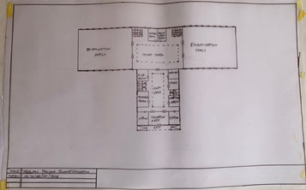
Fig 1.2
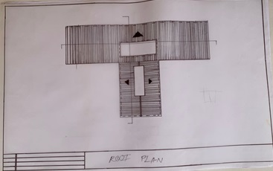

Fig 1.3
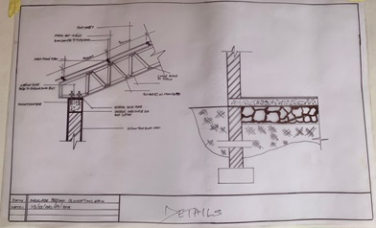
Fig 1.4

Fig 1.5
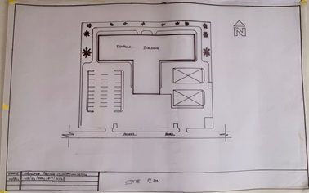
Fig 1.6

Fig 1.7
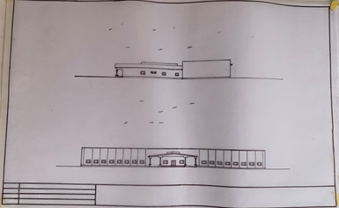
Fig 1.8

